BEFORE THE FLORIDA PUBLIC SERVICE COMMISSION

|  |  |
| --- | --- |
| In re: Review of 2026-2035 Storm Protection Plan, pursuant to Rule 25-6.030, F.A.C., Duke Energy Florida, LLC. | DOCKET NO. 20250015-EI  ORDER NO. PSC-2025-0217-FOF-EI  ISSUED: June 19, 2025 |

The following Commissioners participated in the disposition of this matter:

MIKE LA ROSA, Chairman

ART GRAHAM

GARY F. CLARK

ANDREW GILES FAY

GABRIELLA PASSIDOMO SMITH

FINAL ORDER APPROVING WITH MODIFICATIONS,

DUKE ENERGY FLORIDA, LLC’S

2026-2035 STORM PROTECTION PLAN

APPEARANCES:

DIANNE M. TRIPLETT, MATTHEW R. BERNIER and STEPHANIE A. CUELLO, ESQUIRES, 299 First Avenue North, St. Petersburg, Florida 33701

On behalf of Duke Energy Florida, LLC (DEF).

WALT TRIERWEILER, PATRICIA A. CHRISTENSEN, OCTAVIO SIMOES-PONCE, CHARLES REHWINKEL, MARY A. WESSLING, and AUSTIN A. WATROUS, ESQUIRES, 111 West Madison Street, Room 812, Tallahassee, Florida 32399-1400

On behalf of Office of Public Counsel (OPC).

JAMES W. BREW, LAURA WYNN BAKER and SARAH B. NEWMAN, ESQUIRES, Stone, Mattheis, Xenopoulos & Brew, PC, 1025 Thomas Jefferson Street, NW, Eighth Floor, West Tower, Washington, DC 20007

On behalf of White Springs Agricultural Chemicals, Inc. d/b/a PCS Phosphate – White Springs (PCS Phosphate).

JENNIFER AUGSPURGER and JACOB IMIG, ESQUIRES, Florida Public Service Commission, 2540 Shumard Oak Boulevard, Tallahassee, Florida 32399-0850

On behalf of the Florida Public Service Commission (Staff).

MARY ANNE HELTON, ESQUIRE, Interim General Counsel, Florida Public Service Commission, 2540 Shumard Oak Boulevard, Tallahassee, Florida 32399-0850

Advisor to the Florida Public Service Commission.

BY THE COMMISSION:

Background

Section 366.96(3), Florida Statutes (F.S.), requires each public utility[1] to file a transmission and distribution storm protection plan (SPP) that covers the immediate 10-year planning period, and explains the systematic approach the utility will follow to achieve the objectives of reducing restoration costs and outage times associated with extreme weather events and enhancing reliability. Pursuant to Section 366.96(4)–(6), F.S., at least every three years we are required to determine whether it is in the public interest to approve, approve with modification, or deny each utility’s transmission and distribution SPP filed in accordance with Commission Rule 25-6.030, Florida Administrative Code (F.A.C.). Our decision must be made no later than 180 days from the utility’s filing of a SPP petition that meets the requirements of Rule 25-6.030, F.A.C.

On January 15, 2025, Duke Energy Florida, LLC (DEF or Utility) filed its Petition for Approval of Storm Protection Plan. The Office of Public Counsel (OPC), representing Utility’s customers, intervened in this docket by filing its Notice of Intervention, with an Order Acknowledging Intervention being entered on January 24, 2025. White Springs Agricultural Chemicals, Inc. d/b/a PCS Phosphate – White Springs (PCS Phosphate) filed a Petition to Intervene as well, with an Order Granting Intervention entered thereon on February 12, 2025.

DEF’s proposed 2026-2035 SPP consists of the following nine programs, which are each discussed in greater detail *infra* for purposes of our required statutory review:

* + Distribution Feeder Hardening;
  + Distribution Lateral Hardening;
  + Distribution Self-Optimizing Grid;
  + Distribution Underground Flood Mitigation;
  + Distribution Vegetation Management;
  + Transmission Structure Hardening;
  + Transmission Substation Flood Mitigation;
  + Transmission Substation Hardening; and
  + Transmission Vegetation Management.

On May 16, 2025, DEF and OPC filed their Joint Stipulations.[2] The Joint Stipulations indicate that DEF conferred with counsel for PCS Phosphate regarding the stipulations and proposed resolution, and PCS Phosphate did not oppose same.[3] The Joint Stipulations are attached as Attachment A to this Order. A hearing to fully address DEF’s SPP petition was held on May 20, 2025.[4]

We have jurisdiction over this matter pursuant to Section 366.96, F.S., and Chapter 120, F.S.

Legal Standard

When reviewing each transmission and distribution SPP filed pursuant to Section 366.96, F.S., we must consider the following factors in order to make a public interest determination:

1. The extent to which the plan is expected to reduce restoration costs and outage times associated with extreme weather events and enhance reliability, including whether the plan prioritizes areas of lower reliability performance;
2. The extent to which storm protection of transmission and distribution infrastructure is feasible, reasonable, or practical in certain areas of the utility’s service territory, including, but not limited to, flood zones and rural areas;
3. The estimated costs and benefits to the utility and its customers of making the improvements proposed in the plan; and
4. The estimated annual rate impact resulting from implementation of the plan during the first 3 years addressed in the plan.[5]

Utility storm protection or hardening is an activity that goes above and beyond the basic standard of service to strengthen a utility’s existing infrastructure to withstand the potential for extreme weather. Rule 25-6.030, F.A.C., implements the statute, provides definitions (such as what an SPP is comprised of), and requires the utilities to provide certain information to support their SPPs.

**DECISION**

1. Should the proposed Insulator Upgrade Sub-Program be included in DEF’s proposed 2026-2035 SPP?

**Stipulation**: Yes. It is in the public interest for the Commission to approve DEF’s Insulator Upgrade Sub-Program as a component of the Transmission Structure Hardening Program of the Company’s 2026-2035 Storm Protection Plan (“SPP”).

1. Analysis

DEF and OPC stipulated that it is in the public interest for the Commission to approve DEF’s Insulator Upgrade subprogram as a component of the Transmission Structure Hardening program of DEF’s 2026-2035 SPP. (Attachment A).

This subprogram specifically targets porcelain insulators, which are prone to failure during extreme weather events. Witness Vasquez’ testimony indicates that the Insulator Upgrades subprogram will target the replacement of porcelain insulators which show pin erosion “penciling” of the connections between insulator with glass insulators[6] and that the porcelain insulators with “penciling” are more vulnerable during extreme weather events.[7] According to Witness Vasquez, glass insulators have a more uniform matrix and a zinc sleeve to mitigate pin erosion for enhanced mechanical connections and that such qualities will mitigate outages during extreme weather events.[8]

The record suggests that this Insulator Upgrade subprogram is expected to mitigate outages during extreme weather events, improve operation of the grid during extreme weather events, reduce restoration costs by preventing insulator failures, and minimize outage events through improved insulator performance. By reducing insulator failures, which are a cause of transmission outages during storms, we believe the program should logically reduce both outage durations and restoration costs.

The Insulator Upgrade subprogram is expected to enhance reliability by targeting equipment vulnerable to extreme weather, replacing failure-prone porcelain insulators with more resilient glass alternatives; reducing the occurrence of insulator-related outages; and strengthening infrastructure against extreme weather conditions.[9] By mitigating these failure points, the overall reliability of the transmission grid should improve.

The Insulator Upgrade subprogram uses a two-step prioritization process. First, the SPP model simulates existing conditions under extreme weather events versus hardened conditions for every location on the grid in DEF's territory. This process calculates potential equipment failures and estimates downstream costs and benefits.[10] Next, DEF engineers conduct desk reviews to evaluate the data-driven prioritization based on their experience and knowledge of specific locations, considering on-ground conditions that might not be captured in the model. The output of this process is a data-driven list of locations prioritized by benefit-cost ratios, ensuring the most cost-effective projects are implemented earlier.[11] While there is no statement that the Insulator Upgrade subprogram specifically targets areas with historically lower reliability performance, the benefit-cost analysis would logically tend to prioritize areas where reliability improvements would yield the greatest benefits. Line insulators are prioritized based on inspection data and enhanced weather modeling, focusing on areas where upgrades would be most beneficial during extreme weather events.

DEF has determined that there are no areas within its service territory where it would not be feasible, reasonable, or practical to execute its SPP programs.[12] The effectiveness of the program is supported by forensic analyses showing that transmission storm-hardened assets have performed as intended during extreme weather events, with zero SPP hardened assets failing due to weather conditions.[13] The approach to prioritization and planning across DEF’s service territory supports DEF’s position that all areas are considered feasible for implementation of the Insulator Upgrade subprogram of DEF’s SPP.

As for benefits, while specific quantitative benefit analyses are not provided, the benefits are primarily described in qualitative terms, focusing on improved reliability, reduced failures, and enhanced system resilience during extreme weather events. While no customers are anticipated to be directly impacted in 2026,[14] approximately 123,000 customers will be impacted in 2027, and approximately 28,000 customers will be impacted in 2028.[15]

While we know the planned capital expenditures for the Insulator Upgrade subprogram during 2025-2028, the record does not contain specific calculations or estimates for how the costs related to this particular subprogram would impact utility rates or customers’ bills during this period. However, Section 366.96, F.S., does not command us to evaluate the impact on rates for each particular program or subprogram of the SPP; rather, our consideration of the estimated rate impact for the first three years is based on the SPP as a whole. Our consideration of the rate impact of DEF’s SPP as a whole is discussed *infra.*

1. Conclusion

DEF and OPC stipulated that it is in the public interest for this Commission to approve DEF’s Insulator Upgrade subprogram as a component of DEF’s 2026-2035 SPP. For the reasons set forth above, we agree that the testimony and exhibits support a finding that the Insulator Upgrade subprogram encompasses appropriate storm-hardening measures and that it is in the public interest for the Insulator Upgrade subprogram to be included in DEF’s proposed 2026-2035 SPP.

1. Should the Commission approve, approve with modification, or deny DEF’s Storm Protection Plan?

**Stipulation**: The Parties stipulate and agree that it is in the public interest for the Commission to approve DEF’s 2026-2035 SPP with a clarification regarding the Company’s proposed Over-Head Ground Wire (“OHGW”) Subprogram as described below and modifications to two other programs, also described below.

The record supports a Commission finding that it is in the public interest for DEF to continue to implement the OHGW Subprogram as a part of its SPP, and that DEF continuing to implement the subprogram in 2026, 2027, and 2028, is not evidence of imprudence. Such ongoing approval through this stipulation does not constitute a final resolution of the dispute between the OPC and DEF about whether the OHGW Subprogram should ultimately remain in the company’s SPP. Such a resolution should occur when it is reviewed the next time pursuant to section 366.96(6), Florida Statutes. Accordingly, any continued inclusion of this subprogram in the DEF SPP shall not be cited for precedent that the facts and circumstances of the continued inclusion of DEF’s OHGW Subprogram in the 2026-2035 SPP supports inclusion of a similar program in any company’s SPP.

The parties acknowledge that DEF’s 2026-2035 SPP contemplated within the Feeder Hardening program approximately 1,400 miles of hardening and 44,000 pole replacements and within the Lateral Hardening program approximately 800 miles overhead hardening and 117,000 pole replacements. The Parties stipulate that DEF will reduce its Feeder Hardening scope target by 10% to 13% in 2026, deferring that work to 2027 and beyond. The Parties further stipulate that DEF will reduce its Lateral Hardening scope target by 8% to 11% in 2026, deferring work to 2027 and beyond. The parties agree that this modification will be a target and not a hard cap.

1. Analysis

The agreed upon stipulations between OPC and DEF are the result of a robust discovery process. The stipulations will result in a modification to the proposed SPP that DEF previously filed. As such, what remains for us to analyze in this proceeding are the nine programs that comprise DEF’s SPP.

The evidentiary record before us, comprised of the pre-filed testimonies of DEF witnesses Lloyd, Vazquez and Menendez and OPC witness Mara, as well as Exhibit Nos. 1, 3-5, 14-18, 36, 48-54, permit our informed review of DEF’S proposed SPP consistent with the parties’ stipulations, including with regard to the scope of deployment of certain programs of the SPP. As explained in the analysis below, we accept DEF and OPC’s Joint Stipulations because we find those stipulations are supported by the record evidence and lead to a reasonable outcome consistent with the requirements of Section 366.96, F.S., and Rule 25-6.030, F.A.C.

We evaluate the following nine programs within DEF’s 2026-2035 SPP to determine whether the SPP and its programs are reasonably expected to: reduce restoration costs and outage duration; prioritize areas with lower reliability performance; be feasible, reasonable, and practical; provide transparent cost-benefit explanations; demonstrate their impact on customers; and serve the public interest:

1. **Distribution Feeder Hardening**

This program is a long-term program designed to enhance the resilience of electrical distribution systems against extreme weather events. By incorporating pole inspection and replacement activities, existing feeder circuits can be strengthened to better withstand extreme weather events. This includes strengthening or replacing structures, updating basic insulation levels and conductors to current standards, relocating difficult to access facilities, relocating or undergrounding facilities to address clearance encroachments, and replacing oil-filled equipment as appropriate. All new structures will meet the NESC 250C extreme wind load standard. [16]

The program, anticipated to take 50 years to complete, aims to upgrade approximately 6,500 miles of feeder backbone across over 1,300 feeders.[17] DEF and OPC acknowledge in their Joint Stipulation that DEF’s 2026-2035 SPP is contemplated to harden approximately 1,400 miles of feeder backbone and 44,000 pole replacements. Of particular note in regard to reduced restoration costs and outages, along with increased resilience, is the fact that, according to Witness Lloyd, “the hardening efforts are effective as no hardened assets have been identified as damaged due to the [hurricanes in 2022 through 2024].”[18] Further, Witness Vazquez testified that “[z]ero hardened assets have failed due to extreme weather events.”[19]

1. **Distribution Lateral Hardening**

This program will enable branch lines to better withstand extreme weather events. The Lateral Hardening Program includes undergrounding of the laterals that are most prone to damage during extreme weather events and overhead hardening of those laterals less prone to damage. The program targets approximately 12,000 miles of lateral lines throughout DEF’s service territory.[20]

The program employs 2 primary strategies: Lateral Undergrounding and Lateral Overhead Hardening.[21] Lateral Undergrounding focuses on branch lines that historically experience the most outage events, are most prone to damage during extreme weather events, contain significantly aged assets, are susceptible to vegetation damage and/or have facilities that are inaccessible to trucks. These lines are replaced with modern underground designs.[22] Lateral Overhead Hardening is applied to less vulnerable segments through structure strengthening, conductor upgrades, removing secondary lines, replacing fuses with automated line devices, pole replacement, line relocation, and/or hazard tree removal.[23]

DEF and OPC acknowledge in their Joint Stipulations that within the Distribution Lateral Hardening program, it is estimated that approximately 800 miles of overhead hardening and 117,000 pole replacements will take place under the 2026-2035 SPP. The hardening proposed by this Distribution Lateral Hardening program is reasonably expected to reduce restoration costs and outage times, and increase resilience of the grid, by targeting lateral segments most prone to damage resulting in outages during storms, placing vulnerable laterals underground and thereby reducing both damage costs and outage durations for customers, and enhancing the resilience of distribution lateral lines, which are often more vulnerable to storm damage than feeder lines.

1. **Distribution Self-Optimizing Grid**

This program utilizes automated switching which allows most circuits to be restored from alternate sources. In addition, the program provides segmentation such that the distribution circuits have much smaller line segments, thus reducing the number of customers that are affected by outages. The SOG program consists of three major components: capacity; connectivity; and, automation and intelligence.[24] It has been represented by DEF that its SOG reduces outage impacts by up to 75% and minimizes customer interruptions during extreme weather events.[25]

By the end of 2026, approximately 80% of DEF’s distribution feeders will have automated power rerouting capabilities.[26] The SOG program has demonstrated significant benefits: its system automation, which allows the grid to automatically detect, isolate and reconfigure itself during an outage, results in improved monitoring and control capabilities across the grid, which directly relates to reduced outage durations. During extreme weather events during the period 2022-2024, the SOG, and its incorporated components, such as segmentation automation, capacity, connectivity, and fiber optic communications, helped DEF’s customers to avoid over half a billion minutes of interruptions[27] and it is estimated that the program saved over 300 million minutes of customer outages during the recent Debby, Helene, and Milton hurricanes.[28]

1. **Distribution Underground Flood Mitigation**

This program is designed to enhance the resilience of underground electric systems in flood-prone areas by hardening existing infrastructure to withstand storm surges and flooding during extreme weather events.[29] Underground facilities that are prone to storm surge will be converted to submersible lines and equipment. In some cases, pad mounted equipment is placed on elevated structures, which raises the equipment two to four feet above grade, to mitigate potential flood impacts. This program focuses on those areas that are particularly vulnerable to storm surge during extreme weather events.[30]

This long-term program, anticipated to take 30 years, is expected to deliver significant benefits. Once deployed, the program is expected to decrease Customer Minutes of Interruption (CMI) by approximately 0.6 million to 0.8 million minutes annually.[31] Additional benefits will include reducing the cost of extreme weather events on the distribution system by approximately $0.8 million to $1.0 million annually,[32] strengthening the infrastructure against flooding, and reducing restoration costs following extreme weather events.

1. **Distribution Vegetation Management**

This program consists of routine maintenance trimming, hazard tree removal, herbicide applications, vine removal, customer requested work, and right-of-way brush mowing. DEF trims its feeders on a three-year cycle and trims its laterals on a five-year cycle.[33] Approximately 1,900 miles of feeder backbone and approximately 2,450 miles of laterals are trimmed annually.[34]

The Florida Legislature has found that high winds can cause vegetation to “blow into and damage electrical transmission and distribution facilities, resulting in power outages.”[35] “A majority of the power outages that occur during extreme weather conditions in the state are caused by vegetation blown by the wind.”[36] In order to address this problem in its SPP, DEF noted that its Distribution Vegetation Management program is aimed at preventing branches from falling on the electrical system, and thus, reducing the likelihood of outage events.[37]

1. **Transmission Structure Hardening**

This program includes wood to non-wood upgrades, tower upgrades, adding cathodic protection, automating gang operated air break switches, overhead groundwire upgrades, insulator upgrades and structure inspections.

DEF anticipates that, at program completion, altogether 6,000 towers will be hardened, cathodic protection will have been installed on all eligible towers, an estimated 824 miles of OHGW will have been replaced, 3,000 wood poles will have been replaced; 56,000 insulator sites will have been upgraded, and, 60 gang-operated air break switches will be automated.[38] As noted previously, DEF has not had a hardened transmission structure fail during a storm event.

1. **Transmission Substation Flood Mitigation**

This program builds in protection for substations most vulnerable to flood damage using flood plain and storm surge data. It includes a systematic review and prioritization of substations at risk of flooding to determine the proper mitigation solution, which may include elevating or modifying equipment, or relocating substations altogether. New assets could include control houses, relays, or total station rebuilds to increase elevation, and the like.

Eleven substations have been identified for flood mitigation in DEF’s SPP and it is estimated the program will take 12 years to complete.[39] Once the program’s flood mitigation is completed, expected benefits include an anticipated cost reduction of extreme weather events on the transmission system by approximately $2.2 million to $2.8 million annually, with CMI being reduced by approximately 0.7 million to 0.9 million minutes annually.[40]

1. **Transmission Substation Hardening**

The Transmission Substation Hardening program focuses on enhancing substation resilience against extreme weather events through strategies including upgrading oil breakers to gas/vacuum breakers and replacing electromechanical relays with electronic relays.[41]

Both upgrades implement the latest design standards and improved materials that exceed minimum requirements, and thus enhance overall system resilience. With enhanced infrastructure resilience, it is anticipated that there will be fewer failures during extreme weather events and quicker restoration times with a reduction as well in outages.

Upon completion, the program is estimated to reduce annual restoration costs by approximately $45,000 to $56,000 annually, with CMI estimated to be reduced by approximately 7 million to 9 million minutes annually.[42] With enhanced infrastructure resilience, it is anticipated that there will be fewer failures during extreme weather events and quicker restoration times with a reduction as well in outages.

1. **Transmission Vegetation Management**

The Transmission Vegetation Management program focuses on ensuring adequate conductor-to-vegetation clearance, including cycle trimming, hazard tree identification and mitigation, tree pruning, removals within and outside easements, herbicide application, mowing, and condition-based inspections to minimize vegetation-related interruptions around transmission lines.[43]

As discussed *supra*, the Florida Legislature has found that high winds and blowing vegetation can result in power outages. In order to address this problem in its SPP, DEF offered testimony that its Transmission Vegetation Management program is aimed at preventing branches from falling on the electrical system, and thus, reducing the likelihood of outage events.

The evidentiary record before us – including the pre-filed testimonies of DEF witnesses Lloyd, Vazquez, and Menendez, as well as OPC witness Mara, and Exhibits 1, 3-5, 14-18, 36, and 48-54 – provides a basis for our informed review of DEF's proposed SPP. This review aligns with the parties’ stipulations, particularly regarding the scope of deployment for certain programs within the SPP. As explained in the analysis below, we accept DEF and OPC’s Joint Stipulations because we find they are supported by the record evidence and lead to a reasonable outcome consistent with the requirements of Section 366.96, F.S., and Rule 25-6.030, F.A.C.

We note that all nine of DEF’s programs in its 2026-2035 SPP are continuations of programs we previously approved in DEF’s last SPP in 2022.[44] Nonetheless, we are charged with evaluating and making a determination that the proposed 2026-2035 SPP meets the statutory criteria set forth in Section 366.96, F.S.

1. DEF’s SPP is expected to result in reduced restoration costs and outage times associated with extreme weather events and enhance reliability as well as prioritize areas of lower reliability performance.

Section 366.96(4)(a), F.S., states that when reviewing a utility’s transmission and distribution SPP, we shall consider “[t]he extent to which the plan is expected to reduce restoration costs and outage times associated with extreme weather events and enhance reliability.” DEF presented testimony that its nine programs as referenced above would reduce outages and overall restoration times.

Based upon our above discussion of the attributes of each of the nine programs, we find that DEF has shown that its SPP aims to significantly reduce restoration costs and outage times, providing more reliable service to customers during extreme weather events.

DEF offered testimony on its process to assess system risk and determine project prioritization for its SPP programs based on probability, response, and impact. As detailed above in our review of the Insulator Upgrade subprogram, DEF employs a two-step prioritization process for its SPP programs. We find that these factors document that DEF’s SPP prioritizes areas of lower reliability performance.

Because there was testimony and evidence from DEF supporting that the SPP is expected to reduce restoration costs and outage times associated with extreme weather events and enhance reliability, we find that it meets the statutory criteria of Section 366.96(4)(a), F.S. Furthermore, we find that DEF’s two-step prioritization process is expected to result in the prioritization of areas of lower reliability performance for these programs, which meets the statutory directive of Section 366.96(4)(a), F.S.

1. DEF’s SPP is feasible, reasonable, or practical within the Utility’s service territory.

Section 366.96(4)(b), F.S., requires us to consider the extent to which storm protection of transmission and distribution infrastructure is feasible, reasonable, or practical in certain areas of the utility’s service territory, including, but not limited to flood zones and rural areas.

We find that DEF employs a comprehensive approach to ensure feasibility and practicality in implementing its SPP. Witness Lloyd testified that DEF “has not determined there are any areas of its service territory in which it would not be feasible, reasonable or practical to execute SPP projects.”[45] The company partners with Guidehouse, Inc., a consulting firm, to evaluate and prioritize programs based on benefits-to-cost analysis, asset performance, and storm damage data.[46]

Because there was testimony and evidence from DEF demonstrating that the SPP is feasible, reasonable, and practical in DEF’s service territory, we find that the SPP meets the statutory criteria in Section 366.96(4)(b), F.S.

1. The estimated costs and benefits of DEF’s SPP programs

Section 366.96(4)(c), F.S., requires us to also consider the estimated costs and benefits to the utility and its customers from making the improvements proposed in the SPP. Rule 25-6.030(3)(d)(4.), F.A.C., requires a utility to provide a comparison of the estimated program costs, including capital and operating expenses, and the benefits. Notably, at the planning stage, utilities provide their best estimates of program costs. These costs must be reasonable and supported by the evidence. Estimates of costs and expenses are reviewed and trued-up later in the annual Storm Protection Plan Cost Recovery Clause (SPPCRC) proceeding.

DEF presented testimony and evidence regarding the benefits that its proposed SPP is to generate. These anticipated benefits include reductions of storm restoration costs, increases in service reliability, and reductions of outage events during both extreme and non-extreme weather conditions.

For each of its nine SPP programs, DEF provided the estimated capital costs and operating expenses for 2026 through 2028 which are summarized in Table 1 below.

Table 1

**DEF’s 2026–2028 SPP Program Cost Estimate[47]**

|  |  |  |  |
| --- | --- | --- | --- |
| Program | 2026  (millions) | 2027  (millions) | 2028  (millions) |
| Distribution Feeder Hardening | $164.5M | $220.9M | $230.9M |
| Distribution Lateral Hardening | $249.9M | $304.8M | $298.7M |
| Distribution Self-Optimizing Grid | $115.4M | - | - |
| Distribution Underground Flood Mitigation | $1.5M | $1.5M | $1.6M |
| Transmission Structure Hardening | $174.8M | $180.6M | $151.6M |
| Transmission Substation Flood Mitigation | $6.9M | $6.9M | $15.2M |
| Transmission Substation Hardening | $22.2M | $16.3M | $35.1M |
| Distribution Vegetation Management | $52.4M | $54.0M | $55.6M |
| Transmission Vegetation Management | $25.7M | $23.9M | $27.3M |
| Total | $813.3M | $808.9M | $816M |

*Source: Compiled from information provided in Exh. 4 – BML-2 at pages 16 and 20.*

DEF provided adequate descriptions of the benefits that will result from implementing these SPP programs. DEF also provided estimated program costs, including capital and operating expenses, required by our rule.[48] Because the estimated costs and description of benefits to DEF customers are supported by the evidence, we find that the SPP meets the statutory criteria in Section 366.96(4)(c), F.S.

1. The estimated annual rate impact resulting from implementation of DEF's SPP for the first three years.

Section 366.96(4)(d), F.S., requires us to consider the estimated annual rate impact resulting from implementation of the plan during the first three years addressed in the plan. Notably, these rate impacts are estimates. The actual costs will be trued up in the Storm Protection Plan Cost Recovery Clause. That said, the statute requires the utilities to provide their best cost estimates of their SPPs so that we can consider that information.

DEF originally estimated SPP rate impacts per 1,000 kwh for residential customers of 2% in 2026, 1.5% in 2027, and 1.5% in 2028.[49] DEF and OPC stipulated to reduce the scope target of the Distribution Feeder Hardening program by 10% and to reduce the Distribution Lateral Hardening scope target by 8%. Having considered the provided rate information and scope target reductions, we believe that the deferral of Feeder Hardening and Lateral Hardening work to 2027 and beyond could reduce the rate impact of this SPP. Given that DEF’s modified SPP addresses changes to rates impacts, we find it meets that statutory criteria.

1. Is DEF’s SPP in the public interest?

Finally, Section 366.96(5)–(6), F.S., requires us to determine whether it is in the public interest to approve, approve with modification, or deny a proposed SPP within 180 days of filing. In reaching this decision we are guided by the factors in Section 366.96(4), the Florida Legislature’s intent, and Rule 25-6.030, F.A.C.

DEF and OPC stipulate that the modified SPP is in the public interest and should be approved by us. We agree that the Joint Stipulations lead to a reasonable outcome consistent with law and supported by evidence. Based on the foregoing analysis and record support that the statutory criteria were met, we find that DEF’s modified SPP (which includes the stipulations with OPC) is in the public interest.

1. Conclusion

Based upon the above discussion, we approve DEF’s proposed 2026-2035 SPP (with modifications) because it meets the statutory criteria set forth in Section 366.96, F.S., and is in the public interest. The testimony and exhibits establish that DEF’S SPP, as modified, is expected to result in reduced restoration costs and outage times, prioritizes areas of lower reliability performance, has programs that are feasible, reasonable and practical, has explained costs and benefits, has demonstrated the rate impact on customers, and is in the public interest.

Based on the foregoing, it is

ORDERED by the Florida Public Service Commission that the stipulations, findings, and rulings herein are hereby approved. It is further

ORDERED that Duke Energy Florida, LLC’s 2026-2035 Storm Protection Plan is approved with modifications as set forth herein and described in Attachment A to this Order. It is further

ORDERED that Duke Energy Florida, LLC shall file a modified Storm Protection Plan reflecting our ordered modifications within thirty (30) days of the issuance of this Order for administrative approval by Commission staff. It is further

ORDERED that this docket shall remain open for Commission staff’s verification that the amended Storm Protection Plan, with modifications as set forth herein, was filed as ordered and fully complies with this Final Order. Once these actions are complete, this docket shall be closed administratively.

By ORDER of the Florida Public Service Commission this 19th day of June, 2025.

|  |  |
| --- | --- |
|  | /s/ Adam J. Teitzman |
|  | ADAM J. TEITZMAN  Commission Clerk |

Florida Public Service Commission

2540 Shumard Oak Boulevard

Tallahassee, Florida 32399

(850) 413‑6770

www.floridapsc.com

Copies furnished: A copy of this document is provided to the parties of record at the time of issuance and, if applicable, interested persons.

JLA

NOTICE OF FURTHER PROCEEDINGS OR JUDICIAL REVIEW

The Florida Public Service Commission is required by Section 120.569(1), Florida Statutes, to notify parties of any administrative hearing or judicial review of Commission orders that is available under Sections 120.57 or 120.68, Florida Statutes, as well as the procedures and time limits that apply. This notice should not be construed to mean all requests for an administrative hearing or judicial review will be granted or result in the relief sought.

Any party adversely affected by the Commission's final action in this matter may request: 1) reconsideration of the decision by filing a motion for reconsideration with the Office of Commission Clerk, 2540 Shumard Oak Boulevard, Tallahassee, Florida 32399-0850, within fifteen (15) days of the issuance of this order in the form prescribed by Rule 25-22.060, Florida Administrative Code; or 2) judicial review by the Florida Supreme Court in the case of an electric, gas or telephone utility or the First District Court of Appeal in the case of a water and/or wastewater utility by filing a notice of appeal with the Office of Commission Clerk, and filing a copy of the notice of appeal and the filing fee with the appropriate court. This filing must be completed within thirty (30) days after the issuance of this order, pursuant to Rule 9.110, Florida Rules of Appellate Procedure. The notice of appeal must be in the form specified in Rule 9.900(a), Florida Rules of Appellate Procedure.

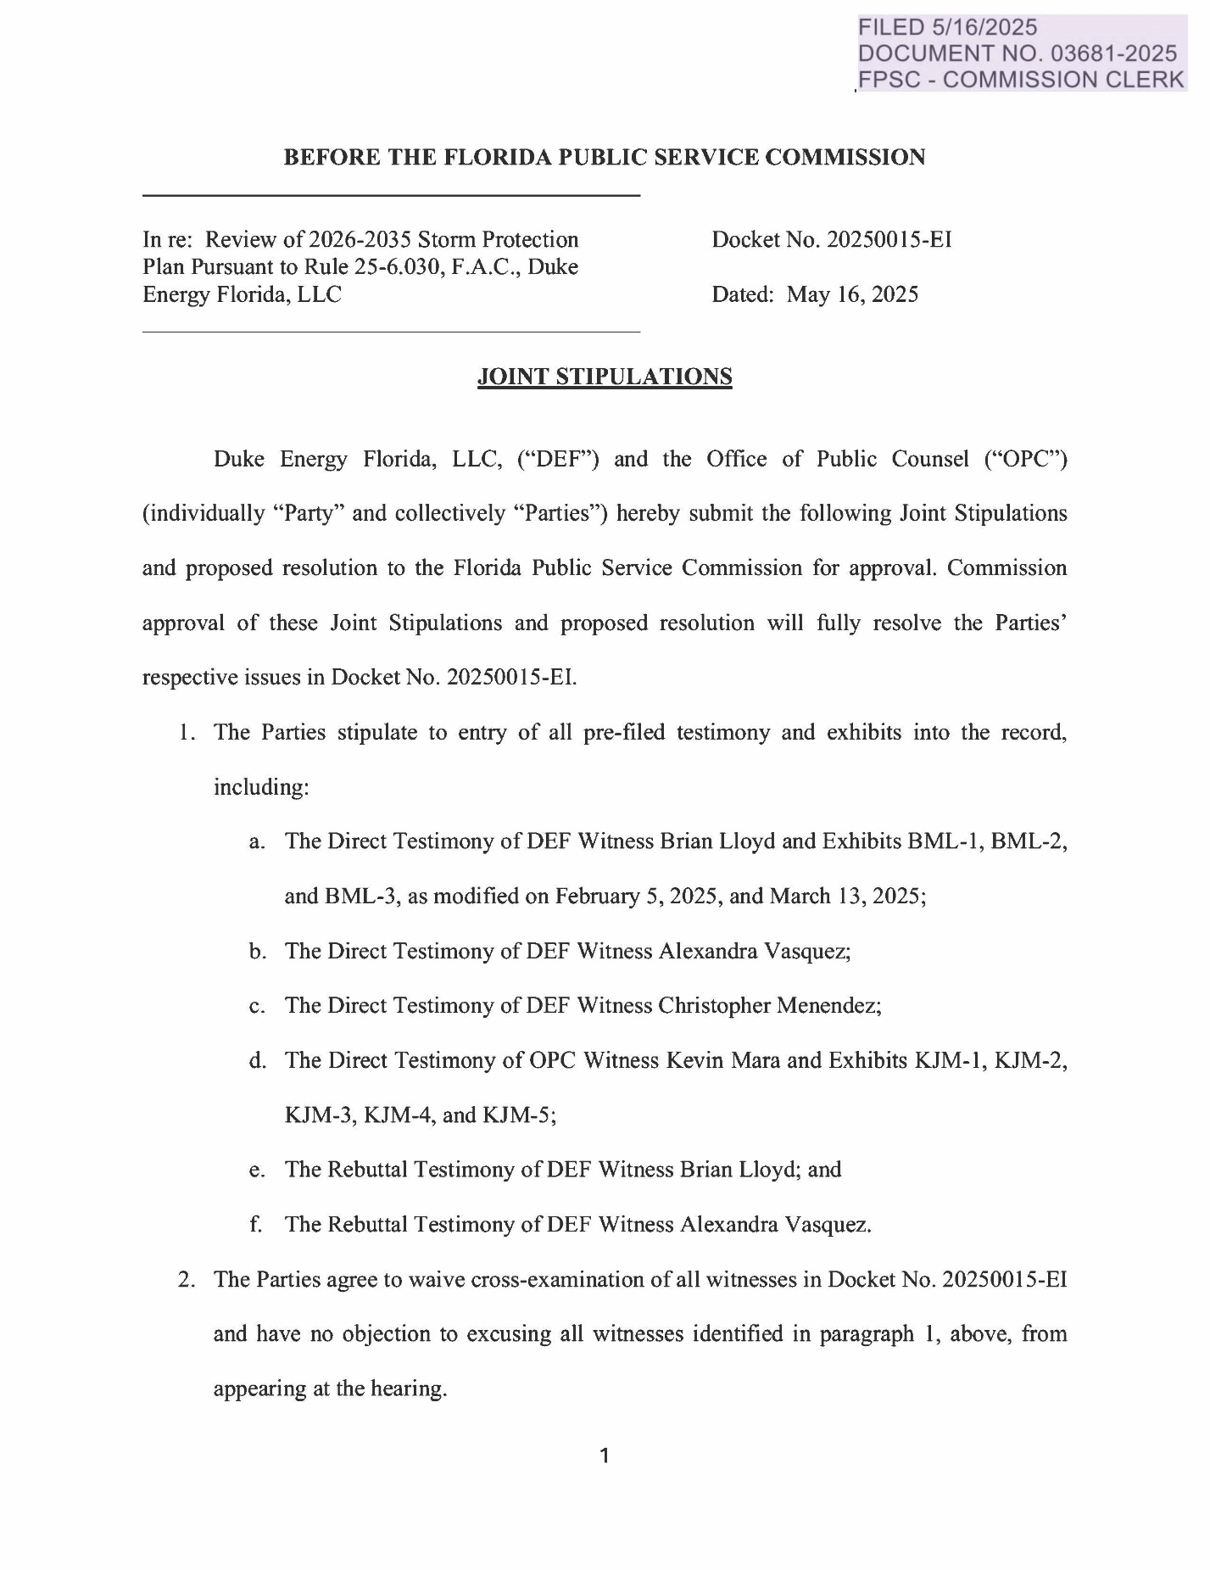

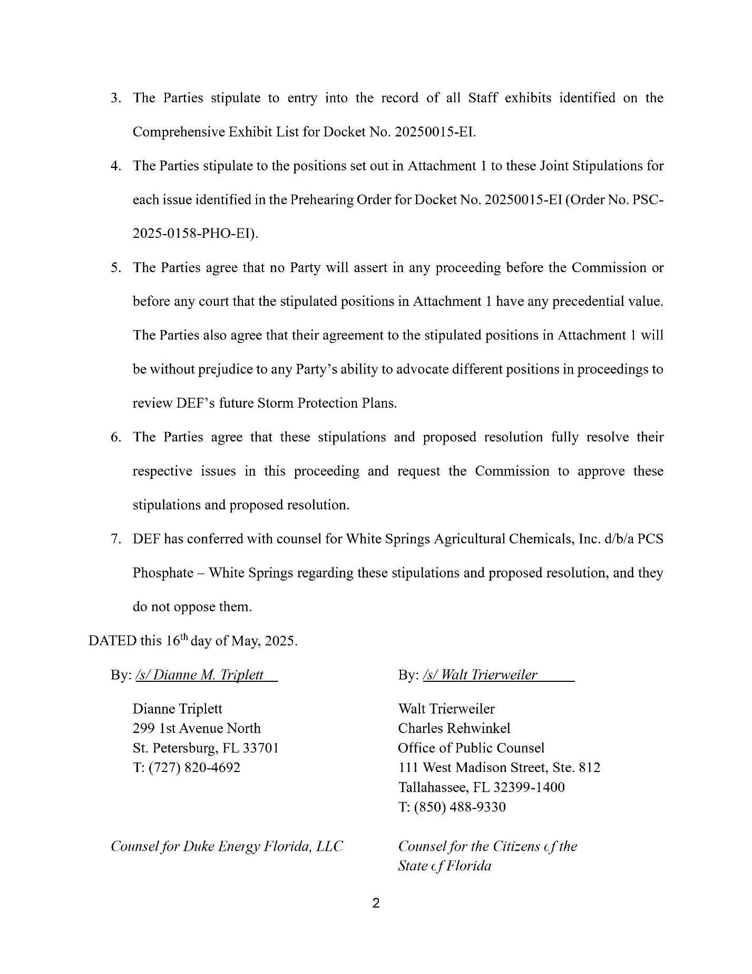

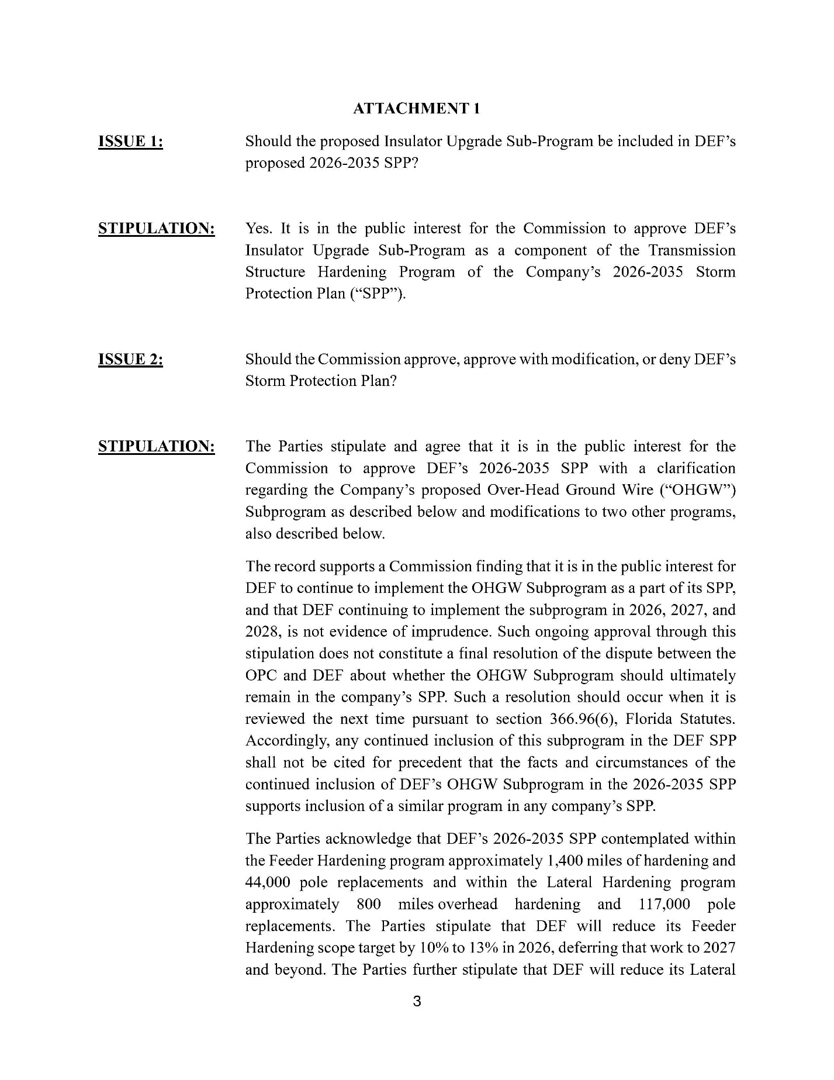

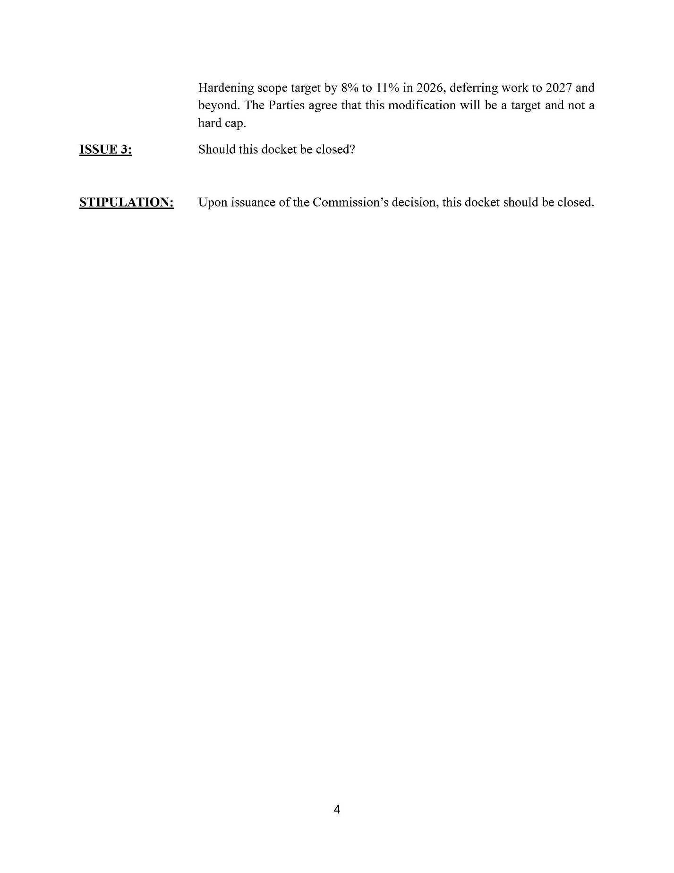

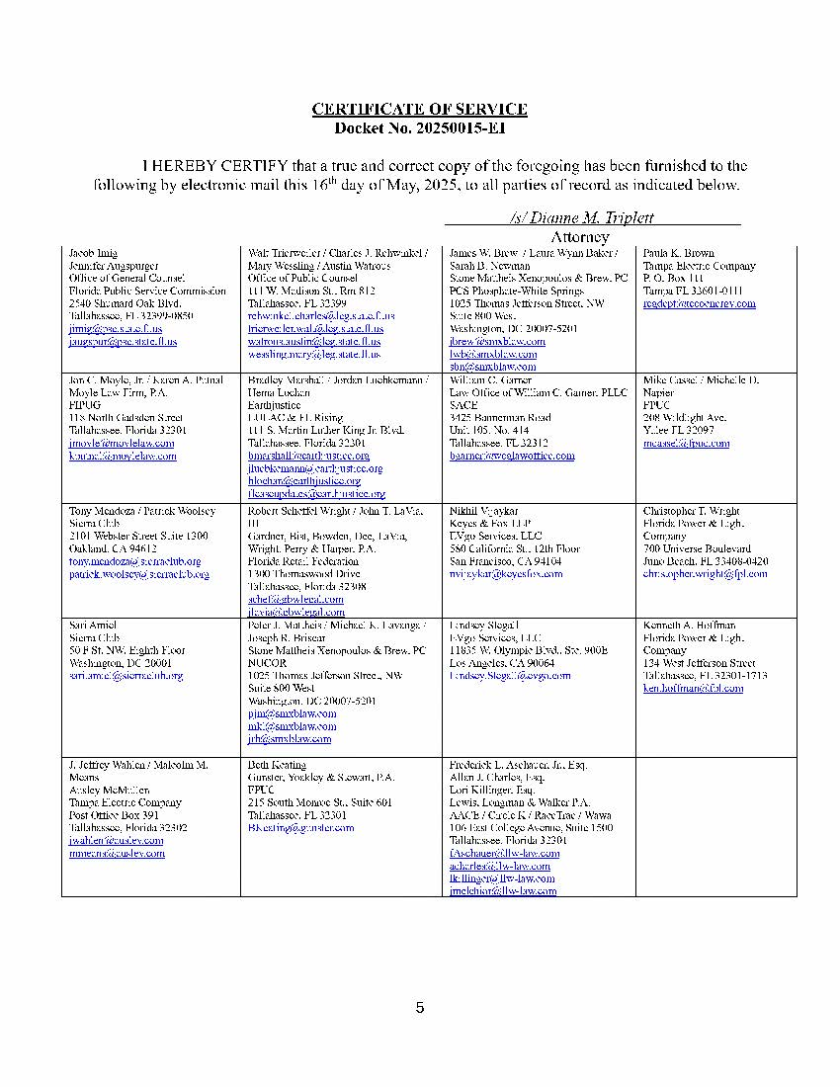

1. Per Section 366.96(2)(a), F.S., in a storm protection plan proceeding the term “public utility” has the same meaning as set forth in Section 366.02(8), F.S., except that it does not include gas utilities. Excluded from the definition of “public utility” under Section 366.02(8), F.S., are rural cooperative electric utilities, as well as municipal electric utilities.
2. Document No. 03681-2025, filed May 16, 2025, in Docket No. 20250015-EI, *Joint Stipulations*.
3. Document No. 03681-2025, *Joint Stipulations*, p. 2; *See also*, TR, p. 19, l. 13-16.
4. Docket Nos. 20250014-EI, 20250015-EI, 20250016-EI, and 20250017-EI were consolidated for purpose of the hearing by Order No. PSC-2025-0029-PCO-EI.
5. Section 366.96(4)–(5), F.S.
6. TR D3-60, l. 6-9.
7. *Id.* at l. 11-13 and 20-21.
8. *Id. at* l. 9-13.
9. EXH 3 – BML-1, p. 39; Exh. 4 – BML-2, pp. 20, 40.
10. TR D3-61, l. 4-10.
11. *Id.* at l. 12-14.
12. TR C2-103, l. 9-10.
13. TR C4-280, l. 2-8.
14. DEF noted that some Transmission projects may show a customer count of 0 because certain assets may not directly serve customers but function as critical infrastructure maintaining power flow within and between utilities. *See* EXH 51 – Staff Exh. 51 – Def’s Response to Staff Interrogatory #15(b), p. 2.
15. EXH 51 – Staff Exh. 51 – DEF Response to Staff Interrogatory #15(b), p.2.
16. EXH 3 - BML-1 (Rev.), p. 7-9.
17. *Id*. at p.7
18. TR C2-109, l. 12-14.
19. TR C4-280, l. 2-3.
20. EXH 3 – BML-1 (Rev.), p. 13.
21. *Id*.
22. *Id.* at pp. 13-15.
23. *Id.* 
24. *Id.* at p. 20.
25. *Id*.
26. *Id*. at p. 20-21.
27. TR C2-109, l. 21-22.
28. EXH 3 – BML-1 (Rev.), p. 20.
29. *Id.* at p. 29.
30. EXH 3 – BML-1 (Rev.), p. 20.
31. *Id.* at p. 30.
32. *Id*.
33. *Id.* at p. 32.
34. *Id.* 
35. Section 366.96(1)(a), F.S.
36. Section 366.96(1)(b), F.S.
37. EXH 3 – BML-1 (Rev.), pp. 32, 54.
38. *Id*. at pp. 35, 40
39. *Id*. at p. 49.
40. *Id.*
41. *Id*. at p. 51.
42. *Id.* at p. 52.
43. *Id*. at p. 54.
44. Order No. PSC-2022-0388A-FOF-EI.
45. TR C2-103, l. 9-10.
46. TR C2-106, l. 4-23; TR C2-107, l. 4-5; EXH 4 – BML-2, p. 3.
47. EXH 4 – BML-2, pp. 16, 20.
48. *Id*.
49. EXH 3 – BML-1 (Rev.) – p. 56.