BEFORE THE FLORIDA PUBLIC SERVICE COMMISSION

In re: Review of Progress Energy Florida’s benchmark for Waterborne Transportation Transactions with Progress Fuels.

Docket No. 031057-EI

Submitted for filing:
April 29, 2004

JOINT MOTION FOR APPROVAL OF
STIPULATION AND SETTLEMENT
The Office of Public Counsel, the Florida Industrial Power Users Group, and Progress Energy Florida (collectively, the Joint Movants) hereby jointly move the Commission to approve the Stipulation and Settlement, dated April 29, 2004 and attached hereto as Exhibit A, which the Joint Movants have entered into for the resolution of all issues in this proceeding, and to abate all actions and events currently pending or scheduled until the Commission has had the opportunity to consider the Stipulation and Settlement. In support of this motion, the Joint Movants represent as follows:
1. The Joint Movants have been engaged in negotiations for the purpose of reaching a comprehensive stipulation in settlement of all issues in this proceeding and thereby avoiding the need for expensive, time consuming litigation of these issues in hearings before the Commission. On April 28, 2004, the Joint Movants notified the Commission that they had reached an agreement in principle on such a settlement and that a definitive settlement agreement would be finalized and submitted for Commission approval soon thereafter. On April 29, 2004, the parties executed the Stipulation and Settlement attached to this joint motion for its approval by the Commission.
2. The Stipulation and Settlement establishes waterborne transportation costs that Progress Energy may recover during calendar year 2004 and a competitive solicitation methodology for determining market-based recoverable waterborne transportation costs beginning in 2005 and thereafter. For 2004, separate cost per ton charges are specified for waterborne deliveries of domestic FOB Mine and FOB Barge coal purchases, and for foreign coal deliveries. The blended, weighted average of the two charges for domestic coal deliveries and the charge for foreign coal deliveries each represent a reduction from the comparable charges in 2003 of over 25 percent, and are expected to result in customer savings of over $13 million compared to the costs that would have resulted had the 2003 charges been in effect. Moreover, both the blended domestic charge and the foreign charge are lower than the initial domestic and foreign market proxy prices that were based on audited waterborne transportation costs 12 years ago in 1992.
3. The methodology established by the Stipulation and Settlement for determining Progress Energy’s recoverable waterborne transportation costs beginning in 2005 and beyond is based on the testimony of William McNulty presented to the Commission on behalf of Staff at the November 2003 fuel hearings, which led to the Commission’s decision establishing this proceeding. The methodology describes the procedures for determining waterborne transportation charges based on market prices for each segment of the waterborne deliveries to Progress Energy’s Crystal River plant site. Under these procedures, Progress Energy’s coal and transportation supplier, Progress Fuels Corporation (PFC), will conduct a segment-by-segment competitive bid solicitation using a documented and auditable Request For Proposals (RFP) process. Each individual solicitation and any resulting contract for waterborne transportation services will be submitted to the Commission for review and approval. In the event the Commission determines that the RFP process for a particular waterborne transportation segment did not produce competitive bids or result in a valid market price, or if the process did not result in a contract, Progress Energy will develop and file a petition for Commission approval of a market price proxy for that segment. When fully implemented, the methodology and related procedures will ensure that the costs charged to customers for waterborne coal transportation based on market-priced contracts or market-based proxies that have been reviewed and approved by the Commission.
4. The Joint Movants represent that this Stipulation and Settlement fairly and reasonably balances the various positions of the parties on issues in this proceeding and serves the best interests of the customers they represent and the public interest in general. The Stipulation and Settlement is fully consistent with and supportive of this Commission’s long standing policy of encouraging the settlement of contested proceedings in a manner that benefits the ratepayers of utilities subject to the Commission’s regulatory jurisdiction and avoids the need for costly, time consuming and inefficient litigation of matters before the Commission. For these reasons, the Joint Movants request that the Commission approve this Stipulation and Settlement.
5. The Joint Movants also ask that all pending and scheduled matters in this proceeding be abated until the Commission has had the opportunity to review the Stipulation and Settlement and to act upon this joint motion for its approval. The Joint Movants ask that the Commission undertake this action at the earliest practicable date in order for the Stipulation and Settlement to be implemented, and its benefits received by customers, in a timely manner.
WHEREFORE, the Joint Movants respectfully request that the Commission approved the Stipulation and Settlement attached hereto at the earliest practicable date, and that this proceeding be abated until this joint motion for approval can be acted upon by the Commission.
Respectfully submitted,

_____________________________ _____________________________

Harold McLean John W. McWhirter
Public Counsel McWhirter, Reeves, McGlothlin,
Robert D. Vandiver Davidson, Kaufman, & Arnold, P.A.
Associate Public Counsel 400 North Tampa Street, Suite 2450

111 West Madison Street Tampa, Florida 33602

Room 812

Tallahassee, Florida 32399-1400 Vicki Gordon Kaufman
McWhirter, Reeves, McGlothlin,
Attorneys for the Citizens of Davidson, Kaufman, & Arnold, P.A.
the State of Florida 117 South Gadsden Street
Tallahassee, Florida 32301
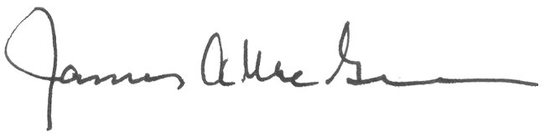
Attorneys for Florida Industrial Power
_____________________________ Users Group

James A. McGee
Associate General Counsel
Progress Energy Service Co., LLC
Post Office Box 14042
St. Petersburg, Florida 33733-4042

Attorney for
Progress Energy Florida, Inc.

Docket No. 031057-EI

CERTIFICATE OF SERVICE
I HEREBY CERTIFY that a true copy of the foregoing Joint Motion has been furnished to the following individual by U.S. Mail this 29th day of April, 2004.
Wm. Cochran Keating, IV, Esquire
Office of the General Counsel
Economic Regulation Section
Florida Public Service Commission
2540 Shumard Oak Blvd.
Tallahassee, FL 32399-0850

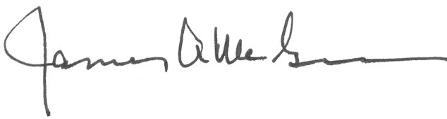

_____________________________
Attorney
EXHIBIT A

STIPULATION AND SETTLEMENT
dated April 29, 2004
(redacted copy)

