BEFORE THE FLORIDA PUBLIC SERVICE COMMISSION

In re: Request of Progress Energy Florida to exclude an Outage Event on April 11 and 12, 2004 from its Annual Distribution Service Reliability Report.

Docket No. ____________

Submitted for filing:
July 27, 2004

REQUEST TO EXCLUDE OUTAGE EVENT
Progress Energy Florida, Inc. (Progress Energy or the Company), pursuant to Rule 25-6.0455(3), F.A.C., hereby requests the Florida Public Service Commission (the Commission) to approve the exclusion of an outage event on April 11 and12, 2004 resulting from the severe weather system described herein from the Company’s Annual Distribution Service Reliability Report for calendar year 2004. In support of its request, Progress Energy states as follows:
Introduction
1. Progress Energy is a public utility subject to the regulatory jurisdiction of the Commission pursuant to Chapter 366, Florida Statutes. The Company’s principal place of business is located at 100 Central Avenue, St. Petersburg, Florida 33701.
2. All notices, pleadings and correspondence required to be served on Progress Energy should be directed to:
James A. McGee, Esquire
Post Office Box 14042 (zip 33733)
100 Central Avenue (zip 33701)
St. Petersburg, Florida
Facsimile: (727) 820-5519
Email: james.mcgee@pgnmail.com
Discussion
3. Commission Rule 25-6.0455(1) requires utilities to file an Annual Distribution Service Reliability Report for each calendar year by March 1st of the following year. The Report provides extensive distribution outage event data and related calculations of reliability indices, as specified in Commission Forms PSC/ECR 102-1, 102-2 and 102-3. Subsection (2) of the Rule allows a utility to exclude from its Annual Distribution Service Reliability Report outage events caused by certain enumerated conditions. Finally, Subsection (3) provides that a utility may also request the exclusion of an outage event not specifically enumerated in Subsection (2) from its Report, and goes on to state: “The Commission will approve the request if the utility is able to demonstrate that the outage was not within the utilitys control, and that the utility could not reasonably have prevented the outage.” This request by Progress Energy is submitted for Commission approval pursuant to the provisions of Subsection (3).
4. The outage event subject to this request resulted from a highly unusual and prolonged severe weather disturbance experienced throughout Progress Energy’s entire service territory on April 11 and 12, 2004 that caused extensive and wide-spread service interruptions to its customers. As the Company subsequently discovered, these conditions were the result of a weather phenomenon known as a Mesoscale Convective System or Complex. A Mesoscale Convective System, or MCS, is a system of thunderstorms that becomes organized on a scale larger than individual thunderstorms, and normally persists for several hours or more. When of sufficient size, shape and duration, the phenomenon is also known as a Mesoscale Convective Complex, or MCC.
5. The occurrence of a MCS or MCC in the deep Southeast region of the country is extremely rare and, in fact, it appears that no previous occurrence in Florida has been recorded by the National Weather Service (NWS). In addition, when these weather systems do occur, they are difficult to identify by normal ground-based weather radar because of their massive size and scale, and generally require the long range perspective of infrared satellite photographs to identify their characteristic shape and other distinguishing attributes. Given these circumstances, Progress Energy found it necessary to retain the services of Weather Services International (WSI), a forensic meteorological consulting firm headquartered in Andover, Massachusetts, to investigate and identify the severe weather system experienced by the Company on April 11th and 12th.
6. The forensic meteorological report prepared by WSI was submitted to Progress Energy on July 20, 2004, a copy of which is included with this request as Attachment A. Using infrared satellite photographs and meteorological data obtained from NWS and/or its parent agency, the National Oceanographic and Atmospheric Administration (NOAA), the WSI report describes the development of a unique confluence of atmospheric conditions over the entire eastern portion of the country. These conditions spawned at least two separate MCSs over the Gulf of Mexico south of Mobile, Alabama that began to intensify as the moved easterly toward the west coast of Florida about 12 hours apart. As can be seen from the satellite photograph below, the first MSC was a massive complex of thunderstorms and squall lines spanning the entire length of Progress Energy’s service territory, from north to south central Florida, when it made landfall and crossed the state on the evening and night of Sunday, April 11th.
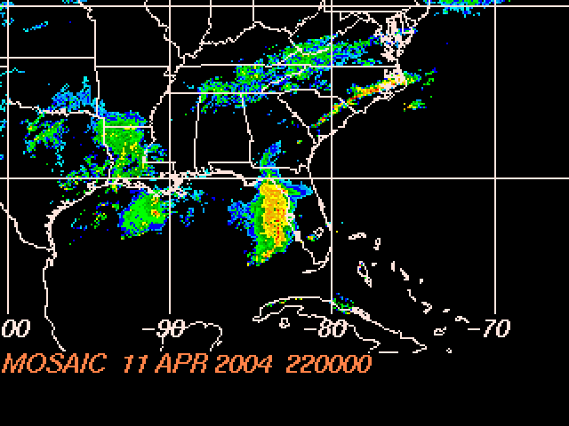
6:00 pm ET, Sunday, April 11, 2004

The second MCS was of generally comparable size and severity, and unfortunately followed nearly the same path as the first across the Progress Energy system on the morning of Monday, April 12th.
7. By the time the second MCS dissipated after reaching the east coast, the two severe weather systems had produced 676 outages on 382 circuits in nearly every area of the Company’s four-region, 35-county service territory. These outages resulted in service interruptions to 66,769 customers, for a total of 5,099,410 Customer-Minutes of Interruption (CMI), which equates to a system average interruption per customer (SAIDI) of 3.33 minutes. The following table shows the effect of the outages for each of Progress Energy’s 19 Operations Centers over the 30-hour period beginning 6:00 p.m. on April 11th, the approximate time of the first MCS-related outage, through midnight on April 12th.
Operations Center | CMI | Customers  Served | Local  SAIDI | System  SAIDI
Apopka | 1,083,354 | 109,145 | 9.93 | 0.71
Buena Vista | 80,284 | 75,990 | 1.06 | 0.05
Clearwater | 405,841 | 151,185 | 2.68 | 0.27
Clermont | 1,293 | 22,786 | 0.06 | 0.00
Conway | 180,607 | 70,918 | 2.55 | 0.12
Deland | 834,076 | 69,575 | 12.0 | 0.55
Highlands | 91,788 | 51,311 | 1.79 | 0.06
Inverness | 195,923 | 63,120 | 3.10 | 0.13
Jamestown | 203,454 | 113,808 | 1.79 | 0.13
Lake Wales | 46,818 | 73,883 | 0.63 | 0.03
Longwood | 371,178 | 71,146 | 5.22 | 0.24
Monticello | 74,200 | 48,923 | 1.52 | 0.05
Ocala | 54,794 | 62,945 | 0.87 | 0.04
Seven Springs | 131,074 | 81,982 | 1.60 | 0.09
St. Petersburg | 1,059,624 | 161,891 | 6.55 | 0.69
Tarpon Springs | 113,358 | 73,054 | 1.55 | 0.07
Walsingham | 130,636 | 146,534 | 0.89 | 0.09
Winter Garden | 20,740 | 59,528 | 0.35 | 0.01
Zephyrhills | 20,368 | 21,523 | 0.95 | 0.01
System Total | 5,099,410 | 1,529,247 | 3.33 | 3.33
- The 30-hour SAIDI of 3.33 minutes for the MCS severe weather event on April 11th and 12th, when proportioned to a 24-hour period, is equivalent to a daily SAIDI of 2.66 minutes. By way of comparison, this daily SAIDI is (a) 11.3 times greater than Progress Energy’s 2003 system daily average SAIDI of 0.23 minutes, (b) 10.2 times greater than the Company’s system daily average SAIDI of 0.26
minutes for the month of April over the period 1997 through 2004, and (c) 9.9 times greater than the Company’s system daily average SAIDI of 0.27 minutes for the month of April 2004, which includes the Outage Event in question. The following table shows Progress Energy’s daily system SAIDI minutes over the seven-day period from April 8 through April 14, 2004.
Daily System SAIDI
April 8 – April 14, 2004
 | April 8 | April 9 | April 10 | April 11 | April 12 | April 13 | April 14
Total CI | 7,291 | 5,239 | 1,813 | 48,613 | 23,095 | 15,787 | 15,848
Total CMI | 478,980 | 349,087 | 127,478 | 3,797,926 | 1,657,261 | 781,034 | 1,146,266
Daily System SAIDI^{1/} | 0.31 | 0.23 | 0.08 | 2.48 | 1.08 | 0.51 | 0.75
^{1/} CMI divided by 1,529,247 system retail customers.

9. In response to the high level of service outages caused by the MCS severe weather disturbances on April 11th and 12th, Progress Energy mobilized all available active and off-duty distribution crews, equipment and supporting vehicles, management and supervisory personnel, and support staff, as well as contract personnel and equipment that were available in the North Central Region. The table below lists the personnel actively involved with restoration activities:
Regional Management and Supervision | 109
Regional Staff Support | 12
System Staff Support | 8
Regional Line Resource Personnel | 379
Contract Personnel | 24
Total Personnel | 532
- The mobilization of crews and equipment, management, supervision and support began as the first MCS struck the evening of Sunday, April 11th. After the restoration effort had continued through the night and the pre-dawn hours of Monday, April 12th, the second MCS struck early that morning, causing more wide-spread damage and service interruptions throughout the Progress Energy distribution system that had not yet recovered from the prior day’s damage. The crews continued their restoration work that afternoon, evening and night until the job was essentially completed the following day, Tuesday, April 13th. The work of the restoration crews was particularly difficult, and their efforts particularly commendable, since the relief and reinforcements that would have normally arrived from remote, unaffected operations centers were not available. The breadth and scope of the back-to-back storms had left no unaffected operations centers, leaving the crews largely on their own and severely taxed.
- As shown by the foregoing, the outage event on April 11th and 12th was not within Progress Energy’s control, nor could it have been reasonably prevented by the Company. To the contrary, the outages and related service interruptions that occurred from the evening of April 11th through April 12th were the result of two massive, consecutive MCS severe weather systems that pummeled Progress Energy’s service territory from end to end twice as they crossed the state. All available service personnel system-wide were mobilized, including management, supervisors and office support staff, to restore service. The work effort proceeded non-stop for over 30 hours, largely without relief under the most difficult circumstances. Despite these circumstances, the restoration of service was managed, worked and completed in an orderly, expeditious manner.
WHEREFORE, Progress Energy respectfully asks that, for the reasons set forth above, the Commission grant this request and approve the exclusion of the outage event on April 11 and 12, 2004 and the resulting system SAIDI of 3.33 minutes from the Company’s Distribution Service Reliability Report for calendar year 2004.
Respectfully submitted,

s/
James A. McGee
Associate General Counsel
Progress Energy Service Company, LLC
Post Office Box 14042
St. Petersburg, FL 33733-4042
Telephone: (727) 820-5184
Facsimile: (727) 820-5519
Attorney for
Progress Energy Florida, Inc.

Attachment A

Forensic Meteorological Report on
the MCS Severe Weather Complex
During April 11 and 12, 2004

Forensic Meteorological Report

Mesoscale Convective Complex Event

April 11 and 12, 2004

Prepared by Weather Services International

July 20, 2004

I. Overview

A broad area of low pressure was located across the southern Ohio Valley on the morning of Sunday, April 11, 2004, with attendant light rain and rain showers extending from eastern Illinois to the Mid Atlantic coastal region, to just south of the southern New England coast.
A cold front extended southwest from the low center across eastern portions of Tennessee to the Texas Gulf coast. An area of heavier showers and thunderstorms accompanied the frontal boundary from northwestern Georgia, southwest to New Orleans, LA.
As the day progressed, several weak areas of low pressure formed along the frontal boundary, and moved northeast into the Mid Atlantic region.
At upper levels, a broad southwesterly flow of moist, unstable air off the Gulf of Mexico was moving up along and ahead of the frontal boundary. As the day progressed, this moisture source, along with several parcels of upper level energy feeding into the system from the southern Plains, provided the fuel to fire several areas of heavy thunderstorms along the cold front as it moved east across the Gulf of Mexico.

Event Analysis

A line of strong to severe thunderstorms formed along the southernmost frontal boundary, and strengthened as it moved east across the southern Gulf coastal region during the day Sunday.
At 1:00PM ET/ 1700 UTC, an area of heavy thunderstorms was located from near Mobile, AL, extending east to the central Florida panhandle. The most intense rain and lightning with this developing mesoscale convective system (MCS) were located from the Pensacola area, east to just west of Panama City, and south for approximately 100 miles south into the Gulf of Mexico.
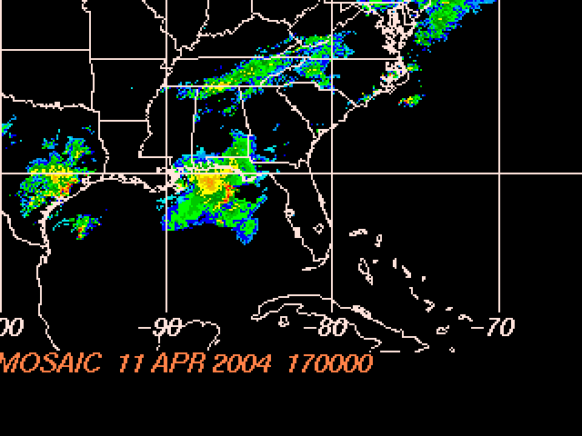
Figure 1 – A complex of developing severe thunderstorms is located across the western panhandle of Florida at 1700 UTC, Sunday, April 11, 2004.
The system continued moving east across the northern Gulf coastal regions of Alabama and Florida as the day progressed, with a well-defined line of severe thunderstorms aligning north-to-south just inside the I-75 corridor, from Valdosta, GA to just offshore Tampa-St. Petersburg by 6:00 PM ET/ 2200 UTC Sunday evening. At this stage of development, the area of severe weather had taken on characteristics of a mesoscale convective system (MCS) , with locally very heavy rains, frequent and damaging lightning strikes, strong winds and hail.
Figure 2 – A developing MCS takes shape west of I-75 and continues moving east as of 2200 UTC Sunday, April 11.

By 7:00 PM ET Sunday, April 11, the MCS was approaching the western coast of Florida, with reports of heavy rains, frequent cloud-to-ground lightning strikes and strong winds from Cedar Key south along the Central West coast.
This first in a series of MCS continued moving east across central Florida into the overnight hours, and weakened to an area of heavy showers as it moved across the eastern shores after midnight.
The areas of most intense activity associated with this first complex were located primarily from the Cedar Key region east-southeast to Orlando.
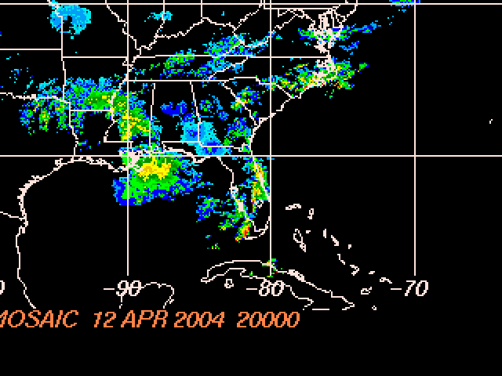
Figure 3 – The first convective complex weakens across the eastern Florida peninsula during the late evening hours of Sunday, April 11, 2004. Meanwhile, a second complex begins to form along the central Gulf coast.
A second complex formed long the central Gulf coast region during the pre-dawn hours of Monday, April 12, 2004, and strengthened as it moved east into the Central West coast after sunrise. As with its predecessor, this secondary MCS was eventually accompanied by severe thunderstorms, wind and hail.
A squall line developed within this secondary MCS during the morning hours, developing a ‘bow echo’ radar signature. This radar reflectivity pattern is typically indicative of a mature thunderstorm complex, and is often associated with very strong to damaging straight-line winds as the initial bow echo advances across a particular region.

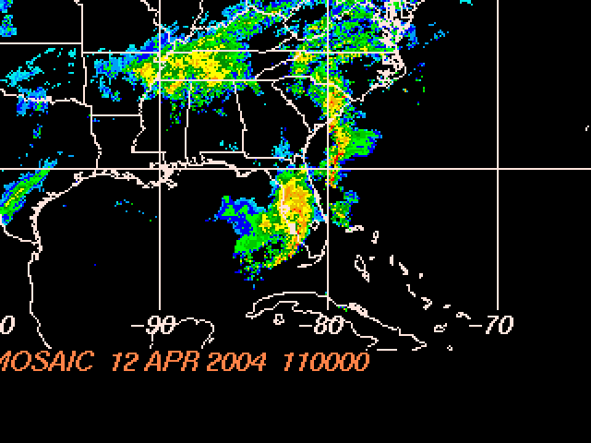
Figure 4 – A second MCS moves across central Florida on Monday morning, April 12, 2004.. The complex was accompanied by a ‘bow echo’ radar signature, indicative of damaging straight-line winds in the immediate vicinity of the advancing storms.

A number of severe weather reports were filed with this complex, including a tornado in Golden Gate, Collier County. Widespread numerous severe weather reports of heavy rains, frequent cloud-to-ground lightning strikes and strong gusty winds were received, with the most intense activity reported from the Spring Hill region, east to Orlando and south to Fort Myers and Naples.
A third and final complex developed behind the second system, and moved across the northern panhandle region of the state as the frontal boundary moved east of the region by late afternoon on Monday, April 12th. Reports of locally very heavy rains, frequent lightning and small hail were reported across portions of northern Florida.
The most intense activity with the last in the series of MCS was reported across northern panhandle locations from Malone to Marianna and Compass Lake, south into Tallahassee.
The cold frontal boundary associated with these series of convective complexes moved offshore slowly during the evening of Tuesday, April 13, 2004.

The daily system average SAIDI levels shown in (a) for 2003 and in (b) for April of 1997 through 2004 do not include outage events enumerated as excludable by Commission Rule 25-6.0455(2). When all outage events are included, the daily system average SAIDI for 2003 increases from 0.23 minutes to 0.31 minutes, while the daily average for the month of April from 1997 through 2004 increases from 0.26 minutes to 0.29 minutes.

