BEFORE THE FLORIDA PUBLIC SERVICE COMMISSION

In re: Energy Conservation Cost Recovery Clause.

Docket No. 040002-EG

Submitted for filing:
October 18, 2004

PREHEARING STATEMENT OF
PROGRESS ENERGY FLORIDA

Progress Energy Florida (PEF), pursuant to Rule 25-22.038, Florida Administrative Code, hereby submits its Prehearing Statement and states as follows:

A. APPEARANCES

JAMES A. MCGEE, Esquire, Post Office Box 14042, St. Petersburg, FL 33733-4042
On behalf of Progress Energy Florida

B. WITNESSES
Witness Subject Matter Issues

John A. Masiello Final True-up, January - December 2003 1

John A. Masiello Estimated/Actual True-up, January - 2 - 3
December 2004 and ECCR Factors
for January - December 2005

C. EXHIBITS
Exhibit No. Witness Description

_________ Masiello ECCR Adjusted Net True-Up for January -
(JAM-1T) December 2003, Schedules CT1 - CT5.

_________ Masiello ECCR Factors for Billings in January -
(JAM-1P) December 2005, Schedules C1 - C5.

D. STATEMENT OF BASIC POSITION
None necessary.

E. STATEMENT OF ISSUES AND POSITIONS

Generic Conservation Cost Recovery Issues

1. ISSUE: What is the appropriate final end-of-period true-up amount for the period January through December 2003?
PEF: $7,379,830 over-recovery. (Masiello)

2. ISSUE: What is the appropriate estimated end-of-period true-up amount for the period January through December 2004?
PEF: $4,481,955 over-recovery. (Masiello)

3. ISSUE: What are the appropriate conservation cost recovery factors for the period January through December 2005?
PEF: Rate Class ECCR Factor
Residential 0.169 cents/kWh
General Service Non-Demand 0.157 cents/kWh
@ Primary Voltage 0.155 cents/kWh
@ Transmission Voltage 0.154 cents/kWh
General Service 100% Load Factor 0.116 cents/kWh
General Service Demand 0.143 cents/kWh
@ Primary Voltage 0.142 cents/kWh
@ Transmission Voltage 0.140 cents/kWh
Curtailable 0.133 cents/kWh
@ Primary Voltage 0.132 cents/kWh
@ Transmission Voltage 0.130 cents/kWh
Interruptible 0.119 cents/kWh
@ Primary Voltage 0.118 cents/kWh
@ Transmission Voltage 0.117 cents/kWh
Lighting 0.064 cents/kWh
(Masiello)

F. STIPULATED ISSUES: None at this time.

G. PENDING MOTIONS: None.

Respectfully submitted,
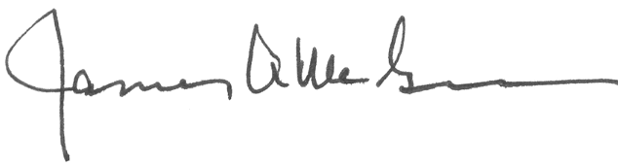
___________________________________
James A. McGee
Associate General Counsel
Progress Energy Service Company, LLC
Post Office Box 14042
St. Petersburg, Florida 33733-4042
Telephone: 727-820-5184
Facsimile: 727-820-5519
Email: james.mcgee@pgnmail.com
Attorney for
Progress Energy Florida, Inc.

