State of Florida   |  | Public Service Commission  Capital Circle Office Center ● 2540 Shumard Oak Boulevard  Tallahassee, Florida 32399-0850  -M-E-M-O-R-A-N-D-U-M-
DATE: | January 26, 2006
TO: | Director, Division of the Commission Clerk & Administrative Services (Bayó)
FROM: | Office of the General Counsel (Rodan)  Division of Economic Regulation (Breman)
RE: | Docket No. 041408-EU – Joint petition of Tampa Electric Company and Withlacoochee River Electric Cooperative, Inc. for expedited interim approval of customer transfers pending consideration of joint application for permanent relocation of territorial boundaries.
AGENDA: | 02/07/06 – Regular Agenda – Proposed Agency Action - Interested Persons May Participate
COMMISSIONERS ASSIGNED: |  |  | All Commissioners
PREHEARING OFFICER: |  |  | Bradley
CRITICAL DATES: |  |  | None
SPECIAL INSTRUCTIONS: |  |  | None
FILE NAME AND LOCATION: |  |  | S:\PSC\GCL\WP\041408.RCM.DOC

Case Background
The retail electric service boundary between Tampa Electric Company (TECO) and Withlacoochee River Electric Cooperative, Inc. (WREC) was established by Order No. 23905, issued December 20, 1990, in Docket No. 900752-EU, In Re: Joint Petition for approval of 1990 amendment to Territorial Agreement by Tampa Electric Company and Withlacoochee River Electric Cooperative, Inc.
On December 17, 2004, TECO and WREC filed a joint petition for expedited interim approval of customer transfers pending Commission consideration of an application for permanent relocation of territorial boundaries. The petition requested that TECO be permitted to provide interim electric service to those portions of the Belle Chase subdivision located in WREC’s territory so that service could be provided to all of the Belle Chase lots in January 2005. WREC did not have adequate facilities within the area to serve the Bell Chase subdivision. The joint petition also stated that TECO and WREC agreed to file a joint application for an amendment to their existing territorial boundary in a subsequent filing. The request for interim service was approved by Order No. PSC-05-0102-PCO-EU, issued January 25, 2005. This docket was held open to address the subsequent joint application for modification of territorial boundaries.
TECO and WREC completed a review of their boundaries in Pasco and Polk Counties and jointly filed a proposed amendment to their retail territorial service boundary on September 8, 2005. The proposed amendment to the existing service territory boundary between TECO and WREC is limited to two geographic areas in addition to the interim service concerns at the Belle Chase subdivision. All three boundary changes are within Pasco County.
The Commission has jurisdiction pursuant to Sections 366.04 and 366.05, Florida Statutes.

Discussion of Issues
Issue 1:1
Should the Commission approve the joint petition of Tampa Electric Company and Withlacoochee River Electric Cooperative, Inc. for an amendment to their territorial boundaries?
Recommendation:
Yes. The proposed amendment is in the public interest and should be approved, effective upon the issuance of a Consummating Order finalizing the Commission’s decision. (Rodan, Breman)
Staff Analysis:
The 1990 boundaries approved by Order No. 23905 were established prior to the various subdivision projects that have resulted in the proposed amendment.
Joint responses by TECO and WREC to staff’s data requests indicate that the utilities have assessed the long-term load, locations of future facilities, and reliability requirements for each of the three areas. In each of the three areas, the least cost approach addressing load growth and system reliability resulted in a retail electric territorial boundary that substantially follows natural boundaries set by the respective development plans. Customers with the same service provider will tend to be grouped together within a development. Thus, the proposed amendment is expected to avoid future uneconomic duplication of facilities because of the coordinated planning and review by TECO and WREC. Drawings of relevant areas showing the new amendment’s boundary lines are contained in Attachment A to this recommendation.
Staff has reviewed the proposed amendment and believes that the joint petition and the amendment are in compliance with Rule 25-6.0440, Florida Administrative Code, and Section 366.04(2), Florida Statutes, the laws governing territorial agreements. No current customers are affected by the proposed boundary changes. No uneconomic duplication of facilities is expected. Based on the foregoing, staff recommends that the joint petition is in the public interest and should be approved.

Issue 2:2
Should this docket be closed?
Recommendation:
Yes. If no protest is filed, this docket should be closed upon the issuance of a Consummating Order. If a protest is filed by a person whose substantial interests are affected within 21 days of the Commission Order approving this amendment, the docket should remain open. (Rodan)
Staff Analysis:
If a protest is filed by a person whose substantial interests are affected within 21 days of the Commission Order approving this amendment, the docket should remain open. If no protest is filed, the docket should be closed upon the issuance of a Consummating Order.

TECO’s Service Area
Additions to TECO’s Service Area
WREC’s Service Area
Additions to WREC’s Service Area
TECO/WREC Service Area within the
Meadow Pointe Subdivision
Additions to WREC’s Service Area

WREC/TECO Service Area within the
Belle Chase Subdivision

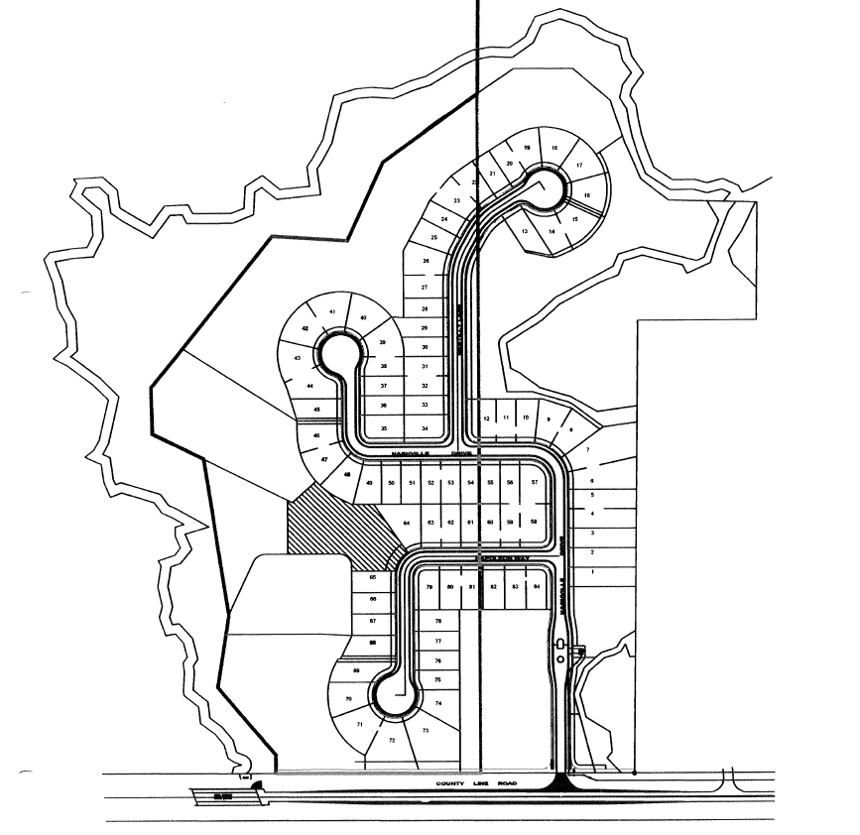
TECO’s Service Area
WREC’s Service Area
Additions to TECO’s Service Area
WREC/TECO Service Area within the
Cannon ranch Subdivision

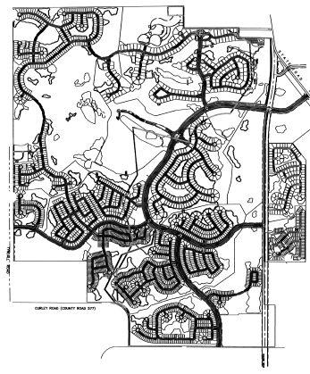
WREC’s Service Area
TECO’s Service Area

Additions to WREC’s
Service Area

Additions to TECO’s
Service Area

