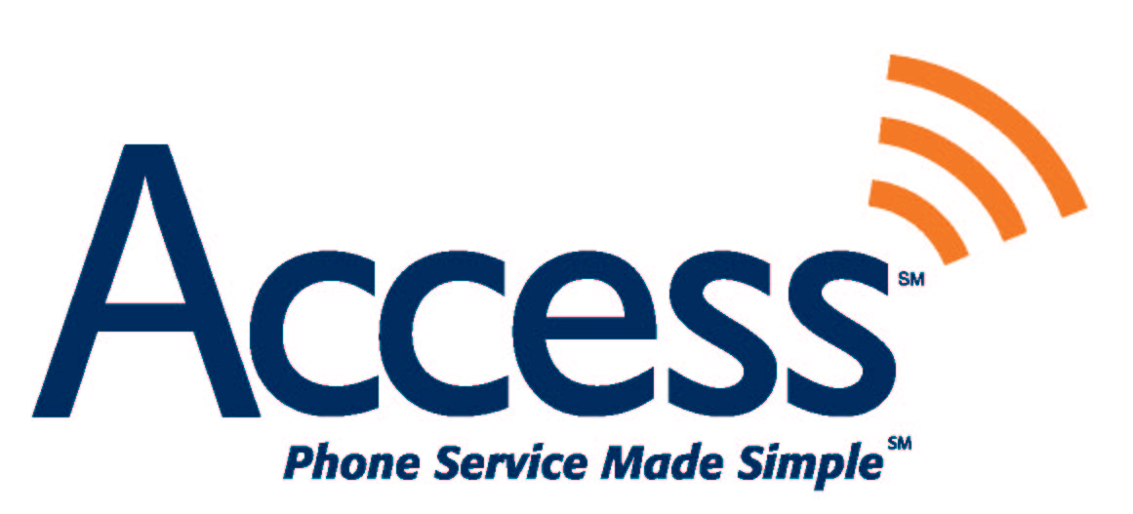

Sharyl D. Fowler
Sr. Regulatory Analyst
4885 Riverside Drive
Suite 304
Macon, Georgia 31210

March 10, 2006

VIA ELECTRONIC AND U.S. MAIL

Ms. Blanca S. Bayó
Division of the Commission Clerk and
Administrative Services
Florida Public Service Commission
2540 Shumard Oak Boulevard
Tallahassee, FL 32399-0850

Re: Docket No. 041269-TP

Dear Ms. Bayó:

Access Integrated Networks hereby informs the Commission that it is currently discussing the amendment to its Interconnection Agreement with BellSouth based on the Commission’s February 28, 2006 decision. There are some items in the proposed amendment that are not Florida-specific as well as a few possible discrepancies with the approved language. We expect these items to be resolved amicably and quickly; however, they will not be completed in time to file an amendment by March 10, 2006.

We will forward the amendment to the Commission for approval as soon as possible, understanding that the effective date of the amendment will remain March 11, 2006.

Sincerely,

Sharyl D. Fowler

Sharyl D. Fowler
Senior Regulatory Analyst

