State of Florida   |  | Public Service Commission  Capital Circle Office Center ● 2540 Shumard Oak Boulevard  Tallahassee, Florida 32399-0850  -M-E-M-O-R-A-N-D-U-M-
DATE: | May 4, 2006
TO: | Director, Division of the Commission Clerk & Administrative Services (Bayó)
FROM: | Division of Competitive Markets & Enforcement (M. Watts)  Office of the General Counsel (Scott, Tan)  Division of Economic Regulation (Lester)
RE: | Docket No. 050938-TP – Joint application for approval of transfer of control of ALLTEL Florida, Inc., holder of ILEC Certificate No. 10 and PATS Certificate No. 5942, from Alltel Corporation to Valor Communications Group, and for waiver of carrier selection requirements of Rule 25-4.118, F.A.C., due to transfer of long distance customers of ALLTEL Communications, Inc. to Alltel Corporate Holding Services, Inc.
AGENDA: | 05/16/06 – Regular Agenda – Proposed Agency Action – Interested Persons May Participate
COMMISSIONERS ASSIGNED: |  |  | All Commissioners
PREHEARING OFFICER: |  |  | Administrative
CRITICAL DATES: |  |  | None
SPECIAL INSTRUCTIONS: |  |  | None
FILE NAME AND LOCATION: |  |  | S:\PSC\CMP\WP\050938.RCM.DOC

Case Background
On December 22, 2005, ALLTEL Florida, Inc., ACI, Alltel Holding Corp., Valor Communications Group (Valor), and Alltel Holding Corporate Services. Inc. (collectively, Applicants) submitted an application requesting approva1 by the Florida Public Service Commission (Commission) for the transfer of control of ALLTEL Florida, Inc. from Alltel Corporation to the entity resulting from the merger of Alltel Holding Corp., Valor, and Alltel Holding Corporate Services. Inc., respectively. The Applicants also seek a waiver of the carrier selection requirements in Rule 25-4.118, Florida Administrative Code, to facilitate the orderly transfer of long distance customers of ACI to Alltel Holding Corporate Services, Inc. These actions are part of a plan to move Alltel's wireline incumbent local exchange company (ILEC), pay telephone company (PATS) and intrastate interexchange company (IXC) to a wireline focused entity. On May 1, 2006, the Applicants filed an amended petition to include a request for name changes for the company on its local and pay telephone certificates, and to incorporate additional conditions. The new name for the wireline controlling entity is Windstream Corporation and each subsidiary incorporates Windstream, respectively, into their names. Staff will administratively process the name change requests in accordance with Administrative Procedures Manual 2.07.C.2.a. Thus, there is not an issue in this recommendation regarding the requests for name change.

ALLTEL Florida, Inc. is a local exchange telecommunications company (LEC) that was issued a certificate to provide local service in Florida on May 3, 1956. It also has a certificate to provide pay telephone service, and operates 79 pay telephones within its LEC territory. As of June 30, 2005, ALLTEL Florida, Inc. had 94,212 local access lines in 27 exchanges, or 1% of the total number of local access lines in Florida. ALLTEL Florida, Inc. and its affiliates serve approximately three million local access lines in 15 states.

ALLTEL Communications, Inc. (ACI) is an intrastate interexchange telecommunications company (IXC) registered to provide long distance telecommunications service in Florida since July 24, 1996. As of June 30, 2005, ACI had approximately 81,400 long distance customers in Florida. Approximately 65.5% of those ACI long distance customers are provided local service by ALLTEL Florida, Inc. All of the long distance customers will ultimately transfer from ACI to Alltel Holding Corporate Services, Inc., a subsidiary of Alltel Holding Corp. A request for waiver of the Commission’s slamming rules related to this transfer is addressed in Issue 2 of this recommendation.

ALLTEL Florida, Inc. and ACI are currently wholly-owned subsidiaries of Alltel Corporation (Alltel).

Valor is a Delaware corporation that owns rural LECs in Arkansas, New Mexico, Oklahoma and Texas. It was formed in 2000 with the acquisition of GTE Southwest Corporation. As of June 30, 2005, Valor’s subsidiaries had approximately 530,000 local access lines in those states.

As a result of changes in the telecommunications industry, Alltel is separating its Wireline Business from its wireless business and merging the Wireline Business with Valor. The Merged Wireline Business will be known as Windstream. Following this merger, the shareholders of Alltel will own 85% of Windstream, and the shareholders of Valor will own 15%. The principal officers of Windstream will be certain current officers of Alltel. Windstream will adopt a corporate logo that is presently being determined. The corporate offices of Windstream will be located in Little Rock, Arkansas. The Applicants state that the end user customers will continue to receive the same rates and quality of service from the same local operations, so the transfer will appear to customers to be only a name change.

As of the filing date of this recommendation, the Federal Communications Commission and the regulatory agencies of Mississippi, North Carolina, Georgia, Missouri and Nebraska have approved the merger of Alltel Holding Corp. into Valor, and the Federal Trade Commission has granted early termination in its review of the proposed transaction, which indicates no objections to the merger.

The Commission is vested with jurisdiction over this matter pursuant to Sections 364.01, 364.33, 364.335 and 364.603, Florida Statutes. Accordingly, staff believes the following recommendations are appropriate.
Discussion of Issues
Issue 1:1
Should the Commission approve the joint application for approval of transfer of control of ALLTEL Florida, Inc., holder of ILEC Certificate No. 10 and PATS Certificate No. 5942, from Alltel Corporation to Windstream Corporation?
Recommendation:
Yes, the Commission should approve the transfer of control of ALLTEL Florida, Inc. from Alltel Corporation to Windstream Corporation. (M. Watts/Lester/Scott/Tan)
Staff Analysis:
I. Jurisdiction

A. Section 364.33, Florida Statutes
The Commission has authority under Section 364.33, Florida Statutes, to approve an application for transfer of control. Staff notes that this provision does not provide specific standards which the Commission may follow in making its decision to approve a transfer of control. However, staff believes that Section 364.01, Florida Statutes, implies a public interest standard that the Commission may follow when deciding whether to approve or deny transfers of control, among other transactions.

The legislative intent in Section 364.01, Florida Statutes, is clear: the Commission is to exercise its jurisdiction in order to protect “the public health, safety, and welfare” as it relates to basic local telecommunications services. Based on the clear intent of the Florida Legislature, the Commission should base its decisions on whether to grant applications for transfer of control if it satisfies the public interest. There is little guidance on what constitutes the “public interest.” It appears that in most cases that what is in the public interest is left up to the interpretation of the particular administrative body charged with upholding that interest. In developing its recommendation, staff reviewed the management, technical, and financial capability of the proposed merged entity.

II. Staff’s Findings

A. Management Capability
As outlined in the Case Background, Alltel is separating its wireless and wireline businesses in two steps. Alltel Holding Corp. was formed to serve as the new parent company of ALLTEL Florida Inc., Alltel Holding Corporate Services, Inc., and its other ILEC subsidiaries. In Attachment A to this recommendation are Alltel Exhibits 1, 2 and 3. Exhibit 1 shows the corporate structure of Alltel before the separation of ACI. Exhibit 2 shows the post-separation corporate structure of the wireless and wireline businesses and the merger of the separated wireline business with Valor, and Exhibit 3 shows the corporate structure of Windstream.
ALLTEL Florida, Inc. is now a wholly owned subsidiary of Alltel and is authorized by the Commission pursuant to ILEC Certificate No. 10 to provide local exchange telecommunications services, and pursuant to PATS Certificate No. 5942 to provide pay telephone services. Alltel Holding Corporate Services, Inc. is now an indirect wholly owned subsidiary of Alltel and is a registered IXC, Registration No. TK045. ACI will remain under the control of Alltel and will no longer provide telecommunications services in Florida, but will transfer its long distance customers to Alltel Holding Corporate Services, Inc.
Under the control of Windstream, ALLTEL Florida, Inc., will not change or become a new entity. The company will become a subsidiary of Windstream. It will continue operating in Florida and will be led by a management staff that is currently involved in the day-to-day management of the Alltel wireline operations. The Applicants claim that the new company will have the same management capabilities to provide service as it had under the control of Alltel. The Applicants have stated that Windstream will not increase rates for basic local service for three years from the date that the Commission’s order approving the amended petition is final, and that it will not use this transaction to petition for a rate increase due to changed circumstances under Section 364.051(4)(a), Florida Statutes. Under Windstream, Alltel Holding Corporate Services, Inc. will likewise maintain the quality of service provided to its long distance customers by ACI. It is Alltel’s belief that the establishment of Alltel’s wireline business as an independent, stand-alone corporation, separate from its wireless business, will serve the public interest by creating a company whose primary strategic focus will be building upon its wireline capabilities by providing services to residential and business customers in its local franchised territory.
B. Technical Capability
The same networks that currently serve Florida customers will continue to serve them after the merger has been completed. As described in the Case Background, ALLTEL Florida Inc.’s past performance with respect to the Commission’s service standards is generally indicative of an acceptable level of service. Also, it appears to staff that Valor’s LECs have acceptable performance records in the states in which they provide wireline services. The Applicants have stated that there are no anticipated problems with its technical workforce, represented or otherwise.
Windstream has agreed to initiate a Service Guarantee Plan (SGP) (Attachment B) in its franchised territory, in addition to the Commission’s rules regarding customer service. Windstream stated that its quality of service will not decline below ALLTEL Florida Inc.’s current level.
Additionally, Windstream committed to building out its broadband network in Florida to meet the following capabilities:
- 75% addressability by December 31, 2006
- 80% addressability by December 31, 2007
- 85% addressability by December 31, 2008
Thus, the merger of these entities should not lessen the Applicants’ capability to provide quality service to Florida’s citizens.
C. Financial Capability
The Applicants state that Windstream will have the requisite financial capability to fully support its operations subsequent to the transfer of control. Windstream will be one of the nation’s largest independent local exchange carriers and it has commitments for debt financing from JP Morgan and Merrill Lynch. The Applicants state that Windstream expects to have ample cash flow and will pay an attractive dividend to investors.
The Applicants provided staff with information on expected cash flow, capital expenditures, special dividends, and balance sheet accounts for Windstream. Portions of this information were filed under claim of confidentiality. Staff also reviewed Valor’s Registration Statement (SEC Form S-4) filed with the Securities and Exchange Commission regarding the merger. The Registration Statement contains detailed financial information on Windstream and is not confidential.

On a book value basis, Windstream is expected to have an 8.6% equity ratio based on the pro forma combined balance sheet as of December 31, 2005. Compared with other rural local exchange carriers (RLECs), this is a very low equity ratio. Staff estimated the market value equity ratio for Windstream at 50.8% based on the current Valor stock price of $12 per share. This market value equity ratio is reasonable in comparison with other RLECs. The market value equity ratio represents investors’ perception of the market value of the wireline assets.

Staff believes Windstream will have a non-investment grade bond rating, i.e., no higher than BB+. In contrast, Alltel Corporation has an A- rating from Standard and Poor’s (S & P) and Valor has a BB- rating from S & P. In its January 18, 2006, report on Alltel Corporation, S & P states:

Debt spun off to the new merged wireline business, which includes debt at the operating subsidiary ALLTEL Georgia Communications Corp. and ALLTEL Communications Holdings of the Midwest, Inc. (formerly Aliant Communications, Inc.), is likely to be lowered to non-investment grade, in line with expectations for the ratings of the new wireline company.

In addition, S & P states that it expects Windstream’s dividend policy to be fairly aggressive.

FitchRatings expects a BBB- rating for the new wireline company, with a Rating Watch Negative designation, indicating the possibility of a downgrade. With a non-investment grade bond rating, Windstream may have difficulty issuing long-term debt at reasonable rates in times of distressed financial markets. However, Windstream has commitments from JP Morgan and Merrill Lynch for term loans – a five year loan for $500 million and a seven year loan for $2.8 billion. Staff believes these loans indicate a significant banking relationship.

Staff notes Windstream, like wireline telecommunications networks in general, faces significant competition from wireless companies and cable companies. Windstream has lost access lines due to wireless and broadband substitution, which, in turn, has decreased revenue.

The Applicants provided staff with projected information that they believe shows Windstream will have the necessary cash flow to meet its debt service and dividend requirements and to fund capital expenditures. Staff believes Windstream will have some cushion in meeting its debt service requirements because it can reduce its dividend if necessary.

After meeting with staff on April 26, 2006, Windstream modified its application to include a set of conditions (Attachment C), including financial conditions, which are attached as Exhibit 6 to the Amended Application. Under these conditions, the assets and cash flow of Alltel Florida, Inc. will be protected by the elimination of liens on Florida assets and by restrictions on dividends paid to Windstream. Staff will be provided with credit rating reports and financial information, which staff can use to monitor Windstream’s financial condition. Finally, Windstream agreed that its debt covenants will be consistent with the April 12, 2006, Commitment letter from J.P. Morgan and Merrill Lynch. Windstream will have no additional financial covenants other than a maximum leverage ratio and a minimum interest coverage ratio.

Staff believes these conditions help mitigate concerns regarding Windstream’s financial capability. In discussions with staff, Windstream representatives stated their belief that the company will obtain debt at rates that are approximately that of an investment grade company and that the debt covenants will be favorable. Given the conditions discussed above, the Applicants’ representations regarding sufficient cash flow, and commitments for debt financing from major banks, staff believes Windstream has the necessary financial capability to support its operations.

III. Conclusion

The Commission may choose to:
1) approve Windstream’s amended petition for transfer of control of Alltel’s wireline entities to Valor; or
2) deny the company’s petition, if the Commission believes the conditions are insufficient, or
3) set the matter for hearing, if the Commission believes a further vetting is necessary.
Staff believes that the amended petition has added safeguards that will protect consumers. Further, based upon the past performance of the companies controlled by the Applicants, and staff’s management, technical, and financial analysis, staff believes that the transfer of control of ALLTEL Florida, Inc. from Alltel Corporation to Windstream Corporation would be in the public interest. The Applicants appear to have the necessary prerequisites to provide quality telecommunications services to Florida customers at fair prices.
Of the options listed above, staff recommends that the Commission should approve the joint application for approval of transfer of control of ALLTEL Florida, Inc., holder of ILEC Certificate No. 10 and PATS Certificate No. 5942, from Alltel Corporation to Windstream Corporation.
Issue 2:2
Should the Commission approve the waiver of the carrier selection requirements of Rule 25-4.118, Florida Administrative Code, in the transfer of ALLTEL Communications, Inc.’s customers to Alltel Corporate Holding Services, Inc.?
Recommendation:
Yes, the Commission should waive the carrier selection requirements of Rule 25-4.118, Florida Administrative Code, in this instance. (M. Watts/Scott/Tan)
Staff Analysis:
Pursuant to Rule 25-4.118(1), Florida Administrative Code, a customer’s carrier cannot be changed without the customer’s authorization. Rule 25-4.118(2), Florida Administrative Code, provides that a carrier shall submit a change request only if one of the following has occurred:
(a) The provider has a letter of agency (LOA) . . . from the customer requesting the change;
(b) The provider has received a customer-initiated call for service . . . ;
(c) A firm that is independent and unaffiliated with the provider . . . has verified the customer’s requested change . . .
Pursuant to Rule 25-24.475(3), Florida Administrative Code, Rule 25-4.118, Florida Administrative Code, is incorporated into Chapter 25-24, and applies to IXCs.
Rule 25-24.455(2), Florida Administrative Code, states:
An IXC may petition for a waiver of any provision of this Part. The waiver shall be granted in whole, granted in Part or denied based on the following:
(a) The factors enumerated in Section 364.337(4), Florida Statutes;
(b) The extent to which competitive forces may serve the same function as, or obviate the necessity for, the provision sought to be waived;
(c) Alternative regulatory requirements for the company which may serve the purposes of this part; and
(d) Whether the waiver is in the public interest.
The authority for Rule 25-4.118, Florida Administrative Code, is found in Section 364.603, Florida Statutes, which is a section the Commission is authorized to waive.
Alltel Corporate Holding Services, Inc. has attested that it will provide for a seamless transition while ensuring that the affected customers understand available choices with the least amount of disruption to the customers. The customers should not experience any interruption of service, rate increase, or switching fees.
In addition, Alltel Corporate Holding Services, Inc. stated in its application that it will be responsible for any outstanding complaints from the affected former ACI customers after the date of the transfer.

Further, neither ACI nor Alltel Corporate Holding Services, Inc. has any outstanding regulatory assessment fees, penalties or interest associated with its IXC registration.
Staff believes that in this instance it is appropriate to waive the carrier selection requirements of Rule 25-4.118, Florida Administrative Code. If prior authorization is required in this event, customers may fail to respond to a request for authorization, neglect to select another carrier, and lose their long distance services. Furthermore, staff believes that granting this waiver will avoid unnecessary slamming complaints during this transition.
Therefore, staff recommends that the Commission approve the waiver of the carrier selection requirements of Rule 25-4.118, Florida Administrative Code, in the transfer of ALLTEL Communications, Inc.’s customers to Alltel Corporate Holding Services, Inc.
Issue 3:3
Should this docket be closed?
Recommendation:
The Order issued from this recommendation will become final and effective upon issuance of a Consummating Order, unless a person whose substantial interests are affected by the Commission’s decision files a protest that identifies with specificity the issues in dispute, in the form provided by Rule 28-106.201, Florida Administrative Code, within 21 days of the issuance of the Proposed Agency Action Order. If the Commission’s Order is not protested this docket should be closed administratively upon issuance of the Consummating Order. (Scott/Tan)
Staff Analysis:
Staff recommends that the Commission take action as set forth in the above staff recommendation.

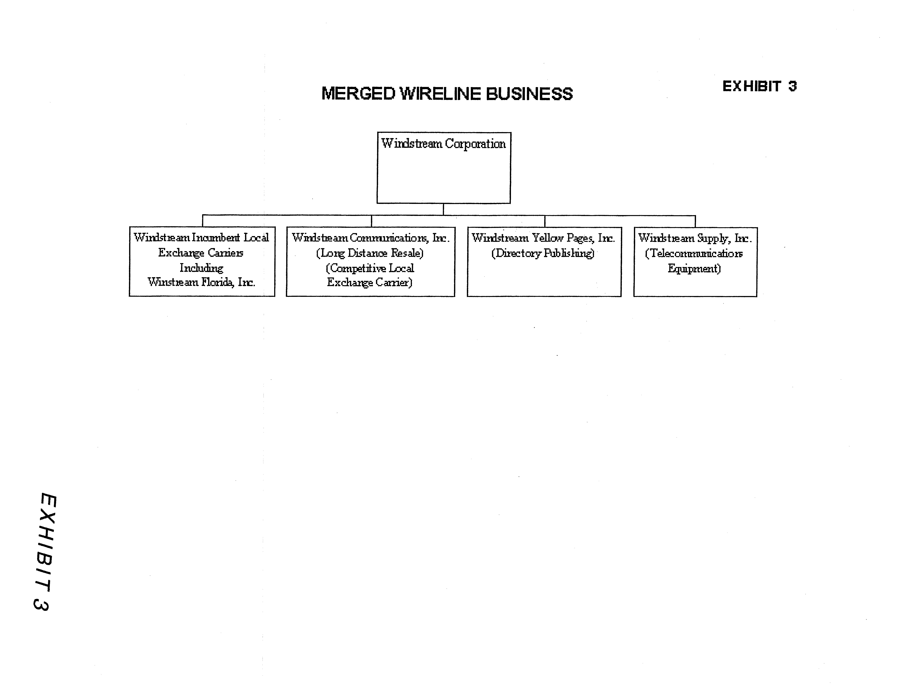
Windstream Service Guarantee Program

Repair of Out of Service Troubles as Reported by Customer

Windstream shall make automatic credits in the amounts specified below for out of service troubles as reported by the customer:

Duration
24 to 48 hours $ 12
> 2 days to 5 days $ 16
> 5 days $ 40

Sundays or holidays are not covered by the SGP and will be calculated and credited to customers consistent with Rule 25-4.110(6), F.A.C.

Customer Installations

Windstream shall make an automatic credit to the customer in the amount of $25 for failure to install service on the agreed upon commitment date. Negotiated commitment dates shall not exceed 5 business days. Windstream shall continue to meet Rule 25-4.066, F.A.C.

Answer Time

Windstream shall establish a Community Service Fund (CSF) in the form of a corporate undertaking. Pursuant to the Service Guarantee Program, Windstream shall make credits to the CSF and such funds shall be disposed of in coordination with the Commission staff to promote Windstream’s Lifeline service.

90% of all calls to the business and repair offices shall be answered by a live attendant prepared to give immediate assistance within 55 seconds of being transferred to the attendant. Windstream shall maintain 100% accessibility.

The amount of CSF credits shall be determined in accordance with the following parameters:

Less than 90%, but greater or equal to 80% - $2,000
Less than 80%, but greater or equal to 70% - $5,000
Less than 70% - $7,000

Force Majeure

In the event of named tropical or hurricane storms, Windstream may invoke Force Majeure by contacting the Director of the Division of Competitive Markets & Enforcement. Windstream shall at that time be relieved of the requirements of this SGP until Force Majeure is canceled.
ALLTEL Spin Off

1. Financial Conditions associated with the merger/spin-off transaction:

a. The liens and guarantees for Florida must be eliminated.
b. Dividends to parent restricted to 90% of Florida net income (net income is calculated as operating revenue minus operating expenses plus/minus non-operating income/expense minus fixed charges minus income taxes). Upstream loans/advances to parent, temporary cash investments, or any other method cannot be used to circumvent the 90% dividend requirement.
c. Must file all credit rating reports with the PSC until as long as the company remains the carrier of last resort.
d. Within 30 days after the close of the transactions, Alltel Florida shall file with the PSC all the final terms and conditions of this financing as described in the application including, but not limited to the following: the aggregate principal amount to be sold or borrowed, price information, estimated expenses, loan or indenture agreement concerning each issuance.
e. Covenants will be consistent with those found in Exhibit A to the April 12, 2006, Commitment letter. There will be no additional Financial Covenants other than the Maximum Leverage Ratio (debt/EBITDA, no more restrictive than 4.5X) and a Minimum Interest Coverage Ratio (EBITDA/interest expense, no more restrictive than 2.75X).

2. Rates:

a. No basic local telecommunications services rates increased for 3 years.
b. Transaction will not be a changed circumstance under 364.051 (4)(a), F.S., in order to increase rates.

3. Quality of Service:

a. SGP in addition to rules regarding customer service.
- Items as presented in the proposed SGP.
c. Commitment that quality of service will not decline below its current level.

4. Broadband:

a. 75% addressability by December 31, 2006
b. 80% addressability by December 31, 2007
c. 85% addressability by December 31, 2008

Clarify that the SGP applies to residential customers and the amounts would be as follows:

24 to 48 hours $12
>2 days to 5 days $16
> 5 days $40

Although it will have no customers or active pay telephones after the merger is complete, ACI will retain IXC registration TI498, PATS Certificate No. 5405 and competitive local exchange telecommunications company (CLEC) Certificate No. 5205.

