State of Florida
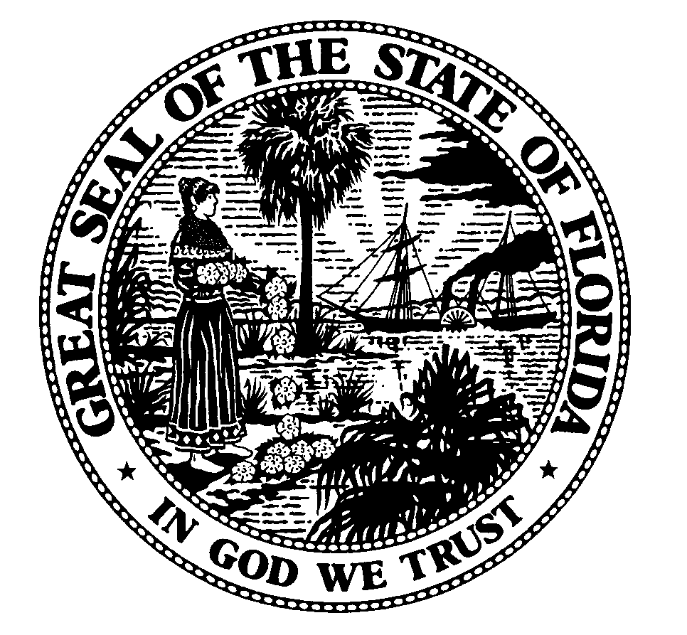

Public Service Commission
-M-E-M-O-R-A-N-D-U-M-

DATE: August 15, 2006
TO: Docket File
FROM: Adam Teitzman, Office of the General Counsel
RE: Docket No. 060455-TP – Complaint against AT&T Communications of the Southern States, LLC d/b/a AT&T d/b/a Lucky Dog Phone Co. d/b/a ACC Business d/b/a SmarTalk d/b/a Unispeaksm Service d/b/a www.prepaidserviceguide.com d/b/a CONQUEST for failure to pay intrastate access charges pursuant to Embarq's tariffs, by Embarq Florida, Inc., f/k/a Sprint-Florida, Incorporated.

There will be an issue identification meeting in the above-referenced docket at the following time and place:

9:30 a.m., Friday, September, 8, 2006
Room 382D, Gerald Gunter Building
2540 Shumard Oak Boulevard
Tallahassee, Florida

The purpose of this meeting is to identify and discuss the issues involved in this docket. Please provide Commission staff with a preliminary list of issues by the close of business on September 6, 2006.

Parties are reminded that it is the responsibility of the parties themselves to present evidence sufficient to support their case. It is not the responsibility of Commission staff to build the record for the parties. As such, the parties should be advised that, to the extent that they do not present evidence sufficient to provide a basis for a Commission decision on an issue, Commission staff may recommend that the Commission dismiss that issue because the record is inadequate or insufficient.

We will also discuss procedural matters associated with this docket. All interested persons are invited to attend.

Those persons not able to attend the meeting should dial the following number promptly at 9:30 a.m., on September 8, 2006, to participate by phone: Suncom: 277-8540; Non-Suncom (850) 487-8540.

If you have further questions about this meeting, please call me at (850) 413-6175.

AJT

