A.3.0 Project Overview

This section presents an overview of the proposed TEC, including a description of the Participants and an overview of the project site and technology, fuel supply, emissions control technologies, costs associated with the project, and project schedule.

A.3.1 Project Participants
The TEC is being proposed as a joint development project by four municipal utilities, including the FMPA, JEA, RCID, and the City of Tallahassee (the City, or Tallahassee). FMPA is a wholesale supplier to 15 city-owned electric utilities throughout Florida. JEA is a retail supplier in Jacksonville, Florida, and in parts of three adjacent counties. RCID is a retail supplier in parts of Orange and Osceola counties. Tallahassee is the principal retail supplier in Tallahassee, Florida. Collectively, the four utilities are referred to as the Participants throughout this Application.
The Participants are developing the proposed TEC to realize the benefits associated with the economies of scale inherent in constructing and operating a large power plant. Table A.3-1 presents each Participant’s ownership percentage in TEC, with each Participant responsible for the costs associated with TEC in proportion to its individual ownership percentage.

Table A.3-1
Proposed TEC Ownership Percentages

Participant | Percent Ownership
FMPA | 38.9
JEA | 31.5
RCID | 9.3
City of Tallahassee | 20.3

A.3.2 Description of the Project Site
The TEC will be developed on a site consisting of approximately 3,000 acres to be located approximately 5 miles southeast of Perry, in Taylor County, Florida. The land is bordered by Highway 27 on the north and the Fenholloway River on the west. Though the TEC project consists of one unit, the site will be designed and constructed with consideration given to allowing the addition of a second unit. However, a second unit is not planned at this time.
Figure A.3-1 presents a conceptual site arrangement drawing, including the locations of the major equipment for TEC.

A.3.3 Overview of Project Technology
The TEC is proposed to be a 765 MW (net) supercritical pulverized coal unit. Coal is the most widely used fuel for the production of power in the United States, and most coal burning power plants use pulverized coal boilers. Pulverized coal units have the advantage of utilizing a proven technology with a very high reliability level and can utilize large domestic coal reserves as well as international sources of solid fuel. They can be sized very large, and the economies of scale can result in low busbar costs. Pulverized coal units are relatively easy to operate and maintain.
New generation pulverized coal boilers can be designed at supercritical steam pressures of 3,206 to 4,500 pounds per square inch gauge (psig), compared to the steam pressures of 2,400 psig for conventional subcritical boilers. This increase in pressure raises the overall efficiency. This increase in efficiency comes at a slightly higher capital cost, however, and the economics of the decision between subcritical and supercritical design depend on the cost of fuel, plant size, and other factors such as the expected capacity factor of the unit and the cost of capital.
The TEC will include one boiler, one steam turbine generator with efficient steam cycle, a cooling system, water and wastewater treatment systems, material handling systems, air quality control systems, electrical interconnections, and other balance-of-plant systems. TEC will consist of the following core technologies:
- 765 MW (net) supercritical coal fired boiler.
- Zero liquid discharge (ZLD) facility.
- Reverse air baghouse.
- Wet, forced oxidation flue gas desulfurization (FGD) system using limestone reagent.
- Wet electrostatic precipitator (WESP).
- Selective catalytic reduction (SCR) system.
- No. 2 oil fired auxiliary boiler and emergency generator.
Other considerations that will be incorporated into the design of TEC include the following:
- Enhanced distributed control system (DCS) with neural network, performance monitoring, and simulator.
- Initial construction that will include landfill area to store 8 years of combustion byproducts, with space reserved for 30 years.

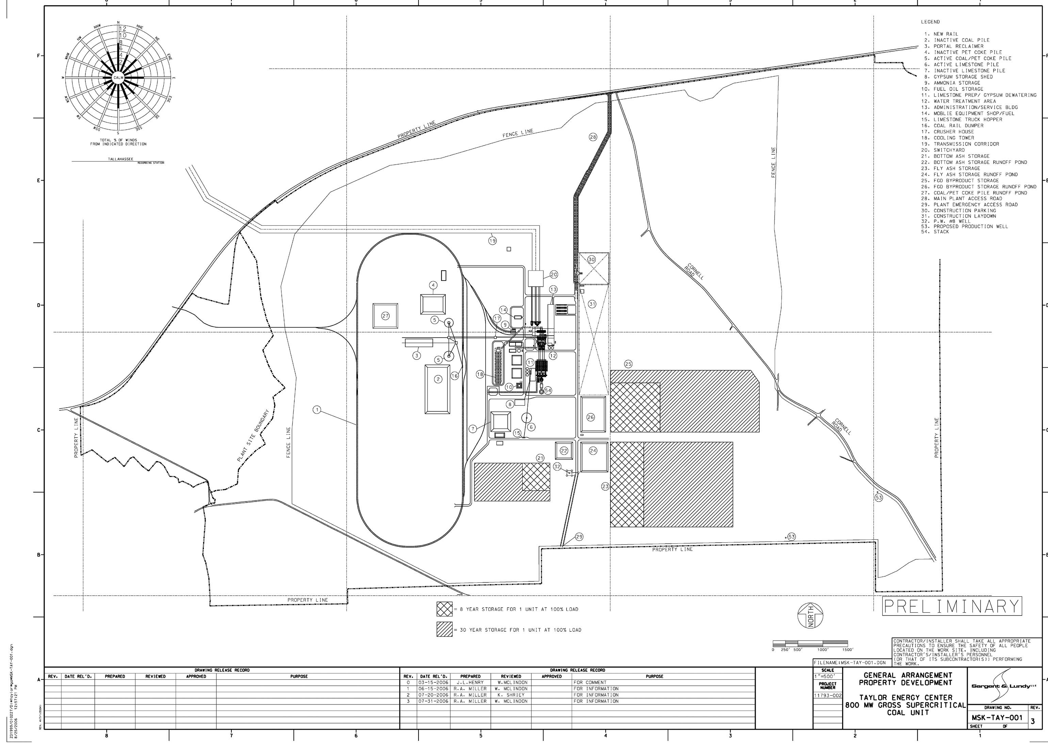
Figure A.3-1
Conceptual TEC Site Arrangement Drawing
- Additional 5 feet of fill and wetland mitigation.
- Foundation piles.
- 3.5 mile Georgia-Florida rail extension to the proposed site, including Route 27 and Fenholloway River crossings.
- Upgrades to plant access roads with acceleration and deceleration lanes.
TEC will have the best available control technologies for air quality control systems, including the following:
- SCR to limit nitrogen oxide (NO_{x}) emissions from the plant.
- A reverse air fabric filter baghouse to limit filterable PM₁₀ particulate emissions.
- A single-tower wet FGD absorption system to remove approximately 97 percent of sulfur dioxide (SO₂) from the flue gas stream.
- A WESP to collect particulate, hazardous air pollutants in particulate form, and acid mists.
Mercury (Hg) emissions will be controlled through the co-benefits of the air quality control equipment mentioned above.

A.3.3.1 Boiler
The outdoor-type, supercritical boiler will be a once-through, balanced draft, single reheat unit capable of firing a blend of pulverized coal and up to 30 percent petcoke. The boiler will be designed for an outdoor installation and will be approximately 280 feet high. Design steam conditions will be 3,600 psig with 1,050º F main steam temperature and 1,100º F reheat steam temperature. The boiler will be the dry-bottom type with low NO_{x} burners and overfire air ports. Boiler draft will be provided by two 50 percent radial forced draft fans and one primary air fan per pulverizer mill.
A blend of crushed coal and petcoke will be delivered to the boiler building day bins. Fuel will be discharged to eight mills (with one as a spare) for pulverizing. Each mill will pulverize approximately 100,000 pounds per hour (lb/h) of fuel. Pulverized fuel will be blown into the boiler from the primary air fans. Low-sulfur No. 2 fuel oil or ultra low-sulfur diesel (ULSD), if available, will be utilized for startup fuel. Startup fuel oil will be provided to the boiler from a 300,000 gallon field erected fuel oil storage tank.
TEC will be designed with an auxiliary boiler burning low-sulfur No. 2 fuel oil, or ULSD, if available. The auxiliary boiler will be designed to provide steam during startup and low load operation. Auxiliary steam generated by the auxiliary boiler will also be used to support boiler hydrostatic testing and chemical cleaning during startup. Based on preliminary design criteria, one auxiliary boiler rated for 220,000 lb/h steam at 233 psig will be provided.

A.3.3.2 Steam Turbine and Thermal Cycle
TEC will include a single 765 MW (net) steam turbine generator. It will be located in an enclosed turbine building that will include a bridge crane for maintenance. The steam turbine is expected to include a high-pressure (HP) turbine, intermediate-pressure (IP) turbine, and a four-flow low-pressure (LP) turbine. Main steam from the boiler will flow through the main steam piping to the HP section of the steam turbine. Exhaust steam from the HP steam turbine will be returned to the boiler to be reheated before flowing to the IP turbine. Exhaust steam from the IP turbine will flow to the boiler feed pump turbine drives as well as the LP turbines.
Boiler feedwater will be provided to the boiler through two 50 percent turbine driven boiler feed pumps. A startup electric motor driven boiler feed pump with variable frequency drive will be used for startup and backup. This pump will also be 50 percent capacity. The cycle will include four stages of LP feedwater heating, a deaerator, and three HP feedwater heater stages. The feedwater heaters will utilize stainless steel tubes, 304SS tubes for LP feedwater heaters and 304N tubes for the HP heaters. LP Heaters 1 and 2 will be located in the condenser hood. LP exhaust steam will be condensed in a two-shell, two-pass condenser with titanium tubes. The thermal cycle would be conventional for large supercritical pulverized coal plants.

A.3.3.3 Cooling System
The circulating water system will consist of a surface condenser, a cooling tower, circulating water pumps, and supply and return circulating water piping. The heat dissipation system will include a mechanical draft wet cooling tower, which will use groundwater as makeup and will be a closed loop system. The cooling tower will be a conventional multi-cell, counterflow, back-to-back style mechanical draft, wet cooling tower. Circulating water and auxiliary water cooling pumps will take suction from the concrete cooling tower basin. The cooling tower will be capable of handling brackish type waters and will be equipped with non-clog fill and drift eliminators.

A.3.3.4 Water and Wastewater Systems
The water supply for TEC will be provided from a system of wells, including one well on standby. The system will handle, on average, approximately 8.1 million gallons per day (mgd), with a maximum use of approximately 9.1 mgd. The total depth of each well will be approximately 400 feet. Each well will be spaced approximately 2,000 feet apart and will have a pumping rate of 3,300 gallons per minute (gpm). Raw well water will be piped to the power plant water treatment system. The filtration and demineralizer systems will provide makeup water to the boiler. Water treatment equipment will include a cartridge filter, reverse osmosis, cation exchangers, anion exchangers, and a degasifier. The demineralizer will be sized for one unit, but there would be space for a second demineralizer.
Wastewater will be produced from process boiler blowdown, cooling tower blowdown, miscellaneous plant drains, byproduct storage area runoff, and sanitary wastes. Various ponds will collect uncontaminated (non-contact) storm water on the site prior to discharge. Sanitary wastes will be treated in an onsite treatment facility or piped to the City of Perry sanitary system. Process wastewaters will be recycled as appropriate to the wet FGD system or sent to a ZLD brine concentrator. After separation of the solid waste, the water will be returned to the filtration process. As a result, no process wastewaters will be discharged offsite. The solid waste will be disposed of in an approved landfill. Figure A.3-2 presents the conceptual water mass balance for TEC, showing the summer maximum case water and wastewater flows.

A.3.3.5 Material Handling Systems and Storage
All solid fuel supplies will be delivered to the site by bottom dump railcars via a new rail spur approximately 3.5 miles in length. Unit trains consisting of between 115 and 135 cars, each containing up to approximately 120 tons, will deliver coal to the site. Onsite fuel storage will allow for up to approximately 90 days. Two reclaim hoppers will also be available for reclaim and blending of fuel. The active coal storage area will be enclosed in a building capable of storing coal for approximately 5 days of operation. Two portal reclaimers will be used to move coal and petcoke from the active storage building to the crusher house. Crushed coal will be conveyed to coal storage silos within the enclosed boiler building.
Conventional mechanical conveying systems will be used to collect and store bottom ash, fly ash, and scrubber byproducts. A drag chain conveyor will remove bottom ash from the boiler to a concrete bunker for removal by front end loader and truck. Fly ash will be collected and stored in a 72 hour storage silo, with truck removal for disposal or sale. Onsite storage provisions will be included for FGD waste, which may also be sold as commercial grade gypsum. The plant property will have space available to accommodate 100 percent of the solid waste by-products from the facility for 30 years if necessary, with approximately 8 years of storage initially available at commercial operation.

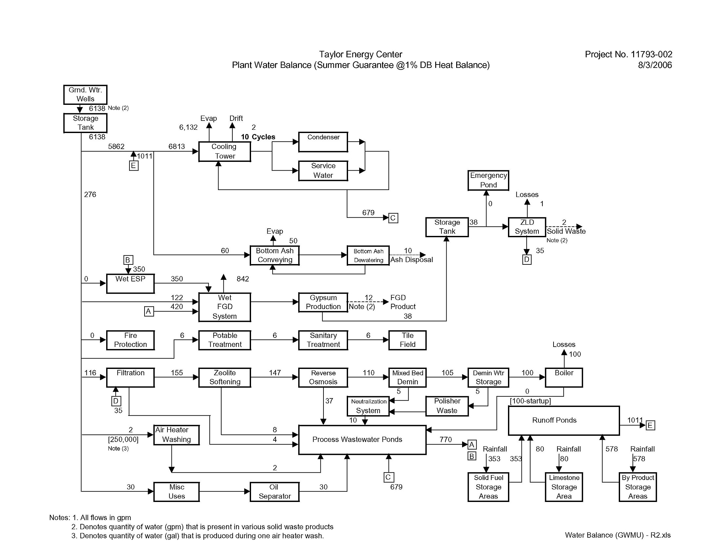

Figure A.3-2
Conceptual TEC Water Mass Balance
Limestone used as a reagent in the FGD system will be delivered to the site by 22 ton capacity haul trucks. TEC will have active and inactive limestone storage piles. The inactive limestone pile will contain about 90 days’ supply of limestone. The active storage pile will be covered and will hold about a 10 day supply of limestone.

A.3.3.6 Air Quality Control Systems
TEC will have the best available control technologies for air quality control systems. SCR will be installed integral with the boiler and combustion controls to limit NO_{x} emissions from the plant. A reverse air fabric filter baghouse will be used to limit filterable PM₁₀ particulate emissions. A single-tower wet FGD system will use limestone slurry absorption to remove approximately 97 percent of SO₂ from the flue gas stream. The FGD system will be designed to produce saleable gypsum byproduct. A WESP will be installed to collect particulate, hazardous air pollutants in particulate form, and acid mists. Treated flue gas will discharge from a concrete shell chimney. Hg emissions will be controlled through the co-benefits of the air quality control equipment mentioned above.
Four radial type induced draft fans connected in parallel will provide the draft to exhaust the flue gas from the boiler, SCR, and fabric filters and then force the gas through the FGD spray tower and WESP to the chimney. The chimney will have an outer concrete shell and an inner fiberglass reinforced plastic (FRP) liner.
Table A.3-2 summarizes the anticipated TEC emissions rates for three of the types of coal that TEC will be capable of burning, assuming each coal type is blended with 28 percent petcoke. The emission rates shown in Table A.3-2 are tentative pending air permitting.

A.3.3.7 Electrical Interconnection
The proposed TEC site is located in the Progress Energy Florida (PEF) system and will connect to the PEF system at a 230 kV interconnection. Interconnecting the plant to the PEF system will be accomplished by PEF consistent with the requirements as set forth in Federal Energy Regulatory Commission (FERC) Docket RM02-1-000 and accompanying Order 2003. According to the FERC rule, PEF must complete a series of studies to determine the impact of the proposed TEC on the transmission grid and identify the new facilities and improvements that will be required to reliably integrate the plant into its system and deliver the output to the project owners. The overall purpose of those studies is the identification of any improvements needed to mitigate impacts on the transmission grid due to the TEC project. The identified improvements would be funded by the project Participants and installed by PEF before the project achieves its

Table A.3-2
Anticipated TEC Emissions Rates by Coal Region
(Assuming 28 Percent Petcoke Blend)

Emission | Coal Region
Emission | Latin America | PRB | Central Appalachia
SO₂ (lb/MBtu) | 0.09 | 0.09 | 0.09
NO_{x} (lb/MBtu) | 0.07 | 0.07 | 0.07
Hg (lb/MBtu) | 1.40 X 10⁻⁶ | 1.90 X 10⁻⁶ | 1.20 X 10⁻⁶
CO₂ (lb/MBtu) | 211 | 215 | 200
CO (lb/MBtu) | 0.154 | 0.154 | 0.154
PM₁₀ (lb/MBtu) | 0.015 | 0.015 | 0.015
CO = Carbon monoxide.
CO₂ = Carbon dioxide.

commercial operation date (COD). The studies to be undertaken as part of the generator interconnection analysis are: (1) a feasibility study; (2) a system impact study; and (3) a facilities study. These studies are to be completed sequentially, and the total time for completion of all three studies is approximately 12 months.
The result of PEF’s first study (the transmission feasibility assessment) indicated that under a variety of scenarios there is, in general, no major impediment to interconnecting the project to the transmission grid. As identified in that assessment, the simplest interconnection to implement would include 230 kV transmission lines from the site running 5.5 miles to the Perry substation (a PEF facility). The interconnection will most likely be designed, built, and operated by PEF. The switchyard onsite will be built for one unit, with space to expand for a second unit. Figures A.3-3 and A.3-4 show the arrangement of the TEC interconnection and auxiliary power systems.
The second step is a system impact study that will identify any impacts (overloads) on the PEF network associated with the plant and will recommend solutions that eliminate or mitigate those impacts. During this study, a preliminary interconnection plan (or plans) will be developed by PEF and shared with the project owners. This study is currently underway and is expected to be completed by September 2006. The objective of this study is to identify the impacts on the transmission system associated with the interconnection of the TEC project; those impacts will be fully mitigated through improvements identified by PEF in this study.
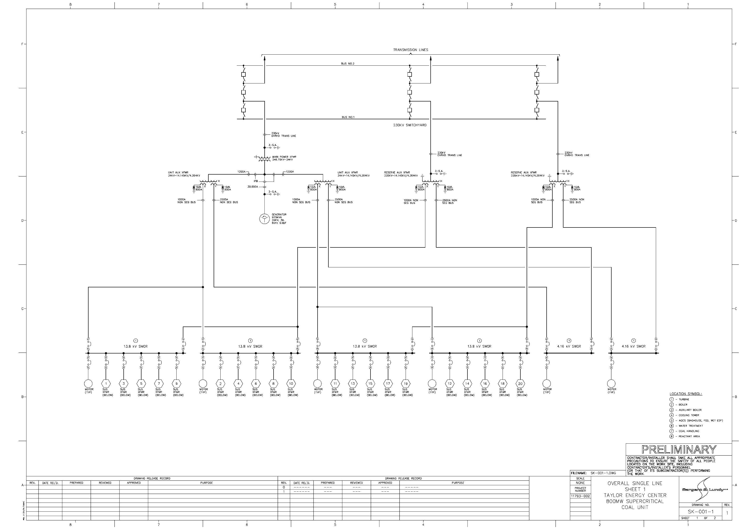

Figure A.3-3
Conceptual TEC Interconnection and Auxiliary Power Systems
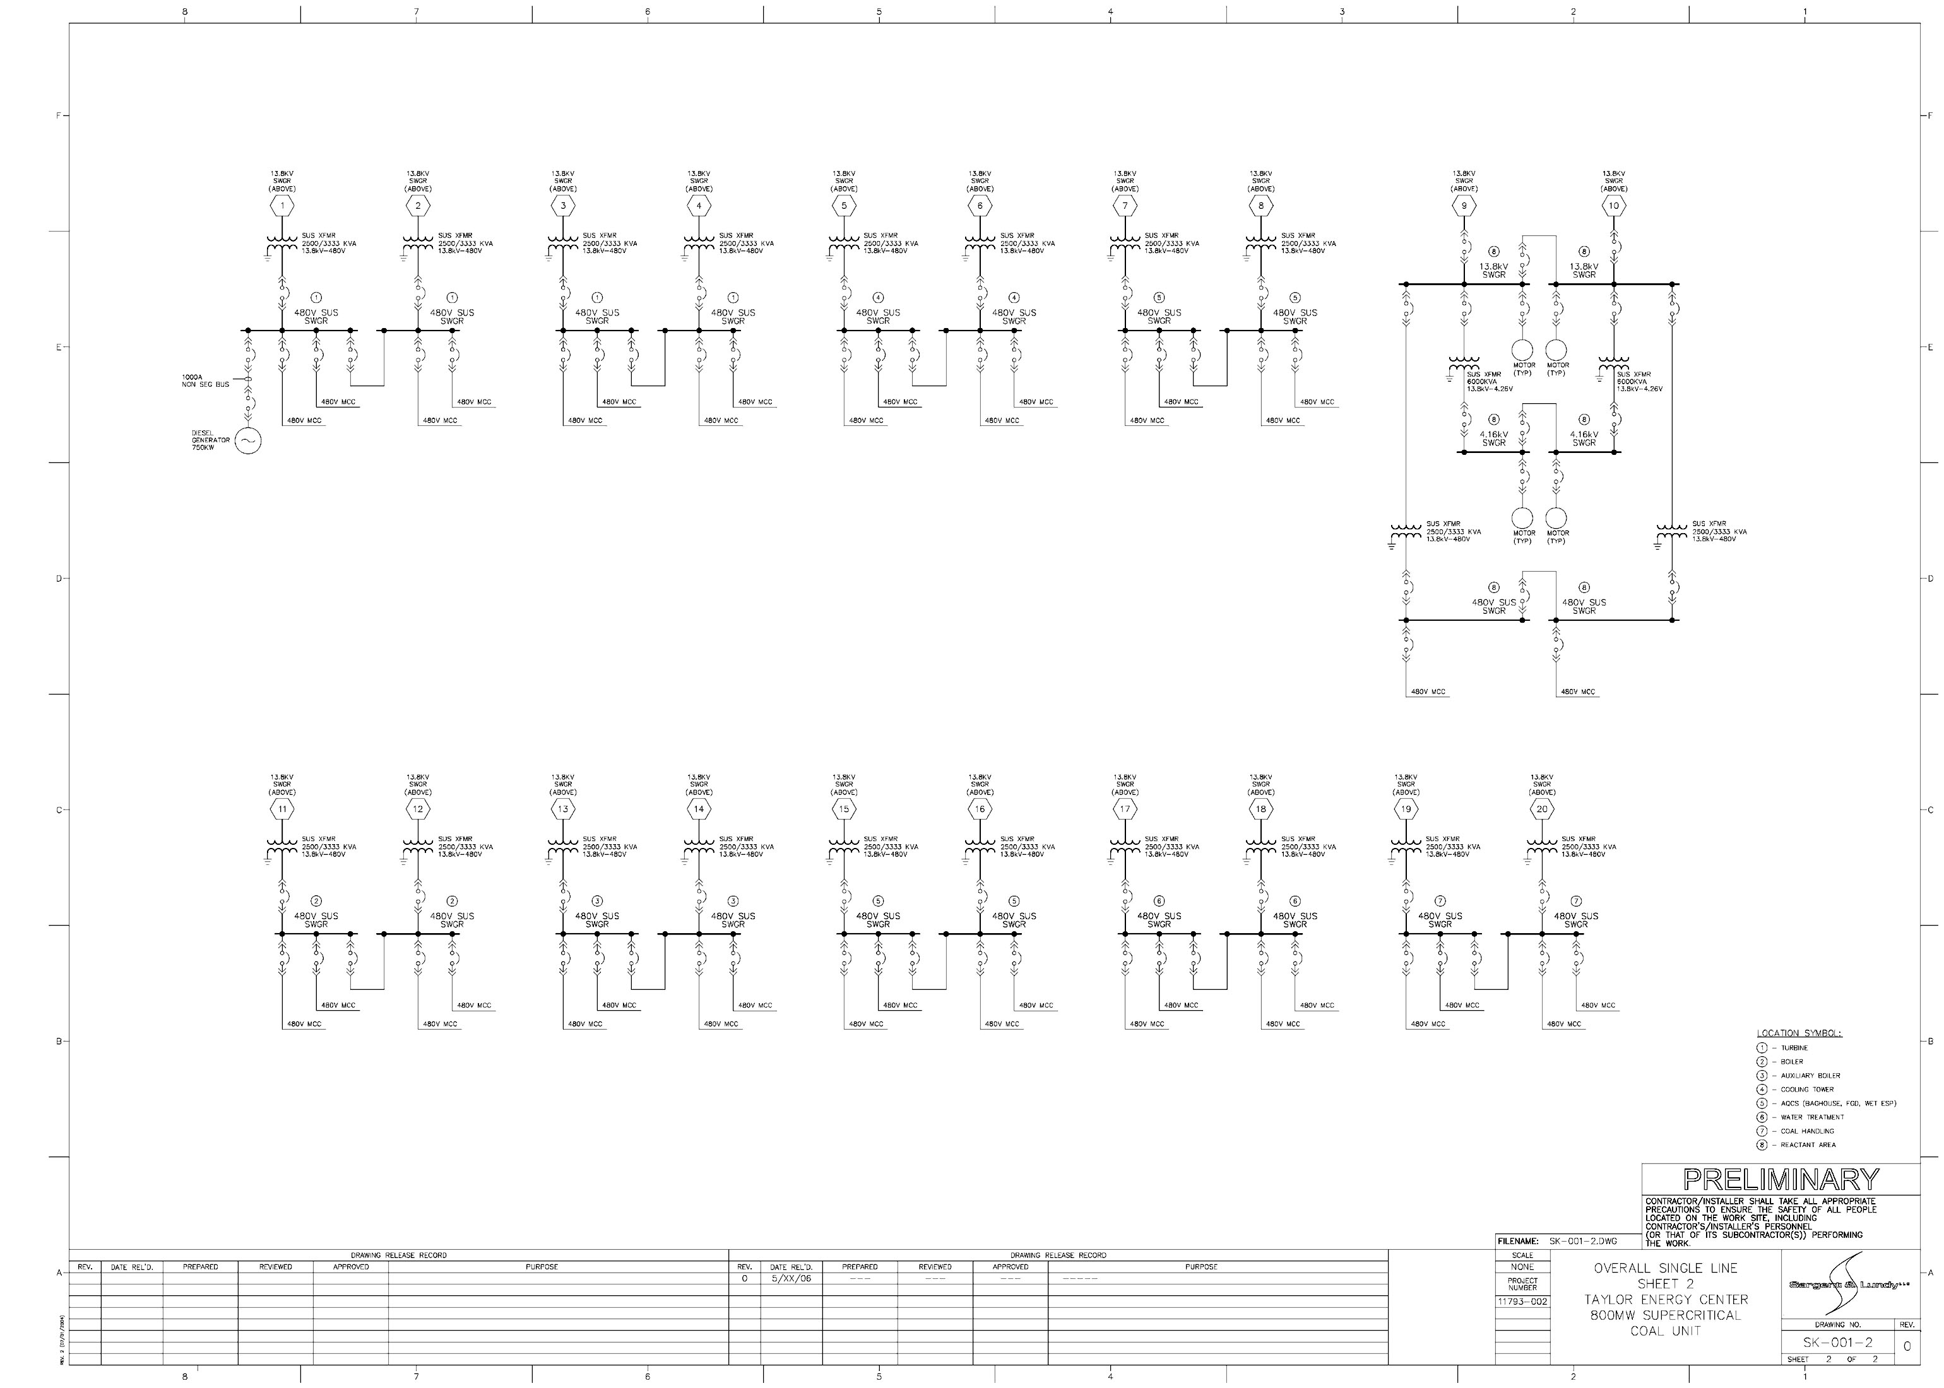

Figure A.3-4
Conceptual TEC Interconnection and Auxiliary Power Systems
The formal interconnection plan is to be developed as part of the third study and is not expected to be finished until early 2007. That plan may include other transmission corridors and facilities beyond the Perry substation to ensure grid reliability and full utilization of the TEC by the project owners. The result of this study is a list of the required facilities, the cost, and the anticipated time frame to interconnect the plant to the grid. Once that study is complete, the project owners would execute an agreement with PEF for funding of the facilities, and detailed design and engineering work would begin. It is anticipated that the PEF facilities and/or improvements will be ready by the time the plant is scheduled to be in service.
The costs for the interconnection and system improvements fall into one of two categories. The first involves direct interconnection costs, that is, costs directly associated with the interconnection of TEC that provide no benefit to the transmission network other than the interconnection of TEC to the network. The second cost category involves network upgrades and improvements that will benefit the transmission network. The categorization of the costs identified in the formal interconnection plan is determined as part of the formal interconnection plan. Since the formal interconnection plan has yet to be completed, the categorization of the costs and their magnitude is not known. For evaluation purposes, the direct interconnection costs were assumed to be those for the 5.5 mile 230 kV transmission lines to Perry substation. The estimated cost for these lines (developed by Sargent & Lundy) is included in the TEC capital cost in Table A.3-5. The cost for the network upgrades and improvements will not be known until the formal interconnection plan has been completed. These costs will be paid for by the project Participants, but their payments will be refunded through credits, including interest to their transmission service costs. Thus, only the transmission service costs have been included in the economic evaluations.

A.3.3.8 Emergency Diesel Generator
An emergency generator will be provided to supply power to the essential service motor control centers during an interruption of the electrical power supply to the site. Typical essential service loads include turbine and boiler feed pump turning gear motors, critical oil pumps, air preheater recirculating pumps, hydrogen side seal oil pumps, flame detector cooling air fans, air heaters, building heat and fuel supply systems, plant communication systems, and essential emergency lighting. Based on preliminary design criteria, the size of the emergency generator will be approximately 1,640 kW. The emergency generator will fire ultra low-sulfur diesel fuel (maximum sulfur content of 0.05 percent and a maximum ash content of 0.25 percent) and will be designed with advanced combustion modifications, including retard timing, to minimize potential NO_{x} emissions.

A.3.4 Fuel Supply
TEC will be capable of using a wide variety of coals, as well as coal and a coal/petcoke blend of up to approximately 30 percent petcoke. On an annual basis, the quantity of solid fuel used at TEC will be in the range of approximately 2.1 to 2.8 million tons, depending on the unit’s annual capacity factor and the source of fuel. The solid fuel can be sourced from multiple locations with alternative transportation options, thus increasing the overall reliability of the fuel supply to TEC. Startup fuel will be low-sulfur fuel oil or ULSD, if available.

A.3.4.1 Fuel Procurement and Delivery
The Taylor Energy Center Fuels Committee (TEC Fuels Committee, or TEC Fuels), which consists of representatives of each of the Participants, is responsible for developing and implementing strategies for fuel procurement and delivery to TEC. Competitive bidding will be utilized to the extent possible to obtain fuel and transportation services. RFPs for fuel and transportation services will be issued after all necessary permits have been obtained for the project and sufficiently prior to commercial operation to ensure that a reliable fuel supply will be available to TEC. Details of the planned fuel procurement and delivery strategy are presented below.
The present strategy calls for maximum flexibilities in the sourcing of fuels from various US and foreign production regions to achieve maximum intra-supplier competition in future years. Similarly, planning calls for maximum flexibilities in the transport logistics for the movement of coals from source points to the TEC.
The TEC Fuels Committee recognizes that the narrow economic differences that currently exist for competing coal and petcoke alternatives indicate that no clear total energy cost alternative is likely to exist over the life of the TEC. Furthermore, the flexibility of the designs of the boiler and associated emissions control systems will allow opportunities for the switching of coal sourcing and transportation linkages in the future. This will allow increased leverage in future negotiations for both fuel supply and transport services.
The TEC Fuels Committee’s strategy focuses on taking advantage of this opportunity for fuel flexibility by establishing a plan that creates and exploits competitive opportunities in the marketplace. Throughout the life of the project, TEC Fuels’ objective will be to promote competition between supply source regions, between suppliers within each region, between transport modes, and between transport service providers within each mode. For example, when it is economical to do so, oceangoing vessels may be used to provide partial delivery of coal and petcoke to TEC as an alternative to complete reliance on rail transportation. In addition, the TEC Fuels Committee will require multiple rail carriers to compete to supply service to TEC. Another key element of the fuel strategy is to use the competitive bidding process to evaluate all fuel options based on the “as-fired” cost to TEC so that a comparison can be made between fuels having different quality, combustion performance, and emissions potentials. This procurement process will offer supply opportunities to all viable suppliers, thus providing TEC with access to a full range of solid fuels from both international and domestic sources.
The TEC Fuels Committee’s initial focus in the development and implementation of the fuel strategy is on the procurement and logistics to deliver solid fuels to TEC. These solid fuels (coal and petcoke) will constitute the overwhelming bulk of fuels – both in economic and performance/reliability terms – over the life of TEC. Other items will ultimately be addressed, including the procurement and delivery of limestone and No. 2 fuel oil for startup, and consideration of railcars to support the fuel plan. The delivered fuel costs presented in Section A.4.0 are based on and include costs for carrier-owned cars. Ultimately, TEC may purchase some or all of the railcars necessary to deliver fuel to TEC, leveraging low cost tax exempt municipal financing to further lower costs.
This fuel strategy provides reasonable flexibility to periodically change fuel sources and delivery modes to maintain competitive pricing and take full advantage of the capability of the TEC unit design to burn a wide range of solid fuels.

A.3.4.2 Identification of Potential Fuels and Sourcing Regions
The following coal/petcoke production regions have been identified as potential sourcing points for the TEC and are more fully discussed in Section A.4.6. Based on the delivered fuel cost projections in Section A.4.0, a blend of Latin American coal and petcoke would result in the lowest production costs for TEC. The next lowest production costs for TEC result from a blend of PRB coal and petcoke:
- Latin American Coals. Principal sourcing identified at this time includes South America (Colombia and Venezuela). Bituminous coal produced in these regions has low-cost linkages to deep water port facilities for ocean vessel delivery to rail-served ports in Florida or adjacent states. Sourcing is projected to expand in the future as new production areas become available.
- Petcoke. Principal sourcing identified includes production from both domestic (Gulf Coast) and foreign (primarily Caribbean) refining regions with ocean vessel deliveries to rail-served ports in Florida or adjacent states.
- PRB Coals. Principal sourcing identified is the subbituminous coal region, with primary production centered in two counties of eastern Wyoming, with secondary production areas located in southeastern Montana.
- Central Appalachia Coals. Principal sourcing identified is the bituminous coal production region of eastern Kentucky, southern West Virginia, the western counties of Virginia, and portions of central Tennessee.
These coal and petcoke production regions, along with a summary description of transport linkages to the TEC, are further described in the following subsections.

A.3.4.3 Rail Service to the TEC Site
Rail service to the TEC site will be provided by a spur-line extension from an existing rail line – the Georgia & Florida Railroad (GFRR). The GFRR is a Class III short line operating over approximately 84 miles of trackage extending between Adel, Georgia (north end) and a paper mill complex at Foley (southeast of Perry), Florida. The GFRR interconnects with the two major eastern Class I railroads – CSX Transportation (CSXT) and Norfolk Southern (NS) Railway at the following locations:
- NS at Albany and Adel, Georgia.
- CSXT at Quitman, Georgia and Greenville, Florida.
CSXT has trackage rights over the GFRR between Quitman, Georgia and Perry, Florida.
Rail movements to the TEC site will entail the utilization of high efficiency unit trains comprised of aluminum body, steel carriage air-door hopper railcars designed for up to approximately 120 tons of coal per car, in trains ranging between 115 and 135 cars in length. Unloading of the unit trains will utilize a high-capacity railcar receiving system. This system will have a nominal rated capability of approximately 4,000 tons per hour. The projected unloading time for a unit train will be about 5 hours.
The following subsections demonstrate the reliability of coal supply at the mines and the ability of the rail transportation infrastructure to reliably deliver coal to the TEC.

A.3.4.4 Latin America Coals and Petcoke
The coal would move by deep-draft ocean vessel to a US Gulf or Atlantic Coast port for terminaling and forwarding by rail to the TEC site. The petcoke would move by deep-draft ocean vessel or barge to a US Gulf or Atlantic Coast port for terminaling and forwarding by rail to the TEC site. The current preferred purchase strategy is to contract for Latin American coal and petcoke delivered to a US port by the fuel supplier(s). This arrangement eliminates the need for international shipping contracts and the associated risks, while preserving pricing competition. It is in the best interest of prospective suppliers to provide fuel deliveries to a US port location designated by TEC at the lowest possible cost. Contractual arrangements may range from single-shipment vessel charters to multi-year term contracts, depending upon future market conditions.
Colombian and Venezuelan source regions have been identified as the most likely international supplies of coal. Deliveries of coals destined for TEC will require that the product first be delivered to a port facility located in the southeastern United States. Movements from the foreign ship loading ports will be by Handymax or Panamax Class vessels moving directly to deep-draft US port locations. At these ports, the vessels will be off-loaded and the coals stored onsite (in-transit storage) for subsequent reloading into railcars for forwarding in unit train service directly to TEC.
Colombia and Venezuela are the largest sources of imported steam coals into the United States in recent years. These are relatively high quality coals with as-received high heat contents and low sulfur contents. These coals are the fuels of choice for eastern US and Gulf Coast utilities and plants that have steam generation and flue gas cleanup systems designed for Central Appalachian coals, because the coals can be burned with minimal impacts on steam-raising equipment and operations.
Colombia and Venezuela collectively produce about 80 million short tons (2005) of coal, with in-place recoverable reserves exceeding 6 billion tons. Production is rapidly ramping up to meet world demand for this coal. These coals are projected as being the import coals of choice in future years because of their high quality and short ocean-transport distances to US Gulf and Atlantic Coast ports. Demand for the coals will be especially strong from Mid-Atlantic and New England utilities that have older generating facilities without cleanup systems, these utilities are facing increasing restrictions on flue gas emissions.
Historically, the primary markets for Colombian and Venezuelan coals have been European utilities. Movement into the United States has peaked when European pricing and demands have slackened. However, starting in late 2003 with the recent dramatic increases in the pricing of eastern US sourced coals, utilities started looking in depth at alternative sourcing, including imported South American coals. The increase in demand for export coals (both metallurgical and steam grades) is being driven by increased procurements by expanding third-world economies (primarily China and India) and has resulted in an interesting and unprecedented phenomenon of simultaneous increases in both exports of US-produced coals and imports of foreign coals – often through the same port.
Petcoke is a waste or byproduct of the oil-refining process. As such, it has no meaningful “cost of production” by which to gauge value. Historically, the bulk of petcoke (approximately 59 percent in 2005) produced in the United States has been sold overseas (primarily in European markets) to domestic industrial users. This has been a fuel of opportunity, depending upon locations of the supply and use points and the connecting transport linkages. For these and other reasons, petcoke prices have historically been quite variable, but usually low cost on a dollar/MBtu basis compared to other fuels such as coal and natural gas.
Potential sourcing of petcoke for supply to TEC will include existing and future refinery/coker facilities that have direct or short-haul rail access to deep water ports located on the US Gulf Coast (Louisiana and Texas), in the Caribbean, and on the Atlantic Coast of Mexico and South America. Projections call for about 35 million metric tonnes per year of new coke-making capacity to be installed worldwide in the period between 2006 and 2010. This rate of addition to petcoke production capacity is approximately six times the growth rate between 1995 and 2000. Approximately 60 percent (21 million tonnes) is forecasted to be installed in the period between 2006 and 2008
Other sources of foreign coals and possibly petcoke for TEC are likely to appear in future years. These may include Russia, South Africa, and Indonesia. While imports to the United States from these regions are relatively limited at the present time, the establishment of expanded in-place port and terminaling facilities for the receipt and rail forwarding of imported coals offers maximum fuel procurement flexibility for TEC in the future.

A.3.4.5 Port and Terminal Facilities for Imported Coals and Petcoke
The size and loaded draft of the ocean vessels delivering coal or coke to US ports will be limited by the physical size and draft limitations of each facility. Potential port locations and limiting conditions are presented in Table A.3-3.

Table A.3-3
Potential Port Locations and Limiting Conditions

Location | Limiting Draft  (feet below MLW) | Limiting Deadweight Tonnage  (metric tonnes) | Railroad Carrier
Jacksonville, FL  Port Authority (JPA) | 38 | 70,000 | CSXT, NS
St. Johns River  Northside Generating Station | 38 | 70,000 | CSXT
Mobile, AL  McDuffie Coal Terminal | 45 | 170,000 | CN, BNSF, CSXT
Tampa Bay, FL  TampaPlex Terminal (TPT) | 40 | 100,000 | CSXT
Lower Mississippi River  International Marine Terminal | 48 | 170,000 | None
Lower Mississippi River  TECO Bulk Terminal, LLC | 48 | 170,000 | None
Port St. Joe, FL | 12 | 3,300 | AN

The coal port at Jacksonville, Florida is prospective at this time. The Jacksonville Port Authority (JPA) has expressed an interest in the development of a bulk terminal facility at the site of a former Jefferson Smurfit paperboard mill, located along the St. Johns River near Talleyrand Avenue and to the north of the existing Talleyrand Marine Port. The 91 acre property is owned by Jax Maritime Partners. Under current JPA plans, the site would be acquired by JPA through eminent domain processes. JPA has indicated that the acquisition is part of a long-term expansion of the Talleyrand port facilities to accommodate its future needs for additional container, general cargo, and import automobile landside facilities, as well as for a new bulk materials terminal. JPA has revealed a memorandum of understanding (MOU) calling for Drummond Coal Company (Drummond) to be the operator of the bulk terminal portion of the new facilities. NS has been reported to be the preferred rail carrier to transport coal from the facility.
As a competing project, a 61-acre parcel of the site has reportedly been purchased from Jax Maritime Partners by Keystone Industries, LLC (Keystone), a subsidiary of Keystone Coal Company. Keystone has disclosed plans to develop the property as a 6 million tons per year throughput bulk terminal, independent from the JPA arrangements. Under Keystone’s plan, both NS and CSXT (via interchange from NS as the carrier serving the port facilities) would have rights to originate rail coal shipments from the terminal facilities.
The Northside Generating Station terminal facility located on the St. John’s River in Jacksonville, Florida is an existing pier and terminaling facility that is owned and operated by JEA. This facility includes a rail-mounted ship-unloader capable of efficiently unloading Panamax class vessels and an overland conveyor linkage to the fuels stockyard of JEA’s Northside Generating Station. The terminal facilities are employed by JEA to deliver petcoke, coals and limestone for the Northside Station.
There is presently only limited rail capability and no handling and railcar loadout systems in place for rail forwarding of coals from the Northside Station. There is space at the adjacent SJRPP Station for the development of coal storage and rail loading facilities. These facilities would take advantage of coal yard area space and the existing rail spur line from the CSXT branch line serving the SJRPP Station. The Northside Generating Station is solely owned by JEA, and the SJRPP Station is jointly owned by JEA and Florida Power & Light. As such, JEA, one of the TEC Participants, has ownership interests such that the existing port facilities could be used for supplying TEC. It is anticipated, however, that one or more of the above alternative port facilities will be developed and available for TEC. The delivered fuel cost projections in Section A.4.0 are based on the use of a port in Jacksonville. Other ports available to serve TEC are described below.
The McDuffie Terminal on Mobile Bay is owned and operated by the Alabama State Docks Department – Port of Mobile, Alabama and is a long-established facility for the export of coals. In recent years, it has expanded to accommodate the inbound movement of bulk commodities, with the addition of two rail-mounted gantry crane type ship unloaders rated at 2,500 tons per hour. At present, inbound coal moves only to barges for transshipment on the Tennessee-Tomhigbee-Warrior River and Intra-Coastal Waterway Systems. Facilities for the efficient loadout of railcars in unit train shipments will require new development.
The TampaPlex Terminal on Tampa Bay, Florida has limitations in its ability to transload from vessels to railcars in terms of both ground areas for interim storage and sufficient space for the development of both trackage and railcar-loading facilities for originating unit train movements. This port location will require major upgrading of facilities to accommodate the throughput tonnage levels required by TEC.
The International Marine Terminal located on the Lower Mississippi River at MP 57 near Myrtle Grove, Louisiana is a terminal of long-standing, handling both export and inbound coal and other bulk commodities movements. The terminal has existing facilities for the unloading of large ocean vessels at both dockside and mid-stream locations. The unloading of vessels in the mid-stream of the river employs multiple cranes (Clyde-Whirley type units with clamshell buckets) mounted on barges. These units transfer the coals directly to barges for either upriver, intra-coastal, or cross-gulf movements. Alternatively, the barges move to adjacent barge docks for unloading and transfer of coal to ground storage for blending and subsequent reloading to cross-gulf or intra-coastal barges. The terminal has an advertised throughput capability of 12 million tons per year with capacity for expansion. The facility has provided transshipment services for the movement of coal to the Progress Energy Florida’s Crystal River Station for more than 40 years.
Similarly, the TECO Bulk Terminal (Electro-Coal Transfer) located on the Lower Mississippi River at MP55 near Davant, Louisiana employs almost identical facilities and operations for terminaling of both inbound and outbound movements of coals and other bulk commodities. This terminal has an announced annual capability of 25 million tons and has been in service for more than 35 years, to transship imported coals in cross-gulf barge units to utility destinations in the Tampa Bay area of Florida.
Either or both of the Lower Mississippi terminals could be employed to transfer foreign-sourced coals from deep-draft ships to shallow-draft barges for forwarding to Peninsular Florida terminals, for reloading to railcars and forwarding to TEC.
The terminaling facilities at Port St. Joe, Florida were developed in the early-1980s to serve the Seminole Station, which is owned and operated by Seminole Electric Cooperative, Inc. at Palatka, Florida. The facility was designed as a water-to-rail transfer for Illinois Basin coals (White County, Illinois) moving by barging down the Ohio-Mississippi Rivers (via Intra-Coastal Waterway movements) to Port St. Joe, Florida. The terminal facilities were originally owned and operated by Materials Transfer, Inc., a subsidiary of International Shipholdings Corporation. Installed facilities include a barge unloading system and ground area for pile storage of up to 200,000 tons of coal. The terminal also includes railcar loadout facilities to load unit coal trains for forwarding over Apalachicola Northern (AN) and CSXT to destinations in Georgia and Florida.
The Port St. Joe facility operated between 1982 and early 1999, when it was shut down due to economic considerations (i.e., lower delivered basis costs for Central Appalachian origin coals moving in all-rail CSXT movements). The port and terminaling facilities are under new ownership and retain the original name – Materials Transfer, Inc. (MTI). The installed facilities and equipment are in place, but are currently inactive except for sporadic movements of petcoke.
Under certain scenarios of future fuel sourcing for TEC, the Port St. Joe facilities could be a component in logistics movements for coals originating in the Illinois Basin (Ohio and Mississippi River movements) and for Intra-Coastal transshipments of imported coals and petcoke from deep-draft terminals located on the Lower Mississippi River on the Port of Mobile, Alabama.

A.3.4.6 Rail Linkages – Ports to TEC
Rail movements from the Jacksonville area port and terminaling facilities would employ CSXT as the originating carrier, with CSXT routing from Jacksonville via Baldwin, Lake City, and Live Oak, Florida to an interconnection with GFRR at Greenville, Florida. Continuation from Greenville, Florida to the TEC site would be over the GFRR.
Rail movements from the McDuffie Coal Terminal at Mobile, Alabama would utilize CSXT as the originating carrier, with unit trains routed eastward via Flomaton, Alabama, Pensacola, and Tallahassee to Greenville, Florida with GFRR continuation to TEC.
Rail movements from ports and terminals in the Tampa Bay area would employ CSXT routings via Plant City, Vitis, Ocala, and Starke to Baldwin, Florida then westward to an interconnection with the GFRR at Greenville, Florida.
Rail movement from the former MTI Terminal at Port St. Joe, Florida would employ the short-line Apalachicola Northern Railroad (AN) as the originating carrier, with movements interchanging to CSXT at Chattahoochee, Florida. CSXT would continue the movements via Tallahassee to Greenville, Florida, with forwarding by the GFRR to TEC.
The projected approximate one-way rail haulage distances for unit train movements of coals and petcoke from the alternative port locations to the TEC site are presented in Table A.3-4. The train movements assume the routings as outlined above, with ranges in mileages dependent upon alternatives in routings. The delivered fuel cost projections in Section A.4.0 assume water-borne delivery to Jacksonville with rail delivery to TEC.

Table A.3-4
Approximate Projected One-Way Haulage Distances to TEC

Port Location | Approximate One-Way Distance
Jacksonville, FL - JPA Terminal | 156.3 miles
St. Johns River – Northside Station | 170.6 miles
Mobile, AL – McDuffie Coal Terminal | 385.2 miles
Tampa Bay, FL – TampaPlex Terminal | 333.6 miles to 404.0 miles
Port St. Joe, FL – MTI Terminal | 220.0 miles

A.3.4.7 Powder River Basin
The next lowest cost as-fired source of fuel for TEC is subbituminous rank coal from the PRB of Wyoming and Montana blended with petcoke. The PRB is divided into two distinct subregions. The Northern Powder River Basin (NPRB) is comprised of mines located in Big Horn and Rosebud Counties of southeastern Montana. The four current mines are large-scale surface mining operations that produced about 37.8 million tons of coal in calendar year 2005. All mines are served by the Burlington Northern Santa Fe (BNSF) railroad as the originating carrier for rail movements. NPRB coals generally have a higher heating value than coals in the Southern Powder River Basin (SPRB), making them generally more desirable for rail hauls to destinations located in the upper Midwest. However, because of longer rail haul distances, higher sodium content and captive rail service from the BNSF, the NPRB coals generally do not compete with coals from the SPRB for movements to the southeastern United States.
The SPRB is centered in two counties (Campbell and Converse Counties of eastern Wyoming). Large-scale surface mines in these two counties produced approximately 390.3 million tons in calendar year 2005, which represents in excess of one third (on a tonnage basis) of all coals produced in the United States. This region is the “Saudi Arabia of coal” because the enormous availability of reserves, thickness of coal seams (which lie relatively close to the surface), and highly efficient mining practices contribute to economics of extraction that are unmatched in the world. Current production is from 15 very large mining operations (ranging up to 90 million tons per year from a single mine), which are owned or controlled by six companies or ownership combinations. Mines located in the southern portion of the basin are competitively served by the BNSF and Union Pacific (UP) railroads by means of the “Joint Line” (owned and maintained by both carriers with day-to-day operations and dispatch functions performed by BNSF). Six mines located within the northern portion of the region are served only by (and are captive to) the BNSF railroad.
The sizes of the individual surface mines located within the SPRB are enormous when compared to other mining operations throughout the United States and indeed throughout the world. The nine largest mine complexes produced between 19.5 and 88 million tons per operation in 2005. The three remaining small mines individually produced between 4 and 12.5 million tons in 2005. All 12 mines (together with three mines that are reopening) are ramping up production in 2006 to meet the projected increases in demand for SPRB coals. Given the enormous reserves and low costs of mining in the region, the expanded production discussed in Appendix A.2 is readily achievable.
Several issues associated with the BNSF-UP “Joint Line” limited rail transportation from the PRB in 2005. The completion of the triple tracking from Walker to Shawnee Junction and other improvements have resulted in significant improvements in rail capacity from the PRB to the point where unit train movements are relatively fluid (as of the third quarter of 2006) and are projected to continue to improve in the future.
With BNSF as the originating rail carrier in the PRB, the routing of unit train movements will be BNSF-direct to Birmingham, Alabama via Lincoln, Nebraska; Kansas City and Springfield, Missouri; and Memphis, Tennessee. At Birmingham, the trains will be interchanged to either CSXT or NS for continuation to TEC via one of the alternative routings described below:
- CSXT – Birmingham, Alabama to an interconnection with GFRR at Quitman, Georgia via Montgomery, Troy and Dothan, Alabama and Bainbridge and Thomasville, Georgia. Continuation over GFRR to TEC.
- CSXT – Bainbridge, Georgia via Tallahassee to an interconnection with GFRR at Greenville, Florida. Continuation over GFRR to TEC.
- NS – Birmingham, Alabama to an interconnection with GFRR at Adel, Georgia via Atlanta, Macon, and Cordele, Georgia. Continuation over GFRR to TEC.
- NS – Leeds, Alabama via Opelika, Alabama and Columbus, Americas, and Albany, Georgia to an interconnection with GFRR at Albany or Adel, Georgia. Continuation over GFRR to TEC.
The projected one-way haul mileage for the above BNSF-originated rail routings will range between 1,962 and 2,062 miles, depending on the locations of individual mines within the PRB and the CSXT/NS routing alternatives between Birmingham, Alabama and Adel/Albany and Quitman, Georgia or Greenville, Florida to the TEC site.
Assuming that UP is the originating rail carrier, the routing of unit train movements will be UP-direct to an interchange to CSXT or NS at either East St. Louis, Illinois or Memphis, Tennessee. The UP routing will be via Joyce, O’Fallons, Gibbon, and Hastings, Nebraska; Marysville and Topeka, Kansas; and Kansas City and St. Louis, Missouri. CSXT continuations from East St. Louis would incorporate a routing via Mt. Vernon, Illinois and Evansville, Indiana or, alternatively Vincennes, Indiana, then move south via Henderson, Kentucky, Nashville and Chattanooga, Tennessee to Atlanta, Georgia. From an interchange at Memphis, the CSXT routing continuation would move northwest to join the above route at Nashville, Tennessee and then move south and east to Atlanta, Georgia. From Atlanta, Georgia, the routing would follow the present-day Florida coal traffic unit train routing via Cordele and Waycross, Georgia.
NS movements from St. Louis would continue eastward via Mt. Vernon, Illinois and Princeton, Indiana to Louisville, Kentucky, then turn south to Atlanta, Georgia via Chattanooga, Tennessee, and a continuation to Adel, Georgia via Macon, Georgia. Routing over NS from Memphis, Tennessee would move eastward to Corinth, Mississippi, then either turn southeast to Birmingham, Alabama and Columbus, Georgia to an interchange with the GFRR at Albany, Georgia or, alternatively, continue eastward to join the above routing at Chattanooga, Tennessee.
The projected one-way haul mileages for the above UP-originated rail routings will range between 1,978 and 2,222 miles, depending on mine locations within the SPRB, the location of the point of interchange between UP and either CSXT/NS and the CSXT or NS routing alternatives via Columbus or Atlanta, Georgia to the GFRR interchange points and continuation to TEC.
As indicated, the NPRB and SPRB coals have enormous reserve and mining capabilities and the BNSF, UP, CSXT and NS rail systems provide multiple routing alternatives. The combination of very large-scale and low-cost mining coupled with competitive rail transportation over a multiple route rail network ensures a reliable and economical coal supply from the PRB coal region for TEC.

A.3.4.8 Central Appalachia
The Central Appalachia (CAPP) coal region has been the premier US coal production region since the late 19th century. It produces both high quality metallurgical grade coals for domestic and export markets and steam grade coals for a broad range of utility and industrial customers throughout the eastern United States. It has historically been the source for the overwhelming majority of domestic coal tonnages used by Florida utilities.
The CAPP is the most intensively mined coal region in the United States, with more than 750 mines listed in the federal Mine Safety and Health Administration (MSHA) database. Many of the mine listings represent inactive operations. The remaining mines range in size from small-scale operations to large-scale mining complexes. The small-scale operations generally rely on third-parties or larger coal companies to aggregate and market the coals and, in many cases, to wash and tipple the coals through “fast-load” railcar loadout facilities capable of meeting the carrier railroad’s requirements for unit train originations.
Mining operations are split between surface mining and underground mining technologies. Deep mines produce roughly 55 percent of total tonnages, with most individual deep mines producing less than 1.0 million tons per year. Surface mines are also relatively small, with larger tonnage operations ranging between 400,000 and 1.5 million tons per year with the largest operations in the 5 million ton per year range.
Production of CAPP coals is declining, with total tonnages of about 235.2 million tons in 2005. As discussed in Appendix A.2, a continuing drop in annual tonnages is forecast due to myriad factors, including a declining reserve base, more difficult and costly mining conditions, increasing environmental and permitting barriers to opening new mines, and shortages of skilled labor.
Both CSXT and NS provide rail service from numerous mines located within the CAPP coal region. Because of the mountainous nature of the region, each railroad serves a separate slate of mines – even though, in some cases, the rail lines may be in proximity as the “crow flies.” Very few mining operations can offer rail originations on both carriers.
The CSXT railroad moves coal to Florida destinations by means of two rail corridors. Coal shipments originating in eastern Kentucky move westward over a network of branchlines to intercept the Cincinnati to Atlanta north-south spine corridor at Winchester and Corbin, Kentucky. From these points, shipments move south via Knoxville, Tennessee through Atlanta, Cordele, and Waycross, Georgia and Callahan, Florida to join the CSXT Savannah to Thomasville, Georgia rail corridor at Waycross, Georgia or, alternatively, continue southeastward to intercept the CSXT Jacksonville to Tallahassee east-west rail corridor at Baldwin, Florida. Unit train movements will then move west from Waycross via Valdosta, Georgia to interconnect to the GFRR at Quitman, Georgia. Alternatively, the trains would move west from Baldwin, Florida via Lake City and Live Oak, Florida to interconnect to the GFRR at Greenville, Florida. Unit trains would continue from either interchange point over the GFRR to TEC.
Alternatively, coals originating at CSXT-served mines in West Virginia, extreme eastern Kentucky, and the western counties of Virginia would move southward over the former Clinchfield mainline corridor between Ashland and Elkhorn City, Kentucky; St. Paul and Speers Ferry, Virginia; and Johnson City, Tennessee to join the above described CSXT mainline at either Knoxville, Tennessee (via NS trackage rights over Johnson City to Knoxville) or alternatively at Atlanta, Georgia.
The above corridors located north of Baldwin, Florida are long-established routings for the movements of large tonnages of CAPP-sourced coals to CSXT-served utility plants in Florida. The Waycross-to-Quitman, Georgia and Baldwin to Greenville, Florida rail corridors historically have not carried any unit train coal traffic; however, the lines appear to be capable of supporting heavy-haul train operations with minimal upgrading. The rail lines are therefore fully capable of supporting the heavy-haul movements of loaded coal unit trains and have sufficient basic capacity to support any additional traffic imposed by TEC.
The projected one-way haul distance for the above CSXT routings will range between 690 and 1,235 miles, depending on mine locations within the CAPP coal region, alternatives in movement routings, and the point of interchange to the GFRR. Haulage distances from the most likely sourcing points located in eastern Kentucky will range from about 690 miles up to about 1,035 miles.
The NS railroad originates limited volumes of coals in central Kentucky and Tennessee over branchlines radiating from the NS Cincinnati, Ohio to Chattanooga, Tennessee north-south mainline corridor. Movements from mines with higher production tonnages located in eastern Kentucky, southern West Virginia, the western portion of Virginia, and east-central Tennessee move south and west over a second mainline corridor via Knoxville, Tennessee to Chattanooga, Tennessee. Movements from both originating corridors would continue south from Chattanooga via Macon and Cordele, Georgia to interconnect with the GFRR at Adel, Georgia. The GFRR would forward the unit train shipments southward to TEC.
One-way rail haulage distances for NS-sourced loadout points range from about 635 miles for central Tennessee mines up to 845 miles for mines located in West Virginia. As with CSXT movements, the haul mileages from individual origin points will vary depending on locations within the CAPP, alternative route corridors, and the point of interchange (Albany or Adel, Georgia) to the GFRR.
The NS rail corridors have historically (and at present) carried significant tonnages of coal in unit train service to several Southern Company (Georgia Power Company) power plants located in south-central and southwestern Georgia. The rail properties are fully capable of supporting heavy-haul unit train movements between mine load points and the Adel, Georgia interchange point without major upgrading or reinforcement of existing trackage or signaling systems. The NS rail corridors would appear to have sufficient transport capacity to adequately accommodate the additional traffic imposed by TEC.
Multiple existing rail routes exist to reliably provide coal from CAPP to TEC if it becomes economical to do so.

A.3.4.9 Fuel Procurement and Delivery Summary
Domestic sourcing of coals for TEC will be able to access major coal supply areas presently producing over 75 percent of all coals mined in the United States. Coupled with the ability to access the world of foreign-sourced coals, these arrangements will provide a high degree of competition in fuel supply for the TEC.
Similarly, the ability to employ multiple sourcing points and logistics systems (competing multiple Class I rail carriers and ports) affords a very high degree of flexibility and intra-modal competition for the transport of fuels to TEC.
The combination of abundant supply options and multiple transportation sources ensures that TEC will be reliably supplied with competitively priced fuel.

A.3.5 Project Capital Costs
The TEC capital cost estimate is based on constructing a nominal 765 MW (net) supercritical coal fired power station on a greenfield site located in Taylor County, near Perry, Florida. The cost estimate is based on a multiple engineer, procure, and construct (EPC) approach, with multiple contracts for the turbine island, boiler island, back-end pollution control island, yard material handling, and other balance-of-plant contracts. Table A.3-5 summarizes the capital cost estimate for the TEC. All costs are escalated to the anticipated May 2012 COD.
The base estimate of approximately $1.421 billion includes one supercritical, coal fired unit with well water makeup, ZLD, No. 2 fuel oil igniters, mechanical draft cooling tower, reverse air baghouse and wet, forced oxidation FGD system using limestone reagent, SCR, and WESP. The base estimate also includes costs for external training, contractor general and administrative (G&A) amounts, and contingency. Adjustments that have been added to and included in the base estimate are as follows:
- Labor per diem applied to 100 percent of the workforce.
- Differential cost to work five 10 hour days per week.
- 5.5 mile transmission interconnect to the Perry substation.
- Spare parts.
- Sacrificial coal bed.
- Commissioning consumables and initial fills.
The owner’s costs of approximately $117 million include staffing, construction management, consultants, travel, insurance, services, supplies, rentals, one-time setup costs, and energy and fuel for startup/commissioning.
The allowance for funds used during construction (AFUDC) is approximately $135 million and is based on a 5.0 percent interest during construction rate.

A.3.6 Project O&M Costs
O&M costs include fixed and nonfuel variable costs. Fixed costs are independent of plant operation, while nonfuel variable costs are directly related to plant operation.

Table A.3-5
Capital Cost Estimate Summary

Description
Base Estimate | $1,420,892,000
Owner’s Costs | $116,994,000
Land | $20,100,000
Community Contribution Lump Sum | $20,000,000
Owner’s AFUDC ⁽¹⁾ | $135,413,000
Total Installed Cost – May 2012 COD | $1,713,399,000
⁽¹⁾AFUDC calculated based on all components of capital cost estimate, including the base estimate, owner’s costs, land, and community contribution.

A.3.6.1 Fixed O&M Costs
Fixed O&M costs include labor, payroll burden, fixed routine maintenance, and administrative costs. For TEC, annual fixed O&M costs in 2005 dollars are estimated to be $17,710,227. This includes an estimated staff of 149 employees with an annual payroll of $11.36 million and contracted annual fixed O&M expenses of $6.35 million. Ongoing capitalized expenditures are an additional aspect of fixed O&M expenses and have been estimated to be $2.50/kW-yr in 2005 dollars. The escalation rate for ongoing capital expenditures is estimated to be 2.0 percent per year over the assumed inflation rate to account for increasing capital expenditures as the unit ages.
A.3.6.1.1 Community Contribution Costs. In addition to the base fixed O&M value is an amount for contribution to the community. In the initial year of construction (2008), the contribution amounts to $20 million, as presented in Table A.3-5. The annual community contribution coinciding with commercial operation of TEC is estimated to be $2.5 million.

A.3.6.2 Nonfuel Variable O&M Costs
Nonfuel variable O&M costs vary as a function of plant generation. FGD reagent (or limestone), water treatment chemicals, ammonia, SCR replacement, fabric filter replacement, and other maintenance are included in the nonfuel variable O&M estimate. The nonfuel variable O&M estimates for TEC (in 2005 dollars) are presented in Table A.3-6 for operation on coals from each region that TEC would be able to utilize, assuming a fuel blend including 28 percent petcoke. Emissions allowance costs are not included in the nonfuel variable O&M estimates in Table A.3-6, since these costs will be accounted for separately in the economic analyses presented in Volumes B through E of this Application.

Table A.3-6
Nonfuel Variable O&M Estimates – Real 2005 $
(Assuming 28 Percent Petcoke Blend)

 | Latin American  Coal | PRB Coal | Central  Appalachian Coal
Nonfuel Variable O&M | $1.36/MWh | $1.37/MWh | $1.15/MWh

A.3.7 Net Project Output and Heat Rate
Table A.3-7 presents net output and net plant heat rate estimates for TEC at summer, winter, and average ambient temperature conditions for coals from each region that TEC will be able to utilize, assuming a fuel blend including 28 percent petcoke. The net plant heat rate estimates include a degradation allowance of 1.5 percent.

Table A.3-7
Estimated TEC Performance⁽¹⁾

Performance Point⁽²⁾ | Latin American Coal |  | PRB Coal |  | Central Appalachian Coal
Performance Point⁽²⁾ | Net Output (MW)⁽³⁾ | Net Plant Heat Rate (Btu/kWh)⁽³⁾ | Net Output (MW)⁽³⁾ | Net Plant Heat Rate (Btu/kWh)⁽³⁾ | Net Output (MW)⁽³⁾ | Net Plant Heat Rate (Btu/kWh)⁽³⁾
Summer Full Load | 754.1 | 9,377 | 752.0 | 9,582 | 757.1 | 9,299
Winter Full Load | 755.1 | 8,990 | 752.7 | 9,190 | 758.1 | 8,916,
Full Load (VWO)⁽⁴⁾ | 765.5 | 9,238 | 764.0 | 9,432 | 769.2 | 9,153
75% VWO Steam Flow | 592.6 | 9,428 | 589.7 | 9,654 | 595.4 | 9,343
50% Min Flow Generation | 392.7 | 9,933 | 390.6 | 10,176 | 395.2 | 9,829
35% Min Flow Generation | 272.5 | 10,535 | 271.6 | 10,805 | 274.7 | 10,424
⁽¹⁾Performance based on 72 percent coal and 28 percent petcoke blend.
⁽²⁾Summer performance at 94º F, winter performance at 27º F, and average performance at 68.6º F.
⁽³⁾Transmission losses are not reflected but will be accounted for in the economic analyses.
⁽⁴⁾VWO = Valves wide open.

A.3.8 Project Forced Outages and Scheduled Maintenance
TEC is expected to have an annual forced outage rate of 5.23 percent. During overhaul years, which occur about every 7 years, the annual scheduled maintenance requirements will be higher than in non-overhaul years; however, the overall average annual scheduled maintenance requirement is expected to be approximately 16 days per year over an overhaul cycle, or 4.38 percent.

A.3.9 Project Schedule
A preliminary schedule has been planned for TEC. Specifications and contract negotiations for long-lead equipment and components such as the turbine generator and supercritical boiler will commence prior to the end of 2006, and negotiation of the contract for the concrete stack is planned in early 2007. Early contracting for this equipment and components is required to support the COD. Detailed plant design will commence during the fall of 2007 and will continue into early 2010. The air permit will be required to start construction and is anticipated to be received by April 1, 2008. Project construction is planned to commence in spring 2008, after all required permits have been obtained. Commissioning and startup is planned to commence in May 2011, and the TEC project is scheduled to begin commercial operation by May 1, 2012. Figure A.3-5 reflects the project schedule.

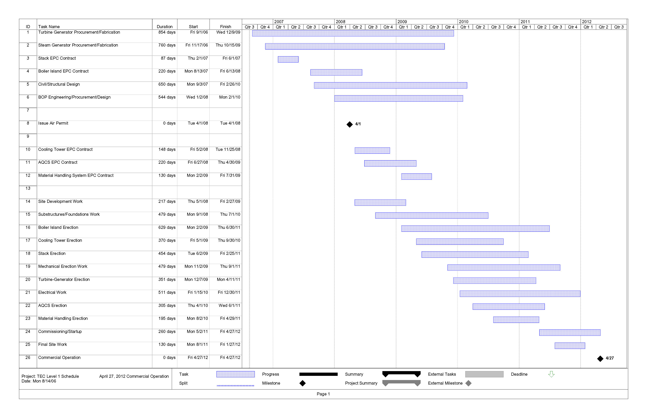

Figure A.3-5
Project Schedule

The GFRR is currently owned and operated by OmniTRAX, Inc., an affiliate of the Broc Companies, Inc., which operates a number of short-line railroads across the United States and Canada. The GFRR is comprised of two segments – the former Georgia Northern Railway (GN) line between Albany and Adel, GA and the former Live Oak, Perry and South Georgia Railroad between Adel, GA and Perry-Foley, FL. The GN was merged into the Georgia Southern and Florida Railroad in late 1993, and became part of the Georgia and Florida Railway shortly thereafter. Up until 1994, the Adel, GA to Perry-Foley, FL line was the Live Oak, Perry and South Georgia Railroad. It was the Georgia & Florida Railroad for a short period (1994-95) then resold to North American Rail Net, Inc. (1995-2005) until North American RailNet was merged into OmniTRAX. The current name is the Georgia & Florida Railway; however, in this Application, it is called by its better known name - the Georgia and Florida Railroad - and acronym “GFRR.”
The east-west CSXT Thomasville-to-Waycross/Savannah, GA mainline crosses the north-south GFRR at grade at the southeast corner of Quitman, GA. Wye connection legs are in place for southbound to west and eastbound train movements. Loaded train movements from Thomasville or Valdosta interchanging to GFRR will require the construction of new southbound wye trackage legs to accommodate direct run-through train operations. Similarly, the east-west CSXT Tallahassee-to-Jacksonville mainline crosses the north-south GFRR line at grade in downtown Greenville without interconnection. An interconnection between the carriers would require the construction of new east-to-southbound and west-to-southbound connector wye legs.

