E.2.0 Description of the City’s Existing System

The City of Tallahassee (City) owns, operates, and maintains an electric generation, transmission, and distribution system that presently supplies electric power and energy to approximately 108,000 customers in a service area consisting of approximately 221 square miles. Incorporated in 1825, the City has operated since 1919 under the same charter and began generating its power requirements in 1902.

E.2.1 Generation System
The City began generating electricity for public use in 1902, with the installation of an 87.5 kilowatt (kW) generating facility, which served approximately 3,000 customers. During the period from 1929 through 1951, the City purchased all of its electric power requirements wholesale from other generating systems. The City began generating its power requirements again on January 1, 1952, with the installation of the first of four generating units at the Sam O. Purdom Generating Station. Currently, the City’s Electric Department operates three generating stations with a total summer net capacity of 746 MW, as described further in Subsection E.2.1.1.

E.2.1.1 Existing Generating Units
The City has two natural gas and oil fueled generating stations that consist of combined cycle, steam, and combustion turbine (CT) electric generating facilities. The Sam O. Purdom Generating Station (Purdom Station) has been in operation since 1952, and the Hopkins Station has been in commercial operation since 1970. The City also has been generating electricity at the C.H. Corn Hydroelectric Station since August 1985.
The Purdom Station is located on 63 acres of land adjacent to the St. Marks River in Wakulla County, 22 miles south of Tallahassee. It was first placed into commercial operation in 1952, and underwent a major renovation in 2000, when two of the plant’s three boilers and steam turbines were retired and a new combined cycle unit was constructed. It currently consists of one steam unit, one combined cycle unit, and two CT units, for a total of four generating units with total net summer and winter capacities of 301 MW and 332 MW, respectively.
The Hopkins Station is located on 230 acres of land, 7 miles west of the City. In 1977, 7 years after its construction, the station was expanded with the addition of a second boiler and power generator. The Hopkins Station currently consists of two steam units and four CT units with total net summer and winter capacities of 434 MW and 454 MW, respectively. Of the net summer capacity, 130 MW is supplied by CTs, which are used primarily to provide peaking capacity.
In 2005, the City installed two CTs at the existing Hopkins Station (HC3 and HC4). The CTs are General Electric (GE) LM6000 SPRINT units, each with a net summer capability of 47 MW and a net winter capability of 49 MW. The units are dual-fueled, capable of operating either on natural gas or No. 2 fuel oil. Emissions of nitrogen oxides (NO_{x}) are controlled through water injection, and high temperature selective catalytic reduction (SCR) is included on each unit to further reduce NO_{x} emissions. Oxidation catalysts were installed to reduce emissions of carbon monoxide (CO) and volatile organic compounds (VOC). HC3 began commercial operation in September 2005, and HC4 began commercial operation in November 2005. Both HC3 and HC4 have quick start capabilities.
In October 2005, the Tallahassee City Commission approved the repowering of the existing Hopkins Unit 2 to a 1x1 7FA combined cycle configuration. The repowering will utilize the existing steam turbine coupled with a GE 7FA CT and a heat recovery steam generator (HRSG). The 7FA CT will be dual-fueled, capable of operation on either natural gas or No. 2 fuel oil. The HRSG will convert the waste heat from the CT to steam for use in the steam turbine. Utilization of the waste heat will improve the efficiency of the combined cycle as compared to the existing steam turbine, with an expected 30 percent reduction in the unit’s net heat rate.
Currently, the City is planning on the repowered 1x1 combined cycle entering commercial operation in May 2008. Preliminary engineering by Sargent & Lundy for the repowered unit estimates a net summer output of approximately 296 MW (including supplemental duct firing) and a net winter output of approximately 333 MW. The City will continue to evaluate further repowering of Hopkins Unit 2 to a 2x1 configuration. The incremental capacity gained from the 1x1 repowering of Hopkins Unit 2 is not included in the total seasonal capacity discussions in this section because of the anticipated summer 2008 in-service date. However, the incremental capacity gained from the repowering is included in the need for capacity determination that is presented in Section E.4.0, beginning in the summer of 2008.
Formerly known as the Jackson Bluff Hydroelectric Station, the C.H. Corn Hydroelectric Station is the third plant operated by the City. The plant is located 20 miles southwest of the City, on the southern tip of Lake Talquin. The facility consists of three generating units and has a total net summer and winter capacity of 11 MW.
Combined, the City’s existing net generating capacity totals 746 MW in the summer and 797 MW in the winter. Table E.2-1 presents a summary of the City’s existing generating units.
Table E.2-1
City of Tallahassee Existing and Committed Generating Facilities (as of December 31, 2005)
Plant | Unit No. |  | Location (County) | Unit Type | Fuel |  | Fuel Transport |  | Commercial In-Service Month/Year | Expected Retirement Month/Year | Gen. Max. Nameplate (kW) | Net Capability
 |  |  |  |  | Primary | Alternate | Primary | Alternate | Commercial In-Service Month/Year | Expected Retirement Month/Year | Gen. Max. Nameplate (kW) | Summer (MW) | Winter (MW)
Existing Generating Facilities
Sam O. Purdom | 7  8  CT-1  CT-2 |  | Wakulla | ST  CC  CT  CT | NG  NG  NG  NG | FO6  FO2  FO2  FO2 | PL  PL  PL  PL | WA  TK  TK  TK | 6/66  7/00  12/63  5/64 | 3/11  12/40  3/11  3/11 | 50,000  247,743  15,000  15,000 | 48  233  10  10 | 50  262  10  10
PLANT TOTAL |  |  |  |  |  |  |  |  |  |  |  | 301 | 332
A.B. Hopkins |  | 1  2  CT-1  CT-2  HC3  HC4 | Leon | ST  ST  CT  CT  CT  CT | NG  NG  NG  NG  NG  NG | FO6  FO6  FO2  FO2  FO2  FO2 | PL  PL  PL  PL  PL  PL | TK  TK  TK  TK  TK  TK | 5/71  10/77  2/70  9/72  9/05  11/05 | 3/16  3/22  3/15  3/17  Unknown Unknown | 75,000  259,000  16,320  27,000  50,000  50,000 | 76  228  12  24  47  47 | 78  238  14  26  49  49
PLANT TOTAL |  |  |  |  |  |  |  |  |  |  |  | 434 | 454
C.H. Corn Hydro Plant |  | 1  2  3 | Leon/ Gadsden | HY  HY  HY | WA  WA  WA | WA  WA  WA | WA  WA  WA | WA  WA  WA | 9/85  8/85  1/86 | Unknown Unknown  Unknown | 4,440  4,440  3,430 | 4  4  3 | 4  4  3
PLANT TOTAL |  |  |  |  |  |  |  |  |  |  |  | 11 | 11
TOTAL SYSTEM CAPACITY AS OF DECEMBER 31, 2005 |  |  |  |  |  |  |  |  |  |  |  | 746 | 797
Unit Type Codes:  ST: Steam Turbine  CC: Combined Cycle  CT: Combustion Turbine  HY: Hydroelectric |  |  |  |  | Fuel Codes:  NG: Natural Gas  WA: Water  FO2: No. 2 Fuel Oil (distillate)  FO6: No. 6 Fuel Oil (residual) |  |  |  |  | Fuel Transportation Codes:  PL: Pipeline  TK: Truck  WA: Water

E.2.1.2 FRCC Operating Reserve Capacity
The City is a member of the Florida Reliability Coordinating Council (FRCC). As a member of the FRCC, the City complies with the FRCC Operating Reserve Policy, which requires that operating reserves be maintained by all FRCC control areas at a value equal to or greater than the loss of generation that would result from the most severe single generation contingency, which is currently 910 MW (according to the FRCC Standards Handbook, FRCC Operating Reserve Policy, revised May 2006). The Operating Reserve Policy further requires that FRCC control areas shall provide spinning reserves equal to or greater than 25 percent of the amount of the FRCC Operating Reserves. FRCC Operating Reserves must be fully available within 15 minutes, and each control area’s operating reserve allocation shall be available to the other FRCC control areas not restricted by any transmission limitations.
The FRCC Operating Reserve requirement is allocated among the FRCC control areas in proportion to each control area’s peak hour net energy load for the year 2000 and the summer gross FRCC capability of its largest unit or ownership share of a joint unit operational in 2000, whichever is greater. Fifty percent is allocated on the basis of peak hour net energy for load (NEL) and 50 percent on the basis of the summer gross FRCC capability of the largest unit.
The allocations stated in the May 2006 FRCC Standards Handbook require the City to maintain 31.6 MW of operating reserves and a minimum of 7.9 MW of spinning reserves.

E.2.1.3 Capacity and Power Sales Contracts
The City has no firm long-term capacity or power sales contracts in place. However, the City conducts short-term and intermediate sale transactions on a routine basis.

E.2.1.4 Capacity and Power Purchase Contracts
In an effort to provide reliable power at the lowest cost, the City has historically entered into both long-term and short-term power purchase agreements with other electric utilities. Currently, the City has a long-term firm capacity and energy purchase agreement with Progress Energy Florida (PEF, formerly Florida Power Corporation) for 11.4 MW. The 11.4 MW purchase from PEF is associated with the City’s former 1.333 percent (11.4 MW) undivided ownership interest in the Crystal River Unit 3 (CR-3) nuclear unit. In September 1999, the City transferred its ownership interest in CR-3 and the decommissioning trust account balance to PEF (Florida Power Corporation at the time). The terms of the transfer include purchasing equivalent electric capacity from PEF through December 3, 2016. In addition to the PEF purchase agreement, the City will continue to evaluate other power purchase opportunities as they may become available.

E.2.1.5 Planned Unit Retirements or Shutdowns
The City continually evaluates whether to retire existing generating units. Table E.2-2 shows the retirement schedule for the existing units within the planning horizon of this Application.

Table E.2-2
City of Tallahassee Anticipated Unit Retirements

Unit Name | Unit Age  (as of 01/01/2006) | Net Summer Capacity (MW) | Net Winter Capacity (MW) | Anticipated Retirement Date
Purdom CT-1 | 42 years | 10 | 10 | March 2011
Purdom CT-2 | 42 years | 10 | 10 | March 2011
Purdom 7 | 39 years | 48 | 50 | March 2011
Hopkins CT-1 | 36 years | 12 | 14 | March 2015
Hopkins 1 | 35 years | 76 | 78 | March 2016
Hopkins CT-2 | 33 years | 24 | 26 | March 2017

E.2.1.6 Total System Resources
The City’s total summer net generating capacity is 746 MW, the majority of which (735 MW, or approximately 98.5 percent) is gas fired, with fuel oil as a backup fuel, at the Purdom and Hopkins Stations. The remaining 11 MW of the City’s generating capacity comes from hydroelectric generation at the C.H. Corn Hydroelectric Station. The City’s power purchase agreement with PEF brings its current total system resources to approximately 757 MW.

E.2.2 Transmission System
The City’s existing transmission system includes approximately 185 circuit miles of transmission lines operating at voltages of 230 kV and 115 kV. The 115 kV transmission network forms a 115 kV loop that extends around and through the City limits. This 115 kV system primarily performs load-servicing functions. Sixteen substations, located at various sites, transform power from the transmission voltage of 115 kV to the distribution network voltage of 12.47 kV. The transmission, distribution, and generation facilities are monitored and controlled remotely from the City’s Electric Control Center via line carrier channels, microwave systems, and communication lines network. The City is interconnected with PEF at five locations on its system and with Georgia Power Company (a subsidiary of the Southern Company) at one location.
A study of the transmission system has identified a number of system improvements and additions that will be required to serve future load in a reliable manner. Figure E.2-1 depicts the City’s proposed transmission system, including the existing system, as well as transmission additions proposed to be in place by 2014.
Over the past decade, the City has experienced expected, but significant, growth and development. This growth has initiated a corresponding increase in the demand for electricity. Of special interest is the fast growing eastern portion of the City and adjacent Leon County, where rapid development has resulted in the need for additional transmission and distribution facilities. Therefore, it is necessary to reinforce this area with proper substation and transmission infrastructure. The City is currently planning and, in some cases, is in the process of constructing several new substations on the east side of its system. These are intended to serve the future load in this rapidly growing area. The new substations (identified on Figure E.2-1 as 14, 15, 17, and 18) will be connected to the City’s 115 kV transmission system. When complete, the area will be served by two reliable loops between Substations 7 and 9 and between Substations 9 and 5. The anticipated in-service dates for these new substations and lines are shown on Figure E.2-1. In addition, the construction of the Eastern Transmission Line (connecting Substation 9 to the proposed Substation 17) is anticipated to be complete by mid-2007.

E.2.3 Service Area
The City currently provides electric service to customers within an area of approximately 221 square miles, which includes the City and certain adjacent unincorporated areas of Leon County. The City’s territorial agreement with Florida Power Corporation (now PEF) expired on December 23, 1998. A new agreement with similar terms has been negotiated; however, it has not been executed pending resolution of other outstanding issues not related to the territorial agreement. Both parties are operating within the terms of the expired agreement. Any new agreement would require approval by the City Commission and, subsequently, the Florida Public Service Commission (FPSC).
The City and Talquin Electric Cooperative, Inc. (Talquin) operate under a 30 year territorial agreement, which was approved by the FPSC in February 1990. Because of the physical location of specific customers, certain City electric customers are connected to the Talquin distribution system, and certain Talquin customers are connected to the City’s system. To avoid unnecessary costs and unnecessary inconvenience to their
respective customers, the City and Talquin have agreed to a reciprocal arrangement in which the City and Talquin purchase and sell capacity from and to each other to serve their respective customers.

E.2.4 Load and Electrical Characteristics
The City has historically experienced peak annual demand in the summer months. The City’s actual total peak demand in the summer of 2005 was 598 MW, after accounting for the demand reductions from DSM programs offered by the City, representing an all-time high peak demand. This compares to an actual peak in the winter of 2005/2006 of 537 MW, after accounting for the demand reductions from DSM programs offered by the City. It should be noted that the City’s forecast winter and summer peak demands show a tendency to converge, although the forecast summer peak demands are higher than the forecast winter peak demands throughout the forecast period. Furthermore, the City’s existing generating system is capable of providing approximately 51 MW more capacity in the winter than in the summer.

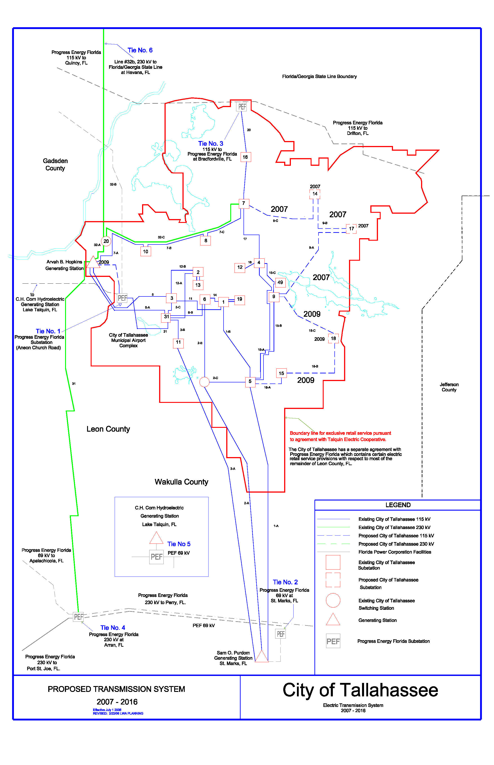
Figure E.2-1
City of Tallahassee’s Transmission System

