E.7.0 The City’s Demand-Side Management
According to Section 403.519 of the Florida Statutes, in its determination of need, the FPSC must take into consideration conservation measures that might mitigate the need for the proposed plant. To address this requirement, the City has tested potential conservation, load management, and demand response (collectively referred to as demand-side management, or DSM) measures for cost-effectiveness utilizing an integrated approach that is based on projections of total achievable capacity and energy reductions and their associated annual costs developed specifically for the City of Tallahassee.
The remainder of this section summarizes the City’s existing DSM programs, presents a discussion of the methodology used to determine the potential cost-effectiveness of new DSM measures, and presents the results of the City’s DSM cost-effectiveness evaluations.

E.7.1 Existing DSM and Conservation Programs
The City is no longer subject to the requirements of the Florida Energy Efficiency and Conservation Act (FEECA) and, therefore, the FPSC does not set numeric conservation goals for the City. Despite this fact, the City expects to continue its commitment to conservation and the DSM programs that prove beneficial to the City’s ratepayers. The City currently offers a variety of conservation and DSM programs to its residential and commercial customers as described below.

E.7.1.1 Residential Secured Energy Efficiency Loans
The City offers loans to its residential customers to improve home energy efficiency. The loans, secured with a property lien, are for a maximum of $7,000 at a 5.0 percent interest rate for 5 years. Loans are issued to install natural gas heating with electric central air conditioners, energy efficient heat pumps and water heaters, natural gas ranges and ovens, natural gas firelogs, ceiling insulation, energy efficient refrigerators, solar water heaters, and other energy conserving appliances. Loans are repaid on the customer’s monthly utility bill and can be repaid at any time within the 5 year period without penalty.

E.7.1.2 Residential Natural Gas Rebates
The City offers rebates to homebuilders and owners of existing homes for the installation of natural gas appliances or the replacement of electric appliances with natural gas appliances. This program benefits the City by directly reducing winter peak demands through fuel switching and benefits the gas utility by increasing the system’s load factor.
Rebates are offered to homebuilders (the person or company that applies for the construction permit) for installing natural gas appliances instead of electric appliances. Rebates ranging from $50 to $800 per appliance are available to eligible builders of new single-family homes or multi-family apartments. Qualifying owners of existing homes are eligible for rebates ranging from $50 to $450 per appliance. Bonus rebates for the installation of multiple gas appliances are available to both new homebuilders and, in certain cases, the contractor installing appliances in existing homes.
Installation of, or conversion to, the following natural gas appliances are included in the rebate program:
- Natural gas furnaces.
- Natural gas water heaters.
- Natural gas ranges and ovens.
- Natural gas firelogs.
- Natural gas clothes dryers.
- Natural gas barbeque grills.
- Natural gas pool and spa heaters.
- Natural gas outdoor lights.
- Hydronic (combination appliance) water/space heaters.
- Natural gas backup generators.
Only those customers who presently have or will install at least a new gas water heater, furnace, or hydronic system are eligible for rebates on the remaining appliances.

E.7.1.3 Residential Low-Income Ceiling Insulation Grants
The City offers grants of up to $500 for the addition of ceiling insulation, where the existing level of insulation is less than R-24. The grants are available to City customers whose income level is at or below 80 percent of Tallahassee’s median income level.

E.7.1.4 Residential Low-Income Energy Retrofit Grants
The City offers grants of up to $500 for the repair of heating, ventilation, and air conditioning (HVAC) systems. The grants are available to City customers whose income level is at or below 80 percent of Tallahassee’s median income level.

E.7.1.5 Residential Information and Audits
This program includes a variety of activities that are intended to improve general knowledge of energy use in the community and, therefore, improve overall energy efficiency. The residential information programs described below benefit the City’s customers by increasing their knowledge of energy use, which will make them better able to lower their utility bills. The programs benefit the utility by reducing demand and energy requirements through improved efficiency and better customer energy usage patterns.
E.7.1.5.1 Energy Information. The City offers presentations to community groups, schools, and individuals. The City provides flyers, folders, brochures, workshops, booklets, bill stuffers, presentations, seminars, and videos. The intent is to educate the public about residential energy efficiency, energy use and conservation, rates, costs, weather, and proper operation of control devices.
E.7.1.5.2 Energy Audits and High Bill Investigations. Class B energy audits are free to the City’s customers and are intended to point out areas of improvement in energy efficiency. When performing an audit, auditors also take the opportunity to distribute literature on efficiency and to recommend other City incentive programs to help increase energy efficiency.
E.7.1.5.3 HVAC Tune-Up Training. The City provides training in “precision HVAC tune-up” to local HVAC service vendors. This is intended to promote improved service procedures for maintaining HVAC efficiency and to introduce local HVAC service providers to improved methods for dealing with ducted air delivery systems and building pressurization effects.
E.7.1.5.4 Energy-Efficient Construction Information. The City promotes the use of the Building Energy Efficiency Rating System (BEERS), which applies to energy efficiency in new construction.

E.7.1.6 Commercial Low Interest Energy Efficiency Loan
Loans are offered to increase the affordability to customers of installing higher efficiency equipment, especially HVAC systems. The loans, secured with a property lien, are for a maximum of $10,000 at a 5.0 percent interest rate for 5 years. Loans are repaid on the customers’ monthly utility bill and can be repaid at any time within the 5 year period without penalty.

E.7.1.7 Commercial Customer Loan
This program offers loans for various energy efficiency measures to commercial customers who have had a recent energy audit. The customer benefits through lowered utility bills in the long run, and the utility benefits from reduced summer and winter peaks achieved through improved equipment efficiency and building envelope integrity. The loans, secured with a property lien, are usually issued at a 5.0 percent interest rate for a 5 year term, up to a maximum of $25,000. Loans in excess of $25,000 may be granted, pending approval by the appropriate City authority. Loans are repaid through the customer’s utility bill, and the interest rate is subject to change. The measures offered through this program are expected to include, but are not limited to, the following:
- Lighting Changeouts--Loans are offered for the replacement of lighting to improve efficiency and to improve color rendering. The majority of program participation is expected to be associated with this measure.
- Fuel Switching--Loans are offered to customers who wish to convert their heating or cooling system to natural gas.
- Building Envelope--Loans are offered to customers who wish to add window treatments, ceiling insulation, and other building envelope efficiency measures.

E.7.1.8 Commercial Demonstrations
This program selects specific high-profile projects that can be used to demonstrate the benefits of energy conservation, advanced technology, or customer-control of energy use. Currently, there is one major demonstration project underway:
- City Facilities--Improvements are being made to City facilities to demonstrate the impact of improved lighting, energy management systems, variable speed motor drives, and building envelope measures including window treatments.
It is intended that demonstration projects in public buildings will increase general public awareness of the opportunities that exist for energy conservation and cost reduction. Additionally, these program measures will benefit the City by reducing energy consumption in City-owned facilities and by reducing peak loads on the electric system.

E.7.1.9 Commercial Information and Audits
The commercial information programs described below will benefit customers by increasing their knowledge of energy use, which will make them better able to lower their utility bills. The programs benefit the utility by reducing demand and energy
requirements through improved efficiency and customer usage patterns. The City aims to improve commercial customer awareness and knowledge about energy use through the following:
- Energy Audits and High Bill Investigation--Audits of customer premises will be provided as required under the FPSC rules. During the audit, auditors will attempt to point out areas in which energy efficiency can be improved and inform customers about available incentives. Customers concerned about high or irregular bills are offered services to assist in correcting the problem.
- Key Accounts Technical Workshops and Seminars--Training will be offered to educate “key account” customers about energy efficiency, building operations, and other energy-related issues.
- Vendor Training--Energy efficiency training will be offered to local vendors.

E.7.2 The City’s DSM Analysis
As discussed previously, the City’s analysis of potentially cost-effective DSM was based on projections of total achievable capacity and energy reductions and their associated annual costs developed specifically for the City. Candidate DSM measures were initially screened using a cost-effectiveness test that was based on the busbar cost of each measure (adjusted for line losses) compared to comparable (appropriate) supply-side resources, where the costs of the supply-side resources and DSM measures were computed on a levelized basis over the DSM measure life. Levelized costs for the DSM measures were lower than or the same as the relevant supply-side options for almost all of the DSM measures screened.
The measures were then combined into bundles of measures affecting similar end uses and/or having similar costs per kWh saved. Projected capacity and energy savings, and implementation costs, were developed for each bundle. Chronological hourly load shapes were then developed for each bundle and combined into an overall DSM composite bundle (portfolio) load shape, which was applied as a load shape adjustment to the base demand and energy forecast. Tables E.7-1a and E.7-1b show the mapping of DSM measures into individual residential and commercial DSM measure bundles, respectively.
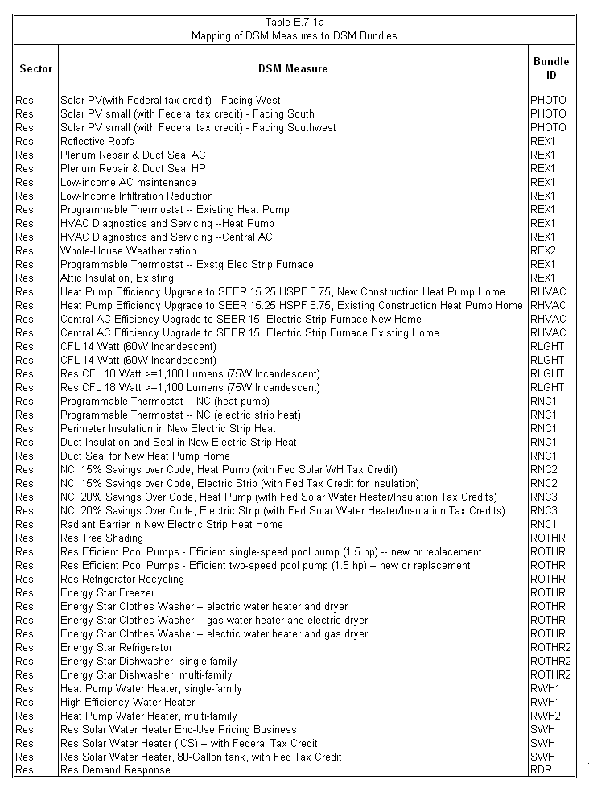
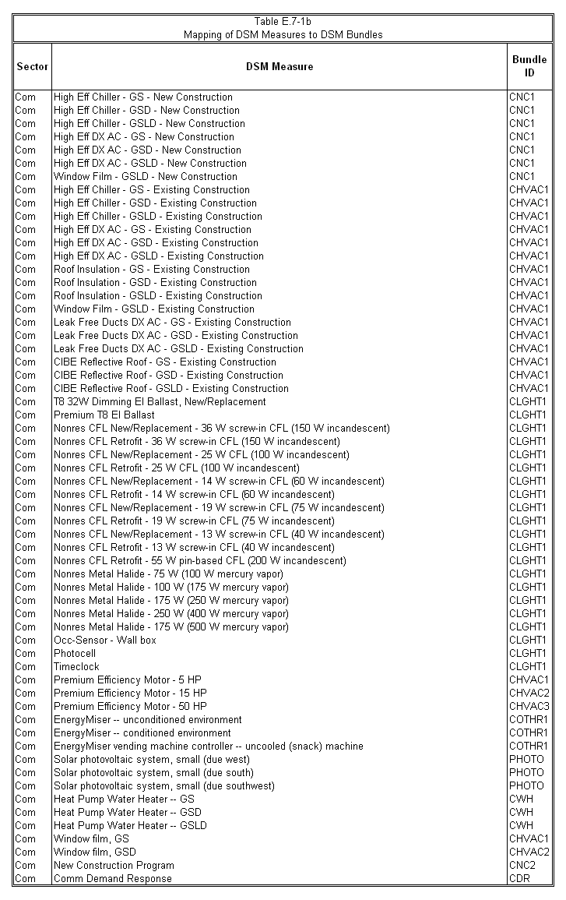
In developing the measure bundles, care was taken to ensure that inclusion of alternative measures addressing the same end use did not result in an overstatement of potential savings. Where measures “competed” for the same end use (e.g., heat pump water heaters and high-efficiency water heaters), either one measure was selected or the market share of each competing measure was estimated so that the total market shares of all measures addressing the same end use totaled 100 percent. Likewise, care was taken to ensure that the composite DSM portfolio did not include measure bundles that competed with each other for the same end uses without creating market shares for each.
The composite portfolio of DSM measures was then analyzed as a reduction to the City’s hourly loads (including seasonal peak demands and energy requirements). The resulting system load shape was evaluated using production cost modeling that was consistent with the methodology described in Section E.5.0. Production cost modeling was performed for the reduced annual load projection scenarios resulting from DSM savings for two different cases: (1) a case in which the City participates in TEC in 2012; and (2) a case in which the City does not participate in TEC. The remainder of this section provides more specific information related to the projected annual peak demand and energy savings associated with the portfolio of DSM measures, the corresponding annual costs to achieve these projected energy savings, and the resulting system economics considering the energy savings and costs for the DSM portfolio.

E.7.2.1 Description of the DSM Portfolio
The non-duplicative DSM measure bundles that comprise the DSM portfolio are described below, aggregated primarily by affected end use.
E.7.2.1.1 Commercial Space Conditioning. This measure bundle included individual measure bundles CHVAC1, CHVAC2, and CHVAC3 from Table E.7-1b. Among the specific measures addressed in the bundle were those affecting heating and cooling usage, such as high-efficiency air conditioning equipment, duct and roof insulation, reflective roofing, and motors used for ventilation. These measures are applied to the renovation and retrofit markets.
E.7.2.1.2 Commercial Lighting. This measure bundle included individual measure bundle CLGHT1 from Table E.7-1b. Among the specific measures addressed in the bundle were various high-efficiency fluorescent bulbs, efficient ballasts, metal halide lights, occupancy sensors, and photocells and time clocks for outdoor lighting. The most common lighting fixture uses the 4-foot fluorescent tubes. There are numerous possible combinations of ballasts, reflectors, and bulbs applicable to the commercial sector. Rather than enumerating all of the various combinations (and estimating current market share for each), measures that represented the typical current practice and a high efficiency alternative were selected. The baseline (current practice for lighting in new and renovation projects) incorporates substantial energy efficiency relative to practice even 5 years ago.
E.7.2.1.3 Commercial New Construction. This measure bundle included individual measure bundle CNC2 from Table E.7-1b. Among the measures addressed in the bundle were a wide range of HVAC, lighting and other measures that are applicable to improving the efficiency of new construction. Savings and cost estimates were estimated at a high level, based on the success of comprehensive new construction programs in California and New England. The comprehensive approach resulted in greater savings at lower costs of energy saved than the individual new construction measures.
E.7.2.1.4 Commercial Water Heating and Vending Machine Controls. This measure bundle included individual measure bundle COTHR1 and CWH from Table E.7-1b. Among the measures addressed in the bundle were both water heating measures such as heat pump water heaters and devices that cut power usage by vending machines when they are not being used.
E.7.2.1.5 Residential Space Conditioning. This measure bundle included individual measure bundles REX1 and RHVAC from Table E.7-1a. Among the specific measures addressed in the bundle were those affecting heating and cooling usage, such as high-efficiency heating and air conditioning equipment and servicing, duct and attic insulation, reflective roofing, and programmable thermostats.
E.7.2.1.6 Residential New Construction. Three different strategies for residential new construction were evaluated. The first (RNC1), consists of a programmable thermostat and some shell upgrades. The second (RNC2), included shell, duct and equipment upgrades to reduces use by 15 percent relative to current code requirements. The third (RNC3), is a 20 percent improvement relative to current code requirements. Among the specific measures addressed in the bundle were those affecting heating, cooling and water heating usage, such as a variety of insulation applications, programmable thermostats and solar water heaters. This third new construction program was incorporated into the final composite bundle.
E.7.2.1.7 Residential Appliances and Pool Pumps. This measure bundle included individual measure bundles ROTHR and ROTHR2 from Table E.7-1a. Among the specific measures addressed in the bundle were high-efficiency home appliances and pool pumps, as well as refrigerator recycling and tree shading.
E.7.2.1.8 Residential Water Heating. This measure bundle included individual measure bundles RWH1, RWH2 and SWH from Table E.7-1a. Among the specific measures addressed in the bundle were high-efficiency water heaters, heat pump water heaters and solar water heaters.
E.7.2.1.9 Residential and Commercial Photovoltaics. This measure bundle included individual measure bundle PHOTO from Tables E.7-1a and E.7-1b. Among the specific measures addressed in the bundle were PV systems at various solar orientations, for both residential and commercial buildings.
E.7.2.1.10 Residential and Commercial Demand Response. This measure bundle included individual measure bundles CDR and RDR from Tables E.7-1a and E.7-1b. In light of the rapid technological advancements in the area of demand response, individual technologies were not modeled. Instead, the experience of other utilities with successful demand response programs were used to generate high-level estimates of total demand-response impacts achievable for the residential and commercial sectors. It was assumed that the same level of impact could be obtained in winter as in summer.

E.7.2.2 Projected Annual Peak Demand and Energy Savings
Table E.7-2 presents the projected annual peak demand and energy savings resulting from implementation of the DSM measures being evaluated by the City. The reductions include projected savings associated with energy efficiency (EE) measures as well as demand response/load control (DR) measures. Projections were developed for calendar year 2007 through calendar year 2025 and were held constant thereafter, similar to the evaluation methodology used for the City’s forecast load.
It should be noted that the peak seasonal demand reductions shown in Table E.7-2 take into account the coincidence of the load profiles developed for each bundle. That is, the peak savings for each DSM bundle may not occur at the same hour for all DSM bundles. The impact of considering only coincident peak demand reductions is very minimal and is, in fact, negligible until the summer of 2025 (at which time, there is a 1 MW differential due to noncoincidence) and until the winter of 2024 (at which time, there is a 1 MW differential due to noncoincidence, which increases to 2 MW during the winter of 2025).
The relative contribution of each DSM bundle comprising the composite DSM portfolio is presented in Table E.7-3.

Table E.7-2
Projected Seasonal Coincident Peak Demand and Annual Energy Savings

Year | EE DSM Bundles |  |  | DR DSM Bundles |  | Total (EE and DR DSM Bundles)
Year | Summer Coincident Peak  Demand Reduction (MW) | Winter Coincident Peak  Demand Reduction (MW) | Annual Energy Reduction (MWh) | Summer Coincident Peak  Demand Reduction (MW) | Winter Coincident Peak  Demand Reduction (MW) | Summer Coincident Peak  Demand Reduction (MW) | Winter Coincident Peak  Demand Reduction (MW) | Annual Energy Reduction (MWh)
2007 | 3 | 2 | 11,200 | 4 | 4 | 7 | 7 | 11,200
2008 | 7 | 6 | 27,999 | 9 | 9 | 15 | 15 | 27,999
2009 | 12 | 11 | 50,398 | 13 | 13 | 25 | 24 | 50,398
2010 | 18 | 17 | 78,397 | 18 | 18 | 37 | 35 | 78,397
2011 | 26 | 24 | 111,996 | 23 | 23 | 49 | 47 | 111,996
2012 | 34 | 31 | 145,594 | 25 | 25 | 59 | 55 | 145,594
2013 | 44 | 39 | 184,793 | 26 | 26 | 70 | 65 | 184,793
2014 | 53 | 47 | 223,991 | 28 | 28 | 81 | 76 | 223,991
2015 | 62 | 56 | 263,190 | 30 | 30 | 92 | 86 | 263,190
2016 | 70 | 63 | 296,789 | 32 | 32 | 102 | 94 | 296,789
2017 | 78 | 70 | 330,387 | 32 | 32 | 110 | 102 | 330,387
2018 | 86 | 77 | 363,986 | 32 | 32 | 118 | 109 | 363,986
2019 | 92 | 83 | 391,985 | 33 | 33 | 125 | 116 | 391,985
2020 | 99 | 89 | 419,984 | 33 | 33 | 132 | 122 | 419,984
2021 | 106 | 95 | 447,983 | 34 | 34 | 139 | 128 | 447,983
2022 | 111 | 99 | 470,382 | 34 | 34 | 145 | 133 | 470,382
2023 | 116 | 104 | 492,781 | 34 | 34 | 151 | 138 | 492,781
2024 | 121 | 108 | 515,180 | 35 | 35 | 156 | 143 | 515,180
2025 | 126 | 112 | 537,579 | 35 | 35 | 161 | 147 | 537,579

Table E.7-3
Individual Bundle Contributions to DSM Portfolio Reductions⁽¹⁾

Bundle | Percent of Summer Peak Demand Reduction (2025) | Percent of Winter Peak Demand Reduction (2025) | Percent of Annual Energy Reduction (2025)
Commercial Space Conditioning (CHVAC1, CHVAC2, CHVAC3) | 22% | 20% | 24%
Residential and Commercial Demand Response (RDR, CDR) | 22% | 24% | 0%
Residential Space Conditioning (REX1, RHVAC) | 20% | 18% | 22%
Commercial Lighting (CLGHT1) | 14% | 13% | 16%
Commercial New Construction (CNC2) | 7% | 7% | 8%
Residential New Construction (RNC3) | 6% | 6% | 7%
Residential Appliances and Pool Pumps (ROTHR, ROTHR2) | 3% | 3% | 7%
Residential Water Heating (RWH1, RWH2, SWH) | 2% | 3% | 4%
Residential Lighting (RLGHT) | 2% | 4% | 7%
Commercial Water Heating & Vending Machine Controls (CWH, COTHR1) | 2% | 3% | 4%
Residential and Commercial Photovoltaics (PHOTO) | 1% | <1% | 1%
^{(1).} Percentages may not total 100 due to rounding.

E.7.2.3 Projected Annual Costs for DSM Measures
Table E.7-4 presents the projected annual costs associated with the DSM savings shown in Table E.7-2. The projected annual costs are the costs for which the City would be responsible for in order to allow the participating customers to realize a 2 year payback on any necessary investments associated with the DSM measures. The annual costs are presented in nominal dollars through 2025, and beyond 2025 are assumed to escalate at the assumed 2.5 percent general inflation rate presented in Section A.4.0.

Table E.7-4
Projected Annual Costs Associated with DSM Savings

Year | Annual Costs  (Nominal $000s)
2007 | $4,523
2008 | $6,680
2009 | $8,968
2010 | $11,367
2011 | $13,913
2012 | $13,696
2013 | $16,242
2014 | $16,806
2015 | $17,622
2016 | $16,157
2017 | $16,725
2018 | $17,620
2019 | $16,411
2020 | $17,221
2021 | $18,372
2022 | $17,620
2023 | $19,258
2024 | $20,471
2025 | $22,212

E.7.2.4 System Economics Considering Projected DSM Savings and Costs
The cumulative present worth cost (CPWC) results of the production cost models for the City’s base case analysis and the scenario in which load projections were reduced to account for DSM savings were compared to one another. Such an analysis can be used to determine whether implementation of DSM measures beyond what the City currently offers may be more beneficial than participating in TEC, or whether a combination of the implementation of the DSM measures along with participation in TEC will offer the City an economic advantage.
The methodology utilized in developing the CPWC results for the DSM portfolio was similar to the approach outlined in Section A.8.0 and Section E.5.0. However, the demand and energy savings projected to be realized through implementation of the DSM portfolio (presented in Table E.7-3) were considered when developing the optimum capacity expansion plan and performing the production cost modeling to calculate the CPWC. A chronological load shape was developed for each year corresponding to the reductions projected for the DSM portfolio. Accounting for the peak demand and energy savings projected to be realized through implementation of the DSM portfolio resulted in lower annual system costs and reduced need for additional capacity. The projected annual costs shown in Table E.7-4 were accounted for, allowing for a comparison of CPWCs between the City’s base case least-cost capacity expansion plan and the capacity expansion plan, reflecting energy savings associated with the DSM portfolio under consideration.
As presented in Section E.5.0, the CPWC for the City’s least-cost capacity expansion plan that includes participation in the TEC beginning May 1, 2012, is approximately $4,320.0 million. The CPWC for the City’s least-cost capacity expansion plan including TEC and reflecting the energy reductions and corresponding costs associated with the DSM portfolio is $4,100.1 million. A comparison of the CPWCs indicates that participation in TEC in conjunction with the DSM portfolio under analysis would result in savings of $219.9 million as compared to participation in TEC without DSM.
Also presented in Section E.5.0 is the base case least-cost capacity expansion plan that does not include participation in TEC, which has a CPWC of $4,472.6 million. The CPWC for the City’s least-cost capacity expansion plan not including TEC, but reflecting the energy reductions and corresponding costs associated with the DSM portfolio, is $4,307.4 million. A comparison of the CPWCs indicates that the City’s least-cost capacity expansion plan not including TEC, but including the DSM portfolio under analysis, results in savings of $165.2 million, compared to the least-cost capacity expansion plan without TEC and DSM.
Based on the results of the City’s DSM analysis, it can be concluded that incorporation of the DSM portfolio under consideration would result in CPWC savings for the least-cost capacity expansion plan involving TEC in 2012 of $207.3 million, compared to the case in which the City does not participate in TEC.
Based on the analysis conducted, the peak demand savings projected for the DSM portfolio would defer the City’s initial capacity requirement from 2011 to 2016. Despite the potential deferral of the need for capacity, the results of the DSM analysis indicate that the City’s participation in TEC in 2012 would nevertheless provide significant additional CPWC savings because of the low cost, baseload coal fired generation that TEC would provide to diversify the City’s existing all natural gas fired generation portfolio. This is illustrated by comparing the CPWC savings of $207.3 million after inclusion of the DSM portfolio to the CPWC differential of approximately $152.6 million without the DSM impacts presented in Section E.5.0. As discussed in Section E.5.0, the City’s least-cost, base case capacity expansion plan not involving participation in TEC includes an LMS100 simple cycle CT in 2011, followed by a CFB in 2016. The City’s least-cost capacity expansion plan that does not involve participation in TEC and incorporates the DSM portfolio includes only a CFB in 2016. The relative increase in CPWC savings from the base case to the cases including the DSM portfolio can be primarily attributed to the relative size of the City’s ownership share of TEC, which provides for a more optimum utilization of baseload capacity when incorporating the demand and energy reductions associated with the DSM portfolio compared to sole ownership of a larger CFB option.

