BEFORE THE FLORIDA PUBLIC SERVICE COMMISSION
DIRECT TESTIMONY OF MATTHEW PRESTON
ON BEHALF OF
FLORIDA MUNICIPAL POWER AGENCY
JEA
REEDY CREEK IMPROVEMENT DISTRICT
AND
CITY OF TALLAHASSEE
DOCKET NO. ________
SEPTEMBER 19, 2006

Q. Please state your name and business address.
A. My name is Matthew Preston. My business address is 222 Severn Avenue, Annapolis, Maryland 21403.

Q. By whom are you employed and in what capacity?
A. I am employed by Hill & Associates, Inc., where I am a partner.

Q. Please describe Hill & Associates.
A. Hill & Associates is a consulting firm that provides expertise to clients who require analyses related to coal demand, supply, pricing, and emissions in domestic and international markets. We perform numerous proprietary studies for individual clients evaluating specific mines, products, power plants, or ports. In addition, we also publish multi-client market reports on the US steam coal market and the international coking and steam coal markets.

Hill & Associates also provides services in the deregulated electric market. Our group focuses in the following areas: market outlook studies forecasting generation by plant, transmission flows, and power prices; evaluation of investment opportunities in new or existing power plants; market dominance analysis; and the evaluation of the impacts of planned and potential new environmental regulations.

Hill & Associates provides services for senior management in the coal industry such as evaluation of mining company organization, market strategy, and management systems.

Hill & Associates provides due diligence economic evaluations of coal and utility assets to determine economic worth and profit potential for clients.

Hill & Associates provides assistance to clients in management of all aspects of the fuels procurement cycle.

Finally, Hill & Associates provides expert witness support for our clients involved in litigation such as dispute trials; arbitrators in coal price, quality, or volume disputes; and supporting experts in utility rate cases.

Q. Please describe your educational background and experience.
A. I have close to 30 years of experience in coal mining and in utility fuel procurement. As a mining engineer, I worked as Assistant Mine Foreman at one of the large longwall mines of Consolidation Coal Company. I then joined General Public Utilities (GPU) in Fuel Procurement and undertook a wide variety of analytical and administrative assignments ranging from coal supplier assessments to corporate strategy development. At Hill & Associates, I lead the company in the area of risk management, probability assessment, long- and short-term energy price forecasting, and am a primary participant in the development of the PRISM™ model. I have a Bachelor’s of Science degree in Mining Engineering from the University of Arizona, and I am a Registered Professional Engineer in Pennsylvania. My résumé is attached as Exhibit __ [MP-1].

Q. What is the purpose of your testimony in this proceeding?
A. The purpose of my testimony is to present the commodity fuel price and allowance price projections prepared by Hill & Associates under my supervision for the Taylor Energy Center Need for Power Application. I will also focus my testimony on the areas related to coal demand, supply, and price outlooks through calendar year 2030. I will address applicable sources of coal that could be used for power production in the Florida region including: Central Appalachia (CAPP), Northern Appalachia (NAPP), Illinois Basin (ILB), Powder River Basin (PRB), and Latin America. I will also discuss Hill & Associates’ forecast projections for petroleum coke (petcoke) prices as well as emission allowance price projections for sulfur dioxide (SO₂), nitrogen oxides (NO_{x}), mercury (Hg), and carbon dioxide (CO₂). Throughout my testimony the term “allowances” refers to the offset of 2,000 pounds and the term “allowance prices” refers to the price to offset 2,000 pounds of emissions for SO₂, NO_{x}, and CO₂. For Hg, these terms refer to the offset of 1 pound of emissions.

In addition to base case forecasts for coal and petcoke prices, Hill & Associates developed fuel and emission allowance price projections for both high and low price sensitivity scenarios as well as a specific forecast that includes the projected impact on fuel and emission allowance price projections of CO₂ emission allowance costs, should such costs result from potential future regulation of CO₂ emissions.

Q. Are you sponsoring any exhibits to your testimony?
A. Yes. Exhibit __ [MP-1] is a copy of my résumé. Exhibit __ [MP-2] is Hill & Associates’ base case fuel and corresponding emission allowance price forecasts. Exhibit __ [MP-3] is Hill & Associates’ high fuel and corresponding emission allowance price sensitivity scenario forecasts. Exhibit __ [MP-4] is Hill & Associates’ low fuel and corresponding emission allowance price sensitivity scenario forecasts. Exhibit __ [MP-5] is Hill & Associates’ fuel and corresponding emission allowance price sensitivity scenario forecasts corresponding to the regulated-CO₂ fuel price analysis. This last exhibit is offered for information purposes only since the regulation of CO₂ emissions, while being discussed, is not presently in place at the state or federal level.

Q. Are you sponsoring any sections of the Taylor Energy Center Need for Power Application, Exhibit __ [TEC-1]?
A. Yes. I am sponsoring Sections A.4.6 (excluding Sections A.4.6.3, A.4.6.4, A.4.6.5.3, A.4.6.5.4, A.4.6.6, A.4.6.7, and A.4.6.8) and A.5.5.

Q. How did Hill & Associates become involved in the Taylor Energy Center Need for Power Application?
A. JEA, Florida Municipal Power Agency (FMPA), Reedy Creek Improvement District (RCID), and the City of Tallahassee (the City) (collectively referred to as the Participants) retained Hill & Associates to develop a reasonable forecast of commodity prices for various fuels (coal, petcoke, natural gas, and distillate and residual fuel oils) and transportation costs for coal and petcoke. Hill & Associates also developed a forecast of emission allowance prices for SO₂, NO_{x}, Hg, and CO₂.

Q. How did Hill & Associates develop the commodity fuel and emission allowance price forecasts?
A. Hill & Associates developed the coal, petcoke, and emission allowance price forecasts using our proprietary PRISMTM model. Hill & Associates subcontracted with Pace Global for natural gas and fuel oil forecasts.

Q. Please describe the PRISMTM model.
A. The PRISMTM model is a proprietary model developed by Hill & Associates for the purpose of forecasting coal, emission allowance, and electricity prices. PRISMTM is a linear programming model that integrates aspects of all fossil fuel markets as they relate to electricity demand. Additionally, the model allows incorporation of natural gas and fuel oil price projections provided by Pace Global in the study, which are discussed in the direct testimony of Dr. Theodore Breton. Projections of electricity demand growth were based on the Energy Information Administration’s (EIA’s) Annual Energy Outlook 2005 and were applied to the EIA Form 714 electricity demand.

Overall, the PRISMTM model captures the relationship between coal, natural gas, fuel oil, and electricity markets while maintaining compliance with local and national air quality standards. The model’s objective is to satisfy US electricity demand at the lowest possible cost while complying with emissions regulations.

Q. What is Hill & Associates’ assumption regarding the Clean Air Interstate Rule (CAIR) and the Clean Air Mercury Rule (CAMR)?
A. The Clean Air Interstate Rule (CAIR) and Clean Air Mercury Rule (CAMR) are considered in the baseline of the PRISMTM model. The PRISMTM model assumes that CAIR and CAMR will be implemented as promulgated in 2005. The PRISMTM model simultaneously considers the potential impact that compliance scenarios such as fuel switching, running one plant instead of another, or the installation of emissions cleanup equipment may have on fossil fuel supply, demand, and price.

Q. Describe the approach you took in developing the fuel forecasts.
A. The initial steps in developing the coal and emission allowance price forecasts were to input to the PRISMTM model specific coal supply curves, CAIR and CAMR environmental regulations, natural gas and fuel oil price forecasts, and electricity demand growth rates. Hill & Associates develops coal supply curves based on our ongoing detailed review of mining operations in all of the major basins. The modeling process includes mine cost, capacity, and reserve estimates for operating coal mines in the contiguous 48 states and Colombia and Venezuela. Mine cost and reserve estimates were also included for undeveloped reserves. Projections were provided for a relatively broad selection of coal qualities from the major producing basins as well as for various qualities of petcoke, allowing for a comprehensive basis from which to interpolate projected prices for any coals from those basins not directly represented.

PRISMTM simultaneously selects the optimum fuel choice for each power plant in order to satisfy electricity demand. The demand created by these choices is applied to the coal supply curves to determine commodity prices for each of the various types of coals modeled.

As previously stated, Hill & Associates assumes that CAIR and CAMR will be implemented as promulgated in 2005. Known local attainment issues and State Implementation Plans (SIPs) have been addressed. In addition, Hill & Associates believes that CAIR and CAMR will provide the regulatory basis that will drive fossil fuel decisions through the forecast period.

The natural gas and fuel oil price projections were provided by Pace Global. Electricity demand growth rates were input into the model based on the EIA’s Annual Energy Outlook 2005 data applied to baseline electricity demand taken from EIA Form 714.

The PRISMTM model combines all of the fuel price data and matches that with the electricity demand component to provide an integrated solution that takes into account the interrelationship of costs across all fuel types.

Q. Describe the varying characteristics of each source of coal that were factored into Hill & Associates’ analysis and price forecasts.
A. Each region analyzed has unique characteristics in coal quality (sulfur content and heating content), and the logistics of extracting and transporting the coal. A summary of each region’s characteristics that were factored into my analysis is provided below:
- CAPP:
- High quality coal used in steam and metallurgical markets.
- Large number of mines with relatively low production capacity.
- Increasing difficulties, such as labor shortages, permitting, bonding and trucking laws, and the increasing expense to develop new mines are creating emerging barriers to new mine development.
- Near-term demand will remain constant. Long-term demand will decrease as utilities transition to lower cost alternatives, including higher sulfur coal, as more existing plants install scrubber technology.
- Overall production to meet demand is expected to drop approximately 50 percent in the next 20 years as low cost reserves are depleted.
- NAPP:
- The bulk of production comes from a relatively low number of large underground mines in the Pittsburgh Seam.
- The balance of production comes from smaller surface and underground mines with production of less than 1 million tons per year.
- Pittsburgh Seam coal is highly valued by utilities, as it is characterized by high heat content, low sulfur content compared to ILB, and good combustibility and handling characteristics.
- Overall NAPP production will increase until 2016 when production is expected to decline as reserves in the Pittsburgh Seam begin to become depleted.
- ILB:
- Production has declined from 158 million tons per year in 1988 to a low of 88 million tons per year in the mid-1990s, primarily due to the passage of the 1990 Clean Air Amendments, which resulted in utilities switching to low sulfur alternatives.
- Typical surface operations are less than 1 million tons per year, while 65 percent of all production comes from underground mining. Production from underground mines averages more than 1 million tons per year per mine.
- Continuing installation of scrubbers will result in increased demand for ILB coal.
- Reserves are estimated to be 5 to 10 times as much as NAPP reserves.
- PRB:
- All production is from surface mining operations with coal classified as low sulfur.
- Total production in 2005 was 434 million tons which represents a 3 percent increase from 2004.
- Demand is expected to reach 700 million tons per year by 2023.
- Latin America:
- Colombia and Venezuela were the largest sources of imported coal to the United States in 2005, providing a total of 21.9 million tons.
- Coals from Latin America are comparable in quality to eastern US coal.
- Coals imported from Latin America are often economically competitive with domestic US coals.

Q. What was the method used to forecast petcoke prices in your analysis?
A. Petcoke is a byproduct of the oil refining process, and as such it has no meaningful “cost of production” by which to gauge future prices. Petcoke typically is priced at a discount to the coal market. Hill & Associates provided a commodity price forecast based on the average of historical petcoke prices.

Q. Have coal prices increased above historical levels?
A. Yes.

Q. What caused this increase in coal prices?
A. During 2003 and 2004, numerous events occurred that resulted in increased coal prices in the eastern United States. Overall demand for coal in the United States increased due to a strengthening US economy which resulted in increased electricity demand and increased domestic steel production. At the same time, the recent trend of steadily decreasing coal exports was reversed in response to the increased demand for all commodities to feed the growing economies of India and China, including metallurgical coal from the United States. The expanding economies of India and China also led to a worldwide shortage in shipping vessels, resulting in extremely high ocean freight rates. The increased ocean freight rates led European buyers to turn from Asia to the United States for swing supply, resulting in increased demand for coal in the Atlantic Basin (further contributing to the reversal of the declining thermal coal export trend).

During this same time period, excess domestic coal production capacity fell to an all time low in the major coal producing regions. The problem was especially acute in the CAPP region due to the bankruptcies of several major mines and declining average productivity due to shifts in mining methods. Production costs increased due to increased costs for oil, natural gas, and steel (which led to higher mine operating costs). An aging workforce coupled with an acute shortage of trained workers to meet growing demand resulted in increased labor costs as producers were forced to raise wages to attract and/or retain workers.

Delivery capacity for coal in the United States was adversely affected by a shift in management focus of the major rail carriers that resulted in a shortage of locomotives, cars, experienced train operators, and dispatchers, all while coal demand was increasing. Rail carriers responded to this increased demand for coal shipments by significantly raising rates, which further disrupted normal shipping patterns. Additionally, transportation was further complicated due to the shortage of barge capacity that resulted from the decades long decline in coal prices and barge shipping rates.

Q. How have these events affected Hill & Associates’ coal price forecast?
A. As reflected in the base case forecast shown in Exhibit __ [MP-2], Hill & Associates viewed these recent events as short lived and, therefore, projects the current sellers’ market for coal will once again revert to a buyers’ market for a variety of reasons, including the belief that the US economy will slow its growth, partly due to higher energy costs. Worldwide supply of raw materials will begin to catch up with the demands of the Indian and Chinese economies, leading to stable or declining incremental shifts of US thermal coals to metallurgical coals. Additionally, investments in shipping will reduce ocean freight rates, and the decreased rates will reopen Asian coal sources to Europe, leading to a decrease in demand for US coals. Domestically, investment in railroad and river transportation infrastructure, as well as modified management practices, will ease the currently constrained coal transportation system and the recent sharp increase in rail and barge transportation costs will ease as well.

Q. Are you familiar with the capabilities of the proposed Taylor Energy Center to burn a wide variety of fuels?
A. Yes. The testimony of Paul Hoonaert on behalf of Sargent & Lundy indicates that the plant design will allow Taylor Energy Center to burn a wide variety of fuels.

Q. Are you familiar with the proposed source of fuel for the Taylor Energy Center?
A. Yes. I understand that the project team evaluated numerous coal sources and selected a blend of Latin American coal and petcoke as the proposed fuel source.

Q. Please comment on the reliability of the supply of Latin American coal.
A. Latin American coal producers have an excellent record of reliability in providing coal for customers in both the United States and around the world.

Q. Are there also domestic coal supplies reliably available to the proposed Taylor Energy Center?
A. Yes. All of the basins studied by Hill & Associates have the ability to reliably supply coal to the proposed Taylor Energy Center.

Q. One of the coal supply regions evaluated in the Need for Power Application was the Powder River Basin. Are you aware of the recent delivery problems associated with Powder River Basin coal?
A. Yes. Hill & Associates views these problems as short term and expects infrastructure improvements to match demand prior to operation of the proposed Taylor Energy Center. This is addressed in the testimony of James Heller.

Q. Please discuss the reliability of the supply of petcoke.
A. In excess of 50 million tons of petcoke is produced annually in the United States and the Caribbean, of which only a small fraction is utilized by the US utility industry for producing electricity. Petcoke production is expected to increase with the increased use of lesser quality crude oils and expansion of refining capacity. Thus, a reliable supply of petcoke should be available for the project.

Q. Did Hill & Associates provide emission allowance price projections?
A. Hill & Associates provided emission allowance price projections for SO₂, NO_{x}, and Hg in the base case forecast and high and low fuel and emissions allowance price scenarios, and also provided SO₂, NO_{x}, Hg, and CO₂ allowance price projections for a sensitivity scenario that reflects the projected impact on fuel prices due to consideration of potential implementation of a national CO₂ allowance cap-and-trade program.

Q. Please describe the process by which emissions allowance price forecasts were developed.
A. Emission allowance prices are forecast using the PRISMTM model. As a linear programming model, PRISMTM includes constraints on SO₂, NO_{x}, Hg, and, in the case of the sensitivity scenario, CO₂. PRISMTM uses a variety of compliance options in meeting these constraints. These options include fuel switching, running one plant in lieu of another, adding emissions control equipment, and buying or selling allowances. Each of the options has an associated cost. PRISMTM simultaneously weighs the economics of the compliance options as it solves for the least cost option to meet electric demand. The model provides the marginal price of emissions consistent with the optimum solution.

Q. Please discuss the assumptions used in developing SO₂ allowance price projections.
A. We anticipate that the reduction in SO₂ emissions associated with CAIR in 2010 will encourage the continued buildout of scrubber technology. Already, scrubber additions for 70 GW of existing generating capacity have been announced for installation by 2010. We assume that this early compliance will result in the banking of allowances prior to 2010. The bank of allowances will be drawn down beginning in 2010 at a rate that provides for a consistent level of power plant emissions. After the bank is exhausted, allowance prices will increase, and additional scrubbing will be required.

Q. Please discuss the assumptions used in developing NO_{x} allowance price projections.
A. NO_{x} emissions will be drastically reduced in the CAIR states beginning in 2010. CAIR will initiate a tremendous buildout of postcombustion NO_{x} controls. However, the price of NO_{x} allowances is expected to escalate relatively smoothly through the implementation of CAIR Phase I in 2010. Hill & Associates projects NO_{x} allowance prices will increase dramatically in 2015 corresponding to CAIR Phase II, when NO_{x} emission limits will be further reduced.

Q. Please discuss the assumptions used in developing Hg allowance price projections.
A. CAMR will set a 38 ton limit on Hg emissions in 2010 (Phase I) followed by a reduced cap of 15 tons in 2018 (Phase II). Phase I is expected to have minimal impact on the utility industry because the co-benefits of equipment installed to achieve emissions reductions associated with CAIR will virtually ensure compliance with CAMR Phase I Hg limits. Hill & Associates projects that no further emissions reductions will be necessary specifically for Hg compliance under Phase I of CAMR. However, we expect some early banking of Hg allowances in preparation for Phase II of CAMR. As a result, Hg allowances will begin to have a value prior the implementation of Phase II of CAMR in 2018.

Q. Please discuss the assumptions used in developing CO₂ allowance price projections.
A. Hill & Associates provided a specific fuel price forecast that included corresponding emission allowance prices for SO₂, NO_{x}, Hg, and CO₂ based on assumptions generally analogous to the proposed McCain/Liebermann Climate Stewardship Act of 2005 (S.342). Currently, there is no national or state legislation that either limits or assigns a cost to CO₂ emissions in the United States or Florida.

More specifically, the following aspects of S.342 were adopted by Hill & Associates to develop the CO₂ scenario fuel and corresponding emission allowance price forecasts:
- Emission levels would be capped at year 2000 levels, with no second phase.
- CO₂ emission allowances would be created.
- CO₂ emission allowances would be fungible both inter- and intra-industries.
- CO₂ emission offsets would be able to be created from domestic and international sources.

In using the PRISMTM model to develop the CO₂ fuel and corresponding emission allowance price sensitivity scenario, a CO₂ emission cap had to be designed specific to the electric generating units (EGUs) notwithstanding the likelihood of an economy-wide national standard as proposed in the Climate Stewardship Act of 2005. Hill & Associates developed such a cap based on CO₂ emissions from EGUs as reported by the US Environmental Protection Agency (EPA) for the year 2000 in the preliminary Summary Emissions Report (Quarter 4: Year-To-Date Values).

The preliminary Summary Emissions Report (Quarter 4: Year-To-Date Values) reported year 2000 EGU CO₂ emissions as 2.45 billion tons. An additional 10 percent was added to this emissions level to create the actual initial CO₂ emission cap for the years 2010 through 2014 used by Hill & Associates in developing the CO₂ fuel and corresponding emission allowance price sensitivity scenario. Beyond 2014 the CO₂ emission cap was increased an additional 0.5 percent per year. These projections were based on the following:
- The potential for relatively low cost CO₂ reductions by power plants (limiting emissions of other “greenhouse gases,” improving station service efficiency, reforestation on company owned property, methane capture at coal mines, etc.).
- The potential for low cost CO₂ emissions offsets from other industries.
- Additional CO₂ emissions offsets/credits assigned to EGUs out of political expediency in an effort to buffer electricity customers from higher electricity costs.

The regulated-CO₂ fuel and corresponding emission allowance price sensitivity scenario also anticipates other changes in fundamentals as compared to the base case forecast in response to a carbon constrained economy, including the following:
- A reduction in electricity demand growth. In the regulated-CO₂ fuel and corresponding emission allowance price sensitivity scenario, electricity demand growth was limited to 1.0 percent in any area of the country that had exceeded 1.0 percent in the base case fuel price forecast.
- An increase in the amount of energy produced by renewables or other non-emitting sources (except nuclear). The renewable standards promulgated by regulation/legislation were used in states where such laws exist (as of year end 2005). States with no current renewable standards were projected to have an average of 12.0 percent of their energy produced by non-emitting sources by 2009 (including current non-emitting sources) with a 0.5 percent growth in renewable energy production every year until a maximum of 20 percent was achieved.
- An increase in the amount of nuclear capacity. The regulated-CO₂ fuel and corresponding emission allowance price sensitivity scenario includes 12 new nuclear units coming online between 2016 and 2020. The base case forecast includes no new nuclear additions throughout the forecast time horizon.

Q. Please describe the impact of considering CO₂ emission allowance price projections on the resulting fuel forecasts developed by Hill & Associates.
A. As shown in Exhibit __ [MP-5], Hill & Associates’ fuel price projections for the scenario in which CO₂ allowance price projections are considered indicate that coal, SO₂, NO_{x}, and Hg allowance prices will trend lower than the base case.

A CO₂ emissions cap will reduce the rate of growth in demand for fossil fuel generation and will influence reversion in the long-term towards a buyers’ market for coal (i.e., lower prices). Lower coal prices in the United States will cause Latin American suppliers to reduce prices to maintain market share.

Petcoke demand for electric generation will remain generally unchanged. Petcoke supply will likely decrease or grow more slowly in response to the transportation sector’s activities to meet the restrictions of the proposed McCain-Lieberman Climate Stewardship Act of 2005. However, as utilities burn only a fraction of the petcoke produced, prices are less likely to be affected.

Q. Please describe the high and low fuel price projections developed by Hill & Associates.
A. Hill & Associates developed high and low commodity price projections for coals, petcoke, natural gas, and fuel oil. These projections are shown in Exhibits __ [MP-3] and __ [MP-4], respectively. In developing both the high and low fuel price forecasts, Hill & Associates chose to vary fundamental parameters that tend to correspond to high or low fuel prices. In doing so, PRISMTM demonstrated the integrated impact on coal and emission allowance prices resulting from these assumptions.

In developing the high fuel price projections, Hill & Associates increased the annual base case (real 2005 $/MBtu) natural gas and fuel oil price projections by 20 percent. Electricity demand growth was increased by 0.2 percent year to year. Additionally, it was assumed that coal producers would encounter increased investment hurdles, thereby discouraging investments in new mine capacity. The end result is a scenario that is generally conducive to high coal prices, and also results in increased emission allowance prices.

In developing the low fuel price projections, Hill & Associates decreased the annual base case (real 2005 $/MBtu) natural gas and fuel oil price projections by 20 percent. Electricity demand growth was reduced by 0.1 percent year to year. Additionally, it was assumed that coal producers would encounter decreased investment hurdles, thereby encouraging investments in new mine capacity. The end result is a scenario that is generally conducive to low coal prices, and also results in decreased emission allowance prices.

Q. Does this conclude your testimony?
A. Yes.

RESUME OF

MATT PRESTON
EDUCATIONAL BACKGROUND
B.S. Mining Engineering, University of Arizona, 1978
PROFESSIONAL EXPERIENCE
Current Position
Matt is currently a Vice President with Hill & Associates.
Matt has worked with a variety of clients including coal companies, utilities, unregulated generating companies, major railroads, government agencies and investment bankers. Some of these tasks include:
- Developing market analyses for domestic and off-shore coal companies.
- Developing fuel procurement strategies for generating stations including probabilistic analysis of potential outcomes.
- Providing expert opinion and subsequent deposition testimony on a coal sales contract dispute.
- Providing forecasts of generator viability.
- Providing due diligence on power plant fuel contracts for potential buyers.
- Developing studies of long term coal basin demand.
Additionally Matt participates heavily or is a principal author of the Company’s annual twenty year forecast of coal and emission prices, supply and demand (“Outlook for U.S. Steam Coal”),the Quarterly Price Forecast and the Central Pennsylvania Coal Supply Study

Prior Experience
Prior to Hill & Associates Matt worked for Pennsylvania Electric Company/General Public Utilities (GPU). Matt performed a variety of administrative and analytical tasks in the Fuel Procurement Department at GPU. Some of these tasks include:
- Coal Price Forecasting and Market Analysis
- Fuel Procurement Strategic Planning
- Fuel Procurement and Contract Administration
- Environmental Emission Credit Strategic Planning
- Environmental Emission Credit Procurement
- Preparation of Testimony for Rate Cases before the Pennsylvania Public Utility Commission
- Preparation of responses to Fuel Related Interrogatories from the Pennsylvania Public Utility Commission, the Pennsylvania Consumer Advocate, The New York Public Service Commission and the Federal Energy Regulatory Commission.
Prior to Pennsylvania Electric and GPU, Matt worked for Consolidation Coal Company, where Matt was an underground Assistant Mine Foreman at the Ireland and Shoemaker mines. During this period Matt worked as a Section Foreman, a Safety Inspector, and assisted in the Labor Relations Department.
Publications and Presentations Subjects
- Fuel Related Risk Management, Or Life Without the Fuel Clause”, Power Plant Performance and Reliability Conference, Denver, Colorado, December 9-10, 1999
- “Risk Management Applications and Fuel Procurement”, Electricity Trading in Transition, Denver, Colorado, January 28, 2000.
- “Integrating the Physical Coal Position, Part I - Understanding and Pricing Optionality in Current Coal Contracts”, Managing Coal Costs and Market Risk, Orlando, Florida, November 29, 2001
- “Prepare for the Resurgence of Coal-Fired Generation?*Climate Change Regulation*”
- Platts: Prepare for the Resurgence of Coal-Fired Generation – Platts/CBI Conference, Chicago, June 28, 2004
- “The Outlook for U.S. Coal Projects”, Coal Power Project Development, Denver, Co., June 2, 2005
- “The U.S Sulfur Credit Market”, McCloskey’s Coal Conference of the Americas, Cartagena, Colombia, March 16, 2006

Base Case Fuel and Corresponding Emission Allowance Price Forecasts – Constant 2005 $/Ton, Unless Otherwise Specified
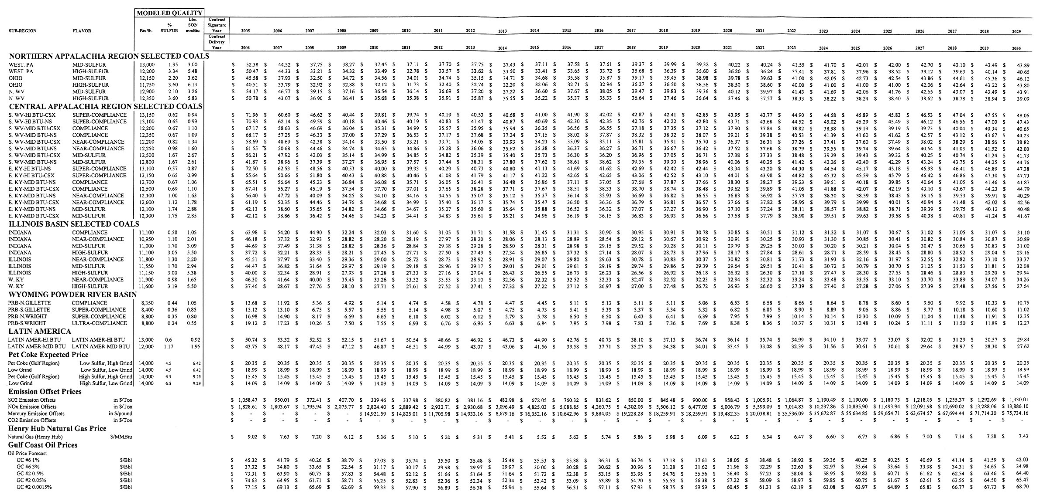
High Fuel and Corresponding Emission Allowance Price Forecasts – Constant 2005 $/Ton, Unless Otherwise Specified
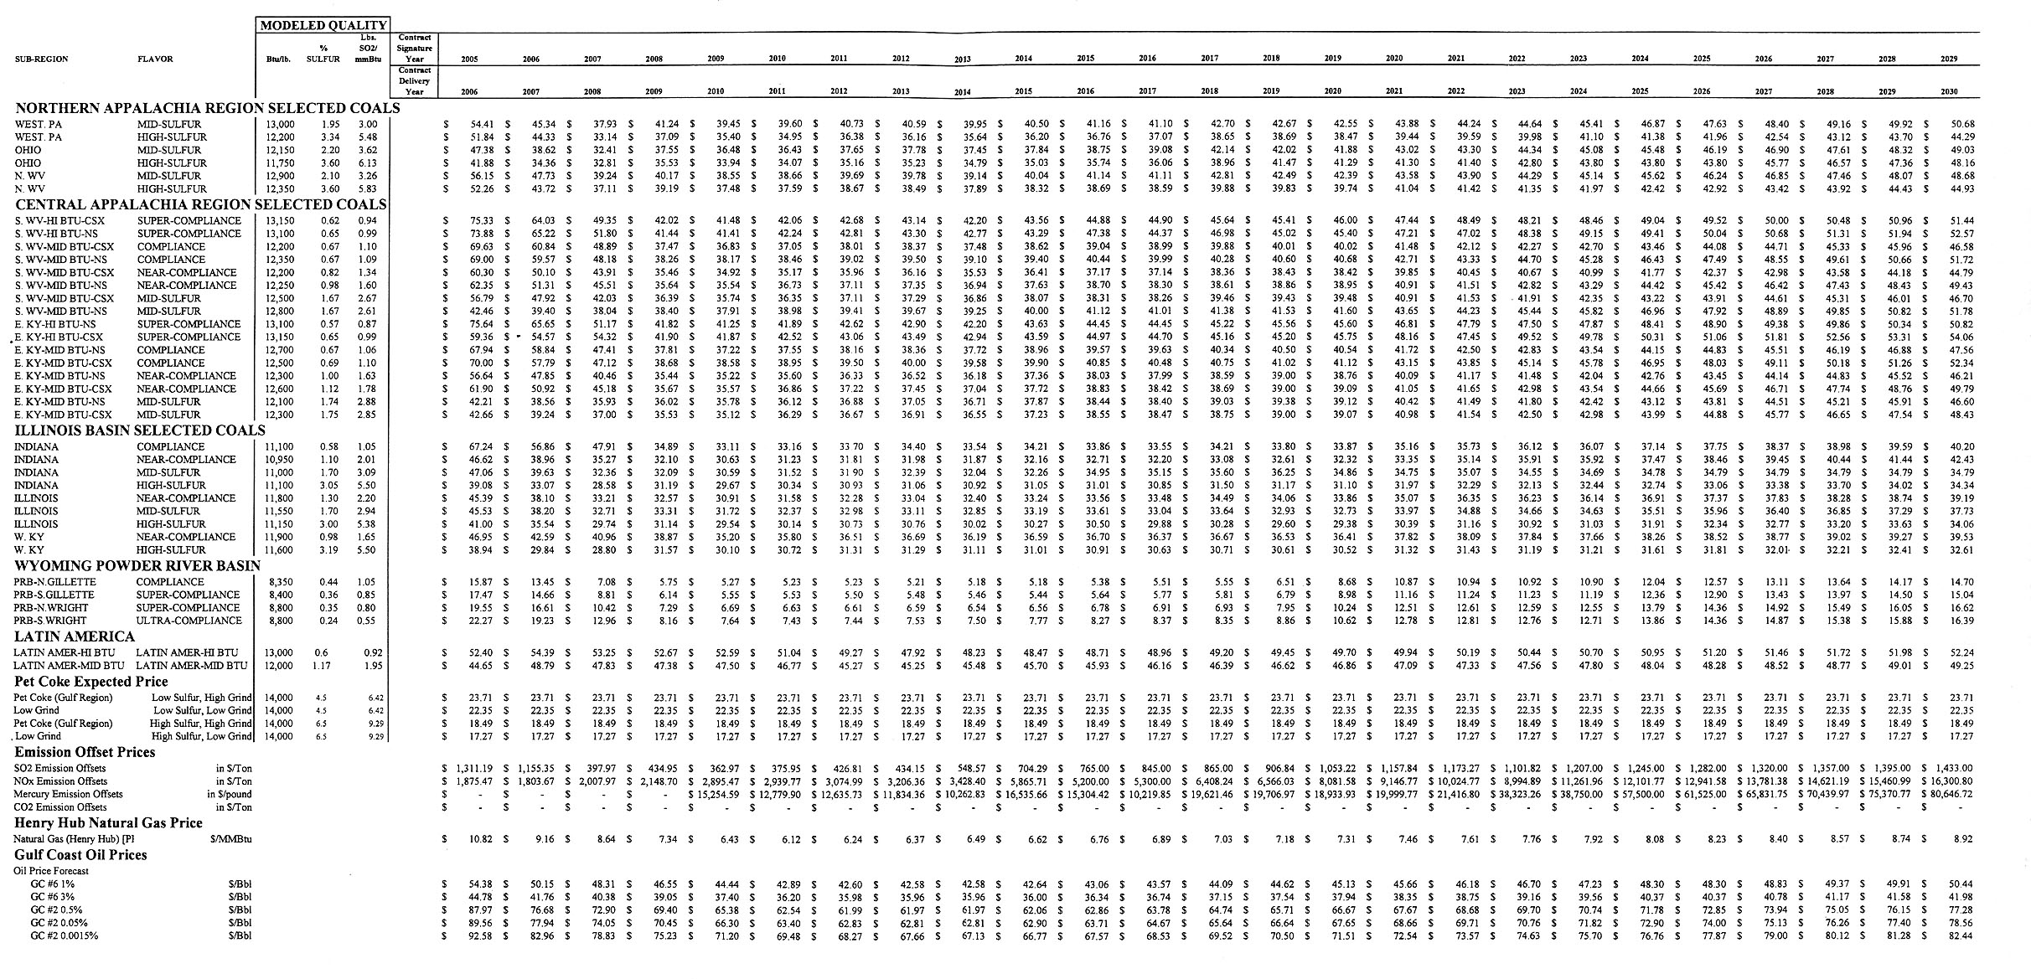
Low Fuel and Corresponding Emission Allowance Price Forecasts – Constant 2005 $/Ton, Unless Otherwise Specified
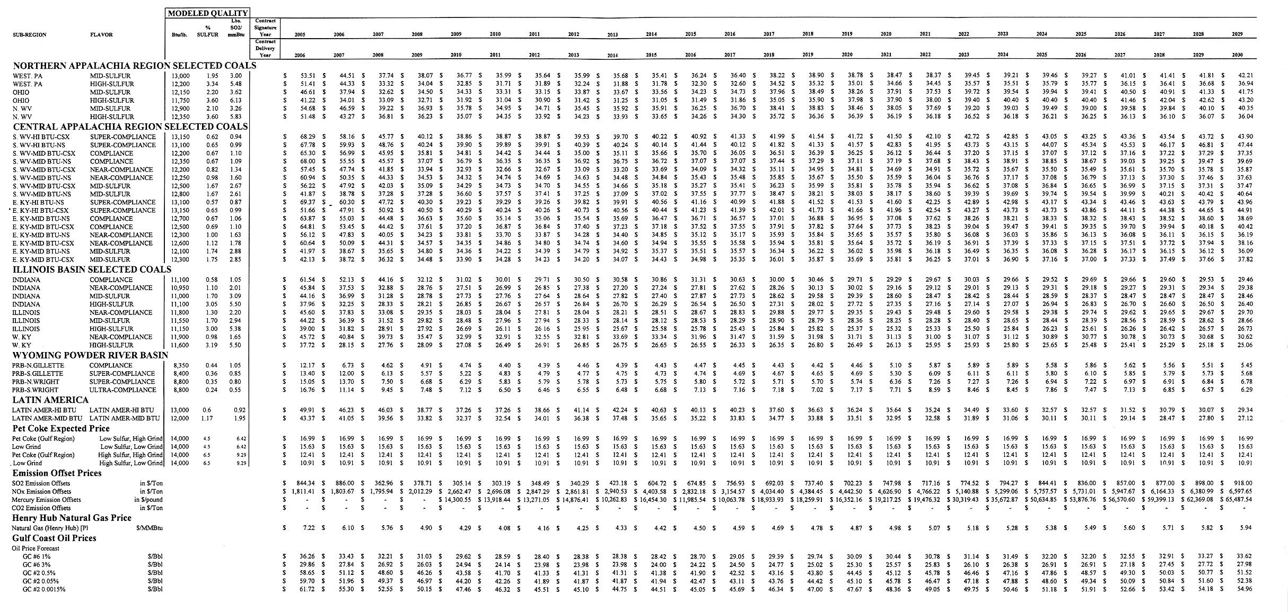
Regulated-CO₂ Fuel and Corresponding Emission Allowance Price Forecasts – Constant 2005 $/Ton, Unless Otherwise Specified
