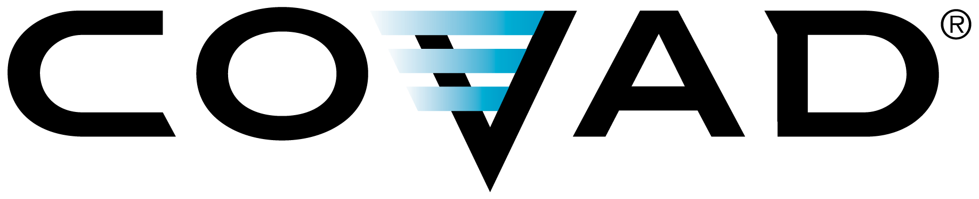
Covad Communications tel: 678.528.6816
1230 Peachtree Street NE fax: 678.528.6806
Suite 1900 www.Covad.com
Atlanta, GA 30309

Via Electronic Transmission

January 4, 2007

Blanca S. Bayo, Director
Division of the Commission Clerk
& Administrative Services
Florida Public Service Commission
2540 Shumard Oaks Boulevard
Tallahassee, FL 32399-0850

In re: Docket No. 030961-TI, Flow-through of LEC Switched Access Reductions by IXCs, pursuant to Section 364.163(2), Florida Statutes.

In re: Docket No. 030867-TL, Petition by Verizon Florida, Inc. to reform intrastate network access and basic local telecommunications rates in accordance with Section 364.164, Florida Statutes.

In re: Docket No. 030868-TL, Petition by Sprint-Florida, Incorporated to reduce intrastate switched network access rates to interstate parity in revenue-neutral manner pursuant to Section 364.164(1), Florida Statutes.

In re: Docket No. 030869-TL, Petition for Implementation of Section 364.164, Florida Statutes, by rebalancing rates in a revenue-neutral manner through decreases in intrastate switched access charges with offsetting rate adjustments for basic services, by BellSouth Telecommunications, Inc.

Dear Mrs. Bayo:

In accordance with the requirements and obligations contained in Order No. PSC-03-1469-FOF-TL, issued on December 24, 2003 (the “Order”) and the Commission’s letter dated October 12, 2006 (the “Letter”), DIECA Communications, Inc. d/b/a Covad Communications Company (“Covad”), by its undersigned counsel, and in accordance with the Order, hereby submits a letter attesting to the amount of intrastate switched access expense reduction it has received over the most recent twelve (12) months.

Further, Covad hereby attests to the following:

- Covad received authority in 2003 to operate as an Interexchange Carrier pursuant to PAA Order No. PSC-03-0575-PAA-TI issued May 6, 2003 and consummated by Order No. PSC-03-0656-CO-TI issued May 29, 2003, both under Docket No. 030143-TI.

- For the period from January 1, 2006 through December 31, 2006, Covad’s intrastate switched access expense reduction was less than $100. As such, Covad is not obligated to flow through the reduction in intrastate switched access charges and is not subject to the Order’s tariff revision requirements.

Letter to Blanca S. Bayo
January 4, 2007
Page 2

Covad provides voice and data communications products and services to consumers and businesses. Covad provides these services throughout the United States in approximately 235 major metropolitan areas in 44 states, including Florida. Covad’s products and services include high-speed, or broadband, data communications, internet access connectivity, voice over internet protocol telephony, or VoIP, and a variety of related services. Covad primarily uses digital subscriber line, or DSL, and DS-1, also referred to as T-1, technologies to deliver its services.

In order to provide these services to consumers in the state of Florida, Covad leases network elements, such as telecommunication lines and central office facilities, from the traditional incumbent local exchange companies, or ILECs, and other carriers, and then combines these network elements with our own nationwide network facilities. In the state of Florida, Covad leases the majority of these network elements from BellSouth Telecommunications, Inc. (BellSouth) and Verizon Communications, Inc. (Verizon).

Thus, Covad’s understanding is that: (a) Covad is not subject to the requirements contained in the Commission’s Order No. PSC-03-1469-FOF-TL; (b) Covad is not obligated to flow through any intrastate switched access rate reductions; and (c) Covad is not obligated to file any revisions to its tariff as a result of the Order.

Please accept this letter as an E-filing on Covad’s behalf and ensure that it is filed in the above-referenced dockets. Feel free to contact me at the above number if you have any questions or concerns.

Sincerely,

s/ Charles E. Watkins

Charles E. Watkins
Senior Counsel
Covad Communications
gwatkins@Covad.com

CEW/jlb

cc: Beth W. Salak, Director, Division of Competitive Markets & Enforcement
Sally A. Simmons, Chief, Bureau of Telecommunications, Arbitrations and Tariffs
Frank Trueblood, Regulatory Analyst

