BEFORE THE FLORIDA PUBLIC SERVICE COMMISSION

In re: Petition for approval of new )
environmental program for cost recovery ) DOCKET NO. 050958-EI
through Environmental Cost Recovery Clause ) FILED: February 14, 2007
by Tampa Electric Company. )
_________________________________________ )

TAMPA ELECTRIC COMPANY’S
PREHEARING STATEMENT

A. APPEARANCES:

LEE L. WILLIS
JAMES D. BEASLEY
Ausley & McMullen
Post Office Box 391
Tallahassee, Florida 32302
On behalf of Tampa Electric Company

B. WITNESSES:

(Direct)

Witness Subject Matter Issues

1. Howard T. Bryant Testimony in Support of Approval of 1, 2
(TECO) Tampa Electric’s Big Bend Flue Gas
Desulfurization System Reliability
Program (“FGD Reliability Program”)
for Cost Recovery through the ECRC

2. Gregory M. Nelson Summary of FGD Reliability Program 1, 2
(TECO) as Activities Necessary for the
Company to Comply with the Incremental
Requirements of the EPA Consent
Decree and Florida Department of
Environmental Protection (“DEP”)
Consent Final Judgment

3. John V. Smolenski Support of ECRC Recovery of FGD 1, 2
(TECO) Reliability Program; description of each
Component of the Program and
Methodology Employed to Determine
Cost Effectiveness; Timing of the FGD
Reliability Program with SCR Installation

(Rebuttal)

4. Howart T. Bryant Rebuttal of Witness Patricia W. Merchant 1, 2
(TECO)

5. Laura R. Crouch Rebuttal of Witness Thomas A. Hewson, Jr. 1, 2
(TECO)

6. John V. Smolenski Rebuttal of Witnesses John B. Stamberg 1, 2
(TECO) and Thomas A. Hewson, Jr.

C. EXHIBITS:

Exhibit Witness Description

1. ___________ Nelson Portions of Consent Decree and Declaratory
(GMN-1) Letter to EPA

2. ___________ Smolenski Big Bend Station FGD Station Reliability
(JVS-1) Study

3. ___________ Smolenski Rebuttal Documents of John V. Smolenski
(JVS-2)

D. STATEMENT OF BASIC POSITION
Tampa Electric Company’s Statement of Basic Position
The Commission should approve each of the thirteen projects that make up the Tampa Electric Company FGD System Reliability Program for recovery in the manner described in Tampa Electric’s positions on Issues 1 and 2 of this Prehearing Statement.

E. STATEMENT OF ISSUES AND POSITIONS
Issue 1: Are the following projects in Tampa Electric Company's Big Bend FGD System Reliability Program costs or expenses incurred by Tampa Electric in complying with environmental laws or regulations and, therefore, entitled to be recovered under the environmental cost recovery clause pursuant to Section 366.8255, Florida Statutes?
(a) Big Bend Units 1-4 Electric Isolation
(b) Big Bend Units 3-4 Split Inlet Duct and Split Outlet Duct
(c) Gypsum Fines Filter
TECO: Yes. Each of the projects listed under subissues (a) (b) and (c) of Issue 1 is necessary to comply with environmental laws and regulations and therefore are entitled to be recovered through the Environmental Cost Recovery Clause pursuant to Section 366.8255, Florida Statutes. (Witnesses: Bryant; Nelson (adopted by Crouch); Crouch and Smolenski)
Issue 2: How should the following remaining projects in Tampa Electric Company's Big Bend FGD System Reliability Program be recovered?

(a) Big Bend Units 1-4 Mist Eliminator Upgrades
(b) Big Bend Units 1-4 On-line Mist Eliminator Wash System
(c) Big Bend Units 1-4 On-line Nozzle Wash System
(d) Gypsum Filter Vacuum Pump Upgrades
(e) Big Bend Units 1-2 Gypsum Blow Down Line
(f) Controls Additions
(g) Big Bend Units 3-4 FGD Booster Fan Capacity Expansion
(h) Big Bend Units 1-2 Recycle Pump Discharge Isolation Bladders
(i) Big Bend Units 1-2 Inlet Duct C-276 Wallpaper
TECO: The costs of the projects listed under this Issue 2 should be recovered through the Big Bend FGD System Reliability (New) ECRC Program, the Big Bend Units 1 and 2 FGD (Existing) ECRC Program and through base rates, allocated among the three methods of recovery in the manner shown in the chart entitled "Big Bend Flue Gas Desulfurization System Reliability Program Recovery of Expenditures-Revised" filed on March 16, 2006 by Tampa Electric, a copy of which is attached hereto and by reference made a part hereof. (Witnesses: Bryant; Nelson (adopted by Crouch); Crouch and Smolenski)
F. STIPULATED ISSUES
TECO: None at this time.

G. MOTIONS

TECO: None at this time.

H. OTHER MATTERS

TECO: None at this time.

DATED this ____ day of February, 2007.

Respectfully submitted,

___________________________________
LEE L. WILLIS
JAMES D. BEASLEY
Ausley & McMullen
Post Office Box 391
Tallahassee, Florida 32302
(850) 224-9115

ATTORNEYS FOR TAMPA ELECTRIC COMPANY
CERTIFICATE OF SERVICE
I HEREBY CERTIFY that a true and correct copy of the foregoing Prehearing Statement, filed on behalf of Tampa Electric Company, has been furnished by U. S. Mail or hand delivery (*) on this _____ day of February, 2007 to the following:
Martha Carter Brown*
Office of General Counsel
Florida Public Service Commission
Room 370N – Gerald L. Gunter Building
2540 Shumard Oak Boulevard
Tallahassee, FL 32399-0850

Ms. Patricia A. Christensen*
Associate Public Counsel
Office of Public Counsel
c/o The Florida Legislature
111 West Madison Street, Room 812
Tallahassee, FL 32399-1400

Mr. Myron Rollins
Black & Veatch Corporation
11401 Lamar Avenue
Overland Park, KS 66211

____________________________________
ATTORNEY
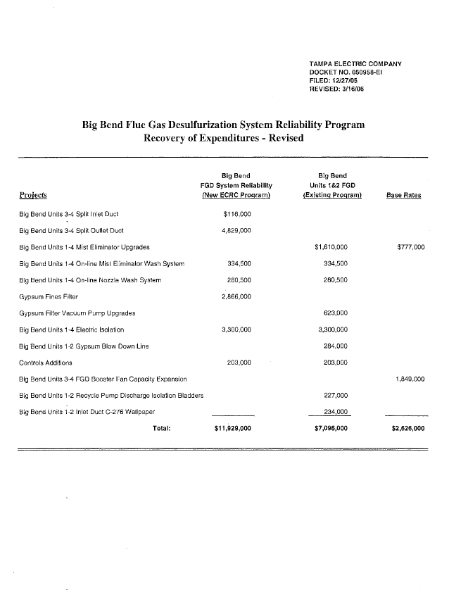

Tampa Electric witness Laura R. Crouch will adopt the testimony submitted by Mr. Nelson.
This exhibit will be adopted by Tampa Electric witness Laura R. Crouch.

