State of Florida   |  | Public Service Commission  Capital Circle Office Center ● 2540 Shumard Oak Boulevard  Tallahassee, Florida 32399-0850  -M-E-M-O-R-A-N-D-U-M-
DATE: | April 12, 2007
TO: | Commission Clerk (Cole)
FROM: | Division of Competitive Markets & Enforcement (Williams, Casey)  Office of the General Counsel (Teitzman)
RE: | Docket No. 060677-TL — Joint petition to implement practices and procedures with Department of Children and Families to automatically enroll eligible customers in Lifeline telephone program, by Citizens of Florida and AARP.
AGENDA: | 04/24/07 — Regular Agenda — Proposed Agency Action - Interested Persons May Participate
COMMISSIONERS ASSIGNED: |  |  | All Commissioners
PREHEARING OFFICER: |  |  | McMurrian
CRITICAL DATES: |  |  | None
SPECIAL INSTRUCTIONS: |  |  | None
FILE NAME AND LOCATION: |  |  | S:\PSC\CMP\WP\060677.RCM.DOC

Case Background

On October 11, 2006, the Office of Public Counsel (OPC) and AARP jointly filed a petition with the Florida Public Service Commission (FPSC or Commission) requesting that it order local exchange telecommunications companies in Florida to implement practices and procedures with the Department of Children and Families (DCF) to automatically enroll eligible customers in the Lifeline telephone program.

On October 20, 2006, Charles J. Crist, as Florida Attorney General, petitioned the FPSC to enter an Order granting leave to the Attorney General to intervene in this docket. According to the Attorney General, “[o]ne million households in Florida who are intended beneficiaries of the Lifeline program are failing to realize its benefits.” Furthermore, the Attorney General expressed his support of the Joint Petition filed by the Office of Public Counsel and AARP to implement automatic enrollment for Lifeline. By Order No. PSC-06-0897-PCO-TL, issued October 26, 2006, the Commission granted the Attorney General’s request to intervene in this docket.

On October 30, 2006, and October 31, 2006, respectively, Windstream Florida, Inc. and TracFone Wireless, Inc. filed Petitions to Intervene in this docket. By Order No. PSC-06-0940-PCO-TL, issued November 7, 2006, the Commission granted Windstream Florida, Inc.’s request to intervene in this docket noting that Windstream’s substantial interests may be affected because it provides incumbent local exchange service in Florida. By Order No. PSC-06-0959-PCO-TL, issued November 17, 2006, the Commission granted TracFone Wireless, Inc.’s request to intervene in this docket since it provides commercial mobile radio services in Florida, and has a Petition for Designation as an Eligible Telecommunications Carrier (ETC) in the State of Florida currently pending before the Federal Communications Commission.

On November 28, 2006, BellSouth Telecommunications, Inc. filed a “Motion For Abeyance” requesting that this docket be held in abeyance for a minimum of six months pending the results of the Commission’s newly initiated On-Line Automated Lifeline and Link-Up Application Process. On December 12, 2006, Embarq Florida, Inc. filed a “Request For Abeyance” asking that the Commission hold this docket in abeyance for at least six months pending results of the Commission’s On-Line Automated Lifeline and Link-Up Application Process and the rule development workshop which was conducted February 6, 2007 to address Lifeline issues.

By Order No. PSC-07-0064-PCO-Tl, issued January 24, 2007, BellSouth’s Motion for Abeyance and Embarq’s Request for Abeyance were denied noting that the FPSC and DCF have been working together on an automatic enrollment process in some fashion for a period of time. An informal meeting was held with the parties on February 5, 2007 to identify areas of agreement and disagreement regarding the Joint Petitioner’s automatic enrollment proposal.

Discussion of Issues

Issue 1: Should the Commission order the local exchange telecommunications companies in Florida to implement practices and procedures with the Department of Children and Families to automatically enroll eligible customers in the Lifeline telephone program?

Recommendation: No. However, this docket should remain open pending analysis of the results of the Lifeline automatic enrollment process being implemented by the Commission and the Department of Children and Families. (Williams, Casey, Teitzman)

Staff Analysis: The Commission has been proactive regarding Lifeline enrollment in Florida. A number of different enrollment methods have been developed, and are continuing to be developed, to make it easier for consumers to enroll in Florida’s Lifeline program. A brief historical summary of the various Lifeline enrollment processes is provided below.

Lifeline Enrollment Processes

Simplified-Certification Form --- By Order No. PSC-05-0153-AS-TL, issued February 8, 2005, in Docket No. 040604-TL, the Commission approved a proposal which allows Lifeline eligible customers to simply sign a document certifying “under penalty of perjury” that the customer participates in one of the Florida Lifeline eligible programs and identifying the qualifying program. This process replaced the previous procedure whereby Lifeline applicants had to provide proof that they are enrolled in one of the qualifying programs. Once completed, the simplified-certification form is submitted via mail or fax to the appropriate ETC to be enrolled in Lifeline. On August 7, 2006, the Commission ordered all ETCs to adopt the simplified-certification enrollment process.

The simplified-certification form is available on the FPSC web site at http://www.psc.state.fl.us/utilities/telecomm/lifeline/lifelinePDFs/ApplicationEnglish.pdf and through various outreach programs. A copy of the simplified-certification form is attached to this recommendation as Attachment A.

Automated Online Application Process — In October 2006, in an effort to further simplify Lifeline enrollment, the Commission created a direct link to a Lifeline application located on the Commission’s Web site. The electronic application process allows consumers the opportunity to complete a Lifeline application online and submit it by hitting one button. Once submitted, the system forwards an automatic e-mail informing the appropriate ETC that a Lifeline application is available for retrieval through the Commission’s secure database. The ETC retrieves the application and enrolls the consumer in Lifeline. All ten incumbent local exchange companies, six competitive local exchange companies and three wireless carriers which have been granted ETC status in Florida are participating in the automated enrollment process. As of April 10, 2007, over 1,300 consumers were enrolled in Lifeline through the Automated Online Application Process.

The automated online Lifeline application is available on the FPSC web site at https://secure.floridapsc.com/(S(o1ts3zqjezhlay2mzlhiem45))/public/lifeline/lifelineapplication.aspx. A copy of the automated application form is also attached to this recommendation as Attachment B.

Automatic Enrollment Process — In April 2006, FPSC and DCF staff renewed their efforts to develop a process whereby potential Lifeline customers, once certified through a DCF program, could automatically receive Lifeline discounts. From the perspective of the client, the automatic enrollment process established by the FPSC and DCF should be seamless from filling out the DCF web application to receiving Lifeline discounts.

The automatic enrollment process entails the DCF client checking a “yes” or “no” box on the DCF web application stating an interest in receiving the Lifeline discounts on his or her telephone service. The “no” box provides an option to the applicant not to subscribe to Lifeline discounts if he or she chooses. If the client answers in the affirmative, the applicant identifies a telephone service provider from a drop-down box on the application and answers several questions. The DCF forwards to the FPSC the names of the clients approved by DCF for benefits making them eligible for Lifeline and have chosen to receive the Lifeline discounts. In addition, the relevant information needed for the client to be enrolled in Lifeline is also transferred. The FPSC electronically sorts the information by ETC and places the names on the same secure web site established for the FPSC’s automated enrollment process for the ETCs to process their customers for Lifeline discounts.

OPC and the AARP Petition

The Petition filed by the Office of Public Counsel requests that the Commission order local exchange telecommunications companies in Florida to “implement practices and procedures with the Department of Children and Families to automatically enroll eligible customers in the lifeline telephone program.” As mentioned above, staff of the FPSC and DCF have been working on an automatic Lifeline enrollment process for DCF clients since April 2006. DCF’s assistance in developing a Lifeline automatic enrollment process has been invaluable.

The process that has been developed by the FPSC differs in some areas from that proposed by OPC and AARP. However, staff believes the intent and goals of the petition have been met. The automatic enrollment process implemented allows for all 19 Florida ETCs to participate in the automatic enrollment process and provides a choice for DCF applicants to enroll in the Lifeline program to receive discounts. Like any new process, monitoring is needed to determine areas where improvements may need to be made. Based upon the results and any unforeseen issues that arise, staff believes input and observations from all parties concerned--OPC, AARP, the Attorney General, DCF, the ETCs, and consumers--should be heard to determine how the process can be improved.

In addition, staff notes that there are automatic Lifeline enrollment bills filed at the Legislature. If one of the bills is signed into law, it will need to be determined if the current process is in compliance with the new statutes.

In order to obtain more experience with the developed automatic enrollment system, receive feedback from the parties, and evaluate any potential relevant statute modifications, staff believes that this docket should be placed in abeyance at this time. Therefore, staff recommends that this docket should remain open pending analysis of the results of the Lifeline automatic enrollment process being implemented by the Commission and the Department of Children and Families.

Issue 2: Should this docket be closed?

Recommendation: No. (Teitzman)

Staff Analysis: Consistent with staff’s recommendation in Issue 1, staff believes this docket should be held open to monitor the current automatic enrollment process, receive feedback, and insure the current program is in compliance with any automatic enrollment statutes enacted.

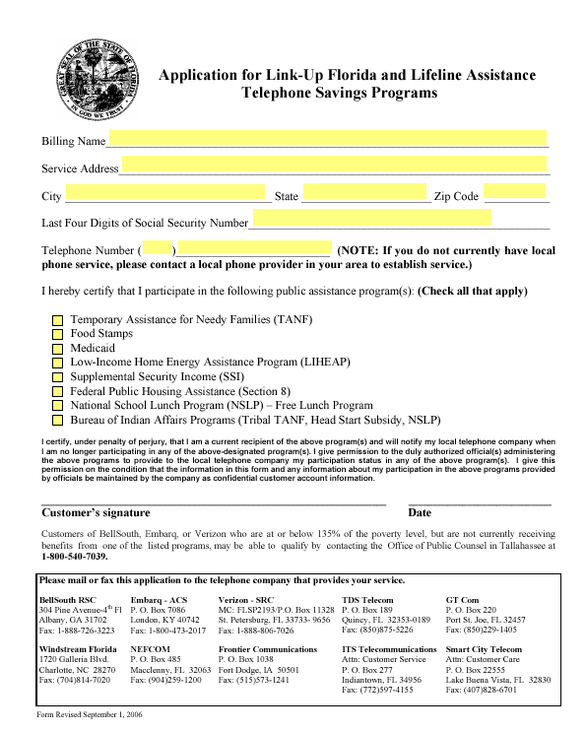
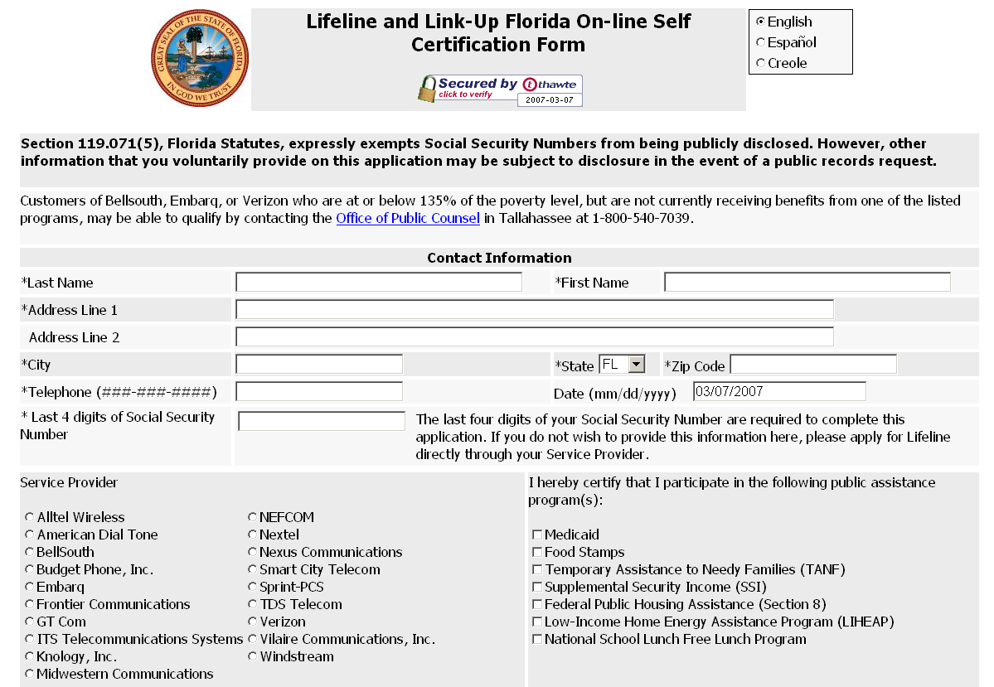
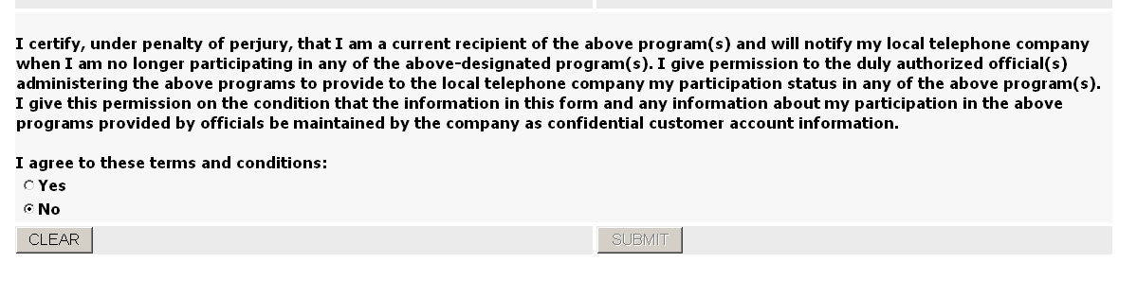

The Lifeline and Link-Up assistance programs help low-income consumers obtain and maintain basic telecommunications service at just, reasonable, and affordable rates by providing a minimum $13.50 monthly credit to eligible consumers.
Section 254(e) of the Communications Act of 1934, as amended (the Act), provides that “only an eligible telecommunications carrier designated under section 214(e) shall be eligible to receive specific Federal universal service support.” Pursuant to section 214(e)(l), a common carrier designated as an ETC must offer the services supported by the federal universal service mechanisms throughout the designated service area either by using its own facilities or by using a combination of its own facilities and resale of another carrier’s services (including the services offered by another ETC), and must advertise these services throughout the designated service area.
Order No. PSC-06-0680-PAA-TL, issued August 7, 2006.
BellSouth d/b/a AT&T Florida, Verizon, Embarq, GTC, Windstream, TDS Telecom, NEFCOM, Frontier, ITS Telecom, Smart City, Nextel Partners, ALLTEL Wireless, Sprint PCS, Knology, Budget Phone, American Dial Tone, Nexus, Vilaire, and Midwestern.

