BEFORE THE PUBLIC SERVICE COMMISSION

In re: Petition for approval to amend Rate Schedules CS-1 and LS-1, by Progress Energy Florida, Inc. | DOCKET NO. 070040-EI  ORDER NO. PSC-07-0421-TRF-EI  ISSUED: May 14, 2007

The following Commissioners participated in the disposition of this matter:

LISA POLAK EDGAR, Chairman
MATTHEW M. CARTER II
KATRINA J. McMURRIAN

ORDER APPROVING AMENDED RATE SCHEDULE SC-1

BY THE COMMISSION:

On January 11, 2007, Progress Energy Florida, Inc. (PEF or Company) filed a Petition for Approval to Amend Rate Schedules SC-1 (Tariff Sheets 6.110 and 7.112) and LS-1 (Tariff Sheet 6.284). On March 2, 2007, we issued Order No. PSC-07-0194-PCO-EI suspending these proposed changes. PEF subsequently withdrew its requested change to rate schedule LS-1 on April 9, 2007. We have jurisdiction over these issues pursuant to Sections 366.04, 366.05, and 366.06, Florida Statutes.
Rate schedule SC-1, which is PEF’s service charges tariff, lists charges for activities such as initial connection and reconnection of service to a premise. PEF proposes to change the charges assessed for reconnection of service for accounts with lighting fixtures after disconnection for nonpayment of bills or violation of Company or Commission rules. The present charges are $40.00 per account for a reconnection during business hours (Monday-Friday, 7 A.M. to 7 P.M.) and $50.00 for reconnection at any other time. PEF’s proposed change will not alter the dollar amount of the charges, but will give the Company the option of assessing the charge for each lighting fixture on an account, rather than assessing a single reconnection charge per account.
PEF states that the proposed change is due to the large number of lighting reconnections it had to perform and the costs incurred for the reconnections. According to PEF, the reconnections typically occur on accounts with multiple lighting fixtures, such as lighting accounts from suburban homeowners associations and housing developments. PEF states that it has been reconnecting 3-4 accounts per week, with a total of 15-50 fixtures. Based on PEF’s figures, the number of fixtures reconnected annually works out to a range between a minimum of 2,340 (3 x 15 x 52) fixtures and a maximum of 10,400 (4 x 50 x 52) fixtures. More precise figures are not available as PEF does not keep records of the exact number of lighting fixtures disconnected and reconnected. PEF has incurred costs between $56.68 and $52.21 per fixture for disconnection and reconnection, with costs decreasing slightly as the number of fixtures reconnected for a particular account rise. Nearly 60% of the costs for disconnecting and reconnecting a fixture comes from labor costs and the use of a bucket truck to remove and replace each fixture’s light bulb. PEF removes the light bulb from light fixtures instead of shutting off power to them since street lighting is typically on the same lines and circuits that provide service to homes and businesses, and not on a discrete circuit of its own. A development of the service charge appears in Attachment A to this Order with costs provided for sample reconnections with 10, 20, 30, 50 and 90 fixtures. The costs are similar to what PEF provided in its last rate case.
PEF asserts that the Company is presently incurring annual costs between $132,631 ($56.68 x 2,340) and $542,984 ($52.21 x 10,400) for disconnection and reconnection of lights for nonpayment of bills. Under the present service charges, PEF is presently receiving revenues between $6,240 (3 x 40 x 52) and $8,320 (4 x 40 x 52) to cover those costs. PEF states that the amount presently collected per account is closer to $40 as most of the reconnection work is scheduled during normal business hours. By subtracting present revenues from present costs, PEF is presently losing between $126,391 and $534,664 annually for disconnection and reconnection of lights due to nonpayment of bills. PEF’s proposed amendment to rate schedule SC-1 will lower the Company’s losses to between $39,031 ($132,631 – (2,340 x $40)) and $126,984 ($542,984 – (10,400 x $40)).
Although the proposed change in the application of reconnection charges will result in increased charges to customers reconnecting, the increased cost is easy for customers to avoid by simply paying bills on time. Approval of the proposed rate schedule will more equitably assign costs for disconnecting and reconnecting light fixtures to the customers causing the expenses, and will lessen the amounts being shifted to other rate classes and customers. Accordingly, PEF’s proposed changes to Rate Schedule SC-1 are hereby approved. PEF shall notify its lighting customers in a mailing before the change in policy is implemented, and shall provide a sample calculation of the current and proposed reconnection charge amounts. Revised Tariff Sheet Nos. 6.110 and 7.112 shall become effective on June 1, 2007.
If a protest is filed within 21 days of the issuance of this order, the tariffs shall remain in effect with any increase held subject to refund pending resolution of the protest. If no timely protest is filed, this docket shall be closed upon the issuance of a Consummating Order.
Based on the foregoing, it is

ORDERED by the Florida Public Service Commission that Progress Energy Florida, Inc.’s Petition for Approval to Amend Rate Schedule SC-1 (Tariff Sheets 6.110 and 7.112) is hereby granted. It is further

ORDERED that Progress Energy Florida, Inc. shall notify its lighting customers in a mailing before the change in policy is implemented, and provide a sample calculation of the current and proposed reconnection charge amounts. It is further

ORDERED that revised Tariff Sheet Nos. 6.110 and 7.112 shall become effective on June 1, 2007. It is further

ORDERED that if a protest is filed within 21 days of the issuance of this order, revised Tariff Sheet Nos. 6.110 and 7.112 shall remain in effect with any increase held subject to refund pending resolution of the protest. It is further
ORDERED that if no timely protest is filed, this docket shall be closed upon the issuance of a consummating order.
By ORDER of the Florida Public Service Commission this 14th day of May, 2007.

/s/ Ann Cole
ANN COLE
Commission Clerk

This is an electronic transmission. A copy of the original signature is available from the Commission's website, www.floridapsc.com, or by faxing a request to the Office of Commission Clerk at 1-850-413-7118.

( S E A L )

LAH

NOTICE OF FURTHER PROCEEDINGS

The Florida Public Service Commission is required by Section 120.569(1), Florida Statutes, to notify parties of any administrative hearing or judicial review of Commission orders that is available under Sections 120.57 or 120.68, Florida Statutes, as well as the procedures and time limits that apply. This notice should not be construed to mean all requests for an administrative hearing or judicial review will be granted or result in the relief sought.

Mediation may be available on a case-by-case basis. If mediation is conducted, it does not affect a substantially interested person's right to a hearing.

The Commission's decision on this tariff is interim in nature and will become final, unless a person whose substantial interests are affected by the proposed action files a petition for a formal proceeding, in the form provided by Rule 28-106.201, Florida Administrative Code. This petition must be received by the Office of Commission Clerk, 2540 Shumard Oak Boulevard, Tallahassee, Florida 32399-0850, by the close of business on June 4, 2007.

In the absence of such a petition, this Order shall become final and effective upon the issuance of a Consummating Order.

Any objection or protest filed in this docket before the issuance date of this order is considered abandoned unless it satisfies the foregoing conditions and is renewed within the specified protest period.

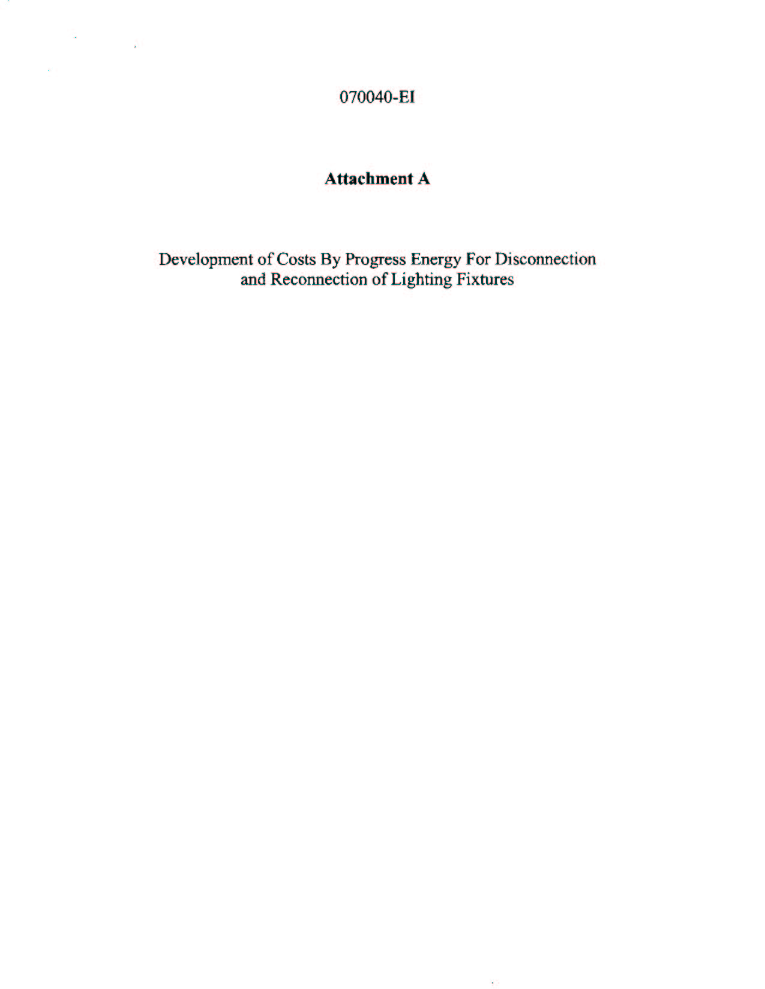
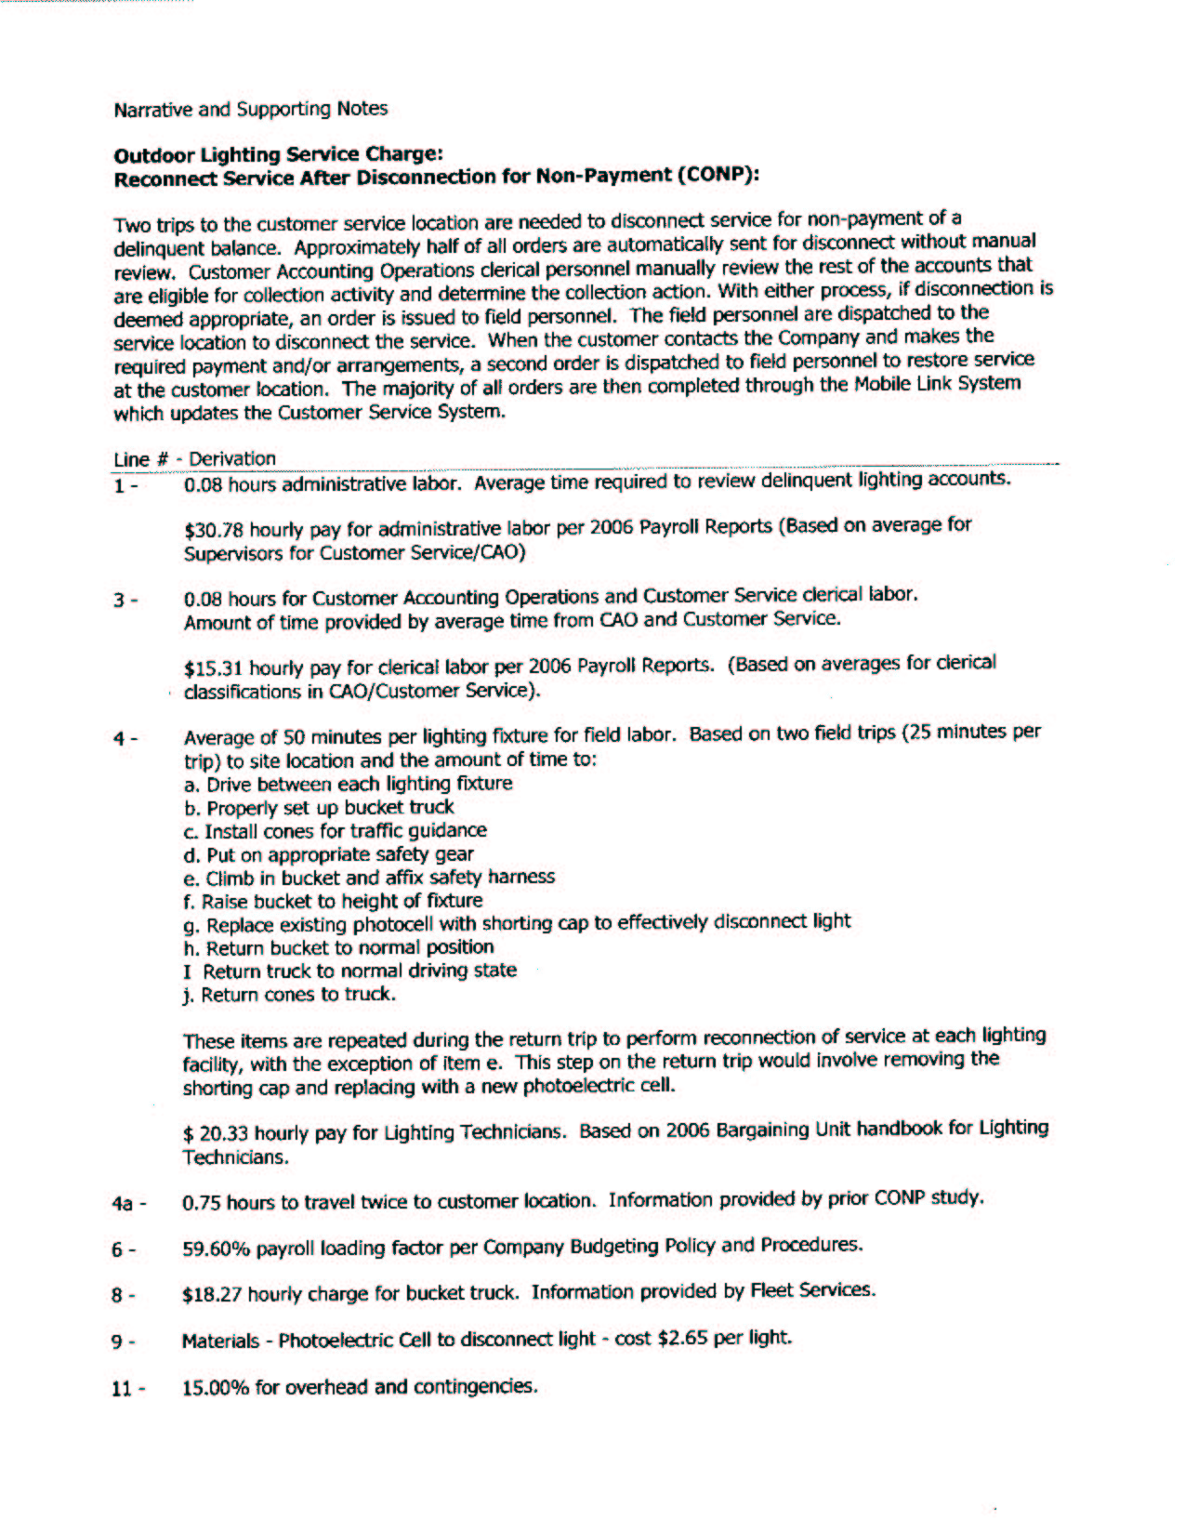
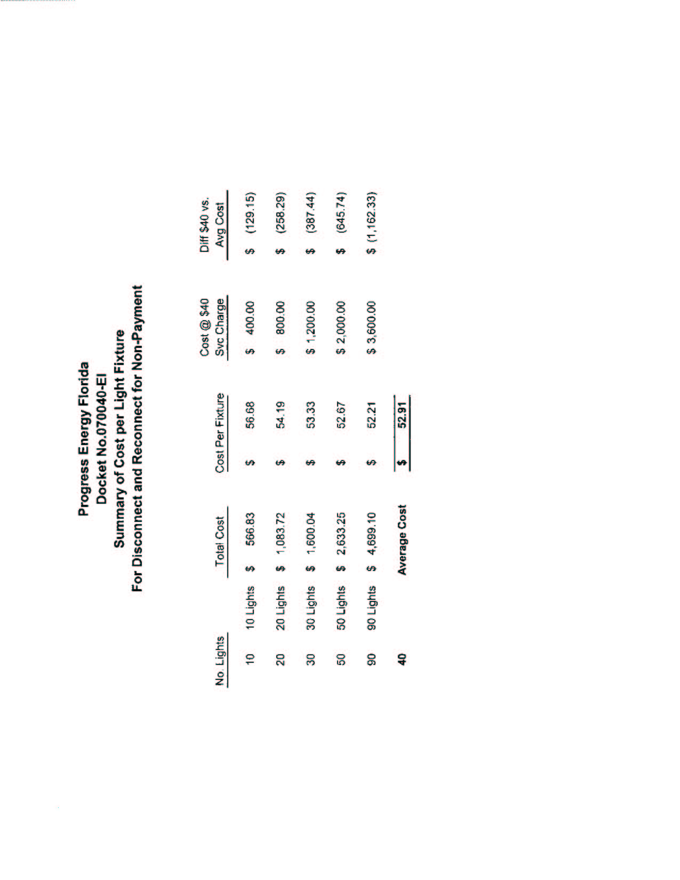
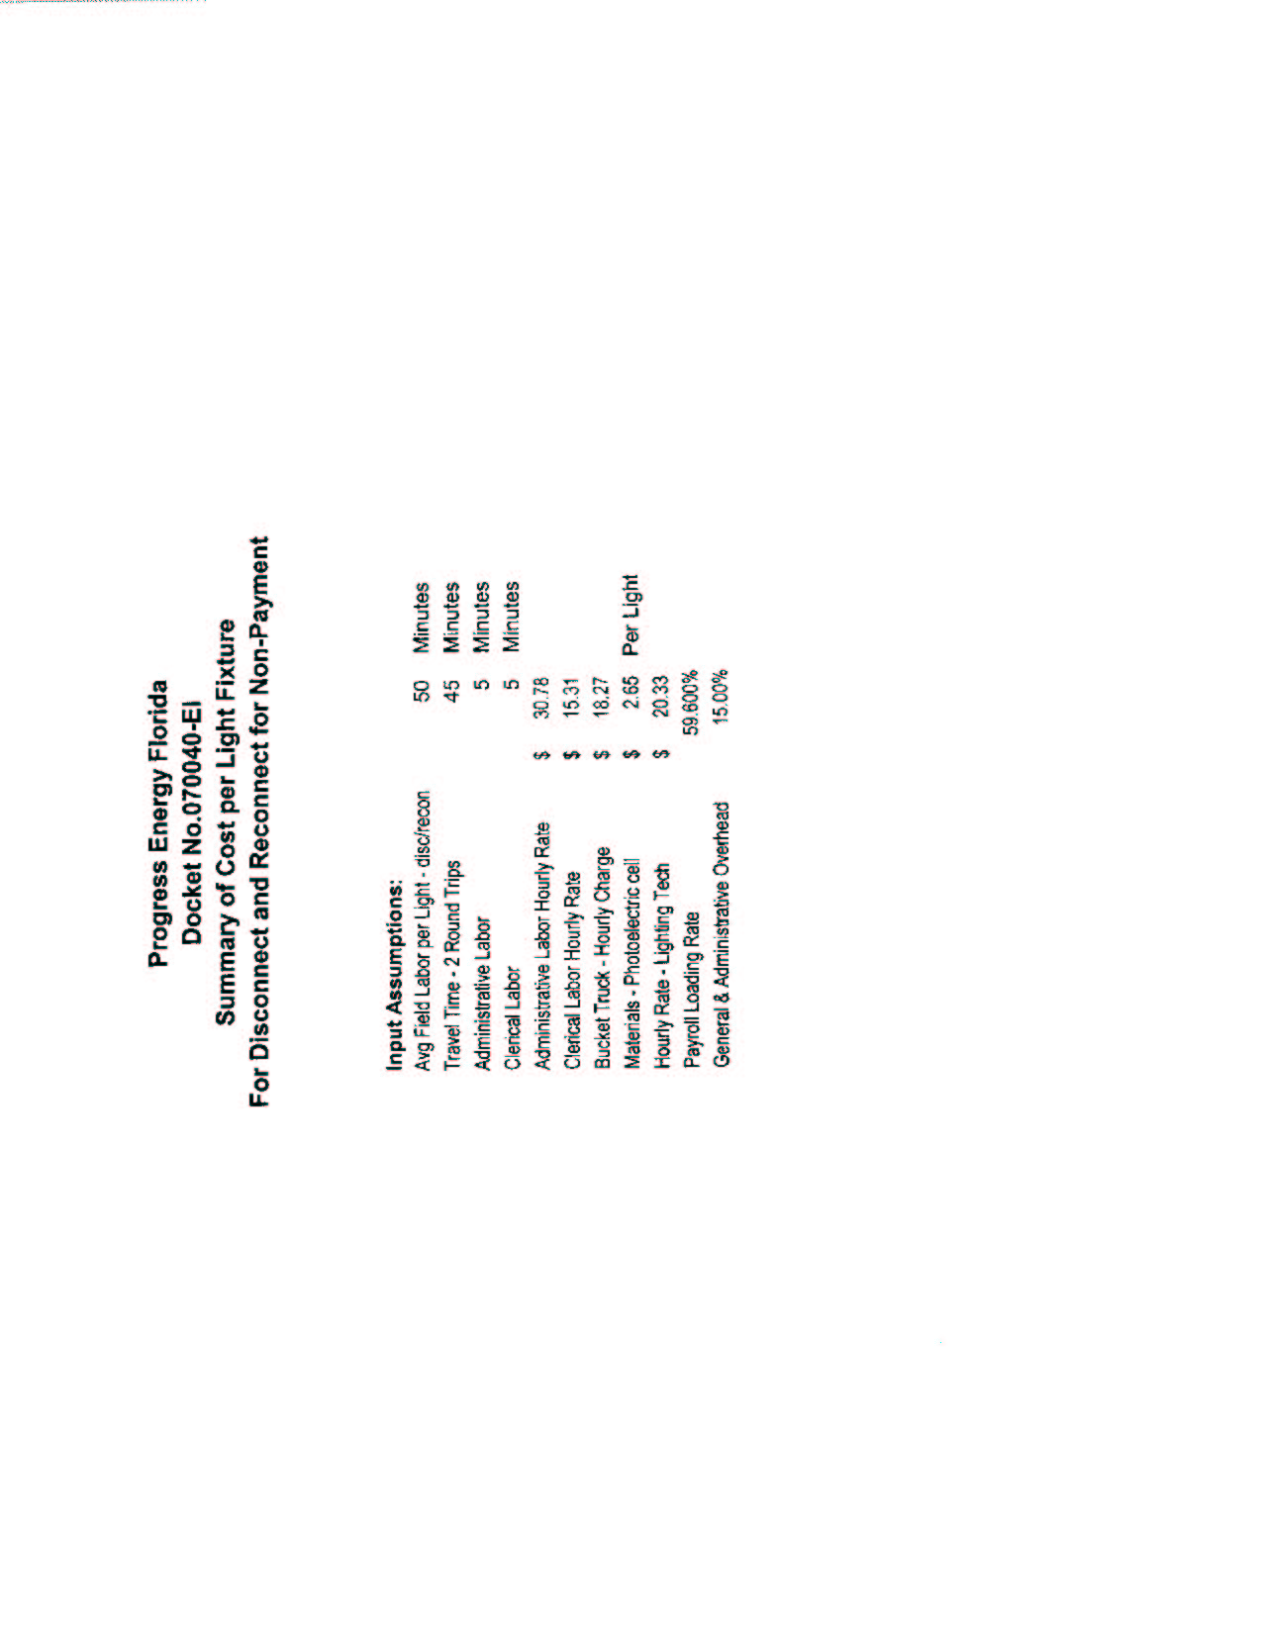
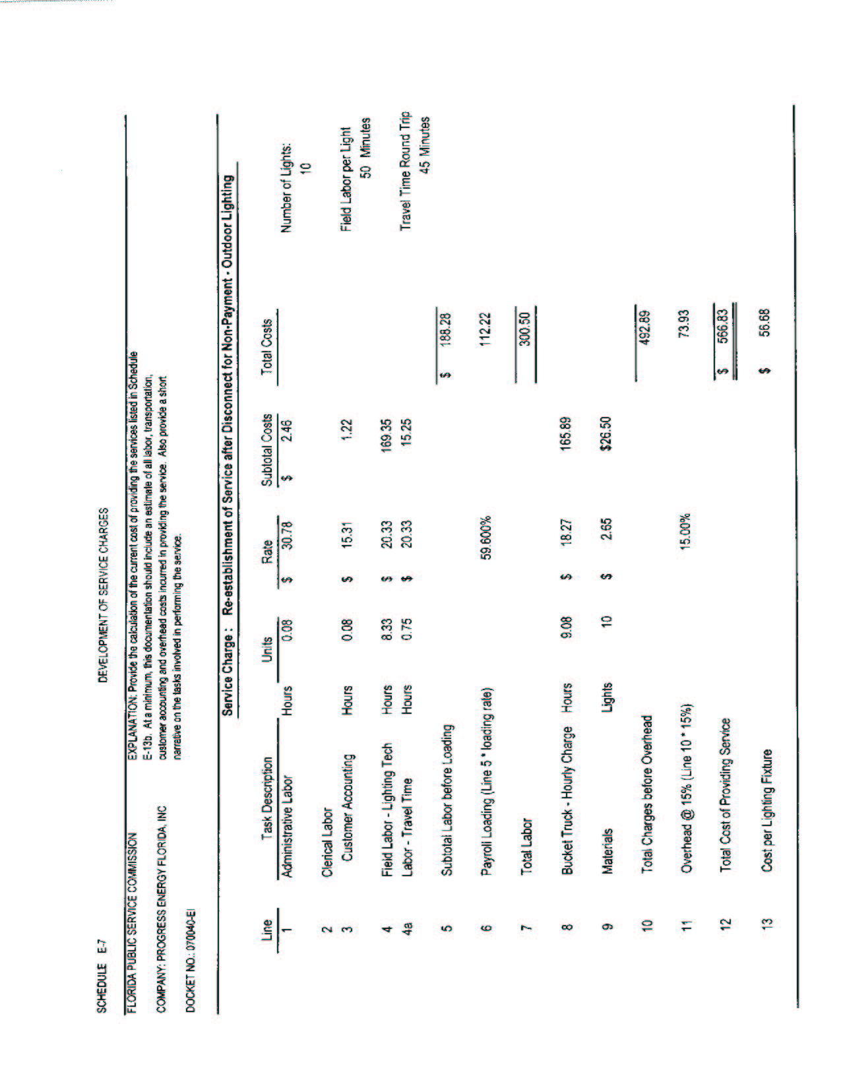
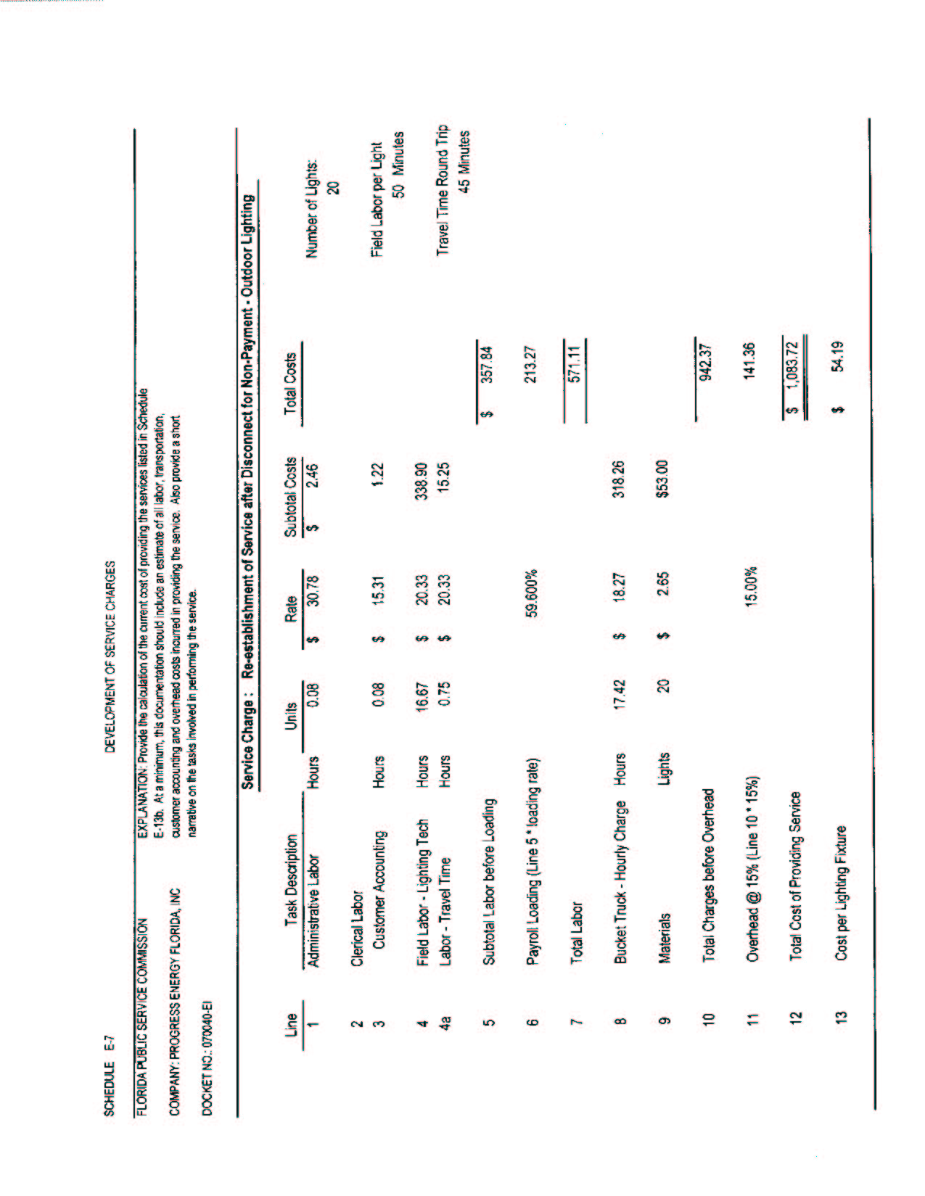
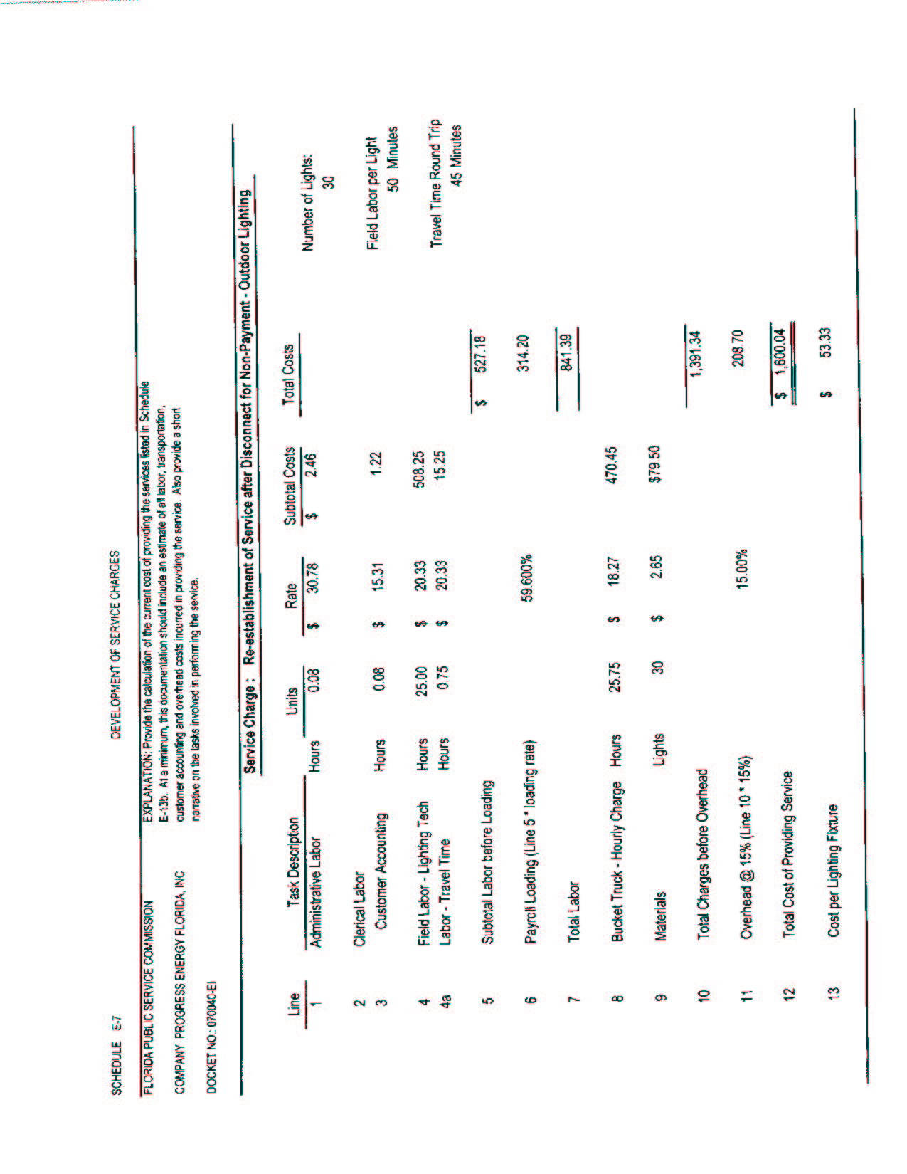
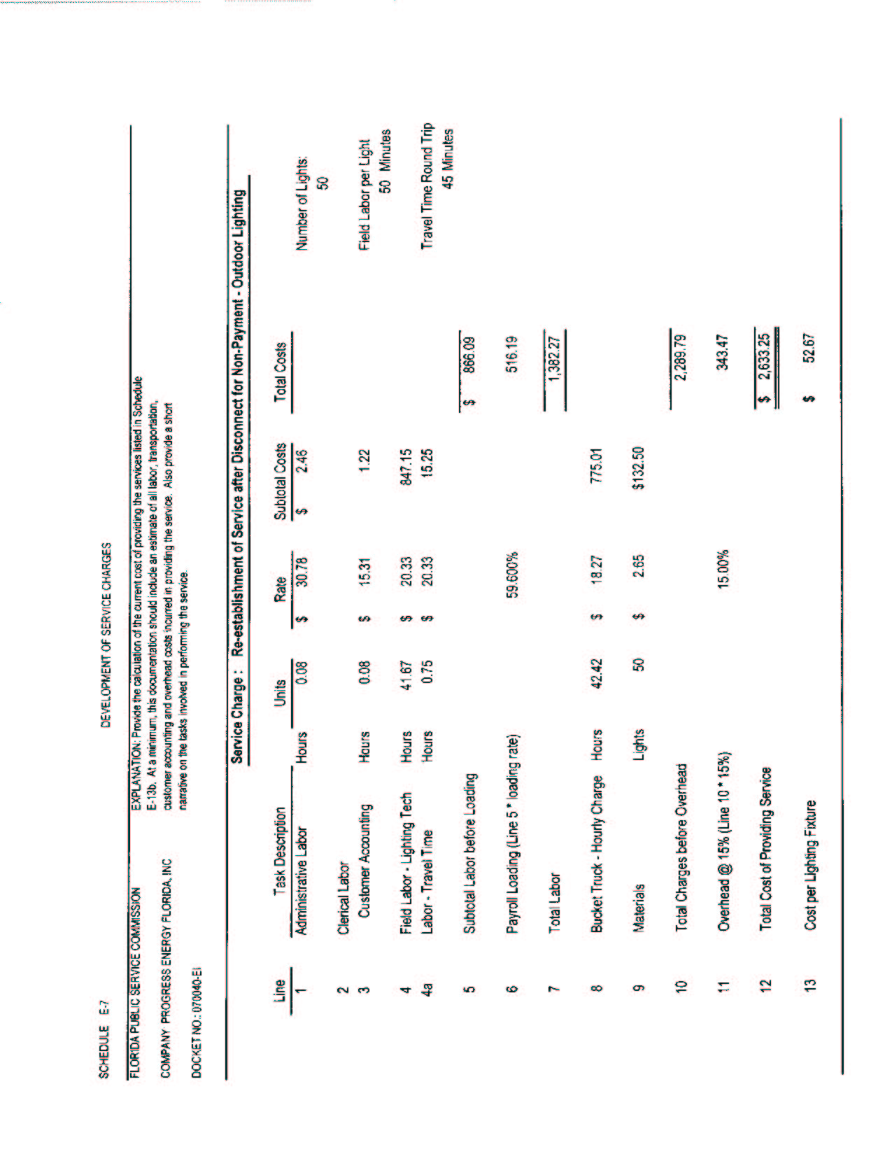
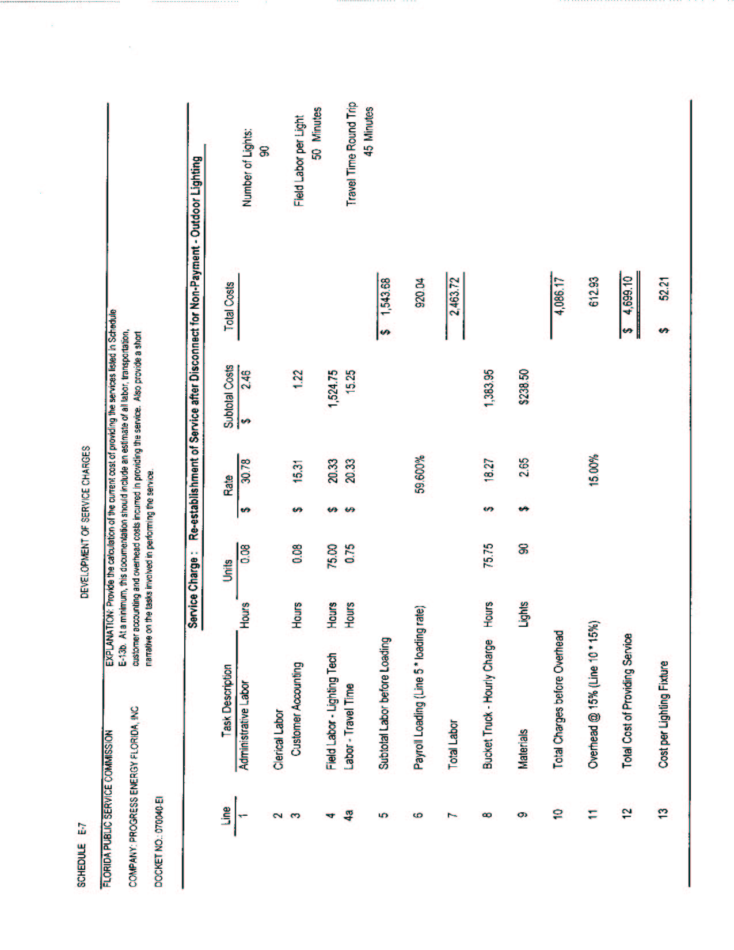

See Order No. PSC-05-0945-S-EI, issued on September 28, 2005, in Docket No. 050078-EI, In Re: Petition for rate increase by Progress Energy Florida, Inc.

