State of Florida   |  | Public Service Commission  Capital Circle Office Center ● 2540 Shumard Oak Boulevard  Tallahassee, Florida 32399-0850  -M-E-M-O-R-A-N-D-U-M-
DATE: | August 02, 2007
TO: | Office of Commission Clerk (Cole)
FROM: | Division of Economic Regulation (Rieger)  Office of the General Counsel (Fleming)
RE: | Docket No. 070275-WS – Application for amendment of Certificates 592-W and 509-S to extend water and wastewater service area to include certain land in Polk County by Cypress Lakes Utilities, Inc.
AGENDA: | 08/14/07 – Regular Agenda – Proposed Agency Action Issue 2 - Interested Persons May Participate
COMMISSIONERS ASSIGNED: |  |  | All Commissioners
PREHEARING OFFICER: |  |  | Carter
CRITICAL DATES: |  |  | None
SPECIAL INSTRUCTIONS: |  |  | None
FILE NAME AND LOCATION: |  |  | S:\PSC\ECR\WP\070275.RCM.DOC

Case Background
On April 17, 2007, Cypress Lakes Utilities, Inc. (Cypress Lakes or utility) filed an application with the Commission to amend Certificate Nos. 592-W and 509-S to add water and wastewater territory to its service area in Polk County, pursuant to section 367.045, Florida Statutes. Cypress Lakes is a Class B utility which provides water and wastewater service in Polk County to approximately 1,218 water customers and 1,123 wastewater customers. The utility’s 2006 annual report shows combined water and wastewater annual operating revenues of $745,699, and a net income of $35,352. The proposed area is in the Southwest Florida Water Management District. The applicant proposes to serve 120 potential water and wastewater residential customers. The area requested by Cypress Lakes consists of approximately 50 acres which is the site of a new development (Phase 12) located inside Cypress Lakes Golf and Country Club. The Commission has jurisdiction pursuant to section 367.045, Florida Statutes.

Discussion of Issues
Issue 1: Should the Commission approve Cypress Lakes’ application to amend Certificates 592-W and 509-S?
Recommendation: Yes. The Commission should approve Cypress Lakes’ application to amend Certificates 592-W and 509-S to include territory as reflected in Attachment A. The resultant order should serve as Cypress Lakes’ amended certificates and should be retained by the utility. The utility should charge the customers in the territory added herein the rates and charges contained in its current tariff until authorized to change by the Commission. (Rieger, Fleming)
Staff Analysis: The application is in compliance with the governing statute, section 367.045, Florida Statutes, and Rule 25-30.036, Florida Administrative Code. The application contains proof of compliance with the noticing provisions set forth in Rule 25-30.030, Florida Administrative Code.
Staff believes that the utility has demonstrated its ability to serve the proposed extended areas and that it has the necessary financial and technical expertise to do so. The Department of Community Affairs has indicated that the utility’s application is consistent with the Polk County Comprehensive Plan. The utility operates a .448 MGD water treatment facility, which consists of pumping and chlorine disinfection, with no storage capability. For wastewater, there is a .175 MGD extended aeration wastewater treatment facility with effluent disposal by means of reuse to two golf courses inside the Cypress Lakes community. To accommodate the additional flows from the proposed area, the utility indicated in its application that its water treatment plant has sufficient capacity. However, expansion will be needed for the wastewater treatment plant. Pursuant to an agreement between the utility and the developer of the property, the developer has agreed to share in funding the $250,000 estimated cost of the improvements to the wastewater treatment plant. The agreement, which is further discussed in Issue 2, also indicates that the water distribution and sewer collection lines will be contributed.
The utility also provided verification of a deed to the water and wastewater treatment plant sites. Adequate service territory maps and a territory description have also been provided. No objections to the application have been received and the time for filing such has expired.
Based on the foregoing, staff believes it is in the public interest to approve the application filed by Cypress Lakes to amend its territory to reflect the area described in Attachment A. The resultant order should serve as Cypress Lakes’ amended certificates and should be retained by the utility. The utility should charge the customers in the territory added herein the rates and charges contained in its current tariff until authorized to change by the Commission.

Issue 2:0
Should the special developer agreement be approved?
Recommendation:
Yes. The special developer’s agreement in Attachment B between Cypress Lakes Associates, Ltd. and Cypress Lakes Utilities, Inc. should be approved. The proposed developer agreement should not impact the service availability charges that may be established in the pending rate case Docket No. 060257-WS. (Rieger)
Staff Analysis:
The utility’s amendment application included an agreement for water and wastewater service for the new 120 connection, Phase 12 development located inside Cypress Lakes Golf and Country Club. Pursuant to Rule 25-30.550(2), Florida Administrative Code, each special service availability contract shall be approved by the Commission prior to becoming effective. Contained within the agreement, the developer agrees to construct and install the complete distribution, collection and interconnection facilities needed to serve Phase 12. Ownership of this property will be conveyed to the utility. The water treatment plant has sufficient capacity. However, expansion of the utility’s wastewater treatment plant will be necessary to accommodate additional flows from the proposed amended area. In the proposed agreement, the developer agrees to pay the utility half of the $250,000 estimated cost for necessary improvements to the utility’s wastewater treatment plant. The utility will in turn provide water and wastewater service to all customers within the proposed area. Existing monthly service rates approved by the Commission shall apply.
Currently, the utility’s service availability fees and charges do not include plant capacity charges for water or wastewater. Pursuant to Order No. PSC-07-0199-PAA-WS, issued March 5, 2007, in Docket No. 060257-WS, the Commission authorized plant capacity charges of $1,500 each for water and wastewater service for new connections. However, the order was protested by the developer. A hearing has been set for September 2007. Negotiations are ongoing among the parties to address the appropriate plant capacity charges for the proposed new development as well as the remaining undeveloped lots in Cypress lakes. The developer’s attorney has provided a letter to staff on July 31, 2007, indicating his understanding that the approval of the certificate amendment and developer agreement does not impact any service availability charges that may be established in the pending rate case docket.
Pursuant to Rule 25-30.550(3), Florida Administrative Code, each special service availability contract and developer’s agreement shall be accompanied by a statement from the utility affirming the current treatment plant connected load, the current treatment plant capacity, and the amount of capacity reserved under the agreement or contract. This information shows that the utility has the capacity to serve the customers in the proposed area with the wastewater expansion. Current CIAC levels for the utility are 23% for water and 34% for wastewater. If the developer’s agreement is approved and the proposed plant capacity charges are approved in the pending rate case, the utility’s CIAC levels for water and wastewater will be approximately 42% and 46%, respectively.
Staff recognizes that developer’s agreements are negotiated transactions. If they are not approved and the utility declines to amend its service territory, the developers might have to provide their own water and wastewater service by building small water and wastewater plants, or installing individual wells and septic tanks, which are not the best environmental option.
Based on the above, staff believes that the special developer agreement in Attachment B between Cypress Lakes Associates, Ltd. and Cypress Lakes Utilities, Inc. should be approved. The proposed developer agreement should not impact the service availability charges that may be established in the pending rate case in Docket No. 060257-WS.
Issue 3:0
Should this docket be closed?
Recommendation:
Yes. If no protest to the approved special developer agreement is filed by a substantially affected person within 21 days of the issuance of this Order, the docket should be closed upon issuance of a Consummating Order. (Fleming)
Staff Analysis: If no protest to the approved special developer agreement is filed by a substantially affected person within 21 days of the issuance of this Order, the docket should be closed upon issuance of a Consummating Order.

CYPRESS LAKES UTILITIES, INC.
EXTENTION OF SERVICE TERRITORY

TO BE ADDED TO WATER AND WASTEWATER CERTIFICATES:

The East 2 of the Northwest 3 of the Northwest 3 of Section 3, Township27 South, Range 23 East, all lying and being in Polk County, Florida, LESS AND EXCEPT the East 132.0 feet of the South 330.0 feet thereof:

TOGETHER WITH
The West 2 of the Northeast 3 of the Northwest 3 of Section 3, Township 27 South, Range 23 East, Polk County, Florida; LESS AND EXCEPT the East 330.0 feet thereof an LESS AND EXCEPT the South 330.0 feet thereof.

TOGETHER WITH
The East 330.0 feet of the West 2 of the Northeast 3 of the Northwest 3 of Section 3, Township 27 South, Range 23 East, Polk County, Florida; LESS AND EXCEPT the South 330.0 feet thereof. Excepting therefrom any portion of the above described land lying within the maintained right-of-way known as Max Cash Road as depicted on Polk County Maintained Right-of-Way Map recorded May 16, 1990, in Map Book 11, Page 55, of the Public Records of Polk County, Florida.

TOGETHER WITH
The West 2 of the Northwest 3 of the Northwest 3 of Section 3, Township 27 South, Range 23 East, all lying and being in Polk County, Florida

TOGETHER WITH
The South 30.0 feet of the West 2 of the Northeast 3 of the Northwest 3 of Section 3, Township 27 South, Range 23 East, all lying and being in Polk County, Florida.

FLORIDA PUBLIC SE`RVICE COMMISSION

Authorizes

Cypress Lakes Utilities, Inc.
Pursuant to
Certificate Number 592-W

to provide wastewater service in Polk County in accordance with the provisions of Chapter 367, Florida Statutes, the Rules, Regulations and Orders of this Commission in the territory described by the Orders of this Commission. This authorization shall remain in force and effect until superseded, suspended, cancelled or revoked by Order of this Commission.

Order Number Date Issued Docket Number Filing Type

PSC-00-0264-FOF-WS 02-08-2000 971220-WS Transfer

* * 070275-WS Amendment

* Order Number and date to be provided at time of issuance.
FLORIDA PUBLIC SERVICE COMMISSION

Authorizes

Cypress Lakes Utilities, Inc.
Pursuant to
Certificate Number 509-S

to provide wastewater service in Polk County in accordance with the provisions of Chapter 367, Florida Statutes, the Rules, Regulations and Orders of this Commission in the territory described by the Orders of this Commission. This authorization shall remain in force and effect until superseded, suspended, cancelled or revoked by Order of this Commission.

Order Number Date Issued Docket Number Filing Type

PSC-00-0264-FOF-WS 02-08-2000 971220-WS Transfer

* * 070275-WS Amendment

* Order Number and date to be provided at time of issuance.
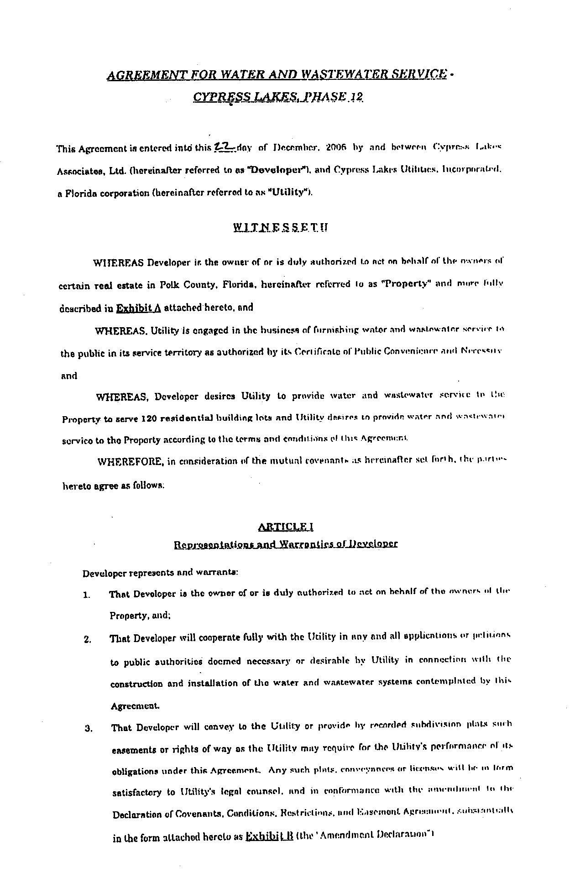
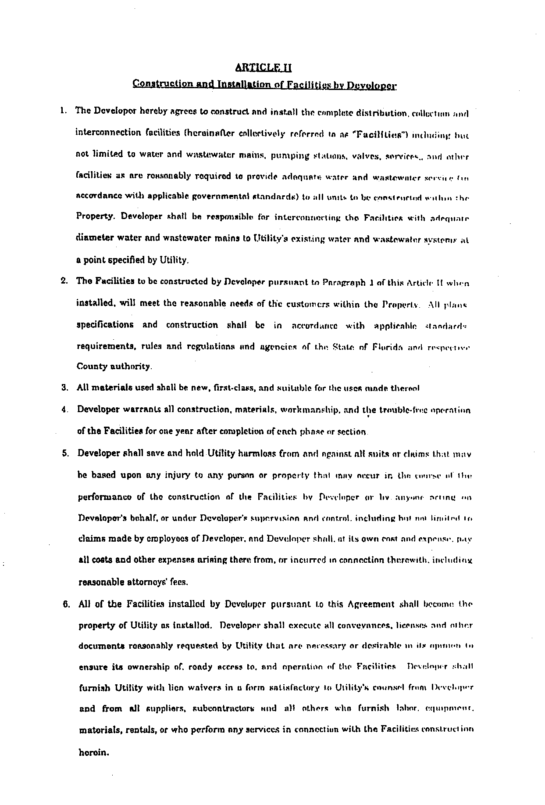
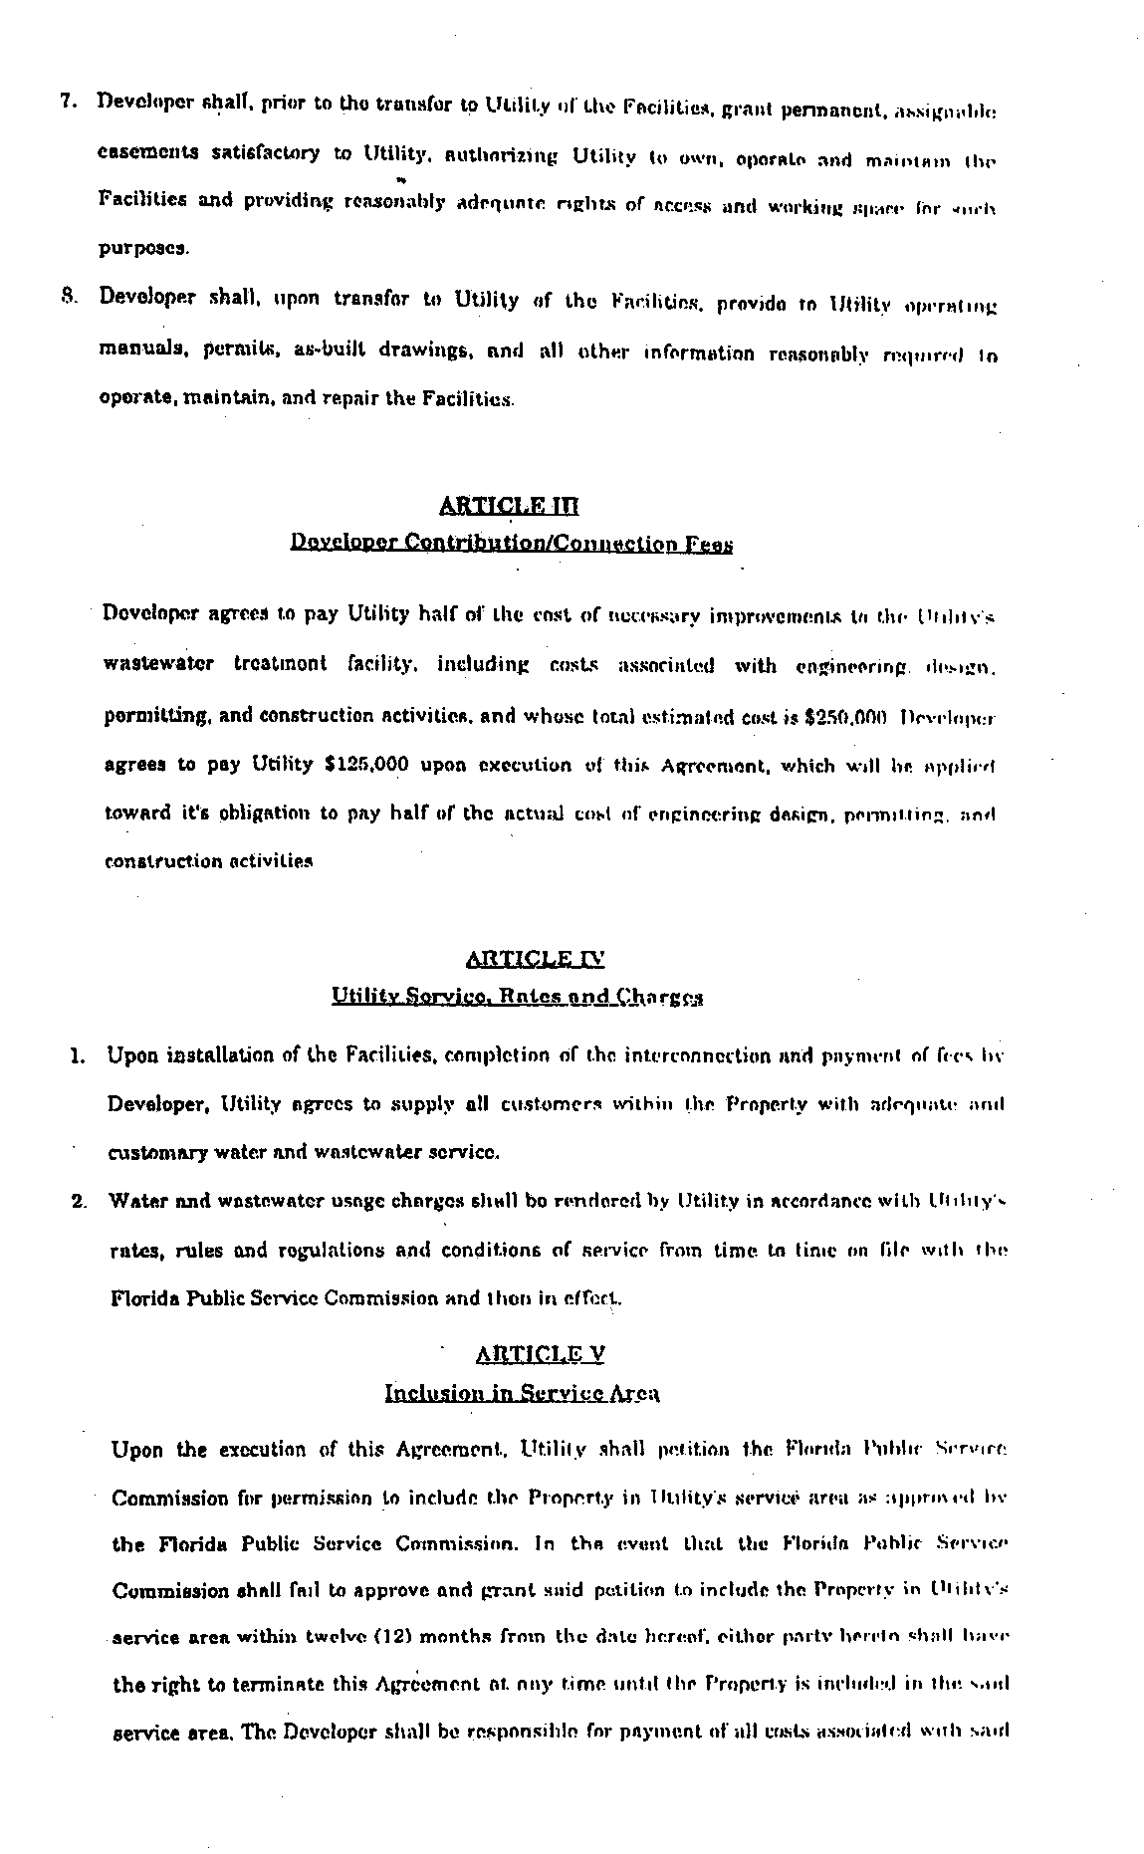
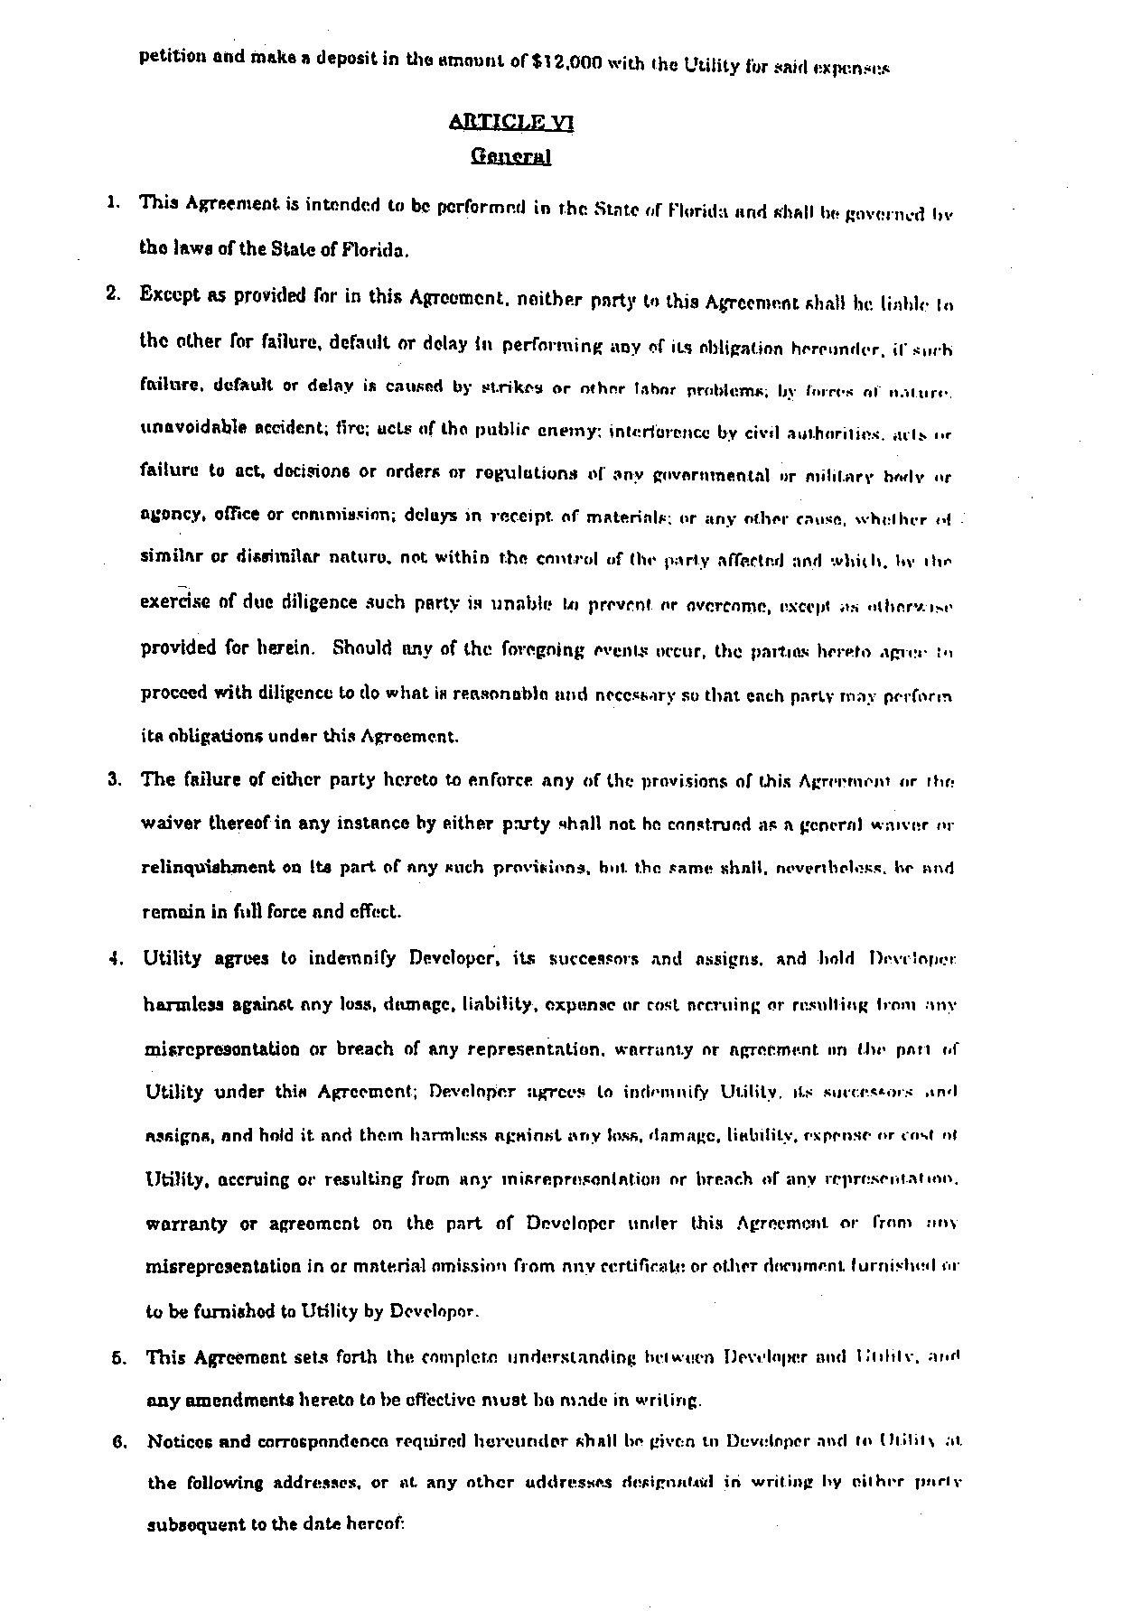
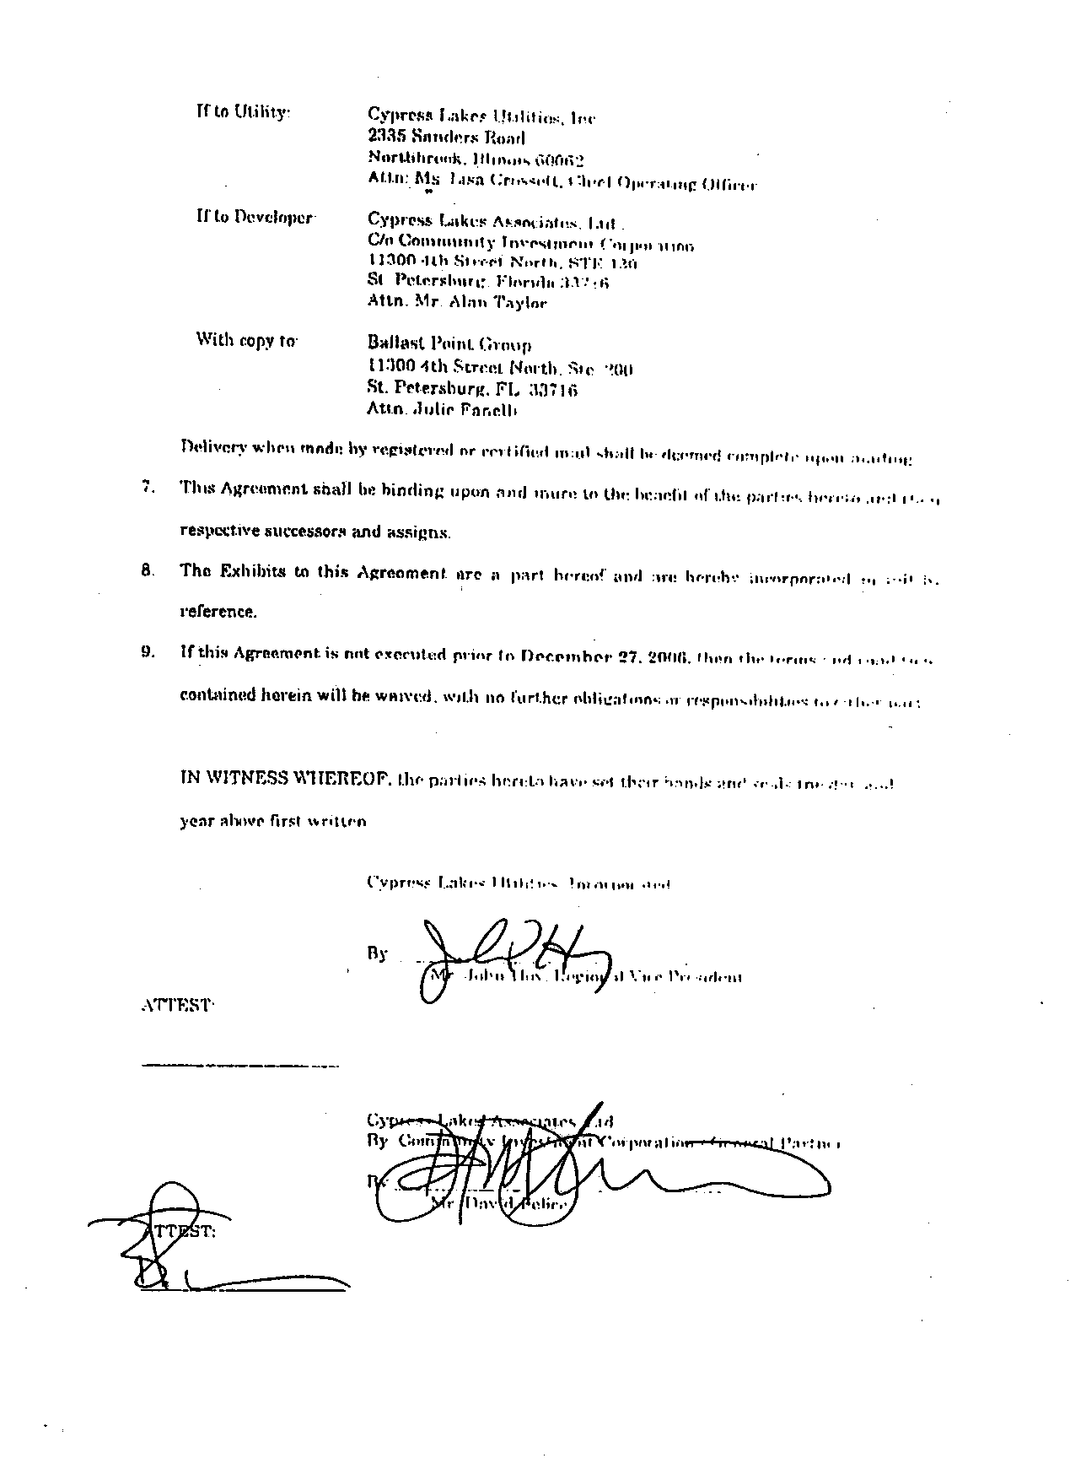
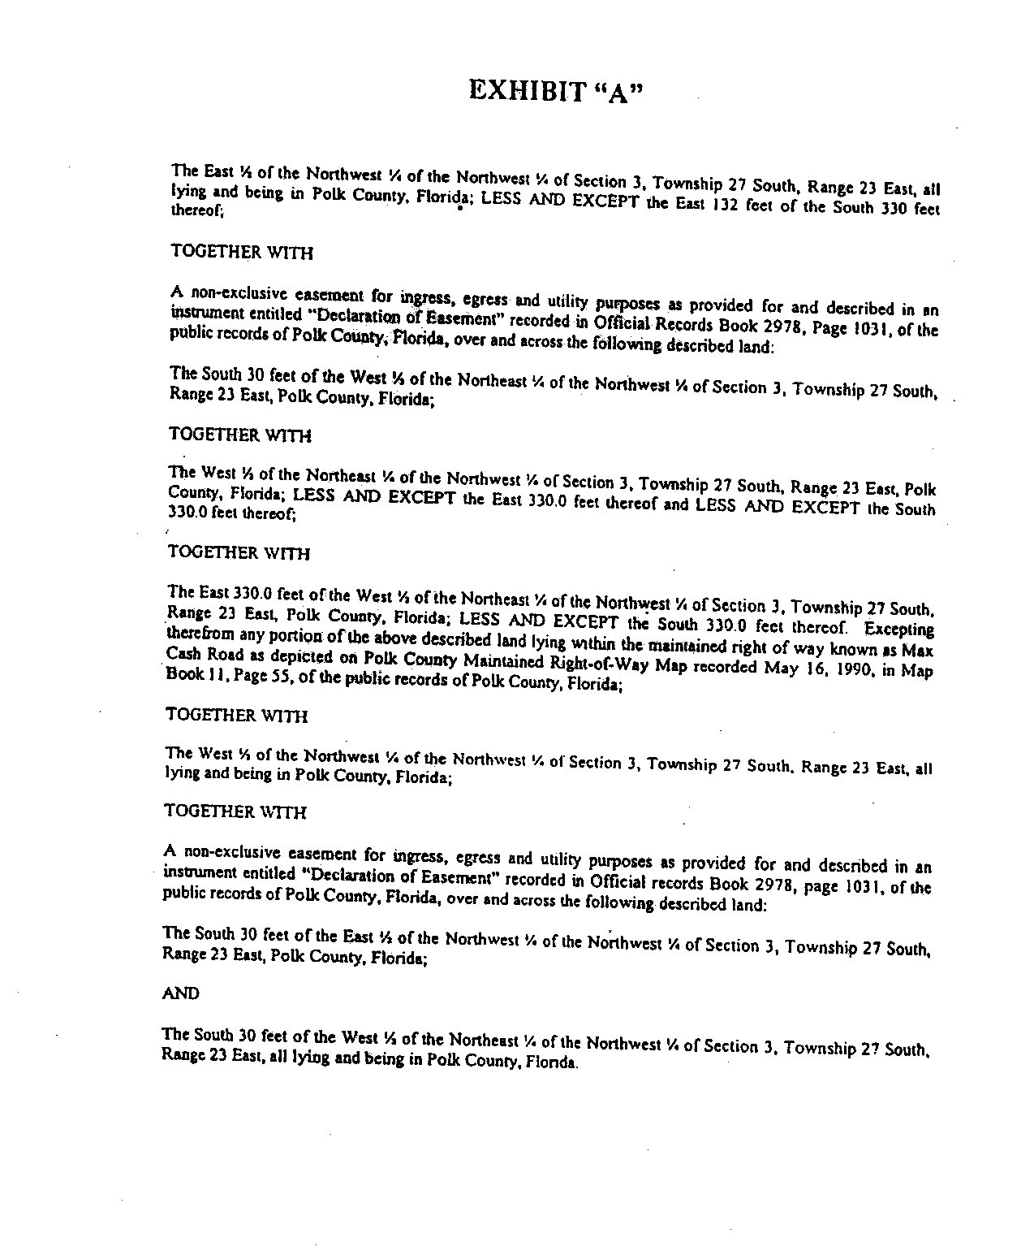

In re: Application for increase in water and wastewater rates in Polk County by Cypress Lakes Utilities, Inc.

