BEFORE THE FLORIDA PUBLIC SERVICE COMMISSION

In re: Petition for extension of governmental adjustment factor tariff and approval of sixth revised tariff sheet No. 9.725 by Florida Power & Light Company. | DOCKET NO. 080223-EI  ORDER NO. PSC-08-0414-TRF-EI  ISSUED: June 23, 2008

The following Commissioners participated in the disposition of this matter:

MATTHEW M. CARTER II, Chairman
LISA POLAK EDGAR
KATRINA J. McMURRIAN
NANCY ARGENZIANO
NATHAN A. SKOP

ORDER APPROVING EXTENSION OF GOVERNMENTAL ADJUSTMENT FACTOR TARIFF AND REVISED TARIFF SHEET

BY THE COMMISSION:

Background
Rule 25-6.115, Florida Administrative Code (F.A.C.), and Florida Power & Light Company’s (FPL) tariff provide the general provisions and terms under which FPL and an applicant (i.e., customer) may enter into a contract for the purpose of converting existing overhead electric distribution facilities to underground. The applicant is required to pay FPL a contribution-in-aid-of-construction (CIAC), which represents the conversion costs incurred by FPL.
In January 2007, the Commission amended Rule 25-6.115, F.A.C., to require investor-owned electric utilities to include the net present value of operational costs including the average historical storm restorations costs over the expected life of the facilities in a CIAC calculation.
In Docket No. 060150-EI, FPL received approval to revise the definition of CIAC to include a governmental adjustment factor (GAF) of 25 percent when the applicant for conversion is a local government meeting specified criteria. The GAF waiver is based on expected savings in storm restoration costs when large contiguous areas are converted from overhead to underground service, and is designed to encourage the installation of underground facilities by reducing the CIAC the customer is required to pay FPL. The 25 percent reduction is based on FPL’s analysis of the 2004 and 2005 hurricane season. Based on the fewer interruptions experienced by underground facilities than overhead facilities, FPL concluded that converting overhead to underground facilities in large communities will reduce the amount of infrastructure damage requiring repair, thereby reducing restoration costs. The general body of ratepayers benefits from these avoided cost savings through the reduction in aggregate storm restoration costs shared by all. In addition, storm restoration overall may proceed more quickly if fewer areas require repair. In the order approving the GAF tariff, we found that the 25 percent reduction represents an average, and that some projects may provide greater or lesser savings to ratepayers.
FPL also received approval to charge the 25 percent reduction not borne by the requesting municipalities as new plant-in-service. In future rate cases, the 25 percent forgone CIAC would be included as an investment to be recovered from the general body of ratepayers.
The GAF tariff is optional, i.e., local governments are not required to utilize the GAF tariff for conversion projects. The GAF tariff is restricted to local governments because local governments are in the best position to guarantee a 100 percent customer conversion participation and to fulfill the GAF requirements, such as undergrounding generally contiguous areas. The GAF tariff is limited to large, contiguous areas because the storm restoration savings are likely to be less than 25 percent for small-scale isolated conversions.
We approved the GAF and associated tariffs as a pilot program to be available for customers that sign undergrounding contracts on or before October 30, 2008. The GAF approval order also directed FPL, at least 60 days prior to the expiration of the GAF tariff, to file a report providing an updated quantification of storm restoration benefits based on any new storm restoration data. Therefore the report would be due by August 31, 2008, i.e., 60 days before October 30, 2008. FPL was also directed to petition us to continue, modify, or discontinue the tariff at that time.
Several municipalities known as the Municipal Underground Utilities Consortium (MUUC) intervened in Docket No. 060150-EI. MUUC members have ongoing interests in converting the existing overhead electric distribution lines in their jurisdictions to underground service, and the majority of its members qualify as “local government applicants” within the scope of FPL’s GAF tariff.
In Docket No. 060198-EI, we required all investor-owned electric utilities to file plans and estimated implementation costs for certain storm preparedness initiatives, including collaborative research. As a result of that directive, FPL, Progress Energy Florida, Tampa Electric Company, Gulf Power Company, Florida Public Utilities Company, Florida Municipal Electric Association, Florida Electric Cooperatives Association, and Lee County Electric Cooperative (collectively the project sponsors) are providing funding to the Public Utility Research Center (PURC) for the coordination of research to investigate the costs and benefits of undergrounding their existing infrastructures. In Phase 1, the existing body of knowledge on the costs and benefits of undergrounding was summarized and analyzed in a report dated February 28, 2007. In Phase 2, actual case studies of overhead-to-underground conversions in four areas of Florida were examined. Phase 3 of the project involves the development and testing of a methodology for analyzing the costs and benefits of specific undergrounding proposals. A model has been produced that electric utilities are currently evaluating. A report on the model is expected to be published by May 30, 2008.
We have jurisdiction pursuant to Sections 366.03, 366.04, 366.05, and 366.06, Florida Statutes.
Decision Approving Extension of GAF Tariff
FPL requests that this Commission: (1) extend the effective period of the GAF tariff so that it will be available to eligible applicants for an additional year beyond the Commission’s original approval, i.e., until October 30, 2009, and (2) accept the report attached to the petition in this docket regarding the status of its continuing efforts to quantify storm restoration costs and benefits in fulfillment of our requirements in the GAF approval order. The report is attached to this order as Attachment A.
In support of its petition, FPL states that the principal source of additional data with which to quantify storm restoration benefits is experience in actual storm restoration. Since the GAF tariff was approved in May 2007, there have been no substantial storms impacting FPL’s service territory. Therefore, FPL has no additional data with which to update the quantification of storm restoration benefits that it provided in support of the GAF tariff. FPL further argues that it has no legitimate basis at this point to change the GAF waiver from the current 25 percent level. FPL finally argues that even if a hurricane struck FPL’s service area in June or July, the interests of its customers would be better served by FPL devoting resources to restoration efforts than compiling and analyzing data on the hurricane for a report to be filed in August 2008.
FPL states that extending the availability period of the GAF tariff will benefit local governments by providing them additional time to implement conversion projects. Large conversion projects require substantial lead times for local governments, and the extension will result in more conversion projects being implemented. This in turn will enable FPL to gather additional cost and benefit information from actual conversion projects.
We find it appropriate to approve FPL’s petition to extend the GAF tariff to be available to eligible customers that sign the agreement on or before October 30, 2009. Extending the tariff will allow additional local governments to enter into undergrounding agreements with FPL. The absence of hurricanes or tropical storms since the approval of the GAF tariff has kept FPL from obtaining additional data to quantify the storm restoration savings due to undergrounding. In the GAF approval order, we found, based on the analysis FPL provided, that the 25 percent is a reasonable percentage. Nevertheless, the GAF waiver may need to be fine-tuned as more information on costs and benefits become available. The absence of hurricanes in the last two years has not allowed FPL to gather additional information. Therefore, we find that, at this point, we have no basis to modify the 25 percent reduction in the otherwise applicable CIAC to recognize the estimated avoided storm restoration costs when large contiguous areas are converted.
Similarly as required by the GAF approving order, FPL shall at least 60 days prior to the expiration of the GAF tariff in October 2009 file a report with this Commission providing an updated quantification of storm restoration benefits based on any new storm-restoration data. Based on the analysis, FPL shall also petition us at that time to continue, modify, or discontinue the tariff.
As noted in the case background, MUUC was a party to Docket No. 060150-EI. FPL states that counsel for MUUC has authorized FPL to represent that MUUC fully supports extension of the availability of the GAF tariff to October 2009.
Based on the foregoing, it is

ORDERED by the Florida Public Service Commission that Florida Power & Light Company’s governmental adjustment factor tariff shall be extended for an additional year until October 30, 2009. It is further

ORDERED that, at least 60 days prior to the expiration of the governmental adjustment factor tariff in October 2009, Florida Power & Light Company shall file a report with this Commission providing an updated quantification of storm restoration benefits based on any new storm-restoration data. It is further

ORDERED that, at that time and based on the analysis of any new storm-restoration data, Florida Power & Light Company shall petition this Commission to continue, modify, or discontinue the tariff. It is further

ORDERED that the tariff approved herein shall become effective on October 31, 2008. It is further

ORDERED that if a protest is filed within 21 days of the issuance of the order, this tariff shall remain in effect, pending resolution of the protest. It is further

ORDERED that if no timely protest is filed, this docket shall be closed upon the issuance of a consummating order.
By ORDER of the Florida Public Service Commission this 23rd day of June, 2008.

/s/ Ann Cole
ANN COLE
Commission Clerk

This is an electronic transmission. A copy of the original signature is available from the Commission's website, www.floridapsc.com, or by faxing a request to the Office of Commission Clerk at 1-850-413-7118.

( S E A L )

ELS

NOTICE OF FURTHER PROCEEDINGS

The Florida Public Service Commission is required by Section 120.569(1), Florida Statutes, to notify parties of any administrative hearing or judicial review of Commission orders that is available under Sections 120.57 or 120.68, Florida Statutes, as well as the procedures and time limits that apply. This notice should not be construed to mean all requests for an administrative hearing or judicial review will be granted or result in the relief sought.

Mediation may be available on a case-by-case basis. If mediation is conducted, it does not affect a substantially interested person's right to a hearing.

The Commission's decision on this tariff is interim in nature and will become final, unless a person whose substantial interests are affected by the proposed action files a petition for a formal proceeding, in the form provided by Rule 28-106.201, Florida Administrative Code. This petition must be received by the Office of Commission Clerk, 2540 Shumard Oak Boulevard, Tallahassee, Florida 32399-0850, by the close of business on July 14, 2008.

In the absence of such a petition, this Order shall become final and effective upon the issuance of a Consummating Order.

Any objection or protest filed in this docket before the issuance date of this order is considered abandoned unless it satisfies the foregoing conditions and is renewed within the specified protest period.
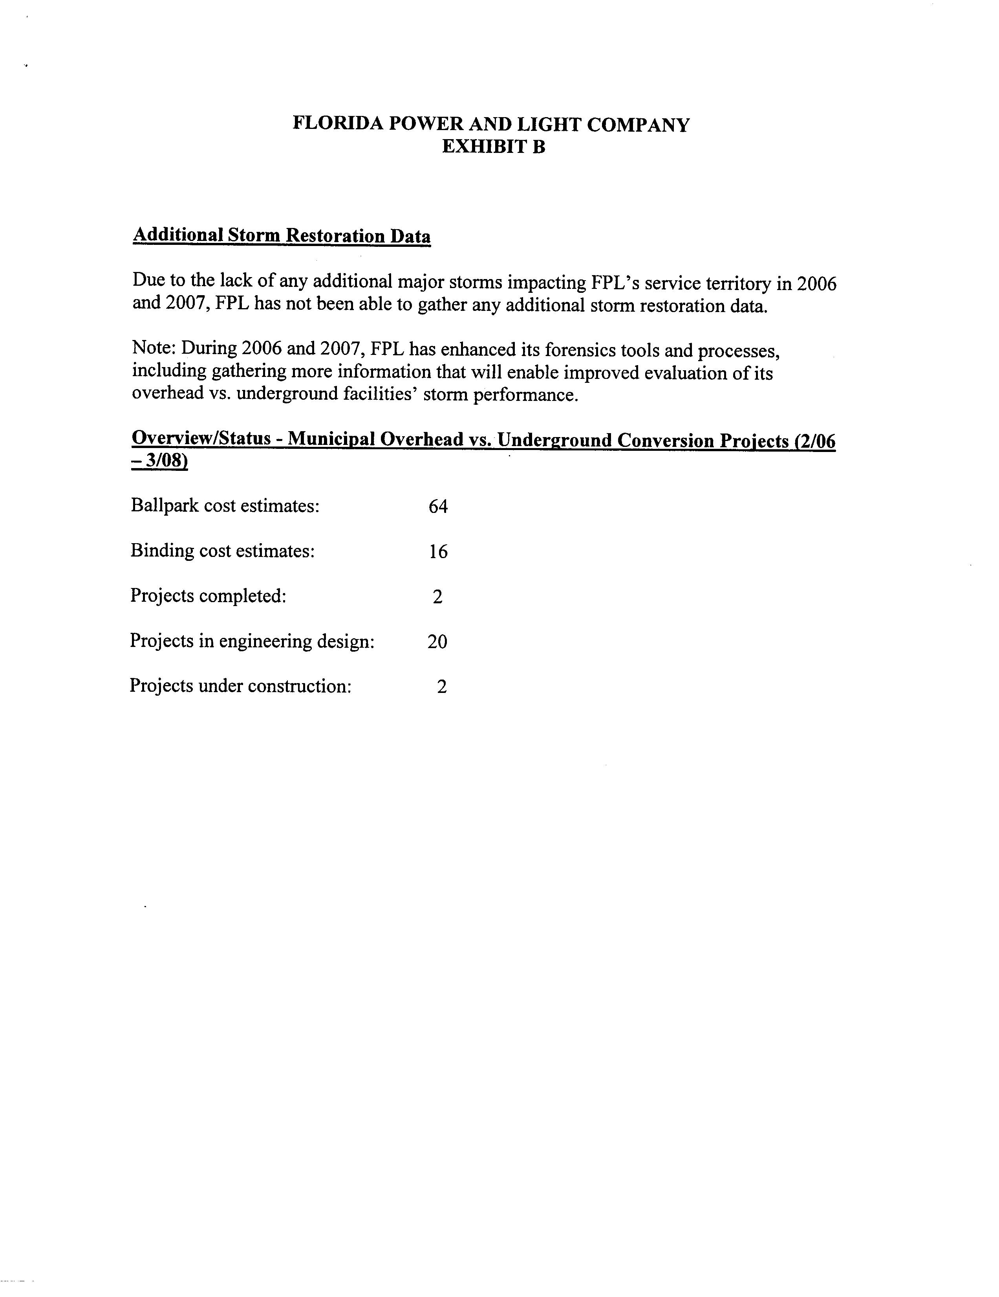

See Order No. PSC-07-0043-FOF-EU, issued January 16, 2007, in Docket No. 060172-EU, In re: Proposed rules governing placement of new electric distribution facilities underground, and conversion of existing overhead distribution facilities to underground facilities, to address effects of extreme weather events.
See Order No. PSC-07-0442-TRF-EI, issued May 22, 2007, in Docket No. 060150-EI, In re: Petition for approval of revisions to contribution-in-aid-of-construction definition in Section 12.1 of First Revised Tariff Sheet No. 6.300, by Florida Power & Light Company.
The intervention was granted in Order No. PSC-07-0442-TRF-EI, p 7.
See Order No. PSC-06-0351-PAA-EI, issued April 25, 2006, in Docket No. 060198-EI, In re: Requirement for investor-owned electric utilities to file ongoing storm preparedness plans and implementation cost estimates.

