State of Florida   |  | Public Service Commission  Capital Circle Office Center ● 2540 Shumard Oak Boulevard  Tallahassee, Florida 32399-0850  -M-E-M-O-R-A-N-D-U-M-
DATE: | December 4, 2009
TO: | Office of Commission Clerk (Cole)
FROM: | Division of Economic Regulation (Kaproth, Bulecza-Banks, D. Buys, Davis, Draper, Hewitt, L'Amoreaux, P. Lee, Piper, A. Roberts, Slemkewicz, Thompson)  Office of the General Counsel (Sayler)  Division of Service, Safety & Consumer Assistance (Hicks, Mills)
RE: | Docket No. 090125-GU – Petition for increase in rates by Florida Division of Chesapeake Utilities Corporation.
AGENDA: | 12/15/09 – Regular Agenda – Proposed Agency Action – Interested Persons May Participate
COMMISSIONERS ASSIGNED: |  |  | All Commissioners
PREHEARING OFFICER: |  |  | Klement
CRITICAL DATES: |  |  | 5-Month Effective Date Waived through 12/15/09 (PAA Rate Case)
SPECIAL INSTRUCTIONS: |  |  | None
FILE NAME AND LOCATION: |  |  | S:\PSC\ECR\WP\090125.RCM.DOC

Table of Contents
Issue Description Page
Case Background 4
TEST PERIOD 6
1 Projected Test Period (Kaproth) 6
2 Bills and Therms (Hewitt, Stallcup) 7
QUALITY OF SERVICE 8
3 Quality of Gas Service (Kaproth, Hicks) 8
RATE BASE 9
4 Unsupported Plant in Service (Kaproth) 9
5 Unsupported Account 473.1, Mains - Steel (Kaproth) 10
6 AMR Communication Equipment (L’Amoreaux) 11
7 Average Service Life, Net Salvage and Depreciation Rate (L’Amoreaux, P. Lee) 13
8 Level of Rate Base (Kaproth) 14
COST OF CAPITAL 15
9 Accumulated Deferred Taxes (Salnova) 15
10 Unamortized Investment Tax Credits (Salnova) 16
11 Reconciliation of Rate Base and Capital Structure (D. Buys) 17
12 Capital Structure (D. Buys) 18
13 Cost Rate for Short-term Debt (Davis) 19
14 Cost Rate for Long-term Debt (Davis) 20
15 Return on Equity (D. Buys) 21
16 Records and Reports in General (Kaproth) 28
17 Weighted Average Cost of Capital (Davis) 30
NET OPERATING INCOME 31
18 Inflation, and Payroll Trend Factors (Hewitt, Kaproth) 31
19 Amortization Period of Positive Acquisition Adjustment (Kaproth, Bulecza-Banks) 33
20 Transition and Transaction Costs (Kaproth, Bulecza-Banks) 35
21 Environmental Clean-up Costs, Recovery Period and Recovery Mechanism (Kaproth) 37
REVENUE REQUIREMENT 40
22 Income Tax Expense (Salnova) 40
23 Net Operating Income (Kaproth) 41
24 Net Operating Income Multiplier (Kaproth) 42
25 Operating Revenue (Kaproth) 43
COST OF SERVICE AND RATE DESIGN 44
26 Cost of Service Methodology (Draper) 44
27 Solar Water Heating Administrative and Billing Service Tariff (Webb) 45
28 Environmental Surcharges (A. Roberts) 49
29 Competitive Firm Transportation Service Discounts (A. Roberts) 51
30 Miscellaneous Service Charges (Thompson) 53
31 Failed Trip Charge (Thompson) 55
32 Meter Re-Read at Consumer Request Charge (Thompson) 56
33 Temporary Disconnect Charge (Thompson) 57
34 Elimination of Cash as a Payment Option (Piper) 58
35 Deposit Charges (Piper) 61
36 Existing FTS-2 and FTS-3 Rate Classes (Thompson) 62
37 Service under Rate Schedules and usage decline (Piper) 63
38 Firm Transportation Charges (Draper) 65
39 Per Therm Usage Charges (Draper) 69
40 Charges for SABS and SAS Shipper Rate Classes (Draper) 71
41 Effective Date for New Rates and Charges (A. Roberts) 73
OTHER ISSUES 74
42 Interim Rate Increase Refund (Kaproth, Slemkewicz) 74
43 Description of all Entries or Adjustments to Various Reports, Books and Records (Kaproth) 75
44 Filing of Merger Data (Sayler, Bulecza-Banks) 76
45 Close Docket (Sayler) 78
Schedule 1 79
Schedule 2 80
Schedule 3 81
Schedule 4 82
Schedule 5 83
Schedule 6 84

Case Background
This proceeding commenced on July 14, 2009, with the filing of a petition for a permanent rate increase by Florida Division of Chesapeake Utilities Corporation. Florida Division of Chesapeake Utilities Corporation (Chesapeake or Company) is an operating division of Chesapeake Utilities Corporation (CUC). The Company is engaged in business as a public utility providing distribution and transportation of gas as defined in Section 366.02, Florida Statutes (F.S.), and is subject to the jurisdiction of the Commission. Chesapeake serves approximately 14,500 customers in Winter Haven, Plant City, St. Cloud, Inverness, Crystal River, and other nearby communities. The Company also provides service to industrial customers in DeSoto, Gadsden, Gilchrist, Holmes, Jackson, Liberty, Suwannee, Union, and Washington Counties, and is ready to provide service, pursuant to an approved territorial agreement, to customers in portions of Pasco County.

Chesapeake requested an increase in its retail rates and charges to generate an increase in annual revenues of $2,965,398. This increase would allow Chesapeake to earn an overall rate of return of 7.15 percent or an 11.50 percent return on equity (range 10.50 to 12.50 percent). The Company based its request on a projected test year ending December 31, 2010. In its petition, Chesapeake stated that 2010 is the appropriate period to be utilized because it best represents expected future operations for use in analyzing the request for rate relief. Chesapeake has elected to have its petition for rate relief processed under the proposed agency action (PAA) procedures authorized by Section 366.06(4), F.S.

In its last rate case the Commission granted Chesapeake a $1,251,900 increase in additional revenues by Order No. PSC-00-2263-FOF-GU. In that order, the Commission found the Company’s jurisdictional rate base to be $21,088,311 for the projected test year ended December 31, 2001. The rate of return was found to be 8.60 percent for the test year using 11.50 percent return on equity.

In Docket No. 040956-GU by Order No. PSC-05-0208-PAA-GU, the Commission granted in part and denied in part Chesapeake’s petition’s for New Customer Classifications and Restructuring of Rates.

In the instant case, the Commission granted Chesapeake, in Order No. PSC-09-0606-PCO-GU, an interim increase of $417,555 in gross annual revenues. This increase would allow the Company to earn an overall rate of return of 6.88 percent or a 10.50 percent return on equity, which is the minimum of the currently authorized return on equity range of 10.50 to 12.50 percent. The Company based its interim request on a historical test year ended December 31, 2008. The interim rates became effective September 17, 2009, for all meter readings made on or after 30 days from the date of the vote approving the interim increase. In the same order, the Commission suspended the final rates and associated tariff revisions proposed by the Company pending a final decision in this docket.

On September 1, 2009, the Office of Public Counsel (OPC) was granted intervention in this proceeding.

Customer meetings were held in Winter Haven on October 14, 2009 and in Crystal River on October 15, 2009. A total of three customers attended the meetings.

On October 28, 2009, CUC and Florida Public Utilities Company (FPUC) announced their corporate merger, whereby, FPUC became a wholly owned subsidiary of CUC. On November 5, 2009, pursuant to Rule 25-9.044(1), Florida Administrative Code (F.A.C.), CUC notified the Commission of its acquisition of FPUC.

Chesapeake’s existing Florida Division, which provides service under the fictitious name “Central Florida Gas Company,” will continue to operate its natural gas distribution utility using the rates, rules, and classifications on file with the Commission.

The newly acquired subsidiary, FPUC, will continue to operate under the name “Florida Public Utilities Company,” as well as the rates, rules, and classifications currently on file with the Commission for both the natural gas utility business and the electric utility business. This proceeding does not affect the rates of FPUC’s gas customers.

This recommendation addresses the requested permanent rate increase by Chesapeake. The Commission has jurisdiction pursuant to Sections 366.041, 366.07, and 366.071, F.S.

Discussion of Issues
TEST PERIOD
Issue 1:
Is Chesapeake's projected test period of the 12 months ending December 31, 2010, appropriate?
Recommendation:
Yes. With the adjustments recommended by staff in the following issues, the projected test year of 2010 is appropriate. (Kaproth)
Staff Analysis:
The Company used actual data for the 2008 historical base test year. This data served as a basis for developing its 2010 projected test year request. The 2010 projected test year was based on the projected level of customers, related revenues, expenses updated for cost changes and trending, capital expenditures, and the projected cost of capital. The projections through 2010 were reviewed and analyzed by staff.
The purpose of the test year is to represent the financial operations of a company during the period in which the new rates will be in effect. Staff believes that the projected test period of the 12 months ending December 31, 2010, as adjusted based on staff’s recommendations in the remaining issues, is representative of the period in which the new rates will be in effect and is appropriate.

Issue 2:
Are the projected bills and therms by rate class for the test year ending December 31, 2010, appropriate for use in this case?
Recommendation:
Yes. The projected number of bills and therms by rate class as contained in Minimum Filing Requirements (MFR) Schedule G-2, pages 10-12, for test year 2010 are appropriate for this rate case. (Hewitt, Stallcup)
Staff Analysis:
Staff reviewed the billing determinates contained in the MFR Schedule G-2, pages 6-8, for the base year plus one and Schedule G-2, pages 10-12 for the projected test year 2010. Staff also reviewed the historical customer data, and the consistency of the projected values with the most recent actual data. According to the Company, the long-term historic trend of consumer data includes the boom years where customer growth rates of 7 percent were seen in 2005 and 2006; which makes it difficult to rely on given the current market uncertainty. The annual average growth rate in the number of consumers fell to 1 percent in 2008 due to the limited building activity in the Company’s service areas. The Company used Fishkind and Associates, Inc. projections from Florida Econocast, April 2009 which indicates that the Florida housing slump will bottom-out in 2009 and begin to recover in late 2010. Therefore, staff believes that the Company’s assumption of 0.75 percent customer growth rate is not overly optimistic.
The Company used the 2000-2008 actual average therm usage of 253 therms for all residential customers for its projected usage for 2009 and 2010 of 258 therms. The Company attributes a modest gain in average projected usage to its effort to add premises with multiple gas appliances, with a large percentage of new residences having added gas appliances such as pool heaters, fire logs, and outdoor kitchens. The large volume therm user forecast was based primarily on individual contacts with each customer and a discussion of consumption projections for 2009 and 2010.
Staff recommends that the billing determinates contained in the MFR Schedule G-2 are appropriate.

QUALITY OF SERVICE
Issue 3:
Is the quality of gas service provided by Chesapeake adequate?
Recommendation:
Staff recommends that the Commission find that the CUC quality of service is satisfactory. (Kaproth, Hicks)
Staff Analysis:
Customer Meetings were held in Winter Haven on October 14, 2009 and in Crystal River on October 15, 2009. The purpose of the meetings was to gather information from customers regarding the Company’s quality of service and its request for a permanent rate increase. No customer attended the meeting in Winter Haven and three customers attended the meeting in Crystal River. Two of the customers voiced opposition to the proposed rate increase.
Quality of service was reviewed by analyzing all complaints taken by the Commission’s Division of Service, Safety, and Consumer Assistance which is an exhibit provided by the Company. This exhibit summarizes complaints from January 1, 2000 to May 31, 2009. The numbers from the testimony exhibit match the Commission’s records. Over this 9 year period, there were a total of 80 complaints, 55 involved billing and 25 involved service. Of the 80 complaints, the Commission complaint staff determined that 25 of the complaints should be designated as apparent infractions; 23 of the infractions related to Chesapeake’s failure to timely respond to complaints within 15 days a required by Rule 25-22.032, F.A.C., 1 violation involved the refund of a deposit, and 1 related to the crediting of an account. During 2008 and 2009, the Commission’s complaint staff determined that 3 complaints should be classified as apparent infractions.
The number of complaints per customer compares favorably with other large Florida Natural Gas utilities. With respect to service quality, Commission records indicate that Chesapeake has not experienced a natural gas outage that would be reportable to the Commission per Rule 25-12.084, F.A.C.
Considering all of the above, staff recommends that the Commission find that the CUC quality of service is satisfactory.

RATE BASE
Issue 4:
Should Plant in Service be adjusted to remove unsupported 2010 Plant in Service based on Audit Finding No. 2?
Recommendation:
No adjustment is necessary to the 2010 Plant in Service balance because additional documents were provided by Chesapeake in its response to the audit report. (Kaproth)

Staff Analysis:
The Company’s records reflected a $32.75 million net increase to the plant in service accounts for the 9 year period ending December 31, 2008. As part of their work to verify the plant balances, staff auditors requested supporting documentation for 244 plant in service transactions totaling $6.19 million (Requests Nos. 7, 25, 41 and 45). The Company provided support for 165 of the 244 transactions totaling $4,052,190. During the audit, Chesapeake stated that documentation for the remaining 79 transactions totaling $2,142,413 either could not be located or was not available.
Chesapeake filed an affidavit with the Commission on August 31, 2009, attesting that Hurricane Jeanne struck Winter Haven, Florida in September 2004, and caused serious structural damage, including severe roof damage, to its office located in Winter Haven, Florida. As a result of the structural damage, some records were destroyed and others lost.
In its written response to Audit Finding No. 2, Chesapeake attached additional documentation totaling $1,946,636. The Company stated that it obtained the support documentation by contacting vendors and asking them to provide duplicate invoices. As some of the missing invoices relate to plant installed 9 years ago, some vendors were no longer in business; as such, Chesapeake was unable to obtain invoices to support all plant. The remaining undocumented amount of plant in service additions is $195,777 ($2,142,413 - $1,946,636). Chesapeake stated that virtually all of the records that remain outstanding and cannot be located are those records that were destroyed by Hurricane Jeanne.
Chesapeake did, however, provide secondary support documentation to justify the remaining plant in service amount of $195,777 which has been verified by staff. The secondary support documentation consisted of the Company’s audited FERC Form 2 (annual report) filed with the Commission, CUC’s U.S. Corporate Tax returns, and CUC’s audited Financial Statements. Staff has reviewed the reconciliation and believes the balance of plant in service on the Company’s books and shown in the MFRs reflects the assets that used in providing utility service.
As the $195,777 represents .6 percent (.006) of the $32,750,000 in plant additions over the 9 year period ending December 31, 2008, and the fact that Chesapeake provided secondary support documentation to justify the plant additions, staff believes that no adjustment is required.

Issue 5:
Should Account 376.1, Mains-Steel, or Account 376.2 – Mains–Plastic, be adjusted due to a continuing property records discrepancy noted in Audit Finding No. 3?
Recommendation:
No. Chesapeake’s revised continuing property records reflect the appropriate account balances for Account 376.1 - Mains-Steel and Account 376.2 - Mains-Plastic of $14,444,603 as of December 31, 1999 and $12,638,540 as of December 31, 2003 and agree with the Federal Energy Regulatory Commission (FERC) Annual Report balances. (Kaproth)
Staff Analysis:
The staff auditors noted that Rule 25-7.014(2), F.A.C., Records and Reports in General, requires that the records shall be maintained in such a manner as to meet the following objectives:
a. An inventory of property record units which may be readily checked for proof of physical existence;
b. The association of costs with such property record units to assure accurate accounting for retirements; and
c. The determination of dates of installation and removal of plant to provide data for use in connection with depreciation studies.
The Company provided the staff auditors with its property records for a sample of fifteen utility accounts. The staff auditors were able to reconcile the prior rate case balance as of December 31, 1999, with the current continuing property records (CPR), except for one material difference of $1,210,750 in Account No. 376.1. However, there was no difference between the Account No. 376.1 balance and the CPR balance as of December 31, 2003.
Chesapeake explained that it converted its records from a manual ledger to a computer- based system in 2005. The discrepancy in Account No. 376.1, which resulted from the change over, was not detected during the change over process. Based on the staff audit finding, Chesapeake researched the error and as a result, filed revised CPRs on October 27, 2009 reflecting the appropriate balance for Account 376.1 Mains-Steel and 376.2 Mains-Plastic of $14,444,603. Based on the revised balances for Account Nos. 376.1 Mains-Steel and 376.2 Mains-Plastic, there is no difference in the net change between the FERC Annual Report balances and the CPR.
Based on the above, the revised continuing property records reflect the appropriate account balances for Account 376.1 - Mains-Steel and Account 376.2 - Mains-Plastic of $14,444,603, as of December 31, 1999, and $12,638,540, as of December 31, 2003, which agrees with the FERC Annual Report balances. Therefore, no adjustment is necessary to either Account 376.1 – Mains–Steel or Account 376.2 – Mains-Plastic.

Issue 6:
Should a sub-account entitled 397.1 AMR Communication Equipment be established?
Recommendation:
No, Sub-Account 397.1 AMR Communication Equipment should not be established. Instead, staff recommends establishing Sub-Accounts 381.1, AMR Meters, and 382.1, AMR Meter Installations. (L’Amoreaux)
Staff Analysis:
Chesapeake asserted that the Company reviewed and evaluated various automatic meter reading (AMR) technology options that could reduce annual meter reading costs, and improve billing reliability and accuracy. After evaluating different technologies, Chesapeake chose the Aclara Star AMR system. The Aclara system is designed for wireless transmission of billing data to the server without the need for hand-held devices. The Aclara system has three major components: the Meter Transmitter Unit (MTU), the Data Collection Unit (DCU), and the network server. The MTU attaches to an existing meter, and reads and transmits data to a DCU. The DCU receives billing data from multiple MTUs and transmits the information daily to the network server. The information received can provide a more accurate picture of consumers’ consumption, useful information which can be provided to ratepayers and gas shippers.

Chesapeake asserted that from April 2007 through early 2008, it conducted a pilot program in Citrus County of Aclara’s STAR AMR equipment. The pilot involved approximately 300 customers. During this pilot, Chesapeake continued to conduct on-site meter readings to verify the accuracy of the AMR system. The pilot showed high reliability and minimal problems. The Company decided to deploy the Aclara system throughout its Florida service territory. Chesapeake believes it will have completed installation by the end of October 2009.

Chesapeake originally proposed to establish Sub-Account 397.1, AMR Communication Equipment, to which the investment in the various AMR components would be booked. When questioned by staff about why the Aclara system should be booked to the communication account rather than the meters account, the Company responded that it believed that a communications Sub-Account was appropriate because the MTUs and DCUs are essentially wireless radio transmitters.

Staff notes that in Docket No. 080163-GU, Florida City Gas requested authorization to establish a new Sub-Account to record the installation costs of its encoder receiver transmitters (ERTs). While Florida City Gas had booked the investment in ERTs to a Sub-Account of Account 381, Meters, they had been expensing the installation costs. The Commission ruled that the ERT installation costs should be booked to Sub-Account 382.1, AMR Meter Installations. The ERTs used by Florida Gas are similar in function to the MTUs used by Chesapeake. Each device transmits measurements to a collection device. However, the ERT collection device is a mobile-based unit, whereas the MTU transmits to a fixed location-based DCU.

Chesapeake subsequently altered its position regarding the establishment of Sub-Account 397.1. Chesapeake now appears to agree with staff that the costs of the AMR system should be booked to in Sub-Account 381.1, AMR Meters, and Sub-Account 382.1, AMR Meter Installations. Chesapeake indicated in response to a staff data request that:

. . . it appears that the purchased cost of the MTU’s should be properly recorded in Account 381, Meters. In addition, the Company upon closer review of commission Order PSC-08-0623-PAA-GU concurs that it did not record the MTU’s appropriately on its books of record or in this filing. The installation cost of the MTU’s should be recorded consistent with how the Company books meter and regulator installation costs, in Account 382, Meter Installations. The Company is prepared to make the necessary adjustments to record these items in the correct Plant Accounts.

However, Chesapeake was silent regarding the account to which the investment in DCUs should be booked. The Code of Federal Regulations describes Account 381, Meters, stating, “this account shall include the cost installed of meters or devices appurtenances thereto, for use in measuring gas delivered to users, whether actually in service or held in reserve.” Based on this definition, staff believes that all of the investments in the Aclara system are properly booked to Sub-Account 381.1, AMR Meters, and associated installation costs should be booked to Sub-Account 382.1, AMR Meter Installations.

Staff recommends that Sub-Account 397.1, AMR Communication Equipment, should not be established. Instead, staff recommends establishing Sub-Accounts 381.1, AMR Meters, and 382.1, AMR Meter Installations.

Issue 7:
What should be the average service life, net salvage and depreciation rate for sub-account 397.1?
Recommendation:
No average service life, net salvage, or depreciation rate needs to be established for Sub-Account 397.1. However, new Sub-Accounts 381.1, AMR Meters, and 382.1, AMR Meter Installations, should have a twenty-year average service life, zero net salvage, resulting in a five percent depreciation rate. (L’Amoreaux, P. Lee)
Staff Analysis:
The Company proposes an average service life of twenty years for the AMR equipment, which is based on the manufacturer’s estimated life for the MTU’s battery. In response to a staff data request, the Company provided work papers regarding the battery life of the MTU and supplied Aclara literature that supports the twenty-year life of the lithium-ion battery contained in the MTU. Staff agrees that the Company’s proposed average service life of twenty years is reasonable and appropriate for Sub-Account 381.1, AMR Meters, and Sub-Account 382.1, AMR Meter Installations.

Chesapeake indicates that when the MTU battery expires, the MTU will be replaced. Refurbishment of the unit or replacement of the battery is not expected. Little resale value other than junk is expected from the retired MTUs. For this reason, staff recommends that a zero net salvage value is appropriate for Sub-Accounts 381.1, AMR Meters, and 382.1, AMR Meter Installations. Pursuant to Rule 25-7.045(8)(a), F.A.C., a gas utility is required to file a depreciation study for the Commission’s review at least once every five years. When Chesapeake files its next study, the depreciation parameters for the AMR system components can be revisited and revised, if warranted.

Staff recommends that no average service life, net salvage, or depreciation rate needs to be set for Sub-Account 397.1. However, new Sub-Accounts 381.1, AMR Meters, and 382.1, AMR Meter Installations, should have a twenty-year average service life, zero net salvage, resulting in a five percent depreciation rate.

Issue 8:
Is Chesapeake's requested rate base in the amount of $46,683,296 for the 2010 projected test year appropriate?
Recommendation:
Yes, $46,683,296 is the appropriate amount of rate base for the 2010 projected test year. (Kaproth)
Staff Analysis:
This is a fallout issue. Staff has not recommended any adjustments to Chesapeake’s proposed 13-month average rate base of $46,683,296 for the 2010 projected test year. (See Schedule 1)

COST OF CAPITAL
Issue 9:
What is the appropriate amount of accumulated deferred taxes to include in the capital structure for the projected test year?
Recommendation:
The appropriate amount of accumulated deferred taxes to include in the capital structure of Chesapeake Utilities Corporation for the 2010 projected test year is $7,454,209, as shown on Schedule 2. (Salnova)
Staff Analysis:
In MFR Schedule G-3, page 2, Chesapeake proposed $7,454,209 of accumulated deferred income taxes (ADITs) to include in the Company’s capital structure for the 2010 projected test year. The 13-month average balance of ADITs was calculated, as shown on Schedule G-1, page 8. ADITs represent the deferred tax liability that arises from timing differences between pretax accounting income and taxable income. A temporary difference originates in one period and reverses in one or more subsequent periods. ADITs are also a component of the capital structure.
Chesapeake has utilized the “bonus” depreciation allowed on its Federal tax returns which has increased the level of Deferred Income Taxes, thus lowering the overall cost of capital. Staff agrees that the methodology used by Chesapeake to calculate ADIT is proper and is consistent with SFAS 109, Internal Revenue Code, and Income Tax Regulations covering the projected test year. However, the appropriate amount of ADIT is affected by other adjustments made by the Commission. The net effect is an increase in the balance of ADITs. Based on staff’s recommendations, the appropriate amount of accumulated deferred taxes to include in the capital structure of Chesapeake for the 2010 projected test year is $7,454,209, as shown on Schedule 2.

Issue 10:
What is the appropriate amount and cost rate of the unamortized investment tax credits to include in the capital structure for the projected test year?
Recommendation:
The appropriate amount and cost rate of the unamortized investment tax credits to include in the capital structure for the 2010 projected year are $123,004 and zero percent, respectively, as shown on Schedule 2. (Salnova)
Staff Analysis:
In its MFR Schedule G-3, Chesapeake proposed a balance of $123,004 of unamortized investment tax credits (ITC) to be included in the Company’s capital structure for the 2010 projected test year. The ITC balance has been amortized over the life of the assets that generated the credits. As a result of the 2007 Depreciation Study (Docket No. 070322-GU), the Commission ordered the Company to reflect the effect of the approved changes in the remaining lives of the related assets on the current amortization of the ITC and on the flowback of excess deferred income taxes.
The Company performed the review and determined that the above items were not impacted as a result of the Depreciation Study. The annual amortization of the ITCs in the amount of $19,523 has remained unchanged since the Company’s 2000 rate case (Docket No. 000108-GU). Staff believes that Chesapeake’s methodology for calculating the balance of the ITCs is appropriate and is in accordance with IRS requirements. However, the appropriate amount of ITCs is affected by other adjustments made by the Commission. The net effect is an increase in the balance of ITCs. Based on staff’s recommendations, the appropriate amount and cost of unamortized ITCs to include in Chesapeake’s capital structure for the 2010 projected test year are $123,004 and zero percent, respectively.

Issue 11:
Have rate base and capital structure been reconciled appropriately?
Recommendation:
Yes. Rate base and capital structure have been reconciled appropriately. (D. Buys)
Staff Analysis:
To reconcile capital structure to rate base, Chesapeake first removed the amounts for customer deposits, deferred taxes, and investment tax credits from rate base. The remaining rate base balance was reconciled over investor sources of capital at the same ratios maintained by CUC. The full amounts for customer deposits, deferred taxes, and investment tax credits were then added to the capital structure. These adjustments are consistent with Chesapeake’s last rate case. Accordingly, staff recommends that rate base and capital structure have been reconciled appropriately.

Issue 12:
What is the appropriate capital structure for the projected test year?
Recommendation:
The appropriate capital structure for the purpose of setting rates in this proceeding reflects a projected equity ratio of approximately 54 percent as a percentage of investor-supplied capital. The appropriate capital structure for the projected 2010 test year is detailed on Schedule 2. (D. Buys)
Staff Analysis:
On MFR Schedule G-3, page 2, Chesapeake filed a projected capital structure based on a 13-month average. This capital structure as filed reflects an equity ratio of 54.11 percent as a percentage of investor capital. First, Chesapeake included customer deposits in the amount of $1,580,224, deferred income taxes in the net amount of $7,454,209, and ITCs in the amount of $123,004 in the capital structure. The Company then made pro rata adjustments to common equity, long-term debt, and short-term debt to reflect the same capital structure ratios maintained by Chesapeake Utilities Corporation. Historically, the Commission has determined the appropriate capital structure, in part, based upon the relationship between the regulated utility and its parent company. In a divisional relationship, as in this case, the Commission has used the consolidated capital structure of the parent company. This methodology is also consistent with the Company’s last rate case. Accordingly, staff recommends that the appropriate capital structure for the purposes of setting rates in this proceeding is the capital structure detailed on Schedule 2.

Issue 13:
What is the appropriate cost rate for short-term debt for the projected test year?
Recommendation:
The appropriate cost rate for short-term debt for the projected test year is 2.90 percent. (Davis)
Staff Analysis:
Staff agrees with the Company’s methodology and calculation of short-term debt. The current Blue Chip Financial Forecast (Blue Chip) issued November 1, 2009 indicates projected cost rates for short-term debt ranging from the three month London Interbank Offered Rate (LIBOR) of .6 percent to the prime bank rate of 3.2 percent for the first quarter of 2010. These projected rates increase to a LIBOR rate of 1.3 percent and a prime bank rate of 4.0 percent by the fourth quarter of 2010. The Company’s cost of short-term debt for historic year 2008 was 2.89 percent. Based upon the Company’s recent experience and the projected cost rates for short-term debt published by Blue Chip, staff agrees that the proposed cost rate for short-term debt of 2.90 percent is reasonable.

Issue 14:
What is the appropriate cost rate for long-term debt for the projected test year?
Recommendation:
The appropriate cost rate for long-term debt for the projected test year is 5.76 percent. (Davis)
Staff Analysis:
Staff agrees with the Company’s methodology and calculation of the cost rate for long-term debt for the projected test year. Chesapeake is an operating division of CUC. Neither CUC nor Chesapeake has a corporate bond rating. The current Blue Chip Financial Forecast (Blue Chip) issued November 1, 2009 reports projected yields on Aaa-rated bonds of 5.3 to 5.7 percent through the fourth quarter of 2010. Blue Chip projects cost rates for Baa-rated bonds of 6.5 to 6.9 percent for this same time period. Based upon the Company’s recent experience and the projected cost rates for long-term debt published by Blue Chip, staff agrees that the Company proposed long-term debt rate of 5.76 percent is reasonable.

Issue 15:
What is the appropriate return on common equity for the projected test year?
Recommendation:
The appropriate return on common equity for the projected test year is 10.8 percent with a range of plus or minus 100 basis points. (D. Buys)
Staff Analysis:
Chesapeake requested a return on common equity (ROE) of 11.5 percent. The Company’s current authorized ROE of 11.5 percent was approved in Order No. PSC-00-2263-FOF-GU, issued November 28, 2000.
Chesapeake requested that the Commission handle its request for a rate increase as a PAA, and consequently, the Commission has not held a hearing on this matter. To support its requested ROE of 11.5 percent, Chesapeake provided the computations and results of four cost of equity valuation methods: the Discounted Cash Flow (DCF) model, the Risk Premium (RP) analysis method, the Capital Asset Pricing Model (CAPM), and the Comparable Earnings (CE) approach. No other parties submitted pre-filed testimony in this docket regarding the appropriate ROE.
Based on the statutory principles for determining the appropriate rate of return for a regulated utility set forth by the U.S. Supreme Court in its Hope and Bluefield decisions, Chesapeake developed two groups of comparable risk utilities to determine its proposed ROE. Chesapeake’s first group (Gas Group) consisted of eight gas companies from the twelve gas companies contained in The Value Line Investment Survey (Value Line). The Company’s second group consisted of the Standard & Poor’s Public Utilities (S&P Utilities). Chesapeake applied the cost of equity valuation methods and models using the average data for the Gas Group and S&P Utilities.
Chesapeake conducted a fundamental risk analysis to determine the Company’s relative risk position within the gas industry by comparing the financial data for the Company, the Gas Group, and the S&P Utilities. Chesapeake compared the capitalization size, market ratios, common equity ratios, return on book equity, operating ratios, coverage ratio, quality of earnings, internally generated funds, and beta. Based on this analysis, the Company concluded that due to its smaller size and higher earnings variability, Chesapeake was more risky than the Gas Group.
Chesapeake’s ROE Valuation Methods and Models
DCF
Chesapeake used a simplified form of the Gordon Model in its DCF analysis to estimate an ROE of 11.49 percent. This DCF model defines the cost of equity as the sum of the adjusted dividend yield and expectations of future growth in cash flows to investors, including dividends and future appreciation in stock price. The Company added a leverage adjustment and flotation cost adjustment to the results from the DCF model. This analysis resulted in an adjusted dividend yield of 4.6 percent, a growth rate of 6.0 percent, a leverage adjustment of 0.66 percent, and a flotation cost adjustment of 23 basis points for a sum of 11.49 percent (4.6 + 6.0 + 0.66 + 0.23 = 11.49).
Chesapeake’s dividend yield of 4.6 percent was based on the average dividend yield of 4.45 percent for the Gas Group during the six-month period November 2008 through April 2009. The Company adjusted the average 4.45 percent dividend yield upwards by 3.0 percent to account for an expected higher yield in the future which resulted in a dividend yield of 4.6 percent.
The Company’s growth rate of 6 percent was derived from the 5-year projected growth rates of earnings per share (EPS) for the Gas Group from IBES/First Call, Zacks, and Value Line. Those growth rates ranged from 4.88 percent to 6.99 percent. Chesapeake disregarded the Value Line projection of 4.88 percent because Value Line’s EPS projection is greater than its dividends per share projection of 4.0 percent which indicates a declining dividend payout ratio for the future. The Company’s growth rate of 6.0 percent was based on its opinion of investor expectations and not on a mathematical formula.
The third component of Chesapeake’s DCF-based ROE calculation is a leverage adjustment of 0.66 percent. The Company explained the leverage adjustment is needed when the results of the DCF model are to be applied to a capital structure that is different than indicated by the market price. Chesapeake explained that the capital structure ratios measured at the utility’s book value show more financial leverage and higher risk, than the capitalization measured at its market value. Hence, it is necessary to develop a cost of equity that reflects the higher financial risk related to the book value capitalization used for rate setting purposes. Using the Modigliani and Miller theory, the Company calculated that the cost of equity increases by 0.66 percent when the book value of equity (57 percent), rather than the market value of equity (70 percent), is used for rate setting purposes.
To adjust for the cost of raising new common equity capital, Chesapeake multiplied a flotation cost adjustment factor of 1.02 (an increase of 2 percent) to the unadjusted DCF result of 11.26 percent for a final DCF result of 11.49 percent. The flotation cost adjustment equates to an addition of 23 basis points. The Company explained that flotation costs are shown to be 4 percent for public offerings of common stocks by gas companies from 2003 to 2007. Chesapeake believes that because flotation costs are not recovered elsewhere, they must be recognized in the rate of return. Chesapeake explained that it used a flotation cost adjustment factor of 1.02 because it applied the flotation cost adjustment to the entire unadjusted DCF result; not just a portion of the DCF model, such as the dividend yield.
RISK PREMIUM
In the risk premium approach, Chesapeake added a premium for the Company’s financial risk to a prospective yield for long-term public utility debt, plus an adjustment for flotation costs. Chesapeake used a forecasted yield on A-rated public utility bonds of 6.5 percent for its prospective yield for long-term public utility debt. The Company added an equity risk premium of 5.5 percent to the forecasted yield on A-rated public utility bonds for a sum of 12.0 percent. Chesapeake added 23 basis points for flotation costs for a result of 12.23 percent.
To estimate the forecasted yield on A-rated public utility bonds, the company combined the forecasted yields on long-term Treasury bonds published in the Blue Chip Financial Forecasts (Blue Chip) issued on April 1, 2009, plus a yield spread of 2.5 percent. Chesapeake based its yield spread of 2.5 percent on the average yield spread between A-rated public utility bonds and 20-year Treasury bonds over the twelve-month period from May 2008 through April 2009.
Chesapeake calculated its equity risk premium by comparing the earned returns on utility stocks to the earned returns on utility bonds. The Company used the S&P Public Utility index to measure the market returns for utility stocks and used the annual yields on public utility bonds to measure the returns on public utility bonds. Chesapeake analyzed four time periods and determined the central tendency of the historical returns for each period. The Company calculated the risk difference or spread between the results to arrive at risk premiums for the four periods of 5.51 percent, 6.58 percent, 6.08 percent, and 6.37 percent. From those four results Chesapeake reasoned that 6.23 percent represents a reasonable risk premium for the S&P Public Utilities. Chesapeake explained that the risk premium of the Gas Group is approximately 88 percent of the risk premium of the S&P Public Utilities based on various differences in the financial fundamentals between the Gas Group and the S&P Public Utilities. The Company opined that a lower risk premium of 5.5 percent for the Gas Group is reasonable in this case.
CAPM
Chesapeake also used a CAPM approach that consisted of three components: a risk-free rate of return, the beta measure of systematic risk, and the market risk premium. The Company used a risk-free rate of 4 percent, a beta of 0.77, and a market risk premium of 8.66 percent. This equates to a cost of equity of 10.67 percent (4.0% + (0.77 x 8.66%) = 10.67%). Chesapeake added a size premium adjustment of 0.94 percent to account for the smaller market capitalization of the Gas Group and added an adjustment of 23 basis points for flotation costs. The Company’s CAPM result for the Gas Group was 11.84 percent (4.0% + (0.77 x 8.66%) + 0.94% + 0.23% = 11.84%).
Chesapeake based its 4.0 percent risk-free rate on the historical yields of 20-year Treasury bonds and the forecasts for the yields on 30-year Treasury bonds published in the April 1, 2009, Blue Chip. The twelve-month average yield for 20-year Treasury bonds from May 2008 through April 2009 was 4.14 percent. The Company indicated the yields for the 30-year Treasury bonds are expected to increase from 3.5 percent in the second quarter of 2009 to 4.3 percent in the third quarter of 2010. Chesapeake contends that forecasts of interest rates should be emphasized to recognize the trend of increasing yields into the future.
The Company used a beta of 0.77 for the Gas Group in its CAPM calculation. Chesapeake based its beta on the average of the betas for the companies in the Gas Group listed in the March 13, 2009, edition of Value Line, which was 0.66. The Company explained that the Value Line betas are based on market value and should be adjusted to reflect the financial risk associated with the rate setting capital structure that is measured at book value. Chesapeake used the Hamada formula to calculate a leveraged beta of 0.77 for the book value capital structure of the Gas Group.
The Company’s market premium in its CAPM was calculated from the total return on the market of equities using forecast and historical data. For the forecast data, Chesapeake used the September 12, 2008, edition of Value Line to determine the forecasted total return of 1,700 stocks in the Value Line Survey. The result was 17.22 percent. For the historical data, the Company calculated the DCF return on the S&P 500 Composite index as of April 30, 2009. The result for the historical market return was 13.29 percent. Chesapeake calculated the average of the 17.22 percent and 13.29 percent result for a combined total market return of 15.26 percent. The Company then subtracted the risk-free rate of 4.0 percent from the total market return of 15.26 percent to arrive at a market premium of 11.26 percent.
Chesapeake added 0.94 percent to its CAPM calculation to account for the smaller size of the Gas Group as compared to the market as a whole. The Company contends that the CAPM could understate the cost of equity according to a company’s size. Chesapeake explained that as the market capitalization of a company decreases, its risk and required return increases. Although the average market capitalization for the Gas Group was in the small-cap range, the Company adopted an adjustment for companies in the mid-cap range to provide a more conservative representation of the size adjustment.
COMPARABLE EARNINGS
Chesapeake applied the comparable earnings approach to analyze returns earned by other non-regulated firms of comparable risk. The Company selected twelve companies from the Value Line universe of 1700 companies that he believed have similar risk parameters to the Gas Group. Chesapeake used six Value Line rankings criteria to select the comparable companies. The criteria were: timeliness rank, safety rank, financial strength, price stability index, beta, and technical rank. The Company calculated the median rates of return for the comparable earnings group of companies over a ten-year period including five historical years and five projected years. The median rate of return for the comparable earnings group over the five-year historical period from 2003 through 2007 was 14.6 percent. The median rate of return over the forecasted period from 2011 through 2013 is 12.8 percent. Chesapeake used the average rates of return for the historical and forecasted periods to compute a cost of equity of 13.7 percent. Chesapeake indicated that it used the results from its comparable earnings method to confirm the results of the Company’s market based models. A summary of the results of Chesapeake’s ROE models is as follows:
Model | Gas Group
DCF | 11.49%
RP | 12.23%
CAPM | 11.84%
Comparable Earnings | 13.70%

The Company concluded that based on the application of a variety of methods and models a reasonable cost of common equity for Chesapeake is 11.5 percent.
ANALYSIS
The Company’s ROE analysis relied on the evaluation of a group of eight gas companies (the Gas Group) selected from Value Line. Chesapeake used four different methodologies to estimate a cost of equity for the Gas Group. In many instances, the Company used dated information for estimates of the inputs for the models. In both the CAPM and the DCF models, the Company made an upward market-to-book value adjustment to the results of both models. In its final analysis, Chesapeake used subjective judgement to interpret the results of those models to derive an estimate for the required ROE.
The indicated return from Chesapeake’s DCF model appears higher than the data suggests. The Company eliminated the Value Line EPS from its data supporting the 5-year projected growth rates. If the Value Line EPS data was considered, the average projected growth rate would be 5.84 percent. Chesapeake added a leverage adjustment to its DCF computation based on its estimate of market value equity ratio of 70 percent for the Gas Group. The Company did not provide any data to support its 70 percent market value ratio. According to AUS, Inc., the average book value equity ratio of the Gas Group is 52 percent compared to Chesapeake’s equity ratio of 54 percent. Hence, a leverage adjustment is not appropriate in this case. Using 4.60 percent for the dividend/price component, 5.84 percent for the growth component, and allowing a flotation factor of 1.02 equates to a DCF result of 10.65 percent (4.60% + 5.84% = 10.44 x 1.02 = 10.65).
The indicated return from the risk premium model also appears overstated. Chesapeake’s risk premium model assumed a yield spread between A-rated public utility bonds over 20-year treasury bonds of 2.5 percent. The Company’s yield spread is based on a twelve month period during which the credit markets experienced higher than normal volatility. This caused the yield spreads to be much wider than recent history showed. The average yield spread from December 1998 through April 2009 is only 1.6 percent. The forecasted yields on 30-year Treasury bonds published in the November 1, 2009, Blue Chip averages 4.6 percent for the four quarters in 2010. Adding a yield spread of 1.6 percent to the 30-year Treasury bond rate of 4.6 percent results in a prospective yield for long-term public utility debt of 6.2 percent. In addition, there is considerable academic research and empirical evidence documenting that risk premiums based on historical earned returns are poor predictors of current market expectations. Putting aside the issue of how the market risk premium was estimated, adding the 5.5 percent risk premium to the prospective yield on longer-term utility bonds of 6.2 percent indicates a return of 11.7 percent.
The Company’s CAPM was based partially on forecasted data from the September 12, 2008, edition of Value Line. Using the most current issue dated November 6, 2009, the market premium component in the CAPM would decrease from 8.66 percent to 7.99 percent. However, the academic criticism of using historical earned returns to estimate the prospective risk premium also applies to the Company’s CAPM analysis. In addition, the Company increased the beta by again using a market-to-book adjustment based on a 70 percent market value equity ratio. Putting aside the issue of how the market risk premium was established, using a current market premium component and the actual Value Line beta measurements, the CAPM indicates a return of 10.44 percent.
The Company chose twelve companies for its Comparable Earnings approach. Based on Value Line data, the Comparable Earnings group is more risky than the Gas Group. The average beta for the Comparable Earnings Group is 88 compared to the average beta of 66 for the Gas Group. Both the average Timeliness Rank and average Safety Rank for the Comparable Earnings Group are slightly greater than the Gas Group. The Value Line ranking criteria collectively indicate that an investment in the Comparable Earnings Group is riskier than an investment in the Gas Group, and thus the expected ROE would be less for the Gas Group.
It is generally accepted that earned or realized returns can and do differ significantly from investor required returns. Investors’ required returns are a function of investors’ expectations of risk and return on a prospective basis. It is reasonable to assume that investors recognize that historical returns are not necessarily a good indicator of future expected returns. There is little doubt that the recent financial crisis and disruption in the capital markets has exerted some degree of upward pressure on current expectations for the market risk premium. However, staff believes the incremental increase in required return, whatever the appropriate amount may be, should be applied to a more up-to-date estimate of the investor-required return.
The Company believes Chesapeake is more risky than the Gas Group because of Chesapeake’s smaller size and higher earnings variability. The Company believes that the cost of equity for the Gas Group provides a conservative measure for Chesapeake and would only partially compensate for its higher risk.
It is evident that Chesapeake is smaller than the companies in the Gas Group. The average market capitalization of the Gas Group is approximately $1.75 billion compared to $220 million for CUC. Chesapeake provided only 4.5 percent of CUC’s annual revenue in 2008. Market capitalization is a measure of a company’s share price multiplied by the total number of shares outstanding. Staff believes that Chesapeake’s smaller size argument is disingenuous based on the fact that Chesapeake is a division of CUC and does not issue its own stock. Hence, Chesapeake does not have a market capitalization measure.
The Company based its earnings variability evaluation solely on the annual returns on book equity for the five years from 2003 through 2007 for the Gas Group, the S&P Public Utilities, and Chesapeake. This evaluation consisted of calculating the coefficient of variation on five data points which statistically is insignificant. Further, the coefficient of variation is based on return over book equity. The level of equity for Chesapeake is determined by the management of CUC, not the market, thus rendering the data less meaningful for comparison purposes. Staff believes that the Company has not provided convincing evidence that Chesapeake is riskier than the Gas Group.
According to AUS Inc., the authorized ROE for the companies in the Gas Group ranges from 10.0 percent to 11.67 percent. The average authorized ROE for the Gas Group is 10.45 percent. The average book value common equity ratio for the Gas Group is 52 percent as compared to 54 percent for CUC as reported by AUS, Inc. Chesapeake’s equity ratio for the projected 2010 test year is also 54 percent as discussed in Issue 12. Staff does not believe the investor-required ROE for Chesapeake is 105 basis points greater than the average authorized ROE for the Company’s Gas Group. Finally, it is reasonable to consider recent Commission decisions in other rate cases for natural gas companies. On May 27, 2009, the Commission authorized a ROE of 10.85 percent with an equity ratio of 48.13 percent for Florida Public Utilities Company. On June 9, 2009, the Commission authorized an ROE of 10.75 percent with an equity ratio of 54.74 percent for Peoples Gas System.
CONCLUSION
Staff recommends an authorized ROE of 10.8 percent. This return is above the average authorized ROE for a group of gas companies identified by the Company as having comparable business traits and risk parameters as Chesapeake. Staff believes this level of ROE also compensates for the financial risk associated with Chesapeake’s capital structure. For the reasons discussed above, staff recommends the Commission set an authorized ROE of 10.8 percent with a range of plus or minus 100 basis points for Chesapeake.

Issue 16:
Should the Return on Equity be reduced for the failure to adequately preserve and maintain plant records required by Rule 25-7.014(5), F.A.C., Records and Reports in General?

Recommendation:
Yes. As Chesapeake failed to adequately preserve and maintain plant records as required by Rule 25-7.014(5), its return on equity (ROE) should be reduced by 5 basis points. The 5 basis point ROE reduction is only for the purpose of calculating the appropriate amount of the revenue requirement. The recommended 10.80 percent ROE should be used for all other purposes. The effect of the 5 basis point reduction to staff’s recommended ROE of 10.80 percent is an ROE of 10.75 percent, resulting in a $15,045 reduction in the revenue requirement. (Kaproth)

Staff Analysis:
Chesapeake filed an affidavit with the Commission on August 31, 2009, attesting that Hurricane Jeanne struck Winter Haven, Florida in September 2004, and caused serious structural damage, including severe roof damage, to its office located in Winter Haven, Florida. As a result of the structural damage, some records were destroyed and others lost. As addressed in Issue 4 of this case, the Company was unable to provide primary support documentation for 100 percent of its plant additions. Chesapeake did provide sufficient secondary evidence to support its plant additions; however, secondary evidence is still less compelling than duplicate backup documents.

Rule 25-7.014(5), F.A.C., states that a utility shall furnish the Commission with any information concerning the facilities or operations which the Commission may request and require for determining rates and judging the practices of the utility. The intention of this rule is to ensure that a utility can justify the level of plant that is being used to provide utility service.

Hurricane Jeanne destroyed primary documentation necessary to support Chesapeake’s plant additions. Section 120.542, F.S., allows a utility to request a rule waiver when compliance with the rule would create a substantial hardship or would violate principles of fairness. Therefore, once the loss was discovered, Chesapeake should have filed a petition for rule waiver based on the destruction of the records by a natural disaster, requesting that plant additions be supported by secondary documents.

Currently, the utility is implementing an electronic document program called DocLink, which provides an original electronic document that the Company will retain in accordance with the Commission regulations. Even though the Company has taken steps to comply with Rule 25-7.014(5), F.A.C., on a going-forward basis, Chesapeake failed to request a rule waiver for not having primary support documentation to support the Company’s plant additions.

Based on the above, staff recommends that Chesapeake’s ROE should be reduced by 5 basis points for not adequately preserving and maintaining plant records as required by Rule 25-7.014(5), F.A.C. The effect of the 5 basis point reduction to the recommended ROE of 10.80 percent is an ROE of 10.75 percent. The 5 basis point ROE reduction is only for the purpose of calculating the appropriate amount of the revenue requirement. The recommended 10.80 percent ROE should be used for all other purposes. The 5 basis point ROE reduction results in a $15,045 reduction in the revenue requirement.

The Commission has the authority to reduce ROE for mismanagement, and in this case, the failure to maintain back-up records for primary documentation, as required by Commission rules, was a poor management decision by the utility. See Order No. 16549, issued September 5, 1986, in Docket No. 850503-GU, In re: Petition of West Florida Natural Gas Corporation for an increase in rates and charges, at 7 (reducing ROE by 50 basis points for mismanagement and misrepresentation regarding a take-or-pay contract with the utility’s largest customer; in addition, reducing ROE by 10 basis points for failing to maintain adequate continuing property records as required by rule and noting the utility’s failure to seek waiver of that rule); Gulf Power Co. v. Wilson, 597 So. 2d 270, 272-74 (Fla. 1992) (upholding the Commission’s decision to reduce ROE by 50 basis points for past utility mismanagement).
Issue 17:
What is the appropriate weighted average cost of capital including the proper components, amounts, and cost rates associated with the projected test year?
Recommendation:
The appropriate weighted average cost of capital for the test year is 6.83 percent, as shown on Schedule 2. (Davis)
Staff Analysis:
The weighted average cost of capital is dependent upon several other issues in this case. This is a fall out issue.
ANALYSIS
The weighted average cost of capital is dependent upon several issues, including but not limited to, Issue 9 regarding accumulated deferred income taxes, Issue 10 – unamortized investment tax credit, Issue 12 – capital structure, Issue 13 – cost rate for short-term debt, Issue 14 – cost rate for long-term debt, Issue 15 - the appropriate return on equity, and Issue 16 – adjustment for not preserving and maintaining company records. If the Commission agrees with the staff recommendations on these issues, the weighted average cost of capital would be 6.83 percent.
The net effect of these adjustments is a decrease in the overall cost of capital from the 7.15 percent requested by Chesapeake to a return of 6.83 percent as recommended herein. Schedule 2 shows the recommended test year capital structure. Based upon the proper components, amounts, and cost rates associated with the capital structure for the test year, staff recommends that the appropriate weighted average cost of capital for Chesapeake for purposes of setting rates in this proceeding is 6.83 percent.

NET OPERATING INCOME
Issue 18:
What are the appropriate trend factors for use in forecasting the test year budget?
Recommendation:
The appropriate trend factors are listed as follows:
Table - 1
Appropriate Trend Factors for 2009 and 2010
Trend Factors | Historic Base Year +1  12/31/2009 | Projected Test Year  12/31/2010
Payroll Only | 3.50% | 3.50%
Customer Growth & Inflation | 0.75% | 2.66%
Inflation Only | 0.00% | 1.90%
Customer Growth | 0.75% | 0.75%

The recommended inflation trend factors of 0 percent for 2009 and 1.90 percent for 2010, result in a decrease of $187,442 to Chesapeake’s proposed 2010 operation and maintenance expenses. (Hewitt, Kaproth)
Staff Analysis:
The Company proposed the following trend factors:
Table - 2
Chesapeake’s Proposed Trend Factors for 2009 and 2010
Trend Factors | Historic Base Year +1  12/31/2009 | Projected Test Year  12/31/2010
Payroll Only | 3.50% | 3.50%
Customer Growth & Inflation | 3.47% | 3.47%
Inflation Only | 2.70% | 2.70%
Customer Growth | 0.75% | 0.75%

In MFR Schedule G-6, page 239, the Company chose as a major assumption the inflation factor of 2.7 percent, for both the historic base year and the projected test year. At the time of the filing of the MFRs in July 2009, Blue Chip Economic Indicators (51 top national forecasters) had a consensus, June average of -0.6 percent CPI rate for 2009 and 1.8 percent for 2010. Although the CPI was predicted to be negative for 2009, it would be unrealistic to roll back the current budget near the end of the year. Therefore, staff chose a 0.0 percent inflation rate for 2009 and 1.9 percent (the current consensus) for the 2010 inflation rate as more appropriate.
In the MFRS, on pages 203 - 210, the Company requested an increase in payroll expense using trend factors of 3.5 percent in 2009 and 3.5 percent in 2010. In response to Staff Data Request No. 117, the Company explained that it utilized the four-year average wage increases for the Florida Division employees as the basis for the trend factor for both 2009 and 2010.
Based on the Company’s historic payroll increases, the four-year average payroll increase is 3.74 percent.
Table - 2
Utility Support for 3.5 percent trend factor
Applied to 2009 and 2010
Year | % Increase
2005 | 3.11%
2006 | 3.28%
2007 | 3.57%
2008 | 5.00%
Four-Year Avg. | 3.74%

In review of the four-average wage increase, staff notes that the average has increased each year and significantly in 2008, at 5 percent. The 5 percent payroll increase did not go into effect until October 1, 2008. However, the Company did request a 3.50 trend factor, which is less than the four-year average salary increase of 3.74 percent.
Staff believes the requested 3.50 percent trend factors for payroll for 2009 and 2010 are reasonable. To maintain a quality work force, it is imperative to attract and maintain experienced personnel. In June 2009, the Commission approved payroll trend factors for Peoples Gas System of 3.50 percent and 4.00 percent, for 2008 and 2009, respectively. The Peoples Gas System rate case did go to hearing; Chesapeake chose to have its case processed using the Proposed Agency Action procedure. While the Commission’s decision in the Peoples Gas System case was based on an evidentiary record and should not serve as the primary basis upon which to approve Chesapeake’s trend factors, staff has included this information for comparative purposes as Chesapeake and Peoples operate in close proximity to each other.
Based on staff’s review of the proposed trending factors, the appropriate trend factors that should be approved are as follows:
Table - 1
Appropriate Trend Factors for 2009 and 2010
Trend Factors | Historic Base Year +1  12/31/2009 | Projected Test Year  12/31/2010
Payroll Only | 3.50% | 3.50%
Customer Growth & Inflation | 0.75% | 2.66%
Inflation Only | 0.00% | 1.90%
Customer Growth | 0.75% | 0.75%

Issue 19:
Should the Commission approve Chesapeake’s request (1) to defer amortization of a positive acquisition adjustment that resulted from the acquisition of Florida Public Utilities Company by Chesapeake Utilities Corporation and (2) to allow Chesapeake to start amortizing the acquisition adjustment should the Company experience overearnings?

Recommendation:
Based on Chesapeake’s agreement that it will restate its books to reflect the Commission’s future decision on the appropriate treatment of the acquisition adjustment, staff recommends that Chesapeake be permitted to defer amortization of the positive acquisition adjustment. However, Chesapeake should not be allowed to begin amortizing the acquisition adjustment for any reason, without prior Commission approval. Deferred amortization does not imply future rate recovery of these deferred costs. (Kaproth, Bulecza-Banks)
Staff Analysis:
Chesapeake Utilities Corporation (CUC) acquired Florida Public Utilities Company (FPUC) on October 28, 2009 in a corporate transaction, whereby FPUC became a wholly-owned subsidiary of CUC. Unlike FPUC, Florida Division of Chesapeake Utilities (Chesapeake) is an operating division of CUC. In the instant case, Chesapeake did not request recovery of dollars related to the positive acquisition adjustment resulting from the purchase of FPUC by CUC. Chesapeake has, however, requested the Commission allow it to defer amortization of the proposed acquisition adjustment, until such time that the regulatory treatment of the acquisition adjustment has been voted on by the Commission. That decision would occur if and when Chesapeake filed a petition requesting recovery of the acquisition adjustment.
Chesapeake informed staff that if it was allowed to defer amortization of its proposed acquisition adjustment, it would restate all pertinent prior period books and records to reflect whatever the Commission determines to be the appropriate treatment of the positive acquisition adjustment and the amortization period.
Chesapeake also requested that it be allowed to begin amortization should it experience earnings in excess of the high point of its authorized return on equity, inclusive of the positive acquisition adjustment, transaction costs, and transition costs. Moreover, Chesapeake believes the overearnings calculation should be based on the “combined company.” As the assets and operations of FPUC and Chesapeake have not been combined, overearnings based on a “combined company” would be inappropriate. Staff does not believe Chesapeake should be allowed to begin amortizing the deferred costs in order to offset potential overearnings, either on a stand alone basis, or on a combined basis. Further, as staff has no basis to recommend approval of the recovery of the acquisition adjustment, transition costs, or transaction costs, the inclusion of these items to calculate overearnings is improper. The calculation and disposition of any potential overearnings should be determined by the Commission should such overearnings occur.
Staff believes there is insufficient information available upon which to base a recommendation on the appropriate amortization period. Further, the final amount of the acquisition adjustment, if any, has yet to be determined. As a result, staff believes that it would be more appropriate to determine the appropriate amortization period if and when Chesapeake seeks Commission approval of the positive acquisition adjustment.
Based on Chesapeake’s agreement that it will restate its books to reflect the Commission’s future decision on the appropriate treatment of the acquisition adjustment, staff recommends that Chesapeake be permitted to defer amortization of the positive acquisition adjustment. However, Chesapeake should not be allowed to begin amortizing the acquisition adjustment for any reason, without prior Commission approval. Deferred amortization does not imply future rate recovery of these deferred costs.

Issue 20:
Should the Commission allow Chesapeake (1) to record transaction and transition costs related to the purchase of Florida Public Utilities by Chesapeake Utilities Corporation as Regulatory Assets, (2) to suspend the amortization of these costs until such time that the regulatory treatment of the transition and transaction costs has been determined by the Commission, and (3) to allow Chesapeake to begin amortizing the Regulatory Assets should the Company experience overearnings?

Recommendation:
Based on Chesapeake’s agreement that it will restate its books to reflect the Commission’s future decision on the appropriate treatment of the transition and transaction costs, staff recommends that Chesapeake be permitted to record the transaction and transition costs as Regulatory Assets and defer amortization of these costs. However, Chesapeake should not be allowed to begin amortizing the Regulatory Assets for any reason, without prior Commission approval. Deferred amortization does not imply future rate recovery of these deferred costs. (Kaproth, Bulecza-Banks)
Staff Analysis:
As stated in Issue 19, Chesapeake Utilities Corporation (CUC) purchased Florida Public Utilities Company (FPUC) on October 28, 2009 in a corporate transaction, whereby FPUC became a wholly-owned subsidiary of CUC. Unlike FPUC, Florida Division of Chesapeake Utilities (Chesapeake) is an operating division of CUC. In the instant case, Chesapeake did not request recovery of dollars related to the Regulatory Assets associated with the transaction and transition costs resulting from the purchase of FPUC by CUC. Chesapeake has, however, requested the Commission allow it to defer amortization of the Regulatory Assets, until such time that the regulatory treatment of the transition and transaction costs has been voted on by the Commission. That decision would occur if and when Chesapeake files a petition requesting recovery of the transition and transaction costs.
Chesapeake informed staff that if it was allowed to defer amortization of the Regulatory Assets, it would restate all pertinent prior period books and records to reflect the Commission’s vote on the establishment of the Regulatory Assets.
Chesapeake also requested that it be allowed to begin amortization should it experience earnings in excess of the high point of its authorized return on equity, inclusive of the positive acquisition adjustment, transaction costs, and transition costs. Moreover, Chesapeake believes the overearnings calculation should be based on the “combined company.” As the assets and operations of FPUC and Chesapeake have not been combined, overearnings based on a “combined company” would be inappropriate. Staff does not believe Chesapeake should be allowed to begin amortizing the deferred costs in order to offset potential overearnings, either on a stand alone basis, or on a combined basis. Further, as staff has no basis to recommend approval of the recovery of the acquisition adjustment, transition costs, or transaction costs, the inclusion of these items to calculate overearnings is improper. The calculation and disposition of any potential overearnings should be determined by the Commission should such overearnings occur.
Based on Chesapeake’s agreement that it will restate its books to reflect the Commission’s future decision on the appropriate treatment of the transition and transaction costs, staff recommends that Chesapeake be permitted to record the transaction and transition costs as Regulatory Assets and defer amortization of these costs. However, Chesapeake should not be allowed to begin amortizing the Regulatory Assets for any reason, without prior Commission approval. Deferred amortization does not imply future rate recovery of these deferred costs.

Issue 21:
What is the appropriate amount of environmental clean-up costs, recovery period and recovery mechanism?

Recommendation:
The appropriate amount of environmental clean-up costs is $956,257 with a recovery period of four years. The mechanism for recovery will be addressed in Issue 28. (Kaproth)

Staff Analysis:
In Witness Pence’s prefiled testimony, he stated that Chesapeake is and was the owner/operator of the Manufactured Gas Plant (MGP) in Winter Haven when it was in operation from approximately 1928 to 1953. Witness Pence explained that the routine operations at the MGPs resulted in releases of MGPs waste materials. It was not until the enactment of the Comprehensive Environmental Response, Compensation and Liability Act (“CERCLA”), in 1980, that the Federal government began regulating such releases. Florida enacted legislation similar to CERCLA in 1983. According to the Company, under CERCLA, all the federal government needed to show is that the property is contaminated and that the defendant is within the class of persons deemed responsible under the “CERCLA”, for the entity to be responsible for the clean-up.

Chesapeake began remediation at its site on May 19, 2001, when the Florida Department of Environmental Regulation approved the Utility’s proposal to implement air spurge/soil vapor extraction (“AS/SVE”) as a remedy for the MFP-hydrocarbon impacts present in soil and groundwater in the northern and central portions of the site. AS/SVE is a form of in situ remedy that provides for all soil and groundwater remediation “in ground” by introduction of forced air into the groundwater and extraction of vapors from the overlying soils.

On December 22, 2006, Chesapeake’s consultants reported that an off-site soil and sediment assessment was successful. In addition, excavation and removal of petroleum-impacted solids related to the former underground petroleum storage tank system for off-site treatment was performed April/May 2008. The Company recently completed four post-removal quarterly groundwater sampling events to confirm that the excavation and off-site treatment of the petroleum-impacted soil was successful. On June 10, 2009, Polk County notified the Company that a minimum of two additional quarterly sampling events would be required for one of the wells to complete the Company’s post-active remediation monitoring obligation for the petroleum impacts.

The Company has calculated the cost to complete solid and groundwater remediation utilizing certain assumptions. The assumptions have been discussed with the environmental consultant performing work at the Winter Haven MGP site who believes they are reasonable in light of work that is being conducted at similar sites throughout Florida and the rest of the country. These assumptions include identification of:

1. estimated volume of impacted soils to be remediated;
2. most likely soil remediation alternatives;
3. capital costs for construction of groundwater treatment systems;
4. projected operation and maintenance costs of the groundwater treatment systems
for the life of the remediation projects; and,
5. performance monitoring costs.

The Company estimated the costs to be $600,000 as follows:

1. Estimated cost to complete remediation of impacted soils and groundwater being treated by the AS/SVE treatment system is projected to be approximately $150,000;
2. Estimated costs to complete an assessment of the southwest portion of the site and to remediate the impacted soils present at that location is projected to be approximately $270,000;
- Remaining costs to address all remaining environmental impacts at the site to the former MGP (excluding off-site soils and sediments, but including legal fees and other consulting fees) of $180,000 for a total estimated cost of $600,000.

In response to Staff Data Request No. 100, Chesapeake increased the estimated cost to complete the remediation to $688,000; the cost was updated to include the actual costs of the operation of the AS/SVE treatment system for the first seven months of 2009. Also, the updated costs include an estimate of one year of post remediation groundwater monitoring that is anticipated to be required by the Florida Department of Environmental Protection after the projected termination of the AS/SVE treatment system in 2012. Staff believes the updated costs are appropriate.

The Company, in its petition, also requested that it be allowed to recoup monies it spent for remediation that were in excess of the monies it collected from its ratepayers. In its last rate case, the Commission granted Chesapeake authority to collect $71,114 annually from its ratepayers for its projected remediation costs. However, this amount has failed to cover the costs incurred by the Company. The Company calculation of its under recovery of $268,257 as of December 31, 2008, is as follows:

Summary of Amounts Collected Through Rates and Cost incurred for
the Remediation of the Manufactured Gas Plant Site
Date | Amounts  Collected | Overearnings Applied | Costs  Incurred | Over(Under) Collected
Beginning bal. @ 12/31/1999 |  |  |  | $504,710
12/31/2000 | $71,114 |  | $17,443 | $558,381
12/31/2001 | $71,114 |  | $106,773 | $522,722
12/31/2002 | $71,114 |  | $318,663 | $275,173
12/31/2003 | $71,114 |  | $137,185 | $209,102
12/31/2004 | $71,114 |  | $97,782 | $182,434
12/31/2005 | $71,114 |  | $96,117 | $157,431
12/31/2006 | $71,114 |  | $138,671 | $89,874
12/31/2007 | $71,114 |  | $176,438 | ($15,450)
12/31/2008 | $71,114 |  | $323,921 | ($268,257)

Chesapeake requested the environmental clean-up cost be recovered over a four year period. A four year recovery of the environmental clean up costs of $956,257 ($268,257 past costs plus its projected costs of $688,000) would be $239,064 a year. Staff verified that the Company did not include the $71,114 yearly expense in calculation of the revenue requirement. Staff reviewed the costs difference between a four year and five year amortization period for the FTS-1 rate class. Under a four-year amortization period, the surcharge for FTS-1 is $0.62, while under a five-year amortization period, the surcharge is $0.50, a $0.12 difference. Staff believes that the reduction of the surcharge for a five-year period of recovery would be minimal compared to the amortization of the costs ending completely after four years. Also, staff believes that these environmental costs need to be removed from the books and recovered by the Company in a timely manner. Therefore, staff recommends the environmental clean-up costs be recovered over a four-year period.

Based on the above, staff recommends the recovery of $956,257 ($688,000 + $268,257) in environmental clean-up costs and a recovery period of four years. The mechanism for the recovery will be addressed in Issue 28.

REVENUE REQUIREMENT
Issue 22:
Should an adjustment be made to Income Tax Expenses for the 2010 projected test year?
Recommendation:
Yes. Total Income Tax Expense should be increased by $70,534 resulting in a total income tax expense of $387,702 for the 2010 projected test year. (Salnova)
Staff Analysis:
Chesapeake proposed a total Income Tax Expense of $317,168 for the 2010 projected test year. Total Income Tax expense consists of income taxes currently payable and deferred income taxes. As shown on MFR Schedule G-2, page 35, Chesapeake applied the currently effective State and Federal income tax rate to compute the current portion of income tax expense. Current taxable income was derived from subtracting the interest expense inherent in the cost of capital from the projected test year net operating income before taxes and from adjusting the net operating income for other permanent and timing differences. Deferred Income Tax Expense was computed for timing differences as shown on Schedule G-2, page 36.
Staff agrees that the methodology used by Chesapeake to calculate Income Tax Expense is consistent with SFAS 109, Internal Revenue Code, and Income Tax Regulations covering the projected test year. However, this is a fallout issue. As shown on Schedule 3, the Income Tax expense is a result of other adjustments made by the Commission. Based on staff’s recommendations, the requested total Income Tax expense of $317,168 (current, deferred, and ITC amortization) should be increased by $70,534, resulting in an adjusted total of $387,702 for the 2010 projected test year.

Amount Requested $317,168
Staff’s Adjustments 70,534
Total Income Tax Expense $387,702

Issue 23:
Is Chesapeake's projected Net Operating Income in the amount of $1,497,585 for the 2010 projected test year appropriate?
Recommendation:
No. Chesapeake’s Net Operating Income with staff’s recommended adjustments is $1,614,492. (Kaproth)
Staff Analysis:
This is a fallout issue. Based on staff’s recommendations, the appropriate Net Operating Income is $1,614,492. (See Schedule 3)

Issue 24:
What is the appropriate 2010 projected test year net operating income multiplier for Chesapeake?
Recommendation:
The appropriate Revenue Expansion Factor is 62.0582 percent and the appropriate Net Income Multiplier is 1.6114, as shown on Schedule 4. (Kaproth)
Staff Analysis:
The appropriate Revenue Expansion Factor and Net Operating Income Multiplier are calculated as shown below:
Line No. | Description | Company | Staff
1 | Revenue Requirement | 100.0000% | 100.0000%
2 | Gross Receipts Tax Rate | 0.0000% | 0.0000%
3 | Regulatory Assessment Rate | (0.5000)% | (0.5000)%
4 | Bad Debt Rate | 0.0000% | 0.0000%
5 | Net Before Income Taxes (1)-(2)-(3)-(4) | 99.5000% | 99.5000%
6 | State Income Tax Rate | 5.5000% | 5.5000%
7 | State Income Tax (5x6) | 5.4725% | 5.4725%
8 | Net Before Federal Income Tax (5-7) | 94.0275% | 94.0275%
9 | Federal Income Tax Rate | 34.0000% | 34.0000%
10 | Federal Income Tax (8x9) | 31.9694% | 31.9694%
11 | Revenue Expansion Factor (8)-(10) | 62.0582% | 62.0582%
12 | Net operating Income Multiplier 100%/Line 11 | 1.6114 | 1.6114

Issue 25:
Is Chesapeake’s requested annual operating revenue increase of $2,965,398 for the 2010 projected test year appropriate?
Recommendation:
No. The appropriate annual operating revenue increase is $2,536,307 for the 2010 projected test year. (Kaproth)
Staff Analysis:
This is a fall out issue. Based on staff’s recommendations, the appropriate annual operating revenue increase is $2,536,307 for the 2010 projected test year. (See Schedule 5) In addition to the base rate increase of $2,536,307, staff is recommending that a 4-year surcharge of $239,064 annually be implemented to recover environmental clean-up costs. This results in a total annual revenue increase of $2,775,371 during the 4-year surcharge period.

COST OF SERVICE AND RATE DESIGN
Issue 26:
What is the appropriate cost of service methodology to be used in allocating costs to the various rate classes?
Recommendation:
The appropriate cost of service methodology to be used in allocating costs to the various rate classes is reflected in staff’s cost of service study contained in Schedule 6, pages 1-26. (Draper)
Staff Analysis:
The appropriate cost of service methodology to be used in allocating costs to the various rate classes is reflected in staff’s cost of service study contained in Schedule 6, pages 1-26. Pages 24 and 25 of Schedule 6 show the present and proposed rates.
The purpose of a cost of service study is to allocate the total costs of the utility system among the various rate classes. The results of the cost of service study are used to determine how any revenue increase granted by the Commission will be allocated to the rate classes. Once this determination is made, base rates are designed for each rate class that recover the total revenue requirement attributable to that class. Base rates for Chesapeake include the fixed monthly transportation charge which is addressed in Issue 38, and the variable per-therm usage charge, which is addressed in Issue 39. In rate design, the transportation charge is typically determined first, with the per-therm energy charge being the fall-out charge.
The Company’s proposed cost of service study is contained in MFR Schedule H. Staff’s recommended study differs from the Company’s filed study. Staff’s study reflects the staff-recommended adjustments to rate of return, operations and maintenance expenses, and resulting operating revenue increase as shown in Issue 25. The proposed rates are designed to recover $2,536,307 for the 2010 projected test year.

Issue 27:
Should the Commission approve the proposed new Solar Water-heating Administrative and Billing Service tariff?
Recommendation:
Yes, the tariff initiating the pilot project should be approved, but any costs associated with the pilot should not be approved at this time. Any costs Chesapeake seeks to recover through the Natural Gas Conservation Cost Recovery Clause should be filed in the 2010 clause proceedings. (Webb)
Staff Analysis:

Overview

As part of its petition for an increase in rates, Chesapeake is proposing a new three-year experimental tariff to be called the Solar Water-Heating Administrative and Billing Service Tariff (SWHS). This initiative would involve the installation of thermal solar water heating systems in combination with high efficiency gas-fired water heaters. Chesapeake states that it intends to absorb the costs of the pilot initiative, except for the marketing and customer information costs which Chesapeake proposed to recover through the Gas Conservation Cost Recovery clause. The costs and revenues from fees were not included in the utility’s determination of revenue requirements in the rate case.

Chesapeake states that its motivation for implementing this pilot initiative is to promote the state’s renewable energy public policy goals. The utility is hopeful that these combination systems would attract additional customers, leading to increased appliance connections, once the gas infrastructure is installed to serve the solar option. Chesapeake estimates that the replacement of 1,000 electric water heaters with combination solar/gas systems would have the potential to reduce approximately 0.718 MW of winter peak demand and approximately 5,925,000 pounds of carbon emissions. Chesapeake asserts the solar component of the installation would provide approximately 70 percent of the hot water produced, with the gas unit(s) providing the backup heating requirements. These installations would improve the energy efficiency and reduce total fuel cycle carbon emissions of existing gas water heating systems.

Pilot description

Because of the high initial costs for the available technologies for residential and small commercial solar water heating as compared to traditional systems, Chesapeake has engineered the pilot initiative to overcome the initial financial barriers for customers, while allowing them to experience the overall positive cost benefits of increased energy efficiency and reduced carbon emissions over the life of the system. The customer would enter into a commercial agreement with a predetermined third-party contractor for the financing, installation, and maintenance of the system. Chesapeake would provide marketing, consumer education services, billing services, and general oversight of the customer service practices of the third parties, for which Chesapeake would receive approximately 20 percent of the customer’s monthly charge to participate. If the third party does not perform as expected by Chesapeake, Chesapeake would have the ability to discontinue billing services for the third party.

Under the proposed pilot initiative, the third-party contractor would finance, install, and maintain the systems for a monthly fee from the customer, estimated to total approximately $35 to $40 per customer, depending on the terms of the contract. This is comparable to a similar program provided by Lakeland Electric, which charges its customers $34.95 monthly. In exchange for marketing, consumer education, billing and oversight activities, Chesapeake would retain a $7.50 administrative fee from each monthly customer payment before remitting the remainder to the third-party contractor. This $7.50 fee was determined based on the utility’s current Shipper Administrative and Billing Services tariff, the commodity billing and collection service for gas marketers, and was not designed to recover the cost of providing the billing and collection services proposed for the pilot initiative. The utility expects to re-evaluate this fee based on actual data in the event it later petitions for permanent program status. If the combination solar/gas combination system is the customer’s only gas appliance, the customer would be responsible for any Contributions in Aid of Construction (CIAC) charges to extend gas services to the premises. Other than the billing fee and any tariffed rates for gas utility services, Chesapeake will impose no other charges on the participating customers. All other costs of participation would be governed by the terms of the customer’s contract with the third party contractor.

Chesapeake would not participate in, nor have a stake in, the customer’s agreement with the third party contractor. Any modifications of the home structure to enable the system would be the responsibility of the customer and completed under applicable building codes and inspected by local building departments. In the event a participating customer moves, the new homeowner would have the option to continue the program at the going rate, or could opt out of the program without penalty. Unless otherwise negotiated between the customer and the third-party contractor, all Renewable Energy Certificates (RECs) generated by the solar/gas combination system would belong to the entity making the investment in the system that produces the carbon reduction, namely, the third-party contractor.

Should a customer elect to cancel his participation in the pilot, a $250 fee would be charged by the third party provider for removal of the system from the customer’s roof. Liability relating to the customer’s roof would be negotiated between the customer and the third-party contractor within the terms of the agreement, with the responsibility for roof repairs belonging to the third-party contractor.

A typical annual maintenance visit for the combination system is estimated by Chesapeake to require approximately one hour of labor at a cost of approximately $80 - $100, which would be absorbed by the third-party contractor. No costs related to maintenance would be charged to the customer, barring those caused intentionally or through the negligence of the homeowner. The installed costs of the system, borne completely by the third-party contractor, are estimated to range between $4,500 and $5,000. According to Chesapeake, a typical, properly maintained thermal solar water heating system should operate for decades. Certain component parts would, of course, require replacement and/or maintenance during that time, including pumps, valves, piping insulation, glycol for freeze protection, etc. Conversely, a tankless gas water heater should experience a service life of approximately twenty years. The life of the combination system would likely fall within these time frames.

Chesapeake has identified at least two non-affiliated third parties that are interested in financing, installing, and maintaining the combination systems. While the utility has not disclosed the names of the interested parties while still in negotiations, it does indicate that appropriate business licensing, insurance and demonstrated technical competency would be required of the third-party contractor. Such demonstrations may involve participation in training programs offered by the Florida Solar Energy Center or other recognized solar training centers.

Chesapeake’s optimal projection for this pilot initiative is that, at the end of the three-year experimental period, it could attract or retain customers it might otherwise have lost, expand into new areas, and meet the environmentally friendly expectations of existing and potential customers. Chesapeake defines optimal success with the pilot initiative as consisting of a minimum of 50 customers volunteering by the end of the three-year period. Should this occur, Chesapeake would petition to convert the pilot to permanent program status and establish a cost-based billing service rate. If the pilot attracts more customers than projected, prior to the three-year period, Chesapeake would accelerate petitioning for permanent program status. Chesapeake used a working estimate target of 25 installations in 2010, building to a minimum of 50 installations in subsequent years for its planning purposes.

Costs

As noted above, Chesapeake is not seeking any increase in revenue requirements in this case to recover costs associated with this pilot. Chesapeake anticipates that the initial cost to modify its customer information and billing system will be approximately $20,000, with additional undefined expenses necessary to establish and administer the internal customer accounting procedures. Because the utility expects 25 or fewer installations in 2010, recovery of this $20,000 from these initial participants would not be practical. Chesapeake projects that if it achieves 25 installations in 2010, it would receive, at most, $2,250 from fees, leaving a minimum of $17,750 unrecovered.

The Company notes that it also expects to lose an average of approximately $53 in base rate revenue for each combination system installed, offset by the $90 in revenue per system per year as a result of the monthly billing service fees, resulting in a net increase of approximately $37 annually per system. At the end of the three-year period, Chesapeake plans to assess the actual costs to provide this service, and would petition the Commission to convert the experimental rate to a permanent cost based rate to be determined at that time.

Chesapeake proposed that consumer education and water heater rebate payments related to the promotion or installation of combination solar/gas water heaters would be recovered through the usual ECCR process, not as part of the proposed billing service fee. The utility estimates that it will expend approximately $25,000 to $30,000 in 2010 for conservation advertising to promote the program in its service areas, primarily through direct mail. Chesapeake states that replacement of existing storage tank electric water heaters with solar/gas combination systems would yield $525 in approved water heater rebates per installation. If the estimated 25 installations are completed in 2010, the total rebate amount would equal $13,125. The material development costs associated with the promotion of the program are estimated at $5,000, with approximately $20,000 for postage. Chesapeake anticipates that its marketing costs during 2010 will increase by approximately $25,000 to $30,000.

CONCLUSION

The gas/solar pilot project is an innovative approach to encouraging solar energy usage. It is a small scale pilot which can gauge the interest in such joint programs in the future. Chesapeake is not requesting recovery of any of the costs associated with the pilot through base rates. It specifically stated that the revenue requirements requested in this case do not include any costs associated with the renewable pilot. Instead, Chesapeake plan to seek approval for recovery of some costs through the Natural Gas Conservation Cost Recovery factor (Docket No. 090004-GU).

While staff is recommending that the Commission approve the tariff as proposed in this filing, we are not recommending that the Commission approve, at this time, the amounts cited by Chesapeake for recovery through the conservation clause. The costs are not adequately supported at this time. As Chesapeake gets further into the pilot, it will be better able to assess the actual costs. The conservation factors for 2010 were approved by the Commission during the November clause proceedings in Order No. PSC-09-0733-FOF-GU, and Chesapeake has not proposed changing those factors in this filing. Chesapeake has stated that the cost impact is minimal because the program will take some time to ramp up. Therefore, it should not be at a significant disadvantage financially if it chooses to begin the pilot prior to the 2010 clause hearings. The pilot should be approved in this docket but approval of the actual costs should be deferred until the annual clause proceedings in 2010.

Issue 28:
Should the Commission approve the new temporary environmental surcharge to recover costs related to environmental remediation of the Company's former manufactured gas plant (MGP) site in Winter Haven?
Recommendation:
Yes. The Commission should approve the temporary environmental surcharge to recover costs related to environmental remediation of the Company’s former MGP site in Winter Haven, over a four-year period, and any over/under- recovery be included in the Company’s true-up at the conclusion of the four-year period. (A. Roberts)
Staff Analysis:
Chesapeake proposed a temporary environmental surcharge to collect costs related to the environmental remediation of the Company’s former MGP site. The temporary surcharge would be a fixed monthly charge included in each customer’s bill for the FTS-A through the FTS-12 rate classes. The FTS-13 and Special Contract Consumers will be excluded from the environmental surcharge because of special negotiated contracts. Costs related to the environmental remediation are currently being collected through base rates in the amount of $71,114 annually. If the temporary surcharge is approved this amount would be removed from base rates and the approved recovery amount (Issue 21) will be collected through the surcharge and amortized over a period of four years.
Chesapeake states, the environmental surcharge has been calculated as a monthly fixed surcharge rate, as opposed to a variable cents per therm rate, that will be applied to the respective rate classes. A fixed surcharge provides for more certainty regarding the revenues generated, and should produce only a minimal true-up amount at the end of the recovery period. The surcharge was designed to cover a pro-rata distribution of the recommended annual amount of $239,064. As discussed in Issue 21, staff recommends a recovery amount of $956,257. A four year amortization period results in the recommended annual amount of $239,064. To derive the monthly surcharge amount by rate class, the 2010 annual therm quantities for each rate class were divided by the total therm quantities for all applicable classes. After the resulting recovery amount ratios were determined they were divided by the number of 2010 bills for each class to determine the monthly fixed surcharge amount for each rate class. Below is a chart showing the monthly fixed surcharge to be applied to each of the applicable rate classes.
Rate Schedule | Fixed Surcharge Amount
FTS-A | $0.37
FTS-B | $0.49
FTS-1 | $0.62
FTS-2 | $1.04
FTS-2.1 | $1.86
FTS-3 | $3.44
FTS-3.1 | $5.58
FTS-4 | $9.55
FTS-5 | $17.47
FTS-6 | $28.85
FTS-7 | $45.48
FTS-8 | $79.51
FTS-9 | $127.43
FTS-10 | $186.61
FTS-11 | $332.54
FTS-12 | $598.88

Staff believes the temporary surcharge is an appropriate method of collecting costs associated with the environmental remediation of the MGP site. First, it allows the Company to recoup necessary costs and expenses associated with the remediation of the MGP site in a timely manner. Under the current recovery method, it would take the Company an estimated 13 years to recoup the estimated full cost of $956,257, on an annual basis of $71,114. In addition to timely collection, the surcharge has the advantage over collection through base rates because once the costs have been recovered, Chesapeake can remove the charge from customer bills without having to file a rate proceeding for modification to its base rates.

The Commission has previously approved temporary surcharges to collect known costs for Gulf Power Company (Gulf) and Progress Energy Florida, Inc. (Progress). Specifically for Gulf, the Commission approved the recovery of $51 million related to restoration activities resulting from Hurricane Ivan; and, for Progress, the Commission approved the recovery of $231 million for storm-related costs for restoration and operation and maintenance expenses resulting from Hurricanes Charley, Frances, Jeanne, and Ivan. Once the costs were collected, Gulf and Progress discontinued the surcharge.

Staff recommends the Commission approve the temporary environmental surcharge to collect costs related to the environmental remediation of the company’s former MGP site over a four year period, and any over/under- recovery be included in the Company’s true-up at the conclusion of the four year period. A residential customer taking service on the FTS-1 rate schedule, will pay an additional $0.62 on their monthly bill for a 4-year period.

Issue 29:
Should Chesapeake be allowed to recover 100 percent of the revenue shortfall associated with Contract Firm Transportation Service discounts offered to industrial customers as opposed to the 50 percent allowed currently?
Recommendation:
Yes. Chesapeake should be allowed to recover 100 percent of the revenue shortfall associated with Contract Firm Transportation Service (CFTS) discounts offered to industrial customers as opposed to the 50 percent allowed currently. (A. Roberts)
Staff Analysis:
Chesapeake’s Contract Firm Transportation Service is available to any FTS-6 or higher customer consuming 50,000 or more therms per year, who can show they have alternative fuel capabilities or a viable bypass option. Customers taking service under the CFTS can receive discounted service through the use of the Competitive Rate Adjustment (CRA) mechanism, which allows the Company to recover revenue shortfalls that occurs from discounted rates offered to any FTS-6 or higher customer who meets the criteria. Currently, the revenue shortfall that occurs from the discounted rate is split 50/50 between shareholders and all other customers not receiving service under the discounted rate mechanism (see chart below for differential).
Having industrial customers on the system greatly benefits all users, particularly the residential customers. Customers benefit because large load users are able to absorb a greater portion of the fixed cost necessary to provide the service; as a result, rates are lower, especially for small load users. Conversely, losing industrial customers who have alternative fuel sources or viable bypass options would pose a greater burden on all ratepayers, and could result in higher rates. As discussed in the Company’s response to Staff’s Data requests No. 195, the Company currently has no customers utilizing the CRA mechanism, and hasn’t since February 17, 2009. Therefore, this change poses no immediate effect to ratepayers because there currently are no industrial customers utilizing the discounted rate mechanism.
Listed below is a chart detailing the CRA differential for a five year period.
Year | Differential | 50% Recovery Amount
2005 | $223,702 | $111,851
2006 | $158,852 | $79,426
2007 | $211,728 | $105,864
2008 | $189,338 | $94,669
2009 | $110,279 | $55,140

The Company asserts that the previous sharing mechanism of shortfalls was rational because the Company had several industrial customers utilizing an interruptible rate, and as a result, was able to charge a premium for service. However, today, the Company is no longer able to charge a premium due to elimination of the interruptible rate class. When a premium was charged, the Company shared 50 percent of that premium with ratepayers. Conversely, now that there are no premiums, the Company believes it should no longer absorb 50 percent of the revenue shortfall from the discounted rate for industrial customers.
After reviewing the information provided by the Company, staff believes the general body of ratepayers benefits from the retention of industrial customers. Requiring the Company to continue absorbing 50 percent of the revenue shortfall may serve as a disincentive to offer discounted service to an industrial customer, who would otherwise leave the system. Staff further believes that it is appropriate to allow the Company to recover 100 percent of the revenue shortfall associated with CFTS discounts offered to industrial customers from ratepayers, as opposed to the 50 percent allowed currently. Allowing the Company to recoup 100 percent of the revenue shortfall associated with CFTS is consistent with treatment of similar gas companies such as Florida City Gas, Peoples Gas, and Sebring Gas, who all currently collect revenue shortfalls associated with Competitive Rate Adjustments from its ratepayers.

Issue 30:
Are the utility's proposed miscellaneous service charges appropriate?
Recommendation:
The appropriate miscellaneous service charges are as follows:
Service Charge | Staff Recommendation
Connection Charge
FTS-A through FTS-3.1 | $52.00
FTS-4 through FTS-6 | $75.00
FTS-7 and above | $200.00
Change of Account Charge | $13.00
Return Check Charge | Greater of $25 or 5% of check
Collection in Lieu of Discontinuance Charge | $40.00
(Thompson)
Staff Analysis:
The miscellaneous service charges are fixed charges that are paid when a customer request a specific one-time service. The miscellaneous service charges are designed to recover the Company’s costs associated with the specific activity. The difference in the cost of this service and the proposed charge will be recovered through base rates for all ratepayers.
Staff’s recommended miscellaneous service charges are contained in the table below. The table also shows the current and proposed charges, the cost to the Company, and the staff recommended charges.
Miscellaneous Service Charge | Current Charge | Company Proposed Charge | Company Cost (MFR E-3) | Staff Recommendation
Connection Charge
FTS-A through FTS-3.1 | $30.00 | $52.00 | $69.45 | $52.00
FTS-4 through FTS-6 | $60.00 | $75.00 | $89.45 | $75.00
FTS-7 and above | $60.00 | $220.00 | $195.40 | $200.00
Change of Account Charge | $15.00 | $13.00 | $11.94 | $13.00
Return Check Charge | Greater of $25 or 5% of check | Greater of $25 or 5% of check |  | Greater of $25 or 5% of check
Collection in Lieu of Discontinuance Charge | $20.00 | $40.00 | $39.60 | $40.00

As shown in the table, staff is recommending the same miscellaneous service charges as the Company has proposed except for the Connection Charge for FTS-7 and above classes. During staff analysis of the cost studies in MFR Schedule E-3, it was found that the cost to the Company for this service is $195.40. The Company proposed a charge of $220.00 in its initial filing. In Staff Data Request No. 122, the Company stated that the proposed charge should have been filed as $200.00. The Company further states that the Company will produce a corrected tariff page to reflect the $200.00 Connection Charge for these rate classes. Staff agrees that a charge of $200.00 is appropriate. This charge would allow for the Company to cover the costs it incurs through providing this service to the FTS-7 and above classes.

Issue 31:
Is the proposed new Failed Trip Charge appropriate?
Recommendation:
Yes. The new failed trip charge of $20.00 is appropriate. (Thompson)
Staff Analysis:
Chesapeake Gas proposed a new miscellaneous service charge for a failed trip when a customer fails to keep a scheduled appointment. The Failed Trip Charge is proposed by the Company to recover the cost of dispatching an employee or contractor to a consumer location where the consumer failed to keep the appointment.
In response to Staff Data Requests Nos. 7-9, the Company explained how the customer will be made aware of the penalty for not meeting an appointment and the guidelines that surround the charge. The Company stated that it will include the proposed new Failed Trip Charge fee in its rate case notices to customers. At the time a customer schedules an appointment, the customer would be notified by the Company’s customer service representative that a failed trip charge will be assessed in the event the customer fails to keep the appointment and has not contacted the Company to cancel. The Company further explained that a customer could cancel the appointment up to two hours prior to the original appointment time and avoid the charge. The proposed charge for this service is $20.00.
The Commission has previously approved Failed Trip Charges for Peoples Gas System and Florida Public Utilities Company. Chesapeake’s proposed charge is similar in both requirements to collect the charge as well as the amount of the charge.
Staff has reviewed the cost information submitted in MFR Schedule E-3 and recommends that the proposed charge is cost-based and appropriate.

Issue 32:
Is the proposed new Meter Re-Read at Consumer Request Charge appropriate?
Recommendation:
Yes. Staff recommends approving the new meter re-read at consumer request charge of $28.00. (Thompson)
Staff Analysis:
The meter re-read at consumer request charge was proposed by the Company to recover the cost of dispatching an employee or contractor to a consumer premise to physically read a meter at a consumer’s request. The Company is in the process of installing Automated Meter Reading (AMR) technology on each consumer premise. Once the process of installation is completed, the Company will then rely on the electronic reads the devices transmit to a central computer via radio and telephone for billing. The meter re-read charge would only be assessed when the consumer contests an electronic read and requests a physical re-read. If the meter re-read shows the electronic read was incorrect, no charge will be assessed.
Staff has reviewed the cost information submitted in MFR Schedule E-3 and recommends that the proposed charge is cost-based and appropriate.

Issue 33:
Is the proposed new Temporary Disconnect Charge appropriate?
Recommendation:
Yes. The new service charge for temporary disconnect of $21.00 is appropriate. (Thompson)
Staff Analysis:
The Temporary Disconnect Charge was proposed by the Company to recover the cost of temporary service discontinuation at the request of a consumer for pest control tenting, remodeling, or other purpose from the consumer causing the cost. In the Company’s cost study, the cost of the service to the Company was computed as $21.63. The proposed temporary disconnect charge is $21.00 for all classes.
Staff has reviewed the cost information submitted in MFR Schedule E-3 and recommends that the temporary disconnect charge is cost-based and appropriate.

Issue 34:
Should Chesapeake be allowed to eliminate cash as a payment option for initial deposit or bills, and require customers to use check, credit or debit cards?
Recommendation:
Chesapeake should be allowed to eliminate cash as a payment option for initial deposits since no customers are using this option any more. However, Chesapeake should continue to accept cash as a bill payment method since customers are still using this option. Chesapeake should also make arrangements for a minimum of two payment locations which accept cash payments without requiring a fee to process the utility payment. The Company also currently accepts money orders even though the tariff does not specify this, so the Company should include the acceptance of money orders in its tariff. (Piper, Draper)
Staff Analysis:

Cash deposits. The number of customers who paid their deposit by cash has declined from 2007 to July 2009. In response to Staff’s Data Request No. 86, Chesapeake stated that in 2007, 72 residential customers paid their deposit with cash; in 2008, 12 residential customers paid their deposit with cash, and as of July 2009, no residential customers have paid their deposit with cash. Only three commercial customers paid their deposit by cash in 2007, and no commercial customers have paid their deposit with cash since then.
Customers have the option to pay their initial deposit by check, money order, credit card, or debit card. Chesapeake’s tariff also provides for certain creditworthiness criteria. If the customer satisfies any of the criteria, then Chesapeake does not require an initial deposit. For example, residential customers who demonstrate creditworthiness through a letter from another utility showing a good payment history do not have to pay a deposit. Finally, residential customers may request that the deposit amount be included on their first bill. Chesapeake stated that the vast majority of commercial customers pay the deposit by check.
Since no customers have paid their initial deposit with cash in 2009, staff recommends that Chesapeake’s proposal to eliminate cash as a payment option for initial deposits be approved.
Cash bill payments. The number of customers who pay bills with cash has decreased in recent years. Chesapeake stated that in 2007, 3,274 residential and 60 commercial customers paid their bills with cash; in 2008, 144 residential and 20 commercial paid with cash; and as of July 2009, 59 residential and 13 commercial paid with cash. Customers can pay their bills with check, money orders, credit cards, debit cards, direct debit, and online payments through the Company’s website. In response to Staff’s Data Request No. 204, Chesapeake stated that other online payment options through Fidelity, Paypal, and Check Free are also available. Credit card payments are also accepted by telephone. No transaction fee is charged for any of these payment options.
Chesapeake projects that it will receive approximately 176,827 bill payments in 2010. To support its position, Chesapeake stated that if the total cash payments received in 2008 (164) were received in 2010, they would only represent .00092% of the total payments. While the number of cash payments is small, Chesapeake stated in response to Staff’s Data Request No. 87, that there is no material difference in collecting cash than in processing other payment methods.
Chesapeake stated that it closed its Winter Haven and Citrus County offices to public access in September 2007. Chesapeake explained that it closed its Citrus County office because it had virtually no walk-in traffic; and, the Winter Haven office was closed because it was located in an area of elevated crime and Chesapeake was concerned about the safety of its employees. In response to Staff’s Data Request No. 86, Chesapeake stated that if it was to return to a public access office to accept cash payments, the Company would incur costs. At least one additional staff person would be required at each office, at an estimated annual cost of $66,560. Both facilities would also require remodeling to provide security for employees and limit public access to the remaining portions of the buildings.
Since the closing of the two offices to public access, Chesapeake explained that customers still use cash to pay their bill under mostly two circumstances. First, customers use cash to pay a field representative who is at the customer’s premises to disconnect for non-payment, and the customer pays the bill in lieu of getting disconnected. Second, Chesapeake stated that occasionally customers put cash in the mail box at the Winter Haven office.
Chesapeake stated that customers have the option to pay with cash at other locations, such as Western Union, Amscot, grocery stores, and other small businesses that accept cash payments and remit the payments to the utility. However, those locations charge a transaction fee. In response to Staff’s Data Request No. 204, Chesapeake stated that Western Union charges $1.00 per payment, Amscot charges $1.50 per payment, and the other local businesses charge similar amounts.
In summary, while staff agrees with Chesapeake that the cash bill payment option is rarely used, staff does not believe it is appropriate to eliminate that option completely. Elimination may result in hardship for those customers who do not maintain a checking account or credit card and thus have no other payment option, which may be low income customers who can ill afford another charge to pay their utility bill. Chesapeake also has not shown that occasionally accepting cash is burdensome to the Company. Since Chesapeake closed its local offices, it should make arrangements with at least as many payment locations that do not charge a transaction fee to customers as were available prior to the closure of the local offices. This was the restriction the Commission placed on Florida Power & Light Company (FPL) in 1994, when FPL chose to close its local offices and entered into a contract with Jack Eckerd Corporation (Eckerds) to collect bill payments for a $0.35 fee. Staff believes that to require customers to pay a processing fee if they choose to pay cash for a regulated service is inappropriate.
Conclusion. Chesapeake should be allowed to eliminate cash as a payment option for initial deposits since no customers are using this option, and Chesapeake’s tariff allows for other payment options, including establishment of creditworthiness which would require no deposit, or payment of deposit on the first bill. However, Chesapeake should continue to accept cash as a bill payment method since customers are still using this option. The Company also currently accepts money orders even though the tariff does not specify this, so the Company should include the acceptance of money orders in their tariff. Finally, Chesapeake should make arrangements for a minimum of two payment locations which accept cash payments without requiring a fee to process the utility payment.

Issue 35:
Are the Company's revisions to its deposit charges appropriate?
Recommendation:
Yes, the Company’s revisions to its deposit charges are appropriate. The FTS-2 class deposit is changing from $170 to $175, while the FTS-3 class deposit is changing from $465 to $300. The FTS-2.1 and FTS-3.1 classes are new, and the proposed initial deposit for those classes is $150 and $500, respectively. (Piper)
Staff Analysis:
Rule 25-7.083(1), F.A.C., requires that each company’s tariff contains specific criteria for determining the amount of initial deposit. Chesapeake’s tariff provides fixed amounts for the initial deposit for customers in all rate classes. Customers that satisfy Chesapeake’s creditworthiness criteria do not have to pay an initial deposit. Due to Chesapeake’s proposal to divide the existing FTS-2 and FTS-3 rate classes into four rate classes (Issue 36), the newly- created rate classes require the calculation of deposit amounts. Specifically, Chesapeake proposed to divide the FTS-2 and FTS-3 classes into FTS-2, FTS-2.1, FTS-3, and FTS-3.1. There are no revisions to the deposit charges to any other classes.
Chesapeake calculated the deposit charges based on the proposed target revenue for the FTS-2, FTS-2.1, FTS-3, and FTS-3.1, rate classes. To calculate the proposed deposit charges, the proposed target revenue for each of those rate classes, minus any other operating revenue, was divided by the number of bills and multiplied by two. The proposed deposit amounts were rounded down so that the deposit charges are a little less than two months of average revenue for the class. This is consistent with Rule 25-7.083(3), F.A.C., which states that the amount of the deposit shall not exceed an amount equal to the average charges for gas service for two months.
The Company provided the calculations of the proposed deposits in response to Staff Second Data Request No. 89. The FTS-2 class deposit is changing from $170 to $175, while the FTS-3 class deposit is changing from $465 to $300. The FTS-2.1 and FTS-3.1 classes are new, and the proposed initial deposit for those classes is $150 and $500, respectively.
Staff recommends that the Company’s proposed revisions to its deposit charges are appropriate and should therefore be approved.

Issue 36:
Should the Commission approve the Company's proposal to divide the existing FTS-2 and FTS-3 rate classes into four rate classes to better match costs and rates?
Recommendation:
Yes. (Thompson)
Staff Analysis:
Chesapeake’s rate schedules are based on annual gas volume consumed. Chesapeake proposed to divide the existing FTS-2 and FTS-3 rate classes into four rate classes: FTS-2, FTS-2.1, FTS-3, and FTS-3.1 to provide for great stratification among the classes.
Currently, the FTS-2 class is available for customers whose annual consumption is greater than 500 therms and up to 3,000 therms. The FTS-3 class is available to customers whose annual consumption is greater than 3,000 therms and up to 10,000 therms. Chesapeake proposed annual therm ranges for the four new rate schedule are shown in the table below:
Proposed Rate Class | Applicability (annual therms)
FTS-2 | > 500 – 1,000
FTS-2.1 | > 1,000 – 2,500
FTS-3 | > 2,500 – 5,000
FTS-3.1 | > 5,000 – 10,000

Chesapeake proposed different monthly firm transportation charges and per therm charges for each class, which are addressed in Issues 38 and 39. Witness Householder stated that the cost of the meter, regulator type and size, and service line size typically distinguish one service class from another. MFR Schedule E-7, shows Chesapeake’s costs of service for service line, meter, and regulator. The investment cost for that equipment changes at the 2,500 annual therm level, which is the proposed breakpoint between the FTS-2.1 and FTS-3 class. The current break-point between FTS-2 and FTS-3 is 3,000 annual therms, which does not align with the cost of service. While Chesapeake stated that there are no initial investment cost differences between the FTS-2 and FTS-2.1 and FTS-3 and FTS-3.1 rate classes, Chesapeake provided other reasons for a greater class stratification in addition to moving the break-point from 3,000 to 2,500 therms annually. Chesapeake stated greater class stratification allows Chesapeake the opportunity to design rates that recover a higher percentage of the Company’s fixed costs from the fixed transportation charge, since Chesapeake experiences very little variable costs in providing distribution service. This change will also mitigate the rate increase for smaller users. This proposed division of classes allows a more direct cost recovery method than the broader rate class divisions.
Staff recommends that Chesapeake’s proposal to divide the existing FTS-2 and FTS-3 rate classes into four rate classes be approved. Staff believes that smaller annual therm ranges within a particular rate class allow for a better matching of cost and rates, and reduce any intra-class subsidization.

Issue 37:
Should existing customers taking service under rate schedule FTS-A, who qualify for FTS-B, be allowed to return to FTS-A if their usage declines in the future?
Recommendation:
No, existing customers taking service under rate schedule FTS-A, who qualify for FTS-B, should not be allowed to return to FTS-A if their usage declines in the future. (Piper)
Staff Analysis:
The FTS-A (0-130 therms) and FTS-B (131-250 therms) rate schedules were closed to new customers in Docket No. 040956-GU, because they were found to be non-cost effective. In Docket No. 040956-GU the Commission allowed any customers who reside in premises that are being served under the FTS-A and FTS-B rate schedules to remain on those rates, because requiring those customers to take service under the FTS-1 rate would result in large percentage increases. Any new customer using between 0-500 therms is served under the FTS-1 rate. Once an existing FTS-B customer’s usage exceeds 250 therms per year, the customer will be permanently classified as an FTS-1 customer.
In addition, customers whose annual therm usage caused them to move to the FTS-1 rate schedule were prohibited from moving back to the FTS-A or FTS-B rate schedules. This change was necessary because Chesapeake’s rate structure for low-usage FTS-A or FTS-B customers, i.e., customers with one or two gas appliances, does not recover the costs to serve the customers. Order No. PSC-05-0208-PAA-GU was silent on whether FTS-B customers whose usage declined could revert to the FTS-A rates.
Chesapeake proposes to discontinue its practice that allows FTS-B customers to return to the FTS-A rate schedule based on a decrease in annual consumption. Chesapeake stated that, historically, the FTS-A class rate structure has not recovered the cost to provide service. In the current tariff filing, the FTS-A class produces a rate of return that is slightly less than the overall system average return. However, the FTS-A class also received a $140,000 O&M expense reduction as a Special Assignment, to avoid a significant rate increase for the low-use customers in the FTS-A class. If customers are allowed to return to the FTS-A class, the historic problem of under-recovering the cost to serve this class will be perpetuated. The remaining rate classes will have to absorb the reduction.
In 2008, Chesapeake served approximately 5,500 FTS-A and FTS-B customers. In 2008, 516 customers, or less than 10 percent, were reclassified from FTS-B to FTS-A. Even for the customers who move between these two classes who this reclassification rule would affect, the monthly increase would be minimal. Under the recommended rates, a customer using 11 therms per month (132 therms annually, which is near the breakpoint between FTS-A and FTS-B), their monthly bill (excluding gas) would be $20.92 under the FTS-B rate versus $18.10 under the FTS-A rate, a difference of $2.82.
Since the FTS-A rate is set below cost and is already closed to new customers, staff believes it is appropriate to discontinue allowing FTS-B customers to return to the FTS-A rate schedule if their annual usage falls below 130 therms.
Issue 38:
What are the appropriate Firm Transportation charges?
Recommendation:
Staff’s recommended Firm Transportation charges are as follows:
Rate Class | Staff Recommended Firm Transportation Charge
FTS - A | $13
FTS - A Experimental | $17
FTS - B | $15.50
FTS - B Experimental | $23
FTS - 1 | $19
FTS - 1 Experimental | $29
FTS - 2 | $34
FTS - 2 Experimental | $48
FTS – 2.1 | $40
FTS – 2.1 Experimental | $87
FTS – 3 | $108
FTS – 3 Experimental | $162
FTS – 3.1 | $134
FTS – 3.1 Experimental | $263
FTS – 4 | $210
FTS – 5 | $380
FTS – 6 | $600
FTS – 7 | $700
FTS – 8 | $1,200
FTS – 9 | $2,000
FTS – 10 | $3,000
FTS – 11 | $5,500
FTS – 12 | $9,000
FTS - 13 | $16,692.25
(Draper)
Staff Analysis:
The Firm Transportation Charge (transportation charge), also referred to as customer charge, is a fixed monthly charge that applies to each customer’s bill, no matter the quantity of gas used for the month. For any given class revenue requirement, any costs that are not recovered through the transportation charge are recovered through the per-therm usage charge. Therefore, a higher transportation charge results in a lower therm charges.
For certain rate classes, Chesapeake’s proposed higher transportation charge results in a reduction in the usage charge when compared to the usage charge in effect prior to interim. To illustrate, the recommended total target revenue for the FTS-B rate class is $627,358 (Schedule 6, page 24 of 25, line 1). Chesapeake proposed to increase the transportation charge from $12.50 to $16.50. To generate the $627,358 target revenue, the usage charge needs to be set at 42.471 cents per therm. That charge is lower than the current 44.073 cents per therm charge. Larger users benefit from a higher transportation charge, since they can offset the overall bill increase due to the higher transportation charge with lower per therm charges. Small users, however, cannot benefit to the same extent from the lower therm charge. Small customers may see larger increases overall, from shifting cost recovery from the variable therm charge to the fixed transportation charge, than larger customers. The shift to a higher fixed charge also reduces the small customer’s ability to affect the overall bill. Staff therefore recommends a $15.50 transportation charge for the FTS-B rate class, which results in a 49.286 cents per therm charge. Staff believes it is appropriate that if the Commission grants Chesapeake a revenue increase, both the transportation and usage charge should increase to impact small and large users within a rate class in a more equitable manner.
Staff’s recommended transportation charges are contained in the table below. The table also shows the present transportation charges and the Company-proposed charges. Chesapeake classifies its customers based on annual therm usage, and does not distinguish between residential and commercial customers.

Proposed  Rate Class Titles | Current  Transportation  Charge  ($/month) | Company Proposed  Transportation  Charge  ($/month) | Staff Recommended  Transportation  Charge  ($/month)
FTS – A | 10 | 13 | 13
FTS - A Experimental | 15.20 | 18.05 | 17
FTS – B | 12.50 | 16.50 | 15.50
FTS - B Experimental | 20.40 | 24 | 23
FTS – 1 | 15 | 21 | 19
FTS - 1 Experimental | 28 | 30 | 29
FTS – 2 | 27.50 | 35 | 34
FTS - 2 Experimental | 55.25 | 50 | 48
FTS – 2.1 | 27.50 | 45 | 40
FTS – 2.1 Experimental | 55.25 | 90 | 87
FTS – 3 | 90 | 108 | 108
FTS – 3 Experimental | 189 | 166 | 162
FTS – 3.1 | 90 | 134 | 134
FTS – 3.1 Experimental | 189 | 269 | 263
FTS – 4 | 165 | 230 | 210
FTS – 5 | 275 | 425 | 380
FTS – 6 | 450 | 700 | 600
FTS – 7 | 475 | 975 | 700
FTS – 8 | 750 | 1,800 | 1,200
FTS – 9 | 900 | 2,775 | 2,000
FTS – 10 | 1,500 | 4,400 | 3,000
FTS – 11 | 3,000 | 8,000 | 5,500
FTS – 12 | 4,000 | 14,400 | 9,000
FTS - 13 | 13,333.33 | 16,692.25 | 16,692.25

The Company asserts that its transportation charges are designed to recover a greater proportion of the total revenue requirement for each class than under the current transportation charges, especially for the larger volume rate classes. The Company stated that Chesapeake currently recovers approximately 65 percent of its total revenues from the small volume FTS-A through FTS-2 classes through the transportation charge. The larger volume classes contribute a significantly lower percentage, about 10 to 20 percent, of total revenue through the transportation charge. Therefore, Chesapeake proposed smaller increases in the transportation charge to the small volume classes, and larger increases for the larger volume classes. The Company’s proposed transportation charges for the large volume classes increase the revenue received from the transportation charge from about 20 percent to 45 to 50 percent. The Company provided an exhibit that shows a comparison of fixed rate revenues by class under the Company’s present and proposed rates.

While staff believes it is appropriate to take steps towards correcting the fixed revenue inequity in the larger volume classes, staff believes that the proposed increases in the transportation charge for the large volume rate classes are too drastic. Staff’s recommended transportation charges result in an approximate 40 percent recovery of total revenues through the fixed transportation charge for the FTS-4 through FTS-12 rate classes. The percentage of revenues achieved from the transportation charge can be seen in Schedule 6, pages 24 and 25 of 26, line 6a.

The rate schedules designated as “experimental” are a fixed charge rate design alternative to the existing FTS-A, FTS-B, FTS-1, FTS-2, and FTS-3 rate schedules. Those rate schedules are applicable to customers using 10,000 therms or less annually. Customers who opt to take service under the fixed rate design pay a fixed monthly transportation charge and no variable per-therm usage charge. The optional fixed rates are elected by customers during an annual open enrollment period. The proposed monthly fixed charge is based on the target revenue for each respective class divided by the number of bills. The staff-recommended charges are lower than the Company-proposed charges because of the reduction in target revenues for the classes that have a fixed charge rate design alternative. Chesapeake provided a calculation of the fixed charge rates in Response to Staff’s Data Request No. 84. Staff adjusted Chesapeake’s calculation to reflect the revised target revenues.

The FTS-13 rate is based on unique circumstances. The FTS-13 rate class includes only one customer, the Mosaic phosphate company. The charge established for this customer is based on the customer’s cost to by-pass the Company’s distribution system. The Florida Gas Transmission (FGT) transmission pipeline traverses the customer’s property, thus, the customer has the ability to directly interconnect with FGT. It is fairly common in the gas industry for large volume industrial customers who have alternative fuel options to receive a rate or special contract that is designed to retain the customers. In the St. Joe Natural Gas Company, Inc., (St. Joe) rate case the Commission approved base rates for St. Joe’s largest customer based on the customer’s cost to by-pass St. Joe, since the customer is located less than 1,000 feet from a FGT pipeline lateral. The Company stated that the FTS-13 rates recovers Chesapeake’s cost to provide service to Mosaic, thus, the remaining body of ratepayers does not subsidize Mosaic.

Staff recommends that the transportation charges as shown in the table above be approved.

Issue 39:
What are the appropriate per therm Usage charges?
Recommendation:
Staff’s recommended per therm Usage charges are as follows:
Rate Class | Staff Recommended Usage Charges  (dollar per therm)
FTS - A | 0.46358
FTS - B | 0.49286
FTS - 1 | 0.46310
FTS - 2 | 0.31960
FTS – 2.1 | 0.30827
FTS – 3 | 0.24102
FTS – 3.1 | 0.20383
FTS – 4 | 0.18900
FTS – 5 | 0.16580
FTS – 6 | 0.15137
FTS – 7 | 0.12300
FTS – 8 | 0.11024
FTS – 9 | 0.09133
FTS – 10 | 0.08318
FTS – 11 | 0.06977
FTS – 12 | 0.06123
FTS - 13 | 0.00000
(Draper)
Staff Analysis:
The usage charge does not include the actual gas commodity, as that is shown separately on the bill. Chesapeake does not purchase gas for its customers, rather, customers purchase gas from shippers as discussed in Issue 40. The usage charges are calculated to recover the class revenue requirement that remains after subtracting the revenues generated by the transportation charges.
The table below shows the usage charges that were in effect prior to the interim increase, the interim charges (effective September 17, 2009), Chesapeake’s proposed charges, and the staff-recommended charges. The staff-recommended charges are subject to change based on the Commission’s vote in other issues. All charges are shown in dollars per therm.
Rate Class | Prior to interim | Interim | Company proposed | Staff recommended
FTS - A | 0.44073 | 0.51060 | 0.56126 | 0.46358
FTS - B | 0.44073 | 0.49422 | 0.48483 | 0.49286
FTS - 1 | 0.44073 | 0.48965 | 0.41331 | 0.46310
FTS - 2 | 0.29356 | 0.31907 | 0.35776 | 0.31960
FTS – 2.1 | 0.29356 | 0.31907 | 0.29692 | 0.30827
FTS – 3 | 0.19781 | 0.21351 | 0.26004 | 0.24102
FTS – 3.1 | 0.19781 | 0.21351 | 0.21414 | 0.20383
FTS – 4 | 0.17907 | 0.19185 | 0.18255 | 0.18900
FTS – 5 | 0.16627 | 0.17710 | 0.15717 | 0.16580
FTS – 6 | 0.14664 | 0.15587 | 0.13976 | 0.15137
FTS – 7 | 0.11094 | 0.11680 | 0.10591 | 0.12300
FTS – 8 | 0.10232 | 0.10787 | 0.09003 | 0.11024
FTS – 9 | 0.08957 | 0.09405 | 0.07923 | 0.09133
FTS – 10 | 0.08314 | 0.08783 | 0.06880 | 0.08318
FTS – 11 | 0.06868 | 0.07225 | 0.05815 | 0.06977
FTS – 12 | 0.06278 | 0.06612 | 0.04848 | 0.06123
FTS - 13 | 0.00000 | 0.00000 | 0.00000 | 0.00000

Some of the staff-recommended usage charges are higher than the Company-proposed charges because staff, in Issue 38, recommended lower transportation charges for certain rate classes. For any given class revenue requirement, any costs that are not recovered through the transportation charge are recovered through the per-therm usage charge. Therefore, a lower transportation charge results in higher usage charges.
Bill Impact. The majority of residential customers take service under the FTS-1 rate schedule. Prior to interim rates, an FTS-1 customer using 20 therms per month paid $23.81. Under the recommended rates, the base rate portion of the bill will increase by $4.45, to $28.26. As discussed in Issue 21, staff also recommends a temporary environmental surcharge for a 4-year period. Including the surcharge of $0.62 for the FTS-1 rate class, increases the 20-therm bill from $23.81 to $28.88, or by $5.07. The bills do not include the cost of gas.

Issue 40:
What are the appropriate charges for the SABS and SAS shipper rate classes?
Recommendation:
The appropriate charges are shown below:
Rate Schedule | SABS | SAS
Monthly Shipper Administration Charge | $300 | $300
Consumer Charge (per consumer in shipper pool) | $5.50 | $7.50
(Draper)
Staff Analysis:
Chesapeake does not purchase gas for its customers. Shippers deliver gas to Chesapeake’s distribution system and Chesapeake subsequently transports the gas to the end-use customers. Chesapeake currently provides service to 11 shippers who provide gas supply to Chesapeake’s consumers. The shipper rate schedules are a tariff applicable to shippers and allow Chesapeake to recover its costs from providing certain administrative and billing services to the shippers, which are defined in Chesapeake’s tariff. In addition, Chesapeake provides service related to the administration of the shipper’s delivery of gas on interstate pipeline systems to Chesapeake’s distribution system
Chesapeake exited the natural gas merchant (or gas sales) function and transferred all customers to transportation service in November 2002. In a transportation service environment, Chesapeake does not purchase gas for its customers. Rather, shippers obtain natural gas for Chesapeake’s customers and deliver it to Chesapeake’s distribution system via an interstate pipeline. Chesapeake then transports the gas to the customer’s meter using its distribution system. Chesapeake is the supplier of last resort. Shippers are selected through competitive bid and contract with Chesapeake to provide gas to Chesapeake’s distribution system. During annual open enrollment periods, customers have the opportunity to choose a shipper and further select from gas supply pricing options offered by each shipper. The shippers adjust the market price of gas on a monthly basis or more frequently for large volume customers depending on their supply contract.
In Docket No. 040956-GU, Chesapeake established two shipper rate schedules and their associated charges: the Shipper Administrative and Billing Service (SABS) rate schedule, and the Shipper Administrative Service (SAS) rate schedule. SABS shippers serve 96.1 percent of Chesapeake’s customers, while SAS shippers serve the remaining 3.9 percent.
Shippers who take service under the SABS rate schedule utilize Chesapeake for billing the cost of gas to the customers and Chesapeake provides all customer account functions such as billing, payment tracking, and related administrative services. Chesapeake currently is contracted with three SABS shippers who purchase the gas for all residential and most small volume commercial customers.
Shippers who take service under the SAS rate schedule do not utilize Chesapeake for billing the cost of gas, but bill their customers directly. Chesapeake contracted with eight SAS shippers. Typically, Chesapeake’s largest commercial customers or new commercial customers chose shippers that provide their own billing services.
The table below shows the current and the proposed shipper charges:
Rate Schedule | SABS |  | SAS
 | Current | Proposed | Current | Proposed
Monthly Shipper Administration Charge | $100 | $300 | $172.5 | $300
Consumer Charge (per consumer in shipper pool) | $3.0 | $5.50 | $0 | $7.50

In addition to the costs currently included in the shipper charges, the Company stated that Chesapeake is proposing to recover its initial investment in Automated Meter Reading (AMR) technology through the shipper charges, as opposed to allocating the AMR costs to Chesapeake’s other customers. As shown in MFR Schedule H-2, page 4 of 10, and in response to Staff’s Data Request No. 203, Chesapeake assigned $2,767,241 in AMR investment costs to the SABS shipper class, and $110,987 to the SAS shipper rate class. The AMR costs were divided between the SABS and SAS classes based on the ratio of the number of customers served by shippers in each class. While the resulting consumer charge is higher for the SAS rate schedule, Chesapeake stated that this is appropriate since the SAS shippers serve the high-volume commercial or industrial customers, and will therefore benefit to a great extent from the AMR daily readings.
In support of assigning the AMR investment cost to the shipper classes, Chesapeake stated that, since it operates in a transportation service environment, the benefit of the daily read data would be related to the gas supply services provided by shippers. Access to daily electronic meter reads will enable shippers to better manage gas deliveries to Chesapeake’s distribution system and minimize imbalance charges. On a monthly basis, Chesapeake compares the gas quantities scheduled by a shipper to the actual amount of gas consumed by customer’s in a shipper’s pool. Any difference between the gas scheduled and the gas consumed is called an imbalance. To correct any imbalances, Chesapeake either sells gas to or purchases gas from the shippers based on gas prices reported in Platts Gas Daily, a publication offering continuous coverage of gas prices. Net imbalance amounts are billed or credited to the shippers and passed on to the customers. Chesapeake stated that the AMR program will provide daily consumption data to the shippers and consumers, which will enable shippers to better keep scheduled gas deliveries in balance with consumption. The Company stated that the potential savings to consumers if deliveries are in balance are significant.

Staff has reviewed the proposed shipper charges and believes they are appropriate and should be approved.

Issue 41:
What is the appropriate effective date for any new rates and charges approved by the Commission?
Recommendation:
The revised rates and charges should become effective for meter readings on or after 30 days following the date of the Commission vote approving the rates and charges. If the Commission vote is protested by anyone other than the utility, the rates may go into effect subject to refund pending resolution of the protest. Customers who take service under the optional experimental fixed rate design should be allowed to retain their current Firm Transportation Charge until the open enrollment period in April 2010 and Chesapeake should absorb any resulting revenue shortfall. Chesapeake should file revised tariffs to reflect the Commission-approved final rates and charges for administrative approval within five (5) business days of issuance of the PAA order. Pursuant to Rule 25-22.0406(8), F.A.C., customers should be notified of the revised rates in their first bill containing the new rates. A copy of the notice should be submitted to staff for approval prior to its use. (A. Roberts)
Staff Analysis:
The revised rates and charges should become effective for meter readings on or after 30 days following the date of the Commission vote approving the rates and charges. This will insure that customers are aware of the new rates before they are billed for usage under the new rates. Under the current schedule the revised rates will be effective for meter readings on or after January 14, 2010. If the Commission vote is protested by anyone other than the utility, the rates may go into effect subject to refund pending resolution of the protest.
Chesapeake proposed to allow any customer who opted to take service under the experimental rate during the March 2009 open enrollment period to retain the rate until the April 2010 open enrollment. In Order No. PSC-07-0427-TRF-GU, Chesapeake received approval for a fixed charge rate design alternative to the existing FTS-A, FTS-B, FTS-1, FTS-2, and FTS-3 rate schedules. Customers who opt to take service under the fixed rate design pay a fixed monthly transportation charge and no variable per-therm usage charge. The optional fixed rates are elected by customers during an annual open enrollment period. Chesapeake states that customers selecting that option expect that the fixed rates will not change for a period of one year. Therefore, Chesapeake is proposing to retain the current fixed rate and make no rate adjustment for these customers. Chesapeake states that it will absorb any resulting revenue shortfall and thus the general body of ratepayers is not impacted by that decision. Chesapeake estimates the revenue shortfall to be $3,582. This amount is subject to change based on the Commission vote on the revenue increase granted.
Chesapeake should file revised tariffs reflecting the Commission-approved final rates and charges for administrative approval within five (5) business day of issuance of the PAA order. Pursuant to Rule 25-22.0406(8). F.A.C., customers should be notified of the revised rates in their first bill containing the new rates. A copy of the notice should be submitted to staff for approval prior to use.
OTHER ISSUES
Issue 42:
Should any of the $417,555 interim rate increase granted by Order No. PSC-09-0606-PCO-GU be refunded to the ratepayers?
Recommendation:
No. Further, the corporate undertaking should be released upon issuance of the Consummating Order in this docket. (Kaproth, Slemkewicz)
Staff Analysis:
By Order No. PSC-09-0606-PCO-GU, issued September 8, 2009, the Commission authorized the collection of interim rates, subject to refund, pursuant to Section 366.071, F.S. The approved interim total revenue requirement was $12,206,558, which resulted in an interim base rate increase of $417,555, or 4.08 percent. The interim collection period is September 2009 through January 2010.
According to Section 366.071, F.S., any refund should be calculated to reduce the rate of return of the utility during the pendency of the proceeding to the same level within the range of the newly authorized rate of return. Adjustments made in the rate case test period that do not relate to the period interim rates are in effect should be removed. Rate case expense is an example of an adjustment which is recovered only after final rates are established.

In this proceeding, the test period for establishment of the interim rate increase was the 12-month period ending December 31, 2008. Chesapeake’s approved interim rates did not include any provisions for pro forma or projected operating expenses or plant. The interim increase was designed to allow recovery of actual interest costs, and the lower limit of the last authorized range for return on equity.

To establish the proper refund amount, if any, staff has calculated a revised interim total revenue requirement utilizing the same data used to establish final rates for the 2010 projected test year. Rate case expense was excluded because this item is prospective in nature and did not occur during the interim collection period. Using the principles discussed above, because the $12,206,558 revenue requirement, granted in Order No. PSC-09-0606-PCO-GU, for the December 2008 interim test year is less than the revenue requirement for the interim collection period of $13,532,608, staff recommends that no refund is required. Further, upon issuance of the Consummating Order in this docket, the corporate undertaking should be released.

Issue 43:
Should Chesapeake be required to file, within 90 days after the date of the final order in this docket, a description of all entries or adjustments to its annual report, rate of return reports, and books and records that will be required as a result of the Commission's findings in this rate case?
Recommendation:
Yes. Chesapeake should be required to file, within 90 days after the date of the final order in this docket, a description of all entries or adjustments to its annual report, rate of return reports, and books and records which will be required as a result of the Commission’s findings in this rate case. (Kaproth)
Staff Analysis:
Chesapeake should be required to file, within 90 days after the date of the final order in this docket, a description of all entries or adjustments to its annual report, rate of return reports, and books and records which will be required as a result of the Commission’s findings in this rate case.

Issue 44:
What, if any, filings should be required from the Florida Division of Chesapeake Utilities and Florida Public Utilities Company as a result of a corporate transaction whereby Florida Public Utilities Company became a wholly-owned subsidiary of Chesapeake Utilities Corporation?
Recommendation:
Florida Public Utilities (FPUC) and Florida Division of Chesapeake Utilities (Chesapeake) should be required to submit data to the Commission no later than April 29, 2011 (18 months of the merger date of October 2009) that details all known benefits, synergies, and cost savings that have resulted from the merger. If costs have risen from the merger, those increases should also be identified. (Sayler, Bulecza-Banks)
Staff Analysis:
In the second quarter of 2009, prior to the filing of the Florida Division of Chesapeake Utilities Corporation’s (Chesapeake or Company) rate case petition, Chesapeake Utilities Corporation (CUC) and Florida Public Utilities Company (FPUC) announced plans to merge in the fourth quarter of 2009. In Docket No. 080366-GU, FPUC’s gas division filed for a proposed agency action (PAA) rate case. By Order No. PSC-09-037S-PAA-GU, issued May 27, 2009, approving in part a gas rate increase for FPUC and requiring additional filings in the event the planned merger with CUC was consummated. By this order, the Commission required the following of FPUC, and by extension, Chesapeake:

- a new docket will be opened;
- the Company shall file MFRs and testimony (reflecting at a minimum, the effect of the merger, the synergies of the merger, and the change in capital structure), within 180 days from the date the merger is consummated, based on a 2011 test year; and
- the increased revenues granted by [Order No. PSC-09-037S-PAA-GU] shall be held subject to refund from the date that the merger is consummated.

By this order, FPUC and Chesapeake were essentially required to file a rate case within 180 days of the merger. The Office of Public Counsel (OPC) protested that FPUC order on other grounds and a full administrative hearing was scheduled.

On October 27, 2009, FPUC filed a motion to approve a stipulation and settlement (Stipulation) between FPUC and OPC. This proposed Stipulation will be addressed by the Commission at its December 15, 2009, Agenda Conference (Item No. 8). In paragraph 5 of the Stipulation, “the parties agree[d] that any issues associated with the recently approved merger of Chesapeake Utilities and FPUC will be resolved in the pending Chesapeake rate case (Docket No. 090125-GU) and applied to [Docket No. 080366-GU].” On October 28, 2009, the merger between CUC and FPUC was consummated, with FPUC becoming a wholly owned subsidiary of CUC.

On November 19, 2009, Commission staff, Chesapeake, and OPC met to discuss Chesapeake’s rate case. Among the items discussed were the effects of this merger on the gas operations of both Chesapeake and FPUC and the time frame for filing the rate case required by Order No. PSC-09-037S-PAA-GU. Chesapeake indicated it would be prepared to file a rate case, should the Commission require it, but thought 18 months from the time of the merger would be more realistic than 180 days. A longer period of time between the merger and the required filing would allow Chesapeake the opportunity to more fully analyze the effects of the merger. Chesapeake indicated that after a period of 18 months, it would more fully be able to show the Commission actual synergies and cost savings resulting from the merger which in turn would support its future request that the Commission grant it an acquisition adjustment premium for the newly acquired FPUC. The acquisition adjustment is discussed above in Issue 19.

At this same meeting, OPC indicated that it was also interested in knowing the benefits and synergies of the merger as well as the cost savings which could be passed along to the ratepayers of the merged gas utilities. However, OPC strongly indicated that it was not in favor of the Commission requiring a rate case either in 180 days or 18 months because it did not want to be in a position of supporting a rate case, which could lead to a rate increase for Chesapeake’s ratepayers. OPC indicated that Chesapeake should be required to make a report the Commission at a date certain which provides the Commission with the ability to determine what cost savings, if any, resulted from the merger, but not a rate case.

Staff notes that Chesapeake is a transport gas utility and FPUC is a merchant gas utility, and the merged utilities will have to account for these operational differences. In addition, CUC is proposing to restructure its corporate structure to account for its acquisition of FPUC.

There are two relevant issues related to the requirement to file post-merger data that must be addressed: the length of time between the merger and required filing, and what should be filed with the Commission. First, staff believes that an 18 month period for filing with the Commission is more reasonable than 180 days. This longer period would allow for greater analysis of the resulting synergies and costs savings. Staff believes that Chesapeake and OPC’s request for a longer time period between the merger and the subsequent merger data filing is reasonable.

Second, staff believes that Chesapeake and FPUC should be required to file post-merger data with the Commission no later than April 2011 (18 months of the merger date of October 2009) that details all known benefits, synergies, and cost savings that have resulted from the merger. If costs have risen from the merger, those increases should also be identified.

Requiring Chesapeake and FPUC to file data that sets forth the detailed cost savings will allow staff the opportunity to determine whether any action should be taken by the Commission to initiate a change in rates.

Therefore, should the Commission approve the Stipulation in Docket No. 080366-GU, staff recommends that Chesapeake and FPUC submit data to the Commission no later than April 29, 2011 (18 months of the merger date of October 2009) that details all known benefits, synergies, and cost savings that have resulted from the merger. If costs have risen from the merger, those increases should also be identified.

Issue 45:
Should this docket be closed?
Recommendation:
If no person whose substantial interests are affected by the proposed agency action files a protest within 21 days of the issuance of the order, this docket should be closed upon the issuance of a consummating order. (Sayler)
Staff Analysis:
At the conclusion of the protest period, if no protest is filed this docket should be closed upon the issuance of a consummating order.

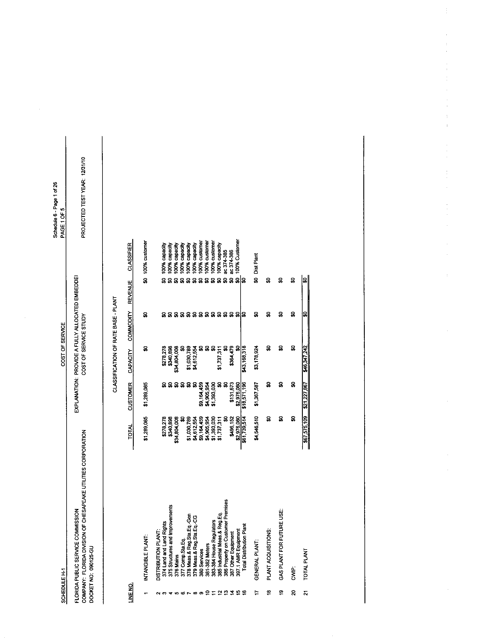
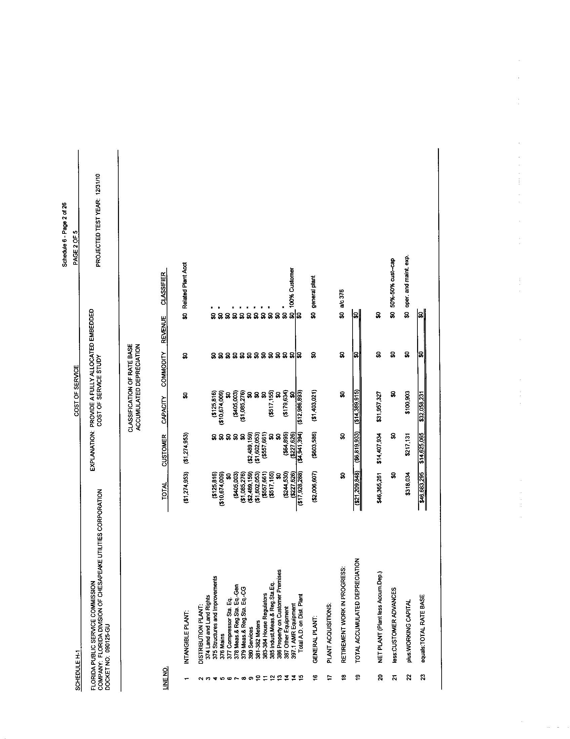
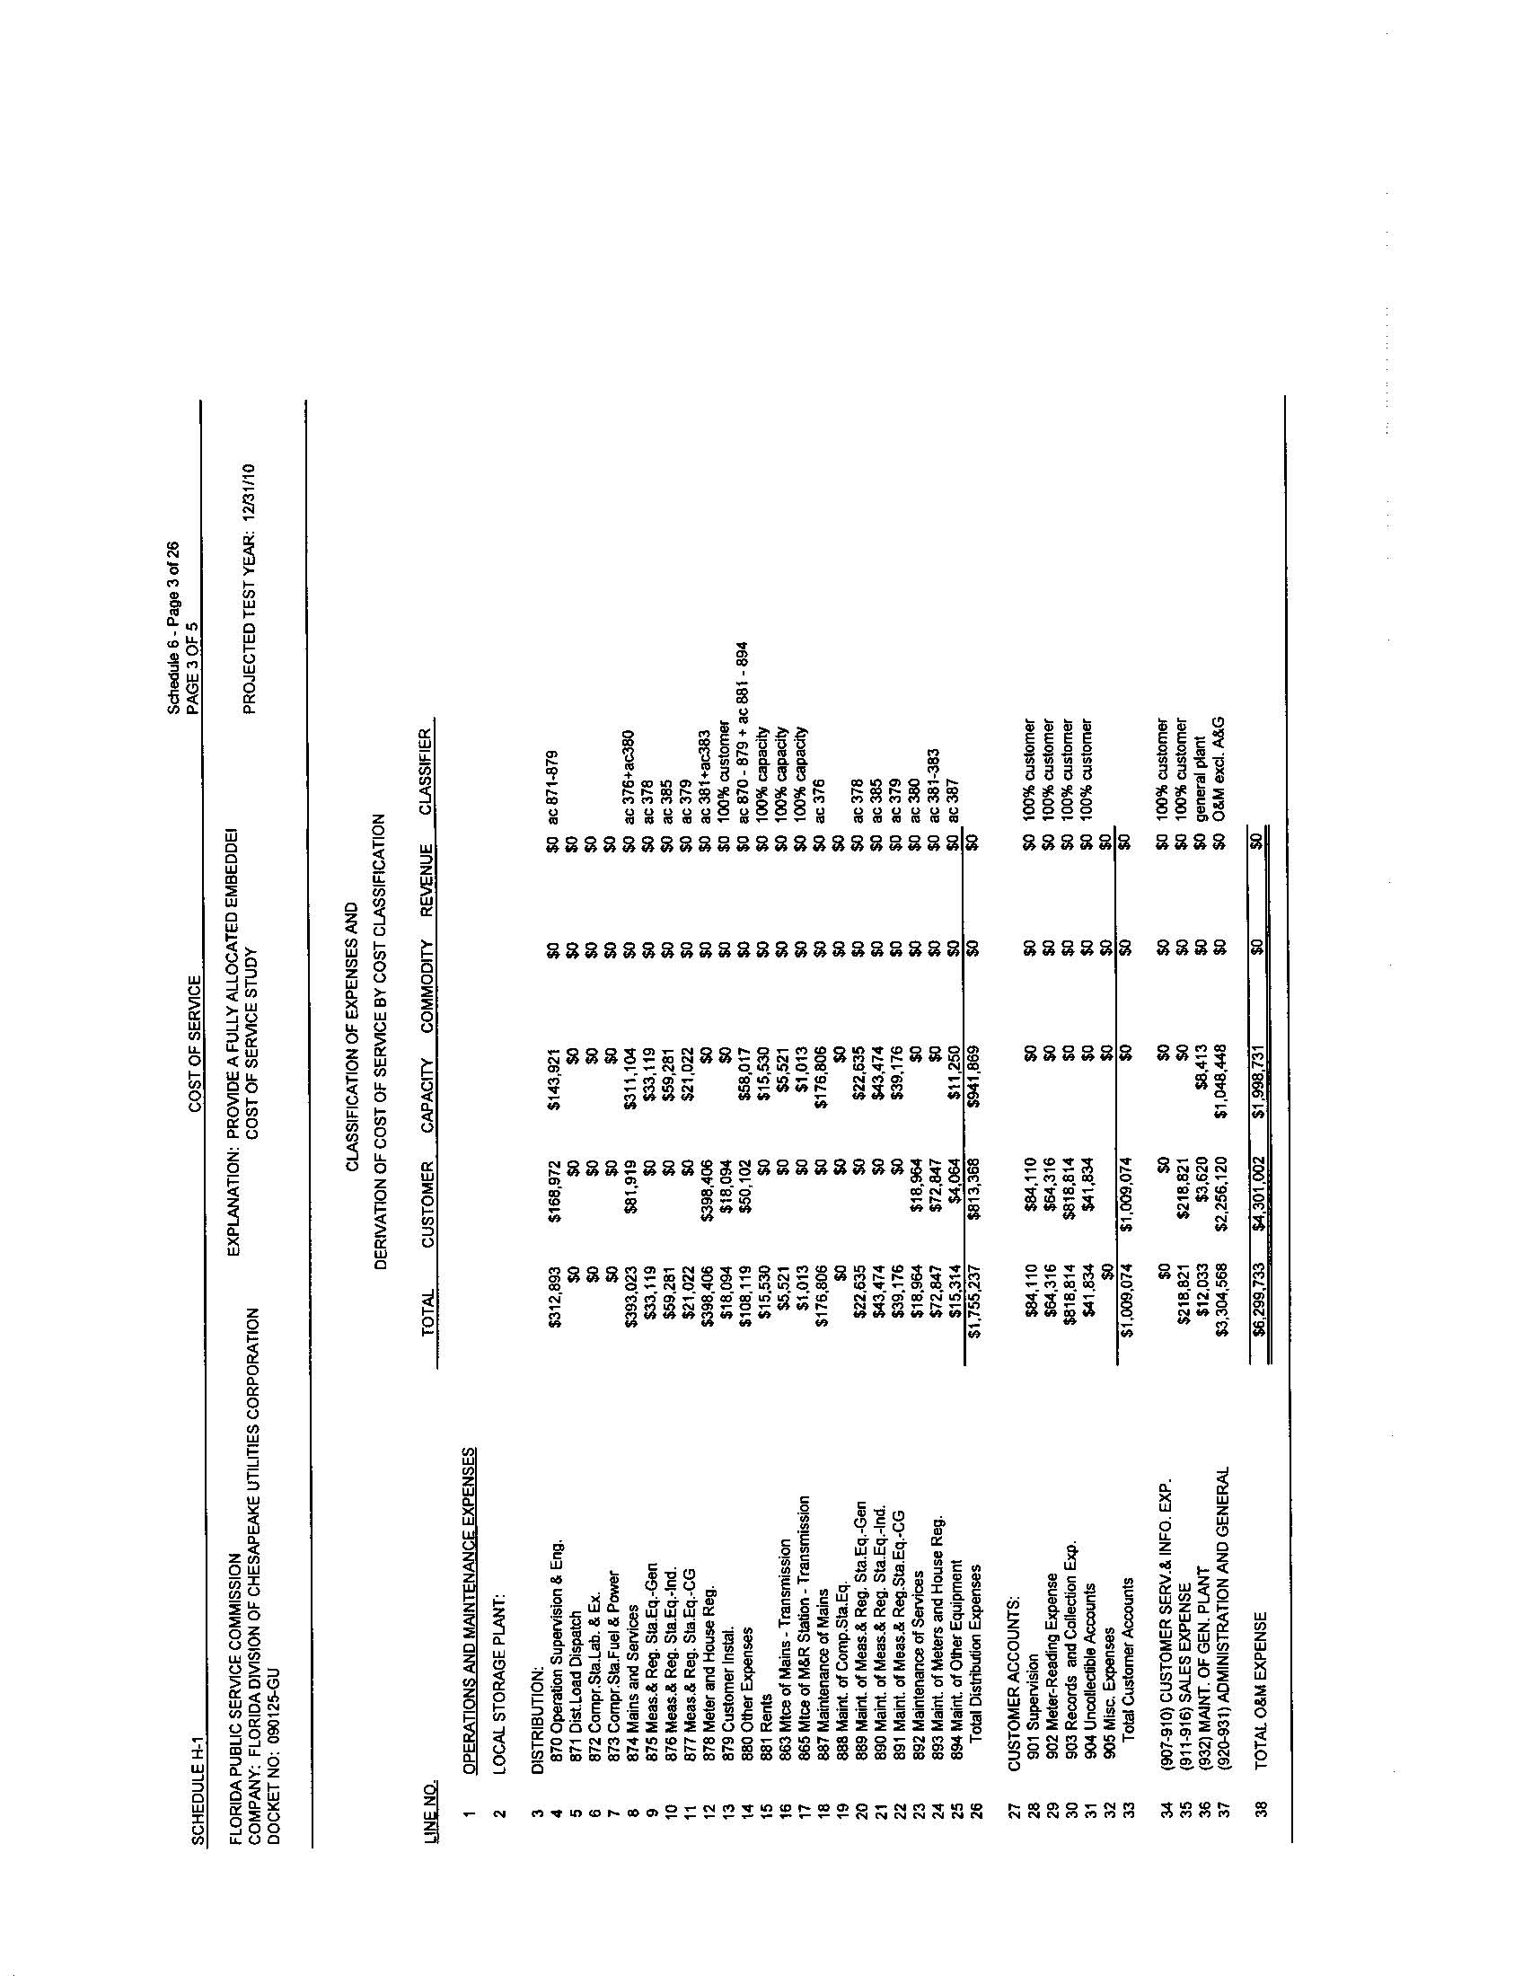
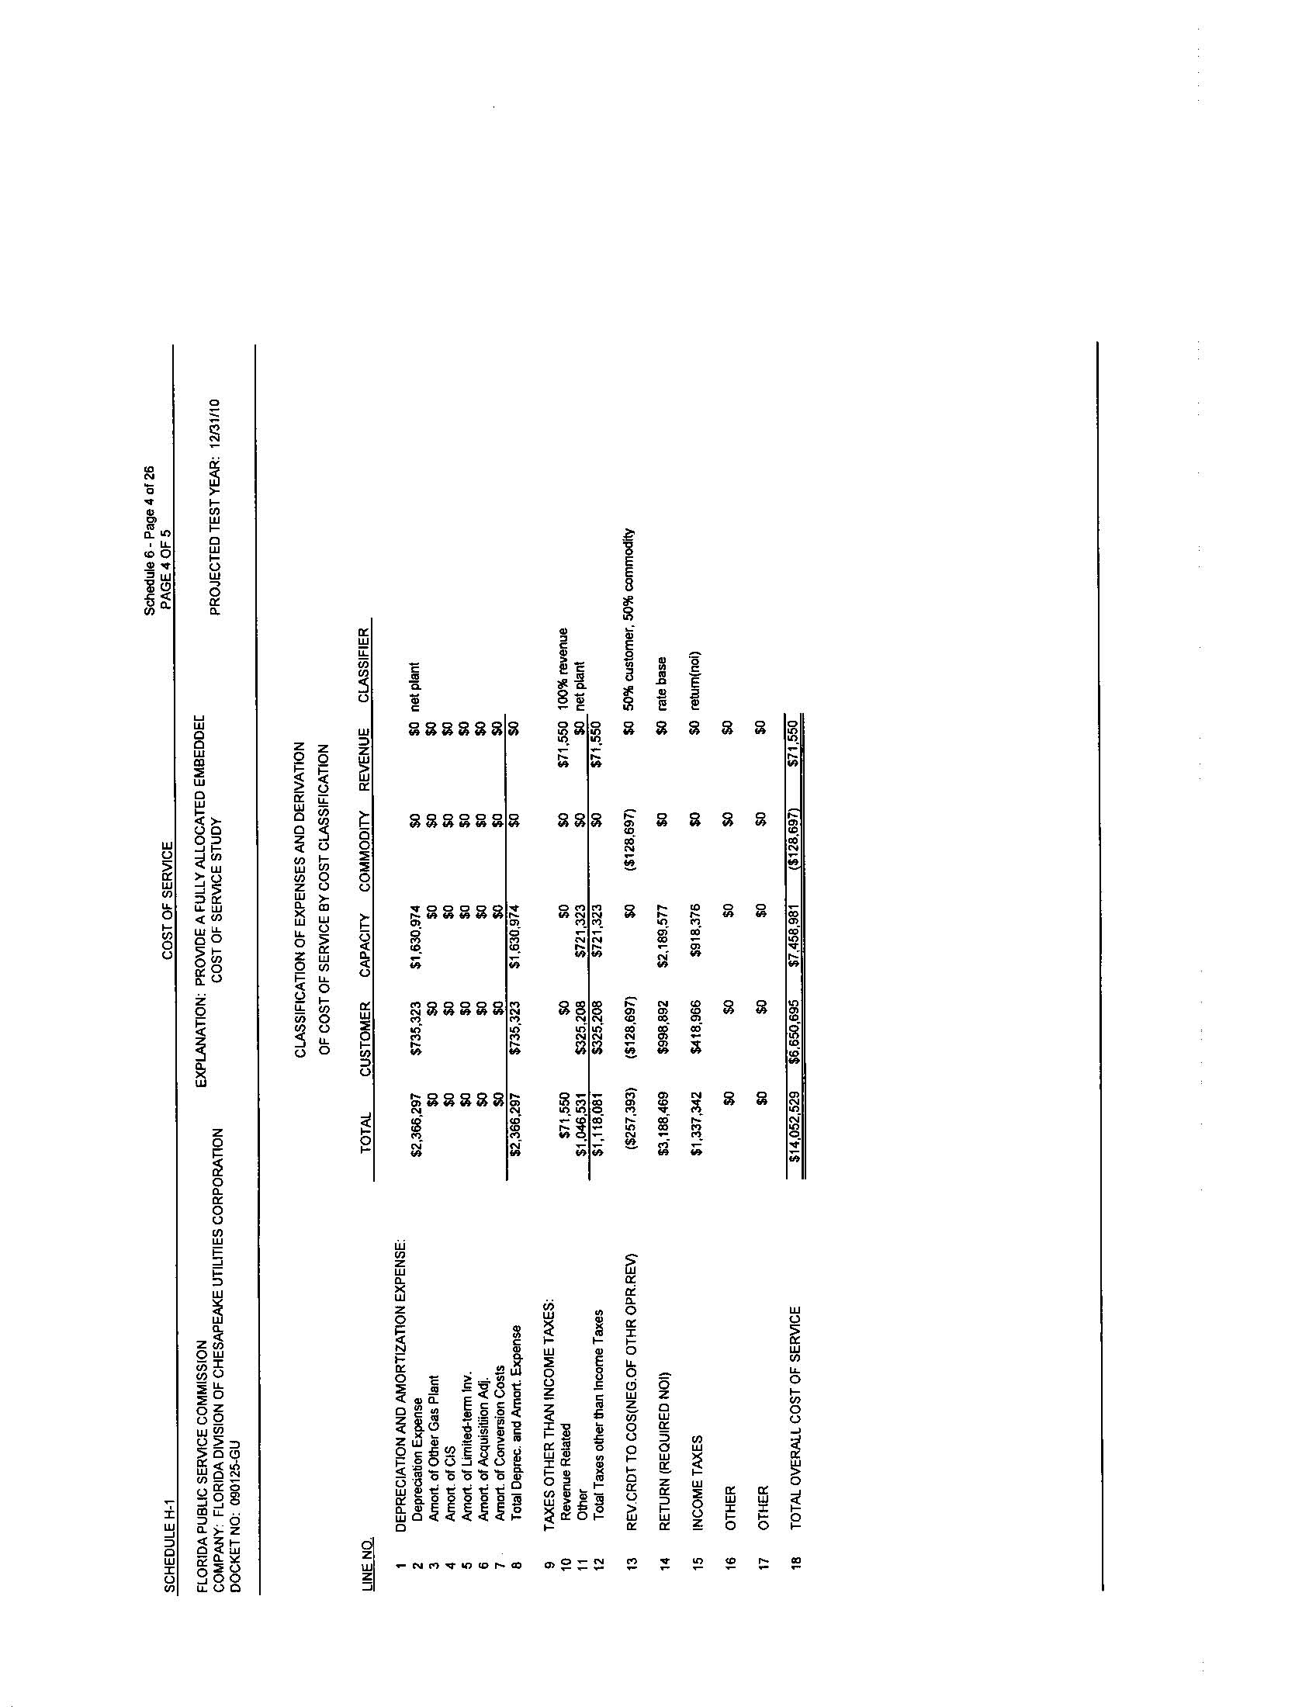
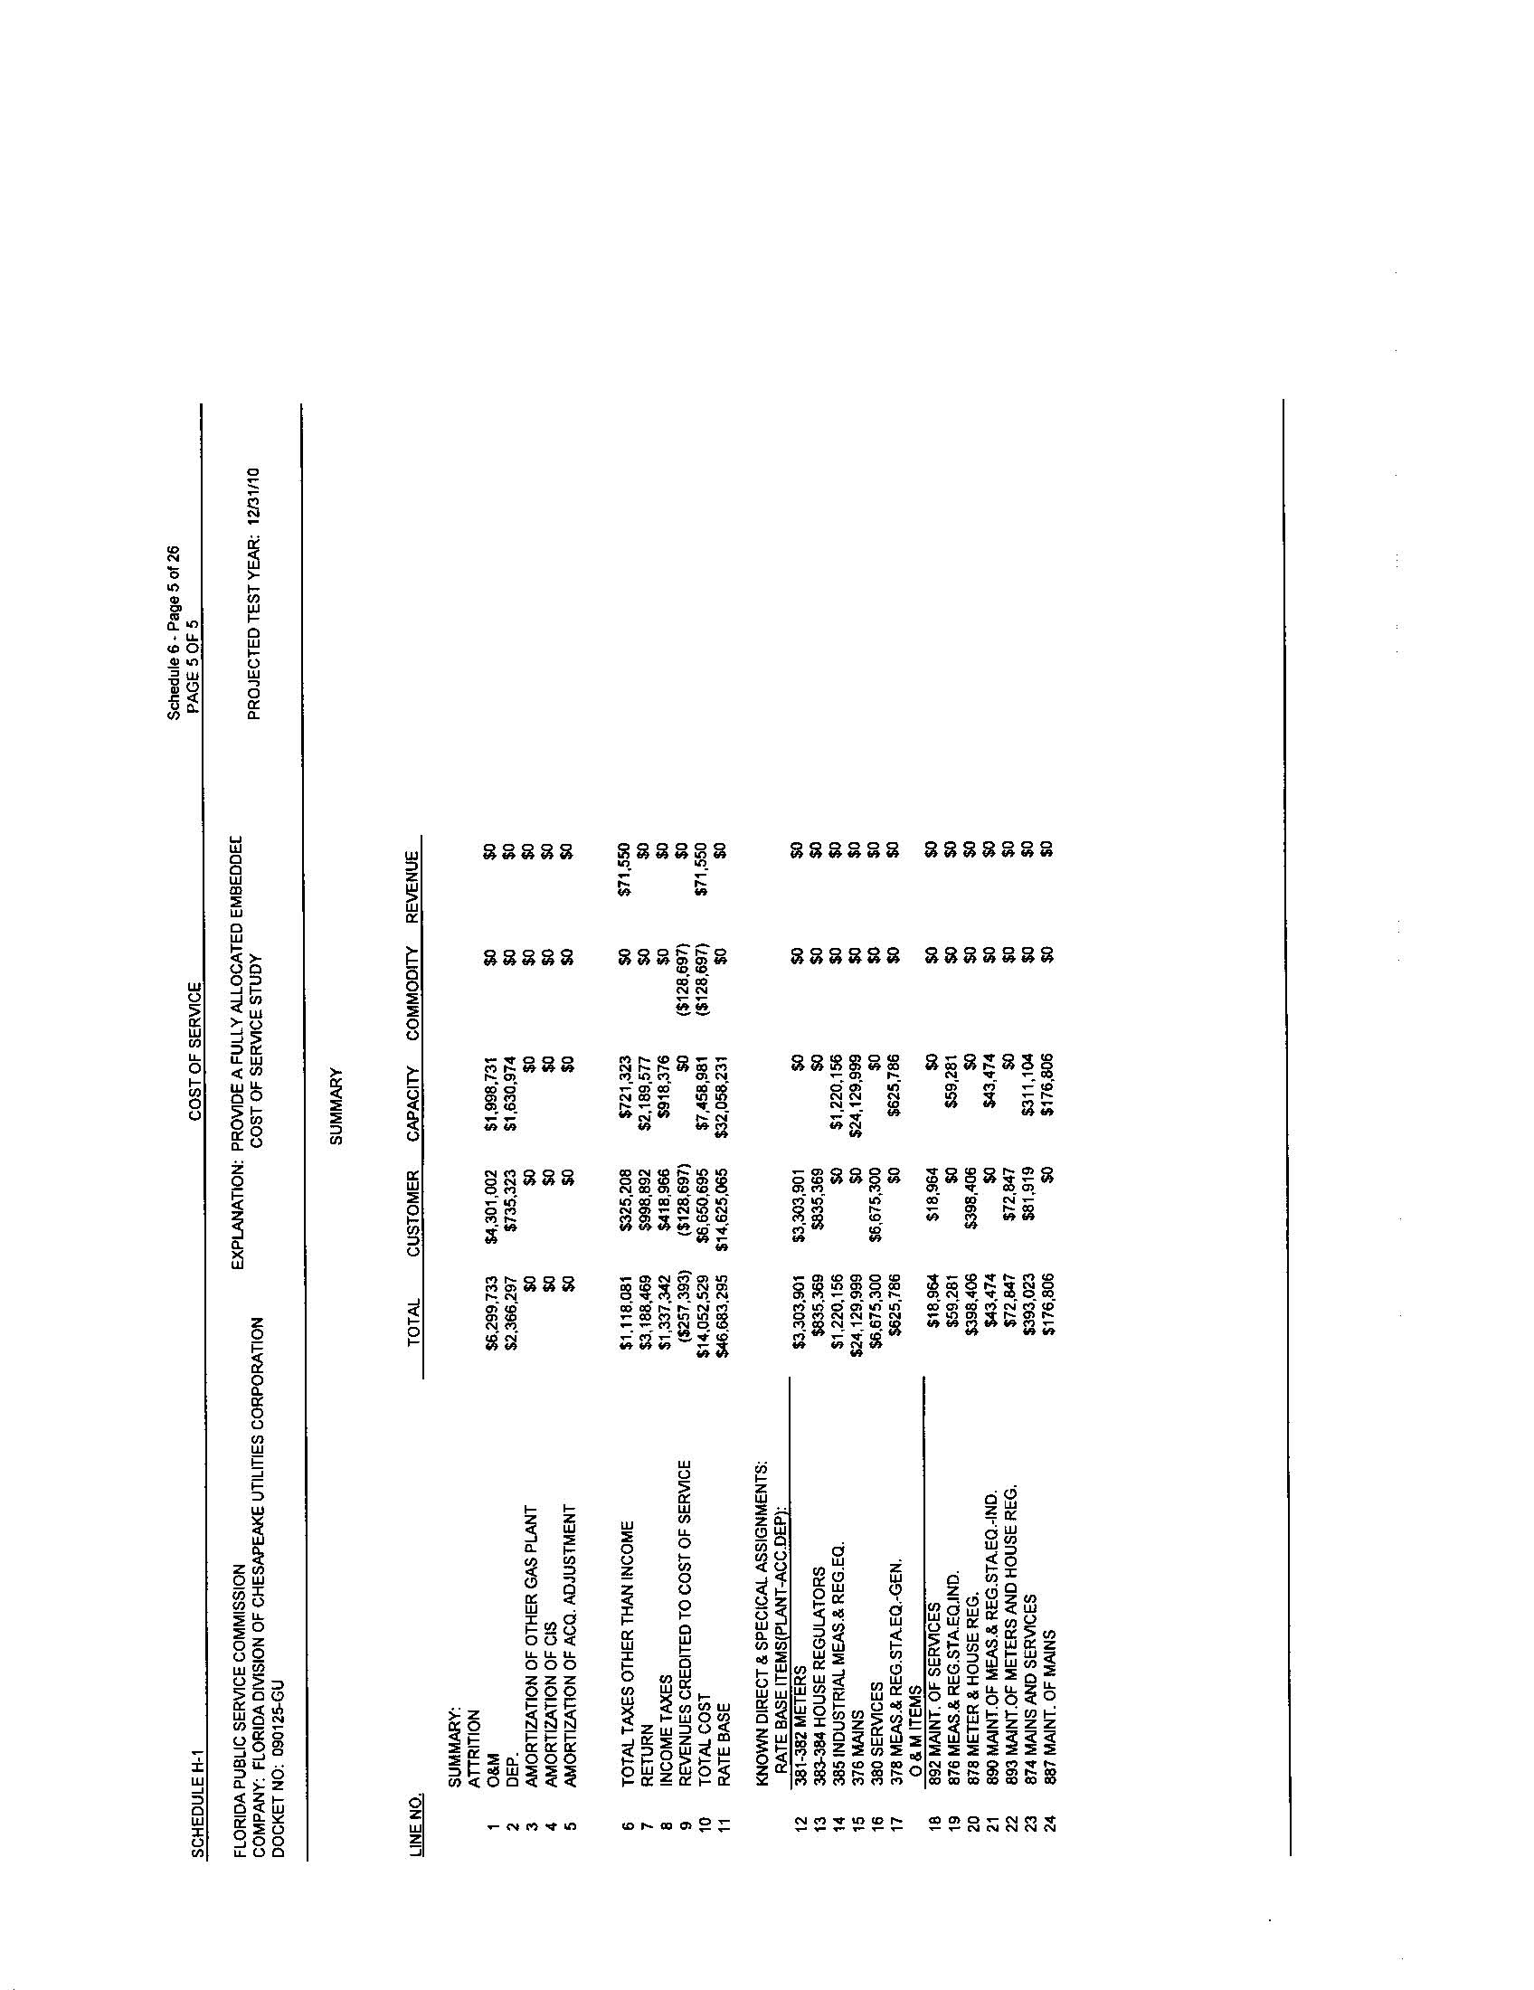
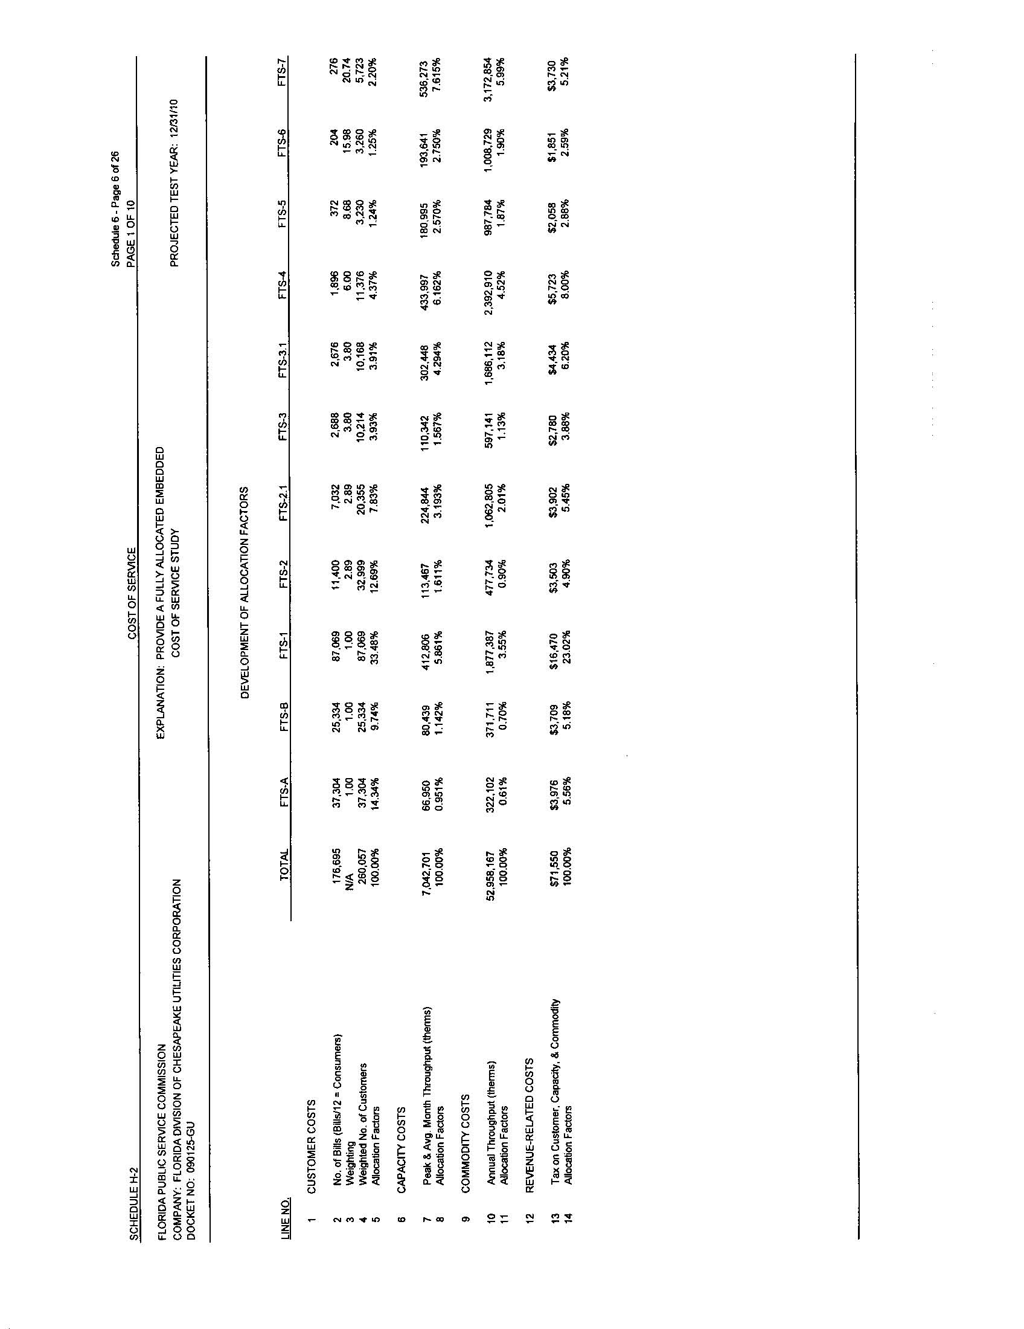
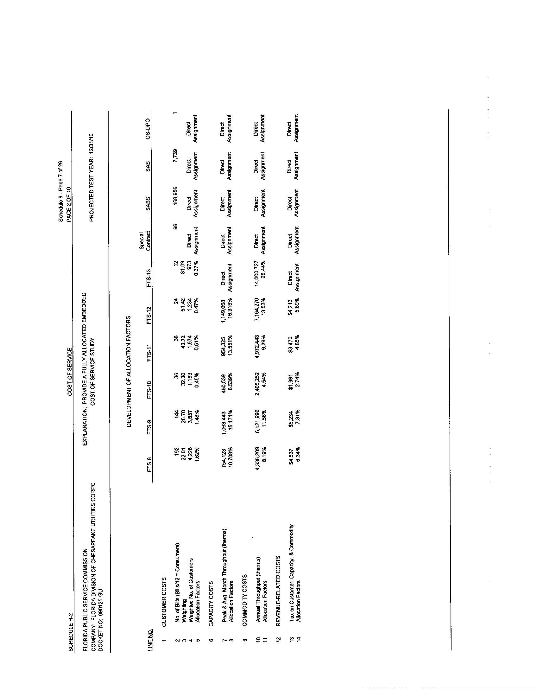
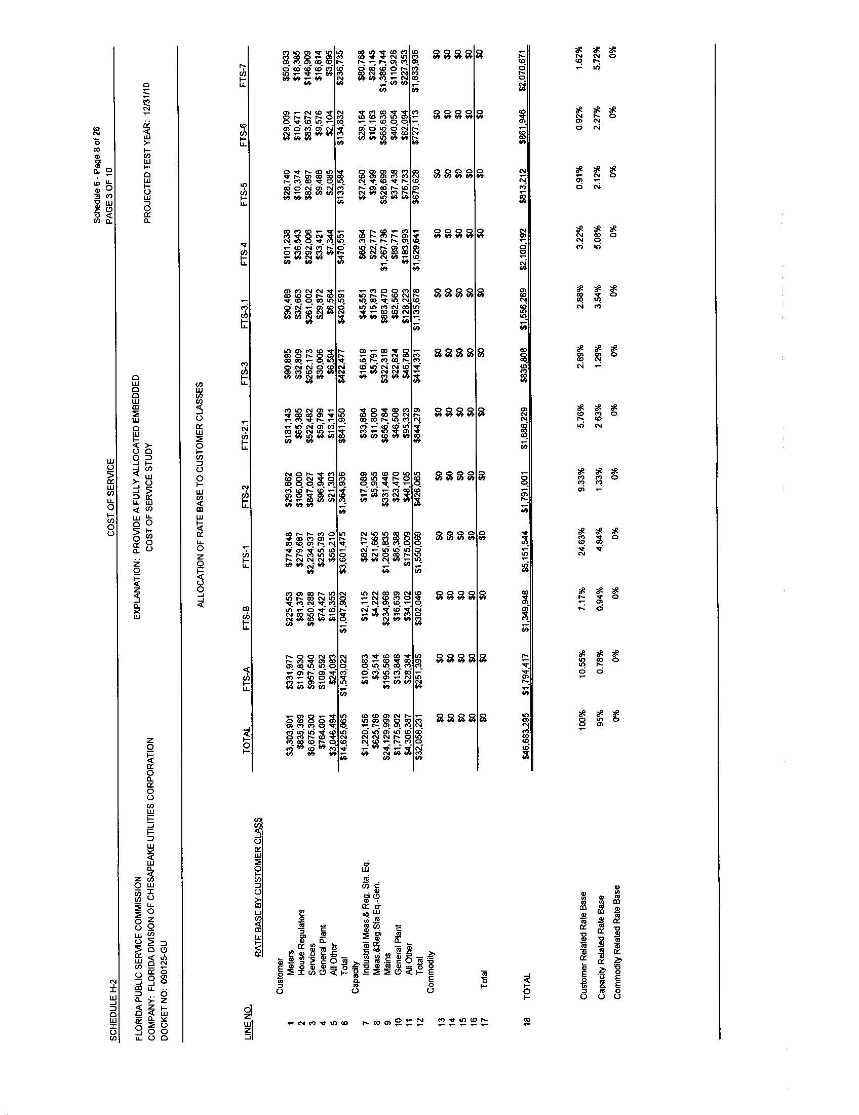
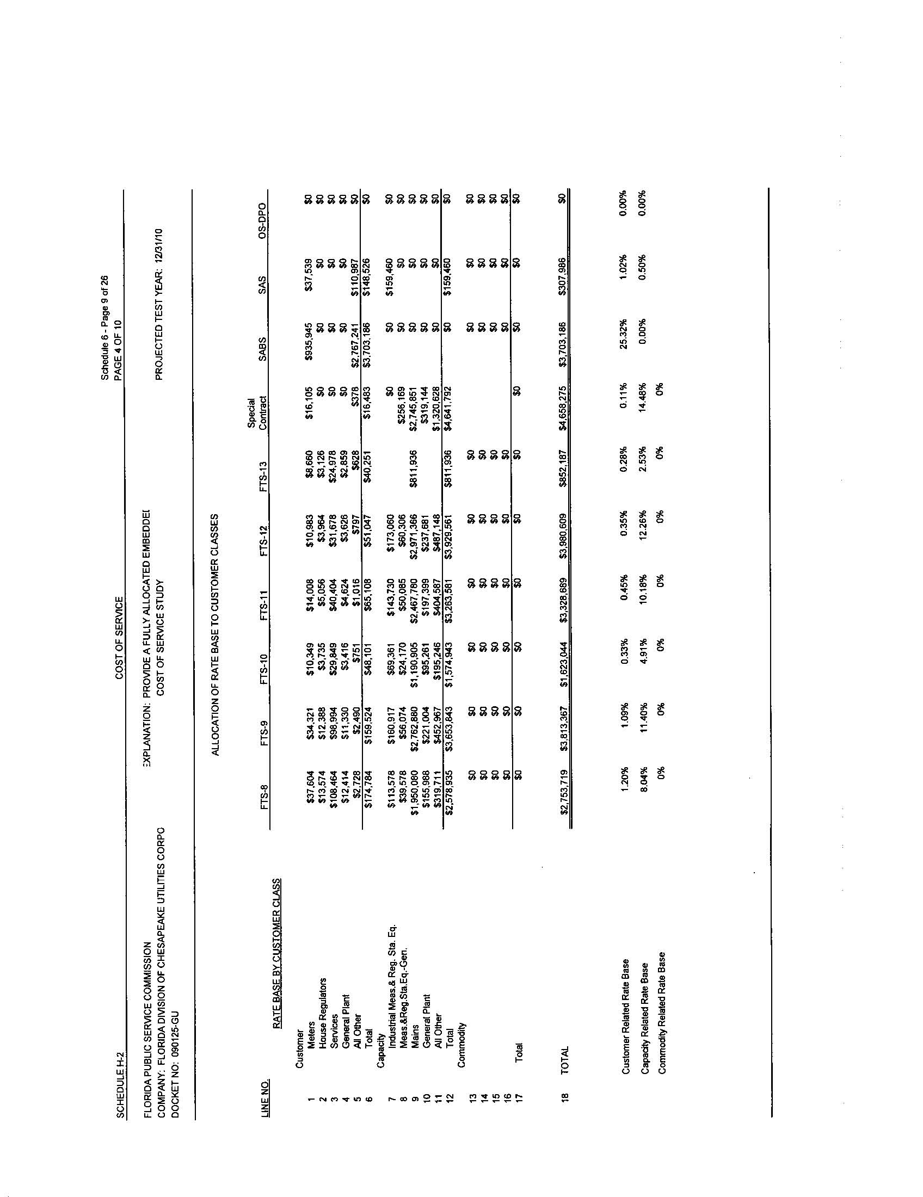
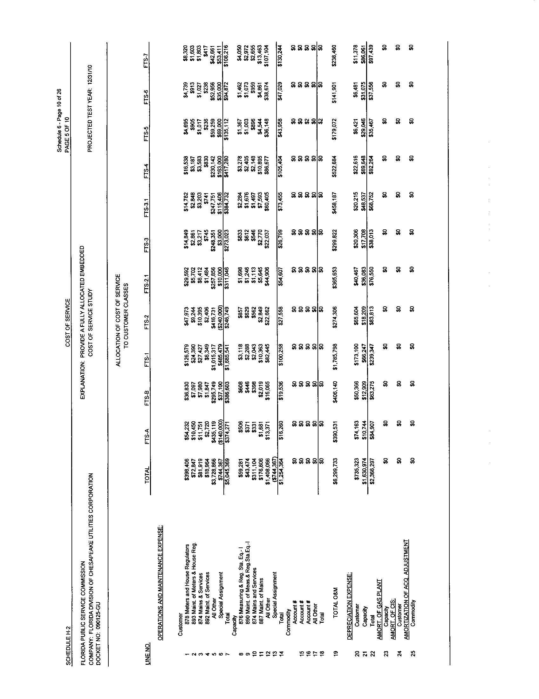
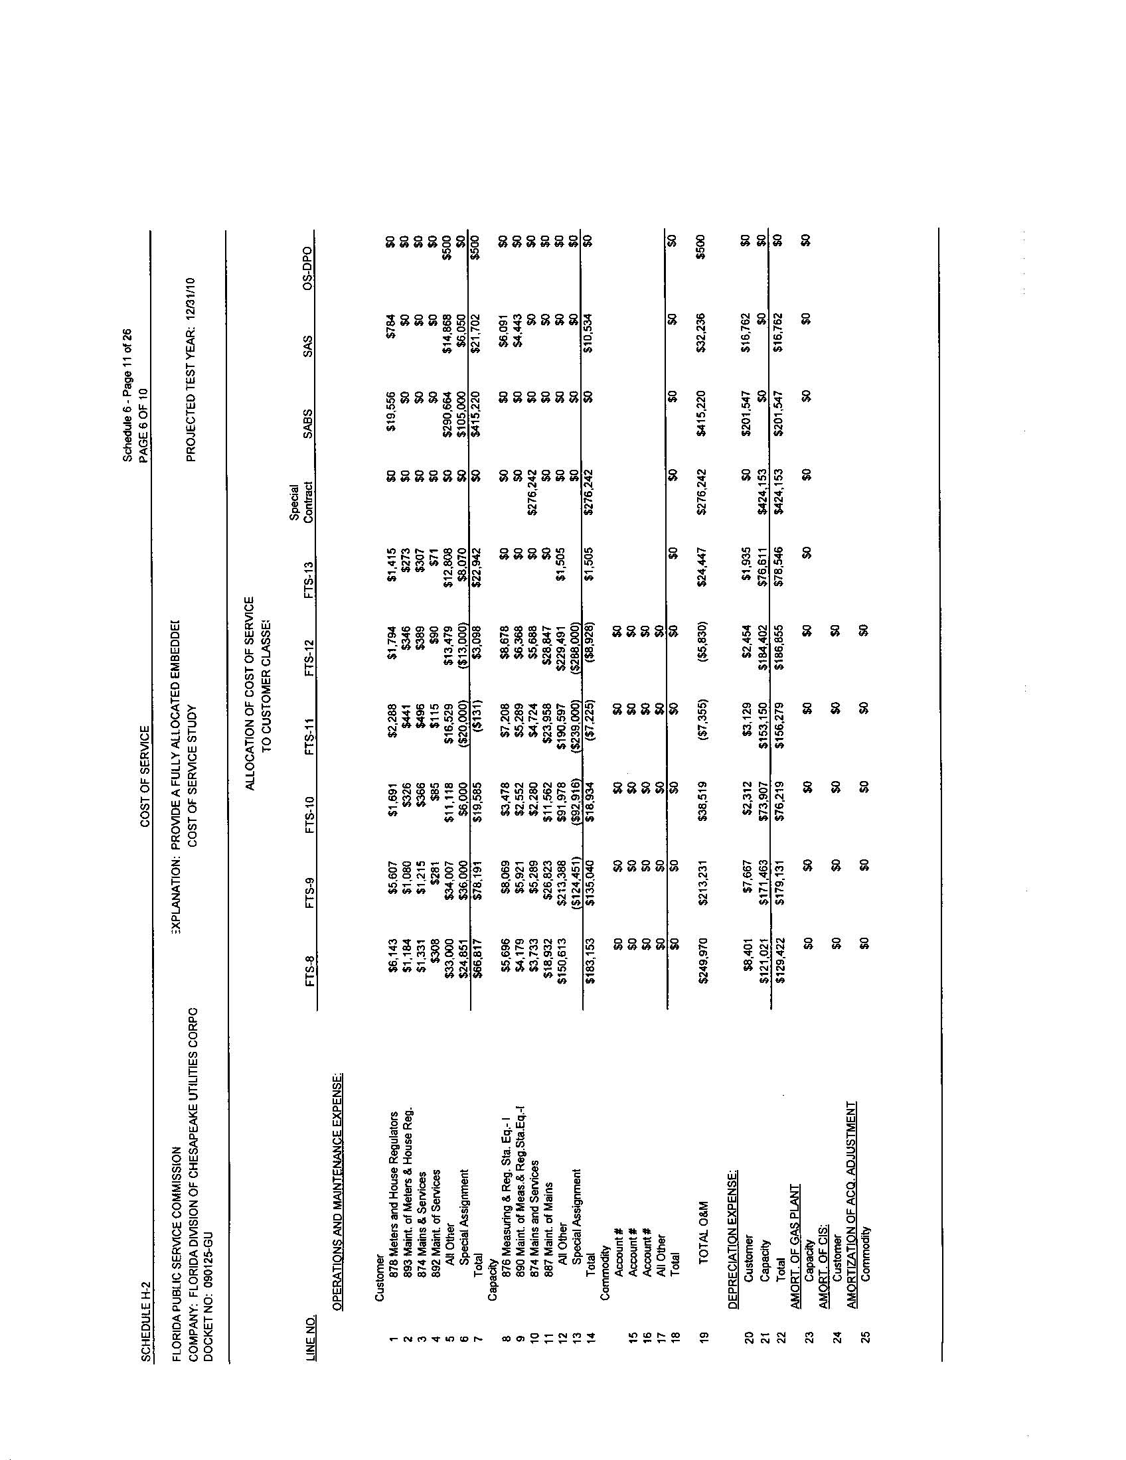
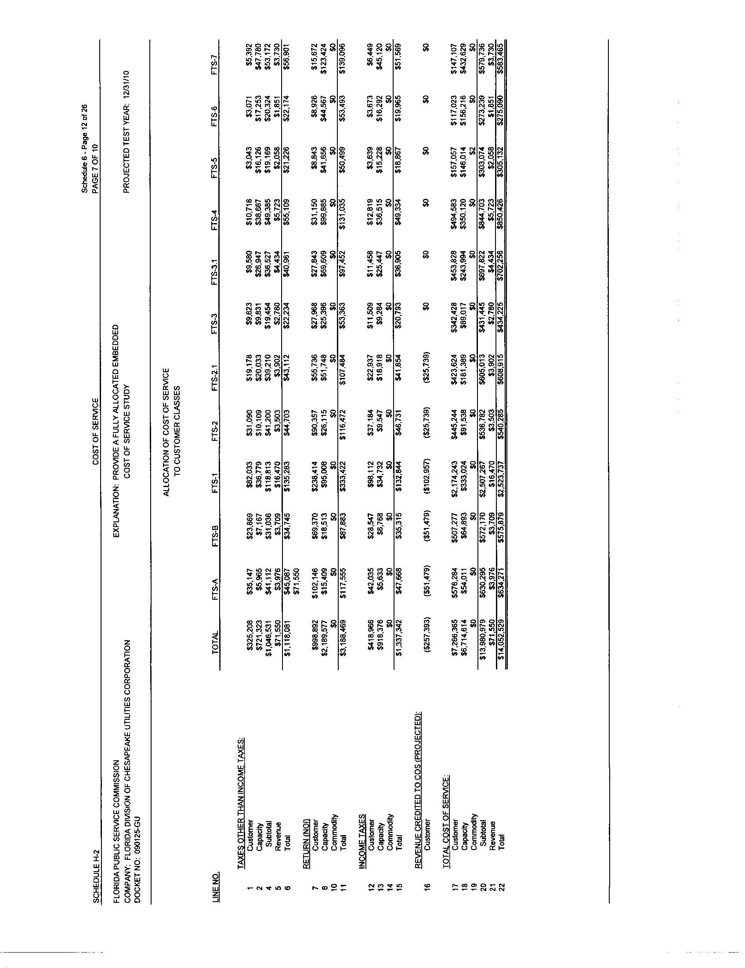
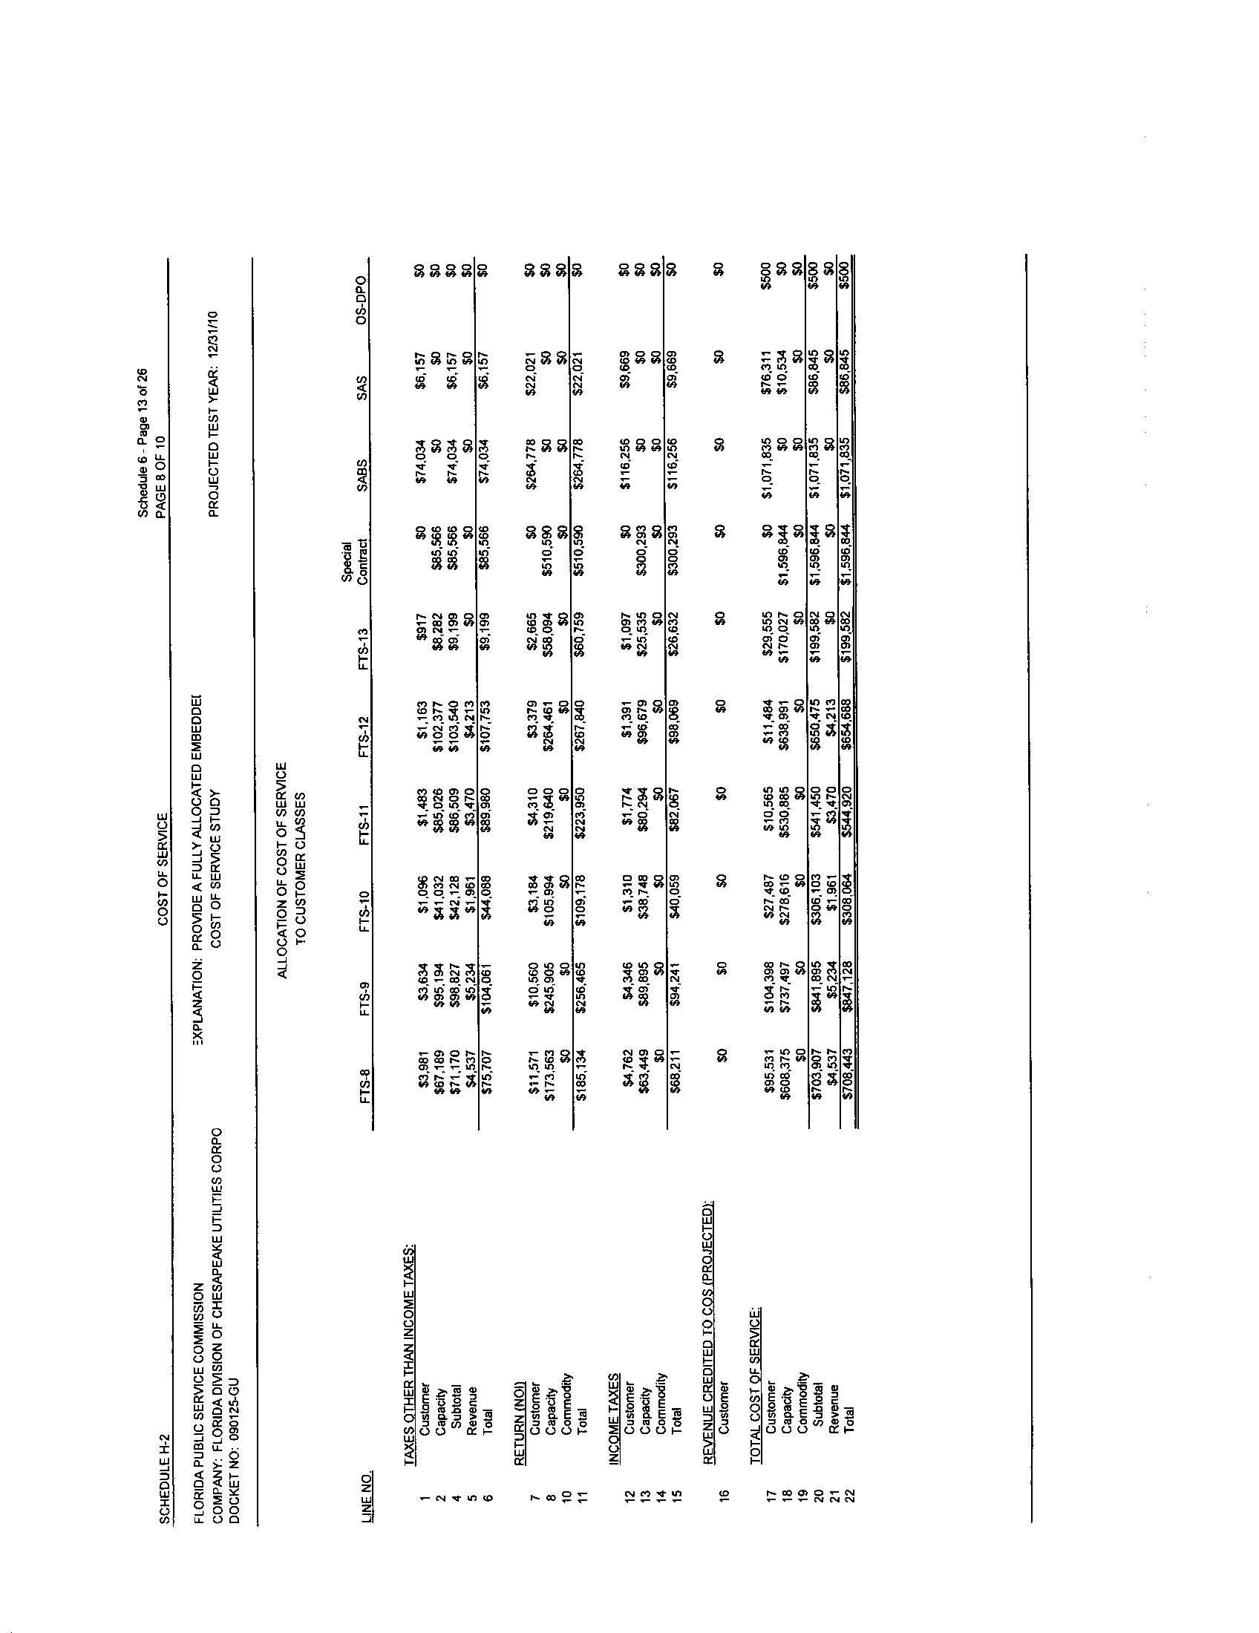
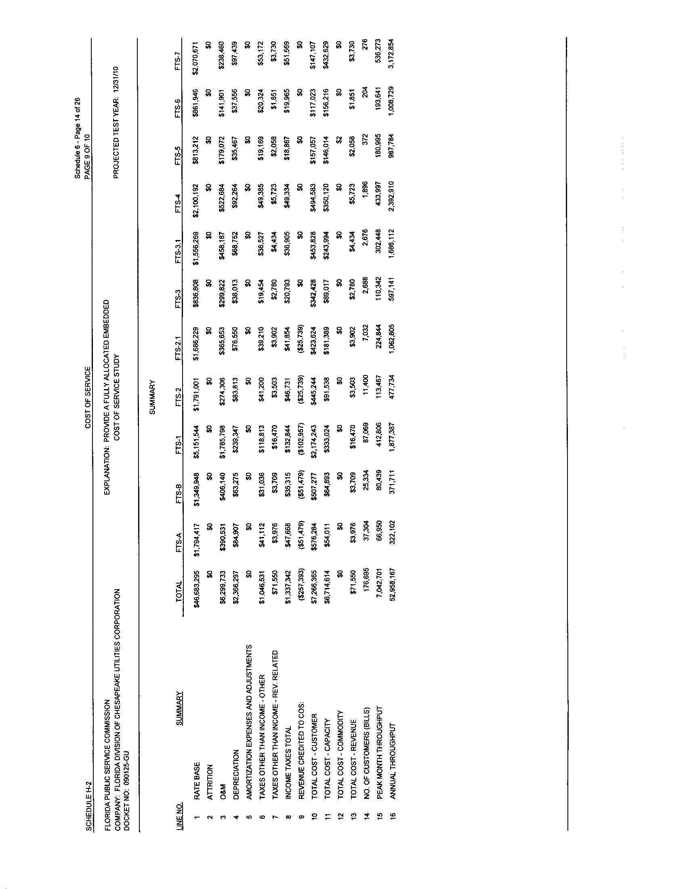
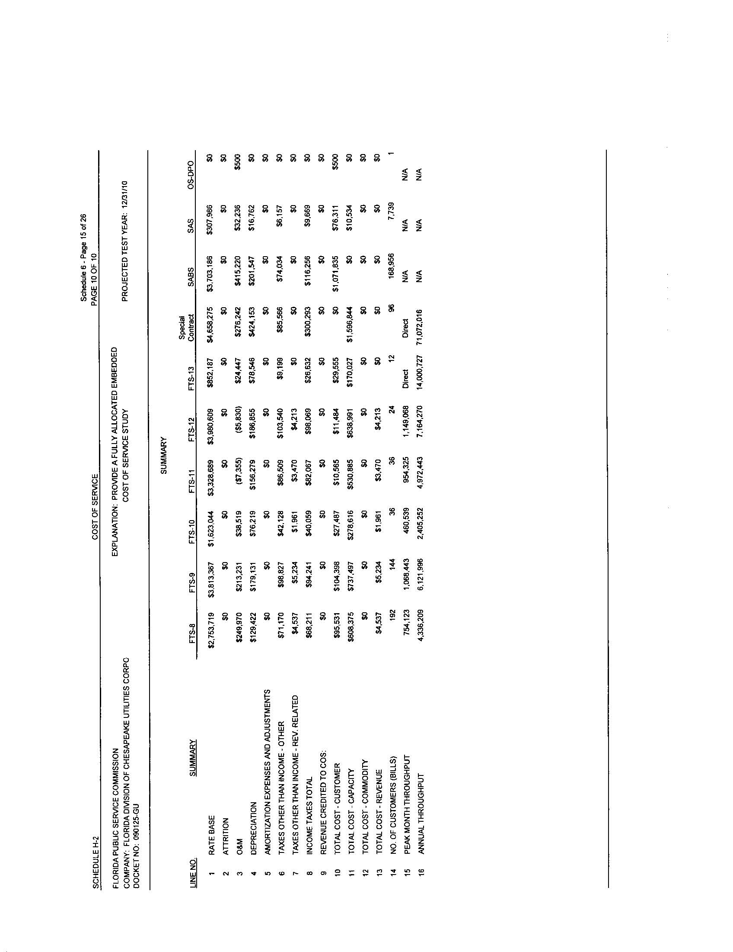
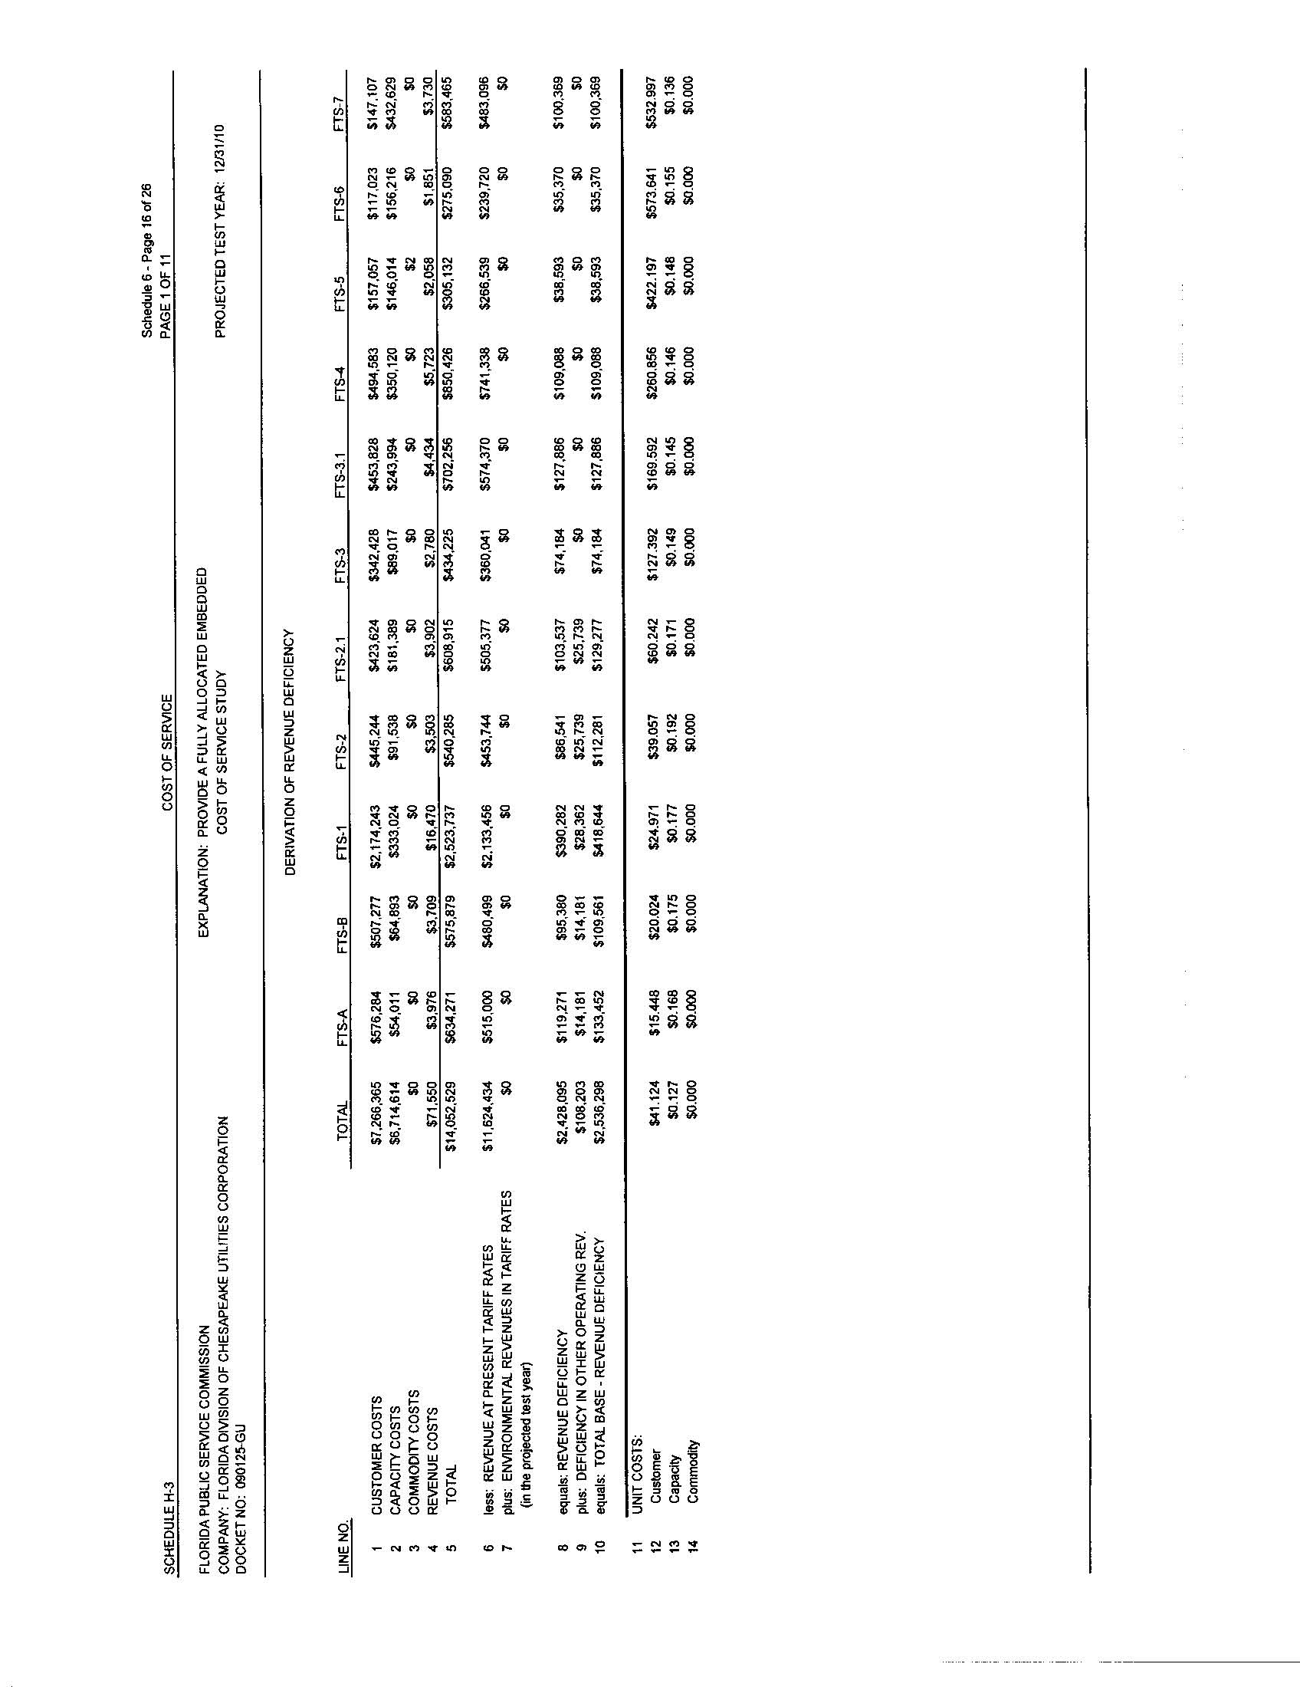
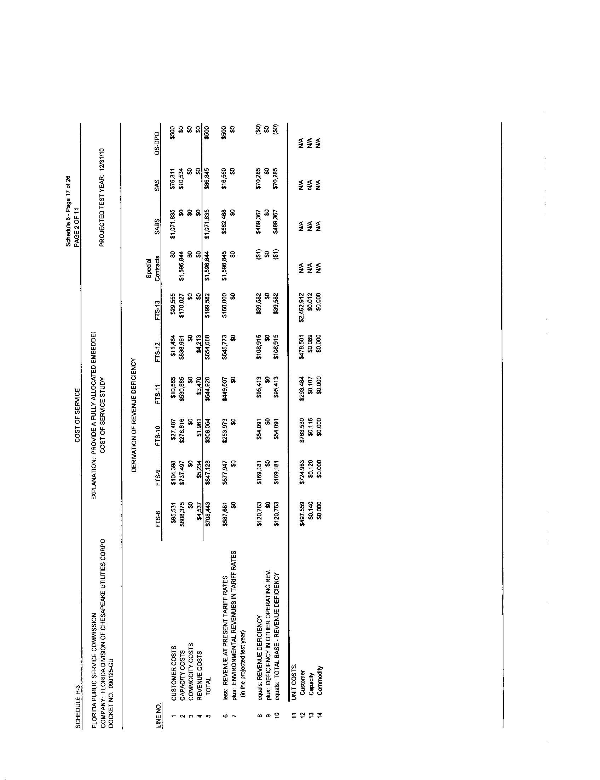
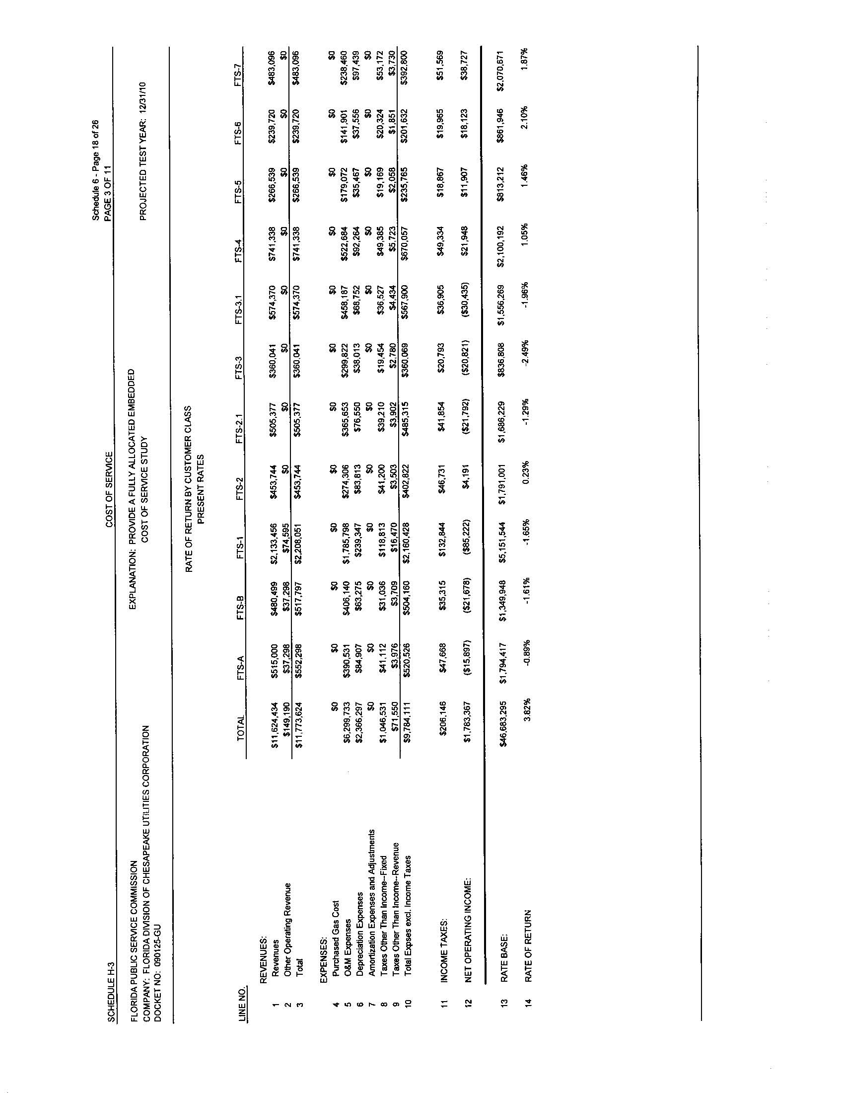
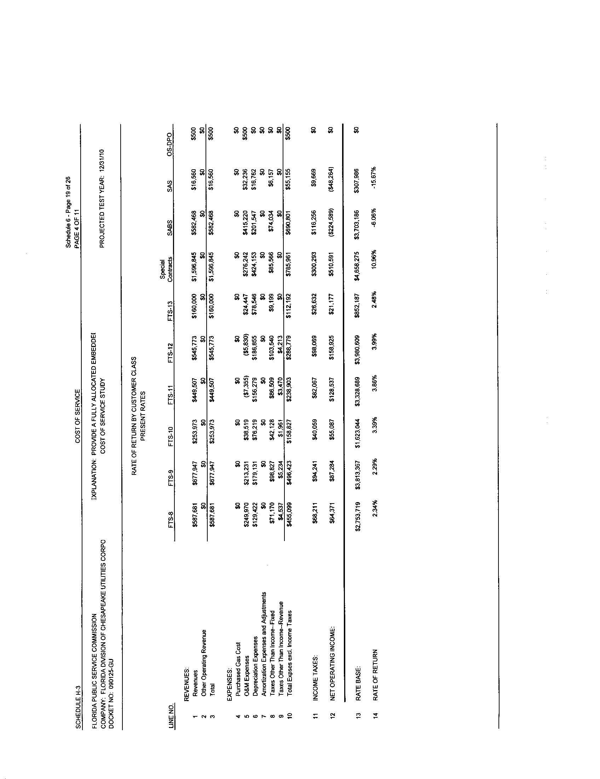
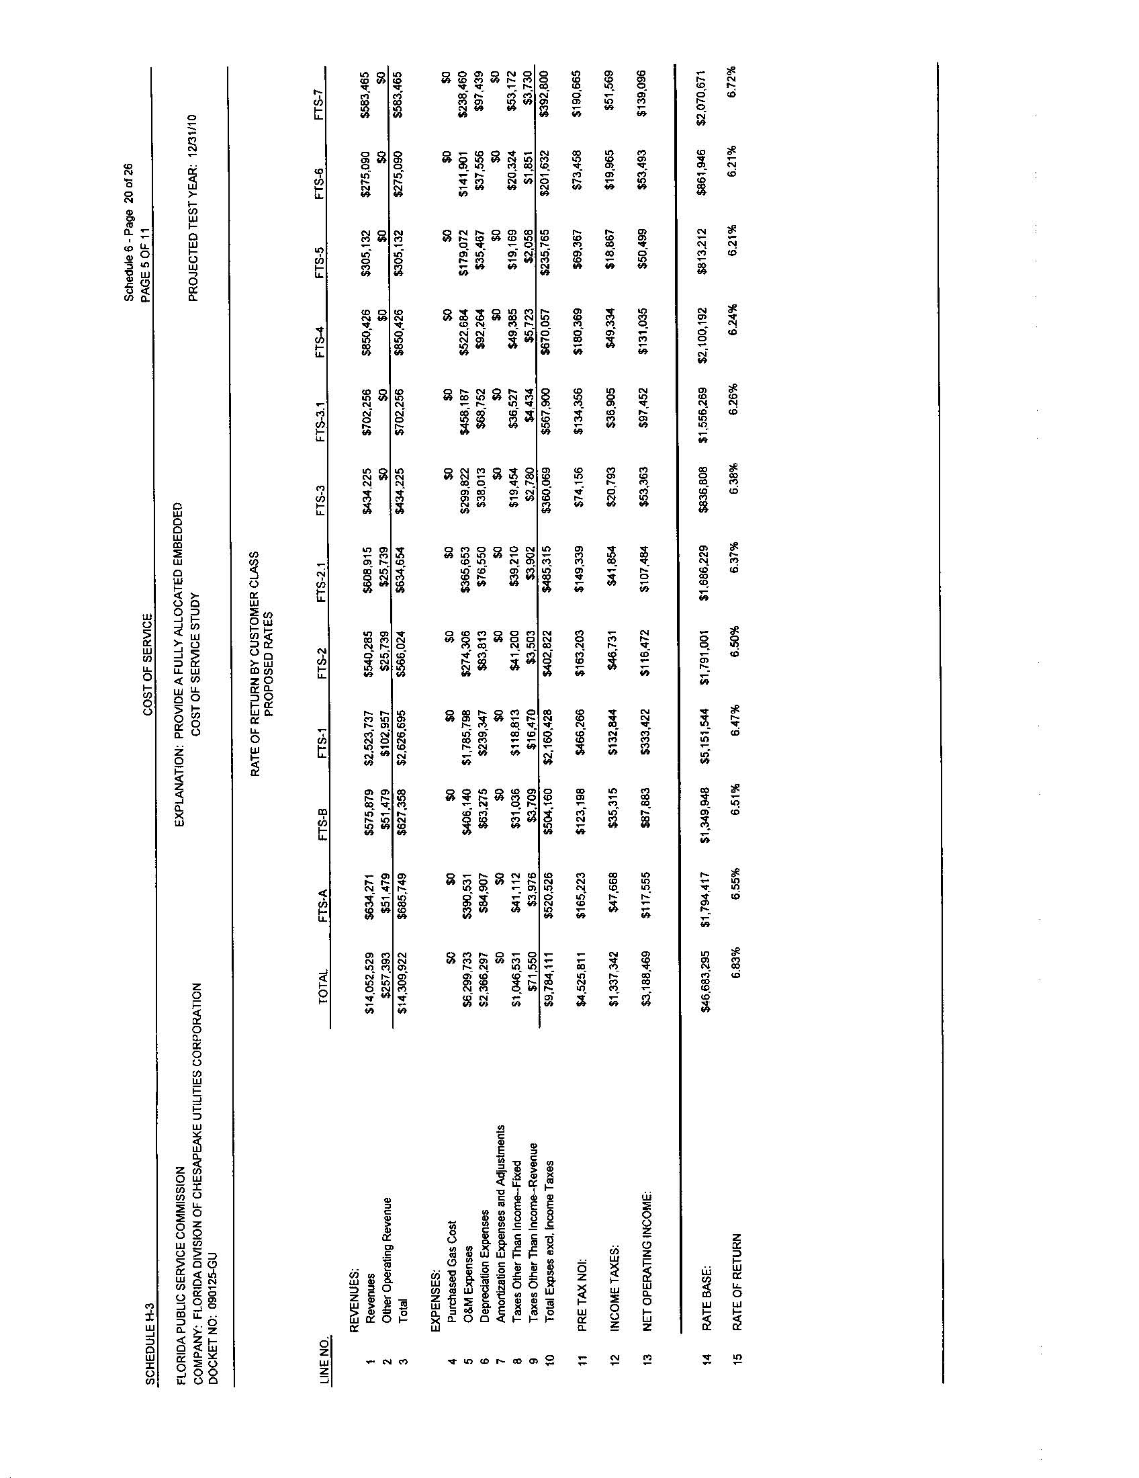
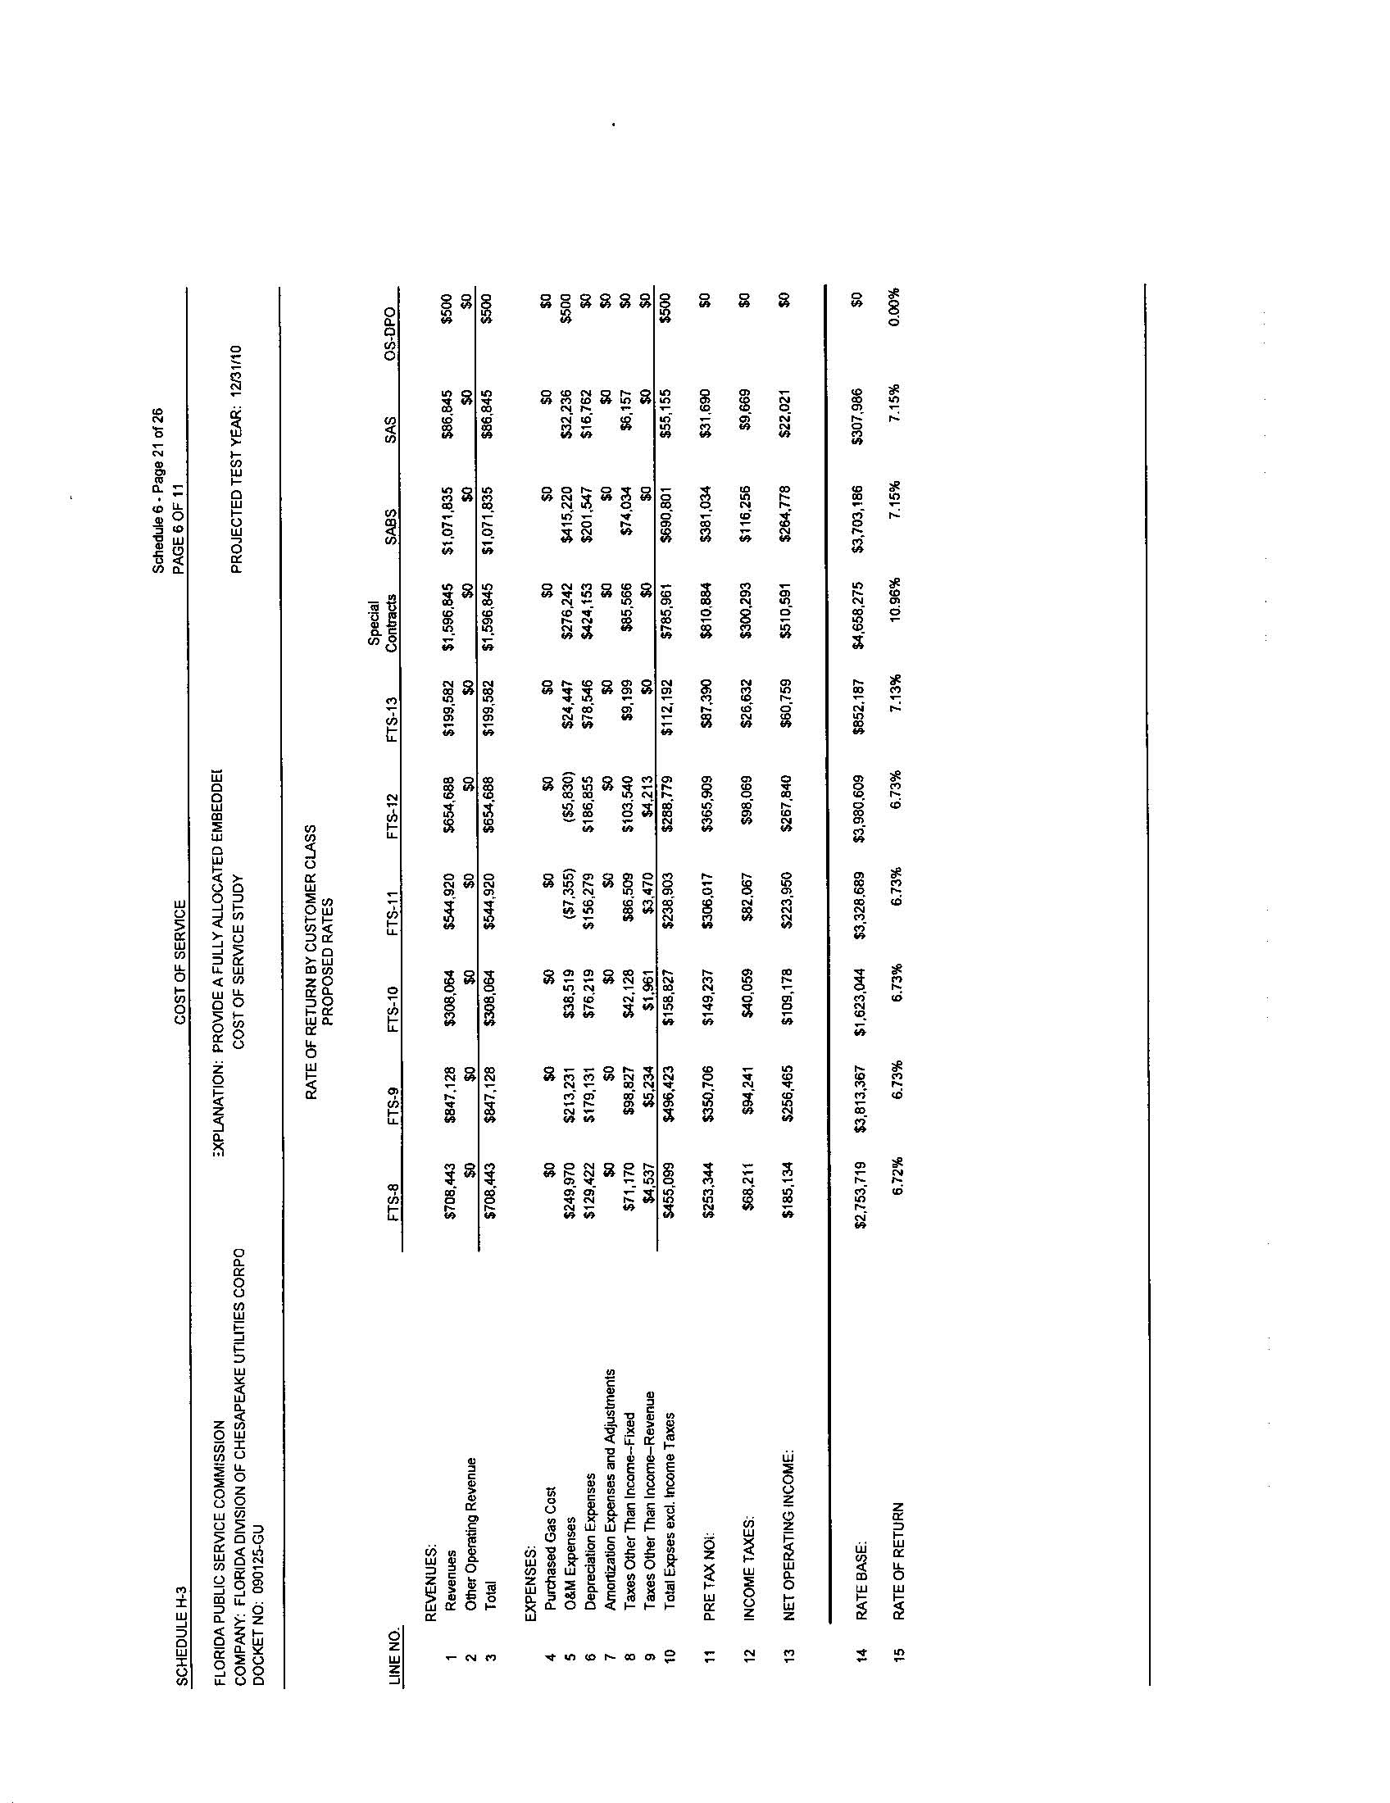
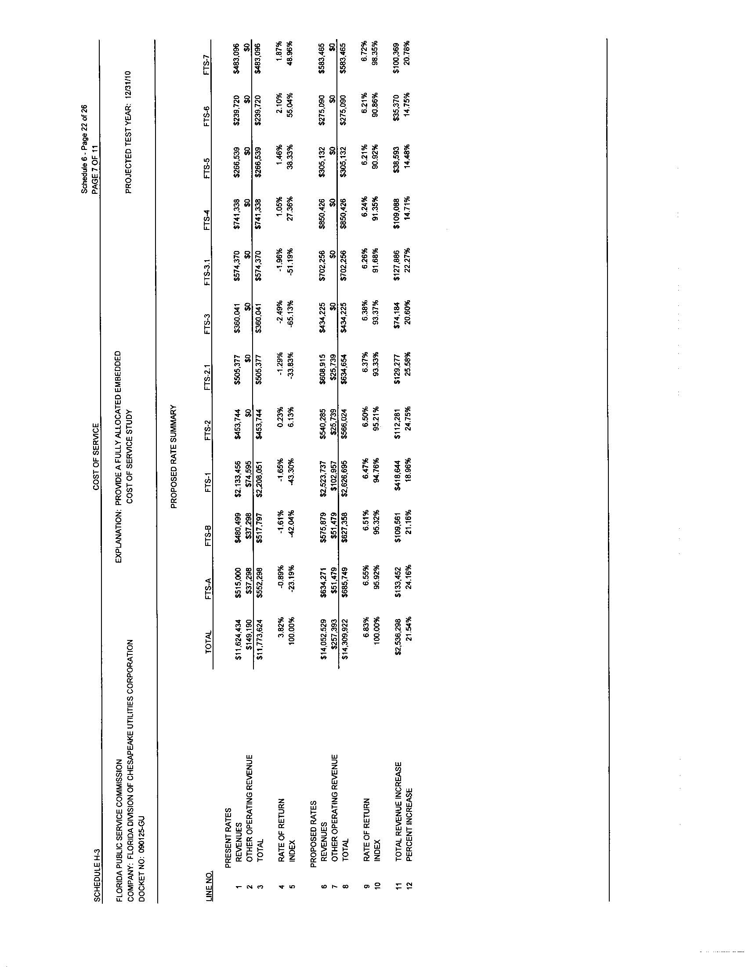
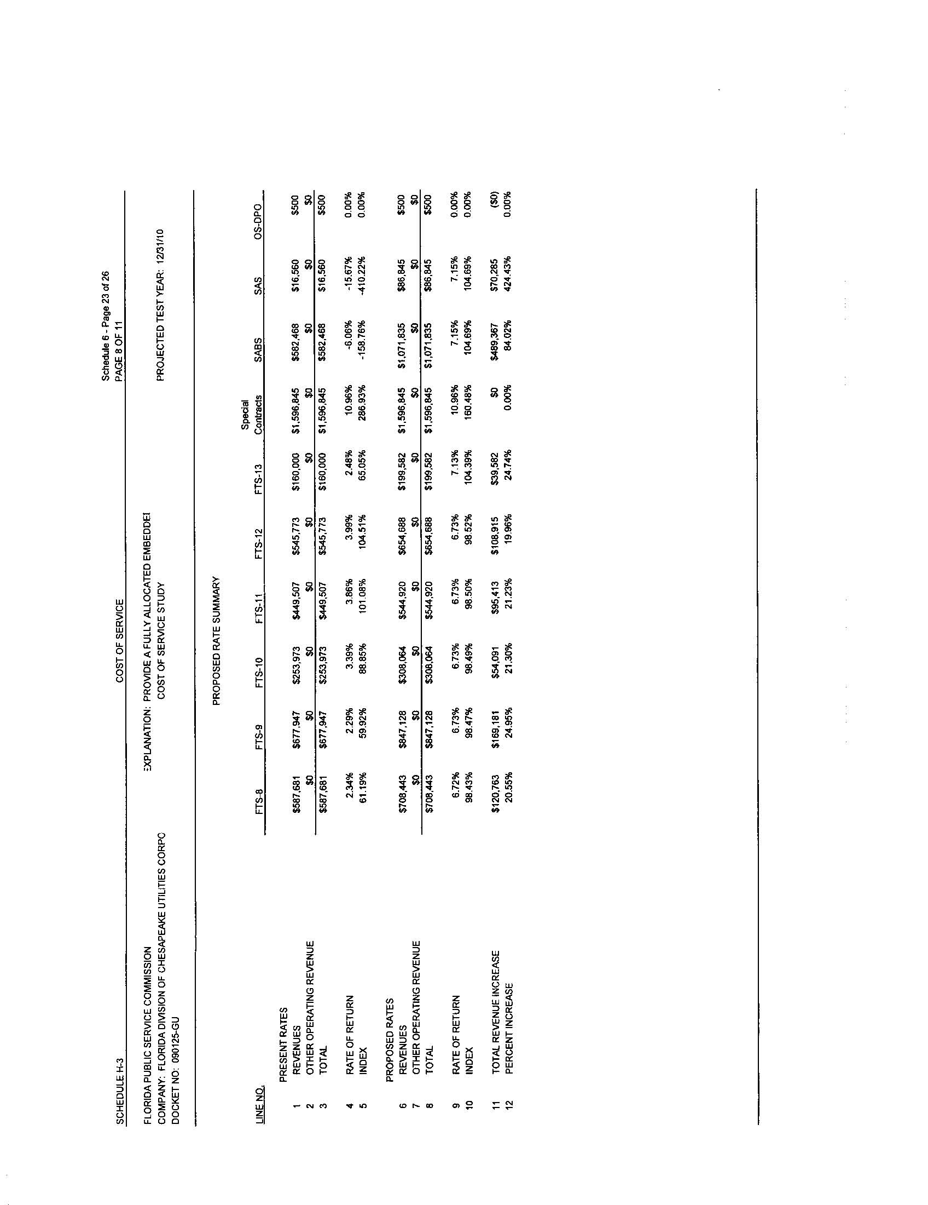
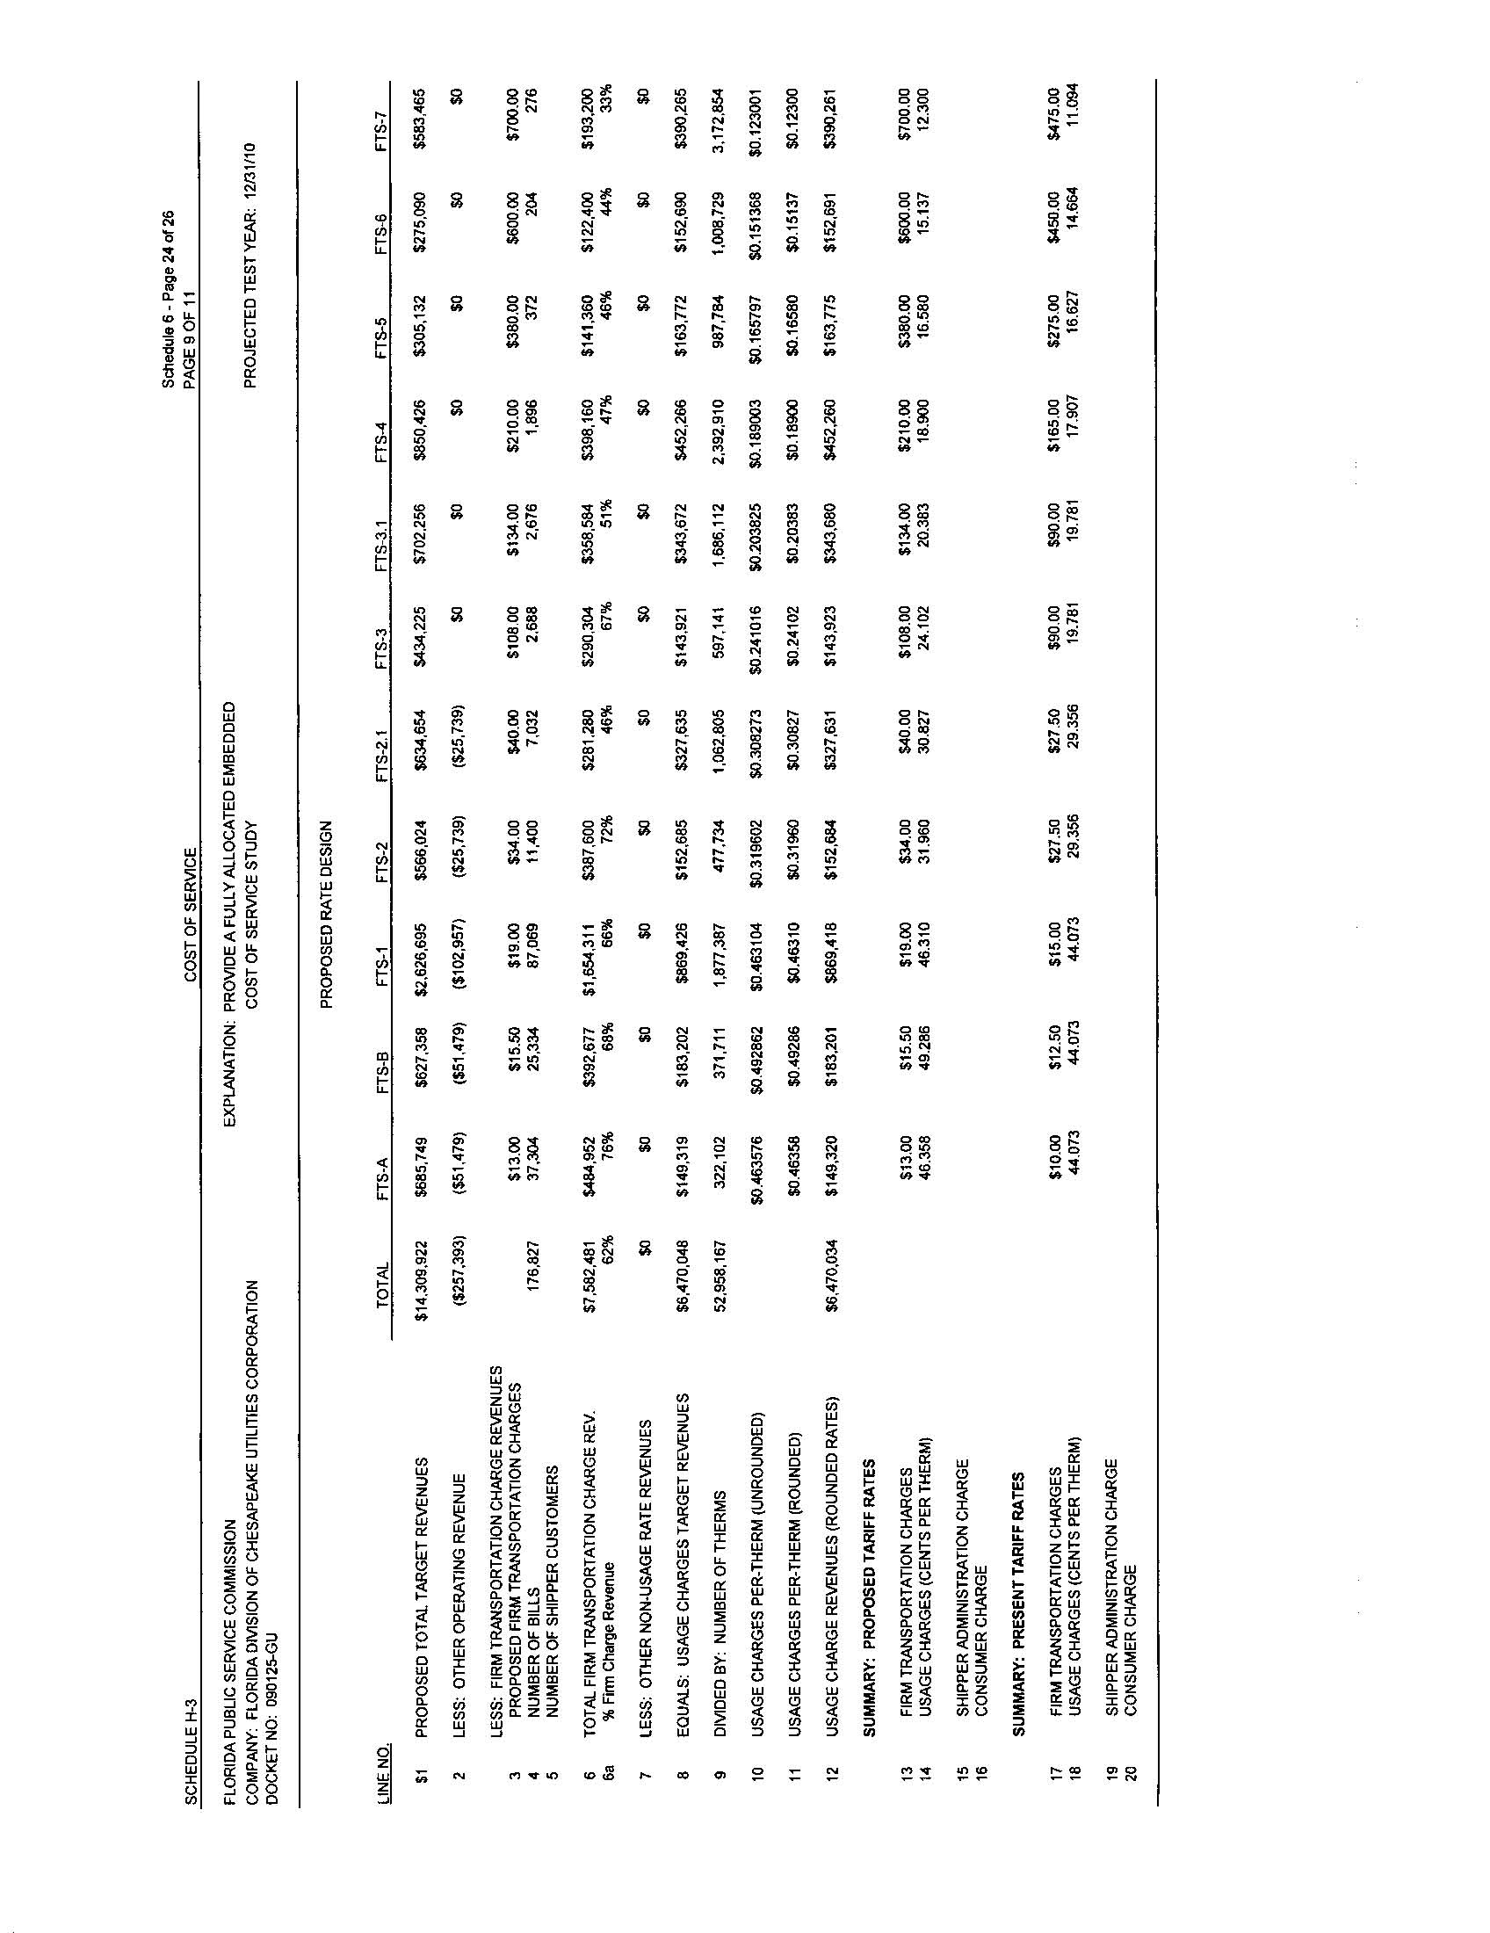
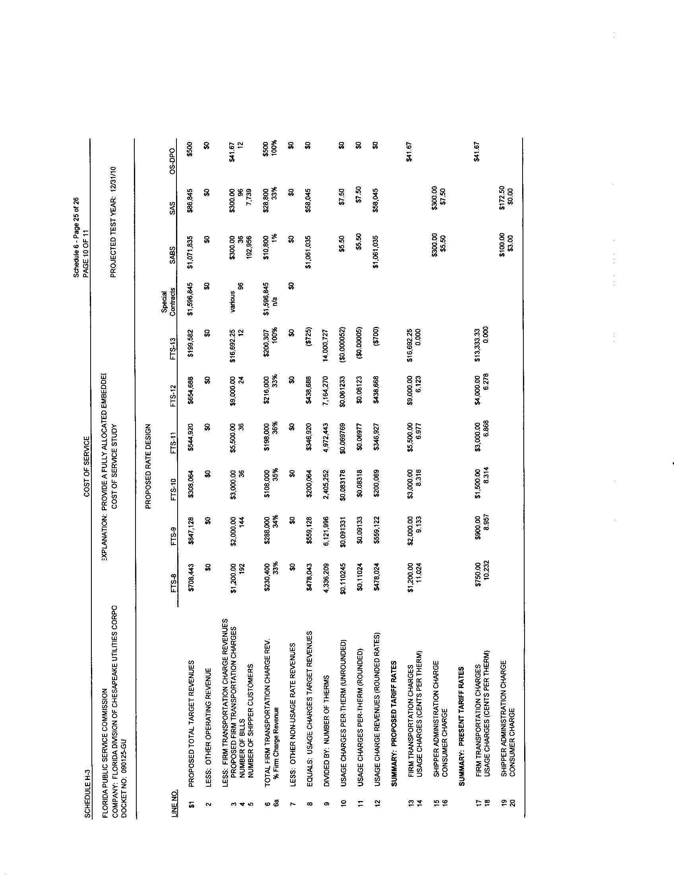
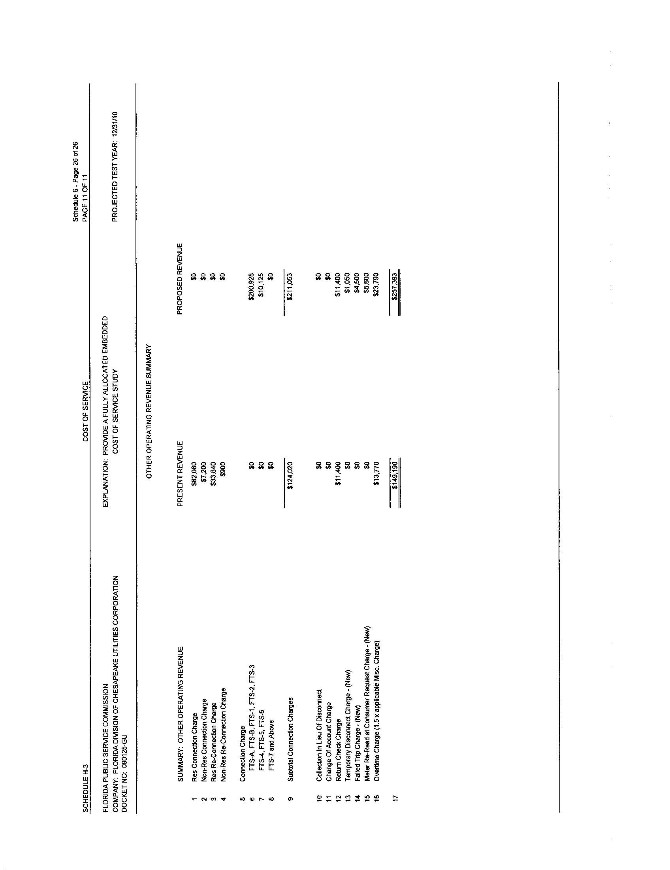

Order No. PSC-00-2263-FOF-GU, issued November 28, 2000, in Docket No. 000108-GU, In re: Request for rate increase by Florida Division of Chesapeake Utilities Corporation.
Order No. PSC-05-0208-PAA-GU, issued February 22, 2005, In re: Petition or authorization to establish new customer classifications and restructure rates, and for approval of proposed revised tariff sheets by Florida Division of Chesapeake Utilities Corporation.
Order No. PSC-09-0606-PCO-GU, issued September 8, 2009, In re: Petition for increase in rates by Florida Division of Chesapeake Utilities Corporation.
Order No. PSC-09-0590-PCO-GU, issued September 1, 2009, In re: Petition for increase in rates by Florida Division of Chesapeake Utilities Corporation.
Order No. PSC-08-0623-PAA-GU, issued September 24,2008, in Docket No. 080163-GU, In re: Petition for approval to create regulatory subaccount of meter installation to capitalize all incurred and future costs associated with installation of encoder receiver transmitters (ERTs) under provisions of Statement of Financial Accounting Standard No. 71, Accounting for the Effects of Certain Types of Regulation (SFAS 71); and requesting depreciation of installation costs of ERTs over 15-year period beginning January 1, 2008, by Florida City Gas.
Order No. PSC-08-0364-PAA-GU, issued June 2, 2008, in Docket No. 070322-GU, In re: 2007 depreciation study by Florida Division of Chesapeake Utilities Corporation, p. 4
Order No. PSC-00-2263-FOF-GU, issued November 28, 2000, in Docket No. 000108-GU, In re: Request for rate increase by Florida Division of Chesapeake Utilities Corporation.
Order No. PSC-08-0327-FOF-EI, issued May 19, 2008, in Docket No. 070304-EI, In re: Petition for rate increase by Florida Public Utilities Company, p. 38
Order No. PSC-00-2263-FOF-GU, issued November 28, 2000, in Docket No. 000108-GU, In re: Request for rate increase by Florida Division of Chesapeake Utilities Corporation, p. 7.
Order No. PSC-00-2263-FOF-GU, issued November 28, 2000, in Docket No. 000108-GU, In re: Request for rate increase by Florida Division of Chesapeake Utilities Corporation.
Federal Power Commission v. Hope Natural Gas Company, 320 U.S. 591 (1944) and Bluefield Water Works & Improvement Company v. Public Service Commission of West Virginia, 262 U.S. 679 (1923).
Order No. PSC-09-0375-PAA-GU, issued May 27, 2009, in Docket No. 080366-GU, In re: Petition for rate increase by Florida Public Utilities Company.
Order No. PSC-09-0411-FOF-GU, issued June 9, 2009, in Docket No. 080318-GU, In re: Petition for rate increase by Peoples Gas System.
Utility’s Petition for Reconsideration was denied by Order No. 16878, issued November 21, 1986.
Order No. PSC- 09-0411-FOF-GU, issued June 9, 2009, in Docket No. 080318-GU, In re: Petition for Rate increase by Peoples Gas System.
Order No. PSC-00-2263-FOF-GU, issued November 28, 2000, in Docket No. 000108-GU, In re: Request for rate increase by Florida Division of Chesapeake Utilities Corporation.
Order No. PSC-09-0733-FOF-GU, issued November 4, 2009, in Docket No. 090004-GU, In re: Natural gas conservation recovery.
$956,257÷4 = $239,064
Order No. PSC-05-0250-PAA-EI, issued March 4, 2005, in Docket No. 050093-EI, In re: Petition for approval of stipulation and settlement for special accounting treatment and recovery of costs associated with Hurricane Ivan’s impact on Gulf Power Company.
Order No. PSC-05-0748-FOF-EI, issued July 14, 2005, in Docket No. 041272-EI, In re: Petition for approval of storm cost recovery clause for recovery of extraordinary expenditures related to Hurricanes Charley, Frances, Jeanne, and Ivan, by Progress Energy Florida, Inc.
This data was provided by Thomas A. Geoffroy, Staff Data Request No. 1-B and No. 198
Order No. PSC-09-0411-FOF-GU, issued June 9, 2009, in Docket No.080318-GU, In re: Petition for Rate Increase by Peoples Gas System.
Order No. PSC-09-0375-PAA-GU, issued May 27, 2009, in Docket No.080366, In re: Petition for Rate Increase by Florida Public Utilities Company.
Order No. PSC-94-0151-FOF-EI, issued February 8, 1994, in Docket No. 931034-EI, In re: Investigation on plan by Florida Power and Light Company to close local offices and contract with Eckerd Drugs to accept payments.
Order No. PSC-05-0208-PAA-GU, issued February 22, 2005, in Docket No. 040956-GU, In re: Petition for authorization to establish new customer classifications and restructure rates, and for approval of proposed revised tariff sheets by Florida Division of Chesapeake Utilities Corporation.
Order No. PSC-07-0427-TRF-GU, issued May 15, 2007, in Docket No. 060675-GU, In re: Petition for authority to implement phase two of experimental transitional transportation service pilot program and for approval of new tariff to reflect transportation service environment, by Florida Division of Chesapeake Utilities Corporation.
Order No. PSC-08-0436-PAA-GU, issued July 8, 2008, in Docket No. 070592-GU, In re: Petition for rate increase by St. Joe Natural Gas Company, Inc.
Order No. PSC-02-1646-TRF-GU, issued November 25, 2002, in Docket No. 020277-GU, In re: Petition of Florida Division of Chesapeake Utilities to convert all remaining sales customers to transportation service and to exit the merchant function.
Order No. PSC-05-0208-PAA-GU, issued February 22, 2005, in Docket No. 040956-GU, In re: Petition for authorization to establish new customer classifications and restructure rates, and for approval of proposed revised tariff sheets by Florida Division of Chesapeake Utilities Corporation.
Order No. PSC-07-0427-TRF-GU, issued May 15, 2007, in Docket No. 060675-GU, In re: Petition for authority to implement phase two of experimental transitional transportation service pilot program and for approval of new tariff to reflect transportation service environment, by Florida Division of Chesapeake Utilities Corporation.

