BEFORE THE FLORIDA PUBLIC SERVICE COMMISSION

In re: Petition for rate increase by Florida Public Utilities Company. | DOCKET NO. 080366-GU  ORDER NO. PSC-09-0848-S-GU  ISSUED: December 28, 2009

The following Commissioners participated in the disposition of this matter:

MATTHEW M. CARTER II, Chairman
LISA POLAK EDGAR
NANCY ARGENZIANO
NATHAN A. SKOP
DAVID E. KLEMENT

FINAL ORDER APPROVING STIPULATION AND SETTLEMENT

BY THE COMMISSION:

Background
This proceeding commenced on December 17, 2008, with the filing of a petition for a permanent rate increase by Florida Public Utilities Company (FPUC or Company). FPUC serves gas customers through two divisions: the Central Florida Division consisting of portions of Seminole, Marion and Volusia Counties, and the South Florida Division consisting of portions of Palm Beach, Broward and Martin Counties. Together, FPUC provides service to over 51,000 residential and commercial customers.

FPUC requested an increase in its retail rates and charges to generate $9,917,690 in additional gross annual revenues. This increase would have allowed the Company to earn an overall rate of return of 8.74 percent with an 11.75 percent return on equity (range 10.75 percent to 12.75 percent). The Company based its request on a projected test year ending December 31, 2009, and requested that its petition for rate relief be processed under the proposed agency action (PAA) procedure authorized by Section 366.06(4), Florida Statutes (F.S.)

FPUC also requested an interim rate increase in its retail rates and charges to generate $984,054 in additional gross annual revenues. Based on FPUC’s calculations, the increase would allow the Company to earn an overall rate of return of 7.66 percent, with a 10.25 percent return on equity, which was the minimum of what was then the authorized return on equity range of 10.25 percent to 12.25 percent. The Company based its interim request on a historical test year ended December 31, 2007. We granted the interim rate increase in Order No. PSC-09-0123-PCO-GU (Interim Rate Order), issued March 3, 2009. The interim rates became effective for all meter readings made on or after March 12, 2009.

Using the PAA procedure, we issued PAA Order No. PSC-09-0375-PAA-GU (PAA Order) on May 27, 2009, in which we proposed a revenue increase of $8,496,230, and an authorized return on equity of 10.85 percent, with a range of plus or minus 100 basis points. The PAA Order did not require a refund of any revenues collected during the interim period. The PAA Order also approved new miscellaneous service charges.

However, before the PAA Order could become final, the Office of Public Counsel (OPC), who had intervened, filed its timely protest of that Order on June 17, 2009. In its protest, OPC listed 26 separate issues, but specifically noted that it was not protesting the test period, the quality of service, cost of capital, or cost of service and rate design sections. Also, FPUC timely filed its cross-petition on June 26, 2009, in which it raised two new issues, and further noted that rate case expense would have to be recalculated to reflect the cost of addressing OPC’s protest. Pursuant to the protests noted above, the petition of FPUC was set for formal hearing in accordance with Rule 25-22.029, Florida Administrative Code (F.A.C.)

Pursuant to Section 366.06(4), F.S., FPUC implemented, subject to refund with interest, the rates and charges approved by the PAA Order. As allowed by Order No. PSC-09-0588-PCO-GU, issued August 31, 2009, the revenues subject to refund with interest for both the interim rates and the implemented PAA rates are protected by a corporate undertaking guaranteed by Florida Public Utilities Company, the consolidated entity, in the amount of $6,000,000.

On October 27, 2009, FPUC filed its Motion to Approve Stipulation and Settlement (Motion), in which FPUC requested that we approve the Stipulation and Settlement which was attached and signed by both parties. The Motion, with the Stipulation and Settlement, is incorporated in this Order as Attachment A.
This Order addresses FPUC's Motion and the parties' Stipulation and Settlement agreement. We have jurisdiction pursuant to Sections 366.06(2) and (4), and 366.07, F.S.
Approval of Stipulation and Settlement
As noted earlier, in the PAA Order, we proposed a revenue increase of $8,496,230, and an authorized return on equity of 10.85 percent, with a range of plus or minus 100 basis points. In its protest, OPC listed 26 separate issues, but specifically noted that it was not protesting the test period, the quality of service, cost of capital, or cost of service and rate design sections. FPUC's cross-petition raised two new issues, and further noted that rate case expense would have to be recalculated to reflect the cost of addressing OPC's protest.
The Stipulation and Settlement states that "OPC and FPUC agree that FPUC shall be entitled to increase its rates and charges so as to produce an additional $7,969,000 in annual revenues." The Stipulation and Settlement would decrease the annual increase previously allowed by the PAA Order by $527,230, while resolving all issues raised by OPC and FPUC. Also, the parties agree in the settlement that any issues associated with the recently approved merger of Chesapeake Utilities and FPUC will be resolved in the pending Chesapeake rate case (Docket No. 090125-GU) and applied to this docket. The Stipulation and Settlement appears to propose a reasonable resolution to the protested issues, and its approval would obviate the need for additional hearings while minimizing the time and expenses to all parties. Therefore, the Stipulation and Settlement entered into between OPC and FPUC is approved.
Partial Refund of Implemented PAA Rates

The Stipulation and Settlement states that, "OPC and FPUC recognize that as a result of this Settlement, FPUC may be required to make a refund to customers. In the event the Commission requires a refund, OPC agrees that such refunds may be made over a period of time not to exceed six (6) months."
On June 4, 2009, FPUC implemented the rates and charges approved by the PAA Order. On an annual basis, the amount of revenues from the Stipulation and Settlement is $527,230 less than that of the PAA Order. FPUC shall be required to refund the difference in the rates, plus interest, that have been collected since the PAA rates were implemented in June 2009 through the date the revised rates go into effect. Based on the revenues allowed in the Stipulation and Settlement, the interim revenues authorized by the Interim Rate Order and collected prior to the implementation of the PAA rates shall not be refunded.
FPUC calculated that the refund amount, including interest, for the period June through November 2009 would be $212,605. The final refund amount will change based on the addition of December 2009 and January 2010 in the calculation.
We find that FPUC shall refund the difference between the rates approved by the PAA Order and the rates resulting from the Stipulation and Settlement, with interest, in the form of a one-time refund on customer bills. FPUC stated that it agrees with this approach and can issue the one-time refund as a credit on customer bills in February 2010. FPUC shall file a report with the Division of Economic Regulation 10 business days prior to the refund being made showing the detailed calculations of the actual refund. Once our staff verifies that the refund is complete, the $6,000,000 corporate undertaking guaranteed by Florida Public Utilities Company, the consolidated entity, shall be released.
Appropriate Settlement Rates

The Settlement did not include revised rates. Our staff requested that FPUC file revised rates and supporting documentation that implement the Stipulation and Settlement. On November 17, 2009, FPUC provided to both our staff and OPC the revised rates and supporting documentation. Our staff reviewed the calculation and made a correction. FPUC agreed with our staff's correction.
OPC's protest did not address the cost of service, rate design, cost of capital, or miscellaneous service charges (initial connect, disconnect, etc). Therefore, FPUC allocated the decrease in annual revenues that results from the Stipulation and Settlement ($527,230) to the rate classes as a percentage of total revenues from sales achieved by each rate class. The resulting rates are shown in Attachment B. The miscellaneous service charges approved in Order No. PSC-09-0375-PAA-GU shall remain unchanged.
The revised rates shall go into effect for meters read on or after January 14, 2010. FPUC shall file tariffs reflecting the rates shown in Attachment B. The Company shall provide notice of the final approved rates as required by Rule 25-22.0406(8), F.A.C. A copy of the notice shall be submitted to our staff for approval prior to its use.
In consideration of the above, it is

ORDERED by the Florida Public Service Commission that the Stipulation and Settlement agreement entered into between Florida Public Utilities Company and the Office of the Public Counsel is approved. It is further

ORDERED that the attachments to this Order are by reference incorporated herein. It is further

ORDERED that the appropriate rates shall be as shown in Attachment B. It is further

ORDERED that Florida Public Utilities Company shall file tariffs reflecting the rates shown in Attachment B. It is further

ORDERED that the revised rates shall go into effect for meters read on or after January 14, 2010. It is further

ORDERED that Florida Public Utilities Company shall provide notice of the final approved rates as required by Rule 25-22.0406(8), F.A.C. A copy of the notice shall be submitted to our staff for approval prior to its use. It is further

ORDERED that the Cost of Capital and Miscellaneous Service Charges set out in the Proposed Agency Action Order were not protested, and shall remain as set out in that Order. It is further

ORDERED that Florida Public Utilities Company shall refund with interest the difference between the proposed agency action rates implemented in June 2009 and the rates resulting from the Stipulation and Settlement, in the form of a one-time refund on customer bills. It is further

ORDERED that Florida Public Utilities Company shall file a report with the Division of Economic Regulation 10 business days prior to the refund being made showing the detailed calculations of the actual refund. It is further

ORDERED that once our staff verifies that the refund is complete, the $6,000,000 corporate undertaking guaranteed by Florida Public Utilities Company, the consolidated entity, shall be released. It is further

ORDERED that this docket shall remain open until our staff has approved the revised tariffs sheets and customer notices, and FPUC has provided our staff with proof that it has made the appropriate refunds with interest. It is further

ORDERED that once staff has verified all of the above actions are complete, this docket shall be closed administratively.
By ORDER of the Florida Public Service Commission this 28th day of December, 2009.

/s/ Ann Cole
ANN COLE
Commission Clerk

This is an electronic transmission. A copy of the original signature is available from the Commission's website, www.floridapsc.com, or by faxing a request to the Office of Commission Clerk at 1-850-413-7118.

( S E A L )

RRJ

NOTICE OF FURTHER PROCEEDINGS OR JUDICIAL REVIEW

The Florida Public Service Commission is required by Section 120.569(1), Florida Statutes, to notify parties of any administrative hearing or judicial review of Commission orders that is available under Sections 120.57 or 120.68, Florida Statutes, as well as the procedures and time limits that apply. This notice should not be construed to mean all requests for an administrative hearing or judicial review will be granted or result in the relief sought.

Any party adversely affected by the Commission's final action in this matter may request: 1) reconsideration of the decision by filing a motion for reconsideration with the Office of Commission Clerk, 2540 Shumard Oak Boulevard, Tallahassee, Florida 32399-0850, within fifteen (15) days of the issuance of this order in the form prescribed by Rule 25-22.060, Florida Administrative Code; or 2) judicial review by the Florida Supreme Court in the case of an electric, gas or telephone utility or the First District Court of Appeal in the case of a water and/or wastewater utility by filing a notice of appeal with the Office of Commission Clerk, and filing a copy of the notice of appeal and the filing fee with the appropriate court. This filing must be completed within thirty (30) days after the issuance of this order, pursuant to Rule 9.110, Florida Rules of Appellate Procedure. The notice of appeal must be in the form specified in Rule 9.900(a), Florida Rules of Appellate Procedure.

Attachment A
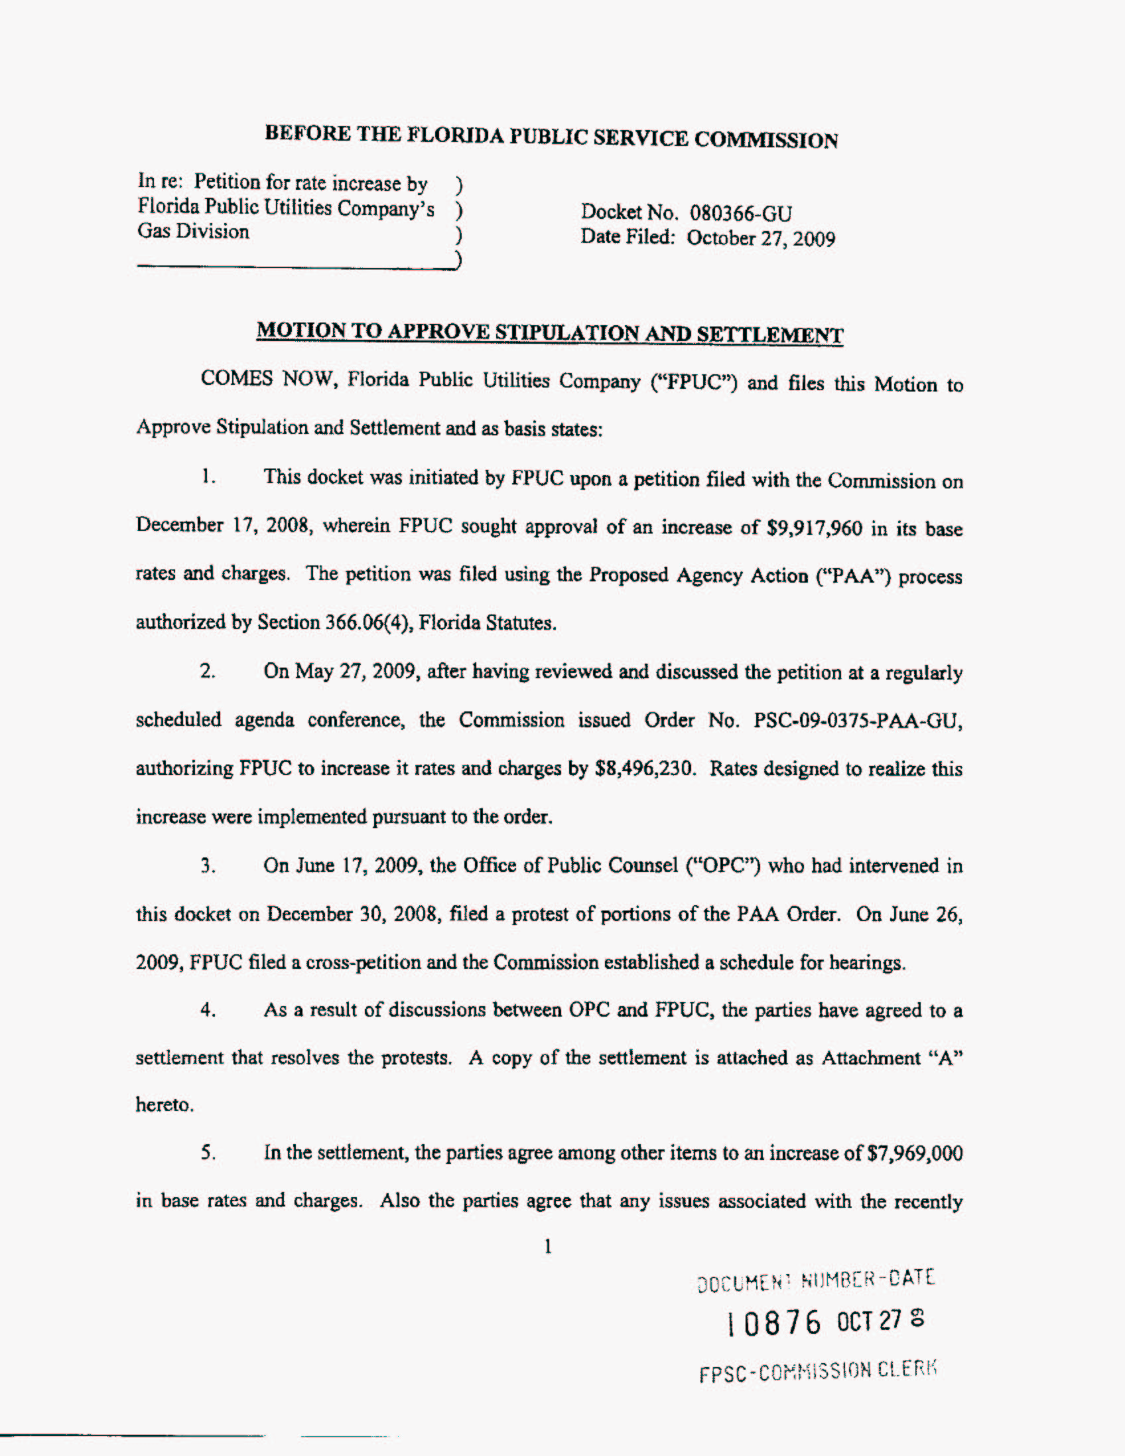
Attachment A
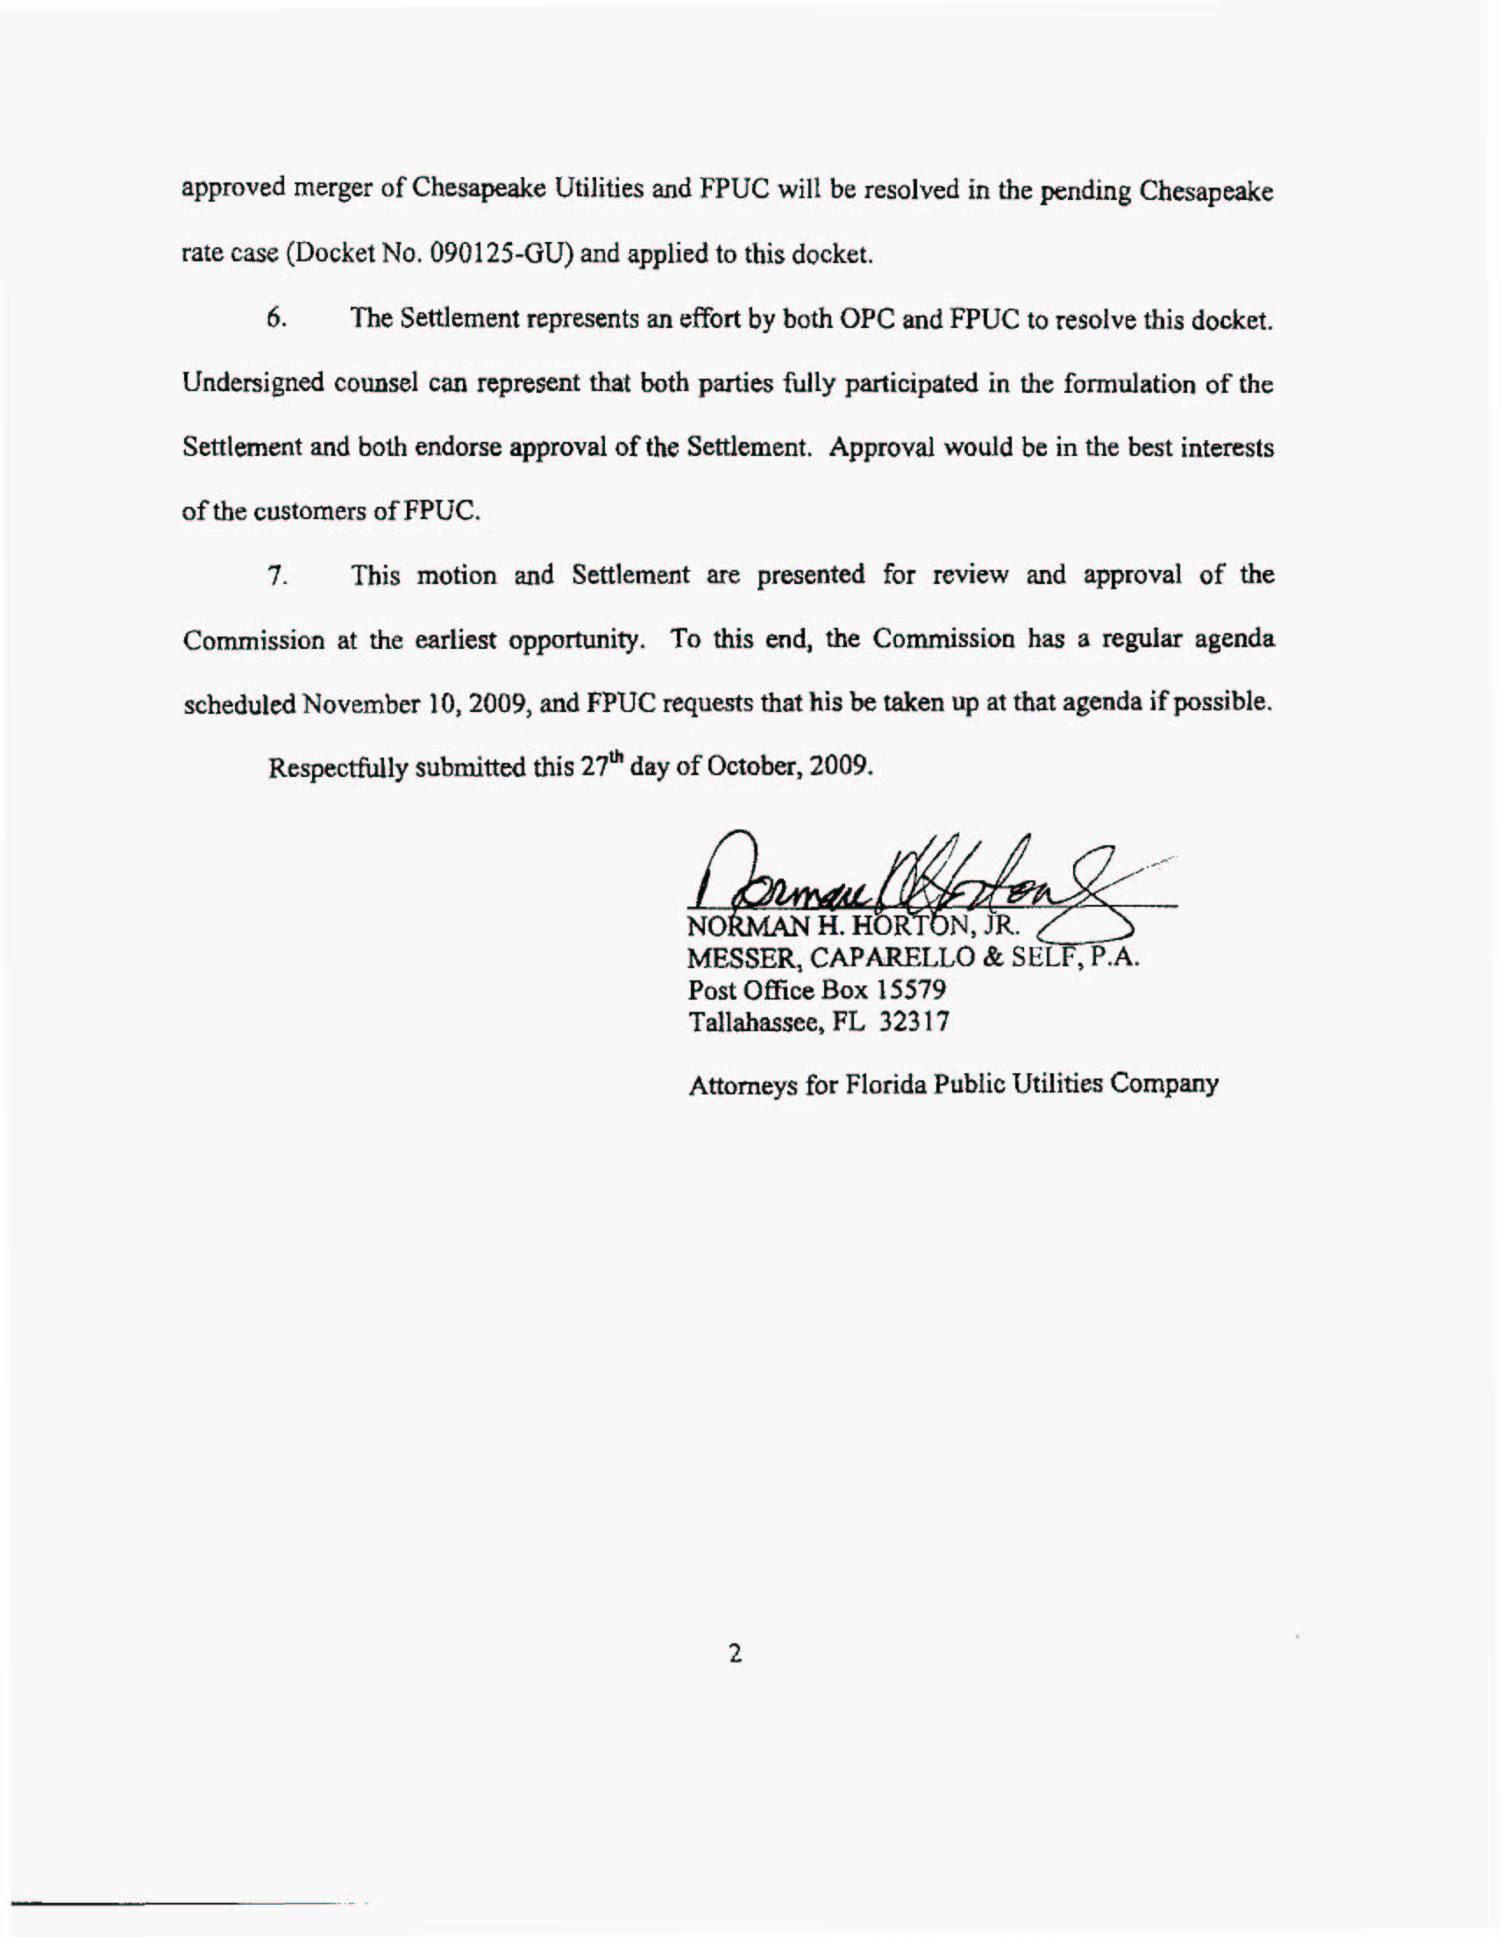
Attachment A
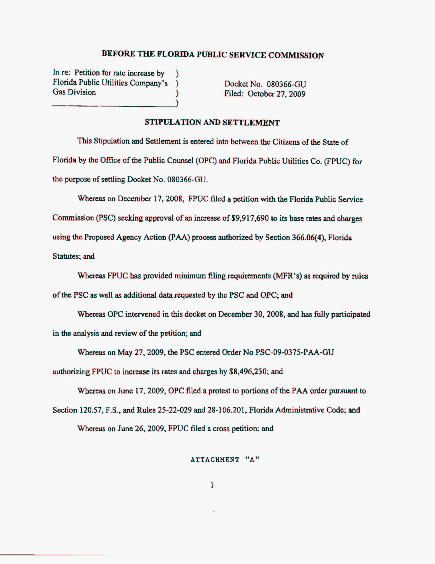
Attachment A
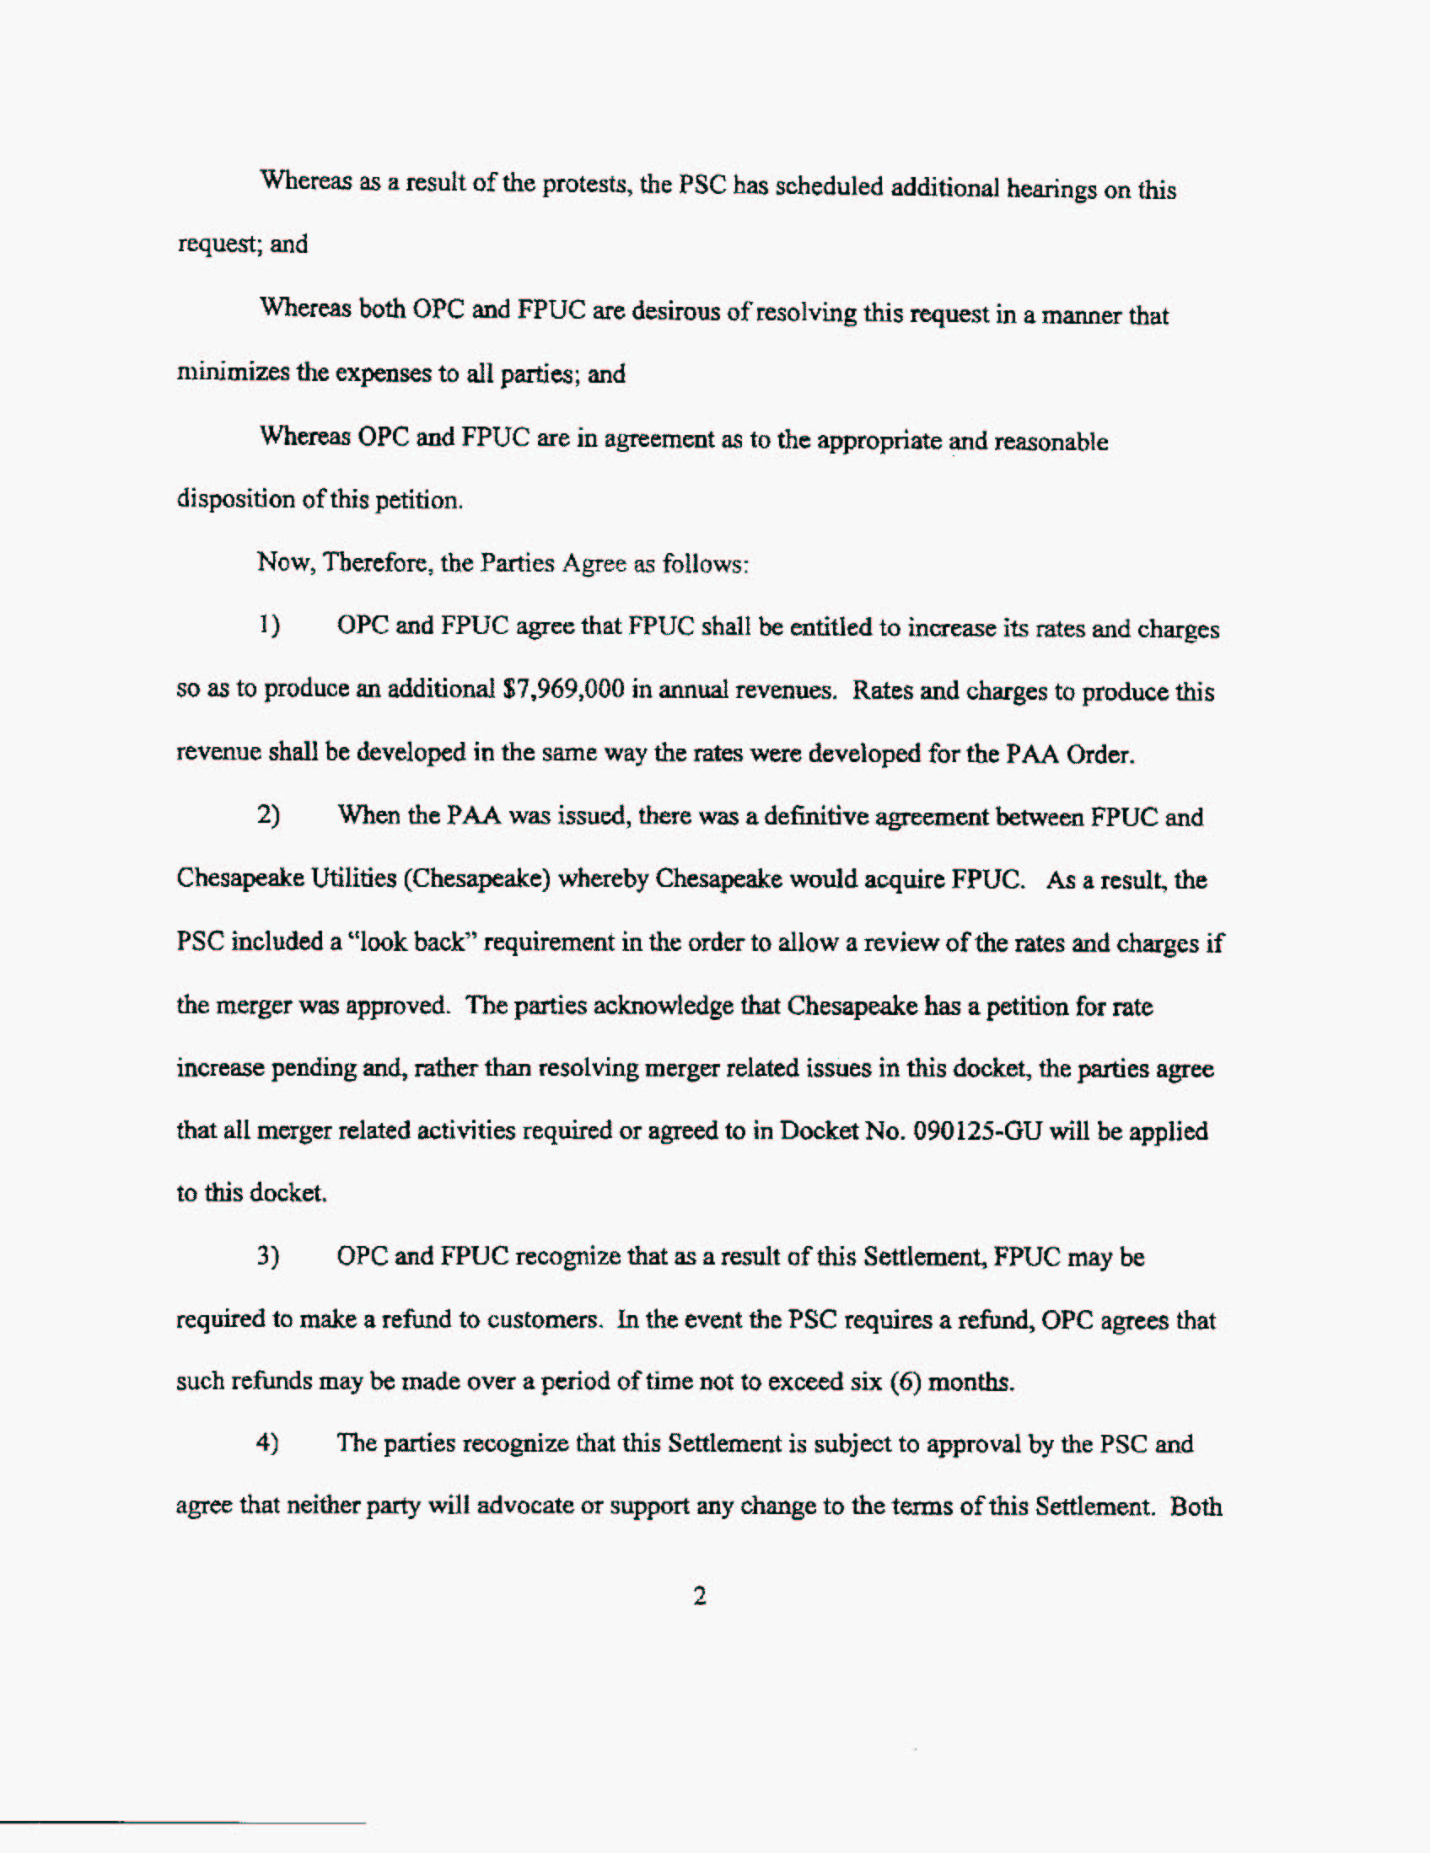
Attachment A
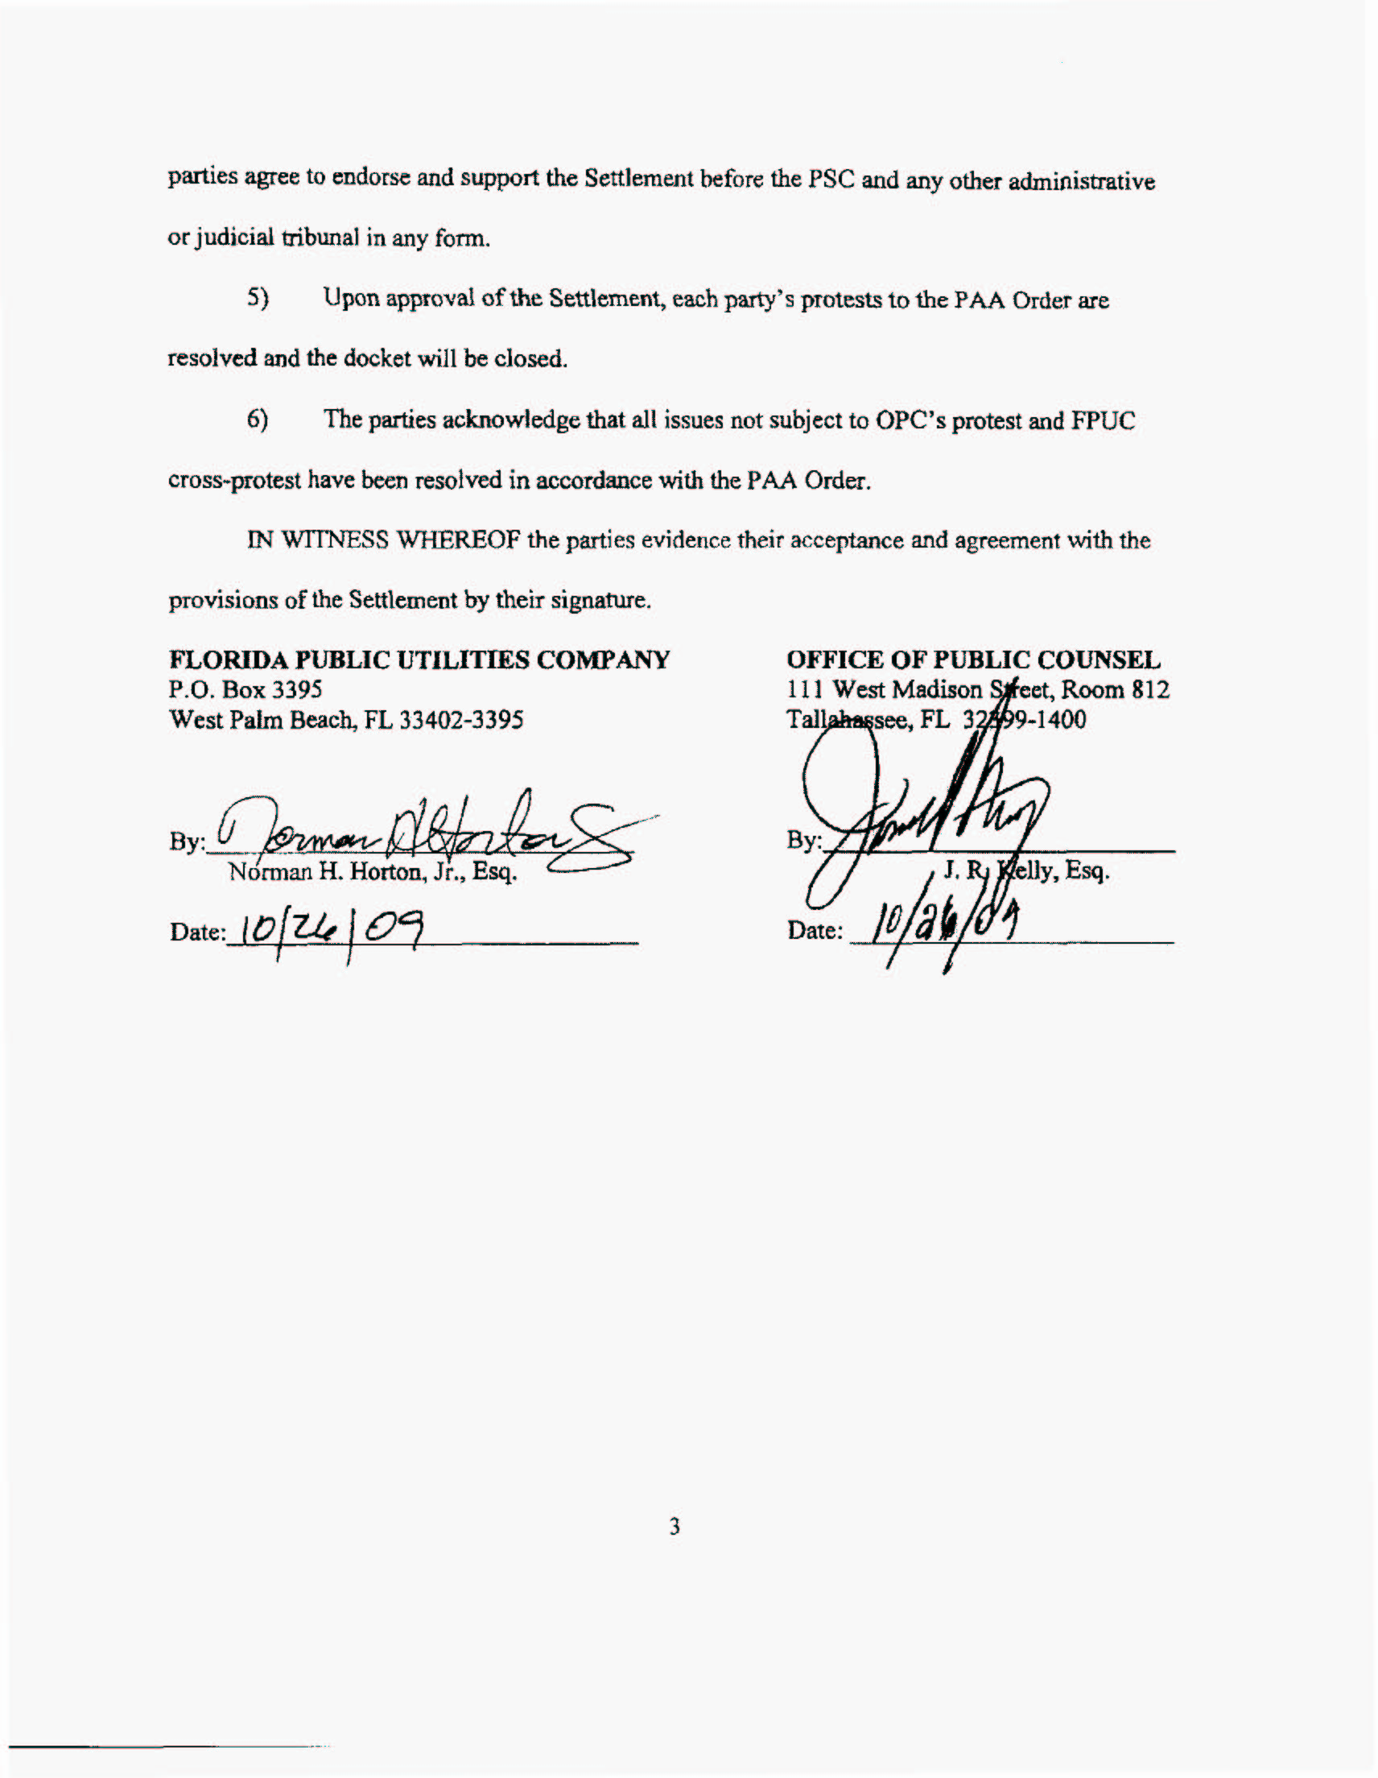
Attachment A
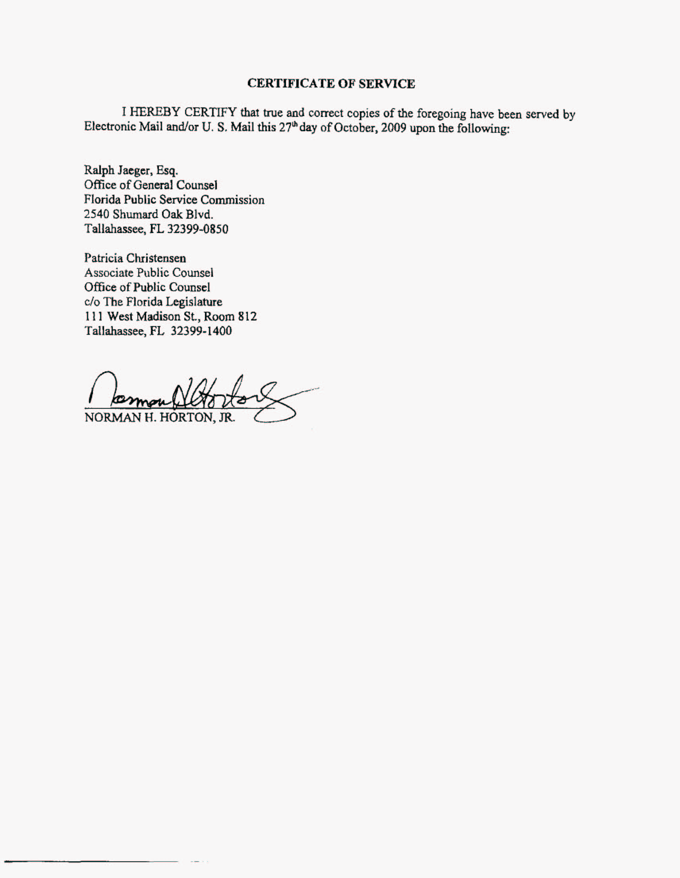

See Order No. PSC-04-1110-PAA-GU, issued November 8, 2004, in Docket No. 040216-GU, In re: Application for rate increase by Florida Public Utilities Company.
As a result of the Stipulation and Settlement, a residential customer using 20 therms will see a $0.39 reduction in their monthly bill when compared to a bill under the PAA rates.
As stated earlier, these rates were implemented subject to refund with interest pursuant to Section 366.06(4), F.S.

