State of Florida   |  | Public Service Commission  Capital Circle Office Center ● 2540 Shumard Oak Boulevard  Tallahassee, Florida 32399-0850  -M-E-M-O-R-A-N-D-U-M-
DATE: | March 4, 2010
TO: | Office of Commission Clerk (Cole)
FROM: | Division of Economic Regulation (Slemkewicz, Draper, Gardner, Kummer, Maurey, A. Roberts, Salnova)  Office of the General Counsel (Klancke, Fleming)
RE: | Docket No. 080318-GU – Petition for rate increase by Peoples Gas System.
AGENDA: | 03/16/10 – Regular Agenda – Decision on Stipulation and Settlement – Interested Persons May Participate
COMMISSIONERS ASSIGNED: |  |  | All Commissioners
PREHEARING OFFICER: |  |  | Skop
CRITICAL DATES: |  |  | None
SPECIAL INSTRUCTIONS: |  |  | None
FILE NAME AND LOCATION: |  |  | S:\PSC\ECR\WP\080318.RCM.DOC

Case Background
This proceeding commenced on August 11, 2008, with the filing of a petition for a permanent rate increase by Peoples Gas System (PGS or Company). The Company is engaged in business as a public utility providing gas service as defined in Section 366.02, Florida Statutes (F.S.), and is subject to the jurisdiction of the Commission. PGS requested an increase in its retail rates and charges to generate $26,488,091 in additional gross annual revenues. PGS based its request on a historical base year ended December 31, 2007, and a projected test year ending December 31, 2009. Intervention was granted to the Office of Public Counsel (OPC) and Florida Industrial Gas Users (FIGU) in this proceeding.
The Commission held an administrative hearing on PGS’ proposed rate increase on March 4-5, 2009. Thereafter, on June 9, 2009, upon consideration of the evidentiary record, the post-hearing briefs of the parties, and staff’s recommendations, the Commission issued Order No. PSC-09-0411-FOF-GU (Final Order) granting PGS an increase in its rates and charges to generate $19,152,365 in additional gross annual revenues.
On June 24, 2009, PGS filed a Motion for Reconsideration (Motion), contesting the Commission’s calculation of the Company’s weighted average cost of capital and revenue requirements. In its motion, PGS only requested the reconsideration of those portions of the Final Order which reconcile the rate base to the capital structure to determine the weighted average cost of capital used in determining the Company’s revenue requirements. PGS did not request oral argument on its Motion for Reconsideration. No response to PGS’ Motion was filed by the intervenors. Staff filed its recommendation for consideration at the August 18, 2009, Agenda Conference. On August 17, 2009, PGS requested that consideration of the recommendation be deferred to an agenda conference at a later date. The request for deferral was approved.
Informal meetings were held on October 12, 2009, and January 20, 2010, to discuss the issues raised in PGS’ Motion for Reconsideration concerning the Internal Revenue Code’s normalization rules and the adjustments to the weighted average cost of capital. On February 5, 2010, the parties filed a Joint Motion for Approval of Stipulation and Settlement (Joint Motion or Stipulation) as a full and complete resolution of the only matters remaining in the docket.
This recommendation addresses the proposed Stipulation. The Commission has jurisdiction pursuant to Sections 366.06(2) and (4), and 366.071, F.S.
Discussion of Issues
Issue 1:1
Should the Commission approve the proposed Stipulation and Settlement?
Recommendation:
Yes. The Commission should approve the proposed Stipulation and Settlement. (Slemkewicz)
Staff Analysis:
All parties to this docket have proffered the proposed Stipulation (Attachment 1) as a complete resolution of all matters pending in Docket No. 080318-GU. The Stipulation was signed by all of the parties in the proceeding. The primary purpose of the Stipulation is to make appropriate adjustments to deferred taxes in order to avoid any potential violation of the normalization rules under the Internal Revenue Code. The major elements contained in the Stipulation are as follows:
- Correction of depreciation reserve adjustment – reduce rate base by an additional $795,370 and associated deferred taxes by $613,628. (Paragraph 1)
- Correction of non-utility portion of common plant adjustment – reduce deferred taxes by $26,439. (Paragraph 2)
- Recognition of deferred taxes related to plant-in-service and related depreciation expense – reduce deferred taxes by $15,872. (Paragraph 3)
- Recognition of deferred taxes related to the adjustment for the West Florida Natural Gas Company acquisition adjustment – reduce deferred taxes by $371,477. (Paragraph 4)
- Increase off-system sales (OSS) to offset any potential change in the previously authorized base rate revenue increase of $19,152,365 – increase OSS revenues by $68,676 and related revenue taxes by $343. (Paragraph 5)
The adjustments in Paragraph 1 of the Stipulation correct an error that was made in an adjustment to the depreciation reserve. The adjustment should have been $1,590,741 instead of the $795,371 that was actually made. As a result, the depreciation reserve should be increased by $795,370, thereby reducing total rate base by the same amount. The deferred taxes associated with this adjustment are a reduction of $613,628.
The adjustments in Paragraphs 2 – 4 correct the amount of the deferred taxes component in the capital structure to avoid any potential violation of the normalization rules under the Internal Revenue Code (IRC). The total of the adjustments to reduce the deferred taxes component in the capital structure is $1,027,416 including the deferred taxes amount in Paragraph 1.
As stated in the Joint Motion, PGS is not seeking any additional rate relief. PGS’ primary objective is to avoid any potential violation of the normalization rules related to deferred taxes under the IRC. As addressed in Paragraph 5, in order to offset any increase in revenue requirements, the OSS revenues have been increased by $68,676 to negate the potential operating revenue increase related to the adjustments in Paragraphs 1 – 4. The end result is that the previously approved $19,152,365 operating revenue increase does not change.
Staff believes that the Stipulation is a fair and reasonable resolution of the outstanding issues in this docket and recommends that it be approved. Since there is no change to the revenue requirements, the currently approved tariffs filed in response to Order No. PSC-09-0411-FOF-GU reflect this increase, and no tariff revisions are needed. Schedules 1 through 5 show the revised rate base, capital structure, net operating income, and operating revenue increase calculation based on the proposed adjustments in the Stipulation.
Issue 2:2
Should this docket be closed?
Recommendation:
Yes. This docket should be closed upon the expiration of the time for appeal. (Klancke, Fleming)
Staff Analysis:
This docket should be closed upon the expiration of the time for appeal.
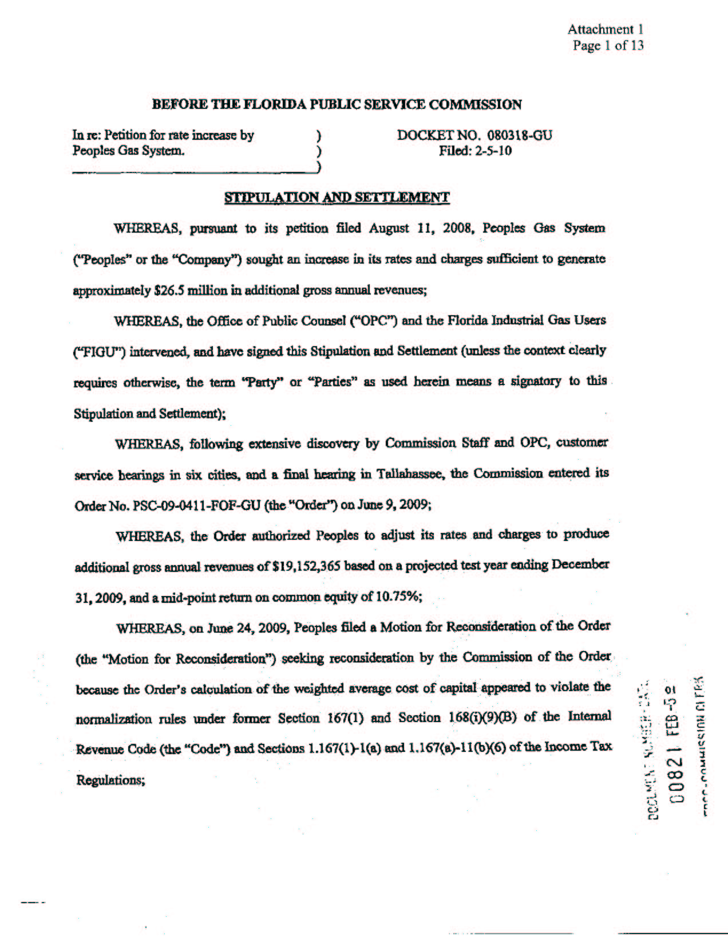
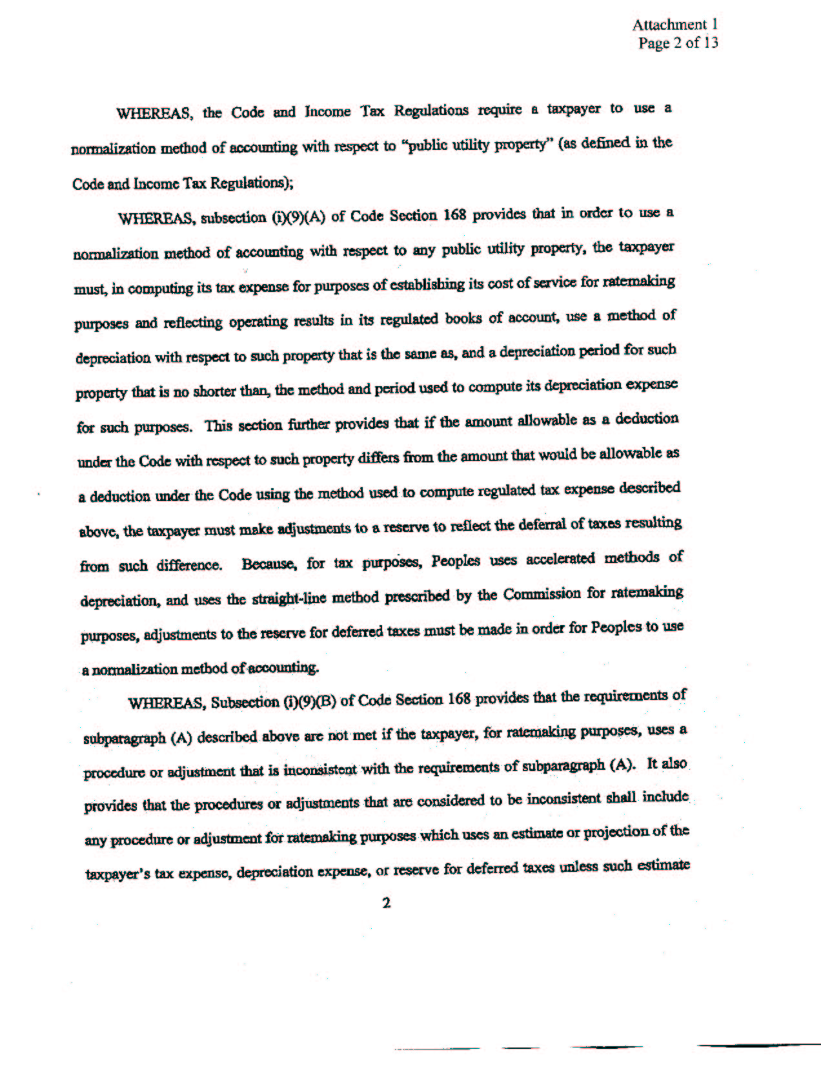
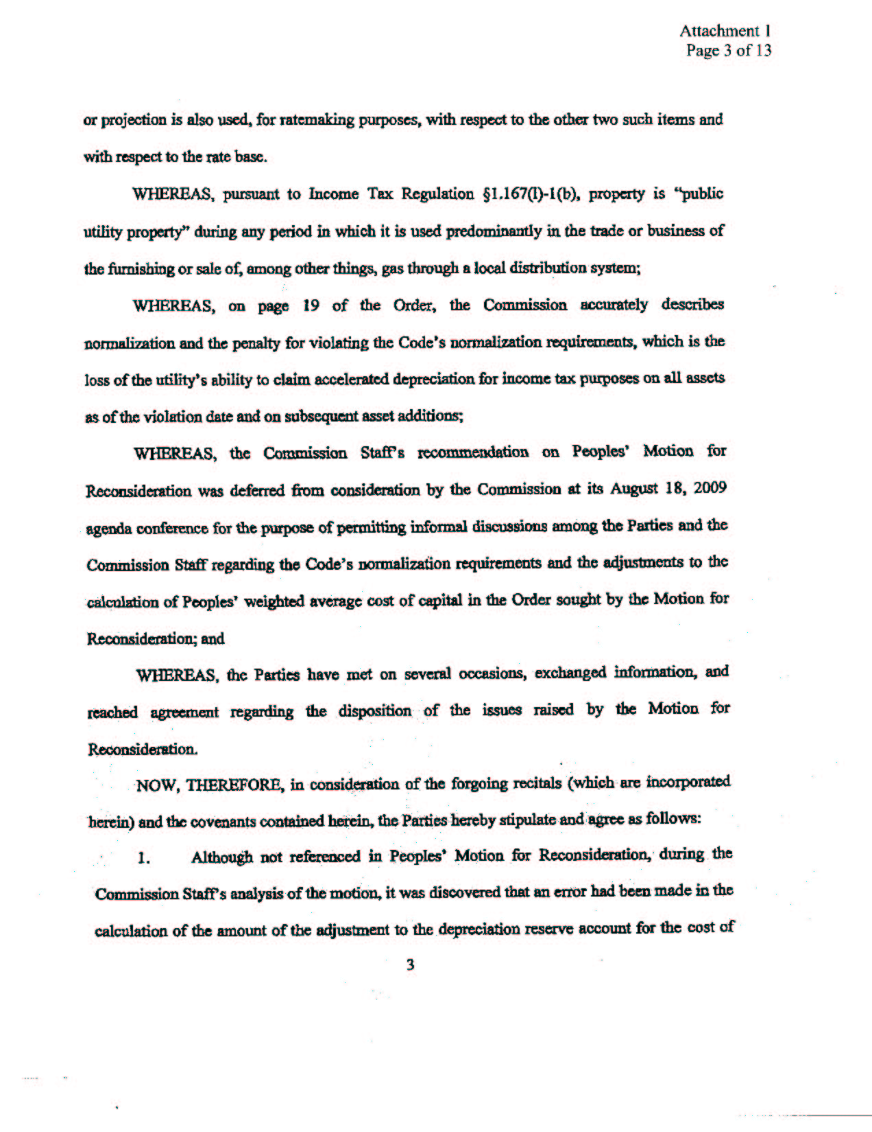
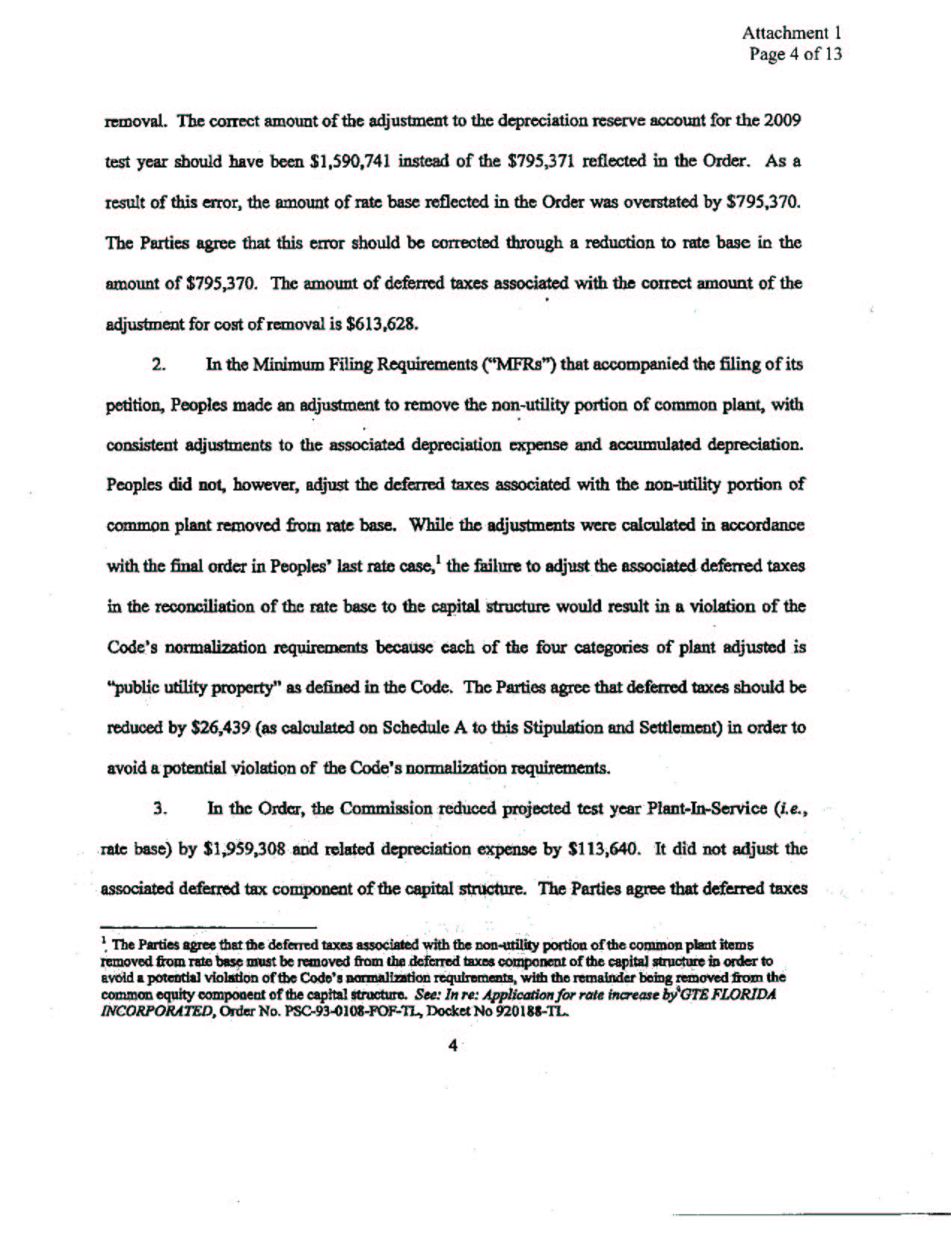
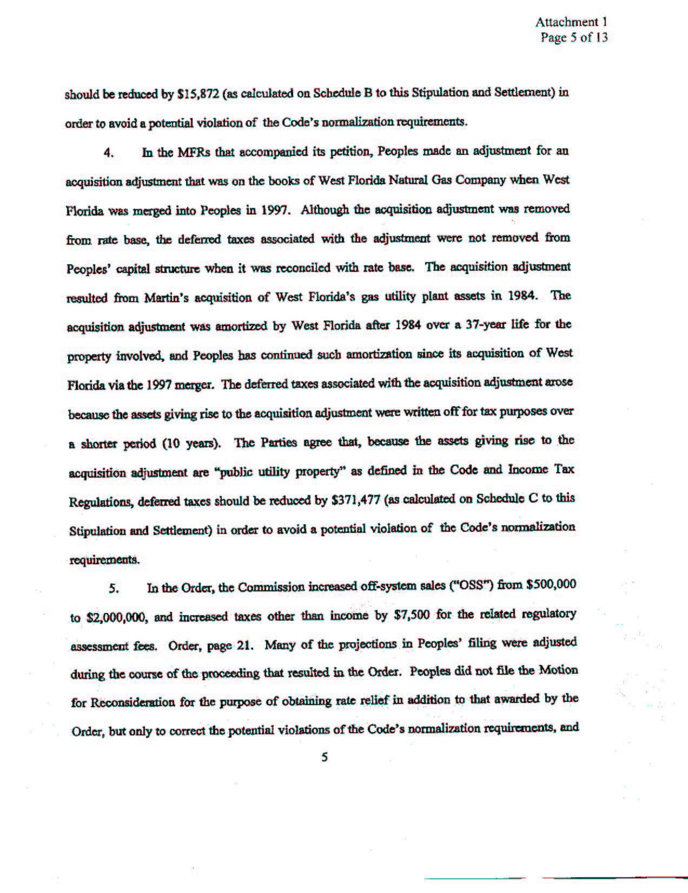
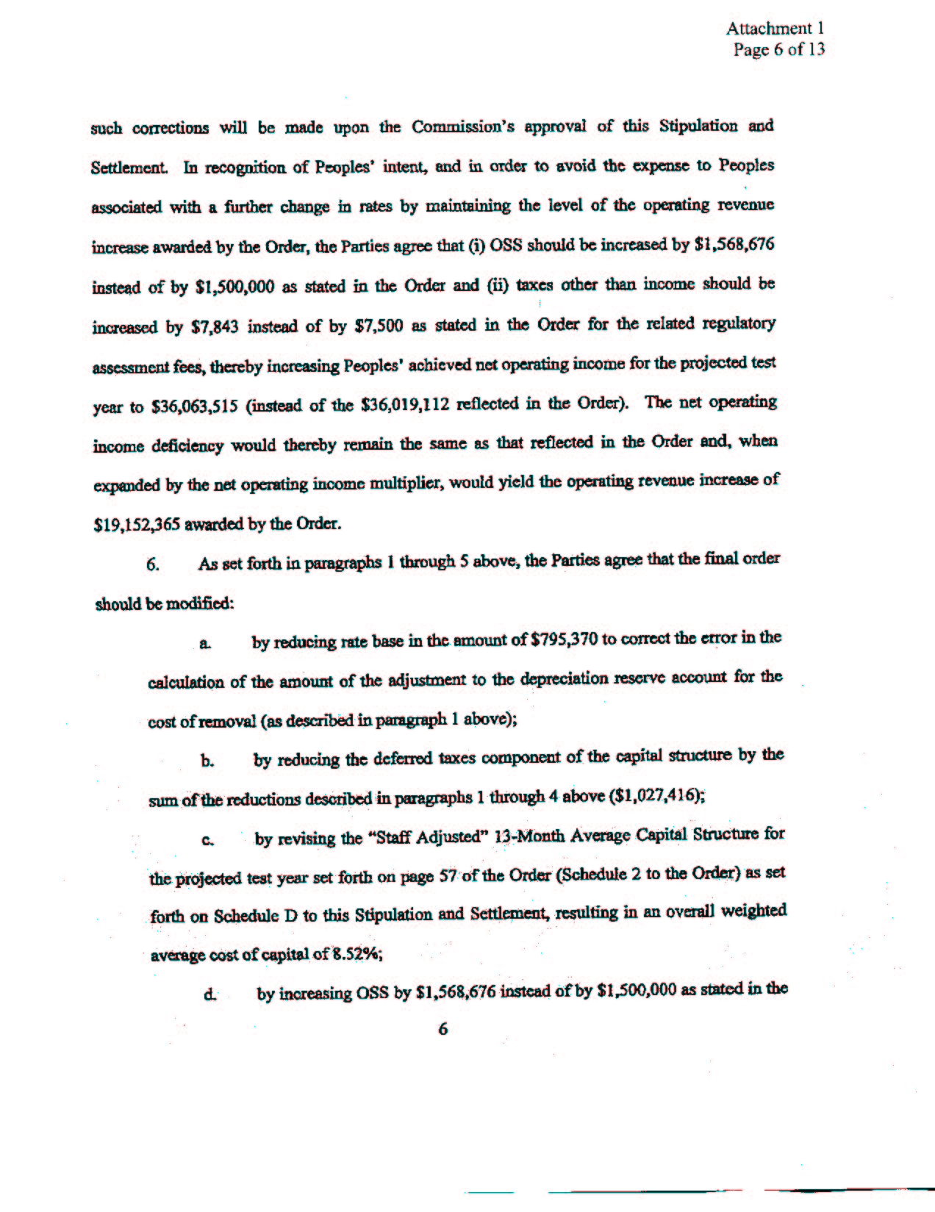
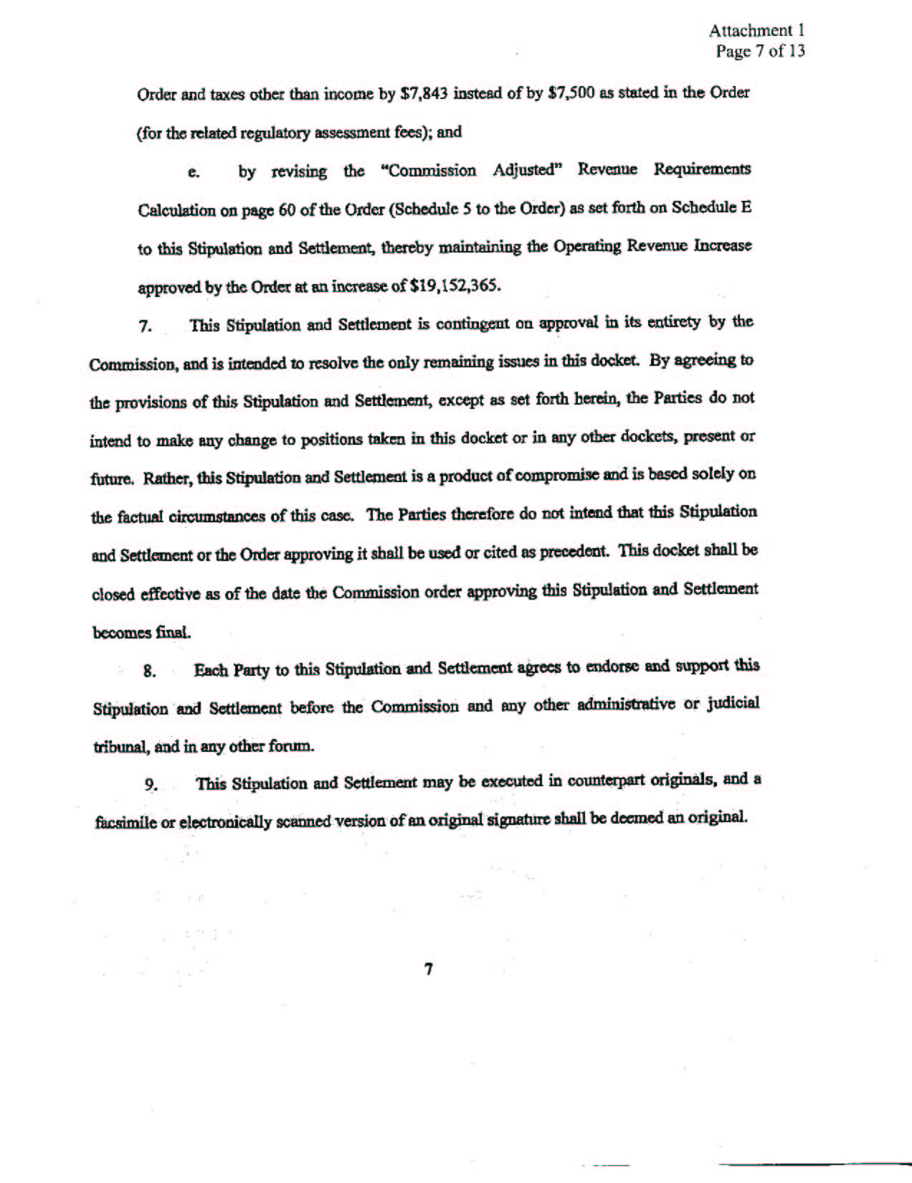
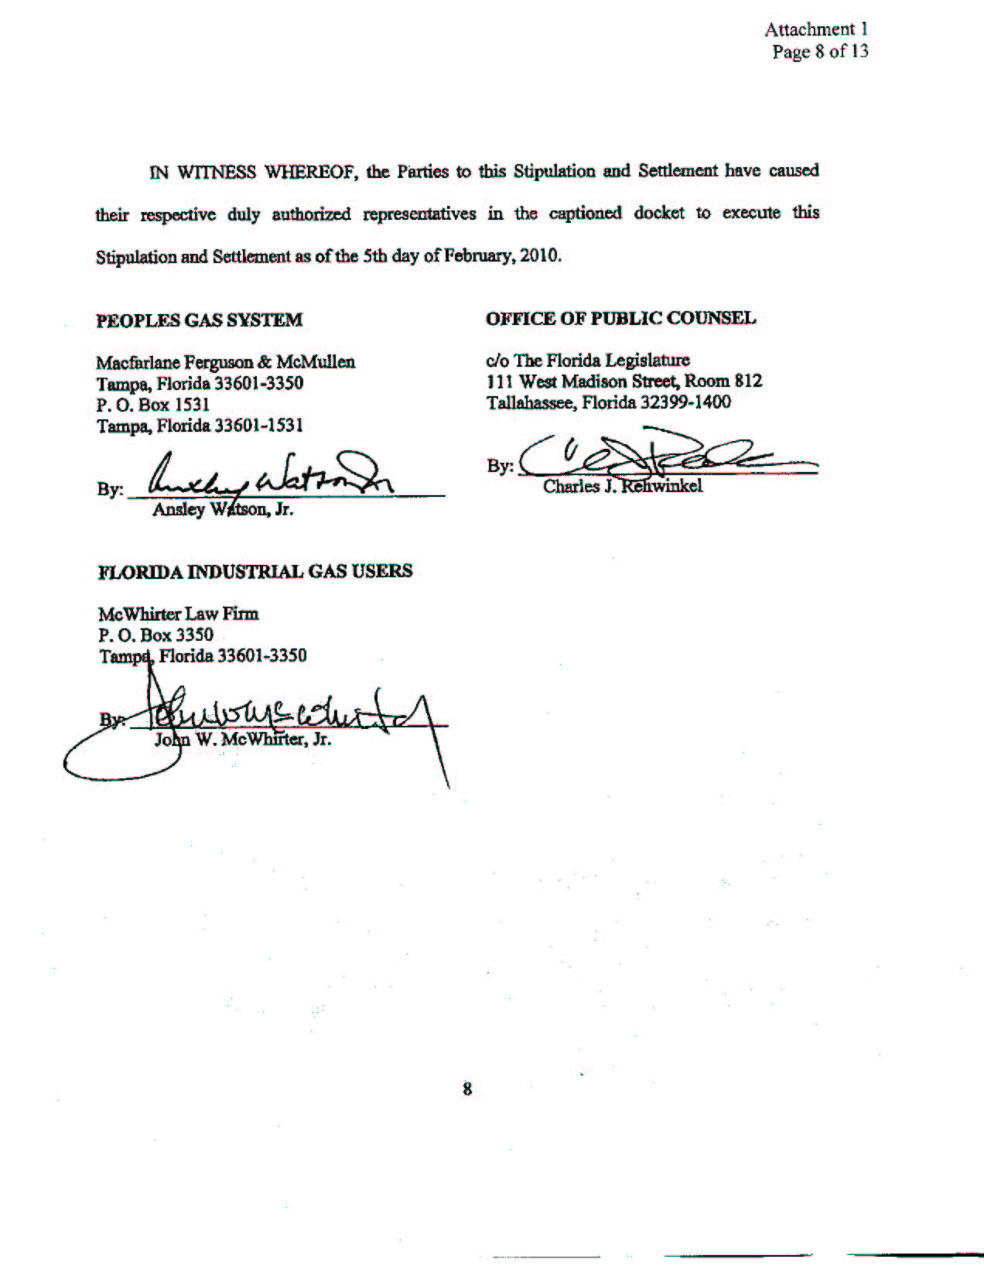
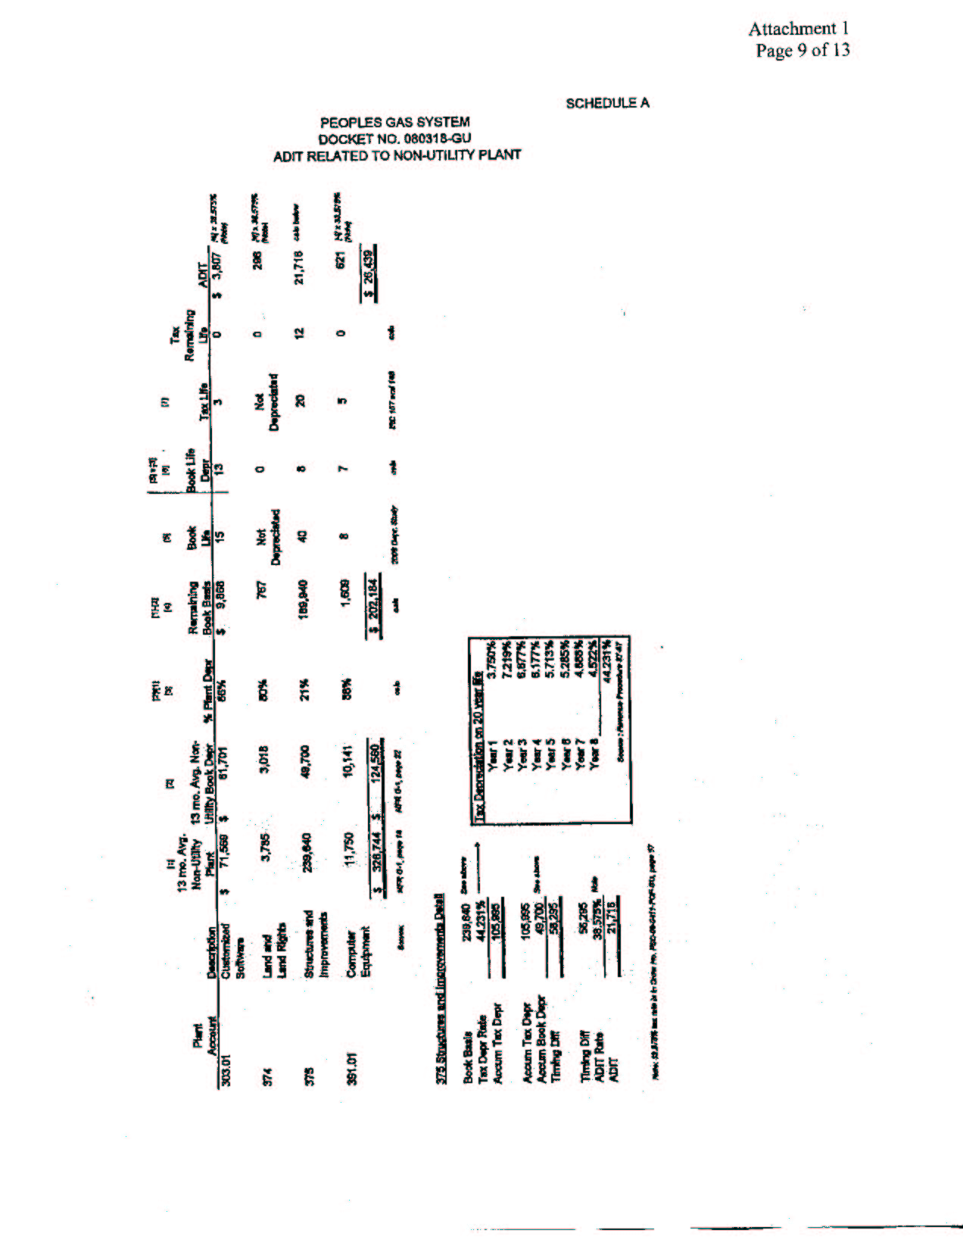
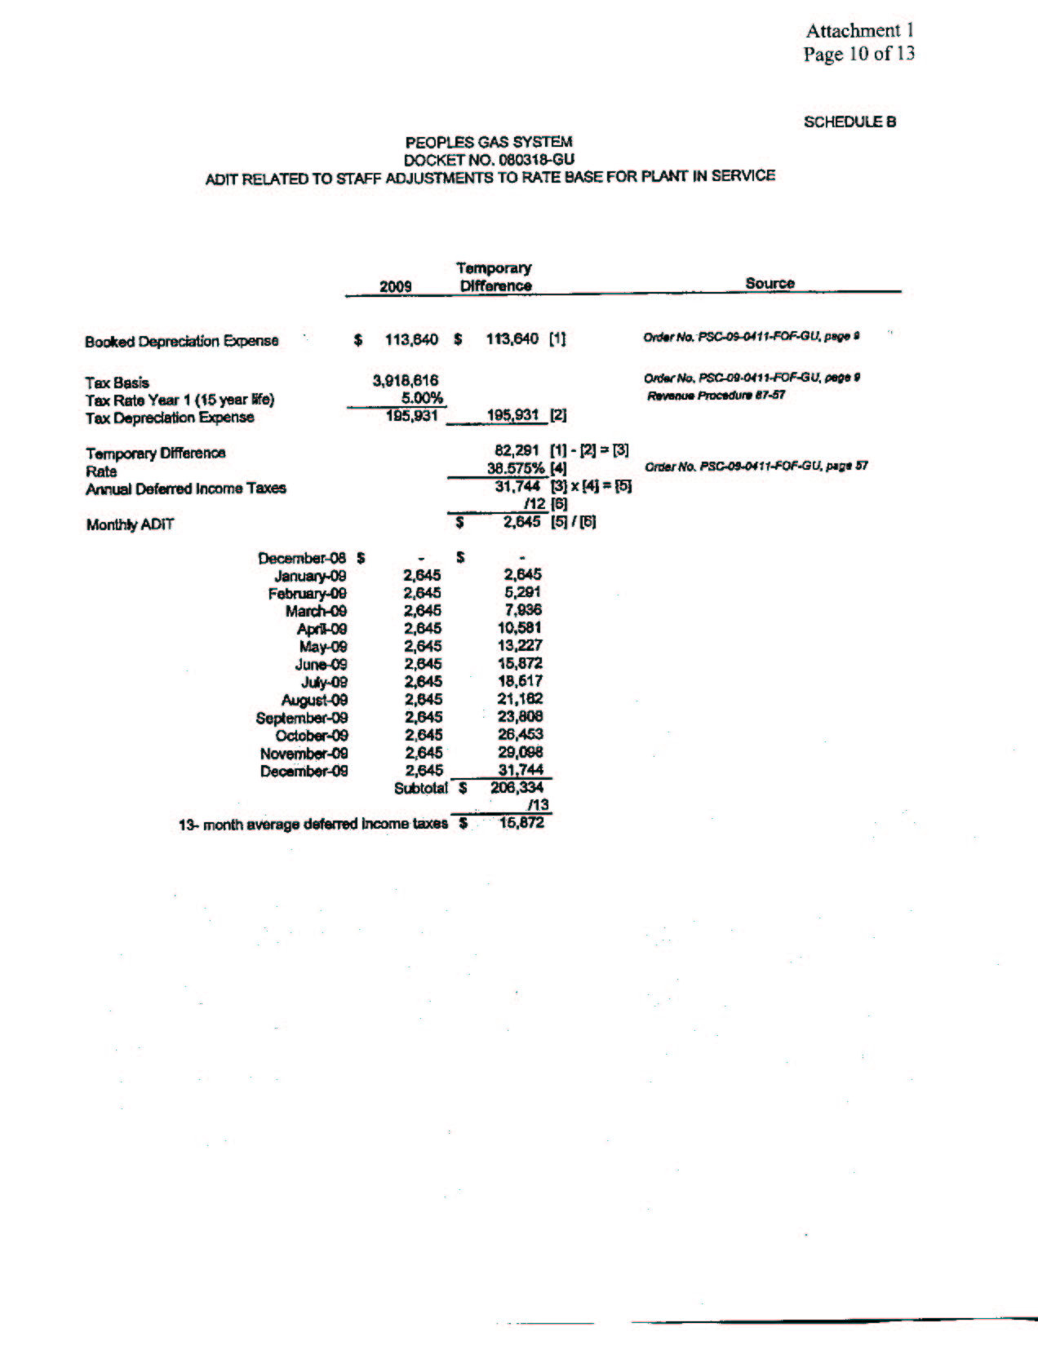
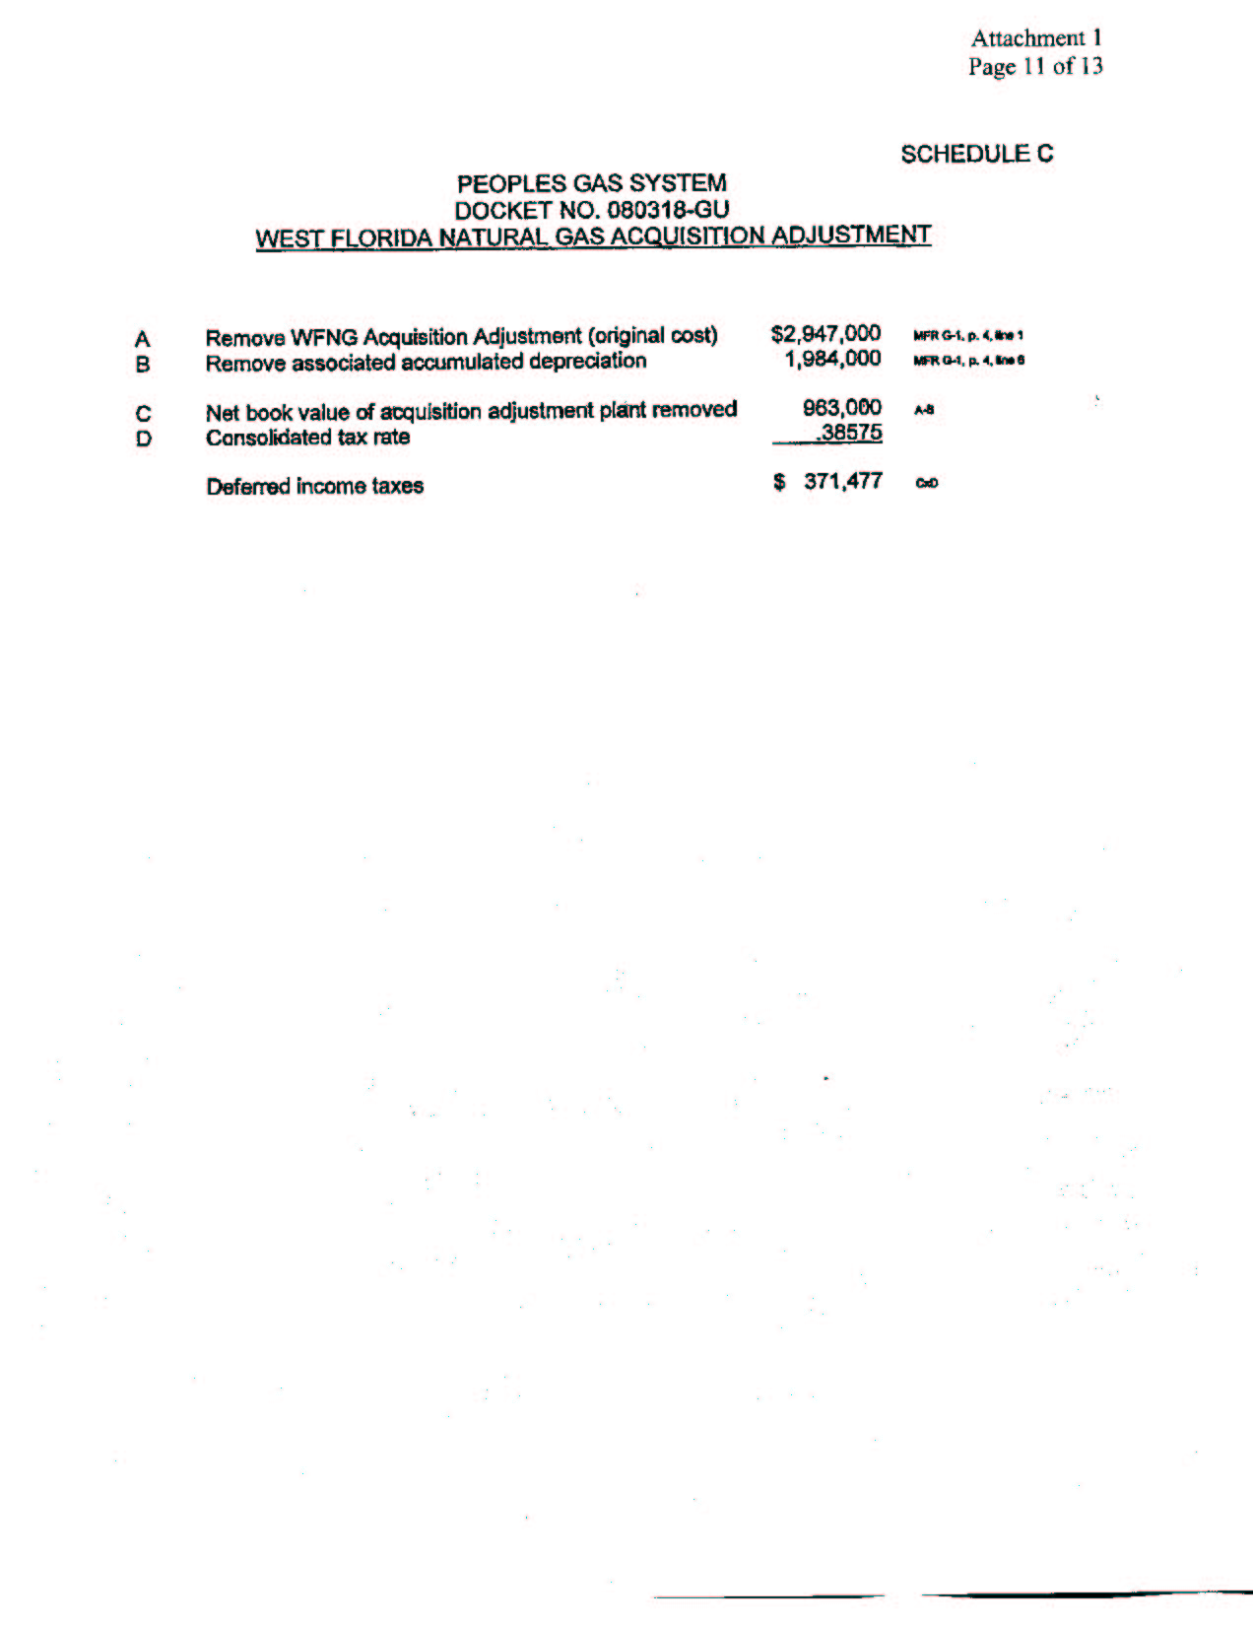
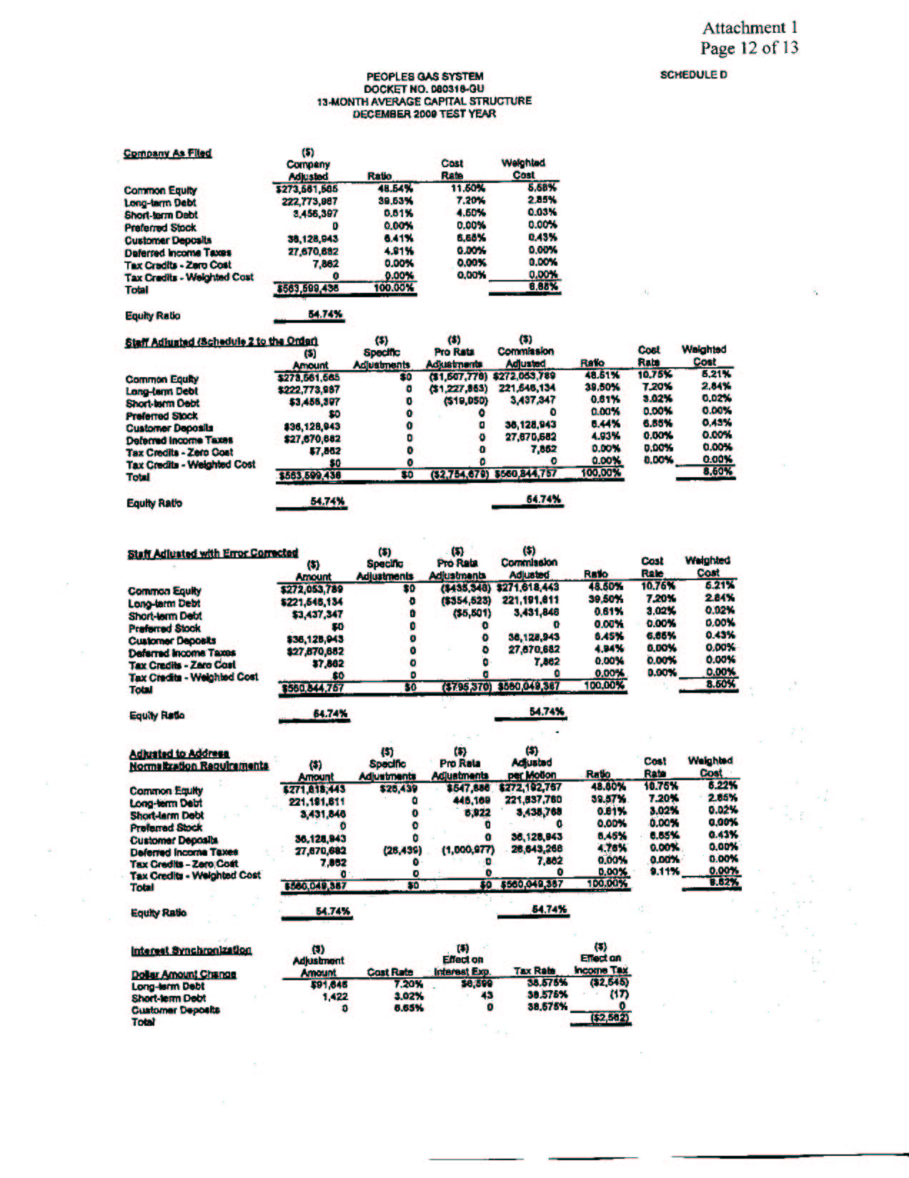
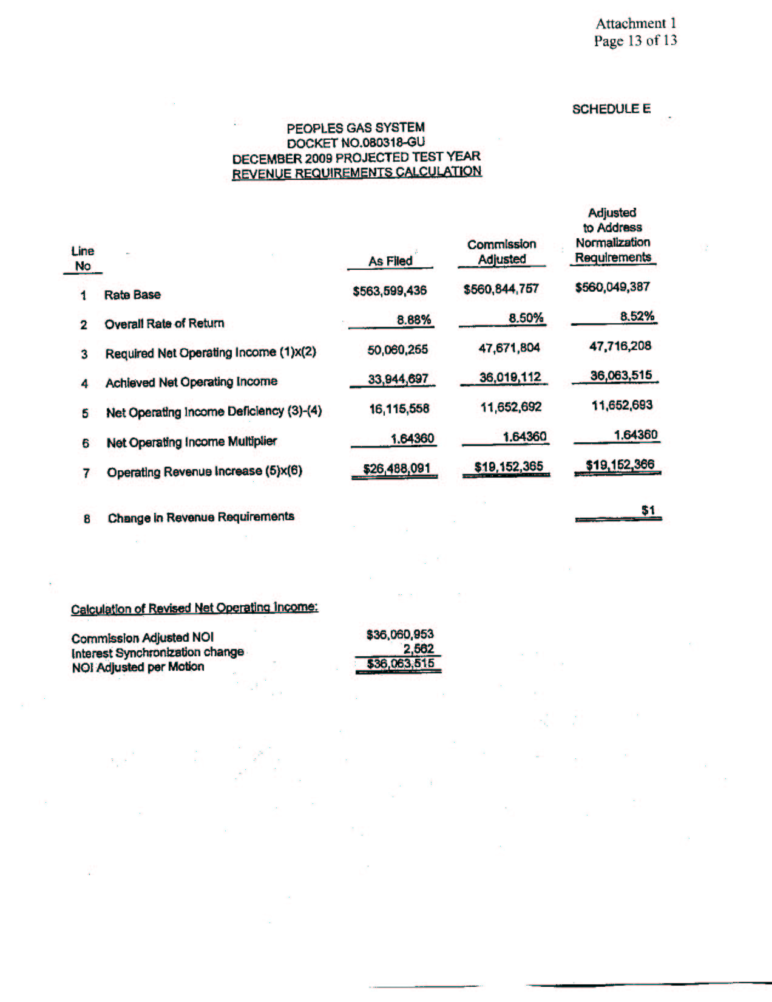

See Order No. PSC-08-0532-PCO-GU, issued August 18, 2008, in Docket No. 080318-GU, In re: Petition for rate increase by Peoples Gas System.
See Order No. PSC-08-0532-PCO-GU, issued August 18, 2008, in Docket No. 080318-GU, In re: Petition for rate increase by Peoples Gas System.
Order No. PSC-09-0411-FOF-GU, issued June 9, 2009, in Docket No. 080318-GU, In re: Petition for rate increase by Peoples Gas System.

