State of Florida   |  | Public Service Commission  Capital Circle Office Center ● 2540 Shumard Oak Boulevard  Tallahassee, Florida 32399-0850  -M-E-M-O-R-A-N-D-U-M-
DATE: | April 23, 2010
TO: | Office of Commission Clerk (Cole)
FROM: | Division of Regulatory Analysis (Casey)  Office of the General Counsel (Tan)  Division of Service, Safety & Consumer Assistance (Moses)
RE: | Docket No. 040763-TP – Request for submission of proposals for relay service, beginning in June 2005, for the hearing and speech impaired, and other implementation matters in compliance with the Florida Telecommunications Access System Act of 1991.
AGENDA: | 05/04/10 – Regular Agenda – Proposed Agency Action - Interested Persons May Participate
COMMISSIONERS ASSIGNED: |  |  | All Commissioners
PREHEARING OFFICER: |  |  | Edgar
CRITICAL DATES: |  |  | None
SPECIAL INSTRUCTIONS: |  |  | Anticipate the need for sign language interpreters and assisted listening devices. Please place near the beginning of the agenda to reduce interpreter costs.
FILE NAME AND LOCATION: |  |  | S:\PSC\RAD\WP\040763.RCM.DOC

Case Background
The Florida Relay System (FRS) provides hearing impaired persons access to basic telecommunications services by using a specialized communications assistance operator (CA) that relays information between the hearing impaired person and the other party of the call. The primary function of the FRS is accomplished by the hearing impaired person using a Telecommunications Device for the Deaf (TDD) which has a keyboard and screen. The person using the TDD types a message to the CA who in turn voices the message to the other party. The reverse of this process completes messages to the hearing impaired person. This is how the term “relay” originated.
The Telecommunications Access System Act of 1991 (TASA) established a statewide telecommunications relay system and became effective May 24, 1991. TASA is authorized under Chapter 427, Florida Statutes. Section 427.701(1), Florida Statutes, provides that the Florida Public Service Commission (FPSC or Commission) shall establish, implement, promote, and oversee the administration of the statewide telecommunications access system to provide access to telecommunications relay services by persons who are hearing impaired or speech impaired, or others who communicate with them. It is estimated that 3 million of the estimated 18.7 million persons living in Florida have been diagnosed as having a hearing impairment. This system provides telecommunications service for hearing impaired persons functionally equivalent to the service provided to hearing persons. TASA provides funding for the distribution of specialized telecommunications devices and provision of intrastate relay service through the imposition of a surcharge of up to $0.25 per landline access line per month. Florida does not impose a TRS surcharge on VoIP or wireless provider lines as the federal TRS program does. By statute, it is only collected from landline access lines. Accounts with over 25 access lines are billed for only 25 lines.
Florida Telecommunications Relay, Inc. (FTRI), a non-profit corporation formed by the local exchange telephone companies (LEC), was named by the FPSC to serve as the TASA administrator. On July 1, 1991, the LECs began collecting an initial $.05 per access line surcharge pursuant to Order No. 24581. Since that time, the surcharge has changed to reflect budgetary needs, but has been maintained at $0.11 per month since June 2007.
The purpose of this recommendation is to approve FTRI’s 2010-2011 proposed budget. The Commission is vested with jurisdiction over these matters pursuant to Chapter 427, Florida Statutes.

Discussion of Issues
Issue 1:1
Should the Commission approve FTRI’s proposed budget as outlined in Attachment A for the fiscal year 2010-2011, effective July 1, 2010, and should the Commission maintain the current Telecommunications Relay Service (TRS) surcharge of $0.11 per month?
Recommendation:
Staff recommends that the Commission approve FTRI’s proposed budget operating revenue of $9,871,383, and proposed budget expenses of $13,950,655 as outlined in Attachment A for the fiscal year 2010-2011, effective July 1, 2010, with one exception. Staff recommends a decrease of $798,047 in Relay Provider Services. Staff also recommends that the TRS surcharge be maintained at $0.11 per month for the fiscal year 2010-2011, effective July 1, 2010. The Commission should order the incumbent local exchange companies, competitive local exchange companies, and shared tenant providers to continue to bill the $0.11 surcharge for the fiscal year 2010-2011, effective July 1, 2010. (Casey, Moses, Tan)
Staff Analysis:
As shown in Table A, minutes of use for traditional TRS has been declining. Sprint Relay, Florida’s current relay provider, projects that the traditional TRS minutes will continue to decline at a rate of approximately 1.5 percent per month or 17.81 percent for the 2010-2011 fiscal year. Traditional relay users are transitioning to the more efficient technologies of IP Relay, Video Relay Service (VRS), CapTel captioning service, IP Captioned Telephone Service (IP CTS), IP Speech to Speech service (IP STS), and Blackberry or Palm wireless devices.

Table A – Florida Traditional TRS Minutes March 2007 – February 2010
VRS and IP Relay
The relay users who use IP Relay and VRS are presently having their relay minutes of use paid through the interstate TRS fund. However, the Federal Communications Commission (FCC) has stated that this arrangement is only temporary. The FCC believes Title IV of the Americans with Disabilities Act and its legislative history make it clear that Congress intended for the states to be responsible for the cost recovery for intrastate relay services provided under their jurisdiction.

In November 2007, the FCC reiterated its goal of allocating VRS and IP Relay costs by intrastate and interstate to have states assume the cost of intrastate VRS and IP Relay. In order FCC 07-186, the FCC stated that Section 225 of the Telecommunications Act provides that the costs caused by interstate TRS shall be recovered from all subscribers for every interstate service, and the costs caused by the provision of intrastate TRS shall be recovered from the intrastate jurisdiction. In footnote 15 of that Order, the FCC noted, “The issue of separation of costs relating to the provision of IP Relay and VRS is pending pursuant to the FNPRM in the 2004 TRS Report & Order.”

Historically, there was no means available to automatically determine the geographic location of IP Relay and VRS calls; therefore, there was no way to determine if a particular IP Relay or VRS call was interstate or intrastate. In a June 2008 order, the FCC approved IP STS service allowing reimbursement from the federal TRS fund stating “We note that this is consistent with the present treatment of the other Internet-based forms of TRS – VRS, IP Relay, and IP CTS – and the fact that because one link of the call is made via the Internet it is generally not possible to determine if a particular call is interstate or intrastate.”

Also in June 2008, the FCC released an order adopting a system for assigning users of IP Relay and VRS ten-digit telephone numbers linked to the North American Numbering Plan (NANP). The order requires that the telephone number assignments be “geographically appropriate NANP numbers.” The ten-digit numbering system for IP Relay and VRS had to be implemented no later than December 31, 2008. Staff believes that instituting a ten-digit numbering system for IP Relay and VRS is the FCC’s initial step in determining whether those services are provided through interstate or intrastate routing. Since the beginning and ending points of calls will now be known, the cost burden of intrastate IP Relay and VRS calls could be assigned to the states.
Presently the VRS compensation rate is $6.70 per minute for the first 50,000 minutes per month, $6.44 per minute for 50,001 minutes to 500,000 minutes per month, and $6.24 per minute over 500,000 minutes per month. The National Exchange Carriers Association (NECA), which is the FCC national fund administrator for TRS, has maintained a file of IP Relay and VRS terminating minutes by state since July 2005. Using the latest six-month’s NECA data, Florida averaged 450,125 VRS terminating minutes per month. Using the last intrastate/interstate relay cost allocation used by the FCC for the two-line CapTel phone as an estimate, states would be responsible for 89% of the VRS costs or approximately $31,077,181 per year for Florida. Both intrastate and interstate VRS costs are presently being paid from the federal TRS Fund.

The IP Relay compensation rate is currently $1.28 per minute, compared to the traditional TRS compensation rate of $0.80 per minute ($0.85 per minute after June 1, 2010). Using the latest six-month’s NECA data, Florida averaged 224,104 IP Relay terminating minutes per month. Using the last FCC intrastate/interstate relay cost allocation as an estimate, states would be responsible for 89% of the IP Relay costs or approximately $3,063,835 per year for Florida. Both intrastate and interstate IP Relay costs are also presently being paid from the federal TRS Fund.
The FCC has not formally opined on the time frame when the IP Relay and VRS costs will shift to the states or what the intrastate/interstate cost allocation will be. Staff contacted the FCC prior to the filing of this recommendation in an attempt to get a timetable of when the FCC would act. The FCC staff would not provide a timeframe, but did say that the issue is being discussed and is on the table.
Staff estimates that the total monthly responsibility of intrastate IP Relay and VRS costs would be approximately $2,845,085 per month or $34,141,016 annually. The $34,141,016 additional IP Relay and VRS costs could increase the annual budget for Florida TRS to over $48 million and likely exceed the current $0.25 cap per access line allowed by statute. If this happens, a legislative change may be necessary to either increase the present TRS cap for local exchange company lines or have all carriers such as wireless and VoIP providers charge the surcharge as the federal TRS program does.
The timeline for a legislative change may impair the stability of the Florida TRS fund. To keep the Florida legislature advised as to the FCC proposal for states to absorb the costs of intrastate VRS and IP Relay costs, the last five Commission annual Relay Reports to the President of the Senate and the Speaker of the House of Representatives have included information and updates on the FCC proposal.
In order to minimize the impact of this change on the Florida TRS Fund, the Commission took action in the 2006-2007 FTRI budget year by maintaining a $0.15 per month TRS surcharge to create a reserve to handle the initial costs of the intrastate VRS and IP Relay cost burden. It is estimated that this will provide a reserve in the Florida TRS fund of $19,837,470 by the end of the current fiscal year in June 2010. This reserve amount should be enough to accommodate the initial intrastate VRS and IP Relay costs should the FCC make a decision in the next fiscal year.
Another alternative is that the federal government take over the entire relay program. However, Section 427.704(1), Florida Statutes, provides that the Commission shall establish, implement, promote, and oversee the administration of a statewide telecommunications access system to provide access to telecommunications relay services by persons who are hearing impaired or speech impaired, or others who communicate with them. Section 427.702(3)(d), Florida Statutes, requires that the telecommunications access system includes the distribution of specialized telecommunications devices necessary for hearing impaired, speech impaired, or dual sensory impaired persons to access basic telecommunications services. Section 427 would have to be eliminated before the federal government could take over the operation of the Florida relay program. All States and the District of Columbia presently have their own Relay programs. Staff is not recommending that the Florida Relay program be eliminated and taken over by the federal government.
CapTel Service
CapTel service, which is a telephone that provides captioning of the incoming call for a hearing impaired person, has had its minutes of use steadily increase over the past year. The average minutes per month for the latest six months increased by 25,503 minutes compared to the previous six month’s average minutes. Sprint Relay projects that the CapTel minutes of use will increase approximately 2 percent per month or 23.3 percent for the 2010-2011 fiscal year. The CapTel cost as approved in the current Sprint Relay contract is $1.40 per minute ($1.47 per minute after June 1, 2010). Table D shows the historical CapTel minutes of use from March 2007, through February 2010.

Table B – CapTel minutes of use March 2007 – February 2010
FTRI Budget
The FTRI 2010-2011 fiscal-year budget was reviewed and approved by the FTRI Board of Directors on March 26, 2010, prior to the filing of its budget with the FPSC. The proposed budget includes an increase in expenses of approximately $2.4 million from the 2009-2010 budget year. The budget projects total revenues to be $9,871,383 and total expenses to be $13,950,655. FTRI believes that the TRS surcharge can remain at $0.11 per access line for the 2010-2011 fiscal year, with its estimated revenue shortfall of $4,079,272 being covered through the surplus account.
Staff requested additional information from FTRI on 21 different accounts which had increases over 10 percent from the previous year’s budget. Appendix B shows FTRI’s responses to staff’s inquiries. After reviewing FTRI’s responses, staff made adjustments in the Relay Provider Account which included a proposed amount of $7,192,583 for the 2010-2011 fiscal-year. FTRI used a rate of $1.40 per minute for projected CapTel minutes of use. By contract, effective June 1, 2010 through May 31, 2011, the CapTel rate increases to $1.47 per minute. If the Commission approves the last option year of Sprint’s relay contract for 2011-2012, the maximum increase allowed for CapTel would be 5 percent. Therefore, for June 2011 estimated minutes of use, staff used a CapTel rate of $1.54 per minute.
Sprint will be purchasing advertising in Florida markets for CapTel service during the FTRI fiscal year 2010-2011. At the time FTRI completed its 2010-2011 budget, it did not have an estimate from Sprint on how the CapTel minutes of use would be affected through the advertising. For its budget, FTRI used Sprint’s estimated CapTel minutes of use (without advertising) for 2010-2011 and increased those minutes by 25 percent due to CapTel advertising.
Staff contacted Sprint and requested an analysis on the effect on CapTel minutes of use due to Sprint advertising in Florida markets. Based on other Sprint markets where CapTel advertising was initiated, Sprint estimated that Florida CapTel minutes of use would increase by an average of 3,000 minutes each month.
Staff also adjusted Sprint’s projected CapTel minutes for CapTel roaming and guest options. By Order PSC-10-0152-PAA-TP, issued March 15, 2010, the Commission removed CapTel roaming and guest options which were estimated as 7% of total CapTel minutes billed. Florida will now only be paying for minutes made from a CapTel phone registered and used in the State of Florida. For FTRI budgetary purposes, staff made a five percent reduction to estimated CapTel minutes which it believes is a conservative and appropriate estimate.
Staff calculated CapTel projected minutes of use starting with Sprint’s estimates, decreased minutes of use for the roaming and guest option elimination, then added 3,000 additional minutes each month for Sprint CapTel advertising. Using the contract minutes of use costs, staff determined CapTel estimated cost for the 2010-2011 fiscal year of $4,378,326, an increase of approximately $642,248 over the 2009-2010 fiscal year.
Staff also made an adjustment to the costs of traditional relay service for the 2010-2011 fiscal year. FTRI used a rate of $0.80 per minute for projected traditional relay service minutes of use. By contract, effective June 1, 2010 through May 31, 2011, the traditional relay service rate increases to $0.85 per minute. If the Commission approves the last option year of Sprint’s relay contract for 2011-2012, the maximum increase allowed for traditional relay service would be 7 percent. Therefore, for June 2011 estimated minutes of use, staff used a traditional relay service rate of $0.91 per minute. Staff calculated traditional relay service projected minutes of use using Sprint’s estimates and contract minutes of use costs to determine traditional relay service estimated cost for the 2010-2011 fiscal year of $2,016,210, compared to FTRI’s estimate of $1,886,959. Staff reduced FTRI’s total proposed relay service provider cost of $7,192,583 by $798,047 to show a cost of $6,394,536 for the 2010-2011 fiscal year.
After analysis of the proposed budget, staff believes FTRI should have sufficient funds for its 2010-2011 fiscal-year budget and will have ample monies in the reserve account to address the initial cost of implementing VRS and IP Relay should that mandate occur. An alternative to using surplus funds would be to increase the TASA surcharge for the 2010-2011 fiscal year by $0.04 ($0.11 to $0.15) per local exchange company access line. However, staff believes that with the economic conditions of today, an increase in the surcharge would not be in the best interest of Florida citizens. Therefore, staff believes that the surcharge should be maintained at $0.11 per month to cover the FTRI 2010-2011 budget. A comparison of FTRI’s 2010-2011 proposed budget, staff’s proposed 2010-2011 budget, and the current 2009-2010 estimated revenue and expenditures is shown below.

 | FTRI Proposed | Staff Proposed | Current
Operating Revenue: | 2010-2011 | 2010-2011 | 2009-2010
Surcharges | $ 9,767,594 | $ 9,767,594 | $10,452,214
Interest Income | 103,789 | 103,789 | 109,609
Total Operating Revenue | $ 9,871,383 | $ 9,871,383 | $10,561,823
Operating Expenses:
Relay Provider Services | $ 7,192,583 | $ 6,394,536 | $ 5,801,127
Equipment and Repairs | 2,973,049 | 2,973,049 | 2,316,514
Equipment Distribution And Training | 1,404,842 | 1,404,842 | 1,047,238
Outreach | 864,400 | 864,400 | 911,344
General & Administrative | 1,515,781 | 1,515,781 | 1,297,659
Total Expenses | $13,950,655 | $13,152,608 | $11,373,882
Deficit | (4,079,272) | ($3,281,225)
Projected Surplus at June 30, 2011 | $15,429,668 | $16,227,715

Conclusion
Staff has reviewed FTRI’s 2010-2011 fiscal year budget request and believes it is reasonable after staff’s adjustments for Relay Provider Services. Staff also believes the Commission’s actions to minimize the impact of funding the intrastate costs of VRS and IP Relay have provided sufficient reserve in the TRS Fund to allow enough time for legislators to make any necessary changes which may be needed to the TRS statute. The current TRS surcharge of $0.11 should meet FTRI’s budget needs for the 2010-2011 fiscal year. Therefore, staff recommends that the Commission approve FTRI’s proposed budget operating revenue of $9,871,383, and revised budget expenses of $13,152,608 for the fiscal year 2010-2011, effective July 1, 2010. Staff also recommends that the TRS surcharge be maintained at $0.11 per month for the fiscal year 2010-2011, effective July 1, 2010. The Commission should order the incumbent local exchange companies, competitive local exchange companies, and shared tenant providers to continue to bill the $0.11 surcharge for the fiscal year 2010-2011, effective July 1, 2010.
Issue 2:2
Should this docket be closed?
Recommendation:
No. This docket should remain open for the duration of the contract period with Sprint as the relay provider. This docket is used to monitor relay and contract issues that arise during the contract term. (Tan)
Staff Analysis:
This docket should remain open for the duration of the contract period with Sprint as the relay provider. This docket is used to monitor relay and contract issues that arise during the contract term.

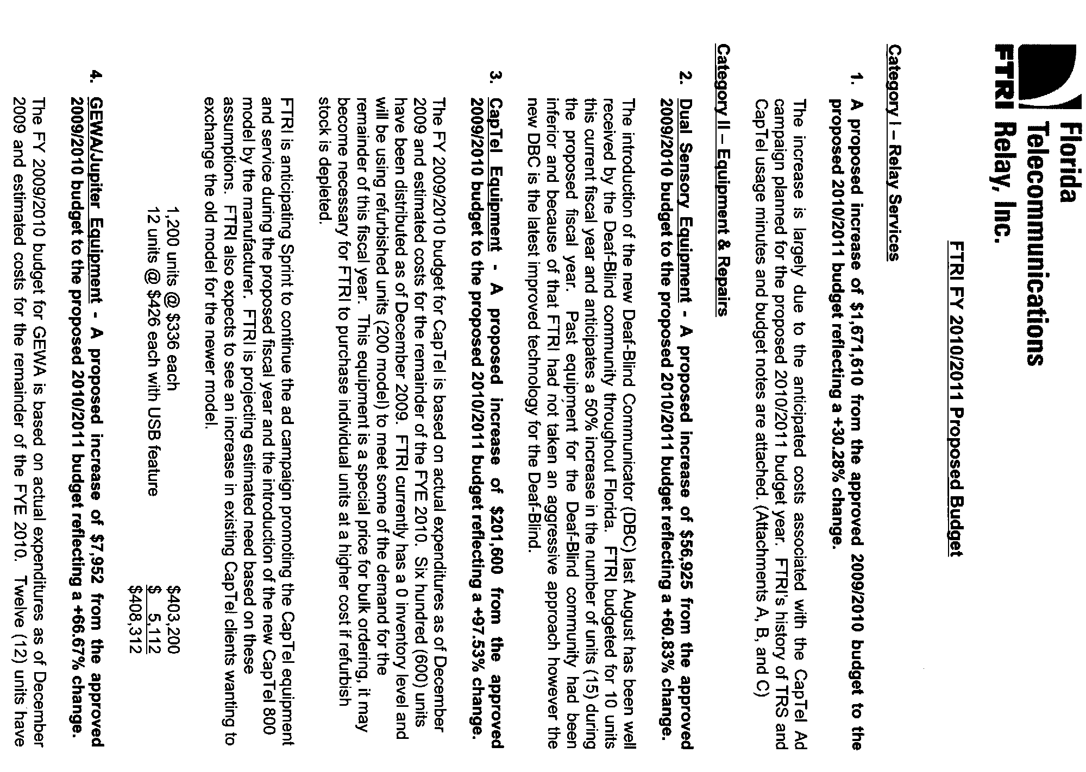

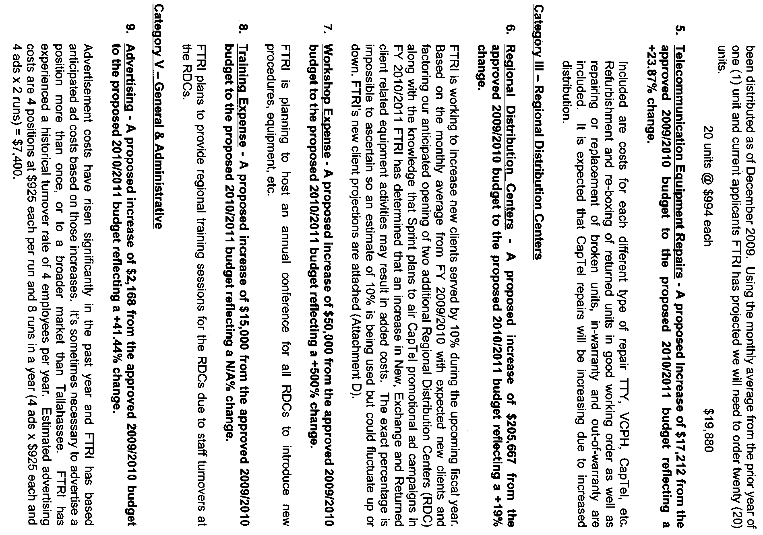

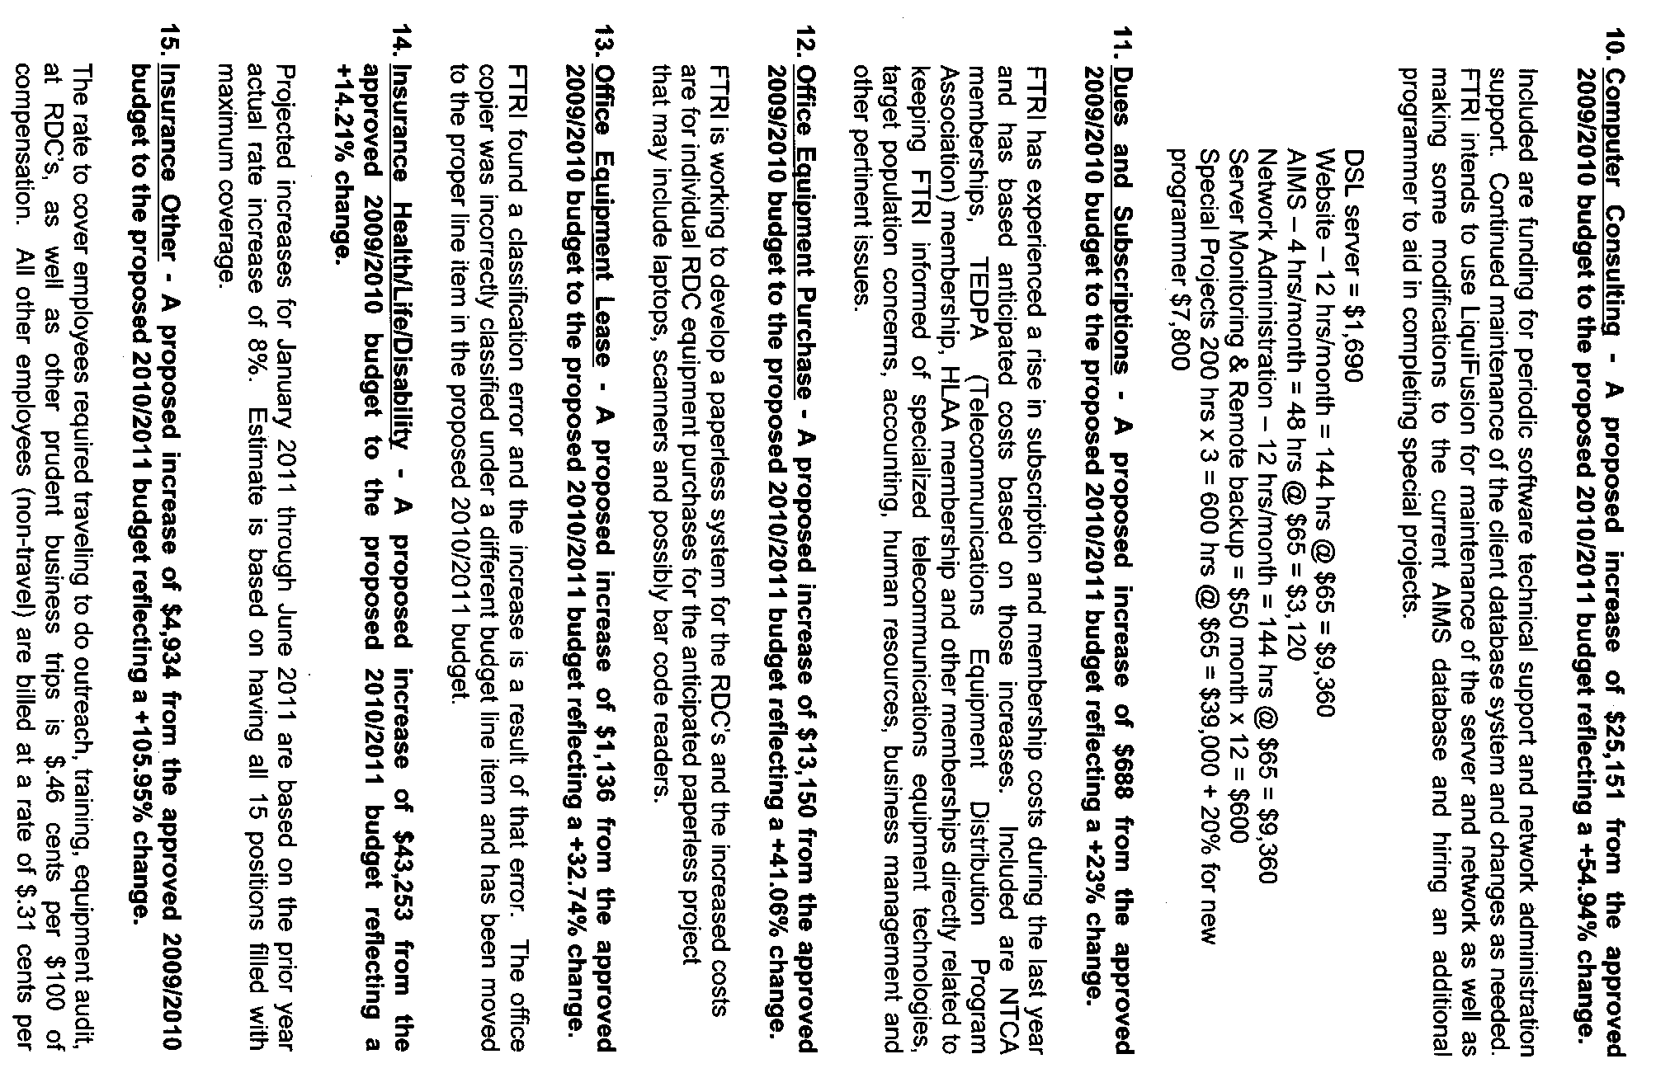

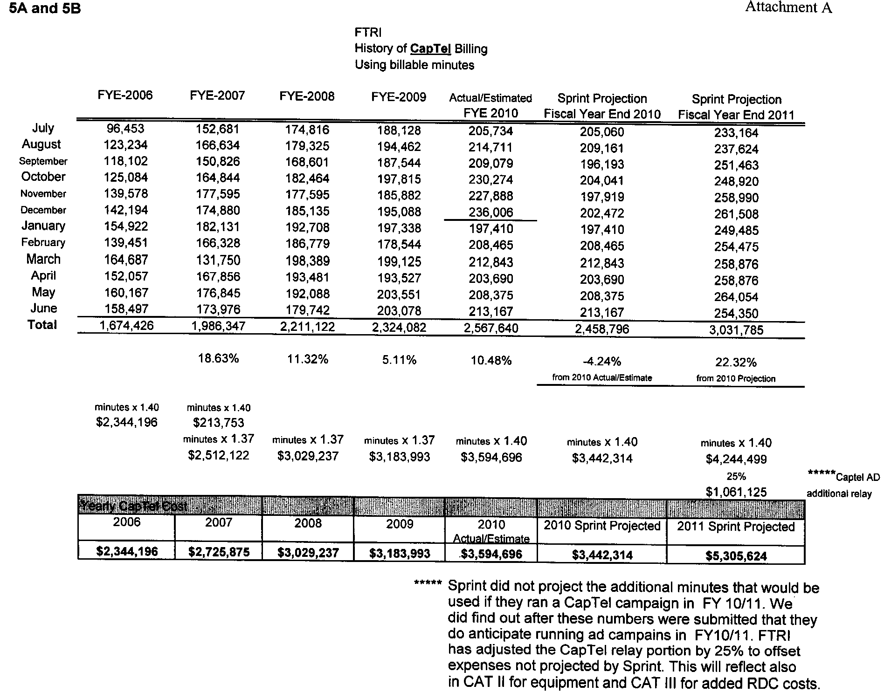

Florida Telecommunications Relay, Inc. projects another decrease in landline access lines subject to the relay surcharge for the budget year 2010-2011. Surcharge revenues are expected to decrease $1,222,861 for the 2010-2011 fiscal year. In addition, with the redefinition of basic local service passed by the Legislature in 2009, some competitive local exchange companies are not collecting or paying the relay surcharges on what they now consider is a non-basic line.
IP Relay allows people who have difficulty hearing or speaking to communicate through an Internet connection using a computer and the Internet, rather than a TTY and a telephone.
Video Relay Service is a form of Telecommunications Relay Service that enables persons with hearing disabilities who use American Sign Language to communicate with voice telephone users through video equipment, rather than through typed text. Video equipment links the VRS user with a TRS operator so that the VRS user and the operator can see and communicate with each other in signed conversation. Because the conversation between the VRS user and the operator flows much more quickly than with a text-based TRS call, VRS has become a popular form of TRS.
IP captioned telephone service allows the user to simultaneously listen to, and read the text of, what the other party in a telephone conversation has said, where the connection carrying the captions between the service and the user is via an IP addressed and routed link.
Speech to Speech relay service utilizes a specially trained CA who understands the speech patterns of persons with speech disabilities and can repeat the words spoken by such an individual to the other party to the call. IP STS uses the Internet, rather than the public switched telephone network, to connect the consumer to the relay provider. Instead of using a standard telephone to make the relay call, an IP STS user can use a personal computer or personal digital assistant (PDA) device and, with the installation of softphone application software, can make a voice call via the Internet to the relay provider. The call is initiated by the user clicking on an icon on his or her computer or PDA; the relay user is then connected to a CA over the Internet and tells the CA the number to be dialed; the CA then connects the IP STS user with the called party and relays the call between the two parties.
Title IV of the Americans with Disabilities Act requires that interstate and intrastate telecommunications relay services are available, to the extent possible and in the most efficient manner, to hearing-impaired and speech-impaired individuals in the United States.
Federal Communications Commission Report and Order, Order on Reconsideration, and Further Notice of Proposed Rule Making in CG Docket No. 03-123, released on June 30, 2004, FCC 04-137.
In the Matter of Telecommunications Relay Services and Speech-to-Speech Services for Individuals with Hearing and Speech Disabilities, CG Docket No. 03-123, FCC 07-186, Released November 19, 2007.
In the Matter of Telecommunications Relay Services And Speech-to-Speech Services for Individuals with Hearing and Speech Disabilities; CG Docket No. 03-123; Speech-to-Speech and Internet Protocol (IP) Speech-to-Speech Telecommunications Relay Services; CG Docket No. 08-15; FCC 08-149, adopted June 11, 2008, released June 24, 2008.
In the Matter of Telecommunications Relay Services and Speech-to-Speech Services for Individuals with Hearing and Speech Disabilities, CG Docket No.03-123, FCC 08-151, adopted June 11, 2008, Released June 24, 2008.
Docket No. 040763-TP, Order PSC-06-0469-PAA-TP, issued June 1, 2006. Effective July 1, 2007, the surcharge was lowered from $0.15 to $0.11 by Order PSC-07-0457-PAA-TP, issued May 29, 2007.
Sprint and the FPSC signed a contract for the provision of relay services which began on June 1, 2005, for a period of three years ending May 31, 2008. The contract contained options to extend the contract for four additional one-year periods, and required mutual consent of both parties to extend the contract. The last contract option will be for the 2011-2012 fiscal year. By contract, Sprint is required to notify the FPSC of its decision whether to extend the relay contract into the last option year by June 1, 2010.

