BEFORE THE FLORIDA PUBLIC SERVICE COMMISSION

In re: Petition for variance from Rules 25-4.0185 and 25-4.073, F.A.C. by Verizon Florida LLC. | DOCKET NO. 090550-TL  ORDER NO. PSC-10-0249-PAA-TL  ISSUED: April 23, 2010

The following Commissioners participated in the disposition of this matter:

NANCY ARGENZIANO, Chairman
LISA POLAK EDGAR
NATHAN A. SKOP
DAVID E. KLEMENT
BEN A. "STEVE" STEVENS III

NOTICE OF PROPOSED AGENCY ACTION
ORDER APPROVING VARIANCE OF RULES 25-4.0185 AND 25-4.073, F.A.C.

BY THE COMMISSION:

NOTICE is hereby given by the Florida Public Service Commission that the action discussed herein is preliminary in nature and will become final unless a person whose interests are substantially affected files a petition for a formal proceeding, pursuant to Rule 25-22.029, Florida Administrative Code.

- Case Background
On December 28, 2009, Verizon Florida LLC (Verizon) filed a petition for variance from Rules 25-4.0185 and 25-4.073, Florida Administrative Code (F.A.C.). On October 2, 2009, we issued Order No. PSC-09-0660-FOF-TP noticing the adoption of amendments to our service quality rules. Of significance in these changes is that, effective October 21, 2009, the service quality rules apply to residential basic local telecommunications service customers only, not all residential lines.

Verizon is requesting a temporary variance from the reporting requirements of Rule 25-4.0185, F.A.C., as it pertains to answer time measurements required by Rule 25-4.073, F.A.C., to allow it to report its answer time performance measurement for all residential lines until it can modify its systems to distinguish basic from nonbasic customers.

On January 22, 2010, we published a notice in the Florida Administrative Weekly of receipt of the petition from Verizon seeking waiver of Rules 25-4.0185 and 25-4.073, F.A.C.
On February 8, 2010, our staff issued a data request to Verizon seeking clarification of what services it believes to be basic telecommunications services. Verizon filed its response on February 12, 2010.
On February 16, 2010, Verizon filed an amended petition, seeking to include a variance of Rules 25-4.070 and 25-4.066, F.A.C., in the petition. Verizon states in the amended petition that, similar to the systems monitoring answer time measurement, it would have to modify the systems that report the data required by these rules to distinguish basic and nonbasic customers.
On March 19, 2010, Verizon again amended its petition to remove the request for variance of Rules 25-4.070 and 25-4.066, F.A.C. Verizon states that it has modified the systems that collect and report the service quality data required by these rules to distinguish basic from nonbasic customers. The effect of the second amendment is to return the petition to its original form.
We are vested with jurisdiction over this matter pursuant to Sections 120.569, 364.01, 364.03, 364.035, 364.15, 364.17, and 364.183, Florida Statutes, (F.S.).
- Analysis
Rule 25-4.0185, F.A.C., states:
(1) Each local exchange telecommunications company shall file with the Commission’s Division of Service, Safety and Consumer Assistance the information required by Commission Form PSC/SSC 28 (10/09), which is incorporated into this rule by reference. Form PSC/SSC 28, entitled “Engineering Data Requirements,” may be obtained from the Commission’s Division of Service, Safety and Consumer Assistance.
(2) The information required by schedules 2, 3, 8, 11, and 15 of Form PSC/SSC 28 shall be filed on a quarterly basis by the large LECs and semiannually by the small LECs on or before the end of the month following the reporting period.
(3) Schedules 2, 3, 11, and 15 of Form PSC/SSC 28 shall apply to basic local telecommunications service only.
(4) Each local exchange telecommunications company shall begin recording basic local telecommunications service data for reporting on schedules 2, 3, 11 and 15 no later than January 1, 2010.
Verizon is requesting this variance pursuant to Rule 28-104.002, F.A.C., which states in pertinent part:
(2) The petition must include the following information:
(d) The applicable rule or portion of the rule;
(e) The citation to the statute the rule is implementing;
(f) The type of action requested;
(g) The specific facts that demonstrate a substantial hardship or a violation of principles of fairness that would justify a waiver or variance for the petitioner;
(h) The reason why the variance or the waiver requested would serve the purposes of the underlying statute; and
(i) A statement whether the variance or waiver is permanent or temporary. If the variance or waiver is temporary, the petition shall include the dates indicating the duration of the requested variance or waiver.

Verizon is requesting a variance from certain requirements of Schedule 15 of Form PSC/SSC 28, which pertains to answer time performance measurements. As stated in the rule, the measurements should only be reported for residential basic local telecommunications lines. However, Verizon states in its petition that the systems it uses to gather answer time data are not capable of distinguishing between basic and nonbasic residential lines. Verizon estimates that it will require 10,000 hours for its technical staff to implement the necessary system changes. Therefore, it is unable to meet the January 1, 2010 implementation requirement of Rule 25-4.0185, F.A.C., for answer time performance measurement. Application of the rule, as it stands, would create a substantial hardship for Verizon. Therefore, it requests that it be allowed to report the answer time performance measurements for all residential lines, not just the basic local telecommunications service lines.
Verizon estimates that it will need six months from the filing of this request to complete the necessary system changes to meet the rule requirement. Therefore, it requests the variance remain in effect until June 30, 2010, with the option for our staff to authorize an additional six months in the event it takes Verizon longer than expected to complete the system changes.

The variance meets the requirements of the underlying statutes (Sections 364.01(4) and 364.183(1), F.S.) because Verizon will be reporting on a broader measure that includes the basic local telecommunications service lines covered by the rule. Because Verizon will be measuring its compliance with the answer time rules on all of its residential lines, not just its basic local telecommunications service lines, basic local service customers will not be harmed, while nonbasic customers will receive a benefit by being included in the answer time measurement and reporting. Verizon acknowledges that we may treat the call-answer-time data that Verizon would provide during the variance period as if it were basic-only data.

On February 8, 2010, our staff sent a data request to Verizon seeking clarification as to which services a Verizon customer is eligible for protection under the Commission’s service quality rules. In its responses to the data request, Verizon listed its rationale for classifying a service as basic or nonbasic (Attachment A). Verizon concurs with our findings in Docket No. 090461-TL, In Re: Petition for modification of Service Guarantee Program by BellSouth Telecommunications, Inc. d/b/a AT&T Florida, that basic local telecommunications service as defined in Section 364.02, F.S., does not include a primary interexchange carrier (PIC) or a local primary interexchange carrier (LPIC). In other words, if a customer selects a local toll or long distance toll provider, the customer’s line is not basic service and will not be protected by our service quality rules.
- Conclusion
We find that Verizon’s rule variance request is reasonable, and that it has met the requirements of Rule 28-104.002, F.A.C., Petition for Variance or Waiver. Therefore, we hereby approve Verizon Florida LLC's request for variance from the answer time requirements of Rules 25-4.0185 and 25-4.073, F.A.C., to allow it to report answer time performance measurements for all residential lines instead of just basic local telecommunications service lines until June 30, 2010, and authorize our staff to administratively approve a six month extension if needed.
Based on the foregoing, it is

ORDERED by the Florida Public Service Commission that Verizon Florida LLC's request for variance from the answer time requirements of Rules 25-4.0185 and 25-4.073, F.A.C., to allow it to report answer time performance measurements for all residential lines instead of just basic local telecommunications service lines until June 30, 2010, is hereby approved. It is further

ORDERED that our staff is authorized to administratively approve another six month extension if needed. It is further

ORDERED that the provisions of this Order, issued as proposed agency action, shall become final and effective upon the issuance of a Consummating Order unless an appropriate petition, in the form provided by Rule 28-106.201, Florida Administrative Code, is received by the Office of Commission Clerk, 2540 Shumard Oak Boulevard, Tallahassee, Florida 32399-0850, by the close of business on the date set forth in the “Notice of Further Proceedings” attached hereto. It is further

ORDERED that this docket shall be closed administratively upon notification by Verizon that the software modifications have been completed.

By ORDER of the Florida Public Service Commission this 23rd day of April, 2010.

/s/ Ann Cole
ANN COLE
Commission Clerk

This is an electronic transmission. A copy of the original signature is available from the Commission's website, www.floridapsc.com, or by faxing a request to the Office of Commission Clerk at 1-850-413-7118.

( S E A L )

TLT

NOTICE OF FURTHER PROCEEDINGS OR JUDICIAL REVIEW

The Florida Public Service Commission is required by Section 120.569(1), Florida Statutes, to notify parties of any administrative hearing that is available under Section 120.57, Florida Statutes, as well as the procedures and time limits that apply. This notice should not be construed to mean all requests for an administrative hearing will be granted or result in the relief sought.

Mediation may be available on a case-by-case basis. If mediation is conducted, it does not affect a substantially interested person's right to a hearing.

The action proposed herein is preliminary in nature. Any person whose substantial interests are affected by the action proposed by this order may file a petition for a formal proceeding, in the form provided by Rule 28-106.201, Florida Administrative Code. This petition must be received by the Office of Commission Clerk, 2540 Shumard Oak Boulevard, Tallahassee, Florida 32399-0850, by the close of business on May 14, 2010.

In the absence of such a petition, this order shall become final and effective upon the issuance of a Consummating Order.

Any objection or protest filed in this/these docket(s) before the issuance date of this order is considered abandoned unless it satisfies the foregoing conditions and is renewed within the specified protest period.
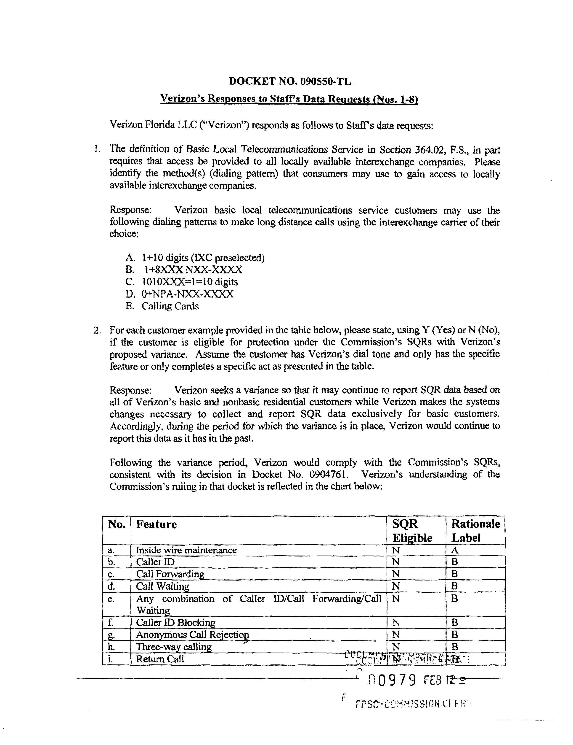
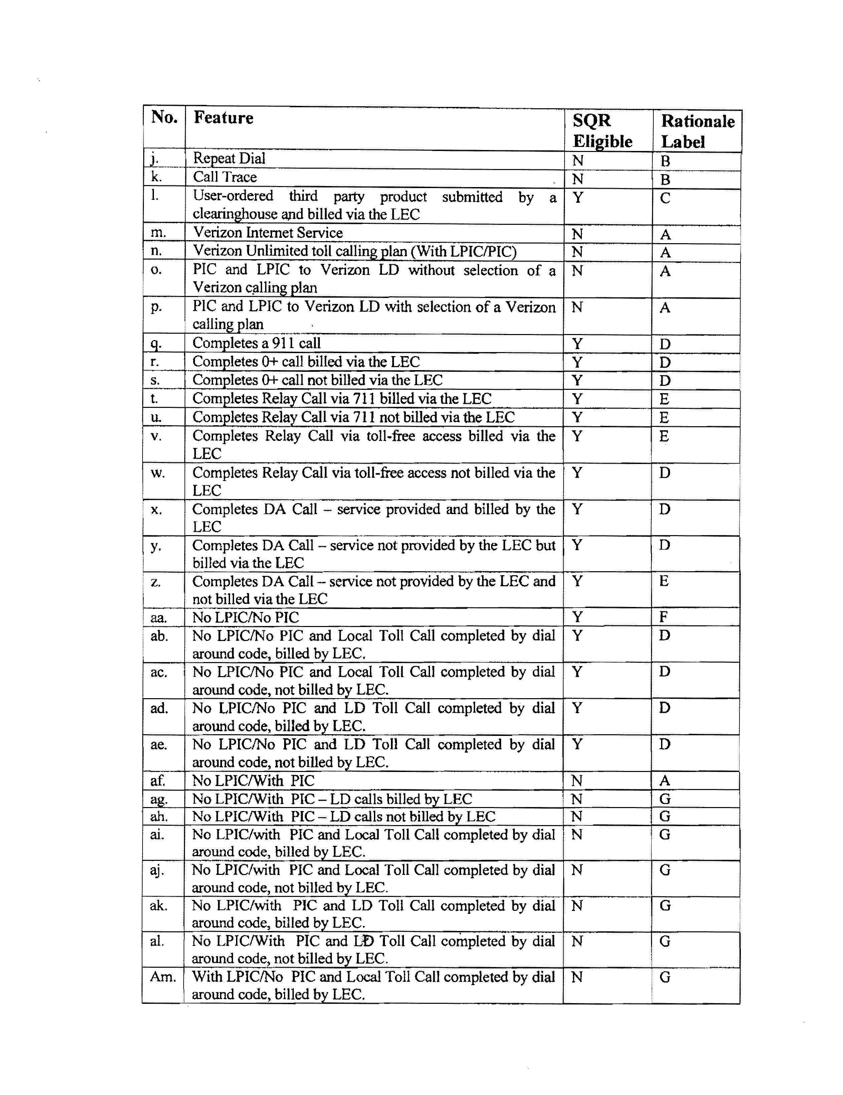
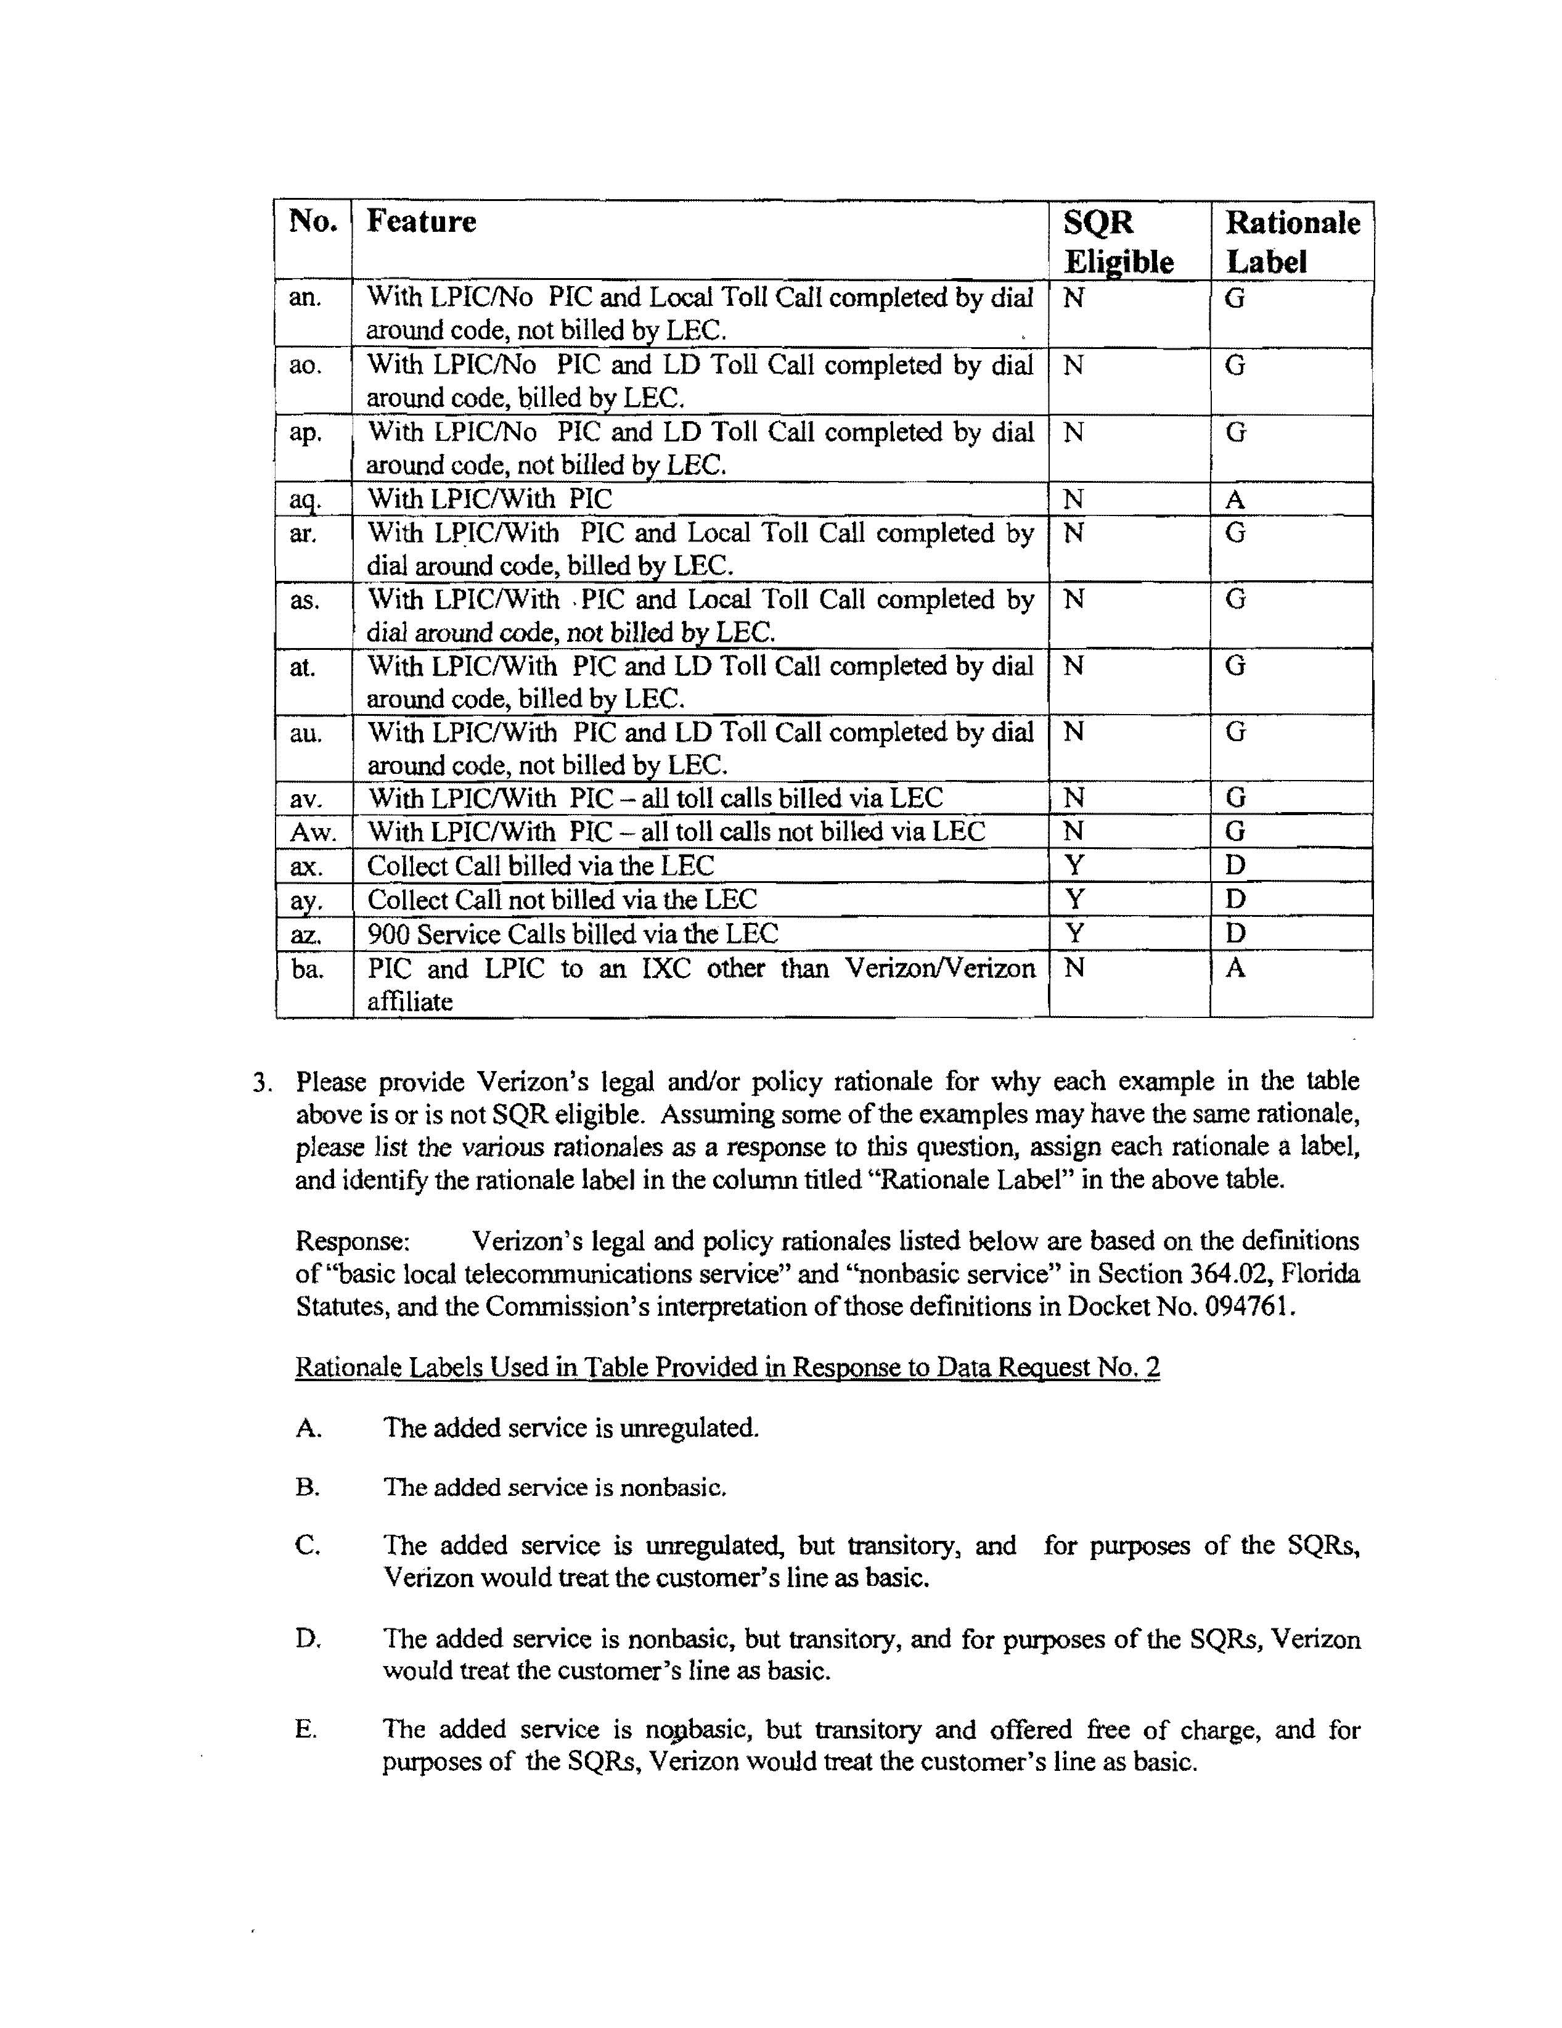
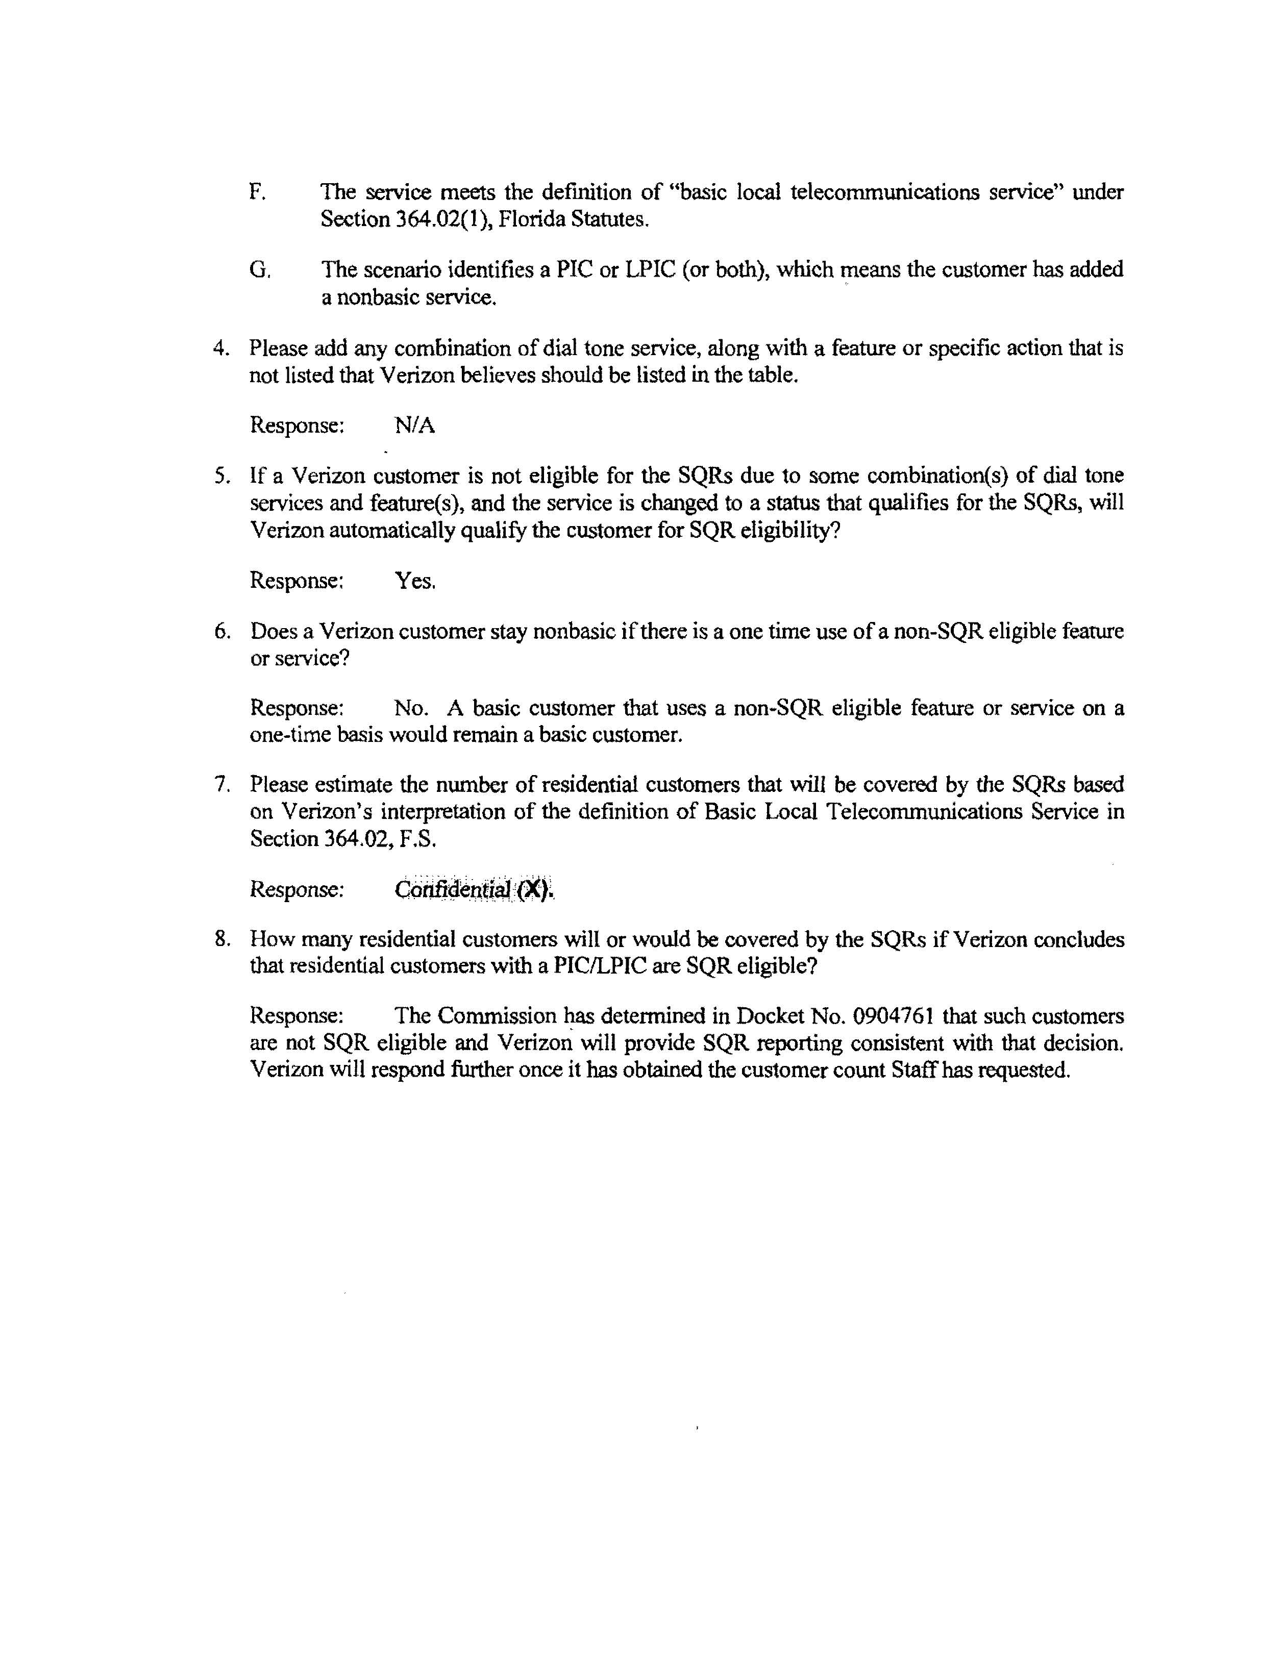

Docket No. 080641-TP – Initiation of rulemaking to amend and repeal rules in Chapters 25-4 and 25-9, F.A.C., pertaining to telecommunications.

