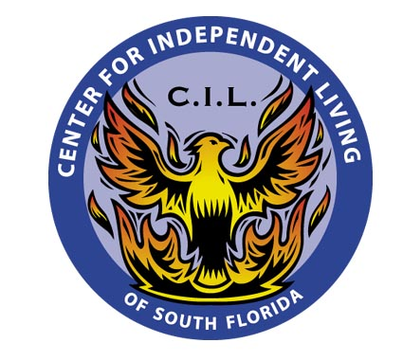
May 17, 2010

Dear Commissioners Argenziano, Edgar, Skop, Klement and Stevens,

RE: Virgin Mobile’s ETC Petition to Offer Lifeline Service, FL Public Service Commission Agenda Item – May 18, 2010

My name is Kelly Greene and I am the Executive Director of the Center for Independent Living of South Florida. Our mission is to empower persons with disabilities to reach their highest level of independence and to advocate for systems change that results in access, equality, inclusion, independence, and choice for all people with disabilities.

In the past year it seems as if participation in the Lifeline program has increased tremendously here in Florida. As more and more providers try to enter into this program, it is more important than ever to make sure that these programs are truly offering free services and not trying to take advantage of our low income residents. Services like these target low income, elderly and other individuals who may not be fully informed on how these services are funded. It is your job as Commissioners to ensure these programs are serving the public’s best interest. With our current economic situation, we understand programs like this are needed now more than ever, but with appropriate and proper offerings to our Lifeline qualified residents. In order to safeguard our state’s low-income residents, please consider the following issues with the Assurance Wireless current ETC petition:

- Unused monthly minutes should roll-over to the next month. The minutes are paid for monthly by the Universal Service Fund and should not go unused. The PSC should require any unused monthly minutes to rollover to the next month.
- Due to the number of international residents in our state, international calling to Central and/or South America should be included in the free minutes, and not an extra charge of $.20 cents a minute or more. Other Lifeline providers provide free international long distance. The PSC should require free international long distance for the 200 monthly minutes.
- Based on the Assurance Wireless website, there is a requirement to pay for text messages out of pocket instead of deducting them from the monthly allotment of 200 minutes. This means the Lifeline user will need to pay in advance for text messages. Having payment for this free program is unacceptable! The PSC should require text messages to be deducted from the free monthly minutes, not an extra
pre-paid charge.

CENTER FOR INDEPENDENT LIVING OF SOUTH FLORIDA, INC.

Board of Directors
President
Alvin W. Roberts
Vice President
Robert Lessne, Ph.D.
Secretary
Rochelle Baer, L.C.S.W.
Treasurer
Joseph Alfano, M.B.A.

Members:
Patricia Bochi, J.D.
Max Gauthier, B.A.
Jose Granda, B.A.
Gregg Goldfarb, J.D.
Barbara Gratzke, B.A.
Sandra Hix, M.A.
Stephen Mander, J.D.
Donald Pruessman, M.A.
Chierno Skinner, M.B.A.
Candace Solla
Ann Thomas, J.D.
Jay Weiss, M.B.A.

CIL of South Florida
Voice: 305-751-8025
TTY: 305-751-8891
Fax: 305-751-8944
Toll-free: 800-854-7551
6660 Biscayne Blvd.
Miami, FL 33138
www.soflacil.org
www.cilsfla.blog.org

Funded by the U.S. Department of Education, Rehabilitation Services Administration; Florida Department of Education,
Division of Vocational Rehabilitation; Miami-Dade County Office of Grants Coordination, foundations and private donations.

- Calls to the Assurance Wireless 800 customer service line should not be deducted from
monthly minutes. This PSC should require this of all Lifeline providers.

Again, we are excited about this new benefit Lifeline is offering and what it means for the
safety and security of our program recipients. We ask you to please approve this petition,
but with these conditions to adequately address consumer concerns and protection.

Sincerely,

Kelly Greene

s/ Kelly Greene
Executive Director
Kelly@soflacil.org

