State of Florida   |  | Public Service Commission  Capital Circle Office Center ● 2540 Shumard Oak Boulevard  Tallahassee, Florida 32399-0850  -M-E-M-O-R-A-N-D-U-M-
DATE: | May 20, 2010
TO: | Office of Commission Clerk (Cole)
FROM: | Division of Economic Regulation (Slemkewicz, P. Lee, Maurey)  Office of the General Counsel (Klancke, Fleming)
RE: | Docket No. 090079-EI – Petition for increase in rates by Progress Energy Florida, Inc.  Docket No. 090144-EI – Petition for limited proceeding to include Bartow repowering project in base rates, by Progress Energy Florida, Inc.  Docket No. 090145-EI – Petition for expedited approval of the deferral of pension expenses, authorization to charge storm hardening expenses to the storm damage reserve, and variance from or waiver of Rule 25-6.0143(1)(c), (d), and (f), F.A.C., by Progress Energy Florida, Inc.  Docket No. 100136-EI – Petition for approval of an accounting order to record a depreciation expense credit, by Progress Energy Florida, Inc.
AGENDA: | 06/01/10 – Regular Agenda – Decision on Stipulation and Settlement – Interested Persons May Participate
COMMISSIONERS ASSIGNED: |  |  | All Commissioners
PREHEARING OFFICER: |  |  | Skop (090079-EI)  Skop (090144-EI)  Skop (090145-EI)  Skop (100136-EI)
CRITICAL DATES: |  |  | None
SPECIAL INSTRUCTIONS: |  |  | None
FILE NAME AND LOCATION: |  |  | S:\PSC\ECR\WP\090079.RCM.DOC
Case Background
On March 20, 2009, Progress Energy Florida, Inc. (PEF or Company) filed a petition for a permanent rate increase. PEF requested an increase in its retail rates and charges to generate $499,997,000 in additional gross annual revenues. The Company based its request on a projected test year ending December 31, 2010. The Company is engaged in business as a public utility providing electric service as defined in Section 366.02, Florida Statutes (F.S.), and is subject to the jurisdiction of this Commission.

The Office of the Public Counsel (OPC), the Office of the Attorney General (AG), the Florida Industrial Power Users Group (FIPUG), the Florida Retail Federation (FRF), the Florida Association for Fairness in Rate Making (AFFIRM), the Navy (NAVY), and White Springs Agricultural Chemicals, Inc. d/b/a PCS Phosphate – White Springs (PCS) intervened in this proceeding.

On March 20, 2009, PEF also filed a Petition for Limited Proceeding to Include the Bartow Repowering Project in Base Rates, in Docket No. 090144-EI. On June 12, 2009, the Commission issued Proposed Agency Action (PAA) Order No. PSC-09-0145-PAA-EI approving PEF’s petition for a limited proceeding and consolidating this matter with Docket No. 090079-EI (Bartow PAA Order). In addition, Order No. PSC-09-0586-PCO-EI, issued August 31, 2009, consolidated Docket No. 090145-EI with Docket No. 090079-EI.

The Commission held an evidentiary hearing on PEF’s proposed rate increase on September 21-25, 28-30, 2009, and October 1, 2009. Thereafter, on March 5, 2010, upon consideration of the evidentiary record, post-hearing briefs of the parties, and staff’s recommendation, the Commission issued Order No. PSC-10-0131-FOF-EI (Final Order).
On March 18, 2010, PEF filed its Motion for Reconsideration of Order No. PSC-10-0131-FOF-EI to Correct Calculation Mistakes in the Commission’s Depreciation Expense, Accumulated Depreciation Reserve, and Revenue Requirements (Motion for Reconsideration). PEF asserted that the Final Order contained nine separate mathematical mistakes in the calculation of PEF’s depreciation expense and accumulated depreciation reserve, totaling approximately $36 million in mistakes in PEF’s revenue requirements, as calculated by this Commission. In its Motion for Reconsideration, PEF further requested that the Final Order be amended to correct the mathematical mistakes in the calculation of PEF’s accumulated depreciation expense, accumulated depreciation reserve, and revenue requirements. PEF has not requested oral argument on its own Motion for Reconsideration; however, PEF has asserted that it is willing to participate in oral argument if the Commission finds oral argument helpful to walk through the calculation mistakes identified in the Motion for Reconsideration.
On March 25, 2010, and March 29, 2010, FIPUG and PCS Phosphate filed their Responses to PEF’s Motion for Reconsideration. Both FIPUG and PCS Phosphate asserted in their respective Responses that to the extent that any of the claimed $36 million in errors is found to be accurate, that the appropriate response is for the Commission to use its broad rate-making authority to adjust the excess depreciation reserve as necessary and appropriate to ensure that there is no increase to PEF’s customer base rates.
On March 29, 2010, OPC filed its Cross-Motion for Reconsideration and Response to PEF’s Motion for Reconsideration (OPC’s Cross-Motion). In OPC’s Cross-Motion it asserted that the Commission erred, as a matter of law, in determining that the $132 million increase in base rate revenues associated with the Bartow Repowering Project (Bartow) was approved prior to and outside of the final determination on January 11, 2010, on PEF's Petition for rate increase filed in this docket. As a result of that alleged error, OPC asserts that the Commission appears to have declined to amortize any more than $23 million of the depreciation reserve surplus to offset the increased revenue requirement resulting from Bartow or any other undifferentiated component of PEF’s overall jurisdictional revenue requirement.

On March 30, 2010, the AG’s Office filed its Cross-Motion for Reconsideration and Response to PEF’s Motion for Reconsideration, affirming and supporting the response and cross-motion filed by OPC. None of the Intervenors have requested oral argument with respect to the Motion for Reconsideration.
On April 5, 2010, PEF filed its Motion to Strike Citizen’s Cross-Motion for Reconsideration and Response to Citizen’s Cross-Motion for Reconsideration (Motion to Strike or PEF Response), arguing that OPC’s Cross-Motion should be stricken on the grounds that it was untimely filed and, in the alternative, responding to OPC’s Cross-Motion.
On March 18, 2010, PEF filed a petition for the approval of an accounting order to allow it to record a depreciation expense credit in Docket No. 100136-EI. This credit would reduce the cost of removal component in its depreciation expense resulting in a reduction of the theoretical reserve imbalance. PEF asserted that the proposed accounting treatment would provide it with the opportunity to earn a fair and reasonable return.
A Joint Motion for Approval of Stipulation and Settlement Agreement (Joint Motion) was filed on May 10, 2010 by PEF, OPC, AG, FIPUG, FRF, PCS, and the NAVY (Joint Movants). The proposed Stipulation and Settlement Agreement (Stipulation) is intended to resolve all of the issues in Docket Nos. 090079-EI, 090144-EI, 090145-EI, and 100136-EI.
This recommendation addresses the Joint Motion for Approval of Stipulation and Settlement Agreement. The Commission has jurisdiction pursuant to Sections 366.06 and 366.071, F.S.
Discussion of Issues
Issue 1:1
Should the Commission approve the proposed Stipulation and Settlement Agreement?
Recommendation:
Yes, the Commission should approve the proposed Stipulation and Settlement Agreement. (Slemkewicz, P. Lee, Maurey)
Staff Analysis:
The Joint Movants have proffered the proposed Stipulation (Attachment 1) as a complete resolution of all matters pending in Docket Nos. 090079-EI, 090144-EI, 090145-EI, and 100136-EI. The major elements contained in the Stipulation are:
- Base rates frozen through the last billing cycle in December 2012 unless return on equity falls below 9.50 percent (Paragraphs 4 and 5)
- Discretion to record a depreciation expense credit of up to $150 million in 2010, up to $250 million in 2011, and up to any remaining balance of the depreciation theoretical reserve imbalance in 2012 (Paragraph 3)
- Discretion to accelerate the amortization of certain regulatory assets (Paragraph 7)
- Recovery of storm damage costs and storm damage reserve replenishment (not to exceed $4.00/1,000 kWh monthly for residential customers) will begin, on an interim basis, 60 days following the filing of a petition (Paragraph 6)
The proposed Stipulation consists of 9 paragraphs of agreement among the Joint Movants. Staff believes that several of the paragraphs merit comment or clarification. These are as follows:
Paragraph 3: This paragraph provides PEF with the discretion to record a retail jurisdictional annual credit to depreciation expense and a debit to the “cost of removal portion” of the depreciation reserve of up to $150 million in 2010, up to $250 million in 2011, and up to the remaining balance of the cost of removal reserve in 2012. These credit amounts are in addition to the annual amortization of the depreciation reserve surplus approved in the Final Order. The Joint Motion states that the credits to depreciation expense will “reduce the existing depreciation theoretical reserve imbalance.”
For financial reporting purposes, PEF separates the book depreciation reserve between the portion attributable to plant life and that attributable to cost of removal. Also, the cost of removal component of the reserve is classified as a regulatory liability for financial reporting purposes. Under Paragraph 3, PEF will record the annual depreciation expense credit as a regulatory credit amortization with a debit to the cost of removal liability. This will have the effect of amortizing the remaining reserve surplus of $667 million identified in the Final Order up to the amount of the cost of removal liability.
As of March 31, 2010, the portion of the depreciation reserve that PEF identifies as being attributable to cost of removal is $587.1 million ($535.2 million retail). This amount will decrease each year due to actual expenditures incurred in removing retired property and will increase due to additional depreciation expense based on the Commission-approved depreciation rates in the Final Order, which PEF estimates to be in the range of $30 - $35 million annually. If the full amount of the depreciation expense credit is taken in 2010 and 2011, PEF will have the discretion in 2012 of recording a credit to depreciation expense up to the amount of the cost of removal liability existing at that time.
Also pursuant to Paragraph 3, if PEF records a depreciation expense credit in a given year that is less than the cap set forth above, the Company is permitted to carry forward and record in subsequent years the difference between the booked amount of the expense credit and the set cap for that year. For example, if PEF records a credit to depreciation expense of $100 million in 2010, it would be permitted to carry forward and record in 2011 or 2012 the $50 million difference between the amount booked and the cap of $150 million, in addition to the $250 million capped amount for 2011.
Paragraph 5: Per the terms of this paragraph, if PEF’s retail base rate earnings fall below 9.5 percent return on equity (ROE) as reported on a historical (12 month rolling period income statement) Commission adjusted or pro-forma basis on a PEF Earnings Surveillance Report (ESR) during the term of this Stipulation, PEF shall be entitled to seek interim, limited, or general base rate relief, or any combination thereof. For purposes of requesting relief under this paragraph, PEF must demonstrate that it recorded the greater of $150 million or the actual depreciation expense credit on an adjusted or pro-forma basis. In addition, PEF may not include any acceleration of the amortization of the deferred regulatory assets identified in Paragraph 7 in the calculation of earnings for purposes of determining if achieved earnings are below 9.5 percent ROE.

Also pursuant to Paragraph 5, if PEF’s retail base rate earnings exceed 11.5 percent ROE as reported on a historical Commission adjusted or pro-forma basis during the term of this Stipulation, any other Party shall be entitled to petition the Commission for a review of PEF’s base rates. The ESR filed with the Commission consistent with Rule 25-6.1352, Florida Administrative Code, will be the basis for determining if PEF’s ROE on a historical or pro-forma basis is above 11.5 percent. The depreciation expense credit and/or the acceleration of amortization of the regulatory assets identified in Paragraph 7 will be included as recognized in the calculation of the achieved ROE in the referenced ESR to which the 11.5 percent will be compared.
Paragraph 6: Per the terms of this paragraph, PEF is not precluded from requesting approval to recover costs (a) that are normally recovered through cost recovery clauses or surcharges, or (b) that are incremental costs not currently recovered in base rates that are determined to be clause recoverable, or (c) that are recoverable through base rates under the nuclear cost recovery legislation or the Commission’s nuclear or integrated gasification combined cycle power plant cost recovery rule.
Paragraph 6 also explicitly addresses storm damage cost recovery. Sixty days following the filing of a petition seeking recovery of storm damage costs, the Joint Movants have agreed that PEF will be allowed to implement, on an interim basis, a monthly storm cost recovery surcharge of up to $4.00/1,000 kWh on residential customer bills based on a 12-month recovery period. If the storm costs exceed that level, any additional costs will be recovered in a subsequent year(s) as determined by the Commission. This paragraph also allows PEF to use the surcharge to replenish its storm damage reserve to the level as of the implementation date of the Stipulation. As reflected in Order No. PSC-10-0131-FOF-EI, PEF is no longer authorized to make any accruals to the storm damage reserve. It is estimated that the storm damage reserve level as of the implementation date will be $136 million. Based on the $4.00/1,000kWh monthly cap for residential customers, the annual amount of the surcharge would be $75.6 million for residential customers and a total of $117.8 million for all of PEF’s customers.
Paragraph 7: Pursuant to this paragraph, PEF will be authorized, at its discretion, to accelerate in whole or in part the amortization of the regulatory assets for FAS 109 Deferred Tax Benefits Previously Flowed Through, Unamortized Loss on Reacquired Debt, Interest on Income Tax Deficiency, and 2009 Pension Regulatory Asset over the term of the Stipulation. Table 1 – 1 below summarizes the amounts associated with each of these regulatory assets.

Table 1 – 1

Regulatory Asset | Date Created | Balance as of March 31, 2010 | Annual Amortization
FAS 109 Regulatory Asset | 1993 | $6.9 M | $0.7 M
Unamortized Loss on Reacquired Debt | 1998 | $19.3 M | $1.4 M
Interest on Income Tax Deficiency | 2009 | $3.1 M | $1.4 M
Pension Regulatory Asset | 2009 | $32.5 M | varies
Total |  | $61.8 M

As noted above in the discussion of Paragraph 5, PEF is precluded from recording an acceleration of the amortization of any of these regulatory assets in the calculation of earnings for purposes of determining eligibility for seeking interim, limited, or general base rate relief to be effective during the term of this Stipulation. PEF, at its sole discretion, will determine the amount, if any, of acceleration of amortization of these regulatory assets will be reflected in the calculation of earnings for purposes of determining if PEF’s achieved ROE is in excess of 11.5 percent. Finally, any balance remaining after the acceleration of amortization of these regulatory assets will continue to be recoverable in rates in the future through amortization included in the cost of service.
Staff has reviewed the terms of the Stipulation. Staff believes that the Stipulation provides a reasonable resolution of the outstanding issues in Docket Nos. 090079-EI, 090144-EI, 090145-EI, and 100136-EI and is in the public interest. Therefore, staff recommends approval of the Stipulation.
Issue 2:2
Should Docket Nos. 090079-EI, 090144-EI, 090145-EI, and 100136-EI be closed?
Recommendation:
Yes, Docket Nos. 090079-EI, 090144-EI, 090145-EI, and 100136-EI should be closed. (Klancke)
Staff Analysis:
If staff=s recommendation on Issue 1 is approved, the signatories to the Stipulation have asked that the order approving the Stipulation be issued as a final action. With the issuance of the Commission=s final order, no further action by the Commission will be necessary. Therefore, absent a timely Notice of Appeal, these dockets should be closed.
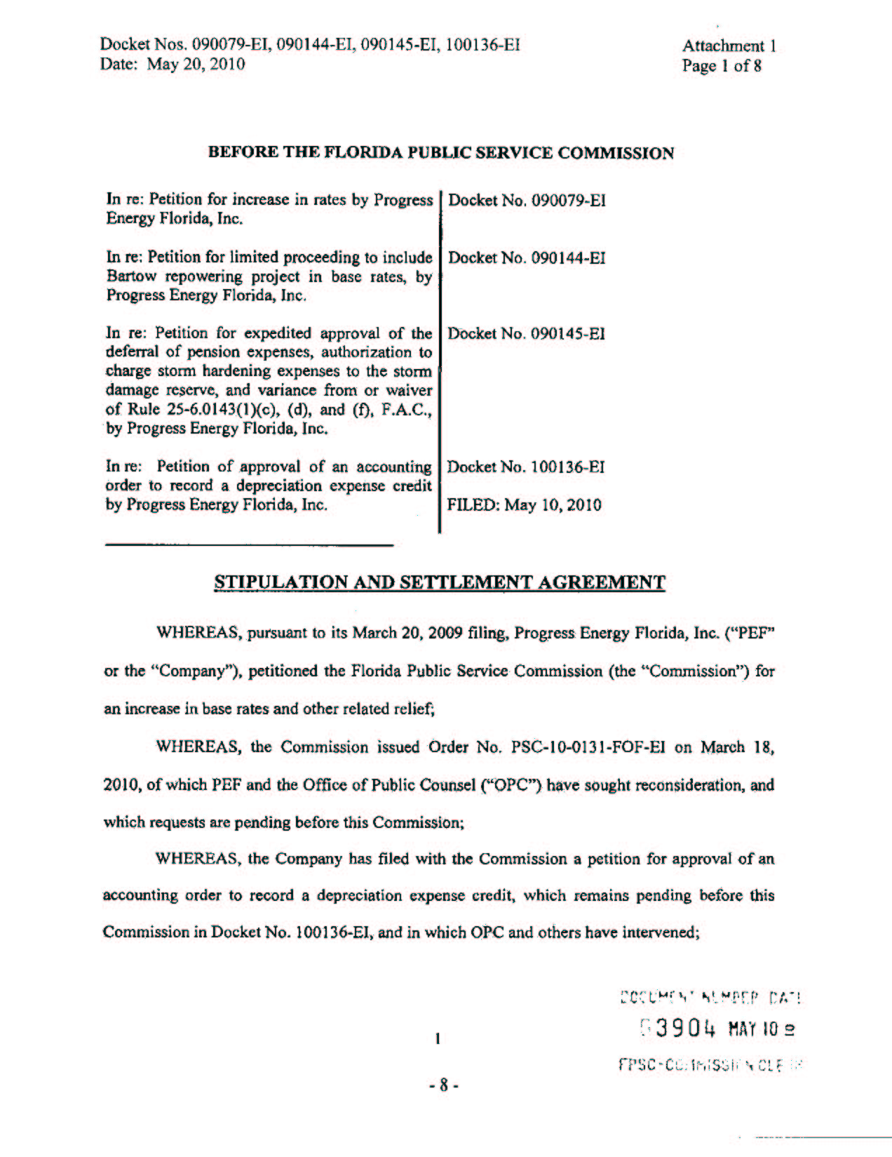
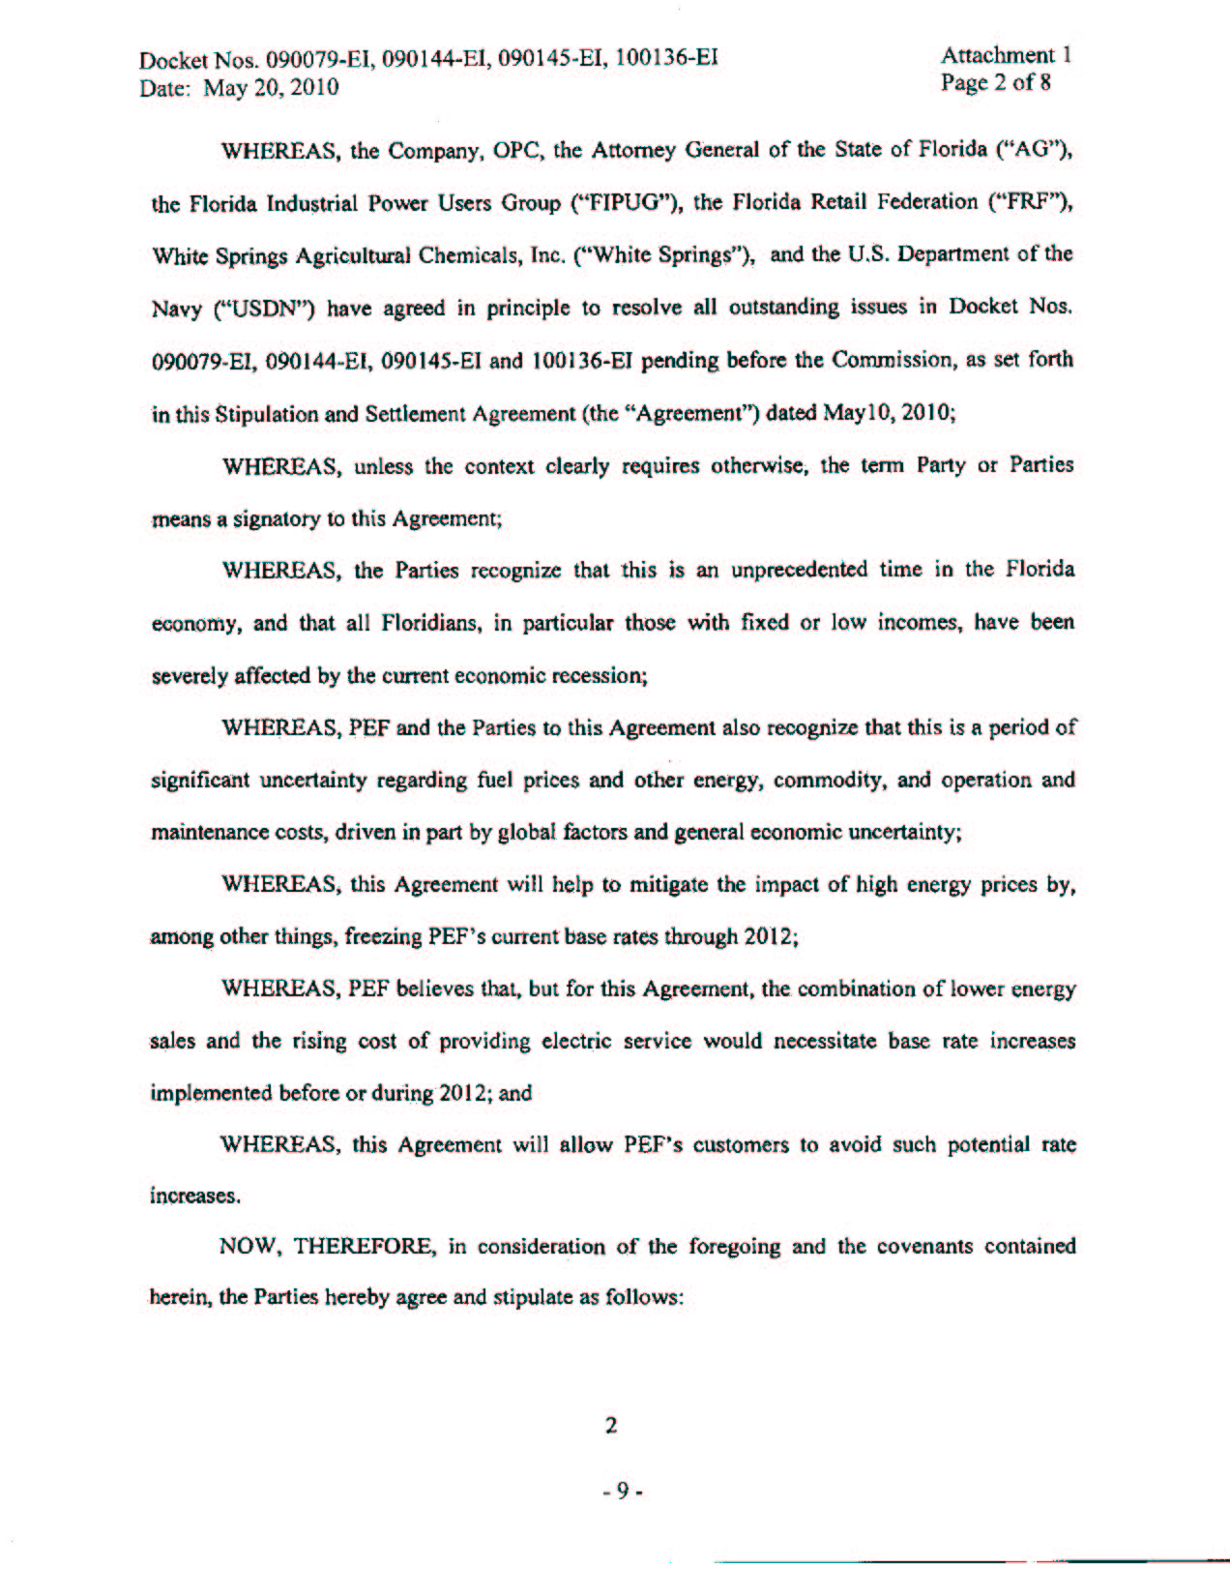
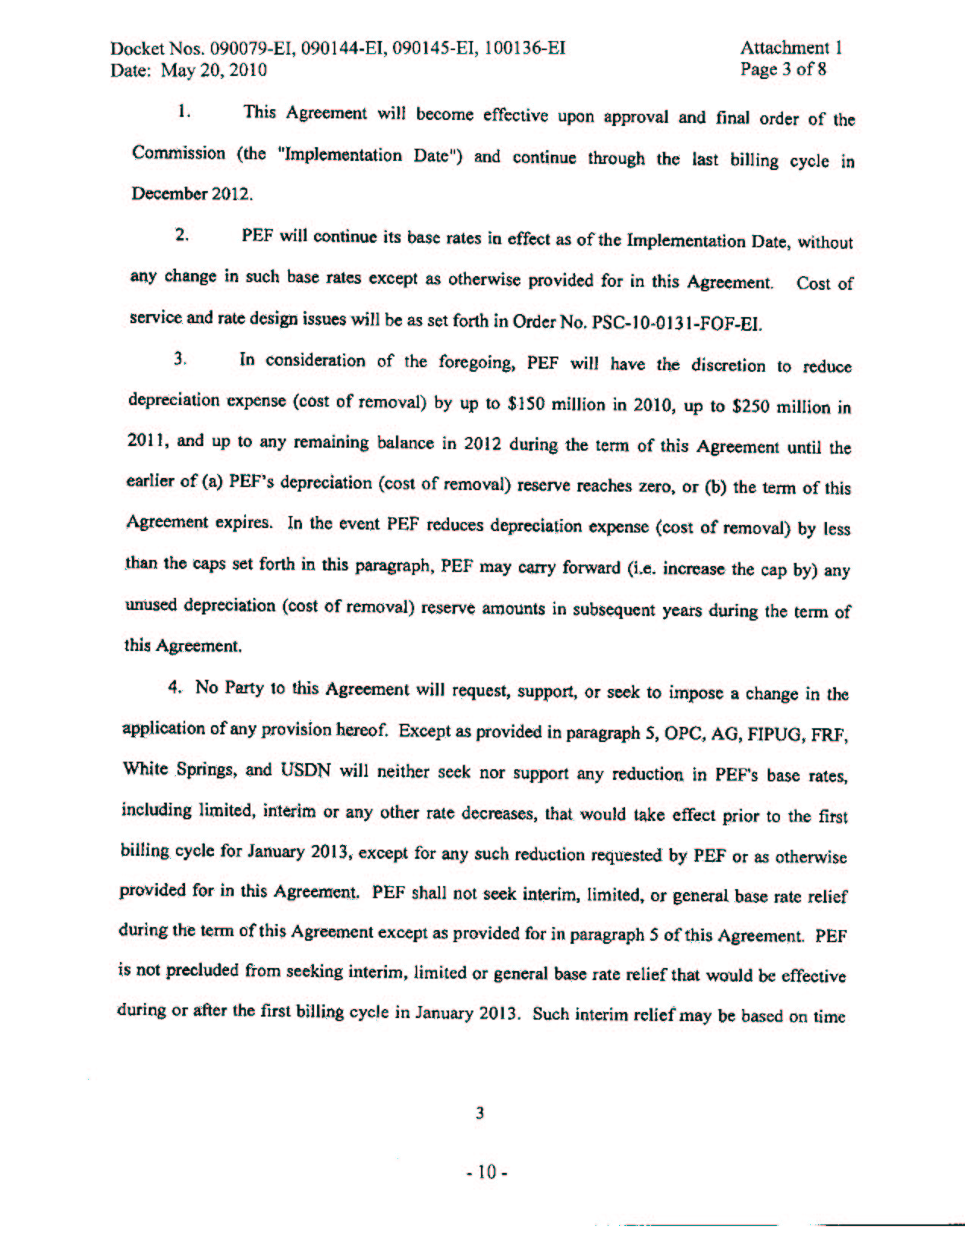
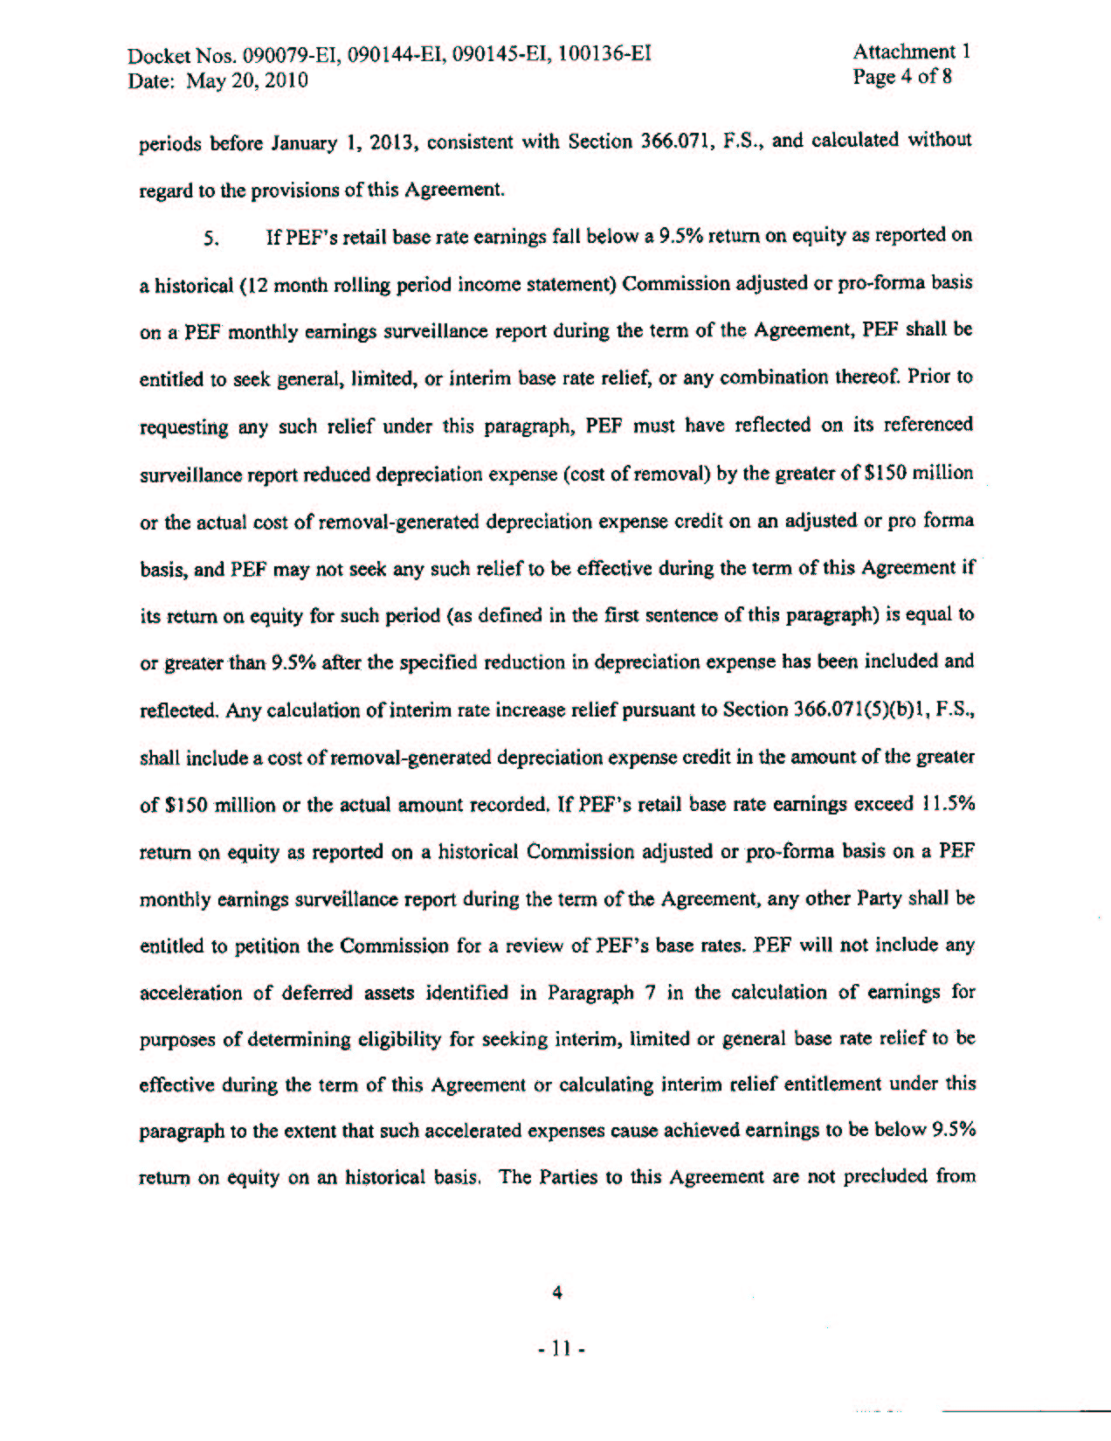
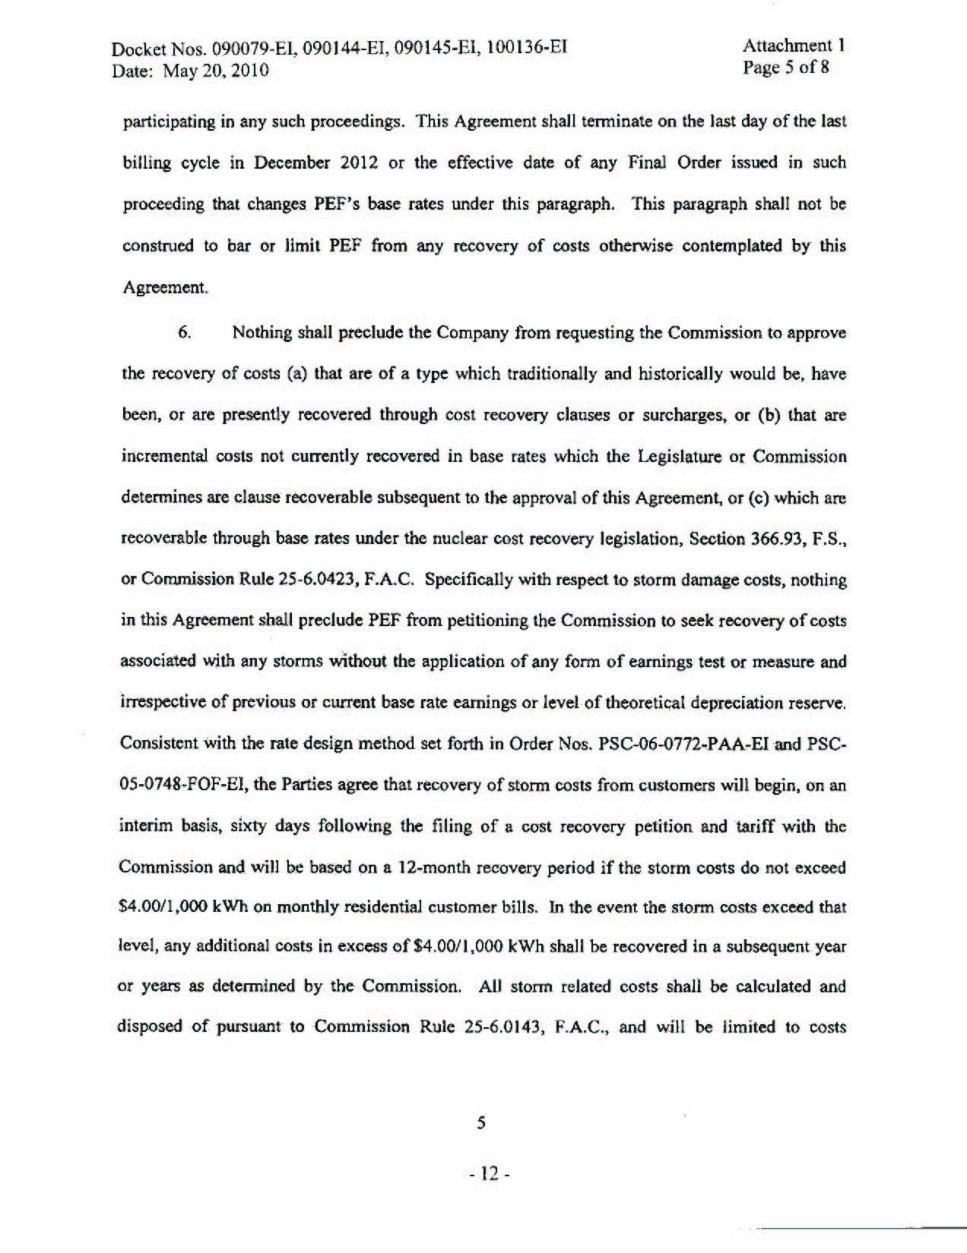
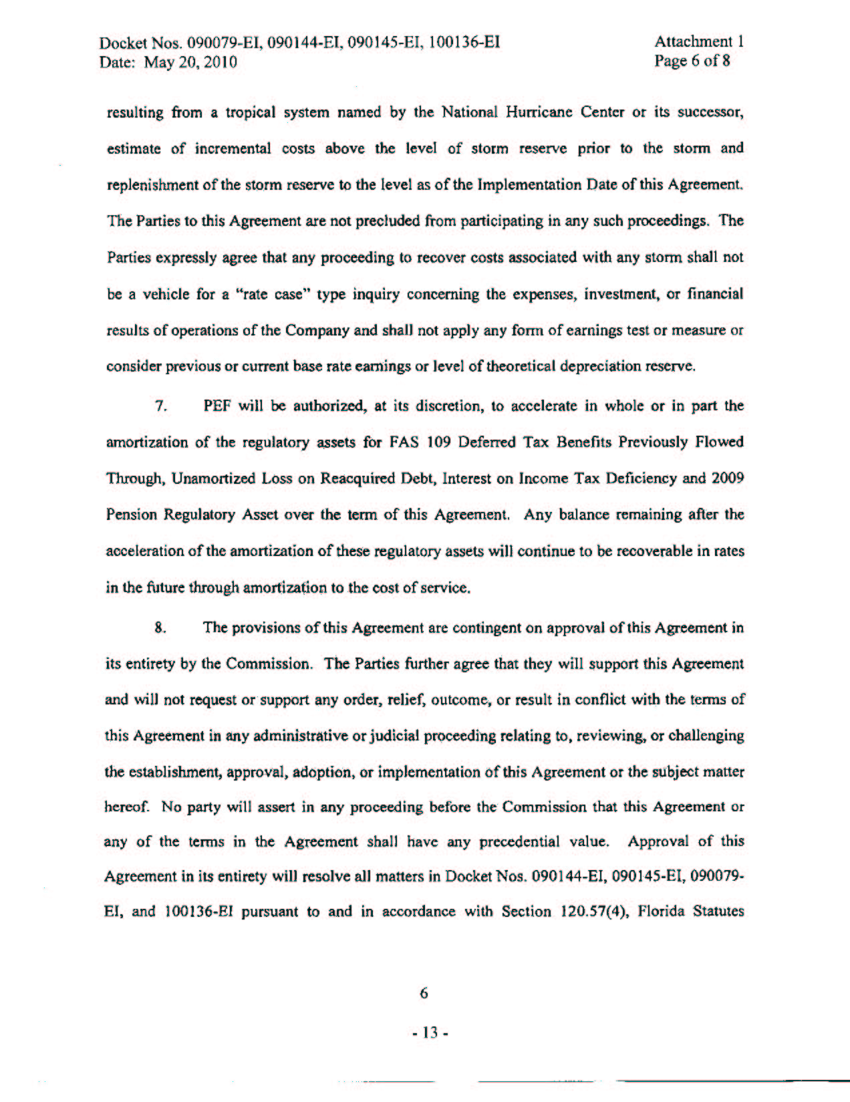
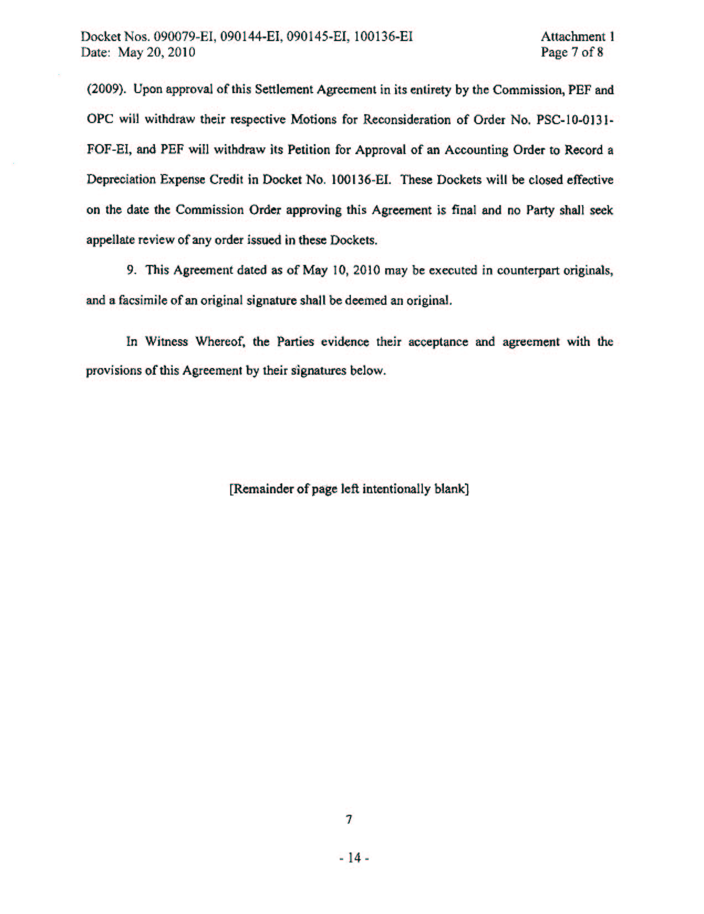
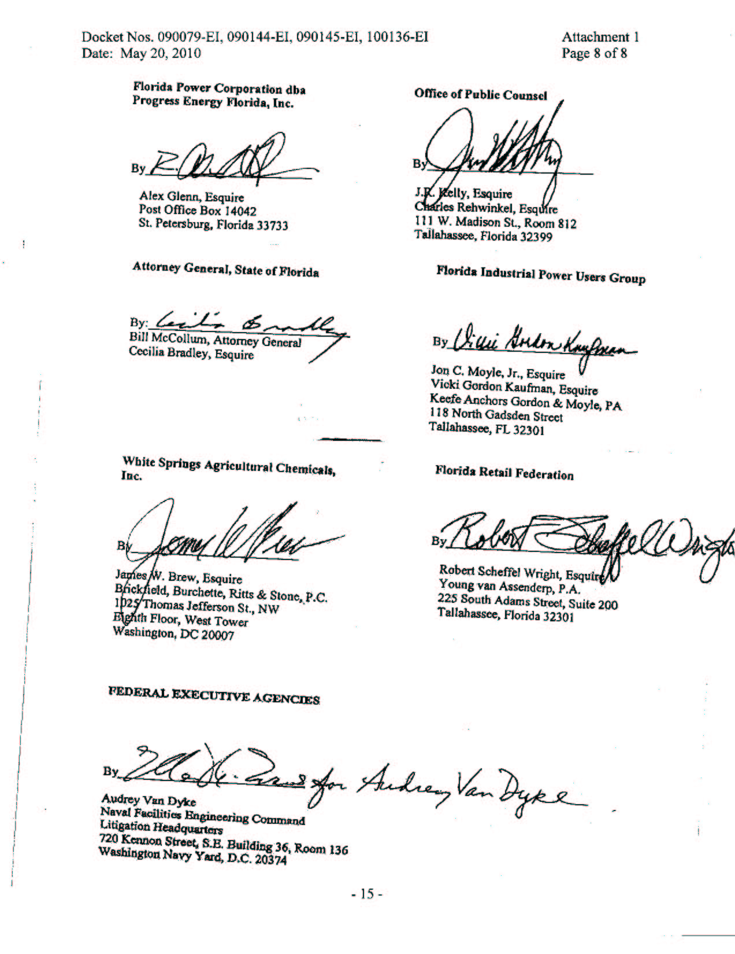

Order No. PSC-09-0105-PCO-EI, issued February 23, 2009.
Order No. PSC-09-0122-PCO-EI, issued March 2, 2009.
Order No. PSC-09-0198-PCO-EI, issued April 1, 2009.
Order No. PSC-09-0199-PCO-EI, issued April 1, 2009.
Order No. PSC-09-0579-PCO-EI, issued August 27, 2009.
Order No. PSC-09-0399-PCO-EI, issued June 6, 2009.
Order No. PSC-09-0200-PCO-EI, issued April 1, 2009.
Order No. PSC-09-0415-PAA-EI, issued June 12, 2009, in Docket No. 090144-EI, In re: Petition for limited proceeding to include Bartow repowering project in base rates, by Progress Energy Florida, Inc.
Order No. PSC-09-0586-PCO-EI, issued August 31, 2009, in Docket No. 090145-EI, In re: Petition for expedited approval of the deferral of pension expenses, authorization to charge storm hardening expenses to the storm damage reserve, and variance from or waiver of Rule 25-6.0143(1)(c), (d), and (f), F.A.C., by Progress Energy Florida, Inc.

