State of Florida   |  | Public Service Commission  Capital Circle Office Center ● 2540 Shumard Oak Boulevard  Tallahassee, Florida 32399-0850  -M-E-M-O-R-A-N-D-U-M-
DATE: | June 30, 2010
TO: | Office of Commission Clerk (Cole)
FROM: | Division of Regulatory Analysis (S. Brown)  Office of the General Counsel (M. Brown, Tan)
RE: | Docket No. 100169-EI – Petition for approval of a renewable energy tariff and standard offer contract, by Florida Power & Light Company.
AGENDA: | 07/13/10 – Regular Agenda – Tariff Filing – Interested Persons May Participate
COMMISSIONERS ASSIGNED: |  |  | All Commissioners
PREHEARING OFFICER: |  |  | Administrative
CRITICAL DATES: |  |  | 12/26/10 (8-Month Effective Date)
SPECIAL INSTRUCTIONS: |  |  | None
FILE NAME AND LOCATION: |  |  | S:\PSC\RAD\WP\100169.RCM.7-13-10DOC

Case Background
Since January 1, 2006, each investor-owned electric utility (IOU) has been required to continuously offer to purchase capacity and energy from specific types of renewable resources. Section 366.91(3), Florida Statutes (F.S.) specifies that the contracts for purchase must be based on the utility’s full avoided cost as defined in Section 366.051, F.S., and provide a term of at least ten years. Rules 25-17.200 through 25-17.310, Florida Administrative Code (F.A.C.), implement the statutes.
Florida Power & Light Company (FPL) filed its petition for approval of a renewable energy tariff and standard offer contract on April 1, 2010. The contract, as directed by Florida Public Service Commission Rule 25-17.250 F.A.C., is based on the 2010 Ten-Year Site Plan, but FPL has no fossil-fueled generating units that could qualify as an avoided unit during the 2010-2019 period. Therefore, in its 2010 Ten-Year Site Plan, FPL included a notation that a fossil-fueled generation unit capable of serving as the avoided unit would next be required in 2025. The unit is a greenfield 1,212 megawatt (MW) natural gas-fired combined cycle plant with a projected in-service date of June 1, 2025.
The Commission has jurisdiction over this matter pursuant to Sections 366.04 through 366.06, 366.91, and 366.92, F.S.
Discussion of Issues
Issue 1:1
Should the Commission approve the standard offer contract filed by Florida Power & Light Company?
Recommendation:
Yes. The standard offer contract and related tariffs comply with Rules 25-17.200 through 25-17.310, F.A.C. (S. Brown)
Staff Analysis:
Because FPL is an IOU, Rule 25-17.250(1), F.A.C., requires it to continuously make available a standard offer contract for the purchase of firm capacity and energy from renewable generating facilities and small qualifying facilities with a design capacity of 100 kilowatts (kW) or less. In its 2010 Ten-Year Site Plan, FPL has not identified any fossil-fueled generating units for the period 2010-2019, but it has identified a unit beyond the ten year planning horizon as the avoided unit. The unit is a greenfield 1,212 MW natural gas-fired combined cycle plant with a projected in-service date of June 1, 2025.
A renewable generator can still elect to have no performance requirements to deliver energy on an as-available basis under the current standard offer. If the renewable generator commits to certain performance requirements based on the avoided unit, including being on-line and delivering capacity by the in-service date, it can receive a capacity payment. To promote renewable generation, the Commission requires multiple options for capacity payments, including the option to receive Early or Levelized payments. Table 1 illustrates the various annual payments that would be made to a renewable facility of 50 MW running at a 94 percent capacity factor, with an in-service date of January 1, 2011.
Table 1 – Estimated Annual Payments to a 50 MW Renewable Facility (94% Capacity Factor)
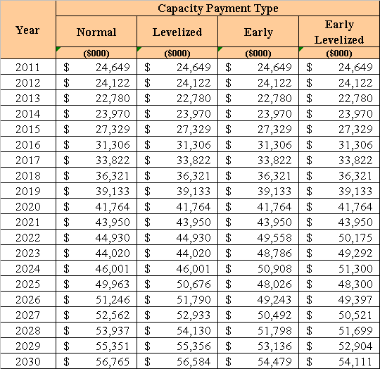
If a renewable generator elects to receive payments under the Normal or Levelized options, it would receive as-available energy rates until 2025, the in-service date of the avoided units. If the Early or Early Levelized options are selected, capacity payments begin at an earlier date but tend to be less in the outer years as the net present value of payments must remain the same. In addition, capacity payments greater than those made under the Normal option require additional performance security from the renewable generator.
FPL submitted a total of twelve revised tariff sheets, including five revised sheets of FPL’s Renewable Standard Offer Contract and seven revised sheets corresponding to FPL’s QS-2 rate schedule. All of the revised sheets reflect the changed date of the avoided unit, with a majority of revisions related to the new economic parameters. Beyond these revisions, all other terms, such as provisions for performance, payment, and security are retained from the 2009 standard offer contract and related tariffs.
The provisions of the 2010 standard offer contract and related tariffs submitted by FPL conform to all requirements of Rules 25-17.200 through 25-17.310, F.A.C. FPL has filed tariff sheets that reflect the economic and technical assumptions of the 2025 avoided unit. The standard offer contract provides flexibility in the arrangements for payment so that a developer of renewable generation may select the payment stream best suited to its financial needs. Staff believes the standard offer contract and related tariffs comply with Rules 25-17.200 through 25-17.310, F.A.C. and therefore should be approved.
Issue 2:2
Should this docket be closed?
Recommendation:
Yes. If the Commission approves staff’s recommendation to approve the proposed standard offer contract and tariffs filed by FPL, and no person whose substantial interests are affected requests a hearing to address this matter, then Docket No. 100169-EQ should be closed, and the standard offer contracts and tariffs filed by FPL should be effective as of the date of the Commission’s vote. If a protest is filed within 21 days of the issuance of the Commission’s order, the tariffs should remain in effect pending resolution of the protest. Potential signatories to the standard offer contract should be aware that FPL’s tariffs and standard offer contracts may be subject to a request for hearing, and if a hearing is held, may subsequently be revised. (M. Brown, Tan)
Staff Analysis:
If the Commission approves staff’s recommendation to approve the proposed standard offer contract and tariffs filed by FPL, and no person whose substantial interests are affected requests a hearing to address this matter, then Docket No. 100169-EQ should be closed, and the standard offer contracts and tariffs filed by FPL should be effective as of the date of the Commission’s vote. If a protest is filed within 21 days of the issuance of the Commission’s order, the tariffs should remain in effect pending resolution of the protest. Potential signatories to the standard offer contract should be aware that FPL’s tariffs and standard offer contracts may be subject to a request for hearing, and if a hearing is held, may subsequently be revised.

