State of Florida   |  | Public Service Commission  Capital Circle Office Center ● 2540 Shumard Oak Boulevard  Tallahassee, Florida 32399-0850  -M-E-M-O-R-A-N-D-U-M-
DATE: | June 30 July 8, 2010
TO: | Office of Commission Clerk (Cole)
FROM: | Division of Regulatory Analysis (S. Brown)  Office of the General Counsel (M. Brown, Tan)
RE: | Docket No. 100167-EI – Petition for approval of revisions to standard offer contract and rate schedules COG-1 and COG-2, by Tampa Electric Company.
AGENDA: | 07/13/10 – Regular Agenda – Tariff Filing – Interested Persons May Participate
COMMISSIONERS ASSIGNED: |  |  | All Commissioners
PREHEARING OFFICER: |  |  | Administrative
CRITICAL DATES: |  |  | 12/26/10 (8-Month Effective Date)
SPECIAL INSTRUCTIONS: |  |  | None
FILE NAME AND LOCATION: |  |  | S:\PSC\RAD\WP\100167.RCM.7-13-10.DOC

Case Background
Since January 1, 2006, each investor-owned electric utility (IOU) has been required to continuously offer to purchase capacity and energy from specific types of renewable resources. Section 366.91(3), Florida Statutes (F.S.) specifies that the contracts for purchase must be based on the utility’s full avoided cost as defined in Section 366.051, F.S., and provide a term of at least ten years. Rules 25-17.200 through 25-17.310, Florida Administrative Code (F.A.C.), implement the statutes.
Tampa Electric Company (Tampa Electric) filed its petition for approval of an amended standard offer contract and accompanying tariff COG-1 and COG-2 rate schedules on April 1, 2010. The contract, as directed by Florida Public Service Commission Rule 25-17.250, F.A.C., is based on the 2010 Ten-Year Site Plan. Tampa Electric has identified a 61 megawatt (MW) aero-derivative combustion turbine as a unit available to be avoided. The in-service date of the unit is projected to commence in 2013.
On July 7, 2010, Tampa Electric filed a revised response to a staff data request. The revised values are shown in Table 1 on page 4 of this recommendation.
The Commission has jurisdiction over this matter pursuant to Sections 366.04 through 366.06, 366.91, and 366.92, F.S.

Discussion of Issues
Issue 1:1
Should the Commission approve the standard offer contract filed by Tampa Electric Company be approved?
Recommendation:
Yes. The standard offer contract and related tariffs comply with Rules 25-17.200 through 25-17.310, F.A.C. (S. Brown)
Staff Analysis:
Because Tampa Electric is an IOU, Rule 25-17.250(1), F.A.C., requires it to continuously make available a standard offer contract for the purchase of firm capacity and energy from renewable generating facilities and small qualifying facilities with a design capacity of 100 kilowatts (kW) or less. In its 2010 Ten-Year Site Plan, Tampa Electric has identified a 61 megawatt (MW) aero-derivative combustion turbine as a unit available to be avoided. The in-service date of the unit is projected to commence in 2013.
A renewable generator can still elect to have no performance requirements to deliver energy on an as-available basis under the current standard offer. If the renewable generator commits to certain performance requirements based on the avoided unit, including being on-line and delivering capacity by the in-service date, it can receive a capacity payment. To promote renewable generation, the Commission requires multiple options for capacity payments, including the option to receive Early or Levelized payments. Table 1 illustrates the various annual payments that would be made to a renewable facility of 50 MW running at a 90 percent capacity factor, with an in-service date of January 1, 2011.

Table 1 – Estimated Annual Payments to a 50 MW Renewable Facility (90% Capacity Factor)
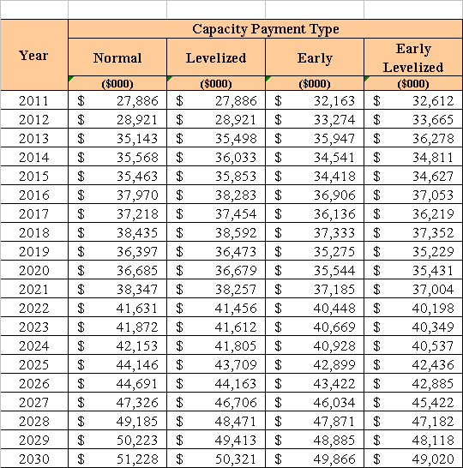
If a renewable generator elects to receive payments under the Normal or Levelized options, it would receive as-available energy rates until 2013, the in-service date of the avoided units. If the Early or Early Levelized options are selected, capacity payments begin at an earlier date but tend to be less in the outer years as the net present value of payments must remain the same. In addition, capacity payments greater than those made under the Normal option require additional performance security from the renewable generator.
Tampa Electric submitted several revised tariff sheets related to the proposed amended standard offer, and corresponding to its COG-1 and COG-2 rate schedules. The revised sheets reflect the modifications in some of the language in the proposed contract, changes in the minimum specifications and milestones, and changes in the economic parameters of the avoided unit. Beyond these revisions, all other terms are retained from the 2009 standard offer contract and related tariffs.
The provisions of the 2010 standard offer contract and related tariffs submitted by Tampa Electric conform to all requirements of Rules 25-17.200 through 25-17.310, F.A.C. Tampa Electric has filed tariff sheets that reflect the economic and technical assumptions of the 2013 avoided unit. The amended standard offer contract provides flexibility in the arrangements for payment so that a developer of renewable generation may select the payment stream best suited to its financial needs. Staff believes the standard offer contract and related tariff complies with Rules 25-17.200 through 25-17.310, F.A.C., and therefore should be approved.
Issue 2:2
Should this docket be closed?
Recommendation:
Yes. If the Commission approves staff’s recommendation to approve the proposed standard offer contract and tariffs filed by Tampa Electric, and no person whose substantial interests are affected requests a hearing to address this matter, then Docket No. 100167-EQ should be closed, and the standard offer contracts and tariffs filed by Tampa Electric should be effective as of the date of the Commission’s vote. If a protest is filed within 21 days of the issuance of the Commission’s order, the tariffs should remain in effect pending resolution of the protest. Potential signatories to the standard offer contract should be aware that Tampa Electric’s tariffs and standard offer contracts may be subject to a request for hearing, and if a hearing is held, may subsequently be revised. (M. Brown, Tan)
Staff Analysis:
If the Commission approves staff’s recommendation to approve the proposed standard offer contract and tariffs filed by Tampa Electric, and no person whose substantial interests are affected requests a hearing to address this matter, then Docket No. 100167-EQ should be closed, and the standard offer contracts and tariffs filed by Tampa Electric should be effective as of the date of the Commission’s vote. If a protest is filed within 21 days of the issuance of the Commission’s order, the tariffs should remain in effect pending resolution of the protest. Potential signatories to the standard offer contract should be aware that Tampa Electric’s tariffs and standard offer contracts may be subject to a request for hearing, and if a hearing is held, may subsequently be revised.

