BEFORE THE FLORIDA PUBLIC SERVICE COMMISSION

In re: Petition for approval of a renewable energy tariff and standard offer contract, by Florida Power & Light Company. | DOCKET NO. 100169-EI  ORDER NO. PSC-10-0463-TRF-EI  ISSUED: July 21, 2010

The following Commissioners participated in the disposition of this matter:

NANCY ARGENZIANO, Chairman
LISA POLAK EDGAR
NATHAN A. SKOP

ORDER APPROVING STANDARD OFFER CONTRACT AND RELATED TARIFFS

BY THE COMMISSION:

- Case Background

Since January 1, 2006, each investor-owned electric utility (IOU) has been required to continuously offer to purchase capacity and energy from specific types of renewable resources. Section 366.91(3), Florida Statutes (F.S.) specifies that the contracts for purchase must be based on the utility’s full avoided cost as defined in Section 366.051, F.S., and provide a term of at least ten years. Rules 25-17.200 through 25-17.310, Florida Administrative Code (F.A.C.), implement the statutes.
Florida Power & Light Company (FPL) filed its petition for approval of a renewable energy tariff and standard offer contract on April 1, 2010. The contract, as directed by Florida Public Service Commission Rule 25-17.250 F.A.C., is based on the 2010 Ten-Year Site Plan, but FPL has no fossil-fueled generating units that could qualify as an avoided unit during the 2010-2019 period. Therefore, in its 2010 Ten-Year Site Plan, FPL included a notation that a fossil-fueled generation unit capable of serving as the avoided unit would next be required in 2025. The unit is a greenfield 1,212 megawatt (MW) natural gas-fired combined cycle plant with a projected in-service date of June 1, 2025.
We have jurisdiction over this matter pursuant to Sections 366.04 through 366.06, 366.91, and 366.92, F.S.
II. Analysis
Because FPL is an IOU, Rule 25-17.250(1), F.A.C., requires it to continuously make available a standard offer contract for the purchase of firm capacity and energy from renewable generating facilities and small qualifying facilities with a design capacity of 100 kilowatts (kW) or less. In its 2010 Ten-Year Site Plan, FPL has not identified any fossil-fueled generating units for the period 2010-2019, but it has identified a unit beyond the ten year planning horizon as the avoided unit. The unit is a greenfield 1,212 MW natural gas-fired combined cycle plant with a projected in-service date of June 1, 2025.
A renewable generator can still elect to have no performance requirements to deliver energy on an as-available basis under the current standard offer. If the renewable generator commits to certain performance requirements based on the avoided unit, including being on-line and delivering capacity by the in-service date, it can receive a capacity payment. To promote renewable generation, we require multiple options for capacity payments, including the option to receive Early or Levelized payments. Table 1 illustrates the various annual payments that would be made to a renewable facility of 50 MW running at a 94 percent capacity factor, with an in-service date of January 1, 2011.
Table 1 – Estimated Annual Payments to a 50 MW Renewable Facility (94% Capacity Factor)
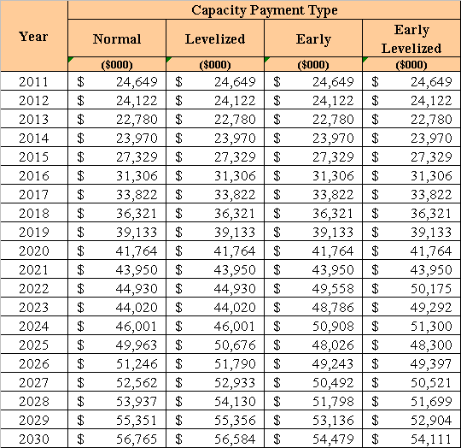
If a renewable generator elects to receive payments under the Normal or Levelized options, it would receive as-available energy rates until 2025, the in-service date of the avoided units. If the Early or Early Levelized options are selected, capacity payments begin at an earlier date but tend to be less in the outer years as the net present value of payments must remain the same. In addition, capacity payments greater than those made under the Normal option require additional performance security from the renewable generator.
FPL submitted a total of twelve revised tariff sheets, including five revised sheets of FPL’s Renewable Standard Offer Contract and seven revised sheets corresponding to FPL’s QS-2 rate schedule. All of the revised sheets reflect the changed date of the avoided unit, with a majority of revisions related to the new economic parameters. Beyond these revisions, all other terms, such as provisions for performance, payment, and security are retained from the 2009 standard offer contract and related tariffs.
The provisions of the 2010 standard offer contract and related tariffs submitted by FPL conform to all requirements of Rules 25-17.200 through 25-17.310, F.A.C. FPL has filed tariff sheets that reflect the economic and technical assumptions of the 2025 avoided unit. The standard offer contract provides flexibility in the arrangements for payment so that a developer of renewable generation may select the payment stream best suited to its financial needs.
III. Decision
Based on the above, we find that FPL’s standard offer contract and related tariffs comply with Rules 25-17.200 through 25-17.310, F.A.C. and are therefore approved.
Based on the foregoing, it is

ORDERED by the Florida Public Service Commission that Florida Power & Light Company’s standard offer contract and related tariffs are hereby approved, effective July 13, 2010. It is further

ORDERED that the provisions of this Order, shall become final and effective upon the issuance of a Consummating Order unless an appropriate petition, in the form provided by Rule 28-106.201, Florida Administrative Code, is received by the Commission Clerk, 2540 Shumard Oak Boulevard, Tallahassee, Florida 32399-0850, by the close of business on the date set forth in the "Notice of Further Proceedings" attached hereto. It is further

ORDERED that if a protest is filed within 21 days of the issuance of the Order, the tariffs shall remain in effect pending resolution of the protest. Potential signatories to the standard offer contract shall be aware that Florida Power & Light Company’s tariffs and standard offer contracts may be subject to a request for hearing, and if a hearing is held, may subsequently be revised. It is further
ORDERED that in the event this Order becomes final, this docket shall be closed.

By ORDER of the Florida Public Service Commission this 21st day of July, 2010.

/s/ Ann Cole
ANN COLE
Commission Clerk

This is an electronic transmission. A copy of the original signature is available from the Commission's website, www.floridapsc.com, or by faxing a request to the Office of Commission Clerk at 1-850-413-7118.

( S E A L )

MCB

NOTICE OF FURTHER PROCEEDINGS

The Florida Public Service Commission is required by Section 120.569(1), Florida Statutes, to notify parties of any administrative hearing or judicial review of Commission orders that is available under Sections 120.57 or 120.68, Florida Statutes, as well as the procedures and time limits that apply. This notice should not be construed to mean all requests for an administrative hearing or judicial review will be granted or result in the relief sought.

Mediation may be available on a case-by-case basis. If mediation is conducted, it does not affect a substantially interested person's right to a hearing.

The Commission's decision on this tariff is interim in nature and will become final, unless a person whose substantial interests are affected by the proposed action files a petition for a formal proceeding, in the form provided by Rule 28-106.201, Florida Administrative Code. This petition must be received by the Office of Commission Clerk, 2540 Shumard Oak Boulevard, Tallahassee, Florida 32399-0850, by the close of business on August 11, 2010.

In the absence of such a petition, this Order shall become final and effective upon the issuance of a Consummating Order.

Any objection or protest filed in this docket before the issuance date of this order is considered abandoned unless it satisfies the foregoing conditions and is renewed within the specified protest period.

