State of Florida   |  | Public Service Commission  Capital Circle Office Center ● 2540 Shumard Oak Boulevard  Tallahassee, Florida 32399-0850  -M-E-M-O-R-A-N-D-U-M-
DATE: | August 5, 2010
TO: | Office of Commission Clerk (Cole)
FROM: | Division of Economic Regulation (Chase, Draper, Slemkewicz)  Division of Regulatory Analysis (Ballinger, S. Brown, Ellis)  Office of the General Counsel (Young)
RE: | Docket No. 090368-EI – Review of the continuing need and costs associated with Tampa Electric Company's five Combustion Turbines and Big Bend Rail Facility.
AGENDA: | 8/17/10 – Regular Agenda – Decision on Stipulation and Settlement – Prior to Hearing - Interested Persons May Participate
COMMISSIONERS ASSIGNED: |  |  | All Commissioners
PREHEARING OFFICER: |  |  | Skop
CRITICAL DATES: |  |  | None
SPECIAL INSTRUCTIONS: |  |  | None
FILE NAME AND LOCATION: |  |  | S:\PSC\ECR\WP\090368.RCM.DOC

Case Background
On October 12, 2009, Tampa Electric Company (TECO or Company) filed a Petition for a step increase in rates pursuant to Order No. PSC-09-0283-FOF-EI (Final Order), issued April 30, 2009, and confirmed on reconsideration in Order No. PSC-09-0571-FOF-EI (Order on Reconsideration), issued August 21, 2009.

The Final Order, in part, granted TECO a step increase in rates to generate a maximum of $33.5 million of additional revenue effective January 1, 2010. This step increase was designed to allow TECO to recover the deferred costs to construct five combustion turbines (CTs) during 2009 and a new rail unloading facility at Big Bend Station (Rail Facility) to be placed in service toward the end of 2009. The step increase was authorized subject to conditions that these facilities would be completed and placed in commercial operation by December 31, 2009, and that the five CTs would continue to be needed for load generation.

The Intervenors in TECO’s rate case proceeding (the Office of Public Counsel (OPC), Office of Attorney General (AG), the Florida Industrial Power Users Group (FIPUG) and the Florida Retail Federation (FRF)), jointly filed a Motion for Reconsideration contesting the Commission’s decision to grant the step increase. The Order on Reconsideration reaffirmed the step increase and provided that a new docket be opened to evaluate whether the conditions imposed in the Final Order have been met. This docket was opened on July 15, 2009, for the purpose of making that determination.

On September 14, 2009, the Intervenors in the rate case proceeding filed a Joint Notice of Administrative Appeal with the Supreme Court of Florida of the Final Order and the Order on Reconsideration, appealing the decision of the Commission to grant the step increase.

By Order No. PSC-09-0842-PCO-EI, issued December 22, 2009, in this docket, the Commission set the matter of the step increase directly for a formal administrative hearing to determine whether TECO satisfied the three conditions for the step increase set out in the Final Order and affirmed in the Order on Reconsideration. Also, in that Order, the Commission authorized a revised step increase of $25,742,209, subject to refund with interest pending final disposition of this matter. On March 11, 2010, Order No. PSC-10-0144-PCO-EI (Order Establishing Procedure) was issued, scheduling the matter for an administrative hearing on September 1 and 2, 2010. OPC and FIPUG have intervened in this docket.

A Joint Motion for approval of Stipulation and Settlement Agreement (Joint Motion) was filed on July 20, 2010, by TECO, OPC, AG, FIPUG and FRF (Joint Movants). The proposed Stipulation and Settlement Agreement (Stipulation) is intended to resolve all issues pending in this docket and in the appeal of the rate case Final Order and Order on Reconsideration. A copy of the Stipulation is appended to this recommendation as Attachment 1.

On July 20, 2010, TECO filed a Consented Motion to Abate requesting that the Commission hold this proceeding in abeyance pending approval of the Stipulation, which was granted on July 22, 2010, by Order No. PSC-10-0468-PCO-EI. That Order provides that if the Stipulation and Settlement Agreement is not approved by August 31, 2010, this matter shall be set for hearing and new procedural dates shall be set.

On July 30, 2010, staff sent a data request to TECO regarding the Stipulation. On August 2, 2010, staff and the Joint Movants met to discuss TECO’s responses to the data request. On that same day, TECO provided written responses to staff’s data request. Minor revisions to two responses were filed on August 4, 2010.
This recommendation addresses the Joint Motion for Approval of Stipulation and Settlement Agreement. The Commission has jurisdiction pursuant to Sections 366.05 and 366.06, Florida Statutes (F.S.)
Discussion of Issues
Issue 1:1
Should the Commission approve the proposed Stipulation and Settlement Agreement?
Recommendation:
Yes, the Stipulation is in the public interest and should be approved. TECO should be required to file revised tariff sheets for administrative approval by staff to reflect the reduced rates for the Interruptible Service class effective January 1, 2011. (Chase, Draper, Slemkewicz, Ballinger)
Staff Analysis: As noted in the case background, the Joint Movants have proffered the proposed Stipulation (Attachment 1) as a complete resolution of all matters pending in this docket and in the pending appeal in the Supreme Court of Florida, styled Citizens of the State of Florida, Office of Public Counsel, et al., Appellants v. Matthew W. Carter II, etc., et al., Appellees, Case No. SC09-1723. The major elements contained in the Stipulation are:
- A refund of $24,000,000 to TECO’s retail customers in the form of a one-time credit to customers’ bills. (Paragraph 1)
- Current rates for all retail customer classes except for the Interruptible Service (IS) class will remain in effect on a permanent basis until the next change in base rates. The current rates were approved in this docket pursuant to Order No. 09-0842-PCO-EI, issued on December 22, 2009, on a temporary basis subject to refund with interest. (Paragraph 2)
- Current rates for the IS customer class will remain in effect for the remainder of 2010. Effective January 1, 2011, the rates applicable to IS customers should be adjusted to effect a $1.28 million annual reduction in revenues from that class. (Paragraph 2)
- Upon approval of the Stipulation in its entirety by the Commission, OPC, AG, FIPUG and FRF will dismiss with prejudice their appeal of the Final Order and the Order on Reconsideration in TECO’s last rate case. (Paragraph 3)
The proposed Stipulation consists of seven paragraphs of agreement among the Joint Movants. Staff believes that several of the paragraphs merit comment or clarification. These are as follows:
Paragraph 1: The one-time credit agreed to by the Joint Movants will include a refund of $22.72 million to non-IS customer classes and the remaining $1.28 million refunded to the IS customer class. Refunds will be applied only to active bills at the time the refunds are made. It will appear as a separate line item on the bill, which will be called “one-time rate refund.” Since the step increase was implemented with Cycle 1 billing for January 2010, the refund will also commence on Cycle 1 billing one month following the date the order regarding such refund becomes final and non-appealable. The one-time refund is expected to appear on the November 2010 bills.
In response to staff’s data request, TECO provided the calculation showing how the $22.72 million refund amount will be allocated to the various non-IS customer classes. First, the total refund amount is allocated to the customer classes based on the demand allocation factor approved in the last rate case. The resulting refund dollar amount per class is then divided by the average monthly usage from the last rate case test year to arrive at a refund cent per kWh factor. To determine the final refund amount per customer, the appropriate cents per kWh factor will be applied to each customer’s billed kWh consumption during the month the refund is made. For example, using this methodology, the residential refund factor is 1.852 cents per kWh. Thus, a residential customer who uses 1,000 kWh during the month the refund is made will receive a refund of $18.52 (or $18.99 with the inclusion of the gross receipts tax savings.)
While the dollar amount of the refund per class is determined by the cost of service study, the refund mechanism will be based on an energy basis (cents per kWh) for all customers. This approach requires the least amount of programming of the Company’s billing system and will allow the refund to take place more quickly. Any overpayment or underpayment of the one-time refund amount will be trued up through the fuel and purchased power cost recovery clause, which is also applied on a kWh basis.
Paragraph 2: In the Stipulation, the Joint Movants agree that the step increase in rates that was approved in this docket by Order No. PSC-09-0842-PCO-EI on December 22, 2009, on a temporary basis subject to refund, should be made permanent for all non-IS customer classes. For the IS customer class, the Stipulation provides that the step increase rates should remain in effect through 2010, and on January 1, 2011, the IS rates should be reduced to effect a $1.28 million annual reduction in revenues from that class until the next change in base rates. The reduction in the IS rates will have the effect of reducing the total step increase from $25.74 million in 2010 to $24.46 million per year in 2011 and subsequent years. TECO will file revised tariff sheets for administrative approval by staff to reflect the reduced IS rates effective January 1, 2011.
Paragraph 3: The Joint Movants agree that upon final approval of this Stipulation in its entirety by the Commission, the pending appeal of the TECO rate case Final Order and Order on Reconsideration filed by OPC, OAG, FIPUG and FRF will be dismissed with prejudice. This will resolve all outstanding issues in Docket No. 080317-EI, the TECO rate case docket, thus enabling it to be closed.
Conclusion
Staff has reviewed the terms of the Stipulation and believes it to be a reasonable resolution of the outstanding issues in this docket and in the Supreme Court appeal of the rate case Final Order and Order on Reconsideration. If approved, the Stipulation provides benefits to all customers in the form of a one-time refund. However, staff notes that the IS customers receive an additional benefit. The Stipulation proposes not only to issue a one-time refund to the IS customers, but also to reduce the IS rates going forward in 2011 by this same amount. That essentially means that the IS class will be exempt from any costs associated with the new CTs. This has a tendency to create inequities among rate classes, since all rate classes typically share in the recovery of plant used to serve them. TECO witness Ashburn provided prefiled testimony in this docket that, had the CTs not been available, the IS customers would have been interrupted during the cold January 2010 winter. The IS class has, therefore, benefitted, and will continue to benefit, from the additional investment in the new facilities.
While TECO does not propose to increase rates to the non-IS customer classes in order to recover the $1.28 million annual revenue reduction for the IS class, the monthly surveillance reports will reflect this lower revenue amount. As a result, the foregone revenues increase the likelihood that TECO will under-earn, and may file for another general revenue increase sooner than it otherwise would if the IS rates were not reduced. However, staff notes that there is little likelihood that an annual revenue reduction of $1.28 million would cause the Company to under-earn. In fact, based on TECO’s Earnings Surveillance Report for May 2010, a l00 basis point change in the return on equity (ROE) equals approximately $25.30 million. Thus, a revenue reduction of $1.28 million would result in an approximate reduction in achieved ROE of 5 basis points.
Staff recognizes that all settlements, by their very nature, contain compromises necessary in order to satisfy all parties. This Stipulation does offer clear benefits to TECO’s customers. An immediate refund to customers is definitely attractive during this current protracted economic recession. Also, the rates of the non-IS customers will not be increased to recover the rate reduction afforded to the IS class. Further, if the Stipulation is approved, all parties will benefit from avoiding the significant costs, delays and uncertainties associated with further litigation with respect to the appeal pending at the Supreme Court of Florida and in the instant docket. Staff believes that the benefits to all parties by this Stipulation outweigh the potential drawbacks resulting from the IS rate reduction. Staff notes that inclusion of this arrangement, as part of the Stipulation will not set any Commission precedent going forward. In conclusion, staff believes the Stipulation is in the public interest and should be approved; it provides a reasonable resolution of the issues in this case and in the appeal pending before the Supreme Court of Florida.
Issue 2:1
Should this docket be closed?
Recommendation:
Yes, if staff’s recommendation on Issue 1 is approved, this docket should be closed. (Young)
Staff Analysis:
If staff’s recommendation on Issue 1 is approved, the signatories to the Stipulation have asked that the order approving the Stipulation be issued as a final action. With the issuance of the Commission’s final order, no further action by the Commission in this docket will be necessary, and the docket should be closed upon expiration of the time for appeal. Staff notes that when the Florida Supreme Court recognizes the withdrawal of the appeal, Docket No. 080317-EI will be closed administratively.
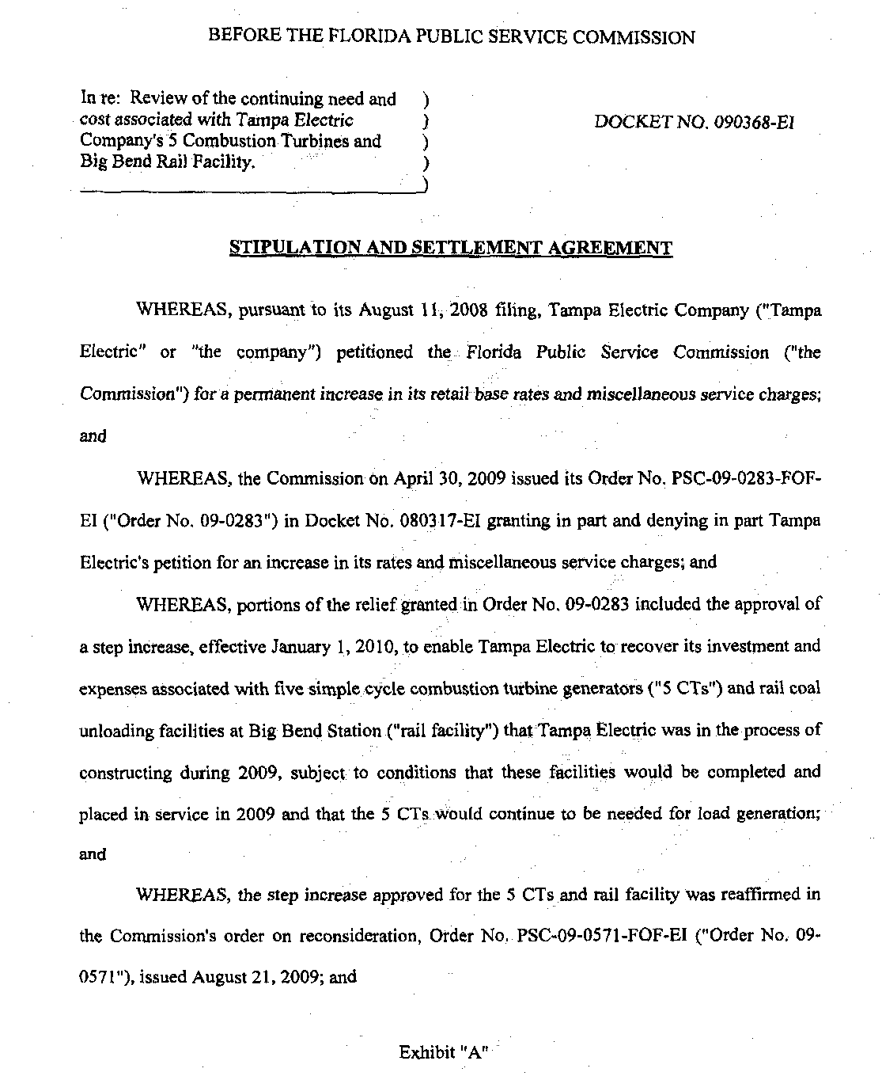
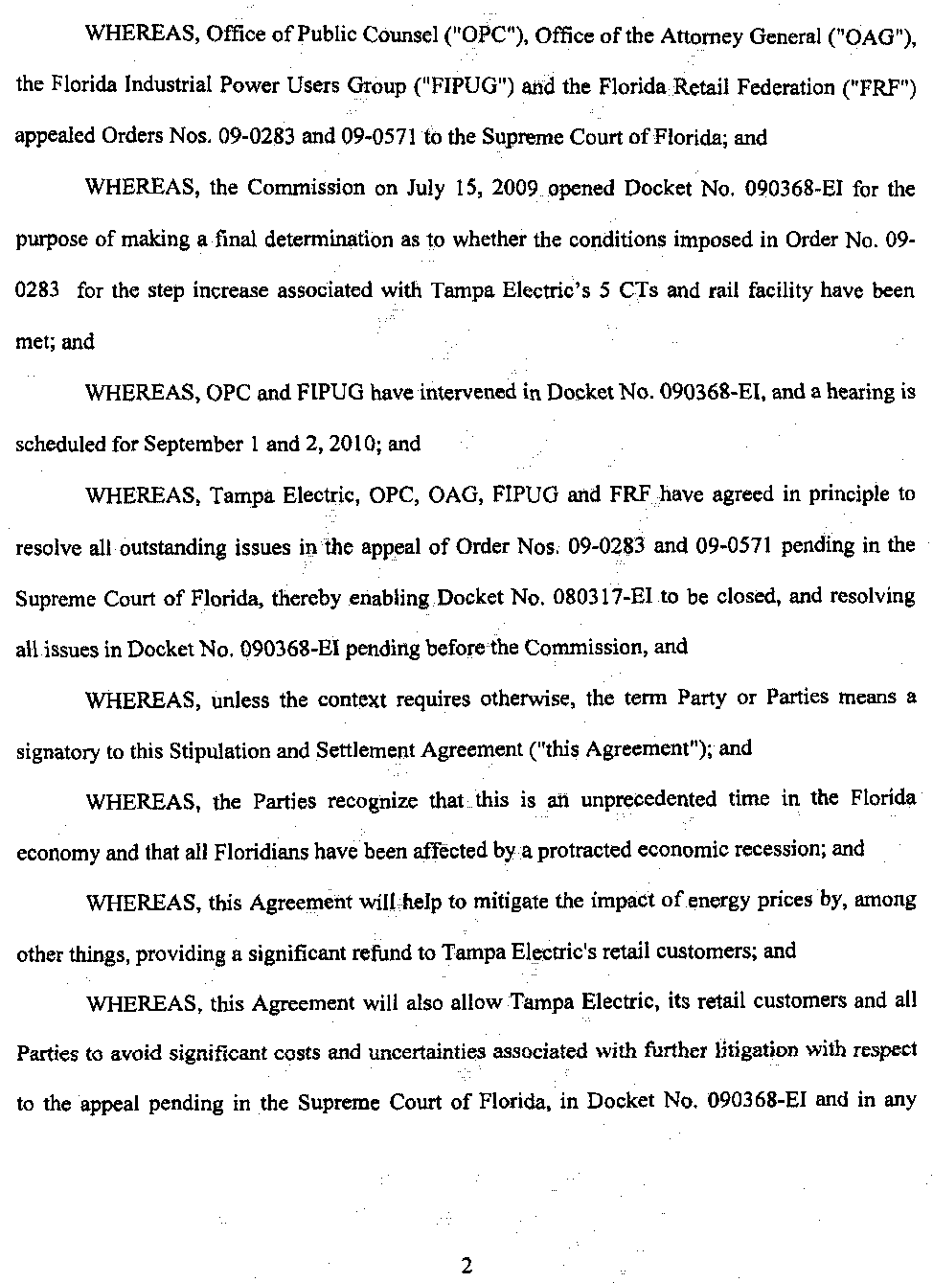
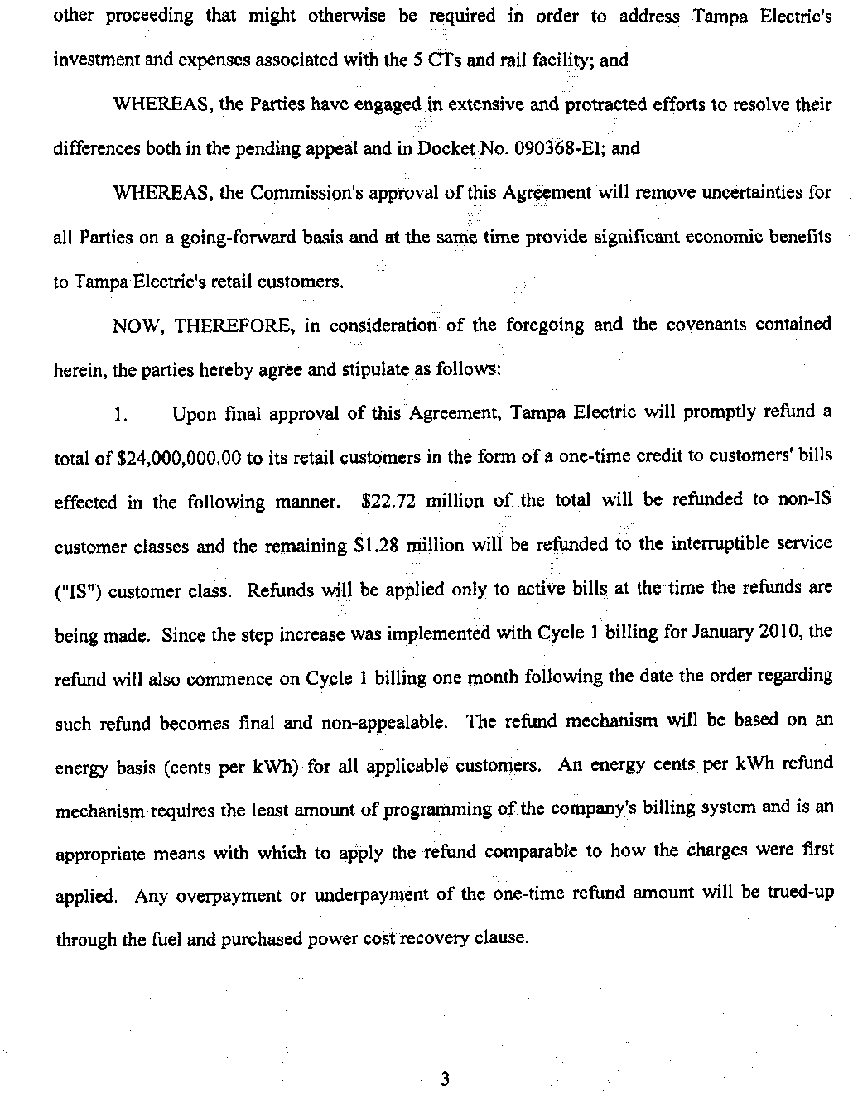
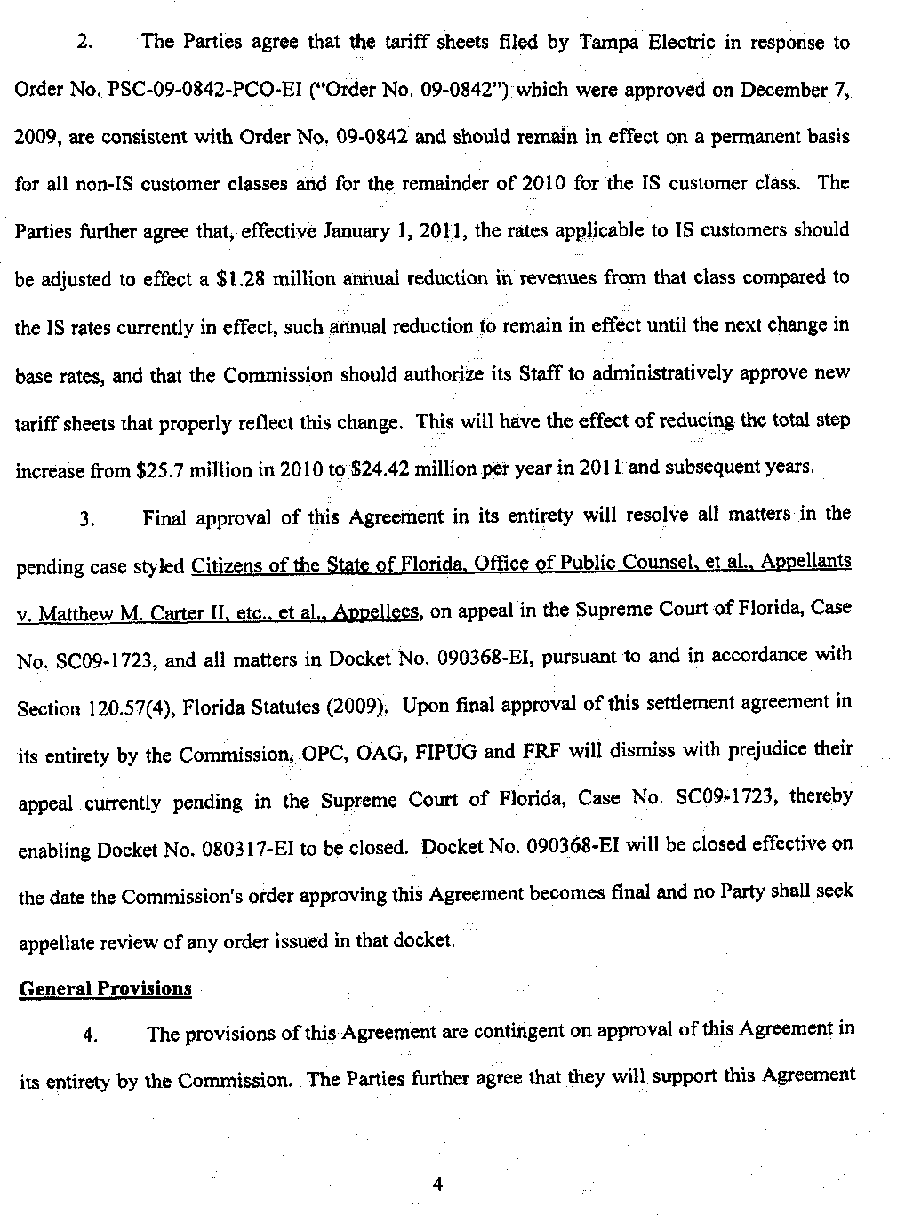
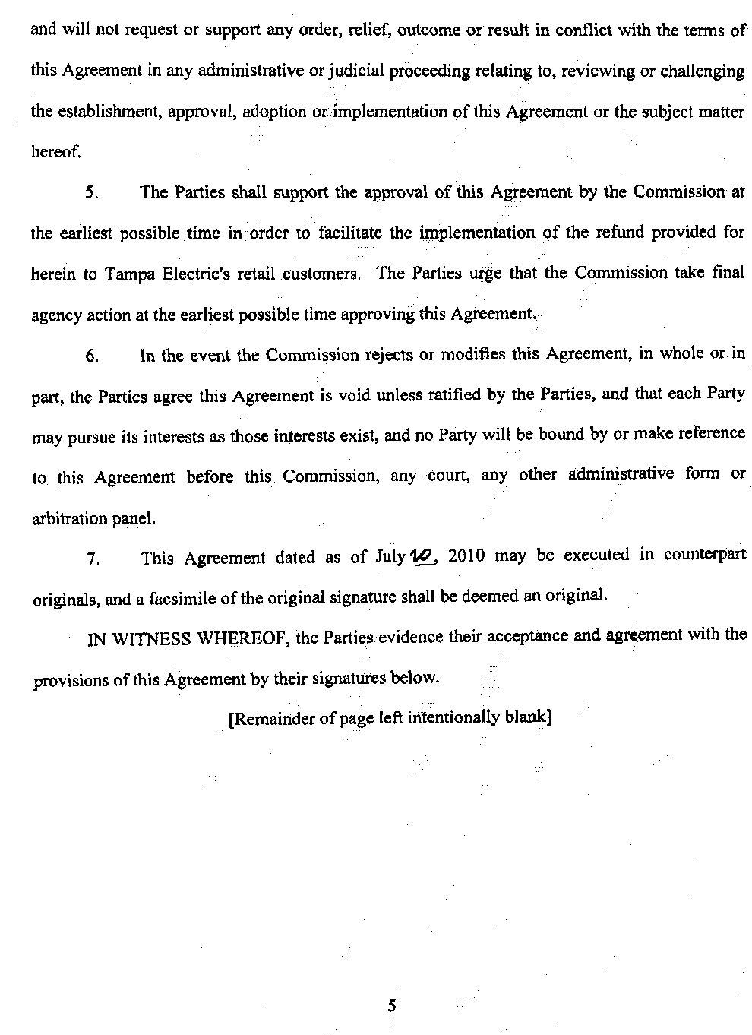
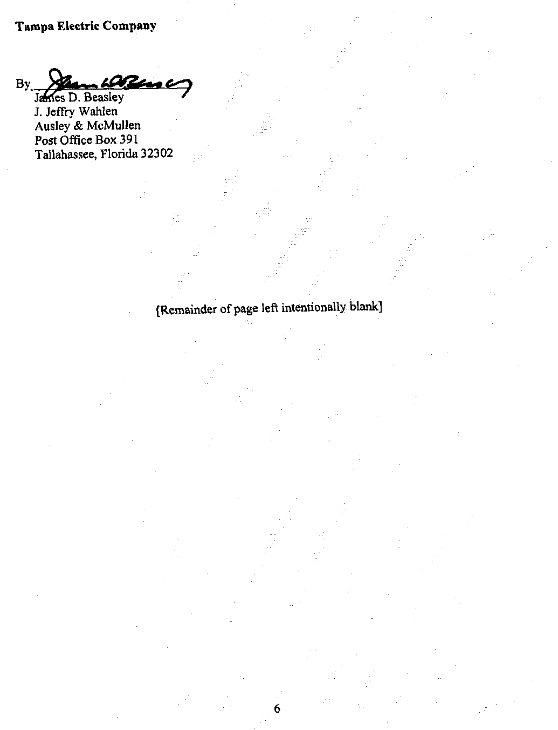
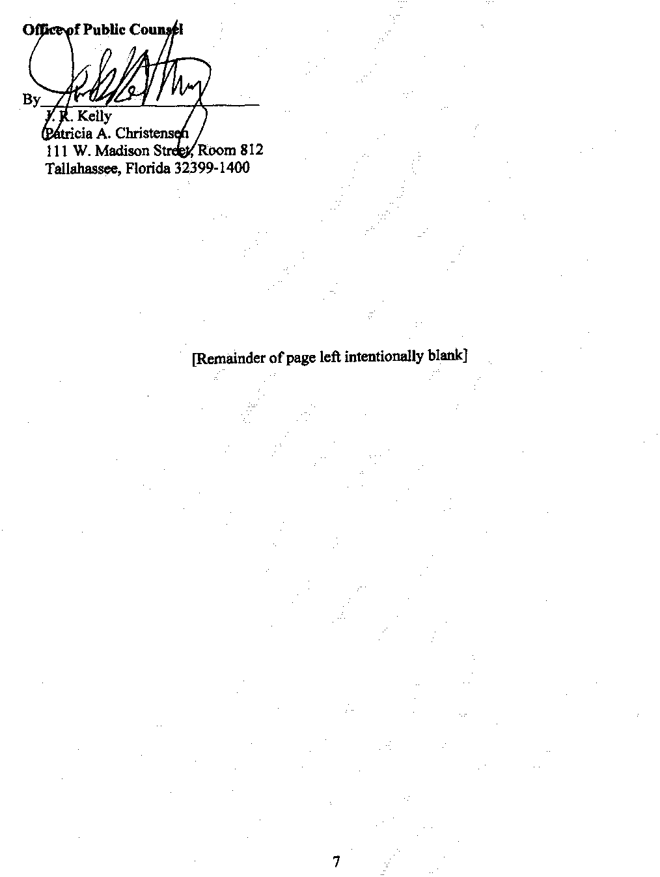
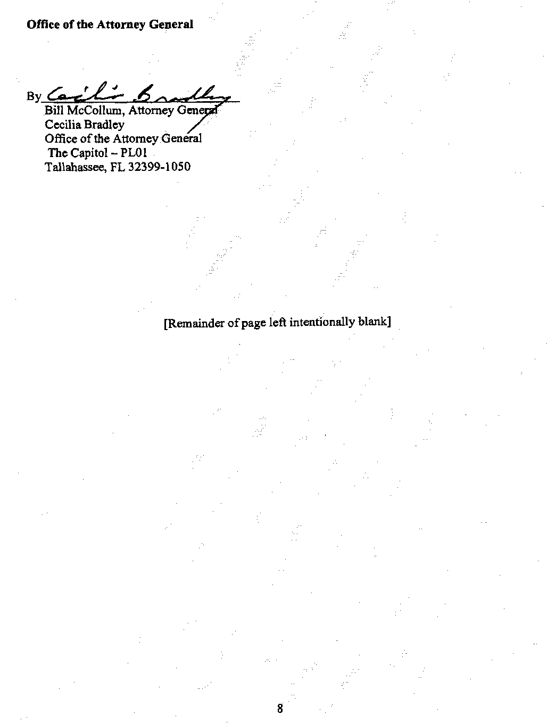
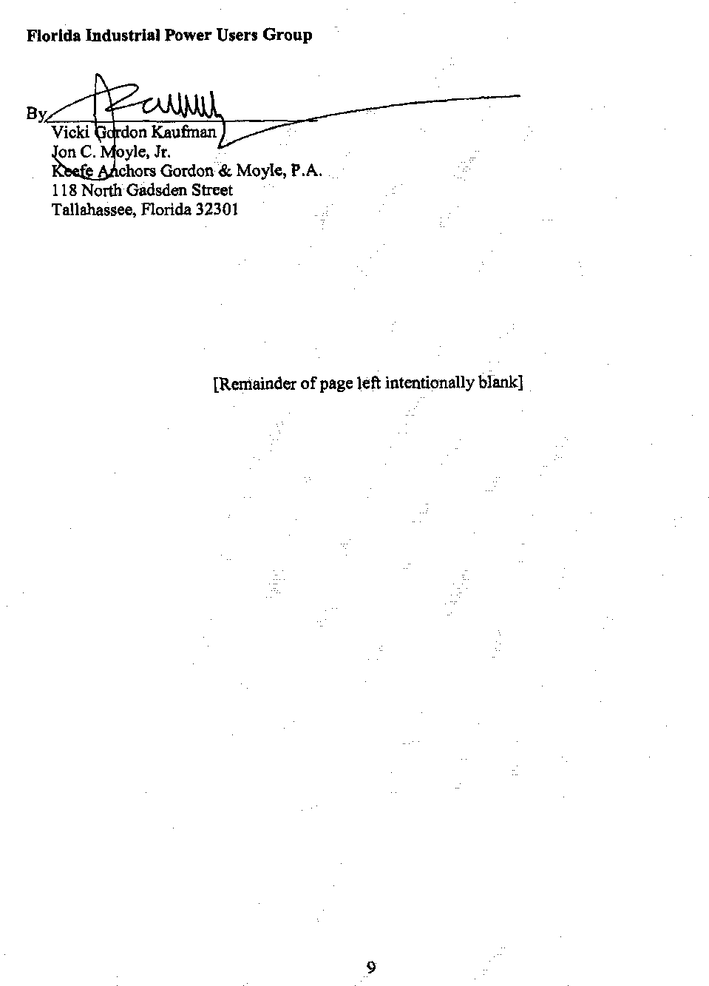
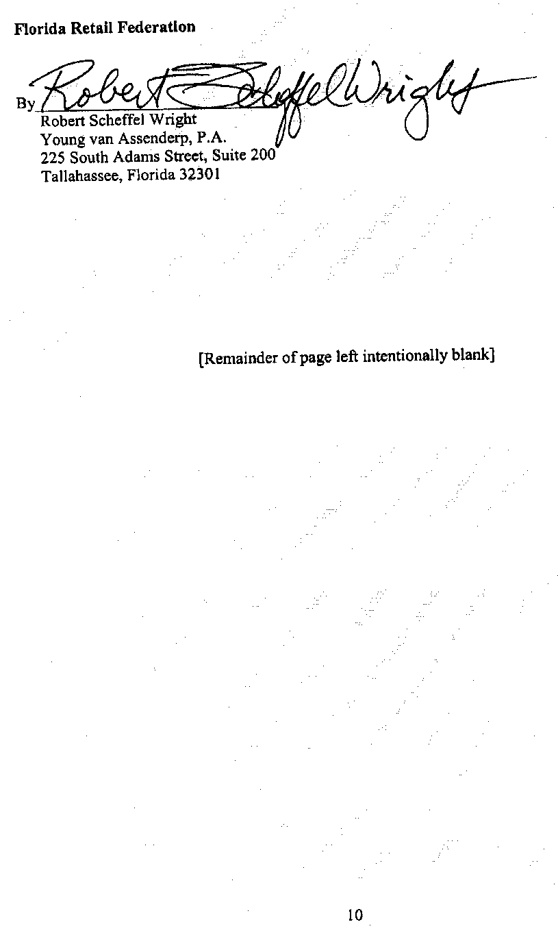

Docket No. 080317-EI, In re: Petition for rate increase by Tampa Electric Company.
Order No. PSC-09-0571-FOF-EI, at 12.
Order No. PSC-09-0842-PCO-EI, at 6.

