State of Florida   |  | Public Service Commission  Capital Circle Office Center ● 2540 Shumard Oak Boulevard  Tallahassee, Florida 32399-0850  -M-E-M-O-R-A-N-D-U-M-
DATE: | May 12, 2011
TO: | Office of Commission Clerk (Cole)
FROM: | Office of the General Counsel (Harris, Teitzman)  Division of Regulatory Analysis (Kennedy, Salak)
RE: | Docket No. 100340-TP – Investigation of Associated Telecommunications Management Services, LLC (ATMS) companies for compliance with Chapter 25-24, F.A.C., and applicable lifeline, eligible telecommunication carrier, and universal service requirements.  Docket No. 110082-TP – Initiation of show cause proceedings against American Dial Tone, Inc., All American Telecom, Inc., Bellerud Communications, LLC, BLC Management LLC d/b/a Angles Communication Solutions, and LifeConnex Telecom, LLC for apparent violations of Chapter 364, F.S., Chapters 25-4 and 25-24, F.A.C., and FPSC Orders.
AGENDA: | 05/24/11 – Regular Agenda – Decision on Offer of Settlement – Final Agency Action - Interested Persons May Participate
COMMISSIONERS ASSIGNED: |  |  | All Commissioners
PREHEARING OFFICER: |  |  | Graham (100340-TP)  Administrative (110082-TP)
CRITICAL DATES: |  |  | None
SPECIAL INSTRUCTIONS: |  |  | None
FILE NAME AND LOCATION: |  |  | S:\PSC\GCL\WP\100340.RCM.DOC

Case Background
In 2009, as in past years, Florida was the number one net contributor to the Federal universal service fund (“USF”), contributing $495,839,000 into the USF while receiving only $221,903,000 from the fund. Florida consumer contributions account for approximately seven percent of the USF monies contributed nationally. In accordance with this Florida Public Service Commission’s (FPSC or Commission) desire for accountability in the federal universal service program, and elimination of fraud, waste, and abuse in the USF, staff monitors all eligible telecommunications carriers (“ETC”) in Florida. On June 28, 2010, staff opened Docket No. 100340-TP to evaluate Associated Telecommunications Management Services’ (“ATMS”) compliance with Chapter 25-24, Florida Administrative Code, and applicable Lifeline, ETC, and universal service requirements applicable to ATMS companies doing business in Florida. As a result of its investigation, on March 24, 2011, staff opened Docket Number 110082-TP in order to recommend the initiation of a show cause proceeding against ATMS.

Florida Lifeline and Link Up

Lifeline was originally implemented in 1985 to ensure that the increase in local rates that occurred in the aftermath of the breakup of AT&T would not put local phone service out of reach for low-income households. Support for low-income households has long been a partnership between the states and the federal government, and the universal service program historically was administered in cooperation with states. Under authority of Chapter 364.10, Florida Statutes, the Florida PSC adopted the requirements of the federal Lifeline and Link Up programs for Florida’s Lifeline and Link Up programs.

The Lifeline, Link-Up, and Toll Limitation Services (“TLS”) programs allow an ETC providing services to qualifying low-income consumers to seek and receive reimbursement through the Universal Service Administrative Company (“USAC”) for revenues it forgoes each month for providing these services. The program was never intended to provide a profit for service providers. In order for a carrier to receive low-income support from USAC, the carrier must first be designated as an ETC. Currently, the Commission has the authority to approve or deny ETC designation for all telecommunications companies, including wireless in Florida.

Investigation Background and Overview

Associated Telecommunications Management Services is a Delaware limited liability company (“LLC”). On April 26, 2010, in answer to a staff data request, ATMS provided its organizational structure showing ATMS-owned companies, including American Dial Tone, Inc. (“ADT”), All American Telecom, Inc. (“All American Telecom”), Bellerud Communications, LLC (“Bellerud”), BLC Management LLC d/b/a Angles Communication Solutions (“BLC”), and LifeConnex Telecom, LLC (“LifeConnex”). ATMS companies received approximately $37 million in universal service low-income program monies from the USF on a national basis for the year 2010. Staff noticed the atypical growth in federal universal service low-income program disbursements for some companies under this ownership and management structure, and also received information from multiple anonymous sources that ATMS’ business practices may not be in compliance with state and federal Lifeline and Link-Up regulations. The Commission had received the following allegations against ATMS companies:

- ATMS using multiple companies so that it can claim duplicate subsidies resulting in overpayments from USAC;
- ATMS sharing customer information and forms among ATMS companies;
- USA Freephone (an ATMS marketing company) placing lifeline applicants with any ATMS company it chooses;
- ATMS not providing written disconnect notices to customers;
- ATMS violating Customer Propriety Network Information (CPNI) requirements by sharing wholesale customer information with sister companies;
- ATMS receives Link Up reimbursement from USAC even though ATMS companies do not charge new applicants a hook up fee (resulting in possible over collection from USAC);
- Lifeline subscriber numbers submitted to USAC by ATMS are inaccurate and result in possible over payment of Universal Service funds;
- resold Lifeline lines claimed at USAC by the underlying carrier may be claimed by ATMS companies resulting in possible overpayment of Universal Service funds;
- ATMS companies providing Lifeline service and collecting Universal Service funds prior to customer completion of Lifeline eligibility certification resulting in possible overpayment of Universal Service funds;
- ATMS companies designated as ETCs may provide the required services using 100 percent resale in violation of law;
- All ATMS-associated companies may not have been disclosed to the Commission;
- All ATMS owners and officers may not have been disclosed to the Commission; and,
- ATMS companies may be operating as a single entity in contradiction of ATMS data request response that each of the ATMS companies is independent.

The following nine ATMS companies were the initial subject of staff’s investigation in Docket No. 100340-TP.

Company | CLEC Certificate Number | IXC Registration Number
Bellerud Communications, LLC | TX 464 | TK 293
LifeConnex Telecom, LLC, f/k/a Swiftel LLC | TX 922 | TK 290
TriArch Marketing, Inc. | N/A (Withdrew application 9/14/10) | N/A (Withdrew application 9/14/10)
American Dial Tone Inc., f/k/a Ganoco, Inc. | TX 274 | TK 292
BLC Management, LLC, d/b/a Angles Communications Solutions | TX 840 (Cancelled by PSC)  TX997(Withdrew application 9/27/10) | TK 070 (Cancelled by PSC)  TK 251 (Withdrew application 9/27/10)
DialTone & More, Inc. | TX 939 (Cancelled by PSC) | TK 155 (Cancelled by PSC)
Ren-Tel Communications, Inc. | N/A | N/A
SCTXLink, LLC | N/A | N/A
All American Telecom, Inc. | TX 996 | N/A

Bellerud, LifeConnex, BLC, and All American Telecom have all previously applied for ETC status in Florida. The Bellerud and All American Telecom petitions for ETC designation were withdrawn by the companies after staff sent data requests to them. The BLC docket was closed administratively by staff because BLC’s competitive local exchange certificate (CLEC) was cancelled and CLEC certification in Florida is a condition for receiving landline ETC designation in Florida. LifeConnex withdrew its petition for ETC designation after staff filed a recommendation to deny ETC status to LifeConnex and prior to consideration by Commissioners. American Dial Tone had already received its ETC designation at the time it was purchased by ATMS on September 30, 2009.

The following chart reflects low-income USF monies received nationally by five ATMS companies from January 2009 through May 2010: LifeConnex; American Dial Tone; Bellerud; TriArch Marketing, Inc. (Triarch); and BLC. ATMS purchased these companies between September 1, 2009, and November 30, 2009. Each of these five companies received ETC designation in at least one state which allows each to file for reimbursement from the USF for revenues it forgoes providing service to Lifeline customers in states where such companies have been designated as an ETC. American Dial Tone is the only ATMS company which presently has ETC designation in Florida.

On September 7, 2010, staff met with ATMS to discuss staff’s specific concerns related to ATMS companies appearing to provide inaccurate information to regulators and engaging in questionable activities; staff also discussed allegations which the Commission had received from other third parties about ATMS companies. Among the additional concerns staff expressed to ATMS were the following:

- the ATMS chief operating officer appeared to have provided false testimony in a regulatory proceeding in South Carolina;
- despite problems with a United States Administrative Company (“USAC”) audit of an ATMS company (LifeConnex), the ATMS owner represented to staff that LifeConnex had “passed” the USAC audit;
- refusal by ATMS to provide Commission staff with a copy of a USAC audit of an ATMS company in Alabama (that also provided service in Florida);
- concerns raised by the USAC audit of an ATMS company in Alabama (obtained from the FCC pursuant to a Freedom of Information Act request);
- ATMS companies may be understating revenue information to the PSC for purposes of calculating the regulatory assessment fee (“RAF”);
- an inaccurate statement was included in an ATMS motion that, “BLC does not have any Florida Lifeline customers;”
- BLC continuing to do business in Florida after its certification had been cancelled for failure to pay RAFs;
- consumer complaints alleging improper disconnects, slamming, and improper bills by ATMS companies.

On January 31, 2011, staff again met with ATMS and presented concerns raised by the investigation. ATMS declined the opportunity to review each staff concern and instead chose to focus on how the matter might be settled. While initially agreeing to submit a proposed settlement by Friday, February 3, 2011, ATMS sought additional time and clarification of what was needed. Staff agreed to additional time and to ATMS providing a framework for a possible settlement. On February 8, 2011, ATMS timely filed a framework for settlement. On that date, pursuant to Section 120.573, Florida Statutes, ATMS companies also filed a Request for Settlement Discussions, Mediation and to Hold Docket in Abeyance. Staff met with ATMS to discuss a possible settlement on February 18, 2011, February 28, 2011, March 7, 2011, March 16, 2011, and March 23, 2011, and conducted a telephone conference with ATMS on March 9, 2011.

The company insisted that any negotiation discussions during these meetings with staff remain confidential and anything discussed during the negotiations could not be used against the company in possible future prosecutory proceedings. On February 21, 2011, after the first meeting, ATMS withdrew, without prejudice, its Request for Settlement Discussions, Mediation and to Hold Docket in Abeyance, noting that settlement discussions were currently on-going. Although ATMS representatives and staff had a total of seven meetings and a conference call during February and March, those discussions failed to produce a workable resolution of the issues, and on March 25, 2011, ATMS filed a “Petition for Mediation and to Hold Docket in Abeyance,” along with a “Request for Oral Argument.”

On March 29, 2011, staff filed a combined Recommendation in Dockets 100340-TP and 110082-TP, recommending the Commission deny ATMS’ Petition for Mediation and initiating show cause proceedings against ADT, Bellerud, LifeConnex, BLC, and All American Telecom. Staff’s investigation concluded that American Dial Tone apparently misrepresented the number of certified Florida Lifeline, Link-Up, and TLS customers it was serving when it filed its 497 forms with USAC. This appeared to result in an overpayment by USAC to American Dial Tone of $1,945,866 from the USF for January 2010, through May 2010.

The March 29, 2011 staff recommendation concluded that American Dial Tone, Bellerud, LifeConnex, All American Telecom, BLC Management, and American Dial Tone were each in apparent willful violation of one or more of the following statutes, rules and orders: Section 364.10(2)(a), Florida Statutes, Section 364.10(2)(e)1, Florida Statutes, Section 364.10(2)(f), Florida Statutes, Section 364.107(3)(a), Florida Statutes, Section 364.24(2), Florida Statutes, Section 364.183(1), Florida Statutes, Rule 25-4.0161, Florida Administrative Code, Rule 25-4.0665(1), Florida Administrative Code, Rule 25-4.118, Florida Administrative Code, Rule 25-24.825(1), Florida Administrative Code, Order No. PSC-06-0298-PAA-TX, Order No. PSC-06-0680-PAA-TL, and Order No. PSC-07-0417-PAA-TL. As a result, staff recommended the show cause proceedings include the cancellation of all companies’ CLEC certificates; the revocation of ADT’s ETC designation; and the imposition of over $16.4 Million in fines. The Recommendation was deferred from the April 5, 2011, Agenda Conference.
Following the filing of the Recommendation, staff continued to work with ATMS in an attempt to reach a settlement of this matter, including a conference call on April 13, 2011, and an in-person meeting on April 27, 2011. As a result of both parties’ continued efforts to reach a settlement, both staff and ATMS were able to agree on a Framework for Settlement (“Settlement Agreement”) which both parties believe meets the goal of a show cause, which is to ensure compliance with Florida Statutes and Commission Rules. Following the agreement on the Framework, on May 6, 2011, ATMS filed a Motion for Approval of Offer of Settlement Agreement, included in its entirety as Attachment One.

Jurisdiction

Pursuant to Section 364.285(1), F.S., the Commission is authorized to impose upon any entity subject to its jurisdiction a penalty of not more than $25,000 for each day a violation continues, if such entity is found to have refused to comply with or to have willfully violated any lawful rule or order of the Commission, or any provision of Chapter 364, F.S.

A willful violation of a statute, rule or order is one done with an intentional disregard of, or a plain indifference to, the applicable statute or regulation. See, L. R. Willson & Sons, Inc. v. Donovan, 685 F.2d 664, 667 n.1 (D.C. Cir. 1982). Utilities are charged with knowledge of the Commission’s orders, rules, and statutes, and the intent of Section 364.285(1) is to penalize those who affirmatively act in opposition to those orders, rules, or statutes. See, Florida State Racing Commission v. Ponce de Leon Trotting Association, 151 So.2d 633, 634 (Fla. 1963), and. Commercial Ventures, Inc. v. Beard, 595 So.2d 47, 48 (Fla. 1992) (utilities are subject to the rules published in the Florida Administrative Code).

In Order No. 24306, issued April 1, 1991, in Docket No. 890216-TL, In Re: Investigation Into The Proper Application of Rule 25-14.003, F.A.C., Relating To Tax Savings Refund for 1988 and 1989 For GTE Florida, Inc., the Commission, having found that the company had not intended to violate the rule, nevertheless found it appropriate to order it to show cause why it should not be fined, stating that “‘willful’ implies an intent to do an act, and this is distinct from an intent to violate a statute or rule.” Additionally, “[i]t is a common maxim, familiar to all minds that ‘ignorance of the law’ will not excuse any person, either civilly or criminally.” Barlow v. United States, 32 U.S. 404, 411 (1833); see also, Perez v. Marti, 770 So.2d 284, 289 (Fla. 3rd DCA 2000) (ignorance of the law is never a defense). Thus, any intentional act, such as the acts described in this docket, would meet the standard for a “willful violation.”

Federal law recognizes that individual states and territories play an important role in accomplishing universal service goals. The FCC also has recognized the important role of the states. Courts have also previously determined that the Telecom Act “plainly contemplates a partnership between the federal and state governments to support universal service,” and that “it is appropriate—even necessary—for the FCC to rely on state action.” The Commission has Florida jurisdiction and authority to impose penalties on the ATMS companies pursuant to the following: Chapter 364, Florida Statutes; Sections 120.80(13)(d) and 364.285, Florida Statutes; Rules 25-24.820 and 25-24.474, Florida Administrative Code.

Discussion of Issues
Issue 1:1
Should the Commission accept Associated Telephone Management Services’ Offer of Settlement to resolve apparent violations of Florida Statutes and Commission Rules?
Recommendation:
Yes, the Commission should accept Associated Telephone Management Services Offer of Settlement to resolve apparent violations of Florida Statutes and Commission Rules. (Harris, Kennedy)
Staff Analysis:
As discussed in the case background, on May 6, 2011, ATMS filed the attached Framework for Settlement (Settlement Agreement) in an effort to fully resolve all apparent violations identified by staff in both the investigation and show cause dockets. Staff notes that from the onset of this investigation, staff’s goal, as is the goal of any investigation or show cause proceeding, was to ensure the companies’ compliance with Florida law and the Commission’s rules and orders. Staff believes the Settlement Offer accomplishes this goal, as well as providing a remedy for apparent past violations. Highlights of specific provisions of the settlement offer are as follows:
Surrender of CLEC certificates. Within 14 days of the final order, ATMS will surrender the CLEC certificates of All American Telecom, Inc., Bellerud Communications, LLC, and LifeConnex Telecom, LLC. As a result, the only ATMS company which may conduct regulated telecommunications service in Florida will be American Dial Tone, Inc.
Suspension of ETC designation. ATMS agrees that within 14 days of the final order, the ETC designation of American Dial Tone will be suspended for a period of two years, subject to Commission review after one year. At the one-year review, based upon ATMS’ compliance with the terms of the Settlement, the Commission may determine that ADT’s ETC suspension may be lifted. During the suspension period, ADT may continue to seek USF reimbursement for those existing customers for which ADT has valid Lifeline certification/eligibility forms on file. ADT may serve new Lifeline customers through resale.
Length of Agreement. ATMS commits to a four year period of heightened monitoring and compliance. The Agreement contains numerous specific provisions detailing compliance metrics and goals, and includes escalating penalties for non-compliance with any of the measures during the four year term.
Compliance with Lifeline Rules. ATMS commits that it will maintain all calls, requests, and forms regarding potential lifeline customers for as long as the subscriber remains an ATMS customer, and then three years thereafter. ATMS commits that it will not seek reimbursement from USF without an accurate, complete certification form. ATMS will provide all lifeline forms from the previous month to staff on a CD, will maintain a regulatory compliance department, and will provide the staff any proposed changes to its lifeline certification forms in advance of changes being made.
Audits ATMS agrees to audits, by independent, third party auditors selected by the staff from a list proposed by ATMS, no more than once per year. The cost of the audits will be borne by ATMS, and shall be for purposes of determining the company’s compliance with the Settlement Agreement.
Payments to the General Revenue Fund. The Settlement Agreement specifies that ATMS will make a $4 Million payment to the State’s General Revenue Fund, in quarterly increments of $250,000, with the first payment to be due 14 days after the Commission’s final order becomes non-appealable. The Settlement Agreement further provides that after the first 8 quarterly payments, further payments will be suspended pending a review of the companies’ compliance with the terms of the Settlement Agreement. If at any time the payments are suspended, the Commission finds that the companies’ are not materially complying with the terms of the Settlement Agreement, then the payments may be resumed and any suspended payments may become due and payable.
Management Services. ATMS commits that it will not provide any management services to any additional Florida certificated telecommunications companies or new wireless Florida ETCs during the term of the Settlement Agreement.
Abridgement of Rights. The Settlement Agreement clearly expresses that the Settlement Agreement does not abridge any statutory rights of the Commission.
Staff believes that, taken in its entirety, the Settlement Agreement provides a reasonable resolution of the outstanding issues in Docket Nos.100340-TP and 110082-TP. Staff further believes that the Commission’s approval of the Settlement Agreement is in the public interest, as it provides for future compliance with Florida Statutes and Commission Rules and provides a voluntary contribution to the State’s General Revenue fund as a remedy for any apparent past violations. Staff suggests that Commission approval of the Settlement Agreement will promote administrative efficiency and will avoid the time and expense of a hearing. Therefore, Staff recommends that the Commission approve the Revised Settlement Agreement submitted by ATMS.
Issue 2:2
Should these Dockets be closed?
Recommendation:
If the Commission approves staff’s recommendation on Issue 1, Docket Number 100340-TP should be closed, while Docket Number 110082-TP should remain open to process the quarterly settlement payments as well as to monitor ongoing compliance with the Settlement Agreement during the four year period of the agreement. (Harris)
Staff Analysis:
If the Commission approves staff’s recommendation on Issue 1, Docket Number 100340-TP should be closed, while Docket Number 110082-TP should remain open to process the quarterly settlement payments as well as to monitor ongoing compliance with the Settlement Agreement during the four year period of the agreement.
Revised Settlement Agreement
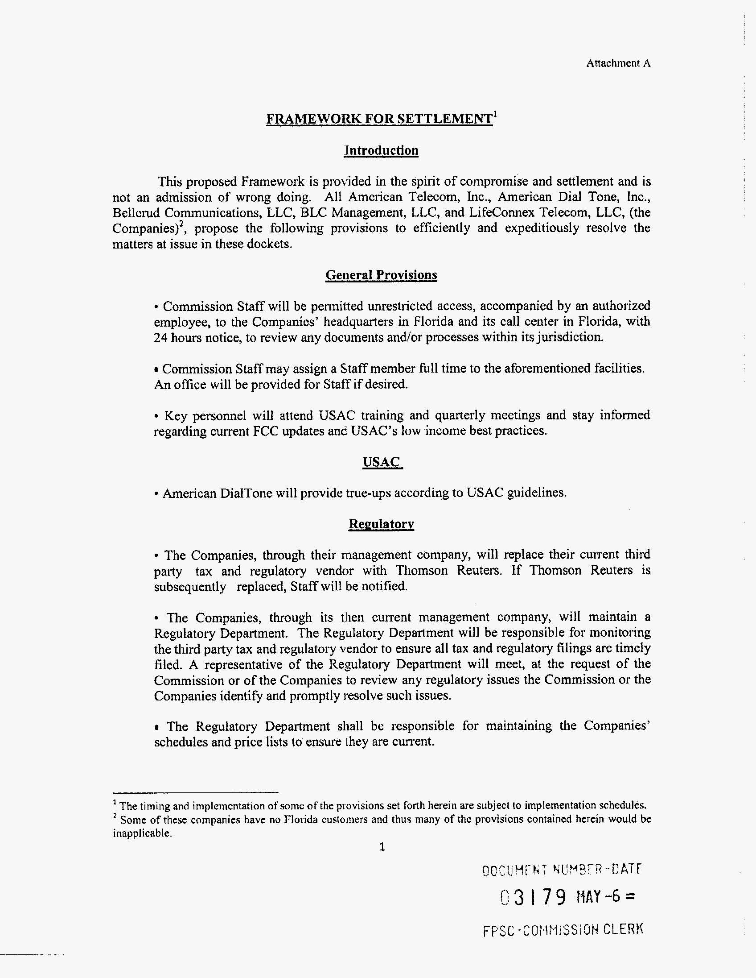
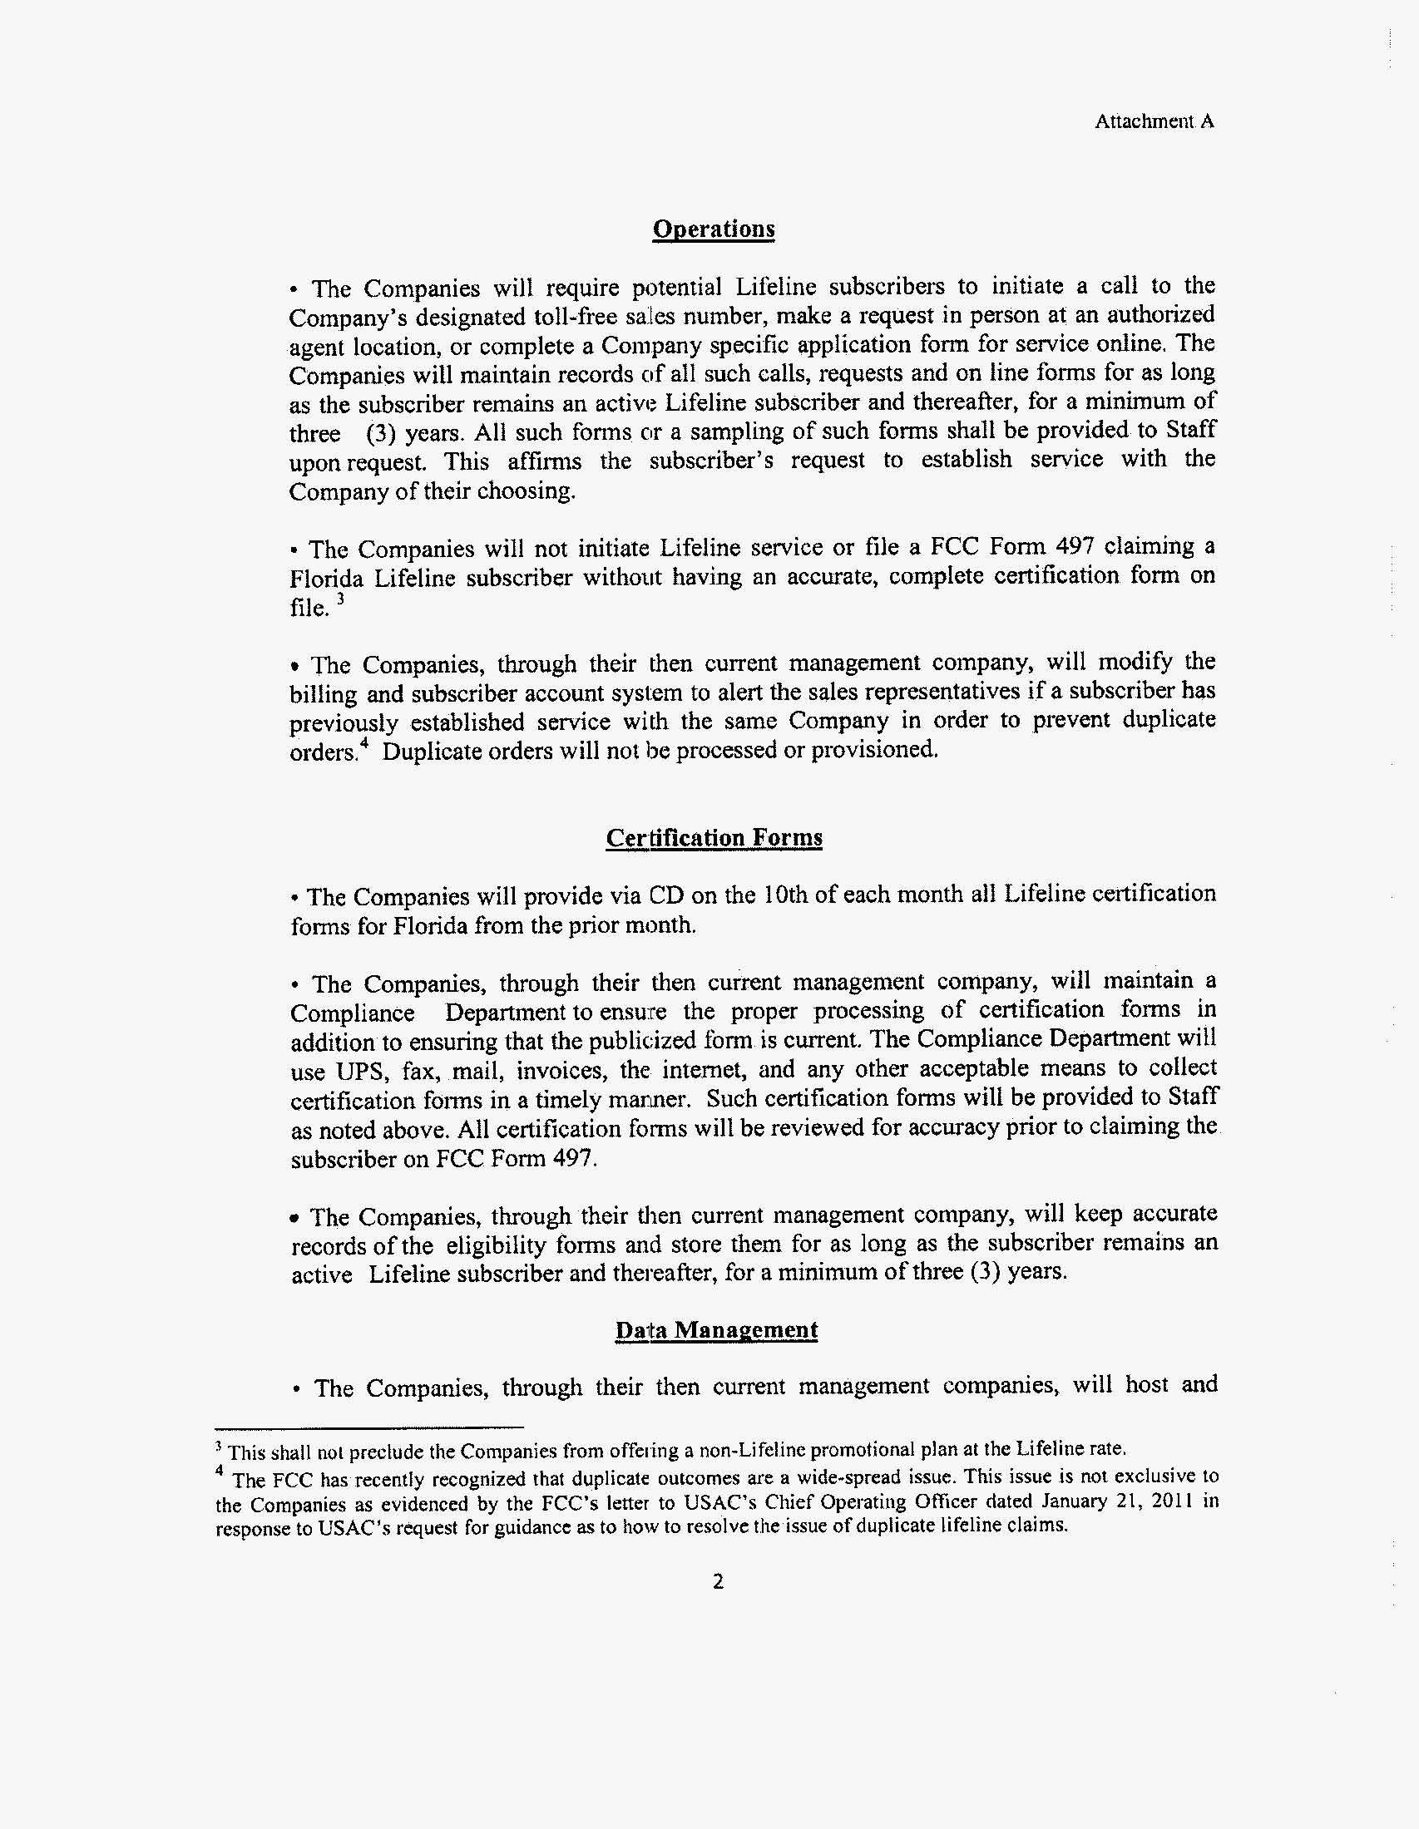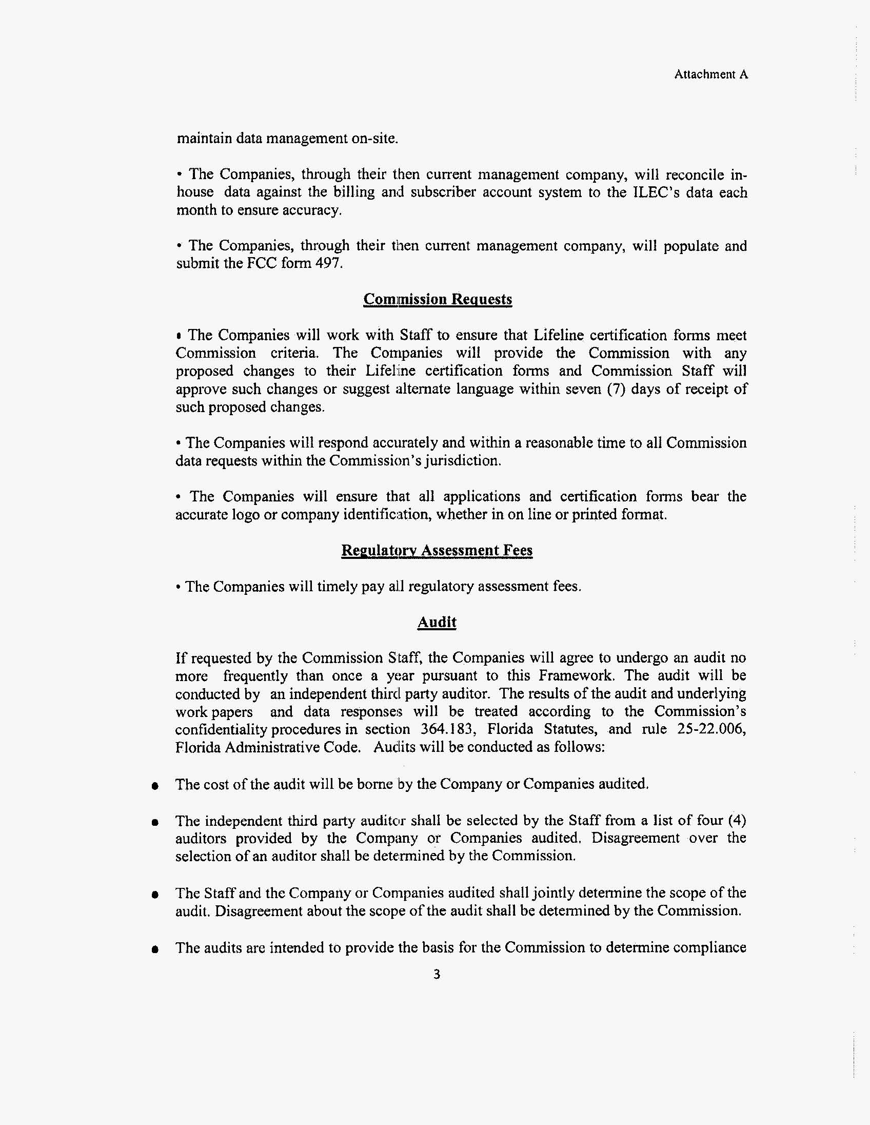
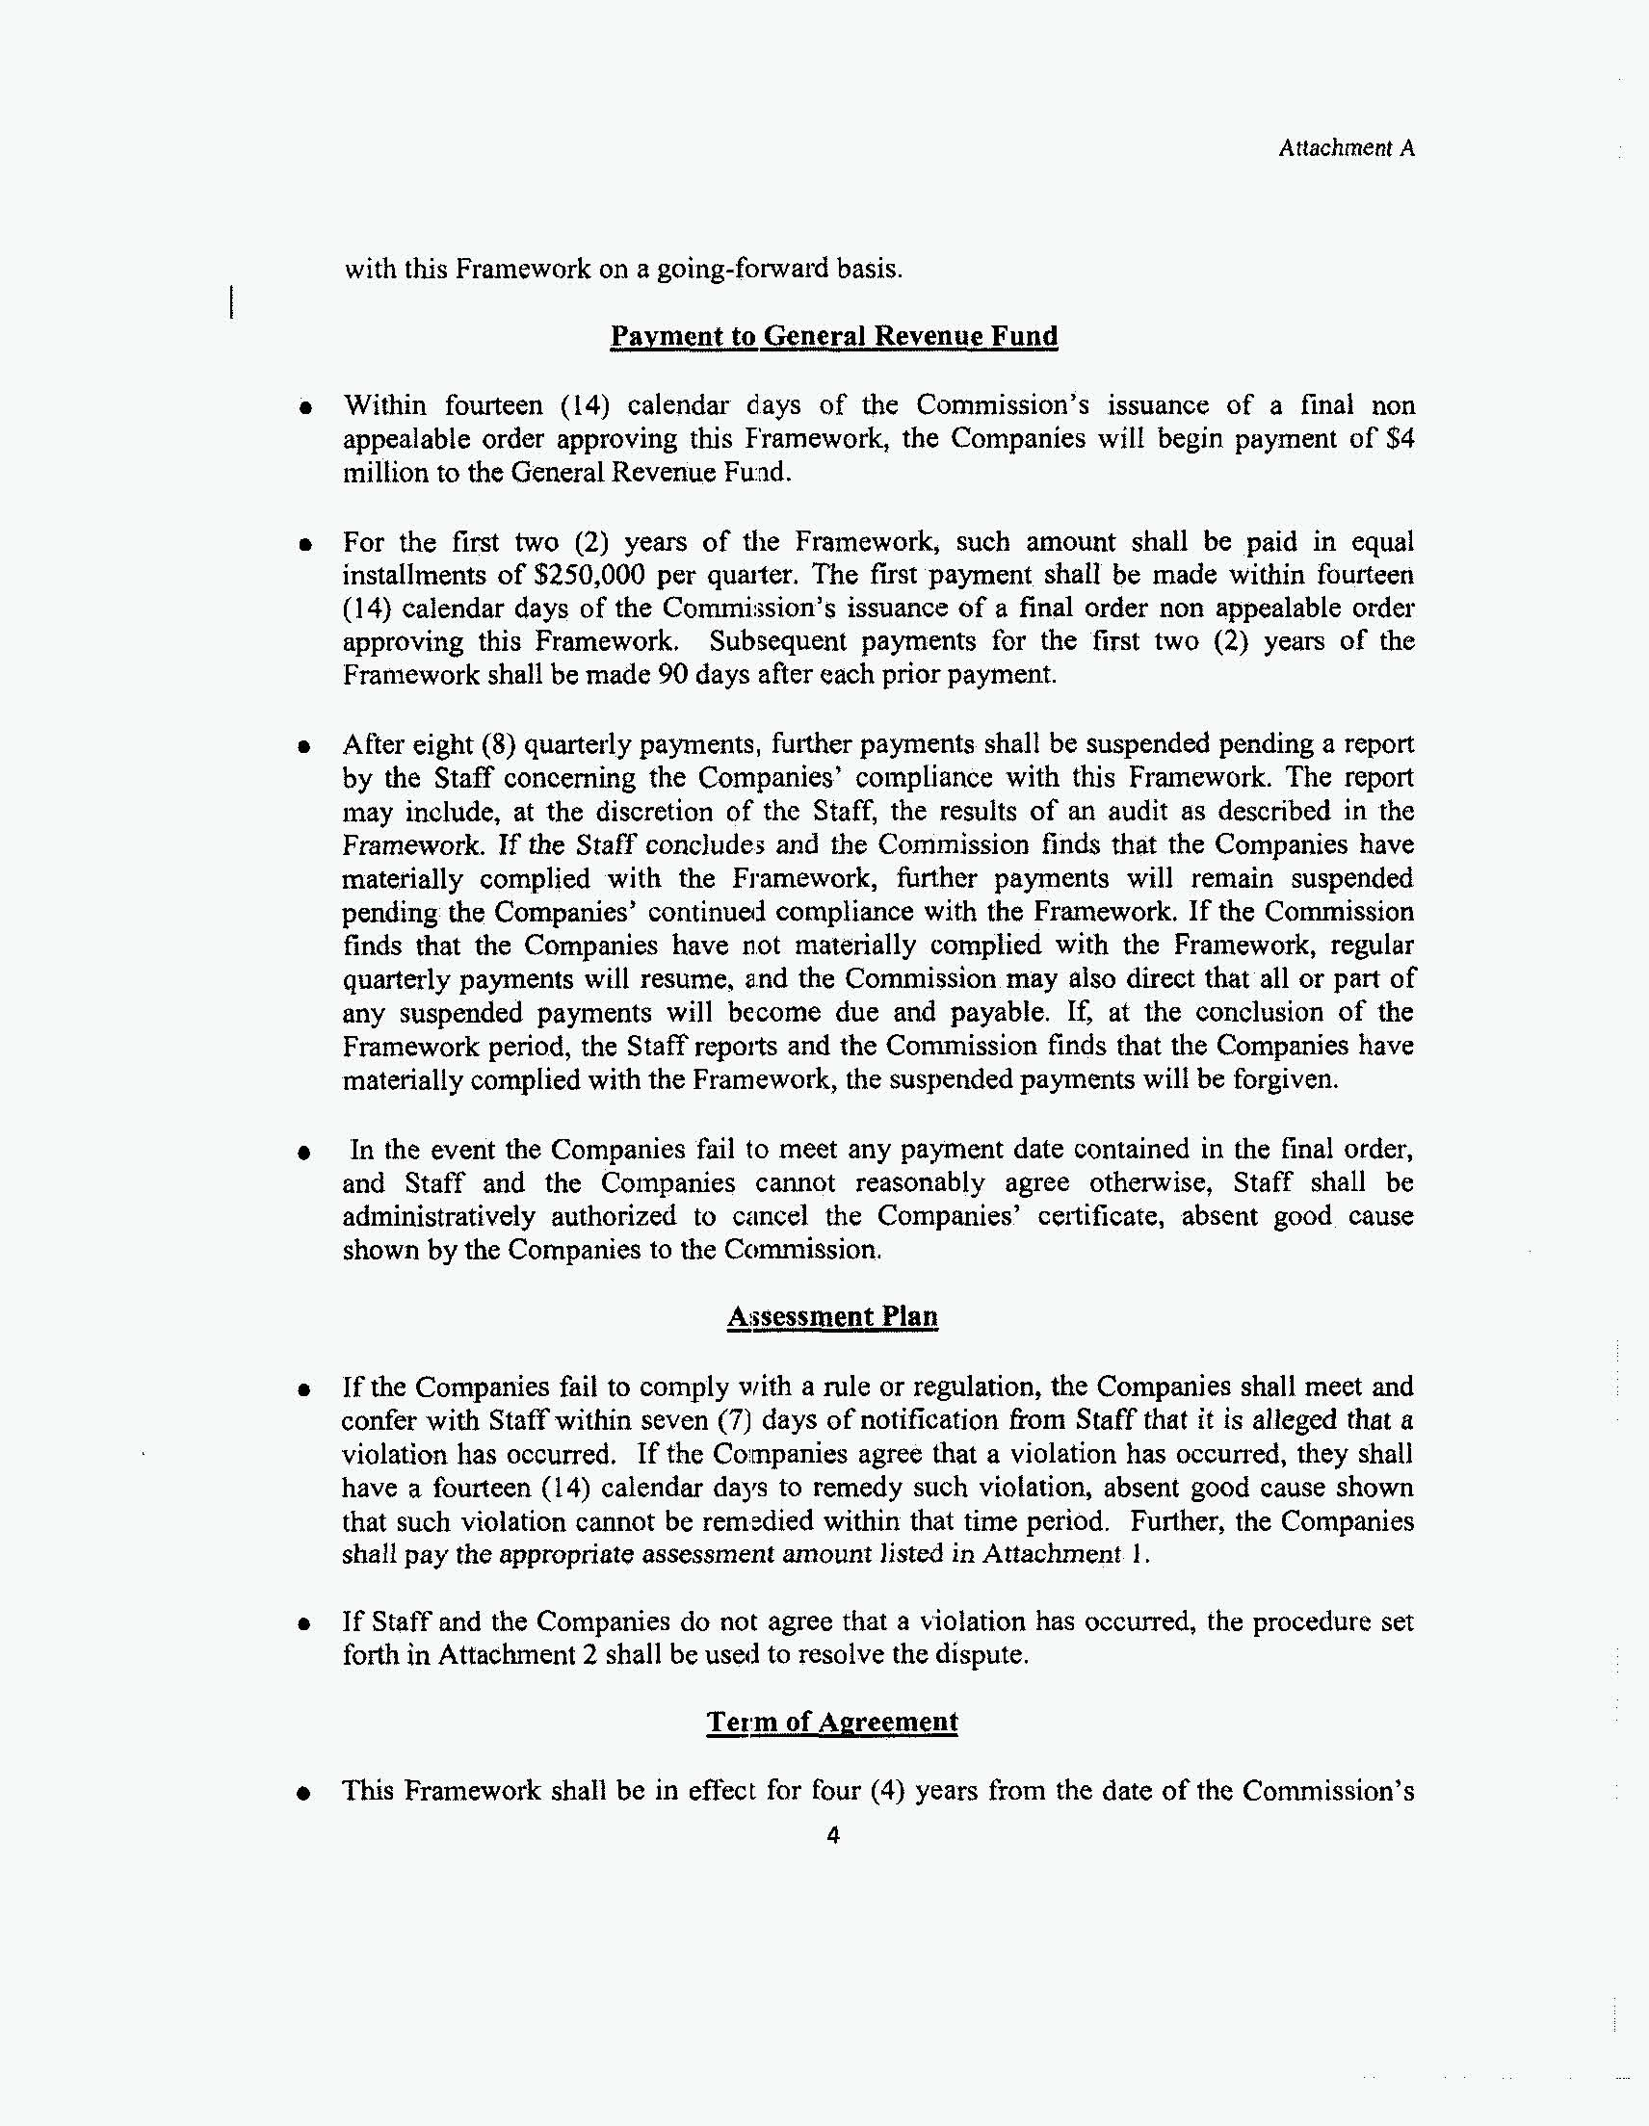
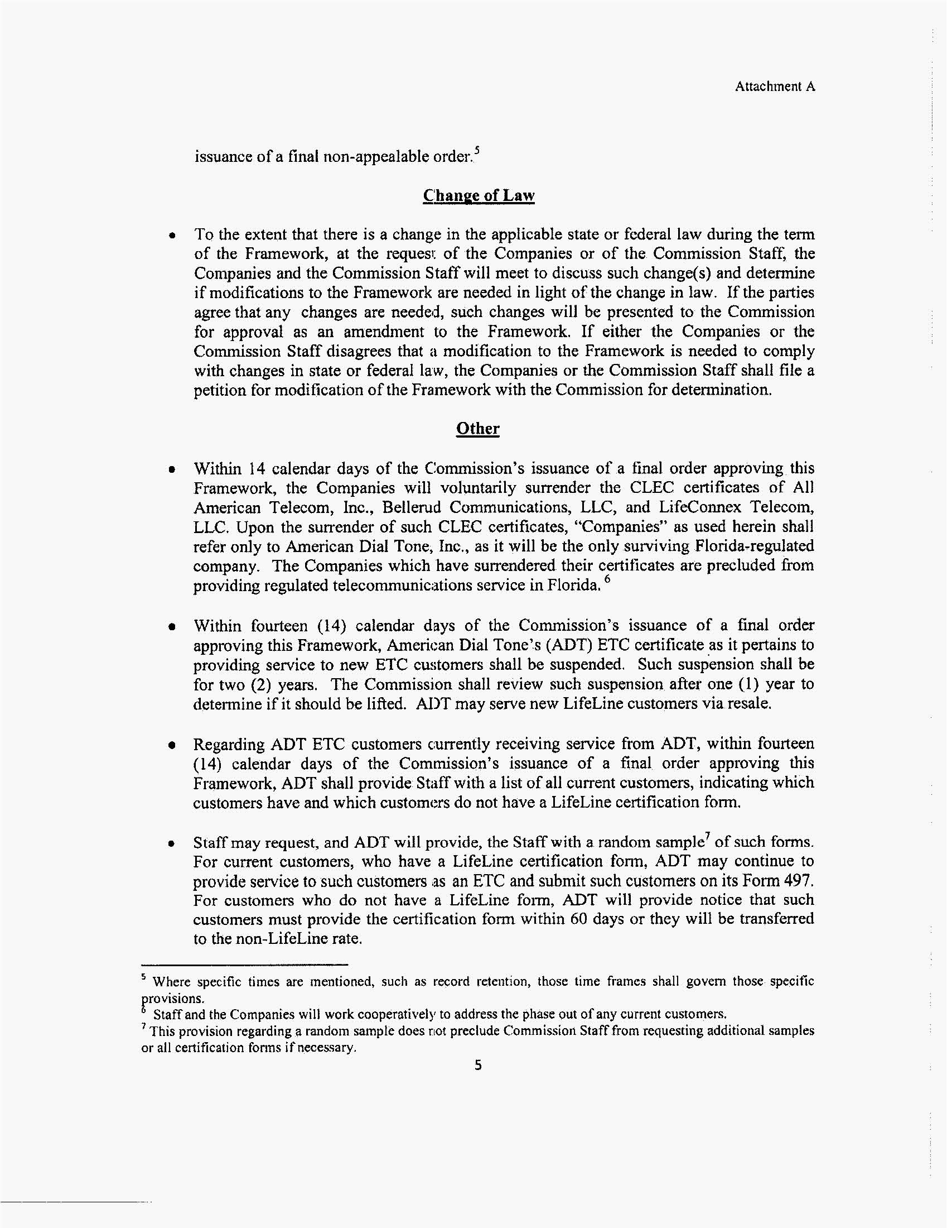
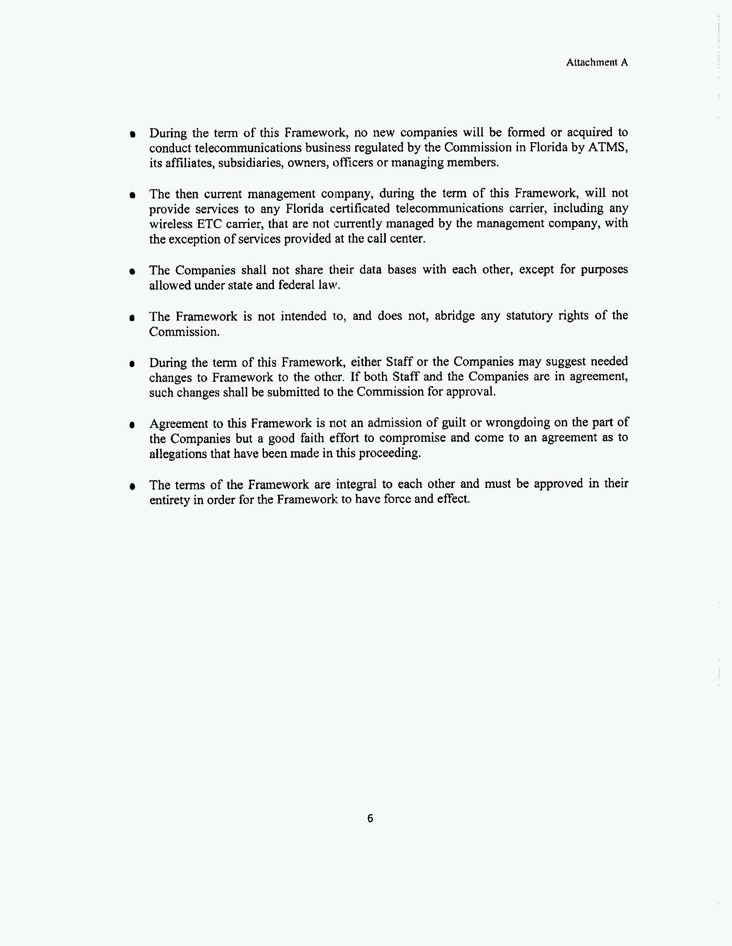
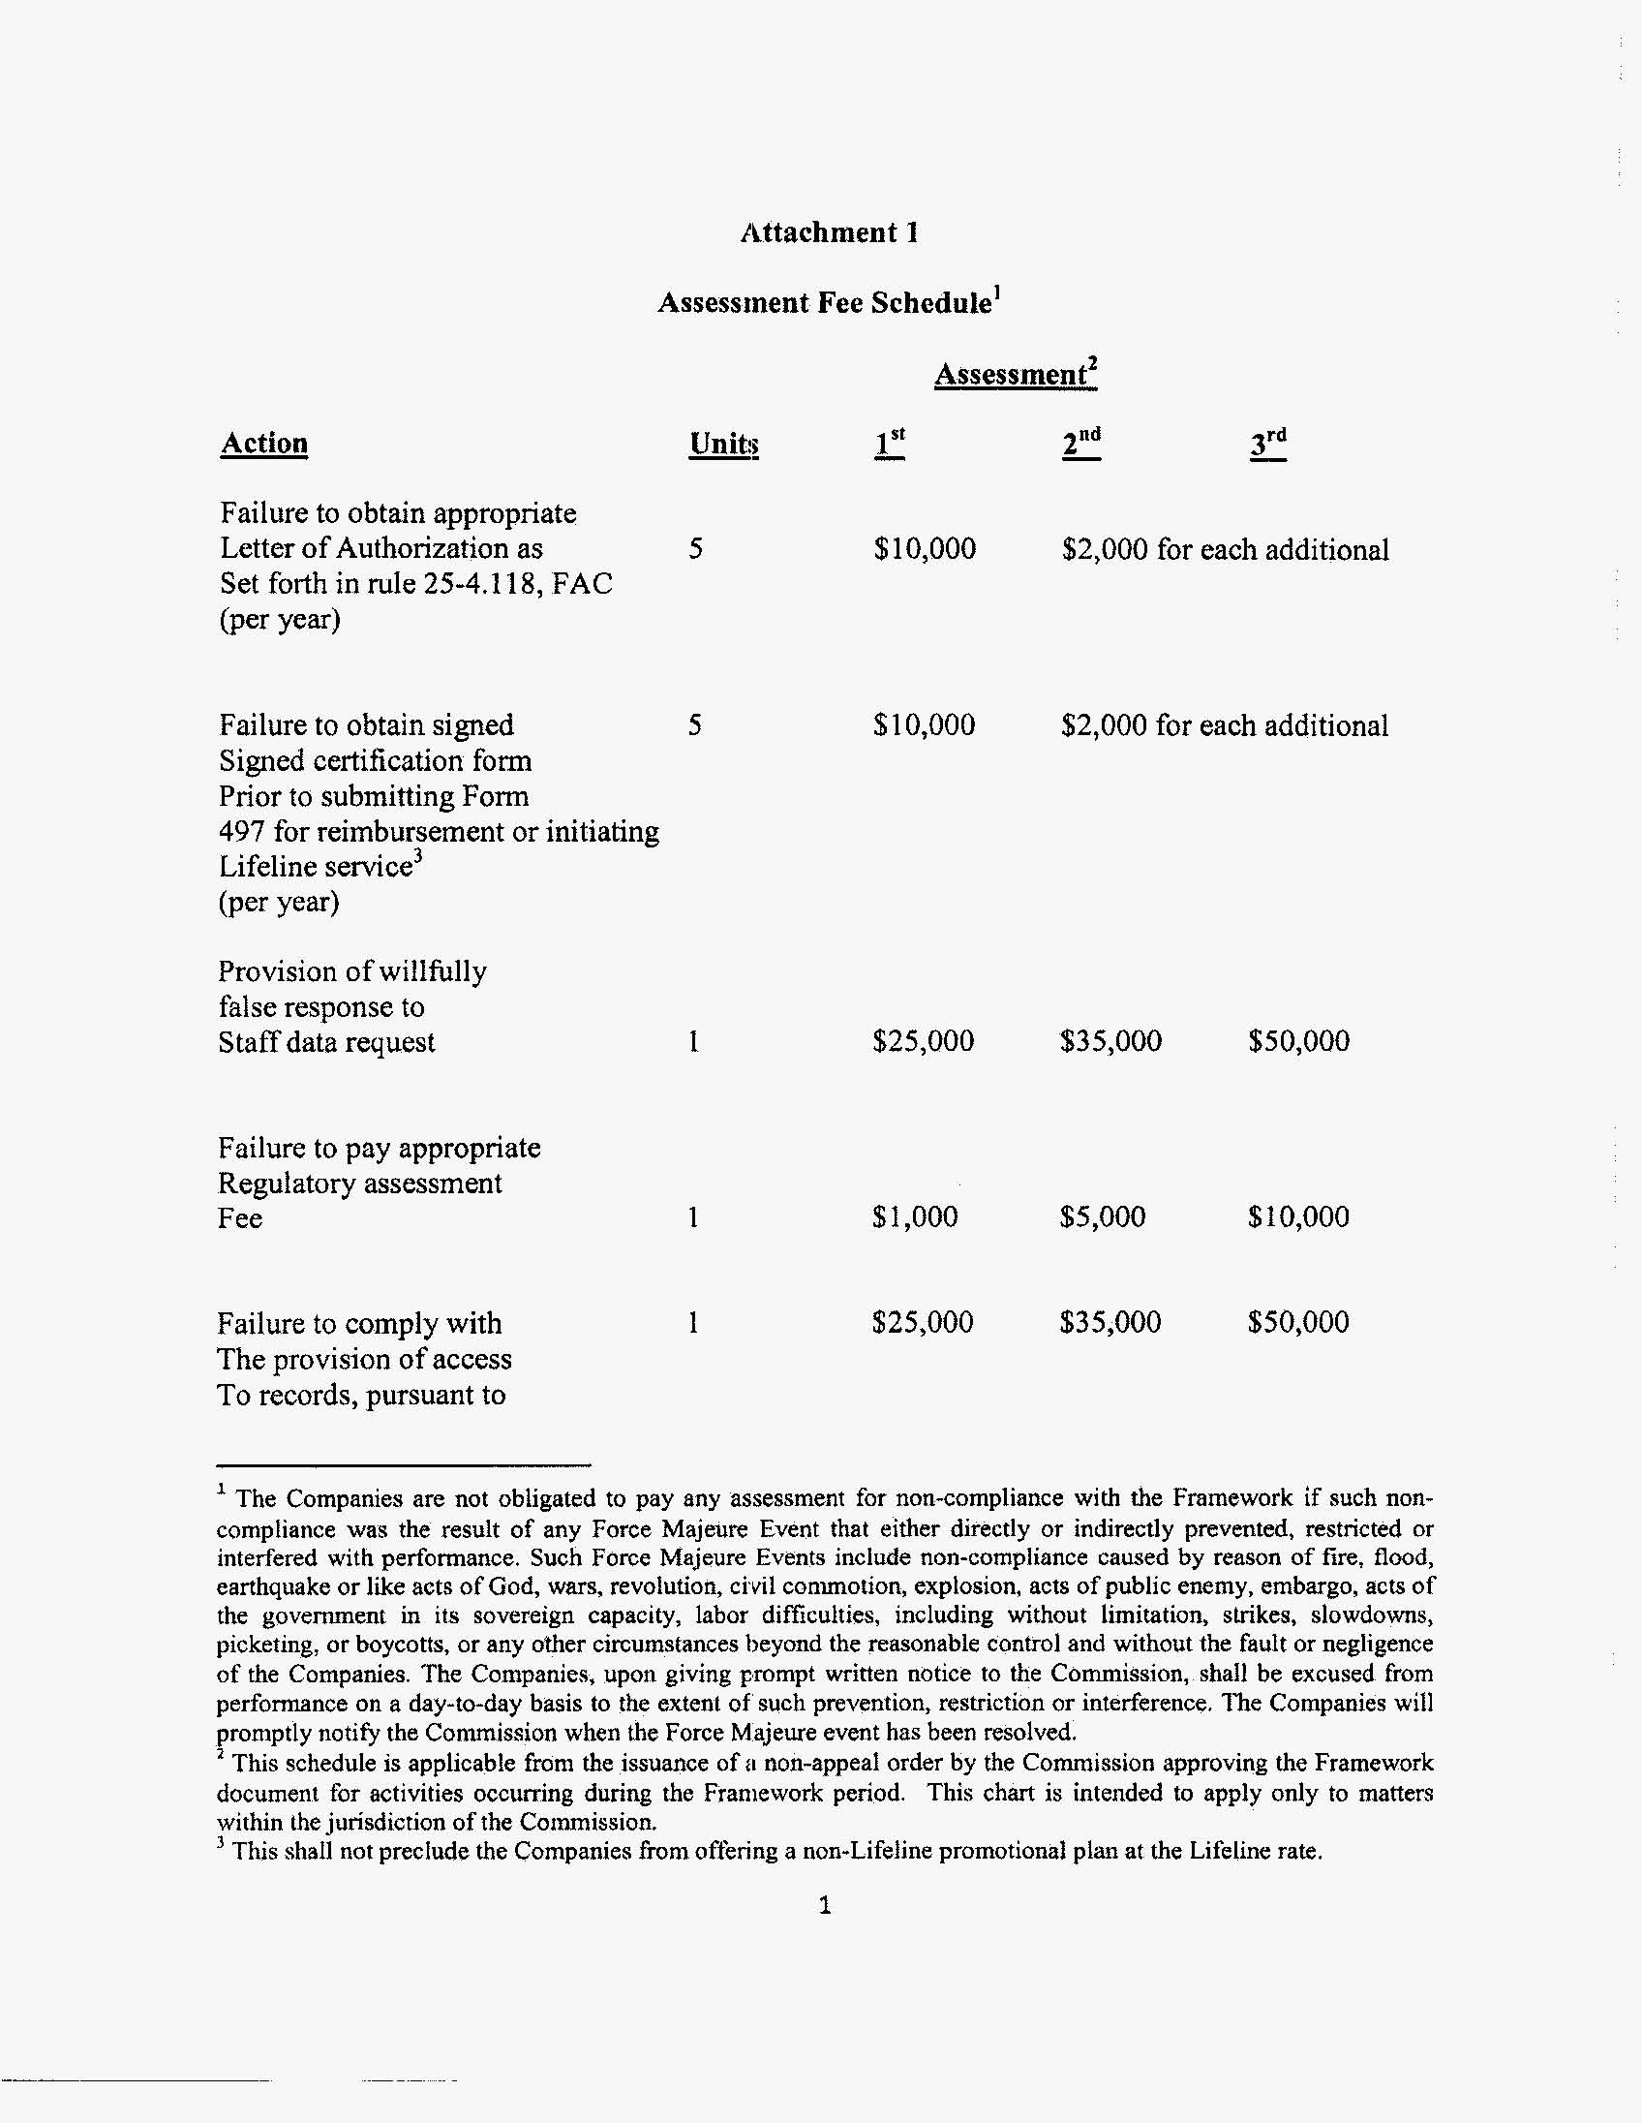
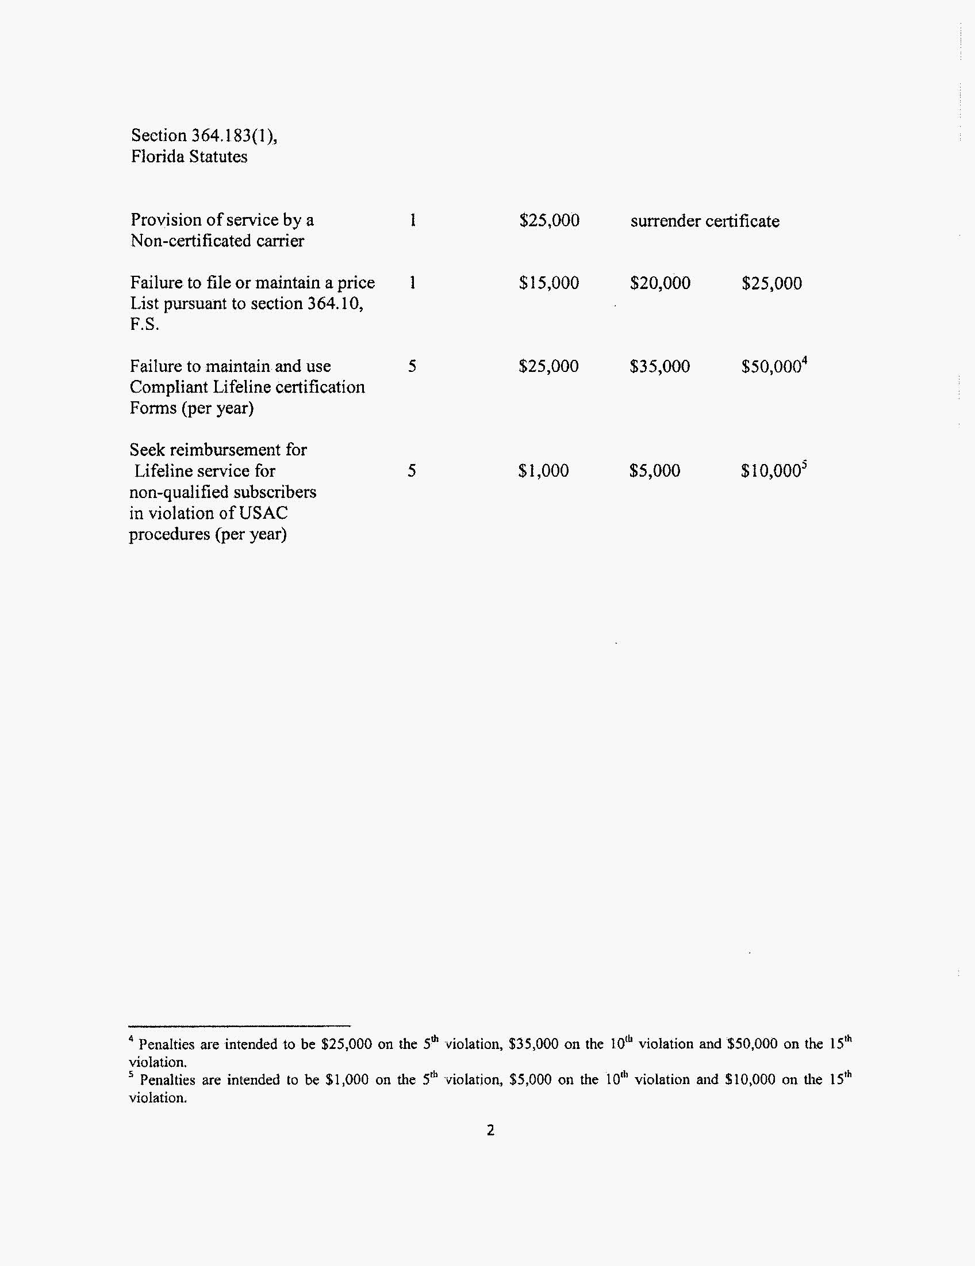
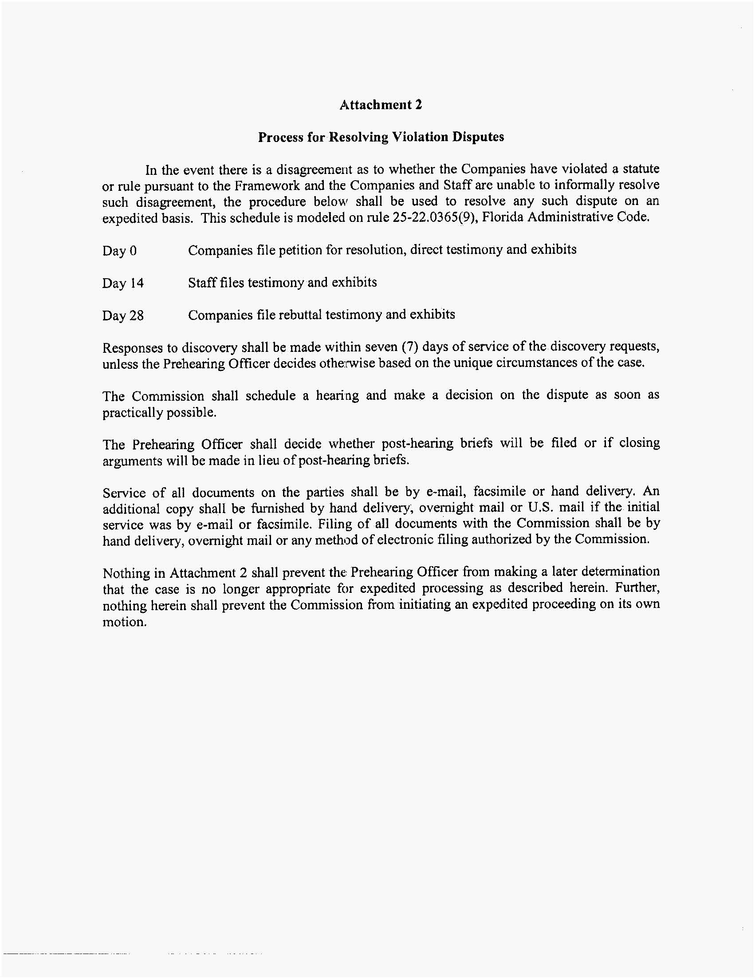

Summary of Staff’s Recommended Show Cause Penalties, by Company.
Violation | American Dial Tone | LifeConnex | BLC Management | Bellerud | All American Telecom | Total
Unauthorized customer moves | $610,000 | $150,000 | $1,160,000 | $0 | $0 | $1,920,000
Multiple ATMS companies providing service to same customer | $2,220,000 | $1,340,000 | $1,270,000 | $20,000 | $0 | $4,850,000
Missing Lifeline certification forms | $3,643,000 | $828,500 | $2,702,000 | $25,000 | $0 | $7,198,500
Senior Citizen Low-Income Discount Plan Qualifier | $1,500 | $2,500 | $500 | $0 | $0 | $4,500
USAC Form 497 | $125,000 | $0 | $0 | $0 | $0 | $125,000
Access to company records | $100,000 | $50,000 | $25,000 | $25,000 | $25,000 | $225,000
Failure to file price list | $25,000 | $25,000 | $25,000 | $25,000 | $0 | $100,000
Providing CLEC service in Florida without a certificate | $0 | $0 | $25,000 | $0 | $0 | $25,000
CPNI | $500,000 | $500,000 | $500,000 | $500,000 | $0 | $2,000,000
 | $7,224,500 | $2,896,000 | $5,707,500 | $595,000 | $25,000 | $16,448,000

2010 Universal Service Monitoring Report, CC Docket No. 98-202.
FCC 11-32, ¶14.
The Universal Service Administrative Company is an independent, not-for-profit corporation designated as the administrator of the federal Universal Service Fund by the Federal Communications Commission.
FCC 11-32, ¶ 14.
The Telecommunications Act of 1996 defines Customer Proprietary Network Information as "information that relates to the quantity, technical configuration, type, destination, location and amount of use of a telecommunications service" that the carrier possesses solely as a result of serving that customer. Customers’ information, compiled from individuals’ telephone calling behaviors, include subscribers personal data, services, amount of usage of services, and calling records. A carrier is allowed to use individual calling records only for purposes such as increasing business or publishing directories, and prohibits a carrier from otherwise disclosing CPNI without express prior authorization by the subscriber. (Order PSC-07-0730-PAA-TL)
Through discovery, staff learned that Triarch Marketing, Inc., Dialtone & More, Inc., Ren-Tel Communications, Inc, and SCTXLink were not conducting business in Florida.
Docket No. 090457-TX, In Re: Petition for designation as an ETC by Bellerud Communications, LLC. Petition withdrawn March 3, 2010. Docket No. 070348-TX, In Re: Amended petition for designation as eligible telecommunications carrier by Swiftel, LLC. Petition withdrawn July 21, 2009. Docket No. 080157-TX, In Re: Application for designation as an eligible telecommunications carrier by BLC Management LLC d/b/a Angles Communications Solutions. Docket closed administratively December 10, 2008. Docket No. 090437-TX, In Re: Petition for designation as eligible telecommunications carrier by All American Telecom, Inc. Petition withdrawn August 5, 2010.
Docket No. 080475-TX, In Re: Compliance investigation of CLEC Certificate No. 8579, issued to BLC Management LLC d/b/a Angles Communication Solutions, for apparent first-time violation of Rule 25-4.0161, F.A.C., Regulatory Assessment Fees; Telecommunications Companies. Order No. PSC-08-0617-CO-TX, issued September 23, 2008.
Recommendation filed June 4, 2009, Document No. 05570-09, Docket No. 070348-TX, Amended petition for designation as eligible telecommunications carrier by Swiftel, LLC n/k/a LifeConnex Telecom, LLC.
As noted in Footnote 6, Ren-Tel Communications and SCTXLink have never been certificated in Florida, and Triarch Marketing withdrew its certificate application in September, 2010.
A complete breakdown of staff’s recommendations regarding apparent violations by company is contained in Attachment 2.
Qwest I, 258 F.3d at 1203; Qwest II, 398 F.3d at 1232.
Qwest I, at 1203.

