State of Florida   |  | Public Service Commission  Capital Circle Office Center ● 2540 Shumard Oak Boulevard  Tallahassee, Florida 32399-0850  -M-E-M-O-R-A-N-D-U-M-
DATE: | July 14, 2011
TO: | Office of Commission Clerk (Cole)
FROM: | Division of Regulatory Analysis (Beard)  Office of the General Counsel (Teitzman)
RE: | Docket No. 090426-TX – Petition for designation as eligible telecommunications carrier (ETC) by Absolute Home Phones, Inc.
AGENDA: | 07/26/11 – Regular Agenda – Proposed Agency Action – Interested Persons May Participate
COMMISSIONERS ASSIGNED: |  |  | All Commissioners
PREHEARING OFFICER: |  |  | Edgar
CRITICAL DATES: |  |  | None
SPECIAL INSTRUCTIONS: |  |  | None
FILE NAME AND LOCATION: |  |  | S:\PSC\RAD\WP\090426.RCM.07-12-11.DOC

Case Background
On September 1, 2009, Absolute Home Phones, Inc. (Absolute) petitioned the Florida Public Service Commission (FPSC or the Commission) for designation as an eligible telecommunications carrier (ETC) throughout the BellSouth Telecommunications, Inc. d/b/a AT&T Florida (AT&T) service area, for the purpose of receiving federal universal service support through Lifeline and Link-Up. The applicant is seeking only low-income support, and is not requesting high-cost support. The applicant intends to provide local exchange and exchange access services in the Designated Service Area using a combination of resale and unbundled network elements, or unbundled network equivalents (UNEs) obtained through interconnection agreements that allow end-to-end switching delivery of calls. Absolute does not seek designation as an ETC in any areas served by rural telephone companies. Absolute is not requesting to provide service in any tribal areas of the State of Florida.
Absolute is a Florida corporation authorized to conduct business as a foreign corporation in the state of Florida and is a competitive local exchange carrier (CLEC) certificated by FPSC. Absolute currently offers service in Arkansas, Florida, North Carolina, and Kentucky. The Absolute website states that it will provide service in the future, in Louisiana, Alabama, Tennessee, and South Carolina. The website also states that Absolute has operating tariffs on file with state regulatory agencies in Alabama, Florida, Georgia, Kentucky, Louisiana, Mississippi, North Carolina, and South Carolina. Absolute has received ETC status in Kentucky, North Carolina and Arkansas. Absolute has pending wireless ETC applications in Georgia and Wisconsin. As of May 2011, Absolute has received funds from the Universal Service Administrative Company (USAC) in North Carolina and Arkansas.
Upon designation as an ETC, Absolute states that it will participate in, and offer Lifeline and Link-Up programs to qualifying low-income consumers and publicize the availability of Lifeline and Link-Up services in a manner reasonably designed to reach those likely to qualify for those services. Absolute offers a local usage plan comparable to the one offered by the incumbent LEC in the service areas for which it seeks designation. Absolute provides to its customers the same ability to remain functional in emergency situations as currently provided by the ILECs to their own customers, including access to a reasonable amount of back-up power, rerouting of traffic around damaged facilities, and the capability of managing traffic spikes resulting from emergency situations. Absolute commits to provide service throughout its proposed ETC-designated service area to all customers making a reasonable request for service.
The Commission has authority under Section 364.10(2), Florida Statutes, to decide a petition by a CLEC seeking designation as an ETC pursuant to 47 C.F.R. § 54.201.
Discussion of Issues
Issue 1:1
Should Absolute be granted landline-only ETC status in the State of Florida?
Recommendation:
Yes. Staff recommends that Absolute be granted landline-only ETC designation in the AT&T wire centers listed in Attachment B of this recommendation for the sole purpose of offering Lifeline discounts to qualifying consumers in Florida. (Beard, Casey)
Staff Analysis:
Under FCC rules, the state commissions have the primary responsibility to designate providers as ETCs. Designation as an ETC is required in order for a provider to be eligible to receive monies directly from the Federal Universal Service Fund (USF). Section 254(e) of the Telecommunications Act of 1996 (Act) provides that “only an eligible telecommunications carrier designated under Section 214(e) shall be eligible to receive specific federal universal service support.” According to Section 214(e)(1), a common carrier designated as an ETC must offer and advertise the services supported by the federal universal service mechanisms throughout a designated service area.
ETC Certification Requirements
CFR Rule 54.201(c), addresses a state commission’s responsibilities related to ETC designation, stating:
Upon request and consistent with the public interest, convenience, and necessity, the state commission may, in the case of an area served by a rural telephone company, and shall, in the case of all other areas, designate more than one common carrier as an eligible telecommunications carrier for a service area designated by the state commission, so long as each additional requesting carrier meets the requirements of paragraph (d) of this section. Before designating an additional eligible telecommunications carrier for an area served by a rural telephone company, the state commission shall find that the designation is in the public interest.
To qualify as an ETC, telecommunications carriers must provide nine services identified in CFR Rule 54.201(d)(1).
- Voice grade access to the public switched network Voice grade access is defined as a functionality that enables a user of telecommunications services to transmit voice communications, including signaling the network that the caller wishes to place a call, and to receive voice communications, including receiving a signal indicating there is an incoming call.
- Local Usage Local usage indicates the amount of minutes of use of exchange service, provided free of charge to end users.
- Dual tone multi-frequency signaling or its functional equivalent Dual tone multi- frequency (DTMF) is a method of signaling that facilitates the transportation of signaling through the network, thus shortening call set-up time.
- Single-party service or its functional equivalent Single party service is telecommunications service that permits users to have exclusive use of a wireline subscriber loop or access line for each call placed, or in the case of wireless telecommunications carriers, which use spectrum shared among users to provide service, a dedicated message path for the length of a user's particular transmission.
(5) Access to emergency services Access to emergency services includes access to services, such as 911 and enhanced 911, provided by local governments or other public safety organizations.
(6) Access to operator services Access to operator services is defined as access to any automatic or live assistance to a consumer to arrange for billing and/or completion, of a telephone call.
(7) Access to interexchange service Access to interexchange service is defined as the use of the loop, as well as that portion of the switch that is paid for by the end user, or the functional equivalent of these network elements in the case of a wireless carrier, necessary to access an interexchange carrier’s network.
(8) Access to directory assistance Access to directory assistance is defined as access to a service that includes, but is not limited to, making available to customers, upon request, information contained in directory listings.
(9) Toll limitation for qualifying low-income consumers Toll limitation or blocking restricts all direct dial toll access.
In addition to providing the above services, ETCs must advertise the availability of such services and the associated charges using media of general distribution.
Additional ETC Certification Requirements
In addition to requiring the above services, the FCC, on March 17, 2005, issued a Report and Order that established additional criteria that all ETC applicants must satisfy in order to be granted ETC status by the FCC. In this Order, the FCC determined that an ETC applicant must also demonstrate:
(1) a commitment and ability to provide the supported services throughout the designated area.
(2) the ability to remain functional in emergency situations.
(3) the ability to satisfy consumer protection and service quality standards.
(4) a provision of local usage comparable to that offered by the incumbent LEC.
(5) an acknowledgement that the applicant may be required by the FCC to provide equal access if all other ETCs in the designated service area relinquish their designations pursuant to Section 214(e)(4) of the Act.
The FCC encouraged states to also adopt these criteria, and the FPSC has done so in Docket No. 010977-TL, In re: State certification of rural telecommunications carriers pursuant to 47 C.F.R. 54.314, by Order No. PSC-05-0824-TL, issued August 15, 2005.
Public Interest Determinations
Under Section 214 of the Act, the FCC and state commissions must determine that an ETC designation is consistent with the public interest, convenience, and necessity for rural areas. They also must consider whether an ETC designation serves the public interest consistent with Section 254 of the Act. Congress did not establish specific criteria to be applied under the public interest tests in Section 214 or Section 254. The public interest benefits of a particular ETC designation must be analyzed in a manner that is consistent with the purposes of the Act itself, including the fundamental goals of preserving and advancing universal service; ensuring the availability of quality telecommunications services at just, reasonable, and affordable rates; and promoting the deployment of advanced telecommunications and information services to all regions of the nation, including rural and high-cost areas. The FPSC has determined that before designating a carrier as an ETC, it should make an affirmative determination that such designation is in the public interest, regardless of whether the applicant seeks designation in an area served by a rural or non-rural carrier.
Beyond the principles detailed in the Act, the FCC and state commissions have used additional factors to analyze whether the designation of an ETC is in the public interest. A rigorous ETC designation process ensures that only fully qualified applicants receive designation as ETCs and that all ETC designees are prepared to serve all customers within the designated service area.
Staff recommends that if there is a future change of company ownership, the new owners should be required to file a petition with the FPSC and make a showing of public interest to maintain the company’s ETC designation. This will ensure that only carriers that are financially viable, likely to remain in the market, willing and able to provide supported services throughout the designated service area, and able to provide an evolving level of universal service are designated as ETCs.
Transitional Lifeline
Transitional Lifeline requires that ETCs offer discounted residential basic local telecommunications service at 70 percent of the residential local telecommunications service rate for any Lifeline subscriber who no longer qualifies for Lifeline. A Lifeline subscriber who requests such services receives the discounted price for a period of one year after the date the subscriber ceases to be qualified for Lifeline. Absolute stated in its response to Staff’s Data Request No. 18, that it understood that Florida’s Lifeline program provides that if a Lifeline customer is no longer eligible for Lifeline, that the ETC must provide a 30 percent monthly discount off its local rate to that customer for a period of 12 months at the ETCs expense.
Lifeline Advertising
In Staff Data Request response No. 27, when Absolute was asked to provide examples on how Absolute would advertise its Lifeline Service offerings in Florida, Absolute responded with specific plans for advertising for the first six months after receiving ETC status in Florida. Absolute will be running a direct mail campaign with post cards, yellow page ads, TV commercials and website advertising as required by Section 214(e)(1)(B) of the Act.
Facilities Requirement
In accordance with 47 C.F.R. 54.201(d)(1), a company must offer the services that are supported by the federal universal service support mechanisms either using its own facilities or a combination of its own facilities and resale of another carrier’s services. On page three of its petition, Absolute states that it intends to offer all of the supported services enumerated under Section 254(c) of the Act using facilities obtained as unbundled network equivalents (UNEs). Section 54.201, C.F.R., states that the term “own facilities” includes a facilities obtained as unbundled network elements.
Rule 25-4.0665(20), Florida Administrative Code, requires ETCs offering Link-Up and Lifeline service to submit quarterly reports to the Commission, no later than 30 days following the ending of each quarter. The quarterly reports must include the following data:
- The number of Lifeline subscribers, excluding resold Lifeline subscribers, for each month during the quarter.
- The number of subscribers who received Link-Up for each month during the quarter.
- The number of Lifeline subscribers added each month during the quarter.
- The number of transitional Lifeline subscribers who received discounted service for each month during the quarter.
- The number of residential access lines with Lifeline service that were resold to other carriers each month during the quarter.
Staff recommends that if Absolute is approved for ETC status, the Commission should also require Absolute to submit the number of UNEs purchased from AT&T for each month during the quarter when it files its quarterly reports. This will allow staff to confirm that Absolute is following FCC rules which require that an ETC must offer the services that are supported by the federal universal support mechanisms either using its own facilities or a combination of its own facilities and resale of another carrier’s services.
Absolute’s Petition
Absolute is requesting that it be granted landline-only ETC status throughout the non-rural AT&T wire centers listed in Attachment B, for the purpose of receiving federal universal service support. Absolute maintains that it is only seeking low-income support, and it is not requesting high-cost support from the federal USF. Absolute’s purpose in requesting ETC status in Florida is to provide Lifeline and Link-Up services over landline access lines.
Absolute has acknowledged the requirements of the Florida Lifeline program, and it has agreed to adhere to the program which provides qualified consumers a total of $13.50 in Lifeline assistance credits consisting of: $6.50 in federal subscriber line charges, $1.75 in federal support for states that have approved the credit, and $1.75 in federal support for states that have approved the credit, and $1.75 which is a 50 percent match of federal support for having a state Lifeline program requiring a $3.50 credit under the Florida eligibility criteria. Absolute indicates that it will provide for the $3.50 credit to qualified clients, advertise the availability of Lifeline, and begin offering these services within 30 days of receiving ETC status.
Absolute states that it can provide local exchange and exchange access services using a combination of resale and UNEs. Federal rules do not require companies to lease UNEs prior to ETC designation. However, Federal rules do require that ETCs provide local exchange and exchange access services using a combination of resale and UNEs prior to requesting reimbursement from the USF.
Absolute has also indicated that its accounts with the FCC and USAC are current, and it is not aware of any outstanding complaints or violations with either entity. As part of the petition process, Absolute has agreed to abide by the Commission’s rules pertaining to the Lifeline and Link-Up programs. Absolute commits to use federal universal service support only for the provision of services for which the support is intended.
Conclusion
Based on staff’s review, along with Absolute’s commitment to abide by both state and federal rules and procedures (See Attachment A), staff believes that Absolute’s petition for landline ETC status is in the public interest and should be approved. If Absolute should decide in the future to seek High Cost universal service funds, or ETC status in rural areas, it should be required to file a petition and make a showing that it would be in the public interest to grant such a request. Upon a decision by the Commission, staff will continue the necessary oversight to ensure that Absolute, along with other ETCs in Florida, are upholding these principles and attaining the goals and objectives of both the state and federal universal service programs. Therefore, staff recommends that Absolute be granted landline-only ETC designation in the AT&T wire centers listed in Attachment B of this recommendation for the sole purpose of offering Lifeline discounts to qualifying consumers in Florida.
Issue 2:2
Should this docket be closed?
Recommendation:
Yes. If no person whose substantial interests are affected files a protest to the Commission’s Proposed Agency Action within 21 days of the issuance of the Commission Order, this docket should be closed upon issuance of a Consummating Order. (Teitzman)
Staff Analysis:
If no person who substantial interests are affected files a protest to the Commission’s Proposed Agency Action within 21 days of the issuance of the Commission Order, this docket should be closed upon issuance of a Consummating Order.
Attachment A
Attachment A
Attachment B

Attachment B

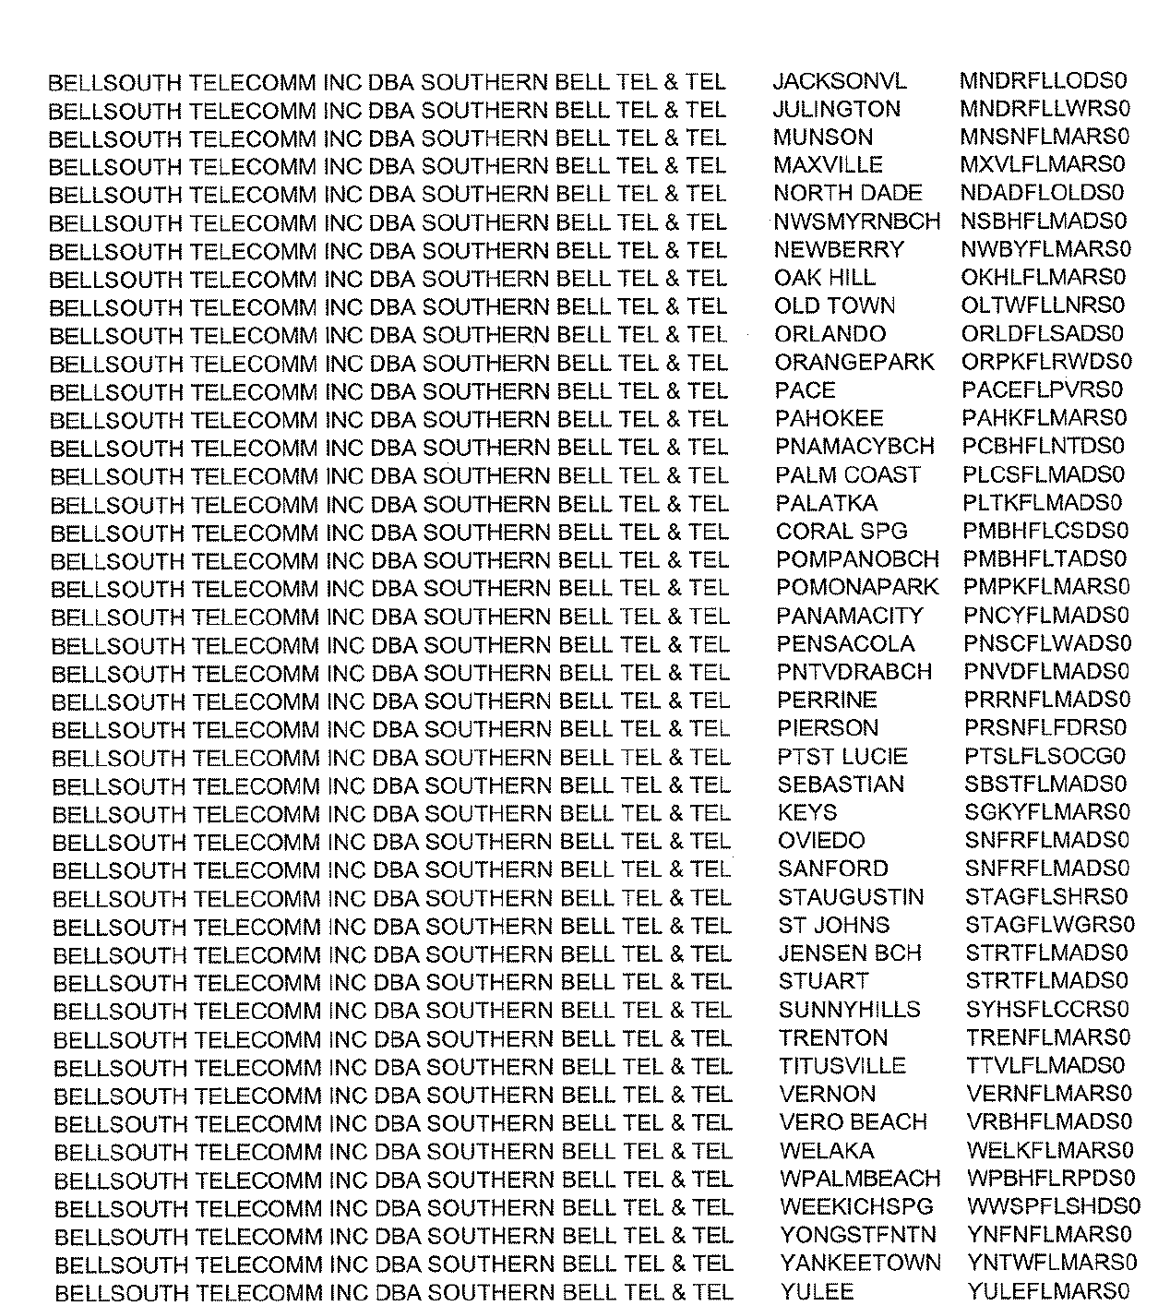

In RE: Application for certificate to provide competitive local exchange telecommunications service by Absolute Home Phones, Inc., PSC-09-0584-CO-TX, issued August 31, 2009, in Docket 090316-TX.
47 U.S.C. § 214(e)(2), 47 C.F.R. § 54.201(b)
47 U.S.C. § 254 of the 1996 Telecom Act
47 U.S.C. § 254(e)(2)
47 C.F.R. § 54.201(c)
In the Matter of Federal-State Joint Board on Universal Service, CC Docket No. 96-45, Order FCC 05-46, Adopted: February 25, 2005, Released: March 17, 2005.
? In the Matter of Federal-State Joint Board on Universal Service, CC Docket No. 96-45, Order FCC 05-46 (¶40), Adopted: February 25, 2005 Released: March 17, 2005.
See Docket No. 100124-TX, In RE: Petition for designation as eligible telecommunications carrier by Sun-Tel USA, Inc., Order No. PSC-10-0634-PAA-TX, issued October 25, 2010.

