State of Florida   |  | Public Service Commission  Capital Circle Office Center ● 2540 Shumard Oak Boulevard  Tallahassee, Florida 32399-0850  -M-E-M-O-R-A-N-D-U-M-
DATE: | September 22, 2011
TO: | Office of Commission Clerk (Cole)
FROM: | Office of the General Counsel (Brown)  Division of Economic Regulation (Rieger)
RE: | Docket No. 110099-EU – Joint petition for approval of territorial agreement in Bradford County by Florida Power & Light Company and City of Starke.
AGENDA: | 10/04/11 – Regular Agenda – Interested Persons May Participate
COMMISSIONERS ASSIGNED: |  |  | All Commissioners
PREHEARING OFFICER: |  |  | Edgar
CRITICAL DATES: |  |  | None
SPECIAL INSTRUCTIONS: |  |  | None
FILE NAME AND LOCATION: |  |  | S:\PSC\GCL\WP\110099.RCM.DOC

Case Background
On April 12, 2011, Florida Power & Light Company (FPL) and the City of Starke, Florida (City) filled a joint petition for approval of a territorial agreement. The joint petition requests the establishment of a service territory boundary between the two utilities in Bradford County. The agreement will result in the transfer of 86 customer accounts and related distribution facilities between the parties. This is the first territorial agreement between these two parties.
This recommendation addresses the parties’ joint petition for approval of the territorial agreement. The Commission has jurisdiction over the matter pursuant to Section 366.04, Florida Statutes (F.S.).
Discussion of Issues
Issue 1: Should the Commission approve the proposed territorial agreement between FPL and the City?
Recommendation: Yes. The proposed territorial agreement attached as Attachment A is in the public interest and should be approved by the Commission. The Commission should direct the parties to file status reports on the transfer of customers every six months until the transfer is complete. (Rieger)
Staff Analysis: On April 12, 2011, FPL and the City filed a joint petition for approval of a territorial agreement. The petition states that the parties initially entered into an agreement on February 27, 2009. The parties did not seek Commission approval of the initial agreement until all necessary filing requirements, including obtaining a legal description of the territorial boundaries, were satisfied. The parties stated that by the time those requirements were satisfied, the list of affected customers referenced in the initial agreement needed to be updated because of customers relocating in and out of the respective service territories. As a result, the parties decided to enter into a restated agreement instead of creating an addendum to the original agreement. FPL and the City entered into a restated territorial agreement on March 21, 2011. The restated territorial agreement was attached to the petition as Exhibit 1, and is attached here as Attachment A.
The agreement establishes a geographic boundary between the two utilities, which was depicted on the maps attached to the agreement as Composite Appendix A. The map also includes a legal description of the proposed boundary line. Staff would point out that this territorial agreement relates to a similar agreement between the City and Clay Electric Cooperative (Clay). In that agreement, a territorial boundary was established between the City and Clay that encompasses some of the same geographical areas. In its Order approving the agreement, the Commission noted that FPL had been apprised of the territorial agreement and did not object to it. The Commission also noted that FPL and the City were in the process of negotiating a territorial agreement. Clay has been apprised of this territorial agreement, and it does not have any objections to it.
The restated territorial agreement addresses the transfer of a total of 86 customer accounts between the parties. Under the agreement, 20 customer accounts (15 residential and 5 commercial) will be transferred from the City to FPL and 66 accounts (54 residential and 12 commercial) will be transferred from FPL to the City. Written notice to all affected customers has been made, as required by Rule 25-6.0440(1)(d), Florida Administrative Code (F.A.C.). The petition states that 6 City customers responded that they were not opposed to the transfer, while 12 FPL customers responded to the proposal, 11 of whom were opposed to the transfer.
The petition states that the transfer of customers will be completed within two years of the Commission approval of the agreement. In response to staff’s data request, the parties indicated that a transfer schedule will be established once the Commission makes a ruling on the petition. In addition, both parties stated that they will work with all affected customers regarding deposits, so that all applicable deposit policies are followed and that the customers suffer no hardship as a result of the transfer.
Pursuant to Section 366.04(2)(d), F.S., the Commission has the jurisdiction to approve territorial agreements between and among rural electric cooperatives, municipal electric utilities, and other electric utilities. Pursuant to Rule 25-6.0440(2), F.A.C., in approving territorial agreements, the Commission may consider the reasonableness of the purchase price of any facilities being transferred, the likelihood that the agreement will not cause a decrease in the reliability of electric service to existing or future ratepayers, and the likelihood that the agreement will eliminate existing or potential uneconomic duplication of facilities. Unless the Commission determines that the agreement will cause a detriment to the public interest, the agreement should be approved. Utilities Commission of the City of New Smyrna v. Florida Public Service Commission, 469 So. 2d 731 (Fla. 1985).
According to the applicants, the proposed territorial agreement eliminates existing or potential uneconomic duplication of facilities, does not cause a decrease in the reliability of electric service to existing or future ratepayers, will not occur at any significant cost, and prevents wasteful expenditures by the parties. Based on all of the above, staff recommends that the proposed territorial agreement is in the public interest and should be approved. Since the agreement contemplates the transfer of customers over a two year period, staff also recommends that the Commission direct the parties to file status reports on the transfers every six months until the transfers are complete.

Issue 2: Should this docket be closed?
Recommendation: Yes. If no person whose interests are substantially affected timely files a protest to the Commission’s proposed agency action order, this docket should be closed upon issuance of a consummating order. (Brown)
Staff Analysis: If no person whose interests are substantially affected timely files a protest to the Commission’s proposed agency action order, this docket should be closed upon issuance of a consummating order.
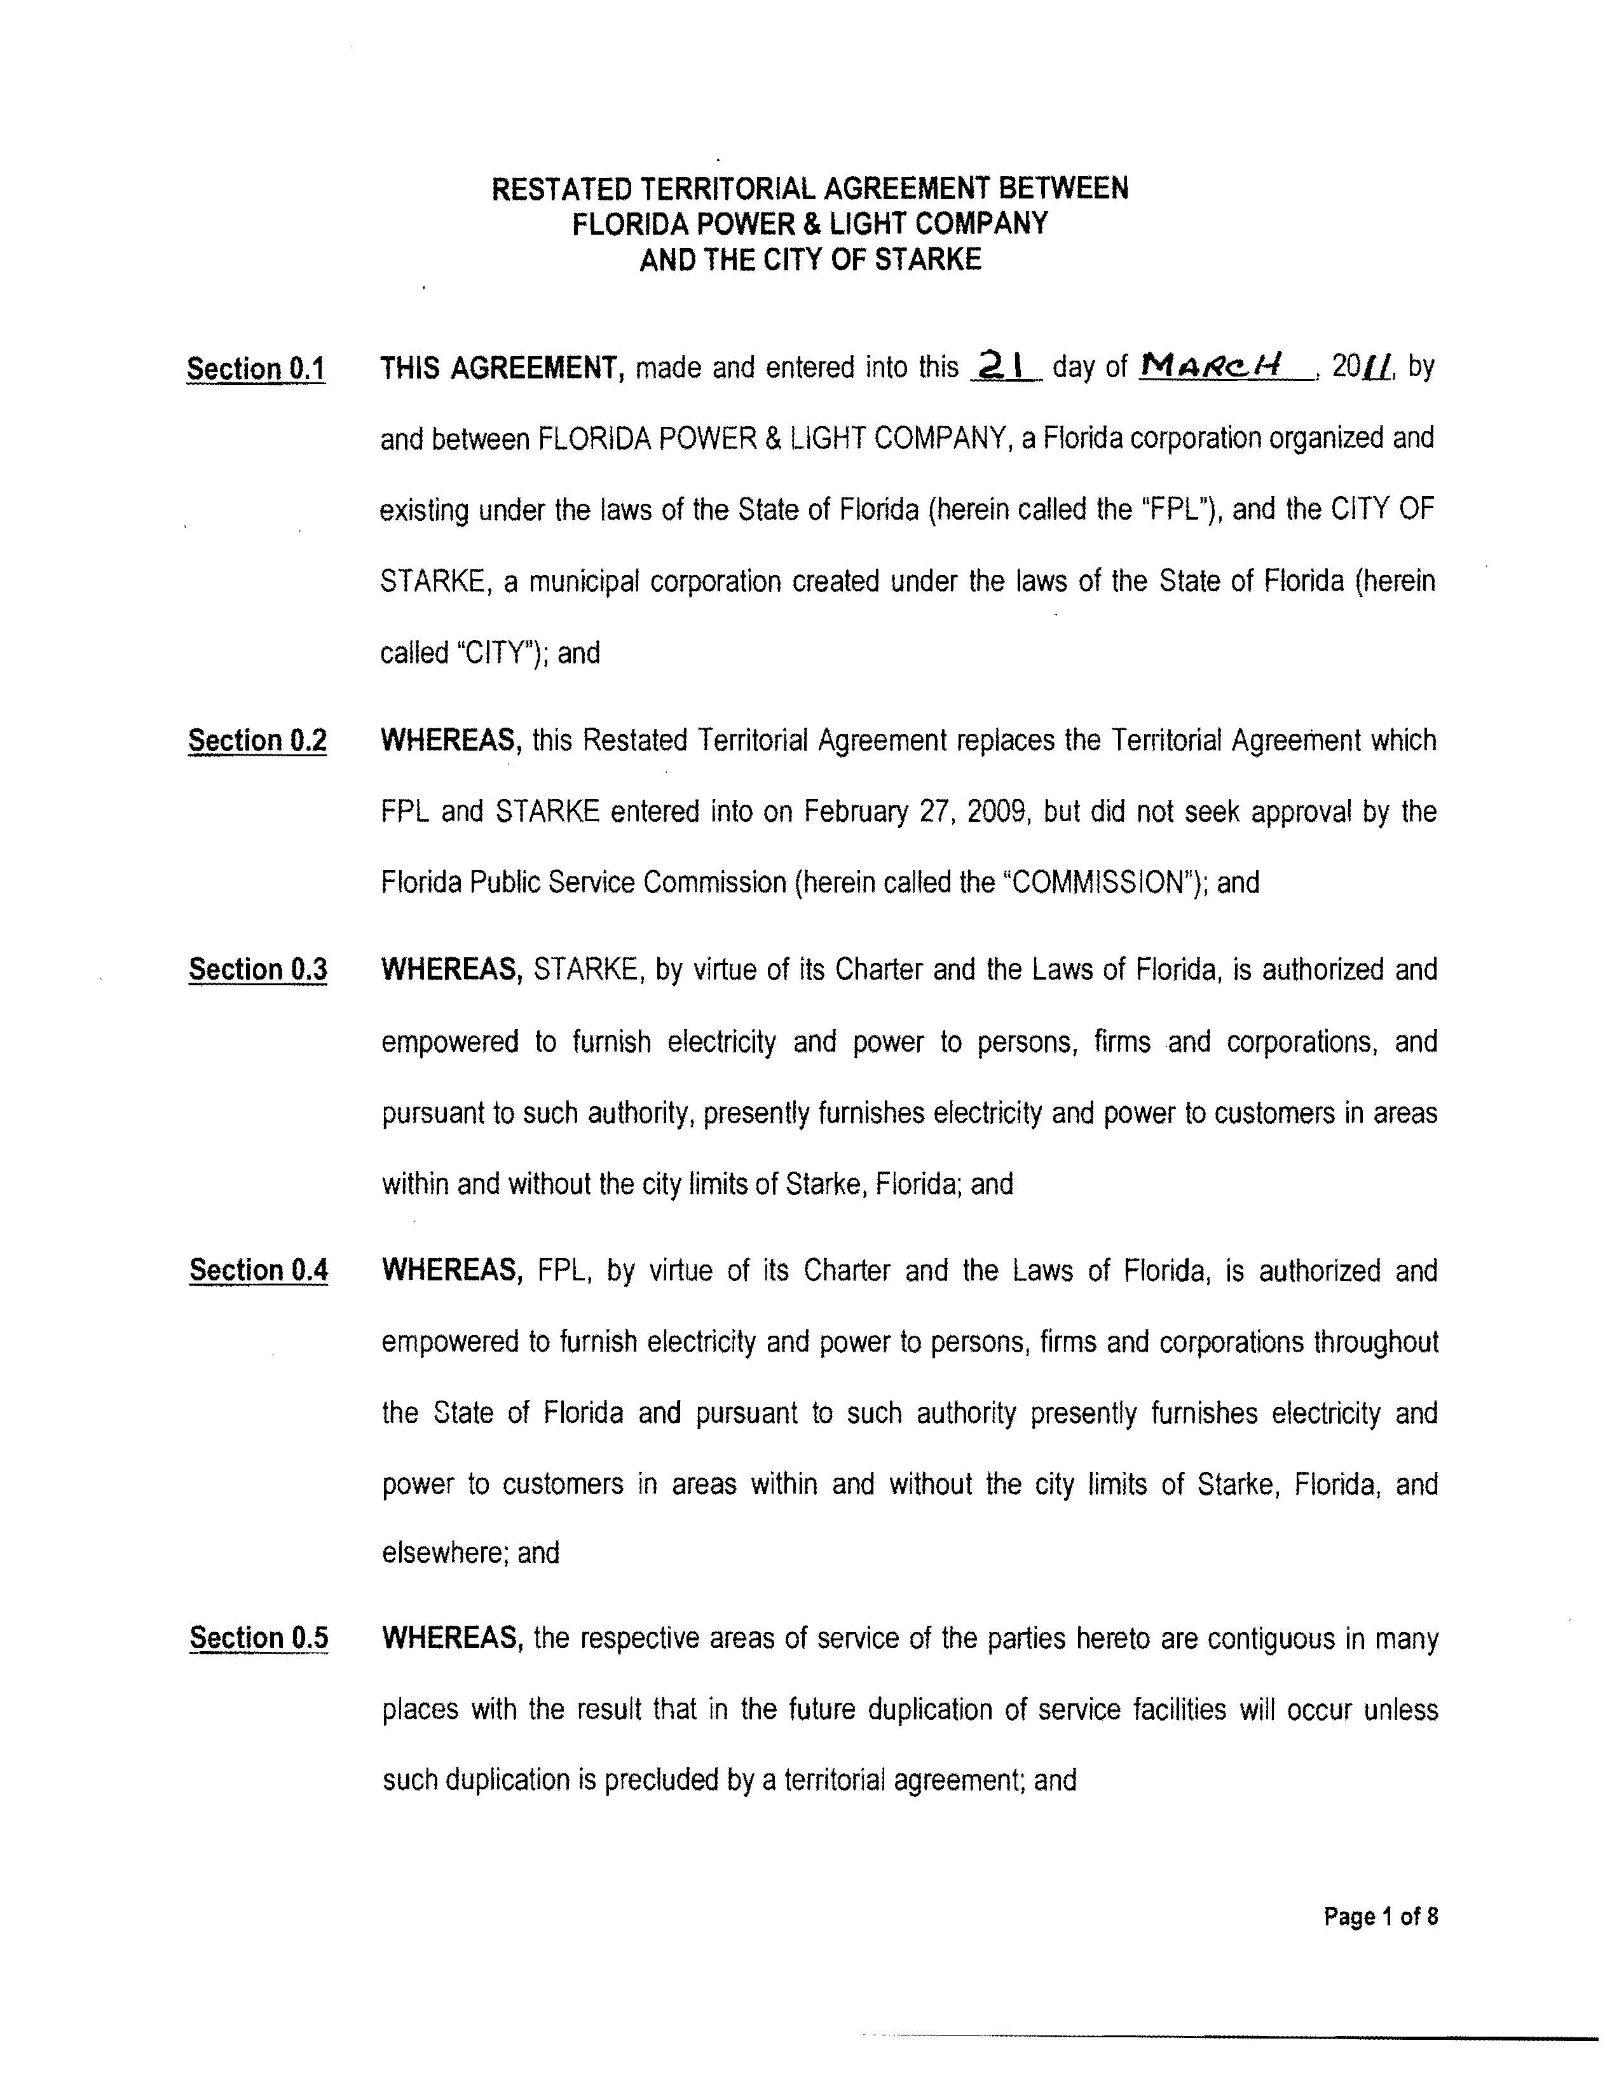
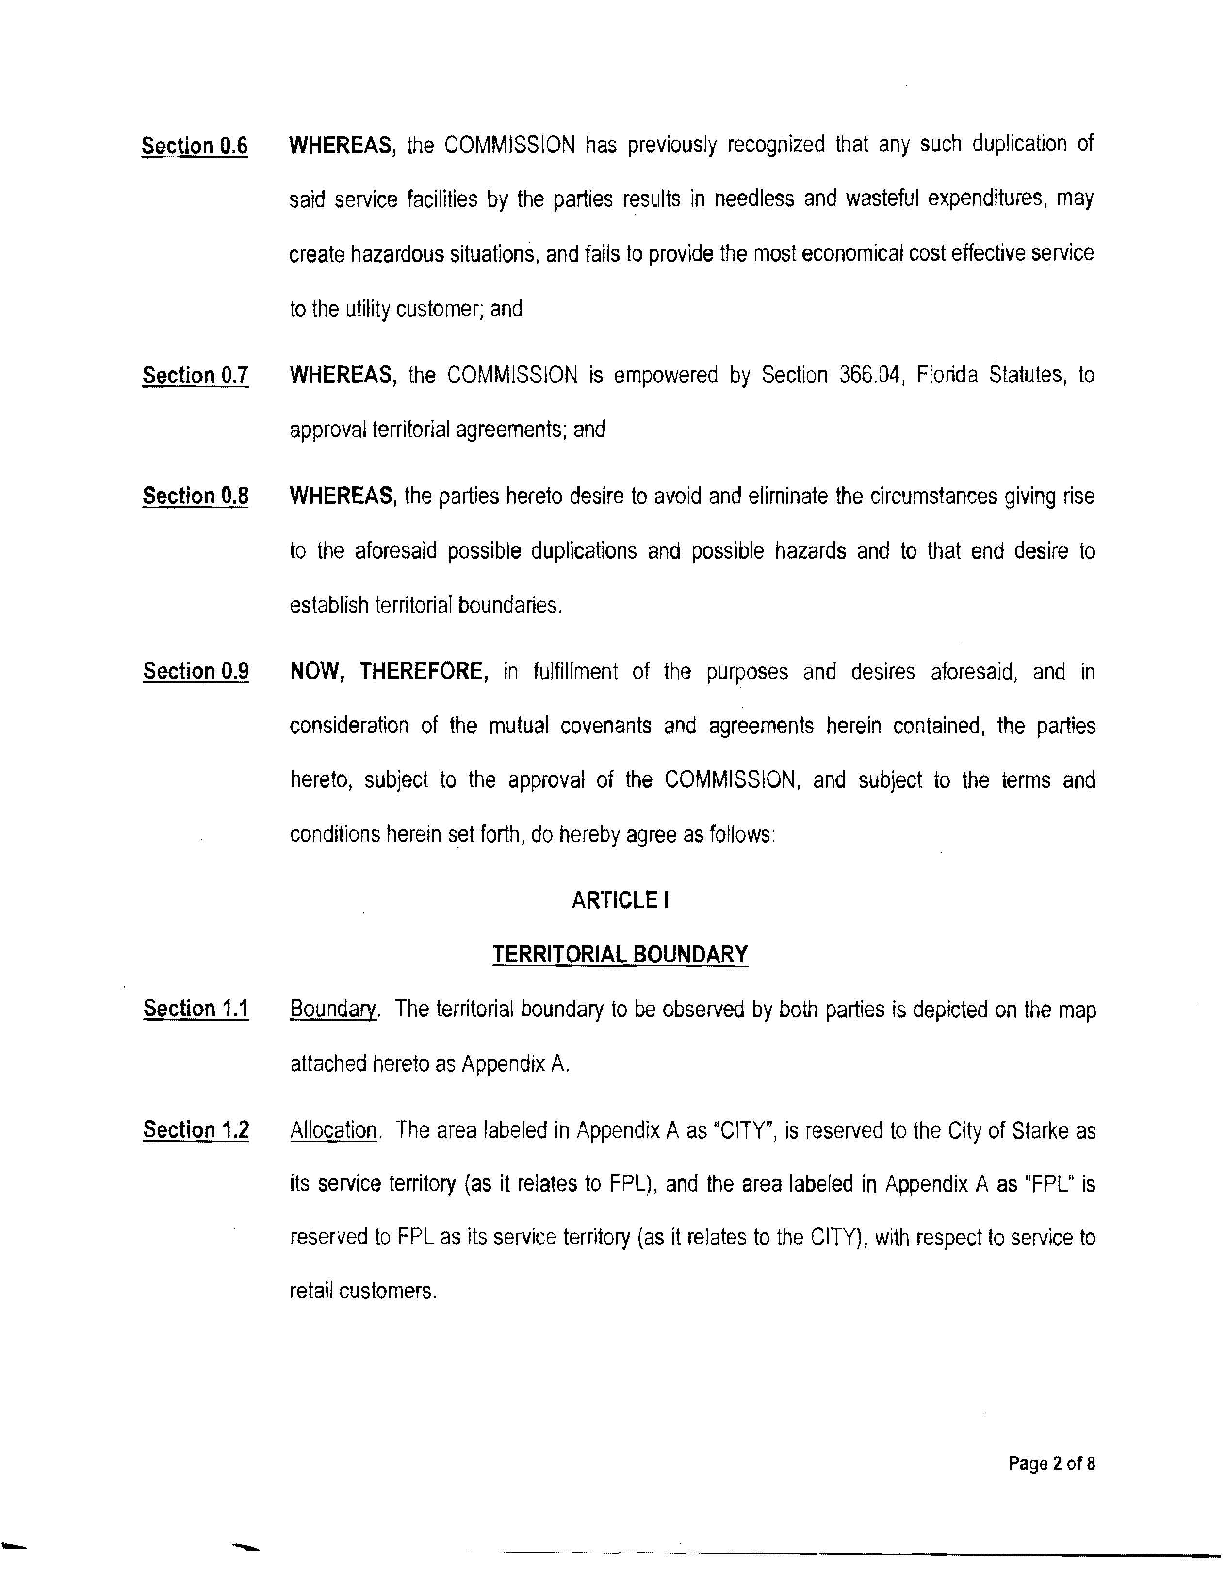
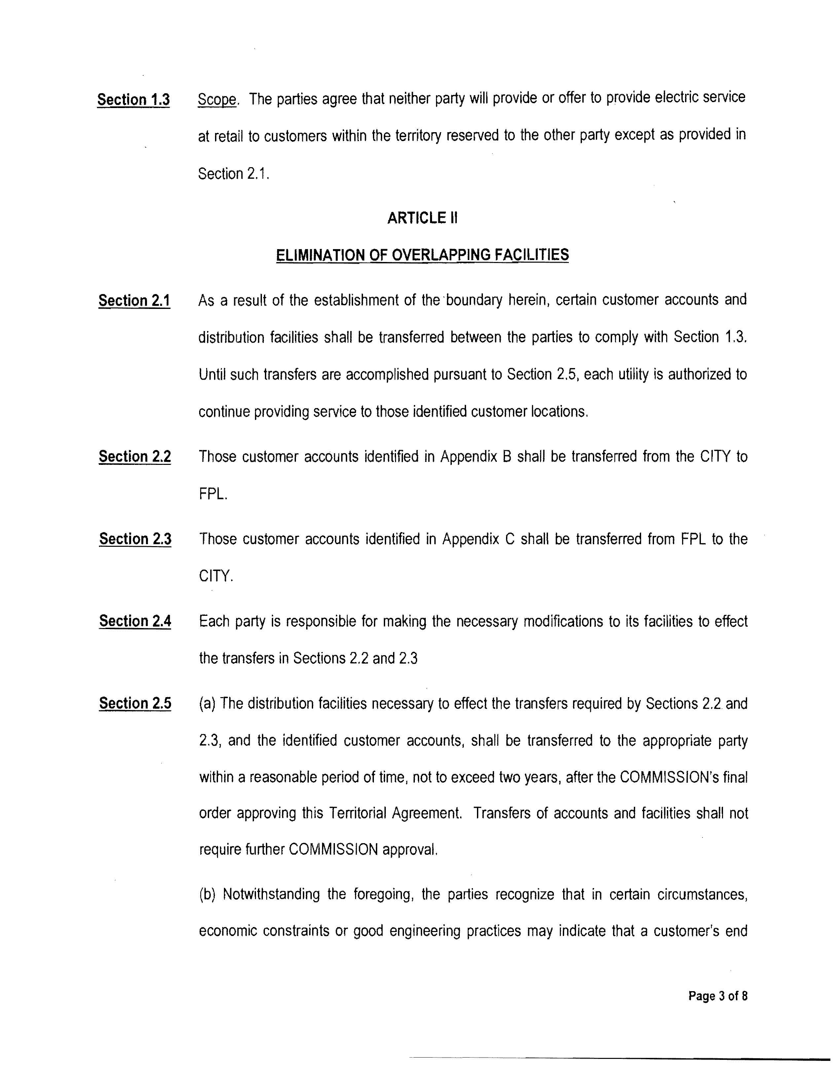
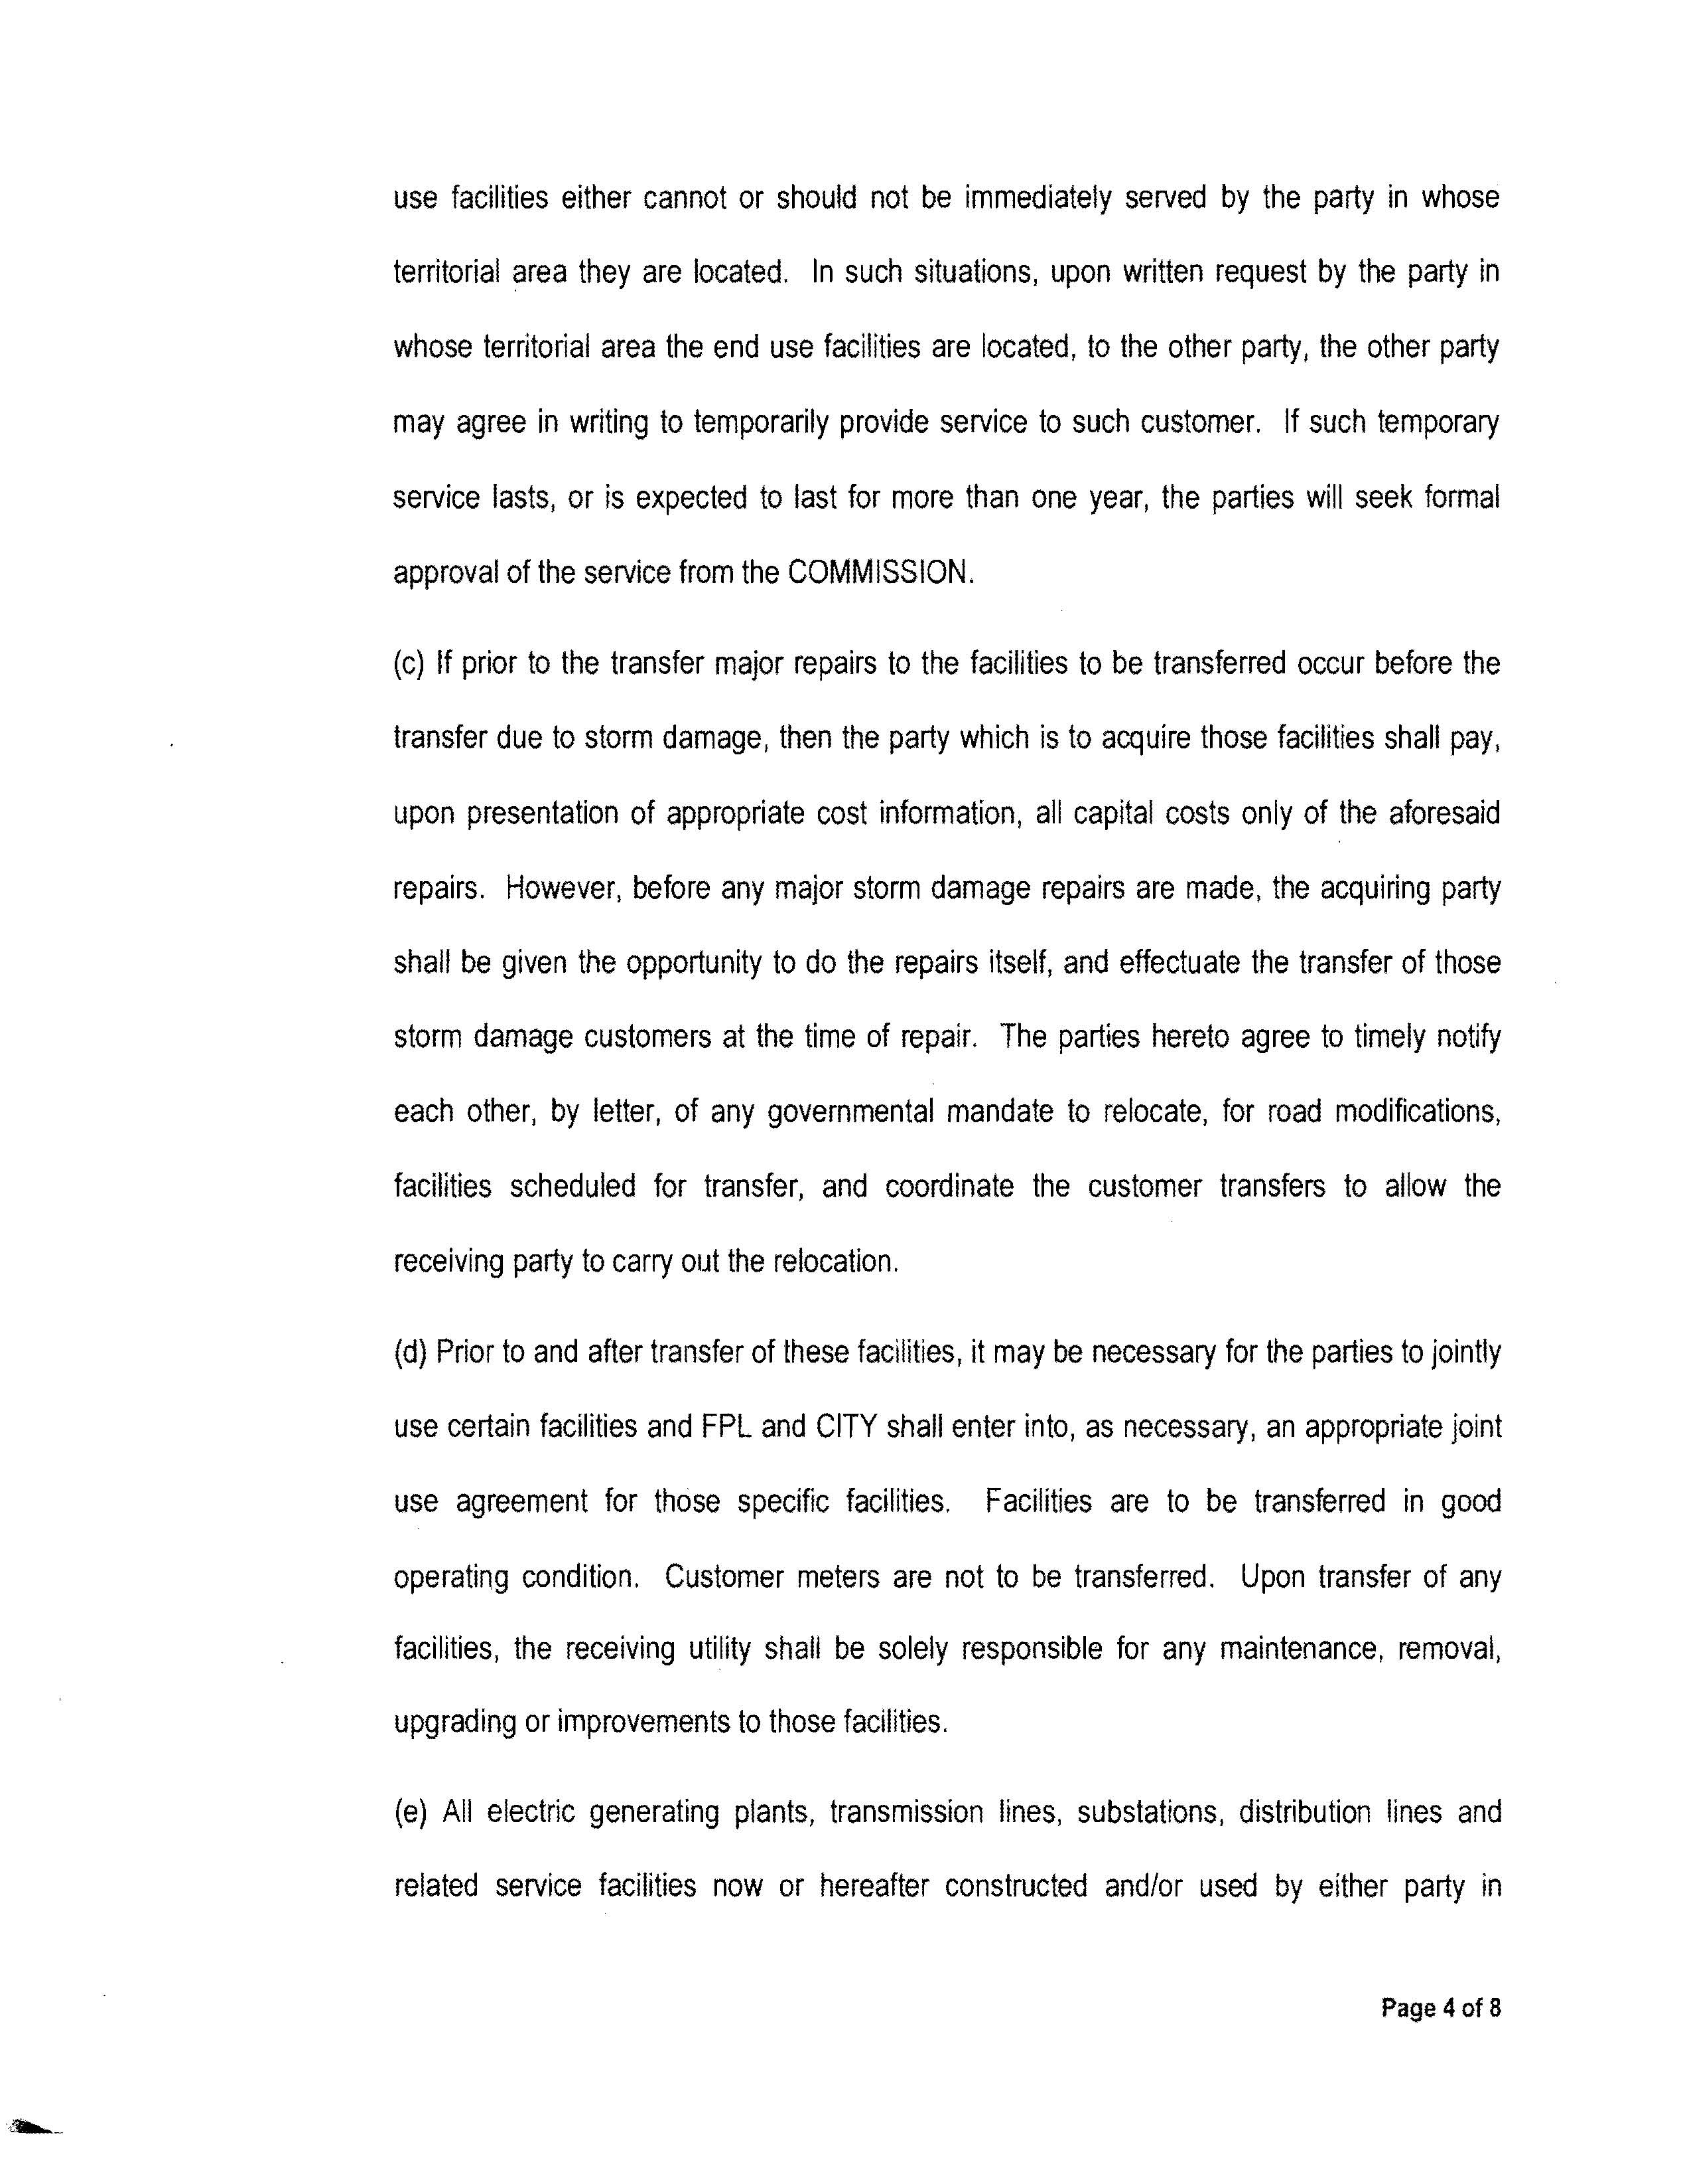
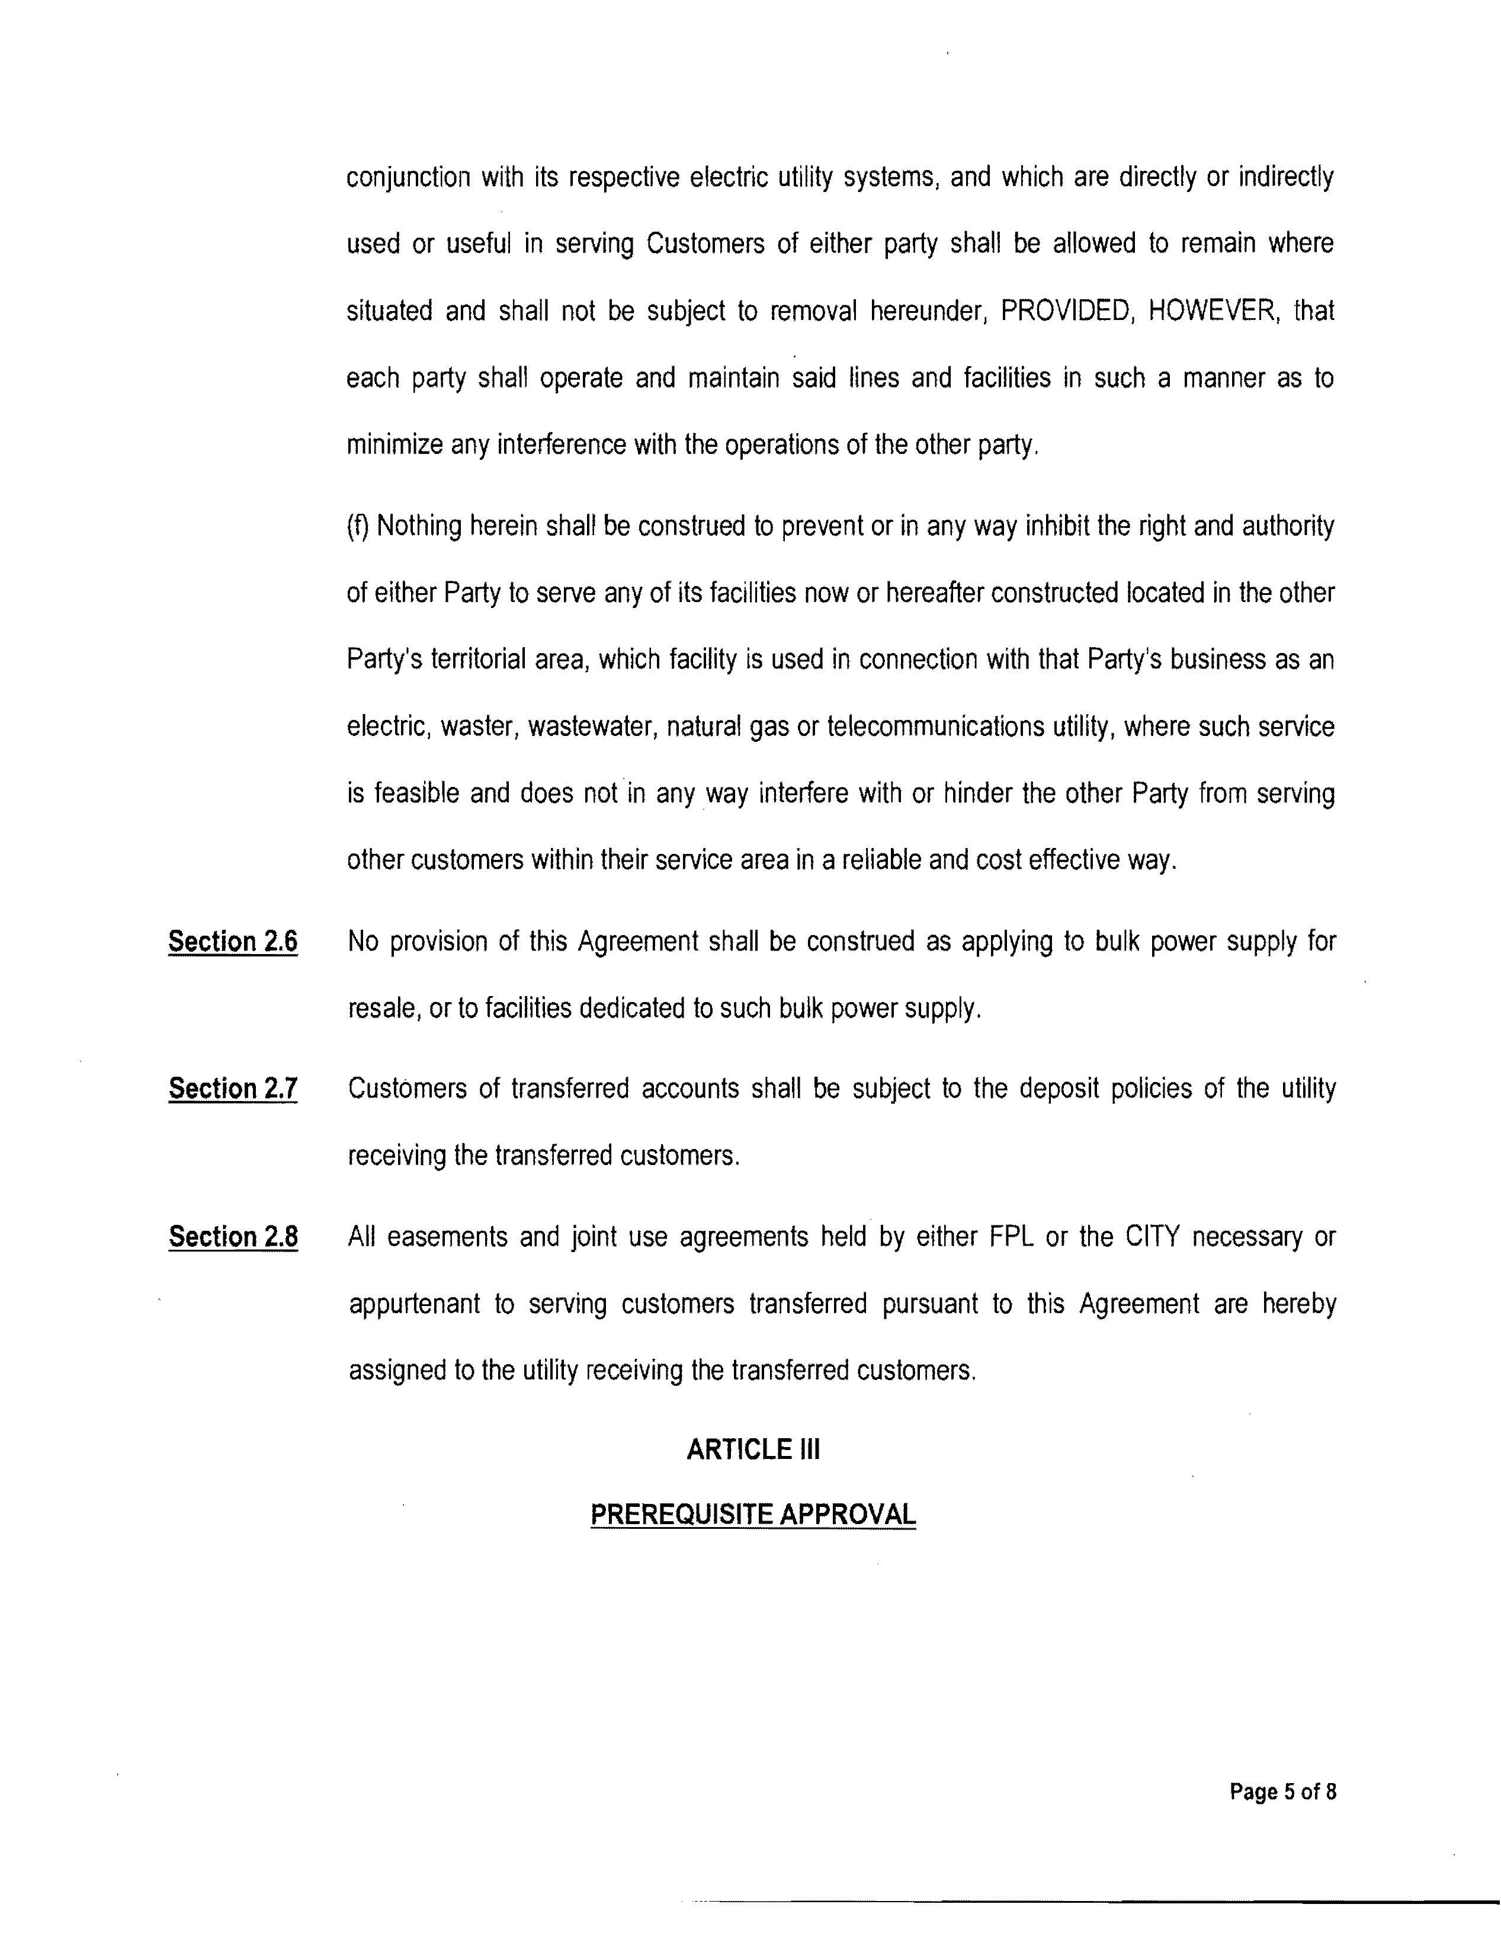
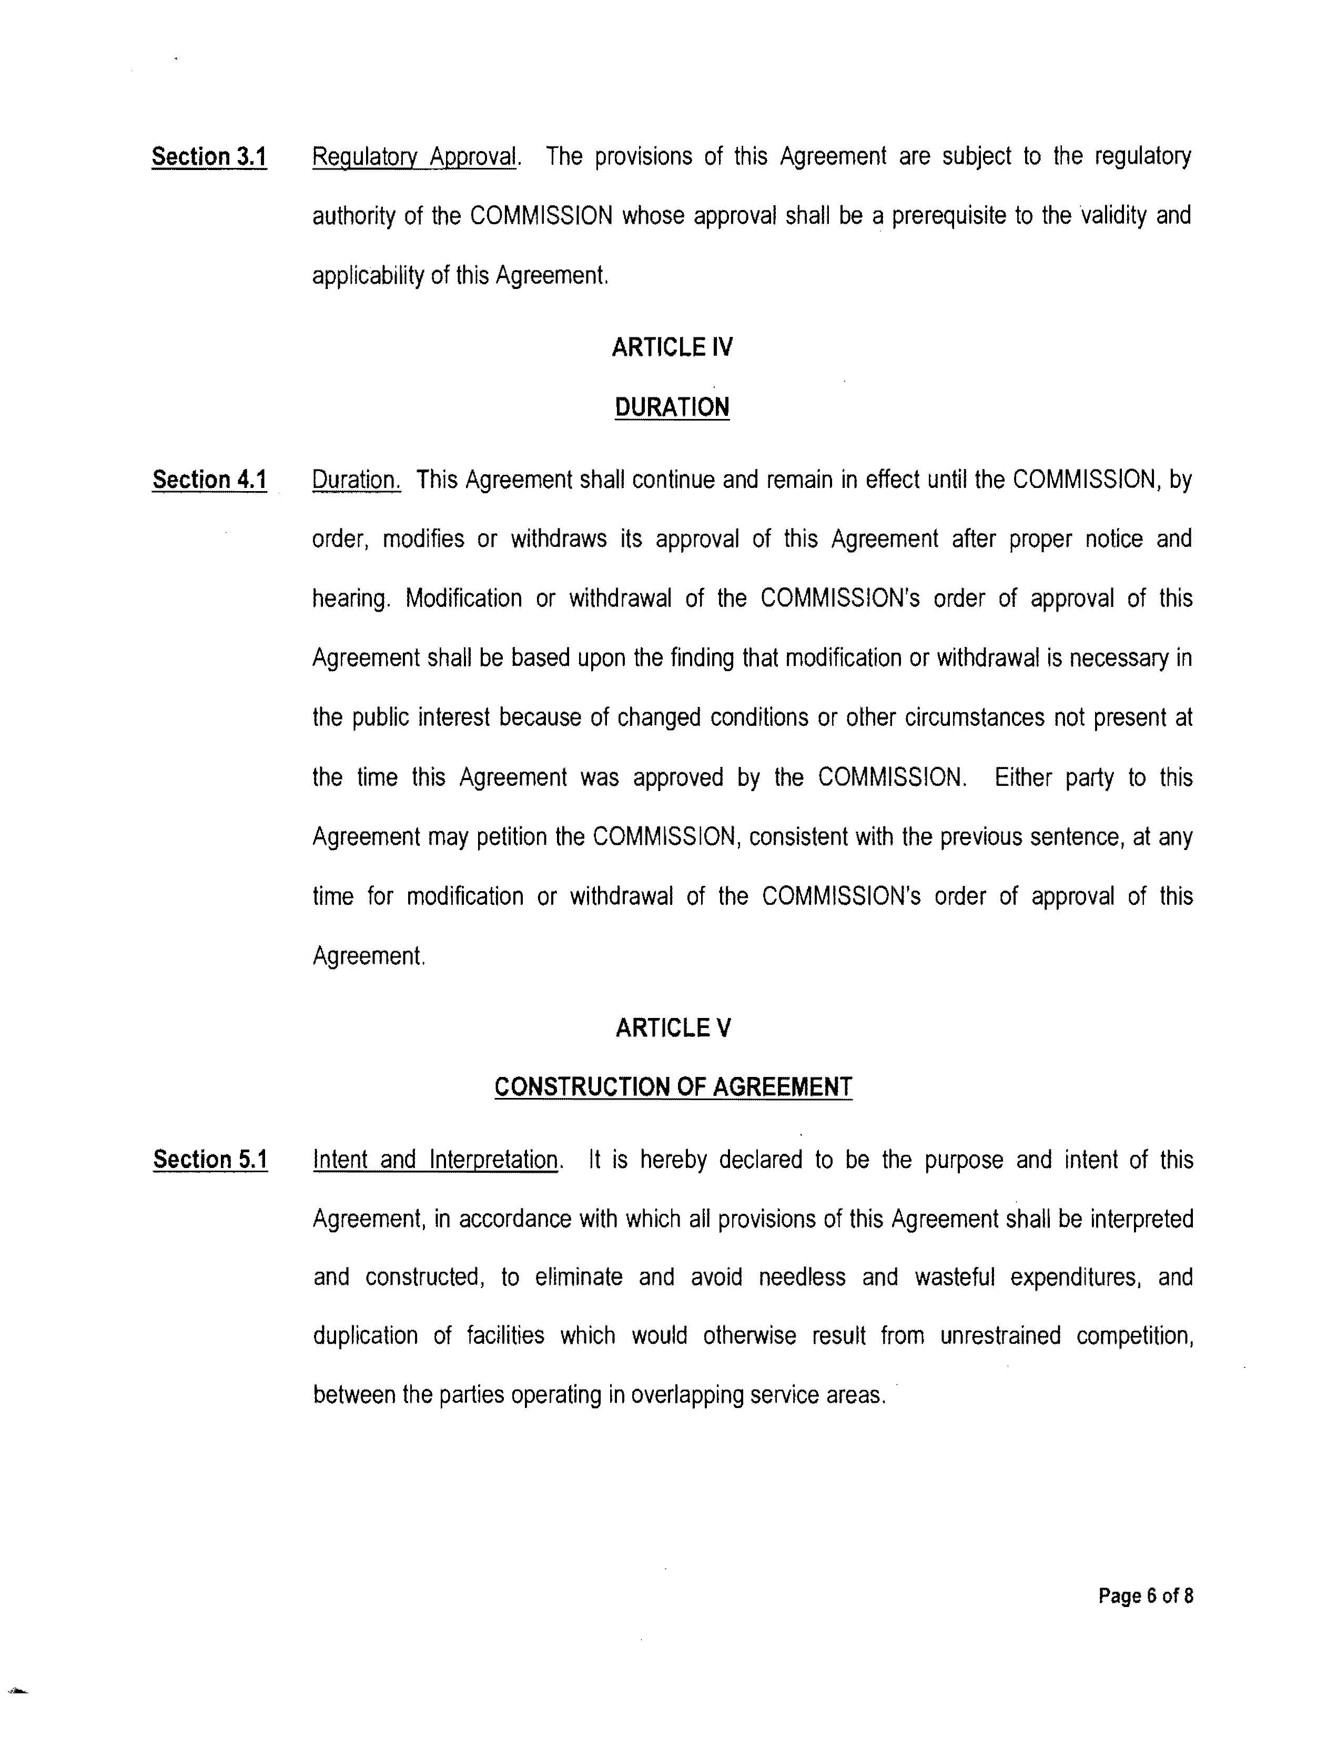
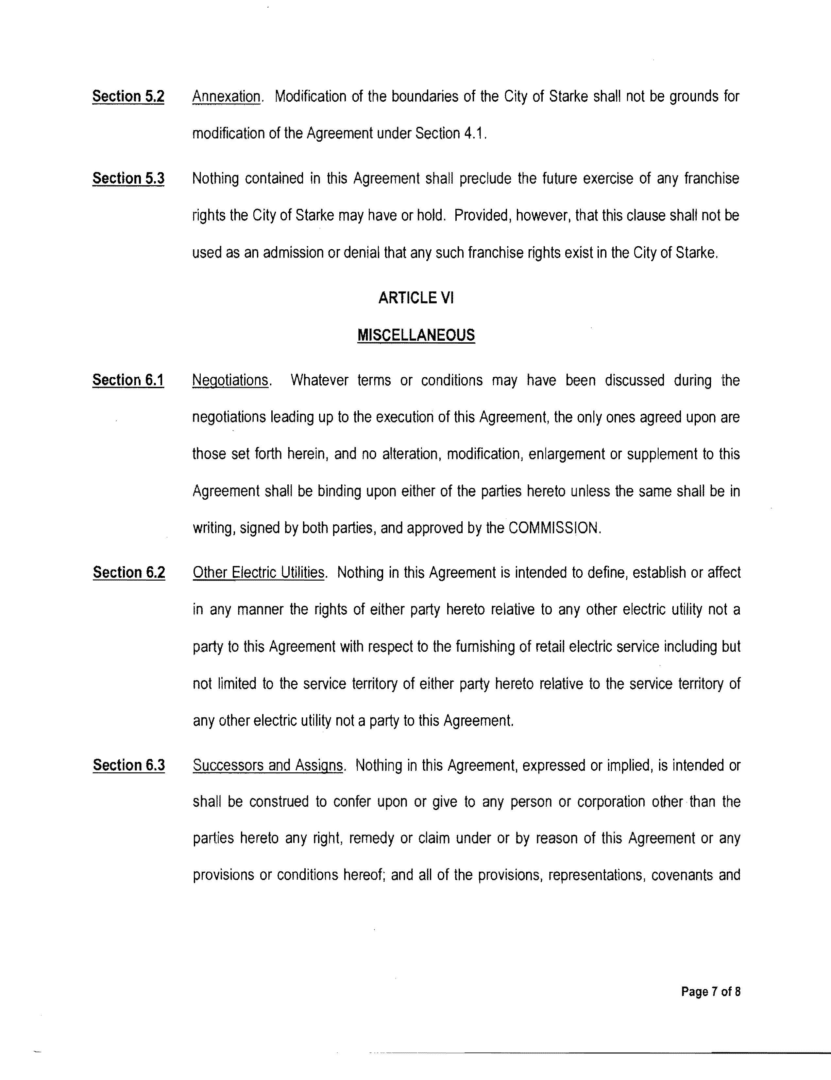
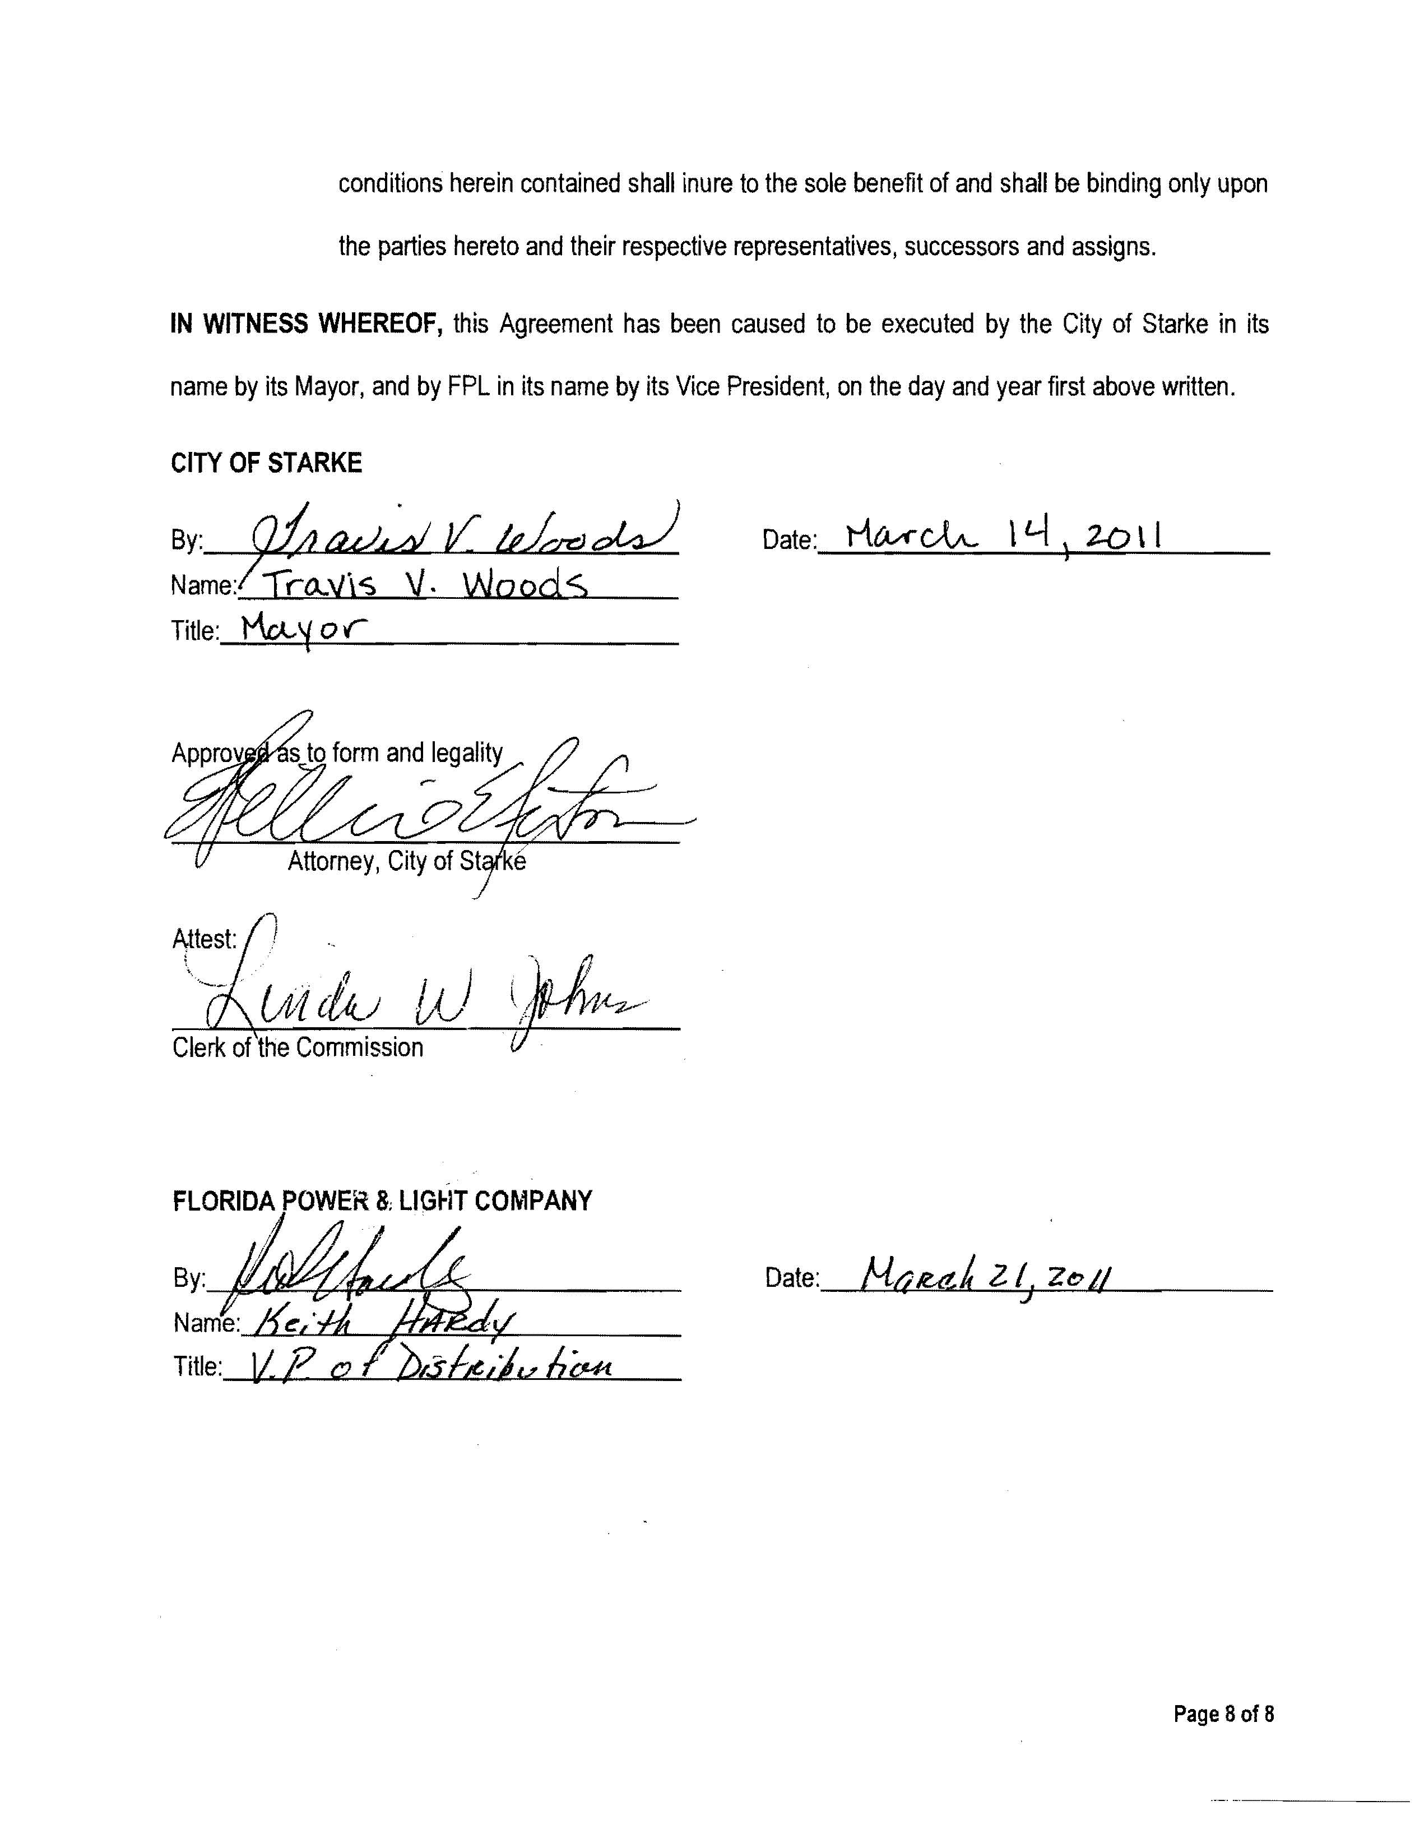

See Order No. PSC-08-0105-PAA-EU, issued February 18, 2008, in Docket No. 070669-EU, In re: Joint petition for approval of territorial agreement in Bradford County by Clay Electric Cooperative, Inc. and City of Starke, Florida.

