State of Florida   |  | Public Service Commission  Capital Circle Office Center ● 2540 Shumard Oak Boulevard  Tallahassee, Florida 32399-0850  -M-E-M-O-R-A-N-D-U-M-
DATE: | September 22, 2011
TO: | Office of Commission Clerk (Cole)
FROM: | Office of the General Counsel (Robinson)  Division of Economic Regulation (Draper)
RE: | Docket No. 110219-EI – Complaint No. 973806E of Casey E. and Allison L. Seaman against Progress Energy Florida, Inc., for alleged improper billing.
AGENDA: | 10/04/11 – Regular Agenda: Issue 1 – Motion to Dismiss – No Oral Argument requested. Participation is at Commission’s discretion.  Issue 2 – Proposed Agency Action – Interested Persons May Participate.
COMMISSIONERS ASSIGNED: |  |  | All Commissioners
PREHEARING OFFICER: |  |  | Balbis
CRITICAL DATES: |  |  | None
SPECIAL INSTRUCTIONS: |  |  | None
FILE NAME AND LOCATION: |  |  | S:\PSC\GCL\WP\110219.RCM.DOC

Case Background
On July 8, 2011, Mr. Casey E. Seaman and Mrs. Allison Seaman (Mr. and Mrs. Seaman or the Seamans) filed a formal complaint (Complaint) against Progress Energy Florida (PEF) alleging that PEF’s meter No. 5834154 (old meter or meter No. 5834154) malfunctioned resulting in an increase in their electricity charges.

The Seamans first contacted the Commission on October 13, 2010, by filing an informal complaint against PEF alleging that their electric billing was excessive during August and September 2010 because meter No. 5834154 was defective. The Seamans disputed the amount of $900, an amount, they allege, was in excess of their normal average monthly bill.

Staff consulted PEF regarding the Seamans’ informal complaint. According to staff’s informal complaint closure letter prepared by the Process Review Team, PEF performed a meter test at the Seamans residence on September 20, 2010, and found the meter to be functioning within the Commission’s guidelines. On September 22, 2010, the Seamans contacted PEF and advised that the home was getting too much voltage. PEF’s technician found the voltage to be within guidelines specified in Rule 25-6.046, Florida Administrative Code (F.A.C.) (120 volts, plus or minus 5 percent tolerance), but replaced meter No. 5834154 with a new meter. On January 11, 2011, meter No. 5834154 was tested again at PEF’s meter testing facility in St. Petersburg, with the Commission’s Engineering Specialist Supervisor from the Tampa District office present. The meter test revealed that the meter functioned properly.

During the informal complaint process, staff had several telephone conversations with the Seamans. In addition, staff responded to the Seamans’ inquiries and provided updates to the Seamans in letters dated November 9, 2010, February 7, 2011, and June 17, 2011. The Seamans were also in contact with PEF during that time period regarding the alleged faulty meter.

The informal complaint process was closed on June 17, 2011, when staff sent the Seamans a complaint closure letter, a copy of which is attached as Attachment A. Staff advised the Seamans that it did not appear that PEF violated any Commission rules or tariff provisions, and therefore the informal complaint process, as specified in Rule 25-22.032, F.A.C., was concluded. However, the letter also advised the Seamans of their right to file a formal petition for relief against PEF, if they disagreed with staff’s complaint closure letter.

On July 8, 2011, Mr. and Mrs. Seaman filed a formal complaint with the Commission. In their formal complaint, Mr. and Mrs. Seaman rejected staff’s conclusion as outlined in staff’s complaint closure letter and denied any financial responsibility for any excessive charges based on the alleged malfunctioning meter. Mr. and Mrs. Seaman allege that staff’s letter shows: (a) a significant rise in their daily kWh consumption which Commission staff characterizes as “an anomaly” disproportionate with kWh usage for prior years; (b) an increase in kWh usage from an average of 80 kWh per day to 180 kWh per day, an increase of 125 percent; and (c) that after the old meter No. 5834154 was replaced by the new meter No. 5488188 on September 22, 2010, the kWh usage “dramatically decreased.” Mr. and Mrs. Seaman assert that staff’s letter proves that their meter was faulty, and they should not be held responsible for the excessive charges from the inaccurate usage readings.

On July 28, 2011, PEF filed its Motion to Dismiss alleging that the Seamans’ complaint failed to meet established pleading requirements and states no cause of action for which relief can be granted. PEF attached the complaint closure letter as Exhibit A to its Motion to Dismiss. Mr. and Mrs. Seaman did not file a response to PEF’s dismissal motion. Neither party requested oral argument.

This matter is before the Commission for the purpose of resolving PEF’s Motion to Dismiss and to address Mr. and Mrs. Seaman’s request for relief. Issue 1 addresses PEF’s Motion to Dismiss, and Issue 2 addresses Mr. and Mrs. Seaman’s request for relief.

The Commission has jurisdiction over this matter pursuant to Chapter 366, Florida Statutes (F.S.).

Discussion of Issues
Issue 1:1
Should the Commission grant PEF’s Motion to Dismiss?
Recommendation:
No. The Commission should deny PEF’s Motion to Dismiss. (Robinson, Draper)
Staff Analysis:

Standard of Review of a Motion to Dismiss
A motion to dismiss questions the legal sufficiency of a complaint. In order to sustain a motion to dismiss, the moving party must show that, accepting all allegations as true and in favor of the complainant, the petition still fails to state a cause of action for which relief may be granted. A court may not look beyond the four corners of the complaint in considering its legal sufficiency.
PEF’s Motion to Dismiss

PEF seeks dismissal of the complaint because:

• The Seamans’ complaint does not satisfy the requirements of Rule 25-22.036, F.A.C.

• The Seamans’ complaint fails to state a cause of action upon which relief can be granted, as the Seamans have failed to particularly allege a set of facts that constitute a violation of any rule, order, or statute.

• Contrary to the Seamans’ contention, the electric meter in question was functioning within the Commission’s accepted standards.

• Commission staff report shows that the old meter No. 5834154 was functioning within the Commission’s approved guidelines as the “meter test results indicated that the meter was registering at a weighted average of 100.00%, which is within acceptable limits of the Commission approved guidelines.”

• The Seamans’ complaint contradicts Commission staff’s report as staff determined the meter complied with Commission rules.
Analysis

The Commission may grant a motion to dismiss upon a finding that the pleading fails to state a cause of action upon which relief can be granted. Rule 25-22.036(2), F.A.C., outlines the procedure for filing a formal complaint. A pleading that conforms to this rule outlines the act or omission that constitutes the violation, the statute that is violated, injury suffered, and remedy or penalty sought. Here, Mr. and Mrs. Seaman allege that the old meter No. 5834154 was faulty resulting in excessive charges, and that once the old meter was replaced, their electric kWh usage and charges reflected their normal usage and charges over the past year. Therefore, they allege that they should not be liable for the excessive charges. Staff believes that if true, the Seamans allegations are sufficient to constitute a cause of action.

In considering PEF’s assertion that the complaint does not conform to the pleading requirements, staff believes that the Seamans should be given the benefit of the doubt, as pro se petitioners. Staff is also aware of PEF’s assertions that the Seamans’ complaint contradicts staff’s complaint closure letter from the informal complaint process, and that the meter, when tested, met the Commission’s guidelines. The Seamans allege that a faulty meter resulted in an inaccurate kWh usage reading for which they seek relief from the Commission. In accordance with the standard for determining the legal sufficiency of a complaint, staff may not look beyond the four corners of the complaint. Staff, therefore, believes the Seamans’ complaint, assuming the allegations are true and giving the Seamans the benefit of the doubt regarding conformance to the pleading requirements, is sufficient to constitute a cause of action.

Conclusion

Considering the alleged facts as true and in the light most favorable to the Seamans, staff recommends that the Commission deny PEF’s Motion to Dismiss, as, if true, the Seamans allegations are sufficient to constitute a cause of action.

Issue 2:2
Should the Seaman’s request for relief from the financial responsibility of their electric bill due to an alleged faulty meter be granted?
Recommendation:
No. Meter No. 5834154 (old meter) was tested twice pursuant to Rules 25-6.059 and 25-6.060, F.A.C., and met the Commission’s guidelines for accuracy. Therefore, there is no conflict in the accuracy of the meter testing that needs resolution by the Commission at this time. (Robinson, Draper)
Staff Analysis:
Rule 25-6.052, F.A.C., establishes the accuracy requirements and test plans for metering devices. Rule 25-6.059, F.A.C., states that a utility shall, without charge, test the accuracy of a meter for a customer upon request. The meter must be tested in conformance with Commission rules. Rule 25-6.060, F.A.C., dictates that in the event of a dispute, the customer’s meter can be tested and the test supervised by a Commission representative. A report of the test must be made to the customer by the Commission. Pursuant to Rule 25-6.059(5), F.A.C., any conflict in the accuracy of the meter testing will be resolved by the Commission. In accordance with Rule 25-22.032(8)(g-h), F.A.C., the Commission may address a customer’s complaint at an agenda conference through the issuance of a proposed agency action or by setting the matter for hearing pursuant to Section 120.57, F.S.

In their complaint, the Seamans expressed their disagreement with the resolution of the informal complaint process as stated in staff’s complaint closure letter. The Seamans assert that staff’s letter stating a significant increase in their daily kWh usage from August 13, 2010, through September 22, 2010, and the dramatic decrease in their daily kWh usage after the meter was replaced sufficiently proves that the old meter was faulty. The Seamans also declare that their home was unoccupied for most of August 2010. Therefore, they contend, the faulty meter must be the reason for the inaccurate usage readings.

Pursuant to Rule 25-22.032, F.A.C., the Process Review Team did a thorough analysis of the Seamans’ complaint and provided a complaint closure letter dated June 17, 2011 to the Seamans. In the complaint closure letter, staff explained that PEF performed a meter test at the Seamans’ residence on September 20, 2010, and the test showed the old meter No. 5834154 to be functioning properly. The old meter No. 5834154 was again tested and determined to be functioning properly at PEF’s meter testing facility on January 11, 2011, and Mr. Velazquez, Engineering Specialist Supervisor from the Commission’s Tampa District office, was present. The Seamans were provided a copy of the meter test report, which showed the meter to be functioning within the guidelines established in Rule 25-6.052, F.A.C., which outlines the accuracy requirements and test plans for metering devices.

Staff agrees with the Seamans that their consumption during the months of August and September 2010 appears to be unusually high. However, the Seamans were informed that high electric usage can be associated with poor home repair, insufficient home and attic insulation, heating, ventilation, and air conditioning units. Additionally, the Seamans’ stated their residence is “quite large” and has two air conditioning units, one of which was replaced because of audible popping sound within the time frame of the spike in kWh usage.

The complaint closure letter also notes that PEF offered to conduct a home energy audit since faulty appliances can cause excessive usage; however, Mr. Seaman declined, stating that the home is already energy efficient. Staff also notes that the complaint closure letter states that attempts at resolving the informal complaint between the parties failed because both party refused the terms offered for the resolution of the complaint.

Staff agrees with the Process Review Team’s complaint closure letter that “it is not always possible for utilities to identify and explain the increase or decrease in a customer’s electric consumption [and] Commission rules do not require PEF to show how energy was consumed.”

Conclusion

The old meter No. 5834154 was tested twice. Both tests met the Commission’s guidelines for accuracy, and the meter tests conformed to the Commission rules. In addition, staff conducted a thorough analysis of the complaint, as evidenced in the complaint closure letter. Mr. and Mrs. Seaman have not provided any documentation or evidence to refute the accuracy of the meter tests. Therefore, there is no conflict in the accuracy of the meter testing that needs resolution by the Commission at this time.
Issue 3:3
Should the docket be closed?
Recommendation:
Yes. If the Commission agrees with staff regarding issues 1 and 2, then if no person whose substantial interests are affected by the proposed agency action for Issue 2 files a protest within 21 days of the issuance of the Order, this docket should be closed upon the issuance of a Consummating Order. (Robinson, Draper)
Staff Analysis:
At the conclusion of the protest period, if no protest is filed this docket should be closed upon the issuance of a Consummating Order.

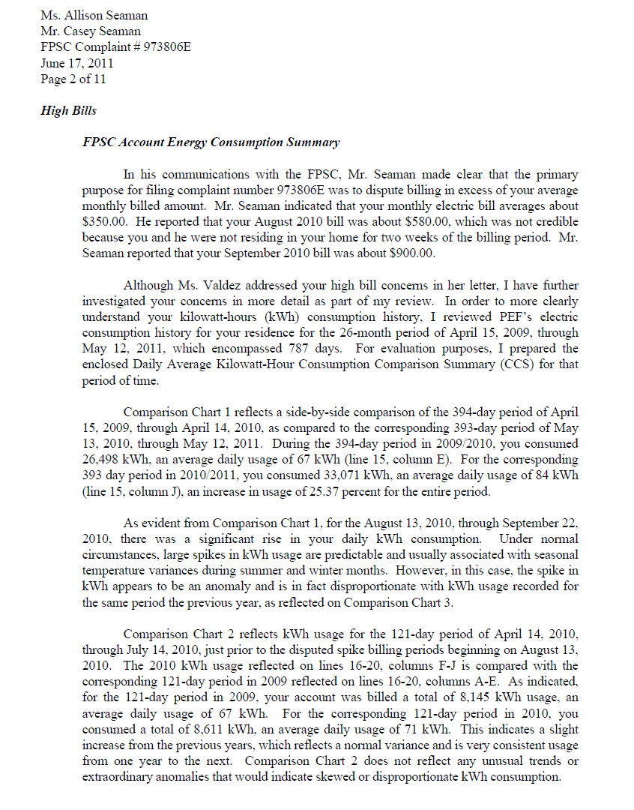

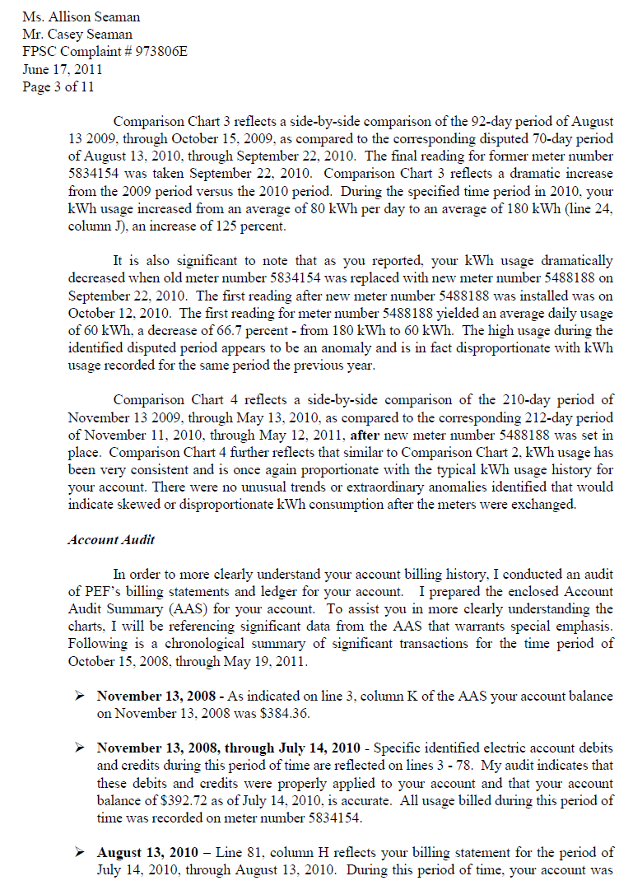
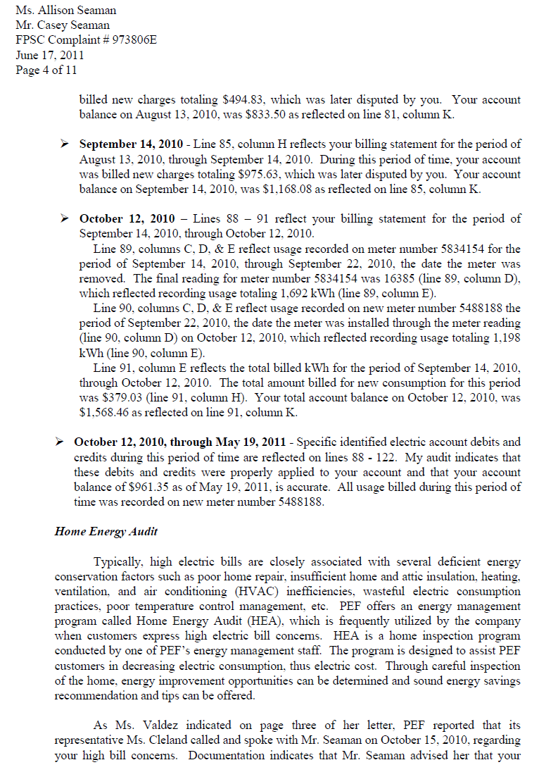
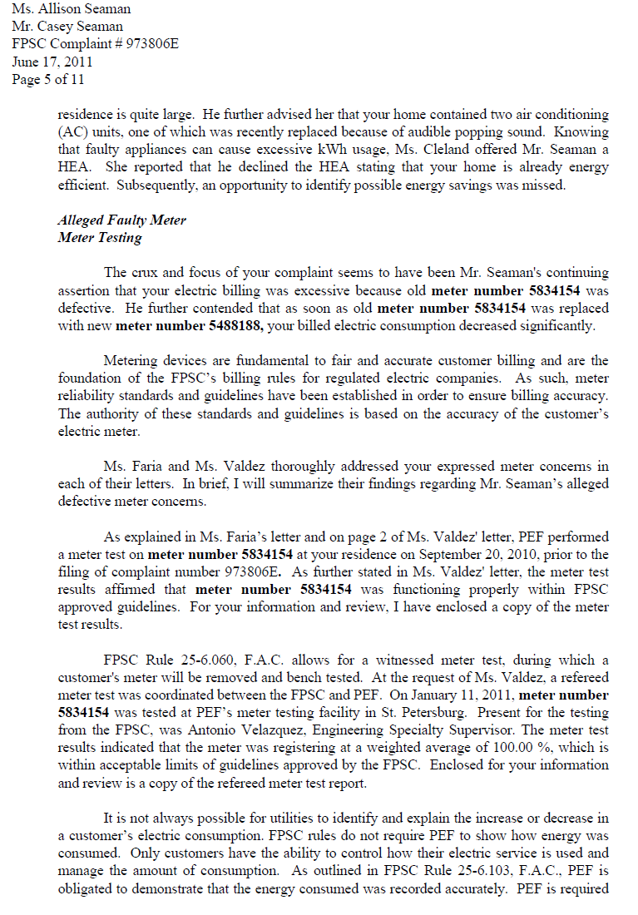
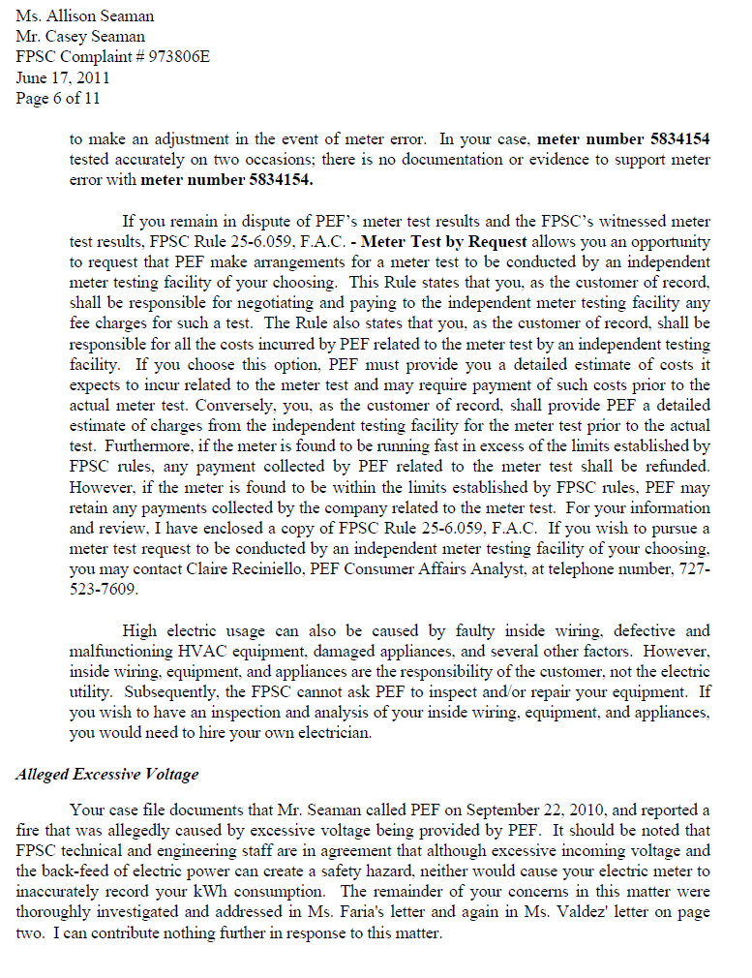

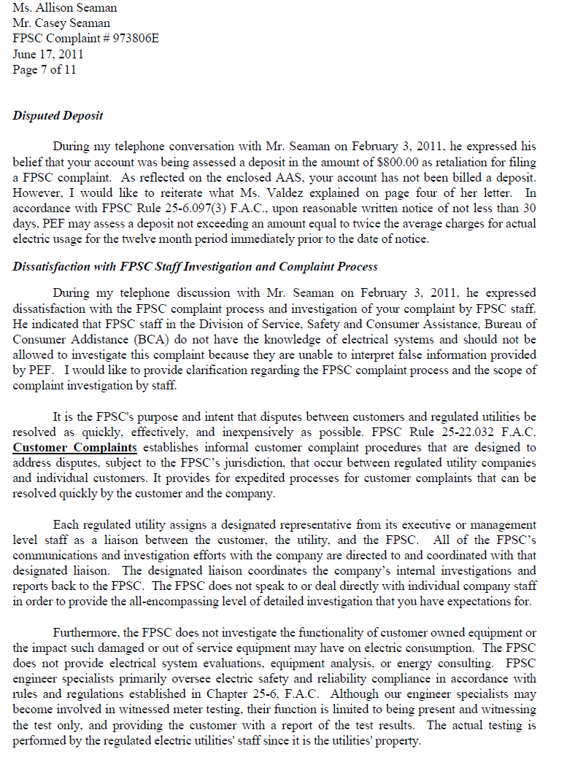
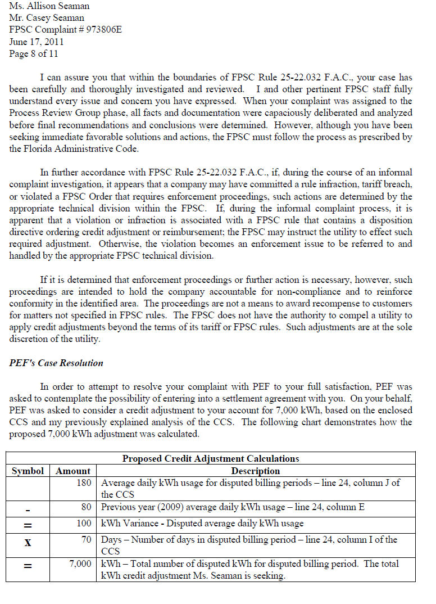
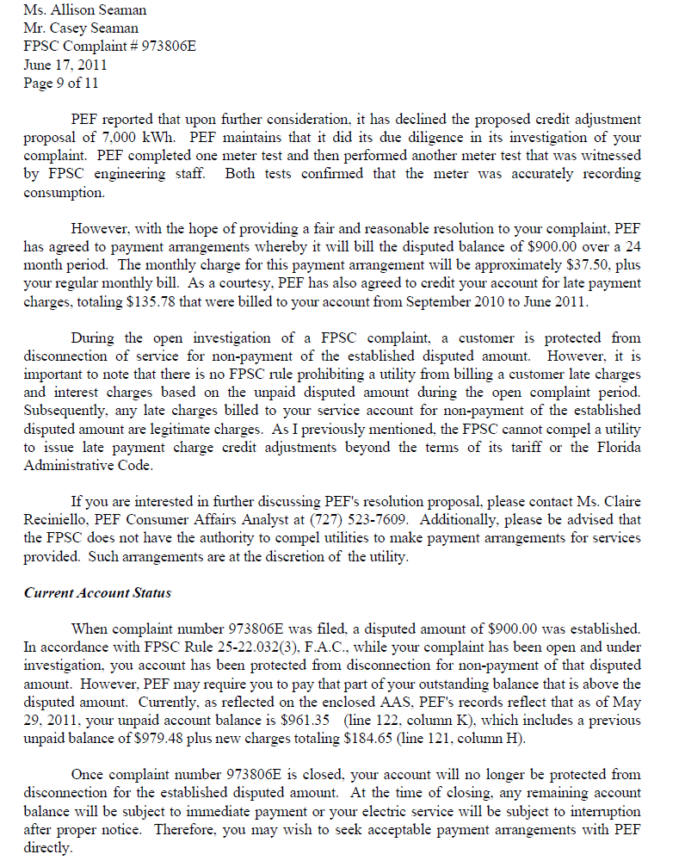

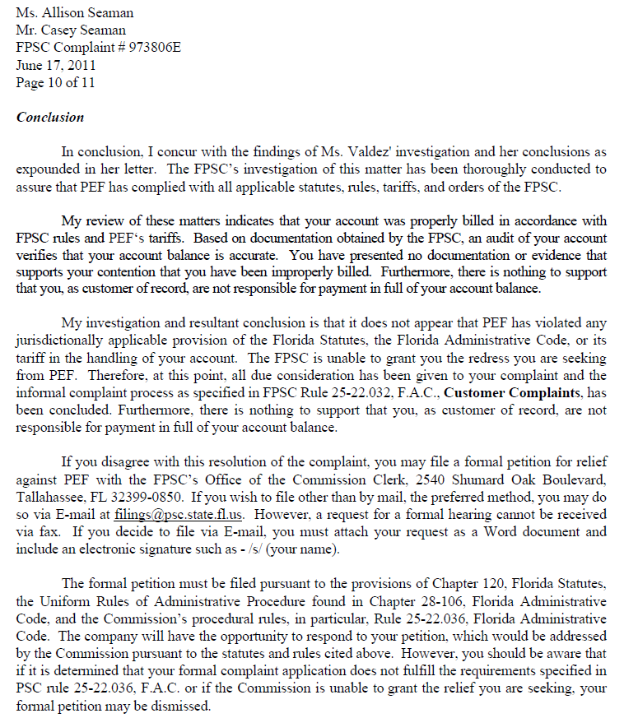

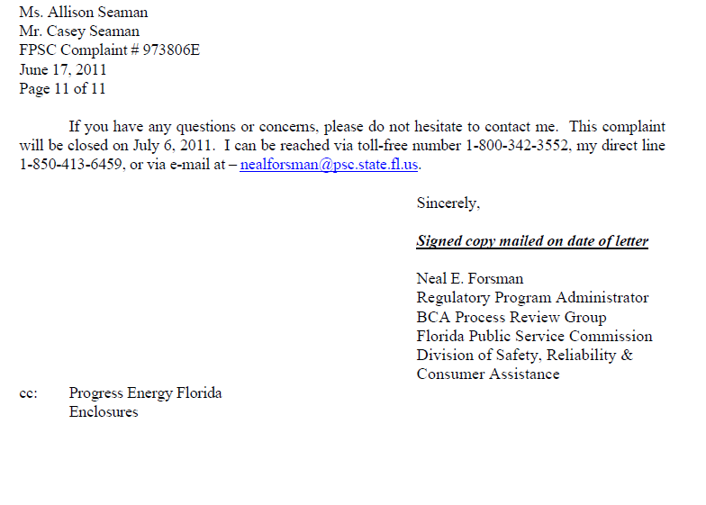

Varnes v. Dawkins, 624 So. 2d 349, 350 (Fla. 1st DCA 1993).
Id. at 350.
Barbado v. Green and Murphy, P.A., 758 So. 2d 1173, 1174 (Fla. 4th DCA 2000) (citing Bess v. Eagle Capital, Inc., 704 So. 2d 621 (Fla. 4th DCA 1997)).
See Order No. PSC-11-0117-FOF-PU, issued on February 17, 2011, in Docket No. 100312-EI, Complaint against Florida Power & Light Company for alleged violations of various sections of Florida Administrative Code, Florida Statutes, and FPL tariffs pertaining to billing of charges and collection of charges, fees, and taxes (granting motion to dismiss with prejudice).
Rule 25-6.059(5), F.A.C., states: “The utility may, at its discretion, conduct its own test of the meter in conformance with the testing standards established by these rules. In the event that separate tests of the same meter conflict as to whether the meter meets the accuracy standards established by these rules, at the request of the utility or the customer, the Commission will resolve the matter.”

