Answer: 3-month LIBOR rate on 11/11/2011 was 0.4628%. 3-month forward 3-month LIBOR rate is 0.6037%

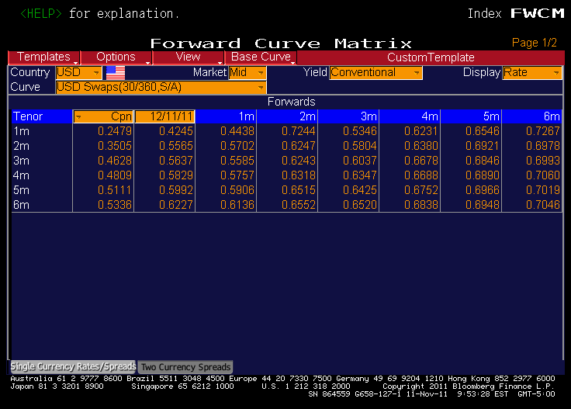

Source: Bloomberg