GULF POWER COMPANY

Before the Florida Public Service Commission

Prepared Direct Testimony of

R. Scott Moore

Docket No. 110138-EI

In Support of Rate Relief

Date of Filing: July 8, 2011

Q. Please state your name and business address.

A. My name is Scott Moore. My business address is One Energy Place, Pensacola, Florida 32520.

Q. By whom are you employed?

A. I am employed by Gulf Power Company (Gulf or the Company). I serve as Gulf’s Power Delivery General Manager.

Q. What are your responsibilities as Gulf’s Power Delivery General Manager?

A. I have responsibility for the employees who work on Gulf’s distribution systems in Northwest Florida. My department handles the nearly 7,700 miles of electrical lines that provide electricity to Gulf’s 431,741 customers (as of March 2011), ranging from Pensacola to Panama City. My department is responsible for providing continuous electric service to the customers we serve, 24 hours a day, 7 days a week, and 365 days per year. I am also responsible for Gulf’s transmission function; however, Gulf Witness Caldwell is the witness in this case addressing Gulf’s transmission function.

Q. Please state your prior work experience and responsibilities.

A. I came to Alabama Power Company in 1988 as a cooperative education student from the University of Alabama – Tuscaloosa. After receiving my degree in 1993, I was hired as an Engineer in the Engineer in Training (EIT) program at Alabama Power in the Mobile Division office. In 1999, I was promoted to Engineering Supervisor and progressed through various distribution leadership positions at Alabama Power during the next several years, including District Operations Manager in Mobile, Operations Manager in Enterprise and Montgomery, and Distribution Manager for the Southeast Division of Alabama Power headquartered in Eufaula. I assumed my current position with Gulf in June 2009.

Q. What is your educational background?

A. I have a Bachelor of Science in Electrical Engineering and Master of Business Administration from the University of Alabama. I am a registered Professional Engineer in the state of Alabama.

Q. What is the purpose of your testimony?

A. My testimony describes the function and operation of an electric distribution system. I address Gulf’s electric distribution system; in doing so, I describe Gulf’s service area, the location of its distribution system within the service area, and some of the geographic and climatic related challenges Gulf faces in planning, operating and maintaining its distribution system. I explain Gulf’s distribution planning process along with Gulf’s distribution budget process for both capital additions and Operation and Maintenance (O&M) expenses. I then present Gulf’s distribution capital additions and O&M budgets for the 2012 test year. I present Gulf’s projected test year investment in distribution facilities, and I explain how and why that investment has increased since Gulf’s last rate case. Next, I will discuss how well Gulf has performed in terms of distribution performance and customer satisfaction. I close my testimony with a discussion of Gulf’s superior performance related to restoration of service following the severe hurricane seasons of 2004 and 2005.

Q. What exhibits do you sponsor?

A. Attached to my testimony is Exhibit RSM-1, Schedules 1 through 14. This exhibit was prepared under my supervision and control. The information contained therein is true and correct to the best of my knowledge and belief.

Q. Which of the Company’s Minimum Filing Requirements (MFRs) do you sponsor?

A. The MFRs I sponsor or co-sponsor are listed on Exhibit RSM-1, Schedule 1. The information contained in the MFRs I sponsor or co-sponsor is true and correct to the best of my knowledge and belief.

1. **AN ELECTRIC DISTRIBUTION SYSTEM**

Q. What is the function of an electric distribution system?

A. The electric power grid is composed of three basic components: the generation source, the transmission system, and the electric distribution system. The electric distribution system provides electrical service to the customer through distribution lines and equipment. The distribution system consists of the facilities beginning at the distribution substation and ending at the customer’s meter.

Q. Please describe the major components of an electric distribution system?

A. The electric distribution system begins in the distribution substation. For electricity to be useful in a home or business, it must be transformed from the higher voltage of the transmission grid to the lower voltage of the distribution system. The place where the conversion from “transmission” to “distribution” occurs is in a distribution substation. A picture of a distribution substation with the major components labeled is set forth in my Exhibit RSM-1, Schedule 2, page 1.

A distribution substation typically performs several key functions for the distribution system:

* It has power transformers that reduce transmission voltages (typically 230,000 volts or 115,000 volts) to distribution voltages (for Gulf this is typically 12,470 volts).
* It has regulator banks which regulate voltage on the distribution system to prevent low voltage and overvoltage conditions.
* It has capacitor banks which help regulate voltage at the substation.
* It has circuit breakers and switches that allow the substation to be disconnected from the transmission grid and/or allows separate distribution lines to be disconnected from the substation when necessary.
* It has a distribution “bus” to which feeders connect.

Once electricity reaches the distribution “bus” within the distribution substation, it flows onto feeders. As shown on Exhibit RSM-1, Schedule 2, page 2, a feeder is made up of a set of four wire circuits. When observing a distribution pole, the three wires at the top of the pole are the wires used to provide three-phase power (typically referred to as “primary” lines which carry electricity). The fourth wire, lower on the pole, is the neutral or ground wire which is connected to the ground (typically referred to as the “neutral”). Feeders are the backbone of the distribution grid and allow for ties between other feeders or other distribution substations.

Feeders, in turn, are connected to “lateral” lines that branch into subdivisions, industrial parks, businesses, or individual homes. As shown on Exhibit RSM-1, Schedule 2, page 3, these lateral lines are made up of one, two, or three primary lines and a neutral. Distribution equipment such as voltage regulators, capacitor banks, electronic and hydraulic reclosers, distribution automation, and switches which are necessary and required for proper voltage control and the safe operation of the distribution system are also often found on feeders and laterals.

Finally, customers are served from laterals (or, in some cases, feeders) using distribution transformers to reduce the voltage to 120/208 volts, 120/240 volts, or 277/480 volts, depending on the customer’s requested service voltage level. The electricity leaves the distribution transformer through a “service” line that then connects to an electric service meter. Please refer to Schedule 3 of my Exhibit RSM-1 for a diagram and component descriptions of the electric power grid.

Q. Please describe the types of customers that Gulf serves from the electric distribution system.

A. There are three major classifications of customers: residential, commercial, and industrial. These customers are defined by usage parameters specific to the customer requirements. Industrial customers typically require three-phase service and have large motor loads and higher capacity requirements for manufacturing capability. Commercial customers require from three-phase to single-phase designs and are typically big box stores, outlet malls and stores, and other large and small commercial businesses. These businesses vary in their electrical demands, but generally they use electric service to provide a product or service to their respective client base. Residential customers are primarily served through single-phase installations where service capability is typically defined by the size of the home and the associated heating and cooling designs of the home.

1. **GULF’S DISTRIBUTION SYSTEM**

Q. Please provide a description of Gulf’s distribution system.

A. As of January 2011, Gulf’s distribution system consists of 109 distribution substations, 5,898 miles of overhead primary lines, 1,786 miles of underground primary lines, and 276 distribution feeders.

Q. Please describe Gulf’s general service area.

A. Gulf’s general service area covers much of the Florida panhandle. In broad geographic terms, it spans from the Escambia River on the Alabama/Florida border in the west approximately 153 miles to the east and from the Florida coast of the Gulf of Mexico north to the Florida/ Alabama border. A map of this broad geographic area in which Gulf’s service area is located is presented on Exhibit RSM-1, Schedule 4. This service area covers approximately 7,550 square miles in eight Florida counties - Bay, Escambia, Holmes, Jackson, Okaloosa, Santa Rosa, Walton, and Washington. Gulf’s service area currently encompasses 71 towns and communities in Northwest Florida.

Q. Does Gulf have electric distribution facilities throughout the broad geographic area you described as Northwest Florida?

A. Yes. Gulf has electric distribution facilities throughout the broad geographic area, except where the retail electric service is provided by a rural electric cooperative. Also, there are some parts of this geographic area that simply do not have any retail customers, so no distribution facilities exist. However, Gulf has an obligation as a public utility to serve such areas, so the Company must be prepared to extend its distribution facilities when customers make such a request.

Q. Where are Gulf’s electric distribution facilities primarily located?

A. Most of Gulf’s electric distribution systems are located in areas of the greatest population density; however, the population density of the Florida panhandle is lower than much of the other more urban populations in the Florida peninsula. Gulf Power’s Service Area & Customer Density Areas are shown on Exhibit RSM-1, Schedule 5. As shown, Gulf is divided into three Districts: Western, Central and Eastern. In the Western District, the greatest densities of customers are around Escambia and Pensacola Bays (Gulf Breeze, Pensacola and Milton) and in and around the following communities to the north: Cantonment, Beulah, Molino, and Century. In the Central District, the greatest densities of customers are around Choctawhatchee Bay in the south (Ft. Walton Beach, Niceville and Destin) and in and around the following communities to the north: Crestview, Laurel Hill, Paxton, DeFuniak Springs and Ponce de Leon. In the Eastern District, the greatest population densities are around St. Andrews Bay (Panama City and Panama City Beach) in the south and in the following communities to the north and east: Vernon, Caryville, Bonifay, Chipley, Graceville, Campbellton, Cypress and an unincorporated area between Sneads and Chattahoochee.

Q. Are there any distinctive aspects or characteristics of Gulf’s service area that affect Gulf’s electric distribution system?

A. Yes. There are geographic and climatic characteristics that affect Gulf’s service areas and distribution system.

Large portions of Gulf’s service area are heavily forested. A map indicating that approximately 72 percent of the land area in the Florida Panhandle is forested is shown in Exhibit RSM-1, Schedule 6. This heavily forested service area has a significant impact on how we perform vegetation management activities.

In addition, a significant part of Gulf’s service area is adjacent to coastal waters and numerous natural bays, intracoastal waterways and rivers. This subjects Gulf’s distribution system to the effects of salt contamination and tropical weather impacts. The tropical weather impacts consist of storm surge up to 20 feet or more and winds in excess of 110 to 140 miles per hour, which are equivalent to a Category 3 hurricane on the Saffir – Simpson hurricane wind scale. A map showing the potential wind field impacts is shown in Exhibit RSM-1, Schedule 4. These impacts have resulted in Gulf adopting unique standards and specifications for its material and equipment. For example, Gulf has adopted the more stringent Grade B construction standard for all new distribution facility construction and uses stainless steel transformers in coastal regions to minimize the adverse effects from salt contamination and corrosion.

Another distinctive characteristic of Northwest Florida that affects Gulf’s distribution system is the frequency of lightning strikes. Vaisala’s National Lightning Detection Network (NLDN) indicates that the cloud to ground lightning incident rate in Northwest Florida is among the highest in the nation. See Exhibit RSM-1, Schedule 7. To address this high incidence of lightning strikes, Gulf’s design standards and specifications require an increased number of lightning arrestor installations and associated grounding enhancements. Later in my testimony I will discuss costs related to lightning arrestor installations.

1. **GULF POWER’S DISTRIBUTION PLANNING PROCESS**

Q. Please describe Gulf’s distribution planning process.

A. Gulf’s planning process is used to determine the most reliable, practical, and economical expansion of the distribution system. Gulf performs “Long Range Area Distribution Studies” (Studies) to identify issues that could adversely impact the delivery of power by the distribution system. These Studies are performed on a 3- to 5-year cycle depending on customer growth and distribution changes. For these Studies, Gulf uses the CYME® International analysis software, which is recognized as one of the industry leaders in this field.

The Studies are initiated by modeling the relevant distribution system and the distribution system loading in their current states. Long-range forecast information based on historical data trends, marketing data and actual field information is compiled to determine system growth in each area. This information is then applied to each feeder to establish an annual forecast demand. The Study is expanded to a 7-year horizon window, and each year is then analyzed to determine the operating conditions and their potential impacts to the distribution system.

Operating conditions requiring corrections are identified along with the most practical and economical solutions. The final recommendations from the Studies are reviewed and approved by distribution management who have knowledge of the district, the distribution system, and any unique characteristics of the area served.

When a significant change occurs in an area that is not currently under study, the distribution planning group performs a “Special Distribution Study.” An example of a significant change would be a large new business customer or a business adding significant electrical load. The latest “Long Range” study of that area is adjusted for the change to determine any potential impact to the distribution system. If an operating condition requiring correction occurs, then a solution is determined, and a recommendation generated. The final recommendations from the Studies are reviewed and approved by distribution management.

Annually, a review of all current planning Studies is performed by distribution management. The justification of each project is compared to the latest actual load to ensure the recommended timing for construction is appropriate. If the recommendations have changed, the project justification and construction schedule are adjusted accordingly. Careful consideration is given to those projects which require longer construction lead times such as new distribution substations, which have a 2-year or more construction timeframe. This timeframe is impacted by equipment availability, permitting and land acquisition, all of which have become major considerations for construction in Northwest Florida.

1. **GULF POWER’S DISTRIBUTION BUDGET PROCESS**

Q. Please describe the distribution budgeting process.

A. The distribution budgeting process consists of two components: the capital additions budget and the O&M budget. The capital additions budget consists of expenditures related to on-going capital replacements and capital construction projects. The O&M budget consists of expenses associated with the daily operation and maintenance of the distribution system.

Q. Please describe Gulf’s distribution capital additions budgeting process.

A. Each year, Gulf’s Corporate Planning organization provides a Budget Message to each planning unit. As discussed in the testimony of Gulf Witness Buck, the Budget Message provides budget guidelines for preparing a budget request. Distribution begins its capital additions budget process by analyzing the two components that make up the distribution capital additions budget: on-going capital replacements and capital construction projects. Capital replacement programs consist of routine replacements of poles, transformers, voltage regulation equipment, reclosers, switches, arrestors, conductors, outdoor lighting, and other assets. Capital construction projects, except for new business construction requests, are a result of the planning Studies that I mentioned previously. Both the capital replacement projects and capital construction projects are developed to support reliability, safety, and customer demand.

Capital replacements and capital construction projects are further subdivided into blanket and specific plant expenditure (PE) categories. Blanket PEs reflect repetitive expenditures based on historical trends and projected customer growth. Blanket PEs include items such as new business overhead and underground construction, meters and transformers, trucks and equipment, tools and test equipment, lighting, pole replacements, and other capital improvement projects. Specific PEs are related to planning projects and major initiatives requiring distribution plant additions. Examples of specific PEs are Advanced Metering Infrastructure (AMI), distribution automation, storm hardening, new feeders, and distribution substations.

The proposed capital additions budget is reviewed by the distribution management team. Once approved, the distribution management team submits a proposed capital additions budget to the Vice President of Customer Operations. Once reviewed and approved by the Vice President of Customer Operations, the capital additions budget is presented to Corporate Planning for inclusion in the Company’s capital additions budget. Mr. Buck will address Gulf’s capital additions budget process within Corporate Planning.

Q. Describe the distribution capital expenditures monitoring process.

A. After the capital additions budget has been approved, each distribution PE is assigned an owner within the distribution organization. Each owner’s responsibility is to monitor expenditures against the budget. Within each PE, Distribution System Orders (DSO) are created, approved, and authorized for construction. DSOs are created by field engineers and approved and authorized by the appropriate level of management based on the cost of the DSO. DSOs are routed to crews for field completion. These completed work orders are then returned to engineering for material and labor reconciliation. Each month, the distribution management team reviews capital project expenditures and any budget variance for all projects. Each project owner is responsible for explaining budget variances.

Budget variances may result in the reallocation of overall capital expenditures within the distribution organization. On a quarterly basis, Corporate Planning requires a detailed explanation of all budget variances

greater than 10 percent or $250,000 (whichever is lower). Variances less than $10,000 do not require a variance explanation.

Q. How are new capital projects or changes to existing projects incorporated in the current year budget?

A. In the event a new project or an increase in capital expenditures associated with an existing project is necessary, Distribution must submit a justification letter to the Vice President of Customer Operations. Once approved by the Vice President of Customer Operations, the letter is forwarded to the Chief Financial Officer (CFO) for review and approval. If the change is approved, the letter is sent to Corporate Planning where the change is documented and the current budget is updated to reflect the change.

Q. Please describe the distribution O&M budgeting process.

A. Gulf’s distribution O&M budget is developed by employees who are very knowledgeable about the distribution systems they operate and maintain on a daily basis. Each year Gulf’s Distribution organization develops a

5-year O&M budget based on historical experience and projected maintenance in order to continue the safe operation and integrity of the distribution system. As I mentioned earlier, Gulf’s Corporate Planning organization provides a Budget Message with guidelines for preparing the budget.

Gulf relies on a combination of inputs in determining the appropriate level of O&M expenses for a budget request. First, the requested level of some distribution O&M expenses is determined by looking at available historical trends. Expenses associated with outage restoration, underground cable fault repairs, and street light maintenance are examples of such expenses. Other O&M expenses are a result of compliance with regulatory requirements. The O&M expenses necessary for Gulf to accomplish the programs in its Storm Hardening Plan are an example of this type of expense. In addition, Gulf’s field personnel have a role in the O&M budget process. Gulf’s field personnel identify maintenance and inspection needs in their areas of responsibility.

As the proposed O&M budget is developed, the distribution management team meets to review and prioritize the O&M programs and projects. The proposed O&M budget is reviewed by the distribution management team. Once approved, the distribution management team submits a proposed O&M budget to the Vice President of Customer Operations. Once reviewed and approved by the Vice President of Customer Operations, the O&M budget is presented to Corporate Planning for inclusion in the Company’s O&M budget. Mr. Buck addresses Gulf’s O&M budget process within Corporate Planning.

Q. How are significant budget variances resolved when unforeseen circumstances arise during the budget year?

A. Where distribution exceeds the budget due to a significant or unforeseen event, it must justify the variance and submit it to the Vice President of Customer Operations. If approved by the Vice President of Customer Operations, the variance is forwarded to the CFO and Corporate Planning. Executive management will review the variance request. If approved, the variance is incorporated into the distribution O&M budget for the year.

Q. Describe the distribution O&M monitoring process.

A. Each distribution O&M program is assigned an owner within the Distribution organization. Each owner’s responsibility is to monitor expenses against budget. Within each program, all variances are reported to distribution management for their review on at least a monthly basis. At the end of each quarter, budget to actual reports are provided to Corporate Planning along with justifications for variances from budget.

1. **GULF POWER’S DISTRIBUTION O&M BUDGET**

Q. What is Gulf’s distribution O&M budget for 2011 and 2012?

A. Gulf’s distribution O&M budget for 2011 is $41,071,000. Gulf’s distribution O&M budget for 2012 is $41,596,000.

Q. Is Gulf’s projected level of distribution O&M expense of $41,596,000 in 2012 reasonable and prudent?

A. Yes. This is the level of distribution O&M expenses that was approved as a result of Gulf’s robust budget process that I described earlier, and this is the level of 2012 distribution O&M expenses that is reasonable, prudent and necessary for Gulf to provide adequate and reliable electric service to our customers. As shown on RSM-1, Schedule 8 of my exhibit, the 2012 budgeted distribution related O&M expenses include the following major activities: Asset Management ($3,550,000), Overhead and Underground Line Operation and Maintenance ($17,035,000), Minor Storms ($748,000), Load Dispatch ($1,274,000), Meters ($3,880,000), Storm Hardening ($440,000), Vegetation Management ($4,918,000), and Engineering and Supervision ($9,751,000).

Q. Please describe Gulf’s Asset Management activity.

A. The Asset Management activity ($3,550,000) includes expenses related to equipment and pole inspection programs that ensure safe and effective operation of distribution equipment. For example, this activity covers Gulf’s padmount equipment inspection programs where Gulf annually inspects all transclosers and vaults on the distribution system. Gulf’s pole inspection program is included in this activity. Gulf’s pole inspection program is conducted annually based on an 8-year cycle as approved by the Florida Public Service Commission (FPSC or the Commission) in Order No. PSC-07-0078-PAA-EU, Docket No. 060531-EU. This activity also includes maintenance expenses for Gulf’s distribution automation program, which includes repair and maintenance of line devices and their associated communication equipment. I will discuss Gulf’s distribution automation program in more detail later in my testimony.

Q. Please describe Gulf’s Overhead and Underground Line Operation and Maintenance activity.

A. Gulf’s Overhead and Underground Line Operation and Maintenance activity ($17,035,000) includes expenses related to line inspection, repair and maintenance programs. For example, Gulf’s annual inspection of mainline feeders using both visual observations and infrared technology is included in this activity. Also included in this activity are the expenses associated with outage-related distribution switching (load transfer or isolation); repair of damaged underground cables; repair of damaged overhead feeders, laterals, and services; and outage restoration efforts.

Q. Please describe Gulf’s Minor Storm activity.

A. The Minor Storm activity ($748,000) includes expenses involved in restoring electric service to Gulf’s customers after weather events such as thunderstorms or winter storms. This activity would include repairing downed feeders or laterals and other equipment damaged by weather events not covered by the Property Damage Reserve.

Q. Please describe Gulf’s Load Dispatch activity.

A. Gulf’s Load Dispatch activity ($1,274,000) includes expenses related to non-outage distribution switching. An example of non-outage distribution switching is the transfer of load between feeders or laterals to facilitate construction or maintenance activities.

Q. Please describe Gulf’s Meters activity.

A. Gulf’s Meters activity ($3,880,000) includes expenses related to Gulf’s meter inspection program. This program implements the “Gulf Power Company Test Plan for Revenue Metering Devices” that is filed with the Commission. The Plan prescribes meter test schedules.

Q. Please describe Gulf’s Storm Hardening activity.

A. Gulf’s Storm Hardening activity ($440,000) includes expenses associated with Gulf’s Storm Hardening Plan approved in Commission Order No. PSC-10-0688-PAA-EI in Docket No. 100265-EI. The pole replacements associated with Gulf’s pole inspection program are a part of Gulf’s Storm Hardening Plan and are the primary costs in this activity.

Q. Please describe Gulf’s distribution Vegetation Management activity.

A. Gulf’s distribution Vegetation Management activity ($4,918,000) includes expenses to clear, trim, and maintain distribution rights of way. Gulf’s Vegetation Management activities are related to Gulf’s Commission approved Vegetation Management Plan in Order No. PSC-06-0947-PAA-EI, Docket No. 060198-EI. This Plan includes a combination of a 3-year trim cycle on all main line feeders, a 4-year cycle on laterals, and an annual cycle of inspections and correction on main line feeders to ensure the approved cycles are achieved.

Q. Please describe Gulf’s Engineering and Supervision expense.

A. Gulf’s Engineering and Supervision expense ($9,751,000) includes the expenses associated with supervision, engineers, and other employees engaged in the general supervision of operating and maintaining the distribution system.

Q. Is Gulf’s projected level of distribution O&M expense of $41,596,000 in 2012 representative of a going forward level of distribution O&M expenses beyond 2012?

A. Yes. This is best illustrated by comparing the 2012 level of distribution O&M expenses to the budgeted levels of distribution O&M expenses for the years 2013-2015, which were also developed in the same budget process. This is shown on Exhibit RSM-1, Schedule 8.

Q. The Commission has historically employed an O&M benchmark calculation in base rate proceedings. How do Gulf’s distribution O&M expenses forecasted for 2012 compare to the O&M benchmark level of distribution expenses?

A. Gulf’s 2012 level of distribution O&M expenses is $3,472,000 below the 2012 O&M benchmark. The O&M benchmark level for distribution provided to me by Gulf Witness McMillan is $45,068,000. Gulf is projecting to spend Distribution O&M in 2012 of $41,596,000. This is shown on Exhibit RSM-1, Schedule 8.

1. **GULF’S DISTRIBUTION INVESTMENT**

Q. Mr. McMillan shows a total of $2.6 billion of plant in service investment in Gulf’s 2012 rate base in this case. Other witnesses have testified that these costs are properly recorded consistent with the Uniform System of Accounts and generally accepted accounting principles. Are the assets associated with these costs used and useful in the provision of electric service to the public?

A. Yes. The distribution assets, which comprise a total of $1,029,829,000 of plant in service in Gulf’s 2012 rate base, are used and useful in Gulf’s provision of electric service.

1. Are these distribution costs reasonable and prudent?
   1. Yes. They are the product of Gulf’s distribution planning process as well as the rigorous budgeting and monitoring process I described earlier in my testimony.

Q. How does the test year level of distribution plant in service compare with the level of distribution plant in service in Gulf’s last rate case?

A. The projected level of distribution plant in service in Gulf’s average rate base is $1,029,829,000. This compares to the 13-month average projected level of distribution plant in service in Gulf’s last rate case of $693,523,000.

Q What have been the major drivers in the $336,306,000 increase in the distribution plant in service in rate base between this test year and Gulf’s last rate case?

A. The major drivers behind the increase in distribution plant in service are customer growth, distribution system loading, the aging distribution system, and increased cost of distribution equipment.

Q. Discuss the impact of customer growth from 2002 through 2010.

A. One of the primary factors causing Gulf’s increased distribution investment has been customer growth. For most of the decade since Gulf’s last rate case, Gulf has experienced customer growth. From 2002 through 2010, Gulf’s number of customers grew from 383,923 to 430,658, an increase of 12 percent. Gulf forecasts increased customer growth from 2010 through the 2012 test year, but at a growth rate lower than prior to the Great Recession.

Q. How has distribution system loading affected distribution investment?

A. Growing cumulative customer consumption has resulted in an increased loading of Gulf’s distribution system. As discussed previously, distribution system loading is an input to the Studies that Gulf performs as part of its distribution planning process. The resulting Studies support Gulf’s investment in additional capital projects which meet the distribution system requirements and are necessary to provide for the safe, reliable and effective operation of the distribution system.

Q. How has an aging distribution system affected distribution investment?

A. As the distribution system ages, more investment is required to replace older equipment. Most distribution equipment has a 30-year expected life. Gulf installed a significant amount of distribution infrastructure to support the 292,044 customers that were added from 1970 to 2010. As equipment on Gulf’s distribution infrastructure approaches the end of its expected life, increased failures and higher maintenance costs could occur. This is particularly evident in Gulf’s service area which is subjected to coastal weather events that affect the distribution infrastructure and the majority of Gulf’s customers. In order to replace aging assets prior to failure and to upgrade the system in specific areas to maintain, or in some cases improve, existing reliability levels, capital investments are required.

Q. How has increased cost of distribution equipment affected distribution investment?

A. The rate of cost increases for new facilities and for facilities that replace existing equipment has risen faster than inflation as measured by the Consumer Price Index (CPI). Distribution equipment such as wire, protective devices, and transformers has been impacted by increases in raw material costs. For example, a standard 25 kVA transformer is built primarily with steel, aluminum, and copper. The costs for these raw materials have resulted in a 116 percent increase in transformer cost from 2002 to 2010. Fleet vehicles used to construct, maintain, and restore electric service require diesel fuel, which has increased in cost by 147 percent since 2002. During that same period, overhead and underground aluminum wires have increased in cost by 176 percent. My Exhibit RSM-1, Schedule 9 shows the cost increases for various types of distribution equipment and diesel fuel. Another example is a distribution substation, which includes the power transformer, distribution feeder breakers and relays. A typical Gulf distribution substation’s cost was approximately $968,000 in 2002. A typical Gulf distribution substation’s cost in 2010 was approximately $1,700,000.

Q. What is Gulf’s distribution capital additions budget for 2011 and 2012?

A. Gulf’s distribution capital additions budget for 2011 is $57,916,000. Gulf’s projected distribution capital additions budget for 2012 is $58,628,000. As shown on Exhibit RSM-1, Schedule 10, the 2012 capital additions budget includes the following types of expenditures: Advanced Metering Infrastructure (AMI) project ($14,606,000), New Business ($14,735,000), Distribution Infrastructure Improvements ($14,175,000), Distribution Transformers ($6,968,000), Storm Hardening ($3,116,000), Lighting ($2,087,000), Asset Management ($1,801,000), and Highway Improvements/Joint Use ($1,140,000).

Q. Describe what is included in the AMI project.

A. The AMI project capital expenditures for 2012 are $14,606,000. The total distribution capital expenditures for the AMI project are $40,782,000. The AMI project consists of a tower-based communication infrastructure and the deployment of new meters having communication capabilities to Gulf’s customers. Gulf began its deployment with a pilot program of 7,000 meters in 2009, allowing us to confirm our planned installation practices and processes, including advance phone calls to customers a week prior to the meter installation.

Gulf has been able to accelerate the deployment of AMI by taking advantage of the availability of experienced contractors who were already mobilized and ready to work on our system. Deployment began in the Pensacola area and will proceed easterly across Northwest Florida, with plans to be essentially complete to all meter points by the end of 2012. As of May 31, 2011, we have approximately 126,000 AMI meters in place, representing about 29 percent of all metering points.

Q. Describe Gulf’s New Business expenditures.

A. Gulf’s New Business capital additions expenditures for 2012 are $14,735,000. New Business includes expenditures for distribution facilities that are necessary to construct additions, extensions, and improvements related to the connection of new residential, commercial, or industrial customers. These expenditures include installation of poles, conduit, and wires which are necessary to serve additional customers and their associated loads. New Business also includes distribution facilities installed to serve a new residential subdivision or a new commercial development.

Q. Describe Gulf’s Distribution Infrastructure Improvement expenditures.

A. Gulf’s Distribution Infrastructure Improvement expenditures for 2012 are $14,175,000. Distribution Infrastructure Improvement expenditures are for improving or replacing equipment that is operating at or beyond capacity. These expenditures also include modifications and additions to the overhead distribution system that are necessary to improve the protection of distribution feeders and laterals and to improve or maintain voltage levels on the distribution system. These modifications are identified, evaluated, and constructed based on recommendations from Gulf’s distribution planning process.

In addition, these expenditures include $1,980,000 for Gulf’s Distribution Automation program which was approved in Gulf’s Storm Hardening Plan in Order No. PSC-10-0688-PAA-EI in Docket No. 100265-EI. This Distribution Automation project is part of a Smart Grid Investment Grant (SGIG) conducted in conjunction with the Department of Energy (DOE) and the Southern Company. Gulf’s capital investment dollars are matched by 50 percent with DOE SGIG funds. The SGIG project has allowed for the addition of state-of-the-art distribution equipment. The 3-year project includes total capital additions of $7,286,000. The Distribution Automation program consists of the installation of protective devices (reclosers), substation relaying changes and a Distribution Supervisory Control and Data Acquisition (DSCADA) System. Gulf is installing reclosers at approximately the mid-way point on distribution feeders. Additional reclosers or automated switches will be deployed on long or critical feeders to further segment the feeder for outage restoration. These devices, along with the substation relaying changes, are intended to minimize customer interruptions from faults on the distribution system. These devices will be controlled remotely by Gulf’s Distribution Control Center personnel and/or placed in an automated restoration scheme.

Q. Describe Gulf’s Distribution Transformers expenditures.

A. Gulf’s Distribution Transformers expenditures for 2012 are $6,968,000. Distribution Transformers includes expenditures associated with the purchase and installation of overhead and underground distribution system transformers as a result of new customers or service improvements.

Q. Describe Gulf’s Storm Hardening expenditures.

A. Gulf’s Storm Hardening expenditures for 2012 are $3,116,000. This expenditure results from Gulf’s 2010 – 2012 Storm Hardening Plan which was approved by the Commission in Docket No. 100265-EI, Order No. PSC-10-0688-PAA-EI. This plan incorporates the 10-Part Storm Preparedness Plan initiatives that were originally approved in Order No. PSC-06-0781-PAA-EI, Docket No. 060198-EI in September 2006. The capital additions expenditures associated with these initiatives include items such as Grade B construction on new distribution construction, pole replacements identified through our annual pole inspections, and extreme wind loading projects.

Q. Describe Gulf’s Lighting expenditures.

A. Gulf’s Lighting expenditures for 2012 are $2,087,000. These expenditures are for the purchase and installation of municipal street lighting and other outdoor lighting facilities.

Q. Describe Gulf’s Asset Management Improvement Program expenditures.

A. Gulf’s Asset Management expenditures for 2012 are $1,801,000. These expenditures are for the purchase and installation of equipment necessary to properly coordinate the distribution system. Lightning protection devices on feeders and laterals are also included in this activity. As mentioned previously, Gulf’s distribution system is exposed to higher than average lightning impacts. Gulf attempts to mitigate these impacts by installing lightning arrestors on distribution feeders and laterals.

Q. Describe Gulf’s Highway Improvements/Joint Use expenditures.

A. Gulf’s Highway Improvements/Joint Use expenditures for 2012 are $1,140,000. These expenditures are used to relocate lines as required by state and county agencies for street and highway construction. Also, this includes the cost associated with the replacement of poles where additional height is needed to meet clearance requirements and to attach to and perform other work in connection with poles in joint use with communication utilities.

Q. Are you responsible for any General Plant expenditures?

A. Yes. While Mr. McMillan will discuss General Plant in his testimony, I am responsible for General Plant expenditures related to Gulf’s Fleet. Gulf’s Fleet expenditures for 2012 are $2,563,000. These expenditures are for vehicles such as line trucks, service bucket trucks, and digger derrick trucks as well as other specialized utility equipment. These expenditures are incurred as a result of a standard replacement plan based on a 10-year cycle for light vehicles and a 12-year cycle for mechanized equipment. Distribution is responsible for the purchase and maintenance of Gulf’s fleet of vehicles (Fleet). Gulf’s Fleet consists of 246 light vehicles (pickups and vans), 10 medium/heavy non-mechanized units, 125 mechanized units (bucket and pole trucks), 169 trailers, and 46 off road units (forklifts, dozers, and boats).

1. **DISTRIBUTION WORKFORCE**

Q. Please address the size of the Distribution workforce at the end of 2010 relative to the size assumed in the 2012 budget.

A. The Distribution department increased its employee population from 358 full time equivalent (FTE) employees in December 2010 to 403 budgeted FTEs by December 2011. The 403 budgeted FTEs will remain the employee population target for Distribution for the 2012 calendar year. Gulf is in the process of filling these 45 positions.

Q. Would the labor costs for any of those FTEs be charged to adjustment clauses?

A. No. Distribution labor costs are recovered through base rates, either as O&M expense or as part of the capitalized cost of construction.

Q. What is the composition of these 45 Distribution positions?

A. As shown on Exhibit RSM-1, Schedule 11, these 45 positions are entry level positions, and they consist of 32 Utilitypersons, 10 Engineers in Training, and 3 Fleet positions. The total labor costs, without benefits, for these positions in 2012 are budgeted to be $1,450,000. Of that total, $822,000 is budgeted to be capitalized, which is equivalent to approximately 24 FTEs, and $628,000, approximately 21 FTEs, is reflected in Gulf’s 2012 O&M budget.

Q. How many of these 45 additional positions are new, and how many are vacancies of positions unfilled at the end of 2010?

A. Most of these 45 positions are vacancies existing at the end of 2010. Distribution had 394 positions budgeted in 2010, but by year end, we only had 358 positions filled. As a result, 36 of the 45 FTEs are for vacancies existing at the end of 2010 and 9 FTEs are new positions. However, all of the FTEs fall into the three categories I mentioned previously, and their justification is the same, whether they are existing vacancies or new positions. Ultimately, the positions are needed to serve Gulf’s customers.

Q. Why did Gulf have so many unfilled Distribution positions at the end of 2010?

A. Several factors contributed to the Distribution vacancies at the end of 2010. First, Gulf was making every effort to keep expenditures low in an attempt to avoid a base rate proceeding from 2008 through 2010. At year end 2007, Gulf had 378 Distribution positions filled out of 403 positions budgeted. Over the next several years, in an effort to cut costs, Gulf did not fill all Distribution vacancies as they occurred. Each vacancy was evaluated to determine if the vacancy could be held open. In 2009, Gulf imposed Company-wide hiring restrictions. These cost-cutting measures were the primary contributors to Distribution’s reduced work force at the end of 2010.

Second, there was an unusually high turnover of Distribution employees during 2010. Approximately 12 engineering positions were vacated as a result of engineers leaving Gulf. This was a result of both internal hiring by other Southern Company operating companies and external hirings. Similarly, we had more vacancies in our line services population. This led to vacancies in our Utilityperson positions, which are entry level positions for our Line Technician classifications.

Q. Please address Gulf’s need to fill the ten Engineer in Training positions that were vacant at year end 2010.

A. These positions have already been filled with 10 entry level EITs. The EIT program was developed and created to provide an avenue to introduce entry level engineers to the utility industry with a focus on building future leaders for the Distribution organization, as well as for Gulf Power. It is an 18-month program where new engineers are exposed to various functional groups including energy sales and efficiency, environmental, customer operations support, distribution planning, metering, and the distribution control center among others. The rotation through these departmental functions provides a high level knowledge of the business function and how all departments of the Company work together to serve our customers. This enhances Gulf’s ability to deliver customer value.

The EIT program was also timely in its creation due to the Smart Grid Investment Grant (SGIG) opportunity that Gulf has been working on with Southern Company and the Department of Energy. The SGIG program initiatives emphasize the increased deployment of distribution technology on Gulf’s distribution system. This enhanced emphasis on technology fits perfectly with establishing a new EIT program to recruit new technologically-savvy engineers entering the work force right out of school. In 2010, a pilot class of EITs was established to evaluate and review the 18-month training program to ensure that the program met the expectations of Distribution management. As a result of the successful pilot program, in 2011, 10 EIT positions were recruited and hired with expected start dates following their successful graduation. All 10 EITs are on board as of the end of May 2011. The EIT program will continue to be a recruiting tool for entry level engineers ensuring future engineers are trained and developed in a consistent manner.

Q. Please address the 32 Utilityperson positions to be added by Gulf.

A. Much like the EIT program, line services employees at Gulf Power are provided a thorough training and educational opportunity through a program called Earned Progression (EP). The EP program establishes a process whereby Line Technicians are developed through a series of classroom and field work programs as they progress from the Apprentice classification to the Journeyman level classification. In order to develop a feeder pool for this program, Gulf hires the entry level Line Technicians into a classification called Utilityperson. This classification provides for a probationary period where Utilitypersons are exposed to the Line Technician duties and responsibilities. During this period, they gain insight into their future role and Gulf evaluates the new employee’s work ethic and commitment to the Line Technician routine. Through past experience, Gulf has learned that this routine is not for everyone and that a Line Technician must possess specific attributes. It is not uncommon to lose some of the new employee entries into the EP program. Typically, this loss occurs during the pole climbing training that Gulf conducts for all participants in the EP program.

As the EP program has evolved, it has become apparent that Gulf must develop groups of Line Technician classes to facilitate training to ensure Gulf’s efforts are both effective and efficient in developing future line services personnel. This focus has allowed us to hold positions through the year and hire when pools of candidates are developed. Typically, Gulf will conduct one or two hiring sessions for Utilitypersons during a calendar year. Because of the length of the program, usually 7 years from Apprentice to top-level Journeyman classification, Gulf has increased the line services complement by 32 positions. This will ensure Gulf has an adequate number of qualified Journeyman Line Technicians.

Q. Please address Gulf’s budgeted additions of 3 Fleet positions.

A. The three additional budgeted Fleet positions consist of two mechanics and one administrative assistant. The two additional mechanic positions were filled in May 2011, and bring the total to 12 mechanics in Gulf’s Fleet organization. The mechanics are responsible for maintaining Gulf’s Fleet as described previously. Much like the line services organization, the development of a mechanic from the entry level Apprentice classification to a Journeyman level Mechanic usually takes years. These additional positions allow Gulf to continue to grow and develop those skills critical to ensuring the safety and maintenance of highly specialized equipment that Gulf uses daily in providing customer service.

Q. Please summarize the need for 45 additional Distribution positions in 2012.

A. Gulf is in the process of filling these positions and we intend to restore our complement in order to get back to the level of Distribution employees that we had budgeted for 2007, before the recession began and before we saw a temporary reduction in customer growth. As Gulf Witness McGee discusses, we are experiencing some measure of customer growth, and this higher rate of customer growth as we emerge from the recession justifies higher levels of Distribution employees relative to 2010 levels. In addition, Gulf is facing an aging work force, particularly in Distribution, and efforts must be undertaken now and into the future to hire and train new entry level positions if we are to meet customer requirements in the future.

1. **GULF’S DISTRIBUTION PERFORMANCE**

Q. How does Gulf assess the quality of its distribution system service?

A. Gulf evaluates distribution system performance from the point of view of our customers. One of the Company’s goals is to be in the upper quartile in customer value when measured against a peer group of utilities. Gulf Power utilizes the Customer Value Benchmark (CVB), which allows the Company to compare and contrast itself against an elite group of 16 peer utilities in the Southeast and nationally. One of the specific drivers of customer satisfaction in the CVB is reliability. Gulf’s CVB survey results indicate that reliability is one of the most important drivers of customer value. The CVB survey measures reliability satisfaction on a 0 to 10 point scale. From 2006 to 2010, Gulf’s residential segment average rating was 8.02, the general business segment average rating was 8.31, and the large business segment average rating was 9.29.

Another measure of how Gulf views distribution system performance is the Commission’s “Review of Florida’s Investor-Owned Electric Utilities (IOU)

Service Reliability” report. In the most recent report which covers the 2009 calendar year, Gulf had zero reliability related complaints.

Q. Does Gulf use any other measures to value distribution system performance?

A. Yes. Consistent with Rule No. 25-6.0455, Gulf also uses the following reliability measures: System Average Interruption Frequency Index (SAIFI), System Average Interruption Duration Index (SAIDI), Momentary Average Interruption Event Frequency Indicator (MAIFIe), Customer Average Interruption Duration Index (CAIDI), and Customers Experiencing More Than Five Interruptions (CEMI5). Gulf’s distribution system performance on these reliability measures over the 2006 to 2010 period has been relatively consistent as shown on Exhibit RSM-1, Schedule 12, pages 1 through 5.

Q. Please describe Gulf’s distribution system performance.

A. Based on the foregoing measures, Gulf’s distribution system performance has been good. The projects and programs in the 2012 Capital and O&M budgets are necessary for Gulf to continue to provide reliable electric service to its customers.

Q. Discuss the impact of the major storm events of 2004 and 2005 on Gulf’s distribution system.

A. Gulf takes great pride in the restoration efforts it makes to ensure that our customers and communities return to normalcy as quickly as possible following major storm events. The tropical storm seasons of 2004 and 2005 had a devastating impact on Gulf’s distribution system. In the 2004 storm season, Gulf’s distribution system endured three named storms: Tropical Storms Bonnie and Frances and Hurricane Ivan (Category 3).While Gulf was still dealing with the aftermath of the 2004 storm season, the 2005 storm season arrived with four named storms: Tropical Storms Arlene and Cindy along with Hurricane Dennisand Hurricane Katrina. Gulf was successful in promptly restoring power to its customers after each of these events; however, these storms have had a lasting impact on Gulf’s distribution system performance.

Hurricane Ivan-related damage to Gulf’s Distribution system was the worst on record for Gulf. Damage to Gulf’s facilities was extensive, and in many cases, catastrophic. See Exhibit RSM-1, Schedule 13 for Hurricane Ivan Surge Inundation maps for Gulf’s service area impacted by storm surge. See Exhibit RSM-1, Schedule 14 for Hurricane Ivan Wind Swath paths for Gulf’s entire service area. Hurricane Ivan hit on September 16, 2004, and outages were widespread throughout Gulf’s service area; 368,644 customers, or 91.6 percent of Gulf’s total customer base, lost power. Every customer in Escambia and Santa Rosa Counties lost power. Transmission, distribution, and tree trimming resources were difficult to acquire because many of them were already working in South Florida assisting utilities in that region with recovery efforts from Hurricanes Charlie and Frances.

By utilizing crews from Canada and 23 states across the United States, Gulf restored service to all customers that could take power in only 13 days. What makes this near complete system restoration even more remarkable is that Gulf had to respond to intense pressure to make resources available in anticipation of the landfall of Hurricane Jeanne, which struck South Florida on September 26, 2004. So, on September 23, 2004, only a week after the storm and with only 75 percent of its customers restored, Gulf began releasing crews to South Florida. Even with this crew release, Gulf repaired and restored almost its entire system in less than two weeks.

Approximately 10 months later, Gulf’s system was again tested as Hurricane Dennis, another Category 3 storm, made landfall in Santa Rosa County on July 10, 2005. Outages were widespread, and although damage to the distribution system was extensive, the overall infrastructure damage was not as great as that caused by Ivan due to the compact nature of Hurricane Dennis. Total Gulf customer outage numbers peaked at 265,918 or about 66 percent of Gulf’s customers. Gulf began damage assessments and restoration efforts on Sunday afternoon, July 10, 2005, almost immediately after the storm passed. All of Gulf’s customers who could take service were restored by July 16, 2005, excluding Santa Rosa Island. Santa Rosa Island suffered extensive damage to both the overhead and underground distribution systems. With the major restoration complete, distribution crews moved to Santa Rosa Island to rebuild the distribution systems on both Navarre and Pensacola Beaches.

Q. What were the impacts to Gulf’s system related to these major storms?

A. The effects of the storm related damage associated with the 2004 and 2005 storm seasons did not end with restoration of power. Gulf continues to experience long term impacts to its distribution system resulting from quickly restoring power after Hurricanes Ivan and Dennis.

Even though power was flowing, the system had not returned to its pre-hurricane condition. Not all equipment failed, but most equipment was affected in various ways and to varying degrees by multiple storms that ravaged Gulf’s system. While each of these hurricanes was different in characteristics, collectively, the compounding effects of the winds and storm surges have had lasting impacts on the performance of our distribution system.

Q. What was the community’s response to Gulf’s restoration efforts?

A. The community’s response to Gulf’s restoration efforts was overwhelmingly positive. Gulf was repeatedly commended by its customers, the press and governmental officials for its storm restoration efforts.

In 2007, Gulf initiated a periodic communication survey with the four active Emergency Operation Centers (EOCs) in Northwest Florida to gauge the Company’s participation and communication levels with the EOCs. In the surveys, the Directors for the Escambia County, Santa Rosa County, Okaloosa County, and Bay County EOCs were asked to gauge Gulf’s participation level, responsiveness, presence in the EOC, and overall information exchange. Three surveys of this type were conducted in the years 2007, 2008, and 2009. In all cases, all four EOCs rated Gulf’s coordination efforts as outstanding. The EOC survey results show that Gulf values, and actively pursues, a positive and cooperative relationship with the leadership in every community served.

The Edison Electric Institute provides two awards for Emergency Response. The first is the Emergency Recovery Award (previously called Emergency Response Award) given to companies who show outstanding recovery of their own system after a natural disaster. The second is the Emergency Assistance Award given to companies that help respond to a natural disaster faced by another company. That is, they send workers, trucks, equipment, and assistance to help another company restore their system following a natural disaster. Gulf Power won the prestigious Recovery Award several times, including in 2004 for Hurricane Ivan and 2005 for Hurricane Dennis. Gulf Power has also won the Assistance Award a number of times, including in 2004 for Hurricane Frances and in 2005 for Hurricanes Katrina and Wilma.

**IX. CONCLUSION**

Q. Please summarize your testimony.

A. Gulf’s distribution system provides safe and reliable electrical service to customers requiring a wide variety of electrical needs through a complex system of technical equipment. This system stretches across Northwest Florida to serve residential, commercial, and industrial customers.

Gulf’s service area encompasses numerous large bays, miles of coast line and some of the most heavily forested areas in the country. It is subjected to a high frequency of lightning strikes, storm surge, tropical storms, and wind loads ranging from 110 to 140 miles per hour. Gulf must be ready to provide and restore service when and where it is requested throughout its 7,550 square mile service area.

Gulf is diligent in the planning process in order to balance requirements needed to construct the most reliable, practical, and economical expansion of the distribution system. Continual investment in the distribution system is necessary to respond to customer needs, evolving distribution system demands, and the natural effects of system aging.

Gulf’s investment in distribution facilities has grown significantly since our last rate case. This growth has been due in part to customer growth, distribution system loading, the aging distribution system, and the

increased costs of distribution equipment. The Company anticipates this investment spending trend to continue in 2012.

Gulf has a rigorous and comprehensive distribution budgeting process based on a systematic planning process. The budgets projected by Gulf for the 2012 test year are the result of our budget and planning processes. Gulf’s projected 2012 distribution capital additions budget is reasonable, prudent, and necessary to provide reliable electric distribution service to Gulf’s customers. Gulf’s projected 2012 distribution O&M expense level is reasonable, prudent and representative of the future level of distribution expenses necessary to provide reliable electric distribution service to Gulf’s customers.

Gulf evaluates distribution system performance from the point of view of our customers and uses the Customer Value Benchmark survey to measure reliability satisfaction. In addition, Gulf evaluates reliability complaints filed with the FPSC and uses standard reliability measures to evaluate overall distribution system reliability performance. These measures demonstrate that Gulf provides reliable service to its customers. The annual “Review of Florida’s Investor-Owned Electric Utilities Service Reliability” report indicates that Gulf had zero reliability related complaints in 2009.

Gulf takes great pride in the restoration efforts it makes to ensure customers and communities return to normalcy as quickly as possible following storm events. For years, Gulf has emphasized the importance of coordination efforts with local governments on storm preparedness. Gulf works closely with the county EOCs in its service area for storm preparedness and restoration activities whenever necessary.

Gulf is committed to customer service through its 24 hours a day, 7 days per week, 365 days per year distribution system operation. Through these efforts, Gulf continues to focus first and foremost on service to our customers.

Q. Does this conclude your testimony?

A. Yes.

AFFIDAVIT

STATE OF FLORIDA ) Docket No. 110138-EI

)

COUNTY OF ESCAMBIA )

Before me the undersigned authority, personally appeared R. Scott Moore, who being first duly sworn, deposes, and says that he is the Power Delivery General Manager of Gulf Power Company, a Florida corporation, and that the foregoing is true and correct to the best of his knowledge, information, and belief. He is personally known to me.

The signed original affidavit is attached to the

original testimony on file with the FPSC.

s/___________________________________  
 R. Scott Moore

Power Delivery General Manager

Sworn to and subscribed before me this ______ day of ________________, 2011.

________________________________________

Notary Public, State of Florida at Large

Commission No. ___________________________

My Commission Expires _____________________

Florida Public Service Commission

           Docket No. 110138-EI

GULF POWER COMPANY

           Witness:  R. Scott Moore

Exhibit No. ____ (RSM-1)

Schedule 1

Page 1 of 1

Responsibility for

Minimum Filing Requirements

Schedule Title

C-6 Budgeted Versus Actual Operating Revenues and Expenses

C-34 Statistical Information

C-41 O&M Benchmark Variance by Function

F-8 Assumptions

Florida Public Service Commission

           Docket No. 110138-EI

GULF POWER COMPANY

           Witness:  R. Scott Moore

Exhibit No. ____ (RSM-1)

Schedule 2

Page 1 of 3

Distribution Substation

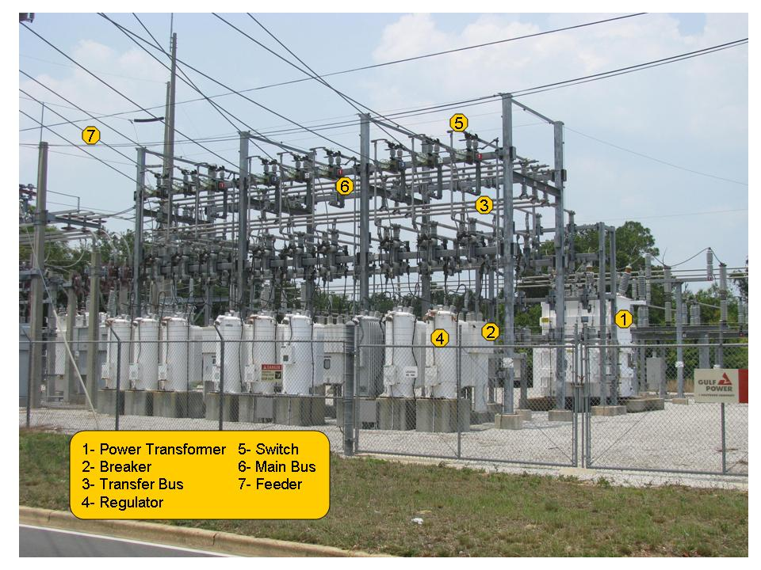

Florida Public Service Commission

           Docket No. 110138-EI

GULF POWER COMPANY

           Witness:  R. Scott Moore

Exhibit No. ____ (RSM-1)

Schedule 2

Page 2 of 3

Feeder

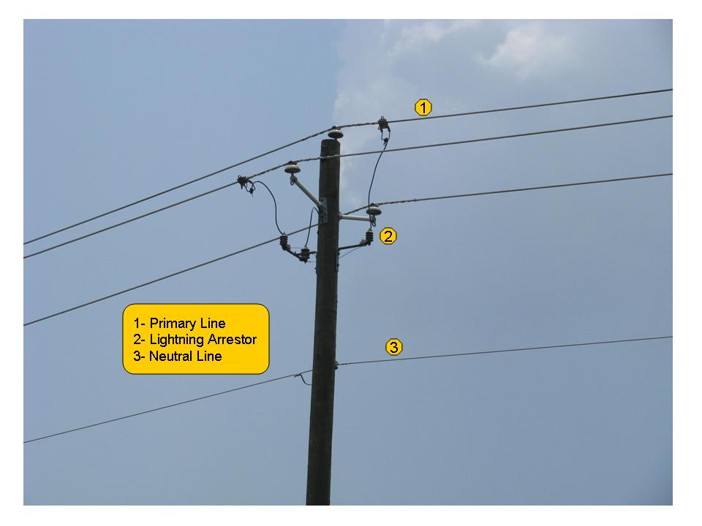

Florida Public Service Commission

           Docket No. 110138-EI

GULF POWER COMPANY

           Witness:  R. Scott Moore

Exhibit No. ____ (RSM-1)

Schedule 2

Page 3 of 3

Lateral Lines

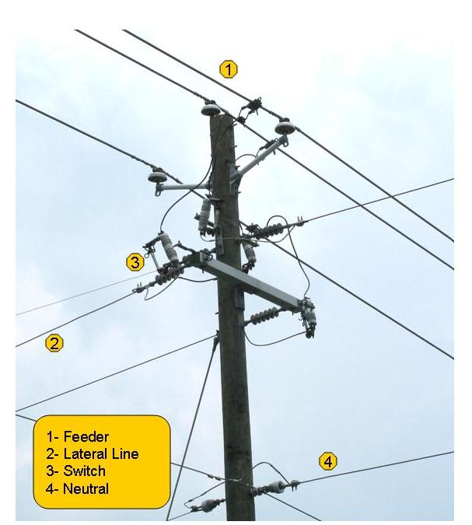

Florida Public Service Commission

           Docket No. 110138-EI

GULF POWER COMPANY

           Witness:  R. Scott Moore

Exhibit No. ____ (RSM-1)

Schedule 3

Page 1 of 1

Electric Power Grid

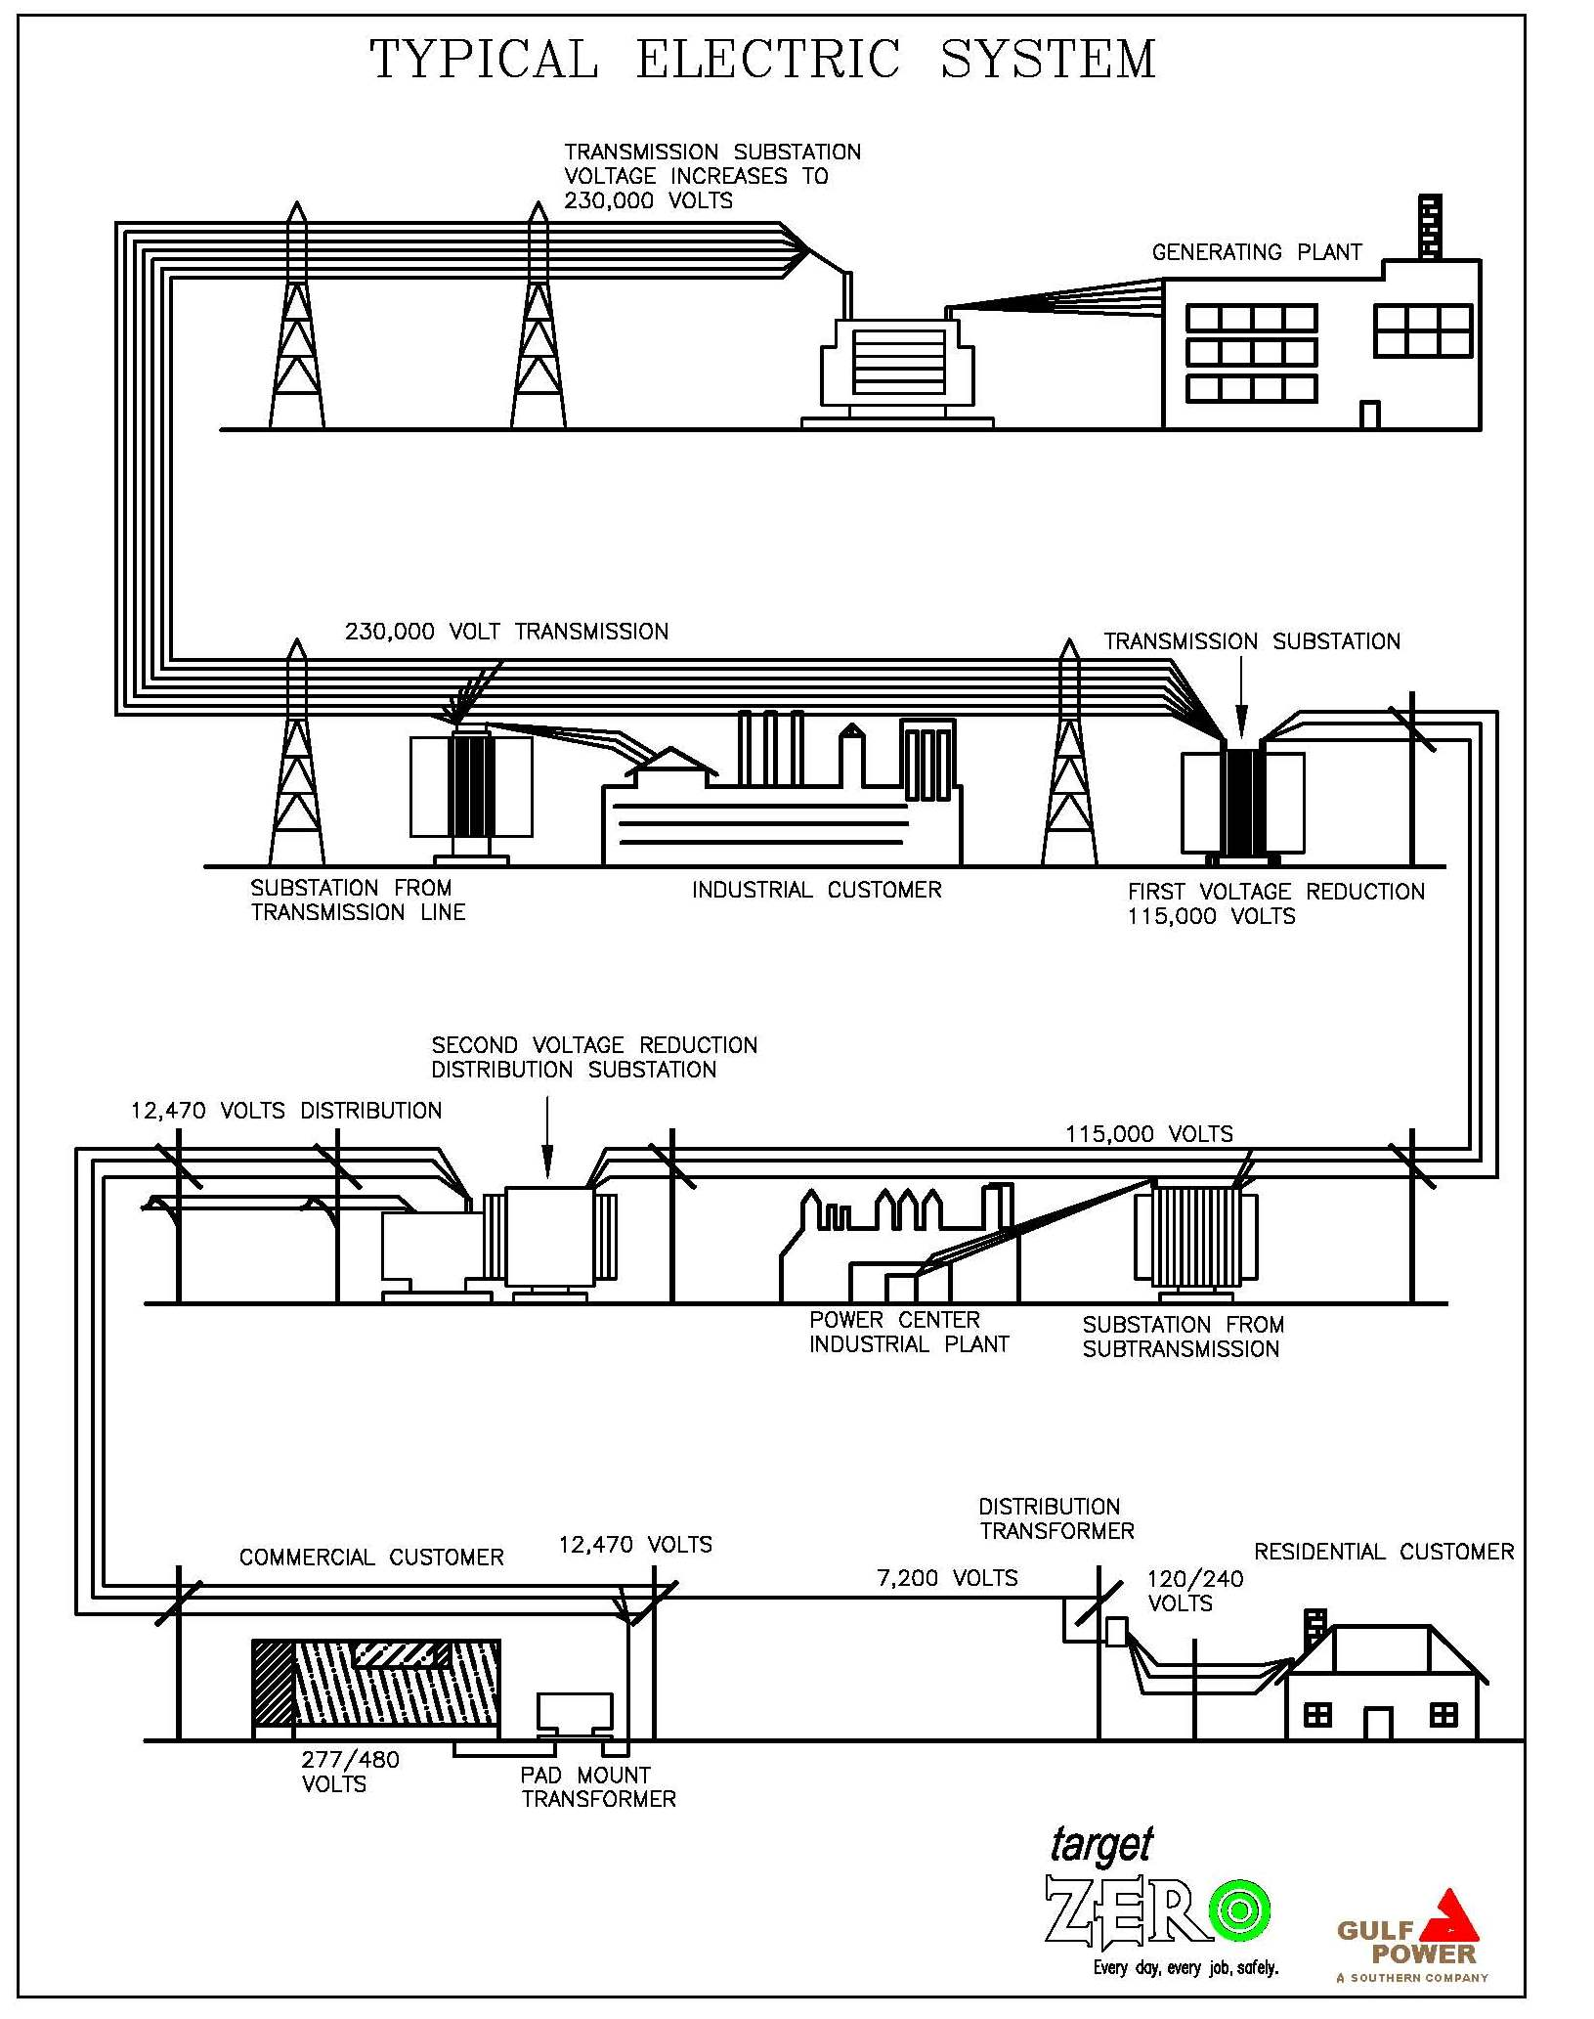

Florida Public Service Commission

           Docket No. 110138-EI

GULF POWER COMPANY

           Witness:  R. Scott Moore

Exhibit No. ____ (RSM-1)

Schedule 4

Page 1 of 1

Gulf Power District Service Areas

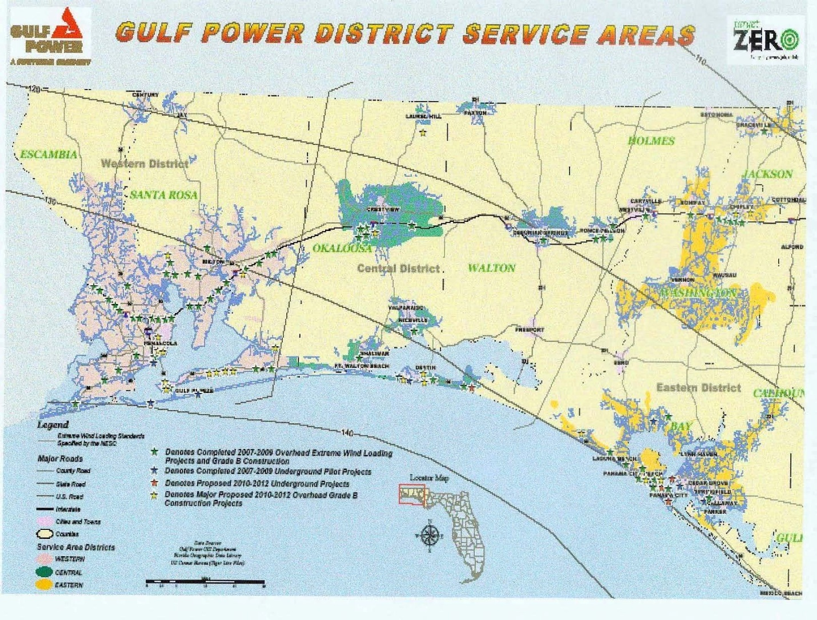

Florida Public Service Commission

           Docket No. 110138-EI

GULF POWER COMPANY

           Witness:  R. Scott Moore

Exhibit No. ____ (RSM-1)

Schedule 5

Page 1 of 1

Gulf Power’s Service Area & Customer Density Areas

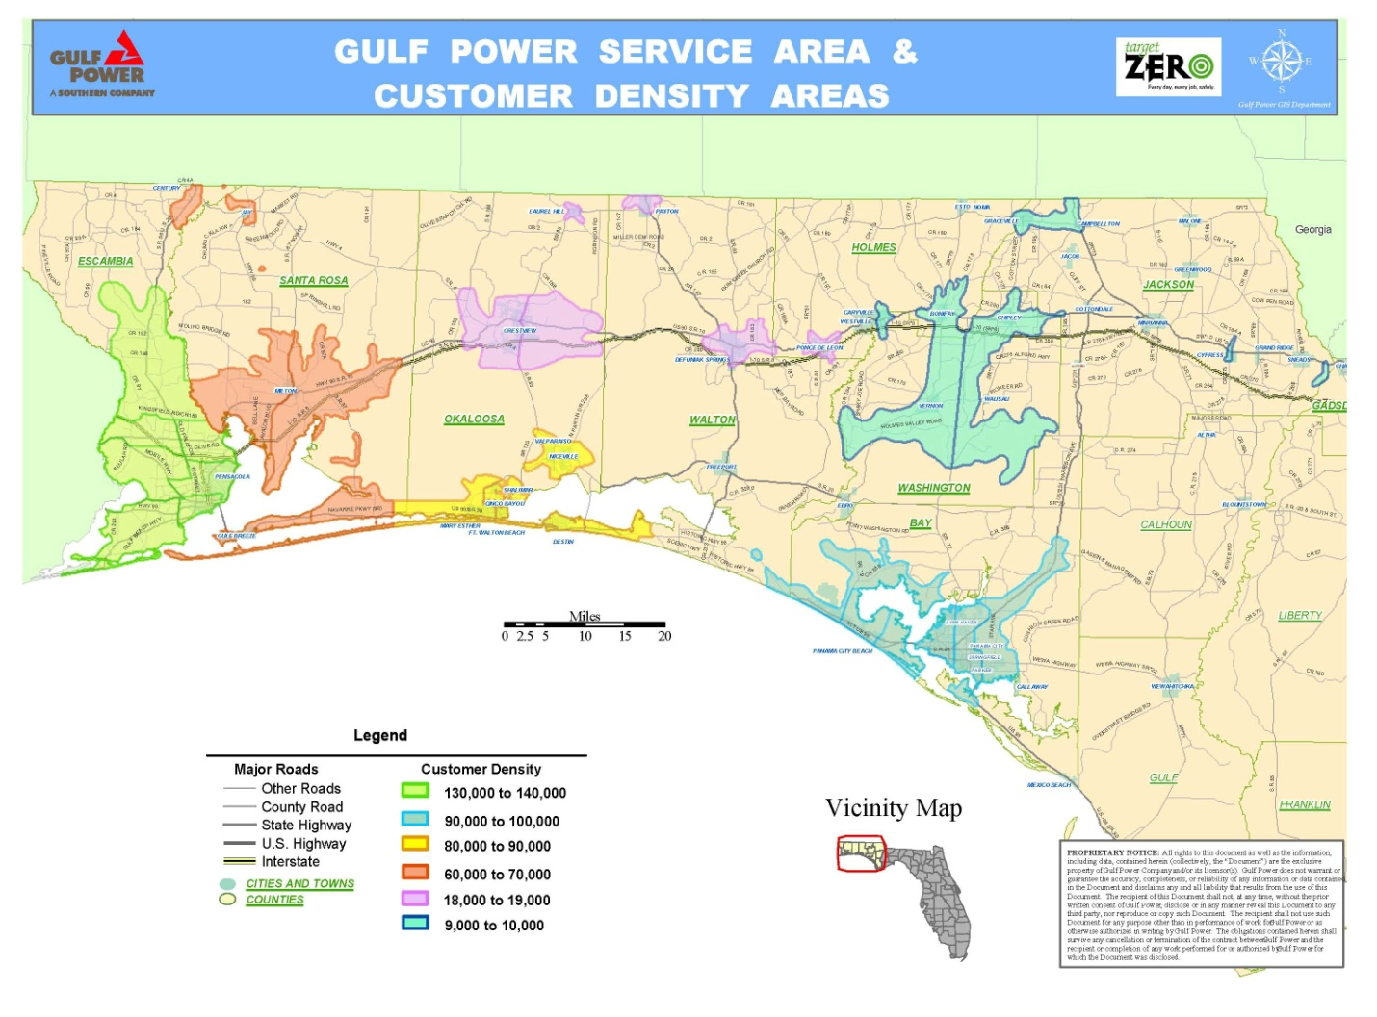

Florida Public Service Commission

           Docket No. 110138-EI

GULF POWER COMPANY

           Witness:  R. Scott Moore

Exhibit No. ____ (RSM-1)

Schedule 6

Page 1 of 1

Land Area in the Florida Panhandle Forested

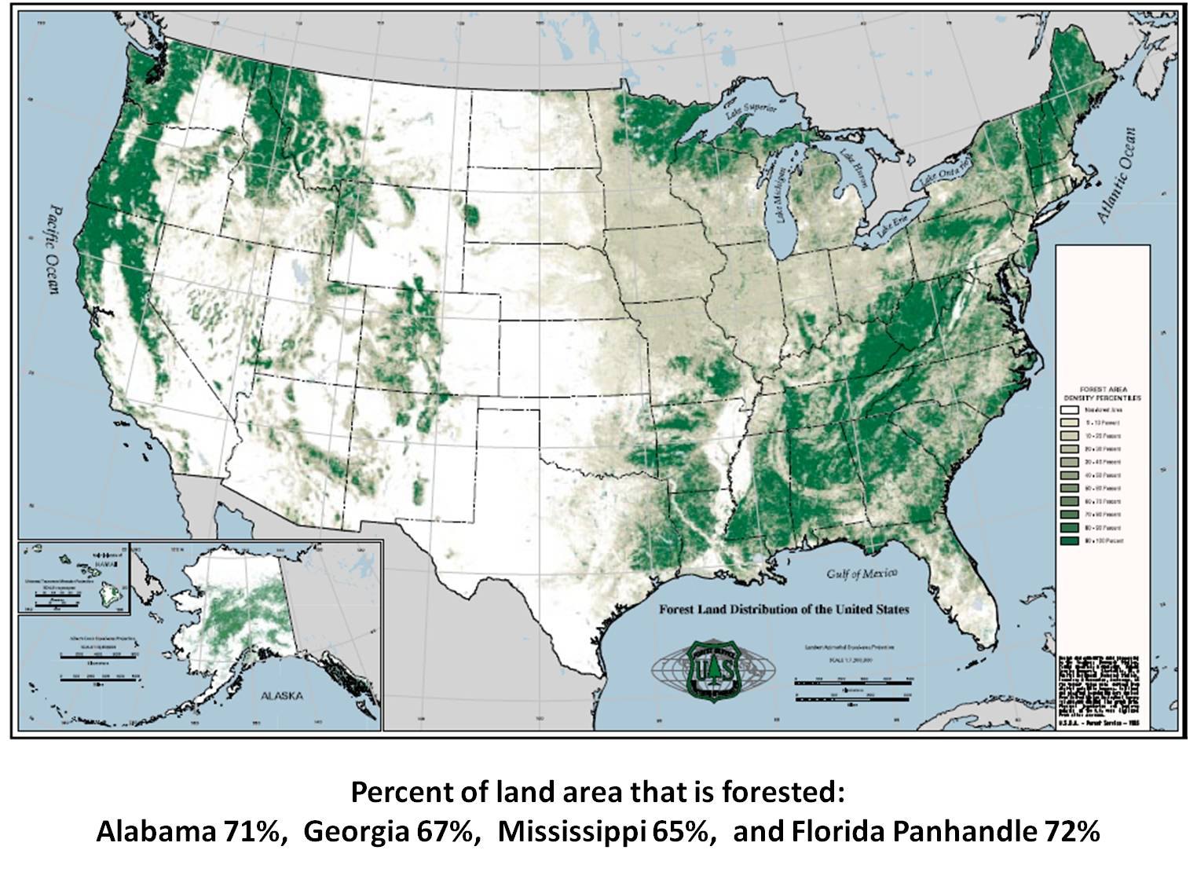

Florida Public Service Commission

           Docket No. 110138-EI

GULF POWER COMPANY

           Witness:  R. Scott Moore

Exhibit No. ____ (RSM-1)

Schedule 7

Page 1 of 1

Vaisala’s National Lightning Detection Network (NLDN)

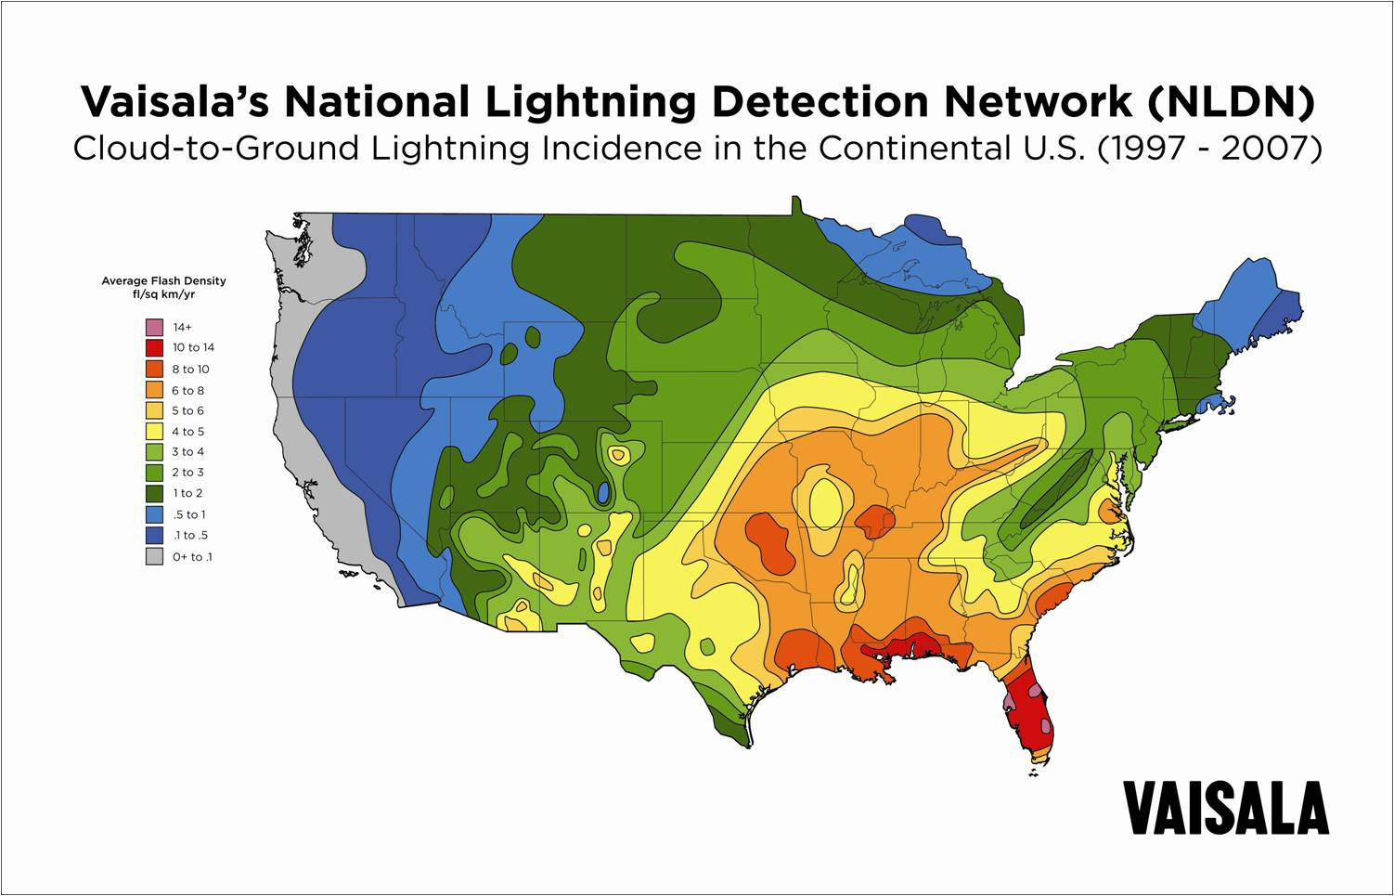

Florida Public Service Commission

           Docket No. 110138-EI

GULF POWER COMPANY

           Witness:  R. Scott Moore

Exhibit No. ____ (RSM-1)

Schedule 8

Page 1 of 1

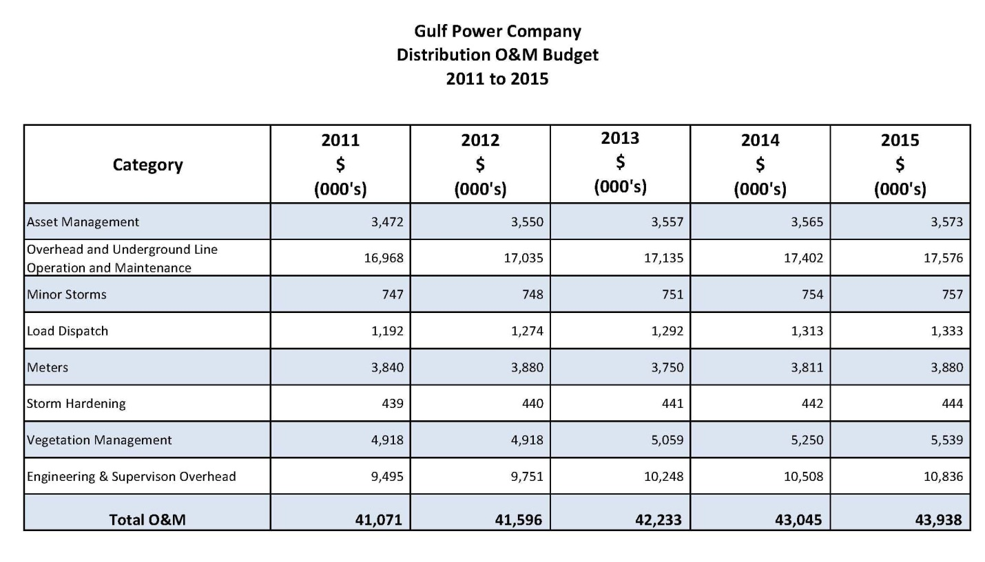

Florida Public Service Commission

Docket No. 110138-EI

GULF POWER COMPANY

           Witness:  R. Scott Moore

Exhibit No. ____ (RSM-1)

Schedule 9

Page 1 of 1

|  |
| --- |
|  |







Florida Public Service Commission

           Docket No. 110138-EI

GULF POWER COMPANY

 Witness:  R. Scott Moore

Exhibit No. ____ (RSM-1)

Schedule 10

Page 1 of 1

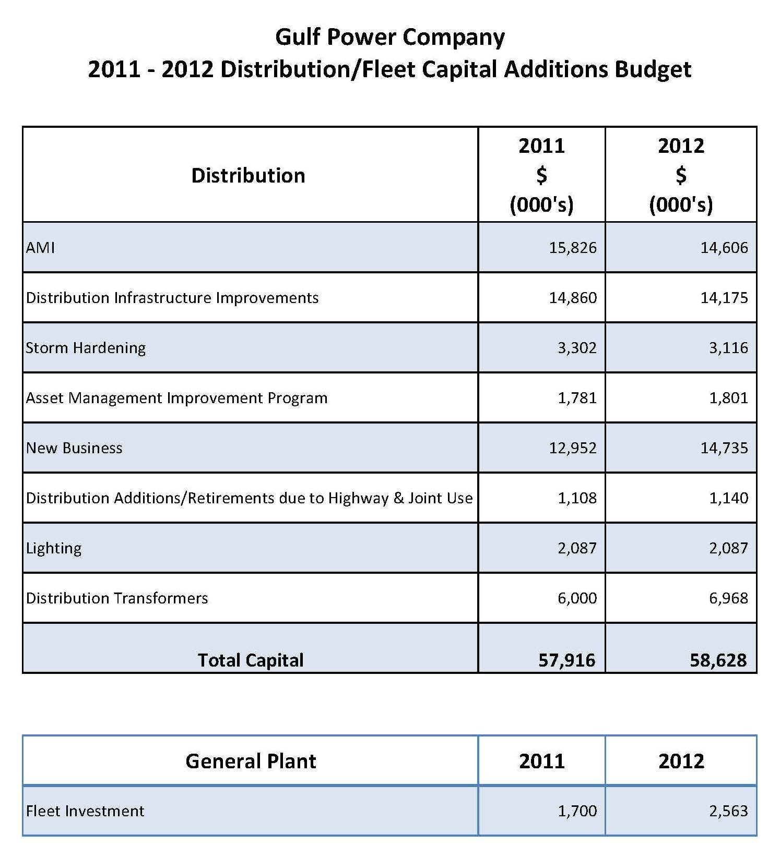

Florida Public Service Commission

           Docket No. 110138-EI

GULF POWER COMPANY

 Witness:  R. Scott Moore

Exhibit No. ____ (RSM-1)

Schedule 11

Page 1 of 1

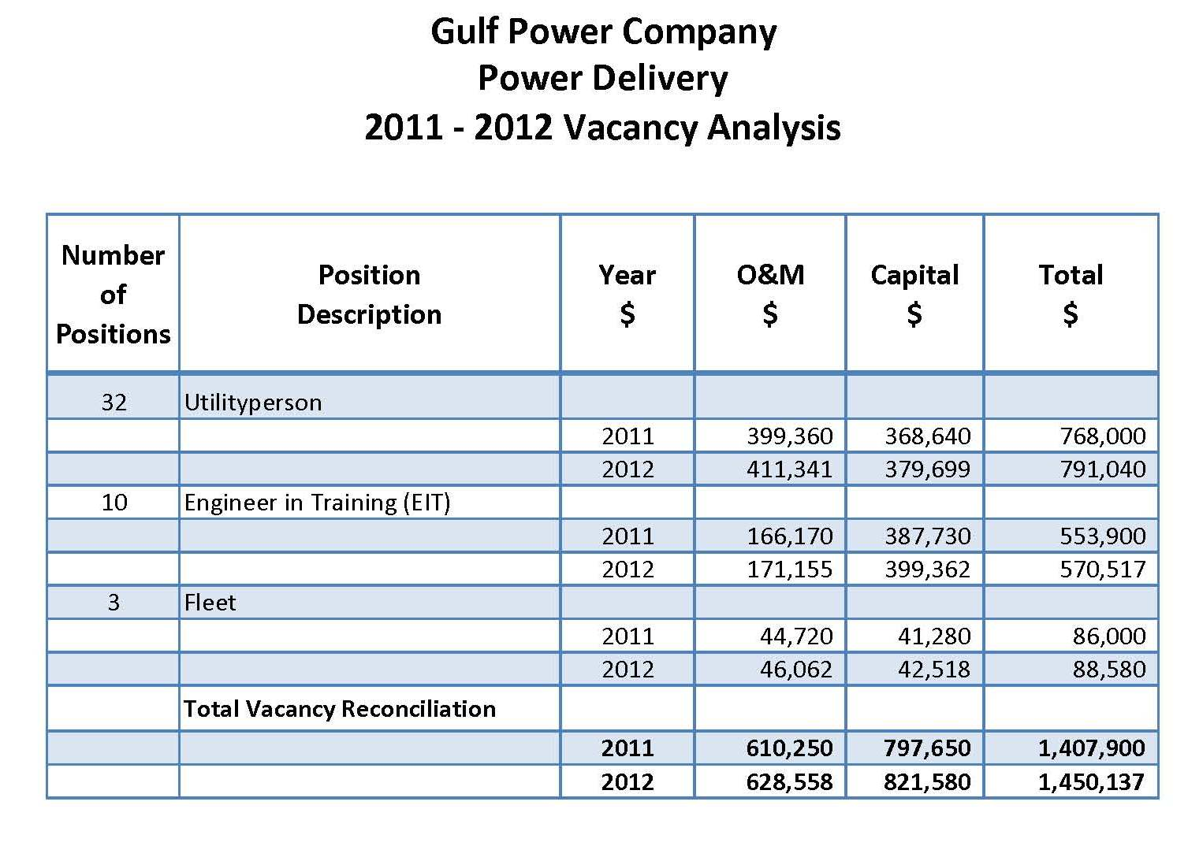

Florida Public Service Commission

           Docket No. 110138-EI

GULF POWER COMPANY

           Witness:  R. Scott Moore

Exhibit No. ____ (RSM-1)

Schedule 12

Page 1 of 5

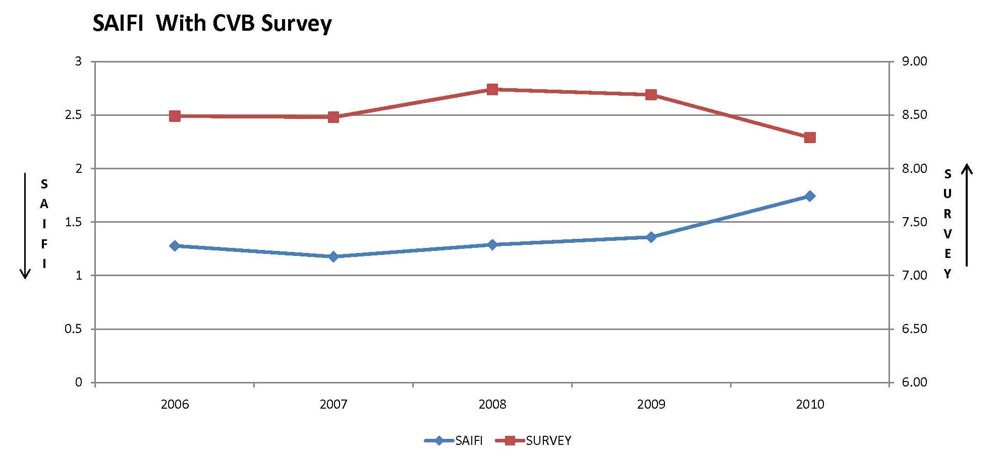

Florida Public Service Commission

           Docket No. 110138-EI

GULF POWER COMPANY

           Witness:  R. Scott Moore

Exhibit No. ____ (RSM-1)

Schedule 12

Page 2 of 5

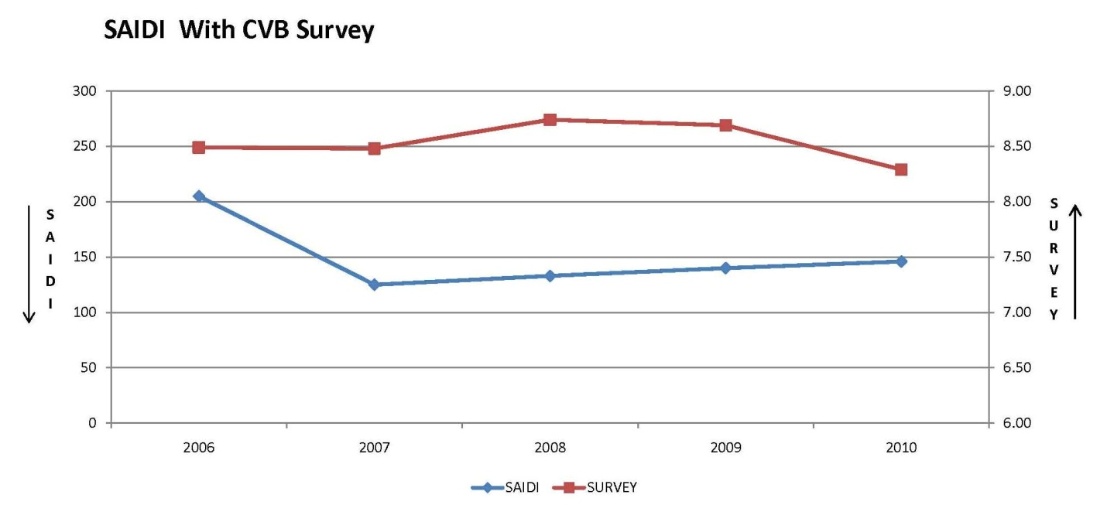

Florida Public Service Commission

           Docket No. 110138-EI

GULF POWER COMPANY

           Witness:  R. Scott Moore

Exhibit No. ____ (RSM-1)

Schedule 12

Page 3 of 5

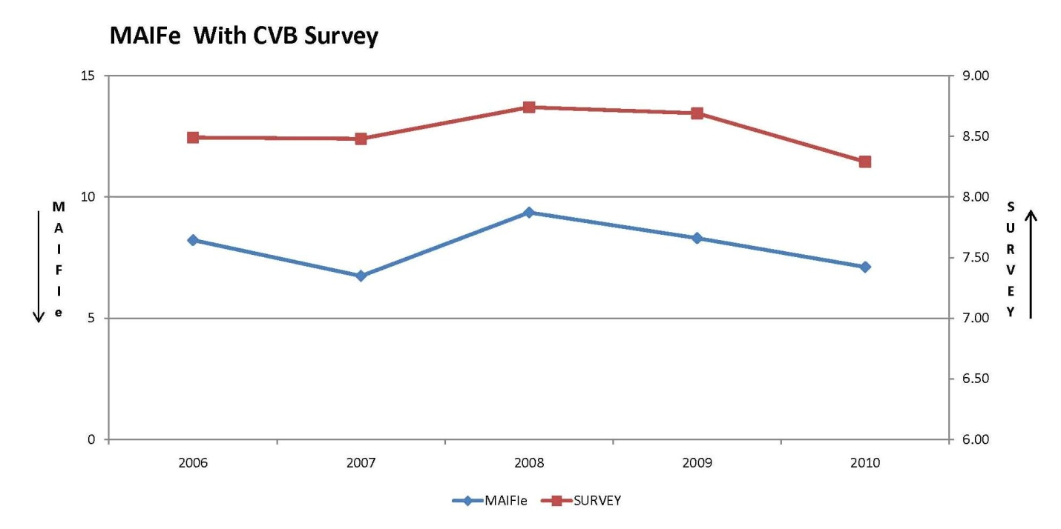

Florida Public Service Commission

           Docket No. 110138-EI

GULF POWER COMPANY

           Witness:  R. Scott Moore

Exhibit No. ____ (RSM-1)

Schedule 12

Page 4 of 5

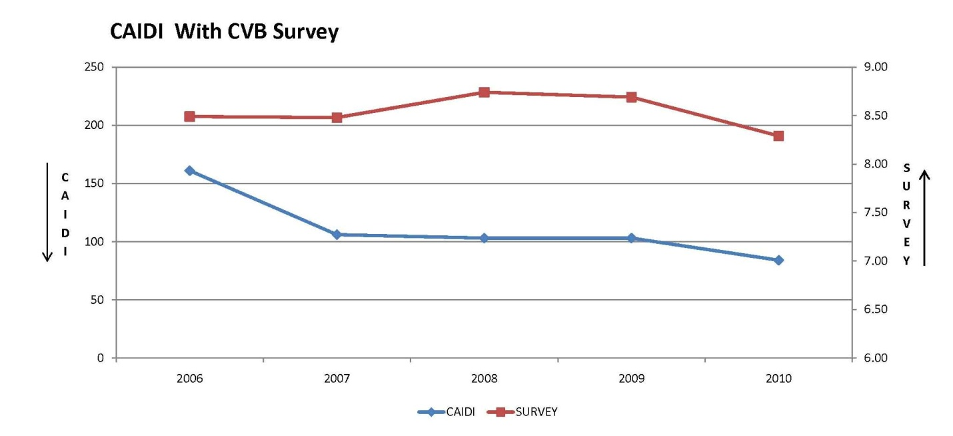

Florida Public Service Commission

           Docket No. 110138-EI

GULF POWER COMPANY

           Witness:  R. Scott Moore

Exhibit No. ____ (RSM-1)

Schedule 12

Page 5 of 5

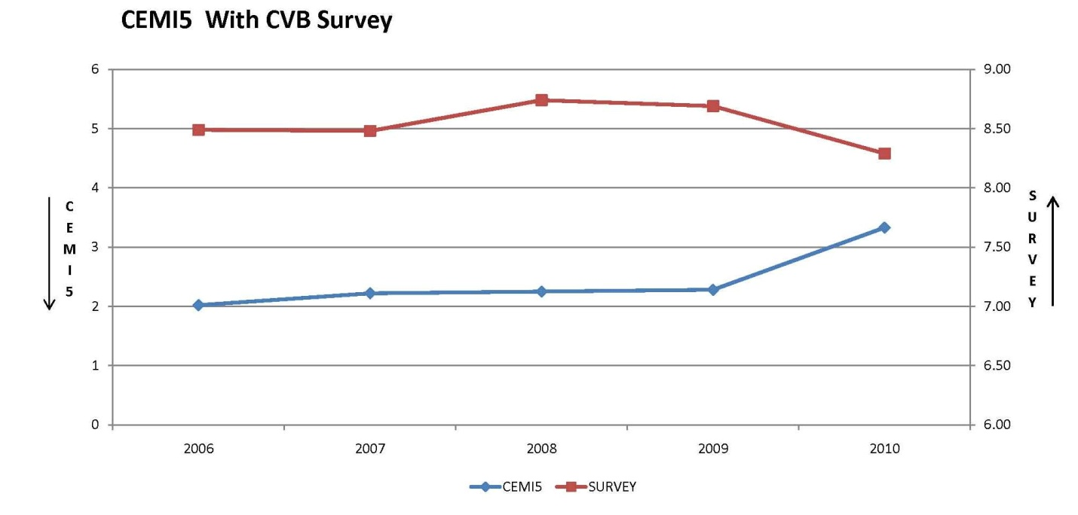

Florida Public Service Commission

           Docket No. 110138-EI

GULF POWER COMPANY

           Witness:  R. Scott Moore

Exhibit No. ____ (RSM-1)

Schedule 13

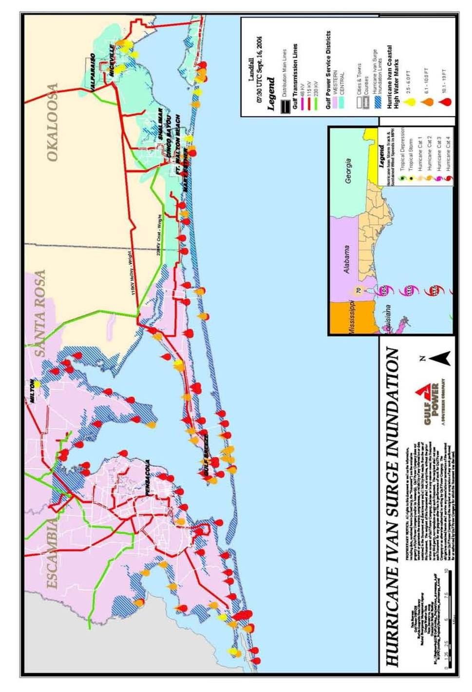 Page 1 of 1

Hurricane Ivan Surge Inundation

Florida Public Service Commission

           Docket No. 110138-EI

GULF POWER COMPANY

           Witness:  R. Scott Moore

Exhibit No. ____ (RSM-1)

Schedule 14

Page 1 of 1

Hurricane Ivan Wind Swaths

