

Supply Chain Management, Code of Conduct

Purpose
The Company is dedicated to conducting its business with honesty, integrity, and impartiality. All employees in the Supply Chain Management Organization are expected to be personally responsible for adherence to the highest standards of ethical behavior. The purpose of this policy is to define generally the standards expected of Supply Chain Management employees and agents in the conduct of their daily business.

Gifts
Employees, agents, and members of their immediate family are prohibited from accepting gifts of any kind
or value that might reasonably be construed as possibly influencing business decisions. Promotional items
of nominal value, such as ball point pens with supplier name affixed, may be accepted as a general business practice since the value is considered minimal and of no consequence. The term “gift” is intended to be inclusive and is not limited to tangible gifts, but shall also include such intangibles as promises for the future, valuable tips or advantageous purchases or sales. Thus, in essence, Supply Chain Management has
a “no gift” policy.

Meals and Entertainment
Reasonable business meals and entertainment on an occasional basis are acceptable when the purpose
is to further the business interest of the Company.

Suppliers
Suppliers will be dealt with in a fair and equitable manner. Evaluation of goods and services will be done objectively, and buying decisions will be made in the best interest of the Company.

Disclosure
Any questionable situations or areas of doubt are to be fully disclosed to the appropriate manager and,
as may be required the Vice President of Supply Chain Management to ensure conformance to the overall purpose and intent of this policy.
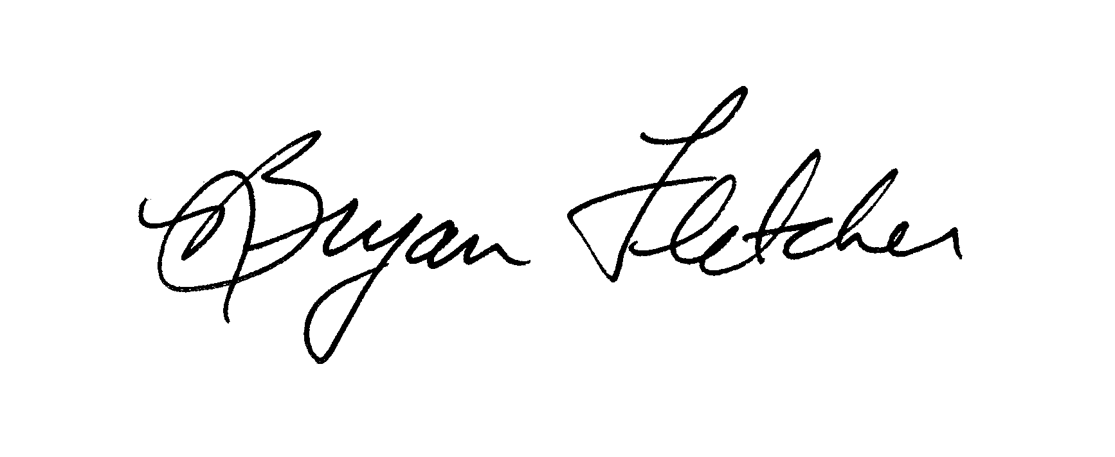

Bryan Fletcher
Southern Company

