FLORIDA PUBLIC SERVICE COMMISSION

NOTICE OF RESCHEDULED RULE DEVELOPMENT WORKSHOP

TO
ALL INTERESTED PERSONS
UNDOCKETED
IN RE: INITIATION OF RULEMAKING TO
ADOPT RULES 25-6.0431 AND 25-7.0391, F.A.C.,
RELATING TO PETITIONS FOR LIMITED PROCEEDINGS
AND TO AMEND RULE 25-22.0406, F.A.C.
CONCERNING NOTICE AND PUBLIC INFORMATION REQUIREMENTS

ISSUED: December 28, 2011
NOTICE is hereby given that the staff rule development workshop scheduled on January 12, 2012, has been rescheduled to March 15, 2012, at the following time and place:

9:30 a.m., Thursday, March 15, 2012
Room 148, Betty Easley Conference Center
4075 Esplanade Way
Tallahassee, FL 32399-0862

The rule development workshop pertains to the adoption of Rules 25-6.0431 and 25-7.0391, F.A.C., relating to petitions for limited proceedings by electric and gas utilities, and the amendment of Rule 25-22.0406, F.A.C., concerning notice and public information requirements for electric and gas utilities and telecommunication companies.

A copy of the draft rules and the agenda for the workshop are attached. One or more Commissioners may be in attendance and participate in the workshop. The person to be contacted regarding this rule development is Kathryn G. W. Cowdery, Office of the General Counsel, 2540 Shumard Oak Boulevard, Tallahassee, Florida 32399-0850, (850) 413-6216, kcowdery@psc.state.fl.us. If you wish to comment but cannot attend the workshop, please submit your comments by March 15, 2012 to Ms. Cowdery at the above address.

In accordance with the Americans with Disabilities Act, persons requiring a special accommodation to participate at this workshop should contact the Office of Commission Clerk no later than five days prior to the workshop at 2540 Shumard Oak Boulevard., Tallahassee, Florida 32399-0850, via 1-800-955-8770 (Voice) or 1-800-955-8771 (TDD), Florida Relay Service.

By DIRECTION of the Florida Public Service Commission this 28th day of December, 2011.

/s/ Ann Cole
ANN COLE
Commission Clerk
Florida Public Service Commission
2540 Shumard Oak Boulevard
Tallahassee, FL 32399
(850) 413-6770
www.floridapsc.com

KC

AGENDA

FLORIDA PUBLIC SERVICE COMMISSION

STAFF RULE DEVELOPMENT WORKSHOP

INITIATION OF RULEMAKING TO
ADOPT RULES 25-6.0431 AND 25-7.0391, F.A.C.,
RELATING TO PETITIONS FOR LIMITED PROCEEDINGS
AND TO AMEND RULE 25-22.0406, F.A.C.
CONCERNING NOTICE AND PUBLIC INFORMATION REQUIREMENTS

Undocketed

March 15, 2012
9:30 A.M.
Betty Easley Conference Center, Room 148
4075 Esplanade Way
Tallahassee Florida

1. Order of presentation. Staff will explain the proposed rules and rule amendments and solicit comments and/or questions, in the following order:

a. 25-6.0431
b. 25-7.0391
c. 25-22.0406

2. Any Other Matters for Discussion

3. Discussion of Next Steps in this Rulemaking

4. Adjourn

25-6.0431 Petition for a Limited Proceeding
(1) This rule shall apply to petitions for a limited proceeding filed pursuant to section 366.076(1), Florida Statutes, which result in changes to base rates to existing customers, subject to the restrictions contained in section (10) of this rule.
(2) Each petition for a limited proceeding shall provide the following general information to the Commission:
(a) The name of the applicant and the address of the applicant’s principal place of business;
(b) The number(s) of the Commission order(s), in which the Commission most recently considered the applicant’s base rates, including consideration of a settlement agreement concerning base rates;
(c) The addresses within the service area where the petition is available for customer inspection during the time the petition is pending; and
(d) A detailed statement of the reason(s) why the limited proceeding has been requested and why a limited proceeding is the appropriate type of proceeding for consideration of the requested relief.
(3) If the utility’s petition includes a request for recovery of rate base components, the following minimum filing requirements shall be filed with the utility’s petition:
(a) A schedule showing the specific rate base components for which the utility seeks recovery, on both a system and jurisdictional basis. The following supporting detail shall be provided for each item requested:
1. the actual or projected cost(s);
2. the date the item was, or is projected to be, placed in service;
3. any corresponding adjustments that are required as a result of adding or removing the requested component(s) from rate base, which may include retirement entries; and
4. all supporting detail by primary account as defined by the Uniform System of Accounts, in accordance with Rule 25-6.014, F.A.C.;
(b) A calculation of the weighted average cost of capital for the most recent twelve-month period, using the mid-point of the range of the last authorized rate of return on equity, the current embedded cost of fixed-rate capital, the actual cost of short-term debt, the actual cost of variable-cost debt, and the actual cost of other sources of capital which were used in the last individual rate proceeding of the utility; and
(c) Detailed descriptions and calculations of all cost savings arising from the implementation of the requested cost recovery items.
(4) If the utility is requesting recovery of operating expenses, the following information shall be provided on both a system and jurisdictional basis:
(a) A detailed description of the expense(s) requested;
(b) The total cost by primary account pursuant to the Uniform System of Accounts;
(c) Supporting documentation or calculations;
(d) Any allocations that are made between systems, affiliates or related parties, including full detail that shows the total amount allocated, a description of the basis of the allocation methodology, the allocation percentage applied to each allocated cost, and the workpapers supporting the calculation of the allocation percentages; and
(e) Calculations for all items or actions that will create cost savings or revenue impacts from the implementation of the requested cost recovery items.
(5) The petition shall identify any impact on retail base rates, including:
(a) A calculation of the revenue change;
(b) Schedules showing jurisdictional rate base, net operating income, cost of capital, and achieved return on equity for both the most recent twelve-month period and the projected 12 month period, if applicable, which demonstrate that, without any increased rates, the utility will earn below its authorized minimum rate of return on equity. The schedules shall include adjustments consistent with the utility’s last rate proceeding, and the annualization of any rate changes occurring during the period. The pro forma effect of each proposal shall be shown separately on the schedules;
(c) A schedule showing how the utility proposes to allocate any change in revenues to rate classes;
(d) A schedule of current and proposed rates for all rate schedules, along with workpapers showing how those rates were derived; and
(e) If the limited proceeding is being requested solely to change the current cost allocation or rate structure on a revenue-neutral basis, the utility shall provide a copy of all workpapers and calculations used to calculate requested rates and allocations between customer classes, and a description of the customer migrations between rate schedules resulting from the restructuring. In addition, the petition shall include the following schedules from Form PSC/ECR/011-E(2/04), entitled “Minimum Filing Requirements for Investor-Owned Electric Utilities,” which is incorporated by reference in Rule 25-6.043, F.A.C.:
1. Schedule E-1, entitled “Cost of Service Studies,”
2. Schedule E-6a, entitled “Cost of Service Study – Unit Costs, Present Rates,”
3. Schedule E-6b, entitled “Cost of Service Study – Unit Costs, Proposed Rates,”
4. Schedule E-8, entitled “Company-Proposed Allocation of the Rate Increase by Rate Class,”
5. Schedule E-13a, entitled “Revenue from Sale of Electricity by Rate Schedule,”
6. Schedule E-13c, entitled “Base Revenue by Rate Schedule – Calculations,”
7. Schedule E-13d, entitled “Revenue by Rate Schedule – Lighting Schedule Calculation,”
8. Schedule E-14, entitled “Proposed Tariff Sheets and Support for Charges.”
These schedules can be obtained from the Commission’s Division of Economic Regulation.
(6) A petition for a limited proceeding shall be processed using the proposed agency action procedure set forth in this rule unless the Commission orders the petition to be set directly for hearing.
(7) A petition for limited proceeding using proposed agency action procedure shall be subject to the following provisions:
(a) Pending a final order by the Commission, the Commission may withhold consent to the operation of all or any portion of the new rate schedules, delivering to the utility requesting such increase, within 60 days, a reason or written statement of good cause for withholding its consent.
(b) The Commission shall enter its vote on the proposed agency action within 5 months of the commencement date for final agency action.
(c) If the Commission’s proposed agency action is protested, the final decision must be rendered by the Commission within 8 months of the date the protest is filed.
(d) At the expiration of 5 months following the commencement date for final agency action, if the Commission has not taken action, or if the Commission’s action is protested by a party other than the utility, the utility may place its requested rates into effect under bond, escrow, or corporate undertaking subject to refund, upon notice to the Commission and filing the appropriate tariffs. The Commission shall, by order, require such public utility to keep accurate account in detail of all amounts received by reason of such increase, specifying by whom and in whose behalf such amounts were paid.
(e) In its final order on the petition for limited proceeding, the Commission shall order the utility to refund with interest, pursuant to Rule 25-6.109, F.A.C., such portion of the increased rate or charge which is found not to be justified and which is collected during the periods specified.
(f) Any portion of such refund not thus refunded to patrons or customers of the public utility shall be refunded or disposed of by the public utility as the Commission may direct; however, no such funds shall accrue to the benefit of the public utility.
(8) If the Commission orders the petition to be set directly for hearing, the following procedure shall apply:
(a) Pending a final order by the Commission, the Commission may withhold consent to the operation of all or any portion of the new rate schedules, delivering to the utility requesting such increase, within 60 days, a reason or written statement of good cause for withholding its consent.
(b) Such consent shall not be withheld for a period longer than 8 months from the date of filing the new rate schedules.
(c) The new rates, or any portion not consented to, may go into effect under bond or corporate undertaking at the end of such period, but the Commission shall, by order, require such public utility to keep accurate account in detail of all amounts received by reason of such increase, specifying by whom and in whose behalf such amounts were paid.
(d) In its final order on the petition for limited proceeding, the Commission shall order the utility to refund with interest, pursuant to Rule 25-6.109, F.A.C., such portion of the increased rate or charge which is found not to be justified and which is collected during the periods specified.
(e) Any portion of such refund not thus refunded to patrons or customers of the public utility shall be refunded or disposed of by the public utility as the Commission may direct; however, no such funds shall accrue to the benefit of the public utility.
(f) The Commission shall take final action in the docket and enter its final order within 12 months of the commencement date for final agency action.
(9) Determination of Commencement Date
(a) As used in this rule, the “commencement date for final agency action” means the date upon which it has been determined by the Commission or its designee that the utility has filed with the clerk the minimum filing information as established by this rule.
(b) Within 30 days after receipt of the petition, the Commission or its designee shall either determine the commencement date for final agency action or issue a statement of deficiencies to the petitioner, specifically listing why the petition has failed to provide the minimum filing information required by this rule. Thereafter, within 15 days after the petitioner indicates to the Commission that it believes that it has filed the required minimum filing information, the Commission or its designee shall either determine the commencement date for final agency action or specifically enumerate in writing why the requirements have not been met, in which case this procedure shall be repeated until the commencement date for final agency action is established.
(c) The Director of the Division of Economic Regulation shall be the designee of the Commission for purposes of determining whether the utility has filed the minimum filing information required by this rule.
(10) A petition for a limited proceeding shall be denied if the Commission finds that:
(a) The utility is earning, or is projected to earn, above the minimum of its authorized rate of return, as shown on its most recent Earnings Surveillance Report filed pursuant to Rule 25-6.1352, if the requested costs are included in its earnings surveillance report; or
(b) The utility’s filing includes more than two separate projects for which recovery would result in a change in base rates to existing customers. Corresponding accounting adjustments for a given proposal are not subject to the above limitation; or
(c) The total increase in revenue requirement for the completed project exceeds five percent of the utility’s most recent twelve month annual jurisdiction base rate revenue; or
(d) The requested plant addition received an affirmative determination of need from the Commission pursuant to section 403.519, Florida Statutes.
(11) An original and 20 copies of the petition and supporting documentation shall be filed with the Office of Commission Clerk. To the extent possible, all filings made electronically or on diskette shall be provided in Microsoft Word format and all schedules and calculations shall be provided in Excel format with formulas intact and unlocked.
Rulemaking Authority: 350.127(2), 366.05, 366.06(1) F.S. Law Implemented: 366.05(1), 366.06(1), 366.076(1) F.S.
History - New:____________

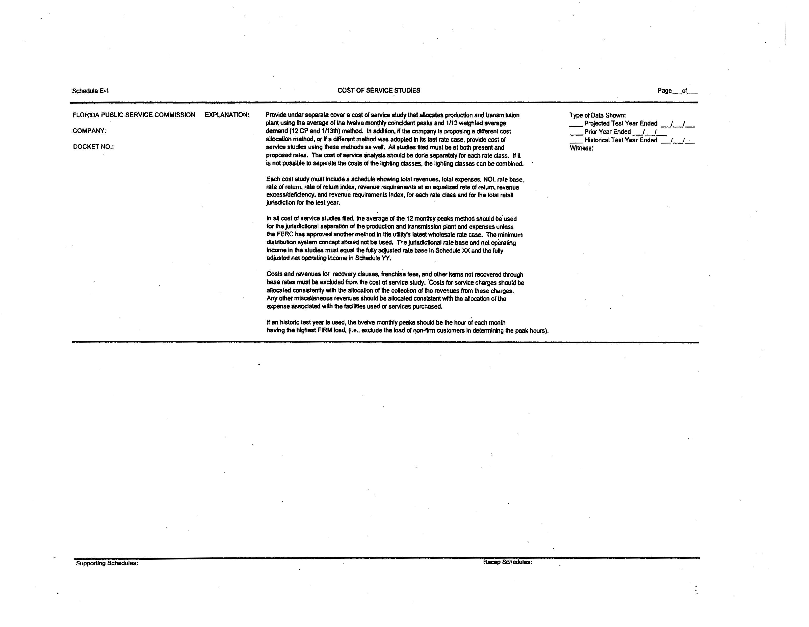
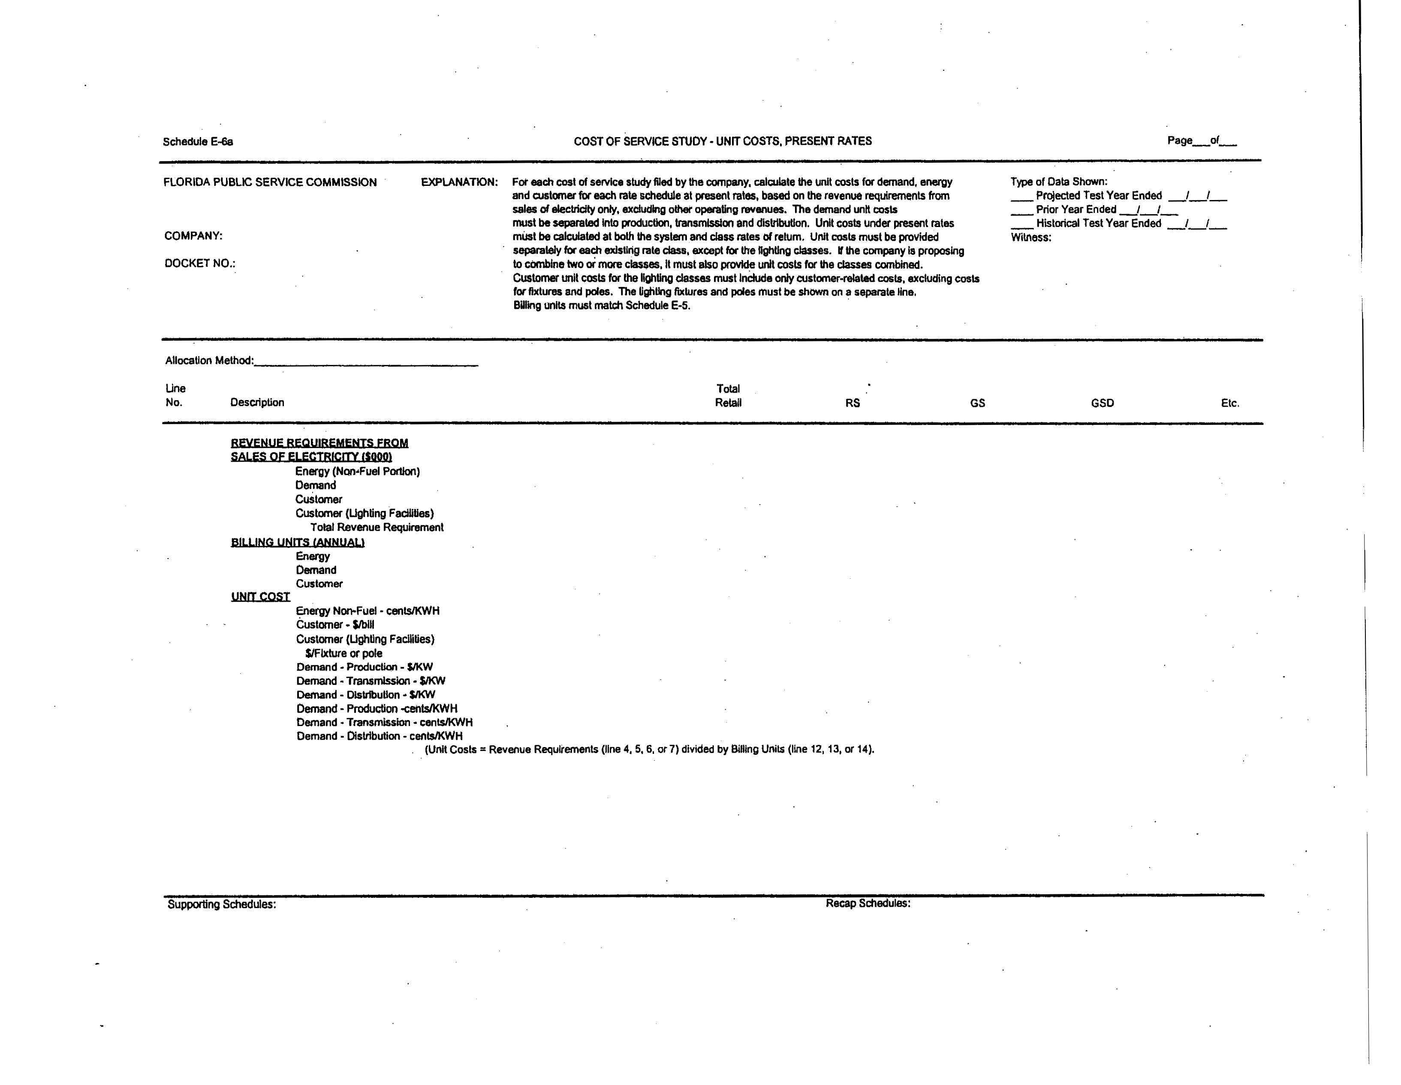
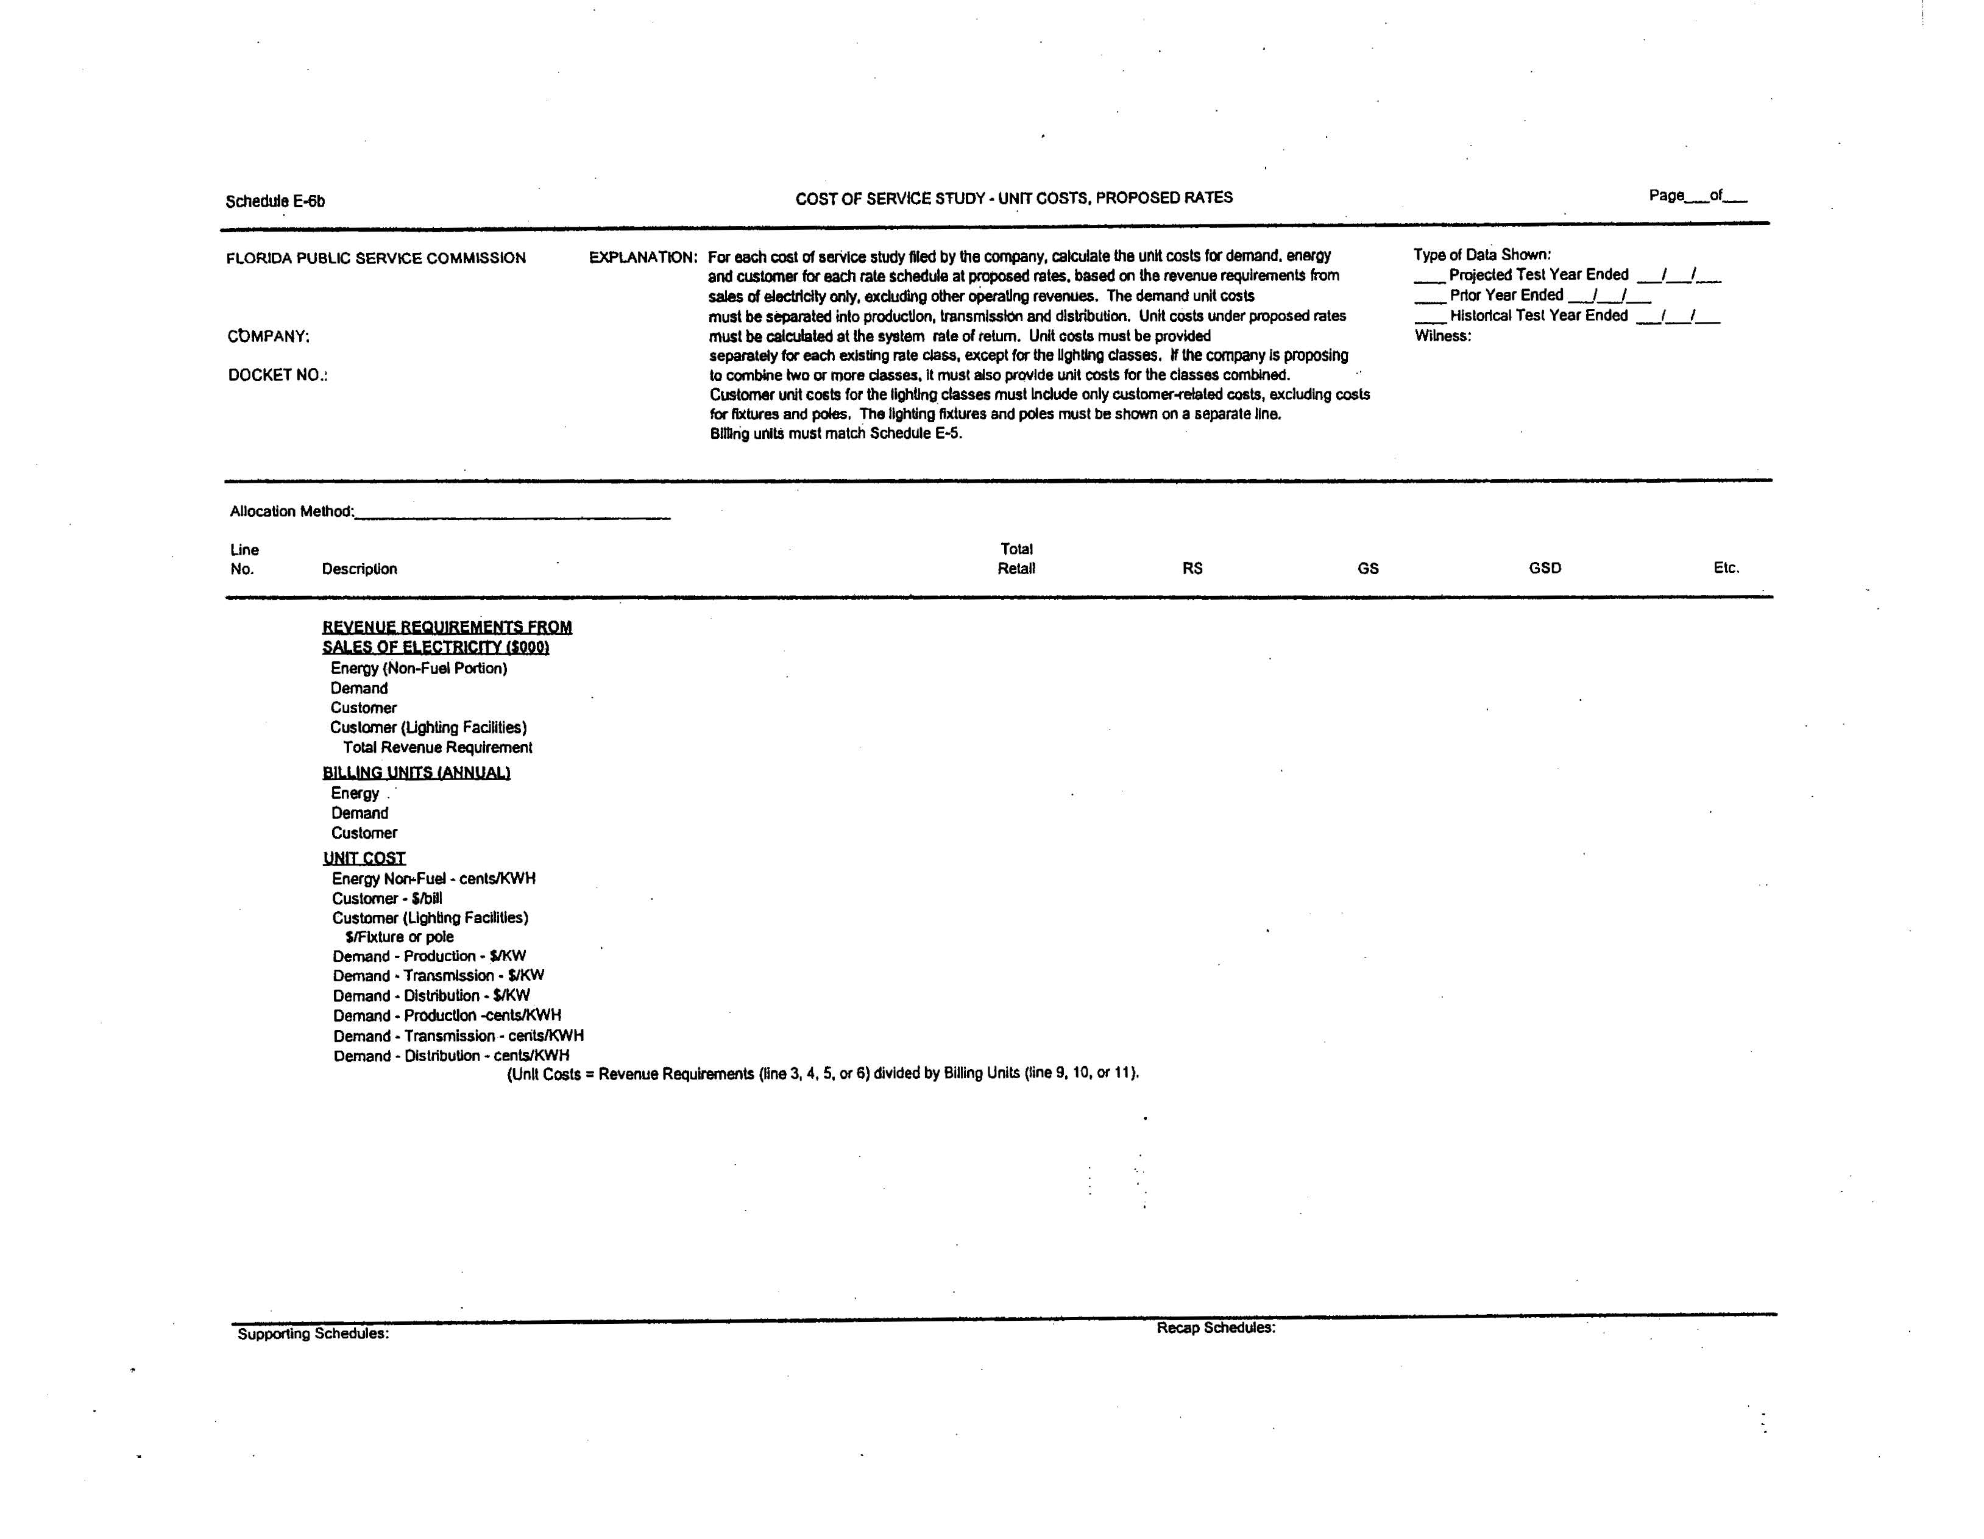
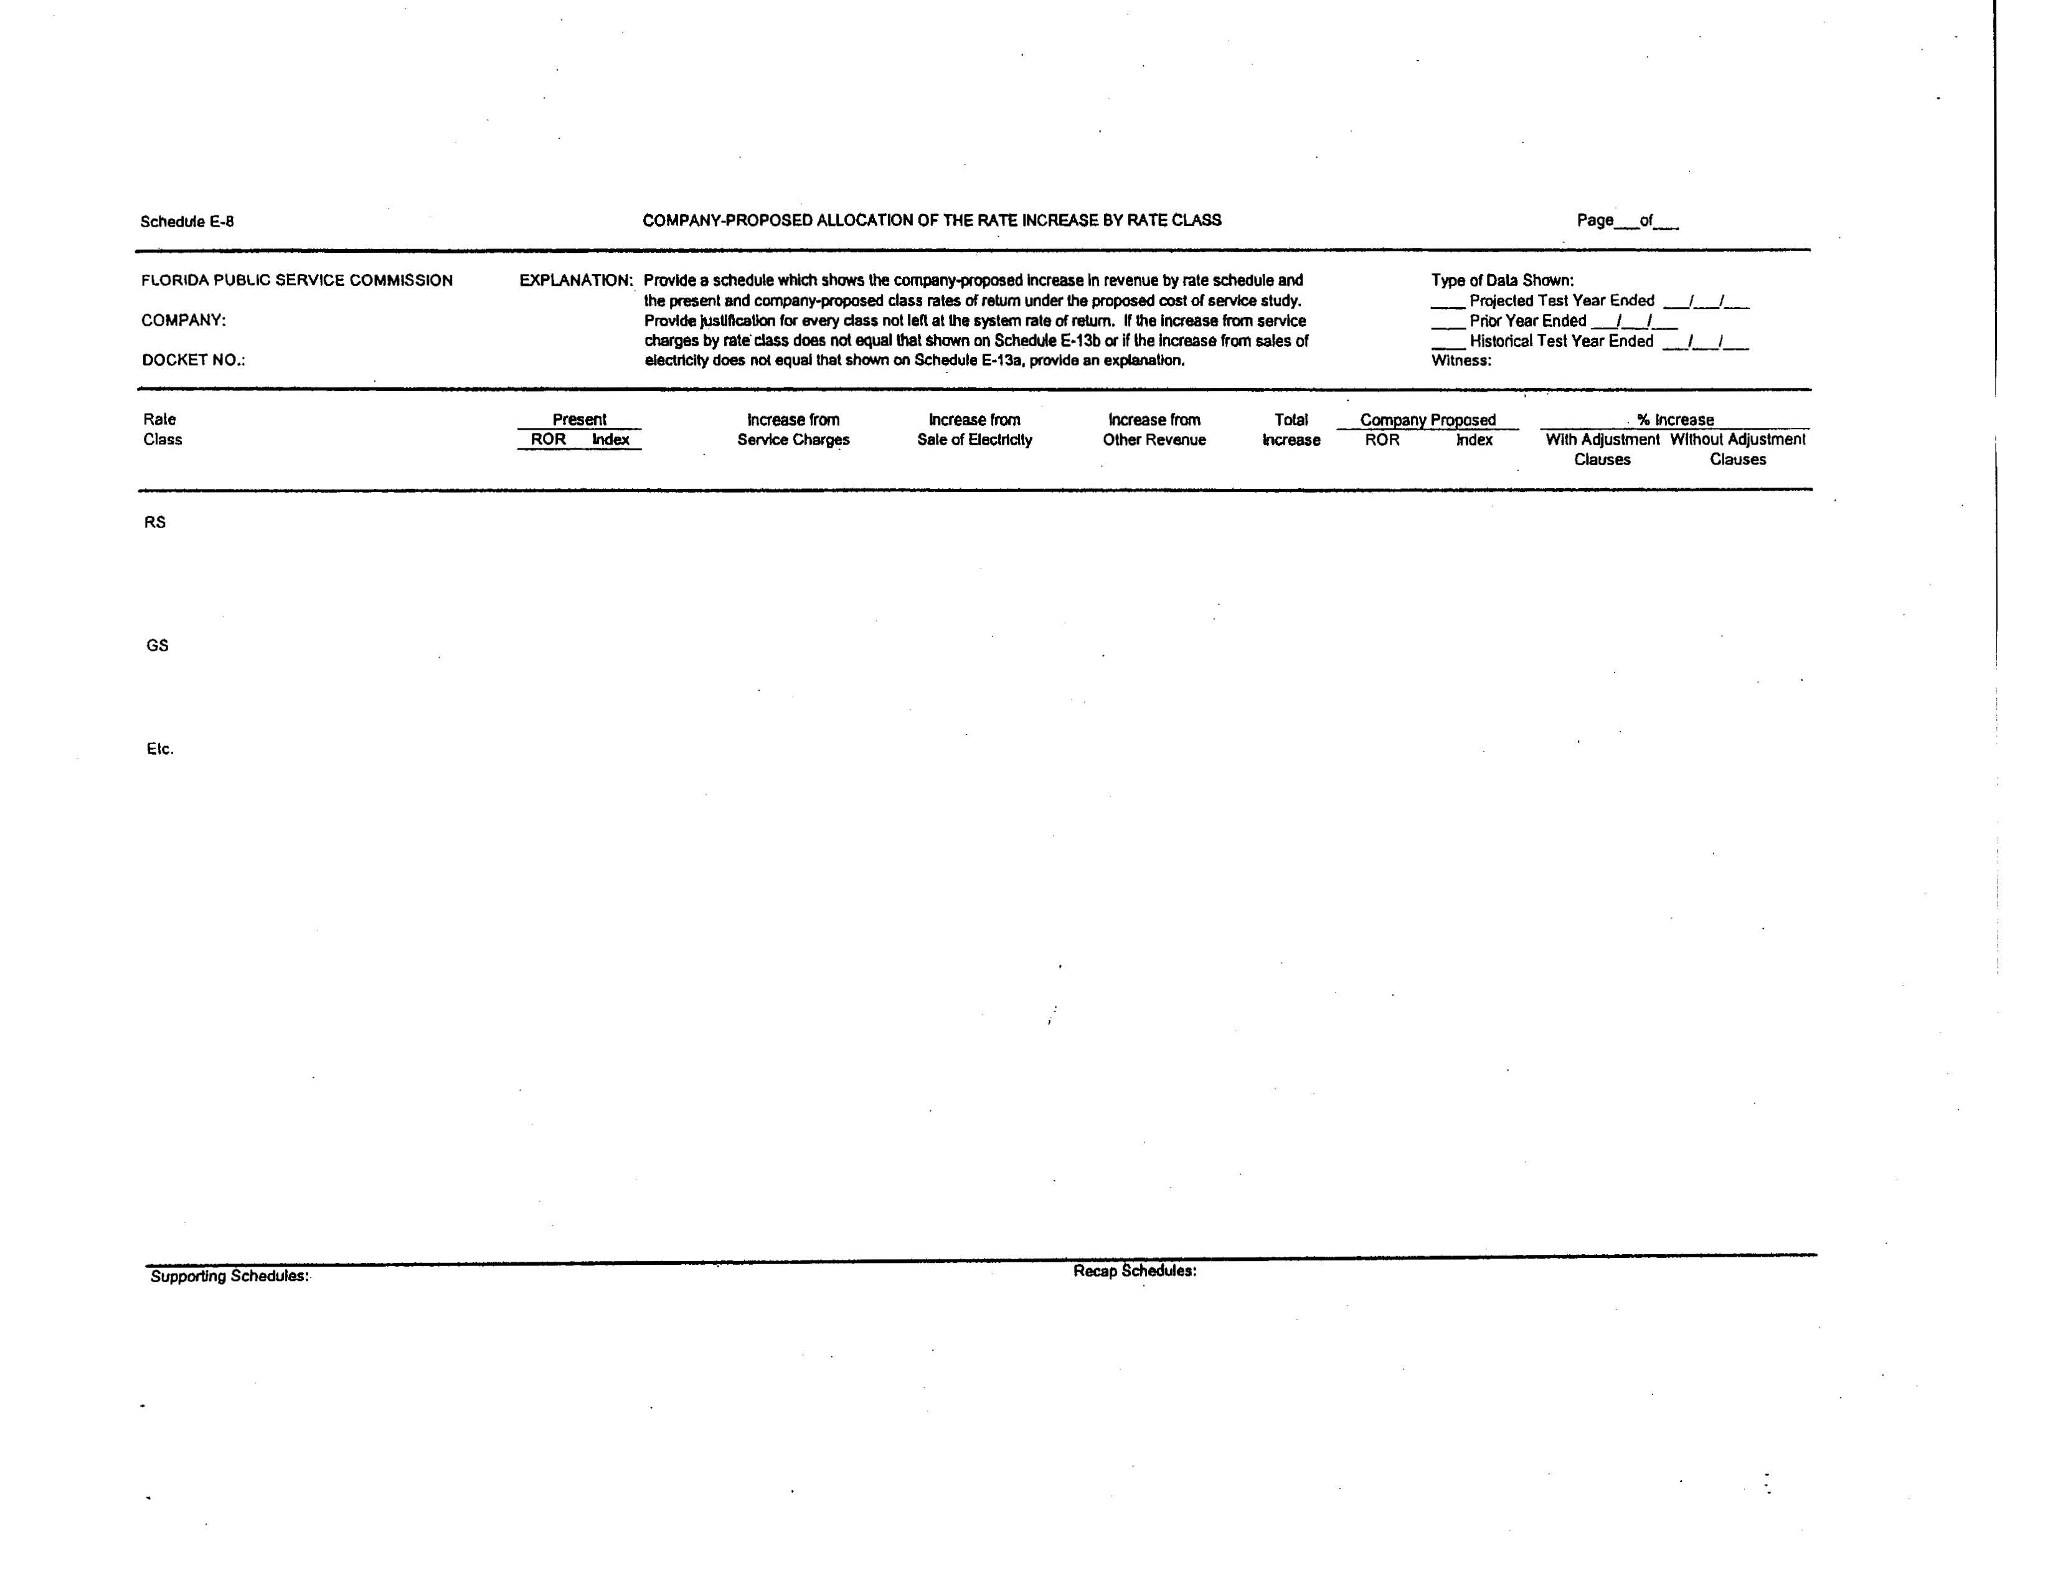
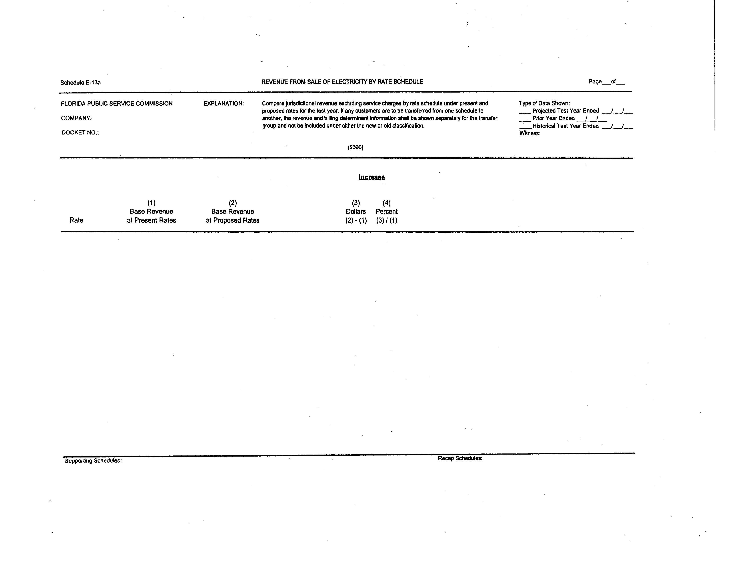
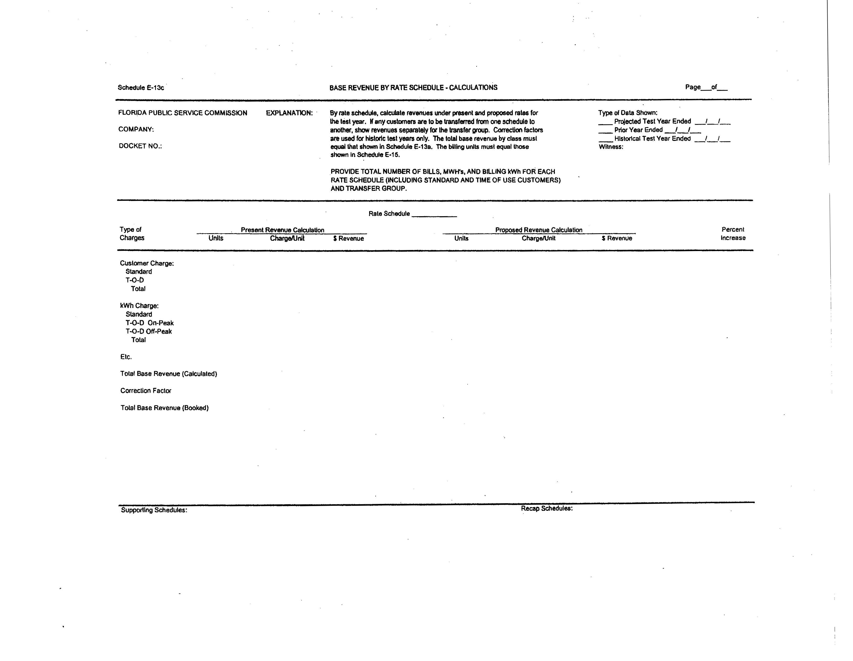
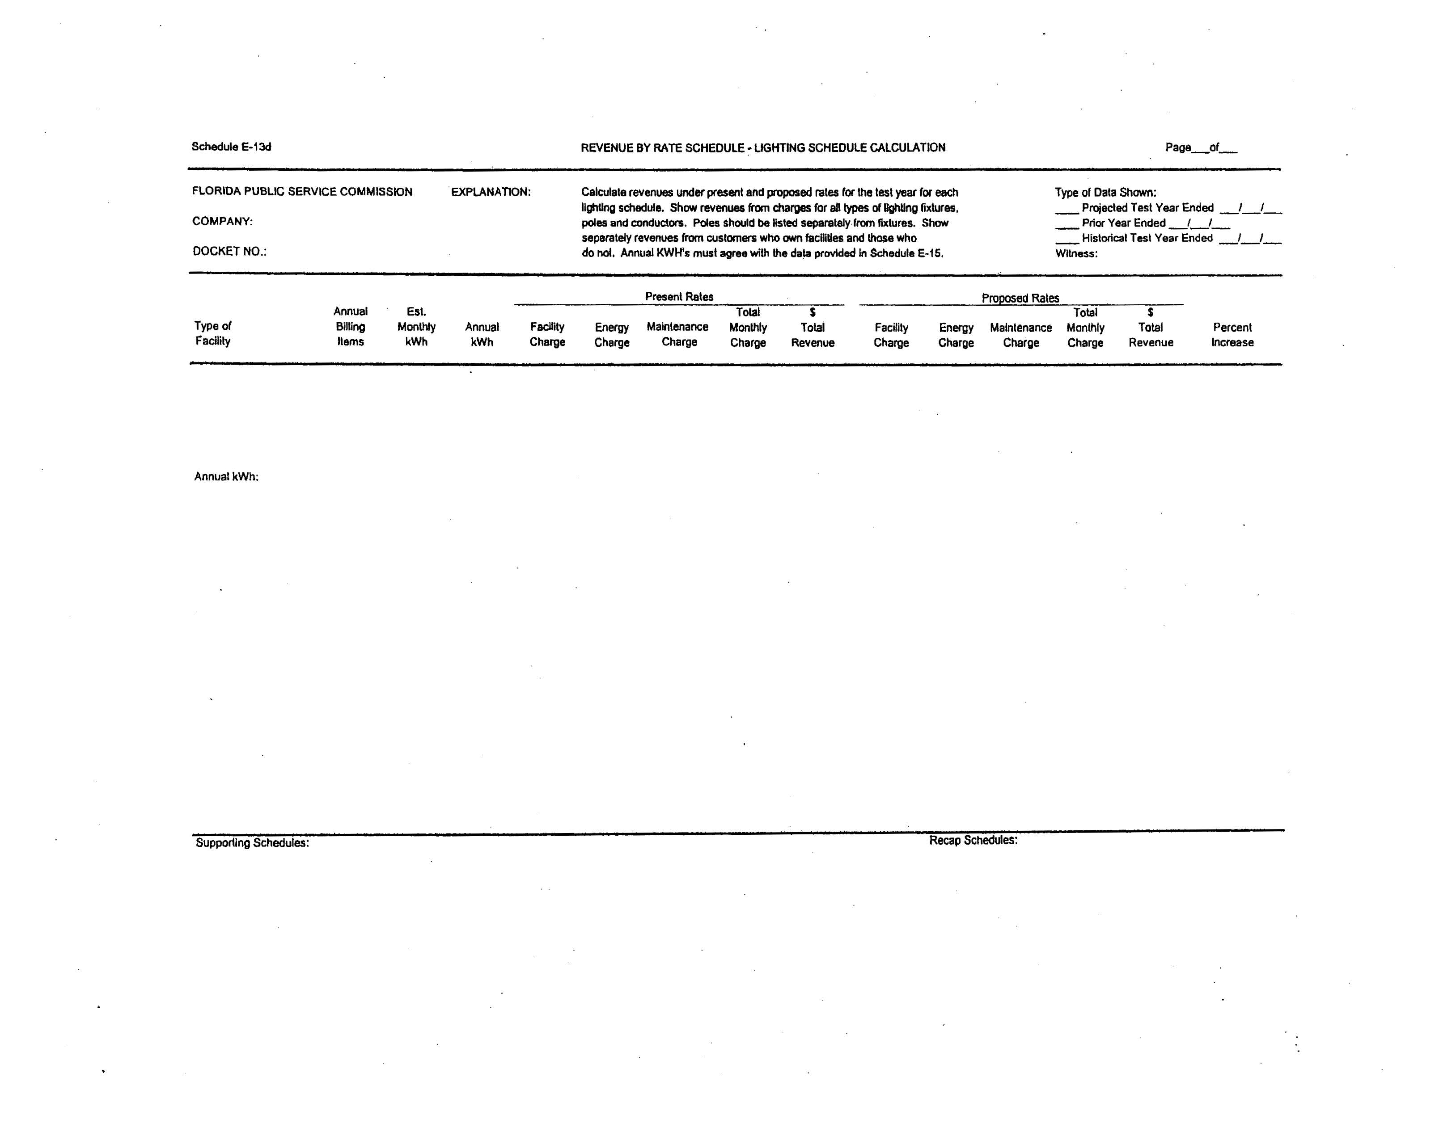
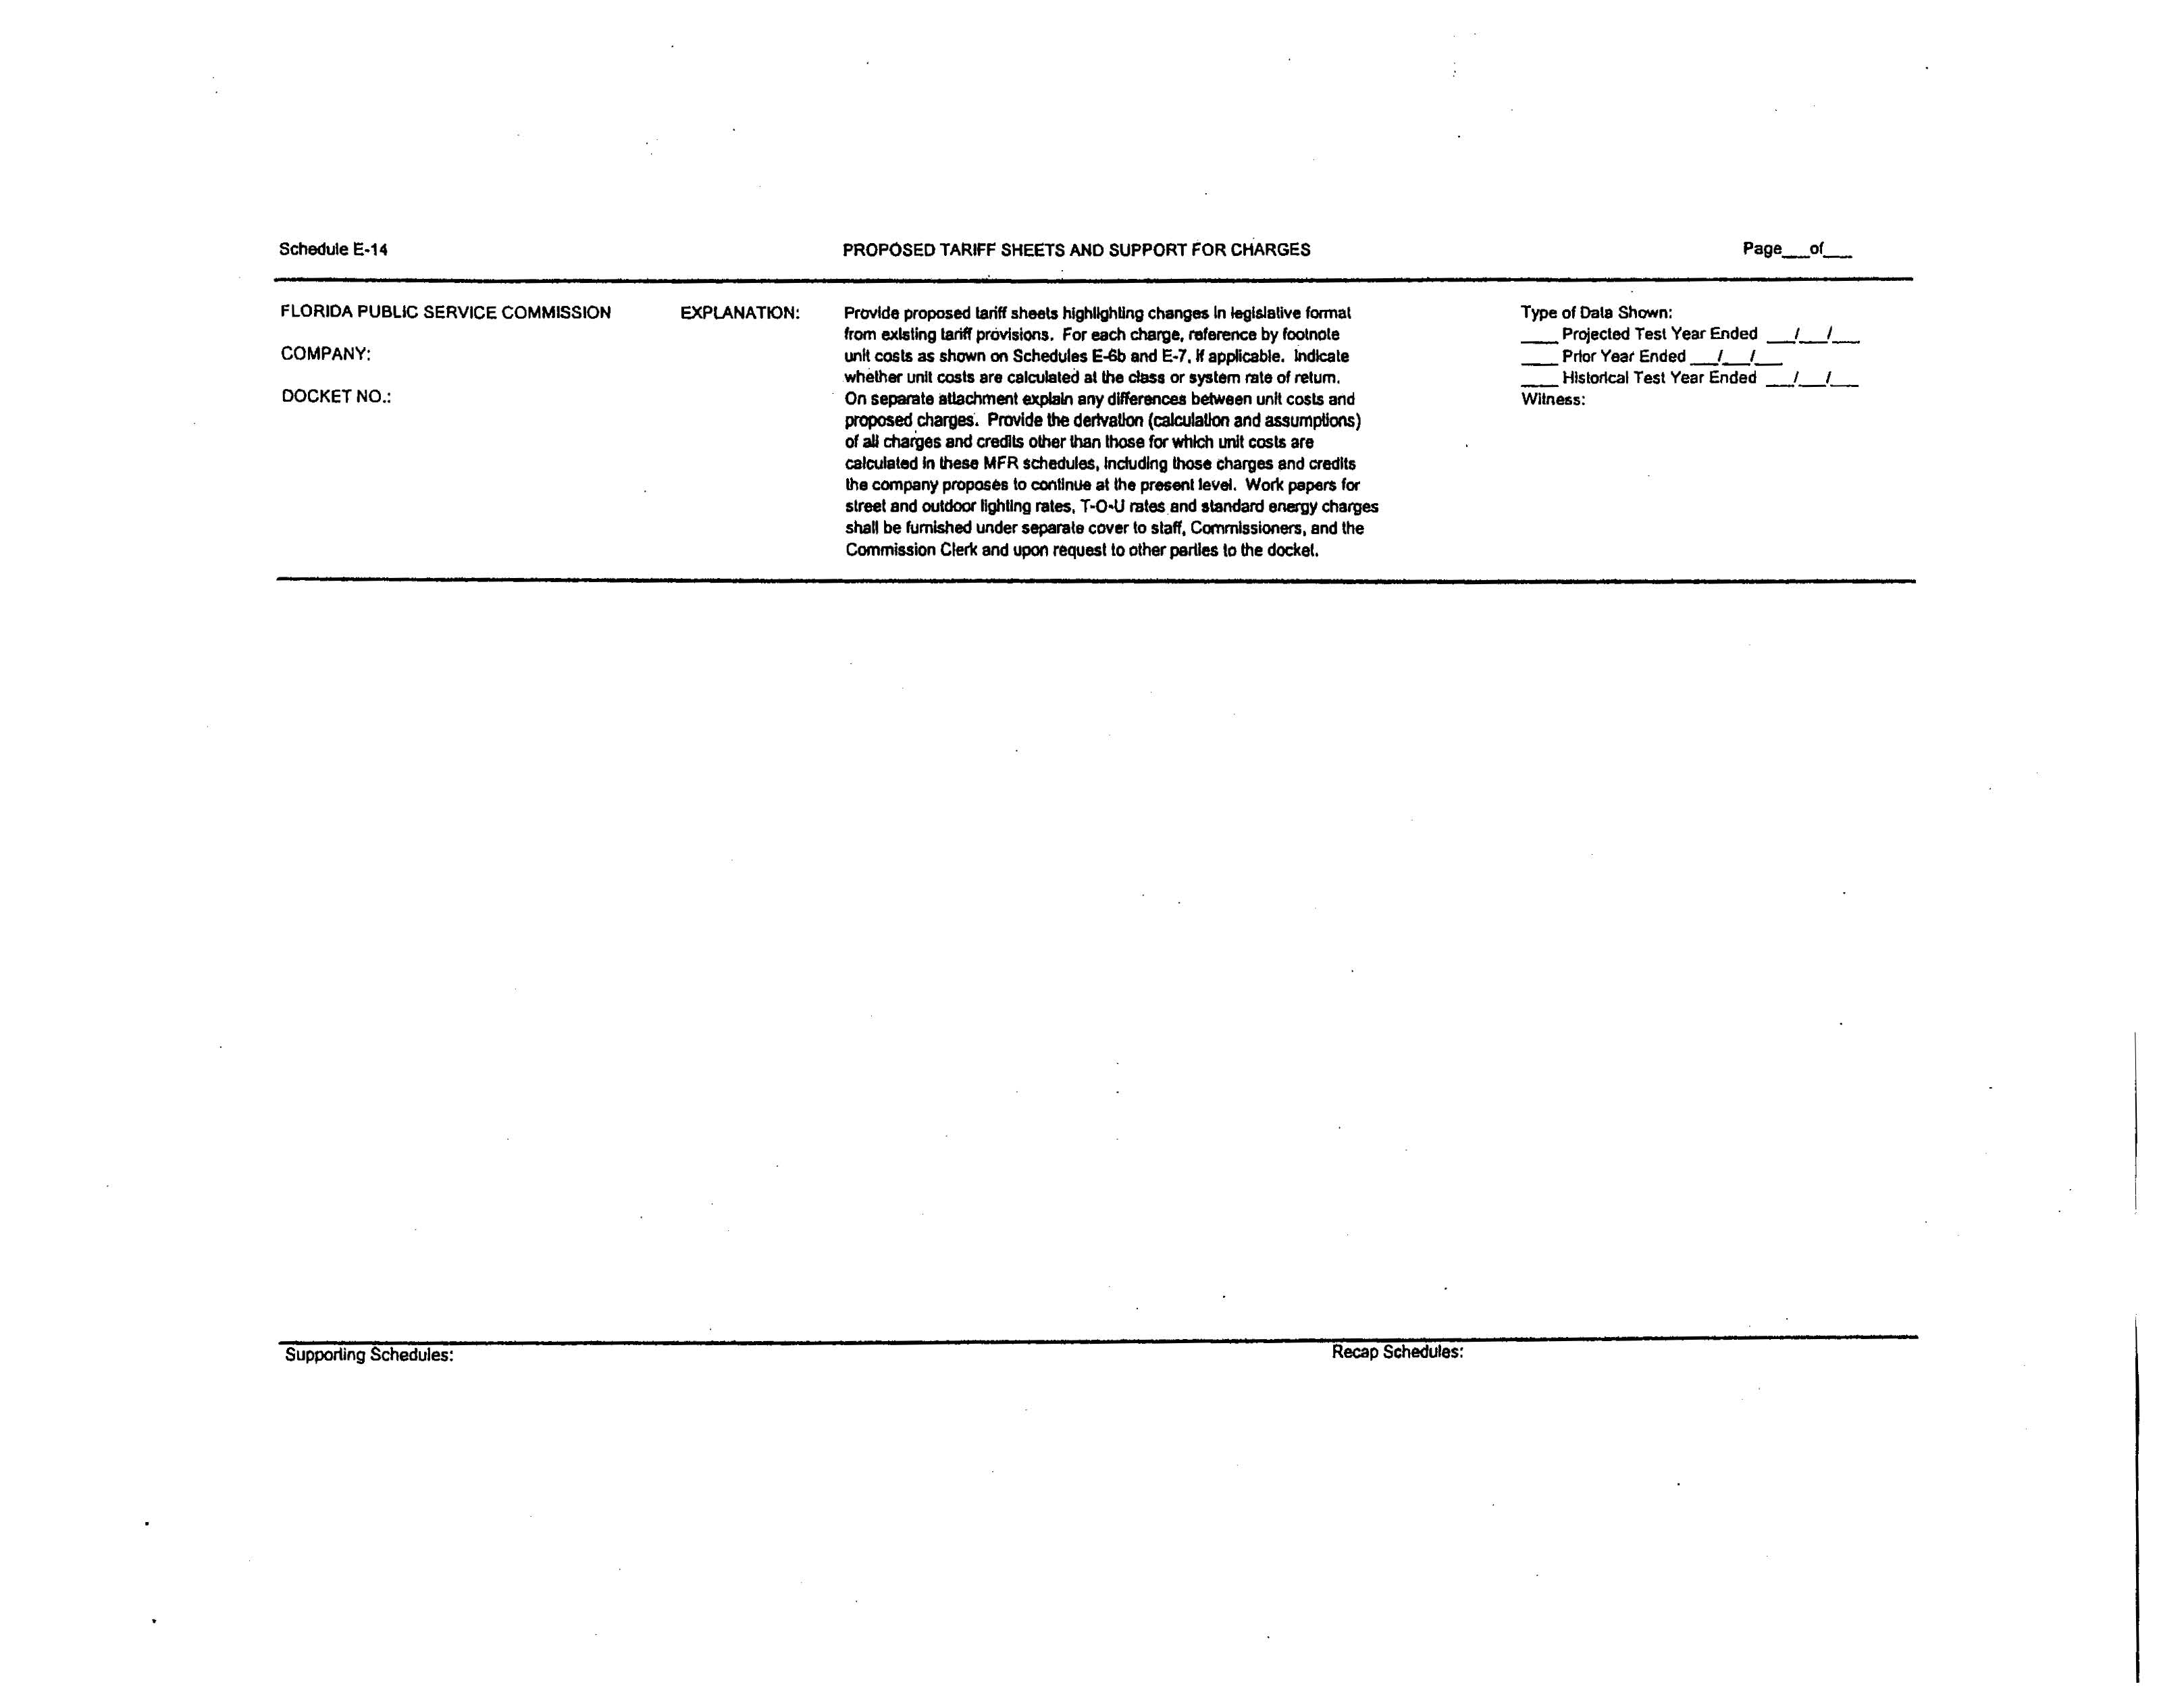
25-7.0391 Petition for a Limited Proceeding
(1) This rule shall apply to petitions for a limited proceeding filed pursuant to section 366.076(1), Florida Statutes, which result in changes to base rates to existing customers, subject to the restrictions contained in section (10) of this rule.
(2) Each petition for a limited proceeding shall provide the following general information to the Commission:
(a) The name of the applicant and the address of the applicant’s principal place of business;
(b) The number(s) of the Commission order(s), in which the Commission most recently considered the applicant’s base rates, including consideration of a settlement agreement concerning base rates;
(c) The addresses within the service area where the petition is available for customer inspection during the time the petition is pending; and
(d) A detailed statement of the reasons why the limited proceeding has been requested and why a limited proceeding is the appropriate type of proceeding for consideration of the requested relief.
(3) If the utility’s petition includes a request for recovery of rate base components, the following minimum information shall be filed with the utility’s petition:
(a) A schedule showing the specific rate base components for which the utility seeks recovery on both a system and jurisdictional basis. The following supporting detail shall be provided for each item requested:
1. the actual or projected cost(s);
2. the date the item was, or is projected to be, placed in service;
3. any corresponding adjustments that are required as a result of adding or removing the requested component(s) from rate base, which may include retirement entries; and
4. all supporting detail by primary account as defined by the Uniform System of Accounts, in accordance with Rule 25-7.014, F.A.C.;
(b) A calculation of the weighted average cost of capital for the most recent twelve-month period, using the mid-point of the range of the last authorized rate of return on equity, the current embedded cost of fixed-rate capital, the actual cost of short-term debt, the actual cost of variable-cost debt, and the actual cost of other sources of capital which were used in the last individual rate proceeding of the utility; and
(c) Detailed descriptions and calculations of all cost savings arising from the implementation of the requested cost recovery.
(4) If the utility is requesting recovery of operating expenses, the following information shall be provided on both a system and jurisdictional basis:
(a) A detailed description of the expense(s) requested;
(b) The total cost by primary account pursuant to the Uniform System of Accounts;
(c) Supporting documentation or calculations;
(d) Any allocations that are made between systems, affiliates or related parties, including full detail that shows the total amount allocated, a description of the basis of the allocation methodology, the allocation percentage applied to each allocated cost, and the workpapers supporting the calculation of the allocation percentages; and
(e) Calculations for all items or actions that will create cost savings or revenue impacts from the implementation of the requested cost recovery items.
(5) The petition shall identify the impact on retail base rates, including:
(a) A calculation of the revenue change;
(b) Schedules showing jurisdictional rate base, net operating income, cost of capital, and achieved return on equity for both the most recent twelve-month period and the projected 12 month period, if applicable, which demonstrate that, without any increased rates, the utility will earn below its authorized minimum rate of return on equity. The schedules shall include adjustments consistent with the utility’s last rate proceeding, and the annualization of any rate changes occurring during the period. The pro forma effect of each proposal shall be shown separately on the schedules;
(c) A schedule showing how the utility proposes to allocate any change in revenues to rate classes;
(d) A schedule of current and proposed rates for all rate schedules, along with workpapers showing how those rates were derived; and
(e) If the limited proceeding is being requested solely to change the current cost allocation or rate structure on a revenue neutral basis, the utility shall provide a copy of all workpapers and calculations used to calculate requested rates and allocations between customer classes, and a description of the customer migrations between rate schedules resulting from the restructuring. In addition, the petition shall include the following schedules from Form PSC/ECR/010-G (11/89), entitled “Minimum Filing Requirements for Investor-Owned Gas Utilities,” which is incorporated by reference in Rule 25-7.039, F.A.C.:
1. Schedule H-1, entitled “Embedded Cost of Service Studies,”
2. Schedule H-2, entitled “Development of Allocation Factors.”
These schedules can be obtained from the Commission’s Division of Economic Regulation.
(6) A petition for a limited proceeding shall be processed using the proposed agency action procedure set forth in this rule, unless the Commission orders the petition to be set directly for hearing.
(7) A petition for limited proceeding using proposed agency action procedure shall be subject to the following provisions:
(a) Pending a final order by the Commission, the Commission may withhold consent to the operation of all or any portion of the new rate schedules, delivering to the utility requesting such increase, within 60 days, a reason or written statement of good cause for withholding its consent.
(b) The Commission shall enter its vote on the proposed agency action within 5 months of the commencement date for final agency action.
(c) If the Commission’s proposed agency action is protested, the final decision must be rendered by the Commission within 8 months of the date the protest is filed.
(d) At the expiration of 5 months following the commencement date for final agency action, if the Commission has not taken action, or if the Commission’s action is protested by a party other than the utility, the utility may place its requested rates into effect under bond, escrow, or corporate undertaking subject to refund upon notice to the Commission and filing the appropriate tariffs. The Commission shall, by order, require such public utility to keep accurate account in detail of all amounts received by reason of such increase, specifying by whom and in whose behalf such amounts were paid.
(e) In its final order on the petition for limited proceeding, the Commission shall order the utility to refund with interest, pursuant to Rule 25-7.091, F.A.C., such portion of the increased rate or charge which is found not to be justified and which is collected during the periods specified.
(f) Any portion of such refund not thus refunded to patrons or customers of the public utility shall be refunded or disposed of by the public utility as the Commission may direct; however, no such funds shall accrue to the benefit of the public utility.
(8) If the Commission orders the petition to be set directly for hearing, the following procedure shall apply:
(a) Pending a final order by the Commission, the Commission may withhold consent to the operation of all or any portion of the new rate schedules, delivering to the utility requesting such increase, within 60 days, a reason or written statement of good cause for withholding its consent.
(b) Such consent shall not be withheld for a period longer than 8 months from the date of filing the new rate schedules.
(c) The new rates, or any portion not consented to, may go into effect under bond or corporate undertaking at the end of such period, but the Commission shall, by order, require such public utility to keep accurate account in detail of all amounts received by reason of such increase, specifying by whom and in whose behalf such amounts were paid.
(d) In its final order on the petition for limited proceeding, the Commission shall order the utility to refund with interest, pursuant to Rule 25-7.091, F.A.C., such portion of the increased rate or charge which is found not to be justified and which is collected during the periods specified.
(e) Any portion of such refund not thus refunded to patrons or customers of the public utility shall be refunded or disposed of by the public utility as the Commission may direct; however, no such funds shall accrue to the benefit of the public utility.
(f) The Commission shall take final action in the docket and enter its final order within 12 months of the commencement date for final agency action.
(9) Determination of Commencement Date
(a) As used in this rule, the “commencement date for final agency action” means the date upon which it has been determined by the Commission or its designee that the utility has filed with the clerk the minimum filing information as established by this rule.
(b) Within 30 days after receipt of the petition, the Commission or its designee shall either determine the commencement date for final agency action or issue a statement of deficiencies to the petitioner, specifically listing why the petition has failed to provide the minimum filing information required by this rule. Thereafter, within 15 days after the petitioner indicates to the Commission that it believes that it has filed the required minimum filing information, the Commission or its designee shall either determine the commencement date for final agency action or specifically enumerate in writing why the requirements have not been met, in which case this procedure shall be repeated until the commencement date for final agency action is established.
(c) The Director of the Division of Economic Regulation shall be the designee of the Commission for purposes of determining whether the utility has filed the minimum filing information required by this rule.
(10) A petition for a limited proceeding shall be denied if the Commission finds that:
(a) The utility is earning, or is projected to earn, above the minimum of its authorized rate of return, as shown on its most recent Earnings Surveillance Report filed pursuant to Rule 25-7.1352, if the requested costs are included in its surveillance report; or
(b) The utility’s filing includes more than two separate projects for which recovery would result in a change in base rates to existing customers. Corresponding accounting adjustments for a given proposal are not subject to this limitation; or
(c) The total increase in revenue requirement for the completed project exceeds ten percent of the utility’s most recent twelve-month annual jurisdictional base rate revenue.
(11) An original and 20 copies of the petition and supporting documentation shall be filed with the Office of Commission Clerk. To the extent possible, all filings made electronically or on diskette shall be provided in Microsoft Word format and all schedules and calculations shall be provided in Excel format with formulas intact and unlocked.
Rulemaking Authority: 350.127(2), 366.05, 366.06(1), 366.076(1) F.S. Law Implemented: 366.05, 366.06, 366.076(1) F.S.
History - New:____________

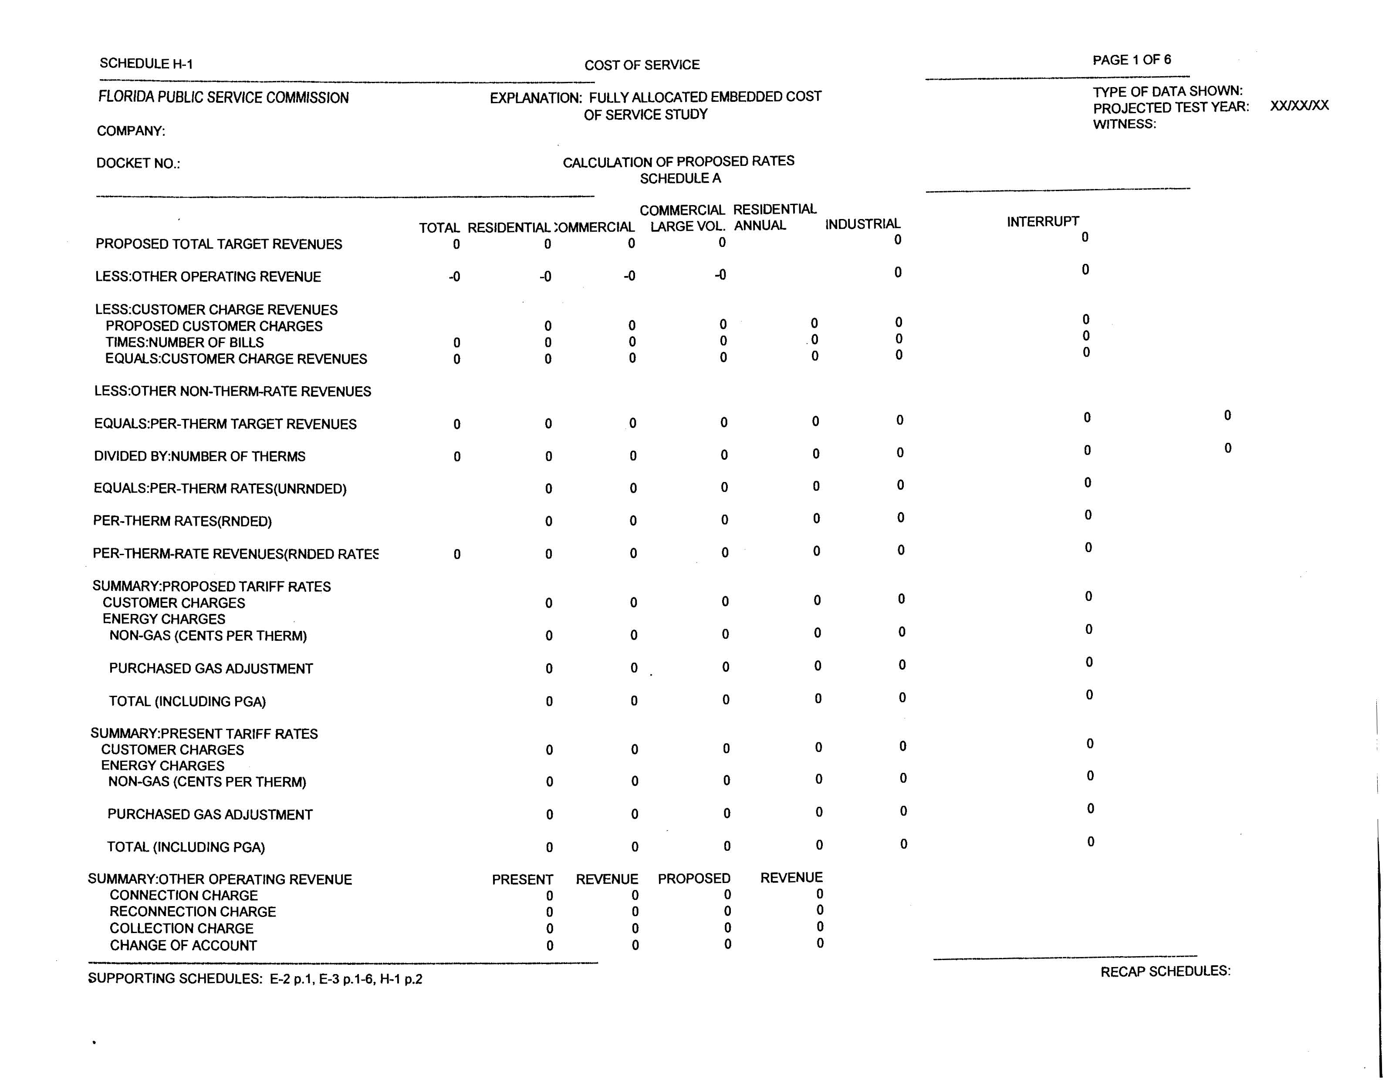
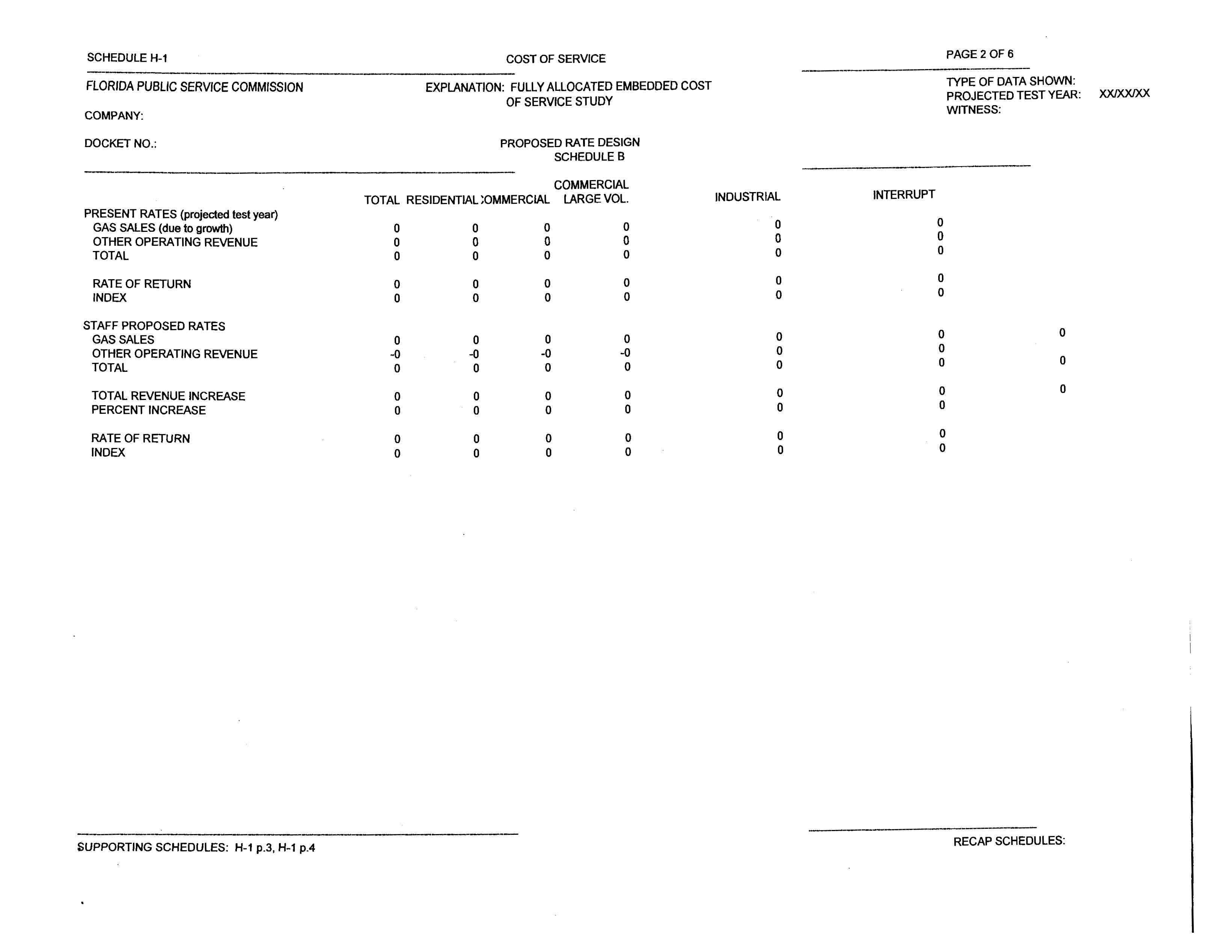
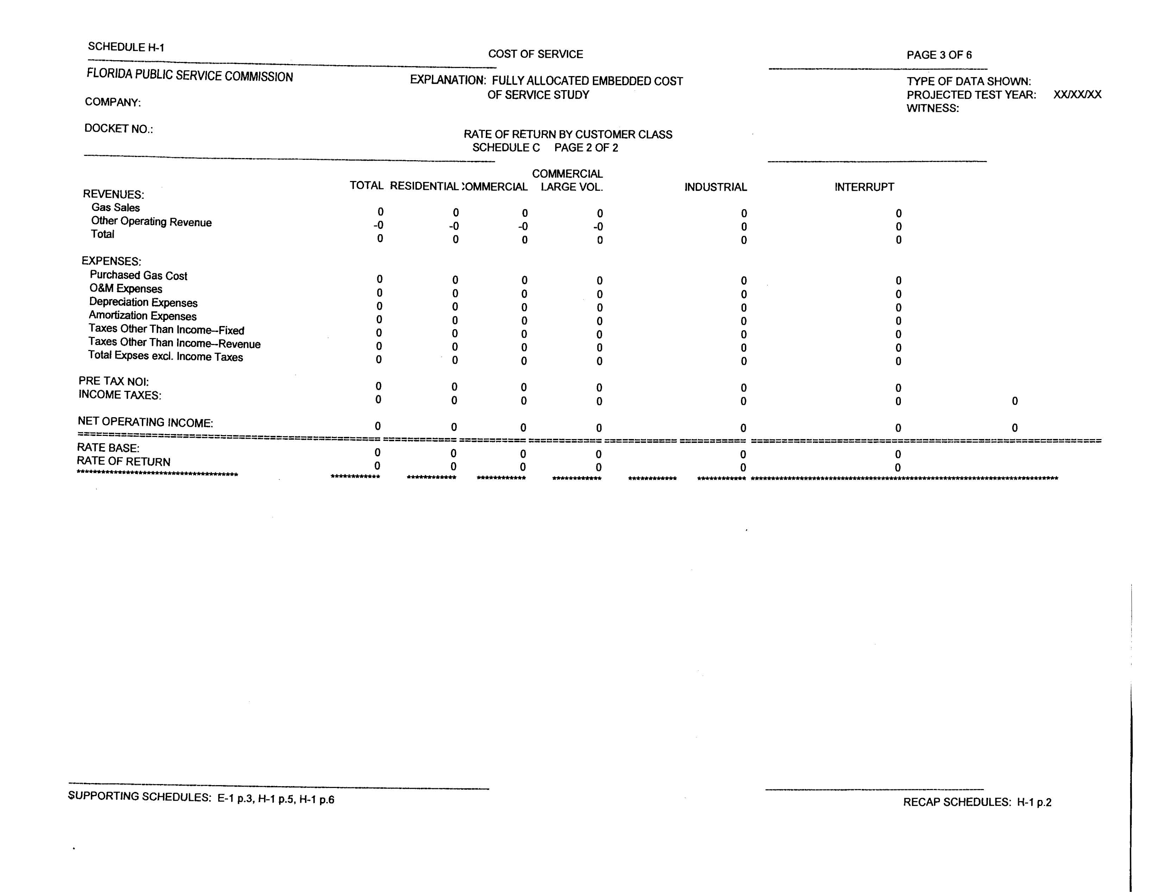
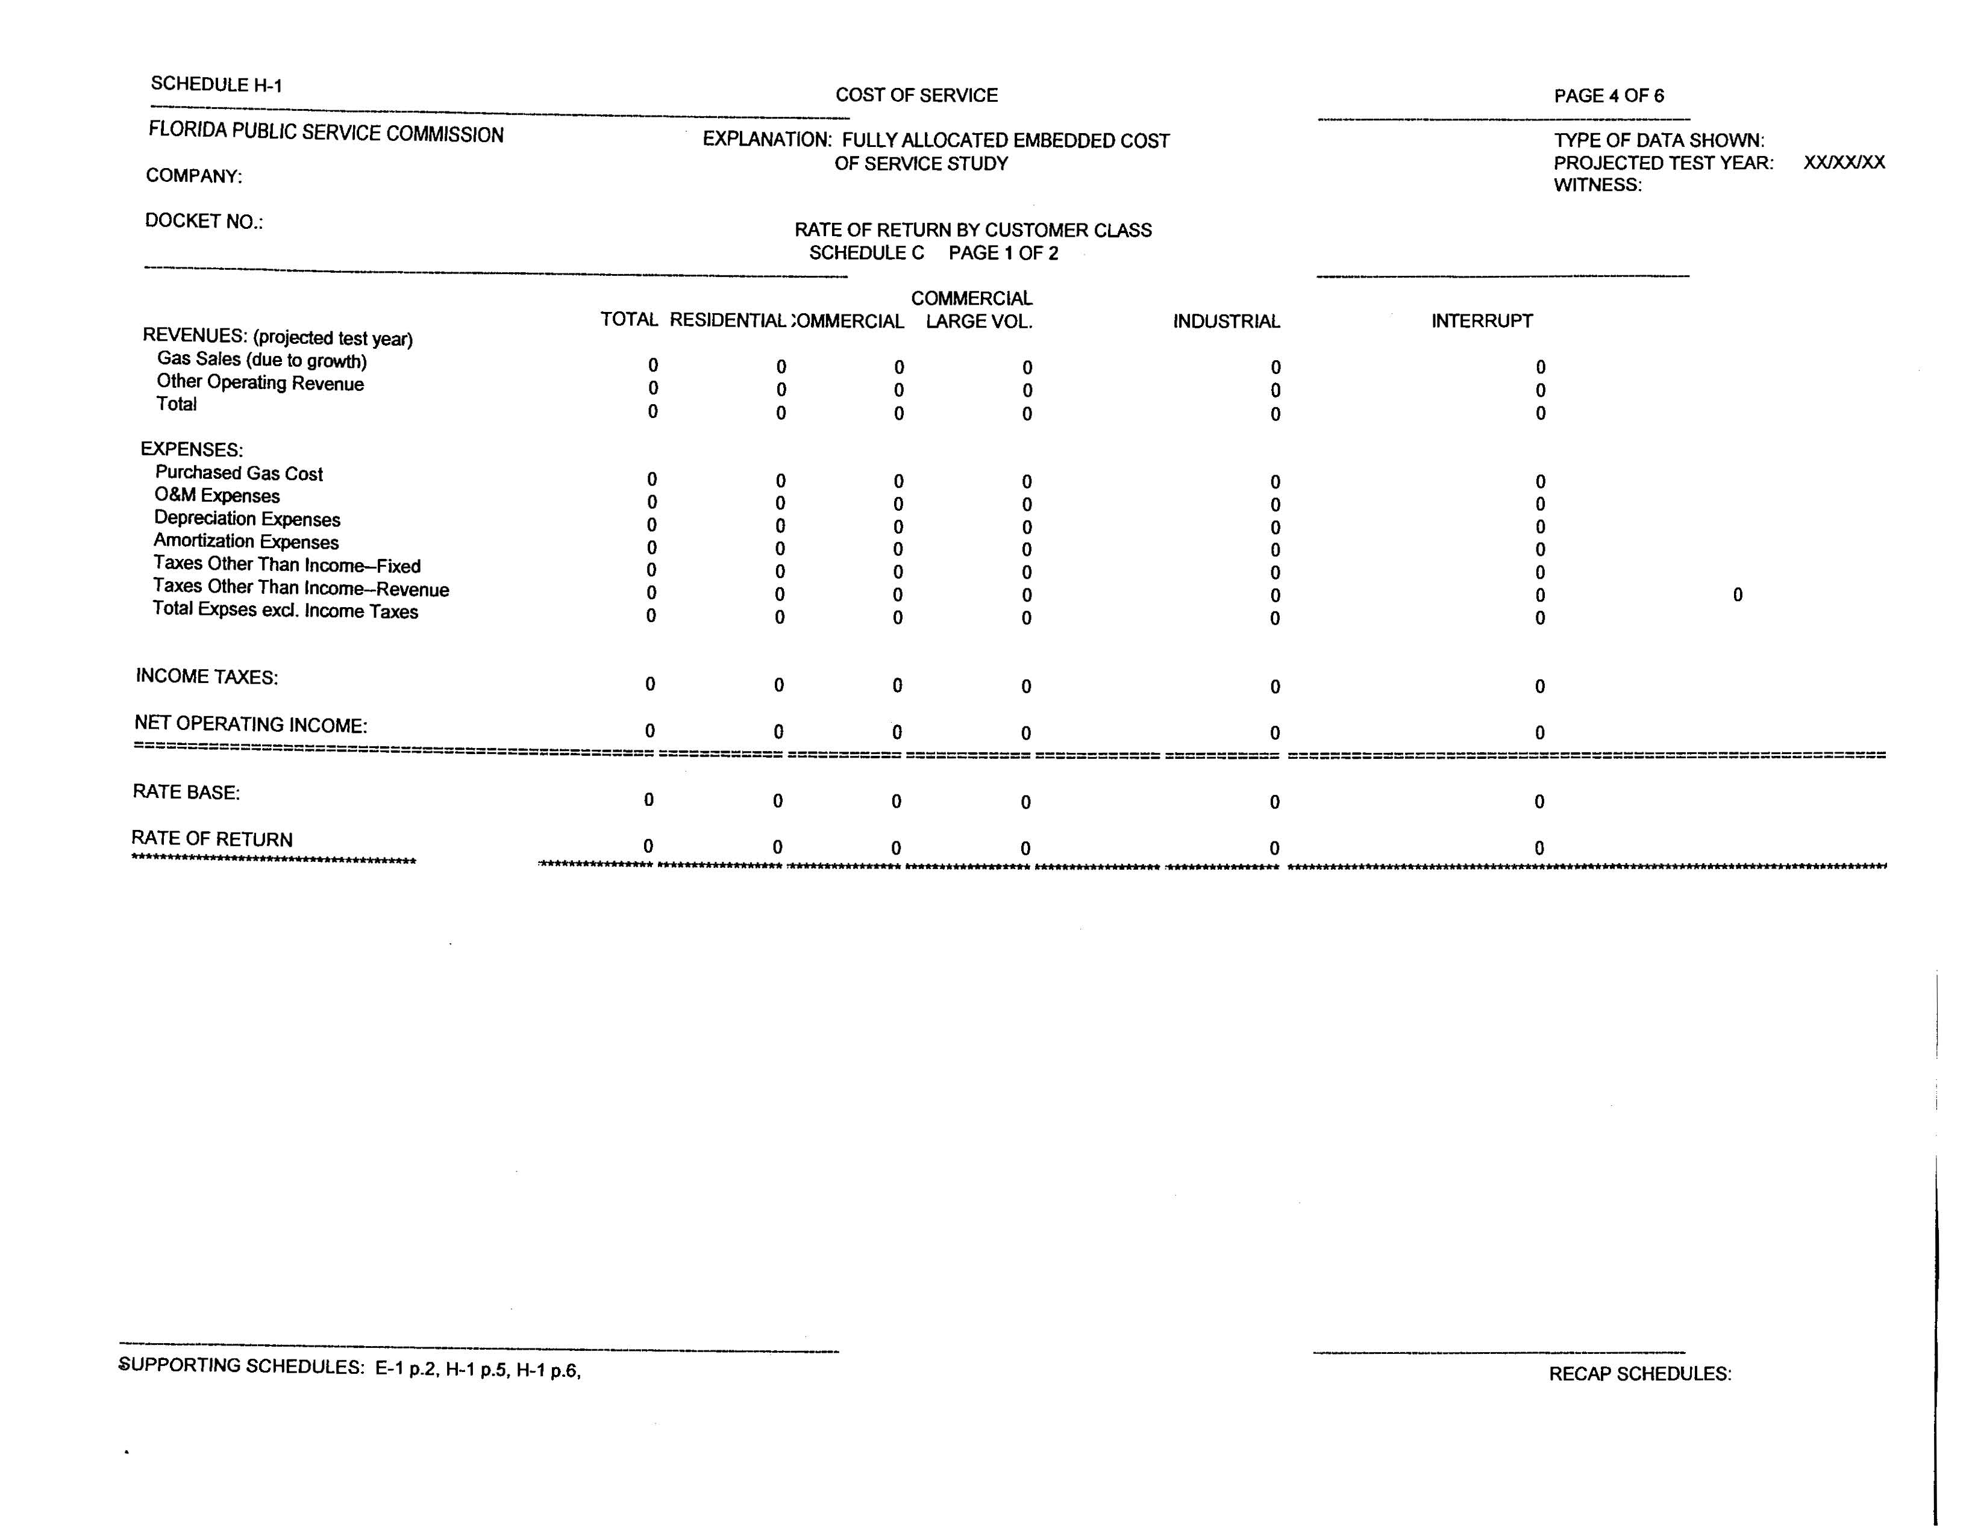
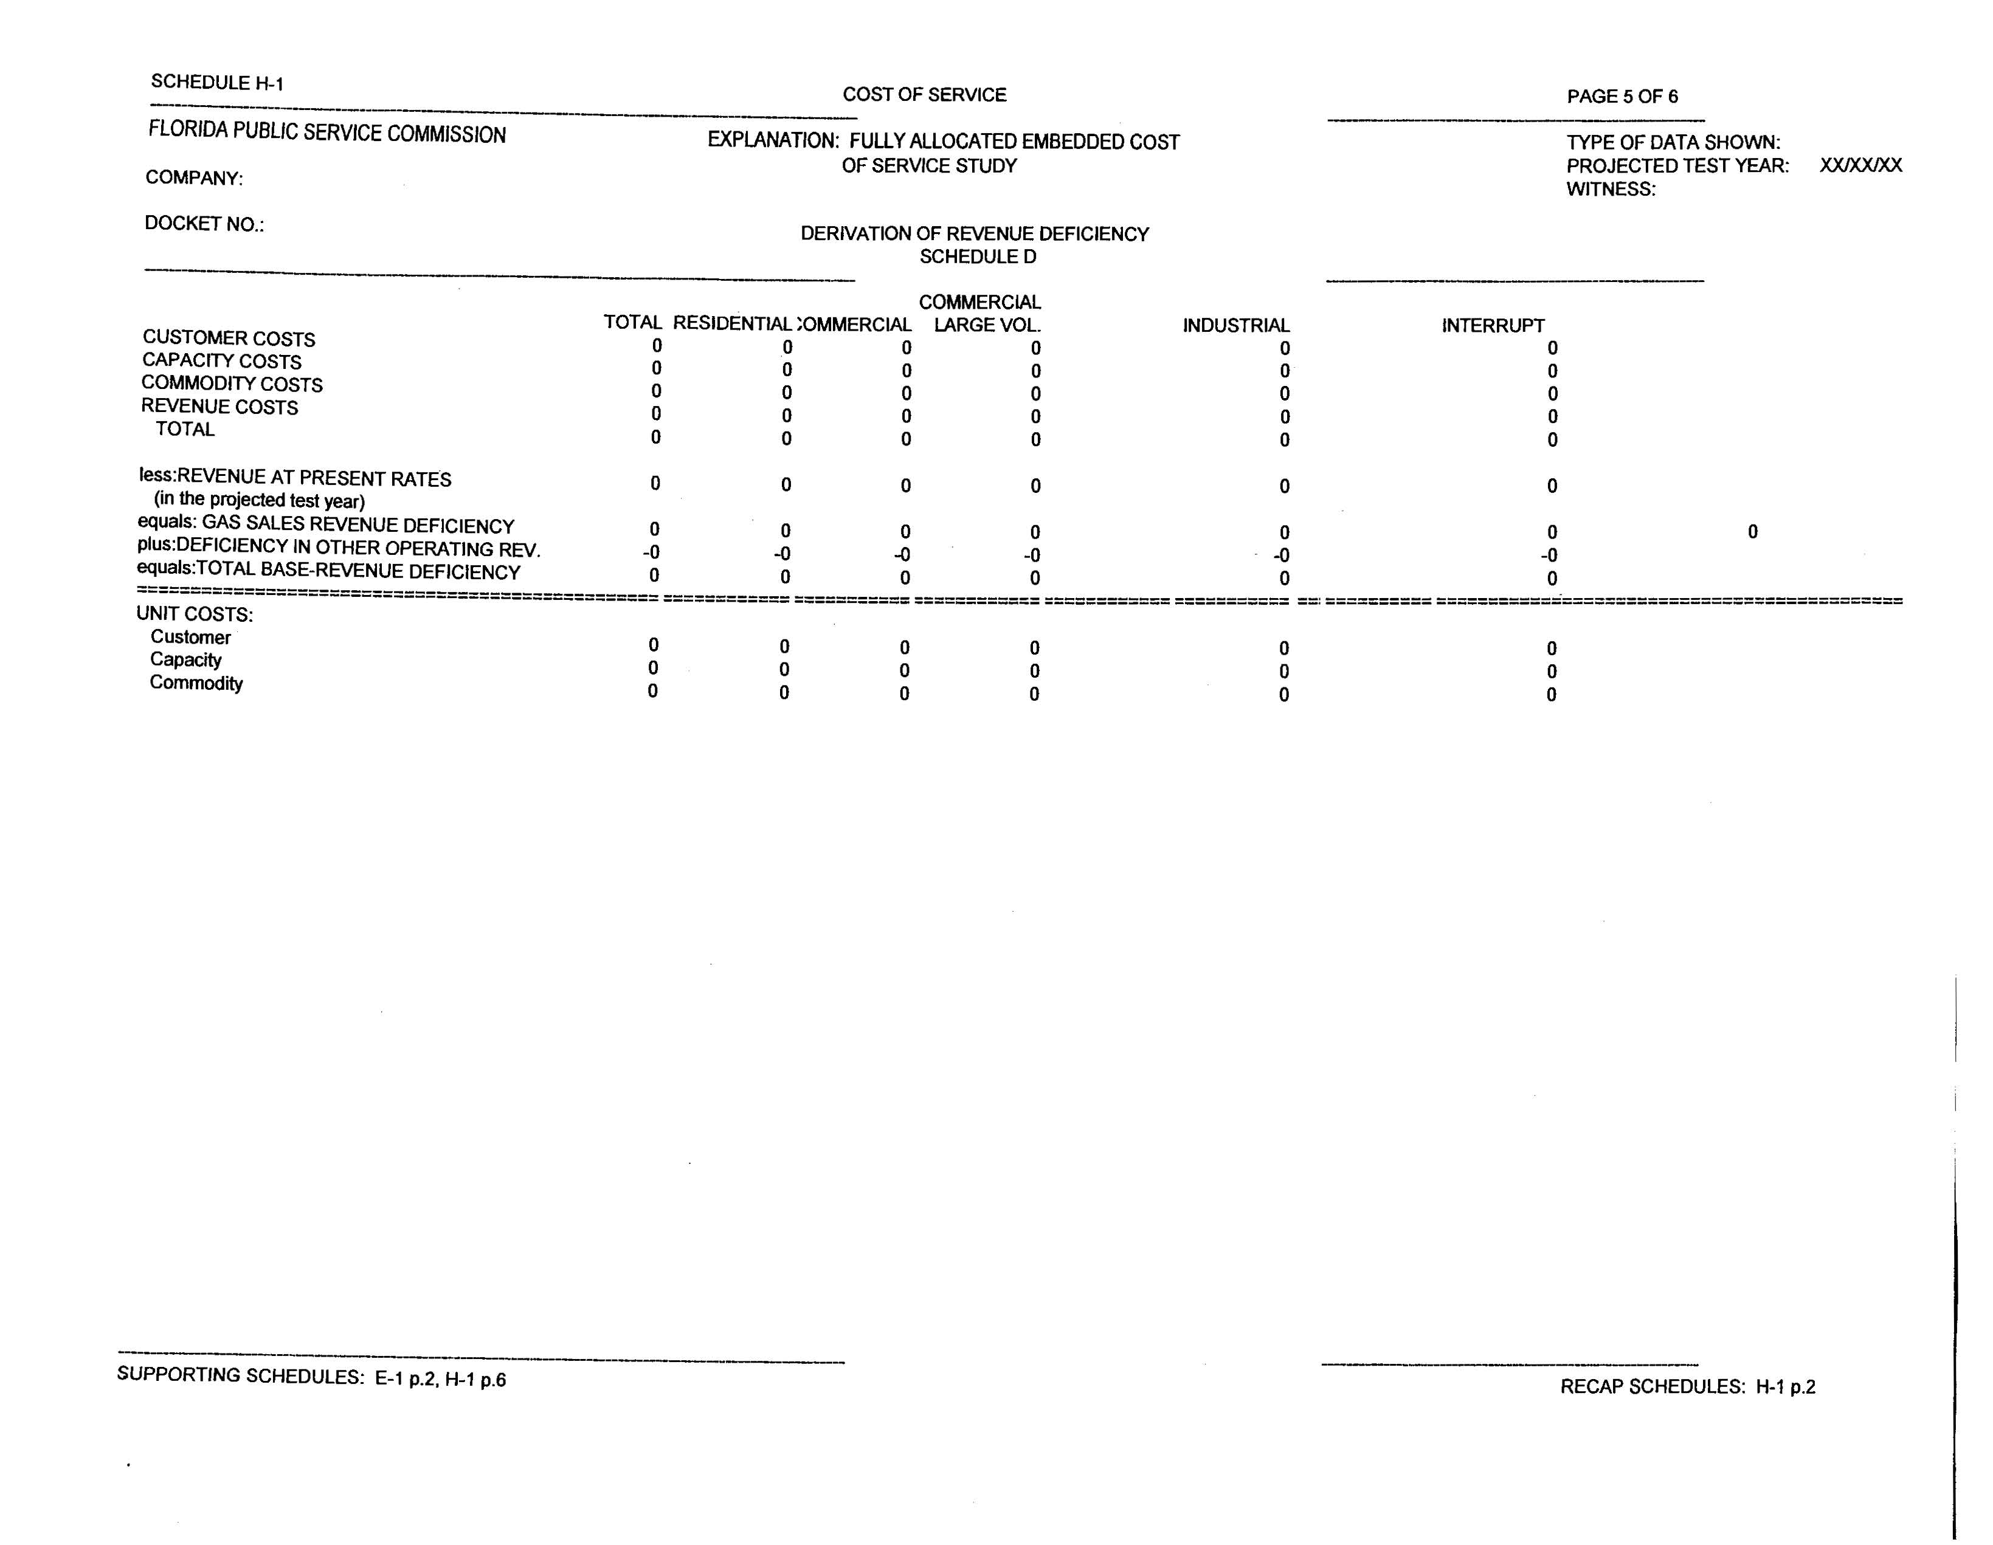
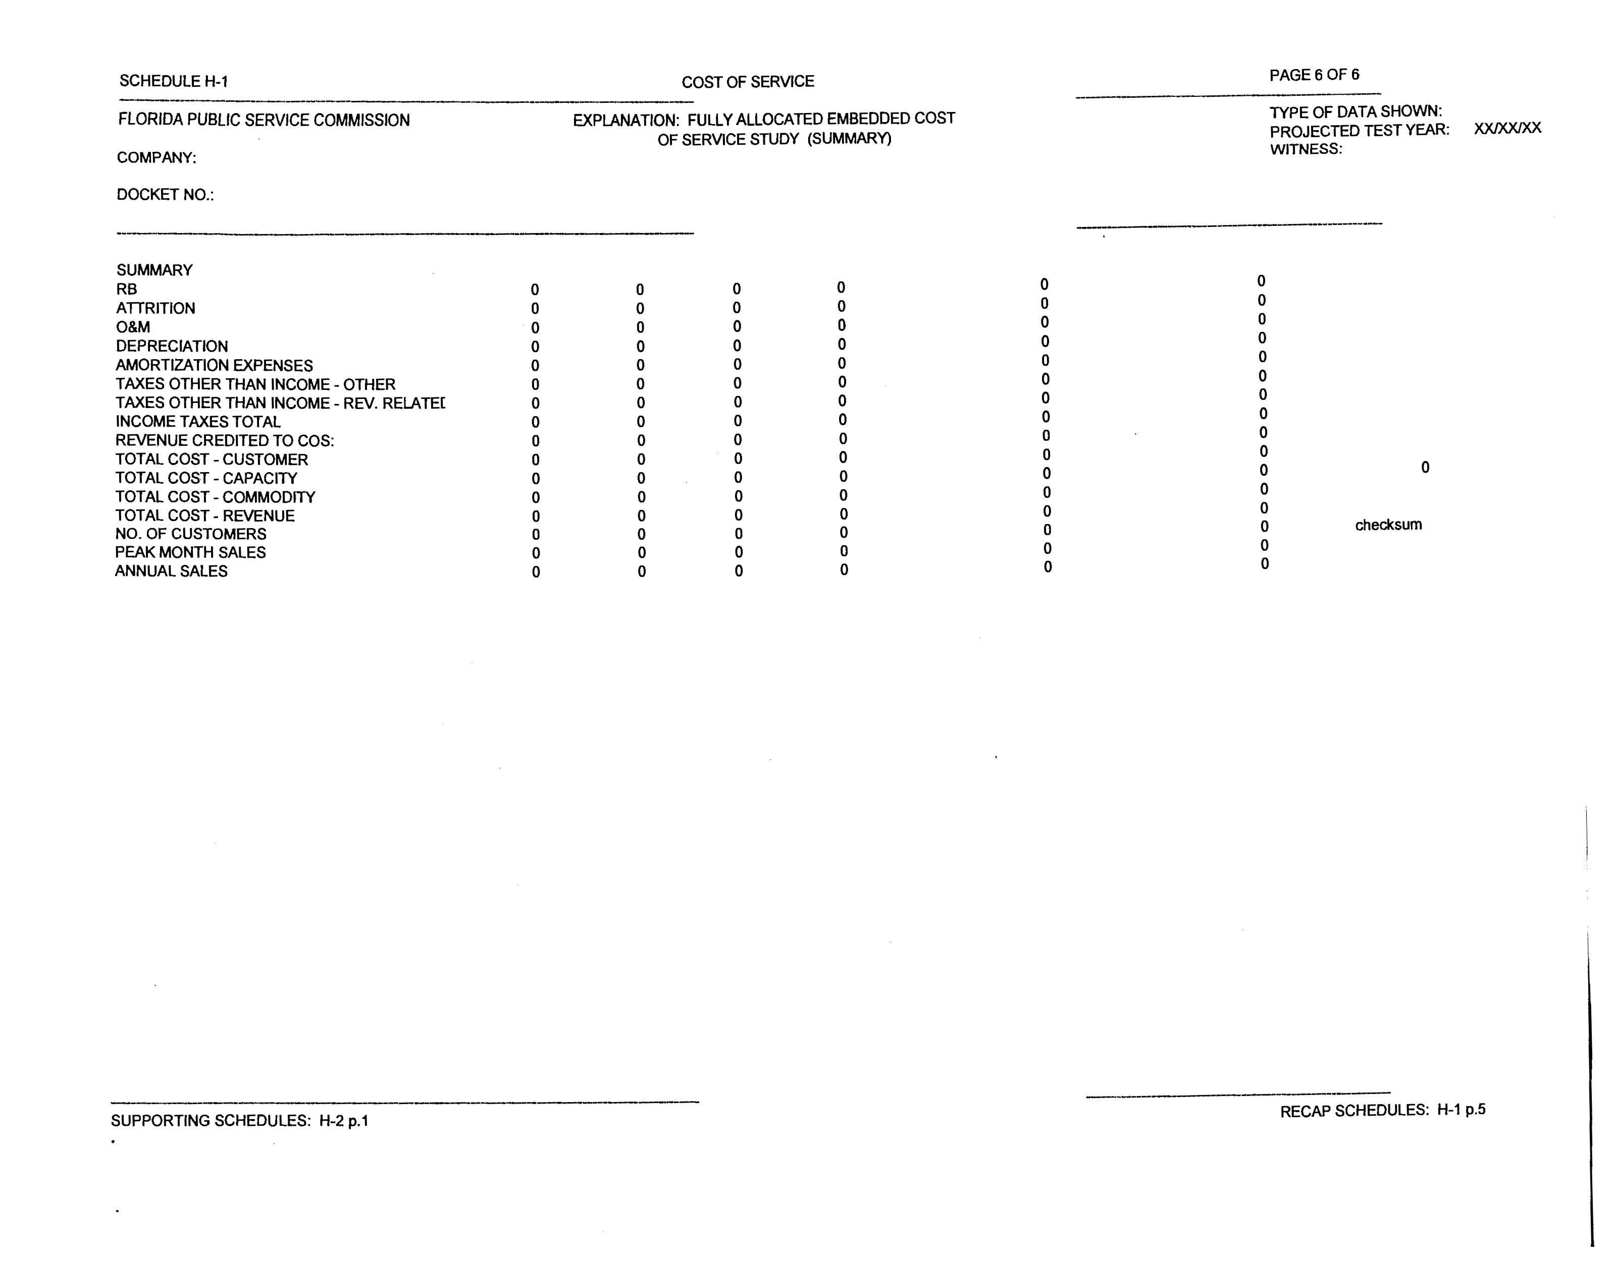
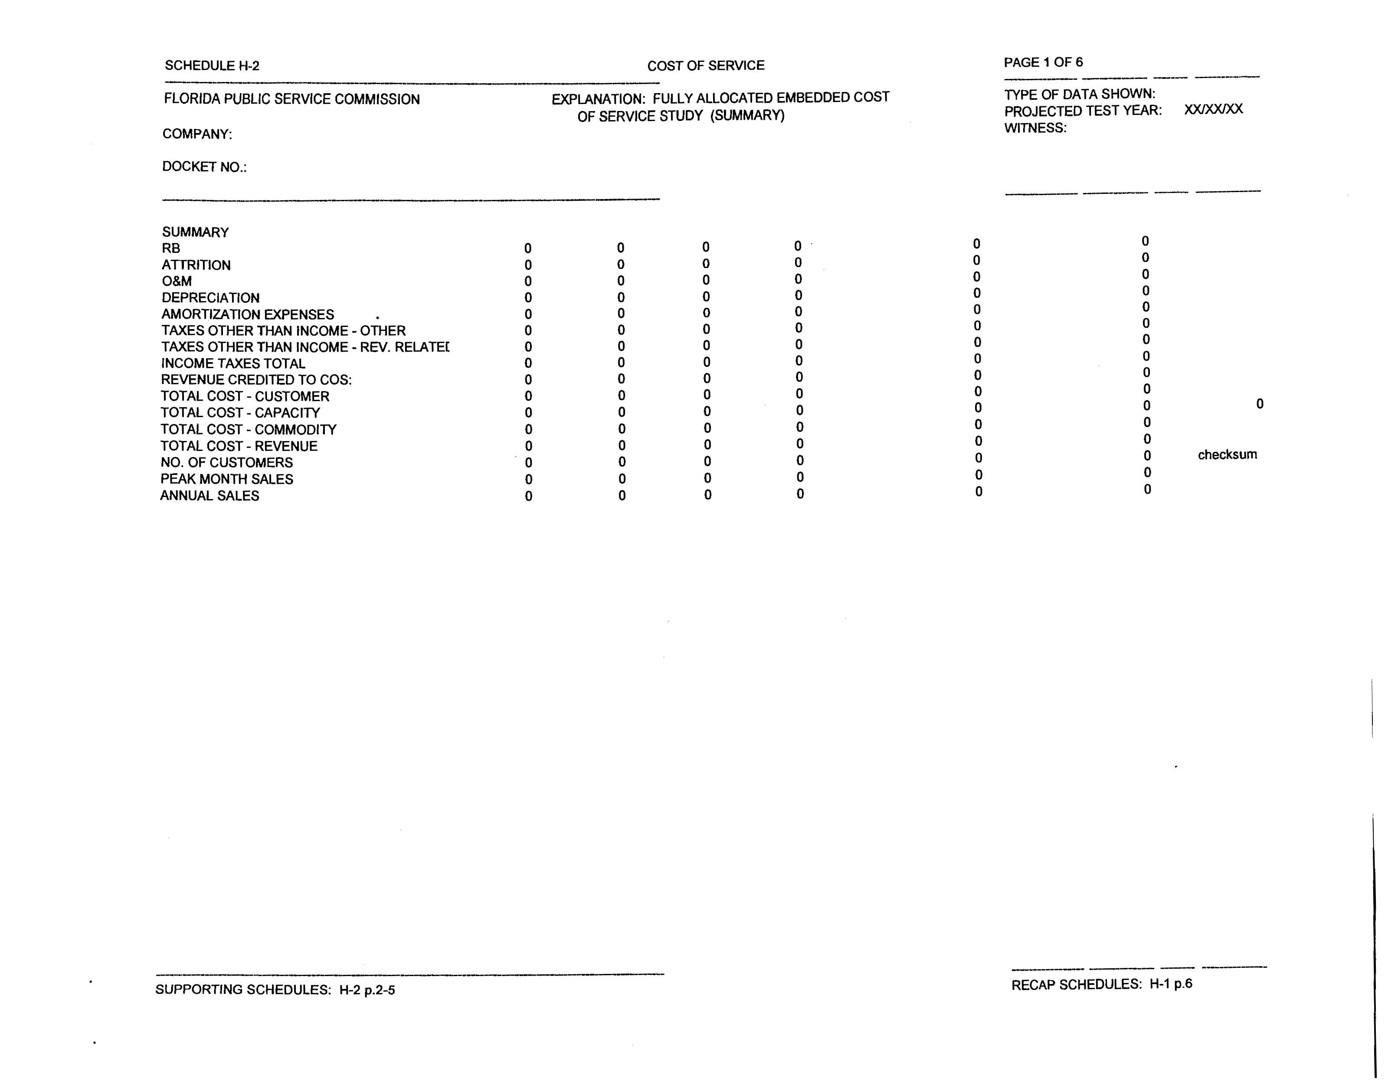
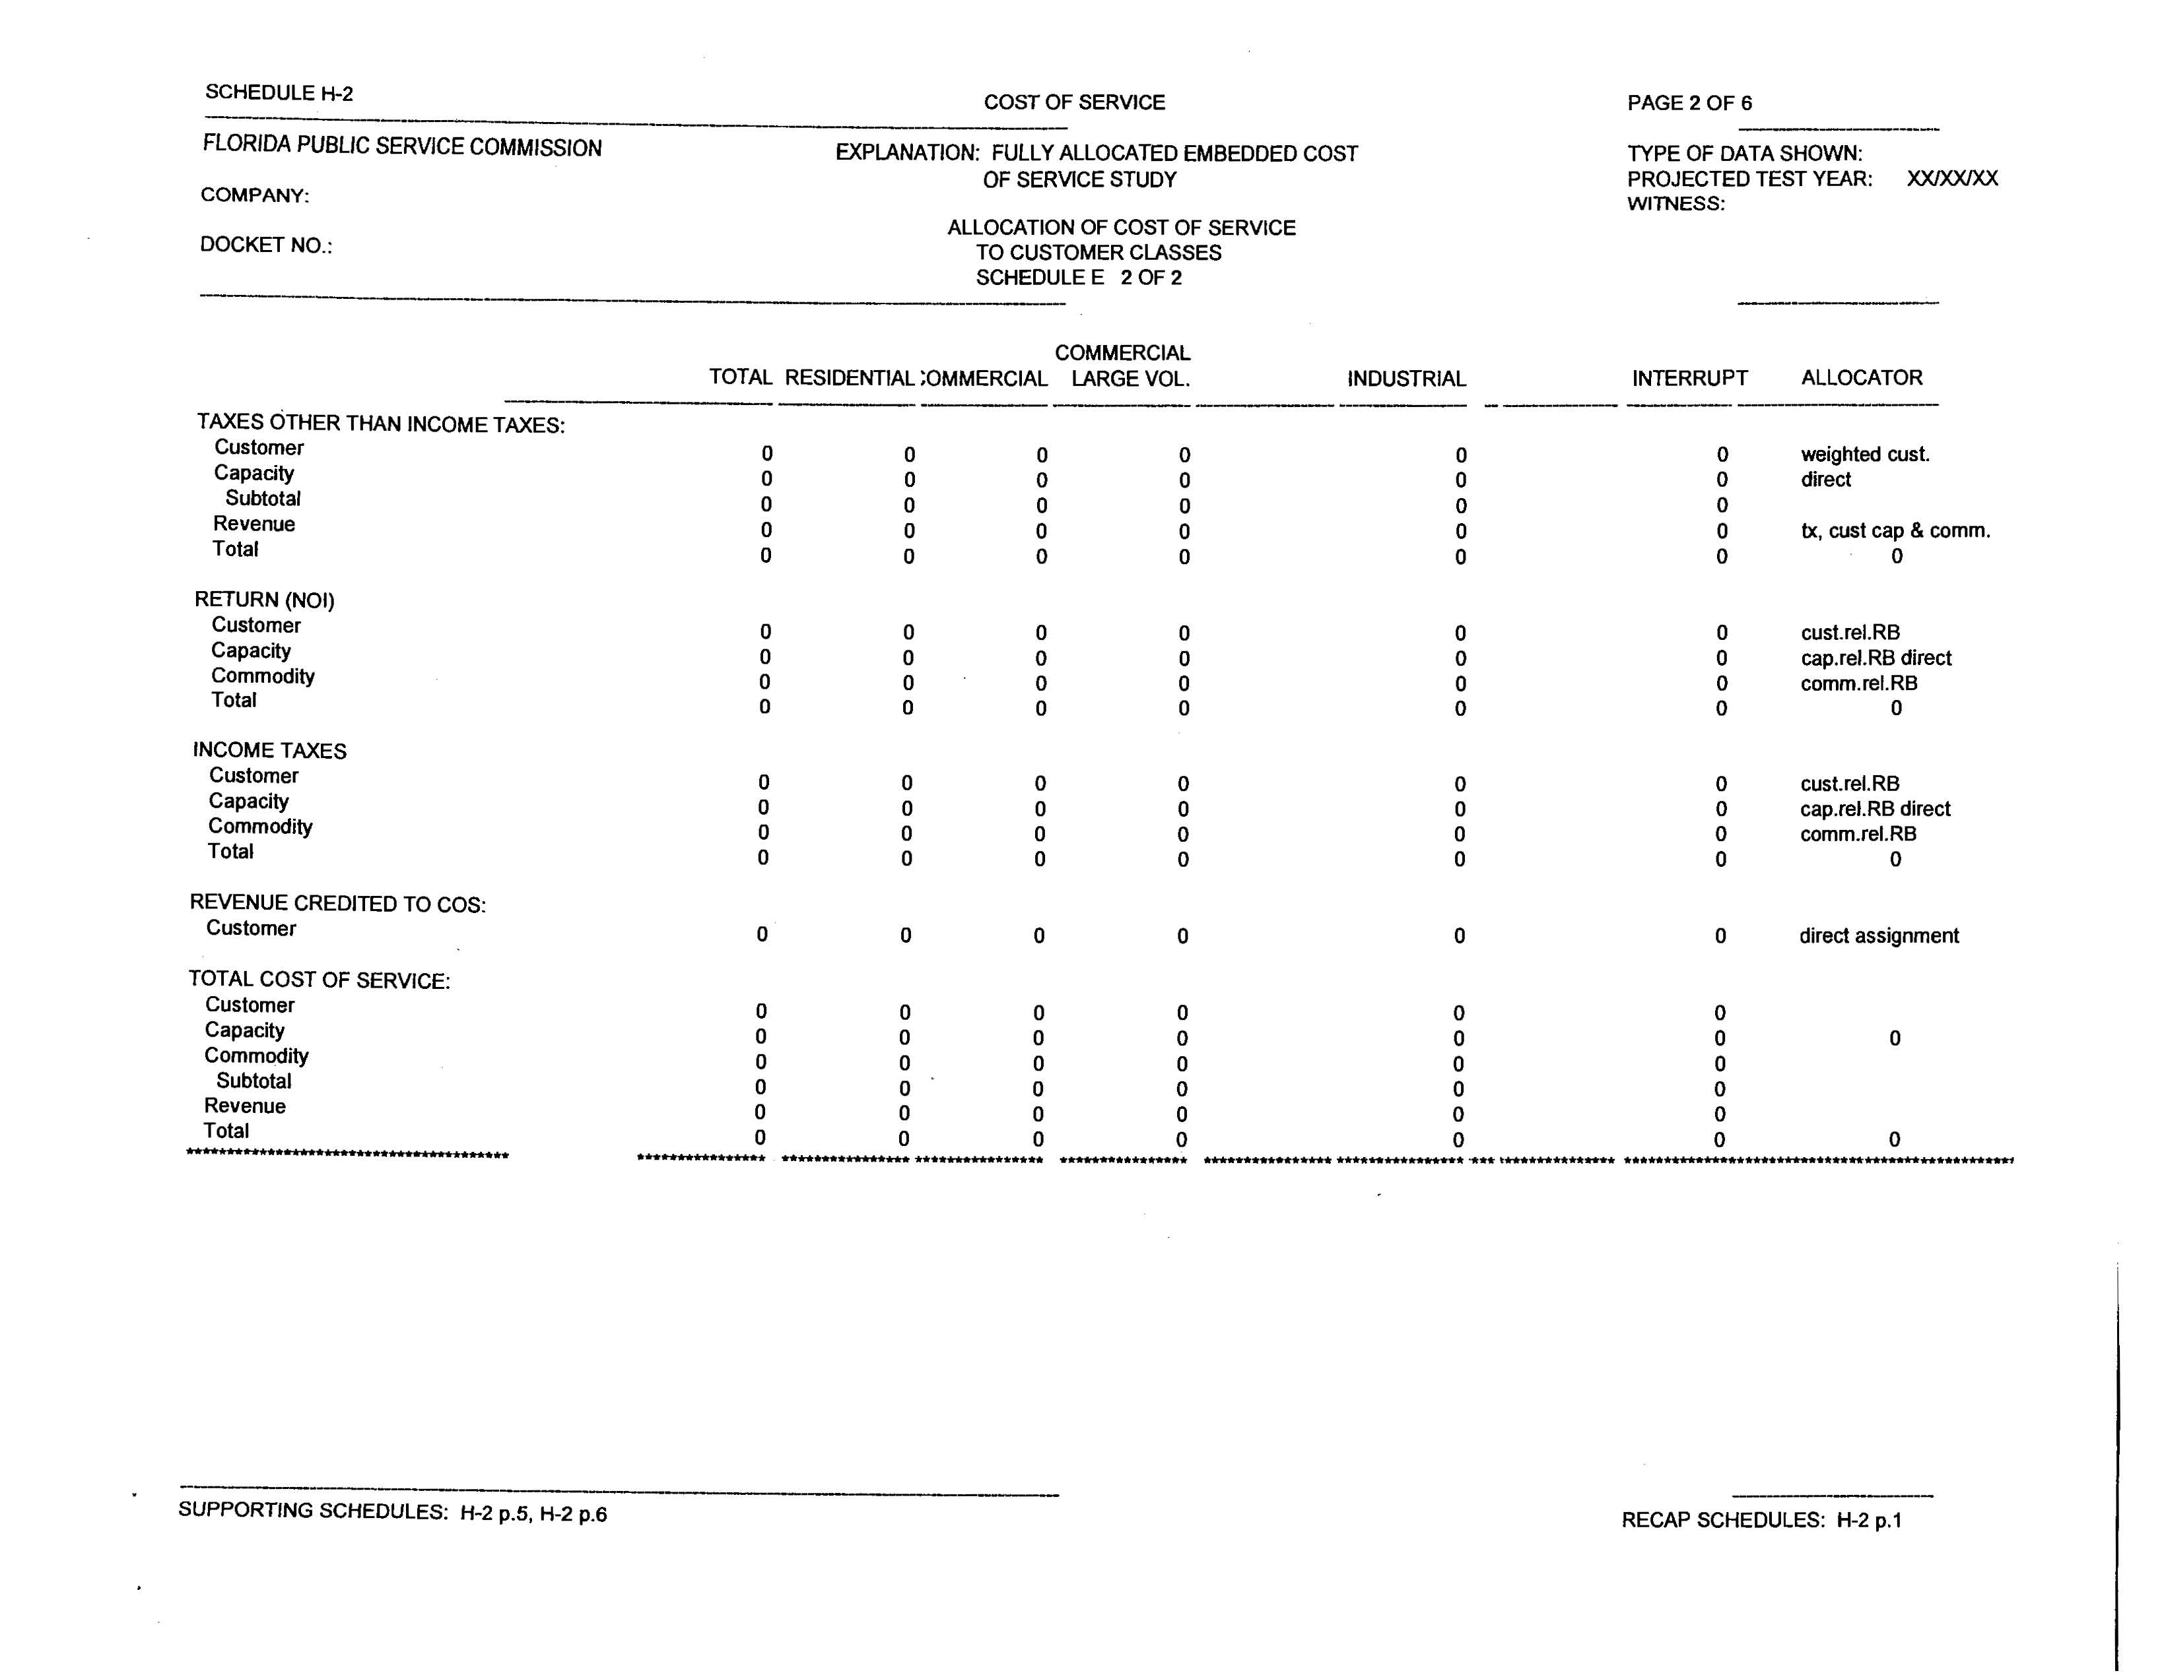
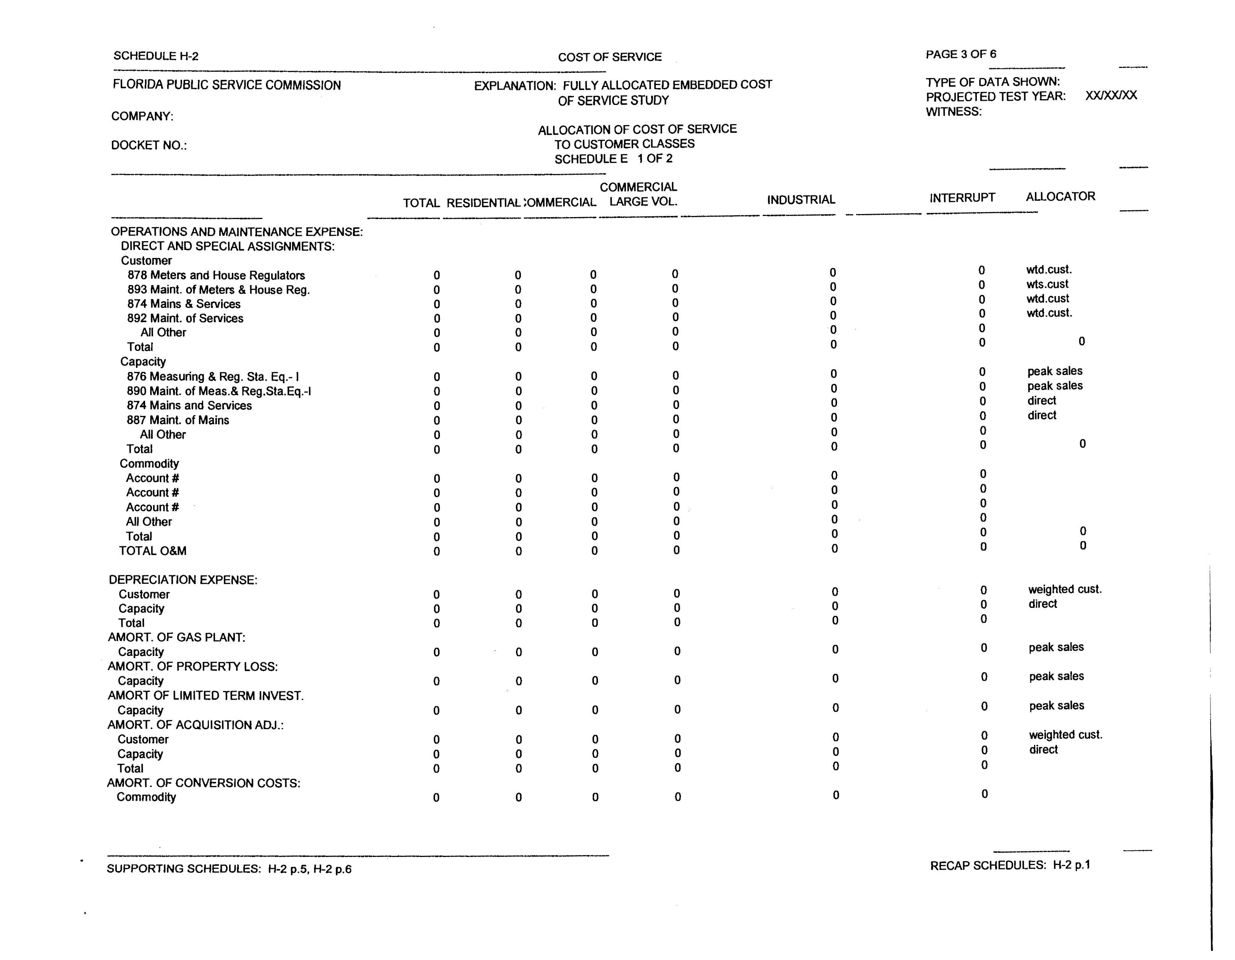
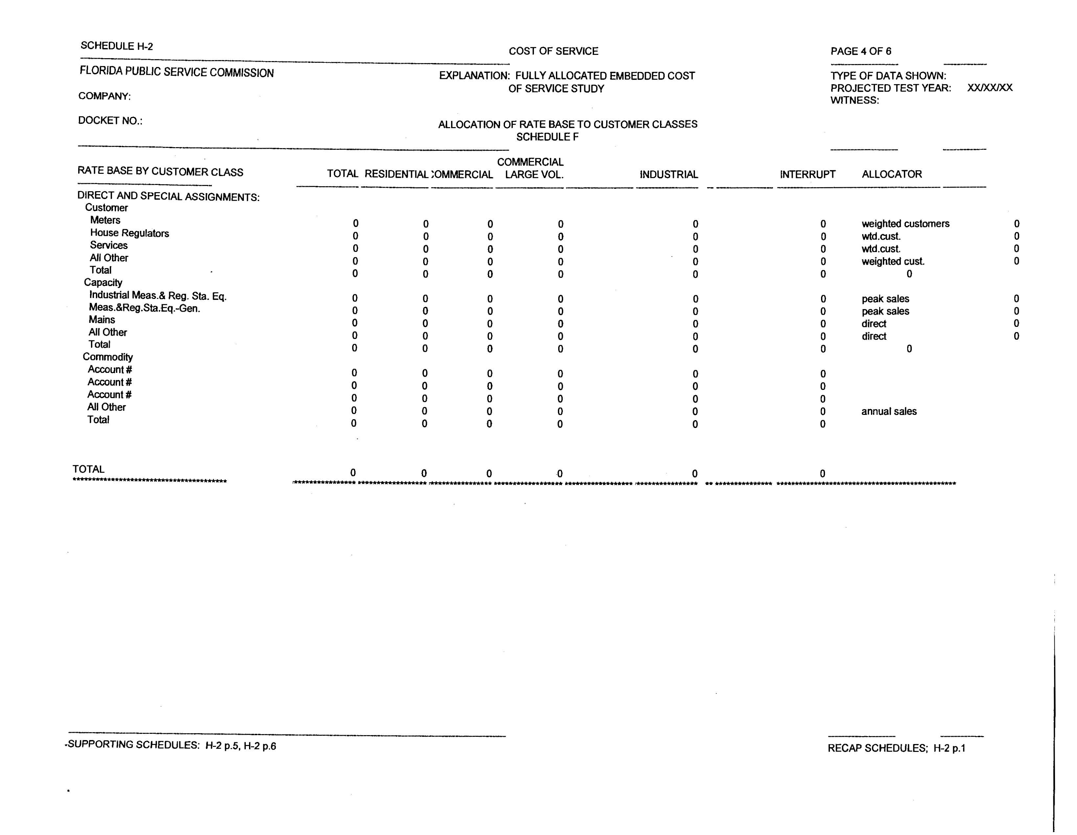
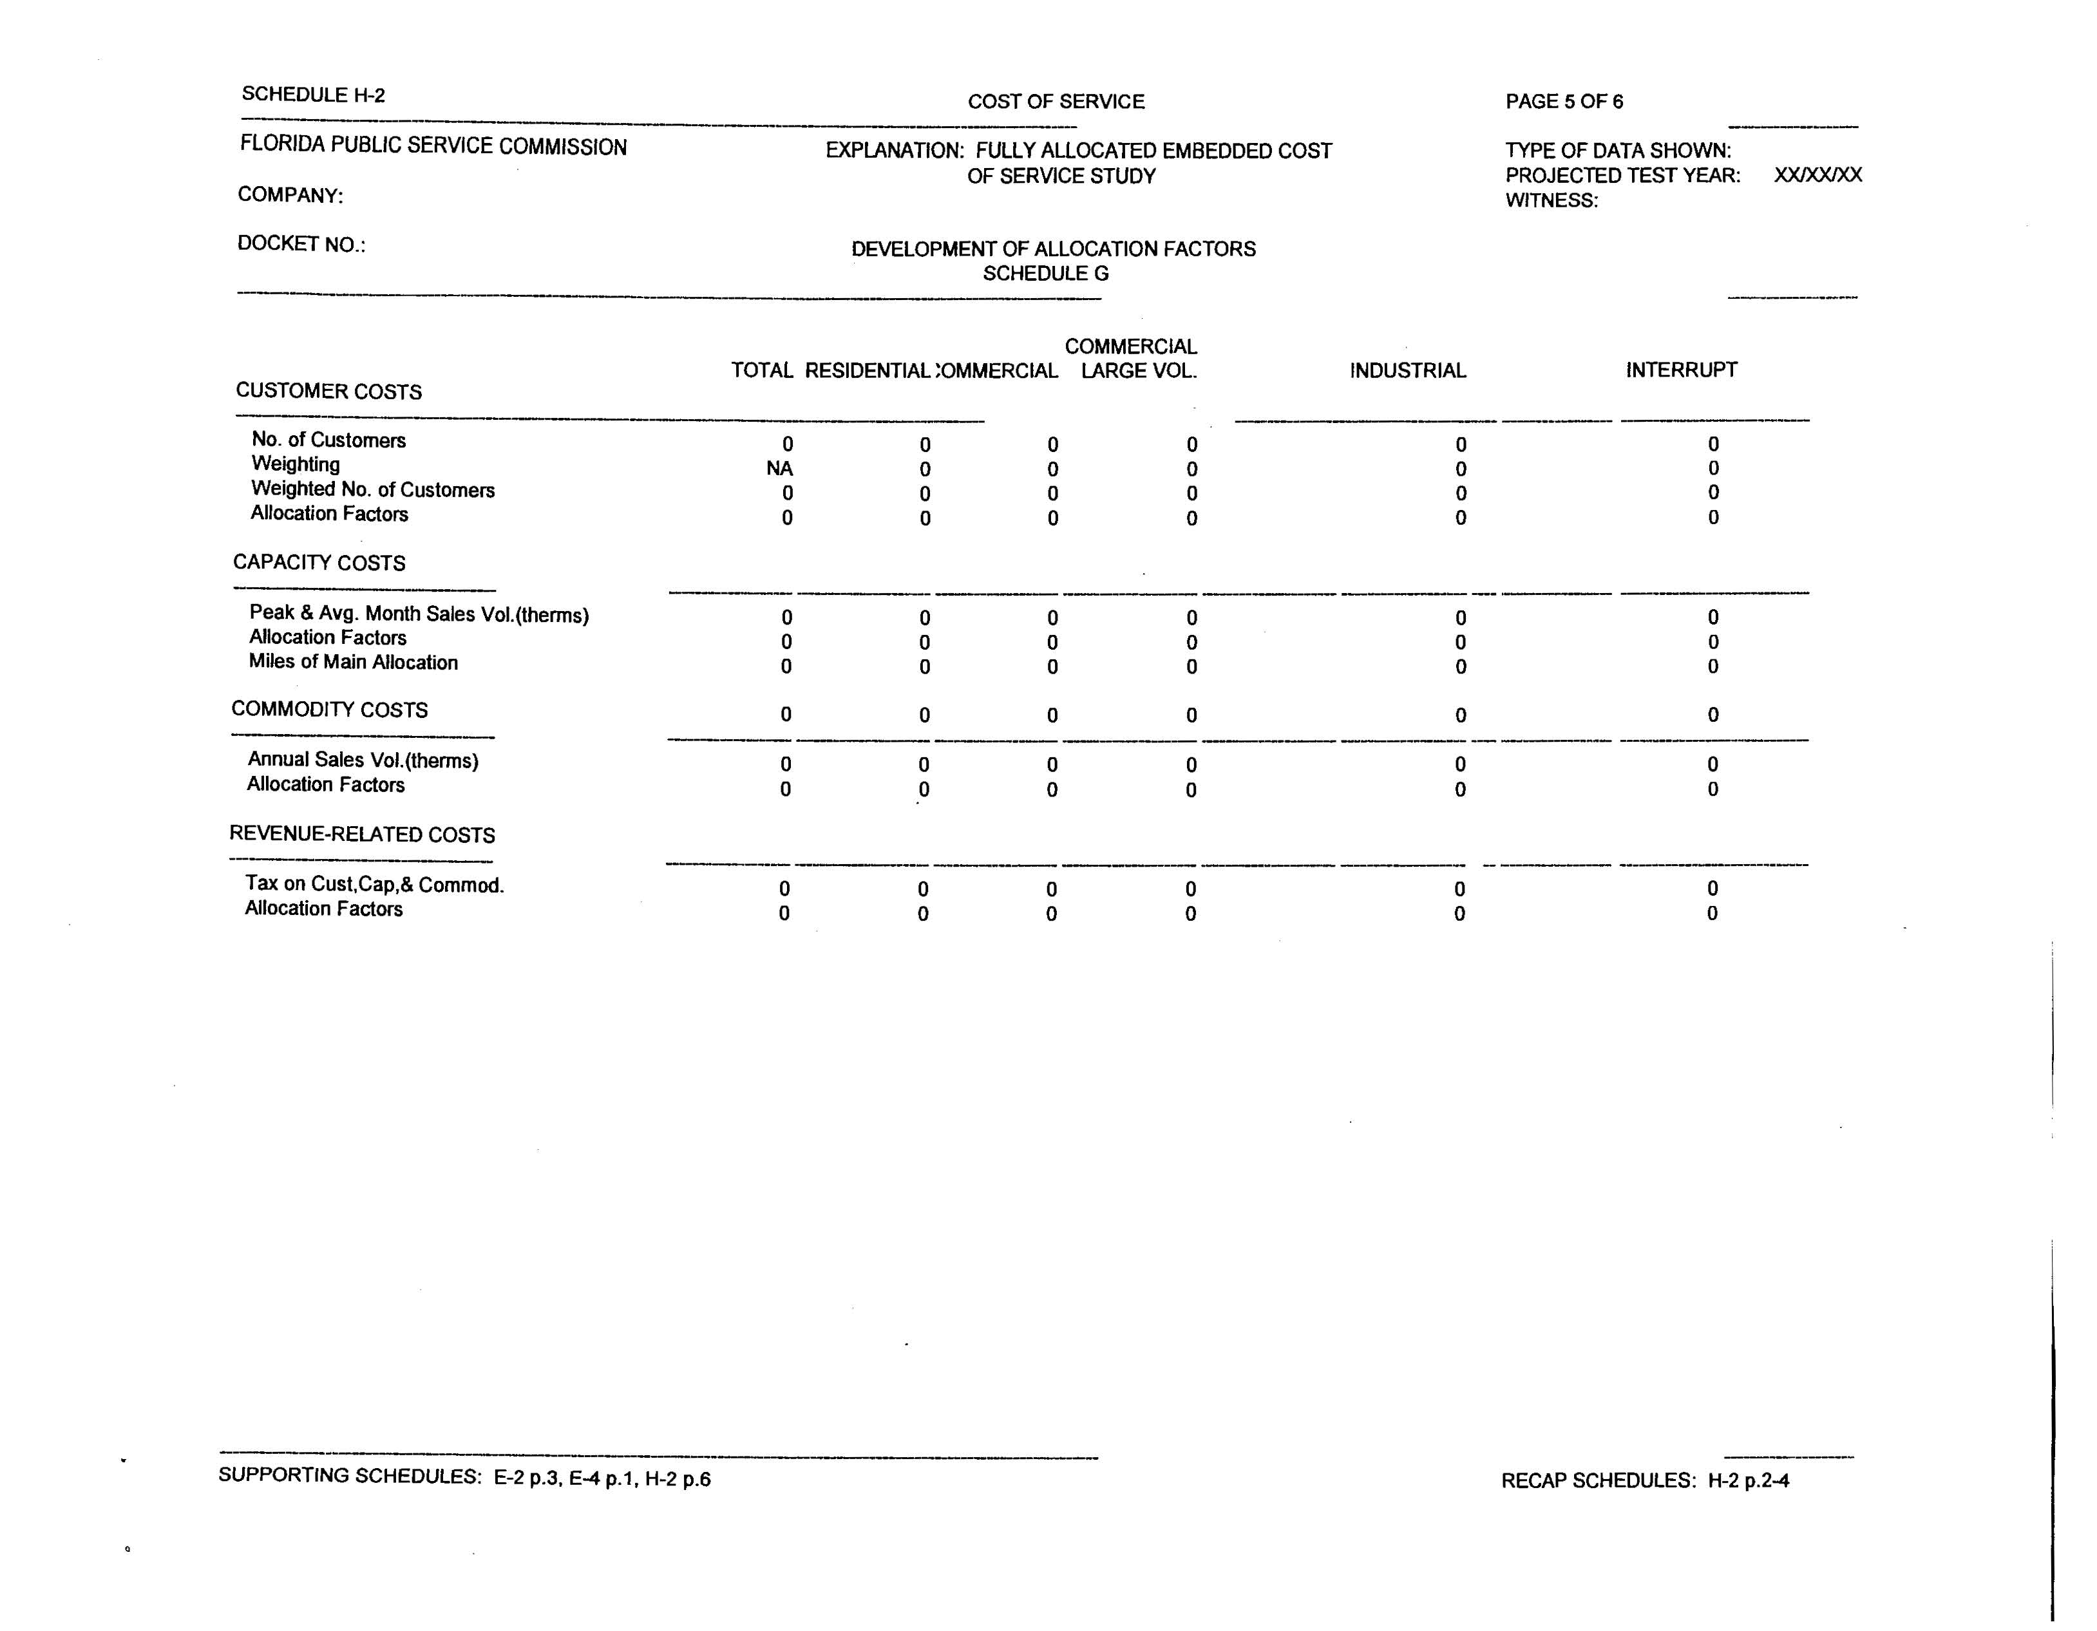
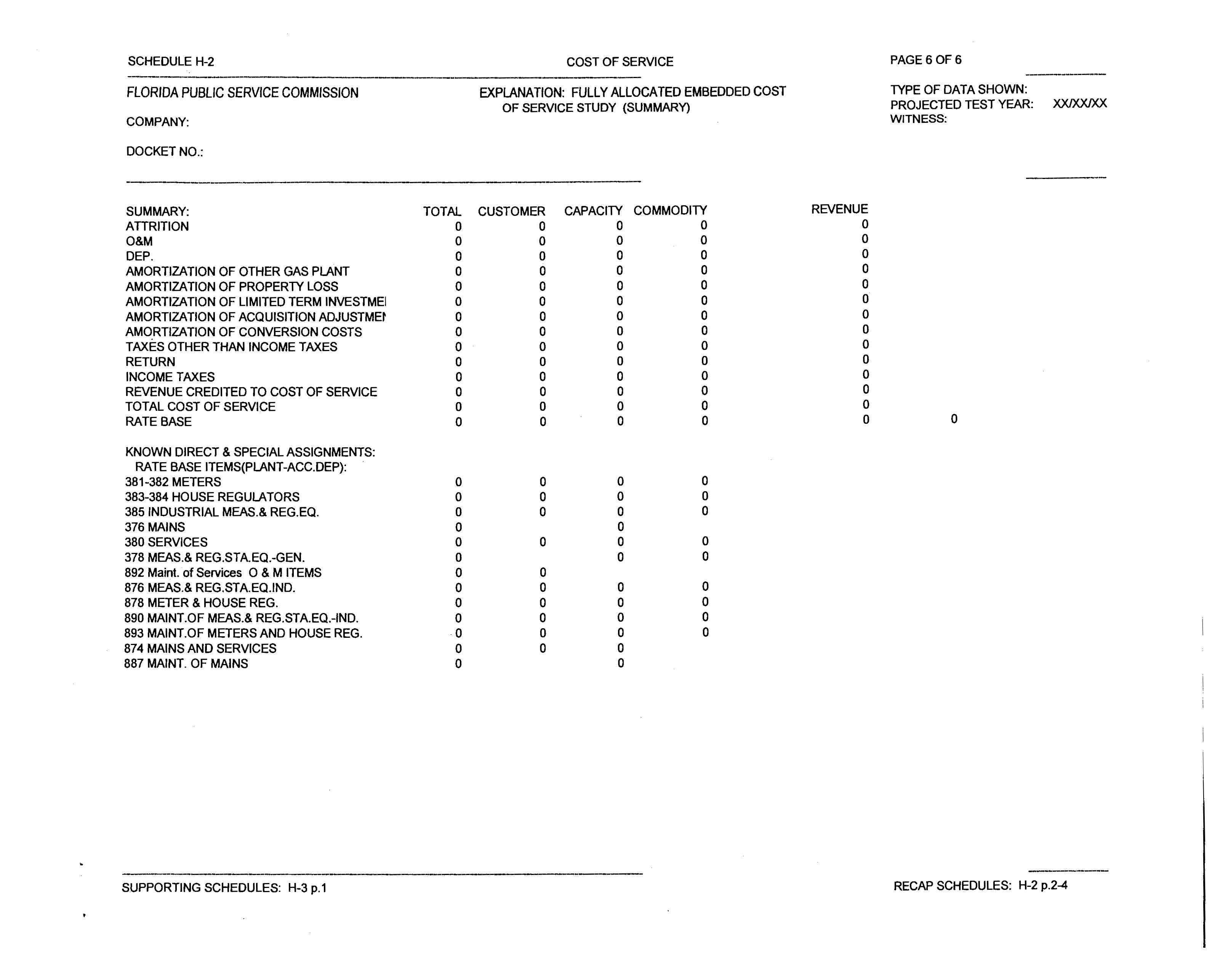
25-22.0406 Notice and Public Information on General Rate Increase Requests and Petitions for Limited Proceedings by Electric, and Gas and Telephone CompaniesUtilities.
(1) The provisions of this rule shall be applicable to all requests for general rate increases and to all limited proceedings filed by electric and gas utilities pursuant to Rules 25-6.0431 and 25-7.0391.by electric, gas and telephone companies subject to the Commission’s jurisdiction.
(2) The following noticing procedures shall apply to requests for a general rate increase:
(a) Upon filing a petition for a general rate increase, tThe utility shall mail a copy of the petition to the chief executive officer of the governing body of each municipality and county within the service area affected.
(b) The utility shall establish a clearly identifiable link on the utility’s website to the address on the Commission’s website that provides electronic access to all documents filed in the rate case.
(c) Location of Minimum Filing Requirements
1.(3)(a) Within 15 days after it has been notified by the Commission that the Minimum Filing Requirements (MFRs) have been met, the utility shall place a copy of the MFRs at its official headquarters and at a location approved by the Commission staff its business office in each municipality in which service hearings were held in the last general rate case of the utility.
2. Within 15 days after the time schedule has been posted on the Commission’s websitemailed to the utility, copies of the MFRs shall be placed in a location approved by Commission staffthe utility business office in each additional city in which service hearings are to be held in the current rate case. Upon customer request a copy of the MFRs shall be placed in a utility business office not located in a city where a service hearing is to be held. The copies of the MFRs shall be available for public inspection during the utility’s regular business hours.
3.(b) In addition to the locations listed above, if the Commission staff determines that the locations listed above will not provide adequate access, the Commission staff will require that copies of the MFRs be placed at other specified locations.
4. Copies of the MFRs shall be available for public inspection during the regular business hours of the location hosting the MFRs, and through a link on the utility’s website.
(d) Rate Case Synopsis
1.(4)(a) Within 15 days after the time schedule for the case has been mailed to the utilityposted to the Commission’s website, the utility shall prepare and submit to the Commission staff for approval and distribute a synopsis of the rate request. The synopsis shall be approved by the Commission or its staff prior to distribution and shall include:
a.1 A summary of the section of the MFRs showing a comparison of the present and proposed rates for major services;
b.2 A statement of the anticipated major issues involved in the rate case;
c.3 A copy of the executive summary filed with the MFRs;
d.4 A description of the ratemaking process and the time schedule established for the rate case; and
e.5 The locations at which complete MFRs are available.
2. Within 7 days following approval of the synopsis, (b) Ccopies of the synopsis shall be distributed to the same locations as required for the MFRs, to the main county library within or most convenient to the service area, and to the chief executive officer of each county and municipality within the service area affected.
(e5) Within 3015 days after the rate case time schedule has been mailed to the utilityposted on the Commission’s website, the utility shall begin prepare and submit a customer notice to Commission staff for approval. The customer notice shall include:sending a notice approved by the Commission or its staff to its customers containing:
1.(a) A statement that the utility has applied for a rate increase and the general reasons for the request;
2.(b) The locations at which copies of the MFRs and synopsis are available, including the link on the utility’s website;
3.(c) The time schedule established for the case, and the dates, times and locations of any hearings that have been scheduled; and
4.(d) A comparison of current rates and service charges and the proposed new rates and service charges. Such notice shall be completed at least 10 days prior to the first scheduled service hearing;.
5. The docket number assigned to the petition by the Commission’s Office of Commission Clerk;
6. A statement that written comments regarding the proposed changes in rates and charges should be addressed to the Office of Commission Clerk, 2540 Shumard Oak Boulevard, Tallahassee, Florida, 32399-0850, and that such correspondence should include the docket number; and
7. A statement that complaints or concerns regarding service may be made to the Commission’s Division of Service, Safety & Consumer Assistance at this toll free number: (800 342-3552.
(f) The utility shall begin sending the notice to customers within 15 days after it has been approved by Commission Staff.
(3) The following noticing procedures shall apply to a petition for a limited proceeding filed pursuant to Rules 25-6.0431 and 25-7.0391:
(a) The utility shall establish a clearly identifiable link on the utility’s website to the address on the Commission’s website that provides electronic access to all documents filed in the limited proceeding.
(b) Within 15 days after the time schedule for the limited proceeding has been posted to the Commission’s website, the utility shall prepare and submit a customer notice to the Commission staff for approval. The customer notice shall contain:
1. A statement that the utility has requested a change in rates, a statement of the amount requested, and the general reason for the request;
2. A statement of where and when the petition and supporting documentation are available for public inspection, including the link on the utility’s website;
3. A comparison of the current and proposed rates;
4. The utility’s address, telephone number, and website address;
5. The docket number assigned to the petition by the Commission’s Office of Commission Clerk;
6. A statement that written comments regarding the proposed changes in rates and charges should be addressed to the Office of Commission Clerk, 2540 Shumard Oak Boulevard, Tallahassee, Florida, 32399-0850, and that such correspondence should include the docket number; and
7. A statement that complaints or concerns regarding service may be made to the Commission’s Division of Service, Safety & Consumer Assistance at this toll free number: (800 342-3552.
(d) The utility shall begin sending the notice to customers within 15 days after it has been approved by staff.
(4) All customer notices prepared pursuant to this rule shall be sent to the customer’s address of record at the time the notice is issued, in the manner in which the customer typically receives the monthly bill, whether electronically or via U.S. mail.
(5) All customer notices regarding the locations and time of Commission-scheduled service hearings or customer meetings shall be sent to the customer no less than 15 days, or more than 45 days, prior to the first Commission-scheduled service hearing or customer meeting.
(6) At least 7 days and not more than 20 days prior to each Commission-scheduled service hearing or customer meeting, the utility shall have published in a newspaper of general circulation in the area in which the hearing or customer meeting is to be held, a display advertisement stating the date, time, location and purpose of the hearing or customer meeting. The advertisement shall be approved by the Commission or its staff prior to publication.
(7) When the Commission issues proposed agency action and a hearing is subsequently held, the utility shall give written notice of the hearing to its customers at least 1514 days in advance of the hearing. This notice shall be approved by the Commission or its staff prior to distribution.
(8) After the Commission’s issuance of an order granting or denying a rate change, the utility shall give notice to its customers of the order and the revised rates. The notice shall be approved in advance by the Commission or its staff and transmitted to the customers with the first bill containing the new rates.
Rulemaking Specific Authority: 350.127(2), 366.05, 366.06(1) FS. Law Implemented: 120.569, 120.57, 364.01(4), 364.035(1), 364.04(3), (4), 364.05(1), (2), 364.19, 366.03, 366.041(1), 366.05(1), 366.06(1), 366.076(1) FS.
History–New 9-27-83, Formerly 25-22.406, Amended 5-27-93, 5-3-99, ________

