State of Florida   |  | Public Service Commission  Capital Circle Office Center ● 2540 Shumard Oak Boulevard  Tallahassee, Florida 32399-0850  -M-E-M-O-R-A-N-D-U-M-
DATE: | March 1, 2012
TO: | Office of Commission Clerk (Cole)
FROM: | Division of Economic Regulation (Kummer)  Office of the General Counsel (Brown)
RE: | Docket No. 110308-GU – Request by Peoples Gas System to modify Tariff Sheet 5.701 to add sections entitled "Limits of Company's Responsibilities" and "Continuity of Service."
AGENDA: | 03/13/12 – Regular Agenda – Interested Persons May Participate
COMMISSIONERS ASSIGNED: |  |  | All Commissioners
PREHEARING OFFICER: |  |  | Administrative
CRITICAL DATES: |  |  | 9/18/2012 (8-Month Effective Date)
SPECIAL INSTRUCTIONS: |  |  | None
FILE NAME AND LOCATION: |  |  | S:\PSC\ECR\WP\110308.RCM.DOC

Case Background
On January 18, 2012, Peoples Gas System (PGS) filed a petition to amend Tariff Sheet No. 5.701 to add two new sections limiting the utility’s liability under certain circumstances. One provision addresses responsibility for activities that occur on the customer’s side of the meter. The second provision addresses continuity of service under circumstances beyond the utility’s control. While electric utilities have similar provisions limiting liability, PGS is the first gas utility to request such language in its tariff. Based on discussions at the February 14, 2012 Agenda Conference, on February 22, 2012, PGS submitted revised language modifying the Continuity of Service provision. The Commission has jurisdiction pursuant to Sections 366.03, 366.04, and 366.06, Florida Statutes (F.S.).
Discussion of Issues
Issue 1:1
Should the Commission approve the proposed changes to the provisions contained on Tariff Sheet No. 5.701, including the revision filed on February 22, 2012?
Recommendation:
Yes. (Brown, Kummer)
Staff Analysis:
The two proposed changes establish limits to the utility’s liability under certain specified conditions. The section entitled Limits of Company’s Responsibilities exempts the utility from responsibility for damages sustained on the customer’s side of the meter, including any damage due to any equipment or appliances installed by the customer on his side of the point of delivery.

This section also limits the utility’s responsibilities for impurities in gas delivered to the customer. PGS notes that PGS, like other distribution utilities in the state, has no control over the characteristics of the gas it delivers to its customers from the interstate pipelines. The Federal Energy Regulatory Commission (FERC) has established standards for some of the more important characteristics of gas, and these characteristics are measured by the pipeline delivering the gas to PGS. Although PGS monitors the federal reporting data, PGS does not have the capability to do its own testing. Its tariff contains specifications for the gas it will accept, but impurities are sometimes introduced to the interstate pipelines, despite FERC standards. It appears that PGS utilizes the information available from the pipelines and has established by tariff other criteria to assure the quality of the gas it delivers; therefore, it should not be responsible for problems associated with impurities that may still exist.

The second section is entitled Continuity of Service. This section states that the utility shall use reasonable diligence to provide regular, uninterrupted service to customers, but shall not be liable for any fatality, injury, or damage to property arising from service interruptions caused by conditions beyond its control, including interruption of service, fluctuations in gas flow, termination or delay in providing or restoring gas service, or failure to warn of interruptions of gas service. This section replaces the Force Majeure provision that has been in PGS’ tariffs for decades. The Continuity of Service section also limits PGS’s liability for damage caused by the utility’s simple or ordinary negligence.
At the February 14, 2012, Agenda Conference, the Commission expressed concerns about the liability exemption for noticing customers in the event of an interruption. Based on those discussions, the tariff was suspended in order for PGS to review Commission comments on the Continuity of Service section. No other issues were raised with the proposed changes. PGS filed revised language on February 22, 2012, incorporating the language discussed at the Agenda Conference, which narrows the limitation on noticing to those interruptions arising from a Force Majeure event or an emergency. The proposed change adds the words “as the result of an emergency or a Force Majeure event” to the last sentence of the Continuity of Service provision. (See Attachment 1)
It has long been held that a regulated utility has the right to limit its liability, as the cost to defend against unlimited liability could result in significantly higher rates to all customers. See Landrum v. Florida Power & Light Company, 505 So. 2d 552, 554 (Fla. 1987), and cases from around the country cited therein, where the Florida Supreme Court said:

It is well established that a limitation of liability contained in a tariff is an essential part of the rate, and that the consumer is bound by the tariff, regardless of his knowledge or assent thereto. . . . Therefore, a tariff validly approved by the Public Service Commission, including a limitation of liability for ordinary negligence, resulting in the interruption of the regular supply of electric service is valid.

The Commission approved a similar limitation of liability provision in TECO’s tariffs by Order No. 911064-EI, issued January 9, 1992, in Docket No. 911064-EI, In re: Petition of Tampa Electric Company for Approval of Tariff Modifications. The Commission said, at pps. 1-2:

We approve the modifications that TECO has proposed to its tariffs. The limitation of liability provisions and indemnification provisions are consistent with the provisions of other electric utilities’ approved tariffs. The legitimacy of such provisions has been recognized many times by the Courts. . . .

We believe that TECO’s proposed tariff revisions represent a reasonable effort to protect against undue risk and liability that may arise in the conduct of its business. We are also mindful of the presumption of validity created by our approval of the limitations of liability included in these tariff modifications. Therefore we wish to make it clear that the modifications are approved with the understanding that the limitations of liability, in whatever legal framework they may occur, apply to acts of “simple”, or “ordinary” neglect of duty, and do not apply to acts of “gross” negligence or dereliction of duty, as those terms are understood and defined in decisional law.

Staff recommends, based on practice and legal precedent, that the Commission approve the proposed tariff changes as revised on February 22, 2012, which are similar to continuity of service and limitations of liability provisions in other utilities’ tariffs. The Commission exercises extensive oversight of a regulated utility’s operations and has established rules and procedures to ensure that it operates safely and in the public interest. Customers have recourse through the Commission’s complaint process to address a regulated activity, or through civil action with respect to damages for gross negligence.

Issue 2:2
Should this docket be closed?
Recommendation:
Yes. If Issue 1 is approved, the tariffs should become effective as of the Commission vote, March 13, 2012. If a protest is filed within 21 days of the issuance of the order, the tariffs should remain in effect pending resolution of the protest. If no timely protest is filed, this docket should be closed upon the issuance of a consummating order. (Brown)
Staff Analysis:
If Issue 1 is approved, the tariffs should become effective as of the Commission vote, March 13, 2012. If a protest is filed within 21 days of the issuance of the order, the tariffs should remain in effect pending resolution of the protest. If no timely protest is filed, this docket should be closed upon the issuance of a consummating order.

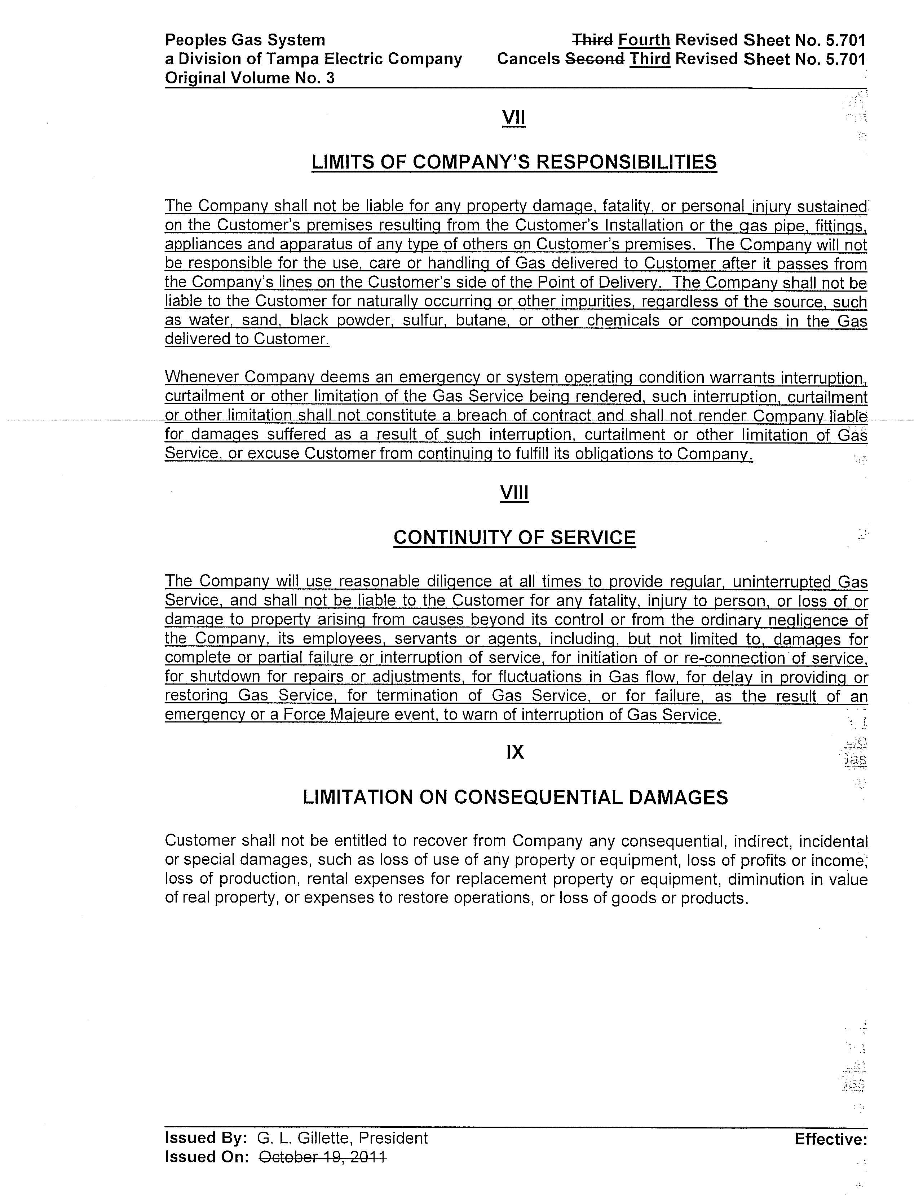

In Landrum, at p. 554, the Court defined “gross negligence” as “a course of conduct. . .such that the likelihood of injury to the other persons or property is known by the actor to be imminent or ‘clear and present’. . . \.

