State of Florida   |  | Public Service Commission  Capital Circle Office Center ● 2540 Shumard Oak Boulevard  Tallahassee, Florida 32399-0850  -M-E-M-O-R-A-N-D-U-M-
DATE: | March 29, 2012
TO: | Office of Commission Clerk (Cole)
FROM: | Division of Economic Regulation (Draper, Rieger, Daniel, Kummer)  Office of the General Counsel (Barrera)
RE: | Docket No. 110271-GU – Petition for approval of transportation service agreement with Florida Public Utilities Company, by Peninsula Pipeline Company, Inc.  Docket No. 110277-GU – Joint petition for approval of territorial agreement in Nassau and Duval Counties by Peoples Gas System and Florida Public Utilities Company; gas transportation agreement by Peoples Gas System and Peninsula Pipeline Company, Inc.; and application for approval of tariff revisions to reflect service in Nassau and Okeechobee Counties, by Florida Public Utilities Company
AGENDA: | 04/10/12 – Regular Agenda - Proposed Agency Action – Interested Persons May Participate
COMMISSIONERS ASSIGNED: |  |  | All Commissioners
PREHEARING OFFICER: |  |  | Graham
CRITICAL DATES: |  |  | 05/22/12 (8-Month Effective Date for tariff)
SPECIAL INSTRUCTIONS: |  |  | None
FILE NAME AND LOCATION: |  |  | S:\PSC\ECR\WP\110271.110277.RCM.DOC

Case Background
Pursuant to Section 366.04(3)(a), Florida Statutes (F.S.), and Rule 25-7.0471, Florida Administrative Code (F.A.C.), Florida Public Utilities Company (FPUC) and Peoples Gas System (Peoples) filed a January 26, 2012 joint petition in Docket No. 110277-GU for approval of a territorial agreement between the Petitioners related to the provision of natural gas service in Nassau and Duval Counties. Each Petitioner owns and operates natural gas distribution facilities in various portions of Florida. FPUC currently has no active customers in Nassau or Duval County. Peoples currently has one customer in Nassau County and 20,080 customers in Duval County. FPUC and Peoples are seeking the Commission’s approval of a territorial agreement that would determine the areas of Nassau and Duval Counties within which each utility would be authorized to provide natural gas service. Further, FPUC is seeking approval of tariff modifications reflecting its intent to provide natural gas service in Nassau and Okeechobee Counties. FPUC currently has no customers in Okeechobee County.
Pursuant to Rule 25-9.034, F.A.C., both FPUC and Peoples have also each filed for the Commission’s approval of separate gas transportation agreements with Peninsula Pipeline Company, Inc. (PPC). The transportation agreements are required to move gas from People’s interconnections with the interstate pipeline system of Florida Gas Transmission Company (FGT), through the Peoples distribution system, and into a new pipeline (the Fernandina Beach Line) to be owned in common by PPC and Peoples.
Docket No. 110271-GU was opened in mid-September 2011 by PPC’s filing of a petition for approval of a Firm Transportation Service Agreement between PPC and FPUC. However, on February 8, 2012, a petition for approval of an amended and revised transportation service agreement between PPC and FPUC was filed as a result of negotiations that arose between Peoples and FPUC in relation to Docket No. 110277-GU.
Docket No. 110277-GU was also opened in September 2011 by FPUC’s filing of a petition for approval of tariff modifications to reflect FPUC’s intent to extend gas service into unserved areas in Nassau and Okeechobee Counties. Subsequently, FPUC and Peoples recognized that a territorial dispute was imminent as a result of their planned expansions of gas service to portions of Nassau County. Peoples had entered into a transportation agreement with RockTenn CP (RockTenn), the owner and operator of a large paper mill on the northern tip of Amelia Island in Nassau County in October 2011. FPUC had obtained commitments from over 200 potential commercial customers to take gas service from the proposed FPUC distribution system expansions in Nassau County. FPUC and Peoples entered into negotiations in late 2011 in an effort to avoid delayed implementation of the expansion plans of both FPUC and Peoples. A January 26, 2012 petition was filed requesting approval of a territorial agreement between Peoples and FPUC. Accompanying the petition was an associated gas transportation agreement between Peoples and PPC.
The recommendation includes two attachments. Attachment A includes the Nassau-Duval County Territorial Agreement, as well as an associated map depicting the service territories of Peoples and FPUC. Attachment B is a map depicting the various pipeline construction segments discussed in Issues 2 and 3.
The parties requested that the Commission consolidate its decisions in Docket Nos. 110271-GU and Docket No. 110277-GU. The parties and staff believe that such administrative consolidation will permit a more complete understanding of the jointly developed plan for the provision of natural gas service to residents of Nassau County. This is staff’s recommendation regarding a territorial agreement, a tariff modification, and two transportation service agreements. The Commission has jurisdiction over these matters pursuant to Section 366.03, 366.04, 366.05, and 366.06, and 368.105, F.S.
Discussion of Issues
Issue 1:1
Should the Commission approve the Joint Petition for the Territorial Agreement in Nassau and Duval Counties between Peoples and FPUC, as well as FPUC’s tariff modifications to extend service in Nassau and Okeechobee Counties?
Recommendation:
The Joint Petition for the Territorial Agreement in Nassau and Duval Counties between Peoples and FPUC is in the public interest and should be approved, pursuant to Section 366.04(3)(a), F.S. In addition, FPUC’s tariff modifications reflecting its extension of service into unserved areas in Nassau and Okeechobee Counties are appropriate and should be approved. (Barrera, Rieger)
Staff Analysis:
On January 26, 2012, Peoples and FPUC filed a Joint Petition for the Commission to approve a territorial agreement in Nassau and Duval Counties, pursuant to Section 366.04(3)(a), F.S., and Rule 25-7.0471, F.A.C. In addition, on September 22, 2011, FPUC filed a petition for approval of tariff modifications to reflect its extension of service into unserved areas in Nassau and Okeechobee Counties.
Territorial Agreement
As disclosed in the joint petition, both FPUC and Peoples have been independently pursuing plans to extend their respective distribution systems to provide service to customers in Nassau County. Peoples provides natural gas service to approximately 20,000 customers in Duval County and one customer in Nassau County. Peoples had recently entered into a transportation agreement with RockTenn, the owner of a large paper mill on the northern tip of Amelia Island in Nassau County and FPUC had obtained commitments from over 200 potential customers to take gas service from the proposed FPUC distribution system expansions in Nassau County. When Peoples and FPUC became aware that a territorial dispute was imminent, they entered into negotiations to address the provision of service in Nassau and Duval Counties. As a result of those negotiations, Peoples and FPUC are seeking the Commission’s approval of the January 24, 2012 Nassau-Duval County Territorial Agreement (the Nassau-Duval Agreement) that specifically defines their respective territorial service areas in both Nassau and Duval Counties, pursuant to Section 366.04(3)(a), F.S. This was considered necessary because of Peoples’ existing presence in Duval County, the close proximity of Duval County to Nassau County, and the fact that both Peoples and FPUC would be serving customers in Nassau County.
The Nassau-Duval Agreement provides that Peoples’ service area shall be (i) the RockTenn Facility (and any expansions thereof), (ii) Peoples’ existing customer identified in the agreement, and (iii) all of Duval County; FPUC’s service area shall be all of Nassau County except those areas of the county reserved to Peoples by the agreement. Neither party currently has any customers in the service area reserved by the other party by the agreement and the agreement provides for no transfers of customers or facilities between the parties. Further, the agreement provides that it would enable as many persons and businesses in Nassau County as possible to receive economical and reliable natural gas service, avoid any territorial dispute between Peoples and FPUC which would inevitably delay the provision of natural gas service by either of the parties, and enable the parties to avoid any unnecessary duplication of facilities.
The Nassau-Duval Agreement will become effective on the date that a Commission order approving it becomes final and effective, and will continue in effect until termination or modification is mutually agreed upon by the parties and approved by the Commission, or until termination or modification is mandated by a governmental entity or court with appropriate jurisdiction. Also, prior to the second anniversary of its effective date, and no more than every fifth anniversary thereafter, the Nassau-Duval Agreement requires the parties to meet and review the status of the agreement and submit a joint status report to the Commission.
FPUC Tariff Modifications
In its petition, FPUC indicated that it had received sufficient interest from potential natural gas customers in both Nassau and Okeechobee Counties to provide economic justification for extending service into those areas. FPUC indicated that for Nassau County it has received executed agreements from over 200 commercial customers. Also, a market study indicated that within the next three years, FPUC believes that over 1,500 new housing starts will occur and new commercial building is expected to double from current construction levels. FPUC projects that approximately 400 residential customers and 240 commercial and industrial customers will be served by the end of year five. Over the initial twenty year horizon, FPUC expects to serve a minimum of 2,500 residential customers and 450 commercial and industrial customers in Nassau County. FPUC indicated that the economic viability of providing service into unserved areas is further enhanced with the proposed transportation service agreement with PPC, as discussed in Issue 2 of this recommendation, and expects to start providing natural gas service to customers in Nassau County by mid November 2012.
For Okeechobee County, FPUC noted in its petition that no other distribution company serves the area. Based on customer growth forecasts, FPUC projects that approximately 50 residential customers and 100 commercial customers will be served by the end of year five. Over a twenty year horizon, FPUC expects to serve a minimum of 750 residential customers and 150 commercial and industrial customers. In order to provide service to Okeechobee County, FPUC plans to interconnect with the Florida Gas Transmission interstate pipeline system which runs about three miles north of the City of Okeechobee. FPUC will construct a city gate station at the interconnection point and construct a 6-inch distribution main south into the City of Okeechobee. FPUC has identified the location of approximately 90 commercial customers located in or near the city limits and has designed distribution facilities capable of providing service to each of these customers.
Conclusion
Pursuant to Section 366.04(3)(a), F.S., the Commission has jurisdiction to approve territorial agreements between and among natural gas utilities. Pursuant to Rule 25-7.0471(2), F.A.C., in approving territorial agreements, the Commission may consider the reasonableness of the purchase price of any facilities being transferred, the likelihood that the agreement will not cause a decrease in the reliability of natural gas service to existing or future ratepayers, and the likelihood that the agreement will eliminate existing or potential uneconomic duplication of facilities. Unless the Commission determines that the agreement will cause a detriment to the public interest, the agreement should be approved. Utilities Commission of the City of New Smyrna v. Florida Public Service Commission, 469 So. 2d 731 (Fla. 1985).
It appears that the Nassau-Duval County Territorial Agreement proposed by Peoples and FPUC eliminates existing or potential uneconomic duplication of facilities, and does not cause a decrease in the reliability of natural gas service to existing or future ratepayers. Therefore, staff recommends that the Joint Petition for the Territorial Agreement in Nassau and Duval Counties between Peoples and FPUC is in the public interest and should be approved, pursuant to Section 366.04(3)(a), F.S. In addition, FPUC’s tariff modifications reflecting its extension of service into unserved areas in Nassau and Okeechobee Counties are appropriate and should be approved.

Issue 2:1
Should the Commission approve the revised Transportation Service Agreement between FPUC and PPC as filed on February 8, 2012, in Docket No. 110271-GU?
Recommendation:
Yes. The revised Transportation Service Agreement between FPUC and PPC (revised agreement) as filed on February 8, 2012, in Docket No. 110271-GU, should be approved. (Draper)

Staff Analysis:
On September 19, 2011, PPC filed a petition for approval of a transportation service agreement with FPUC to enable FPUC to serve Nassau County. As noted in the case background, subsequent to the original filing, concern about a potential territorial dispute in Nassau County led to additional negotiations among Peoples, FPUC and PPC. The original agreement was therefore modified reflecting the negotiations that included Peoples. On February 8, 2012, PPC filed a petition for approval of an amended and revised transportation service agreement with FPUC to be effective February 1, 2012. Under the revised agreement, FPUC will pay PPC for the transportation of gas from the FGT/Peoples interconnection through Peoples’ system and PPC’s portion of the Fernandina Beach Line to points of delivery to FPUC in Nassau County. FPUC’s payments to PPC are proposed for recovery through the Purchased Gas Adjustment (PGA).

To establish context, staff first provides a review of PPC’s regulatory framework. PPC is an intrastate natural gas transmission company subject to the Commission’s jurisdiction under Chapter 368.101, Florida Statutes (F.S.). PPC is a subsidiary of Chesapeake Utilities Corporation (Chesapeake). In Order No. PSC-07-1012-TRF-GP, PPC received approval of an intrastate gas pipeline tariff that allows PPC to construct and operate intrastate pipeline facilities and to actively pursue transportation agreements with gas customers. PPC provides transportation service only, and does not engage in the sale of natural gas. The tariff includes the general terms, conditions, and rules under which PPC can operate.

Pursuant to Order No. PSC-07-1012-TRF-GP and PPC’s approved tariff, PPC is allowed to enter into certain pipeline projects without express Commission approval, pursuant to negotiated contracts. PPC’s tariff does not include rates and charges, as those would be negotiated individually based on market conditions and the specific needs of each customer pursuant to Section 368.105(3), F.S. Contracts between affiliated companies, however, must be specifically approved by the Commission prior to implementation.

FPUC’s discussions with potential intrastate pipeline providers, including PPC, began in 2008. Following the merger between Chesapeake and FPUC in October 2009, both PPC and FPUC are now subsidiaries of Chesapeake. PPC therefore is required to seek Commission approval of the revised agreement with FPUC, consistent with PPC’s tariff Sheet 12, Section 4(d).

FPUC considered several options to serve new load in Nassau County. Historically, interstate pipelines such as FGT have made investments in physical extensions of transmission laterals to a local distribution company’s growth areas. FPUC stated that it had discussions with FGT and Southern Natural Gas Company, LLC (SONAT). Both FGT and SONAT operate interstate transmission facilities close to Nassau County. However, FPUC stated that SONAT was not interested in the project and the FGT cost estimate was not a viable economic option.

FPUC also reviewed its existing tariff provisions for funding expansion. The primary mechanism is the Maximum Allowable Construction Cost (MACC). The formula under this tariff provision showed that it was cost effective for FPUC to extend its facilities, based on the expected load and associated revenues. However, FPUC determined that PPC’s proposal was the best overall option. In addition, the PPC option allows for FPUC to grow into pipeline capacity over time, keeping initial rates lower that they would otherwise be if FPUC had to contract for a greater amount of capacity now, or run the risk of such capacity not being available for growth later. Connection to Peoples through PPC (as discussed in Issue 3) would also allow multiple interstate pipeline connections for FPUC to provide greater reliability and flexibility.

PPC option. PPC states in the amended petition that the revised agreement was developed through an “arm’s length” transaction. FPUC issued a request for proposal (RFP) to all potential entities that could provide a valid proposal for the Nassau County project. FPUC states that it evaluated the terms and pricing under each proposal received, and PPC was awarded the original contract over other competitive bidders. Subsequently, further negotiations took place which included Peoples as well as PPC, resulting in the revised agreement filed on February 8, 2012. In response to staff’s data request, FPUC provided an evaluation of the bid responses, which indicates the PPC was ranked No. 1. FPUC evaluated the proposals based on several criteria such as cost, route, in-service date, and capacity. PPC also provided information in response to staff’s data request showing that the revised agreement results in lower overall costs to FPUC when compared to the original agreement filed in September 2011.

The charges to FPUC under the revised agreement includes costs associated with: (1) the transportation charges PPC will pay to Peoples for Peoples’ new investments discussed in Issue 3; (2) PPC’s 46.46 percent pro-rata share of the new Fernandina Beach Line; and (3) PPC’s cost to construct two wholly-owned laterals connected to the Fernandina Beach Line to serve FPUC in Nassau County. The Fernandina Beach Line is the orange line shown on the map in Attachment B.

FPUC is proposing to recover the payments to PPC under the revised agreement through its PGA mechanism consistent with other gas transmission pipeline costs incurred by FPUC. Staff notes that in the annual PGA docket the Commission does not set an actual factor, but a PGA cap. FPUC provided information showing that the impact of the revised agreement on the PGA cap will be minor (increase of less than 3 cents on the 2013 cap), and in future years the cap is projected to decrease as a result of the revised agreement, as a result of new customers in Nassau County.

FPUC conducted a detailed market study of the Nassau County area which shows significant potential for natural gas usage, and it already has signed commitments from over 200 commercial customers in Nassau County to convert to natural gas service. Many of these customers are currently served by propane and switching to natural gas would result in a significant cost savings. FPUC explained that it will recover its construction costs of the Nassau County distribution system through revenues generated by its tariff rates charges to the customers. Staff has reviewed the cost estimates contained in the confidential documents and believes the revised agreement between FPUC and PPC is prudent and should be approved.
Issue 3:1
Should the Commission approve the Gas Transportation Agreement between Peoples and PPC as filed on January 26, 2012, in Docket No. 110277-GU?
Recommendation:
Yes. The Gas Transportation Agreement (agreement) between Peoples and PPC as filed on January 26, 2012, in Docket No. 110277-GU, should be approved. (Draper)

Staff Analysis:
To support the transportation agreement between FPUC and PPC discussed in Issue 2, PPC entered into an agreement with Peoples which allows for the transportation of gas by PPC across Peoples’ system. The agreement requires that Peoples install the gas distribution facilities and equipment required to provide the transportation service. Because Peoples’ existing wholesale sales tariff would not allow adequate recovery of the investment necessary to support Peoples’ transportation of gas for PPC, Peoples and PPC entered into this agreement. The agreement allows for a fixed monthly charge for service similar to the capacity reservation charge paid to a Federal Energy Regulatory Commission (FERC) regulated interstate pipeline for transportation service. The charge is designed to recover Peoples’ cost of the investment. The Commission has approved a similar arrangement between Peoples and the Florida Division of Chesapeake Utilities. The agreement was entered into on January 24, 2012 and has a 15-year initial term. Peoples will begin to recover its investment for the extension of facilities upon the in-service date of the facilities.

The agreement provides for the receipt of gas by Peoples from FPUC at Peoples’ interconnection(s) with FGT (receipt points), and the transport of that gas by PPC over Peoples’ system to the interconnect with the Fernandina Beach Line at the Nassau/Duval county line (delivery point). At that point, the gas would be transported by PPC through the Fernandina Beach Line which is jointly owned by Peoples and PPC. PPC would then construct laterals off the Fernandina Beach Line to interconnect with FPUC’s distribution system.

Peoples currently has four interconnections with FGT and two with Southern Natural Gas (SNG) west of Jacksonville. Thus, under the joint petition, no new interconnections with interstate pipelines will be required in order to bring natural gas service to Nassau County. Peoples and FPUC signed a capacity release agreement which allows Peoples to make a temporary release of its interstate pipeline transportation capacity on FGT to FPUC. This release allows FPUC to transport gas on the interstate pipeline for delivery to Peoples’ interconnect point(s). The capacity release agreement itself does not require Commission approval, and may result in savings to Peoples’ customers, because any reduction in capacity costs will flow through the PGA to Peoples’ customers. The amount of the savings will depend on the quantity of capacity released to FPUC.

Use of Peoples’ system. The agreement provides for Peoples’ recovery of the following costs, including a return: (1) Peoples’ replacement of 2.25 miles of Peoples’ existing 12-inch pipeline with 2.25 miles of 20-inch pipeline (white line on the map in Attachment B); and (2) Peoples’ incremental construction costs to build a 16.2 mile 12-inch line instead of an 8-inch line from northern Duval county to the Nassau/Duval County line (yellow line).
Based on a contractual arrangement with RockTenn, Peoples had originally planned to construct an 8-inch line originating at its existing 12-inch line in the North Jacksonville area and terminating at the RockTenn facility. Under the revised agreement, the original 33.1 mile extension will be divided into two segments. Instead of the originally planned 8-inch line from North Jacksonville to RockTenn, Peoples will construct a 16.2 mile 12-inch line from North Jacksonville to the Nassau/Duval county line. Peoples and PPC will then jointly construct and own the 16.9 mile segment from the county line to connect with Peoples facilities serving RockTenn (Fernandina Beach Line). PPC will then construct laterals to serve FPUC off this Fernandina Line extension.

RockTenn is responsible for the construction costs associated with the originally planned 33.1 mile 8-inch pipeline extension from Peoples’ existing facilities in North Jacksonville to the RockTenn facility. PPC will be responsible for the incremental cost for enlarging the 16.2 mile extension from North Jacksonville to the county line from an 8-inch line to a 12-inch line. The cost of the Fernandina Line extension will be shared by PPC (46.46 percent) and Peoples (54.54 percent). PPC will recover from FPUC, under the agreement discussed in Issue 2, the 2.25 mile upgrade (white line), the incremental sizing of the 16.2 mile line extension (yellow line), and PPC’s share of the Fernandina Beach Line (orange line). The total cost for the projects was provided under confidentiality orders. Based on responses to the information provided in staff discovery, the proposed reservation charge contained in the PPC agreement is designed to recover the cost to Peoples for the additional facilities necessary for PPC to provide service to FPUC over a 15 year period.

Peoples states in the joint petition that Peoples is capable of providing service to PPC under the agreement without adversely impacting existing Peoples’ customers or affecting Peoples’ ability to serve additional customers on its distribution system. Staff notes that between rate cases the agreement will have no impact on Peoples’ base rates, and in a rate case such investment is typically treated as a direct assignment facility and removed from the cost of service study.

Staff has reviewed the agreement and the information provided by Peoples and PPC, and recommends that the agreement is reasonable and cost based, and should therefore be approved.

Issue 4:1
Should these dockets be closed?
Recommendation:
Yes, if the Commission approves Issues 1, 2, and 3, the agreements should go into effect as requested and the modified tariffs should be approved administratively unless a protest is received within the specified time frame. The tariffs should become effective on April 10, 2012. (Barrera)
Staff Analysis:
The agreements discussed above allow for the cost effective expansion of natural gas service into the areas of Nassau and Okeechobee Counties. FPUC and Peoples have reached agreement on service areas in Nassau County and no other party has indicated interest in serving the specified areas. If the Commission approves Issues 1, 2, and 3, the dockets should be closed unless a protest is received within the specified timeframe. The amended tariffs should be approved administratively and the contracts should be allowed to become effective on the requested dates. The tariffs should become effective on April 10, 2012.

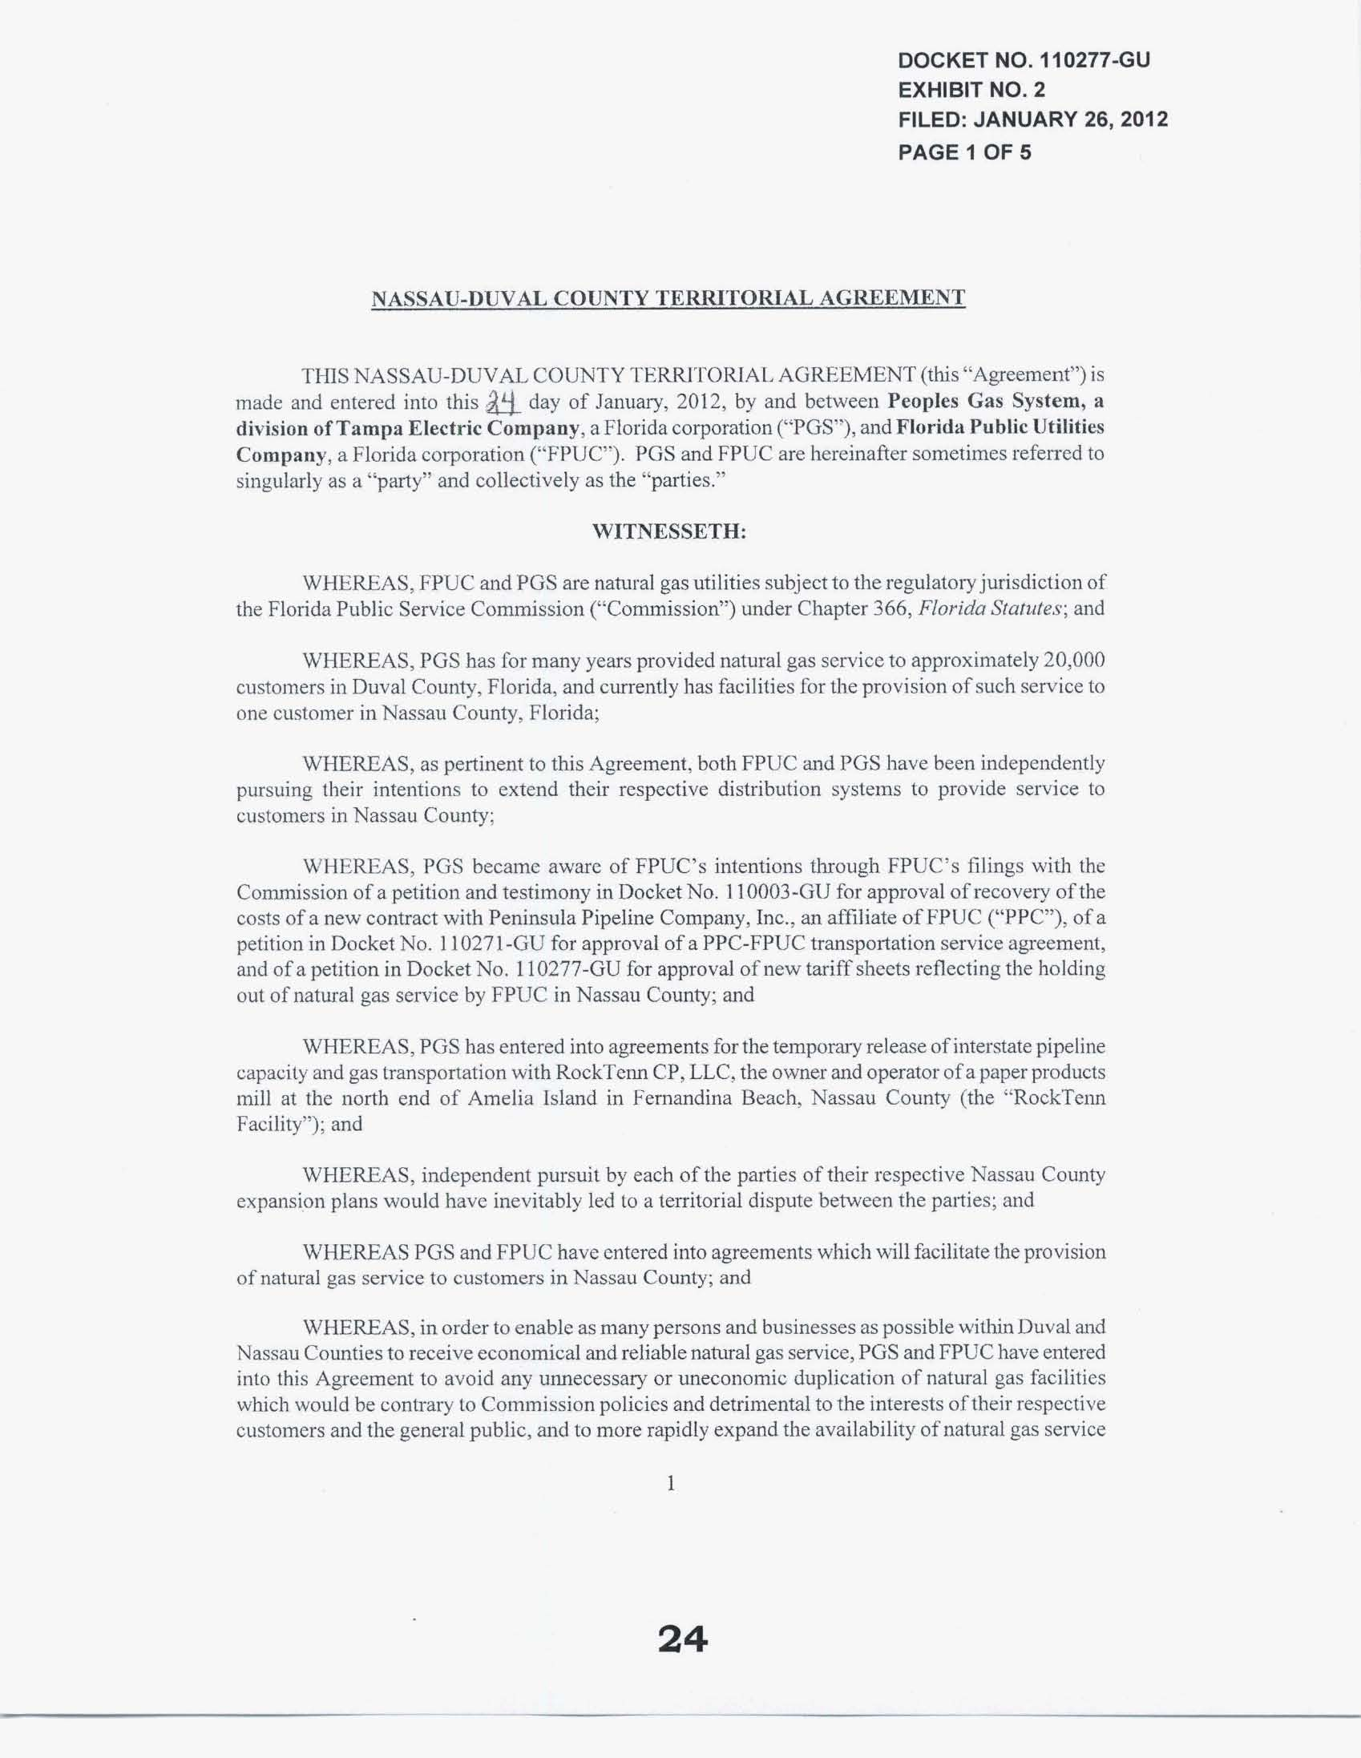
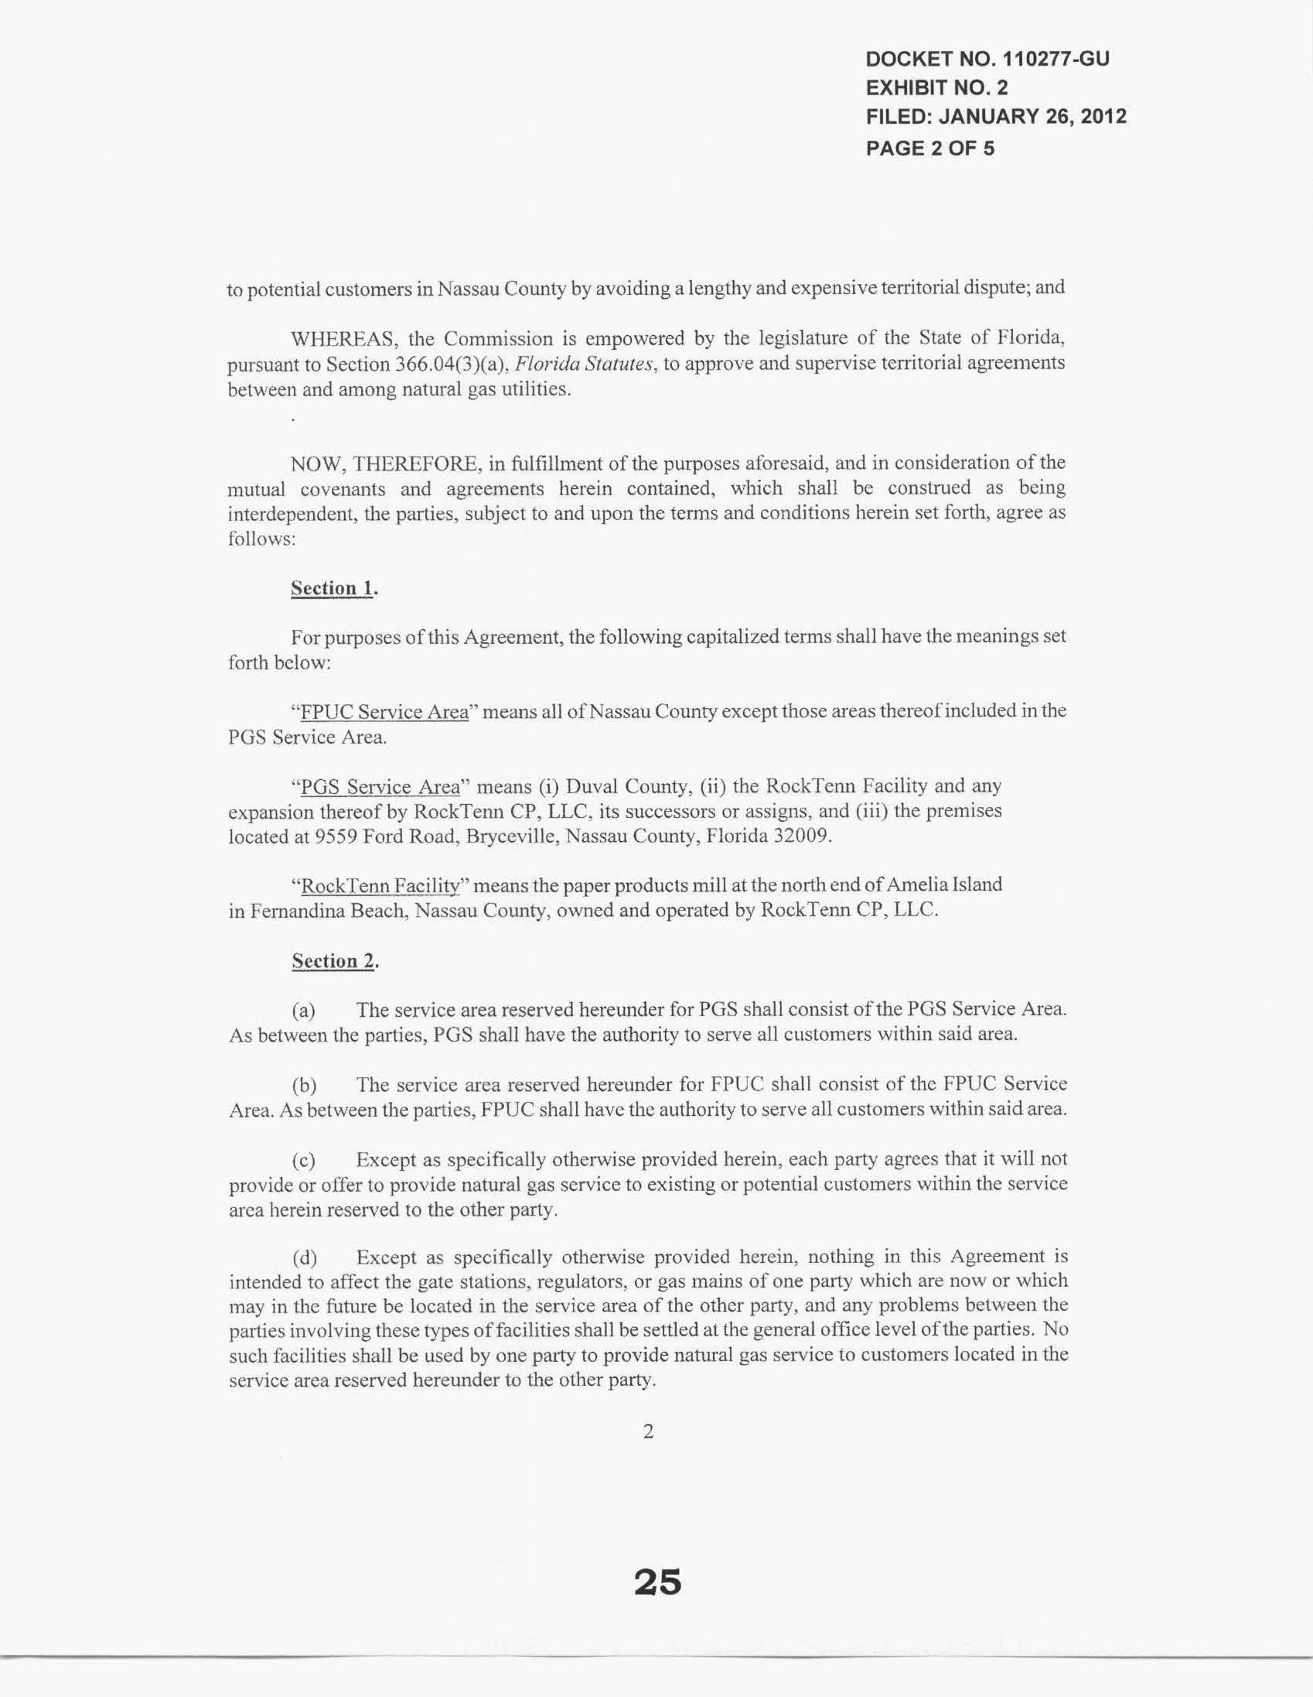
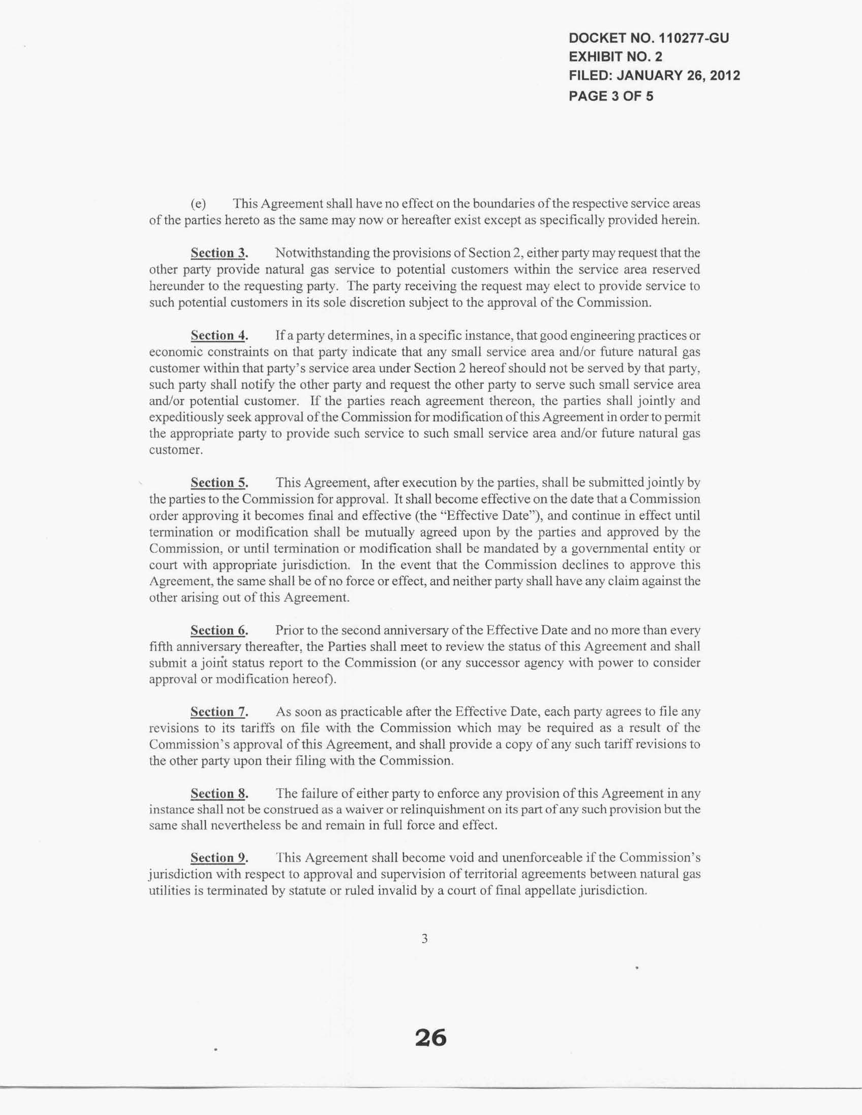
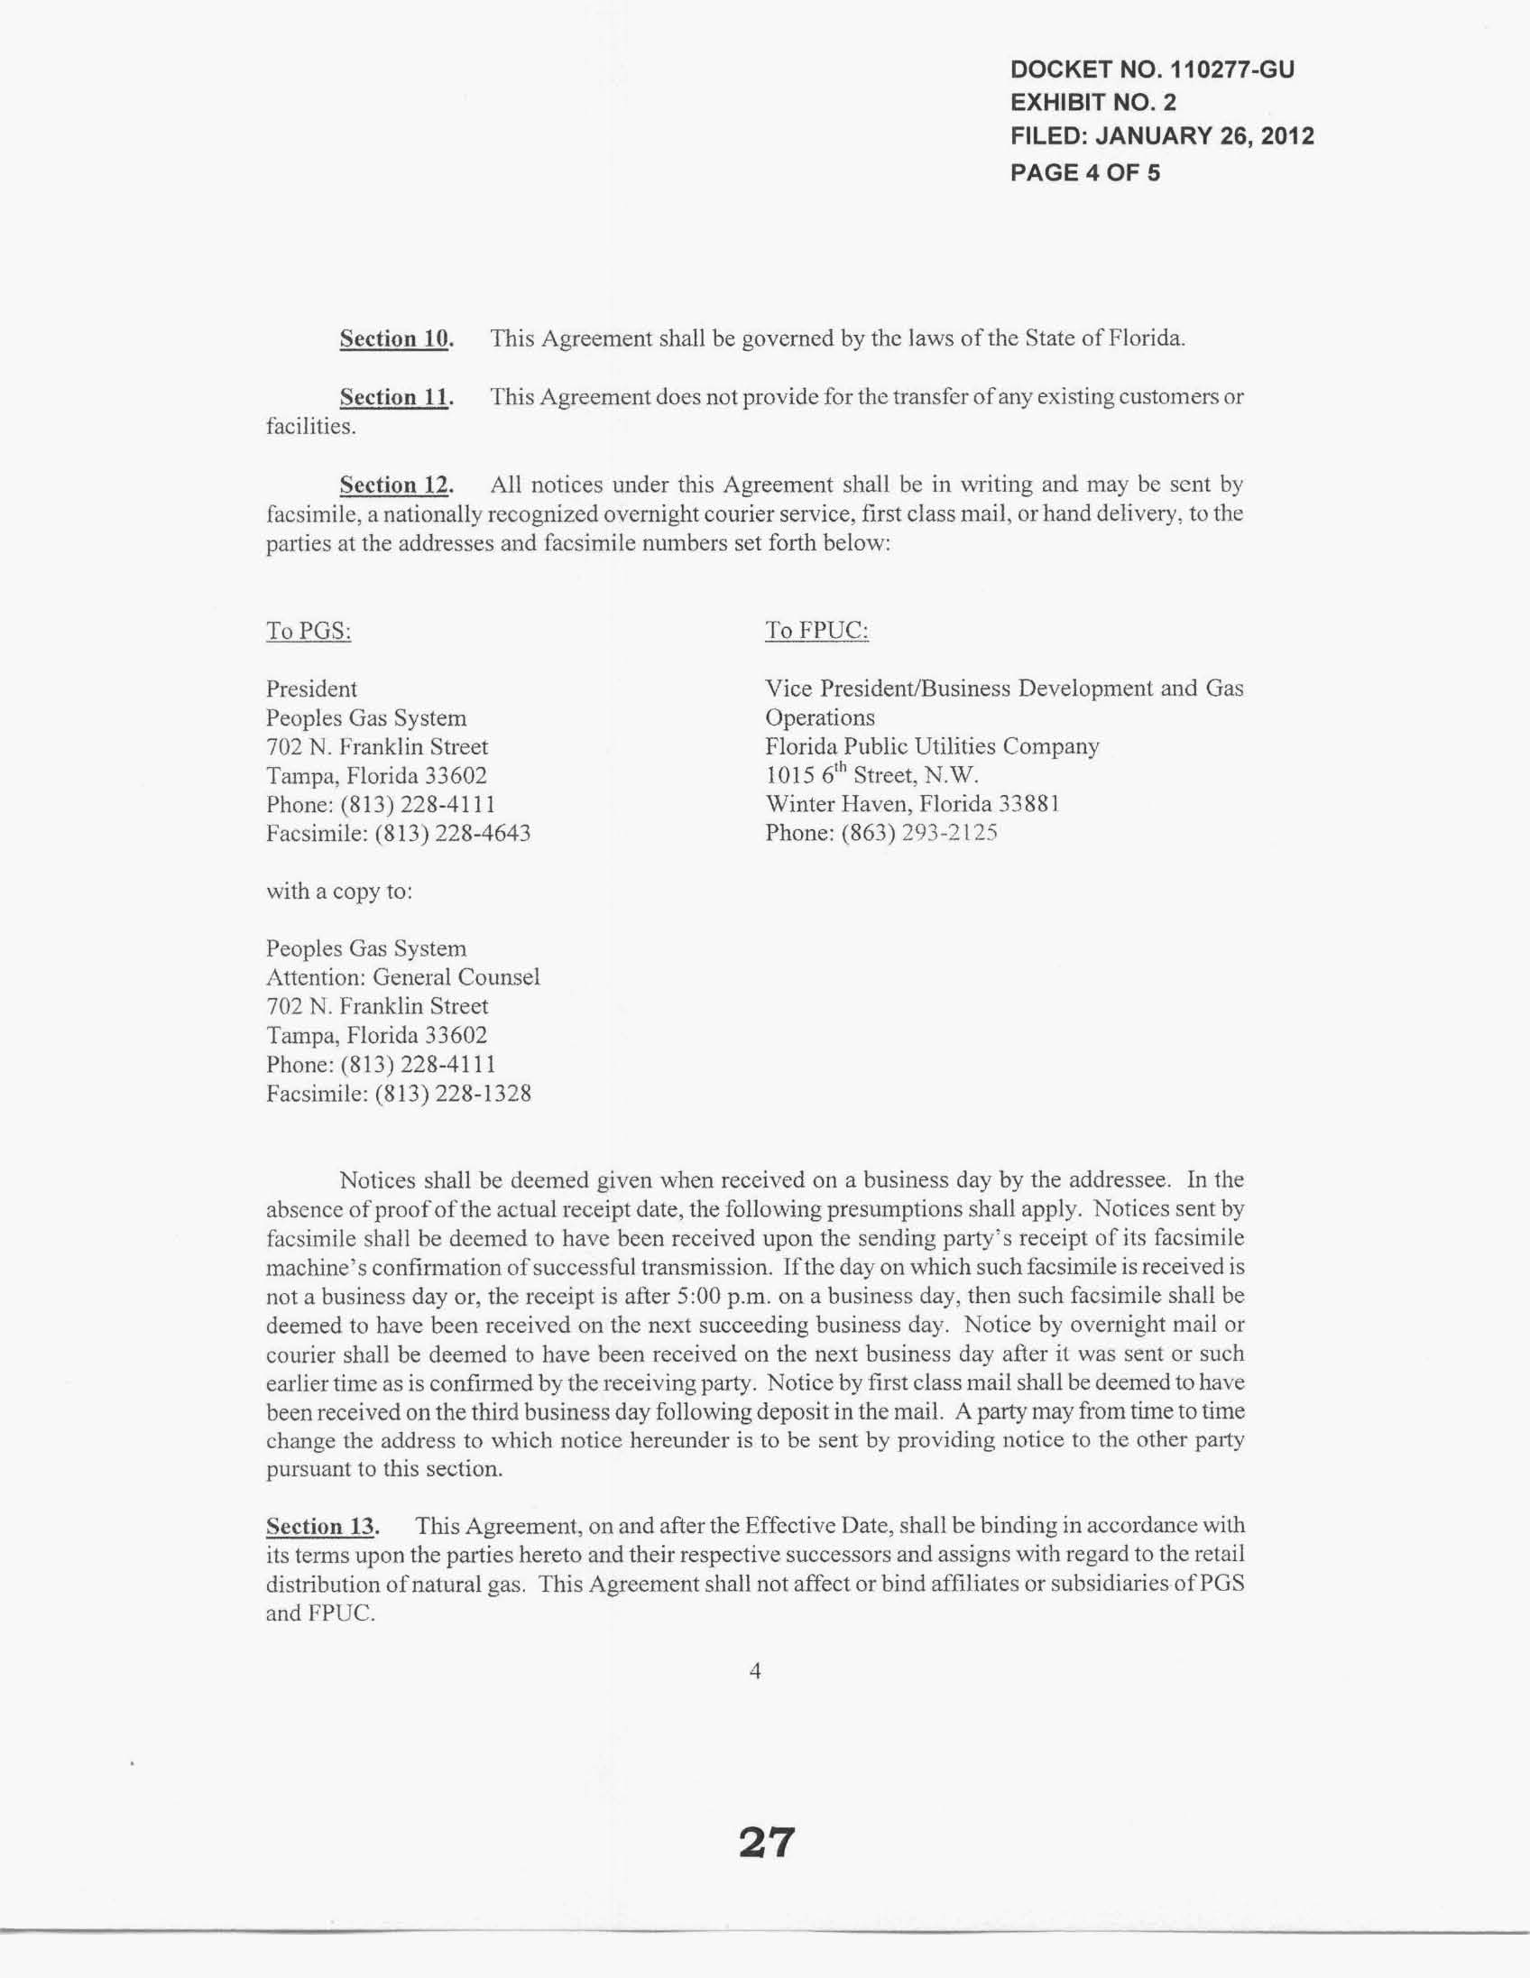
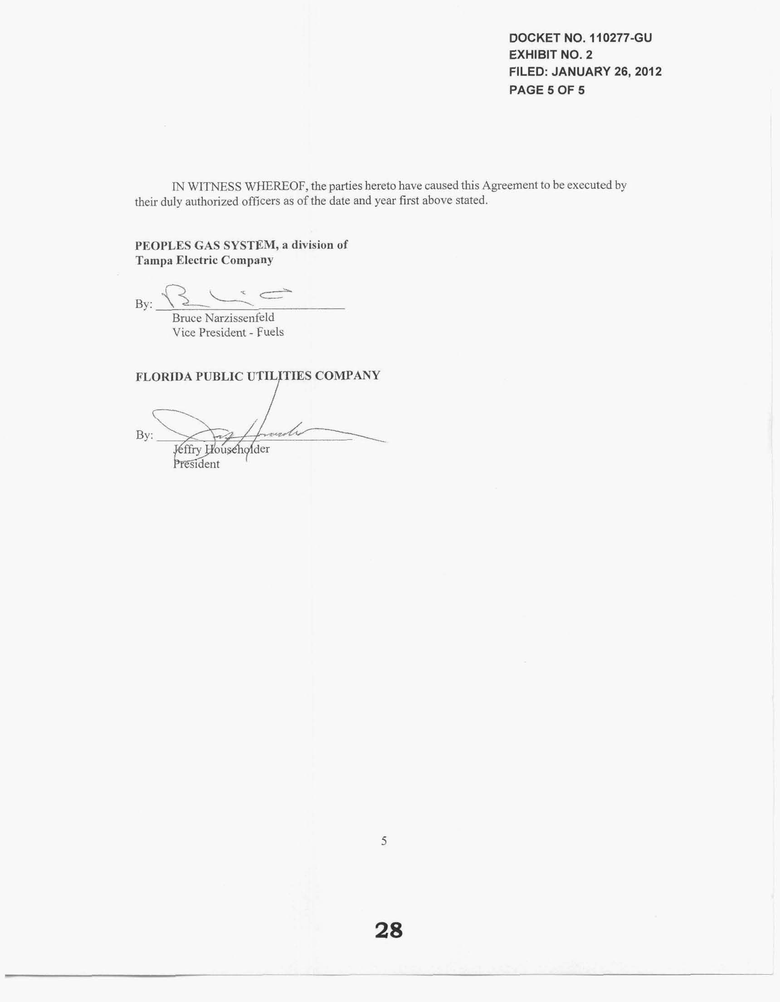
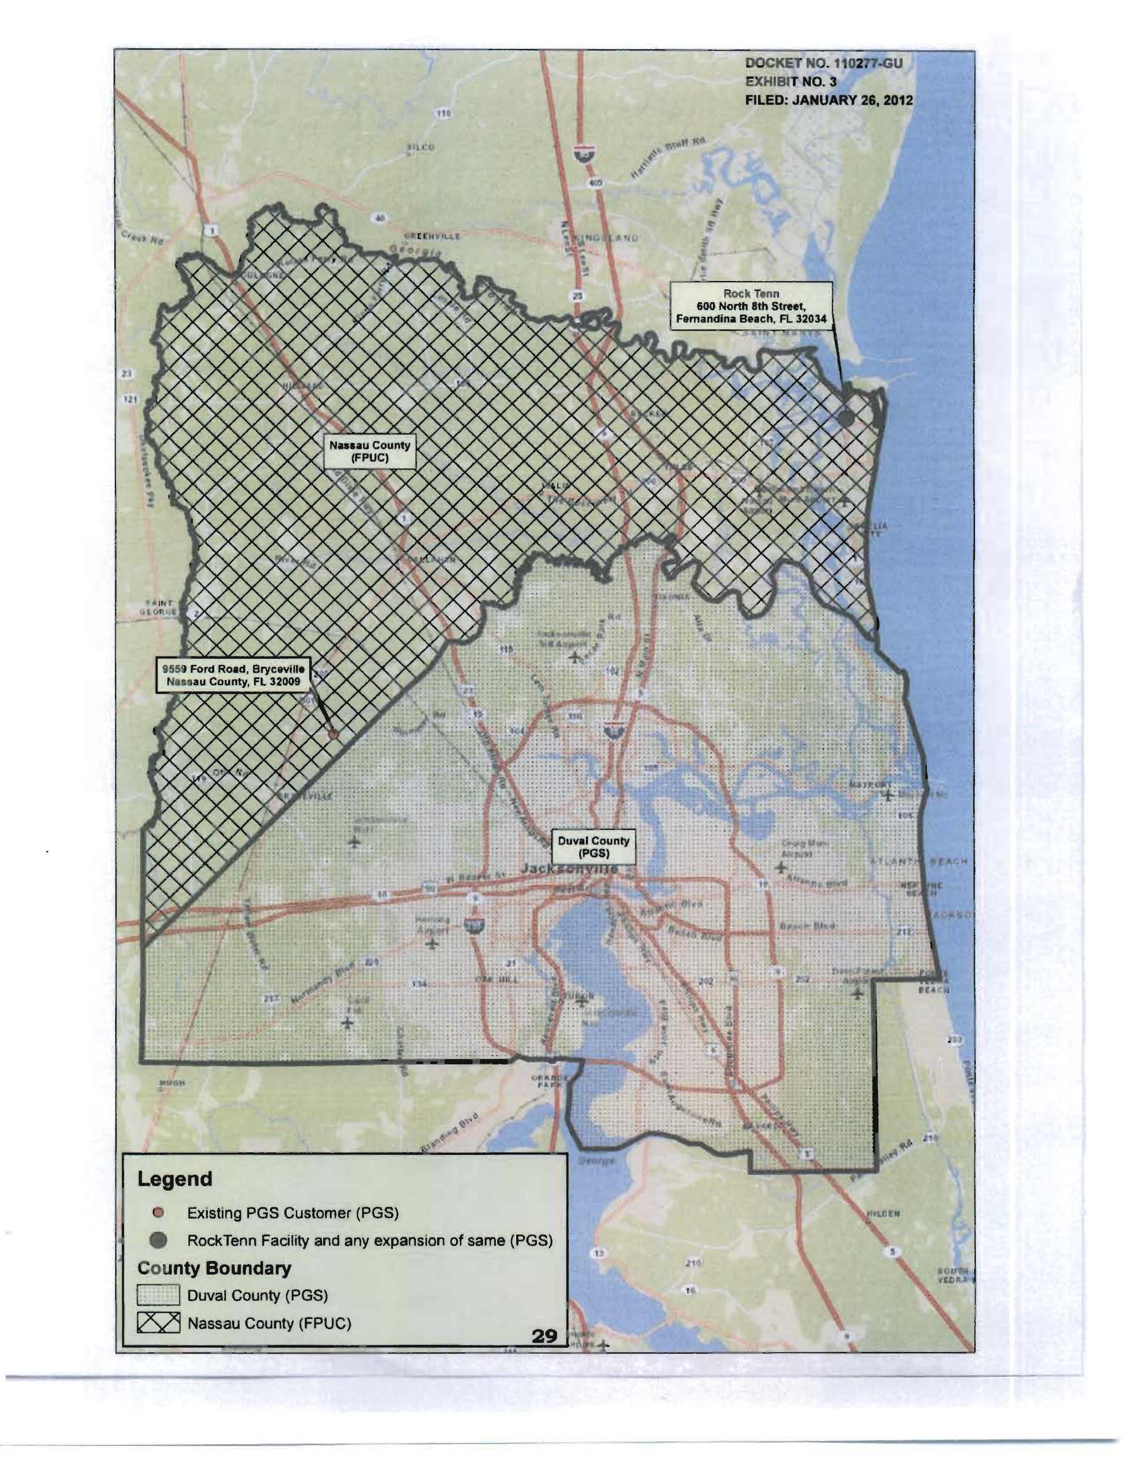

Pipeline Construction Segments
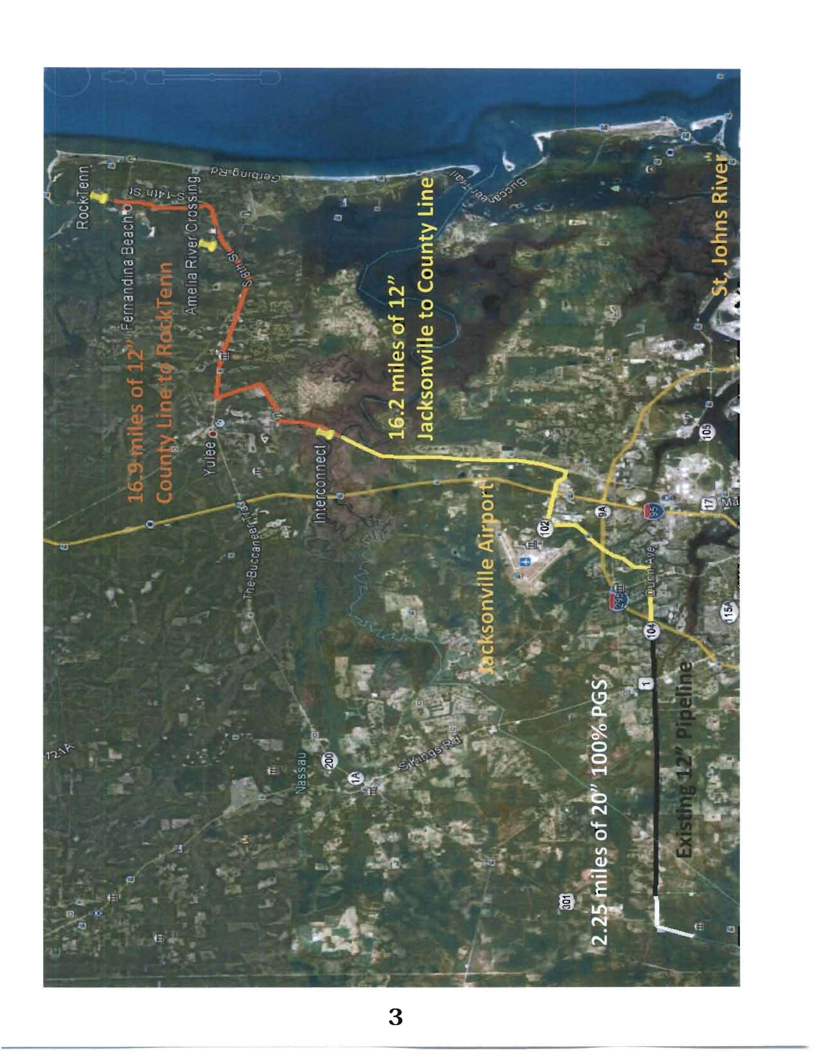

Order No. PSC-07-1012-TRF-GP, issued December 21, 2007, Docket No. 070570-GP, In re: Petition for approval of natural gas transmission pipeline tariff by Peninsula Pipeline Company, Inc.
The response is in Confidential Document No. 01463-12.
The response is in Confidential Document No. 01466-12.
Order No. PSC-07-0944-PAA-GU, issued in Docket No. 070399-GU, In re: Joint Petition for approval of territorial agreement in Pasco County, master territorial agreement, and gas transportation agreement, by Peoples Gas System and Florida Division of Chesapeake Utilities Corporation.
The total costs were provided under Confidential Document No. 01546-12, p5.
Ibid., pp. 11-22

