BEFORE THE FLORIDA PUBLIC SERVICE COMMISSION

In re: Request by Peoples Gas System to modify Tariff Sheet 5.701 to add sections entitled "Limits of Company's Responsibilities" and "Continuity of Service." | DOCKET NO. 110308-GU  ORDER NO. PSC-12-0172-TRF-GU  ISSUED: April 2, 2012

The following Commissioners participated in the disposition of this matter:

RONALD A. BRISÉ, Chairman
LISA POLAK EDGAR
ART GRAHAM
EDUARDO E. BALBIS
JULIE I. BROWN

ORDER APPROVING TARIFF MODIFICATIONS

BY THE COMMISSION:

BACKGROUND
On January 18, 2012, Peoples Gas System (PGS) filed a petition to amend Tariff Sheet No. 5.701 to add two new sections limiting the utility’s liability under certain circumstances. One provision addresses responsibility for activities that occur on the customer’s side of the meter. The second provision addresses continuity of service under circumstances beyond the utility’s control. While electric utilities have similar provisions limiting liability, PGS is the first gas utility to request such language in its tariff. Based on discussions at our February 14, 2012 Agenda Conference, PGS submitted revised language modifying the Continuity of Service provision on February 22, 2012. As explained below, we approve the tariff modifications. We have jurisdiction pursuant to Sections 366.03, 366.04, and 366.06, Florida Statutes (F.S.).
DECISION
The two proposed changes establish limits to the utility’s liability under certain specified conditions. The section entitled Limits of Company’s Responsibilities exempts the utility from responsibility for damages sustained on the customer’s side of the meter, including any damage due to any equipment or appliances installed by the customer on his or her side of the point of delivery.

This section also limits the utility’s responsibilities for impurities in gas delivered to the customer. PGS notes that PGS, like other distribution utilities in the state, has no control over the characteristics of the gas it delivers to its customers from the interstate pipelines. The Federal Energy Regulatory Commission (FERC) has established standards for some of the more important characteristics of gas, and these characteristics are measured by the pipeline delivering the gas to PGS. Although PGS monitors the federal reporting data, PGS does not have the capability to do its own testing. Its tariff contains specifications for the gas it will accept, but impurities are sometimes introduced to the interstate pipelines, despite FERC standards. It appears that PGS utilizes the information available from the pipelines and has established by tariff other criteria to assure the quality of the gas it delivers; therefore, it should not be responsible for problems associated with impurities that may still exist.

The second section is entitled Continuity of Service. This section states that the utility shall use reasonable diligence to provide regular, uninterrupted service to customers, but shall not be liable for any fatality, injury, or damage to property arising from service interruptions caused by conditions beyond its control, including interruption of service, fluctuations in gas flow, termination or delay in providing or restoring gas service, or failure to warn of interruptions of gas service. This section replaces the Force Majeure provision that has been in PGS’ tariffs for decades. The Continuity of Service section also limits PGS’s liability for damage caused by the utility’s simple or ordinary negligence.
PGS filed revised language on February 22, 2012, to narrow the limitation on noticing to those interruptions arising from a Force Majeure event or an emergency. The proposed change adds the words “as the result of an emergency or a Force Majeure event” to the last sentence of the Continuity of Service provision.
It has long been held that a regulated utility has the right to limit its liability, as the cost to defend against unlimited liability could result in significantly higher rates to all customers. See Landrum v. Florida Power & Light Company, 505 So. 2d 552, 554 (Fla. 1987), and cases from around the country cited therein, where the Florida Supreme Court said:

It is well established that a limitation of liability contained in a tariff is an essential part of the rate, and that the consumer is bound by the tariff, regardless of his knowledge or assent thereto. . . . Therefore, a tariff validly approved by the Public Service Commission, including a limitation of liability for ordinary negligence, resulting in the interruption of the regular supply of electric service is valid.

We approved a similar limitation of liability provision in TECO’s tariffs by Order No. 911064-EI, issued January 9, 1992, in Docket No. 911064-EI, In re: Petition of Tampa Electric Company for Approval of Tariff Modifications. We said, at pps. 1-2:

We approve the modifications that TECO has proposed to its tariffs. The limitation of liability provisions and indemnification provisions are consistent with the provisions of other electric utilities’ approved tariffs. The legitimacy of such provisions has been recognized many times by the Courts. . . .

We believe that TECO’s proposed tariff revisions represent a reasonable effort to protect against undue risk and liability that may arise in the conduct of its business. We are also mindful of the presumption of validity created by our approval of the limitations of liability included in these tariff modifications. Therefore we wish to make it clear that the modifications are approved with the understanding that the limitations of liability, in whatever legal framework they may occur, apply to acts of “simple”, or “ordinary” neglect of duty, and do not apply to acts of “gross” negligence or dereliction of duty, as those terms are understood and defined in decisional law.

Based on practice and legal precedent, we approve the proposed tariff changes as revised on February 22, 2012, which are similar to continuity of service and limitations of liability provisions in other utilities’ tariffs. We exercises extensive oversight of a regulated utility’s operations and we have established rules and procedures to ensure that it operates safely and in the public interest. Customers have recourse through our complaint process to address a regulated activity, or through civil action with respect to damages for gross negligence.

Based on the foregoing, it is

ORDERED by the Florida Public Service Commission that the Request by Peoples Gas System to modify Tariff Sheet 5.701 to add sections entitled "Limits of Company's Responsibilities" and "Continuity of Service" is approved, effective March 13, 2012. It is further

ORDERED that if a protest is filed within 21 days of issuance of the Order, the tariff shall remain in effect pending resolution of the protest. It is further

ORDERED that if no timely protest is filed, this docket shall be closed upon the issuance of a Consummating Order.

By ORDER of the Florida Public Service Commission this 2nd day of April, 2012.

/s/ Ann Cole
ANN COLE
Commission Clerk
Florida Public Service Commission
2540 Shumard Oak Boulevard
Tallahassee, Florida 32399
(850) 413-6770
www.floridapsc.com

Copies furnished: A copy of this document is provided to the parties of record at the time of issuance and, if applicable, interested persons.

MCB

NOTICE OF FURTHER PROCEEDINGS

The Florida Public Service Commission is required by Section 120.569(1), Florida Statutes, to notify parties of any administrative hearing or judicial review of Commission orders that is available under Sections 120.57 or 120.68, Florida Statutes, as well as the procedures and time limits that apply. This notice should not be construed to mean all requests for an administrative hearing or judicial review will be granted or result in the relief sought.

Mediation may be available on a case-by-case basis. If mediation is conducted, it does not affect a substantially interested person's right to a hearing.

The Commission's decision on this tariff is interim in nature and will become final, unless a person whose substantial interests are affected by the proposed action files a petition for a formal proceeding, in the form provided by Rule 28-106.201, Florida Administrative Code. This petition must be received by the Office of Commission Clerk, 2540 Shumard Oak Boulevard, Tallahassee, Florida 32399-0850, by the close of business on April 23, 2012.

In the absence of such a petition, this Order shall become final and effective upon the issuance of a Consummating Order.

Any objection or protest filed in this docket before the issuance date of this order is considered abandoned unless it satisfies the foregoing conditions and is renewed within the specified protest period.

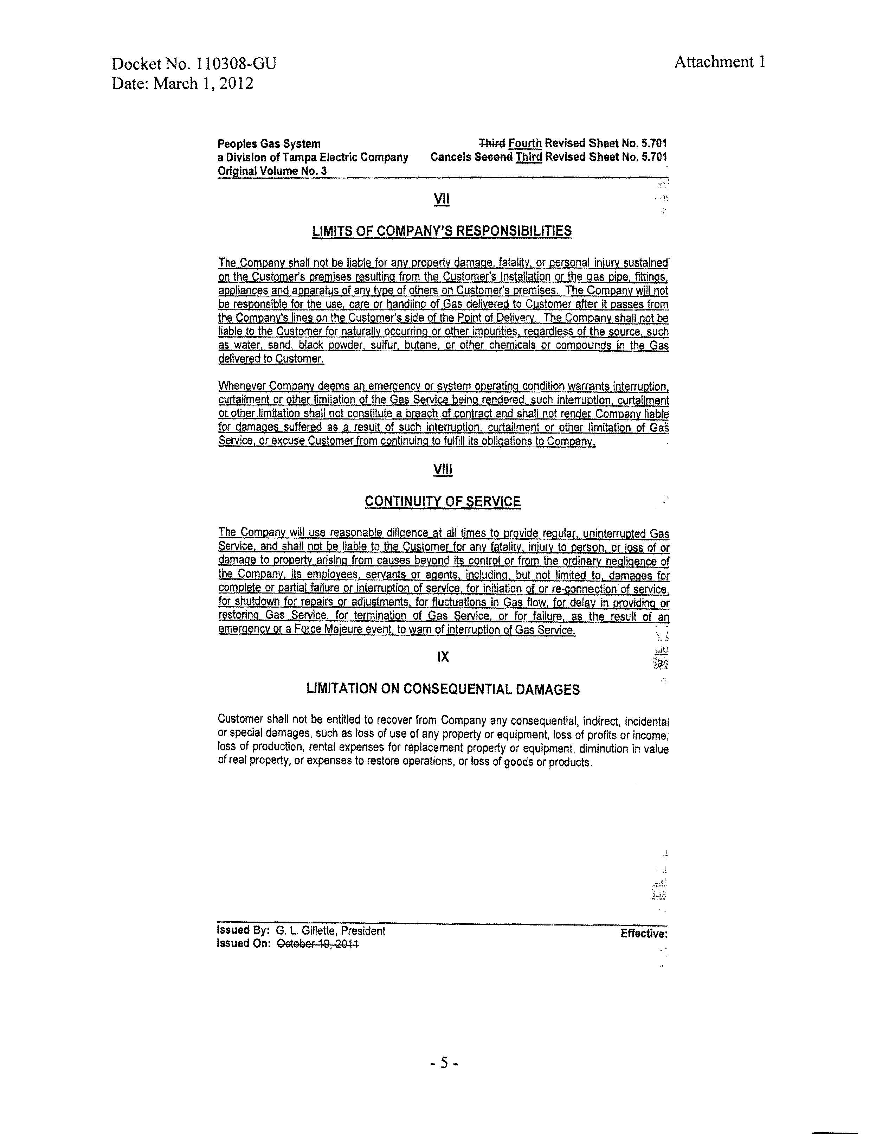

In Landrum, at p. 554, the Court defined “gross negligence” as “a course of conduct. . .such that the likelihood of injury to the other persons or property is known by the actor to be imminent or ‘clear and present’. . . “

