State of Florida   |  | Public Service Commission  Capital Circle Office Center ● 2540 Shumard Oak Boulevard  Tallahassee, Florida 32399-0850  -M-E-M-O-R-A-N-D-U-M-
DATE: | June 7, 2012
TO: | Office of Commission Clerk (Cole)
FROM: | Division of Regulatory Analysis (Ma)  Office of the General Counsel (Robinson)
RE: | Docket No. 120069-EQ – Petition for approval of revisions to renewable energy tariff, by Florida Public Utilities Company.
AGENDA: | 06/19/12 – Regular Agenda – Interested Persons May Participate
COMMISSIONERS ASSIGNED: |  |  | All Commissioners
PREHEARING OFFICER: |  |  | Edgar
CRITICAL DATES: |  |  | None
SPECIAL INSTRUCTIONS: |  |  | None
FILE NAME AND LOCATION: |  |  | S:\PSC\RAD\WP\120069.RCM.DOC

Case Background
Section 366.91(3), Florida Statutes (F.S.), requires that each investor-owned utility (IOU) to continuously offer to purchase capacity and energy from renewable energy generators. Commission Rules 25-17.200 through 25-17.310, Florida Administrative Code (F.A.C.), implement the statute, and require each IOU to file with the Commission by April 1 of each year a standard offer contract based on the next avoidable generating unit or planned purchase. Florida Public Utilities Company (FPUC or Company) filed its petition for approval of an amended standard offer contract on March 30, 2012.
Because FPUC does not own or operate any electric generating plants, this utility does not have any planned generating unit that can be avoided. For such a circumstance, Rule 25-17.250(1), F.A.C., requires the utility to base the standard offer contract on avoiding or deferring a planned purchase. FPUC currently has purchased power agreements with Gulf Power Company (Gulf) for the Northwest Division and JEA for the Northeast Division. The rate schedules submitted, REN-1 and REN-2, reflect pricing for each division in accordance with the purchased power agreements for that region.
The Commission has jurisdiction over this standard offer contract pursuant to Sections 366.04 through 366.06 and 366.91, Florida Statutes (F.S.).

Discussion of Issues
Issue 1:1
Should the Commission approve the standard offer renewable energy tariff filed by Florida Public Utility Company be approved?
Recommendation:
Yes. The standard offer renewable energy tariffs comply with Rules 25-17.200 through 25-17.310, F.A.C. (Ma)
Staff Analysis:
Because FPUC is an IOU, Rule 25-17.250(1), F.A.C., requires it to continuously make available a standard offer contract for the purchase of firm capacity and energy from renewable generating facilities and small qualifying facilities with a design capacity of 100 kilowatts (kW) or less.
Since FPUC does not generate any electric energy for sale to retail customers, FPUC does not file a Ten-Year Site Plan and has no planned unit that can serve as an avoided unit. In such a case, Rule 25-17.250(1), F.A.C., requires that the standard offer be based on avoiding or deferring a planned purchase. The standard offer contract provided by FPUC meets this requirement as it is based on avoiding or deferring planned purchases under the current electric purchased power agreements FPUC holds with its suppliers, Gulf Power Company for the Northwest Division and JEA for the Northeast Division.
Northwest Division
FPUC submitted proposed revisions to the renewable energy tariff for the Northwest Division consisting of Sheet Nos. 18, 20, 21, and 23. These revisions are provided in type-and-strike form in Attachment A of this recommendation. The proposed rate schedule REN-1 (energy only pricing) for the Northwest Division is unchanged in all respects with one exception. The base fuel cost in the energy rate for FPUC’s wholesale supplier was reduced from 5.056 cents per kWh ($50.56 per MWh) to 4.840 cents per kWh ($48.40 per MWh). The rate schedule REN-2 (energy and firm capacity pricing) for the Northwest Division is not changed in any respect. Payments for firm capacity from FPUC to the renewable provider remain at $0.00 per kW of billing capacity.
FPUC’s original contract with Gulf for delivery of power to the Northwest Division prevents capacity payments to a renewable tariff from being made in this region. The original purchased power agreement was executed in December 2006 and became effective January 1, 2008. The terms of the purchased power agreement between FPUC and Gulf included a ratchet provision for computing the minimum capacity purchase, and as a result the capacity payment to Gulf would not decrease from the amount initially established, even if the overall demand was subsequently reduced by conservation or the addition of renewable resources.
On January 26, 2011, FPUC petitioned the Commission for Amendment No. 1 to this contract which, among other modifications, lowered the minimum purchase threshold to 91 MW and eliminated the ratchet provision, allowing a renewable energy provider to contribute to avoiding additional capacity over and above 91 MW. On June 14, 2011, the Commission approved FPUC’s petition for Amendment No. 1 to purchased power contract for generation service between FPUC and Gulf Power Company.
On July 12, 2011, the City of Marianna filed a petition protesting the Commission Order approving Amendment No. 1 and requested a formal proceeding. Following oral arguments by City of Marianna and FPUC, the Commission dismissed with prejudice City of Marianna’s petition of protest. Subsequently, the City of Marianna filed an administrative appeal to the Supreme court on March 19, 2012, which is currently under review.
On January 5, 2012, FPUC and Gulf filed a letter of agreement that Gulf would continue to invoice FPUC for capacity payments according to the rates and terms in the original Purchased Power Agreement pending the outcome of any appeal of the Commission’s “Final Order” approving Amendment No. 1. Thereafter, payments will be subject to true-up if the Commission’s decision is upheld.
Table 1 below shows the estimated payments to a renewable energy provider in the Northwest Division generating 50 MW at a capacity factor of 70 percent. This analysis assumes the original Purchased Power Agreement Gulf is currently invoicing FPUC, pending appeals to Amendment No. 1, and also includes the use of the existing ratchet provision discussed previously. Although no capacity payment is made for firm energy in the Northwest Division, the minimum performance requirement for the standard offer contract in the Northeast Division was used for this example. Because the original Purchased Power Agreement between FPUC and Gulf ends in 2017, payments beyond 2017 cannot be calculated.
Table 1 - Estimated Annual Payments to a 50 MW Renewable Facility (70 % Capacity Factor)
in FPUC’s Northwest Division
Year | Energy | Renewable Provider Payments
Year | Energy | Capacity Rate | Total Capacity Payments | Energy Rate | Total Energy Payments | Total Payments to Renewable Provider
Year | MWh | ($/kW-mo) | ($000) | ($/MWh) | ($000) | ($000)
2013 | 306,600 | 0.00 | 0.00 | 51.25 | 15,713 | 15,713
2014 | 306,600 | 0.00 | 0.00 | 51.25 | 15,713 | 15,713
2015 | 306,600 | 0.00 | 0.00 | 51.25 | 15,713 | 15,713
2016 | 306,600 | 0.00 | 0.00 | 51.25 | 15,713 | 15,713
2017 | 306,600 | 0.00 | 0.00 | 51.25 | 15,713 | 15,713

Pending the final approval of Amendment No. 1, FPUC will be required to file, in a subsequent docket, a revision to rate schedule REN-2 to offer capacity payments to renewable providers in its Northwest Division in the event its overall demand exceeds the contract minimum of 91 MW.
Northeast Division
FPUC submitted proposed revisions to the renewable energy tariff for the Northeast Division consisting of Sheet Nos. 24, 26, 27, and 29. These revisions are provided in type-and-strike form in Attachment A of this recommendation. The proposed rate schedule REN-1 (energy only pricing) for the Northeast Division is unchanged in all respects with one exception. The base fuel cost in the energy rate for FPUC’s wholesale supplier was reduced from 5.064 cents per kWh ($50.64 per MWh) to 4.774 cents per kWh ($47.74 per MWh). The rate schedule REN-2 (energy and firm capacity pricing) for the Northeast Division is also not changed in any respect. Payments for firm capacity from FPUC to the renewable provider remain at the previous year’s amount of $11.38 per kW of billing capacity.
Table 2 below shows estimated payments to a renewable energy provider in the Northeast Division generating 50 MW at a capacity factor of 70 percent, the minimum performance requirement for the standard offer contract in the Northeast Division. As in the Northwest Division with Gulf, the term of the contract with JEA is limited such that only the amounts shown below can be determined at this time.

Table 2 - Estimated Annual Payments to a 50 MW Renewable Facility (70 % Capacity Factor)
in FPUC’s Northeast Division
Year | Energy | Renewable Provider Payments
Year | Energy | Capacity Rate | Total Capacity Payments | Energy Rate | Total Energy Payments | Total Payments to Renewable Provider
Year | MWh | ($/kW-mo) | ($000) | ($/MWh) | ($000) | ($000)
2013 | 306,600 | 11.38 | 6,828 | 47.74 | 14,637 | 21,465
2014 | 306,600 | 11.38 | 6,828 | 47.74 | 14,637 | 21,465
2015 | 306,600 | 11.38 | 6,828 | 47.74 | 14,637 | 21,465
2016 | 306,600 | 11.38 | 6,828 | 47.74 | 14,637 | 21,465
2017 | 306,600 | 11.38 | 6,828 | 47.74 | 14,637 | 21,465
2018 | 306,600 | 11.38 | 6,828 | 47.74 | 14,637 | 21,465

Conclusion

Staff believes that the payments for capacity and energy provided in the tariff revisions are representative of the FPUC’s avoided cost. The payments for capacity and energy are based on FPUC avoiding or deferring planned purchases it would otherwise make from its wholesale suppliers. The provisions of the standard offer contract, including proposed tariff revisions, are in compliance with Rules 25-17.200 through 25-17.310, F.A.C., and should therefore be approved.
Issue 2:2
Should this docket be closed?
Recommendation:
If the Commission approves staff’s recommendation to approve the proposed standard offer contract and tariffs filed by FPUC, and no person whose substantial interests are affected requests a hearing to address this matter, then Docket No. 120069-EQ should be closed upon issuance of a Consummating Order, and the standard offer contracts and tariffs filed by FPUC should be effective as of the date of the Commission’s vote. If a protest is filed within 21 days of the issuance of the Commission’s Order, the tariffs should remain in effect pending resolution of the protest. Potential signatories to the standard offer contract should be aware that approval of FPUC’s tariffs and standard offer contracts may be subject to a request for hearing, and if a hearing is held, may subsequently be revised. (Robinson)
Staff Analysis:
If the Commission approves staff’s recommendation to approve the proposed standard offer contract and tariffs filed by FPUC, and no person whose substantial interests are affected requests a hearing to address this matter, then Docket No. 120069-EQ should be closed upon issuance of a Consummating Order, and the standard offer contracts and tariffs filed by FPUC should be effective as of the date of the Commission’s vote. If a protest is filed within 21 days of the issuance of the Commission’s Order, the tariffs should remain in effect pending resolution of the protest. Potential signatories to the standard offer contract should be aware that approval of FPUC’s tariffs and standard offer contracts may be subject to a request for hearing, and if a hearing is held, may subsequently be revised.

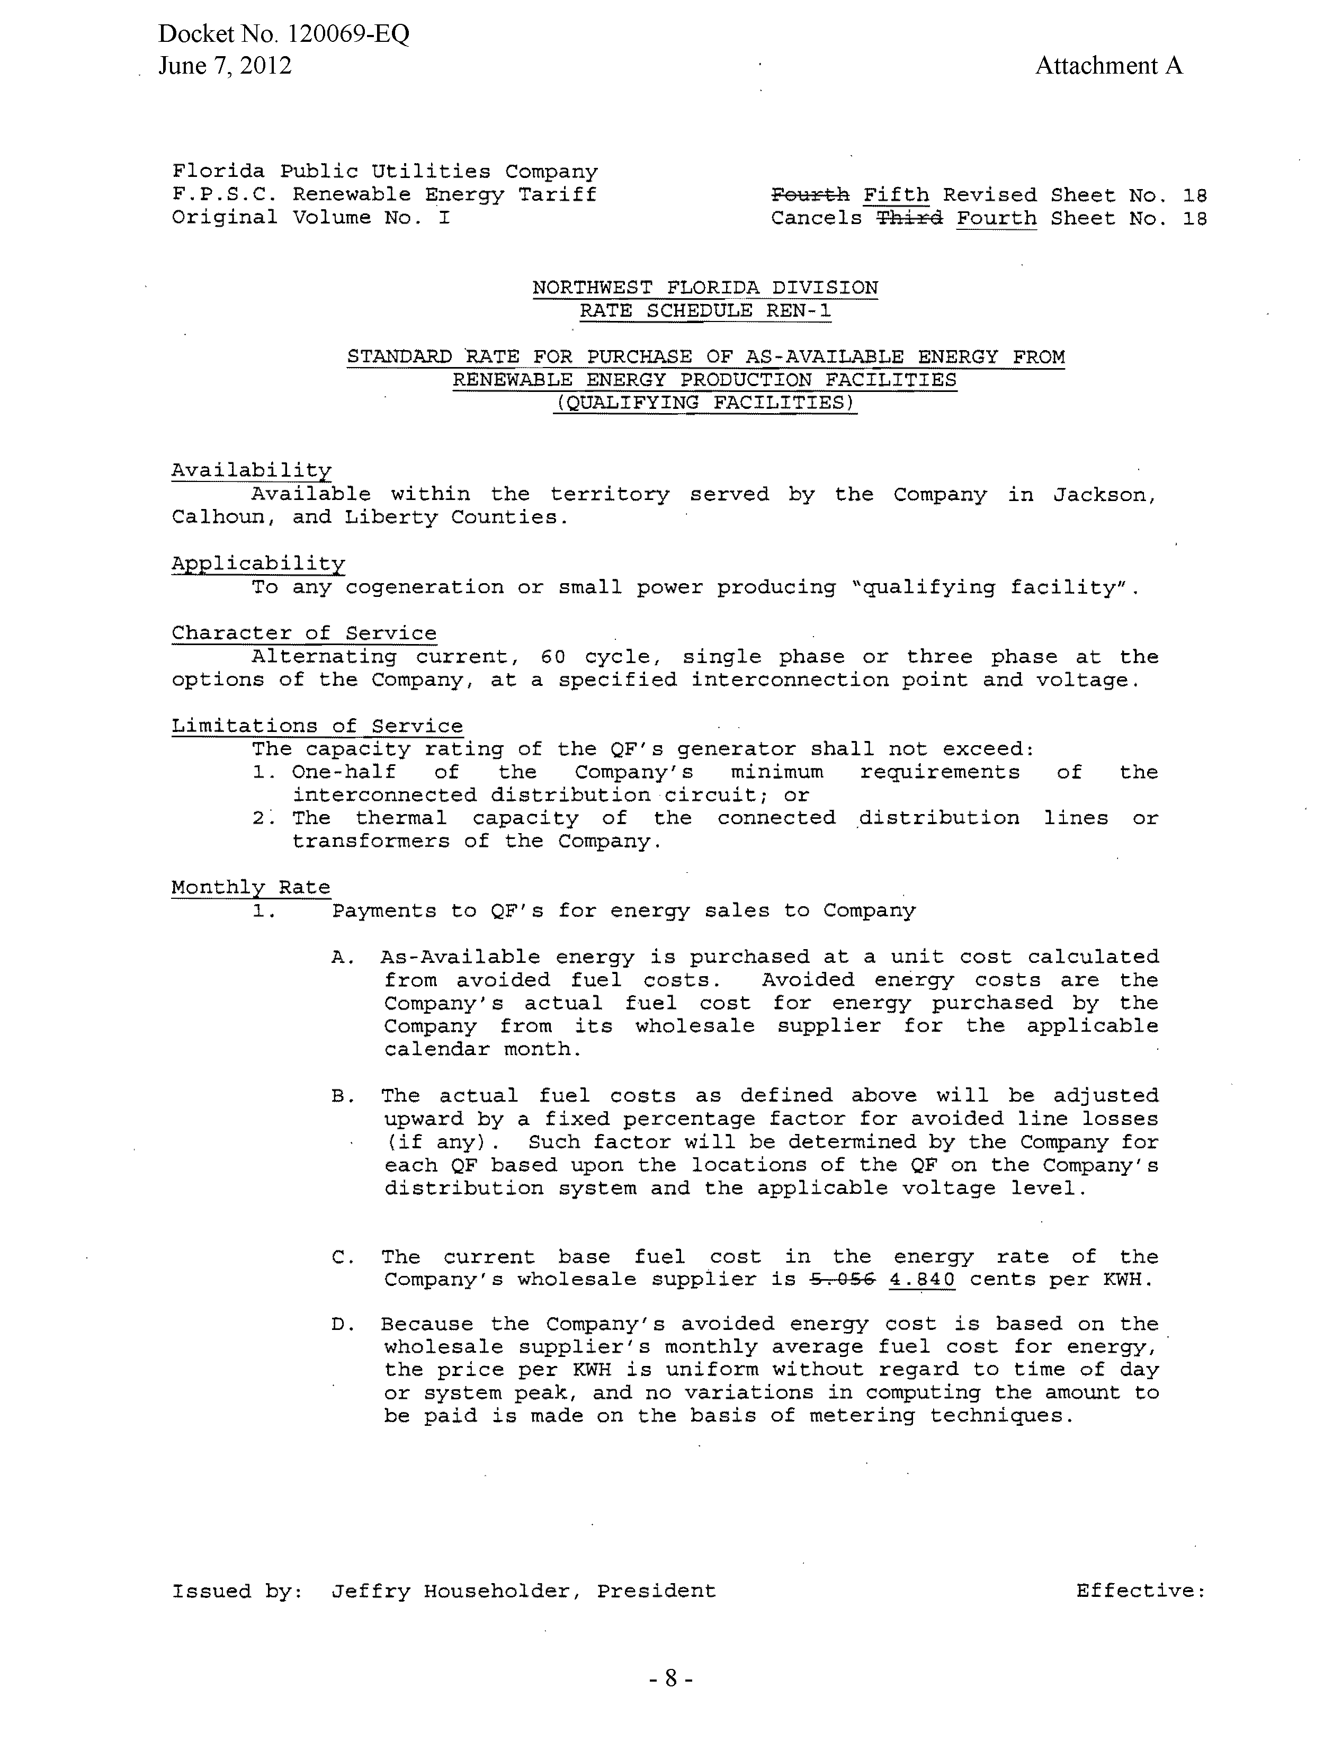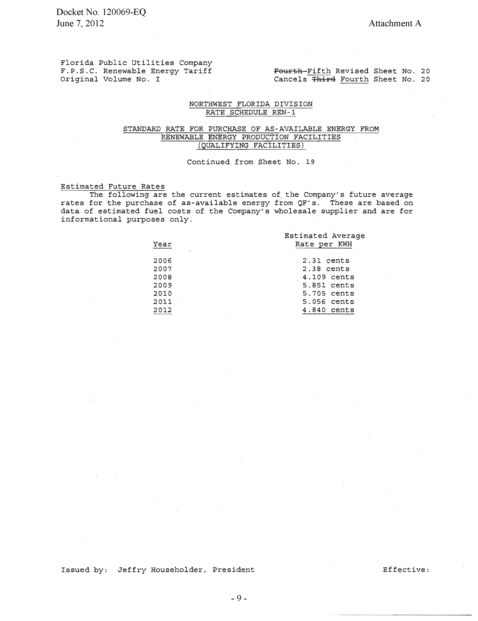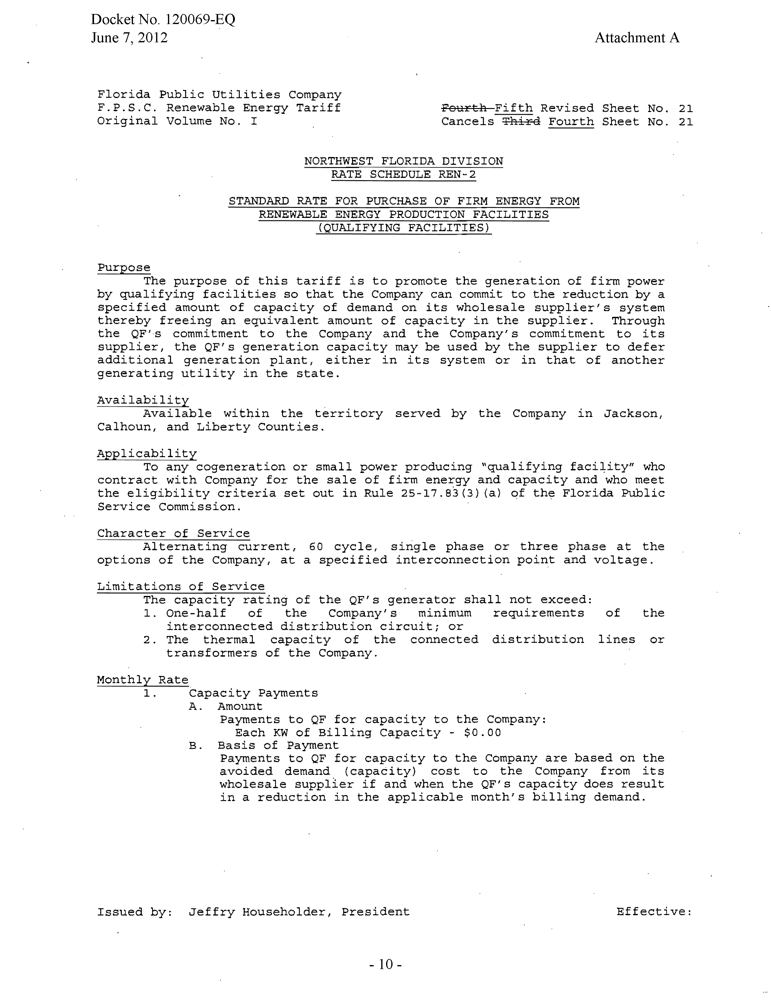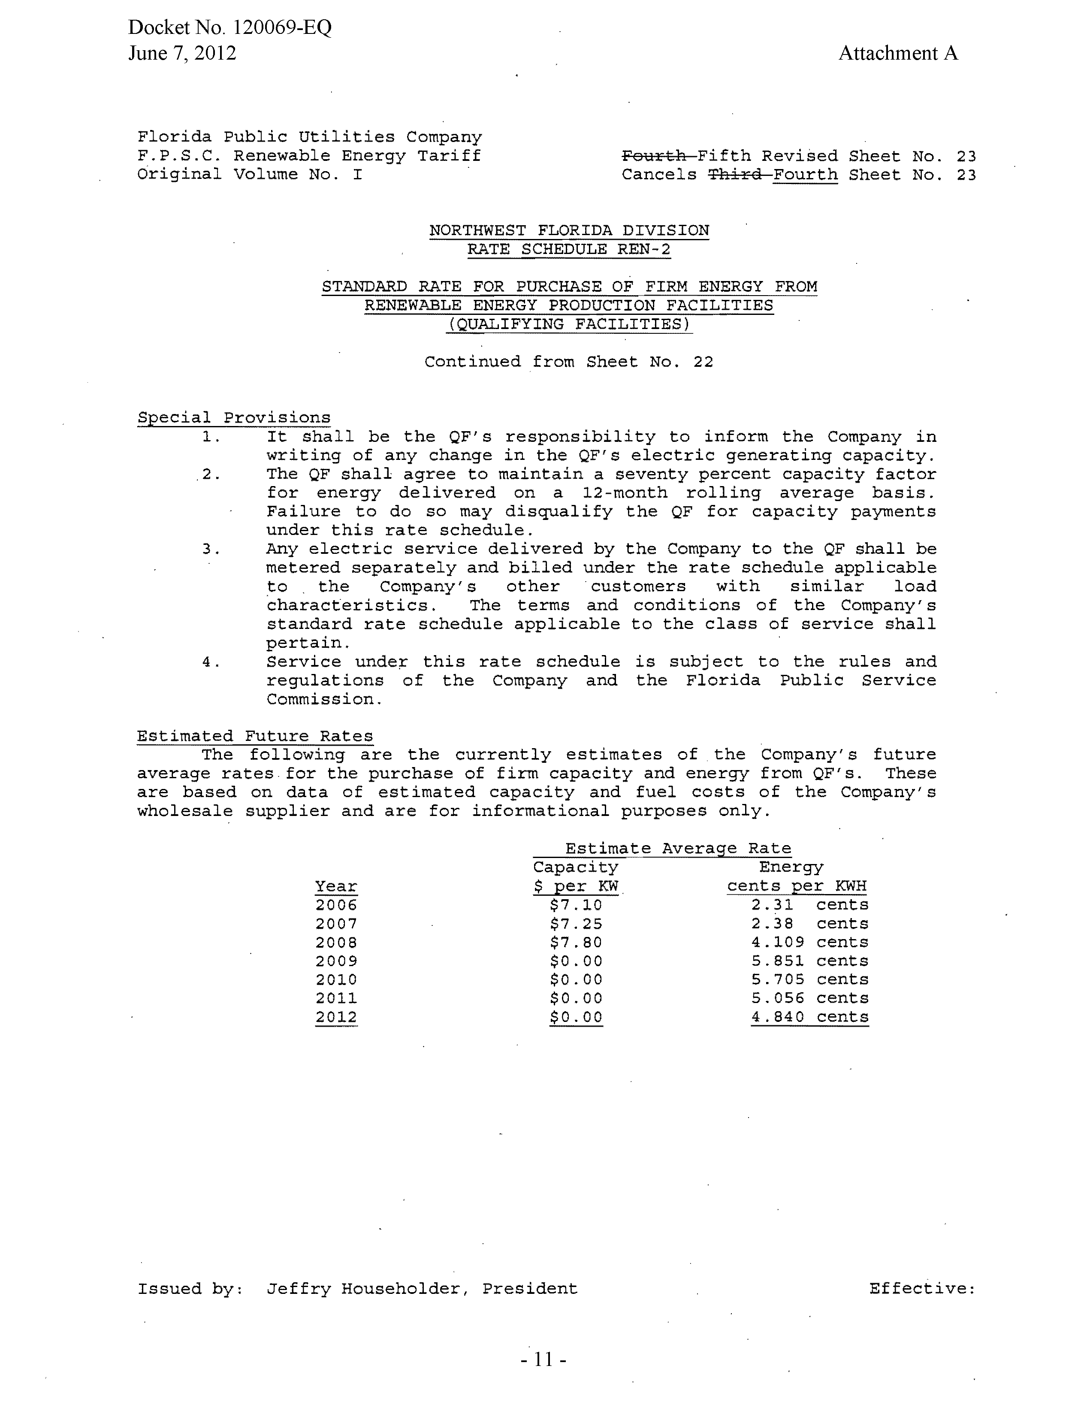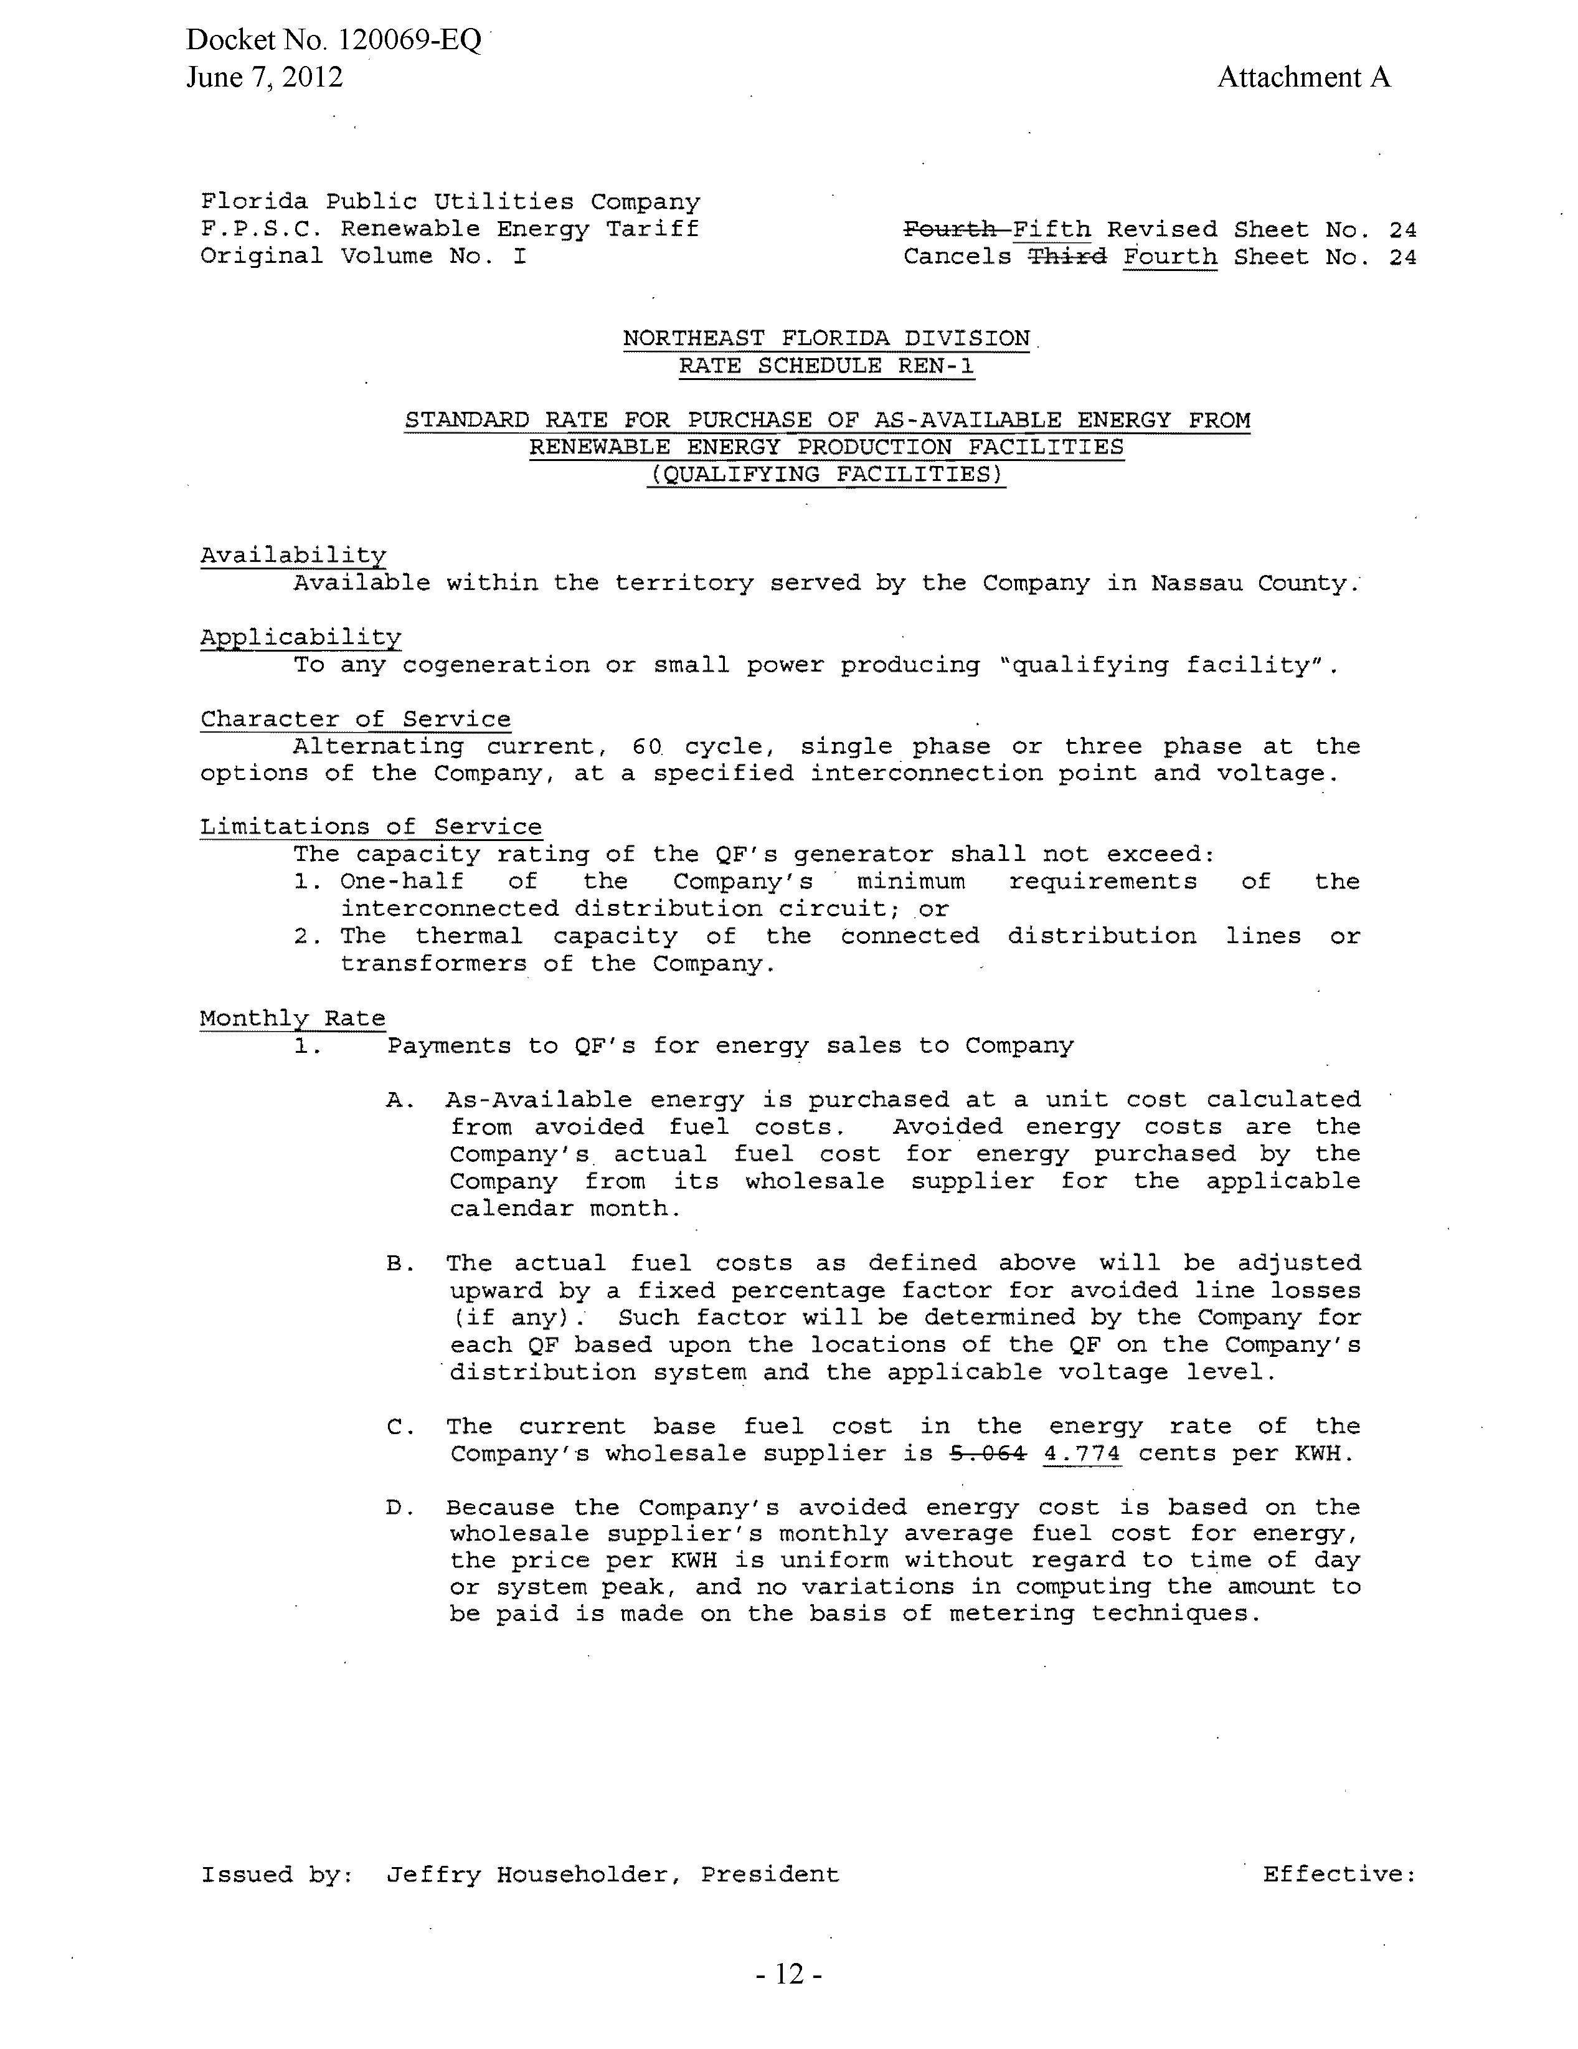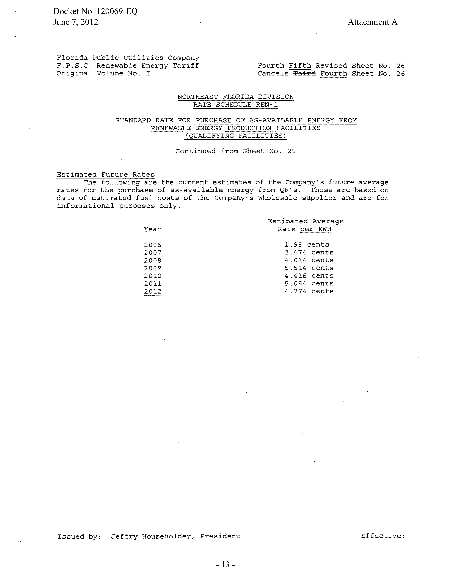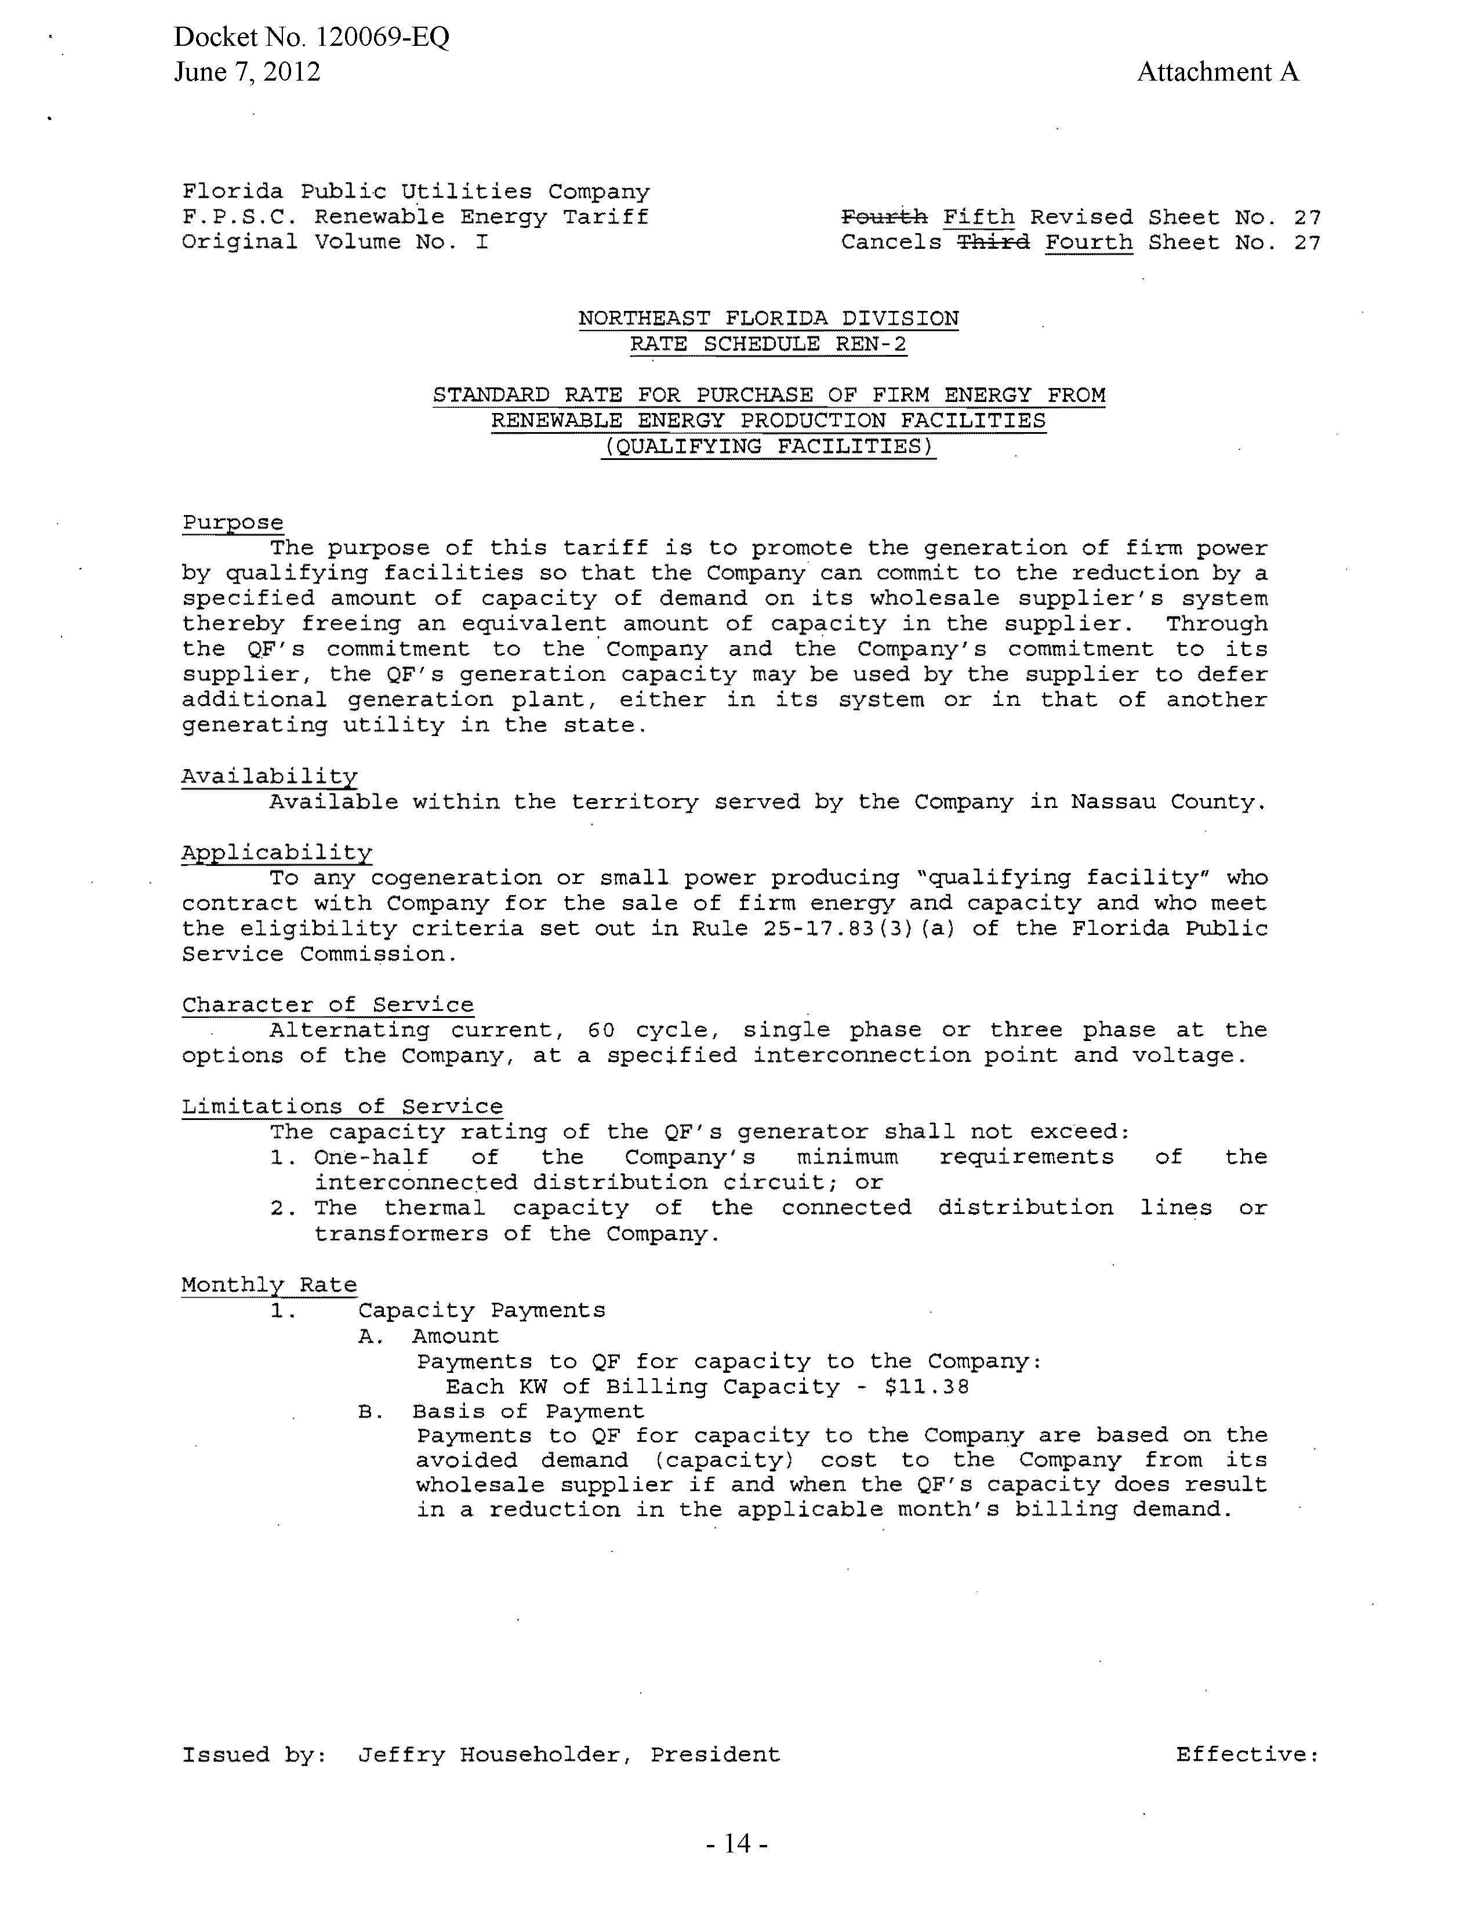
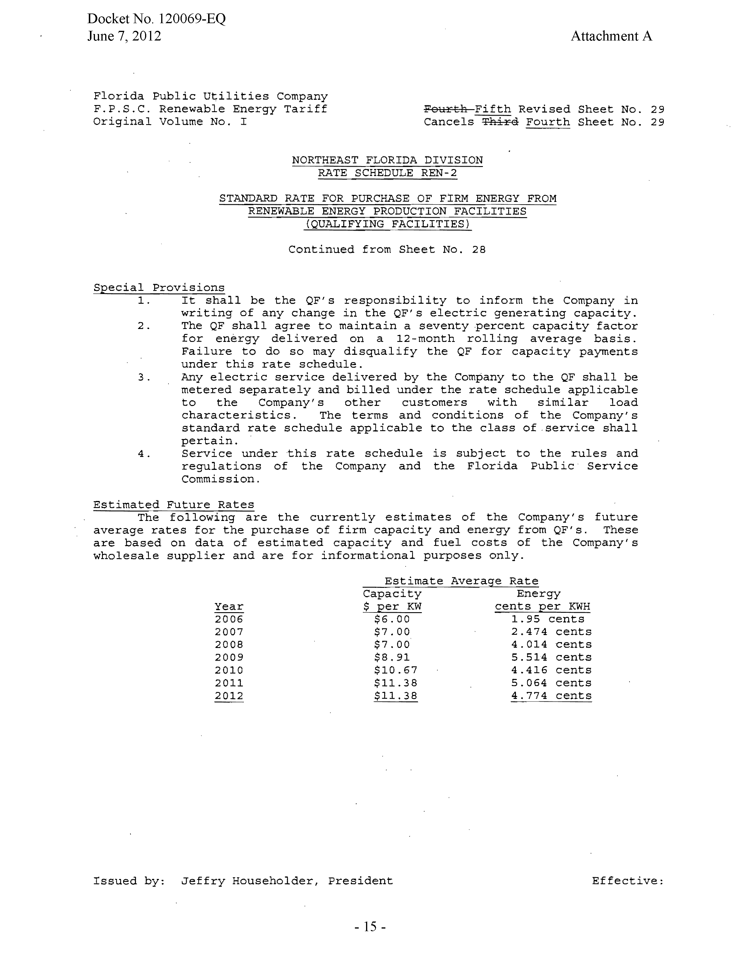

See Order No. PSC-07-0476-PAA-EI, issued June 6, 2007, in Docket No. 070108-EI, In re: Petition for approval of agreement for generation services and related terms and conditions with Gulf Power Company for Northwest Division (Marianna) beginning 2008, by Florida Public Utilities Company.
See Docket No. 110041-EI, In re: Request for Approval of Amendment No. 1 to the Agreement for Generation Services Between Gulf Power Company and Florida Public Utilities Company, by Florida Public Utilities Company.
See Order No. PSC-11-0269-PAA-EI, issued June 21, 2011, in Docket No. 110041-EI, In re: Request for Approval of Amendment No. 1 to the Agreement for Generation Services Between Gulf Power Company and Florida Public Utilities Company, by Florida Public Utilities Company.
See Order No. PSC-12-0056-FOF-EI, issued February 9, 2012, in Docket No. 110041-EI, In re: Request for Approval of Amendment No. 1 to the Agreement for Generation Services Between Gulf Power Company and Florida Public Utilities Company, by Florida Public Utilities Company.
See Order No. PSC-11-0296-TRF-EQ, issued July 8, 2011, in Docket No. 110089-EI, In re: Petition for Approval of Revisions to Renewable Energy Tariff, by Florida Public Utilities Company.

