BEFORE THE FLORIDA PUBLIC SERVICE COMMISSION

In re: Petition for approval of a negotiated renewable energy power purchase contract for power purchased with Rayonier Performance Fibers, LLC, by Florida Public Utilities Company. | DOCKET NO. 120058-EQ  ORDER NO. PSC-12-0312-CFO-EQ  ISSUED: June 18, 2012

ORDER GRANTING Florida Public Utilities Company’S REQUEST FOR CONFIDENTIAL CLASSIFICATION (DOCUMENT NO. 03358-12)
(CROSS-REFERENCED DOCUMENT NO. 02875-12)

BY THE COMMISSION:

On May 4, 2012, Florida Public Utilities Company (FPUC) requested confidential classification for information contained in its revised Attachment B submitted in response to Commission Staff’s First Data Request. (Document No. 02875-12).

On May 25, 2012, FPUC submitted a revised request for confidential classification for information contained in its second revised Attachment B submitted with its updated response to Staff’s First Data Request. (Document No. 03358-12). Specifically, FPUC requested confidential classification of its revised Attachment B, its Appendix F, and all highlighted information on the submitted CD. FPUC noted that it no longer requested confidentiality for the item identified as Net Present Value of Annual Savings for each filed revised version of Attachment B.

FPUC stated that the information contained in Document Nos. 02875-12 and 03358-12, exclusive of the Net Present Value, met the definition of “proprietary confidential business information” pursuant to Section 366.093, Florida Statutes (F.S.), and Rule 25-22.006(4), Florida Administrative Code (F.A.C.), in that: (1) the information represents data provided in the context of confidential contractual negotiations and concerns bids or other contractual data between FPUC and Rayonier Performance Fibers, LLC (Rayonier); (2) the information includes terms and rates, which if publicly disclosed could be detrimental to FPUC and Rayonier’s business operations; and (3) FPUC and Rayonier treat the information as proprietary confidential business information and the information has not been publicly disclosed. The justification for the confidential classification of the information contained in Document Nos. 02875-12 and 03358-12 is attached hereto and incorporated herein as Attachment A.

We have jurisdiction over this matter pursuant to Section 366.093, F.S., and Rule 25-22.006(4), F.A.C.

Pursuant to Section 366.093(1), F.S., information that this Commission finds to be proprietary confidential business information must be kept confidential and exempt from Section 119.07(1) [the Public Records Act]. Proprietary confidential business information is defined as information that: (1) is intended to be and is treated by the company as private, in that disclosure of the information would cause harm to the company’s ratepayers or business operations, and (2) has not been voluntarily disclosed to the public. Pursuant to Section 366.093 F.S., proprietary confidential business information includes, but is not limited to, information relating to bids, other contractual data, or competitive interests, the disclosure of which will prove detrimental to the utility’s business operations or ratepayers.

I find that the information described in Attachment A to this Order satisfies the criteria set forth in Section 366.093, F.S., for classification as proprietary confidential business information. (Document Nos. 02875-12 and 03358-12, exclusive of the Net Present Value). The information relates to bids, other contractual data, and competitive interests, and public disclosure of this information will be detrimental to FPUC and its affiliates’ business operations and ratepayers. Therefore, I find it appropriate to grant FPUC’s request for confidential classification of the information described in Attachment A (Document Nos. 02875-12 and 03358-12).

Pursuant to Section 366.093(4), F.S., the information for which confidential classification is granted herein shall remain protected from disclosure for a period of 18 months from the date of issuance of this Order. At the conclusion of the 18-month period, the confidential information will no longer be exempt from Section 119.07(1), F.S., unless FPUC or another affected person shows, and this Commission finds, that the information continues to be proprietary confidential business information.

Based on the foregoing, it is

ORDERED by Commissioner Eduardo E. Balbis, as Prehearing Officer, that Florida Public Utilities Company’s Request for Confidential Classification of the information contained in both revised responses to Commission Staff’s First Data Request (Document Nos. 02875-12 and 03358-12, exclusive of the Net Present Value), which is identified in Attachment A, is granted. It is further

ORDERED that the confidentiality granted to the information specified herein shall expire eighteen (18) months from the date of the issuance of this Order, in the absence of a renewed request for confidentiality. It is further

ORDERED that this Order shall be the only notification by the Commission to the parties of the date of declassification of the materials discussed herein.

By ORDER of Commissioner Eduardo E. Balbis, as Prehearing Officer, this 18th day of June, 2012.

/s/ Eduardo E. Balbis
EDUARDO E. BALBIS
Commissioner and Prehearing Officer
Florida Public Service Commission
2540 Shumard Oak Boulevard
Tallahassee, Florida 32399
(850) 413-6770
www.floridapsc.com

Copies furnished: A copy of this document is provided to the parties of record at the time of issuance and, if applicable, interested persons.

PER

NOTICE OF FURTHER PROCEEDINGS OR JUDICIAL REVIEW

The Florida Public Service Commission is required by Section 120.569(1), Florida Statutes, to notify parties of any administrative hearing or judicial review of Commission orders that is available under Sections 120.57 or 120.68, Florida Statutes, as well as the procedures and time limits that apply. This notice should not be construed to mean all requests for an administrative hearing or judicial review will be granted or result in the relief sought.

Mediation may be available on a case-by-case basis. If mediation is conducted, it does not affect a substantially interested person's right to a hearing.

Any party adversely affected by this order, which is preliminary, procedural or intermediate in nature, may request: (1) reconsideration within 10 days pursuant to Rule 25-22.0376, Florida Administrative Code; or (2) judicial review by the Florida Supreme Court, in the case of an electric, gas or telephone utility, or the First District Court of Appeal, in the case of a water or wastewater utility. A motion for reconsideration shall be filed with the Office of Commission Clerk, in the form prescribed by Rule 25-22.0376, Florida Administrative Code. Judicial review of a preliminary, procedural or intermediate ruling or order is available if review of the final action will not provide an adequate remedy. Such review may be requested from the appropriate court, as described above, pursuant to Rule 9.100, Florida Rules of Appellate Procedure.
ATTACHMENT A

(Justification for Document No. 02875-12)
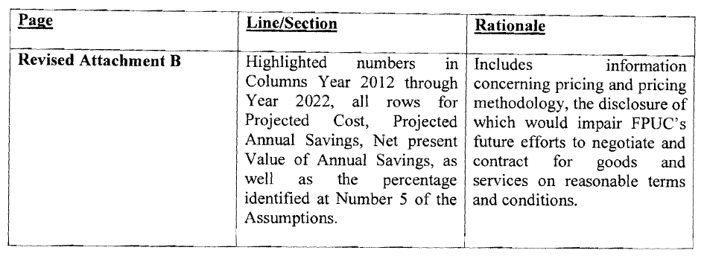

(Justification for Document No. 03358-12)
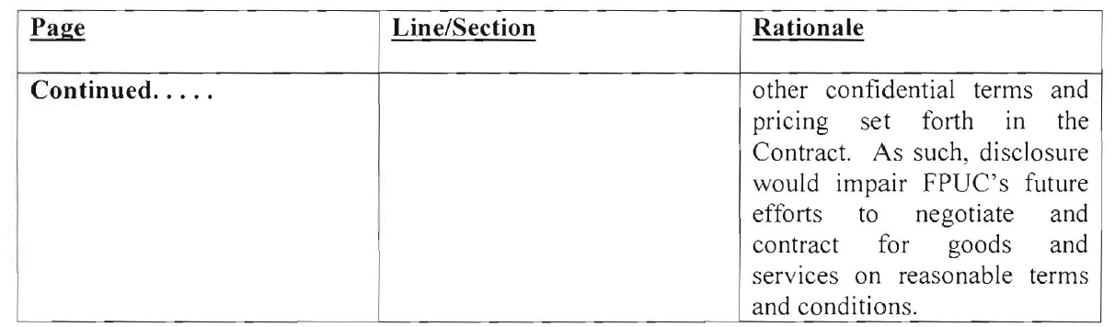

FPUC’s original Attachment B was granted confidential classification by Order No. PSC-12-0180-CFO-EQ, issued on April 5, 2012, in this docket.

