BEFORE THE FLORIDA PUBLIC SERVICE COMMISSION

In re: Fuel and purchased power cost recovery clause with generating performance incentive factor. | DOCKET NO. 120001-EI
In re: Energy conservation cost recovery clause. | DOCKET NO. 120002-EG
In re: Environmental cost recovery clause. | DOCKET NO. 120007-EI  ORDER NO. PSC-12-0425-PAA-EU  ISSUED: August 16, 2012

The following Commissioners participated in the disposition of this matter:

RONALD A. BRISÉ, Chairman
LISA POLAK EDGAR
ART GRAHAM
EDUARDO E. BALBIS
JULIE I. BROWN

NOTICE OF PROPOSED AGENCY ACTION ORDER
APPROVING STIPULATION AND SETTLEMENT AGREEMENT

BY THE COMMISSION:

NOTICE is hereby given by the Florida Public Service Commission that the action discussed herein is preliminary in nature and will become final unless a person whose interests are substantially affected files a petition for a formal proceeding, pursuant to Rule 25-22.029, Florida Administrative Code.

Case Background

The cost recovery dockets, Energy Conservation Cost Recovery (ECCR), Fuel and Purchased Power Cost Recovery Clause (Fuel Clause), and the Environmental Cost Recovery Clause (ECRC) are continuing dockets in which we address issues pertaining to Florida’s Investor-Owned electric Utilities (IOU). These IOUs are Florida Power & Light Company, Progress Energy Florida, Inc., Gulf Power Company, Florida Public Utility Company and Tampa Electric Company. Intervenors for all three cost recovery clause dockets include the Office of Public Counsel, Federal Executive Agencies, Florida Industrial Power Users Group, Florida Retail Federation, and White Springs Agricultural Chemicals, Inc. In addition, the Southern Alliance for Clean Energy (SACE) and Florida Solar Energy Industry Association (FLASEIA) intervened in the ECCR clause dockets. We have jurisdiction pursuant to Chapter 120 and several provisions of Chapter 366, including Sections 366.04 - 366.06 and 366.80 - 366.85, Florida Statutes (F.S.).

Analysis

This Commission, when appropriate, allows recovery of a return on capital investments through the Fuel and Purchased Power Cost Recovery Clause, the Conservation Cost Recovery Clause, and the Environmental Cost Recovery Clause. Traditionally, we have relied on the jurisdictional capital structure and cost rates for each component of the capital structure approved in each IOU’s most recent base rate case to determine the appropriate weighted average cost of capital. In certain instances, significant differences have developed between an IOU’s weighted average cost of capital authorized in the last base rate case and their current weighted average cost of capital. For example, in a recent cost recovery clause docket, the difference between the current cost of capital as reported in the Earnings Surveillance Report and the cost of capital from the last rate case has been over 100 basis points. A methodology that more closely aligns current costs with current cost recovery was developed and is set out in a Settlement and Stipulation Agreement (Agreement) (Attachment A).
The new methodology applies to clause cycling expenses beginning January 1, 2013. A timeline example of the methodology is provided in Attachment A. In addition to the methodology, the Agreement includes the following elements of note:

- Progress Energy will be allowed to exclude its Clean Air Interstate Rule investments from the application of the new method in 2013 and will be allowed to continue use of the current method on those investments in setting clause rates for 2013.

- No Party will challenge the justness or reasonableness of the new methodology or the appropriateness of the weighted average cost of capital reflected in the May Earnings Surveillance Reports used thereunder in any Clause proceedings. Any Party may challenge a mathematical error that it contends has been made in calculating the weighted average cost of capital in an Earnings Surveillance Report.

- The provisions are contingent on approval of the Agreement in its entirety by this Commission. The Parties agree to support the Agreement and will not request or support any order, relief, outcome or result in conflict with the terms of the Agreement in any administrative or judicial proceeding relating to, reviewing or challenging the establishment, approval, adoption or implementation of the Agreement.

- If we reject or modify the Agreement in whole or in part, it is void unless ratified by the Parties, and that each Party may pursue its interests as those interests exist, and no Party will be bound by or make reference before us, any court, any other administrative forum or arbitration panel.

- The Parties asked that we take the following actions:

  - Restate and affirm our conclusion in Order No. PSC-94-0044-FOF-EI that “potentially controversial and time consuming evidentiary debates regarding the appropriate capital structure and return on equity should be the subject of proceedings [other than the clause proceedings].”

  - Confirm the appropriateness of the weighted average cost of capital calculation methodology set forth in the Agreement for application to the calculation of projected Clause factors, actual/estimated true-ups of Clause factors and final true-ups of Clause factors in all subsequent dockets unless and until modified by us.

Decision

Evidentiary debates regarding the appropriate capital structure and the return on equity shall be the subject of proceedings other than the clause proceedings. Therefore, unless and until modified by us, we hereby approve use of the weighted average cost of capital calculation methodology as established in the Agreement in all subsequent clause dockets. Further, the Agreement filed by the parties is in the public interest because the methodology more accurately aligns current costs with cost recovery and sends a more precise price signal. Therefore, we find it appropriate to approve the Stipulation and Settlement Agreement of the parties, addressing the methodology for calculating the allowable return on clause-approved investments.

Based on the foregoing, it is

ORDERED by the Florida Public Service Commission that the Stipulation and Settlement Agreement is hereby approved for Docket Nos. 120001-EI, 120002-EG, 120007-EI. It is further

ORDERED that the provisions of this Order, issued as proposed agency action, shall become final and effective upon the issuance of a Consummating Order unless an appropriate petition, in the form provided by Rule 28-106.201, Florida Administrative Code, is received by the Commission Clerk, 2540 Shumard Oak Boulevard, Tallahassee, Florida 32399-0850, by the close of business on the date set forth in the “Notice of Further Proceedings” attached hereto. It is further

ORDERED that Docket Nos. 120001-EI, 120002-EG, 120007-EI shall remain open to address the evidentiary issues presented in each.

By ORDER of the Florida Public Service Commission this 16th day of August, 2012.

/s/ Ann Cole
ANN COLE
Commission Clerk
Florida Public Service Commission
2540 Shumard Oak Boulevard
Tallahassee, Florida 32399
(850) 413-6770
www.floridapsc.com

Copies furnished: A copy of this document is provided to the parties of record at the time of issuance and, if applicable, interested persons.

TLT

NOTICE OF FURTHER PROCEEDINGS OR JUDICIAL REVIEW

The Florida Public Service Commission is required by Section 120.569(1), Florida Statutes, to notify parties of any administrative hearing that is available under Section 120.57, Florida Statutes, as well as the procedures and time limits that apply. This notice should not be construed to mean all requests for an administrative hearing will be granted or result in the relief sought.

Mediation may be available on a case-by-case basis. If mediation is conducted, it does not affect a substantially interested person's right to a hearing.

The action proposed herein is preliminary in nature. Any person whose substantial interests are affected by the action proposed by this order may file a petition for a formal proceeding, in the form provided by Rule 28-106.201, Florida Administrative Code. This petition must be received by the Office of Commission Clerk, 2540 Shumard Oak Boulevard, Tallahassee, Florida 32399-0850, by the close of business on September 6, 2012.

In the absence of such a petition, this order shall become final and effective upon the issuance of a Consummating Order.

Any objection or protest filed in these dockets before the issuance date of this order is considered abandoned unless it satisfies the foregoing conditions and is renewed within the specified protest period.

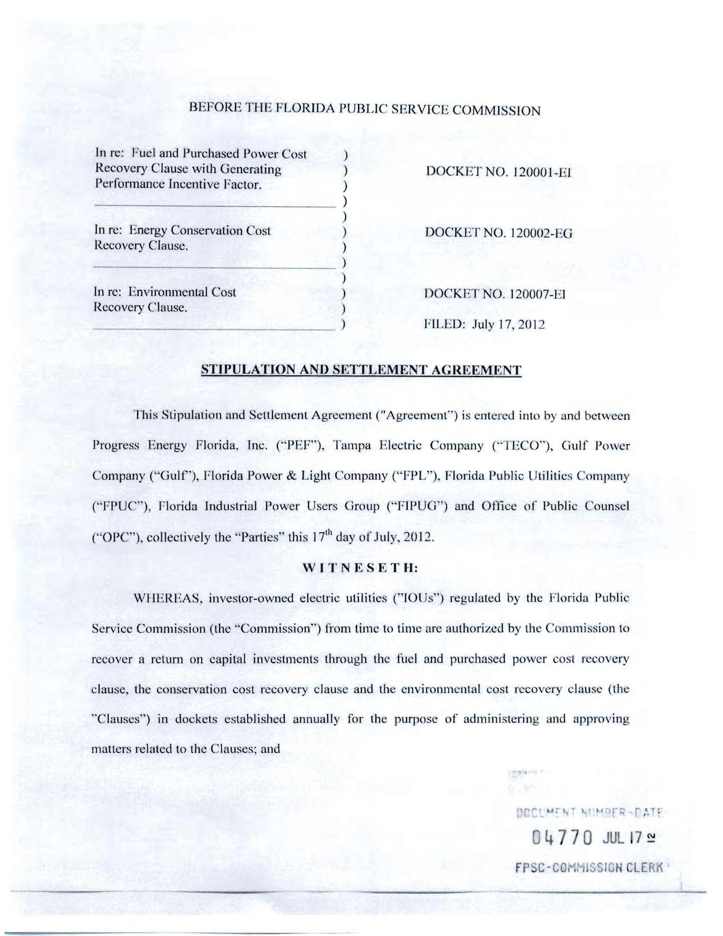
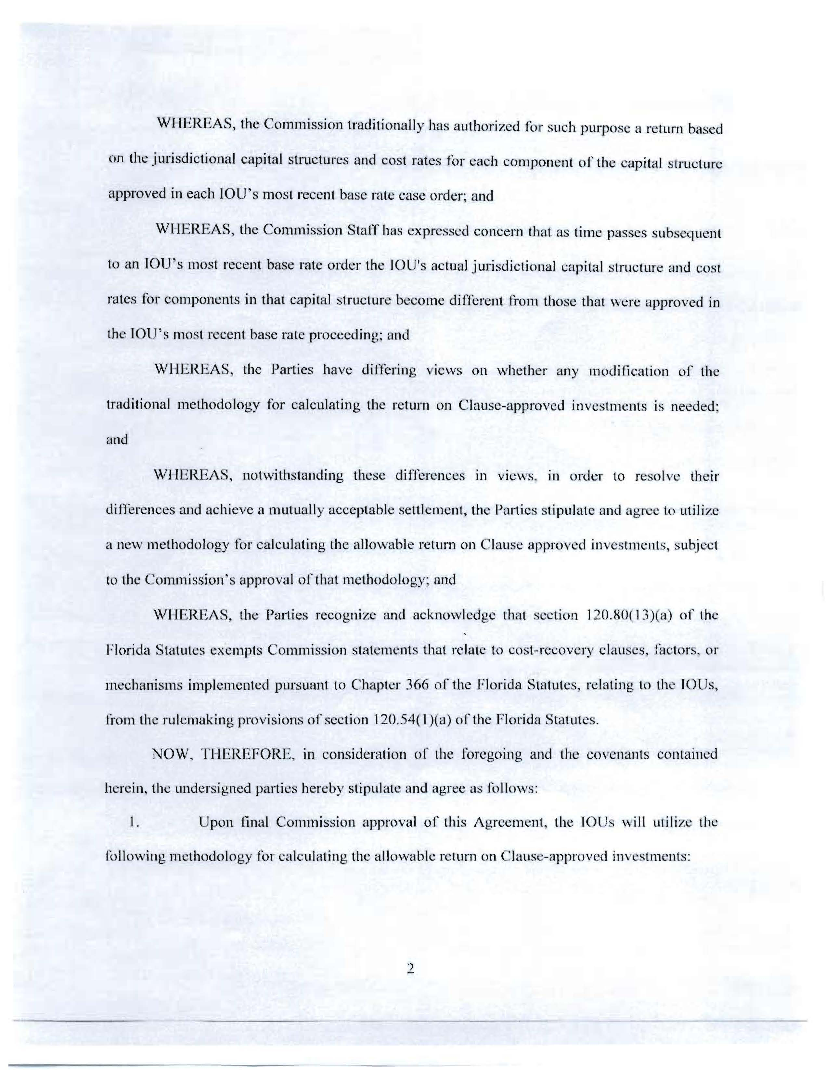
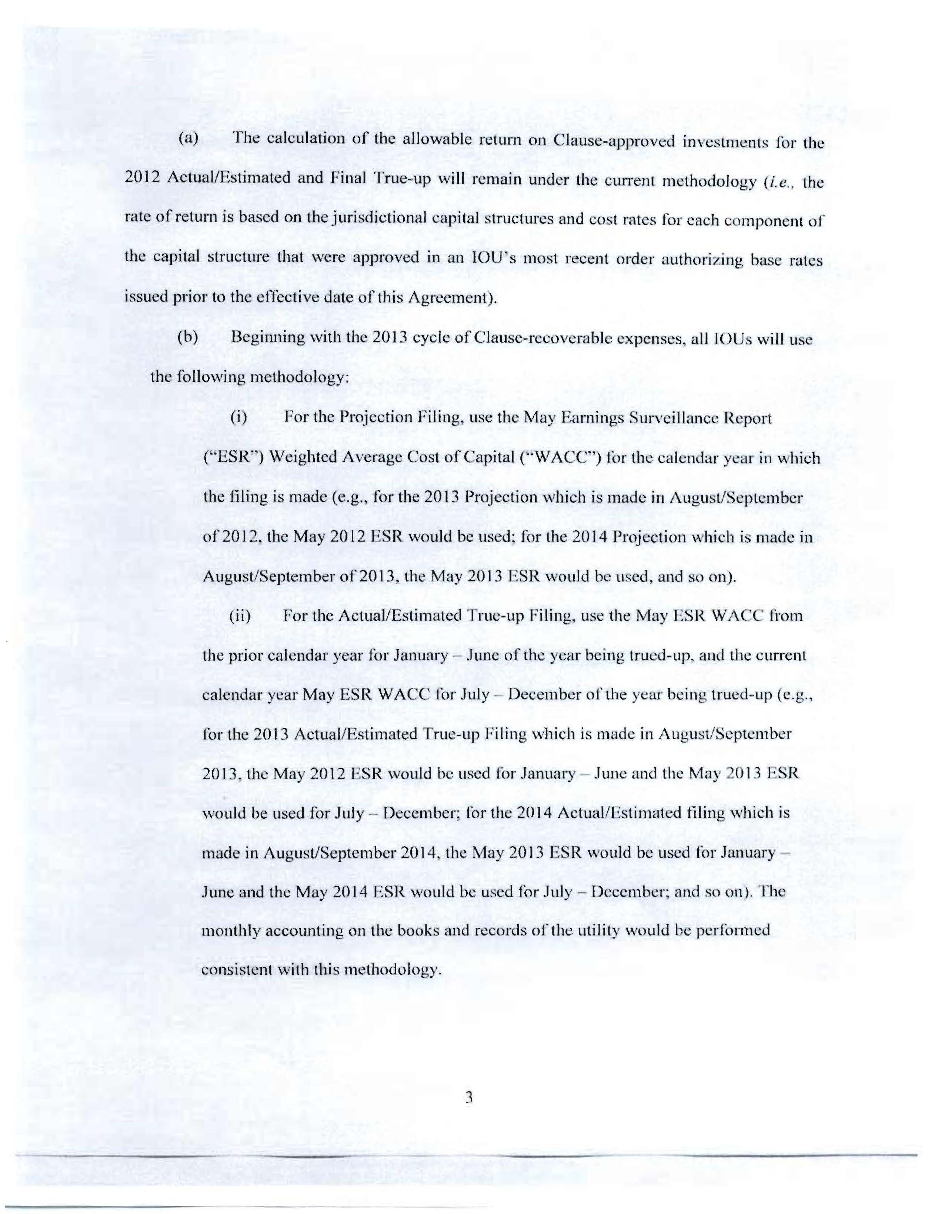
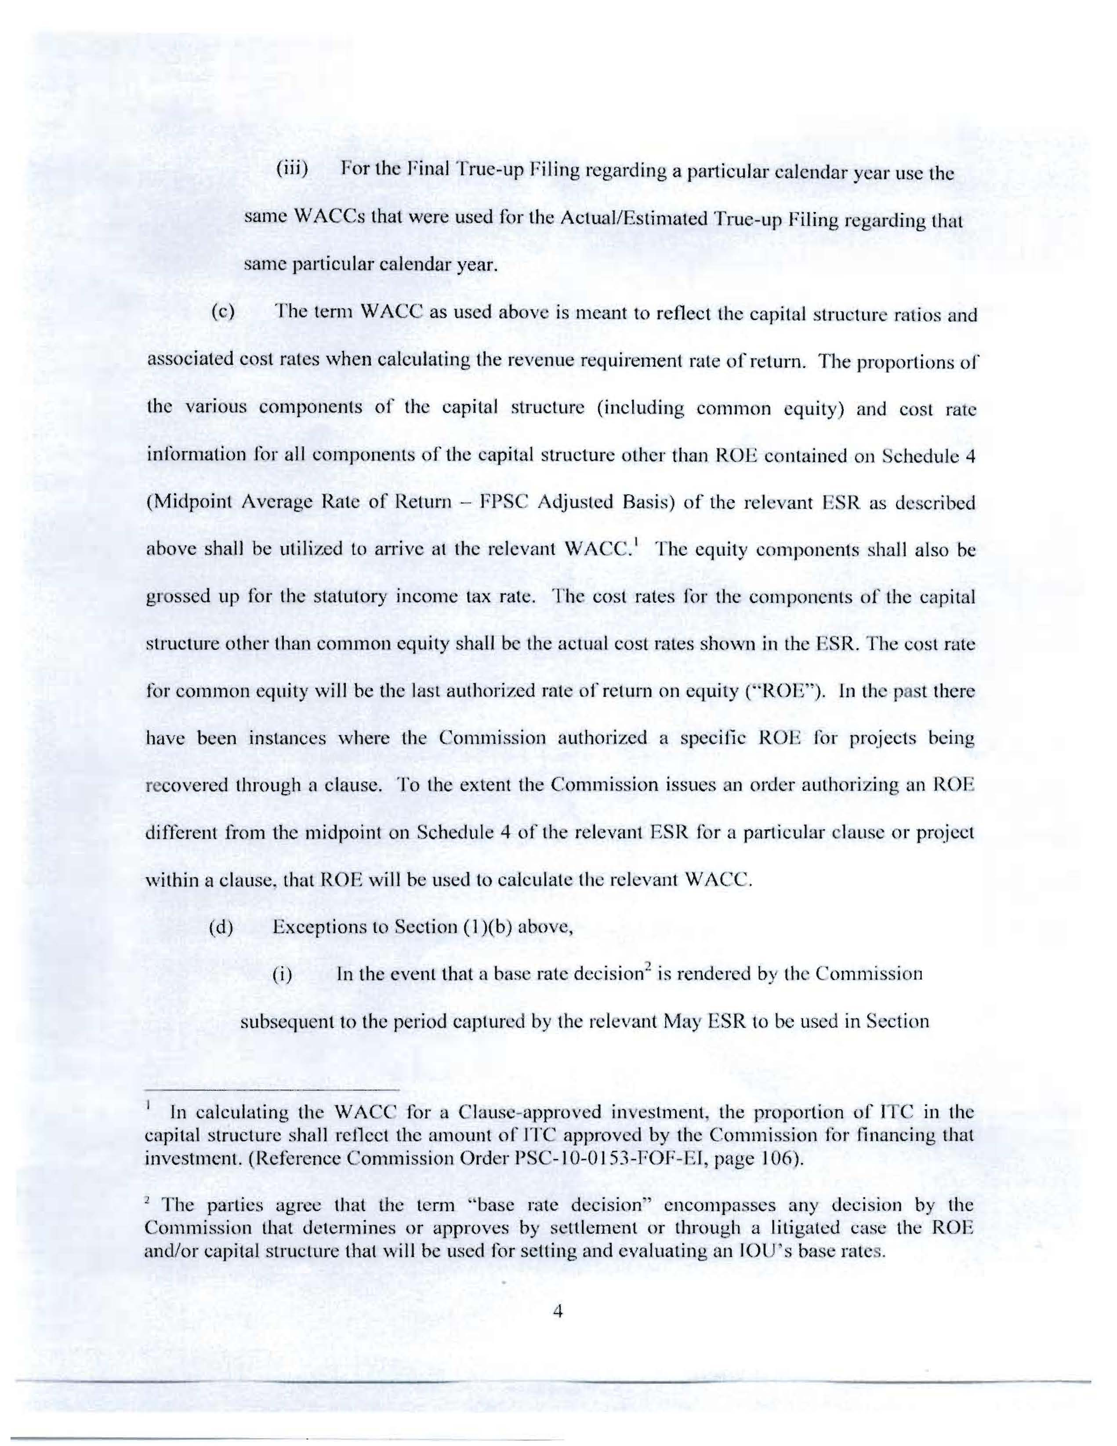
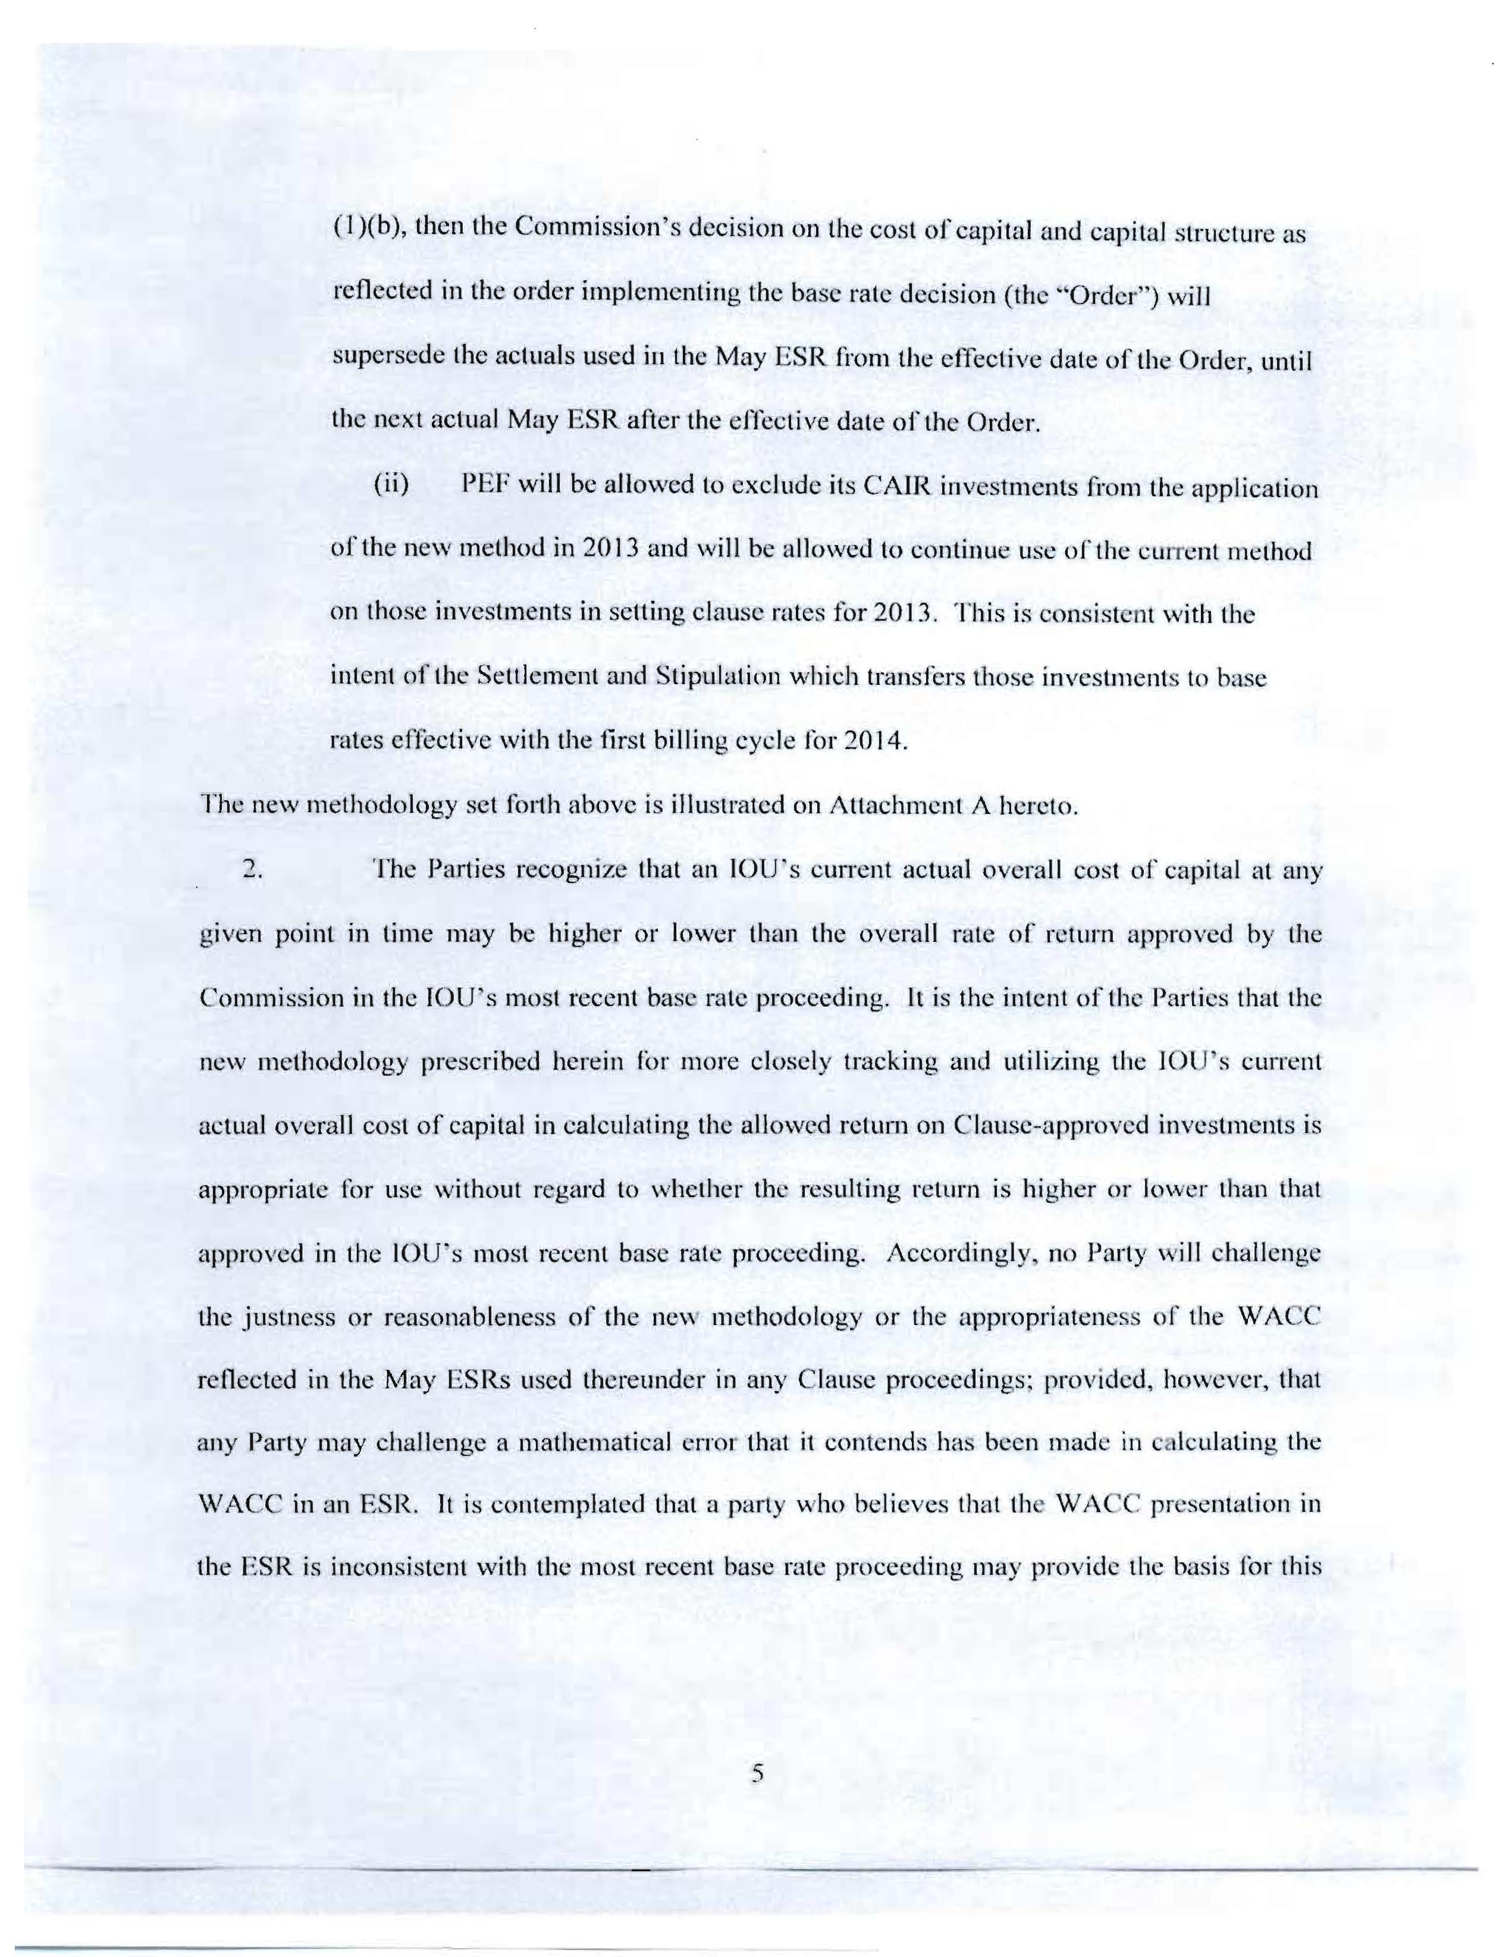
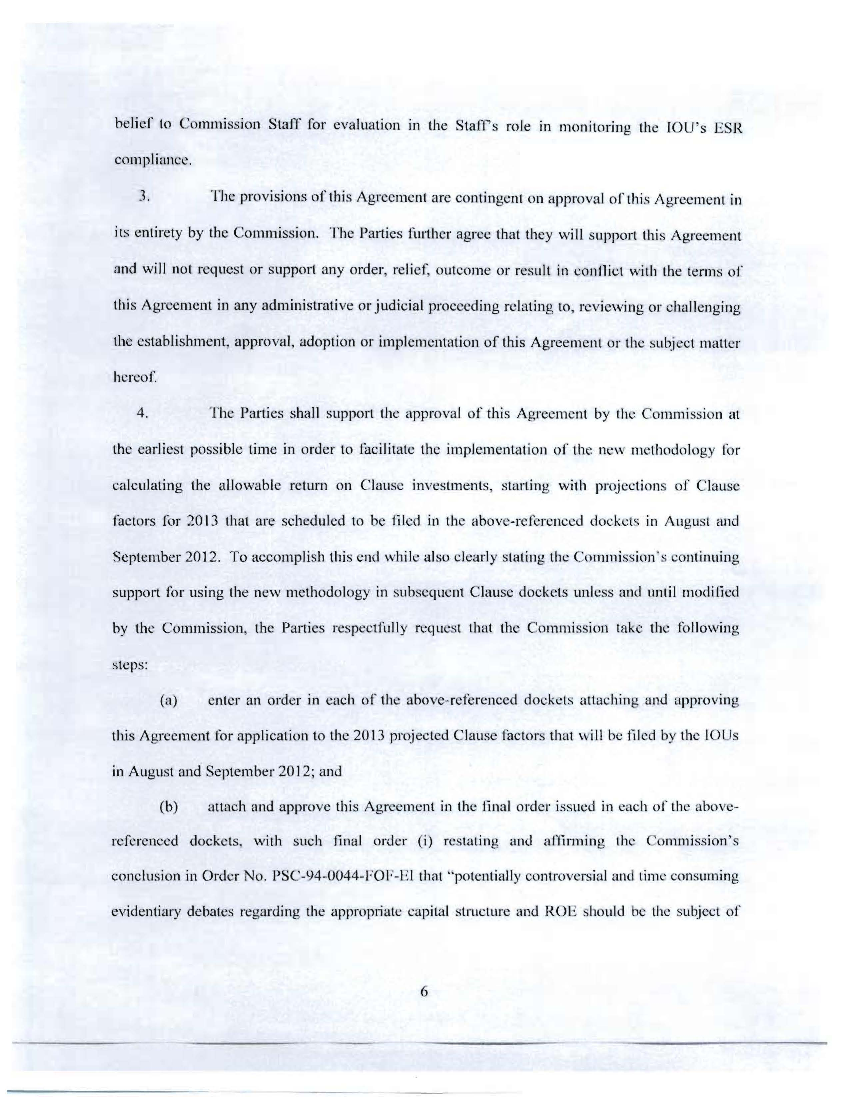
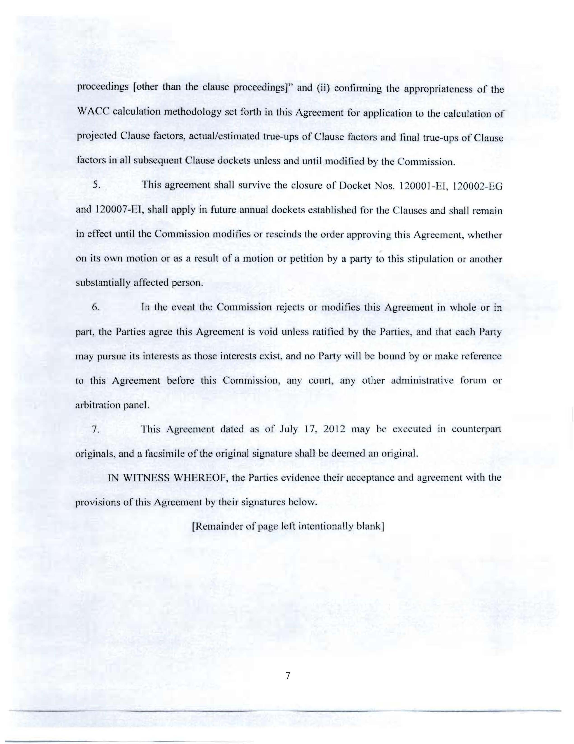
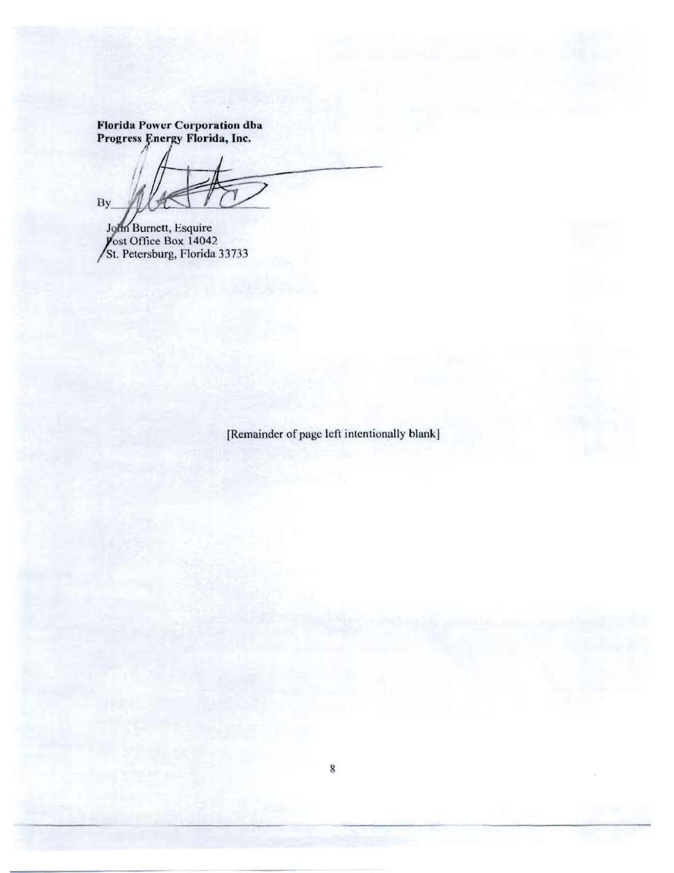
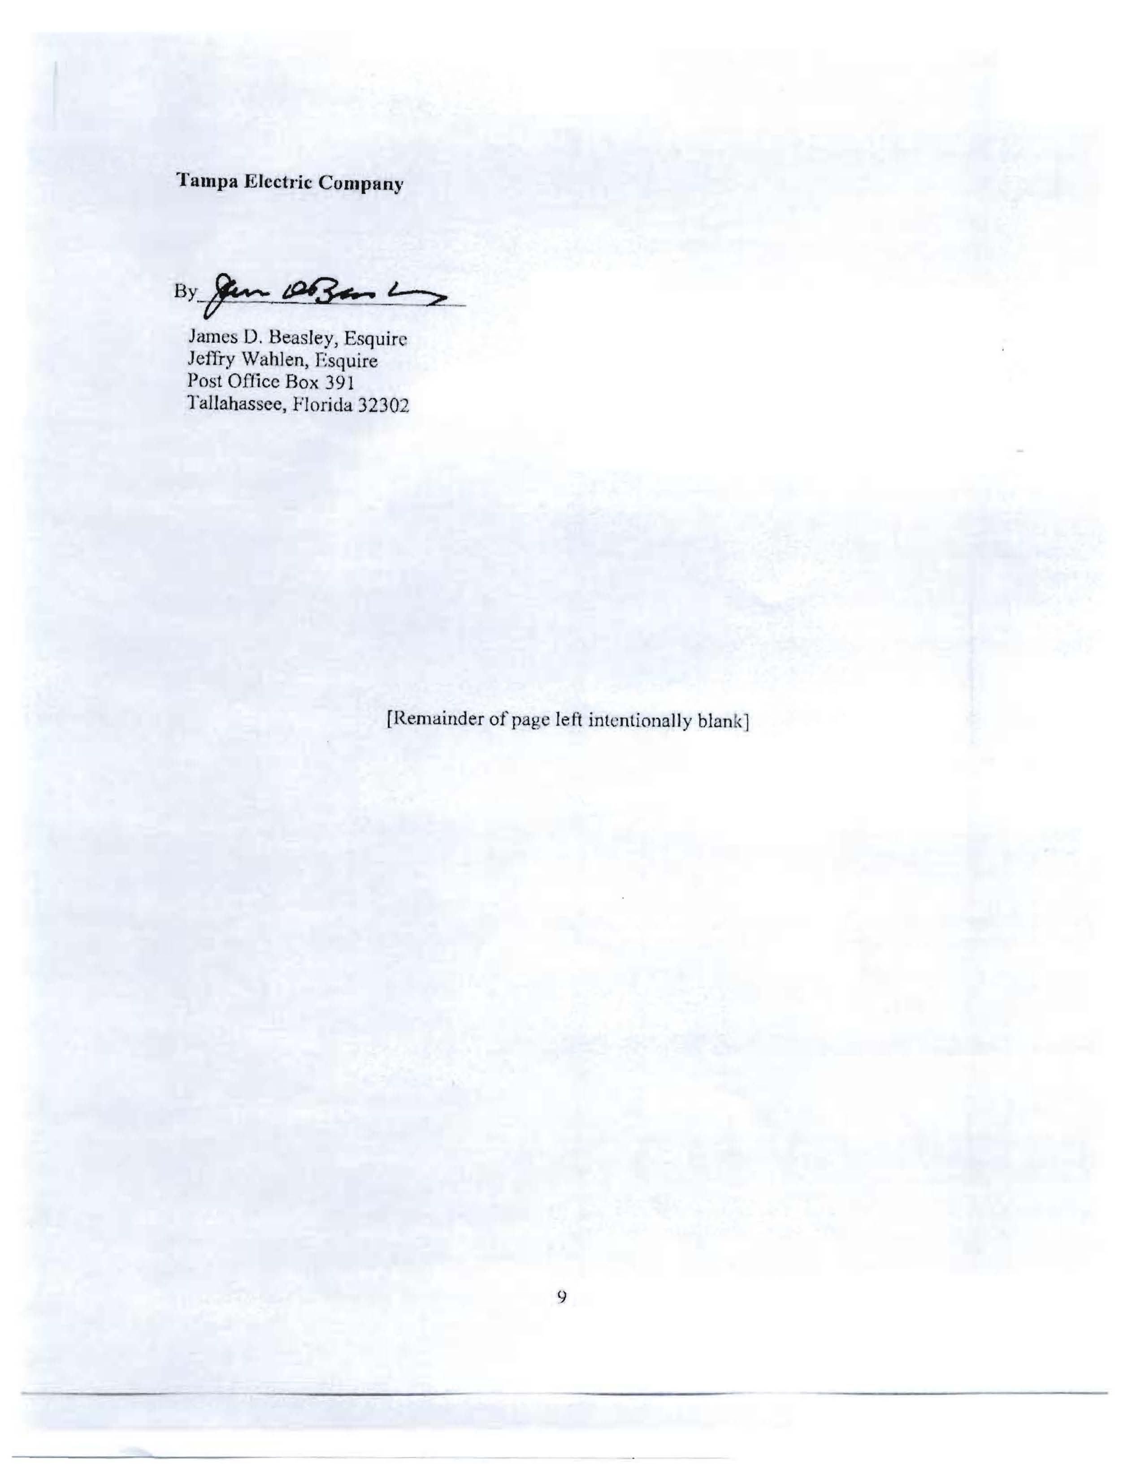
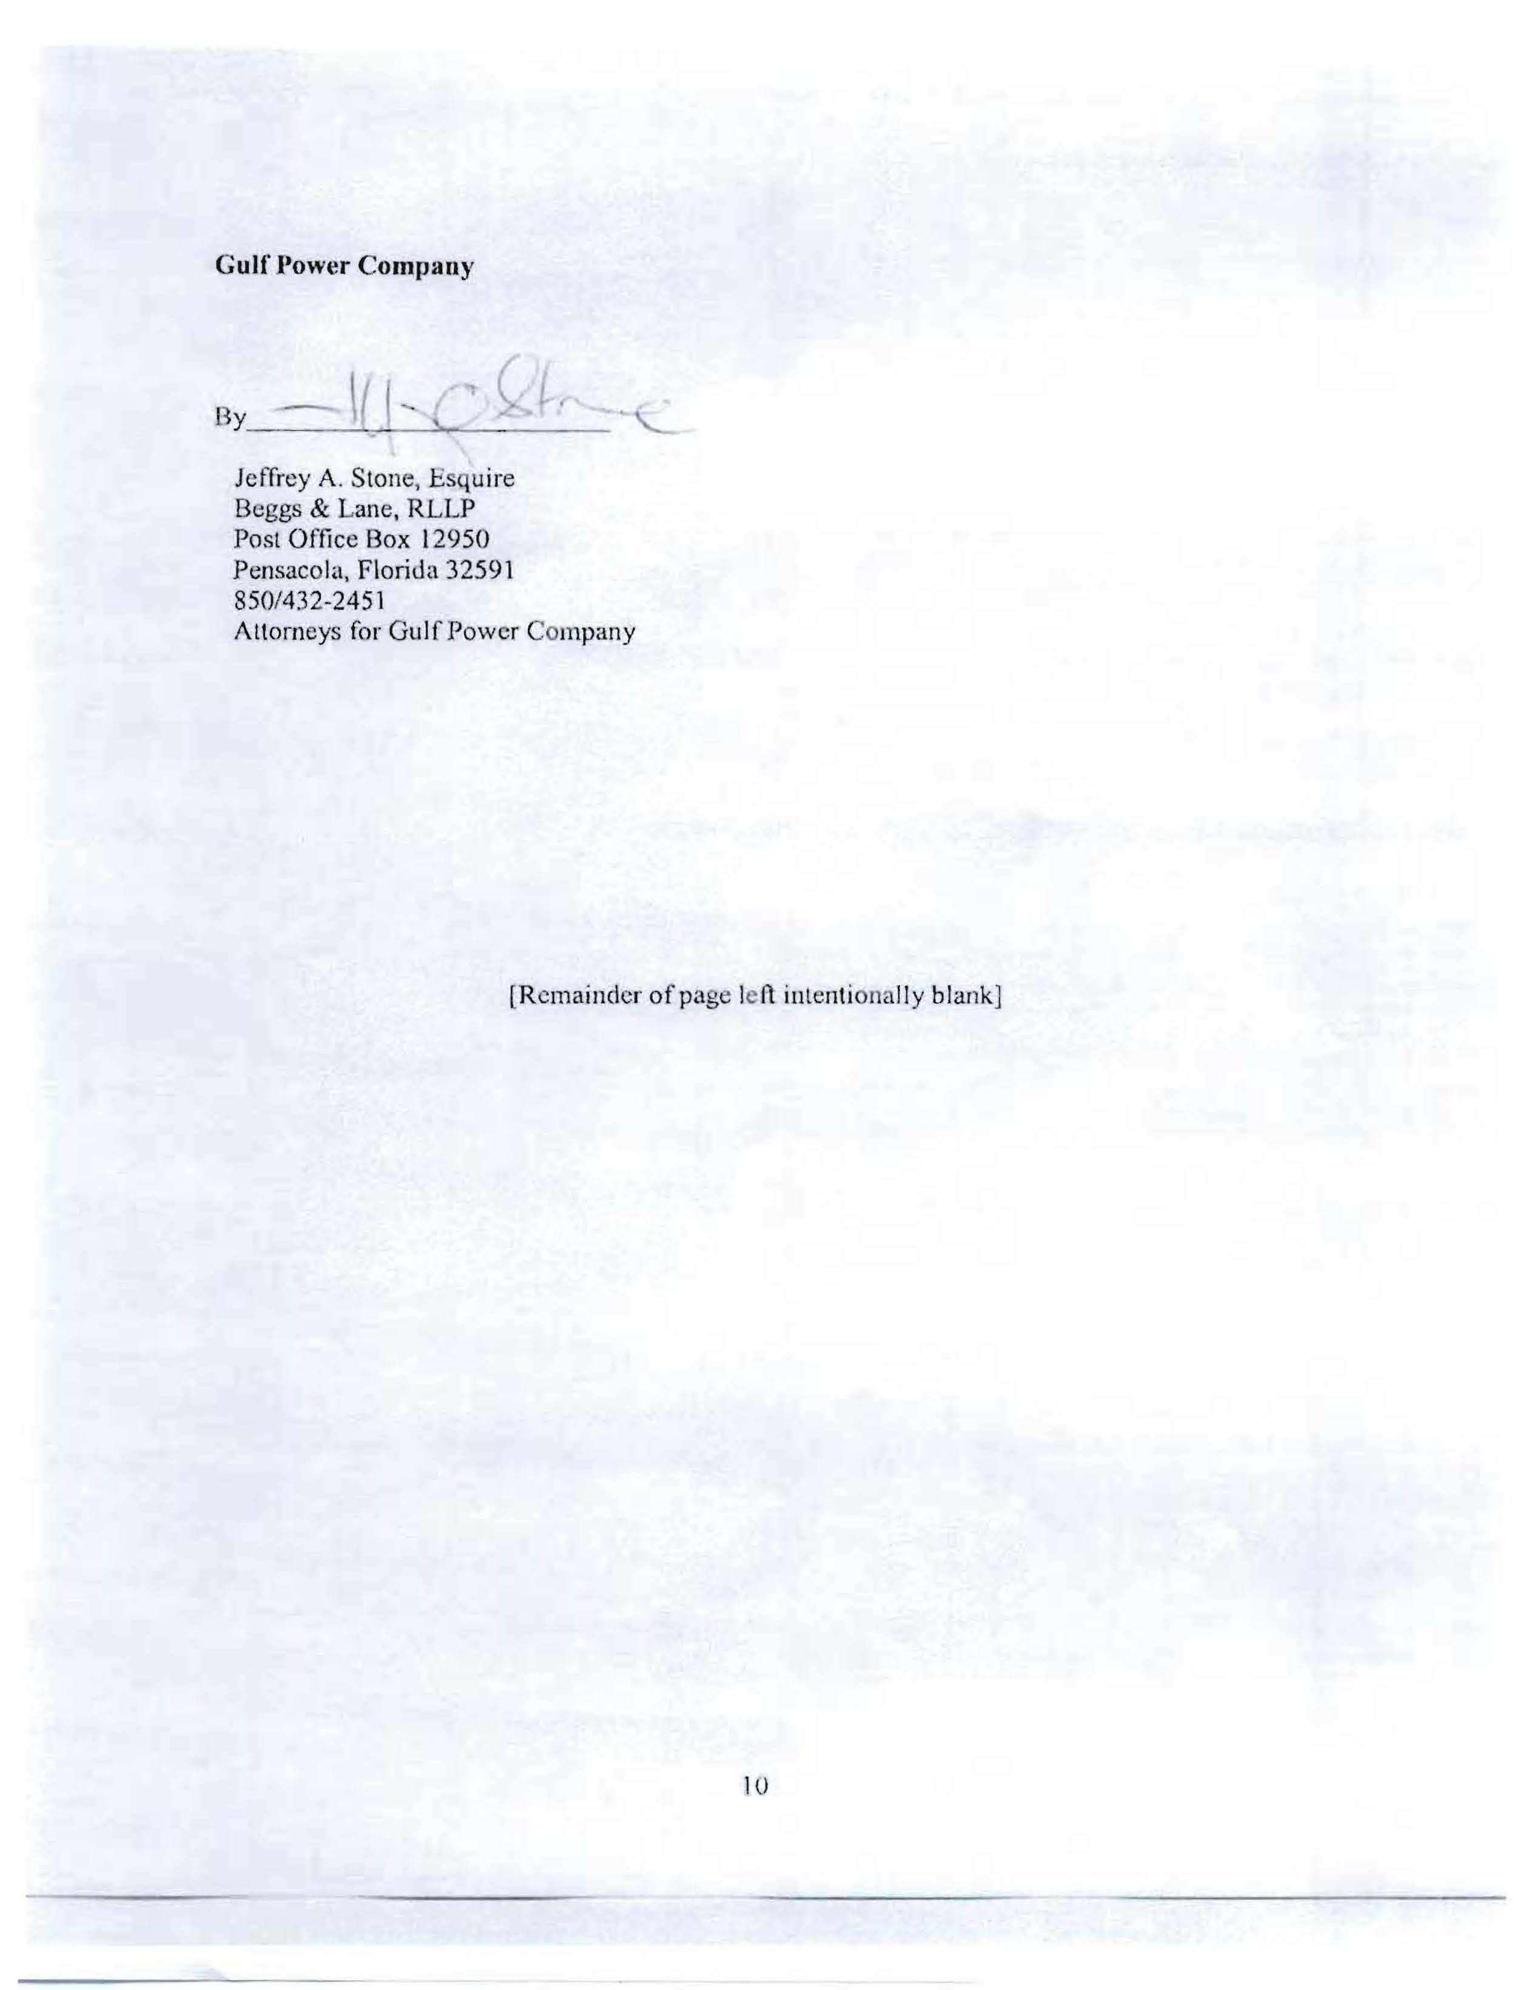
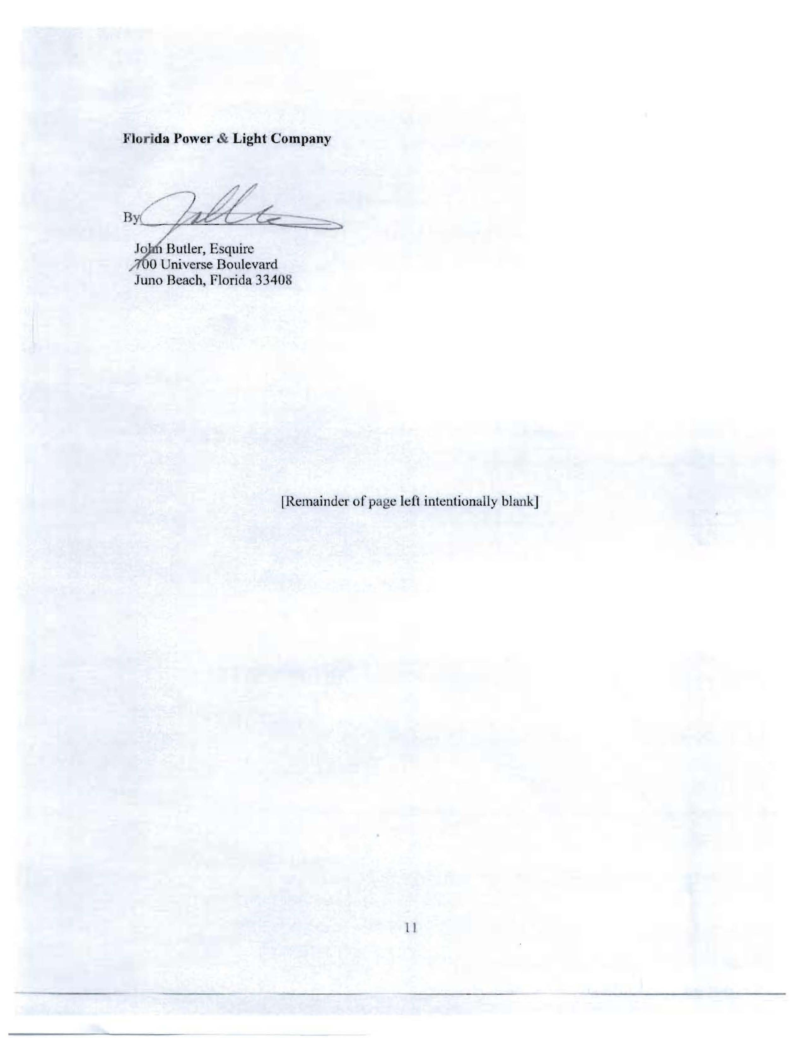
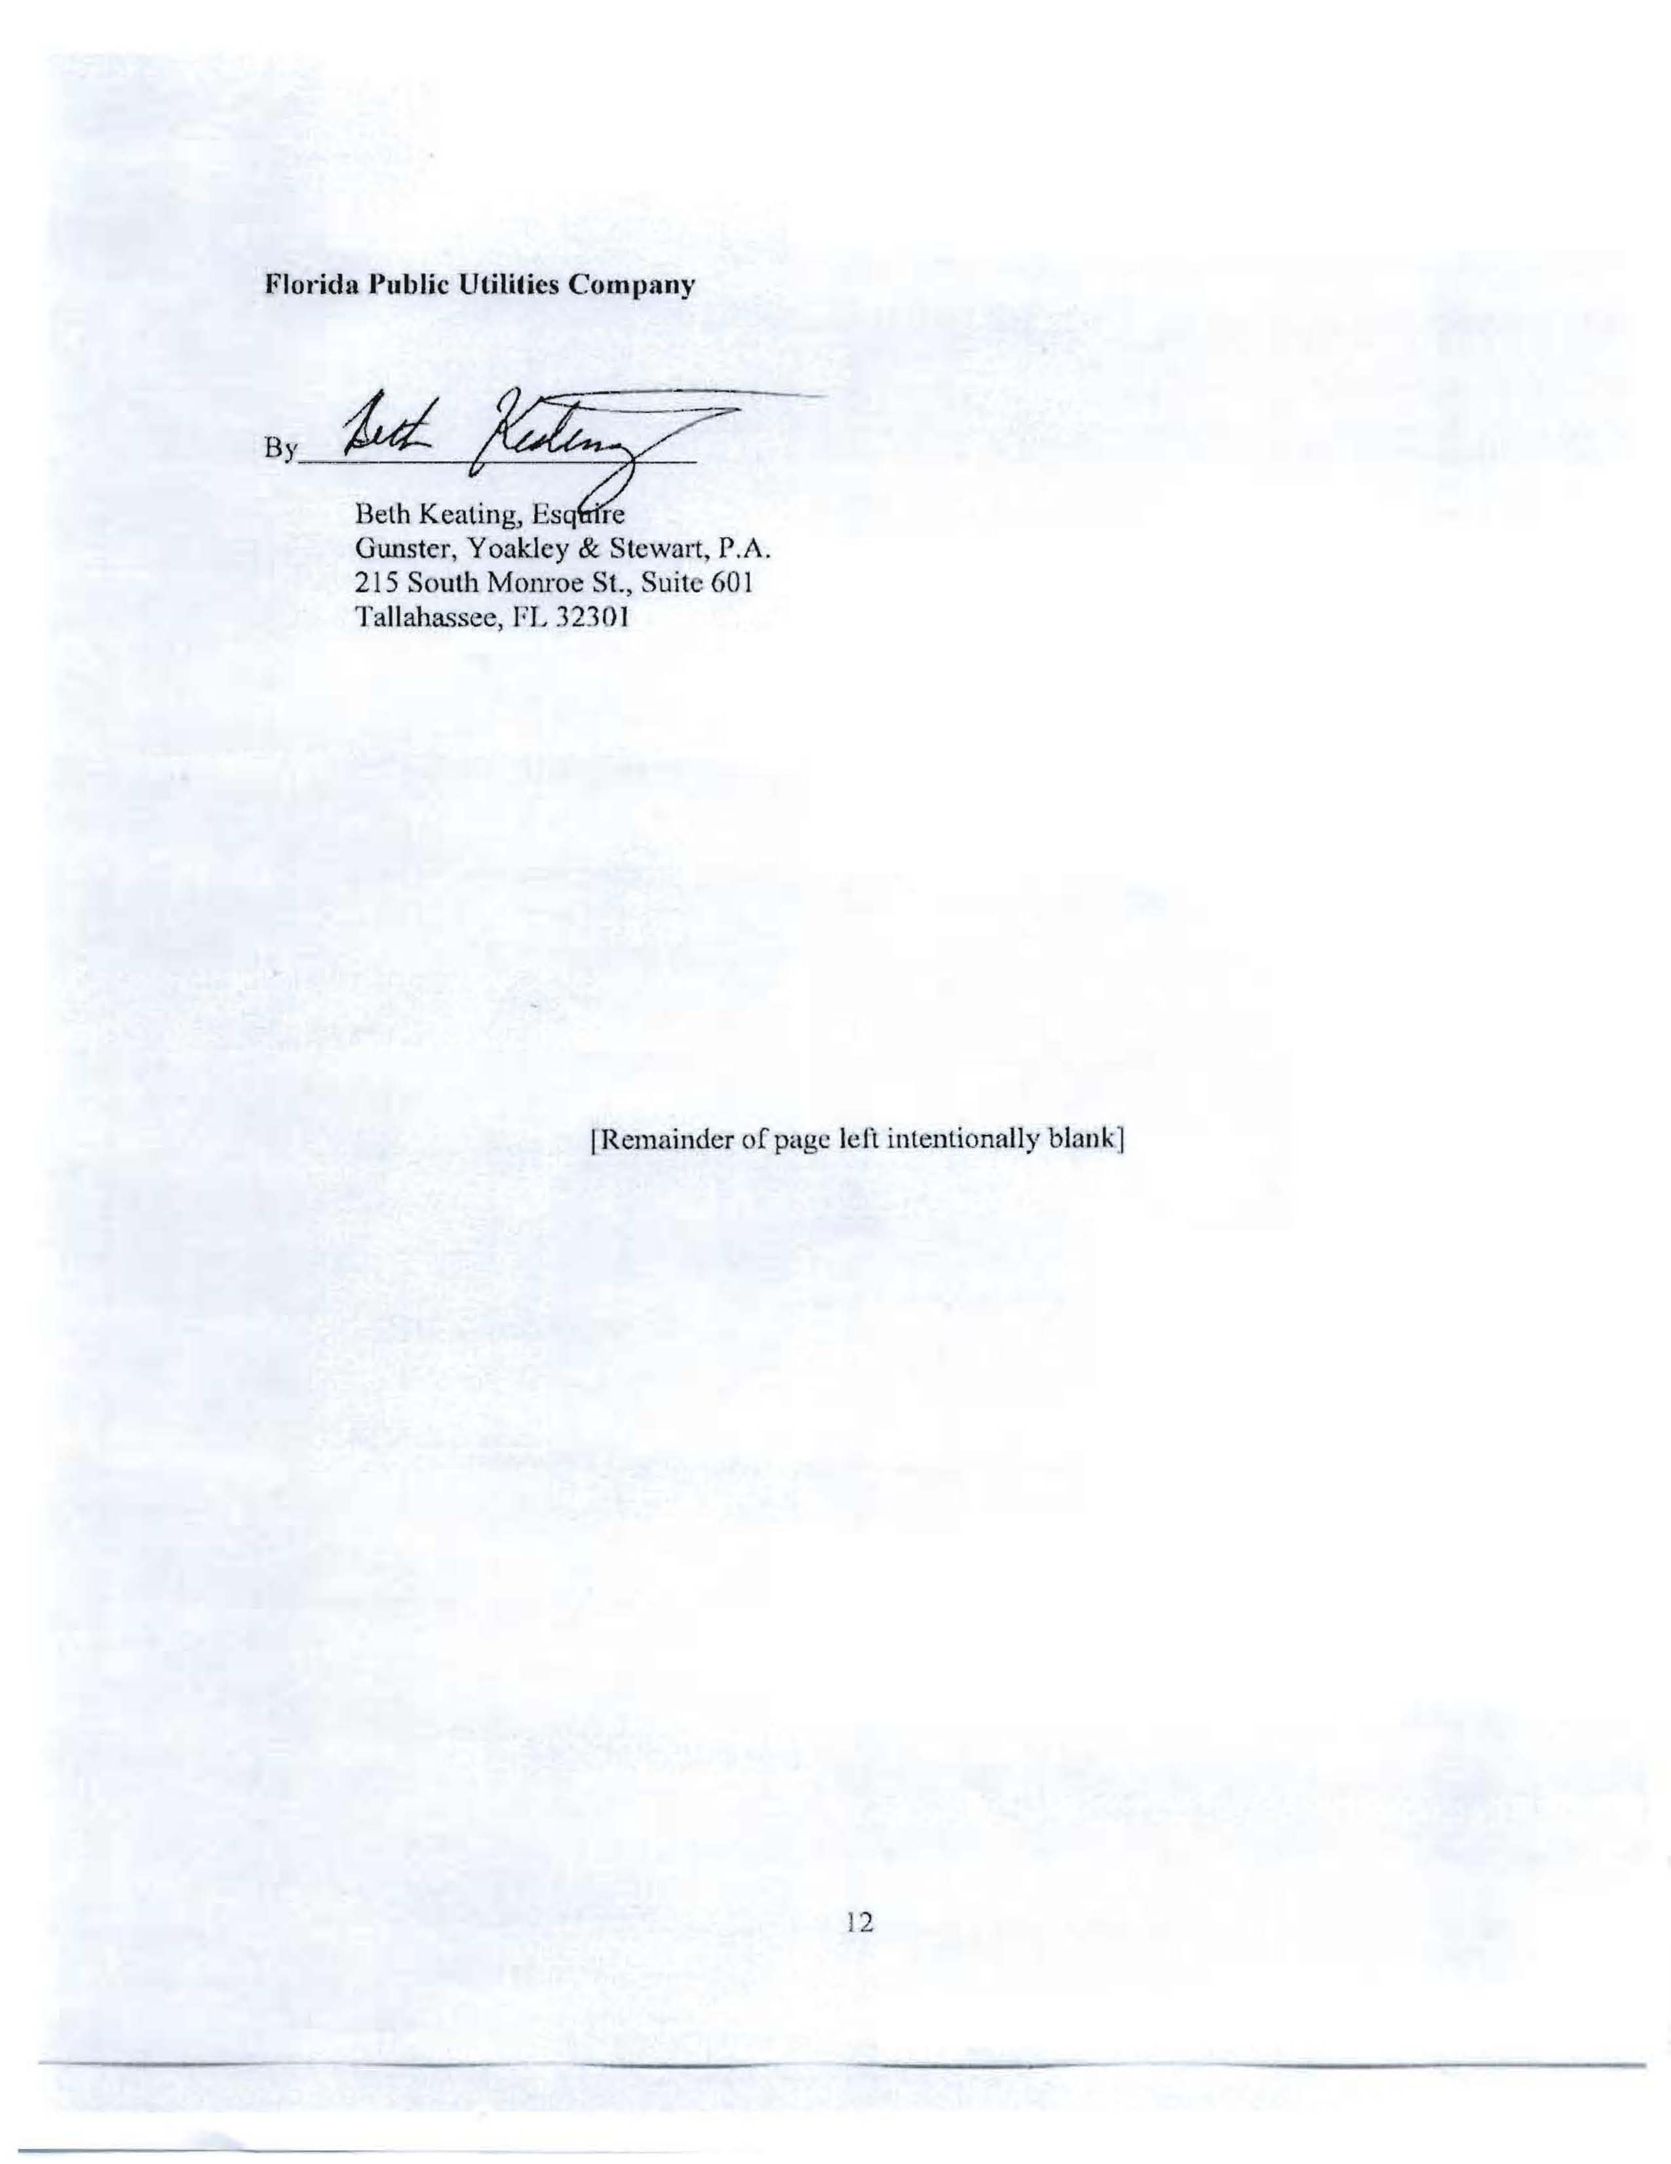
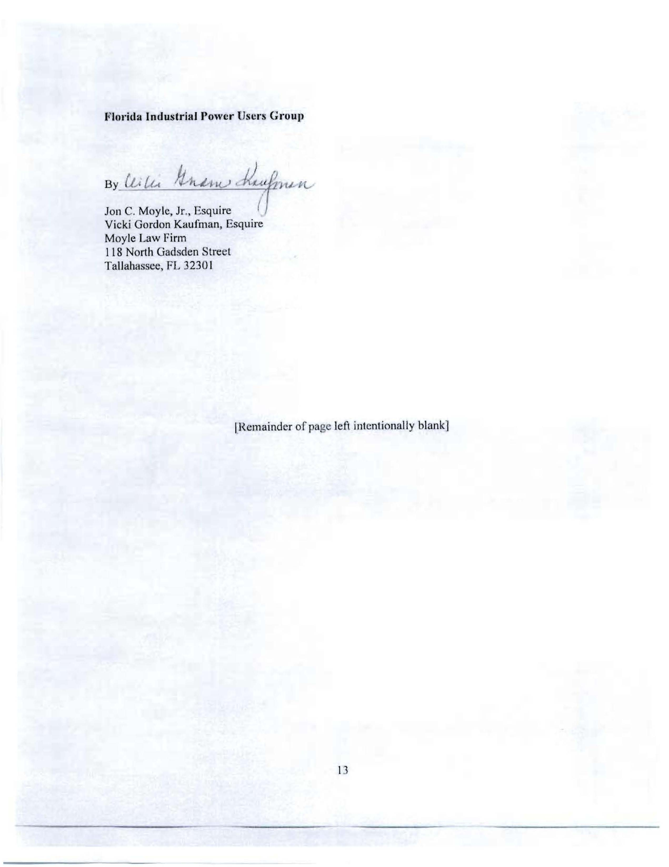
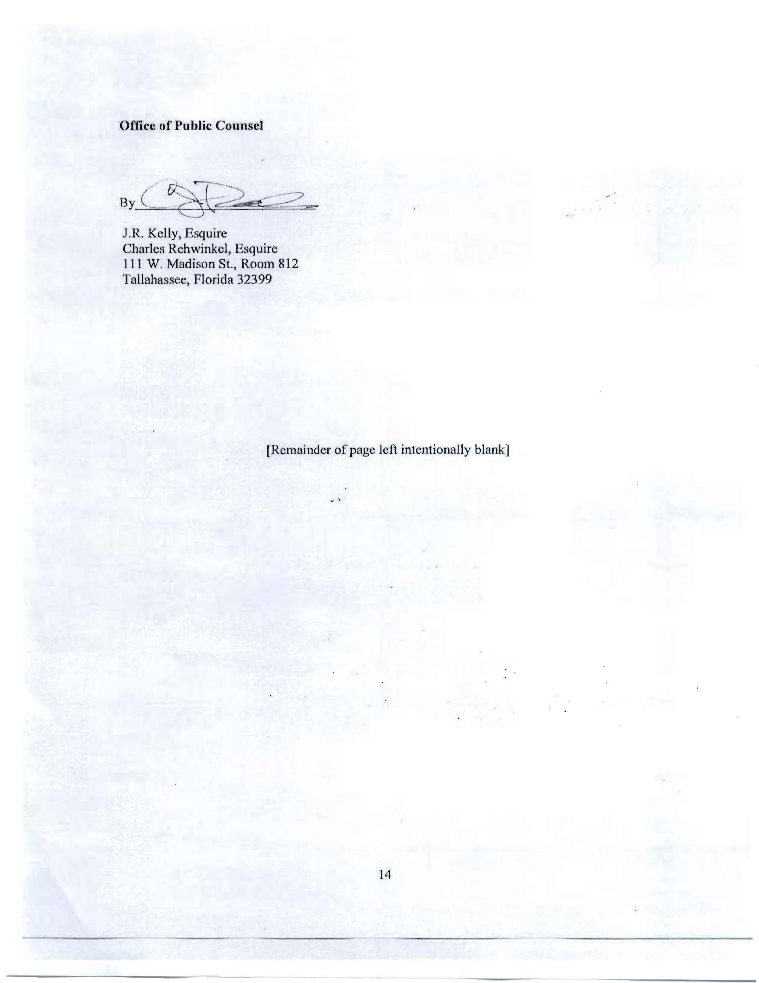
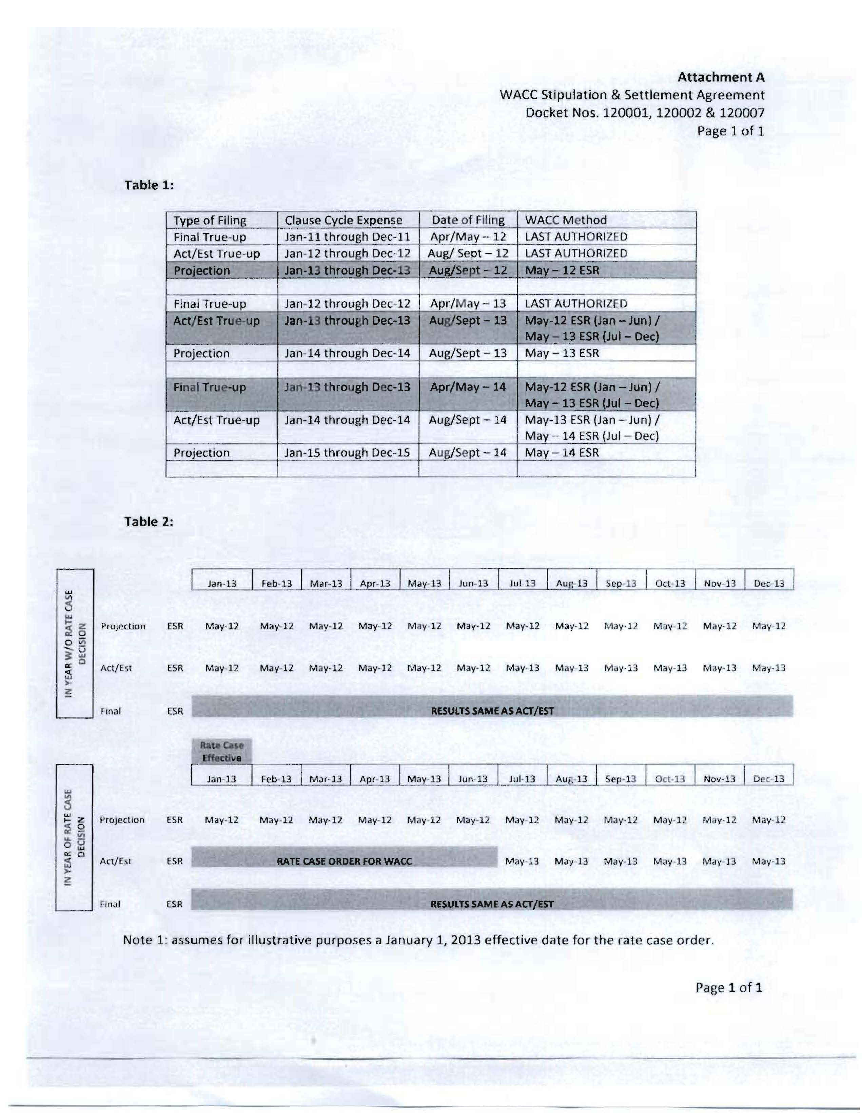

July 17, 2012, the parties filed the Settlement and Stipulation Agreement in Docket Nos. 120001-EI, 120002-EG, and 120007-EI. The signatories are the five electric IOUs, the Office of Public Counsel, Federal Executive Agencies, Florida Industrial Power Users Group, and White Springs Agricultural Chemicals, Inc.
Order No. PSC-94-0044-FOF-EI, issued January 12, 1994, Docket No. 930613-EI, In re: Petition to establish an environmental cost recovery clause pursuant to Section 366.0825, Florida Statutes, by Gulf Power Company.

