State of Florida   |  | Public Service Commission  Capital Circle Office Center ● 2540 Shumard Oak Boulevard  Tallahassee, Florida 32399-0850  -M-E-M-O-R-A-N-D-U-M-
DATE: | April 12, 2013
TO: | Office of Commission Clerk (Cole)
FROM: | Division of Engineering (Brady, L'Amoreaux, Watts)  Division of Accounting and Finance (Cicchetti, Makki, Springer)  Division of Economics (Bruce, Hudson)  Office of the General Counsel (Klancke)
RE: | Docket No. 090459-WS – Application for original certificates for proposed water and wastewater system and request for initial rates and charges in St. Lucie County by Bluefield Utilities, LLC.
AGENDA: | 04/25/13 – Regular Agenda – Proposed Agency Action for Issues 3 – 6 -- Interested Persons May Participate
COMMISSIONERS ASSIGNED: |  |  | All Commissioners
PREHEARING OFFICER: |  |  | Brisé
CRITICAL DATES: |  |  | 05/06/13 (Statutory deadline for original certificate pursuant to Section 367.031, Florida Statutes.)
SPECIAL INSTRUCTIONS: |  |  | None
FILE NAME AND LOCATION: |  |  | S:\PSC\ENG\WP\090459.RCM.DOC

Case Background
On September 25, 2009, Bluefield Utilities, LLC (Bluefield or Utility) filed an application for original water and wastewater certificates and initial rates and charges (application). The Utility is a Florida limited liability company (LLC) ultimately owned by Evans Properties, Inc. (Evans) through a utility subsidiary, Evans Utilities Company, Inc. The proposed territory consists of 10,876 acres, all owned by Evans in St. Lucie County. Bluefield’s service territory is located in the South Florida Water Management District (SFWMD). At buildout, Bluefield proposes to provide service to 1,873 water and 1,853 wastewater equivalent residential connections (ERCs) with 20 existing and proposed structures remaining or being connected to existing septic systems.

On September 11, 2009, shortly before the application in this docket was filed, a separate application was filed in Docket No. 090445-WS for original water and wastewater certificates and initial rates and charges for Grove Land Utilities, LLC (Grove Land), another LLC owned by Evans. In October of 2009, St. Lucie County, Fort Pierce Utilities Authority (FPUA), the City of Port St. Lucie (City), and Martin County filed objections to the application in this docket. Similar objections were received in the Grove Land docket.

On April 5, 2010, the City’s protest to Bluefield’s application was withdrawn. On April 7, 2010, Order No. PSC-10-0224-PCO-WS was issued consolidating the remaining objections in the Grove Land and Bluefield dockets and establishing the procedures for a hearing to be held in February 2011. On April 8, 2010, FPUA’s protest to Bluefield’s application was withdrawn. On December 13, 2010, Order No. PSC-10-0728-PCO-WS was issued granting an emergency stipulated motion for abatement. Continued motions for abatement were granted by orders issued on February 7, March 8, and June 21, 2011. On February 24, 2012, Order No. PSC-12-0083-PCO-WS was issued rescinding the prior order consolidating the Grove Land and Bluefield applications so that Grove Land’s application could proceed to an Agenda Conference, as all objections to that docket had been withdrawn. The Commission subsequently approved Grove Land’s certificates in Order No. PSC-12-0224-PAA-WS. Further continued motions for abatement in this docket were granted on April 25 and October 31, 2012. On October 18, 2012, St. Lucie County withdrew its protest to the application. On December 4, 2012, Martin County filed its notice of withdrawal of its objection, thereby resolving the final outstanding objection to this application.

While the withdrawals filed by the City and St. Lucie County were conditioned upon the Commission’s approval of the settlement agreements executed by these parties and Bluefield, the withdrawals filed by FPUA and Martin County were not conditioned upon Commission approval of the respective settlement agreements. However, Martin County’s withdrawal was conditioned upon the removal of all territory in Martin County from Bluefield’s requested service territory. Moreover, the City’s withdrawal was also conditioned upon the removal of certain territory in St. Lucie County which has been characterized as part of the City’s extended service area.

This recommendation addresses the settlement agreements involved in this proceeding, the granting of water and wastewater certificates, and the establishment of initial rates and charges. The Commission has jurisdiction pursuant to Sections 367.031, 367.045, 367.081, 367.091, 367.101, and 367.171, Florida Statutes (F.S.).
Discussion of Issues
Issue 1:
Should the Commission approve the City of Port St. Lucie and St. Lucie County settlement agreements with Bluefield?
Recommendation:
Yes. The Commission should approve the settlement agreements. If the Commission agrees, then the Commission should address the remaining issues. If the Commission does not approve the settlement agreements, the formal hearing for these protests should be rescheduled. (Klancke, Brady)

Staff Analysis:
As stated in the case background, the City conditioned its April 5, 2010 withdrawal of its protest to Bluefield’s application upon the Commission approving the “Agreement Between Bluefield Utilities, LLC and The City of Port St. Lucie, Florida” (City’s Settlement Agreement) dated March 22, 2010, and appended to this recommendation as Attachment A. Similarly, St. Lucie County conditioned its October 18, 2012 withdrawal upon the Commission approving the “Settlement Agreement Among Bluefield Utilities, LLC, Evans Utilities Company, Inc.[,] Evans Properties, Inc., the St. Lucie County Water and Sewer District, and St. Lucie County, Florida” (St. Lucie County’s Settlement Agreement) dated September 18, 2012 and appended to this recommendation as Attachment B. Because these agreements are similar, staff addresses both settlement agreements below.

The City’s Settlement Agreement specifies that Bluefield agreed to not provide potable water, wastewater or reclaimed water utility service nor place any utility lines within the City’s Service Area as set forth on page 20 of this recommendation. The City’s Settlement Agreement further provides that following the execution of the settlement agreement, Bluefield was required to file the necessary documentation with the Commission to withdraw the properties located within the City’s Service Area from it’s application and deliver copies of the City’s Settlement Agreement to the Commission to be included as a part of the Commission’s approval of the certificates in this proceeding. Since the date of the City’s April 5, 2010 withdrawal of its protest, Bluefield has filed with the Commission the revised maps and legal descriptions for the territory for which the Utility continues to seek certification. The revised service territory sought for certification in this proceeding expressly excludes the properties contained within the City’s Service Area. In addition, as noted above, Bluefield has provided a copy of the City’s Settlement Agreement which has been included as Attachment A to this recommendation.

Notwithstanding the foregoing, the City’s Settlement Agreement further provides that should Evan’s Properties, Inc., and/or any subsidiary thereof, apply to the City of Port St. Lucie Utility Systems Department for potable water and/or wastewater service for a property located within the City’s Service Area owned by Evans Properties and the City refuses or is unable to provide such service, Bluefield reserves the right to serve said property. Staff does not believe there are any objectionable conditions contained within the City’s Settlement Agreement which would warrant the Commission’s disapproval.

St. Lucie County’s Settlement Agreement contained the following three primary provisions whereby the parties would be bound if the Commission ultimately agreed that Bluefield should be granted water and wastewater certificates for the requested area.

Utility Boundaries. Under this provision, Bluefield agreed to not provide or seek to provide domestic utility service outside the boundaries of the service territory sought in this docket (Bluefield’s Utility Territory) without prior written approval from the St. Lucie County Commission. This provision also included the following proviso:

This paragraph shall not prohibit Bluefield from, (a) providing surface water retention and/or cleansing services that would require Bluefield to take surface water from outside of Bluefield’s Utility Territory…, (b) selling water retention or cleansing services or credits to customers outside of Bluefield’s Utility Territory, or (c) selling bulk potable or non-potable water to the City of Port St. Lucie or the Fort Pierce Utility Authority, or any other customers not located within the District’s utility service area . . . .

Staff notes the Commission has determined that pursuant to Section 367.045(5)(a), F.S., it “may not grant authority greater than that requested in the application . . . .” Further, the above provision does not deprive or give up any jurisdiction of the Commission. Staff notes that pursuant to Section 367.022(12), F.S., bulk sales to a governmental authority are exempt from the Commission’s regulation. Further, for jurisdictional sales, staff notes that pursuant to Sections 367.021 and 367.045(2), F.S., a utility may not provide service outside its certificated territory. Staff does not believe there are any objectionable conditions in this provision which would warrant the Commission’s disapproval.

County Review. This provision underscores St. Lucie County’s right to review and approve the engineering plans for any water or wastewater plant to be constructed within Bluefield’s Utility Territory. The provision specifically notes that such review shall not be unreasonably withheld, and that approval or comments will be provided within 45 days of submission. Again, staff can discern no conditions which would warrant the Commission’s disapproval.

Preemption by Public Service Commission. This provision specifically identifies services that may be rendered by Bluefield which would not come under St. Lucie County’s Settlement Agreement, such as (a) serving biofuel, energy, or alternative energy production, (b) providing agriculture or surface water cleansing and retention services, and (c) delivering potable and non-potable bulk water services to customers not located in the District’s utility service area. Further, the provision notes Bluefield would be permitted to provide the specifically identified services “pursuant to applicable regulation by the FPSC and/or the FDEP.” As with the prior two provisions, staff can discern no conditions which would warrant the Commission’s disapproval.

The parties, after extensive negotiations, filed the above referenced settlement agreements to avoid the time and expense of further litigation. Staff recommends the Commission should accept the parties’ settlement agreements as a reasonable resolution of this matter. These settlement agreements will result in withdrawal of objections to the certificate application of Bluefield and will avert the need for a hearing. Further, if any of the above-cited provisions of the settlement agreements could be said to bind the Commission’s authority to act in this docket, staff notes the provisions would be unenforceable against the Commission. The Commission has approved similar agreements in the past where it has determined that the parties could not bind the Commission’s authority. By Order No. PSC-99-0635-FOF-WU, issued on April 5, 1999, in Docket No. 960444-WU, In re: Application for Rate Increase and Increase in Service Availability Charges in Lake County by Lake Utility Services, Inc., the Commission approved a settlement agreement between the Utility and the Office of Public Counsel which purported to bind the Commission from instituting future proceedings to change the Utility’s rates and charges set forth in the settlement agreement. In approving the parties’ settlement agreement, the Commission noted at page six that “the specific provisions were . . . ‘not fatal flaws; they are simply unenforceable against the Commission and are void ab initio. The parties cannot give away or obtain that for which they have no authority.” Similarly, staff believes to the extent these settlement agreements may contain unenforceable language, it is still appropriate to approve the settlement agreement.

In conclusion, staff notes the Commission has always favored settlement agreements and staff recommends that the settlement agreements executed between Bluefield, the City, and St. Lucie County are reasonable resolutions to the controversy, are in the public interest, and should be approved. If the Commission agrees, then the Commission should address the remaining issues contained in this recommendation. Because withdrawal of the City’s and St. Lucie County’s protests are contingent upon approval of these settlement agreements, if the Commission does not approve the settlement agreements, the formal hearing for these protests should be rescheduled.

Issue 2:0
Should the application for original water and wastewater certificates by Bluefield Utilities, LLC be approved?
Recommendation:
Yes. Bluefield should be granted Certificate Nos. 660-W and 566-S to serve the territory described in Attachment C, effective the date of the Commission’s vote. The resultant order should serve as the Utility’s water and wastewater certificates and it should be retained by the Utility. Bluefield should be required to file executed copies of its water and wastewater lease agreements, containing legal descriptions of the water and wastewater treatment sites, within 30 days after the date of the order granting the certificates. (Brady, Cicchetti, L'Amoreaux, Makki, Springer, Watts, Klancke)
Staff Analysis:
On September 25, 2009, Bluefield filed an application for original certificates to provide water and wastewater services in Martin and St. Lucie Counties. The application contains proof of compliance with the noticing provisions set forth in Rule 25-30.030, Florida Administrative Code (F.A.C.). As noted, the application was protested by several governmental entities, all of which have subsequently withdrawn their objections, with the last objection withdrawn on December 4, 2012.
By letter dated January 3, 2013, staff notified Bluefield of updated information needed for the application to be deemed complete. The Utility’s response was filed on February 6, 2013. As such, the application is in compliance with the governing statute, Section 367.045, F.S., and other pertinent statutes and administrative rules concerning an application for original certificates. Therefore, pursuant to the statutory deadline for original certificates in Section 367.031, F.S., the application must be ruled upon by May 6, 2013.
Territory. In its February 6th filing, the Utility confirmed that the Martin County properties and three parcels in St. Lucie County should be removed from the territory sought in the application. For the remaining St. Lucie County properties, the application contains adequate service territory and system maps, along with a modified territory description, as prescribed by Rule 25-30.033(1)(l),(m), and (n), F.A.C. A description of Bluefield’s water and wastewater territory is appended to this recommendation as Attachment C.
Proof of Ownership. Pursuant to Rule 25-30.033(1)(j), F.A.C., the application contains proposed water and wastewater lease agreements provided as proof that the Utility will have long-term access to the land upon which the water and wastewater treatment facilities will be located. As noted, all the land is owned by Bluefield’s parent, Evans, which intends to lease the land under the proposed treatment plant sites to Bluefield, should certificates be granted. The lease agreements are for the initial term of twenty years and provide for automatic renewals after the initial term without the necessity for the execution of any further instruments. The renewals will be in increments of 10 years, up to a maximum of 99 years. Staff believes the leases provide proof that the Utility will have long-term access to the land upon which the water and wastewater treatment facilities will be located. Staff recommends the Utility be required to file executed copies of its water and wastewater lease agreements, containing legal descriptions of the water and wastewater treatment sites, within 30 days after the date of the order granting the certificates, pursuant to Rule 25-30.033(1)(j), F.A.C. It should be noted that acceptance of the leases as proof of long-term access to the land under the treatment facilities is not a determination as to the prudence of the costs of the leases.
Financial and Technical Ability. Rule 25-30.033(1)(e), (r), and (s), F.A.C., requires a statement showing the financial and technical ability of the applicant to provide service, a detailed financial statement, and a list of all entities upon which the applicant is relying to provide funding along with those entities’ financial statements. Since Bluefield has not been authorized by the Commission to provide service for compensation, it is relying upon the financial backing of its parent and landowner, Evans. The Commission has traditionally allowed reliance on the parent’s financial ability in similar situations. The Commission’s reasoning has been the logical vested interest of a parent in the financial stability of its subsidiary. The application contains Evans’ most recent financial statement as well as a funding agreement between Evans and Bluefield, whereby Evans agrees to provide reasonable and necessary funding to the Utility to build and operate the utility systems in St. Lucie County. The application indicates Evans owns and controls 43,000 acres of real property in Florida, free and clear of debt, on which it conducts substantial commercial activities. In addition, Evans has conducted continuous and successful business operations in Florida for over fifty years. Staff believes Evans’ financial statement and continuous business operations in Florida show adequate and stable funding reserves for the Utility. Therefore, staff recommends that Bluefield has demonstrated it will have access to adequate financial resources to operate the Utility.
With respect to technical ability, the application indicates Bluefield’s intent to retain the best people to design the facilities, work with state and local governments in the permitting and construction of the facilities and to operate the facilities thereafter. With regard to permits, Bluefield intends to acquire a consumptive use permit from the SFWMD for any new wells it drills in addition to acquiring the capacity of any existing wells it purchases from Evans in St. Lucie County. Due to the resources Bluefield expended during the organizational phase of the certificate process, the financial resources pledged by its parent, as well as the parent’s prior experience in utilizing water resources for citrus production, staff recommends that Bluefield has demonstrated it will have access to adequate technical resources to operate the Utility.
Need for Service. Rule 25-30.033(1)(e), F.A.C., also requires a showing of the need for service in the proposed area to be served, the identity of any other utilities within the proposed area that could potentially provide service, and the steps the applicant took to ascertain whether such other service is available. The proposed service area consists of two separate areas of land in St. Lucie County totaling 10,876 acres previously used for citrus production by Evans. According to the application, Evans remains actively engaged in an ongoing effort to transition its properties from exclusively agricultural to a more varied and adaptable posture. The application further notes this transition occurs during the waning of Florida’s citrus industry, a significant overhaul in the state’s growth management laws, and an increasing interest in the formation of public and private partnerships due to the ebb and flow of state and federal monies available to assist in water harnessing and wastewater treatment and disposal projects.
Projects under consideration for Bluefield by Evans include residential and commercial development; projects in coordination with the water management districts or other state agencies; innovative wastewater services upon the implementation of new nutrient standards; assisting in the funding of gaps currently being experienced by local governments by providing property and infrastructure for water retention and cleansing; production of biofuels; and provision of service housing for onsite workers. The original application indicated there are no central potable water or wastewater services in the area, nor any other utility capable of providing the necessary level of service. In addition, since Bluefield’s parent owns all the land in its proposed service territory, Bluefield believes it would be in the best position to provide water and wastewater services from its properties in the most efficient and cost-effective manner.
Copies of letters supporting Bluefield’s application were provided by the Department of Agriculture and Consumer Services (Department of Agriculture) and SFWMD. The Department of Agriculture, acknowledging the unprecedented challenges facing citrus growers due to the impacts of citrus greening and canker as well as poor market conditions and global competition, supported Evans’ efforts to diversify its business activities. SFWMD expressed its support for the public-private partnership proposed by Evans for Grove Land and Bluefield to capture excess water currently being discharged into Indian River Lagoon’s estuarine system by constructing a reservoir and stormwater treatment area located on Evans’ Grove Land properties. The reservoir is intended to reduce damaging tidal discharges into the Indian River Lagoon and improve the health of the St. Lucie River and estuary while also providing a significant new source of water. Since certification last year, Grove Land has obtained grant funding from the St. Lucie River Issues Team, SFWMD, and the St. Johns River Water Management District to pursue the financial feasibility of constructing the Grove Land reservoir, stormwater treatment area, and associated infrastructure and a Request for Proposals has been issued. Evans believes that a demonstration of the feasibility of these projects for Grove Land will create a similar opportunity for Bluefield. Staff recommends that Bluefield has provided a demonstration of need consistent with prior Commission decisions.
Comprehensive Plan Consistency. Rule 25-30.033(1)(f), F.A.C., requires a statement that, to the best of the applicant’s knowledge, the provision of service will be consistent with the water and wastewater sections of the local comprehensive plan as approved by the Department of Community Affairs (DCA) at the time the application is filed. Bluefield’s application contains such a statement and the proposed ERCs through buildout of Phase IV are consistent with the allowed densities in the Future Land Use Maps of St. Lucie County. While the DCA originally objected to the application, in a letter dated July 14, 2011, it stated it no longer had any objections to the application given its newly created role which leaves local governments with the primary role of commenting on comprehensive plan consistency. Further, St. Lucie County’s objections to the application, in part based on comprehensive plan issues, have been withdrawn. Therefore, staff recommends that Bluefield has demonstrated that the provision of potable water and wastewater services will be consistent with the local comprehensive plans.
Facilities Design. Rule 25-30.033(1)(g), (h), and (i), F.A.C., requires a description of when the applicant proposes to begin service, the number of ERCs proposed to be served, and the types of customers. Bluefield proposes to provide potable water and wastewater services in four phases. Construction for Phase I is intended to begin as soon as practicable after certification and be completed within seven years, with 80 percent buildout in year seven. In Phase I, potable water service will be provided to 261 ERCs and wastewater to 241 ERCs, with 20 existing structures and proposed structures utilizing on-site septic systems. At buildout of Phase IV in 2025, the Utility proposes to serve 1,873 potable water and 1,853 wastewater ERCs. Proposed initial rates and charges are based on residential and general service customers served by 5/8” x 3/4” meters at 80 percent of Phase I development.
Rule 25-30.033(1)(o), (p), and (q), F.A.C., requires statements regarding the proposed capacities of lines and plant, types of treatment provided, and whether effluent disposal by means of reuse will be utilized. The total proposed water system capacity for Phase I lines and plant is 91,350 gallons per day (GPD). Water will be produced from one new well and four existing wells varying in size from 3” to 12.” The existing wells will be agricultural wells purchased from Evans and improved by flushing and disinfecting the piping and valves and then elevating and sealing the well-head pads. The wells will be connected to four water treatment plants each having 500 gallon hypochlorinators and 3,000 gallon storage tanks. The total proposed wastewater system capacity for Phase I lines and plant is 65,070 GPD, which will be provided by four pre-engineered wastewater treatment plants varying in size form 10,000 GPD to 25,000 GPD. Treatment will be by extended aeration and will include a nitrogen removal process with effluent disposal to percolation ponds. According to the application, the provision of reuse for effluent disposal is not financially feasible in Phase I, but will be considered for future phases.
Regulatory Requirements. Bluefield has indicated its intent to comport with the National Association of Regulatory Utility Commissioners’ Uniform System of Accounts. In addition, Bluefield has indicated it is aware that it may not change its rates or charges, add new services, serve outside its certificated territory, or sell the Utility without prior Commission approval.
Conclusion. Based on all the above, staff recommends it is in the public interest to grant Bluefield Utilities, LLC Certificate Nos. 660-W and 566-S to serve the territory described in Attachment C, effective the date of the Commission’s vote. The resultant order should serve as the Utility’s water and wastewater certificates and it should be retained by the Utility. Bluefield should be required to file executed copies of its water and wastewater lease agreements, containing legal descriptions of the water and wastewater treatment sites, within 30 days after the date of the order granting the certificates.

Issue 3:
What are the appropriate potable water and wastewater rates and return on investment for Bluefield Utilities, LLC?
Recommendation:
Bluefield’s potable water and wastewater rates shown on Schedule Nos. 1 and 2, respectively, are reasonable and should be approved. The approved rates should be effective for services rendered on or after the stamped approval date on the tariff sheets, pursuant to Rule 25-30.475, F.A.C. Bluefield should be required to charge the approved rates until authorized to change them by the Commission in a subsequent proceeding. A return on equity of 11.16 percent plus or minus 100 basis points should also be approved. (Brady, Bruce, Hudson, Klancke)
Staff Analysis:
Rule 25-30.033(1)(t), (u), (v), and (w), F.A.C., specifies the requirements for establishing rates and charges for original certificates, including submission of a cost study, growth projections, and data related to the projected plant, capital structure, and operating expenses. As noted, Bluefield’s proposed water and wastewater rates are based on 80 percent of Phase I capacity, which is consistent with Commission policy for setting initial rates and charges. Bluefield anticipates that 80 percent of Phase I design capacity will occur seven years after the initiation of construction. The water and wastewater facilities are conceptually designed to be in accordance with the local comprehensive plan’s density restrictions. As such, water and wastewater ERCs at 80 percent buildout of Phase I are anticipated to be 248 and 228, respectively. Water and wastewater usage per ERC is estimated at 350 GPD and 270 GPD, respectively.
Projected Rate Base. Consistent with Commission practice in applications for original certificates, projected rate base is established only as a tool to aid the Commission in setting initial rates and is not intended to formally establish rate base. Bluefield’s projected rate base calculations are shown on Schedule No. 1 for water service and Schedule No. 2 for wastewater service.
The Utility’s projected water and wastewater utility plant in service and contributions in aid of construction (CIAC) are consistent with 80 percent of design capacity for the described facilities. Accumulated depreciation and amortization of CIAC are based on the average service lives guidelines, as set forth in Rule 25-30.140, F.A.C. Working capital is based on one-eighth of the operating and maintenance expense for each service. Staff recommends that Bluefield’s proposed rate base calculations of $491,826 for water service and $637,515 for wastewater service shown on Schedule Nos. 1 and 2, respectively, are reasonable and should be approved.
Cost of Capital. Bluefield’s projected capital structure consists of 40 percent equity and 60 percent debt. The Utility’s proposed cost of equity of 11.16 percent is consistent with the Commission’s most recent leverage graph formula, and its proposed cost of debt of 5.87 percent is based on the 10-year average prime rate plus 1 percent. Staff recommends that the Utility’s cost of equity and debt are reasonable. These costs result in an overall cost of capital of 7.98 percent as shown on the following chart.
Cost of Capital
Description | Amount | Weight | Cost Rate | Weighted Cost
Common Equity | $ 451,737 | 40% | 11.16% | 4.46%
Long and Short-Term Debt | $ 677,605 | 60% | 5.87% | 3.52%
Overall Cost of Capital | $1,129,342 | 100% |  | 7.98%
Range of Reasonableness |  |  | High | Low
Return on Common Equity |  |  | 12.16% | 10.16%
Based on these calculations, staff recommends the appropriate return on equity for Bluefield is 11.16 percent, plus or minus 100 basis points, and the Utility’s initial rates should reflect an overall cost of capital of 7.98 percent.
Net Operating Income. The projected net operating incomes for potable water and wastewater services are shown on Schedule Nos. 1 and 2, respectively. They are based on the projected rate base for each system and the projected overall cost of capital of 7.98 percent. The resulting net operating incomes for potable water and wastewater services are $39,248 and $50,874, respectively.
Revenue Requirements. The calculations for Bluefield’s projected water and wastewater revenue requirements are also shown on Schedule Nos. 1 and 2, respectively. The revenues include operating and maintenance expenses, depreciation and amortization expenses, taxes other than income, as well as the above return on investment. The Utility’s proposed operating and maintenance expenses appear reasonable and net depreciation and amortization expenses are consistent with the guidelines in Rule 25-30.140, F.A.C. As a limited liability company, Bluefield has no income tax expense. Taxes other than income tax are based on regulatory assessments fee of 4.5 percent of the Utility’s gross revenues. Staff recommends that Bluefield’s revenue requirements for potable water and wastewater services of $146,792 and $173,030, respectively, are reasonable and should be approved.
Rates and Rate Structure. Bluefield has structured its rates in accordance with Rule 25-30.033(2), F.A.C., which requires that a base facility and usage rate structure, as defined in Rule 25-30.437(6), F.A.C., be utilized for metered service. Bluefield’s proposed potable water rates shown on Schedule No. 1 consist of a base facility charge of $19.70 and a usage charge per 1,000 gallons of $2.78. Proposed wastewater rates shown on Schedule No. 2 consist of a base facility charge of $25.26 and a usage charge per 1,000 gallons of $4.73, with a maximum usage cap of 8,000 gallons for residential service. Staff recommends that Bluefield’s proposed rates are reasonable and its rate structure is consistent with Commission rules.
Conclusion. Based upon the above, staff recommends that Bluefield’s potable water and wastewater rates shown on Schedule Nos. 1 and 2, respectively, are reasonable and should be approved. The approved rates should be effective for services rendered on or after the stamped approval date on the tariff sheets, pursuant to Rule 25-30.475, F.A.C. Bluefield should be required to charge the approved rates until authorized to change them by the Commission in a subsequent proceeding. A return on equity of 11.16 percent plus or minus 100 basis points should also be approved.
Issue 4:
What are the appropriate water and wastewater service availability policy and charges for Bluefield Utilities, LLC?
Recommendation:
Bluefield’s proposed service availability policy and charges shown on Schedule Nos. 1 and 2 should be approved. The approved charges should be effective for connections made on or after the stamped approval date on the tariff sheets, pursuant to Rule 25-30.475, F.A.C. Bluefield should be required to collect its approved service availability charges until authorized to change them by the Commission in a subsequent proceeding. (Bruce, Hudson, Klancke)
Staff Analysis:
Pursuant to Rule 25-30.580(1), F.A.C., the maximum amount of CIAC, net of amortization, should not exceed 75 percent of the total original cost, net of depreciation, of the utility’s facilities and plant when the facilities and plant are at their designed capacity. Rule 25-30.580(2), F.A.C., provides that the minimum amount of CIAC should not be less than the percentage of such facilities and plant that is represented by water transmission and distribution and sewage collection systems.

Bluefield’s water and wastewater service availability policy requires developers to construct and convey all on-site distribution and off-site transmission facilities. At the Utility’s option, where facilities are required to serve more than one developer, the first developer may be required to construct oversized facilities. In that event, subsequent developers, builders, and individuals who connect to those facilities, or use those facilities, may be required to pay their prorata share of the costs of the facilities, which will be refunded to the developer who constructed the facilities. Bluefield’s proposed water and wastewater service availability charges shown on Schedule Nos. 1 and 2 include meter installation charges, as well as main extension and plant capacity charges. Bluefield’s proposed service availability charges result in net contribution levels of 62 percent for water and 64 percent for wastewater, consistent with the guidelines in Commission rules.
Staff recommends that Bluefield’s proposed service availability policy and charges shown on Schedule Nos. 1 and 2 should be approved. The approved charges should be effective for connections made on or after the stamped approval date on the tariff sheets, pursuant to Rule 25-30.475, F.A.C. Bluefield should be required to collect the approved charges until authorized to change them by the Commission in a subsequent proceeding.

Issue 5:
Should Bluefield Utilities, LLC's proposed miscellaneous service charges be approved?
Recommendation:
Yes. Bluefield’s proposed miscellaneous service charges should be approved and effective for services rendered or connections made on or after the stamped approval date on the tariff sheets, pursuant to Rule 25-30.475, F.A.C. Bluefield should be required to charge its approved miscellaneous service charges until authorized to change them by the Commission in a subsequent proceeding. (Bruce, Hudson, Klancke)
Staff Analysis:
Rule 25-30.460, F.A.C., defines the categories of miscellaneous service charges. The purpose of these charges is to place the burden for requesting or causing these services on the cost causer, rather than the general body of ratepayers. Bluefield’s proposed charges for the four categories of miscellaneous service are shown on the table below.
Miscellaneous Service Charges
Description | Water Service | Wastewater Service
Initial Connection | $15.00 | $15.00
Normal Reconnection | $15.00 | $15.00
Violation Reconnection | $15.00 | Actual Cost
Premise Visit Charge | $15.00 | $15.00
Since the Utility has not yet begun service, Bluefield’s proposed charges are based on estimated expenses; however, similar charges have been approved by the Commission. When both water and wastewater services are provided, a single charge is appropriate unless circumstances beyond the control of the Utility require multiple actions.
Staff recommends that Bluefield’s proposed miscellaneous service charges should be approved and effective for services rendered or connections made on or after the stamped approval date on the tariff sheets, pursuant to Rule 25-30.475, F.A.C. Bluefield should be required to charge its approved miscellaneous service charges until authorized to change them by the Commission in a subsequent proceeding.

Issue 6:
What is the appropriate Allowance for Funds Used During Construction (AFUDC) rate for Bluefield Utilities, LLC?
Recommendation:
An annual AFUDC rate of 7.980 percent and a discounted monthly rate of 0.64184974 percent should be approved and applied to the qualified construction projects beginning on or after the date the certificates of authorization are issued. (Brady)
Staff Analysis:
Rule 25-30.033(4), F.A.C., authorizes utilities obtaining initial certificates to accrue an annual allowance for projects found eligible pursuant to Rule 25-30.116(1), F.A.C. This allows the utility to earn compensation for capital costs incurred during construction, but ratepayers are not required to pay for those capital costs until the plant is actually in service and considered used and useful. For purposes of establishing an AFUDC rate, the utility’s overall cost of capital is used. Therefore, staff recommends that an AFUDC rate of 7.980 percent, with a discounted monthly rate of 0.64184974 percent, be approved and applied to qualified construction projects beginning on or after the date the Commission vote on certificates of authorization.

Issue 7:
Should this docket be closed?
Recommendation:
No. The certification portion of this recommendation will become final agency action upon the Commission's vote. The docket should remain open pending receipt of executed copies of Bluefield’s water and wastewater lease agreements, containing legal descriptions of the water and wastewater treatment sites. If no timely protest to the proposed agency action portion of this recommendation with respect to initial rates and charges is filed with the Commission by a substantially affected person, a Consummating Order should be issued. Following the expiration of the protest period with no timely protest, the issuance of a Consummating Order, and the Utility’s submission of the lease agreements, the docket should be closed administratively. (Klancke)
Staff Analysis:
The certification portion of this recommendation will become a final agency action upon the Commission's vote. The docket should remain open pending receipt of executed copies of Bluefield’s water and wastewater lease agreements, containing legal descriptions of the water and wastewater treatment sites. If no timely protest to the proposed agency action portion of this recommendation with respect to initial rates and charges is filed with the Commission by a substantially affected person, a Consummating Order should be issued. Following the expiration of the protest period with no timely protest, the issuance of a Consummating Order, and the Utility’s submission of the lease agreements, the docket should be closed administratively.

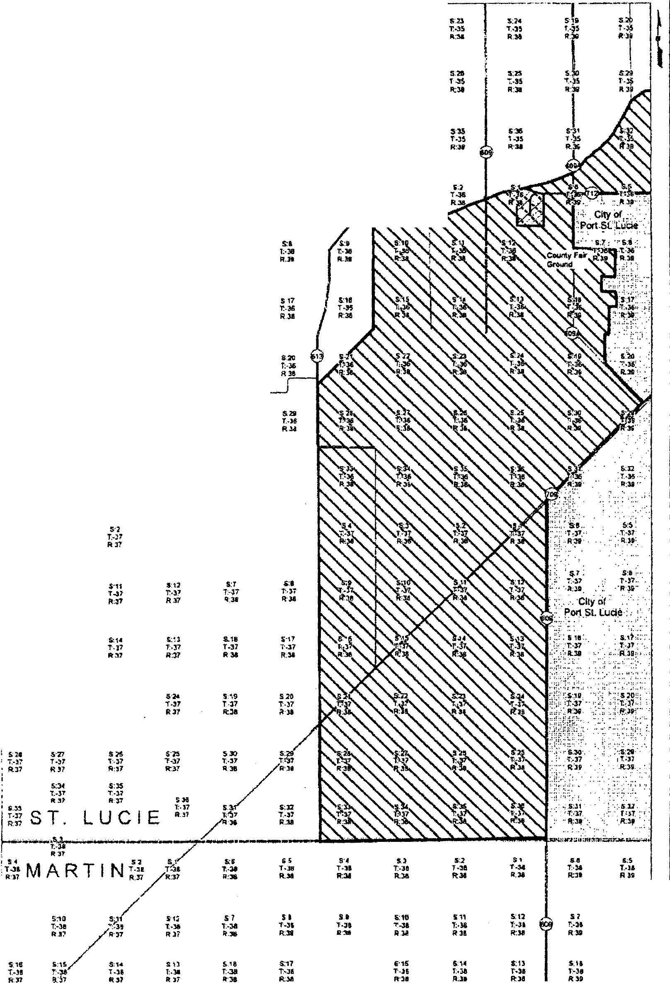


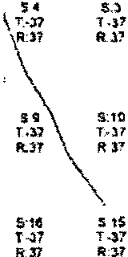


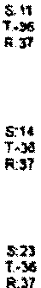




A BLUEFIELD UTILillES 301 E- Pine St.S!.*'le 1020, Orlinda, Fl :12101

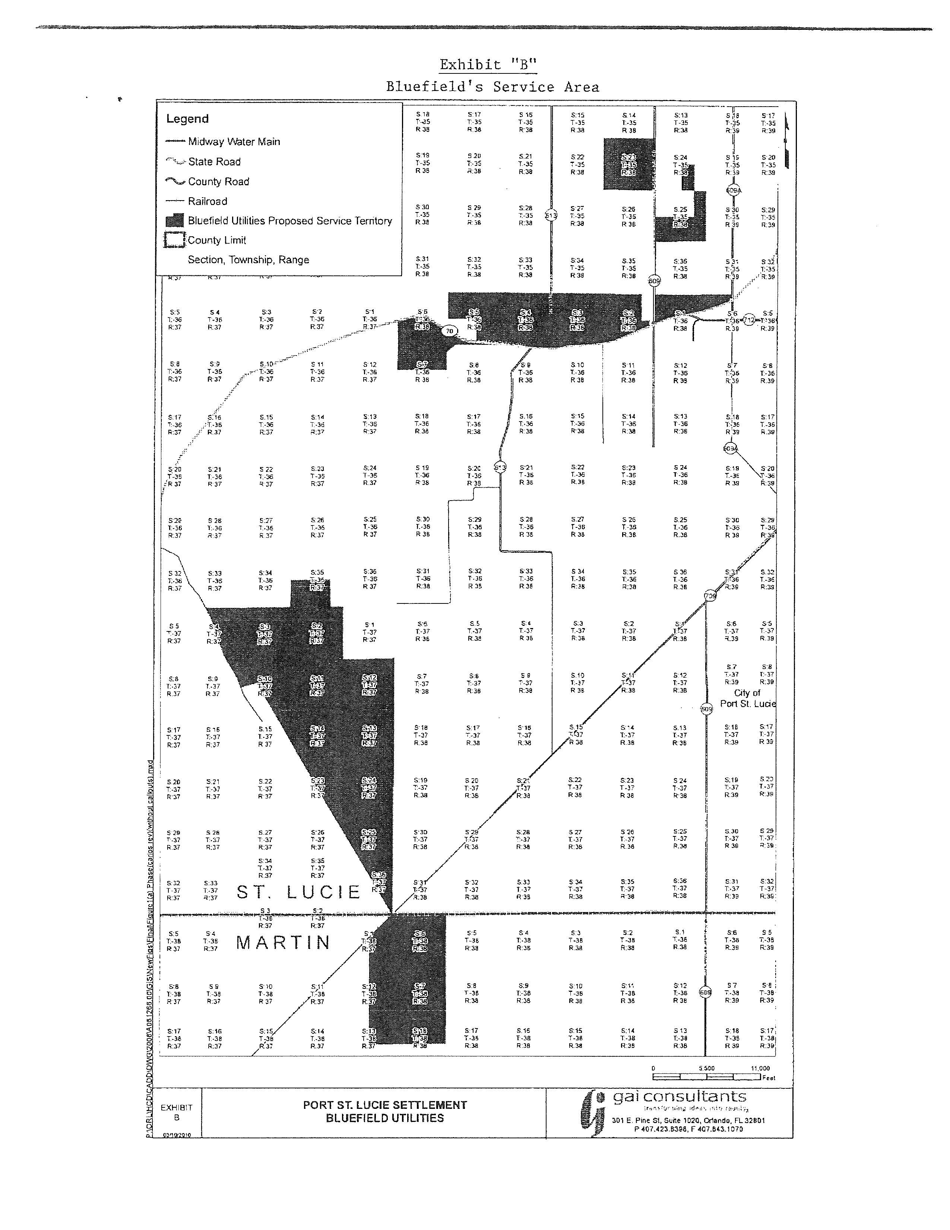

Bluefield Utilities, LLC
Description of Water and Wastewater
in St. Lucie Counties

DESCRIPTON ID Parcel 1
Township 36 South, Range 38 East
Section 1
Township 36 South, Range 39 East
Section 6

That part of the NE 1/4 of Section 1, Township 36 South, Range 38 East, LESS the North 48 feet; AND that part of the NW 1/4 of Section 6, Township 36 South, Range 39 East, LESS the following described land: Begin at the intersection of the North right-of-way line of State Road 70 (Okeechobee Road) and the West right-of-way line of County Road 609A; thence North a distance of 250.19 feet; thence S 65° W a distance of 208.71 feet; thence South a distance of 250.19 feet; thence N 65° E a distance of 208.71 feet to the Point of Beginning. TOGETHER WITH that part of the West 1/2 of Section 1, Township 36 South, Range 38 East, LESS the canal right of way. All land lying North of State Road 70 (Okeechobee Rd) and its associated widening to date in St. Lucie County.

DESCRIPTION ID Parcels 2, 8 &15
Township 37 South, Range 37 East
Sections 2-4, 9-15, 23-26 & 36
Township 36 South, Range 37 East
Section 35

Section 2 LESS the North 125 feet AND all of Section 3 LESS the North 125 feet AND that portion of Sections 4 & 9 lying East of the following described line: Commence at the South line of the North 100 feet of said Section 4; thence run West a distance of 3,500 feet to the Point of Beginning; thence S 28° E a distance of 1,550 feet; thence S 14° E a distance of 950 feet; thence S 20° E a distance of 1,700 feet; thence S 23° E a distance of 600 feet; thence S 20° E a distance of 550 feet; thence S 30° E a distance of 2,550 feet; thence S 21° E a distance of 400 feet to the East line of said Section 9 all lying in Township 37 South, Range 37 East in St. Lucie County, Florida. TOGETHER WITH portions of Sections 10, 11, 12, 13, 14, 15, 23, 24, 25, 26 and 36 all lying in Township 37 South, Range 37 East in St. Lucie County, Florida, more particularly described as follows: Begin at the Northwest corner of Section 10 and run South 2,170 feet; thence S 21° E a distance of 800 feet; thence N 73° 42’00” E along said South line a distance of 1,646.50 feet; thence S 30° 44’ 17” E a total distance of 24,491 feet to the South line of Section 36, thence East along said South line for 110 feet to a line 140 feet West of the East line of said Sections 36, 25, 24 and 13; thence along said parallel line North 3 miles to the South line of Section 12; thence East along said South line 5 feet to a line parallel with and 135 feet West of the East line of said Section 12; thence North 1 mile to the North line of Section 12, thence West along said North line of Sections 12, 11 and 10 for 3 miles to the Point of Beginning.
TOGETHER WITH the West 3/4 of the South 1/2 of Section 35, Township 36 South, Range 37 East in St. Lucie County, Florida.

DESCRIPTION ID Parcel 4 & 10
Township 35 South, Range 38 East
Section 25

The East 1/2 of the NE 1/4 and the South 1/2 of Section 25, Township 35 South, Range 38 East in St. Lucie County, LESS the road and canal rights of way.

DESCRIPTION ID Parcel 5, 14 & 18
Township 36 South, Range 38 East
Sections 2-5 & Sections 9-10

The West 3/4 and that part of the NE 1/4 of the SE 1/4 of Section 2 LESS canal right of way, AND that part of Sections 3 & 4, LESS road and canal rights of way, AND the East 1/2 and NW 1/4 of Section 5, LESS road and canal rights of way, AND that part of Section 9, the NW 1/4 of Section 10, all lying North of State Road 70 (Okeechobee Rd) and the associated widening all in Township 36 South, Range 38 East in St. Lucie County, Florida

DESCRIPTION ID Parcel 9
Township 35 South, Range 38 East
Section 24

The West 1/2 of the SE 1/4 of Section 24, Township 35 South, Range 38 East in St. Lucie County, LESS the East 25 feet, the West 51 feet and the South 25 feet thereof.

DESCRIPTION ID Parcel 13
Township 35 South, Range 38 East
Section 23

Section 23, Township 35 South, Range 38 East in St. Lucie County Florida. LESS road and canal rights of way.

DESCRIPTION ID Parcel 17
Township 36 South, Range 38 East
Sections 5-8

That part of Section 5, LESS canal & road rights of way, AND that part of Section 6, AND the North 1/2 of Section 7, LESS the South 50 feet and LESS the road right of way. TOGETHER WITH that part of Section 8 that lies North and West of Summerlin Road all in Township 36 South, Range 38 East, lying South of State Road 70 (Okeechobee Road) and its associated widening in St. Lucie County, Florida.
FLORIDA PUBLIC SERVICE COMMISSION

authorizes

Bluefield Utilities, LLC
pursuant to
Certificate Number 660-W

to provide water service in St. Lucie County in accordance with the provisions of Chapter 367, Florida Statutes, and the Rules, Regulations, and Orders of this Commission in the territory described by the Orders of this Commission. This authorization shall remain in force and effect until superseded, suspended, cancelled or revoked by Order of this Commission.

Order Number Date Issued Docket Number Filing Type

* * 090459-WS Original Certificate

*Order Number and date to be provided at time of issuance.

FLORIDA PUBLIC SERVICE COMMISSION

authorizes

Bluefield Utilities, LLC
pursuant to
Certificate Number 566-S

to provide wastewater service in St. Lucie County in accordance with the provisions of Chapter 367, Florida Statutes, and the Rules, Regulations, and Orders of this Commission in the territory described by the Orders of this Commission. This authorization shall remain in force and effect until superseded, suspended, cancelled or revoked by Order of this Commission.

Order Number Date Issued Docket Number Filing Type

* * 090459-WS Original Certificate

*Order Number and date to be provided at time of issuance.

BLUEFIELD UTILITIES, LLC
WATER SYSTEM

Water Rate Base
Utility Plant in Service |  | $ 1,504,229
Accumulated Depreciation |  | (233,537)
Contributions in Aid of Construction (CIAC) |  | (922,253)
Accumulated Amortization of CIAC |  | 131,183
Working Capital Allowance |  | 12,204
Water Rate Base |  | $ 491,826

Water Revenue Requirement
Revenue Requirement |  | $ 146,792
Operation and Maintenance Expense |  | 97,629
Depreciation Expense |  | 50,956
CIAC Amortization Expense |  | (47,647)
Taxes Other Than Income |  | 6,606
Total Operating Expense |  | $ 107,544
Return on Investment |  | $ 39,248
Water Rate Base |  | $ 491,826
Rate of Return |  | 7.980%

Monthly Water Service Rates – Residential and General Service
5/8" x 3/4" | $ 19.70
3/4" | 29.55
1.0" | 49.25
1.5" | 98.50
2.0" | 157.60
3.0" | 315.20
Charge per 1,000 gallons |  | $ 2.78

Comparison Residential Water Service Bills
5,000 gallons | $ 33.60
7,500 gallons | $ 40.55
10,000 gallons | $ 47.50

Water Service Availability Charges

Plant Capacity Charge (ERC = 350 GPD) |  | $ 314.00
All Other – per gallon |  | 0.90
Main Extension Charge (ERC = 350 GPD) |  | $ 1,758.00
All Others – per gallon |  | 5.02
Meter Installation Charge
5/8” x 3/4" |  | $ 295.00
3/4" |  | 370.00
1” |  | 420.00
All Other Sizes |  | Actual Cost

BLUEFIELD UTILITIES, LLC
WASTEWATER SYSTEM

Wastewater Rate Base
Utility Plant in Service |  | $ 1,983,876
Accumulated Depreciation |  | (270,306)
Contributions in Aid of Construction (CIAC) |  | (1,245,814)
Accumulated Amortization of CIAC |  | 156,016
Working Capital Allowance |  | 13,743
Wastewater Rate Base |  | $ 637,515

Wastewater Revenue Requirement
Operating Revenue |  | $ 173,030
Operating and Maintenance Expense |  | 109,943
Depreciation Expense |  | 76,961
CIAC Amortization Expense |  | (72,534)
Taxes Other Than Income |  | 7,786
Total Operating Expense |  | $ 122,156
Return on Investment |  | $ 50,874
Wastewater Rate Base |  | $ 637,515
Rate of Return |  | 7.980%

Monthly Wastewater Service Rates – Residential Service
Base Facility Charge | $ 25.26
Charge per 1,000 gallons (8,000 gallon maximum) | $ 4.73

Monthly Wastewater Service Rates – General Service
Base Facility Charge
5/8" x 3/4" | $ 25.26
3/4" | 37.89
1.0" | 63.15
1.5" | 126.30
2.0" | 202.08
3.0" | 404.16
Charge per 1,000 gallons |  | $ 4.73
Comparison Residential Wastewater Service Bills
5,000 gallons | $ 48.91
7,500 gallons | $ 60.74
10,000 gallons | $ 63.10

Wastewater Service Availability Charges
Plant Capacity Charge
Residential (ERC = 270 GPD) | $ 2,268.00
All Others – per gallon | 8.40
Main Extension Charge
Residential (ERC = 270 GPD) |  | $ 765.00
All Others – per gallon |  | 2.83

Issued April 30, 2012, in Docket No. 090445-WS, In re: Application for original certificates for proposed water and wastewater system and request for initial rates and charges in Indian River, Okeechobee and St. Lucie counties by Grove Land Utilities, LLC.
Order No. PSC-08-0540-PAA-WS, issued August 18, 2008, in Docket No. 080103-WS, In re: Application for certificates to provide water and wastewater service in Hardee and Polk Counties by TBBT Utility LLC; Order No. PSC-07-0076-PAA-SU, issued January 29, 2007, in Docket No. 060602-SU, In re: Application for certificate to provide wastewater service in Lee and Charlotte Counties by Town and Country Utilities Company; and Order No. PSC-07-0274-PAA-WS, issued April 2, 2007, in Docket No. 060694-WS, In re: Application for certificates to provide water and wastewater service in Flagler and Volusia Counties by D & E Water Resources.
Order no. PSC-12-0224-PAA-WS, issued April 30, 2012, In re: Application for original certificates for proposed water and wastewater system and request for initial rates and charges in Indian River, Okeechobee and St. Lucie counties by Grove Land Utilities, LLC.
Order No. PSC-04-0980-FOF-WU, p. 7, issued October 8, 2004, in Docket No. 021256-WU, In re: Application for certificate to provide water service in Volusia and Brevard Counties by Farmton Water Resources, LLC and Order No. PSC-92-0104-FOF-WU, p. 19, issued March 27, 1992, in Docket No. 910114-WU, In re: Application of East Central Services, Inc., for an original certificate in Brevard, Orange and Osceola Counties.
Order No. PSC-12-0339-PAA-WS, issued June 28, 2012, in Docket No. 120006-WS, In re: Water and wastewater industry annual reestablishment of authorized rate of return on common equity for water and wastewater utilities pursuant to Section 367.081(4)(f), F.S.
Order No. PSC-09-0224-PAA-WU, issued April 30, 2012, in Docket No. 090445-WS, In re: Application for original certificates for proposed water and wastewater system and request for initial rates and charges in Indian River, Okeechobee and St. Lucie counties by Grove Land Utilities, LLC.

