State of Florida   |  | Public Service Commission  Capital Circle Office Center ● 2540 Shumard Oak Boulevard  Tallahassee, Florida 32399-0850  -M-E-M-O-R-A-N-D-U-M-
DATE: | July 18, 2013
TO: | Office of Commission Clerk (Cole)
FROM: | Office of the General Counsel (Cowdery)  Division of Economics (Brown, Rome)
RE: | Docket No. 130168-EU – Proposed Repeal of Rule 25-17.006, F.A.C., Electric Utility System Conservation End Use Data.
AGENDA: | 07/30/13 – Regular Agenda – Interested Persons May Participate
COMMISSIONERS ASSIGNED: |  |  | All Commissioners
PREHEARING OFFICER: |  |  | Brown
CRITICAL DATES: |  |  | None
RULE STATUS: |  |  | Proposal May Be Deferred
SPECIAL INSTRUCTIONS: |  |  | None
FILE NAME AND LOCATION: |  |  | S:\PSC\GCL\WP\130168.RCM.DOC

Case Background
In 1980, the Legislature enacted the Florida Energy Efficiency and Conservation Act (FEECA). In 1982, the Commission adopted Rule 25-17.006, Florida Administrative Code (F.A.C.), Electric Utility System Conservation End Use Data, in order to develop data useful in implementing Section 366.82, F.S. The rule requires certain defined utilities to submit conservation information and other related information to the Commission every four years. In 2008, Section 366.82, F.S., was amended by the Legislature to detail factors the Commission is required to take into consideration in developing appropriate goals for increasing the efficiency of energy consumption and increasing the development of demand-side renewable energy systems.
Pursuant to Section 366.82(6), F.S., of FEECA, the Commission reviews the goals every five years. As part of the Commission’s demand-side management (DSM) goal-setting process, participating utilities are required to provide the Commission with Technical Potential Studies indicating the potential for establishing conservation goals for the residential and commercial sectors. It has become apparent that the information required by Rule 25-17.006, F.A.C., is duplicative of information the Commission receives as part of its DSM goal-setting proceeding. Some of the information is also readily available through governmental sources.
Notice of the rule development appeared in the May 21, 2013, edition of the Florida Administrative Register. There was no request for a workshop and no workshop was held.
This recommendation addresses whether Rule 25-17.006, F.A.C., should be repealed as redundant and obsolete because it requires utilities to submit duplicative information available to the Commission through other sources. The Commission has jurisdiction pursuant to Section 120.54, Florida Statutes.

Discussion of Issues
Issue 1:1
Should the Commission propose the repeal of Rule 25-17.006, F.A.C., Electric Utility System Conservation End Use Data?
Recommendation:
Yes, the Commission should propose the repeal of Rule 25-17.006, F.A.C., as set forth in Attachment A. (Cowdery, Brown, Rome)
Staff Analysis:
Rule 25-17.006, F.A.C., requires that, every four years, a company defined as a “utility” in Section 366.82(1), F.S., must survey and submit certain conservation end use data to the Commission. Currently, the utilities subject to this rule are Duke Energy, Florida Power & Light Company, Gulf Power Company, JEA, Orlando Utilities Commission, and Tampa Electric Company. Reports have been filed with the Commission pursuant to this rule since 1984. Under the current rule, the next reporting period is in 2014.
The rule requires each of the above-named electric utilities to survey its proportionate share of 1,350 residential customer accounts in order to collect information on appliance stock, housing characteristics, household demographic characteristics, and twelve months of kilowatt- hour billing history. The purpose of providing the required information to the Commission is to assist in the review and revision of conservation goals pursuant to Section 366.82, F.S., and Rule 25-17.0021, F.A.C., in estimating potential savings achievable through various conservation measures and technologies, and in analyzing conservation alternatives to mitigate the need to construct new power plants in Florida.
Section 366.82, F.S., was amended by the Legislature in 2008 to specify that in developing the conservation goals, the Commission shall evaluate the full technical potential of all available demand-side and supply-side conservation and efficiency measures, including demand-side renewable energy systems. The amendment requires the Commission to take into consideration the costs and benefits to participating customers and the general body of ratepayers, including utility incentives and participant contributions. The Commission is also required to consider the need for incentives to promote both customer-owned and utility-owned energy efficiency and DSM energy systems and the costs imposed by state and federal regulations on the emission of greenhouse gases. The time period to review conservation goals is every five years. It has become apparent that the information required by Rule 25-17.006, F.A.C., is duplicative of the information the Commission receives as part of its DSM goal-setting proceeding. In addition, some of the information gathered is also readily available through other governmental sources.

Information pertaining to demographics, housing size, and income levels can be obtained from other sources such as the utilities’ internal customer surveys, residential on-site and online customer audits conducted by the utilities, or from governmental sources. Section 366.82(11), F.S., requires utilities to offer residential audits through their conservation programs. These audits are available to all residential customers and can better provide more current conservation information, rather than waiting the four-year period to provide the Commission with information regarding a sample of a small portion of random customers.

Repeal of Rule 25-17.006, F.A.C., would result in a more streamlined regulatory process because it would eliminate the obsolete requirement of filing reports which, due to the 2008 amendment of Section 366.82, F.S., are duplicative of information provided to the Commission in the conservation goal-setting proceedings. In addition, repeal of the rule would provide economic savings for the six participating utilities and their customers because utilities would not incur the administrative and operating expenses associated with performing the redundant tasks required by Rule 25-17.006, F.A.C. These administrative and operating expenses are recovered from all classes of utility customers including residential, commercial and industrial customers. Repeal of the rule could be expected to lower compliance costs for the utilities, and thus lower costs for ratepayers.
Statement of Estimated Regulatory Costs (SERC)
Pursuant to Section 120.54, F.S., agencies are encouraged to prepare a statement of estimated regulatory costs (SERC) before the adoption, amendment, or repeal of any rule. The SERC is appended as Attachment B. As a result of the rule repeal, the Commission and the six affected utilities should achieve a cost savings by not having to collect, file, and evaluate duplicative information. The SERC analyzes whether the rule repeal is likely to have an adverse impact on growth, private sector job creation or employment, or private sector investment in excess of $1 million in the aggregate within 5 years after implementation. The SERC concludes that the repeal of Rule 25-17.006, F.A.C., will likely not directly or indirectly increase regulatory costs in excess of $200,000 in aggregate in Florida within 1 year after implementation. Further, the SERC concludes that the rule repeal will not likely have an adverse impact on business competitiveness, productivity, or innovation in excess of $1 million in the aggregate within 5 years of implementation. Thus, the rule repeal does not require legislative ratification, pursuant to Section 120.541(3), Florida Statutes. In addition, the SERC states that a repeal of Rule 25-17.006, F.A.C., would not have an adverse impact on small businesses, and would have no impact on small cities or small counties. The SERC addresses additional statutory requirements. Staff recommends that Rule 25-17.006, F.A.C., should be repealed.

Issue 2:2
Should this docket be closed?
Recommendation:
Yes. If no requests for hearing or comments are filed, the rule should be filed with the Department of State, and the docket should be closed. (Cowdery)
Staff Analysis:
If no requests for hearing or comments are filed, the rule should be filed with the Department of State, and the docket should be closed.

25-17.006 Electric Utility System Conservation End Use Data.
(1) PURPOSE: The purpose of this rule is to provide for the periodic submission of certain conservation information and other related information to the Commission. Applications of this rule include:
(a) Gathering information to review and revise conservation goals pursuant to Rule 25-17.0021, F.A.C.;
(b) Gathering information to estimate the potential kilowatt hour (KWH) and kilowatt demand (KW) savings achievable through various conservation measures and conservation technologies; and
(c) Gathering information to enable the Commission to analyze conservation alternatives to mitigate the need to construct new power plants in Florida.
(2) APPLICABILITY: This rule shall apply to all electric utilities that fall under the definition of “utility” in Section 366.82(1), F.S.
(3) SURVEY YEAR: In order to accomplish the purpose of this rule, starting with calendar year 1998 and every four years thereafter, 1,350 residential customer accounts throughout Florida shall be surveyed to collect information on appliance stock, housing characteristics, household demographic characteristics, and twelve months of kilowatt hour billing history.
(4) METHODOLOGY: For the purposes of obtaining the data described in subsection (3), each utility shall interview its proportionate share of residential customers to yield a total of 1,350 usable, complete observations for the state.
(a) By November 1st prior to the survey year each utility shall provide to the Director of the Division of Economic Regulation its total number of residential customers of record as of June 30th prior to the survey year.
(b) By January 15 of the survey year the Director of the Division of Economic Regulation shall allocate the number of customer accounts for which each utility must conduct a field interview based on the information submitted pursuant to paragraph (4)(a).
(5) By January 15th of the survey year, the Commission shall prescribe the survey instrument each utility must use to gather the information on appliance stocks, housing characteristics, household demographic characteristics, and twelve months of KWH billing history. Nothing in this paragraph shall be construed to prohibit an electric utility from adding additional questions to its own survey.
(6) Each utility shall draw a random sample of residential customers who meet the following requirements:
(a) Customers must be customers of record as of July 1st of the survey year.
(b) Customers must have been continuously billed during each month of the 12-month period starting July 1st of the year prior to the survey year.
(c) Seasonal customers billed in accordance with paragraph (6)(b) may be counted toward the required number of sample customers.
(d) Each utility shall make at least four attempts to arrange a survey interview with each customer drawn from its random sample of customer accounts. Each utility must make attempts to arrange survey interviews during evenings and weekends. Evening and weekend field interviews shall be conducted for those customers normally not available during weekdays from 8:00 a.m. to 5:00 p.m. Only after four attempts to arrange an interview have been made shall another customer be drawn at random from the utility’s list of customers.
(7) RESULTS: Each utility shall report the survey information and billing history on each individual respondent to the Commission on or before December 1st of the calendar year in which the survey is conducted. This information shall be reported such that no individual customer’s identity can be determined. The information reporting format shall be prescribed by the Director of the Division of Economic Regulation prior to April 1st of the survey year. The medium for reporting the information shall be a three and one-half inch computer diskette using an ASCII delimited database structure unless another medium is approved in writing by the Director of the Division of Economic Regulation.
Specific Authority 350.127(2), 366.05(1) FS. Law Implemented 366.05(1), 366.82 FS. History–New 6-14-82, Amended 1-20-85, Formerly 25-17.06, Amended 9-7-87, 5-10-93, 3-7-94, 3-17-98, Repealed___________.

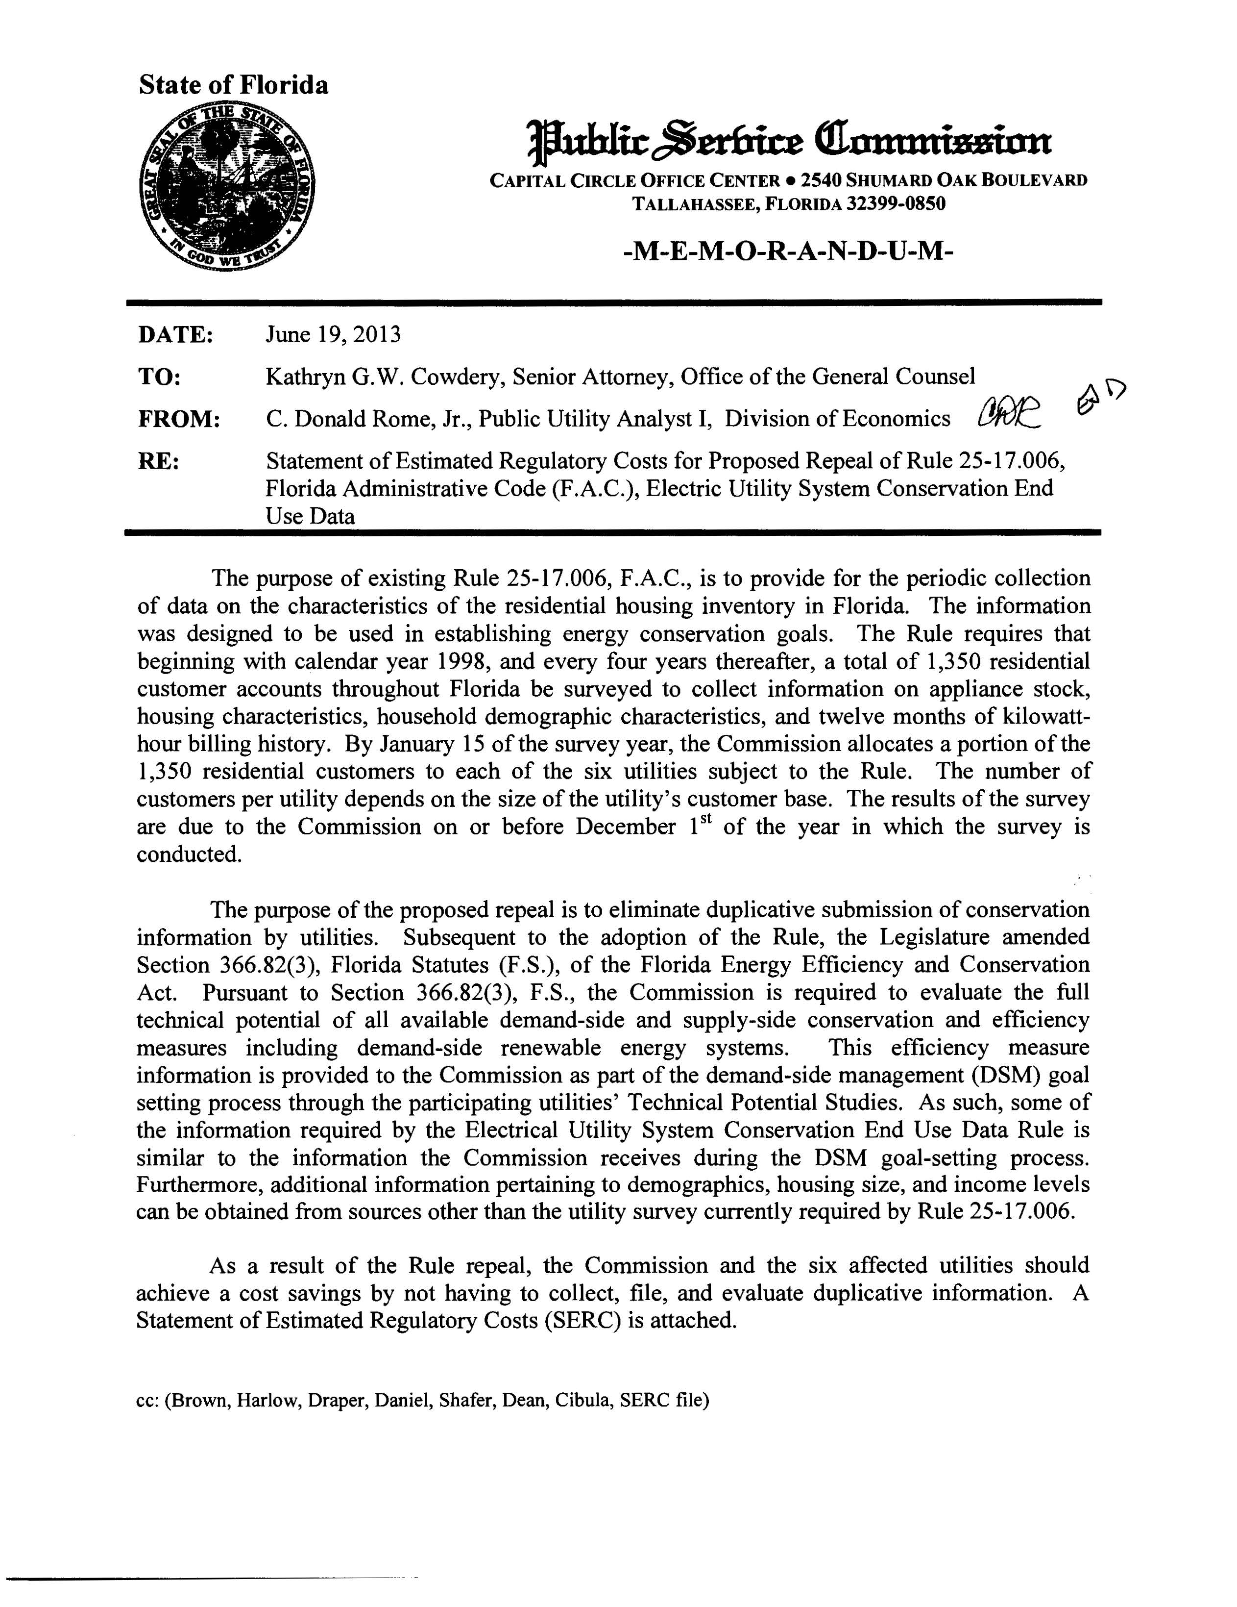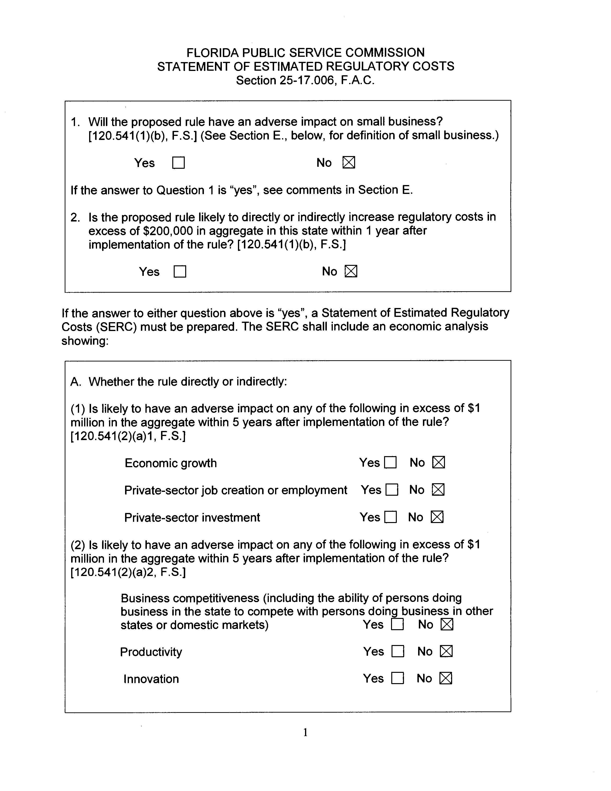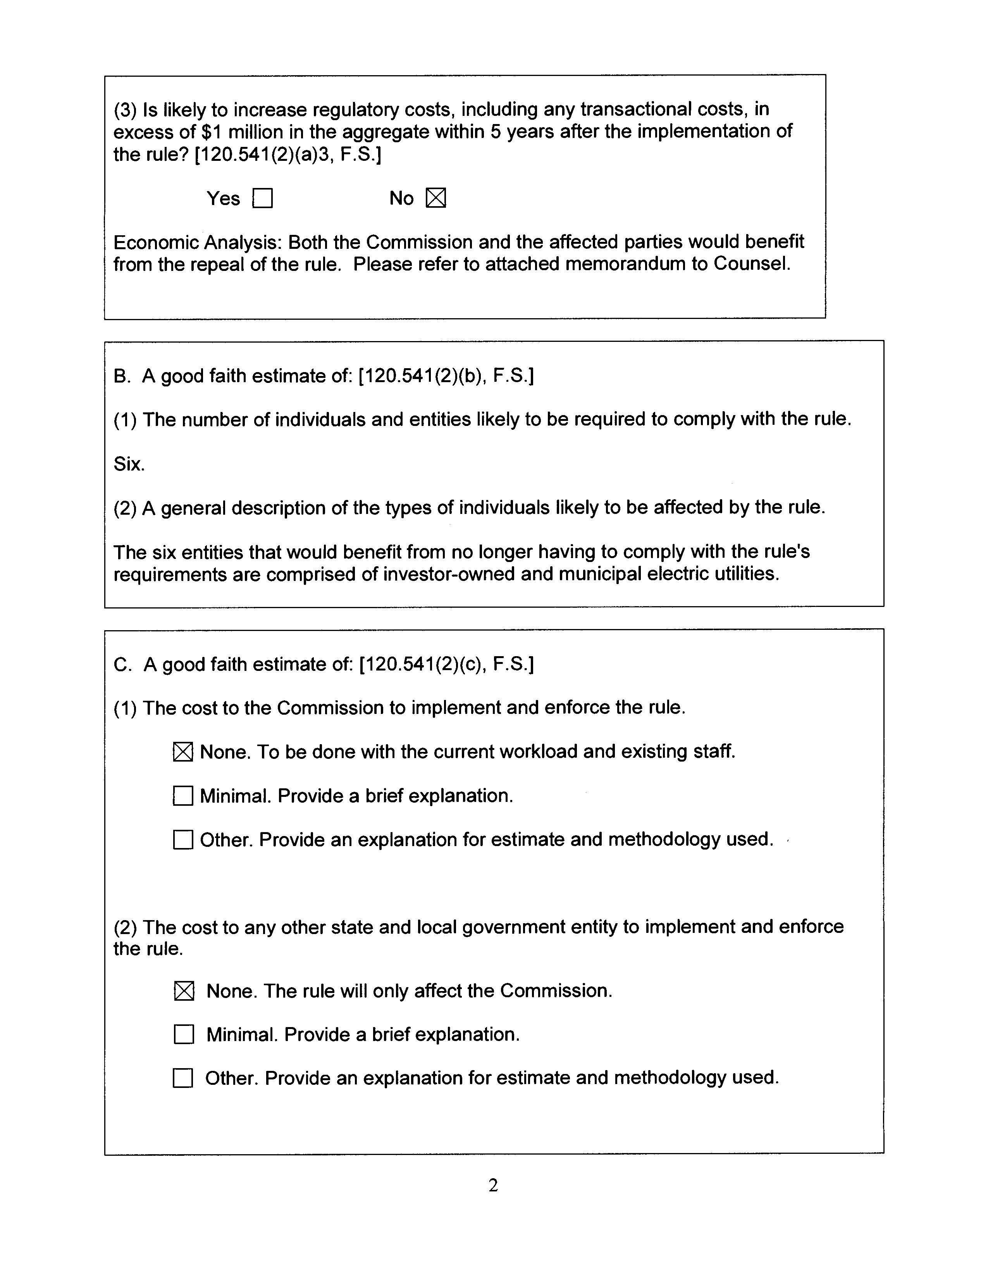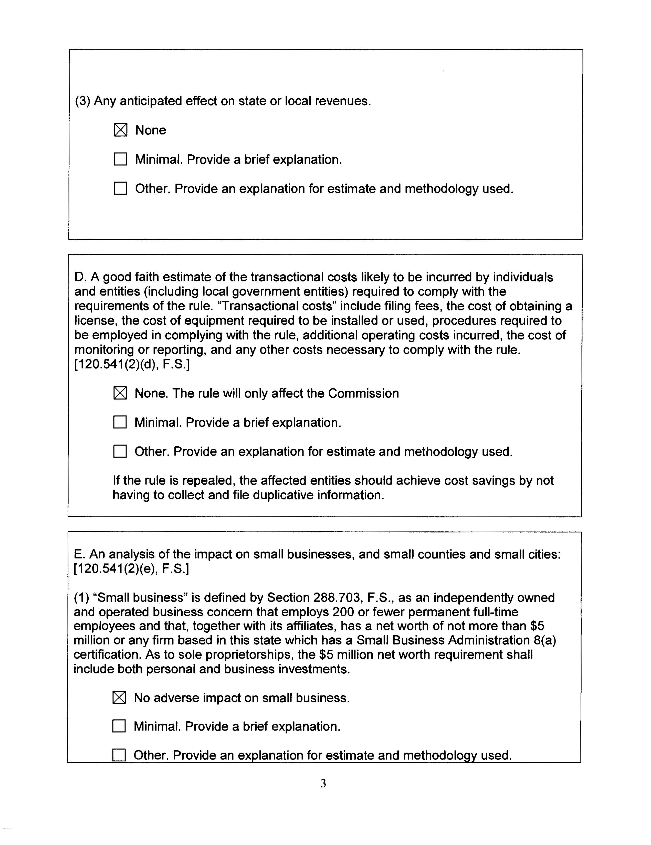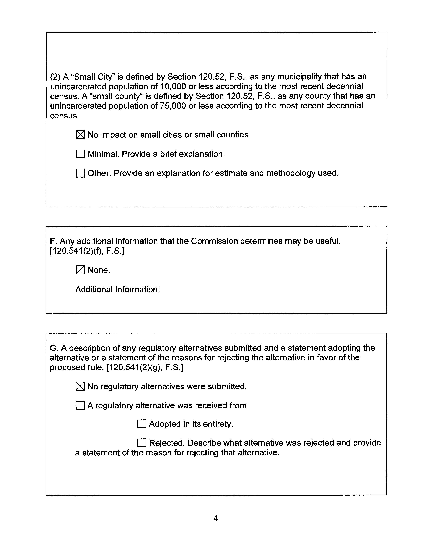

Chapter 80-65, Laws of Florida, addressing Sections 366.80 – 366.85, Florida Statutes (F.S.)

