State of Florida   |  | Public Service Commission  Capital Circle Office Center ● 2540 Shumard Oak Boulevard  Tallahassee, Florida 32399-0850  -M-E-M-O-R-A-N-D-U-M-
DATE: | July 18, 2013
TO: | Office of Commission Clerk (Cole)
FROM: | Office of the General Counsel (M. Brown)  Division of Economics (King)
RE: | Docket No. 130166-GU – Joint petition for approval of territorial agreement in Orange County by Peoples Gas System and The Lake Apopka Natural Gas District.
AGENDA: | 07/30/13 – Regular Agenda – Proposed Agency Action – Interested Persons May Participate
COMMISSIONERS ASSIGNED: |  |  | All Commissioners
PREHEARING OFFICER: |  |  | Brown
CRITICAL DATES: |  |  | None
SPECIAL INSTRUCTIONS: |  |  | None
FILE NAME AND LOCATION: |  |  | S:\PSC\GCL\WP\130166.RCM.DOC

Case Background
On June 17, 2013, Peoples Gas System (Peoples) and the Lake Apopka Natural Gas District (Lake Apopka) filed a joint petition for approval of a territorial agreement in Orange County. Peoples is a public utility regulated by the Florida Public Service Commission (Commission) pursuant to Chapter 366, Florida Statues (F.S.), and provides natural gas to approximately 345,000 customers throughout the State of Florida, including customers in Orange County. Lake Apopka is an independent special district of the State of Florida created by the Legislature in 1959. It was created for the purposes of constructing and operating one or more natural gas transmission and distribution systems for its member municipalities of Apopka, Winter Garden, and Clermont, and for the benefit of nearby municipalities and unincorporated areas and the public within the statutory area of service of the district. Lake Apopka is not a public utility as defined by Section 366.02(1), F.S., but is a natural gas utility subject to the Commission's jurisdiction under Section 366.04(3), F.S., for the purposes of resolving territorial disputes and approving territorial agreements. The Commission does not have jurisdiction over Lake Apopka’s rates and charges. Lake Apopka provides natural gas service to approximately 15,000 customers in Orange and Lake Counties.

In the 1990s, the companies entered into transfer agreements which specified that Peoples would provide natural gas service to certain customers in Orange County, and that Lake Apopka would have an option to purchase the facilities when it was ready to provide such service. Upon Lake Apopka's purchase of the facilities, at their depreciated book value, the customers served by those facilities would be transferred to Lake Apopka. In July 2012, Peoples was notified that Lake Apopka wanted to acquire all the facilities installed by Peoples pursuant to the transfer agreements.

In order to complete the purchase and sale of the facilities, the companies have entered into an Asset Purchase and Sale Agreement which provides for, upon the closing of the transaction, the transfer of the facilities as well as approximately 144 accounts that may receive natural gas service through those facilities from Peoples to Lake Apopka. Peoples and Lake Apopka seek Commission approval of the Territorial Agreement (Attachment A), which will become effective only upon the closing of the purchase and sale as outlined in the Asset Purchase and Sale Agreement. The map attached to the Agreement and Attachment B show the area in which the facilities to be transferred are located. The Commission has jurisdiction over this matter pursuant to Section 366.04, F.S.

Discussion of Issues
Issue 1:1
Should the Commission approve the joint petition for approval of the territorial agreement in Orange County between Peoples and Lake Apopka?
Recommendation:
Yes. The territorial agreement between Peoples and Lake Apopka will not cause a detriment to the public interest and should be approved. (M. Brown, King)
Staff Analysis:

Pursuant to Section 366.04(3)(a), F.S., the Commission has the jurisdiction to approve territorial agreements between and among natural gas utilities. Rule 25-7.0471(2), Florida Administrative Code, states that in approving territorial agreements, the Commission may consider the reasonableness of the purchase price of any facilities being transferred, the likelihood that the agreement will not cause a decrease in the reliability of gas service to existing or future ratepayers, and the likelihood that the agreement will eliminate existing or potential uneconomic duplication of facilities. Unless the Commission determines that the agreement will cause a detriment to the public interest, the agreement should be approved. Utilities Commission of the City of New Smyrna v. Florida Public Service Commission, 469 So. 2d 731 (Fla. 1985).
Based upon transfer agreements executed in the 1990s, the petitioners agreed that Peoples would provide natural gas service to certain customers in Orange County, and that Lake Apopka would have an option to purchase, at depreciated book value, the facilities installed to serve such customers when it was ready to provide such service. In July 2012, Lake Apopka notified Peoples that it was ready to purchase the facilities. The companies have now entered into an Asset Purchase and Sale Agreement which provides for, upon the closing of the transaction, the transfer from Peoples to Lake Apopka of the facilities as well as the approximately 144 accounts that receive natural gas service through those facilities. If approved, the territorial agreement would become effective upon the closing of the purchase and sale called for by the Asset Purchase and Sale Agreement.

The approximately 144 accounts that would be transferred from Peoples to Lake Apopka have been provided notice of the possible transfer. The notice informed customers that Lake Apopka will apply the same rates as charged by Peoples through September 30, 2014. The notice also provided a telephone number for customers to call for additional information. Prior to the notices being sent and Lake Apopka agreeing to charge the same rates as Peoples, a handful of customers had expressed opposition to being transferred based on the difference in rates between the two utilities. Commission staff also spoke to one customer that expressed concern regarding the rate difference between the companies. However, since the notices have been sent, Lake Apopka and Commission staff have not received any calls or inquiries from customers. One residential customer contacted Peoples opposing the transfer.

Peoples and Lake Apopka represent that approval and implementation of the territorial agreement will not cause a decrease in the availability or reliability of natural gas service from either company, or to the existing or future ratepayers. In addition, they assert that approval of the territorial agreement by the Commission will assist in avoiding future uneconomic duplication of facilities by the parties, and will expedite the handling of applications for service by future potential natural gas customers; therefore, the agreement is in the public interest.

It appears that the proposed agreement eliminates the potential uneconomic duplication of facilities and will not cause a decrease in the reliability of gas service. In addition, the purchase price of the facilities (at their depreciated book value) appears reasonable. Therefore, based on the above, staff believes that the proposed territorial agreement will not cause a detriment to the public interest and recommends approval.
Issue 2:2
Should this docket be closed?
Recommendation:
Yes. If no person whose interests are substantially affected timely files a protest to the Commission’s Proposed Agency Action Order, this docket should be closed upon issuance of a Consummating Order. (M. Brown)
Staff Analysis:
- If no person whose interests are substantially affected timely files a protest to the Commission’s Proposed Agency Action Order, this docket should be closed upon issuance of a Consummating Order.

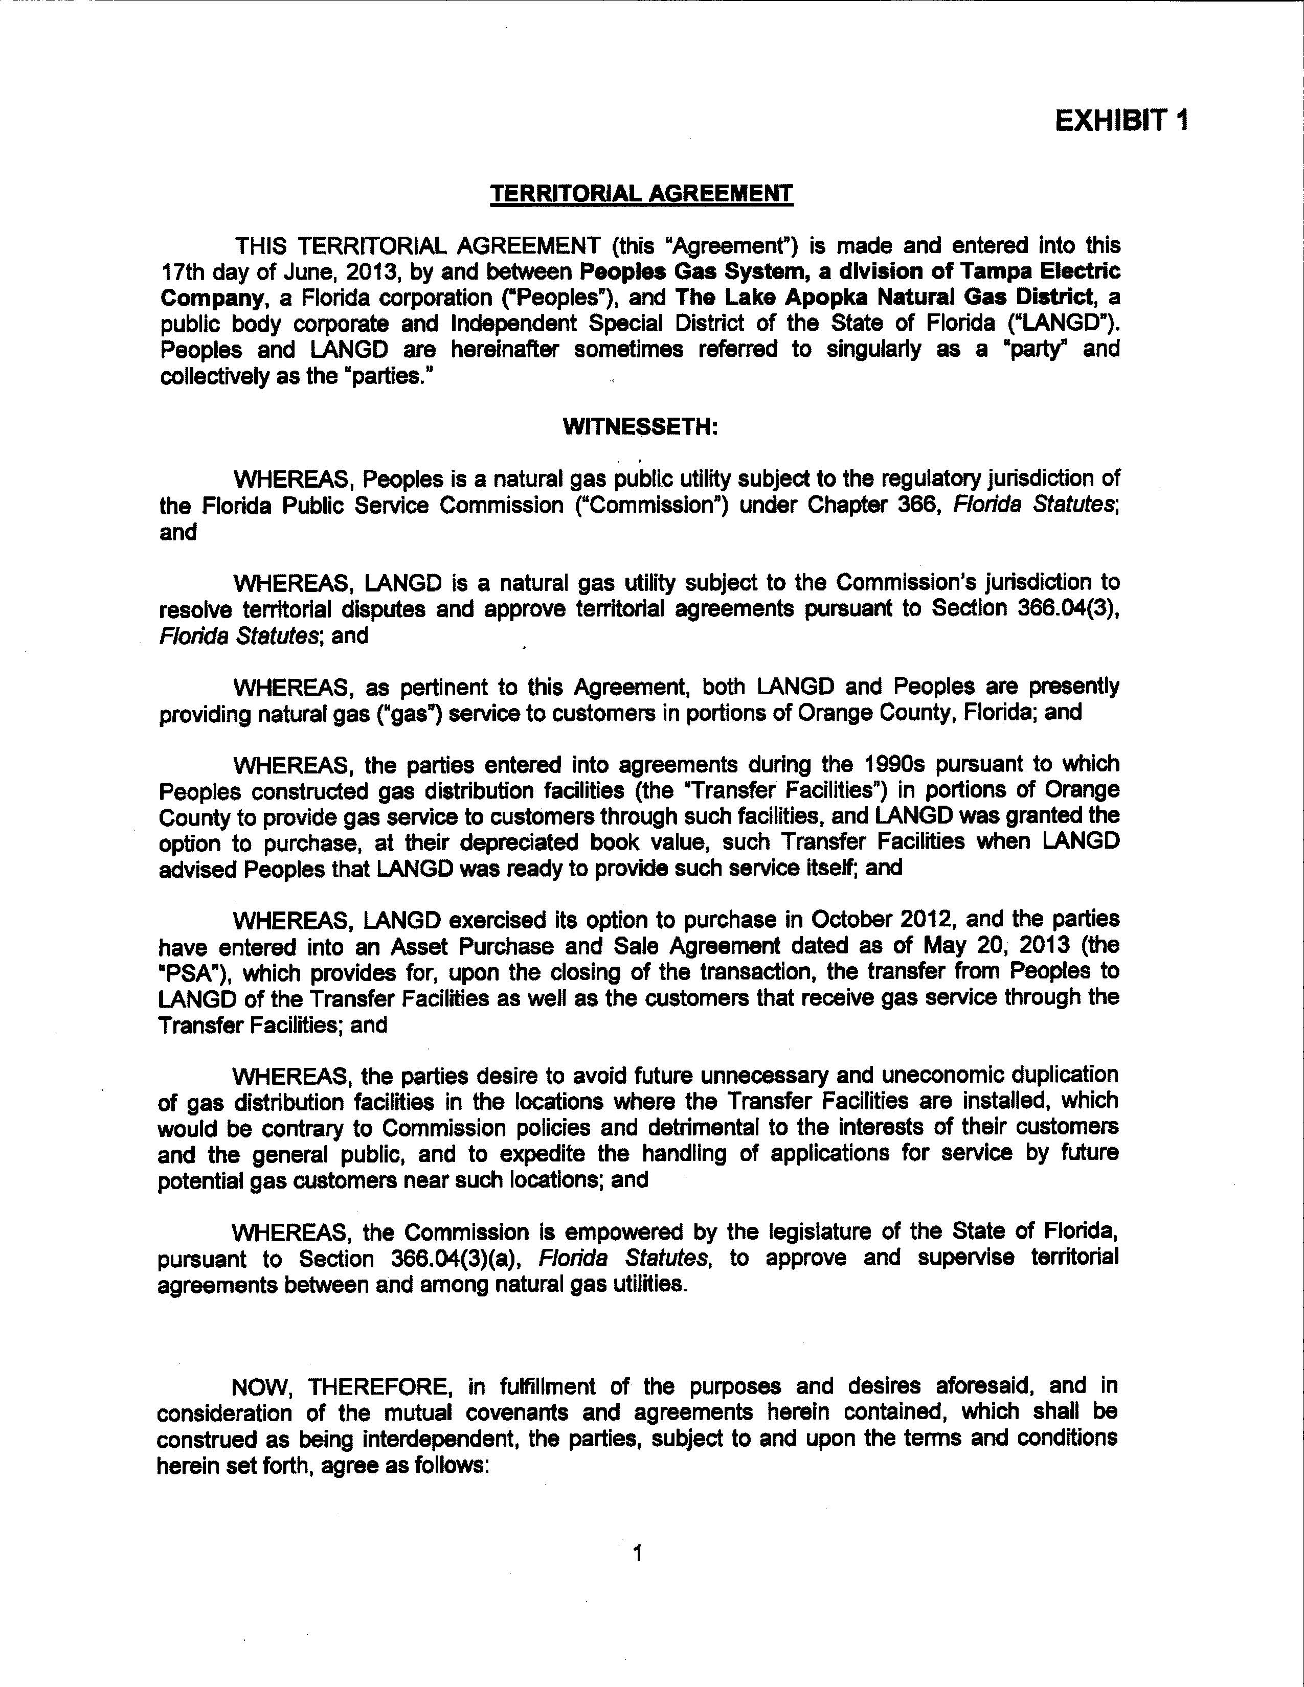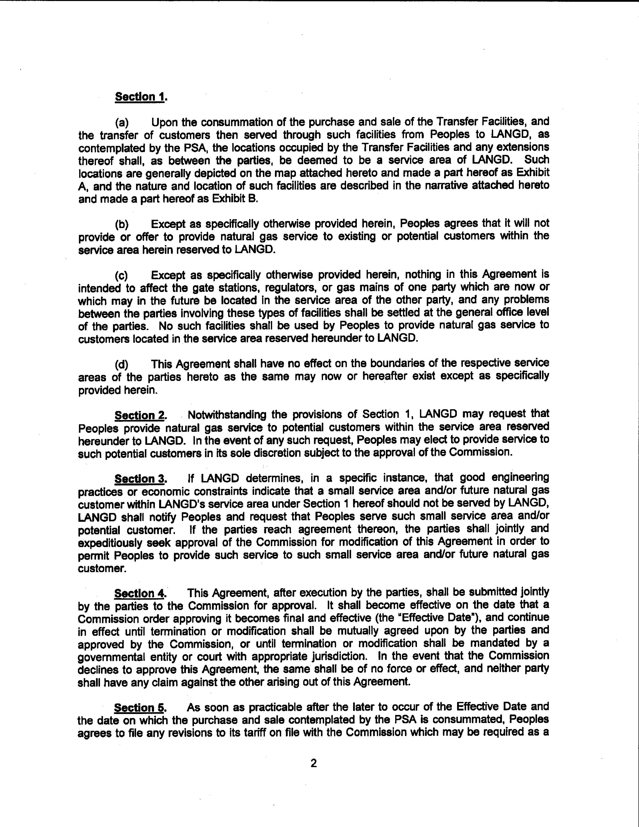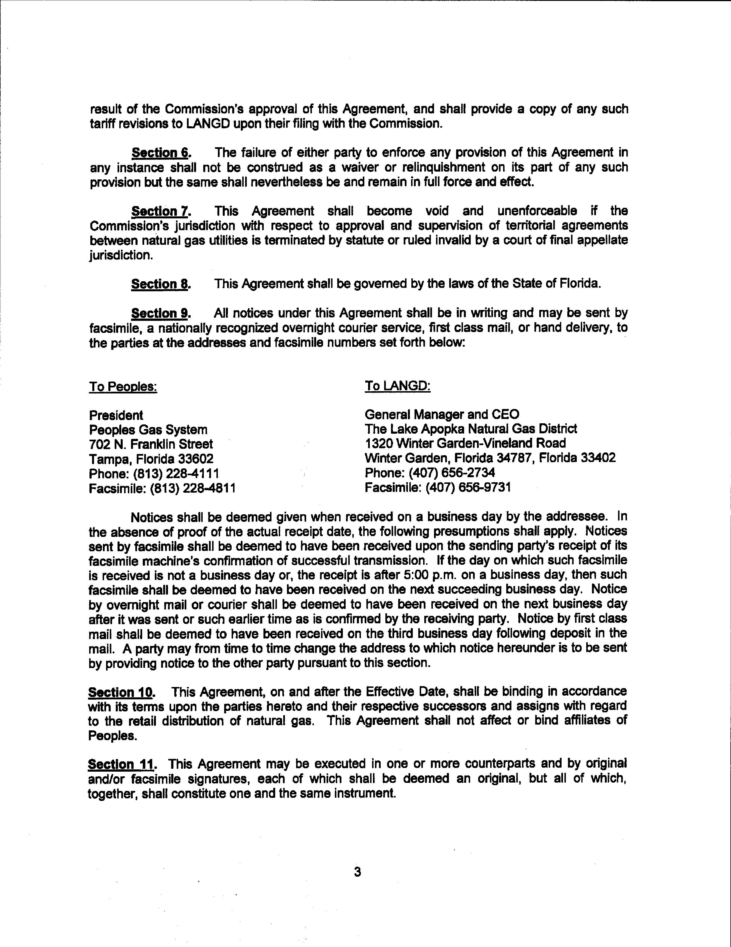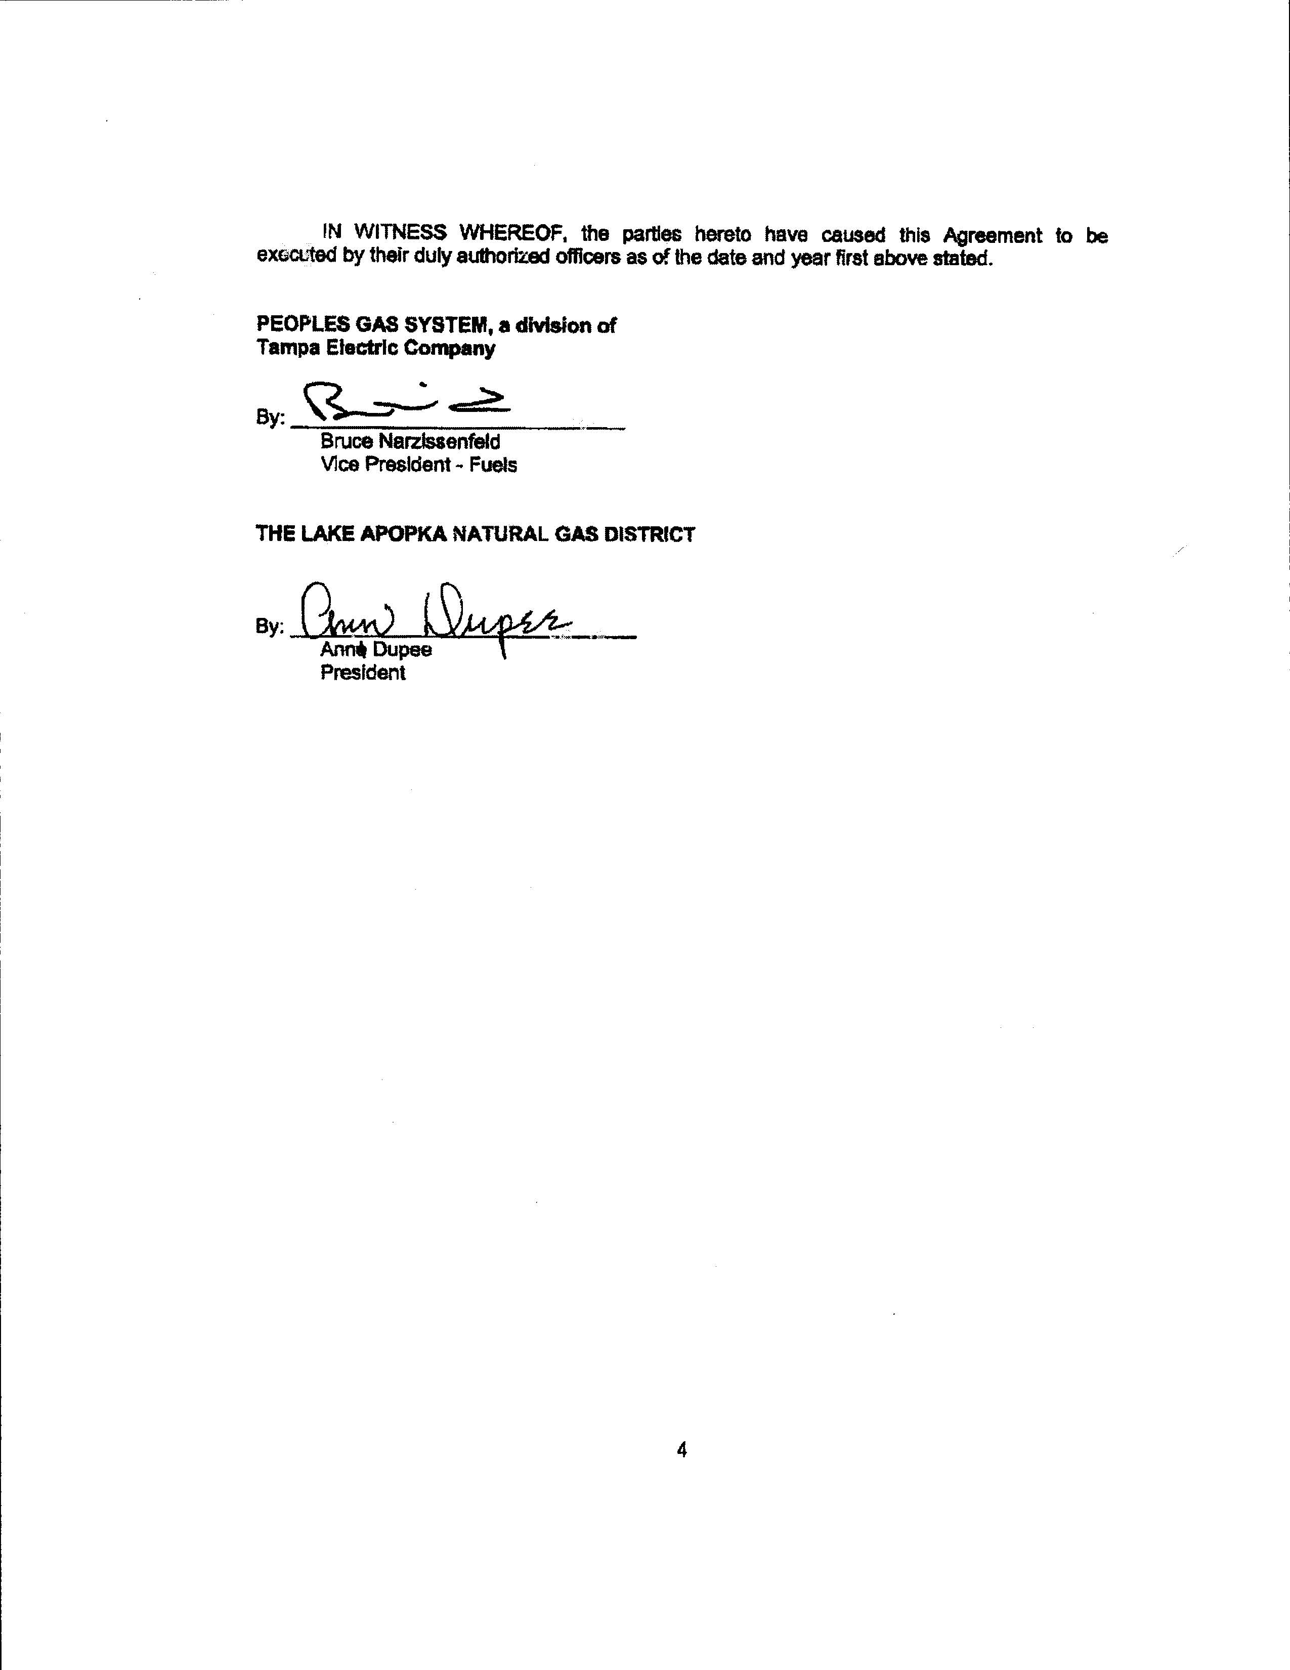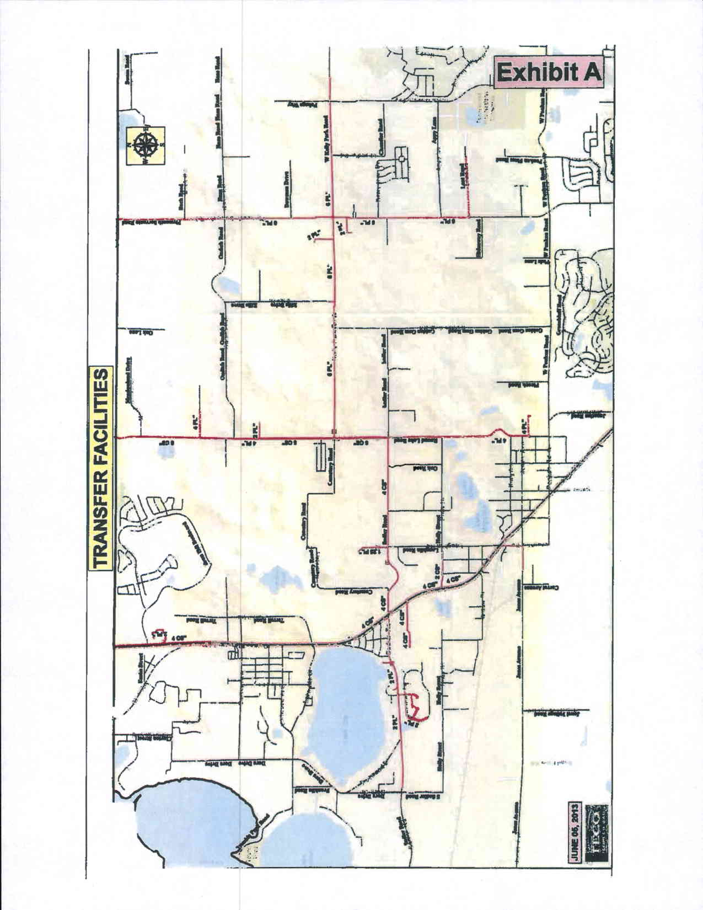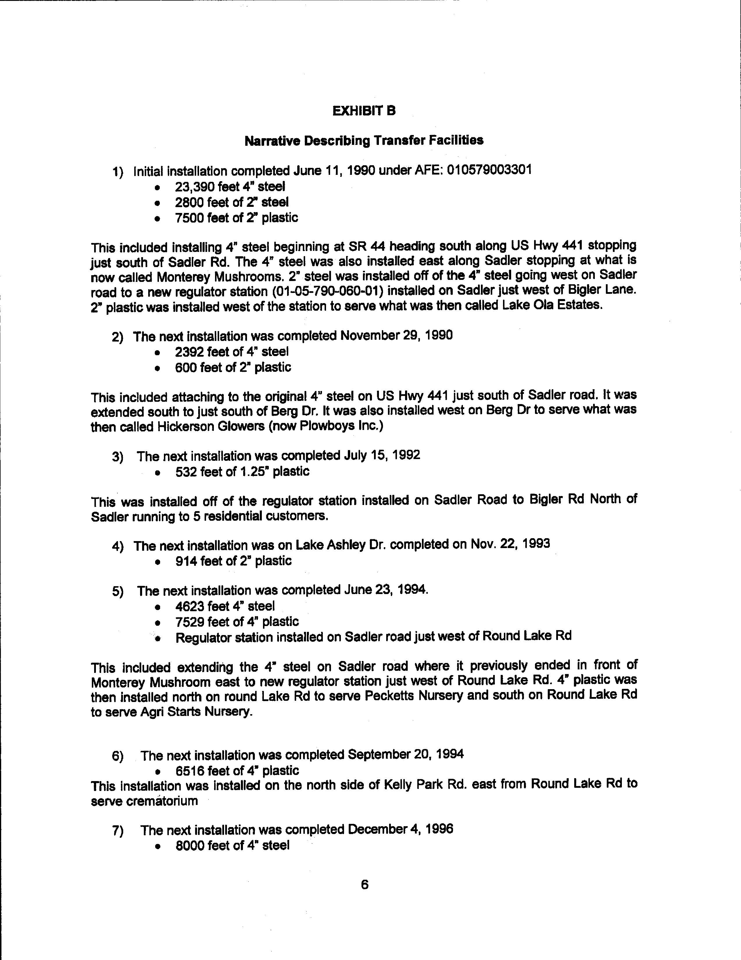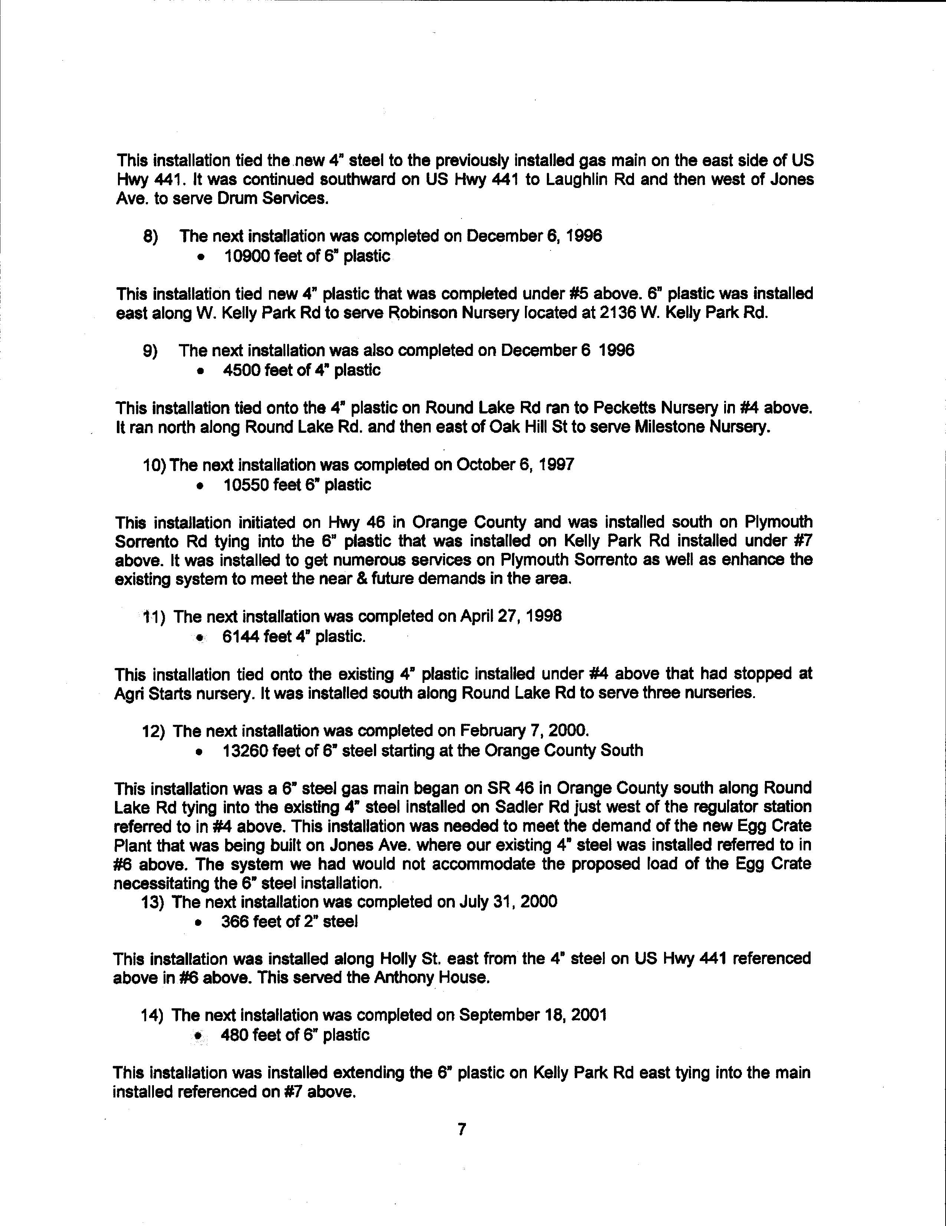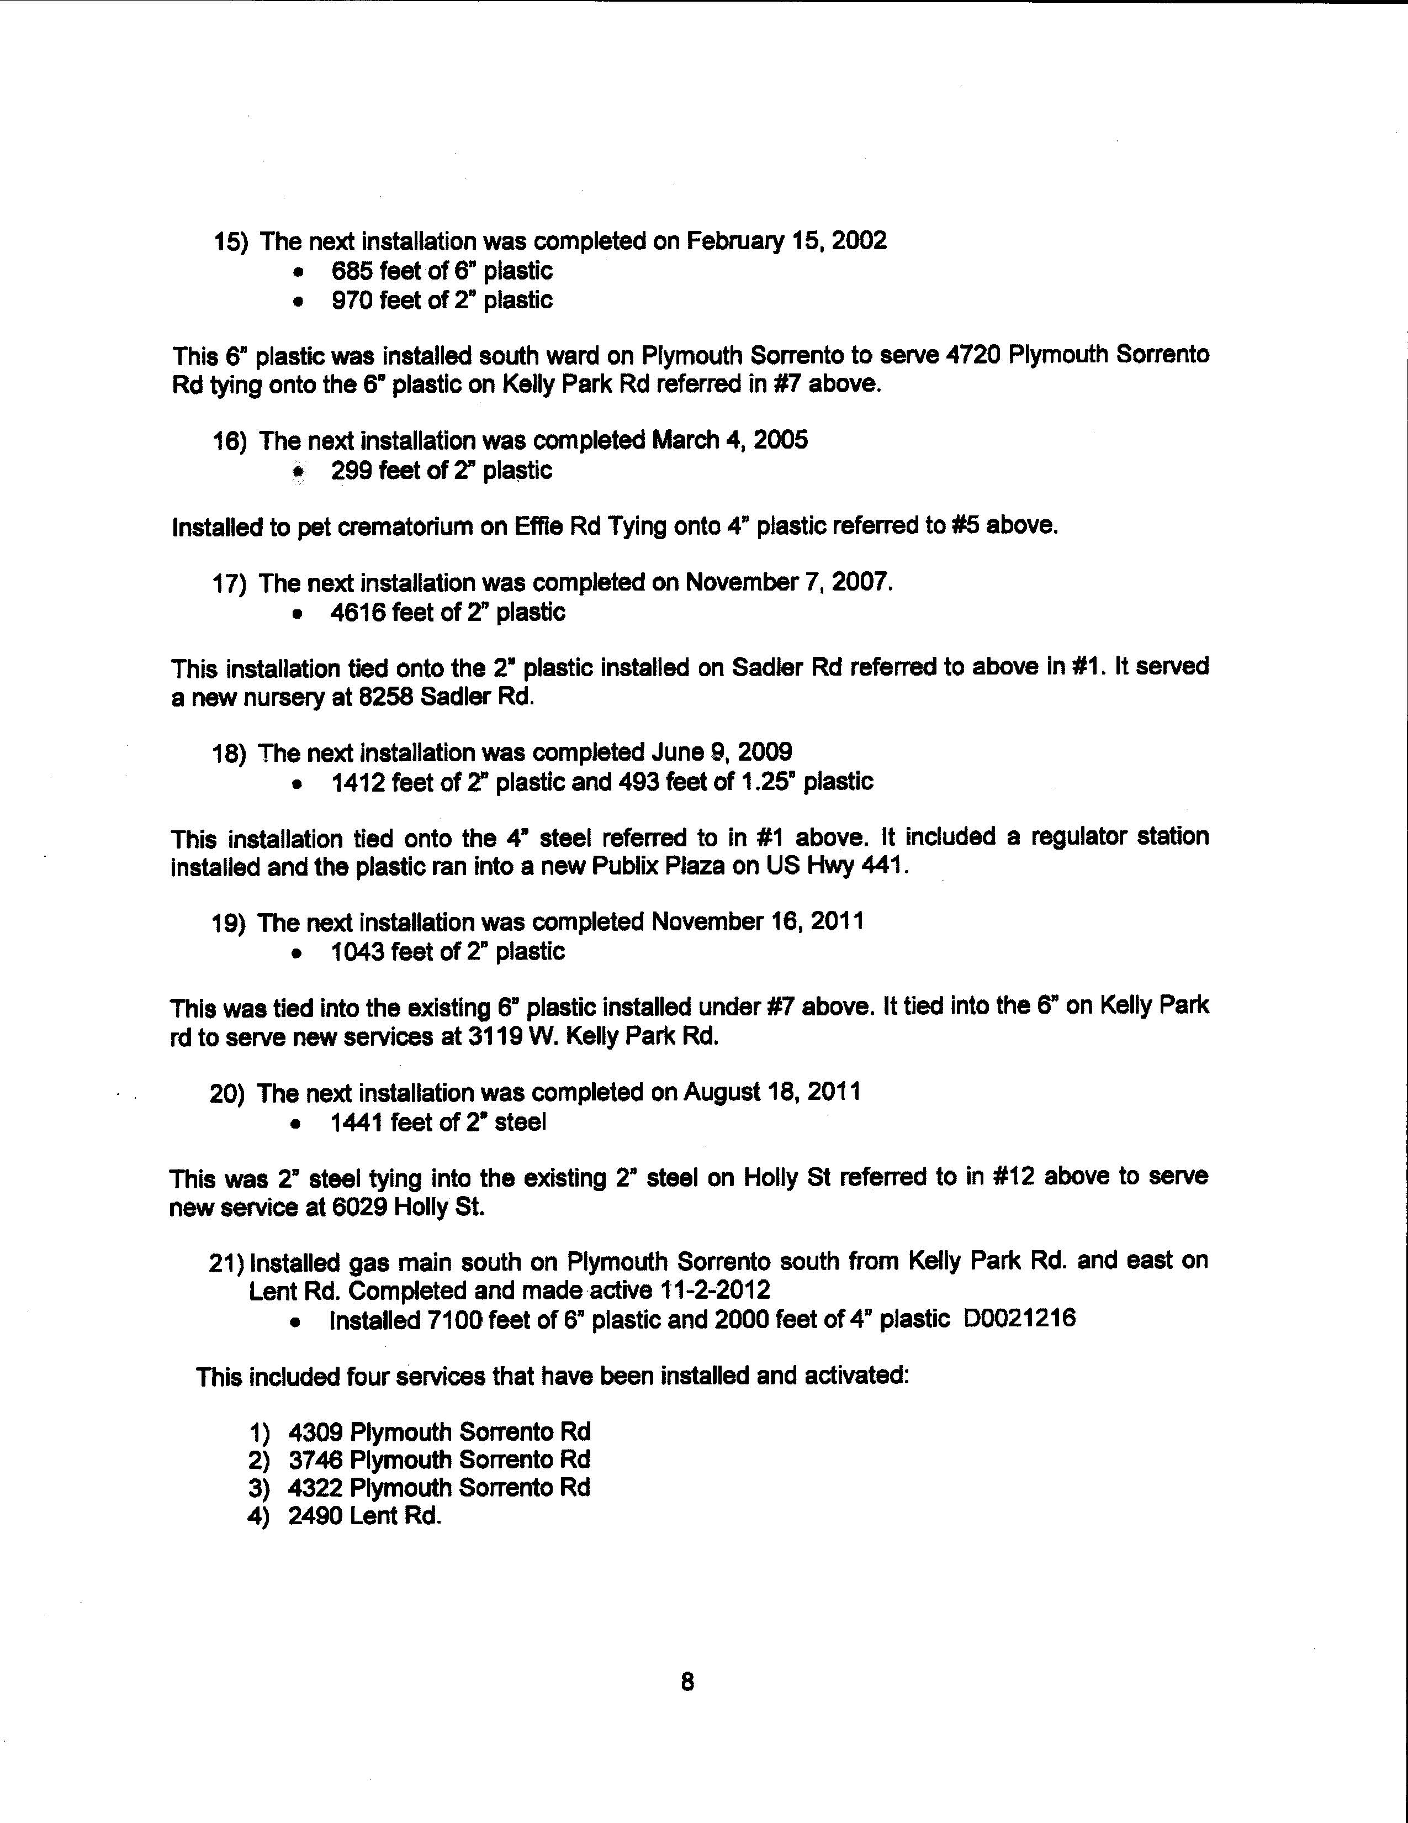
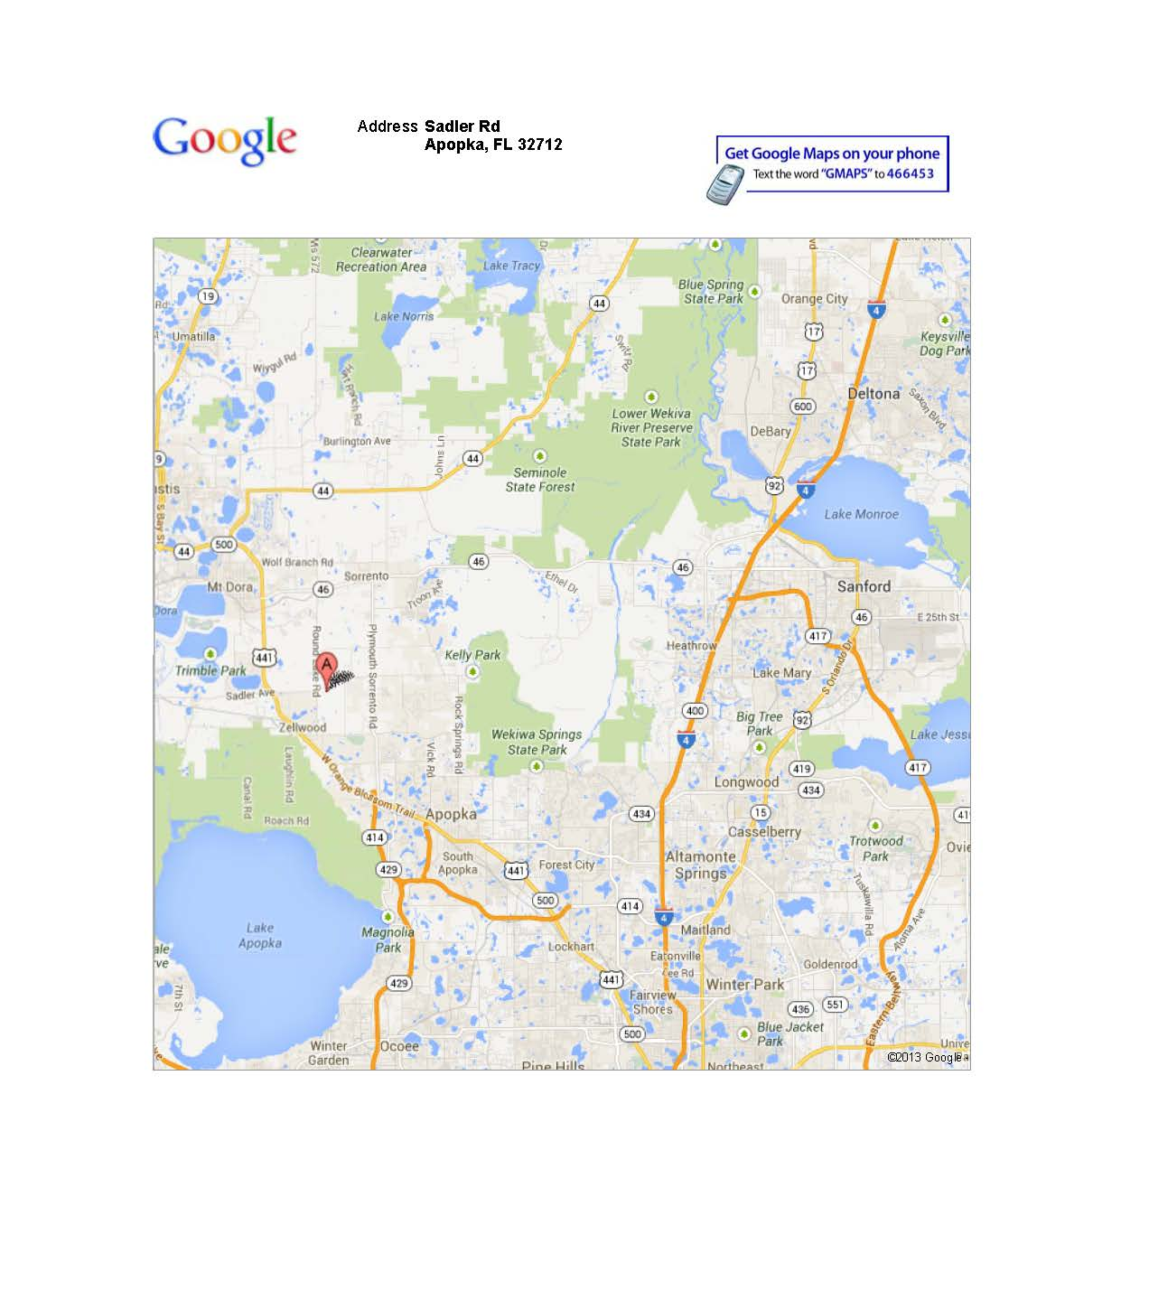

Of the 144 total accounts, 67 are residential and 77 are commercial. Not all of the 144 accounts are currently “active.”

