State of Florida   |  | Public Service Commission  Capital Circle Office Center ● 2540 Shumard Oak Boulevard  Tallahassee, Florida 32399-0850  -M-E-M-O-R-A-N-D-U-M-
DATE: | November 19, 2013
TO: | Office of Commission Clerk (Cole)
FROM: | Division of Accounting and Finance (Maurey)  Division of Industry Development and Market Analysis (Breman)  Division of Economics (King)  Office of the General Counsel (Lawson)
RE: | Docket No. 130245-EI – Petition for base rate increase for extended power uprate systems placed in commercial service by Florida Power & Light Company.
AGENDA: | 12/03/13 – Regular Agenda – Proposed Agency Action - Interested Persons May Participate
COMMISSIONERS ASSIGNED: |  |  | All Commissioners
PREHEARING OFFICER: |  |  | Brown
CRITICAL DATES: |  |  | None
SPECIAL INSTRUCTIONS: |  |  | None

Case Background
In 2006, the Florida Legislature enacted Section 366.93, Florida Statutes (F.S.), encouraging the development of nuclear energy in the state. In that section, the Legislature directed the Commission to adopt rules providing for alternative cost recovery mechanisms that would encourage investor-owned electric utilities to invest in nuclear power plants. The Commission adopted Rule 25-6.0423, Florida Administrative Code (F.A.C.), which provides for an annual clause recovery proceeding to consider investor-owned utilities’ requests for cost recovery for nuclear plants.
By Order No. PSC-08-0021-FOF-EI, the Commission made an affirmative determination of need for Florida Power & Light Company’s (FPL) Extended Power Uprate (EPU) project. The EPU project involved FPL's four nuclear units located at two nuclear generating plant sites in Florida: Turkey Point Units 3 and 4, and St. Lucie Units 1 and 2. The EPU projects have gone into commercial service at various points in time, with the majority of the costs going into plant in service when the modifications were completed in 2012 and 2013.
On October 4, 2013, FPL filed a petition to increase its base rates by the $94,064,105 revenue requirements associated with the uprate of Turkey Point Unit 4 pursuant to Rule 25-6.0423(7), F.A.C. Further, FPL has requested a base rate decrease of $917,671 associated with the 5-year amortization of existing assets that are being retired during 2013 pursuant to Rule 25-6.0423(7)(e), F.A.C. FPL has also included a $19,142,379 true-up of the 2012 base rate revenue requirement for the 2012 modifications made at the St. Lucie and Turkey Point nuclear units. In total, FPL has requested a net base rate increase of $113,206,484. This represents a base rate increase of $1.14 per month on a typical 1,000 kWh residential bill.

The Commission has jurisdiction over this subject matter pursuant to Section 366.93, F.S., and other provisions of Chapter 366, F.S.

Discussion of Issues
Issue 1:1
Should FPL's request to increase its base rates by $94,064,105 for the EPU systems placed in commercial service during 2013 be approved?
Recommendation:
No. A base rate increase of $94,235,311 for the 2013 EPU project modifications at Turkey Point Unit 4 should be approved. This approval should be subject to true-up and revision based on the final review of the 2013 modification expenditures in the Nuclear Cost Recovery Clause (NCRC). (Maurey)
Staff Analysis:
FPL has requested approval to increase its base rates by $94,064,105 for the EPU project modifications at Turkey Point Unit 4 that went into service during 2013.
Rule 25-6.0423(7), F.A.C., states the following:
(7) Commercial Service. As operating units or systems associated with the power plant and the power plant itself are placed in commercial service:
(a) The utility shall file a petition for Commission approval of the base rate increase pursuant to Section 366.93(4), F.S., separate from any cost recovery clause petitions, that includes any and all costs reflected in such increase, whether or not those costs have been previously reviewed by the Commission; provided, however, that any actual costs previously reviewed and determined to be prudent in the Capacity Cost Recovery Clause shall not be subject to disallowance or further prudence review except for fraud, perjury, or intentional withholding of key information.
(b) The utility shall calculate the increase in base rates resulting from the jurisdictional annual base revenue requirements for the power plant in conjunction with the Capacity Cost Recovery Clause projection filing for the year the power plant is projected to achieve commercial operation. The increase in base rates will be based on the annualized base revenue requirements for the power plant for the first 12 months of operations consistent with the cost projections filed in conjunction with the Capacity Cost Recovery Clause projection filing.
(c) At such time as the power plant is included in base rates, recovery through the Capacity Cost Recovery Clause will cease, except for the difference between actual and projected construction costs as provided in subparagraph (5)(c)4. above.
(d) The rate of return on capital investments shall be calculated using the utility’s most recent actual Commission adjusted basis overall weighted average rate of return as reported by the utility in its most recent Earnings Surveillance Report prior to the filing of a petition as provided in paragraph (7)(a). The return on equity cost rate used shall be the midpoint of the last Commission approved range for return on equity or the last Commission approved return on equity cost rate established for use for all other regulatory purposes, as appropriate.
(e) The jurisdictional net book value of any existing generating plant that is retired as a result of operation of the power plant shall be recovered through an increase in base rate charges over a period not to exceed 5 years. At the end of the recovery period, base rates shall be reduced by an amount equal to the increase associated with the recovery of the retired generating plant.

In compliance with Rule 25-6.0423(7), F.A.C., FPL submitted its calculation of the annualized base rate revenue requirements for the EPU project modifications for the first 12 months of operations. This calculation is shown in FPL’s response to staff’s data request. (See Schedule No. 1) In the process of completing its responses to staff discovery, FPL identified certain adjustments to its projections, the transmission jurisdictional separation factor, the amount of salvage, and a work order error that resulted in a net increase of $171,206 to the requested 2013 base rate revenue requirement. Staff has reviewed FPL’s revised calculation of the jurisdictional annual revenue requirement. Staff believes the revised annual revenue requirement of $94,235,311 has been calculated in compliance with Rule 25-6.0423(7), F.A.C., and should be approved.
The 2013 expenditures related to the EPU project modifications are subject to review in the NCRC. A final determination of the reasonableness and prudence of the 2013 expenditures will be made during 2014. Based on FPL’s revised calculations, the increase in Electric Plant in Service included in the calculation is $738,740,557 ($703,304,266 jurisdictional), net of joint owners. If the $738,740,557 amount is revised based on a final audit and review of the 2013 expenditures, the annual revenue requirement will have to be recalculated. This would require a true-up of the revenues already collected and a revision of the related tariffs. Therefore, staff recommends that the approval of the $94,235,311 base rate increase be made subject to true-up and revision based on the final review of the 2013 EPU project modification expenditures at the St. Lucie and Turkey Point units in the NCRC.
Issue 2:2
Should FPL’s request to decrease its base rates by $917,671 for a 5-year period to reverse the excess amortization associated with previously retired assets be approved?
Recommendation:
Yes. The appropriate base rate decrease is $917,671 for the 5-year amortization period. At the end of the amortization period, base rates should be increased by an amount equal to the rate decrease recommended here. (Maurey)
Staff Analysis:
FPL has requested approval to decrease its base rates by $917,671 for a 5-year period. As a direct result of the EPU project modifications, certain existing assets have been replaced or are no longer necessary for the operation of the plant. Therefore, these assets are being retired pursuant to Rule 25-6.0423(7)(e), F.A.C.
However, due to an over recovery through the NCRC of the amount associated with past retirements, a rate decrease is necessary in this instance. This results in a negative annual amortization of $831,213 ($792,405 jurisdictional) over the 5-year period. In addition, FPL has proposed to adjust the annual amortization by annual depreciation expense and property tax expense credits of $131,885 ($125,267 jurisdictional), resulting in a net negative annual amortization of $963,099 ($917,671 jurisdictional).
Staff recommends that the Commission approve $917,671 as the appropriate base rate decrease for the 5-year amortization period to reverse the excess amortization associated with previously retired assets. In addition, base rates should be increased by an amount equal to the decrease recommended here at the end of the 5-year amortization period.

Issue 3:3
Should FPL's request to increase its base rates by $19,142,379 for the true-up of the 2012 base rate adjustment be approved?
Recommendation:
No. The appropriate base rate increase is $18,795,383 for the true-up of the 2012 base rate adjustment. (Maurey, Breman)
Staff Analysis:
Per Order No. PSC-12-0647-PAA-EI, FPL was authorized to increase its base rates by $243,978,281 for the 2012 modifications made at the St. Lucie and Turkey Point nuclear units. This approval was subject to true-up and revision based on the final review of the 2012 expenditures in the NCRC in Docket No. 130009-EI.
As shown on page 1 of Attachment D to FPL’s Petition, the Company is requesting a true-up to increase base rates by $19,142,379. The primary reasons for the true-up are (1) the difference between the estimated amount of plant-in-service used in the previous calculation and the final amount used in the current calculation, and (2) the difference between the estimated amount of net book value of retirements, removal, and salvage used in the previous calculation and the final amount used in the current calculation.
In the process of completing its responses to staff discovery, FPL identified adjustments related to incremental transmission asset salvage, salvage incorrectly included in plant-in-service, and an amount for the true-up of removal costs that resulted in a net $346,996 reduction to its requested 2012 true-up base rate revenue requirement. Staff has reviewed the true-up calculation and recommends that the $18,795,383 base rate increase be approved.

Issue 4:4
What is the appropriate effective date of FPL’s revised base rates?
Recommendation:
If the Commission approves the staff recommendations in Issues 1, 2, and 3, the revised base rates should be implemented with the first billing cycle for 2014, which falls on January 2, 2014. Staff’s recommended total increase should be allocated among the various rate classes consistent with the Cost of Service study approved by the Commission in Order No. PSC-13-0023-S-EI. Furthermore, FPL should file revised tariff sheets to reflect the revised base energy and demand charges to implement the Commission vote in Issues 1, 2, and 3 for administrative approval by staff prior to their effective date. (King)
Staff Analysis:
The total retail revenue requirements are allocated among the various rate classes based on the allocations of nuclear revenue requirements in the Cost of Service study approved by the Commission in Order No. PSC-13-0023-S-EI. The total base rate increase recommended in Issues 1, 2, and 3 results in an increase of $1.14 to the 1,000 kilowatt-hour residential bill.

If the Commission approves the staff recommendations in Issues 1, 2, and 3, the revised base rates should be implemented with the first billing cycle for 2014, which falls on January 2, 2014. Furthermore, FPL should file revised tariff sheets to reflect the revised base energy and demand charges to implement the Commission vote in Issues 1, 2 and 3 for administrative approval by staff prior to their effective date.

Issue 5:5
Should this docket be closed?
Recommendation:
If no person whose substantial interests are affected by the proposed agency action files a protest within 21 days of the issuance of the order, a consummating order should be issued. FPL should file revised tariff sheets to reflect the base energy and demand charges implemented by the Commission’s vote on Issues 1, 2, and 3 for administrative approval by staff prior to the effective date of the new rates. Once these actions are complete, this docket should be closed administratively. (Lawson)
Staff Analysis:
If no person whose substantial interests are affected by the proposed agency action files a protest within 21 days of the issuance of the order, this docket should be closed upon the issuance of a consummating order. FPL should file revised tariff sheets to reflect the base energy and demand charges implemented by the Commission’s vote on Issues 1, 2, and 3 for administrative approval by staff prior to the effective date of the new rates. Once these actions are complete, this docket should be closed administratively.

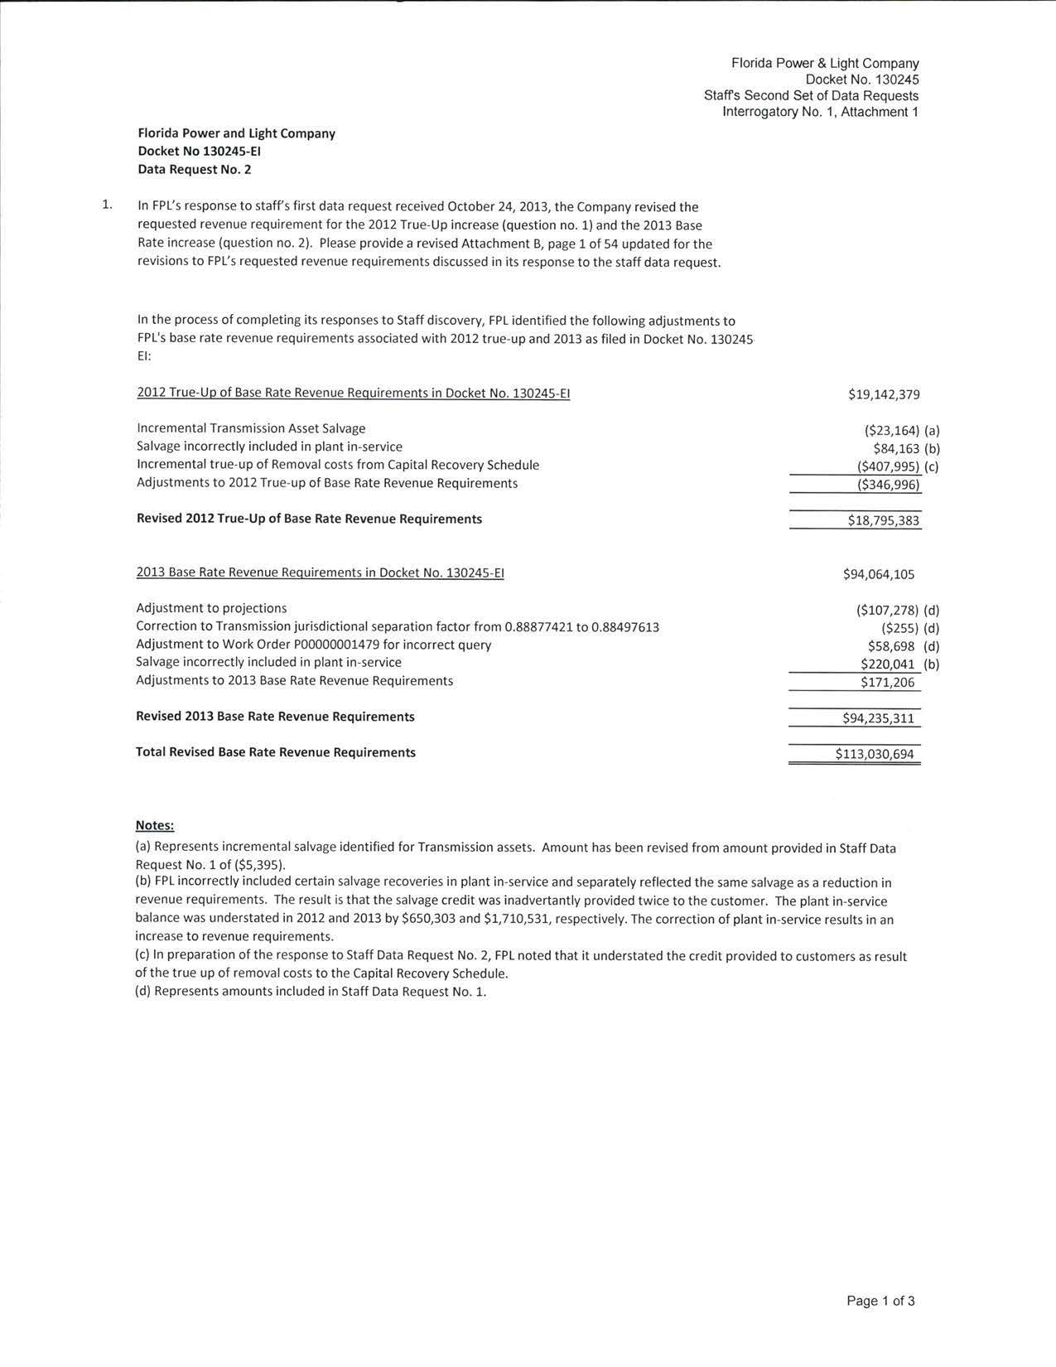

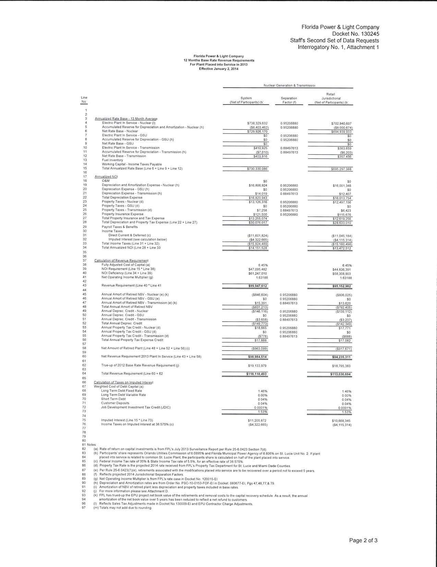

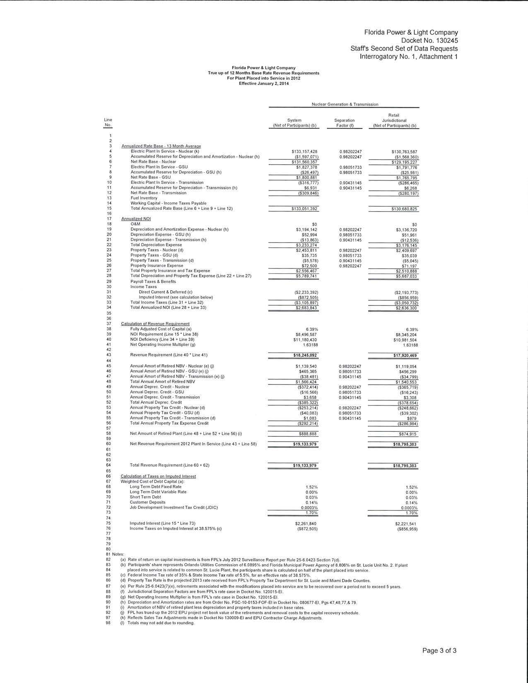

See Order No. PSC-08-0021-FOF-EI, issued January 7, 2008, in Docket No. 070602-EI, In re: Petition for determination of need for expansion of Turkey Point and St. Lucie nuclear power plants, for exemption from Bid Rule 25-22.082, F.A.C., and for cost recovery through the Commission's Nuclear Power Plant Cost Recovery Rule, Rule 25-6.0423, F.A.C.
See Order No. PSC-12-0647-PAA-EI, issued December 11, 2012, in Docket No. 120244-EI, In re: Petition for approval for base rate increase for extended power uprate systems placed in commercial service by Florida Power & Light Company.
See Order No. PSC-13-0023-S-EI, issued January 14, 2013, in Docket No. 120015-EI, In re: Petition for increase in rates by Florida Power & Light Company.

