State of Florida   |  | Public Service Commission  Capital Circle Office Center ● 2540 Shumard Oak Boulevard  Tallahassee, Florida 32399-0850  -M-E-M-O-R-A-N-D-U-M-
DATE: | December 4, 2014
TO: | Office of Commission Clerk (Stauffer)
FROM: | Division of Engineering (Matthews, Mtenga)  Division of Economics (Garl)  Office of the General Counsel (Murphy)
RE: | Docket No. 140180-EQ – Petition for approval of amendment to extend term of negotiated renewable energy power purchase contract with Rayonier Performance Fibers, LLC, by Florida Public Utilities Company.
AGENDA: | 12/18/14 – Regular Agenda – Proposed Agency Action – Interested Persons May Participate
COMMISSIONERS ASSIGNED: |  |  | All Commissioners
PREHEARING OFFICER: |  |  | Brisé
CRITICAL DATES: |  |  | None
SPECIAL INSTRUCTIONS: |  |  | Consider recommendations for Docket Nos. 140180-EQ and 140185-EQ simultaneously

Case Background
On September 12, 2014, Florida Public Utilities Company (FPUC) filed a petition requesting the approval of an amendment to the approved purchased power agreement (Amended Agreement) between FPUC and Rayonier Performance Fibers, LLC (Rayonier). The original purchased power agreement was approved by the Commission for purposes of cost recovery by Order No. PSC 12-0380-PAA-EQ, issued July 23, 2012, in Docket 120058-EQ. The facility is a certified Qualifying Facility (QF) as that term is defined by the Federal Energy Regulatory Commission rules and Rule 25-17.080, Florida Administrative Code (F.A.C).
Rayonier currently owns and operates mills in Jessup, Georgia and Fernandina Beach, Florida, that produce high-purity cellulose products from wood chips. The steam created by this process is utilized by Rayonier’s existing steam turbines to partially mitigate its electric demand. As such, the Rayonier facility is a renewable energy resource as defined by Section 366.91 (2)(d), Florida Statutes (F.S.).
The original purchased power agreement has been in place and producing savings for FPUC’s customers for two years. This recommendation addresses FPUC’s petition to extend the term of the original agreement an additional 14 years, from October 2022 to September 2036. The Commission has jurisdiction over this matter pursuant to Sections 366.051, 366.91 and 366.92, F.S.

Discussion of Issues
Issue 1:1
Should FPUC's request to extend the term of its negotiated purchased power agreement with Rayonier be approved?
Recommendation:
Yes. The terms and conditions of the approved original purchased power agreement will continue under the extension period. Extending the term of the negotiated purchased power agreement is estimated to provide a net present value (NPV) savings of $8.2 million over the entire Amended Agreement’s term. (Matthews, Mtenga)
Staff Analysis:
The original purchased power agreement between FPUC and Rayonier currently provides FPUC with a viable source of renewable capacity and energy. The parties have been operating under the original purchased power agreement for almost two years, and have encountered no notable operational issues.
Because the anticipated benefits have been realized since the original purchased power agreement began in October 2012, the parties believe these benefits will continue to accrue over an extended period. Therefore, the parties have negotiated an Amendment No. 1 to extend the term of the original agreement an additional 14 years. (See Attachment A) The Amended Agreement extends the expiration date from 2022 to 2036 which is the same expiration date as the new Eight Flags Energy, LLC (Eight Flags) purchased power agreement discussed in Docket 140185-EQ. Rayonier will purchase low pressure steam from Eight Flags, an affiliate of Chesapeake Utilities, which is also the parent company of FPUC. The low pressure steam from Eight Flags will allow Rayonier to channel additional high pressure steam into its electric generating unit. The high pressure steam will enable Rayonier to increase the output of its generator and potentially sell additional renewable energy to FPUC, thereby increasing the savings to FPUC’s customers. The current purchased power agreement already allows for the purchase of this additional energy. FPUC’s petition in this docket is solely requesting approval of the extension of the original purchased power agreement.
In its response to a staff data request, FPUC stated that the increase in capacity gained from the additional output will have no impact on the transmission facilities connecting the Rayonier generating unit to FPUC’s system. In fact, FPUC plans to relocate the transmission facilities from an inaccessible, marshy area to a more easily accessible road right-of-way, which will greatly improve the overall system reliability by conforming to FPUC’s storm hardening standards.
The annual savings projected for the Amended Agreement was provided (confidential) with the petition in the instant docket. The Amended Agreement payments are estimated to provide a net present value (NPV) savings of $8.2 million over the entire term.
Conclusion
The terms and conditions of the approved original purchased power agreement will continue under the extension period. Extending the term of the negotiated purchased power agreement is estimated to provide a net present value (NPV) savings of $8.2 million over the entire Amended Agreement’s term. Therefore, staff recommends that the Amended Agreement be approved as requested by FPUC.

Issue 2:2
Should this docket be closed?
Recommendation:
Yes. This docket should be closed upon issuance of a Consummating Order unless a person whose substantial interests are affected by the Commission’s decision files a protest within 21 days of the issuance of the proposed agency action. (Murphy)
Staff Analysis:
This docket should be closed upon issuance of a Consummating Order unless a person whose substantial interests are affected by the Commission’s decision files a protest within 21 days of the issuance of the proposed agency action.
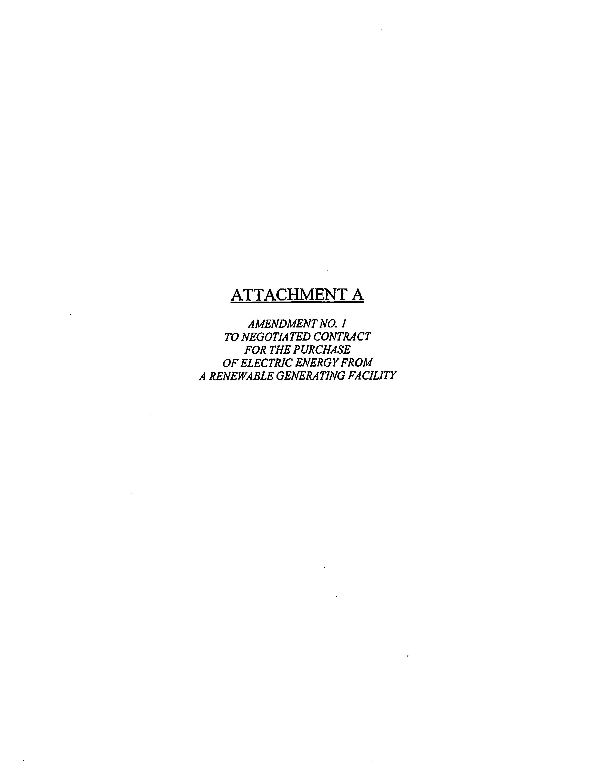
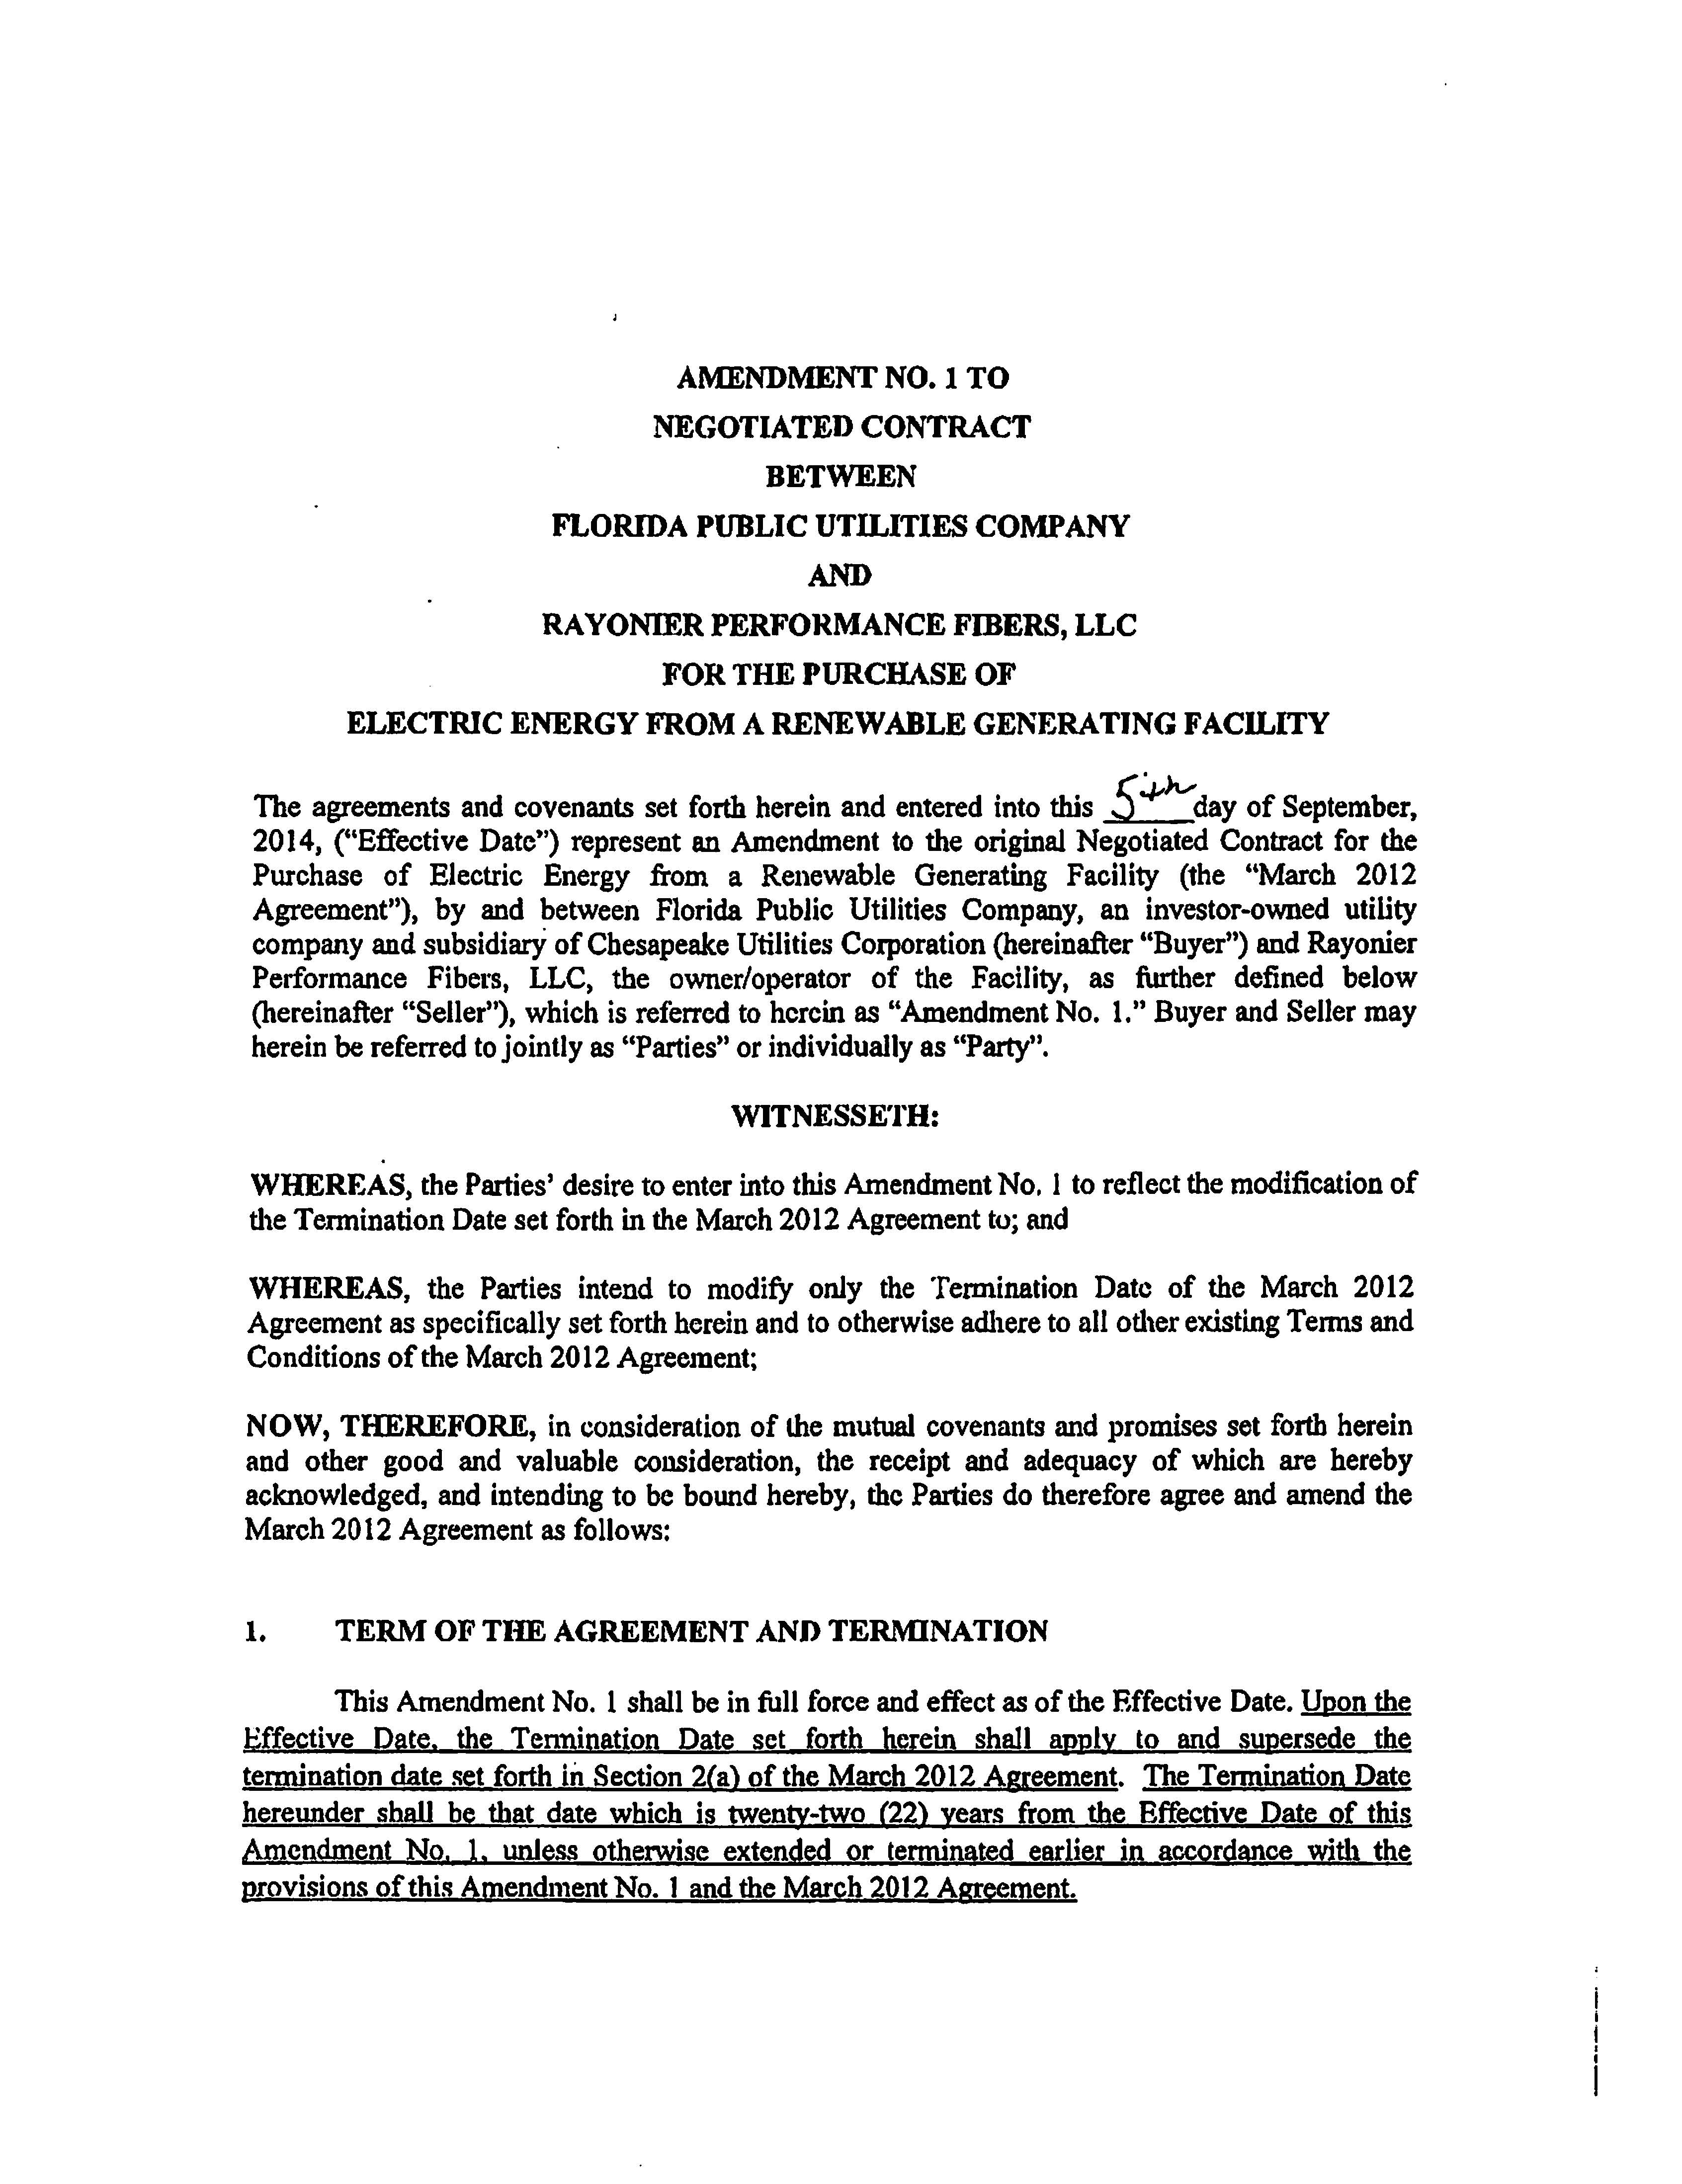
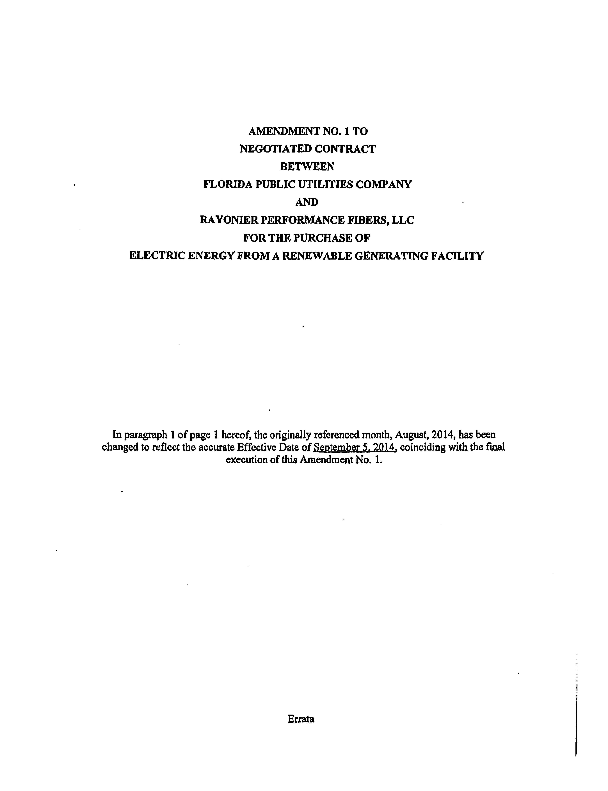
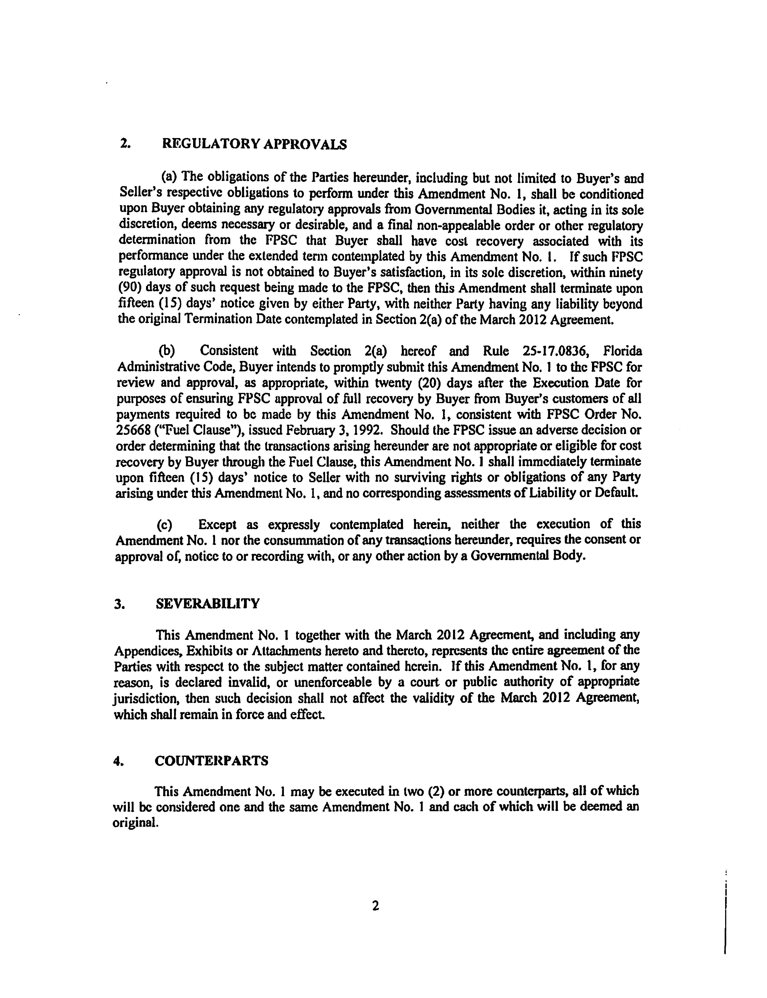
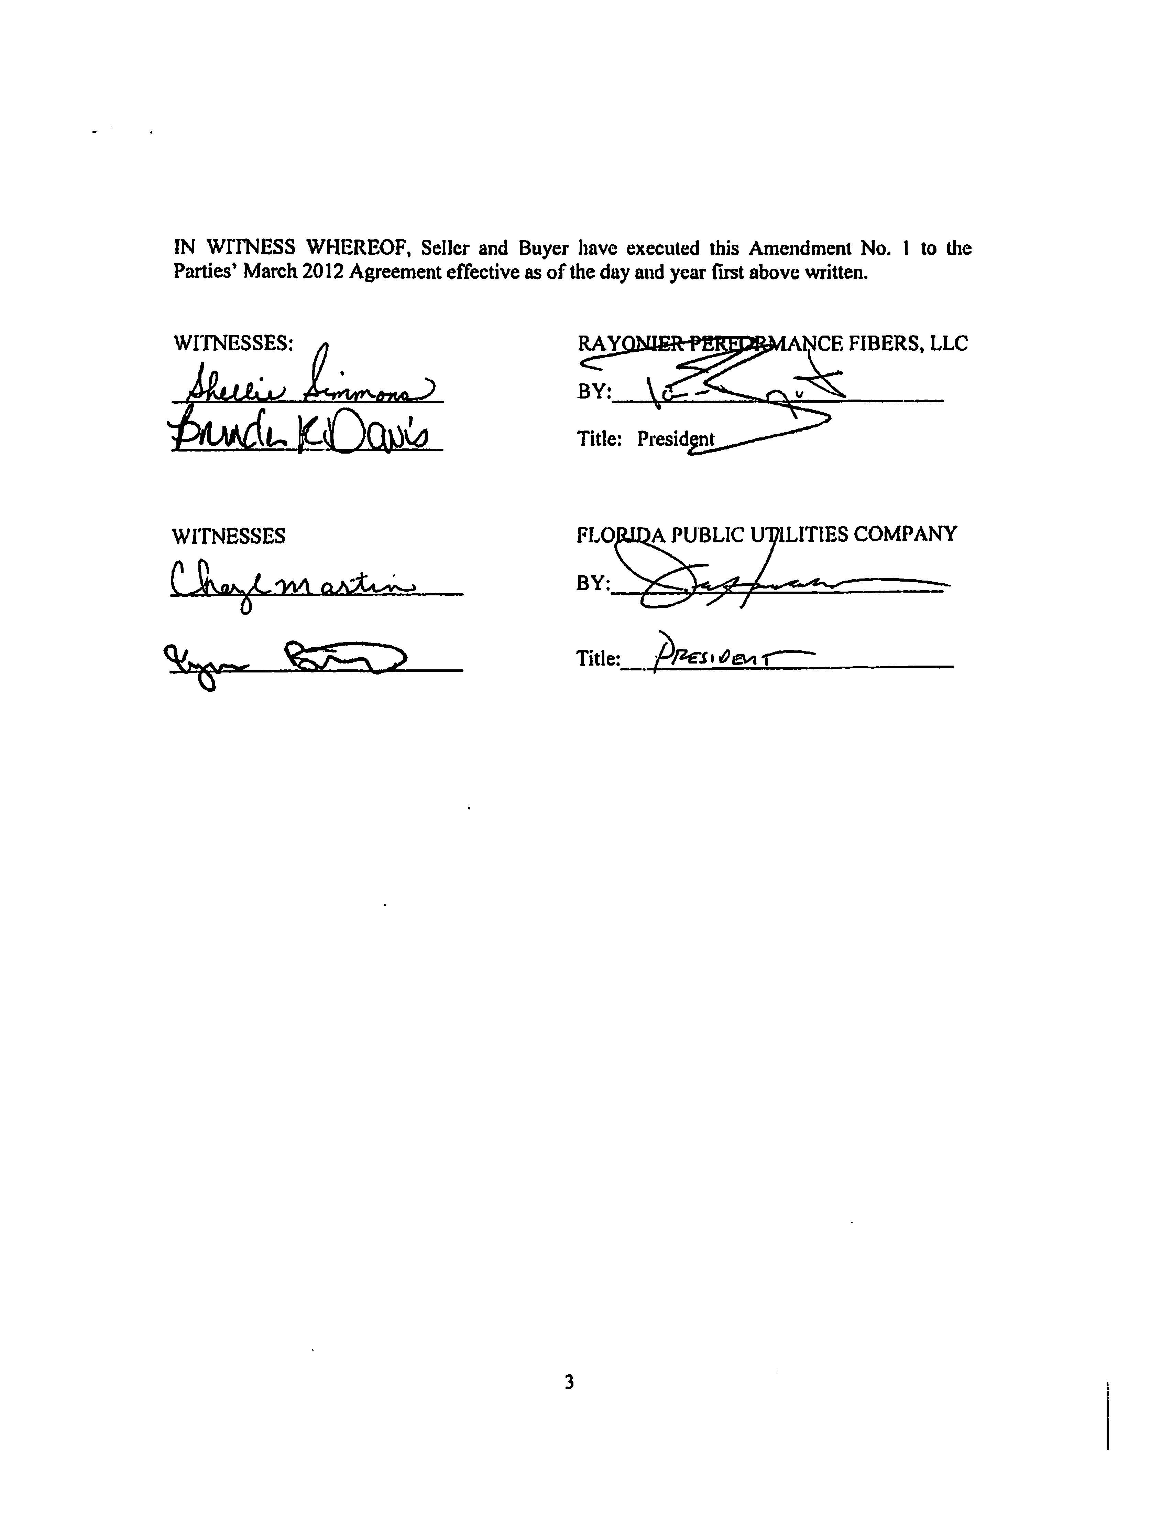
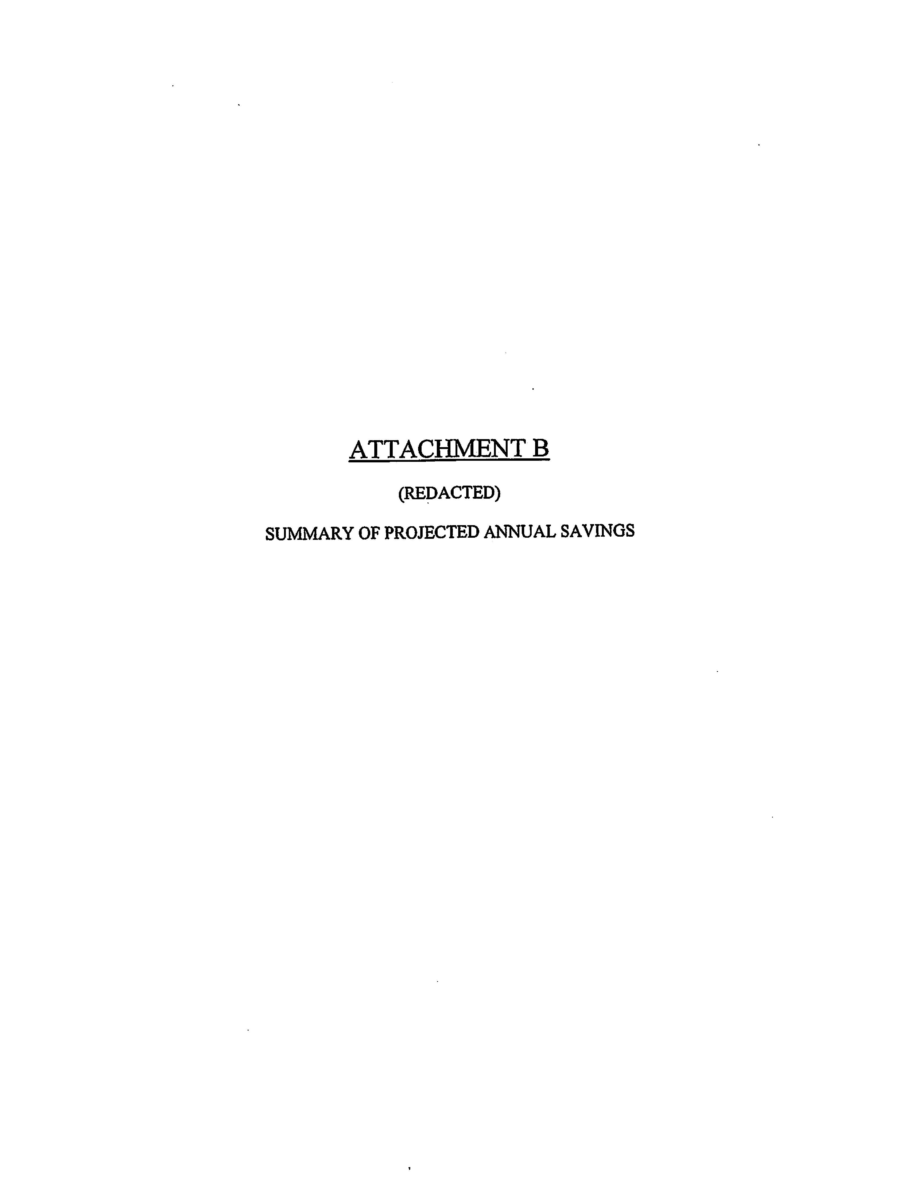
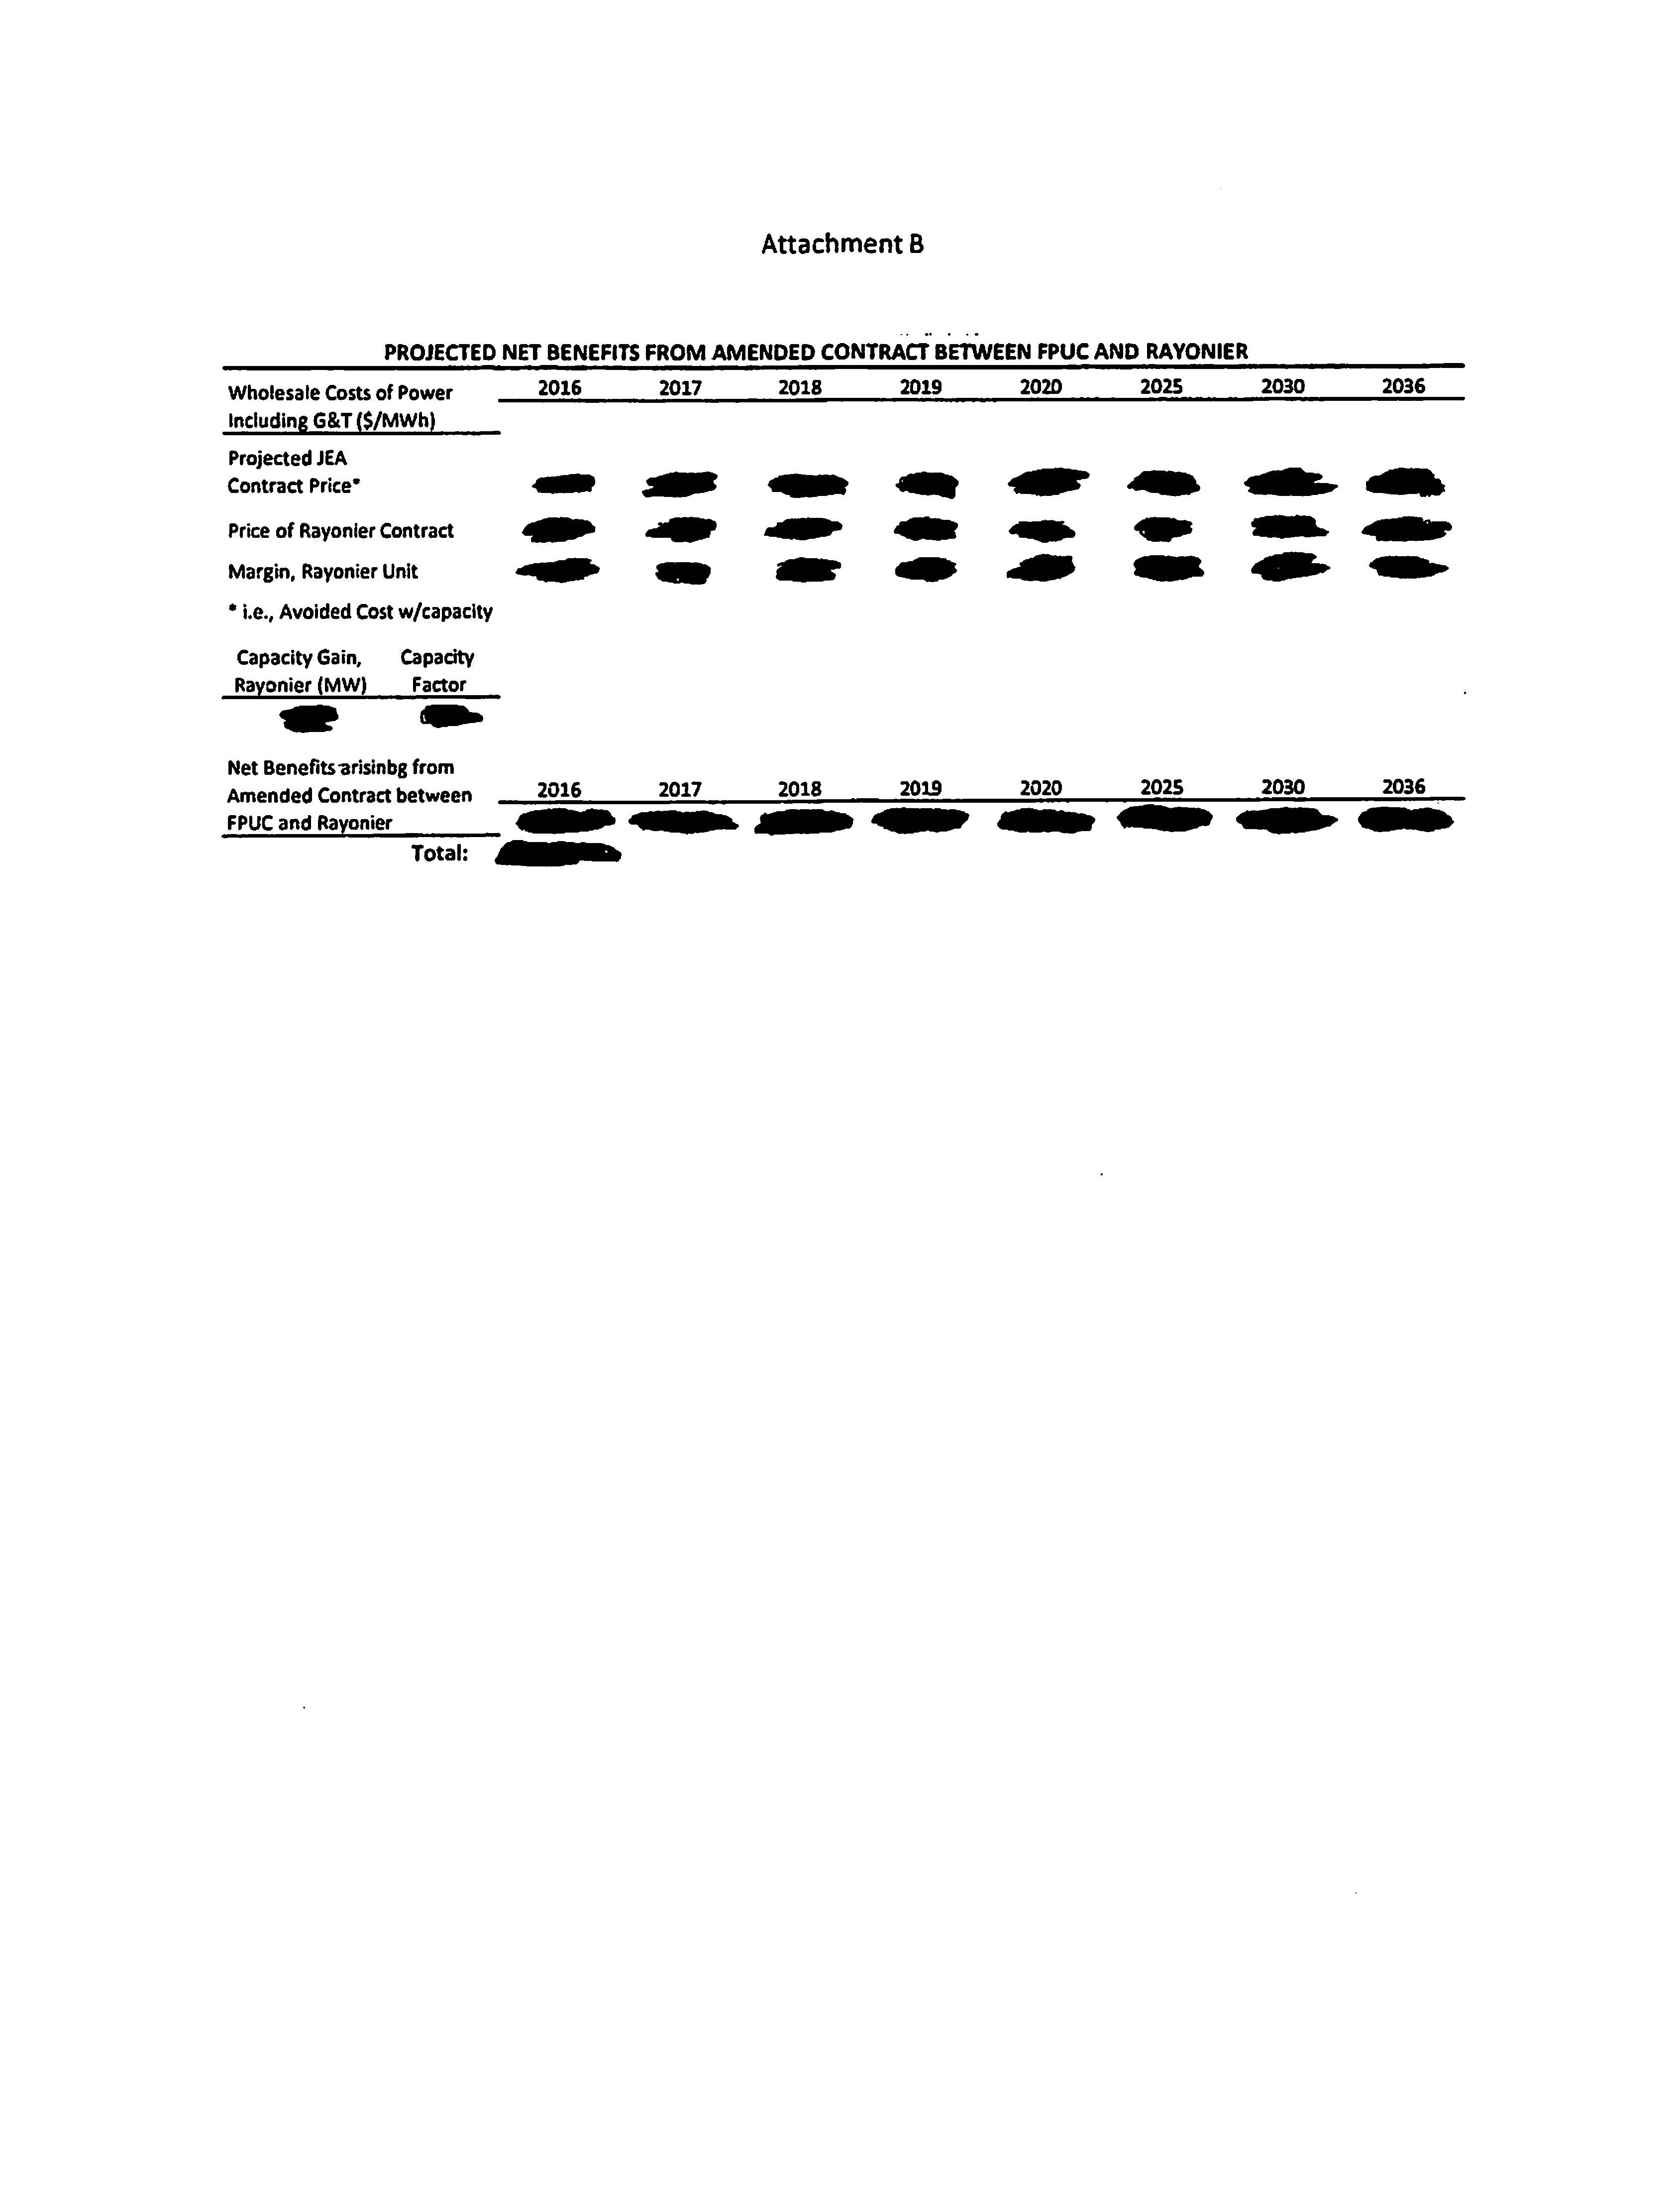

See Docket No.120058-EQ, In re: Petition for approval of a negotiated renewable energy power purchase contract for power purchased with Rayonier Performance Fibers, LLC, by Florida Public Utilities Company.
See FPUC’s responses to staff’s first data request, No. 2.

