State of Florida   |  | Public Service Commission  Capital Circle Office Center ● 2540 Shumard Oak Boulevard  Tallahassee, Florida 32399-0850  -M-E-M-O-R-A-N-D-U-M-
DATE: | December 8, 2014
TO: | Office of Commission Clerk (Stauffer)
FROM: | Office of Telecommunications (Casey)  Office of the General Counsel (Page)
RE: | Docket No. 110013-TP – Request for submission of proposals for relay service, beginning in June 2012, for the deaf, hard of hearing, deaf/blind, or speech impaired, and other implementation matters in compliance with the Florida Telecommunications Access System Act of 1991.  Docket No. 140029-TP – Request for submission of proposals for relay service, beginning in June 2015, for the deaf, hard of hearing, deaf/blind, or speech impaired, and other implementation matters in compliance with the Florida Telecommunications Access System Act of 1991.
AGENDA: | 12/18/14 – Regular Agenda – Interested Persons May Participate
COMMISSIONERS ASSIGNED: |  |  | All Commissioners
PREHEARING OFFICER: |  |  | Brisé (110013-TP)  Administrative (140029-TP)
CRITICAL DATES: |  |  | 03/03/15 (Parties have requested an early transition of Sprint's Relay contract from June 1, 2015 to March 3, 2015.)
SPECIAL INSTRUCTIONS: |  |  | Please place at the beginning of the agenda or at a time certain to reduce interpreter costs.

Case Background
The Florida Public Service Commission (Commission) currently contracts with AT&T Corporation (AT&T) for the provision of Florida relay service. The existing Florida relay service provider contract expires May 31, 2015. On January 16, 2014, AT&T provided written notice to the Commission that it does not intend to extend the relay provider contract into the option periods when the existing contract to provide relay service in Florida expires. AT&T is exiting the relay provider market in all states in which it has a relay contract.
Based on a competitive bid evaluation process, the Commission awarded the new relay provider contract to Sprint Communications Company, L.P., (Sprint) effective June 1, 2015, for a period of three years ending May 31, 2018. The contract contains options to extend the contract for four additional one-year periods, and requires mutual consent by both parties to extend the contract.

On November 26, 2014, AT&T and Sprint (Joint Movants) filed a Joint Motion For Expedited Approval of Early Transition of Relay Service Providers from AT&T to Sprint (Attachment A) effective March 3, 2015. This recommendation addresses the Joint Movants’ Motion for Expedited Approval. The Commission has jurisdiction pursuant to Section 427.704, Florida Statutes.

Discussion of Issues
Issue 1:1
Should the Commission approve an amendment to the current AT&T relay contract to end its provision of relay service on February 28, 2015, and approve an amendment to the Sprint relay service contract to change the effective date of the Sprint contract to March 1, 2015, and change the end date to February 28, 2018?
Recommendation:
Yes. The Commission should approve an amendment to the current AT&T relay contract to end its provision of relay service on February 28, 2015, with the condition that AT&T reimburse Florida Telecommunications Relay, Inc. (FTRI) $0.33 per session minute for traditional relay service and $0.16 per session minute for CapTel service from March 1, 2015 through May 31, 2015. The Commission should also approve an amendment to the Sprint relay service contract to change the effective date of that contract to March 1, 2015, and change the end date to February 28, 2018. The amendments to the contracts should be effective upon the signature of the Commission’s Executive Director, Sprint, and AT&T. (Casey, Page)
Staff Analysis:
The Commission currently contracts with AT&T for the provision of Florida traditional relay service and CapTel service. On January 16, 2014, AT&T notified the Commission that it does not intend to extend the relay provider contract after May 31, 2015. Through a competitive bid process, the Commission subsequently chose Sprint as the new Florida relay provider effective June 1, 2015. On November 26, 2014, AT&T and Sprint filed a Joint Motion For Expedited Approval of Early Transition of Relay Service Providers from AT&T to Sprint effective March 3, 2015.
Joint Movants’ Motion for Expedited Approval
The Joint Movants seek to transition the Florida traditional relay service and CapTel provider business from AT&T to Sprint three months earlier than provided in the parties’ contracts. Because AT&T is in the process of exiting the relay business nationwide, the Joint Movants’ petition requests that Sprint’s first day of service as the new Florida relay provider begin approximately ninety (90) days early, on March 3, 2015.

The parties’ motion proposes that AT&T’s existing contract would terminate effective March 2, 2015, and that Sprint’s successor contract would become effective on March 3, 2015. Although the rates payable under the new Sprint TRS contract are higher than the rates payable to AT&T under the current contract, Sprint would provide service at the lower AT&T rates from March 3, 2015 through May 31, 2015. AT&T would reimburse Sprint for the difference between the respective rates in a method and manner to be determined by the parties. Beginning June 1, 2015, and continuing thereafter, Sprint would charge and receive payment of the contractual rates for traditional relay service and CapTel service per contract as established in Docket No. 140029-TP, and AT&T would cease reimbursement to Sprint.

Staff Analysis
The Joint Movants are requesting that Sprint’s contract commence ninety days prior to the contracted effective date of June 1, 2015, while retaining the same end date of May 31, 2018. Staff has concerns with this proposal since it would add ninety days to a contract which was awarded based on a request for proposal which included a three-year contract with four one-year options. Staff believes the Joint Movants’ request may be outside the scope of procurement policy since it would be an additional procurement of service without use of a request for proposal as required by Section 427.704, Florida Statutes. Staff believes moving the start date and the end date of the Sprint contract up ninety days would be more appropriate since the original three year term and subsequent four one-year options which were included in the request for proposal, and contracted for with Sprint, would remain intact.
AT&T’s contract provided for a contract service date of June 1, 2012, for a period of three years ending May 31, 2015. Sprint’s contract provides for a contract start date of June 1, 2015, for a period of three years ending May 31, 2018. The Joint Movants prefer to modify the proposed transition date from March 3, 2015 to March 1, 2015, if staff proposes to move both the start date and the end date of the Sprint contract up ninety days. Sprint had previously advised the Commission of its willingness to transition relay service early via Sprint’s response to the relay request for proposal which included the following:

Sprint would be happy to begin service prior to the scheduled June 1, 2015 Transition Date. Sprint will be prepared to work with the FPSC to coordinate an earlier transition timeline. Sprint requires a minimum of 60 days after a receiving an executed contract to implement service. If desired and with cooperation from the FPSC and the current provider, Sprint projects a start date of January 6, 2015.

Both AT&T’s and Sprint’s contracts provide that the agreement may not be changed or modified except by a formal written amendment executed by the authorized representatives of the companies and the Commission. The Commission has previously approved amendments to relay contracts for such terms as contract options, changes in technology, and improvements to service quality.

AT&T’s existing contract includes a rate of $0.76 per session minute for intrastate traditional relay calls, and $1.47 per session minute for intrastate CapTel calls processed for the State of Florida. Sprint’s contract specifies a rate of $1.09 per session minute for intrastate traditional relay calls, and $1.63 per session minute for intrastate CapTel calls. Sprint’s contract rates are $0.33 per session minute more for traditional relay service and $0.16 per session minute more for CapTel service. Staff believes if the Commission approves the early transition, AT&T should reimburse FTRI the per minute differential from March 1, 2015 through May 31, 2015.

If the early transition is approved by the Commission, Sprint would charge and receive payment of the Sprint contractual rates for three years as established in Docket No. 140029-TP beginning March 1, 2015, for traditional relay service and CapTel service. Staff would provide AT&T with the actual billed per session minutes each month (March 2015, April 2015, May 2015) for traditional relay service and CapTel service. AT&T would subsequently reimburse FTRI the actual cost differential of the per minute session minutes within 30 days of receiving the notice from Commission staff.
Conclusion

Staff believes an early transition from AT&T to Sprint as of March 1, 2015, would be seamless, beneficial to the state, and in the best interests of the deaf, hard of hearing, deaf-blind and speech impaired community in Florida. Sprint relay has been evaluated during the recent request for proposal process and scored the highest technical points and had the most competitive prices of the bidders.

Although the Joint Movants would prefer the Commission approve their original filing adding ninety additional days to Sprint’s contract and having AT&T reimburse Sprint for the rate differential for the first ninety days, the Joint Movants stated in a December 4, 2014 conference call that they would acquiesce to staff’s suggested changes. Therefore, staff recommends that the Commission should approve an amendment to the current AT&T relay contract to end its provision of relay service on February 28, 2015, with the condition that AT&T reimburse FTRI $0.33 per session minute for traditional relay service and $0.16 per session minute for CapTel service from March 1, 2015 through May 31, 2015. The Commission should also approve an amendment to the Sprint relay service contract to change the effective date of Sprint’s contract to March 1, 2015, and the end date to February 28, 2018. Sprint would still retain the ability to exercise the four one-year options after the original three year term as set forth in the current contract.

The Commission should direct the Commission’s Executive Director or designee to finalize and sign contract amendment language in accordance with the Commission decision. Amendments to each contract should be signed by a qualified representative of each party, and the Commission’s Executive Director or designee. Two originals would be signed so each party has an original signed amendment. The amendments to the contracts should be effective upon the signature of the Commission’s Executive Director, Sprint, and AT&T.

The amendment to the AT&T contract should specify that AT&T will continue to be bound by the provisions of its contract pertaining to the Commission’s access to records in Section 3 of the AT&T contract, and specify that if payment is not received by FTRI within the 30 day due date, AT&T will be liable for interest charges at prime lending rates that will be incurred against the unpaid balance until such time as payment is received. The amendment to the AT&T contract should also specify that the provision on transition to the new provider remains as specified in Section 9 of the contract and paragraph B.57 of the request for proposals. This provision requires AT&T to assist in the transfer of the relay service to Sprint, and use reasonable efforts to ensure the following:

- Efforts will be made to accomplish the transfer of service by means of toll-free number portability so that a toll-free number change number portability so that (sic.) for FRS is not needed. If a toll-free number change for FRS is necessary, intercept referral service to the new Provider will be made available by AT&T as of the date of the transfer and continuing for a period of three (3) consecutive months thereafter.
- AT&T will designate a person to coordinate the transfer and communicate with the Commission and the incoming Provider concerning the transfer.
- Complaints in process on the effective date of the transfer of service to the new Provider should be responded to by AT&T within fifteen (15) days of such effective date.
- If there are any other published administrative lines, service will be maintained for a period of sixty (60) days after date of transfer of service to the new Provider, and callers will be referred to the new Provider during such period.

The amendment language should also state that as provided in paragraph A.3 of the request for proposals, the amendment to the AT&T contract shall be construed according to the laws of the state of Florida. Moreover, the AT&T contract amendment should specify that if AT&T fails to abide by the contract amendments as stated above, AT&T may be subject to liquidated damages as stated in paragraph B.56 of the request for proposals.
Issue 2:2
Should these dockets be closed?
Recommendation:
Docket No. 140029-TP should remain open for the duration of the contract. Docket No. 110013-TP should be closed administratively by staff after the last rate differential payment is made by AT&T to FTRI. (Page, Casey)
Staff Analysis:
Docket No. 140029-TP should remain open for the duration of the contract. Docket No. 110013-TP should be closed administratively by staff after the last rate differential payment by AT&T is made to FTRI.
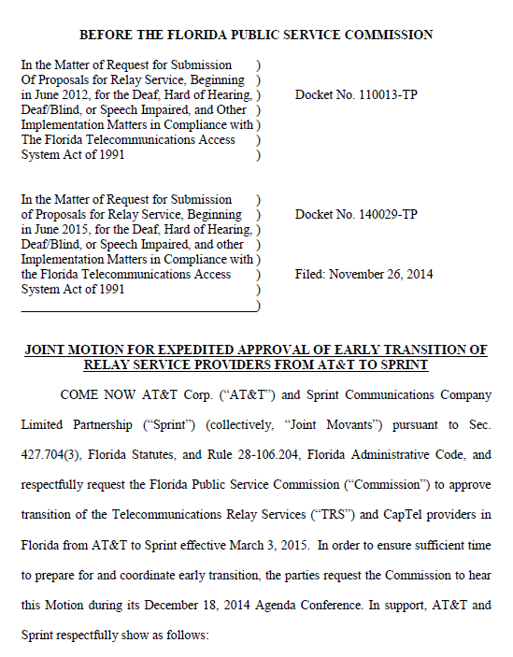
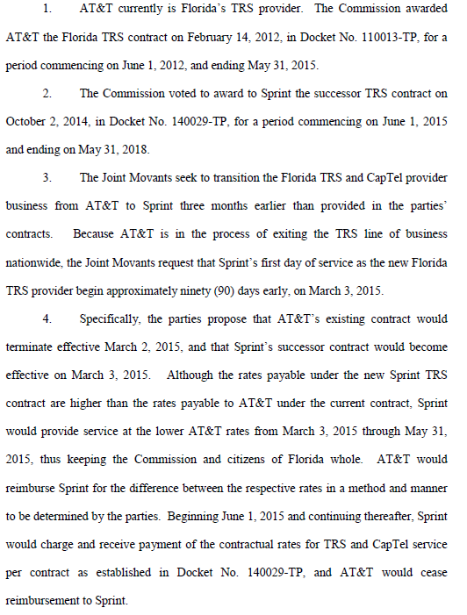

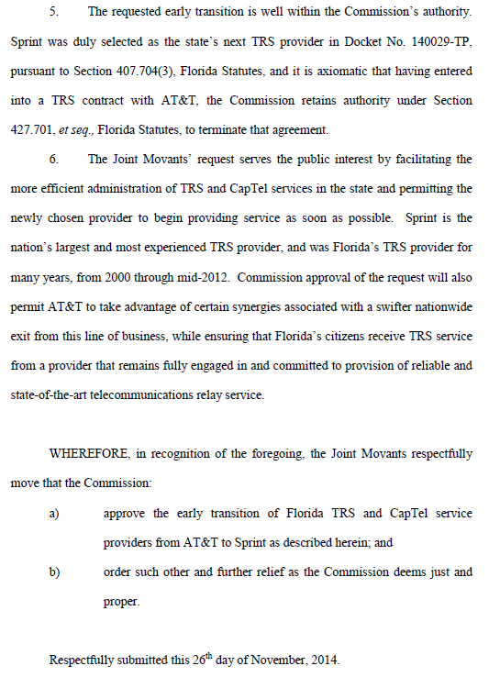

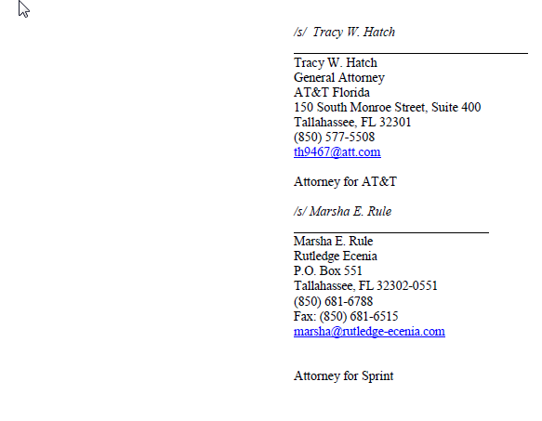

A captioned telephone service which uses a telephone that looks similar to a traditional telephone but also has a text display that allows the user, on one standard telephone line, to listen to the other party speak and simultaneously read captions of what the other party is saying.

