BEFORE THE FLORIDA PUBLIC SERVICE COMMISSION

In re: Petition for approval of transportation service agreement for an extension in Nassau County with Florida Public Utilities Company, by Peninsula Pipeline Company, Inc. | DOCKET NO. 140189-GU  ORDER NO. PSC-14-0713-PAA-GU  ISSUED: December 31, 2014

The following Commissioners participated in the disposition of this matter:

ART GRAHAM, Chairman
LISA POLAK EDGAR
RONALD A. BRISÉ
EDUARDO E. BALBIS
JULIE I. BROWN

NOTICE OF PROPOSED AGENCY ACTION
ORDER APPROVING THE TRANSPORTATION SERVICE AGREEMENT

BY THE COMMISSION:

NOTICE is hereby given by the Florida Public Service Commission that the action discussed herein is preliminary in nature and will become final unless a person whose interests are substantially affected files a petition for a formal proceeding, pursuant to Rule 25-22.029, Florida Administrative Code (F.A.C.).

Background

On September 30, 2014, Peninsula Pipeline Company, Inc. (Peninsula) filed a petition seeking approval of a firm transportation service agreement (Agreement) between Peninsula and Florida Public Utilities Company (FPUC) for an extension in Nassau County. Peninsula operates as a natural gas transmission company as defined in Section 368.103(4), Florida Statutes (F.S.).

By Order No. PSC-07-1012-TRF-GP, we approved an intrastate gas pipeline tariff that allows Peninsula to construct and operate intrastate pipeline facilities and to actively pursue agreements with gas customers. Peninsula provides transportation service only, and does not engage in the sale of natural gas. Pursuant to Order No. PSC-07-1012-TRF-GP, Peninsula is allowed to enter into certain gas transmission agreements without our prior approval. However, Peninsula is requesting our approval of this Agreement as it does not fit any of the criteria enumerated in the tariff for which our approval would not be required. Both Peninsula and FPUC are subsidiaries of Chesapeake, and agreements between affiliated companies must be approved by this Commission pursuant to Section 368.105, F.S., and Order No. PSC-07-1012-TRF-GP.
Peninsula is seeking to extend its existing infrastructure in Nassau County by 4.6 miles to interconnect with FPUC’s distribution system near the City of Yulee north of Jacksonville. During its evaluation of the petition, Commission staff issued a data request to both Peninsula and FPUC for which responses were received on October 29, 2014. This Commission has jurisdiction over this matter pursuant to Sections 366.05(1), 366.06, and 368.105, F.S.

Discussion

The proposed Agreement provides for an extension of Peninsula’s existing Fernandina Beach Line to allow FPUC to serve new load in Nassau County and will be in effect for an initial period of 20 years. This Commission addressed Peninsula’s construction of the Fernandina Beach Line and associated transportation service agreement between Peninsula and FPUC in Order No. PSC-12-0230-PAA-GU. The Fernandina Beach Line is labeled “PPC/PGS Joint Pipeline” in the map provided in Attachment A. The Fernandina Beach Line is jointly owned by Peninsula and Peoples Gas System (PGS).

Pursuant to the proposed Agreement, Peninsula will construct a 4.6 mile steel pipeline extending from the existing Fernandina Beach Line along William Burgess Road as shown in Attachment A. Peninsula stated that it has received all required permits and anticipates the construction to be completed in the second quarter of 2015. The negotiated monthly reservation charge included in the proposed Agreement is designed to allow Peninsula to recover its investment and operational costs associated with the extension. These costs include design engineering, permitting, material and installation costs, on-going maintenance costs, property taxes, and Peninsula’s return on investment.

The parties assert that the rates contained in the Agreement are consistent with a market rate in that they are within the ranges of rates set forth in similar agreements as required by Section 368.105(3)(b), F.S. In response to Commission staff’s data request, Peninsula provided a comparison of construction costs (confidential) for other similar agreements entered into by Peninsula. While construction costs vary for each project due to pipe size, construction conditions, permitting, etc., we find that Peninsula’s construction costs for the proposed extension appear reasonable and comparable to other projects.

Peninsula explained in its petition and in response to Commission staff’s data request that the area to be served by this pipeline extension is expected to experience considerable growth in gas usage. Specifically, there are two major projects planned for development: the Terrapointe East Nassau Employment Center and the Nassau County Government complex. Both projects are expected to include new residential subdivisions and commercial and industrial space.

To support the proposed Agreement, Peninsula lists three benefits of Peninsula, as opposed to FPUC, constructing this extension: (1) Peninsula has expertise to construct and manage this type of pipeline, (2) the extension will be made from an existing Peninsula facility, thus avoiding negotiating interconnection rights with a third party, and (3) Peninsula’s construction and ownership will avoid FPUC undertaking the costs and risk for this project, protecting FPUC’s ratepayers.

Prior to the construction of the Fernandina Beach Line in 2012, FPUC issued a request for proposal (RFP) to all potential entities that could provide a valid proposal to bring gas from the Florida Gas Transmission Company (FGT) interstate pipeline into Nassau County. This Commission evaluated the RFP responses including FPUC’s self-build option, and approved the resulting agreements in Order No. PSC-12-0230-PAA-GU. Since this project is an extension from an existing Peninsula pipeline for which FPUC already has a transportation service agreement, FPUC did not issue an RFP to obtain construction cost estimates from other entities for this line extension. FPUC also stated that, operationally, it is not practical to contract with another pipeline operator for a relatively small extension, and the capacity held by FPUC on the existing Peninsula pipeline is the same capacity that will be used to deliver gas to the proposed extension.

FPUC is proposing to recover the payments to Peninsula under the proposed Agreement through its Purchased Gas Adjustment (PGA) mechanism consistent with other gas transmission pipeline costs incurred by FPUC. In the annual PGA docket we do not set an actual factor, but a PGA cap. FPUC provided information showing that the impact on the PGA cap will be minor. While FPUC will incur costs associated with this service expansion to new areas, the anticipated new load will help spread the costs over a larger customer base.

Decision

Based on the petition and responses from FPUC and Peninsula to Commission staff’s data request, we find the proposed Agreement is cost effective, reasonable, meets the requirements of Section 368.105, F.S., and benefits FPUC’s customers. We hereby approve the Transportation Service Agreement between Peninsula and FPUC dated September 26, 2014, for an extension in Nassau County.

Based on the foregoing, it is

ORDERED by the Florida Public Service Commission that the Transportation Service Agreement between Peninsula Pipeline Company, Inc. and Florida Public Utilities Company for an extension in Nassau County is approved. It is further

ORDERED that the provisions of this Order, issued as proposed agency action, shall become final and effective upon the issuance of a Consummating Order unless an appropriate petition, in the form provided by Rule 28-106.201, Florida Administrative Code, is received by the Commission Clerk, 2540 Shumard Oak Boulevard, Tallahassee, Florida 32399-0850, by the close of business on the date set forth in the “Notice of Further Proceedings” attached hereto. It is further

ORDERED that in the event this Order becomes final, this docket shall be closed.

By ORDER of the Florida Public Service Commission this 31st day of December, 2014.

/s/ Hong Wang
HONG WANG
Chief Deputy Commission Clerk
Florida Public Service Commission
2540 Shumard Oak Boulevard
Tallahassee, Florida 32399
(850) 413-6770
www.floridapsc.com

Copies furnished: A copy of this document is provided to the parties of record at the time of issuance and, if applicable, interested persons.

DJ

NOTICE OF FURTHER PROCEEDINGS OR JUDICIAL REVIEW

The Florida Public Service Commission is required by Section 120.569(1), Florida Statutes, to notify parties of any administrative hearing that is available under Section 120.57, Florida Statutes, as well as the procedures and time limits that apply. This notice should not be construed to mean all requests for an administrative hearing will be granted or result in the relief sought.

Mediation may be available on a case-by-case basis. If mediation is conducted, it does not affect a substantially interested person's right to a hearing.

The action proposed herein is preliminary in nature. Any person whose substantial interests are affected by the action proposed by this order may file a petition for a formal proceeding, in the form provided by Rule 28-106.201, Florida Administrative Code. This petition must be received by the Office of Commission Clerk, 2540 Shumard Oak Boulevard, Tallahassee, Florida 32399-0850, by the close of business on January 21, 2015.

In the absence of such a petition, this order shall become final and effective upon the issuance of a Consummating Order.

Any objection or protest filed in this/these docket(s) before the issuance date of this order is considered abandoned unless it satisfies the foregoing conditions and is renewed within the specified protest period.
Map showing location of proposed Peninsula extension

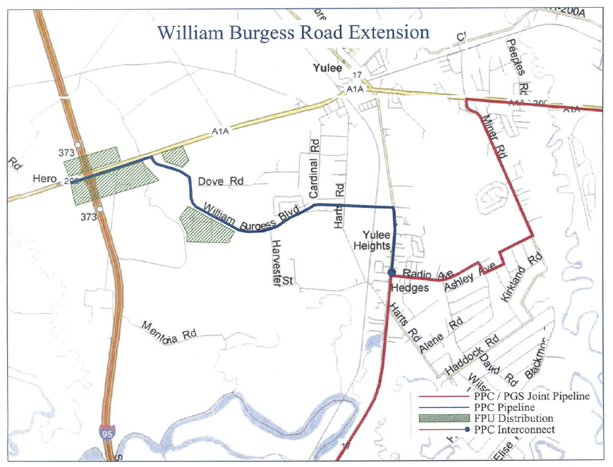

See Order No. PSC-06-0023-DS-GP, issued January 9, 2006, in Docket No. 050584-GP, In re: Petition for declaratory statement by Peninsula Pipeline Company, Inc. concerning recognition as a natural gas transmission company under Section 368.101, F.S., et seq.
Order No. PSC-07-1012-TRF-GP, issued December 21, 2007, in Docket No. 070570-GP, In re: Petition for approval of natural gas transmission pipeline tariff by Peninsula Pipeline Company, Inc.
Peninsula Pipeline Company, Inc., Intrastate Pipeline Tariff, Original Vol. 1, Sheet No. 12, Section 4.
Order No. PSC-12-0230-PAA-GU, issued May 9, 2012, in Docket No. 110271-GU, In re: Petition for approval of transportation service agreement with Florida Public Utilities Company, by Peninsula Pipeline Company.
The projected $/therm impact to the PGA factor was provided under a claim of confidentiality.

